An Unusual Presentation of Penile Fracture: Report of Two Cases

ABSTRACT
Penile fracture is a rare condition that is easily identified by its classical clinical features. However, its features and course of the condition could be altered by the timing of presentation and the occurrence of complications. Delayed presentation is directly associated with delayed intervention with attendant poor clinical outcome. The occurrence of concomitant injuries like urethral rupture is associated with morbidities such as urethral stricture and urethra-cutanous fistula if not promptly and primarily repaired. We present two rare case reports of a delayed presentation of penile fracture and penile fracture with concomitant urethral injury. The patient in the first case report presented with localized right sided penile swelling and painful erection while the patient in the second case report presented with diffuse penile swelling, pain and urethral bleeding following trauma to the erect penis during intercourse. Both cases had immediate repair with good anatomical and functional outcome. This article highlights the invaluable role of primary repair in the management of penile fracture irrespective of the pattern of presentation.
Keywords: Penile fracture, Penile swelling, Haematoma, Urethral injury
INTRODUCTION
The penis is an organ of pleasure that has to be erect to be sexually useful. In this same erect state, it is prone to fracture when force is applied to it. The penis is fractured when one or both of the tunica albuginea ruptures. Penile fracture is relatively uncommon, occurring in 1 per 175,000 men in US¹. It is considered a urologic emergency requiring immediate intervention to prevent complications². Diagnosis of penile fracture is often clinical; the patient characteristically hears a “popping” or “clicking” sound followed by immediate loss of erection, intense pain and penile swelling/deformity.
In about 20% of patients, urethral bleeding and sometimes acute urinary retention may occur as a result of concomitant urethral injury³.Penile fracture that is associated with urethral injury is considered a complex or severe injury which is often linked to rupture of both corpora cavernosa³. In other to prevent significant morbidity, immediate penile exploration with evacuation of the haematoma, control of bleeders and repair of the rent in the tunica albuginea has been advocated⁴ ⁻ ⁶.
Patients with penile fracture usually present early and also rarely suffer urethral injury, hence the need to report two cases with peculiar presentation. The first case is that of delayed presentation and the second case is that of tear of the tunica albuginea of both corpora cavernosa and complete urethral disruption resulting in urethral bleeding.
Case presentation
CASE REPORT 1
A 32-year old artisan presented to the urology outpatient department with penile swelling and painful erection for two weeks. He provided a detailed history stating that his penis hit the thigh of his partner during sexual intercourse from a rear position accompanied by loss of tumescence and a popping sound. He experienced progressive swelling of the penis and pain on the penis. Pain disappeared over time while swelling persisted. Afterwards, he had painful erections which necessitated consultation to a nurse who advised him to visit the urology outpatient department. Patient past medical and surgical history was insignificant. General physical examination revealed no notable finding. The patient’s vital signs were stable. Examination of the external genitalia revealed swelling on the ventro-latral aspect of the right side of the mid - penile shaft, 4cm long and 3cm wide, non – tender, firm and no differential warmth (fig.1). Based on the typical history and examination findings, a clinical diagnosis of penile fracture was made. Patient was admitted into urology ward and had pre-operative investigations. Penile ultrasonography revealed a heterogenous and mainly hypoechoic mass on the lateral aspect of the penis on the right side and a tear of the corpora cavernosa. Full blood count, renal function test and urinalysis all yielded normal results. In operating theatre, a careful exploration of the penis was performed. It revealed a bulging, organized haematoma under the buck’s fascia, and a 3cm transverse tear on the right inferolateral tunica albuginea (fig.2 a, b). The defect was repaired using vicryl 2/0 suture, ensuring proper alignment and closure (fig.3). A size 16F foley catheter was passed to facilitate urine drainage which was removed on the second post - operative day. Patient received intravenous ciprofloxacin and metronidazole, rectal diclofenac.
He had uneventful recovery with no immediate post - operative complications. After a thorough assessment, the patient was discharged on the fifth post-operative day with oral antibiotics and analgesics. Additionally, the patient received detailed post-operative instructions, including strict adherence to medication regimens and the avoidance of sexual contact for 12 weeks to ensure proper healing and reduce the risk of breakdown of repair. He had no post-operative complication. He is presently having good erection and satisfactory sexual intercourse.
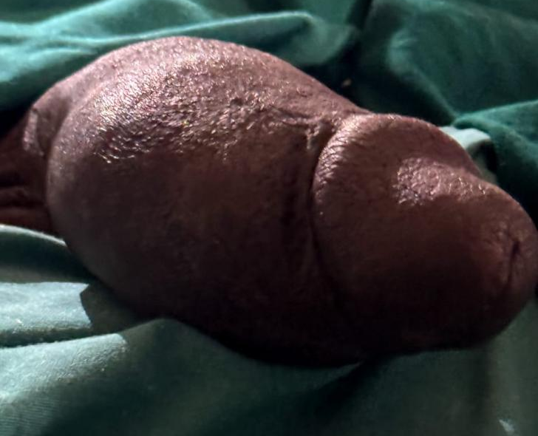
Figure 1: Preoperative picture showing right sided penile swelling
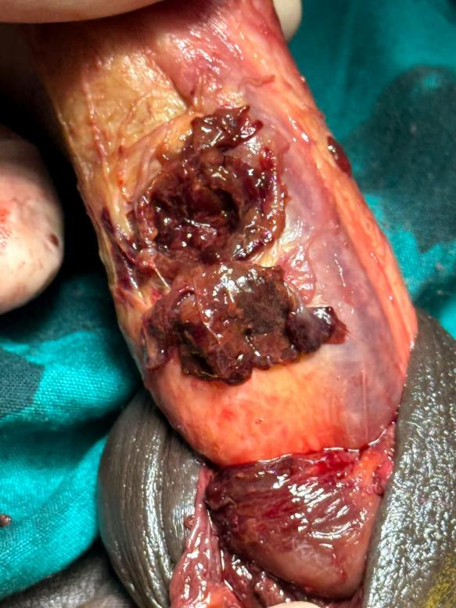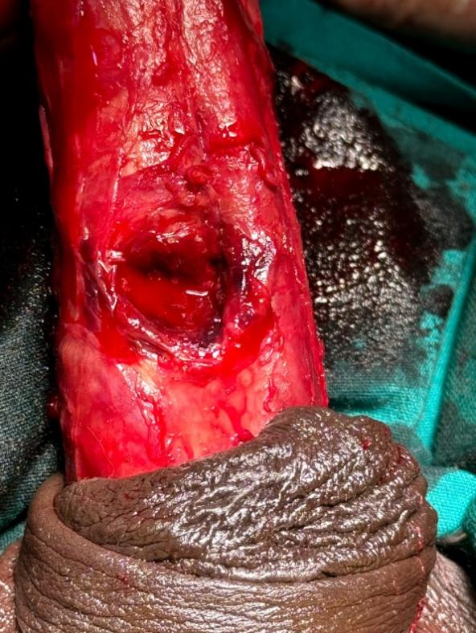
B
A
Figure 2
A – Penile surgical exploration showing penile haematoma
B – Defect in the inferolateral tunical albuginea

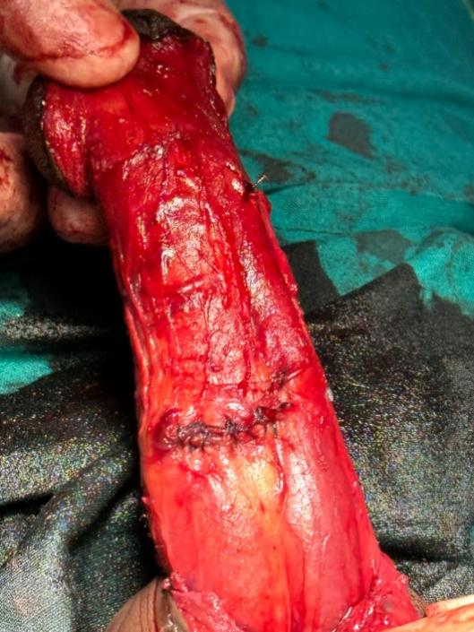
Figure 3: Defect repaired with vicryl suture
CASE REPORT 2
A 43-year old business man presented to the accident and emergency with bleeding per urethra, penile swelling and pain for four hours. He gave further history stating that his turgid penis hit the thigh of his partner during sexual intercourse from the rear position. He heard a popping sound accompanied by loss of tumescence, pain which was acute in onset, penile swelling/deformity and urethral bleeding with estimated blood loss of 100mls. Last urine void was an hour before the incident, hence wasn’t in retention of urine. Past medical and surgical history was insignificant. He was anxious looking but was in satisfactory general condition. His vital signs were stable. Examination of the external genitalia revealed ecchymosis of the penile skin, blood at the tip of penis, swelling of the penis. A diagnosis of penile fracture with urethral injury was made. He had pre-operative complete blood count and renal function test which were normal. He had immediate penile exploration in theatre; findings were haematoma, 3cm transverse tear on the inferior aspect of each tunica albuginea mid shaft and complete disruption of the urethra at the same level (fig.4). The defect was repaired with vicryl 2/0 suture ensuring proper alignment and closure. The urethra was spatulated, end to end anastomosis done over a size 16F foley catheter stent with vicyl 4/0 suture (fig.5). Post operatively he received intravenous antibiotics, intramuscular diclofenac and sedation with diazepam to prevent erection which may disrupt urethra repair.
He had uneventful recovery with no immediate post - operative complications. After a thorough assessment, the patient was discharged on the fifth post-operative day with oral antibiotics, analgesics and indwelling catheter. Additionally, the patient received detailed post-operative instructions, including strict adherence to medication regimen, care of the indwelling catheter, doing a paracatheter retrograde urethrography on post – operative day 21 and the avoidance of sexual contact for 12 weeks to ensure proper healing and reduce the risk of breakdown of repair. Urethra catheter was removed at 4 weeks after repair without a para - catheter retrograde urethrogram because he couldn’t afford it. He is passing urine with good stream.

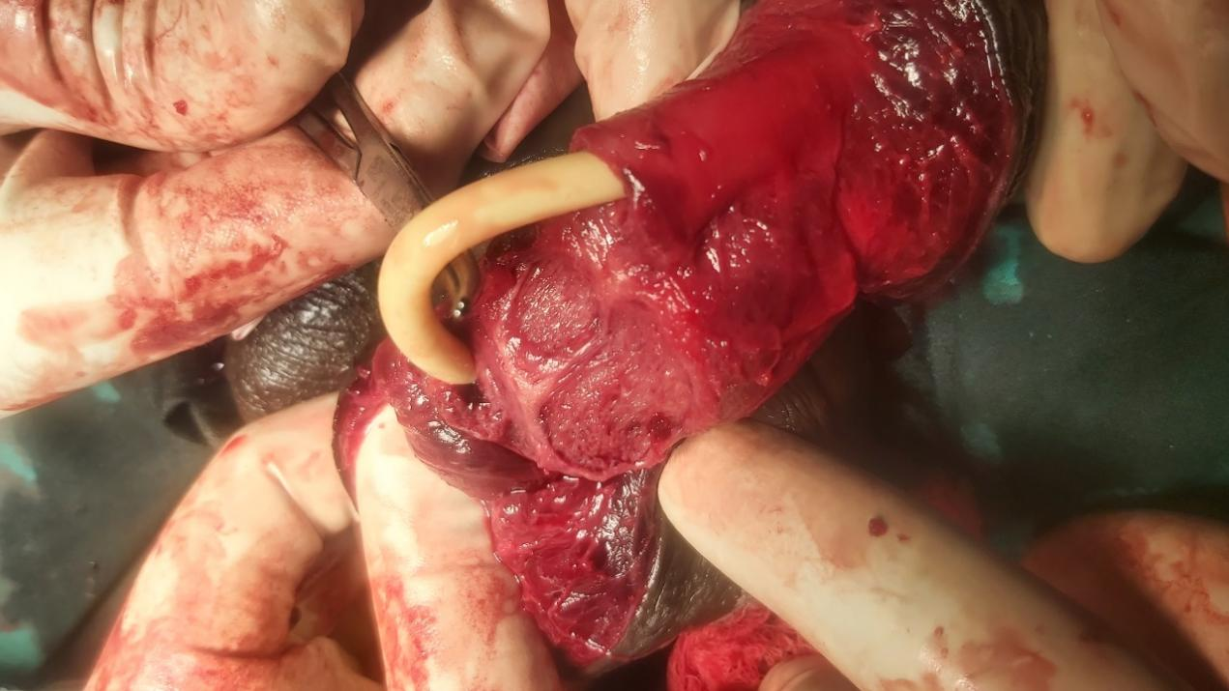
Figure 4: Defect in both tunica albuginea and urethral disruption

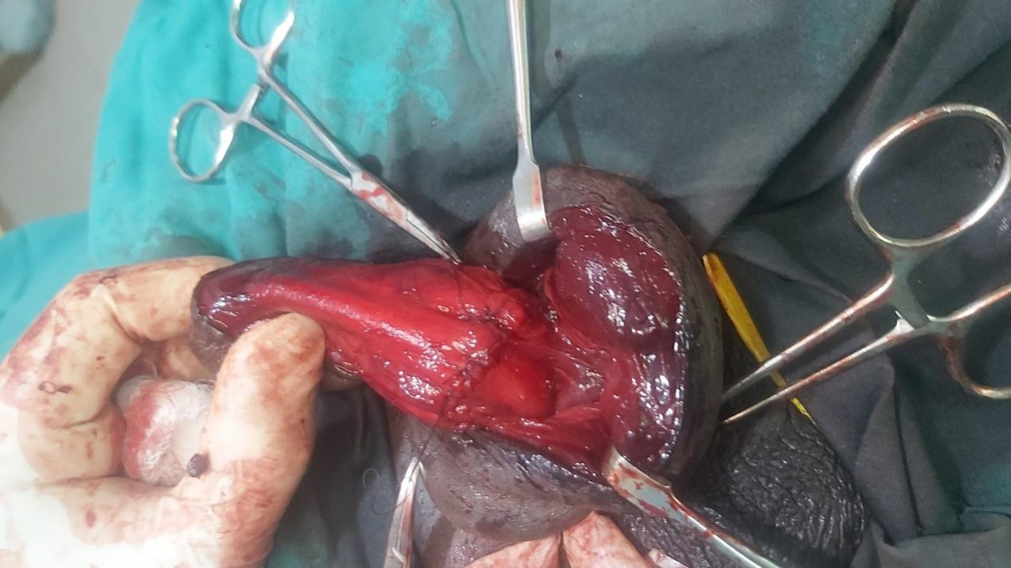
Figure 5: Defect and urethral disruption repaired
DISCUSSION
Penile fracture is a relatively uncommon condition that is easily diagnosed because of its distinct clinical features. It occurs most commonly in middle aged men between the ages of 30 – 50 years^{7, 8}. The age of the patients presented in this article falls within this age bracket. Tang et al⁹ described these age group as being very active sexually with aggressive sexual behavior and have tendency to use sex enhancing drugs for various reasons. Adventurous sexual behavior which is common among men of this age bracket is associated with employment of different sexual positions during sexual activity. The rear entry position popularly known as “doggy position” has been documented as the most common position linked with penile fracture^{10, 11}. Usually, in this position, the turgid penis slips out of the vagina and hits the perineum or thigh of the partner resulting in tear of the tunica albuginea. In our report, the patients alluded to sexually engaging their partners through this “doggy position” and experiencing the same mechanism of injury hence supporting this position as the leading sexual position linked to penile fracture. Majority of patients with penile fracture present for treatment within few hours of injury, though some authors have reported late presentation^{12, 13}. Reasons such as social scenarios associated with penile fracture, personal embarrassment and ignorance to the potential complications of penile fracture are attributed to delay between injury and presentation and subsequent management¹⁴. The timing of presentation in cases of penile fracture has been shown to have an impact on the outcomes of repair¹⁵. Early recognition and prompt surgical intervention are crucial for achieving optimal outcomes¹⁶.Delayed presentation, on the hand, may result in several challenges which include delayed diagnosis and subsequent delayed surgical repair which may increase of complications and poorer functional outcomes. Prolonged delays can also result in fibrosis and scarring of the tunica albuginea, making the repair more challenging and increasing the likelihood of long term sequalae such as erectile dysfuncton, penile curvature, urethral stricture or urethra-cutanous fistula in case of urethral tear and painful erections which the patient in the first case report had. Penile fracture is easily diagnosable because of its distinct clinical history of a popping sound followed by immediate loss of erection, intense pain and penile swelling/deformity. This typical clinical history when combined with the physical finding of penile swelling, ecchymosis and deviation of the penis to opposite side as a result of haematoma and oedema on the affected side eliminates completely any chance of a misdiagnosis. Presentation with blood per urethra and difficult voiding points to the suspicion of a urethral injury¹⁷. The circular fibers of the tunica albuginea that forms the corpora cavernosa is stretched and thinned during erection. The normal thickness is 2mm, but this decreases to just 0.25mm when the corpora are fully engorged, and the penis is erect¹⁸. Their weakest point is generally on the ventral side of the penile shaft immediately adjacent to the urethra, where most ruptures occur. It explains the mechanism of any associated urethral injuries. Urethral injury is more likely to occur when both corpora are ruptured¹⁹. The patient in the second case report had rupture of both corpora. Though penile fracture can be diagnosed based solely on history and physical examination, imaging modalities such as penile ultrasound, cavernosography, magnetic resonance imaging should be performed in equivocal cases. In delayed presentation, the typical physical finding of penile echymoses and bending of the penile shaft away from the site of tunica tear may be absent making the diagnosis of penile fracture doubtful. Ultrasonography, which is readily available and quick to perform, is able to depict the tunica albuginea tear most times as a hypoechoic discontinuity in the normally echogenic tunica²⁰. The reason penile ultrasound was done for the patient who delayed in presenting was to determine and document the status of the tunica tear since he was already having erection. A pre-operative urethrogram was not considered for the patient with urethral injury to avoid delayed assess to the operating room. The European Association of Urology guideline for management of penile fracture recommends intra – operative cystoscopy over retrograde urethrogram because of a higher false positive rate and possible delay in accessing the operating room attributed to retrograde urethrogram^{21, 22}.
Both patients had operative intervention which is considered the preferred approach for most penile fractures. It provides direct visualization and precise repair of the defect, immediate anatomical and functional restoration, reducing long term risk. It also addresses concurrent issues like urethral injuries and haematoma evacuation^{1, 23}.Skin incision was subcoronal incision which is known to give good access for degloving and also cosmetically appealing²⁴. The patient in the first case report had unilateral fracture whereas the patient in the second case report had bilateral fracture. Unilateral fractures are common in 89.7% of cases in some series and very rarely bilateral cases in up to 1.9%²⁴. Where isolated fractures occur, right fracture is more frequently documented as seen in the first case report⁹. One layer repair was done in both case reports with vicryl 2/0 suture, the knots buried under the tunica to minimize post-operative scarring¹². The urethra in the second case report was repaired primarily, spatulated, and anastomosed with vicryl 4/0 over an indwelling catheter with continuous suture^{24, 25}, although interrupted suture repairs are most documented²⁶. Primary repair have been proven to have good outcome in some reports²⁷. This was demonstrated in both cases by the immediate straightening of the penis, good healing of the incision wound and the good stream of urine in the second case report post repair.
CONCLUSION
Penile fracture is a rare condition that is easily diagnosed because of its distinct clinical features. Certain rare features of the condition like delayed presentation and concomitant urethral injury could confuse its diagnosis, delay intervention and cause poor functional outcome. Irrespective of the manner of presentation, primary repair offers the best opportunity of restoration of both the anatomy and physiology of the penis with good functional outcome.
Consent
As per international standards or university standards, patient(s) written consent has been collected and preserved by the author(s).
Disclaimer (Artificial intelligence)
Author(s) hereby declare that NO generative AI technologies such as Large Language Models (ChatGPT, COPILOT, etc.) and text-to-image generators have been used during the writing or editing of this manuscript.

REFERENCES
- Amer, T., Wilson, R., Chlosta, P., AlBuheissi, S., Qazi, H., Fraser, M., & Aboumarzouk, O. M. (2016). Penile fracture: A meta-analysis. Urologia Internationalis, 96(3), 315–329. https://doi.org/10.1159/000444884
- Mahapatra, R. S., Kundu, A. K., & Pal, D. K. (2015). Penile Fracture: Our Experience in a Tertiary Care Hospital. World Journal of Men's Health, 33(2), 95–102. https://doi.org/10.5534/wjmh.2015.33.2.95
- Pariser, J. J., Pearce, S. M., Patel, S. G., & Bales, G. T. (2015). National Patterns of Urethral Evaluation and Risk Factors for Urethral Injury in Patients With Penile Fracture. Urology, 86(1), 181–185. https://doi.org/10.1016/j.urology.2015.03.039
- Eke, N. (2002). Fracture of the penis. British Journal of Surgery, 89(5), 555–565. https://doi.org/10.1046/j.1365-2168.2002.02075.x
- Mbonu, O. O., & Aghaji, A. E. (1992). 'Fracture' of the penis in Enugu, Nigeria. *Journal of the Royal College of Surgeons of Edinburgh*, *37*(5), 309–310. https://pubmed.ncbi.nlm.nih.gov/1282547/
- Gamal, W. M., Osman, M. M., Hammady, A., Aldahshoury, M. Z., Hussein, M. M., & Saleem, M. (2011). Penile fracture: long-term results of surgical and conservative management. Journal of Trauma, 71(2), 491–493. https://doi.org/10.1097/TA.0b013e3182093113
- Kati, B., Akin, Y., Demir, M., Boran, O. F., Gumus, K., & Ciftci, H. (2019). Penile fracture and investigation of early surgical repair effects on erectile dysfunction. Urologia, 86(4), 207–210. https://doi.org/10.1177/0391560319844657
- Barros, R., Schul, A., Ornellas, P., Koifman, L., & Favorito, L. A. (2019). Impact of surgical treatment of penile fracture on sexual function. Urology, 126, 128-133. https://doi.org/10.1016/j.urology.2018.11.047
- Tang, Z., Yang, L., Wei, Q., Wang, F., Liu, L. R., Tan, P., Qiu, S., & Fan, Y. (2018). Management and outcomes of penile fracture: a retrospective analysis of 62 cases with long-term assessment. Asian Journal of Andrology, 20(4), 412–413. https://doi.org/10.4103/aja.aja_36_17
- Arikan, M. G., Akgul, B., Turk, S., Tantekin, O. O., Cakiroglu, B., & Arda, E. (2024). Beyond conventional wisdom: unexplored risk factors for penile fracture. Sexual Medicine. https://doi.org/10.1093/sexmed/qfae068
- Syarif, S., Azis, A., Natsir, A. S., & Putra, M. Z. D. A. (2024). What is the most dangerous sexual position that caused the penile fracture? A systematic review and meta-analysis. International Brazilian Journal of Urology, 50(1), 28-36. https://doi.org/10.1590/S1677-5538.IBJU.2023.0419
- Omisanjo, O. A., Bioku, M. J., Ikuerowo, S. O., Sule, G. A., & Esho, J. O. (2015). A prospective analysis of the presentation and management of penile fracture at the Lagos State University Teaching Hospital (LASUTH), Ikeja, Lagos, Nigeria. African Journal of Urology, 21(1), 52–56. https://doi.org/10.1016/J.AFJU.2014.07.001
- Yunusa, B., Wullie, K., Willie, S. E., Konneh, S., Sherriff, S., Cassell, A., & Ikpi, E. (2019). Penile Fracture: Delayed Presentation, Primary Urethral Repair and Satisfactory Outcome. Case Reports in Urology, 2019, 1456914. https://doi.org/10.1155/2019/1456914
- Waseem. M, Upadhyay.R, Kapoor. R et al. Fracture of the penis: an atypical presentation. Int J Emerg Med 2013;6: 32
- Imran, M., Kamran, A., Tanveer, A., & Farho, M. A. (2023). Penile fracture: A case report. International Journal of Surgery Case Reports, 110, 108749. https://doi.org/10.1016/j.ijscr.2023.108749
- Wong, N. C., Dason, S., Bansal, R. K., Davies, T. O., & Braga, L. H. (2017). Can it wait? A systematic review of immediate vs. delayed surgical repair of penile fractures. Canadian Urological Association Journal, 11(1-2), 53–60. https://doi.org/10.5489/cuaj.4032
- Sawh, S. L., O'Leary, M. P., Ferreira, M. D., Berry, A. M., & Maharaj, D. (2008). Fractured penis: a review. International Journal of Impotence Research, 20(4), 366–369. https://doi.org/10.1038/ijir.2008.12
- Yogi, P., Sapkota, S., Shiwakoti, S., Dongol, U. M. S., Paudyal, P., & Karki, A. (2022). Penile Fracture: A Case Report. Journal of Nepal Medical Association, 60(254), 895–897. https://doi.org/10.31729/jnma.7876
- Bhoil, R., & Sood, D. (2015). Signs, symptoms and treatment of penile fracture. Emerg Nurse, 23(6), 16–17. https://doi.org/10.7748/en.23.6.16.s21
- Zare Mehrjardi, M., Darabi, M., Bagheri, S. M., Kamali, K., & Bijan, B. (2017). The role of ultrasound (US) and magnetic resonance imaging (MRI) in penile fracture mapping for modified surgical repair. International Urology and Nephrology, 49(6), 937–945. https://doi.org/10.1007/s11255-017-1550-x
- Kominsky, H., Beebe, S., Shah, N., & Jenkins, L. C. (2020). Surgical reconstruction for penile fracture: a systematic review. International Journal of Impotence Research https://doi.org/10.1038/s41443-019-0212-1
- Lumen, N., Kuehhas, F. E., Djakovic, N., Kitrey, N. D., Serafetinidis, F., Sharma, D. M., & Summerton, D. J. (2015). Review of the current management of lower urinary tract injuries by the EAU Trauma Guidelines Panel. European Urology, 67(5), 925–929 https://doi.org/10.1016/j.eururo.2014.12.035
- Shah, N., Khan, I. U., Aslam, R., & Latif, A. (2022). Penile Fractures: The Successful Outcome of Immediate Surgical Intervention. Pakistan Journal of Medical & Health Sciences, 16(12), 21–23. https://doi.org/10.53350/pjmhs22161221
- Rajih, E., Alenizi, A., & El-Hakim, A. (2015). Penile fracture with two ipsilateral corporal tears and delayed presentation: A case report. Canadian Urological Association Journal, 9(9-10), E741–E743. https://doi.org/10.5489/cuaj.2959
- Rahman, M. J., Faridi, M. S., Mibang, N., & Singh, R. S. (2016). Penile manipulation: The most common etiology of penile fracture at our tertiary care center. Journal of Family Medicine and Primary Care, 5(2), 471–473. https://doi.org/10.4103/2249-4863.192347
- Faridi, M. S., Agarwal, N., Saini, P., Kaur, N., & Gupta, A. (2015). Myriad presentations of penile fracture: report of three cases and review of literature. *Journal of Family Medicine and Primary Care*, *4*(2), 273–275. https://doi.org/10.4103/2249-4863.154674
- Barros, R., Guimarães, M., Nascimento Jr., C., Araújo, L.R., Koifman, L., & Favorito, L.A. (2018). Penile refracture: a preliminary report. International Brazilian Journal of Urology, 44, 800-804. https://doi.org/10.1590/S1677-5538.IBJU.2018.0124

