Case study
INTRAGASTRIC FOREIGN BODY: A CASE STUDY

Abstract
We report the case of a 25-year-old female patient seen in consultation for foreign body ingestion. The patient had involuntarily swallowed a toothbrush for 10 days. The study aims to report and analyse a case of an intragastric foreign body, highlighting its diagnosis, management, and outcomes. After swallowing the brush, she consulted a health facility where a laxative and analgesic-based treatment was instituted, and she was reassured that the brush would come out in the stool. When she failed to see the brush in the stool and experienced additional abdominal pain, she consulted us for treatment.
She had no previous medical or surgical history. Oesogastroduodenal endoscopy revealed a toothbrush, part of which was downstream of the pylorus. We attempted extraction using the diathermic loop. After several unsuccessful attempts, we observed the lower part of the brush embedded in the wall (or mucosa) of the descending duodenum (D2), with suspected perforation. We therefore proposed surgical management, which involved extraction of a toothbrush by approaching the duodenal bulb, followed by epiplooplasty. Post-operative management was straightforward. Foreign body ingestion is most often accidental, as in our patient. Endoscopy remains the most appropriate method for extraction, but if extraction by this route is not possible, surgery remains a good alternative.

Key words : Toothbrush, Oesogastroduodenal endoscopy, Surgery, Mali
Introduction
Foreign bodies are ingested objects that can become lodged in the digestive tract, sometimes perforating it if management is delayed [1].
Foreign body ingestion is the second most common indication for emergency endoscopy [2]. Foreign body ingestion comprises a true foreign body (ie, non-food) ingestion and food bolus impaction. Foreign body ingestion is not uncommon and accounts for roughly 4% of urgent endoscopies undertaken (Becq et al., 2021 ; Gatto et al., 2021). The management of foreign bodies accounts for around 4% of endoscopic emergencies in clinical practice [3]. At-risk populations include the elderly and/or edentulous, psychotics, prisoners, children and patients with a history of esophageal pathology. Pathology of the esophageal epithelium leads to perturbations of the normal proliferation-differentiation gradient (Whelan et al., 2018; Yousef et al., 2024). It has been shown that the shorter the time to treatment, the greater the chance of finding the foreign body [3]. Of the foreign bodies that reach the stomach, 80-90% evacuate spontaneously via the gastrointestinal tract, 10-20% require non-surgical treatment and ≤ 1% require surgical removal. Thus, conservative management is appropriate for most blunt objects in asymptomatic patients. However, objects > 6 cm in length or > 2.5 cm in diameter rarely protrude beyond the stomach [3].
We report a case of toothbrush ingestion that migrated into the duodenum discovered during upper GI endoscopy.
Case report
This was a 25-year-old patient, with no particular pathological history, seen in consultation for ingestion of a foreign body. The patient had involuntarily swallowed a toothbrush for 10 days. After swallowing the brush, she consulted a health facility where a laxative and analgesic-based treatment was instituted, and she was reassured that the brush would be evacuated in the stool. When the brush failed to evacuate in the stool and she experienced abdominal pain, she consulted us for treatment.
X-rays revealed well-aligned ponctiform opacities reminiscent of the head of a toothbrush in the right hypochondrium (figure 1).

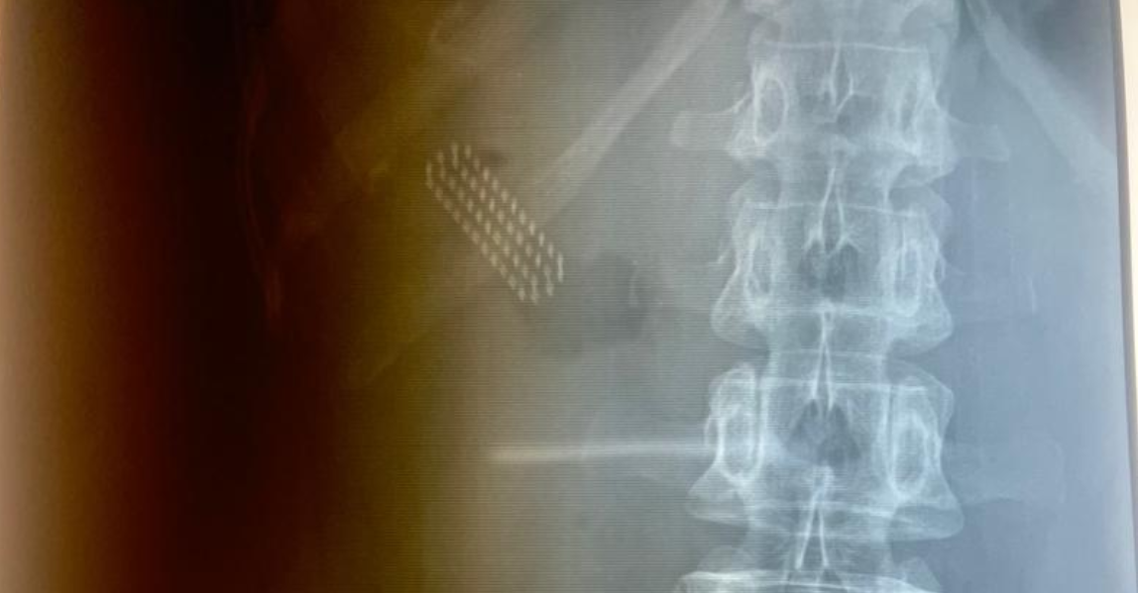
Figure 1 : X-ray image of the toothbrush

Oesogastroduodenal endoscopy revealed a toothbrush in the stomach, part of which was downstream of the pylorus. An unsuccessful attempt was made to remove the toothbrush using the diathermic loop (figure 2). After several unsuccessful attempts, we noticed that the lower part of the brush was impacted in the 2nd duodenum, with suspected perforation. We therefore proposed surgical management.
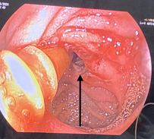
Figure 2 : Endoscopic view of foreign body embedded

Surgery involved removal of the foreign body after a 1.5 cm incision on the anterior wall of the gastric antrum opposite the foreign body in the avascular zone, followed by suture of the orifice and epiploplasty (figure 3). The immediate post-operative course was straightforward.
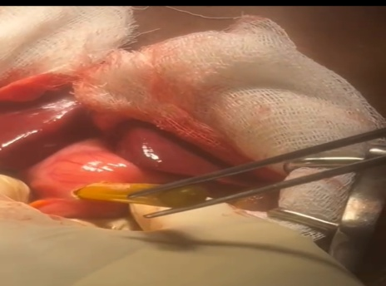 | 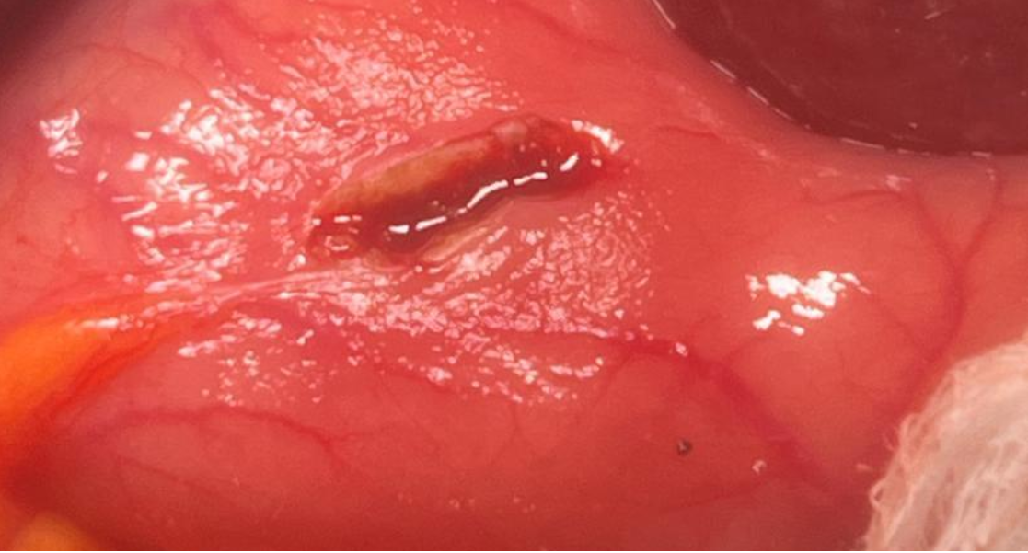
Figure 3 and 4 : Intraoperative view of the foreign body

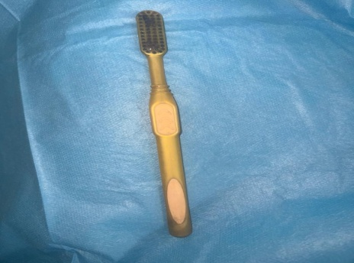
Figure 5 : Removed toothbrush

DISCUSSION
Epidemiological aspects
Ingested foreign bodies are numerous and frequent, but poorly documented. In the United States, 1,500 deaths are recorded every year, with paradoxically only 0 and 1 deaths out of a series of 852 adults and 2,600 children, suggesting the high frequency of this type of ingestion [4].
Diagnostic aspects
The clinical picture may vary: sometimes it is asymptomatic, the only complaint being the patient's or accompanying person's account of accidental ingestion of foreign bodies.
When it is symptomatic, the signs depend essentially on the level of blockage of the foreign bodie in the digestive tract, leading to retro-sternal pain, odynophagia, dysphagia, hypersialorrhea and sometimes vomiting in the case of large “blunt” objects, creating an obstructive syndrome requiring emergency extraction. Most of the time, it involves food in an adult with an organic anomaly of the oesophagus-gastro-duodenal tract [4].
Therapeutic aspects
It has been shown that the shorter the delay, the greater the chance of finding the foreign body [5]. The success rate of endoscopic management of foreign body ingestions varies from 90 to 95% according to the latest studies, with a complication rate of < 5% [6].

Conclusion
Foreign body ingestion is most often accidental, as in our patient. Endoscopy remains the most appropriate method for extraction, but if extraction by this route is not possible, surgery remains a good alternative.
Conflict of interest
The authors declare no conflict of interest in relation to this article.
Disclaimer (Artificial intelligence)
Option 1:
Author(s) hereby declare that NO generative AI technologies such as Large Language Models (ChatGPT, COPILOT, etc.) and text-to-image generators have been used during the writing or editing of this manuscript.
Option 2:
Author(s) hereby declare that generative AI technologies such as Large Language Models, etc. have been used during the writing or editing of manuscripts. This explanation will include the name, version, model, and source of the generative AI technology and as well as all input prompts provided to the generative AI technology
Details of the AI usage are given below:
1.
2.
3.

Bibliographical references
1.Manuels du résidant Zubair Malik, MD, Virtua Health System Vérifié/Révisé avr. 2023
2. Océane B, Bénédicte C, Yaniv B, Olivier G. Prise en charge des corps étrangers du tractus digestif, Volume 28, numéro 1, Janvier 2021
3. Vincent Q. Post’u 2020 : Corps étrangers du tractus digestif supérieur chez l’adulte. Paris : JFHOD,2020
4. Letard J C. Post’u 2003 : Les corps étrangers ingérés. Paris : JFHOD,2003
5. Libanio D, Garrido M, Jacome F, Dinis-Ribeiro M, Pedroto I et al. Foreign body ingestion and food impaction in adults: better to scope than to wait. UEG Journal 2018; 6: 974- 80
6. Jingjing Yuan et al. Delayed endoscopic removal of sharp foreign body in the oesophagus increased clinical Medecine 2019; 98:26.
7. Becq, A., Camus, M., & Dray, X. (2021). Foreign body ingestion: Dos and don’ts. Frontline Gastroenterology, 12(7), 664–670. https://doi.org/10.1136/flgastro-2020-101450
8. Gatto, A., Capossela, L., Ferretti, S., Orlandi, M., Pansini, V., Curatola, A., & Chiaretti, A. (2021). Foreign Body Ingestion in Children: Epidemiological, Clinical Features and Outcome in a Third Level Emergency Department. Children, 8(12), 1182. https://doi.org/10.3390/children8121182
9. Whelan, K. A., Muir, A. B., & Nakagawa, H. (2018). Esophageal 3D culture systems as modeling tools in esophageal epithelial pathobiology and personalized medicine. Cellular and Molecular Gastroenterology and Hepatology, 5(4), 461–478. https://doi.org/10.1016/j.jcmgh.2018.01.011
10. Yousef, A., Krause, A., Yadlapati, R., Sharma, P., & Weissbrod, P. A. (2024). Upper esophageal sphincter and esophageal motility pathology on manometry in retrograde cricopharyngeal dysfunction. Otolaryngology–Head and Neck Surgery, 171(2), 478–485. https://doi.org/10.1002/ohn.735

