A case report of hyponatremia due to primary polydipsia in kidney transplant recipient

Abstract
Background:
Hyponatremia is a common electrolyte abnormality in kidney transplant recipients and may result from a variety of etiologies, including infections, drug effects, rejection, and hormonal disturbances. Hyponatremia due to polydipsia, however, is rarely reported in the post-transplant setting.
Case Presentation:
We report the case of a 40-year-old woman with end-stage kidney disease secondary to presumed chronic interstitial nephritis who underwent deceased donor kidney transplantation. Her post-transplant course was complicated by antibody-mediated rejection, which was successfully treated with corticosteroids, plasma exchange, intravenous immunoglobulin, and rituximab, resulting in stable graft function. Seven months after transplantation, she was found to have asymptomatic severe hyponatremia (serum sodium 119 mEq/L). Evaluation revealed hypotonic hyponatremia with low urine osmolality (88 mOsm/kg) and low urine sodium (23 mEq/L), normal thyroid and adrenal function, and euvolemic clinical status. Detailed history revealed excessive water intake of approximately 5 liters per day over the preceding two weeks. The cause of polydipsia in the patient was the thought that intake of more water will lead to reduced creatinine as reinforced by one of her acquaintance, who was also a kidney transplant recipient. Fluid restriction led to immediate correction of serum sodium and normalization of urine osmolality, confirming a diagnosis of polydipsia-induced hyponatremia. The patient remained normonatremic on follow-up with stable graft function after behavioural counselling.
Conclusion:
Polydipsia is an uncommon but important cause of hyponatremia in kidney transplant recipients. Careful history taking and appropriate biochemical evaluation are critical for diagnosis. Early recognition and fluid restriction with counselling can effectively prevent recurrence and serious complications.
Keywords- Hyponatremia, Patient, Polydipsia, Kidney transplant

Introduction
Hyponatremia is one of the most common electrolyte disorders encountered in clinical practice [1], and this is also true among kidney transplant recipients [2]. The clinical manifestations and management of hyponatremia depend on its severity and chronicity. A thorough clinical and biochemical evaluation is essential to identify the underlying etiology, as treatment strategies vary significantly based on the cause. Hyponatremia can cause mild symptoms like giddiness to severe manifestations like obtundation, coma, seizures and even death. So it important to identify hyponatremia early and treat it. The cause of hyponatremia in post kidney transplantation patients could be due to fluid overload, calcineurin inhibitor toxicity, transplant kidney rejection. Hyponatremia due to primary polydipsia has rarely been reported in kidney transplant setting.
In general, an average adult requires approximately 2–4 litres of water daily to maintain adequate hydration. Polydipsia is defined as excessive water intake, with consistent excretion of dilute urine of more than 3 liters/day [3-4]. Here, we report a case of severe hyponatremia in a kidney transplant recipient due to polydipsia, an etiology that has been rarely reported in the post-transplant setting. Identifying the etiology is also crucial to prevent recurrence.

Case Report
A 40-year-old woman with chronic kidney disease (CKD) stage 5, presumed secondary to chronic interstitial nephritis, had been on maintenance hemodialysis for three years. She underwent deceased donor kidney transplantation at another centre. The total ischemia time was 12 hours.
On postoperative day 8, she developed reduced urine output with a rise in serum creatinine from 1.5 mg/dL to 2.0 mg/dL. A transplant kidney biopsy performed on the same day revealed active antibody-mediated rejection. She was treated with three doses of intravenous methylprednisolone (500 mg each), followed by five sessions of plasma exchange with intravenous immunoglobulin (100 mg/kg per session) and a single dose of rituximab (500 mg).
Following treatment, her serum creatinine improved to a nadir of 1.3 mg/dL and subsequently stabilized at 1.4 mg/dL. She remained clinically stable without complaints.
Seven months post-transplant, she was found to have asymptomatic hyponatremia with a serum sodium level of 119 mEq/L. Two weeks prior to this episode, her serum creatinine was 1.6 mg/dL, prompting a repeat transplant kidney biopsy, which was normal.
Further evaluation revealed a measured serum osmolality of 257 mOsm/kg, urine osmolality of 88 mOsm/kg, and urine sodium of 23 mEq/L. Thyroid-stimulating hormone level was 2.5 mIU/L, and serum cortisol was 22 µg/dL.
On detailed history taking, the patient reported consuming approximately 5 litres of water daily for the preceding two weeks, following advice from an acquaintance who was also a kidney transplant recipient, in the belief that increased fluid intake would improve renal function.
She was admitted, and fluid intake was restricted to 2 litres per day. Her urine output decreased from 4.5 litres/day to 2.5 litres/day. Serum sodium corrected to 135 mEq/L over two days, and urine osmolality increased to 535 mOsm/kg (Figure 1, Table 1).
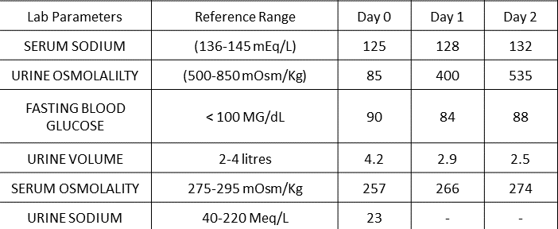Table 1: Serial Serum sodium, Urine osmolality, blood glucose, urine volume, serum osmolality and urine sodium values
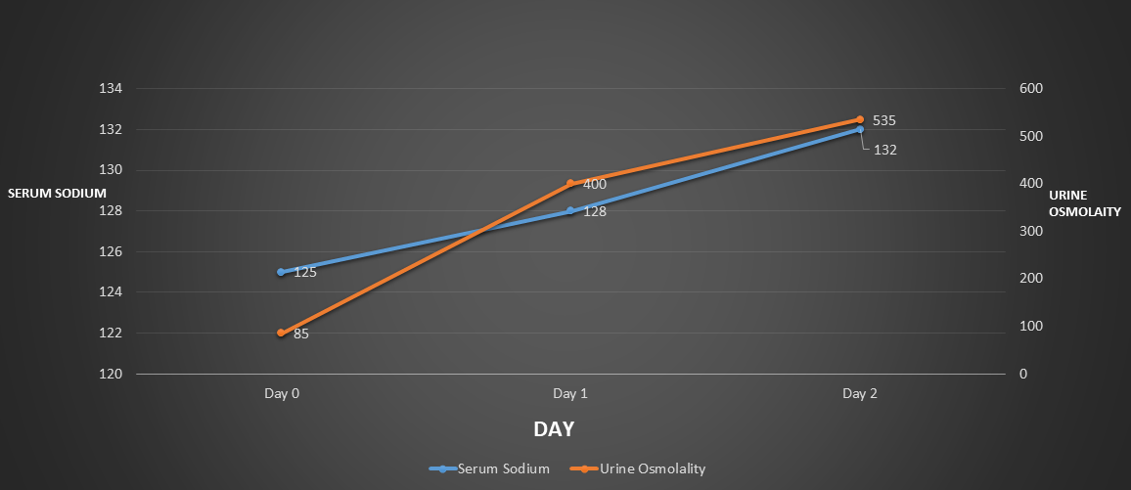
Figure 1: Serial Sodium and Urine osmolality values
Based on clinical and laboratory findings, a diagnosis of hyponatremia secondary to polydipsia was made. On follow-up, her serum sodium remained within the normal range, and serum creatinine stabilized between 1.5 and 1.6 mg/dL at one year post-transplant. She received psychiatric counselling regarding excessive water intake and the risks of water intoxication, including seizures and coma. No further episodes of hyponatremia were noted.
The samples were analysed using Mindray BS 400 and Mindray BS 600 machine.

Discussion
Kidney handles the electrolytes balance in our body and measuring electrolytes in post kidney transplant period is of vital importance as dyselectrolytemias is very common in the post transplant period including, hyponatremia, hypokalemia, hyperkalemia and hypocalcemia. Hyponatremia is common in kidney transplant recipients and can occur due to multiple etiologies. Syndrome of inappropriate antidiuretic hormone secretion (SIADH) may result from infections such as tuberculosis or nocardiosis [5]. Glucocorticoid withdrawal is another recognized cause [6]. Post-transplant polyuria may lead to sodium wasting and hyponatremia [7]. Impaired free water excretion due to acute tubular necrosis or transplant rejection may also contribute [8].
Calcineurin inhibitors can affect sodium handling; cyclosporine inhibits the sodium–hydrogen exchanger in the proximal tubule, while tacrolimus alters distal tubular sodium transport and may induce aldosterone resistance [9].
Hyponatremia due to polydipsia, however, is uncommon in kidney transplant recipients, with very few cases reported. The diagnostic approach to hyponatremia involves assessment of volume status, serum osmolality, urine osmolality, and urine sodium concentration. Our patient was clinically euvolemic, with low urine osmolality and low urine sodium, indicating appropriate renal dilution and intact vasopressin suppression. These findings supported the diagnosis of polydipsia-induced hyponatremia.
Primary polydipsia is characterized by excessive fluid intake leading to dilute urine and polyuria [10]. It is most commonly associated with psychiatric or developmental disorders [11]. Habitual polydipsia refers to excessive water intake driven by the belief that it promotes health [12]. The pathophysiology of primary polydipsia is not fully understood and may involve excessive water intake exceeding renal excretory capacity or a reduction in renal free water excretion. In some cases, antidiuretic hormone suppression may play a role [13]. The differential diagnosis of polydipsia is mainly nephrogenic and central diabetes insipidus. The first step in diagnosis is through medical history. A low plasma sodium in the presence of low urine osmolality is indicative of primary polydipsia. But the gold standard test for diagnosis in case of discrepancies in the reports is the water deprivation test, which measures the Arginine Vasopressin activity through measurement of urine osmolality [14-15]
In our patient, rapid correction of hyponatremia with fluid restriction confirmed the diagnosis. Measurement of serum cortisol and thyroid function is essential in such cases to exclude adrenal insufficiency and hypothyroidism. There is no standardized treatment protocol for primary polydipsia; fluid restriction and patient counselling remain the cornerstone of management. This case highlights the importance of considering psychological and behavioural factors when evaluating hyponatremia in the post-transplant period.

Conclusion
Polydipsia is a rare and often overlooked cause of hyponatremia, presenting with nonspecific features. It remains a diagnosis of exclusion after ruling out adrenal insufficiency, hypothyroidism, and other common etiologies. Detailed history taking is crucial for diagnosis, supported by appropriate laboratory evaluation.
Polydipsia-induced hyponatremia in kidney transplant recipients is particularly rare but can be effectively managed if identified early, thereby preventing severe complications. A multidisciplinary approach involving nephrologists, psychiatrists, and other specialists may be required. In our case, early recognition and fluid restriction with counselling resulted in an excellent outcome. Water restriction with behavioural intervention remains the mainstay of therapy, while evidence for pharmacological treatment remains limited.

COMPETING INTERESTS DISCLAIMER:
Authors have declared that they have no known competing financial interests OR non-financial interests OR personal relationships that could have appeared to influence the work reported in this paper.
Consent
As per international standards or university standards, patient(s) written consent has been collected and preserved by the author(s).
Disclaimer (Artificial intelligence)
Author(s) hereby declare that NO generative AI technologies such as Large Language Models (ChatGPT, COPILOT, etc.) and text-to-image generators have been used during the writing or editing of this manuscript.

References:
- Mercier-Guidez E , Loas G . Polydipsia and water intoxication in 353 psychiatric inpatients: an epidemiological and psychopathological study. Eur Psychiatry. 2000;15(5):306–11 .https://doi.org/10.1016/S0924-9338(00)00399-0

- Robertson GL . Differential diagnosis of polyuria. Annu Rev Med. 1988;39(1):425–42 .https://doi.org/10.1146/annurev.me.39.020188.002233

- Rondon H, Badireddy M. Hyponatremia [Internet]. PubMed. Treasure Island (FL): StatPearls Publishing; 2023. Available from: https://www.ncbi.nlm.nih.gov/books/NBK470386/

- Carlos G Musso, Alejandrina Castañeda, María Giordani, Cesar Mombelli, Silvia Groppa, Nora Imperiali, Guillermo Rosa Diez, Hyponatremia in kidney transplant patients: its pathophysiologic mechanisms, Clinical Kidney Journal, Volume 11, Issue 4, August 2018, Pages 581–585, https://doi.org/10.1093/ckj/sfy016

- Motiwala HG, Sanghvi NP, Barjatiya MK: Syndrome of inappropriate antidiuretic hormone following tuberculous epididymo-orchitis in renal transplant recipient: case report. J Urol. 1991, 146:1366-1367 https://doi.org/10.1016/s0022-5347(17)38097-7

- Bromberg JS, Alfrey EJ, Barker CF.: Adrenal suppression and steroid supplementation in renal transplant recipients. Transplantation. 1991, 51:385-390. https://doi.org/10.1097/00007890-199102000-00023

- Schafer JA: Renal water reabsorption: a physiologic retrospective in a molecular era. Kidney Int. 2004, 66:20-27 https://doi.org/10.1111/j.1523-1755.2004.09104.x

- Hoang TD, Bao VQ, Phat VH: Massive polyuria after kidney transplantation. Pediatr Nephrol. 2010, 25:383-38. https://doi.org/10.1007/s00467-009-1344-1

- Bagchi S, Husain Zaidi S, Prasad Mathur R: Severe symptomatic hyponatremia-an uncommon presentation of tacrolimus nephrotoxicity. Nephrol Dial Transplant. 2011, 26:2042-2044. https://doi.org/10.1093/ndt/gfr133

- Christ-Crain M, Bichet DG, Fenske WK, Goldman MB, Rittig S, Verbalis JG, Verkman AS: Diabetes insipidus. Nat Rev Dis Primers. 2019, 8:5. https://doi.org/10.1038/s41572-019-0103-2

- Dundas B, Harris M, Narasimhan M: Psychogenic polydipsia review: etiology, differential, and treatment. Curr Psychiatry Rep. 2007, 9:236-41. https://doi.org/10.1007/s11920-007-0025-7

- Sailer C, Winzeler B, Christ-Crain M: Primary polydipsia in the medical and psychiatric patient: characteristics, complications and therapy. Swiss Med Wkly. 2017, 147:14514. https://doi.org/10.4414/smw.2017.14514

- Sailer CO, Winzeler B, Nigro N, : Characteristics and outcomes of patients with profound hyponatraemia due to primary polydipsia. Clin Endocrinol :492-499. https://doi.org/10.1111/cen.13384

- Dashe AM , Cramm RE , Crist CA , Habener JF , Solomon DH . A water deprivation test for the differential diagnosis of polyuria. JAMA. 1963;185(9):699–703 .https://doi.org/10.1001/jama.1963.03060090031011

- Verbalis JG . Disorders of body water homeostasis. Best Pract Res Clin Endocrinol Metab. 2003;17(4):471–503 .https://doi.org/10.1016/S1521-690X(03)00049-6

