Short communication

Progressive Greying in Common Coots (Fulica atra): A New Records from Rajasthan Wetlands, India
.

ABSTRACT
Colour aberrations are well documented in many wild birds, but less synthesized for waterfowl. Leucism (partial or total) is a hereditary condition that alters the generation of pigments (eumelanin and/or phae-omelanin) in feathers due to a lack of pigment-producing cells in the skin. This study reports two cases in Fulica atra Linnaeus, 1758 (Common Coot) from Rajasthan, India, via opportunistic surveys at Kanota Dam, Jaipur (26°54′51.4″ N, 75°56′29.3″ E) on 26 December 2024, and Menar Lake, Udaipur (24°35′22.5″ N, 74°06′25.8″ E) on 30 December 2024. Direct visual observations with photography documented plumage, bare-part coloration, and behavior for 15-20 min per individual. At Kanota Dam (flock ~30 coots), one showed irregular white patches on mantle, scapulars, wing coverts, and asymmetrical white feathers. At Menar Lake (mixed flock ~100 coots/dabbling ducks), one had extensive pale plumage with contiguous white patches on breast, neck, and dorsum. These progressive greying records expand known pigmentation anomalies in F. atra and highlight needs for wetland monitoring.

Keywords: Fulica atra, leucism, albinism, progressive greying, pigmentation, colour aberration.

1. INTRODUCTION
Aberrant pigmentation provides insights into developmental biology, genetics, and environmental stressors (Duarte et al., 2017). Chromatic or color aberrations in bird plumage represent a research sector investigated for over a century. Apparently, such anomalies can be of environmental or genetic origin, in the latter case linked to mutations which, in turn, can be triggered by environmental circumstances (e.g., isolation in small populations, pollutants, and other circumstances). In some cases, the aberrations can be caused by diseases, injuries, or anomalies in eating habits (Kumar et al., 2025; Dodaro et al., 2024). Color aberrations are classified into several kinds based on the chemical, physiological, genetic, and environmental factors that cause the phenotypic patterns. Van Grouw (2021) distinguished leucism (congenital absence of melanin-producing cells), progressive greying (progressive loss of melanin-producing cells), albino (complete absence of melanin due to a lack of the key enzyme), brown (incompletely colored melanin), ino (even less completely colored melanin), dilution (altered melanin deposition), and melanism (altered melanin distribution). Leucism and progressive greying (or progressive depigmentation) are two color aberrations in which melanin production is partially inhibited, resulting in the presence of white feathers in birds (van Grouw 2013). More specifically, leucism and progressive greying are frequently confused abnormalities that are difficult to distinguish in the field. Leucism (partial or total) is a hereditary condition that alters the generation of pigments (eumelanin and/or phae-omelanin) in feathers due to a lack of pigment-producing cells in the skin (van Grouw, 2013). The body plumage is predominantly sooty black on the head and neck, transitioning to a grayish color on the back and flanks. During the flight, a narrow whitish band along the trailing edges of the secondaries becomes visible. The feet of the bird are greenish-gray and equipped with distinctively lobed long toes. The iris of both male and female birds is a vivid crimson. The elongated toes extend beyond the tail tips during flight, while the rounded wings produce rapid, whirring beats; the subtlest smear of the orange-red is visible on the tibia. Notably, there is no seasonal variation in the plumage (Khan et al., 2025). Leucism frequently produces a patchy and bilaterally symmetrical pattern of white feathers, usually on the wings, abdomen, and head. Progressive greying, on the other hand, causes a steady loss of pigment-producing cells with age; during the early stages of progressive greying, white feathers are randomly dispersed, primarily on the head, back, and flanks (van Grouw, 2013, 2014). In leucistic birds, white feathers are present in the juvenile plumage and will never change throughout life, but in progressive greying, the juvenile plumage is normal and the white feathers come later in life. This aberration could be induced by genetic abnormalities that cause pigment cell loss or by extrinsic non-heritable causes (diseases, nutritional deficiency: van Grouw, 2013). The eyes in leucism and progressive greying keep their colour differently than in albinism (van Grouw, 2013). The common coot (Fulica atra) is a widely distributed rail species with distinctive black plumage and a prominent white frontal shield. Aberrations can affect both feathers and keratinized bare structures (the frontal shield in the case of the common coot) used in social signalling.

2. material and methods
During opportunistic surveys at two wetlands in Rajasthan, color-aberrant Common Coots (Fulica atra) were observed and documented in the wetlands falling in the ecotonal region of Arid and Semi-Arid biogeographic zones of Rajasthan, India (Sharma et al., 2024). The first individual was recorded at Kanota Dam, Jaipur (26°54'51.4"N 75°56'29.3"E) on 26 December 2024, and the second at Menar Lake, Udaipur (24°35'22.5"N 74°06'25.8"E) on 30 December 2024. Both sites are well-known wintering grounds for waterbirds, with Kanota Dam representing a large freshwater reservoir surrounded by agricultural fields and Menar Lake forming a shallow village-managed wetland supporting high densities of migratory species. Observations were made using binoculars (8×42) and a spotting scope (20–60×), with each aberrant bird monitored for approximately 15–20 minutes to record plumage details, bare-part pigmentation, and behavior in relation to conspecifics. Photographs were taken from multiple angles using DSLR equipment. Field notes included habitat description, environmental context, flock composition, and approximate distance to the subject. Diagnostic criteria for colour aberration followed van Grouw’s (2021) nomenclature, focusing on the extent, location, and symmetry of white patches and the presence of normal iris pigmentation to distinguish partial leucism from progressive greying. Although genetic or histological sampling was not possible, and the single-visit nature of the survey limited longitudinal diagnosis, both observations were carefully recorded in standardized field logs, providing reliable case reports of colour aberrations in coots from two distinct wetlands of Rajasthan.

3. results and discussion
At Kanota Dam, Jaipur (26 December 2024), a single Common Coot (Fulica atra) exhibiting aberrant plumage was observed within a mixed flock of approximately 30 conspecifics feeding along the shallow margins of the reservoir. The bird was an adult individual, identifiable by its well-developed white frontal shield and body proportions. Aberration was evident as irregular white patches distributed across the mantle, scapulars, and wing coverts, contrasting sharply with the otherwise uniform blackish-grey plumage typical of the species. The distribution of white feathers appeared asymmetrical, being more pronounced on the right flank and wing. The frontal shield and bill were normally pigmented, showing the typical bright white colouration, and the eyes retained normal reddish-brown pigmentation, ruling out albinism. No depigmentation of the legs or toes was noted. The bird fed actively alongside normally pigmented coots, showing no signs of behavioural impairment or avoidance by flock members. At Menar Lake, Udaipur (30 December 2024), a second aberrant coot was recorded in a larger mixed aggregation of several hundred coots and dabbling ducks. This individual differed in appearance, displaying more extensive pale plumage, with large contiguous white patches over the breast, neck, and dorsal region, giving the bird an overall mottled black-and-white appearance. In contrast to the Kanota bird, the pattern appeared more diffuse and less patchy, with scattered white feathers also present on the crown and nape. The frontal shield and bill were normally pigmented, and the iris was dark reddish, again confirming the presence of ocular melanin. The individual engaged in typical foraging behavior and was observed diving repeatedly with the flock, without apparent social exclusion or predation risk. Taken together, both observations confirm the presence of multi-site colour aberrations in wild Common Coots in Rajasthan. Based on the adult age class, retention of normal bare-part and eye pigmentation, and irregular distribution of white feathers, the condition in both cases is more consistent with progressive greying rather than with partial leucism. Progressive greying is frequently misidentified but represents distinct mechanisms leading to the presence of white feathers due to partial inhibition of melanin production (van Grouw, 2013, 2014). In the present observations from Rajasthan, two adult Common Coots (Fulica atra) exhibited atypical white plumage patterns differing in distribution and extent. Both individuals retained normal pigmentation of the bill, frontal shield, and eyes, excluding albinism, which is characterized by a complete lack of melanin, including in ocular and keratinized structures (van Grouw, 2006, 2013). Instead, the observed asymmetrical and irregular distribution of white feathers, along with the normal bare-part coloration, is more consistent with progressive greying. This condition arises due to the gradual loss of melanocytes with age, leading to progressive depigmentation of feathers (van Grouw, 2013). In contrast, leucism is a congenital condition in which melanin-producing cells fail to populate certain feather follicles, typically resulting in symmetrical white patches visible from the first plumage stage and remaining constant throughout life. Comparable cases of progressive greying in Fulica atra have been documented from Kerala, India (Raveendran et al., 2016), and Netherland (van Grouw, 2021), along with Albinism from Nepal (Pradhan & Shreshtha, 2003), Leucism from Netherland (van Grouw, 2006) and Incomplete albinism from Gujrat (van Grouw et al., 2016), suggesting that such aberrations, though rare, occur sporadically across the species’ range. The occurrence of two independent cases within Rajasthan further indicates that pigment loss in coots may not be geographically restricted but may appear at low frequencies within widespread populations. The absence of behavioural differences or social exclusion among flock members also supports earlier observations that colour aberrations generally do not impede social integration or foraging efficiency in waterbirds (Hariharan et al., 2016). Nonetheless, aberrant individuals may experience higher predation risk in some environments due to reduced camouflage, although this was not evident during the present field encounters (Jangir et al., 2024a; Jangir et al., 2024b; Choudhary et al., 2025). The mechanisms driving progressive greying in wild birds remain incompletely understood. While age-related melanocyte depletion appears to be the primary cause, environmental and physiological stressors such as nutritional deficiencies, disease, or exposure to pollutants may exacerbate pigment cell loss (van Grouw, 2013). Given that both individuals were observed in wetlands influenced by anthropogenic activity and fluctuating water quality, future studies could explore whether environmental stress contributes to the frequency or expression of such pigmentation anomalies in waterbird populations. Long-term monitoring and photographic documentation could further help differentiate between congenital and progressive pigment loss in free-ranging individuals (Jangir et al., 2023). In conclusion, the two records presented here constitute rare but valuable observations of progressive greying in Common Coots from Rajasthan. These findings expand the geographic documentation of colour aberrations in Fulica atra within the Indian subcontinent and highlight the importance of field-based ornithological observations in recognizing and understanding phenotypic variability in wild bird populations.

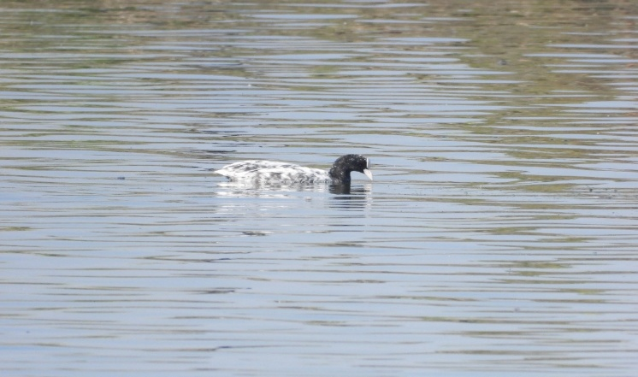
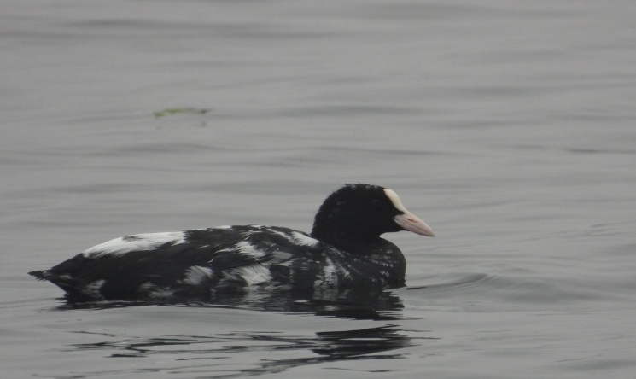
Fig 1: Common Coot with progressive greying at Knaota dam, Jaipur. Figure 2: Common Coot with progressive greying at Menar lake, Udaipur.

4. Conclusion
The present study documents two rare cases of colour aberration in adult common coots (Fulica atra) from wetlands in Rajasthan, India. Both individuals are best described as having progressive greying rather than leucism or albinism due to the asymmetrical distribution of white feathers, adult plumage stage, and preservation of normal eye and bare-part pigmentation. These observations expand the geographic record of pigmentation anomalies in the species and highlight the importance of careful field-based documentation in distinguishing among colour aberrations. Continued monitoring of wetland bird populations may provide further insights into the ecological and physiological factors influencing pigment loss in wild birds.

Disclaimer (Artificial intelligence)
Option 1:
Author(s) hereby declare that NO generative AI technologies such as Large Language Models (ChatGPT, COPILOT, etc.) and text-to-image generators have been used during the writing or editing of this manuscript.
Option 2:
Author(s) hereby declare that generative AI technologies such as Large Language Models, etc. have been used during the writing or editing of manuscripts. This explanation will include the name, version, model, and source of the generative AI technology and as well as all input prompts provided to the generative AI technology
Details of the AI usage are given below:
1.
2.
3.

References
- Choudhary, R., Sharma, V., Jangir, D. K., & Dutta, S. (2025). Intersex plumage in Plum-headed Parakeet (Psittacula cyanocephala). Rivista Italiana di Ornitologia, 95(1). https://doi.org/10.4081/rio.2024.807
- Duarte, R. C., Flores, A. A., & Stevens, M. (2017). Camouflage through colour change: Mechanisms, adaptive value and ecological significance. Philosophical Transactions of the Royal Society B: Biological Sciences. https://doi.org/10.1098/rstb.2016.0342
- Hariharan, C., Raveendran, J., Prabhu, V., & John, A. (2016). Eurasian Coot (Fulica atra) affected by progressive greying. Malabar Trogon, 14(1–3). https://www.researchgate.net/publication/312000000_Eurasian_Coot_Fulica_atra_affected_by_progressive_greying
- Jangir, D. K., Choudhary, R., Sharma, V., & Dutta, S. (2023). First record of brown plumage aberration in Indian Pied Starling (Gracupica contra) from India. Ornis Hungarica, 31, 165–167. https://doi.org/10.2478/orhu-2023-002
- Jangir, D. K., Choudhary, R., Sharma, V., & Dutta, S. (2024). Progressive greying in the white-eared bulbul (Pycnonotus leucotis). Taprobanica, 13(1), 31–32. https://doi.org/10.47605/tapro.v13i1.325
- Jangir, D. K., Choudhary, R., Sharma, V., & Mathur, P. (2024). Erythrism in House Sparrow (Passer domesticus): A record from Rajasthan, India. International Studies on Sparrows, 45, 27–29. https://doi.org/10.59443/ISSpar-2023-0004
- Pradhan, N., & Shrestha, M. B. (2023). Records of avian deformities in Nepal. Ornis Hungarica, 31(2), 151–164. https://doi.org/10.2478/orhu-2023-0026
- Sharma, V., Choudhary, R., Dutta, S., Singh, P., Kumawat, R. K., & Sharma, K. K. (2024). New sightings and habitat suitability mapping of endemic Platyceps gracilis (Günther, 1862). Biogeographia – The Journal of Integrative Biogeography, 39(2) https://doi.org/10.21426/B6.39859
- van Grouw, H. (2006). Not every white bird is an albino: Sense and nonsense about colour aberrations in birds. Dutch Birding, 28(2), 79–89. https://www.dutchbirding.nl/journal
- van Grouw, H. (2013). What colour is that bird? The causes and recognition of common colour aberrations in birds. British Birds, 106, 17–29. https://britishbirds.co.uk/article/what-colour-is-that-bird-the-causes-and-recognition-of-common-colour-aberrations-in-birds/
- van Grouw, H. (2014). Some black-and-white facts about the Faeroese white-speckled Common Raven Corvus corax varius. Bulletin of the British Ornithologists’ Club, 134(1), 4–13. https://boc-online.org/bulletin/bulletin-134
- van Grouw, H. (2021). What's in a name? Nomenclature for colour aberrations in birds reviewed. Bulletin of the British Ornithologists' Club, 141(3), 276–299. https://doi.org/10.25226/bboc.v141i3.2021.a5
- van Grouw, H., Mahabal, A., Sharma, R. M., & Thakur, S. (2016). How common is albinism really? Colour aberrations in Indian birds reviewed. Dutch Birding. https://nhm.openrepository.com/bitstream/handle/10141/622245/Grouw+DB38(2016)_Albinism+Indian+Birds.pdf?sequence=1
- Dodaro, G., Battisti, C., & Mastrobuoni, G. (2024). Chromatic aberrations in Eurasian Coot (Fulica atra): new record and a review from Italy suggest a cautious approach in diagnoses. Rivista Italiana di Ornitologia, 94(2).
- Khan SS, Javed T, Khan MS, Farooq Z, Wajid M. Morphometry, hematology, and plasma chemistry of common coot (Fulica atra) in Punjab, Pakistan. J Adv Vet Anim Res. 2025 Mar 26;12(1):312-320. doi: 10.5455/javar.2025.l898. PMID: 40568499; PMCID: PMC12186804.
- P. Girish Kumar, P. Ezhil Praveena, and R. Richard Churchil. 2025. “Gene Frequency of Plumage Pattern, Comb Type, Skin Colour, and Feather Traits in Indigenous Chickens of Kerala, India”. Journal of Advances in Biology & Biotechnology 28 (8):1029–1037. https://doi.org/10.9734/jabb/2025/v28i82776.

