Evaluating the Therapeutic Effects of Aqueous Leaf Extract of Nephrolepis biserrata on Biochemical, Haematological, Physical, Atherogenic, and Histopathological Parameters in Testosterone Propionate-Induced Benign Prostatic Hyperplasia in Male Wistar Rats

ABSTRACT

Background: Benign Prostatic Hyperplasia (BPH) is a common non-cancerous enlargement of the prostate gland, predominantly affecting men over the age of 50 (1). It results from the overgrowth of stromal and smooth muscle cells within the prostate (2), leading to lower urinary tract symptoms (LUTS), such as frequent urination, nocturia, and difficulty voiding, which can severely reduce quality of life.
Aim: This study aimed to evaluate the therapeutic effects of the aqueous leaf extract of Nephrolepis biserrata on biochemical, haematological, physical, atherogenic, and histopathological parameters in testosterone propionate-induced BPH in male Wistar rats.
Objectives: To evaluate phytochemical composition, proximate and mineral content, biochemical and haematological parameters, and histological changes in prostate tissue following extract administration.
Methods: After 7 days of acclimatization, rats were exposed to 8 mg/kg of testosterone propionate subcutaneously for 11, 22, and 33 days. They were then treated with 100, 200, and 300 mg/kg of Nephrolepis biserrata aqueous leaf extract orally for the same durations. At the end of the experimental periods, animals were euthanized, and blood and tissue samples were collected for haematological, biochemical, and histological analyses.
Results: The extract enhanced antioxidant enzyme activities (SOD, CAT, GPX), reduced malondialdehyde (MDA) concentration, decreased inflammatory biomarkers, normalized lipid profiles (reduced total cholesterol, LDL, triglycerides, elevated HDL), and restored the architectural structure of the prostate tissue.
Conclusion: Nephrolepis biserrata protects against testosterone propionate-induced BPH by enhancing oxidative stress defense, reducing inflammation, and attenuating tissue disruption. These findings support further studies, including clinical trials and mechanistic investigations.
Keywords: Nephrolepis biserrata, oxidative stress, inflammation, testosterone propionate, Benign Prostatic Hyperplasia, Nigeria

INTRODUCTION
Benign Prostatic Hyperplasia (BPH) is a common non-cancerous enlargement of the prostate gland, predominantly affecting men over the age of 50 (Kishorebabu et al., 2019). It results from the overgrowth of stromal and smooth muscle cells within the prostate (Mugisha, 2025) and is characterized by lower urinary tract symptoms (LUTS), including frequent urination, nocturia, and difficulty in voiding, which can significantly reduce quality of life. The pathophysiology of BPH is multifactorial, involving hormonal imbalances, particularly elevated dihydrotestosterone levels, as well as chronic inflammation and oxidative stress (Egan, 2016).
Conventional treatment options for BPH include alpha-adrenergic blockers, such as doxazosin, and 5-alpha-reductase inhibitors, like finasteride. Although these therapies are effective, they are often associated with adverse side effects, including sexual dysfunction, gynecomastia, and hypotension. Consequently, there has been growing interest in plant-based alternatives that may offer comparable therapeutic efficacy with reduced toxicity and fewer side effects (Chislett et al., 2023).
Nephrolepis biserrata, commonly known as buckler fern or Paku in certain parts of Malaysia, is a perennial fern that grows abundantly in wet and shaded environments such as riverbanks and marshes (Rosli, 2014). Traditionally, the plant has been used in the management of various ailments, including miscarriage prevention, support of foetal development, wound healing, and gastrointestinal disorders (Oyawaluja et al., 2024). Scientific interest in Nephrolepis biserrata is largely attributed to its rich phytochemical composition, which includes alkaloids, flavonoids, tannins, saponins, terpenoids, steroids, phenols, and cardiac glycosides (Alamgir, 2018). These bioactive compounds are widely recognized for their anti-inflammatory, antioxidant, and anti-androgenic properties, making Nephrolepis biserrata a promising candidate for the management of BPH. In addition, lipid metabolism plays a crucial role in BPH progression, as dyslipidemia has been shown to exacerbate prostatic enlargement and inflammatory processes (Thomas-Charles & Fennell, 2019).
Given these properties, this study was designed to evaluate the therapeutic potential of the aqueous leaf extract of Nephrolepis biserrata in testosterone propionate-induced BPH in male Wistar rats. Specifically, the study aimed to assess the extract’s effects on biochemical, haematological, physical, atherogenic, and histopathological parameters. To achieve this aim, the following objectives were pursued: (1) to evaluate the phytochemical composition of Nephrolepis biserrata; (2) to assess its proximate and mineral composition; (3) to determine selected biochemical parameters following extract administration; (4) to assess haematological parameters in treated and control animals; and (5) to evaluate histological changes in prostate architecture following treatment.

MATERIALS AND METHODS
Fresh leaves of Nephrolepis biserrata were collected from the Choba River bank in Rivers State, Nigeria, and authenticated at the Herbarium of the University of Port Harcourt. The leaves were thoroughly washed to remove debris, air-dried at room temperature, and ground into a fine powder using a mechanical grinder. The powdered plant material was extracted with deionized water by maceration, and the resulting filtrate was concentrated using a water bath before being stored at 4 °C until further analysis. Qualitative phytochemical screening of the aqueous leaf extract was conducted to identify major bioactive constituents. Standard procedures described by Harborne and Trease & Evans were employed, revealing the presence of alkaloids, flavonoids, saponins, tannins, terpenoids, steroids, and phenolic compounds.
Eighty healthy male Wistar rats weighing 200–250 g were used for this study. The animals were housed under standard laboratory conditions, maintained at 25–28 °C with a 12-hour light/dark cycle, and allowed to acclimatize for one week prior to experimentation. All procedures involving animal handling and experimental protocols adhered to the ARRIVE guidelines for the care and use of laboratory animals (NIH publication, 1996, No. 85-23). Ethical approval was obtained from the Ethics Committee of the University of Port Harcourt, Choba, Rivers State, Nigeria (Approval No.: UPH/CEREMAD/REC/MM98/048).
Rats were randomly divided into sixteen groups of five animals each (Wu et al., 2021). Group 1 served as the normal control and received distilled water for 33 days. Groups 2–4 were negative controls and received testosterone propionate (TP) at 8 mg/kg body weight for 11, 22, and 33 days, respectively. Groups 5–7 were positive controls and received TP at 8 mg/kg in combination with finasteride (5 mg/kg) and doxazosin (1 mg/kg) for 11, 22, and 33 days, respectively. Groups 8–10 were treated with TP plus N. biserrata extract at 100 mg/kg, groups 11–13 received TP plus 200 mg/kg extract, and groups 14–16 received TP plus 300 mg/kg extract for the same durations.
The safety of the aqueous leaf extract was evaluated using the OECD Guideline 425 (Up-and-Down Procedure). Oral administration of the extract at doses up to 5000 mg/kg produced no observable signs of toxicity or mortality, indicating that the extract is non-toxic at the therapeutic doses used. Benign prostatic hyperplasia was induced by daily subcutaneous injections of TP at 8 mg/kg for 11, 22, or 33 days. The normal control group received distilled water, while positive control rats received TP in combination with finasteride and doxazosin. Following BPH induction, treatments were administered according to group allocation, with positive controls receiving finasteride plus doxazosin and experimental groups receiving N. biserrata extract at 100, 200, and 300 mg/kg for the respective durations.
At the end of each treatment period, rats were sacrificed, and blood samples were collected for biochemical and haematological analyses. Prostate and testis tissues were carefully excised for histopathological examination and biochemical assays. Lipid profile parameters, including total cholesterol, HDL, LDL, and triglycerides, were measured using standard enzymatic methods (Allain et al., 1974; Kannan et al., 2014; Telles et al., 2018). Inflammatory markers, namely TNF-α, IL-6, and CRP, were quantified using established methods (Zhao et al., 2023; Wunderle et al., 2025), while oxidative stress parameters, including malondialdehyde (MDA), catalase, glutathione peroxidase, and superoxide dismutase, were assessed using standard assay procedures. Prostate-specific antigen (PSA) levels were determined following previously described protocols (Adhyam & Gupta, 2012; Ajala et al., 2023).
.

RESULTS

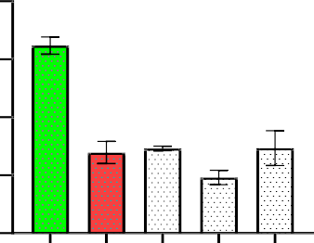
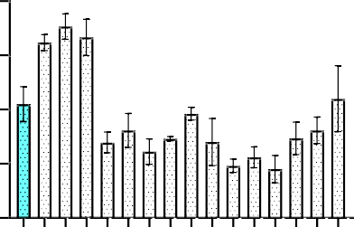
8 8
#
*
*
*
*
* *
CRP(mg/L) (day 11)
6 6
CRP(mg/L)
4 4
2 2
0 0
group 1 (cntrl)
group 2
group 3
group 4
group 5
group 6
group 7
group 8
group 9
group 10
group 11
group 12
group 13
group 14
group8
group5(+ctr)
group2(-ctr)
group 15
group 16
group14
group11

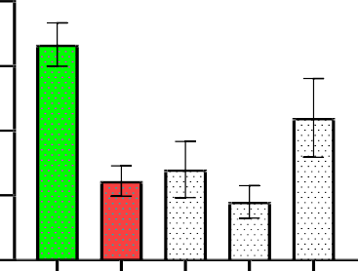
#
*
*
*
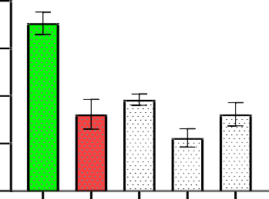
8
#
*
*
*
*
CRP (mg/L)(day 33)
8
CRP(mg/L) (day 22)
6
6
4
4

2 2

0 0
group4(-ctr)
group7(ctr)
group10
group13
group16
group3(-ctr)
group6(+ctr)
group9
group12
group15

Figure 1. Dose- and time-dependent reduction of CRP levels by N. biserrata extract in TP-induced BPH rats. Values are mean ± SEM (n = 5). p < 0.05 vs positive control; #p < 0.05 vs negative control. Nephrolepis biserrata aqueous leaf extract attenuates C-reactive protein (CRP) concentration on day (11), (22), and (33). Testosterone propionate–induced groups exhibited elevated CRP levels, indicating increased systemic inflammation. Treatment with the extract resulted in a dose- and time-dependent reduction in CRP concentrations, suggesting potent anti-inflammatory activity. These findings are consistent with previous studies reporting that plant-derived polyphenols and flavonoids can reduce systemic inflammation and lower CRP levels in experimental models of prostatic hyperplasia and other inflammatory conditions (Li et al., 2020; Sharma et al., 2021; Krishnamoorthi et al., 2024). All values are expressed as mean ± SEM (n=5); *p < 0.05 compared with positive control groups, #p < 0.05 compared with negative control groups. Extract = Nephrolepis biserrata.
.
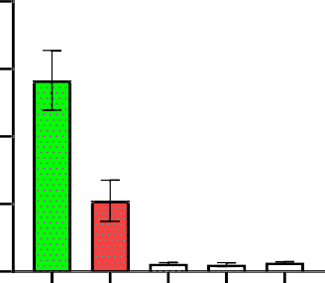
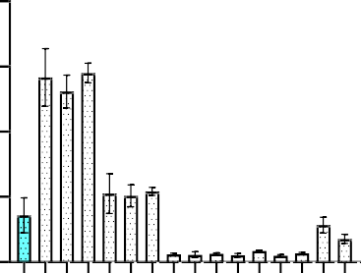
80 80
#
*
* *
*
*
* *
IL-6(pg/mL) (day 11)

60 60
IL-6(pg/mL)

40 40

20 20

0 0
group 1 (cntrl)
group 2
group 3
group 4
group 5
group 6
group 7
group 8
group 9
group 10
group 11
group 12
group 13
group 14
group 15
group 16
group 8
group 11
group 14
group 5 (+ctr)
group 2 (-ctr)

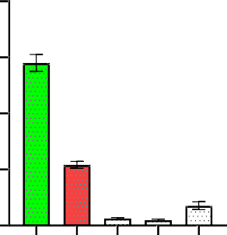
80
IL-6(pg/mL) (day 33)
#
*
#* #*
*#
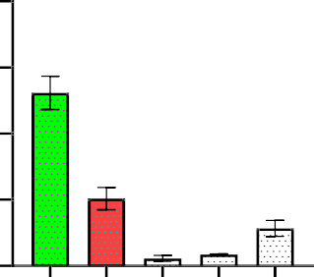
80
#
*
*
*# *#
IL-6 (pg/mL)(day 22)
60
60

40
40

20 20

0 0
group 4 (-ctr)
group 7 (ctr)
group 10
group 13
group 16
group 3 (-ctr)
group 6 (+ctr)
group 9
group 12
group 15

Figure 2. Attenuation of IL-6 by N. biserrata extract across 11, 22, and 33 days in TP-induced rats. Values are mean ± SEM (n = 5). p < 0.05 vs positive control; #p < 0.05 vs negative control.
Nephrolepis biserrata aqueous leaf extract attenuates interleukin-6 (IL-6) levels on day (11), (22), and (33).
Testosterone propionate–induced groups showed elevated IL-6 levels, reflecting enhanced inflammatory response, while treatment with the extract resulted in a progressive reduction in IL-6 levels across the treatment durations, indicating anti-inflammatory activity of the extract. All values are expressed as mean ± SEM (=5), *p<0.05 when compared with positive control groups, while #p<0.05 was significant when compared with the negative control groups. Extract = Nephrolepis biserrata.

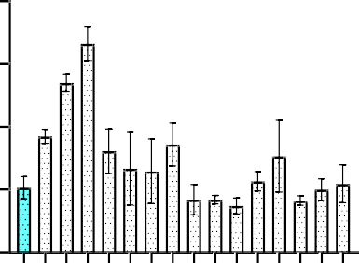
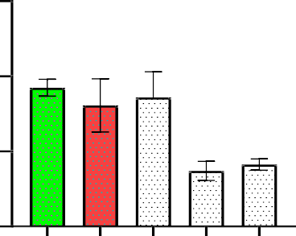
20 15
*
*
TNF(pg/mL) (day 11)
*
*

15 10
TNF(pg/mL)

10
5
5

0 0
group 1 (cntrl)
group 2
group 3
group 4
group 5
group 6
group 7
group 8
group 9
group 10
group 11
group 12
group 13
group 14
group 15
group 16
group8
group11
group14
group2(-ctr)
group5(+ctr)

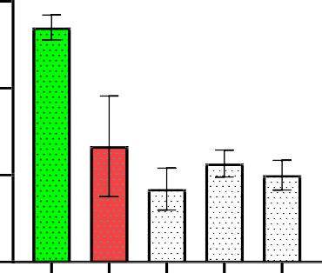
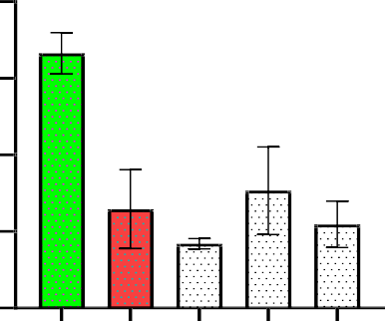
15 20
#
*
*
*
*
TNF(pg/mL) (day 33)
#
*
*
*
*
TNF (pg/mL)(day 22)

15
10
10

5
5

0 0
group 3 (-ctr)
group 6 (+ctr)
group 9
group 12
group 15
group4(-ctr)
group7(ctr)
group10
group13
group16

Figure 3. TNF-α levels decreased by N. biserrata extract in a dose- and time-dependent manner. Values are mean ± SEM (n = 5). p < 0.05 vs positive control; #p < 0.05 vs negative control.
Nephrolepis biserrata aqueous leaf extract attenuates tumor necrosis factor alpha (TNF-α) levels on day (11), (22), and (33).
Testosterone propionate–induced groups exhibited elevated TNF-α levels, indicating enhanced inflammatory activity associated with benign prostatic hyperplasia, while treatment with the extract resulted in a marked reduction in TNF-α levels across the experimental periods, suggesting effective anti-inflammatory action. All values are expressed as mean ± SEM (=5), *p<0.05 when compared with positive control groups, while #p<0.05 was significant when compared with the negative control groups. Extract = Nephrolepis biserrata. These findings support earlier reports that chronic inflammation plays a central role in BPH progression and that suppression of pro-inflammatory cytokines contributes to prostate tissue remodeling and symptom regression (Konkol et al., 2019;Wu et al., 2021).

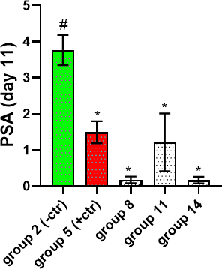
8
*
* *

6
PSA(ng/mL)

4

2

0
group 1 (cntrl)
group 2
group 3
group 4
group 5
group 6
group 7
group 8
group 9
group 10
group 11
group 12
group 13
group 14
group 15
group 16

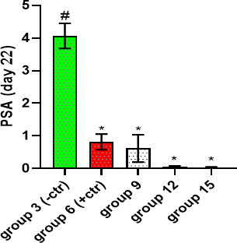
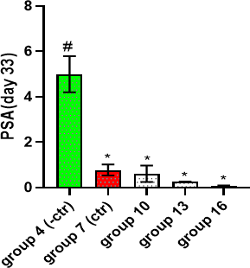
Figure 4. Reduction of PSA concentration following N. biserrata treatment in TP-induced BPH rats. Values are mean ± SEM (n = 5). p < 0.05 vs positive control; #p < 0.05 vs negative control.
Effect of aqueous extract of Nephrolepis biserrata on prostate-specific antigen (PSA) concentration on day (11), (22), and (33). Testosterone propionate–induced groups showed elevated PSA levels, indicative of androgen-driven prostatic hyperplasia, while treatment with the extract resulted in a progressive reduction in PSA concentration across the experimental periods. All values are expressed as mean ± SEM (=5), *p<0.05 when compared with positive control groups, while #p<0.05 was significant when compared with the negative control groups. Extract = Nephrolepis biserrata. Elevated PSA levels are a recognized surrogate marker of androgen-driven prostatic hyperplasia, and their reduction following treatment suggests effective modulation of prostatic epithelial activity (Adhyam and Gupta 2012).
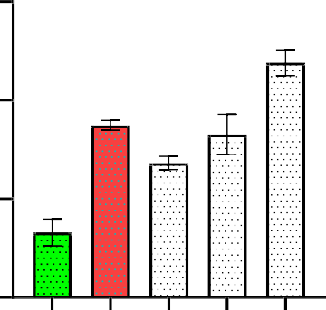
30
#*
*
*
*
#
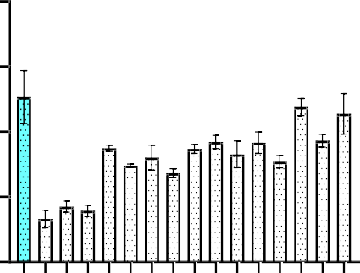
40
* *
*
*
*
*
*
* * *
P/CAT (day 11)

30 20
P/CAT

20
10
10

0 0
group 1 (cntrl)
group 2
group 3
group 4
group 5
group 6
group 7
group 8
group 9
group 10
group 11
group 12
group 13
group 14
group 15
group 16
group 2 (-ctr)
group 5 (+ctr)
group 8
group 11
group 14

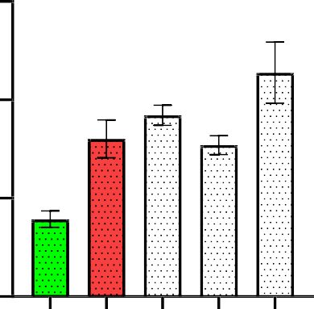
30
*
*
*
*
#
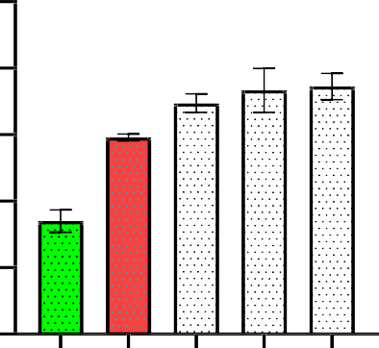
25
*
*
*
*
#
P/CAT (day 33)

20
P/CAT (day 22)
20
15

10 10

5
0 0
group 4 (-ctr)
group 7 (ctr)
group 10
group 13
group 16
group 3 (-ctr)
group 6 (+ctr)
group 9
group 12
group 15

Figure 5. Catalase (CAT) activity restored by N. biserrata extract in TP-induced rats. Values are mean ± SEM (n = 5). p < 0.05 vs positive control; #p < 0.05 vs negative control.
Effect of aqueous extract of Nephrolepis biserrata on catalase (CAT) activities on day (11), (22), and (33). Testosterone propionate–induced groups showed reduced catalase activity, indicating impaired antioxidant defense, while treatment with the extract resulted in a progressive increase in CAT activities across the experimental periods, suggesting enhancement of endogenous antioxidant capacity. All values are expressed as mean ± SEM (=5), *p<0.05 when compared with positive control groups, while #p<0.05 was significant when compared with the negative control groups. Extract = Nephrolepis biserrata..
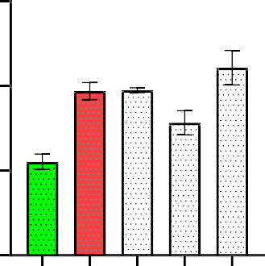
60
*
*
*
#
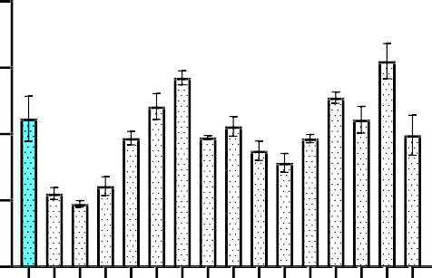
80
*
* * *
P/GPX (day 11)

60 40

40
P/GPX
20
20

0 0
group 2 (-ctr)
group 5 (+ctr)
group 8
group 11
group 14
group 1 (cntrl)
group 2
group 3
group 4
group 5
group 6
group 7
group 8
group 9
group 10
group 11
group 12
group 13
group 14
group 15
group 16

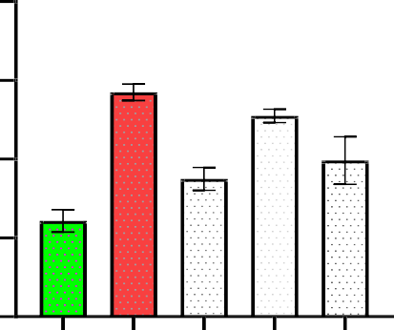
80
*
*
#*
#
#
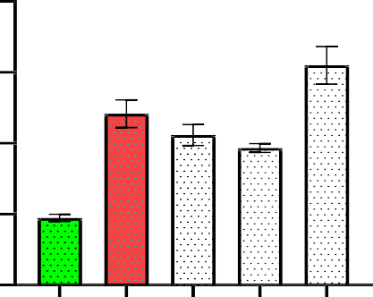
80
#*
*
*
*
#
P/GPX (day 33)

60 60
P/GPX (day 22)

40 40

20 20

0 0
group4(-ctr)
group7(ctr)
group10
group13
group16
group3(-ctr)
group6(+ctr)
group9
group12
group15

Figure 6. Glutathione peroxidase (GPX) activity increased by extract administration. Values are mean ± SEM (n = 5). p < 0.05 vs positive control; #p < 0.05 vs negative control. Nephrolepis biserrata aqueous extract attenuates glutathione peroxidase (GPX) activity on day (11), (22), and (33). Testosterone propionate–induced groups exhibited reduced GPX activity, indicating increased oxidative stress, while treatment with the extract resulted in a progressive increase in GPX activity across the experimental periods, suggesting improved antioxidant defense. All values are expressed as mean ± SEM (=5), *p<0.05 when compared with positive control groups, while #p<0.05 was significant when compared with negative control groups. Extract = Nephrolepis biserrata.
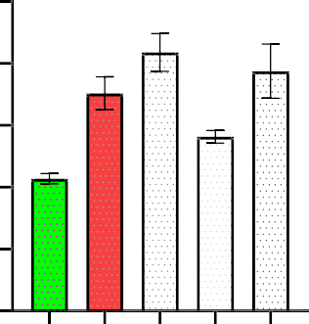
50
*
*
*
#
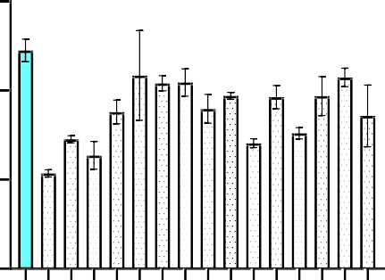
60
* *
*
*
*
40
P/SOD (day 11)

40 30
P/SOD

20
20
10

0 0
group 1 (cntrl)
group 2 (-ctr)
group 2
group 3
group 4
group 5
group 6
group 7
group 8
group 9
group 10
group 11
group 12
group 13
group 14
group 15
group 16
group 5 (+ctr)
group 8
group 11
group 14

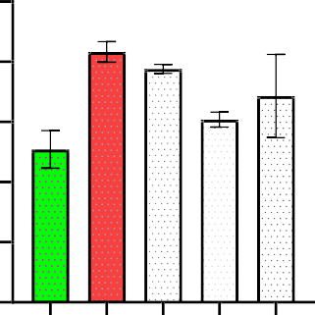
50
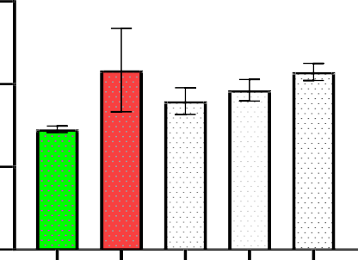
60
P/SOD (day 33)
40
P/SOD (day 22)

40 30

20
20
10

0 0
group 4 (-ctr)
group 7 (ctr)
group 10
group 13
group 16
group9
group12
group15
group3(-ctr)
group6(+ctr)

Figure 7. Reduction of MDA levels (lipid peroxidation) by N. biserrata extract. Values are mean ± SEM (n = 5). p < 0.05.
Nephrolepis biserrata aqueous extract attenuates tissue peroxidation by elevating glutathione peroxidase (GPX) activities on day (11), (22), and (33). Testosterone propionate–induced groups showed increased tissue peroxidation, reflecting heightened oxidative stress, while administration of the extract resulted in a significant elevation of GPX activity across the experimental periods, indicating enhanced antioxidant defense. All values are expressed as mean ± SEM (=5), p<0.05. Restoration of endogenous antioxidant enzymes following extract administration indicates attenuation of oxidative stress, a key contributor to testosterone-induced prostatic enlargement (Randenia et al., 2024;Tang et al., 2025).

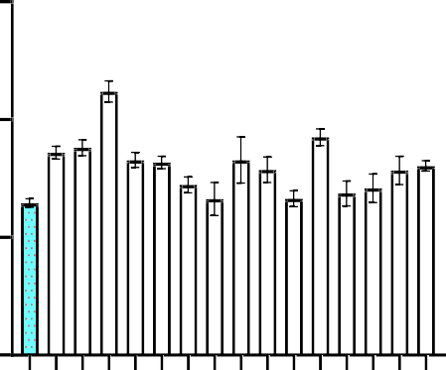
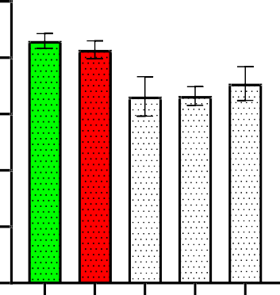
15 10
*
* *
*
*
*
total chol (mmol/L) day 11
Total Chol.(mmol/L)

8
10
6

4
5
2

0 0
group 1 (cntrl)
group 2 (-ctrl)
group 2
group 3
group 4
group 5
group 6
group 7
group 8
group 9
group 10
group 11
group 12
group 13
group 14
group 15
group 16
group 5 (+ctrl)
group 8
group 11
group 14

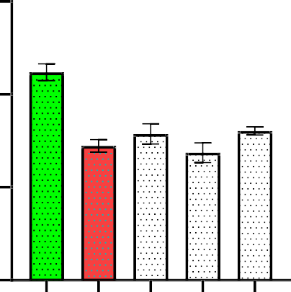
15
Total chol (mmol/L) 33
#
*
*
*
*
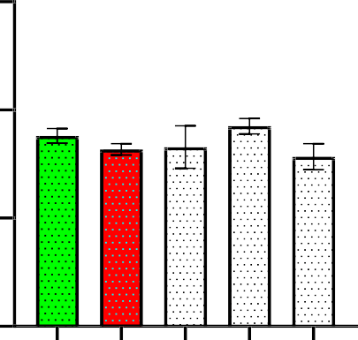
15
Total chol (mmol/L) 22

10
10

5 5

0 0
group 4 (-ctrl)
group 7 (+ctrl)
group 10
group 13
group 16
group 3 (-ctrl)
group 6 (+ctrl)
group 9
group 12
group 15

Figure 8. Normalization of total cholesterol (TCHOL) by extract in TP-induced BPH rats. Values are mean ± SEM (n = 5). p < 0.05 vs positive control; #p < 0.05 vs negative control. Nephrolepis biserrata aqueous leaves extract attenuates reduced total cholesterol in experimental groups concentration on day (11), (22) and (33). ALL Values are expressed mean±SEM (=5), *p<0.05 when compared with positive control groups. while #p<0.05 was significant when com pared with the with negative control groups. Extract= of nephrolepis biserrata
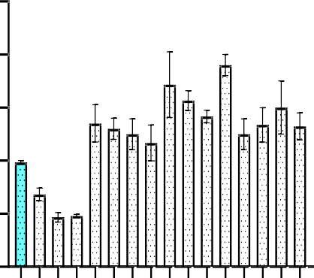
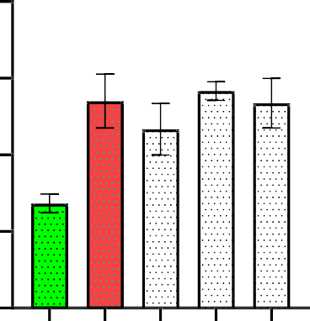
5 4
*
*
*
*
*
#
HDL-C (mmol/L) 11

4 3
HDL-C (mmol/L)

3
2
2
1
1

0 0
group1(cntrl)
group2
group3
group4
group5
group6
group7
group8
group9
group10
group11
group12
group13
group14
group15
group16
group 2 (-ctrl)
group 5 (+ctrl)
group 8
group 11
group 14

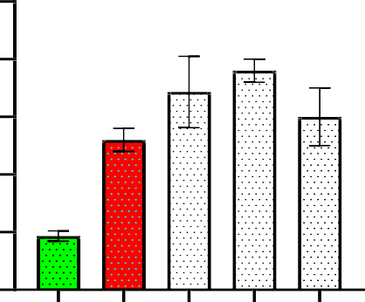
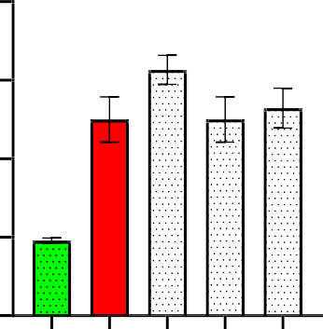
5 4
*
*
*
*
#
HDL-C (mmol/L) 33
*
*
*
*
#
HDL-C (mmol/L) 22

4 3

3
2
2
1
1

0 0
group 4 (-ctrl)
group 7 (+ctrl)
group 10
group 13
group 16
group3(-ctrl)
group6(+ctrl)
group 9
group12
group15

Figure 9. HDL-C concentration increased by N. biserrata treatment. Values are mean ± SEM (n = 5).
The aqueous extract of Nephrolepis biserrata ameliorates high-density lipoprotein (HDL) concentration on day (11), (22), and (33). Testosterone propionate, induced groups showed reduced HDL levels, indicating dyslipidemia associated with benign prostatic hyperplasia, while treatment with the extract resulted in a dose- and time-dependent increase in HDL concentration across the experimental periods, suggesting improvement in lipid metabolism. All values are expressed as mean ± SEM (=5), *p<0.05 when compared with positive control groups, while #p<0.05 was significant when compared with the negative control groups. Extract = Nephrolepis biserrata.

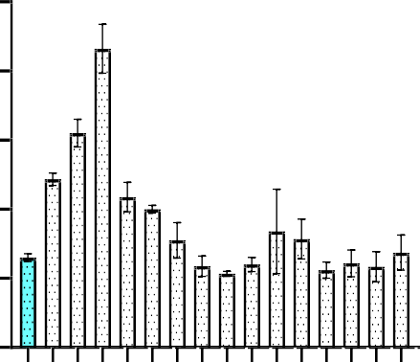
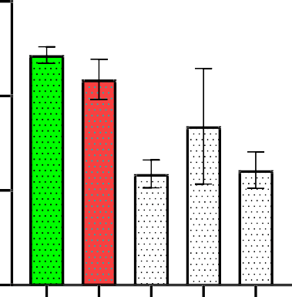
5 3
*
*
*
LDL-C (mmol/L) 11

4
LDL-C (mmol/L)
2
3

2 1
1

0 0
group1(cntrl)
group2
group3
group4
group5
group6
group7
group8
group9
group10
group11
group12
group13
group14
group15
group16
group 2 (-ctrl)
group 5 (+ctrl)
group 8
group 11
group 14

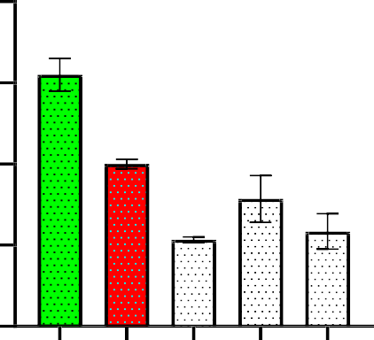
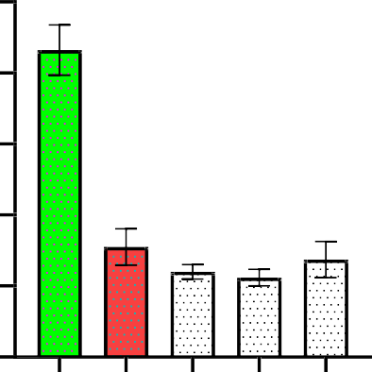
4 5
#
*
*
#*
#*
LDL-C (mmol/L) 33
#
*
*
*
*
LDL-C (mmol/L) 22
4
3
3
2
2

1 1

0 0
group 4 (-ctrl)
group 7 (+ctrl)
group 10
group 13
group 16
group 3 (-ctrl)
group 4 (-ctrl)
group 9
group 12
group 15

Figure 10. Reduction of LDL-C by extract in TP-induced rats. Values are mean ± SEM (n = 5).
Effect of aqueous leaf extract of Nephrolepis biserrata on low-density lipoprotein cholesterol (LDL-C) concentration in testosterone propionate–induced benign prostatic hyperplasia in male Wistar rats. Testosterone propionate administration resulted in elevated LDL-C levels, indicating dyslipidemia associated with benign prostatic hyperplasia, while treatment with the extract produced a reduction in LDL-C concentration, suggesting an improvement in lipid metabolism.
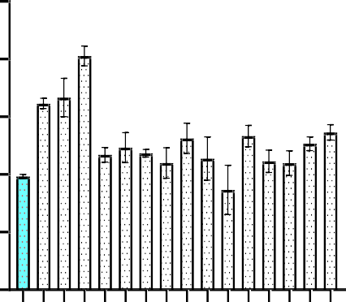
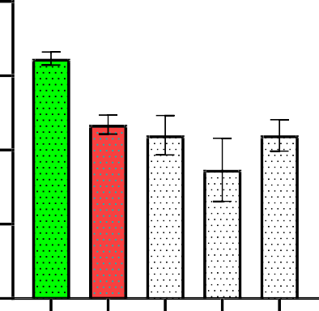
5 4
*
*
*
Triglyceride (mmol/L) 11
*
*

4 3
Triglycerides (mmol/L)

3
2
2
1
1

0 0
group1(cntrl)
group2
group3
group4
group5
group6
group7
group8
group9
group10
group11
group12
group13
group14
group15
group16
group 2 (-ctrl)
group 5 (+ctrl)
group 8
group 11
group 14

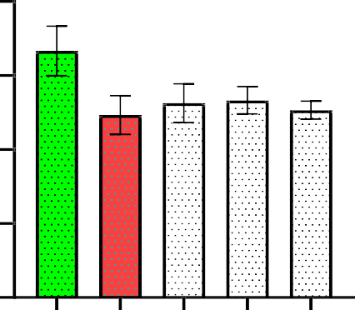
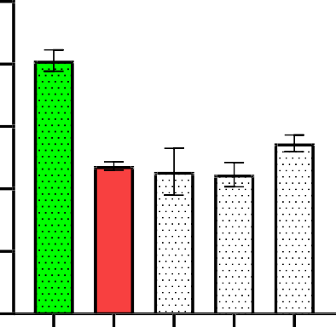
4 5
Triglyceride (mmol/L) 33
#
*
*
*
*
Triglyceride (mmol/L) 22
4
3
3
2
2

1 1

0 0
group 4 (-ctrl)
group 7 (+ctrl)
group 10
group 13
group 16
group 3 (-ctrl)
group 6 (+ctrl)
group 9
group 12
group 15

Figure 11. Triglyceride levels ameliorated by N. biserrata extract. Values are mean ± SEM (n = 5).
Effect of aqueous leaf extract of Nephrolepis biserrata on triglyceride concentration in testosterone propionate, induced benign prostatic hyperplasia in male Wistar rats. Testosterone propionate administration resulted in elevated triglyceride levels, indicating altered lipid metabolism associated with benign prostatic hyperplasia, while treatment with the extract led to a reduction in triglyceride concentration, suggesting an ameliorative effect on dyslipidemia.

2.5
VLDL-C (mmol/L)

2.0

1.5

1.0

0.5
2.0

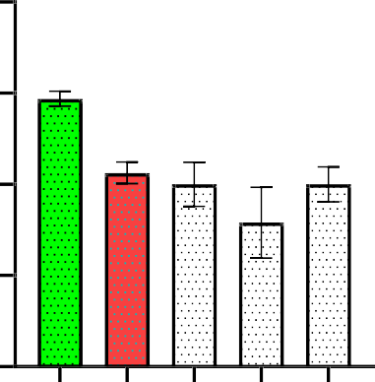
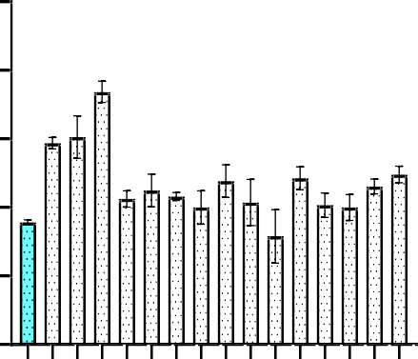
1.5
*
VLDL-C (mmol/L) 11
*
* *

1.0

0.5

0.0
group1(cntrl)
group2
group3
group4
group5
group6
group7
group8
group9
group10
group11
group12
group13
group14
group15
group16
group 2 (-ctrl)
group 5 (+ctrl)
group 8
group 11
group 14
0.0

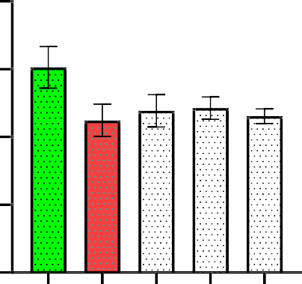
2.0
VLDL-C (mmol/L) 22

1.5

1.0

0.5

0.0
group 4 (-ctrl)
group 7 (+ctrl)
group 10
group 13
group 16
group 3 (-ctrl)
group 6 (+ctrl)
group 9
group 12
group 15
2.5

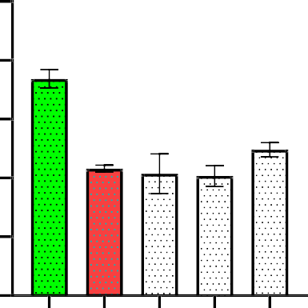
2.0
#
*
*
*
*
VLDL-C (mmol/L) 33

1.5

1.0

0.5

0.0

Figure 12. VLDL-C levels decreased by extract treatment. Values are mean ± SEM (n = 5).The aqueous extract of Nephrolepis biserrata ameliorates very low-density lipoprotein (VLDL) concentration in testosterone propionate–induced benign prostatic hyperplasia on day (11), (22), and (33). Testosterone propionate–induced groups exhibited elevated VLDL levels, reflecting dyslipidemia associated with benign prostatic hyperplasia, while treatment with the extract resulted in a progressive reduction in VLDL concentration across the experimental periods, indicating improvement in lipid metabolism. All values are expressed as mean ± SEM (=5), *p<0.05 when compared with positive control groups, while #p<0.05 was significant when compared with the negative control groups. Extract = Nephrolepis biserrata.

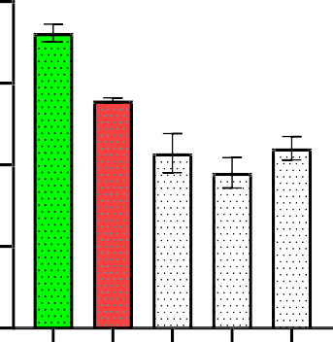
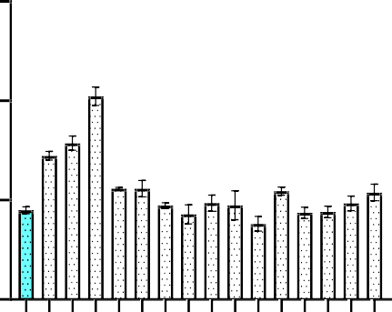
15 8
#
*
*
#* *
*
* *
N
5
on HDL-C(mmol/L) 11
Non HDL-C(mmol/L)

6
10
4

2

0 0
group 1 (cntrl)
group 2
group 3
group 4
group 5
group 6
group 7
group 8
group 9
group 10
group 11
group 12
group 13
group 14
group 15
group 16
group 2 (-ctrl)
group 5 (+ctrl)
group 8
group 11
group 14

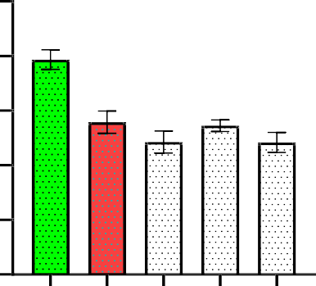
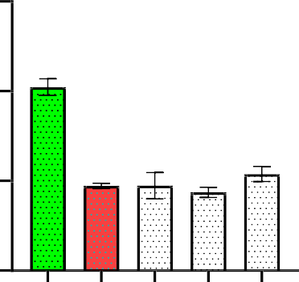
10 15
#
*
*
*
*
Non HDL-C (mmol/L) 33days
#
*
*
*
*
Non HDL-C(mmol/L) 22days

8
10
6

4
5
2

0 0
group 4 (-ctrl)
group 7 (+ctrl)
group 10
group 13
group 16
group 3 (-ctrl)
group 6 (+ctrl)
group 9
group 12
group 15

Figure 13. Improvement in HDL-C levels following extract administration. Values are mean ± SEM (n = 5).The aqueous extract of Nephrolepis biserrata ameliorates HDL concentration on day (11), (22), and (33). Testosterone propionate–induced rats exhibited reduced HDL levels, consistent with dyslipidemia associated with BPH. Treatment with the extract progressively increased HDL concentrations over the experimental period, suggesting improvement in lipid profile. All values are expressed as mean ± SEM (n=5); *p < 0.05 compared with the positive control, #p < 0.05 compared with the negative control. Improvement in HDL and overall lipid balance may contribute to both prostatic and cardiovascular protection, as dyslipidemia is implicated in BPH pathogenesis through vascular dysfunction and inflammatory signaling (Krishnamoorthi et al., 2024).

Histopathological Examination
Prostate and testis tissues were fixed in 10% neutral buffered formalin, routinely processed, embedded in paraffin wax, sectioned at appropriate thickness, and stained with hematoxylin and eosin (H&E). Microscopic examination was carried out to evaluate tissue architecture, cellular morphology, and the presence of inflammatory changes.

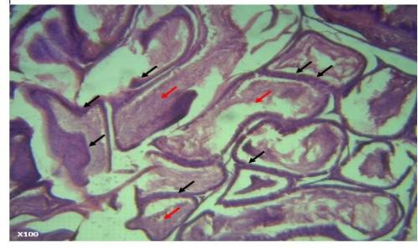
Plate 1: Photomicrograph of prostate of normal control
Photomicrograph of the prostate of the normal control group. The photomicrograph shows a normal prostate with acini lined by secretory columnar epithelial cells. The glandular lumen contains corpora amylacea (red arrow).

Plate 2: Photomicrograph of prostate of negative control 11 days

There is adenosis or atypical adenomatous hyperplasia of the prostate gland as indicated by the presence of uniform round glands arranged in a circumscribed nodule in the fibromuscular stroma and reduced secretory epithelium
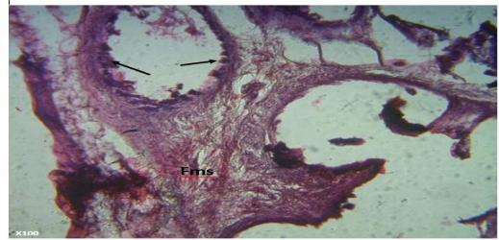

Plate 3: Photomicrograph of prostate of negative control 22 days

Photomicrograph of the prostate of the negative control group (22 days). The photomicrograph shows hyperplasia of the secretory epithelium with mild disruption of the glandular lining [black arrow]. The fibromuscular stroma (Fms) is evident surrounding the glandular structures.

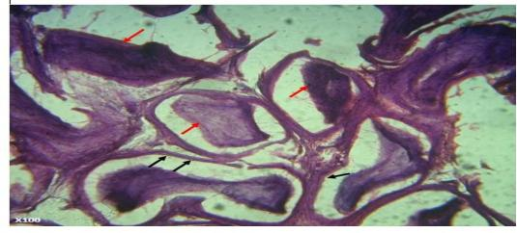

Plate 4: Photomicrograph of prostate of negative control 33days
Photomicrograph of the prostate of the negative control group (33 days). The photomicrograph shows prostate acini with a cystic atrophy appearance characterized by reduced height of the secretory epithelium [black arrow]. The presence of corpora amylacea is also observed within the glandular lumen [red arrow].

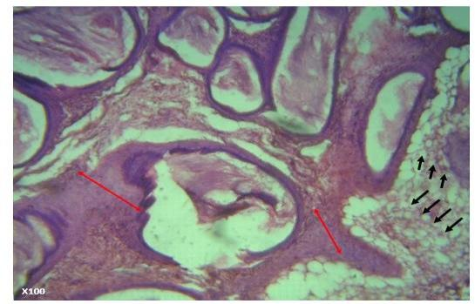
Plate 5: Photomicrograph of prostate of positive control 11 days
Photomicrograph of the prostate of the positive control group (11 days). The photomicrograph shows an increased thickness of the fibromuscular stroma (red line) and the presence of uniform round glands arranged in circumscribed nodules within the fibromuscular stroma (green arrow), indicating adenosis or atypical adenomatous hyperplasia of the prostate gland.

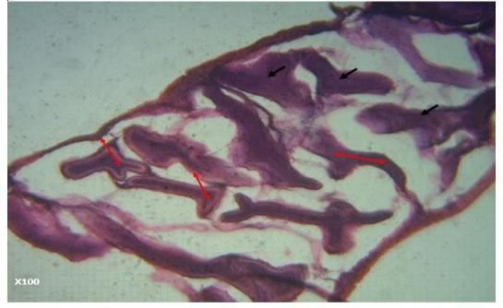
Plate 6. Photomicrograph of prostate of positive control 22 days

Photomicrograph of the prostate of the positive control group (22 days). The photomicrograph shows papillated acini (red line) with a slightly decreased thickness of the fibromuscular stroma. The glandular lumen contains secretions that appear collagenous.

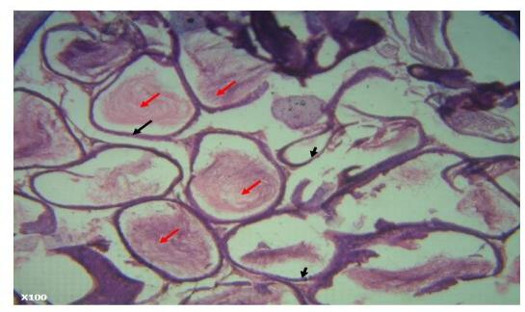
Plate 7: Photomicrograph of prostate of positive control 33 days
Photomicrograph of the prostate of the positive control group (33 days). The photomicrograph shows a normal prostate with acini lined by secretory columnar epithelial cells. The glandular lumen contains corpora amylacea.

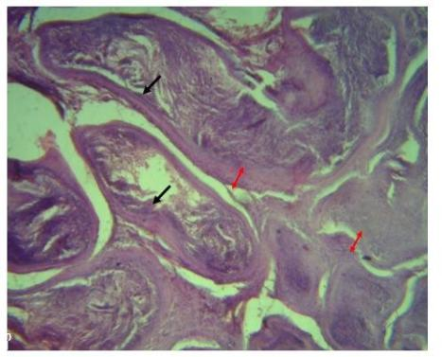

Plate 8: Photomicrograph of extract treated group which received 100mg/kg b. wt of the extract for 11 days
Photomicrograph of the prostate of the extract-treated group that received 100 mg/kg body weight of the extract for 11 days. The photomicrograph shows an increased thickness of the fibromuscular stroma (red line) surrounding the acini, indicating prostatic hyperplasia. The glandular lumen contains collagenous secretions.
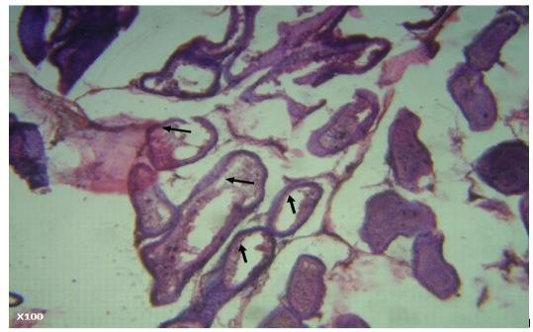
Plate 9: Photomicrograph of extract treated group which received 100mg/kg b. wt of the extract for 22 days
Photomicrograph of the prostate of the extract-treated group that received 100 mg/kg body weight of the extract for 22 days. The photomicrograph shows a reduction in the fibromuscular stroma, with the secretory epithelium clearly observed (black arrow).

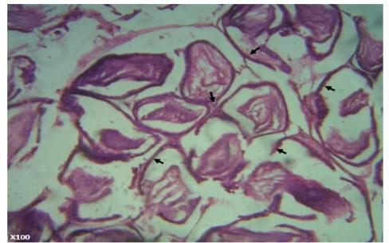
Plate 10: Photomicrograph of extract treated group which received 100mg/kg b.wt of the extract for 33 days

Photomicrograph of the prostate of the extract-treated group that received 100 mg/kg body weight of the extract for 33 days. The photomicrograph shows a normal prostate with acini lined by secretory cuboidal to columnar epithelium (black arrow). The glandular lumen contains corpora amylacea.

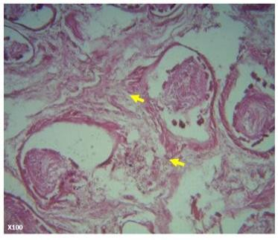

Plate 11: Photomicrograph of extract treated group which received 200mg/kg b. wt of the extract for 11 days
Photomicrograph of the prostate of the extract-treated group that received 200 mg/kg body weight of the extract for 11 days. The photomicrograph shows a moderate increase in the fibromuscular stroma, which appears less dense.

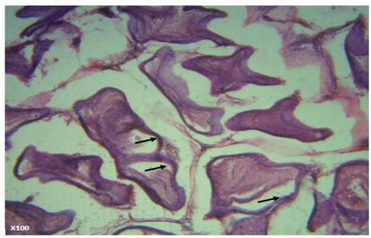
Plate 12: Photomicrograph of extract treated group which received 200mg/kg b. wt of the extract for 22 days
Photomicrograph of the prostate of the extract-treated group that received 200 mg/kg body weight of the extract for 22 days. The photomicrograph shows a normal prostate with more papillated acini lined by secretory cuboidal to columnar epithelium (black arrow). The glandular lumen contains corpora amylacea.

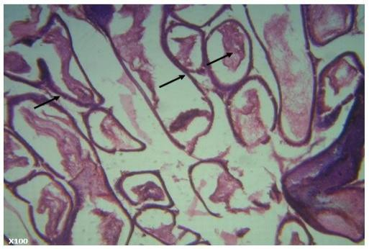
Plate 13: Photomicrograph of extract treated group which received 200mg/kg b. wt of the extract for 33 days

Photomicrograph of the prostate of the extract-treated group that received 200 mg/kg body weight of the extract for 33 days. The photomicrograph shows a normal prostate with acini lined by secretory cuboidal to columnar epithelium (black arrow).

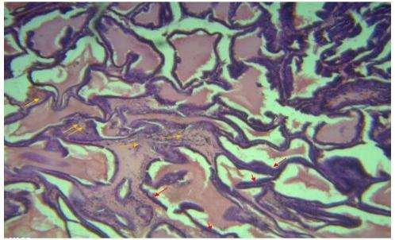
Plate 14: Photomicrograph of extract treated group which received 300mg/kg b.wt of the extract for 11 days

Photomicrograph of the prostate of the extract-treated group that received 300 mg/kg body weight of the extract for 11 days. The photomicrograph shows the presence of cellular infiltration within the stroma (yellow arrow), indicating mild inflammation of the prostate. The acini are lined by dense epithelium composed predominantly of tall columnar cells (black arrow). The glandular lumen contains corpora amylacea.

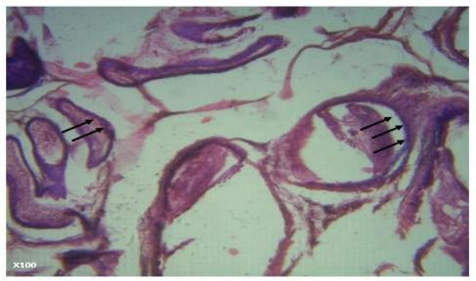

Plate 15: Photomicrograph of extract treated group which received 300mg/kg b. wt of the extract for 22 days

Photomicrograph of the prostate of the extract-treated group that received 300 mg/kg body weight of the extract for 22 days. The photomicrograph shows a normal prostate with acini lined by secretory cuboidal to columnar epithelium (black arrow).

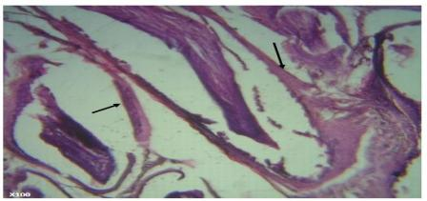

Plate 16: Photomicrograph of extract treated group which received 300mg/kg b. wt of the extract for 33 days
Photomicrograph of the prostate of the extract-treated group that received 300 mg/kg body weight of the extract for 33 days. The photomicrograph shows a normal prostate with acini lined by secretory cuboidal to columnar epithelium (black arrow).

Testosterone propionate (TP) administration significantly elevated systemic inflammatory markers, including C-reactive protein (CRP), interleukin-6 (IL-6), and tumor necrosis factor-alpha (TNF-α), compared with normal controls (p < 0.05). Treatment with aqueous leaf extract of Nephrolepis biserrata produced dose- and time-dependent reductions in these markers, with the highest dose (300 mg/kg) restoring CRP, IL-6, and TNF-α levels close to baseline, comparable to the positive control (finasteride + doxazosin), indicating potent anti-inflammatory effects. TP-induced BPH rats also exhibited oxidative stress, evidenced by elevated malondialdehyde (MDA) levels and reduced antioxidant enzyme activities, including catalase (CAT) and glutathione peroxidase (GPX). Administration of N. biserrata extract significantly increased CAT and GPX activities while decreasing MDA levels in a dose- and duration-dependent manner (p < 0.05), demonstrating restoration of antioxidant defense. Furthermore, prostate-specific antigen (PSA) levels, significantly elevated in TP-treated groups, were progressively reduced by extract treatment across all doses and time points, suggesting modulation of androgen-driven prostatic changes. TP administration induced dyslipidemia, characterized by increased total cholesterol, LDL-C, VLDL-C, and triglycerides, alongside decreased HDL-C (p < 0.05). Extract treatment normalized these lipid parameters dose- and time-dependently, with the 300 mg/kg dose significantly reducing total cholesterol, LDL-C, VLDL-C, and triglycerides, and elevating HDL-C compared to negative controls, indicating potential cardioprotective effects. Histological examination of prostate tissue from TP-treated rats revealed epithelial hyperplasia, glandular crowding, and stromal thickening, whereas extract-treated groups showed progressive restoration of normal architecture, reduced epithelial proliferation, and well-defined acini. The highest dose (300 mg/kg) for 33 days restored prostate histology comparable to normal controls, and testicular histology also showed marked improvement, reflecting mitigation of TP-induced degeneration.

DISCUSSION
The present study confirmed that testosterone propionate reliably induced benign prostatic hyperplasia (BPH) in male Wistar rats, as reflected by biochemical, haematological, and histopathological alterations consistent with previous reports (Konkol et al., 2019; Kayode et al., 2020). Testosterone-induced rats displayed dyslipidemia, characterized by elevated total cholesterol, low-density lipoprotein cholesterol, and triglycerides, alongside reduced high-density lipoprotein cholesterol, corroborating the lipid disturbances associated with BPH progression (Tyagi et al., 1999). Treatment with aqueous leaf extract of Nephrolepis biserrata at 100, 200, and 300 mg/kg led to dose- and time-dependent normalization of lipid profiles, suggesting antihyperlipidemic and cardioprotective properties. Elevated inflammatory markers, including TNF-α, IL-6, and CRP, observed in untreated BPH rats, were significantly reduced following extract administration, consistent with the anti-inflammatory effects of the plant’s phenolic, flavonoid, saponin, and tannin constituents (Wu et al., 2021; De Nunzio et al., 2020; Rubió et al., 2013). Oxidative stress, evidenced by increased malondialdehyde levels and decreased catalase and glutathione peroxidase activities, was markedly attenuated in treated groups, highlighting the extract’s potent antioxidant capacity, likely mediated by its flavonoids and phenolics (Pérez-Torres et al., 2021). Prostate-specific antigen (PSA) levels, elevated in testosterone-induced rats, were reduced in extract-treated groups, suggesting modulation of androgen-driven prostatic growth, although direct measurement of 5-alpha reductase activity was not performed. Histological evaluation revealed epithelial hyperplasia, glandular proliferation, and stromal thickening in BPH rats, whereas extract-treated groups exhibited reduced epithelial thickness, decreased glandular crowding, and restoration of normal prostate architecture; testicular histology also indicated recovery from testosterone-induced degeneration (Konkol et al., 2019). Overall, these findings demonstrate that Nephrolepis biserrata exerts significant antioxidant and anti-inflammatory effects, improves lipid metabolism, and may modulate androgen-mediated prostatic alterations, supporting its potential as a therapeutic agent for BPH.
CONCLUSION
This study demonstrates that the aqueous leaf extract of Nephrolepis biserrata possesses significant therapeutic potential in testosterone propionate–induced benign prostatic hyperplasia (BPH) in male Wistar rats. The extract improved lipid profiles, reduced inflammatory markers, enhanced antioxidant enzyme activities, and restored normal prostate histology.
While reductions in PSA levels suggest a potential modulatory effect on androgen-driven prostatic enlargement, direct measurement of 5-alpha reductase activity was not performed, and therefore the specific mechanism remains to be determined.
These results highlight Nephrolepis biserrata as a promising natural candidate for managing BPH and support further studies, including clinical trials and mechanistic investigations, to confirm its effects on androgen metabolism and identify the active phytochemicals responsible for its therapeutic actions.
.

COMPETING INTERESTS DISCLAIMER:
Authors declare no competing financial, non-financial, or personal interests.

Disclaimer (Artificial intelligence)
Option 1:
Author(s) hereby declare that NO generative AI technologies such as Large Language Models (ChatGPT, COPILOT, etc.) and text-to-image generators have been used during the writing or editing of this manuscript.
Option 2:
Author(s) hereby declare that generative AI technologies such as Large Language Models, etc. have been used during the writing or editing of manuscripts. This explanation will include the name, version, model, and source of the generative AI technology and as well as all input prompts provided to the generative AI technology
Details of the AI usage are given below:
1.
2.
3.

REFERENCES
- Kishorebabu A, Sree SN, Chandralekha SP. (2019). A review on benign prostatic hyperplasia. World Journal of Current Medical and Pharmaceutical Research, 192–197.
- Mugisha EK. (2025). Pathophysiology of benign prostatic hyperplasia: Cellular and molecular mechanisms. IDOSR Journal of Applied Sciences, 10(1), 26–35. https://doi.org/10.59298/IDOSRJAS/2025/101.263500
- Egan KB. (2016). The epidemiology of benign prostatic hyperplasia associated with lower urinary tract symptoms: Prevalence and incident rates. Urologic Clinics of North America, 43(3), 289–297. https://doi.org/10.1016/j.ucl.2016.04.001
- Chislett B, Chen D, Perera ML, Chung E, Bolton D, Qu LG. (2023). 5-alpha reductase inhibitors use in prostatic disease and beyond. Translational Andrology and Urology, 12(3), 487–496. https://doi.org/10.21037/tau-22-690
- Rosli NHM. (2014). Photosynthetic studies on eight filmy ferns (Hymenophyllaceae) from shaded habitats in Malaysia [Doctoral dissertation]. University of Malaya, Malaysia.
- Oyawaluja BO, Oyawaluja AA, Akinyimika DE, Odukoya OA, Coker HA. (2024). Antioxidant profiling, phytochemical investigation and pharmacognostic evaluation of Nephrolepis biserrata (SW.) Schott (Nephrolepidaceae). Tropical Journal of Phytochemistry and Pharmaceutical Sciences, 3(2), 208–215. https://doi.org/10.26538/tjpps/v3i2.8
- Alamgir ANM. (2018). Secondary metabolites: Secondary metabolic products consisting of C and H; C, H, and O; N, S, and P elements; and O/N heterocycles. In Therapeutic use of medicinal plants and their extracts: Volume 2—Phytochemistry and bioactive compounds (pp. 165–309). Springer International Publishing. https://doi.org/10.1007/978-3-319-92387-1_3
- Thomas-Charles C, Fennell H. (2019). Anti-prostate cancer activity of plant-derived bioactive compounds: A review. Current Molecular Biology Reports, 5(3), 140–151. https://doi.org/10.1007/s40610-019-00123-x
- Kayode OT, Owolabi AV, Kayode AAA. (2020). Biochemical and histomorphological changes in testosterone propionate-induced benign prostatic hyperplasia in male Wistar rats treated with ketogenic diet. Biomedicine & Pharmacotherapy, 132, 110863. https://doi.org/10.1016/j.biopha.2020.110863
- Tyagi A, Rajalakshmi M, Jeyaraj DA, Sharma RS, Bajaj JS. (1999). Effects of long-term use of testosterone enanthate. II. Effects on lipids, high and low density lipoprotein cholesterol and liver function parameters. International Journal of Andrology, 22(6), 347–355. https://doi.org/10.1046/j.1365-2605.1999.00190.x
- Zhang Q, Jiang K, Huo RC, Zhang JQ, Yang ZG. (2023). Association between interleukin-6 and lower urinary tract symptoms of benign prostatic hyperplasia. Revista Internacional de Andrología, 21(2), 100334. https://doi.org/10.1016/j.androl.2021.10.002
- Rubió L, Motilva MJ, Romero MP. (2013). Recent advances in biologically active compounds in herbs and spices: A review of the most effective antioxidant and anti-inflammatory active principles. Critical Reviews in Food Science and Nutrition, 53(9), 943–953. https://doi.org/10.1080/10408398.2011.574802
- Pérez-Torres I, Castrejón-Téllez V, Soto ME, Rubio-Ruiz ME, Manzano-Pech L, Guarner-Lans V. (2021). Oxidative stress, plant natural antioxidants, and obesity. International Journal of Molecular Sciences, 22(4), 1786. https://doi.org/10.3390/ijms22041786
- Raafat M, Kamel AA, Shehata AH, Ahmed ASF, Bayoumi AM, Moussa RA, Abourehab MAS, El-Daly M. (2022). Aescin protects against experimental benign prostatic hyperplasia and preserves prostate histomorphology in rats via suppression of inflammatory cytokines and COX-2. Pharmaceuticals, 15(2), 130. https://doi.org/10.3390/ph15020130
- Konkol Y, Vuorikoski H, Streng T, Tuomela J, Bernoulli J. (2019). Characterization of a model of prostatic diseases and obstructive voiding induced by sex hormone imbalance in the Wistar and Noble rats. Translational Andrology and Urology, 8(Suppl 1), S45–S57. https://doi.org/10.21037/tau.2019.02.03
- Wu D, Shi ZE, Xu D, Wu Y, Qian SB, Qi J. (2021). Serum interleukin-6 and acute urinary retention in elderly men with benign prostatic hyperplasia in China: A cross-sectional study. Translational Andrology and Urology, 10(1), 455–465. https://doi.org/10.21037/tau-20-914
- Adhyam M, Gupta AK. (2012). A review on the clinical utility of PSA in cancer prostate. Indian Journal of Surgical Oncology, 3(2), 120–129. https://doi.org/10.1007/s13193-012-0142-6
- Randenia N, Noer E, Anjani G. (2024). The role of phenolic compounds as anti-inflammatory in obese individuals. Indonesian Journal of Global Health Research, 6(2), 703–714. https://doi.org/10.37287/ijghr.v6i2.2682
- Tang XH, Liu ZY, Ren JW, Zhang H, Tian Y, Hu JX, Sun ZL, Luo GH. (2025). Comprehensive RNA-seq analysis of benign prostatic hyperplasia (BPH) in rats exposed to testosterone and estradiol. Scientific Reports, 15(1), 2750. https://doi.org/10.1038/s41598-025-87205-2
- Krishnamoorthi R, Ganapathy AA, Hari Priya VM, Kumaran A. (2024). Future aspects of plant-derived bioactive metabolites as therapeutics to combat benign prostatic hyperplasia. Journal of Ethnopharmacology, 330, 118207. https://doi.org/10.1016/j.jep.2024.118207
- De Nunzio C, Presicce F, Tubaro A. (2020). Inflammatory mediators in benign prostatic hyperplasia. Nature Reviews Urology, 17, 299–313. https://doi.org/10.1038/s41585-020-0309-5
- Fontana F, Raimondi M, Marzagalli M, Di Domizio A, Limonta P. (2020). Natural compounds in prostate cancer prevention and treatment: Mechanisms of action and molecular targets. Cells, 9(2), 460. https://doi.org/10.3390/cells9020460
- Allain CC, Poon LS, Chan CSG, Richmond W, Fu PC. (1974). Enzymatic determination of total serum cholesterol. Clinical Chemistry, 20(4), 470–475. https://doi.org/10.1093/clinchem/20.4.470
- Kannan S, Mahadevan S, Ramji B, Jayapaul M, Kumaravel V. (2014). LDL-cholesterol: Friedewald calculated versus direct measurement—study from a large Indian laboratory database. Indian Journal of Endocrinology and Metabolism, 18(4), 502–504. https://doi.org/10.4103/2230-8210.137496
- Telles S, Pal S, Sharma SK, Singh A, Kala N, Balkrishna A. (2018). The association between the lipid profile and fasting blood glucose with weight-related outcomes in healthy obese adults. BMC Research Notes, 11(1), 383. https://doi.org/10.1186/s13104-018-3485-4
- Zhao X, Niu Y, Zhao XL, Ruan HJ, Xiang Y, Wang LY, Feng Y, Tang QY. (2023). Associations between serum TNF-α, IL-6, hs-CRP and GLMD in obese children and adolescents: A cross-sectional study. Diabetes, Metabolic Syndrome and Obesity, 16, 3915–3923. https://doi.org/10.2147/DMSO.S434482
- Wunderle C, Martin E, Wittig A, Tribolet P, Lutz TA, Köster-Hegmann C, Stanga Z, Mueller B, Schuetz P. (2025). Comparison of the inflammatory biomarkers IL-6, TNF-α, and CRP to predict the effect of nutritional therapy on mortality in medical patients at risk of malnutrition: A secondary analysis of the randomized clinical trial EFFORT. Journal of Inflammation (London), 22(1), 16. https://doi.org/10.1186/s12950-025-00442-0
- Ajala AO, Adedeji TA, Busuyi JS. (2023). A comparative study of prostate specific antigen (PSA) point-of-care-testing (POCT) techniques. Annals of Health Research, 9(1). https://doi.org/10.30442/ahr.0901-05-189

