Immunohistochemistry and Histology Evaluation of Neurodevelopmental and Neurocognitive Changes in the Offspring of Depressed Mice Administered Paroxetine Prenatally
Original Research Article
Abstract
Depression, a prevalent biopsychiatry disability leading to dysfunction behavioural abilities due to its symptomatic expression, is much more severe in gestational period affected both maternal and child’s health. Paroxetine, a selective serotonin reuptake inhibitors (SSRI) is used in the treatment of chronic and severe depression, but its impact on foetus via utero exposure has not been fully established. Thus, this study assessed the neurodevelopmental and neurocognitive changes in the offspring of depressed mice administered paroxetine prenatally. The effects on miroglia, neuromodulatory, neuroinhibitory, apoptotic and neuronal architectural mapping at adulthood biomarkers were assayed for in the selected brain hippocampal region of cornu ammonis and dendate gyrus. Seventy female Swiss mice (25-30g) were induced with prenatal depression using chronic unpredictable mild stress (CUMS) in pregnant Swiss dams at gestation days (GD) 13 to 19. Group 1 which served as control, consisted offspring of non-CUMS-treated dams, and received saline (2 mL/kg, p.o). Groups 2 and 3 include offspring of non-CUMS-treated dams and received paroxetine (2.5 mg/kg and 5mg/kg, p.o) from GDs 13-19. Group 4 consist of offspring of CUMS-exposed dams and served as CUMS control. Groups 5 and 6 consist of offspring of CUMS-exposed dams, treated with paroxetine (2.5 and 5 mg/kg, p.o) from GD 13-19. Offspring (pups: males and females) were weaned at postnatal day (PND) 21-22 and randomly assigned into 6 groups (n =10) above. Paroxetine potentiated IBA-1 across hippocampal regions except paroxetine reversal intervention in cornu ammonis 1 (CA1) and dendate gyrus (DG) of male and that of the female CA3 and DG. Paroxetine also potentiated BDNF across the brain region except in the reversal effect of CA1 region in female mice when compared to CUMS. In addition, paroxetine increased PARV across hippocampal region except CUMS and paroxetine groups when compared to control in male. Paroxetine advanced BCL-2 and reduced BAX across hippocampal regions in both sexes while paroxetine potentiated normal neuronal cells, and CUMS showed the expression of pyknotic cells. These implychanges in microglia function and paroxetine displayed improved hippocampal neuronal life, neuroinhibitory and neurogenesis with a normal neuronal architectural circuitry except in stressed mice in CA1, CA3 and DG.
1. Introduction
A major depressive episode is characterized by the presence of a severely mental disabled mood that persists for at least a period of fourteen days termed reoccurring or secluded. It can be categorized as mild with little signs of displayed behavioral dysfunction, moderate, or severe as seen in inefficient interaction and when included with a psychosis trait it causes psychiatric depression ^{[1, 2]}. These cases could be worsen in pregnancy with clinical manifestation in the form of unipolar or bipolar emotional disorder ^{[4, 5]}. These depressive episode are triggered by painful life events that could be loss of life, properties, associational trauma and even cases of bereavement ^{[3, 6, 8]}. Gestational depression could be life threatening due to its multiple life complexity of mother and child’s health perspective ^{[7, 9, 16]}. It becomes more worsen with diagnosis of dysthymia ^{[10, 12]} which involves a chronic but milder mood disturbance with recurrent brief episodes induced by unprecedented stressful life circumstances ^{[11, 17, 20]}.
Paroxetine has been one of the major medicines in the class of selective serotonin reuptake inhibitors (SSRI) for maintaining normal mood function and cognitive due to its peculiarity as a long acting agent in making the availability of serotonin as a neurotransmitter available within the synaptic cleft ^{[13,15, 17]}. This makes it a more better choice when compared to monoamine oxidase inhibitors and the tricyclic antidepressant class of drugs used in the management of severe depression ^{[, 18, 19, 32]}. Paroxetine is also indicated for obsessive compulsive disorder, premenstrual disorder and social phobia ^{[20, 21, 22]}. Paroxetine also acts on dopamine and norepinephrine receptors though with low affinity but also useful in the management of psychiatry conditions. ^{[24, 25, 27]}. Due to its choice in treatment of gestational depression, there is need to evaluate its impact on foetus due to its potency in crossing placenta barriers and active coordination of sympathetic and parasympathetic control in brain signaling ^{[23, 25, 34]}.
There are previous studies that involves the use of paroxetine in the treatment of gestational depression but thorough modeling of a real life experiences with examination of neurobehaviorals across age trajectories assessment has not be well established, involving measuring of the histological architecture and immunochemical changes of essential neuronal brain biomarkers within the hippocampal region of the cornu ammonis 1 (CA1), cornu ammonis 3 (CA3) and dendate gyrus (DG) ^{[24, 27, 30]}. Other studies have been able to mimic a single stress restraint model after postnatal administration of antidepressant but unlike this studies that mirrors the impact of paroxetine on neurobehaviorals at infancy, adolescent and adulthood with essential biomarker measurement after sacrifice at adulthood ^{[25, 26, 28]}. It is this literature gap that this study tends to attend to through histological, immunohistochemical and neuronal density count appraisal of sex-dimorphism on the impact of paroxetine and chronic unpredictable mild stress in the hippocampal regions ^{[24, 27, 29, 30]}.

2. Materials and Methods
2.1 Use and Care of Animal
The study was performed at the Faculty of Basic Medical Sciences, Delta State University (DELSU), Abraka, Nigeria, having an ethical approval RBC/FBMS/DELSU/24/305. A total of seventy female Swiss Albino mice (24–29 g) were obtained from the Animal Centre of the College of Health Sciences, Abraka, Nigeria. These animals were housed in a temperature-controlled environment (22±3 ◦C) with a 12-hour light: 12-hour dark cycle and relative humidity of 40–70%, with standard pellets and water provided ad libitum during acclimatization and experimentation.

2.2 Preparation of Chemicals
Paroxetine was purchased from Phegacare Pharmaceuticals in Nigeria, which was procured from Globela Pharma Pvt Ltd. Reagents included thiobarbituric acid (Cat No. SIG T5500), sodium hydrogen phosphate (Cat No. BDH9298), potassium carbonate (Cat No. BDH9256), Ellman reagent [5′, 5′-Dithiobis-(2-nitrobenzoate) DTNB] (Cat No. D8130), and sodium chloride (Cat No. BDH9286). Inflammatory assay kits were sourced from BioLegend (San Diego, USA): TNF-α: Cat no: 430904, IL-6: Cat no: 43260. The processes were conducted following the standard protocols outlined by the manufacturer.

2.3 Experimental Plan, Animal Randomization and Administration of Drug
Depressive episodes was conducted prenatally using CUMS in gestational Swiss mice on gestation days (GD) 13 to 19, equivalent to the second and third trimesters of human pregnancy as pertaining to embryo development and peak brain growth spurts. Serving as the control, Group 1 consists of offspring from non-CUMS-treated dams and received saline (10 mL/kg, p.o.). Group 2 consists of offspring from non-CUMS-treated dams that collected paroxetine (2.5 mg/kg, p.o.) from GD 13-19. Group 3 consists of offspring from non-CUMS-treated dams who were administered paroxetine (5 mg/kg, p.o.) from GD 13-19. Group 4 is made up of offspring from CUMS-exposed dams from GD 13-19 and serves as the negative control. Group 5 consists of offspring from CUMS-exposed dam’s dispensed paroxetine (2.5 mg/kg, p.o.) from GD 13-19. Group 6 consists of offspring from CUMS-exposed dams treated with paroxetine (5 mg/kg, p.o.) from GD 13-19. Neurodevelopmental malformation due to sex variations, male and female offspring of non-CUMS, CUMS, and CUMS-paroxetine administered dams were weaned on postnatal days (PND) 21-22 and randomly delegated into six groups (n = 10). To prevent the litter effect, N = 3 were randomly chosen from each dam. Behavioral assessment of Y-maze were conducted on the offspring at various periodicals equivalent to various developmental stages: PNDs 25-30 (infancy stage), PNDs 35-40 (adolescence), and PNDs 85-90 (adulthood) (Scheme 1). Specific brain region hippocampus were harvested.
2.3.1 Induction of Stress Paradigm
The procedure for CUMS was outline based on modification ^{[9]}, which comprises of random and unpredictable exposure of rodents to different stressors. Based on this research, dams were exposed to various stressors from GD13-19 as scheduled below (Table 1):
Table 1: Schedule of stressors in CUMS-induced prenatal depression of dams
GD | Stressors and duration
13 | Hypoxia (15 min)
14 | 45◦ cage tilting (18hrs)
15 | Damping bedding (4 hrs)
16 | Forced swim test (20 mins)
17 | Cold stress (15 min)
18 | Cylinder Constraint (15 mins)
19 | Food/water deprivation (15hrs)

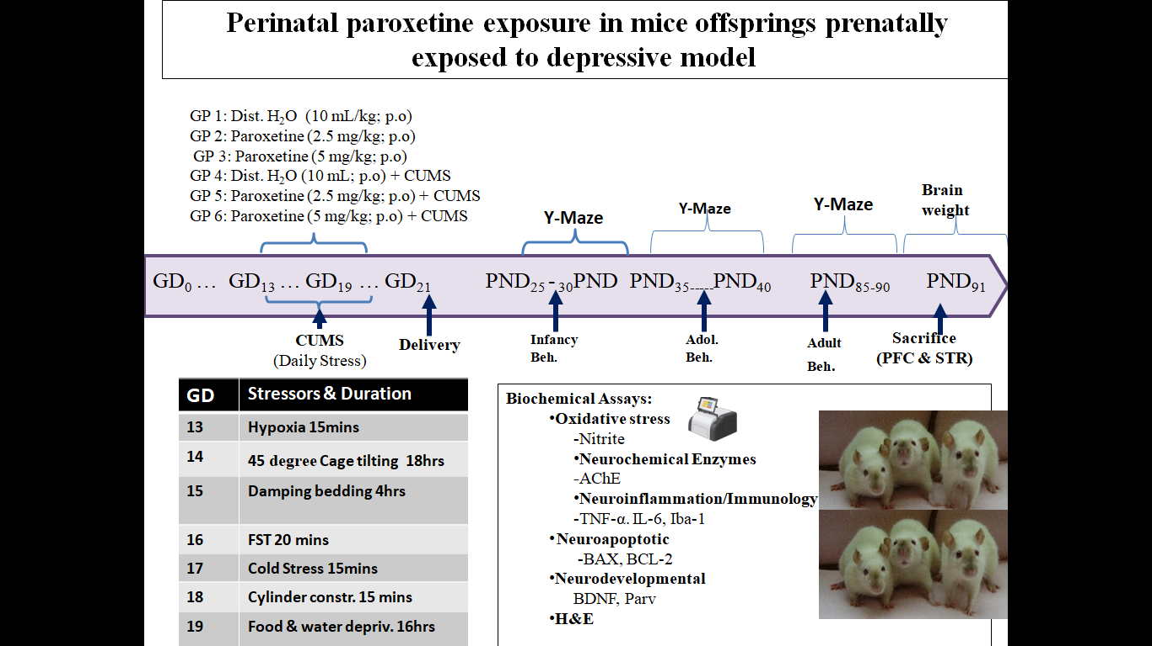
Scheme 1: Schematic experimental flow chart
2.4 Immunohistochemical Assay
Mice brains in the respective groups for immunohistochemistry of glial parvalbumin (PARV), ionized calcium-binding adaptor molecule 1 (IBA-1), Bcl-2-Associated X (BAX), B –cell lymphoma 2 (BCL-2) and Brain-Derived Neurotrophic Factor (BDNF) were anaesthetized with ether and perfused transcardially with sterile phosphate buffered saline (PBS) and later with 10% buffered formaldehyde. Thereafter, brains were rapidly harvested, and fixed with 10% phosphate buffered formaldehyde at 25°C for 48 h. Selected brain regions were assayed for using immunohistochemical procedures previously described ^{[37]} including preparation of tissue, tissue fixation, serum blocking, primary antibody incubation, marked second antibody incubation, staining, result judgment and imaging. Selected brain region was assayed for using immunohistochemical procedures of which includes preparation of tissue or cell, tissue or cell fixation, serum blocking, primary antibody incubation, marked second antibody incubation, staining, result judgment and imaging.
2.5 Histological Tissue Preparation for Microscopic Examination
The process of preparation of tissue for histological examinations is separated into the following tissues (brain) under these stages: Firstly, the tissue was processed by impregnating the specimen into embedding medium to provide a support and suitable consistency for the microtomy sectioning using different graded solutions of alcohol from 70% to 100% to dehydrate, the tissue. Thereafter the tissue was processed using the paraffin wax method with an automatic tissue processor by the following schedule. The sample was embedded in paraffin wax at 70⁰C and cut with a rotary microtone 4µ. The staining technique employed in this study is the haematoxylin and eosin staining techniques. Stained tissue images were captured using digital microscopic eyepiece ‘Scoptek’ Dcm 500, 5.0mega pixels connected to Usb 2.0 computer.
2.6 Statistical Measurement
Data were presented as Mean ± S.E.M. (standard error of the mean), and the analyzed results were compared among groups using one- or two-way ANOVA followed by Bonferroni’s test post hoc. Differences in data were considered statistically significant when the p-value was ≤ 0.05. Statistical analyses were conducted using Graph Pad Prism software (Version 8.0).

3. Results
3.1 Effects of prenatal paroxetine administration on microglia’s function in hippocampus of male and female mice offspring induced with prenatal depression
The effect of Paroxetine and CUMS on ionized calcium-binding adapter molecule 1 (IBA-1) induced significant immunohistochemical changes in Hippocampus (HPC) in male and female mice are shown in Fig. 1a-d. In Fig. 1a male, there is a significance increase (P<0.05) immunopositive cells in paroxetine (2.5mg/kg, 5mg/kg) and CUMS respectively when compared to control in the cornu ammonis 1 (CA 1), cornu ammonis 3 (CA 3), and dendate gyrus (DG) while there is a decrease in combination of paroxetine (2.5mg/kg, 5mg/kg) with CUMS respectively when compared to CUMS alone in CA 1 and DG except for CA 3. In Fig. 1b female, there is a significance increase (P<0.05) immunopositive cells in paroxetine (2.5mg/kg, 5mg/kg) and CUMS respectively when compared to control in the CA 1, CA 3, and DG while there is a decrease immunopositive cells in combination of paroxetine (2.5mg/kg, 5mg/kg) with CUMS respectively when compared to CUMS alone in CA 1 and DG except for CA 3 except for CA 1 paroxetine (5 mg/kg) and CUMS combination. The photomicrograph of the effect of paroxetine and CUMS on mice offspring neuroimmunity ionized calcium-binding adapter molecule 1 (IBA-1) in hippocampus of direct appreciable values as captured are below in Fig. 1c male and Fig. 1d female having a clear neuro-immunopositve cell expression within the brain regions.

Fig. 1a-b: Effects of prenatal paroxetine on ionized calcium-binding adapter molecule 1 (IBA-1) in the brains of male (a) and female (b) mice offspring following to prenatal depression
Bars are expressed as mean + SEM (n=4). ****P<0.0001versus vehicle control, #P<0.05, ##P<0.001, ###P<0.001, ####P<0.0001 versus CUMS treated group. Statistical level of significance analysis was by two way ANOVA followed by Turkeys post hoc test. CUMS= Chronic Unpredictable mild stress.
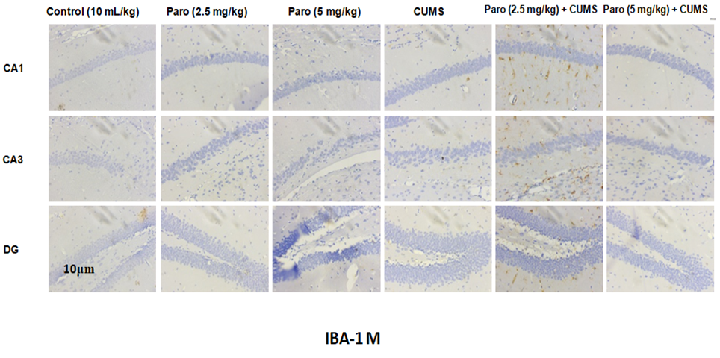
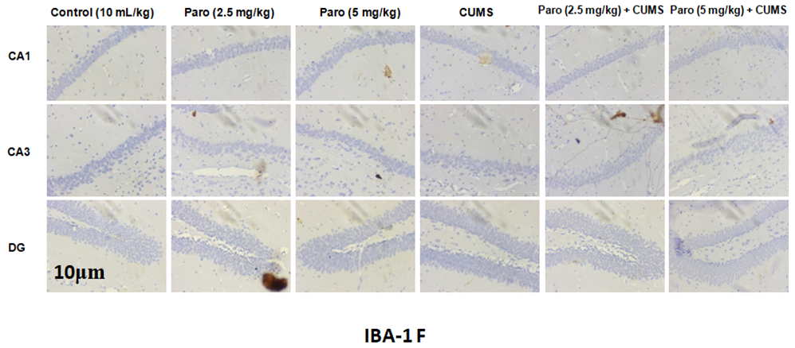
Fig. 1c-d: Illustrative photomicrographs showing effects of prenatal paroxetine immunohistochemical changes and expressions of ionized calcium-binding adapter molecule 1 (IBA-1) immunopositive cells in the brains of male (c) and female (d) mice offspring following to prenatal depression. Higher expression in the images indicates high immunopositive cell expression, while lower expression indicates low immunopositive cell expression.
Photomicrograph are expressed as mean + SEM (n=4). ****P<0.0001versus vehicle control, #P<0.05, ##P<0.001, ###P<0.001, ####P<0.0001 versus CUMS treated group. Statistical level of significance analysis was by two way ANOVA followed by Turkeys post hoc test. CUMS= Chronic Unpredictable mild stress

3.2 Effects of prenatal paroxetine delivery on neurogenesis in hippocampus of male and female mice offspring induced with prenatal depression
The effect of Paroxetine and CUMS on brain derived neurotrophic factor (BDNF) immunochemical changes in Hippocampus (HPC) in male and female mice are shown in Fig. 2a-d. In Fig. 2a male, there is a significance increase (P<0.05) immunopositive cells in paroxetine (2.5mg/kg, 5mg/kg) and CUMS respectively when compared to control in the cornu ammonis 1 (CA 1), cornu ammonis 3 (CA 3), and dendate gyrus (DG) while there is increase in combination of paroxetine (2.5mg/kg, 5mg/kg) with CUMS respectively when compared to CUMS alone in CA 1, CA 3 and DG except for CA3 paroxetine (2.5 mg) with CUMS that decreases immunopositive cells. In Fig. 2b female, there is a significance increase (P<0.05) immunopositive cells in paroxetine (2.5mg/kg, 5mg/kg) and CUMS respectively when compared to control in the CA 1, CA 3, and DG while there is a decrease immunopositive cells in combination of paroxetine (2.5mg/kg, 5mg/kg) with CUMS respectively when compared to CUMS alone in CA 3 and DG except for CA 1 paroxetine (5 mg/kg) and CUMS combination. The photomicrograph of the effect of paroxetine and CUMS on mice offspring neurodevelopment brain derived neurotrophic factor (BDNF) in hippocampus of direct appreciable values as captured are below in Fig. 2c male and Fig. 2d female having a clear neuro-immunopositve cell expression within the brain regions.

Fig. 2a-d: Effects of prenatal paroxetine on brain derived neurotrophic factor (BDNF) in the brains of male (a) and female (b) mice offspring following to prenatal depression
Bars are expressed as mean + SEM (n=4). ****P<0.0001versus vehicle control, #P<0.05, ##P<0.001, ###P<0.001, ####P<0.0001 versus CUMS treated group. Statistical level of significance analysis was by two way ANOVA followed by Turkeys post hoc test. CUMS= Chronic Unpredictable mild stress
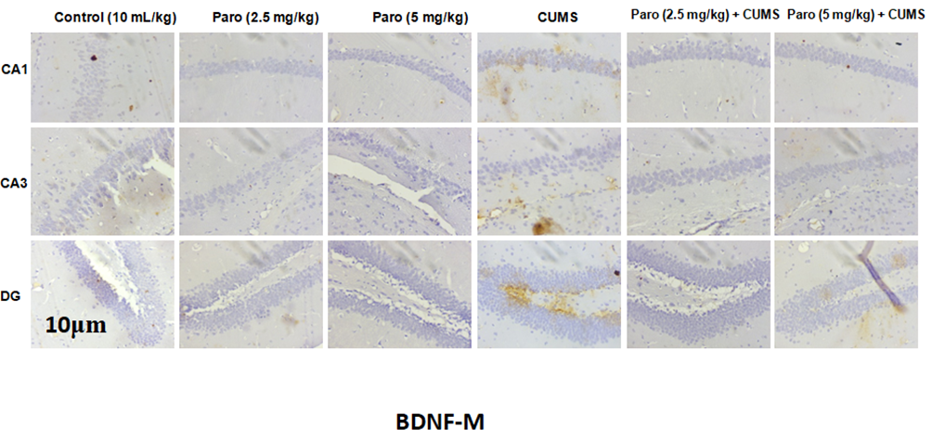
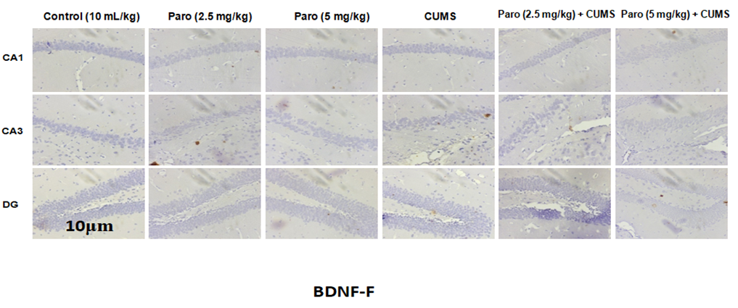
Fig. 2c-d: Illustrative photomicrographs showing effects of prenatal paroxetine immunohistochemical changes and expressions of brain derived neurotrophic factor (BDNF) immunopositive cells in the brains of male (c) and female (d) mice offspring following to prenatal depression. Higher expression in the images indicates high immunopositive cell expression, while lower expression indicates low immunopositive cell expression.
Photomicrograph are expressed as mean + SEM (n=4). ****P<0.0001versus vehicle control, #P<0.05, ##P<0.001, ###P<0.001, ####P<0.0001 versus CUMS treated group. Statistical level of significance analysis was by two way ANOVA followed by Turkeys post hoc test. CUMS= Chronic Unpredictable mild stress

3.3 Effects of prenatal paroxetine delivery on neuroregulatory marker in hippocampus of male and female mice offspring induced with prenatal depression
The effect of Paroxetine and CUMS on Parvalbumin (PARV) immunochemical changes in Hippocampus (HPC) in male and female mice are shown in Fig. 3a-d. In Fig. 8a male, there is a significance increase immunopositive cells in paroxetine (2.5 mg/kg, 5 mg/kg), CUMS respectively when compared to control in cornu ammonis 1 (CA1), cornu ammonis 3 (CA3) and dendate gyrus (DG) while there is a significance increase in combination of paroxetine (2.5 mg/kg, 5 mg/kg) and CUMS when compared to CUMS alone in the CA1, CA3 and DG. In Fig. 3b female, there is a significance increase in paroxetine (2.5mg, 5mg), CUMS when compared to control in CA1, CA3and DG except a decrease immunopositive cells in paroxetine (2.5 mg/kg), CUMS in CA3. While there is a significance increase (P<0.05) in combination of paroxetine (2.5 mg/kg, 5 mg/kg) and CUMS when compared to CUMS only in CA1, CA3 and DG. The photomicrograph of the effect of paroxetine and CUMS on mice offspring neuroinhibitory parvalbumin (PARV) in hippocampus of direct appreciable values as captured are below in Fig. 3c male and Fig. 3d female having a clear neuro-immunopositve cell expression within the brain regions.

Fig. 3a-d: Effects of prenatal paroxetine on Parvalbumin (PARV) in the brains of male (a) and female (b) mice offspring following to prenatal depression
Bars are expressed as mean + SEM (n=4). *P<0.05, **P<0.01, ***P<0.001, ****P<0.0001versus vehicle control, ##P<0.001, ###P<0.001, ####P<0.0001 versus CUMS treated group. Statistical level of significance analysis was by two way ANOVA followed by Turkeys post hoc test. CUMS= Chronic Unpredictable mild stress
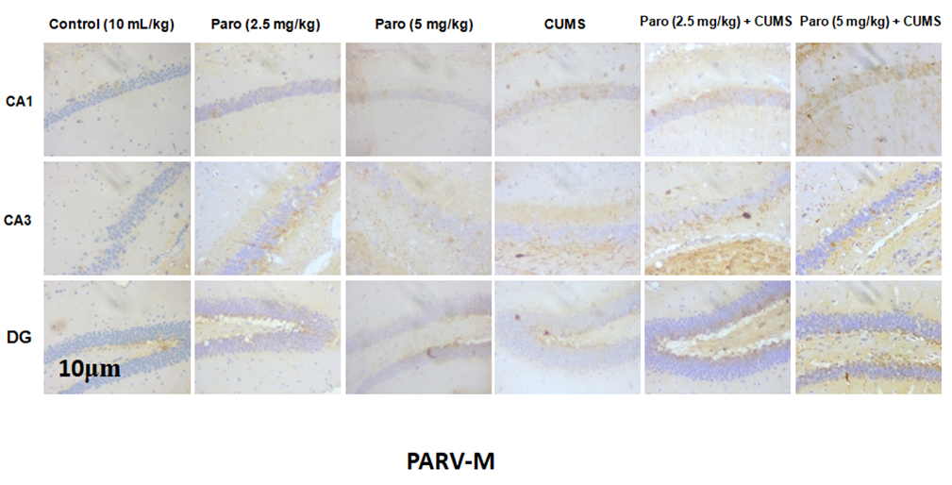

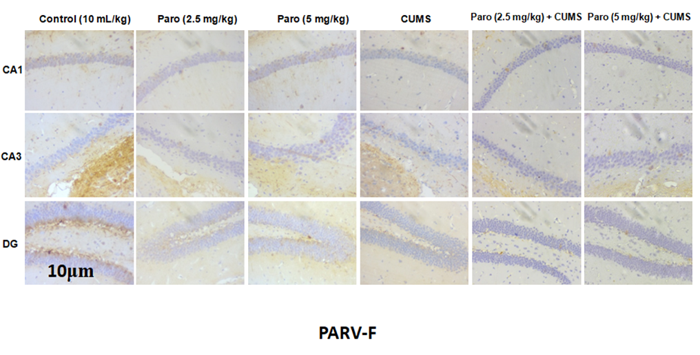
Fig. 3c-d: Illustrative photomicrographs showing effects of prenatal paroxetine immunohistochemical changes and expressions of parvalbumin (PARV)immunopositive cells in the brains of male (c) and female (d) mice offspring following to prenatal depression. Higher expression in the images indicates high immunopositive cell expression, while lower expression indicates low immunopositive cell expression.
Photomicrographs are expressed as mean + SEM (n=4). *P<0.05, **P<0.01, ***P<0.001, ****P<0.0001versus vehicle control, ##P<0.001, ###P<0.001, ####P<0.0001 versus CUMS treated group. Statistical level of significance analysis was by two way ANOVA followed by Turkeys post hoc test. CUMS= Chronic Unpredictable mild stress

3.4 Effects of prenatal paroxetine delivery on apoptotic markers in hippocampus of male and female mice offspring induced with prenatal depression
The effects of Paroxetine and CUMS on Bcl-2 associated X protein (BAX) and B-cell leukemia/lymphoma 2 (BCL-2) immunochemical changes in the Hippocampus (HPC) in male and female mice are shown in Fig. 4a-f. In Fig. 4a male, there is a significance increase immunopositive cells in paroxetine (2.5 mg/kg, 5 mg/kg), CUMS when compared to control across cornu ammonis 1 (CA 1), cornu ammonis 3 (CA 3) and dendate gyrus (DG), while there is a significance decrease (P<0.05) immunopositive cells in combination of Paroxetine (2.5 mg/kg, 5 mg/kg) with CUMS when compared to CUMS alone across CA1, CA3 and DG except for paroxetine 5mg/kg combination with CUMS in DG. In Fig. 4b female, there is a significance increase in (P<0.05) in paroxetine (2.5 mg/kg, 5 mg/kg), CUMS when compared to control across CA1, CA3 and DG while there is a significance decrease (P<0.05) immunopositive cells in combination of paroxetine (2.5 mg/kg, 5 mg/kg) with CUMS respectively when compared to CUMS in CA1, CA3 and DG except in the CA3 were there is significance decrease in paroxetine (2.5 mg/kg) with CUMS when compared to CUMS alone.
In Fig. 4c male, there is a significance increase (P<0.05) in paroxetine (2.5 mg/kg, 5mg, kg), CUMS respectively when compared to control in the CA1, CA3 and DG, while there is a significance decrease in combination of paroxetine (2.5 mg/kg, 5 mg/kg) with CUMS when compared to CUMS only in the CA1 and DG except for CA3 that increase when compared to CUMS alone. In Fig. 4d female, there is a significance increase (P<0.05) immunopositive cells in paroxetine (2.5 mg/kg, 5mg, kg), CUMS respectively when compared to control in the CA1, CA3 and DG, except for CUMS group across the hippocampal regions while there is a significance increase (P<0.05) immunopositive cells in combination of paroxetine (2.5 mg/kg, 5 mg/kg) with CUMS respectively when compared to CUMS only in the CA1, CA3 and DG.
The photomicrograph of the effect of paroxetine and CUMS on mice offspring apoptotic B-cell leukemia/lymphoma 2 associated X protein (BAX) and B-cell leukemia/lymphoma 2 (BCL-2) in hippocampus of direct appreciable values as captured are below in Fig. 4e-f male and female (BAX) and Fig. 4g-h male and female (BCL-2) having a clear neuro-immunopositve cell expression within the brain regions.

Fig. 4a-d: Effects of prenatal paroxetine on Bcl-2 associated X protein (BAX) and B-cell leukemia/lymphoma 2 (BCL-2) in the brains of male BAX (a) and female BAX (b); male BCL-2 (c) and female BCL-2 (d ) in mice offspring following to prenatal depression
Bars are expressed as mean + SEM (n=4). ****P<0.0001versus vehicle control, #P<0.05, ##P<0.001, ###P<0.001, ####P<0.0001 versus CUMS treated group. Statistical level of significance analysis was by two way ANOVA followed by Turkeys post hoc test. CUMS= Chronic Unpredictable mild stress.
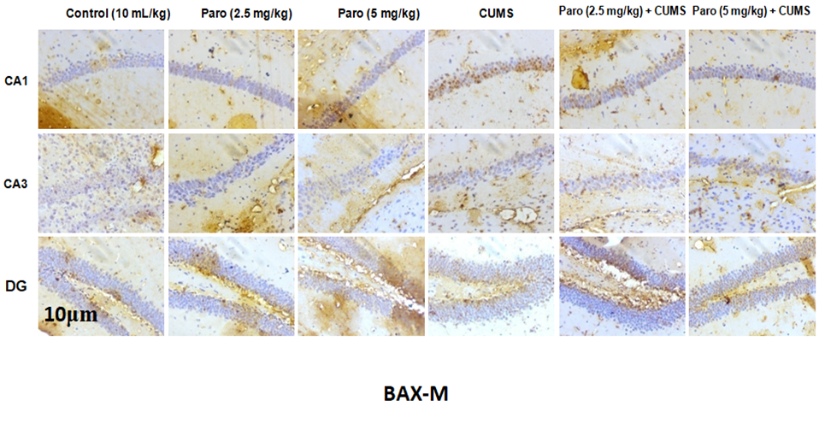
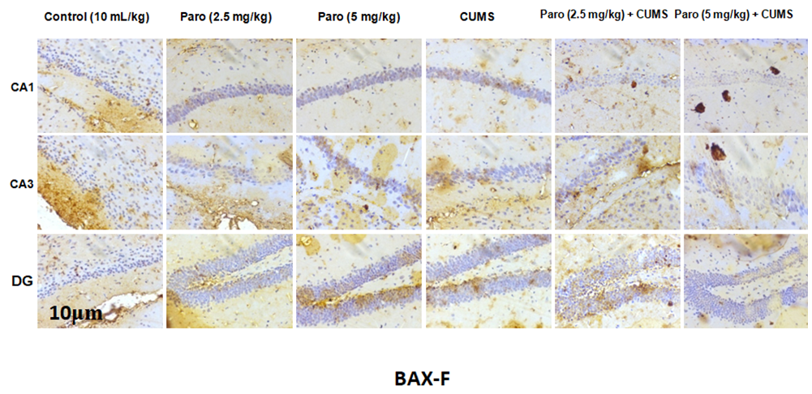
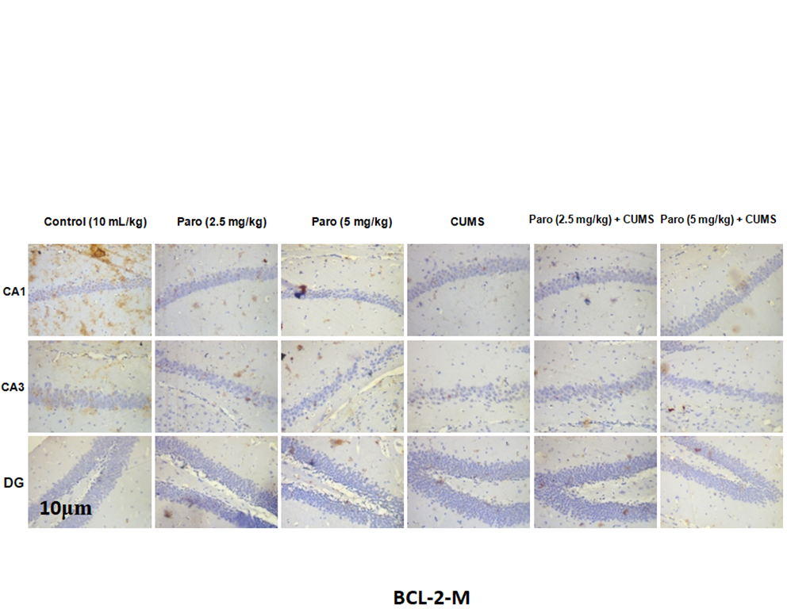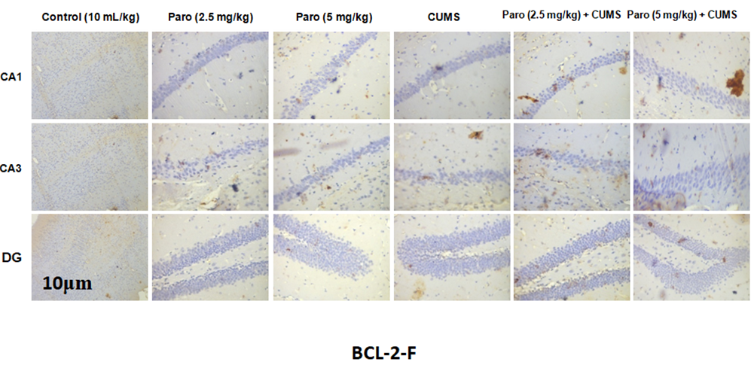
Fig. 4e-h: Illustrative photomicrographs showing effects of prenatal paroxetine immunohistochemical changes and expressions of B-cell leukemia/lymphoma 2 associated X protein (BAX) and B-cell leukemia/lymphoma 2 (BCL-2) immunopositive cells in the brains of male BAX (e) and female BAX(f); male BCL-2 (g) and female BCL-2 (h) mice offspring following to prenatal depression. Higher expression in the images indicates high immunopositive cell expression, while lower expression indicates low immunopositive cell expression.
Photomicrograph are expressed as mean + SEM (n=4). ****P<0.0001versus vehicle control, #P<0.05, ##P<0.001, ###P<0.001, ####P<0.0001 versus CUMS treated group. Statistical level of significance analysis was by two way ANOVA followed by Turkeys post hoc test. CUMS= Chronic Unpredictable mild stress.

3.5 Effects of prenatal paroxetine delivery in hippocampus histological view of male and female mice offspring induced with prenatal depression
The effects of Paroxetine and CUMS on histology in the Hippocampus (HPC) in male and female mice are shown in Fig. 5a-b. In Fig. 5a male, in the hippocampus (HPC) control group, there are normal area of hippocampal formation noted; the cornu ammonis (CA) layers including CA1,CA3 and dendate gyrus (DG) are normal, their neuronal cells are well structurally organized (white arrow). In HPC paroxetine (2.5 mg/kg) group, the area of the hippocampal formation appeared normal; the CA layers including CA1 ,CA3 and DG neuronal cells are well structurally organized with very few pyknotic cells across all the layers (black arrow). In HPC paroxetine (5 mg/kg) group, there are normal area of hippocampal formation noted; the CA layers including CA1,CA3 and DG are normal, their neuronal cells are well structurally organized (white arrow). In HPC CUMS group, the area of the hippocampal formation appeared moderately normal; the CA layers including CA1, CA3 and DG showed moderate pyknotic neuronal cells (black arrow). In HPC paroxetine (2.5 mg/kg) + CUMS, the area of the hippocampal formation appeared moderately normal; the CA layers including CA1 and DG showed moderate pyknotic neuronal cells (black arrow) while the CA3 layer appeared normal(white arrow). In STR paroxetine (5 mg/kg) + CUMS group, The area of the hippocampal formation appeared moderately normal; the CA layers including CA1 ,CA3 and DG showed moderate pyknotic neuronal cells (black arrow).
In Fig. 5b female, in the hippocampus (HPC) control group, there are normal area of hippocampal formation noted; the CA layers including CA1,CA3 and DG are normal, their neuronal cells are well structurally organized (white arrow). In HPC paroxetine (2.5 mg/kg) group, there are normal area of hippocampal formation noted; the CA layers including CA1 and DG are normal, their neuronal cells are well structurally organized (white arrow). There are few pyknotic neurons in the CA3 layer (black arrow). In HPC paroxetine (5 mg/kg) group, there are normal area of hippocampal formation noted; the CA layers including CA1,CA3 and DG are normal, their neuronal cells are well structurally organized (white arrow). In HPC CUMS group, the area of hippocampal formation noted appeared moderately normal; the CA layers including CA1, CA3 and DG are moderately normal with few pyknotic neuronal cells (black arrow). In HPC paroxetine (2.5 mg/kg) + CUMS, The area of hippocampal formation noted appeared moderately normal; the CA layers including CA1, CA3 and DG are moderately normal with few pyknotic neuronal cells (black arrow). In STR paroxetine (5 mg/kg) + CUMS group, the area of hippocampal formation noted appeared moderately normal; the CA layers including CA1, CA3 and DG are moderately normal with few pyknotic neuronal cells (black arrow).

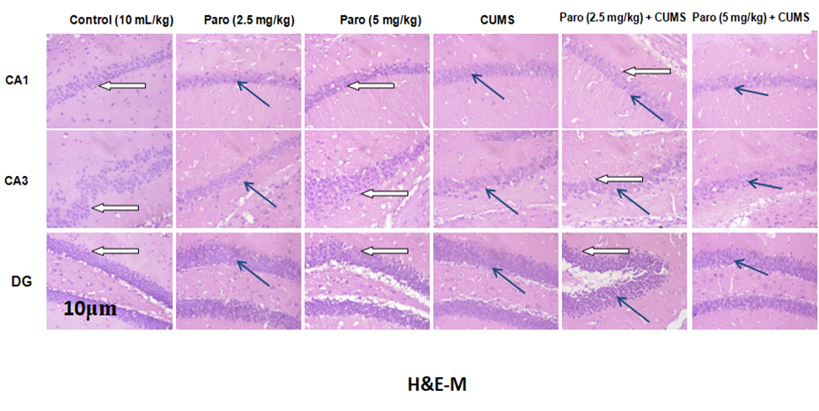
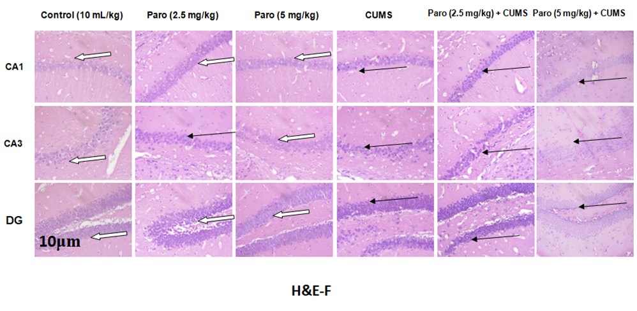

Fig. 5a-b: Histology showing effects of prenatal paroxetine and CUMS in the brains of male (a) and female (b) mice offspring following to prenatal depression.

4. Discussion
The investigation into the impacts of maternal unexpected stress protocol and intermittent prenatal exposure to paroxetine exposes complex developmental programming across structural, behavioral, neurochemical, and molecular domains in the adult mice offspring ^{[33, 34, 35]}. The evaluation of IBA-1 a marker of microglial activation supports this immune involvement and increased neuroinflammation activity due to paroxetine and CUMS treatment compared to controls ^{[37, 45, 50]}. Therefore, a highly relevant finding concerns the co-exposure groups in several hippocampal sub-regions (CA1, CA3 and DG), the combination of paroxetine and CUMS resulted in a deduction in IBA-1 expression compared to CUMS only ^{[34, 36]}. This introduces that while paroxetine causes its own inflammatory changes, it may also moderate the deep inflammatory phenotype induced by chronic stress, possibly through stabilizing the stress axis or impairment of neurotransmitter availability that influences microglial state ^{[38, 42]}.
The investigations related to neuroplasticity and cell survival further opens the nature of the developmental adjustment as both CUMS and paroxetine exposure led to super expression of Brain Derived Neurotrophic Factor (BDNF) and Parvalbumin (PARV), as the neuroinhibitory marker being an important marker for inhibitory GABAergic interneurons ^{[36, 37]}. This concurrent upregulation of development determinant and inhibitory parameters can be analysed as a rewarding signalling based on the developing brain is attempting to increase both synaptic equilibrium and regulatory inhibition to manage over stimulation or cell loss induced by stress and paroxetine exposure ^{[42, 44]}. Chronic stress protocol have been shown to raise hippocampal B-cell lymphoma-2 associated X protein (BAX) and lower B-cell lymphoma-2 (Bcl-2) appearances, marking increased cell death ^{[45, 52]}, inferring treatments with paroxetine can normalize these biomarkers ^{[43, 49]}. Prior work with paroxetine in adult animals infers a neurotrophic/anti-apoptotic profile as reductions in pro-apoptotic proteins, though sexual di-morphic and developmental stage-specific differences ^{[50, 52]}. Our finding suggest by demonstrating that the combination of paroxetine + CUMS produced a sex-dependent moderation of BAX and BCL-2 in the dendate gyrus, consistent with a protective/anti-cell death influence in various mechanisms, although through distinctive intrinsic strategies in sexes. These opens up that males and females make use of distinct molecular strategies to give feedback to combined prenatal insults, particularly regarding CA1, CA3 and DG inherent perseverance ^{[53, 54]}.
The histology demonstrated that chronic unpredictable mild stress triggers pyknotic neurons and moderately alters hippocampal frame work in both male and female mice, in line with former work on stress-induced neurodegeneration ^{[28, 32]} as administration of paroxetine only largely preserved normal hippocampus stability ^{[20, 45]}. Importantly, stressed-exposed male mice treated with 2.5 mg/kg paroxetine exhibited substantial coverage of the CA3 neuronal layer, preventing the pyknotic changes observed in other sub-regions and in untreated CUMS groups ^{[27, 31]}. This neuronal safeguarding effect was lowly evident in female mice majorly at higher paroxetine doses, pointing notable sex and dose-dependent responses. Such variability in depression inhibitors action and neuroplasticity are well-noted in the research ^{[44, 51]}. These outcomes refers paroxetine offers dose-specific neuroprotection against stress-induced hippocampal deterioration especially in males, affirming its multiplicity in therapeutic potential ^{[37, 53]}.

Conclusion
Paroxetine and gestational stress induces prolonged deficits in offspring via impaired adult working memory as these behavioral outcomes are notably connected to disruptions in neuroimmunity and cellular homeostasis with effects in sexes differences. Prominently, as both paroxetine and CUMS generate neuropathology, the concurrent administration of paroxetine often modulated the most severe stress effects specifically by reducing pro-apoptotic signaling. Evaluation of histology affirmed magnitude association of CUMS dysfunction hippocampus structure, but paroxetine at lower dosage provided neuro-protection to the CA3 neuronal stratal, an effect appreciated substantially in male mice only. Outcome of the work diligently marked that the neurobiological consequences of paroxetine use and maternal stress are highly complex, showing proof sex-dependent and dose feedback. Hence, futuristic study and clinical guide must put into consideration both sex in developmental stage.
Acknowledgements: We wish to thank the Staff and Students of the following laboratories for their guidance and technical support:
1. DELSU Joint Canada-Israel Neuroscience and Biopsychiatry Laboratory, Department of Pharmacology, Faculty of Basic Medical Sciences, College of Health Sciences, Delta State University, Abraka, Delta State, Nigeria.
2. Laboratory for Experimental and Translational Neurobiology (LETNeu), Department of Anatomy, Faculty of Basic Medical Sciences, University of Medical Sciences, Ondo, Ondo State, Nigeria.

COMPETING INTERESTS DISCLAIMER:
Authors have declared that they have no known competing financial interests OR non-financial interests OR personal relationships that could have appeared to influence the work reported in this paper.

Disclaimer (Artificial intelligence)
Option 1:
Author(s) hereby declare that NO generative AI technologies such as Large Language Models (ChatGPT, COPILOT, etc.) and text-to-image generators have been used during the writing or editing of this manuscript.
REFERENCES
- Poletti, S., Mazza, M. G., & Benedetti, F. (2024). Inflammatory mediators in major depression and bipolar disorder. Translational Psychiatry, 14(1), 247. https://doi.org/10.1038/s41398-024-02921-z
- Pu, Y., Tan, Y., Qu, Y., Chang, L., Wang, S., Wei, Y., Wang, X., & Hashimoto, K. (2021). A role of the subdiaphragmatic vagus nerve in depression-like phenotypes in mice after fecal microbiota transplantation from Chrna7 knock-out mice. Brain, Behavior, and Immunity. https://doi.org/10.1016/j.bbi.2020.12.032
- Quintana-Domeque, C., & Ródenas-Serrano, P. (2017). The hidden costs of terrorism: The effects on health at birth. Journal of Health Economics, 56, 47–60. https://doi.org/10.1016/j.jhealeco.2017.0
- Rachid, F. (2018). Maintenance repetitive transcranial magnetic stimulation (rTMS) for relapse prevention in with depression: A review. Psychiatry Research, 262, 363–372. https://doi.org/10.1016/j.psychres.2017.09.009
- Rai, D., Lee, B. K., Dalman, C., Golding, J., Webb, E., & Lundberg, M. (2013). Parental depression, maternal antidepressant use during pregnancy, and risk of autism spectrum disorders: population based case-control study. BMJ, 346, f2059. https://doi.org/10.1136/bmj.f2059
- Rajkumar, R. P. (2024). Resolving a paradox: Antidepressants, neuroinflammation, and neurodegeneration. Exploration of Neuroprotective Therapy, 4(1), 11–37. https://doi.org/10.37349/ent.2024.00068
- Rapoport, J. L., Giedd, J. N., & Gogtay, N. (2012). Neurodevelopmental model of schizophrenia: update 2012. Molecular Psychiatry, 17, 1228–38. https://doi.org/10.1038/mp.2012.23
- Rodriques, I., & Pieters, W. R. (2019). Assessing the predictors of satisfaction with life of employees in Windhoek, Namibia. SA Journal of Human Resource Management, 17(0), a1145. https://doi.org/10.4102/sajhrm.v17i0.1145
- Ross, L. E., Grigoriadis, S., Mamisashvili, L., VonderPorten, E. H., Roerecke, M., Rehm, J., Dennis, C.-L., Koren, G., Steiner, M., Mousmanis, P., & Cheung, A. (2013). Selected pregnancy and delivery outcomes after exposure to antidepressant medication: A systematic review and meta-analysis. JAMA Psychiatry, 70(4), 436–443. https://doi.org/10.1001/jamapsychiatry.2013.684
- Rudzki, L., Stone, T. W., Maes, M., Misiak, B., Samochowiec, J., & Szulc, A. (2021). Gut microbiota-derived vitamins: underrated powers of a multipotent ally in psychiatric health and disease. Progress in Neuro-Psychopharmacology and Biological Psychiatry. https://doi.org/10.1016/j.pnpbp.2020.110240
- Saedi Marghmaleki, V., Radahmadi, M., Alaei, H., & Khanahmad, H. (2024). Protective Effects of Long-Term Escitalopram Administration on Memory and Hippocampal BDNF and BCL-2 Gene Expressions in Rats Exposed to Predictable and Unpredictable Chronic Mild Stress. Brain Sciences. https://doi.org/10.3390/brainsci14050420
- Sanz, E. J., De-las-Cuevas, C., Kiuru, A., Bate, A., & Edwards, R. (2005). Selective serotonin reuptake inhibitors in pregnant women and neonatal withdrawal syndrome: A database analysis. Lancet, 365(9458), 482–487. https://doi.org/10.1016/S0140-6736(05)17865-9
- Sarkar, A., Chachra, P., Kennedy, P., Pena, C. J., Desouza, L. A., Nestler, E. J., & Vaidya, V. A. (2014). Hippocampal HDAC4 contributes to postnatal fluoxetine-evoked depression-like behavior. Neuropsychopharmacology, 39(9), 2221–2232. https://doi.org/10.1038/npp.2014.73
- Savignac, H. M., Dinan, T. G., & Cryan, J. F. (2011). Resistance to early-life stress in mice: effects of genetic background and stress duration. Frontiers in Behavioral Neuroscience, 5, 13. https://doi.org/10.3389/fnbeh.2011.00013
- Schroer, J., Warm, D., De Rosa, F., Luhmann, H. J., & Sinning, A. (2023). Activity-dependent regulation of the BAX/BCL-2 pathway protects cortical neurons from apoptotic death during early development. Cellular and Molecular Life Sciences, 80(6), 175. https://doi.org/10.1007/s00018-023-04824-6
- Secor, A., Macauley, R., Stan, L., Kagone, M., Sidikiba, S., Sow, S., Aronovich, D., Litvin, K., Davis, N., Alva, S., & Sanderson, J. (2020). Mental health among Ebola survivors in Liberia, Sierra Leone and Guinea: results from a cross-sectional study. BMJ Open, 10, e035217. https://doi.org/10.1136/bmjopen-2019-035217
- Sheikholeslami, M. A., Ghafghazi, S., Pouriran, R., Mortazavi, S. E., & Parvardeh, S. (2021). Attenuating effect of paroxetine on memory impairment following cerebral ischemia-reperfusion injury in rat: The involvement of BDNF and antioxidant capacity. European Journal of Pharmacology, 893, 173821. https://doi.org/10.1016/j.ejphar.2020.173821
- Sickmann, H. M., Arentzen, T. S., Dyrby, T. B., Plath, N., & Kristensen, M. P. (2015). Prenatal stress produces sex-specific changes in depression-like behavior in rats: implications for increased vulnerability in females. Journal of Developmental Origins of Health and Disease, 6(6), 462–74. https://doi.org/10.1017/S2040174415001282
- Simmons, R. K., Stringfellow, S. A., Glover, M. E., Wagle, A. A., & Clinton, S. M. (2013). DNA methylation markers in the postnatal developing rat brain. Brain Research, 1533, 26–36. https://doi.org/10.1016/j.brainres.2013.08.005
- Skonieczna-Żydecka, K., Grochans, E., Maciejewska, D., Szkup, M., Schneider-Matyka, D., Jurczak, A., Łoniewski, I., Kaczmarczyk, M., Marlicz, W., Czerwińska-Rogowska, M., Pełka-Wysiecka, J., Dec, K., & Stachowska, E. (2018). Faecal Short Chain Fatty Acids Profile is Changed in Polish Depressive Women. Nutrients, 10(12), 1939. https://doi.org/10.3390/nu10121939
- Slekiene, J., & Mosler, H.-J. (2019). The link between mental health and safe drinking water behaviors in a vulnerable population in rural Malawi. BMC Psychology, 7(1), 44. https://doi.org/10.1186/s40359-019-0320-1
- Smach, M. A., Zarrouk, A., Hafsa, J., Ghorbel, H., Ben Ammar, J., Chouchane, B., & Lamine, K. (2021). Maillard reaction products and phenolic compounds from roasted peanut flour extracts prevent scopolamine-induced amnesia via cholinergic modulation and antioxidative effects in mice. Journal of Medicinal Food, 24(6), 645–652. https://doi.org/10.1089/jmf.2020.0028
- Steiner, J. P., Bachani, M., Wolfson-Stofko, B., Lee, M. H., Wang, T., Li, G., Li, W., Strayer, D., Haughey, N. J., & Nath, A. (2015). Interaction of paroxetine with mitochondrial proteins mediates neuroprotection. Neurotherapeutics, 12(1), 200–216. https://doi.org/10.1007/s13311-014-0315-9
- Sun, Y., Blumberger, D. M., Mulsant, B. H., Rajji, T. K., Fitzgerald, P. B., Barr, M. S., Downar, J., Wong, W., Farzan, F., & Daskalakis, Z. J. (2018). Magnetic seizure therapy reduces suicidal ideation and produces neuroplasticity in treatment-resistant depression. Translational Psychiatry. https://doi.org/10.1038/s41398-018-0302-8
- Sun, N., Zhang, J., Wang, J., Liu, Z., Wang, X., Kang, P., Yang, C., Liu, P., & Zhang, K. (2022). Abnormal gut microbiota and bile acids in patients with first-episode major depressive disorder and correlation analysis. Psychiatry and Clinical Neurosciences. https://doi.org/10.1111/pcn.13368
- Swanson, S. A., Hernandez-Diaz, S., Palmsten, K., Mogun, H., Olfson, M., & Huybrechts, K. F. (2015). Methodological considerations in assessing the effectiveness of antidepressant medication continuation during pregnancy using administrative data. Pharmacoepidemiology and Drug Safety, 24(9), 934–942. https://doi.org/10.1002/pds.3798
- Tao, Y., Shen, W., Zhou, H., Li, Z., Pi, T., Wu, H., Shi, H., Huang, F., & Wu, X. (2024). Sex differences in a corticosterone-induced depression model in mice: Behavioral, neurochemical, and molecular insights. Brain Research, 1823, 148678. https://doi.org/10.1016/j.brainres.2023.148678
- Taylor, S. E., Way, B. M., & Seeman, T. E. (2011). Early adversity and adult health outcomes. Development and Psychopathology, 23(3), 939–954. https://doi.org/10.1017/S0954579411000411
- Tolentino, J. C., & Schmidt, S. L. (2018). DSM-5 Criteria and Depression Severity: Implications for Clinical Practice. Frontiers in Psychiatry, 9, 450. https://doi.org/10.3389/fpsyt.2018.00450
- Tollenaar, M. S., Beijers, R., Jansen, J., Riksen-Walraven, J. M. A., & de Weerth, C. (2011). Maternal prenatal stress and cortisol reactivity to stressors in human infants. Stress, 14(1), 53–65. https://doi.org/10.3109/10253890.2010.499485
- Tseilikman, V. E., Tseilikman, O. B., Karpenko, M. N., Traktirov, D. S., Obukhova, D. A., Shatilov, V. A., Zhukov, M. S., Manuilov, G. V., Yegorov, O. N., Aristov, M. R., Lipatov, I. A., Buksha, I. A., Epitashvili, A. E., Pashkov, A. A., & Novak, J. (2024). Unraveling the serotonergic mechanism of stress-related anxiety: Focus on co-treatment with resveratrol and selective serotonin reuptake inhibitors. *Biomedicines*, *12*(11), 2455. https://doi.org/10.3390/biomedicines12112455
- Umukoro, S., Ogboh, S. I., Omorogbe, O., & Adekeye, A. A. (2017). Evidence for the involvement of monoaminergic pathways in the antidepressant-like activity of cymbopogon citratus in mice. Drug Research (Stuttgart), 67(7), 419–424. https://doi.org/10.1055/s-0043-106586
- Van den Bergh, B. R. H., Mulder, E. J. H., Mennes, M., & Glover, V. (2005). Antenatal maternal anxiety and stress and the neurobehavioural development of the fetus and child: Links and possible mechanisms. A review. Neuroscience & Biobehavioral Reviews, 29(2), 237–258. https://doi.org/10.1016/j.neubiorev.2004.10.007
- Van de Wouw, M., Boehme, M., Lyte, J. M., Wiley, N., Strain, C., O'Sullivan, O., Clarke, G., Stanton, C., Dinan, T. G., & Cryan, J. F. (2018). Short-chain fatty acids: Microbial metabolites that alleviate stress-induced brain-gut axis alterations. Journal of Physiology, 596, 4923–4944. https://doi.org/10.1113/JP276431
- Vasilakis-Scaramozza, C., Aschengrau, A., Cabral, H., & Jick, S. S. (2013). Antidepressant use during early pregnancy and the risk of congenital anomalies. Pharmacotherapy, 33(7), 693–700. https://doi.org/10.1002/phar.1211
- Waffarn, F., & Davis, E. P. (2012). Effects of antenatal corticosteroids on the hypothalamic-pituitary-adrenocortical axis of the fetus and newborn: experimental findings and clinical considerations. American Journal of Obstetrics and Gynecology, 207(6), 446–454. https://doi.org/10.1016/j.ajog.2012.06.012
- Wang, H., Liu, L., Rao, X., Zeng, B., Yu, Y., Zhou, C., Zeng, L., Zheng, P., Pu, J., Xu, S., Cheng, K., Zhang, H., Ji, P., Wei, H., & Xie, P. (2020). Integrated phosphoproteomic and metabolomic profiling reveals perturbed pathways in the hippocampus of gut microbiota dysbiosis mice. Translational Psychiatry, 10(1), 346. https://doi.org/10.1038/s41398-020-01024-9
- Wang, H., He, Y., Sun, Z., Ren, S., Liu, M., Wang, G., & Yang, J. (2022). Microglia in depression: An overview of microglia in the pathogenesis and treatment of depression. Journal of Neuroinflammation, 19(1), 132. https://doi.org/10.1186/s12974-022-02492-0
- Wang, L., Yuan, F., Yuan, Q., Dai, G., Lu, X., Zhou, L., Zheng, Y., Wu, Y., Wang, M., & Chen, G. (2024). Peripheral inflammatory cytokines are associated with the microstructural characteristics of the corpus callosum and prefrontal cortex as detected by magnetic resonance T1/T2 mapping in the CUMS rat model. Heliyon, 10(23), e40428. https://doi.org/10.1016/j.heliyon.2024.e40428
- Wang, Y. L., Chen, L., Zhong, X. L., Liu, Q. S., Li, W. Q., Cheng, Y., & Du, Y. (2025). Antidepressant effects of Ershiwei Roudoukou pills and its active ingredient Macelignan: Multiple mechanisms involving oxidative stress, neuroinflammation, and synaptic plasticity. Translational Psychiatry, 15(1), 163. https://doi.org/10.1038/s41398-025-03378-4
- Wen, S. W., Yang, Q., Garner, P., Fraser, W., Olatunbosun, O., Nimrod, C., & Walker, M. (2006). Selective serotonin reuptake inhibitors and adverse pregnancy outcomes. American Journal of Obstetrics and Gynecology, 194(4), 961–966. https://doi.org/10.1016/j.ajog.2006.02.019
- Weinstock, M. (2017). Prenatal stressors in rodents: Effects on behavior. Neurobiology of Stress, 6, 3–13. https://doi.org/10.1016/j.ynstr.2016.08.004
- Wubetu, M., Sintayehu, M., Aeta, M. A., Reta, H., & Derebe, D. (2018). Ethnobotany of medicinal plants used to treat various mental illnesses in Ethiopia: A systematic review. Asian Journal of Plant Science & Research, 8, 9–33. http://www.imedpub.com/abstract/ethnobotany-of-medicinal-plants-used-to-treat-various-mental-illnesses-in-ethiopia-a-systematic-review-2249-7412-1000429.html
- Wu, X., Zhang, X., Sun, L., Lu, X., & Shen, C. (2023). Icariin prevents depression-like behaviors in chronic unpredictable mild stress-induced rats through Bax/cytoplasm C/caspase-3 axis to alleviate neuronal apoptosis. *Cellular and Molecular Biology*, *69*(7), 196–204. https://doi.org/10.14715/cmb/2023.69.7.32
- Wu, Y., De Asis-Cruz, J., & Limperopoulos, C. (2024). Brain structural and functional outcomes in the offspring of women experiencing psychological distress during pregnancy. Molecular Psychiatry, 29(7), 2223–2240. https://doi.org/10.1038/s41380-024-02449-0
- Xia, J., Wang, H., Zhang, C., Liu, B., Li, Y., Li, K., Li, P., & Song, C. (2023). The comparison of sex differences in depression-like behaviors and neuroinflammatory changes in a rat model of depression induced by chronic stress. Front Behav Neurosci. https://doi.org/10.3389/fnbeh.2022.1059594
- Xu, W., Yao, X., Zhao, F., Zhao, H., Cheng, Z., Yang, W., Cui, R., Xu, S., & Li, B. (2020). Changes in hippocampal plasticity in depression and therapeutic approaches influencing these changes. Neural Plasticity. https://doi.org/10.1155/2020/8861903
- Xu, D. H., Du, J. K., Liu, S. Y., Zhang, H., Yang, L., Zhu, X. Y., & Liu, Y. J. (2023). Upregulation of KLK8 contributes to CUMS-induced hippocampal neuronal apoptosis by cleaving NCAM1. Cell Death & Disease, 14(4), 278. https://doi.org/10.1038/s41419-023-05800-5
- Zaghmi, A., Pérez-Mato, M., Dopico-López, A., Candamo-Lourido, M., Campos, F., & Gauthier, M. A. (2022). New perspectives for developing therapeutic bioconjugates of metabolite-depleting enzymes: Lessons learned combating glutamate excitotoxicity. Biomacromolecules, 23(5), 1864–1872. https://doi.org/10.1021/acs.biomac.2c00117
- Zhang, J., Ma, L., Chang, L., Pu, Y., Qu, Y., & Hashimoto, K. (2020). A key role of the subdiaphragmatic vagus nerve in the depression-like phenotype and abnormal composition of gut microbiota in mice after lipopolysaccharide administration. Translational Psychiatry, 10(1), 186. https://doi.org/10.1038/s41398-020-00878-3
- Zhang, X., Zhu, L. B., He, J. H., Zhang, H. Q., Ji, S. Y., Zhang, C. N., Hou, N. N., Huang, C. P., & Zhu, J. H. (2020). Paroxetine suppresses reactive microglia-mediated but not lipopolysaccharide-induced inflammatory responses in primary astrocytes. Journal of Neuroinflammation, 17(1), 50. https://doi.org/10.1186/s12974-020-1712-0
- Zhang, Y., Gu, F., Chen, J., & Dong, W. (2010). Chronic antidepressant administration alleviates frontal and hippocampal BDNF deficits in CUMS rat. Brain Research. https://doi.org/10.1016/j.brainres.2010.09.095
- Zhao, K., Zhang, Y., Yang, S., Xiang, L., Wu, S., Dong, J., Li, H., Yu, H., & Hu, W. (2025). Neuroinflammation and stress-induced pathophysiology in major depressive disorder: mechanisms and therapeutic implications. Frontiers in Cellular Neuroscience, 19, 1538026. https://doi.org/10.3389/fncel.2025.1538026
- Zheng, Y., & Xu, L. (2025). Bidirectional crosstalk between microglia and serotonin signaling in neuroinflammation and CNS disorders. Frontiers in Immunology https://doi.org/10.3389/fimmu.2025.1646740

