AMELIORATIVE EFFECT OF APPLE CIDER VINEGAR ON PANCREATIC ISLET DEGENERATION AND HYPERGLYCEMIA IN LETROZOLE-INDUCED PCOS IN WISTAR RATS

Abstract
Aims:
To investigate the protective and ameliorative effects of apple cider vinegar (ACV) on pancreatic islet degeneration and hyperglycemia in a letrozole-induced rat model of polycystic ovary syndrome (PCOS).
Study design:
Experimental in vivo study utilizing a controlled rat model of PCOS induced by letrozole, with intervention groups receiving ACV treatment.
Place and Duration of Study: The study was conducted at the College of Medical Sciences, University of Calabar, Nigeria, over a period of approximately two months, 2025.
Methodology:
Twenty-one adult female Wistar rats were divided into three groups: control, PCOS control, and letrozole + ACV treatment (n=7 per group). PCOS was induced via oral administration of letrozole (1 mg/kg) daily for 14 days. ACV (2 ml/kg) was administered concurrently during the treatment phase. Fasting blood glucose (FBG) was measured at baseline, mid-induction, post-induction, mid-treatment, and post-treatment. Pancreatic tissues were collected for histological analysis with Hematoxylin and Eosin staining to assess tissue architecture and pathology. Statistical analysis was performed using repeated-measures ANOVA with significance set at P<0.05.
Results:
Histological analysis showed normal pancreatic architecture in control rats, whereas PCOS rats exhibited significant islet necrosis and fibrosis. ACV-treated rats showed significant histological improvement with reduced necrosis and fibrosis compared to PCOS control). Fasting blood glucose levels increased during induction, but after ACV treatment, glucose levels significantly decreased compared to untreated PCOS rats, approaching baseline levels. Specifically, post-treatment FBG in the ACV group was significantly lower than in the PCOS control group, with.
Conclusion:
ACV exerts significant protective and restorative effects on pancreatic tissue and glucose regulation in a rat model of PCOS, likely through its antioxidant and anti-inflammatory properties. These findings support further exploration of ACV as a natural adjunct therapy for managing metabolic disturbances in women with PCOS.

Keywords:
Polycystic ovary syndrome, apple cider vinegar, pancreatic islet degeneration, hyperglycemia.

  - Introduction
Polycystic ovary syndrome (PCOS) is one of the most common endocrine disorders affecting women of reproductive age, with a prevalence estimated between 4% and 13%, depending on diagnostic criteria and populations studied (Ghafari et al., 2025; World Health Organization, 2025). It is characterized by hyperandrogenism, oligo- or anovulation, and polycystic ovarian morphology. Beyond reproductive dysfunction, PCOS is strongly associated with metabolic disturbances, notably insulin resistance, obesity, dyslipidemia, and an increased risk of developing type 2 diabetes mellitus (T2DM) (Liao et al., 2022; Liu et al., 2019).
Insulin resistance is considered a core feature of PCOS, contributing to hyperinsulinemia, which exacerbates ovarian androgen production and disrupts normal folliculogenesis (Singh et al., 2023). This interconnected cycle perpetuates hyperglycemia, oxidative stress, and low-grade chronic inflammation, forming a vicious cycle that aggravates metabolic and reproductive abnormalities (Rambaran & Islam, 2025).
Oxidative stress (OS) results from an imbalance between increased production of reactive oxygen species (ROS) and compromised antioxidant defenses, leading to cellular damage (Vona et al., 2021). In PCOS, elevated ROS levels damage pancreatic β-cells, impairing insulin secretion and contributing to glucose intolerance (Malin et al., 2015). Moreover, oxidative stress activates inflammatory pathways, resulting in increased production of pro-inflammatory cytokines such as tumor necrosis factor-alpha (TNF-α) and interleukin-6 (IL-6), which further impair insulin signaling (Nugent et al., 2008).
Chronic inflammation is another hallmark of PCOS, with elevated circulating markers like high-sensitivity C-reactive protein (hs-CRP), TNF-α, and IL-6 linked to insulin resistance and cardiovascular risks (Chen et al., 2015). These inflammatory mediators interfere with insulin receptor signaling by inducing inhibitory phosphorylation of insulin receptor substrate-1 (IRS-1), leading to decreased glucose uptake (Alipourfard et al., 2019). The mutual reinforcement between oxidative stress and inflammation creates a feedback loop that perpetuates metabolic dysfunction, ovarian androgen excess, and adiposity (Liu et al., 2025).
Over time, the persistent insult of oxidative stress, inflammation, and insulin resistance leads to pancreatic β-cell exhaustion and degeneration, impairing insulin secretion and glucose homeostasis (Yong et al., 2021). As a consequence, women with PCOS are at a significantly increased risk of developing T2DM at a younger age compared to the general population (Liao et al., 2022).
Current management strategies primarily focus on lifestyle modifications and pharmacological interventions like metformin, hormonal contraceptives, and insulin-sensitizers. However, these treatments often have limitations, including adverse side effects, poor adherence, and variable efficacy (Melin et al., 2024). For instance, metformin, although widely used, can cause gastrointestinal disturbances and may not be effective for all patients, especially those with high body mass index (BMI) (Harmooshi et al., 2021). Hormonal therapies such as oral contraceptives (OCPs) can exacerbate insulin resistance and are not suitable for all women (Cortés & Alfaro, 2014).
Given these limitations, there is a growing interest in exploring natural, accessible, and safe adjunct therapies for managing metabolic disorders such as PCOS and type 2 diabetes mellitus (T2DM). One such promising candidate is apple cider vinegar (ACV), known locally in Nigeria simply as “vinegar” or “ACV” in contemporary discourse. Traditionally, vinegar has been widely used in Nigerian cuisine as a flavor enhancer and preservative, and it also holds a place in folk medicine systems across various cultures for its purported health benefits (Ezemba et al., 2021).
ACV is a fermented liquid derived from apple juice, produced through a process of fermentation involving yeast and acetic acid bacteria. Its primary active component is acetic acid, which is believed to be responsible for many of its health-promoting effects, including regulation of blood glucose levels, appetite suppression, and weight management (Chen et al., 2023). In addition to acetic acid, ACV contains various bioactive compounds such as polyphenols—including chlorogenic acid, caffeic acid, catechin, and gallic acid—that contribute to its antioxidant and anti-inflammatory properties (Ayoub et al., 2015).
In Nigeria and other traditional settings, ACV is often used to aid digestion, improve appetite, and treat ailments such as sore throats, digestive discomfort, and infections (Johnston & Gaas, 2006). Scientific studies increasingly support its health benefits, demonstrating that ACV can improve insulin sensitivity, reduce postprandial blood glucose, and support weight loss—all of which are critical in managing metabolic conditions like PCOS and T2DM (Nazni et al., 2015; Agbor et al., 2025). Its antioxidant and anti-inflammatory properties further enhance its therapeutic potential by mitigating oxidative stress and systemic inflammation which key factors involved in the pathogenesis of these disorders (Singh & Garg, 2022).
Animal studies have provided compelling evidence that apple cider vinegar (ACV) may exert protective effects on pancreatic tissue and improve metabolic health by reducing oxidative stress and inflammation. For instance, in diabetic rat models, ACV supplementation has been shown to improve glycemic control, enhance the activities of antioxidant enzymes, and preserve the architecture of pancreatic islets (Hmad Halima et al., 2018; Halima et al., 2017). These findings suggest that ACV may help mitigate oxidative damage and support pancreatic function in the context of diabetes. Furthermore, in models of polycystic ovary syndrome (PCOS), ACV has demonstrated potential in restoring ovarian structure and function and improving metabolic parameters, although the precise mechanisms underlying these effects remain to be fully elucidated (Agbor et al., 2025). These preclinical data underscore the therapeutic promise of ACV as an adjunct in managing metabolic and reproductive disturbances associated with PCOS and diabetes.
Letrozole is a non-steroidal aromatase inhibitor commonly used in clinical settings to induce ovarian cyst formation and hyperandrogenism, thereby serving as a valuable agent for creating experimental models of polycystic ovary syndrome (PCOS) (Guang et al., 2018). By inhibiting the conversion of androgens to estrogens, letrozole effectively mimics the hormonal imbalances observed in women with PCOS, including elevated androgens and disrupted ovarian function (Xu et al., 2020). Moreover, recent research has demonstrated that letrozole administration in rodent models not only induces ovarian cysts but also leads to metabolic disturbances such as insulin resistance and hyperglycemia which are key features shared with human PCOS and its associated risk of developing type 2 diabetes mellitus (T2DM) (Begum et al., 2022). This dual impact makes letrozole a suitable agent for studying the intertwined reproductive and metabolic aspects of PCOS, allowing for a comprehensive evaluation of potential therapeutic interventions such as apple cider vinegar. Therefore, utilizing letrozole in this study provides a relevant and reliable model to investigate the protective effects of ACV against pancreatic islet degeneration and hyperglycemia associated with PCOS-like metabolic dysfunction.
The present study aimed to investigate the potential protective and ameliorative effects of ACV on pancreatic islet degeneration and hyperglycemia in a letrozole-induced PCOS rat model. This model closely mimics human PCOS, including ovarian cyst formation, insulin resistance, and metabolic disturbances (Morshedzadeh et al., 2025). Understanding the cellular and molecular mechanisms by which ACV confers its effects could support its use as a complementary therapy in managing PCOS-associated metabolic complications.

  - Materials and Methods
  - Experimental Animals
Twenty-one adult female albino Wistar rats (150-180 g, 8–10 weeks old) were obtained from the animal house at the College of Medical Sciences, University of Calabar. The rats were housed in individually ventilated cages (IVC) in a controlled environment with a 12-hour light/dark cycle. The rats had free access to standard commercial rat chow and water throughout the experiment.
2.2 Sources and Preparation of Materials
Letrozole was sourced from Bafna Pharmaceutical Limited, India, stored in a cool, dry place, and prepared fresh daily by dissolving in 0.5% Carboxymethyl Cellulose (CMC) as the vehicle. Apple Cider Vinegar (ACV) was purchased from Bragg Live Products LLC, USA, stored at room temperature.
  - Animal Housing and Monitoring
Animals were housed under standard laboratory conditions with sawdust bedding and acclimatized for two weeks. Estrous cycle was monitored via cytology.
  - Induction of PCOS and Experimental Design
PCOS was induced according to the method reported by Ibrahim et al., (2022) and Agbor et al., (2025) with little modification. Letrozole was administered at 1 mg/kg body weight orally daily for 14 days. Rats were randomly assigned into three groups (n=7 each):
Group A: Control (distilled water)
Group B: PCOS control (1mg/kg)
Group D: Letrozole + ACV 2 ml/kg
  - Blood Glucose Measurement Schedule
Fasting blood glucose (FBG) levels were measured at five key points:
1. Before Induction: Baseline FBG after overnight fasting, establishing initial glycemic status.
2. During Induction: Midway through the 14-day letrozole administration (around day 7), to monitor changes during PCOS induction.
3. After Induction: Immediately after the 14-day induction period, prior to treatment, to confirm PCOS-related glycemic alterations.
4. During Treatment: Midpoint of the 14-day treatment period with ACV (around day 7 of treatment), to assess early effects.
5. After Treatment: At the end of the treatment regimen (day 14), to evaluate final effects of ACV on glucose levels.
Blood samples were obtained via tail vein or cardiac puncture following an overnight fast, and glucose levels were measured using a glucometer. The percentage change in FBG (% FBG change) was calculated to quantify relative differences between groups.
  - Animal Sacrifice and Tissue Collection
On day 43, rats were anesthetized with ketamine (80 mg/kg, intraperitoneally). After confirming deep anesthesia, animals were dissected. The pancreas was carefully excised, washed in saline, fixed in 10% formalin, and processed for histological examination.
  - Histological and Biochemical Analysis
Pancreatic tissues were embedded, sectioned, and stained with Hematoxylin and Eosin (H&E) to evaluate cellular architecture, islet integrity, and any pathological changes.
  - Statistical Analysis
Data were analyzed using SPSS v24.0. Repeated-measures ANOVA followed by Dunnett’s post hoc test was performed, with significance set at P<0.05.

  - Results & Discussion
Results
Histological Observation
Control rats displayed normal pancreatic architecture with intact acini, basophilic and acidophilic cells, and blood vessels. In contrast, PCOS-induced rats showed significant pancreatic damage, including islet necrosis, increased connective tissue, vacuolation, vascular congestion, and overall tissue degeneration. Rats treated with letrozole and apple cider vinegar exhibited marked improvement, with reduced necrosis, less fibrosis, and partial restoration of normal pancreatic structure (fig. 1).
Fasting Blood Level
Before induction, all groups had similar glucose levels. During PCOS induction, glucose levels rose slightly but not significantly. After induction, the PCOS control group showed a slight increase, whereas the treatment group (letrozole + ACV) demonstrated a significant reduction in blood glucose levels compared to the PCOS group, indicating an ameliorative effect of ACV on hyperglycemia (Table 1).

Discussion
The present study demonstrated that apple cider vinegar (ACV) exerts protective and ameliorative effects on pancreatic islet degeneration and hyperglycemia in a letrozole-induced PCOS rat model. Histopathological analysis revealed significant tissue improvements following ACV treatment, corroborated by reductions in fasting blood glucose (FBG) levels, indicating improved glycemic control. These findings align with prior research highlighting ACV’s antioxidant, anti-inflammatory, and metabolic benefits.
In the control rats, the pancreatic architecture was intact, with well-preserved acini, blood vessels, and islet cells, consistent with normal pancreatic histology (Figure 1A). Conversely, PCOS-induced rats exhibited marked pancreatic damage, including islet necrosis, increased connective tissue deposition (fibrosis), vacuolation, and vascular congestion—features indicative of β-cell injury and degeneration, which are commonly observed in models of metabolic stress and oxidative injury (Malin et al., 2015; Nugent et al., 2008). These pathological changes impair insulin secretion, contributing to hyperglycemia, and reflect the oxidative and inflammatory milieu characteristic of PCOS (Liu et al., 2025).
Treatment with ACV markedly improved pancreatic histology, evidenced by decreased necrosis, less fibrosis, and partial restoration of normal acinar and islet structures (Figure 1C). The bioactive polyphenols and acetic acid in ACV are known to possess potent antioxidant and anti-inflammatory properties, which can neutralize reactive oxygen species (ROS) and suppress pro-inflammatory cytokines, thereby protecting pancreatic β-cells from oxidative damage and promoting tissue regeneration (Ayoub et al., 2015; Hmad Halima et al., 2018). These effects are critical because oxidative stress-induced β-cell apoptosis and inflammation are central to the progression of pancreatic dysfunction in metabolic syndromes (Malin et al., 2015).
The glycemic data reinforce the histological findings. Baseline FBG levels were comparable across all groups, indicating similar starting metabolic states. During PCOS induction, there was a slight, non-significant increase in blood glucose, consistent with the development of insulin resistance (Table 1). Post-induction, the PCOS control group showed a modest, non-significant elevation in FBG, aligning with early metabolic disturbances observed in PCOS models (Morshedzadeh et al., 2025). Importantly, following ACV treatment, the rats exhibited a significant reduction in blood glucose levels compared to untreated PCOS rats, demonstrating ACV’s hypoglycemic potential.
Mechanistically, ACV’s acetic acid component has been shown to enhance insulin sensitivity by promoting GLUT4 translocation in peripheral tissues and suppressing hepatic gluconeogenesis, leading to improved glucose uptake and utilization (Chen et al., 2023). Additionally, its polyphenols mitigate oxidative stress and systemic inflammation, both of which impair insulin signaling pathways (Singh & Garg, 2022). These combined effects help restore euglycemia and protect pancreatic β-cell function, as reflected in the histological improvements observed.
The mutual reinforcement between oxidative stress and inflammation is pivotal in PCOS pathogenesis, leading to β-cell damage and insulin resistance (Liu et al., 2025). Excess ROS damages pancreatic tissue, triggers inflammatory cytokine production (e.g., TNF-α, IL-6), and impair insulin receptor signaling, creating a vicious cycle that exacerbates metabolic dysfunction (Alipourfard et al., 2019). ACV’s bioactive compounds can interrupt this cycle by scavenging ROS, reducing cytokine levels, and improving insulin receptor sensitivity (Ayoub et al., 2015; Halima et al., 2017). The observed preservation of pancreatic architecture and reduction in fibrosis further support the hypothesis that ACV promotes cellular survival and regeneration by attenuating oxidative and inflammatory insults.
Although derived from an animal model, these findings hold translational potential. The letrozole-induced PCOS model mimics human hormonal and metabolic disturbances, including ovarian cyst formation, hyperandrogenism, insulin resistance, and hyperglycemia (Begum et al., 2022). The positive effects of ACV on pancreatic health and glucose metabolism suggest its utility as a safe, accessible adjunct in managing PCOS-related metabolic complications.
Nonetheless, clinical studies are essential to confirm efficacy and safety in humans. Future research should focus on elucidating molecular pathways modulated by ACV, such as its effects on oxidative stress markers, inflammatory mediators, insulin signaling components, and β-cell regeneration. Additionally, investigations into optimal dosing, long-term safety, and combined therapeutic strategies are warranted.
This study's limitations include a relatively short treatment duration and a small sample size, which may restrict the generalizability of the findings. Moreover, the specific bioactive constituents responsible for the observed effects were not isolated or quantified, warranting further phytochemical analyses. Long-term studies and clinical trials are necessary to establish the therapeutic potential of ACV in human PCOS.

Table 1: Fasting Blood Glucose and % FBG change among experimental groups
Groups | Fasting Blood Glucose (mmol/L) |  |  |  |  | % FBG change
Groups | Before induction | During induction | After induction | During Treatment | After Treatment | % FBG change
A | 3.72 ± 0.32 | 5.20 ± 0.34 | 5.26 ± 0.32 | 4.06 ± 0.20 | 4.22 ± 0.39 | 2.13 ± 3.03
B | 3.73 ± 0.23 | 3.60 ± 0.17* | 4.90 ± 0.48 | 4.18 ± 0.47 | 4.42 ± 0.20 | 14.52 ± 1.45*
C | 4.50 ± 0.23 | 4.18 ± 0.21 | 4.82 ± 0.18 | 3.54 ± 0.13 | 4.30 ± 0.16 | -5.28 ± 0.56 ª
* = significantly different from A at p<0.05
a= significantly different from B at p<0.05

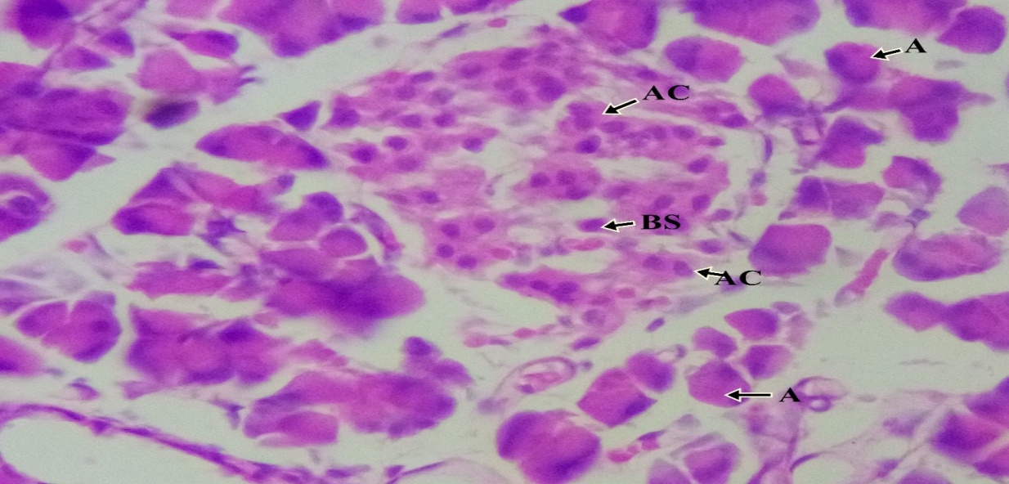

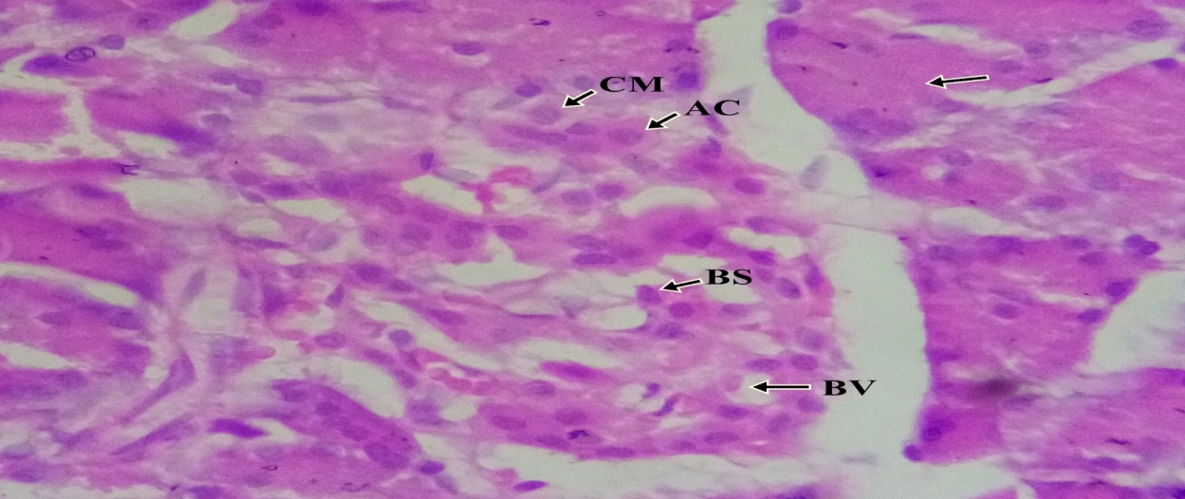

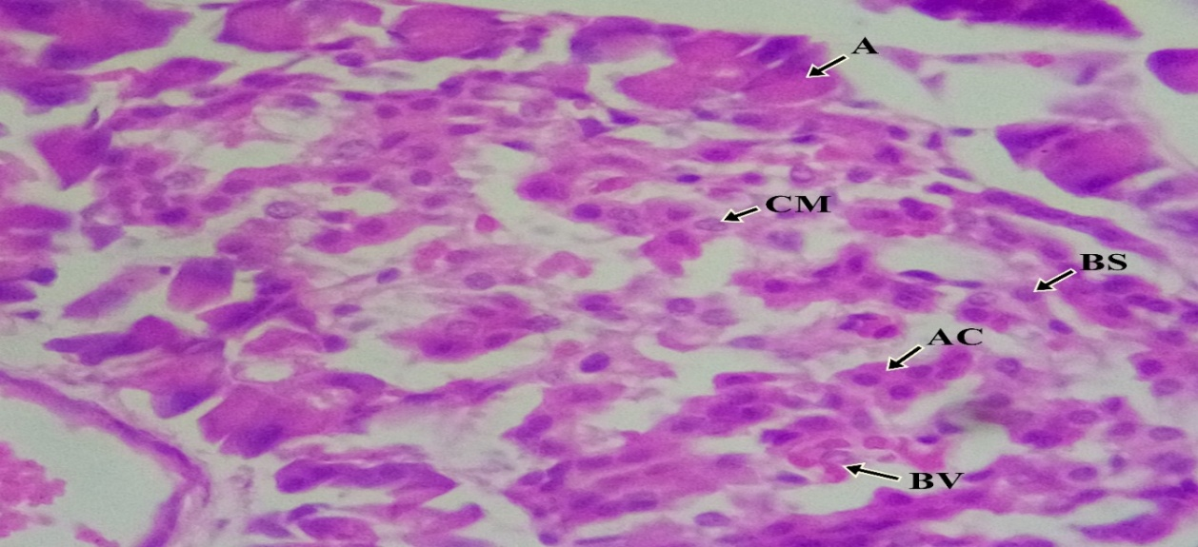

A
X400
X400
B
X400
C

Figure 1: Photomicrographs of pancreatic tissue sections stained with Hematoxylin and Eosin (H&E) at 400x magnification.
(A) Normal pancreatic architecture in the control group showing intact acini (A), blood vessels (BV), basophilic (BS) and acidophilic (AC) cells. (B) Pancreatic tissue from the PCOS control group exhibiting islet necrosis, increased connective tissue, vacuolation, vascular congestion, and tissue degeneration. (C) Pancreatic section from the letrozole + ACV treated group showing reduced necrosis, decreased fibrosis, diminished vascular congestion, and partial restoration of normal acinar and islet structure. Arrows indicate focal areas of interest.
A (Acinus); BV (Blood vessels), BS (Basophilic cells), AC (Acidophilic cells), CM (Chromophilis), Arrow (focal).
Conclusion
In summary, ACV demonstrated significant protective effects against pancreatic islet degeneration and hyperglycemia in a letrozole-induced PCOS rat model. Its antioxidant and anti-inflammatory properties likely underpin these benefits, offering a promising natural adjunct therapy for managing metabolic disturbances in PCOS. These findings support further exploration of ACV’s role in clinical settings aimed at improving pancreatic function and glycemic control in women with PCOS.
Competing Interests
The authors declare that they have no competing interests.
Ethical Approval
This study was approved by the Animal Research Ethics Committee of University of Calabar, approval number 312ANA7346.

COMPETING INTERESTS DISCLAIMER:
Authors have declared that they have no known competing financial interests OR non-financial interests OR personal relationships that could have appeared to influence the work reported in this paper.

Disclaimer (Artificial intelligence)
Option 1:
Author(s) hereby declare that NO generative AI technologies such as Large Language Models (ChatGPT, COPILOT, etc.) and text-to-image generators have been used during the writing or editing of this manuscript.

References
- Ghafari, A., Maftoohi, M., Eslami Samarin, M., Barani, S., Banimohammad, M., & Samie, R. (2025). The last update on polycystic ovary syndrome (PCOS), diagnosis criteria, and novel treatment. Endocrine and Metabolic Science, 17, 100228. https://doi.org/10.1016/j.endmts.2025.100228
- World Health Organization. (2025, February 7). Polycystic ovary syndrome. https://www.who.int/news-room/fact-sheets/detail/polycystic-ovary-syndrome
- Liao, W. T., Huang, J. Y., Lee, M. T., Yang, Y. C., & Wu, C. C. (2022). Higher risk of type 2 diabetes in young women with polycystic ovary syndrome: A 10-year retrospective cohort study. World Journal of Diabetes, 13 (3), 240-250. https://doi.org/10.4239/wjd.v13.i3.240
- Liu, H., Jin, L., Wang, X., Shi, J., He, Y., Sun, N., & Yang, F. (2025). Reactive oxygen species in polycystic ovary syndrome: Mechanistic insights into pathogenesis and therapeutic opportunities. Redox Biology, 85, 103776. https://doi.org/10.1016/j.redox.2025.103776
- Liu, Q., Xie, Y.-j., Qu, L.-h., Zhang, M.-x., & Mo, Z.-c. (2019). Dyslipidemia involvement in the development of polycystic ovary syndrome. Taiwanese Journal of Obstetrics and Gynecology, 58 (4), 447–453. https://doi.org/10.1016/j.tjog.2019.05.003
- Singh, S., Pal, N., Shubham, S., Sarma, D. K., Verma, V., Marotta, F., & Kumar, M. (2023). Polycystic ovary syndrome: Etiology, current management, and future therapeutics. Journal of Clinical Medicine, 12 (4), 1454. https://doi.org/10.3390/jcm12041454
- Rambaran, N., & Islam, M. S. (2025). Decoding androgen excess in polycystic ovary syndrome: Roles of insulin resistance and other key intraovarian and systemic factors. World Journal of Diabetes, 16 (7), 108789. https://doi.org/10.4239/wjd.v16.i7.108789
- Vona, R., Pallotta, L., Cappelletti, M., Severi, C., & Matarrese, P. (2021). The impact of oxidative stress in human pathology: Focus on gastrointestinal disorders. Antioxidants, 10(2), 201. https://doi.org/10.3390/antiox10020201
- Malin, S. K., Kirwan, J. P., Sia, C. L., & González, F. (2015). Pancreatic β-cell dysfunction in polycystic ovary syndrome: Role of hyperglycemia-induced nuclear factor-κB activation and systemic inflammation. American Journal of Physiology-Endocrinology and Metabolism, 308 (9), E770–E777. https://doi.org/10.1152/ajpendo.00510.2014
- Nugent, D. A., Smith, D. M., & Jones, H. B. (2008). A review of islet of Langerhans degeneration in rodent models of type 2 diabetes. Toxicologic Pathology, 36(4). https://doi.org/10.1177/0192623308318209
- Chen, L., Chen, R., Wang, H., & Liang, F. (2015). Mechanisms linking inflammation to insulin resistance. International Journal of Endocrinology, 2015, 508409. https://doi.org/10.1155/2015/508409
- Alipourfard, I., Datukishvili, N., & Mikeladze, D. (2019). TNF-α downregulation modifies insulin receptor substrate 1 (IRS-1) in metabolic signaling of diabetic insulin-resistant hepatocytes. Mediators of Inflammation, 2019, 3560819. https://doi.org/10.1155/2019/3560819
- Yong, J., Johnson, J. D., Arvan, P., Han, J., & Kaufman, R. J. (2021). Therapeutic opportunities for pancreatic β-cell ER stress in diabetes mellitus. Nature Reviews Endocrinology, 17(8), 455-467. https://doi.org/10.1038/s41574-021-00510-4
- Melin, J., Forslund, M., Alesi, S., Piltonen, T., Romualdi, D., Spritzer, P. M., Tay, C. T., Pena, A., Witchel, S. F., Mousa, A., & Teede, H. (2024). Metformin and combined oral contraceptive pills in the management of polycystic ovary syndrome: A systematic review and meta-analysis. The Journal of Clinical Endocrinology & Metabolism, 109(2), e817–e836. https://doi.org/10.1210/clinem/dgad465
- Harmooshi, N. N., Abeshtan, A., Zakerkish, M., Mirmomeni, G., & Rahim, F. (2021). The effect of metformin on body mass index and metabolic parameters in non-diabetic HIV-positive patients: A meta-analysis. Journal of Diabetes & Metabolic Disorders, 20 (2), 1901–1911. https://doi.org/10.1007/s40200-021-00869-1
- Cortés, M. E., & Alfaro, A. A. (2014). The effects of hormonal contraceptives on glycemic regulation. Linacre Quarterly, 81 (3), 209–218. https://doi.org/10.1179/2050854914Y.0000000023
- Ezemba, A. S., Osuala, O. J., Orji, M. U., Ezemba, C. C., & Anaukwu, C. (2021). Production and Comparative Physicochemical Analysis of Vinegar from Locally Grown Fruits in Nigeria and Industrial Produced Vinegar. American Journal of Microbiological Research, 9 (1), 25-33. https://doi.org/10.12691/ajmr-9-1-4
- Chen, G. L., Zheng, F. J., Lin, B., Yang, Y. X., Fang, X. C., Verma, K. K., & Yang, L. F. (2023). Vinegar: A potential source of healthy and functional food with special reference to sugarcane vinegar. Frontiers in Nutrition, 10, 1145862. https://doi.org/10.3389/fnut.2023.1145862
- Ayoub, N., Omar, A., Nor, A., Allithy, E., Faleh, F., Mariah, R., Mohamed, M., Ayat, A., Shafik, S., Elshweikh, S., Mohamed, S., El Sayed, S., Faleh, M., Shafik, R., & Allithy, A. (2015). Apple Cider Vinegar (A Prophetic Medicine Remedy) Protects against Nicotine Hepatotoxicity: A Histopathological and Biochemical Report. Asian Journal of Clinical Pharmacology, 3(6), 122-127. https://doi.org/10.12691/ajcp-3-6-4
- Johnston, C. S., & Gaas, C. A. (2006). Vinegar: Medicinal uses and antiglycemic effect. MedGenMed, 8 (2), 61. https://pubmed.ncbi.nlm.nih.gov/16926800/
- Nazni, P., Singh, R., Devi, R. S., Singh, H., Singh, S., Singh, K., Singh, H., & Kumar, S. (2015). Assessment of hypoglycemic effects of apple cider vinegar in type 2 diabetes. International Journal of Food and Nutritional Sciences, 14(5). https://www.researchgate.net/publication/280000000_Assessment_of_hypoglycemic_effects_of_apple_cider_vinegar_in_type_2_diabets
- Agbor, C., Fischer, C., Francis, C., Takim, E., & Odom, E. (2025). Dose-dependent ameliorative effects of apple cider vinegar on ovarian architecture and body weight in a rat model of letrozole-induced PCOS. Asian Journal of Research in Medical and Pharmaceutical Sciences, 14. https://doi.org/10.9734/ajrimps/2025/v14i3331
- Singh, J., & Garg, A. P. (2022). Antimicrobial activity of apple cider vinegar treated selected vegetables against common food borne bacterial pathogens. Bioscience Biotechnology Research Communications, 15(2). https://doi.org/10.21786/bbrc/15.2.13
- Ibrahim, Y. F., Alorabi, M., Abdelzaher, W. Y., Toni, N. D. M., Thabet, K., Hegazy, A., Bahaa, H. A., Batiha, G. E.-S., Welson, N. N., Morsy, M. A., Venugopala, K. N., & Abdel-Aziz, A. M. (2022). Diacerein ameliorates letrozole-induced polycystic ovarian syndrome in rats. Biomedicine & Pharmacotherapy, 149, 112870. https://doi.org/10.1016/j.biopha.2022.112870
- Hmad Halima, B., Sarra, K., Jemaa Houda, B., Sonia, G., & Abdallah, A. (2018). Antidiabetic and antioxidant effects of apple cider vinegar on normal and streptozotocin-induced diabetic rats. International Journal of Vitamin and Nutrition Research, 88 (5-6), 223–233. https://doi.org/10.1024/0300-9831/a000246
- Halima, B., Gara, S., Khlifi, S., Jemaa, H. B., Slama, F., & Aouidet, A. (2017). Apple cider vinegar attenuates oxidative stress and reduces the risk of obesity in high-fat-fed male Wistar rats. Journal of Medicinal Food, 21 (3), 254–262. https://doi.org/10.1089/jmf.2017.0039
- Guang, H. J., Li, F., & Shi, J. (2018). Letrozole for patients with polycystic ovary syndrome: A retrospective study. Medicine (Baltimore), 97 (44), e13038. https://doi.org/10.1097/MD.0000000000013038
- Xu, J., Dun, J., Yang, J., Zhang, J., Lin, Q., Huang, M., Ji, F., Huang, L., You, X., & Lin, Y. (2020). Letrozole rat model mimics human polycystic ovarian syndrome and changes in insulin signal pathways. Medical Science Monitor, 26, e923073. https://doi.org/10.12659/MSM.923073
- Begum, N., Manipriya, K., & Veeresh, B. (2022). Role of high-fat diet on letrozole-induced polycystic ovarian syndrome in rats. European Journal of Pharmacology, 917, 174746. https://doi.org/10.1016/j.ejphar.2022.174746
- Morshedzadeh, N., Behrouz, V., & Ahmadi, A. R. (2025). Cross-sectional study of the relationship between dietary inflammatory index and inflammatory hormonal and metabolic profiles in polycystic ovary syndrome. Scientific Reports, 15(1), 40211. https://doi.org/10.1038/s41598-025-24046-z

