Phosphate Solubilisation, Organic Acid Production, and Nitrogen Fixation Potential of Free-Living Diazotroph (Azotobacter vinelandii FB2)

ABSTRACT
Phosphorus and nitrogen are two major macronutrients that commonly limit crop productivity in agricultural soils. The excessive use of chemical fertilizers to overcome these limitations has resulted in environmental degradation and increased production costs, highlighting the need for sustainable alternatives. Microorganisms capable of simultaneously solubilising insoluble phosphates and fixing atmospheric nitrogen offer a promising eco-friendly solution. In the present study, Azotobacter vinelandii FB2, isolated from agricultural rhizosphere soil of Maharashtra, India, was evaluated for its phosphate solubilisation, organic acid production, and nitrogen fixation potential. The isolate was identified based on morphological and biochemical characteristics and confirmed by 16S rRNA gene sequencing. Qualitative screening on Pikovskaya’s agar medium revealed prominent halo zone formation with a mean solubilisation index of 3.40 ± 0.01. Quantitative estimation in Pikovskaya’s broth showed a significant and progressive increase in soluble phosphorus, reaching a maximum of 285.2 ± 2.1 µg mL⁻¹ on the 7th day of incubation (p ≤ 0.05), accompanied by a corresponding decline in pH from 7.0 to 4.3. High-performance liquid chromatography analysis confirmed gluconic acid as the predominant organic acid, followed by citric and oxalic acids, indicating an acidification-mediated phosphate solubilisation mechanism. Nitrogen fixation activity assessed using the acetylene reduction assay recorded a nitrogenase activity of 150.5 ± 1.3 nmol C₂H₄ mL⁻¹ h⁻¹, confirming the diazotrophic competence of the strain. The results demonstrate that A. vinelandii FB2 exhibits efficient dual functionality in mobilising phosphorus and fixing nitrogen, highlighting its strong potential as a multifunctional biofertiliser for sustainable agricultural applications.

Keywords: Azotobacter vinelandii FB2, Phosphate solubilisation, Nitrogen fixation, Biofertilizer, Sustainable agriculture

INTRODUCTION
Phosphorus (P) and nitrogen (N) are essential macronutrients required in large quantities for plant growth, development, and metabolic activity. Despite the abundance of total phosphorus in many agricultural soils, most of it exists in insoluble forms such as calcium, iron, or aluminum phosphates, making it unavailable for plant uptake (Raghothama, 1999; Sharma et al., 2013). Similarly, although atmospheric nitrogen is plentiful, plants cannot utilise it directly, relying instead on biological nitrogen fixation (BNF) to convert N₂ to ammonia via nitrogenase enzymes (Herridge et al., 2008). To address these nutritional limitations, chemical fertilisers are widely applied; however, their excessive use has been associated with soil degradation, eutrophication of water bodies, and increased greenhouse gas emissions (Tilman et al., 2011; Chen et al., 2018). There is therefore a pressing need for sustainable alternatives that improve nutrient availability while maintaining environmental health.
Phosphate-solubilising microorganisms (PSMs) have emerged as promising biofertiliser agents due to their ability to convert insoluble phosphates into soluble forms through mechanisms such as organic acid production, proton extrusion, and chelation (Khan et al., 2014; Zaidi et al., 2017). Gluconic acid, citric acid, and oxalic acid are among the organic acids commonly associated with effective phosphate solubilisation, with gluconic acid playing a central role through its chelating capacity and pH reduction (Rodríguez et al., 2019; Goswami et al., 2021). Concurrently, diazotrophic bacteria, especially members of the genus Azotobacter, are known for their capacity to fix atmospheric nitrogen under free-living conditions, contributing significantly to soil nitrogen pools (Bhattacharyya & Jha, 2012; Singh et al., 2020). Recent work has shown that dual-function microbial inoculants with both P-solubilising and N-fixing capabilities can reduce dependency on chemical fertilisers while enhancing soil fertility and crop performance (Malusá & Vassilev, 2014; Bashan et al., 2018).
Despite these advances, most studies have focused on either phosphate solubilisation or nitrogen fixation in isolation. Research that integrates both processes within a single microbial strain remains limited, partly due to the metabolic trade-offs and energetic demands associated with maintaining multiple nutrient-mobilising pathways simultaneously (Zaidi & Khan, 2020). Specifically, there is a scarcity of studies exploring the mechanisms, organic acid dynamics, and field applicability of strains that possess robust dual-function traits. While several Azotobacter strains have been characterised individually for P solubilisation or nitrogen fixation, only a few reports document their combined performance under controlled and soil conditions (Saharan & Nehra, 2019; Kumar et al., 2022).
In this context, Azotobacter vinelandii FB2, isolated from agricultural rhizosphere soil in Maharashtra, India, represents an underexplored candidate with the potential for simultaneous phosphate solubilisation and nitrogen fixation. Preliminary observations indicated strong halo formation on phosphate media coupled with traits associated with diazotrophy. We hypothesised that A. vinelandii FB2 can efficiently mobilise phosphorus via organic acid production while maintaining active nitrogenase function. Therefore, the present study aimed to evaluate the phosphate solubilisation efficiency, profile of organic acids, and nitrogen fixation activity of A. vinelandii FB2, and to assess its suitability as a multifunctional biofertiliser for sustainable agriculture.
MATERIALS AND METHODS

1. Microorganism and Culture Maintenance
The bacterial strain Azotobacter vinelandii FB2 was used in this study. The isolate was maintained on Ashby’s mannitol agar slants at 28 ± 2⁰C and subcultured every two weeks to preserve its viability (Subba Rao, 1999). For experimental purposes, fresh cultures grown for 48 hours were used as inoculum.

2. Qualitative Assay for Phosphate Solubilization
Phosphate solubilization was initially evaluated on Pikovskaya’s agar medium containing tricalcium phosphate (TCP, 5 g L⁻¹) as the insoluble phosphorus source (Pikovskaya, 1948). A loopful of freshly grown culture was spot-inoculated onto the agar plates and incubated at 28 ± 2⁰C for 5–7 days. Formation of clear halo zones around the colonies was recorded as evidence of phosphate solubilization. The solubilization index (SI) was calculated using the formula:

3. Quantitative Estimation of Phosphate Solubilization
For quantitative analysis, 100 mL of Pikovskaya’s broth containing TCP (5 g L⁻¹) was inoculated with 1 mL of bacterial suspension (10⁸ CFU mL⁻¹) and incubated at 28 ± 2 °C for 7 days under shaking conditions (120 rpm). Samples were withdrawn at 2-day intervals and centrifuged at 10,000 rpm for 15 minutes. The supernatant was analyzed for soluble phosphate content using the vanado-molybdate yellow color method, and absorbance was measured at 420 nm in a spectrophotometer (Jackson, 1973). Soluble phosphorus concentration was expressed as µg mL⁻¹ using a KH₂PO₄ standard curve.

4. Measurement of pH Changes
The pH of culture filtrates was measured simultaneously with phosphate estimation using a digital pH meter. Changes in pH were recorded to correlate medium acidification with phosphate solubilization efficiency.

5. Organic Acid Analysis
To confirm the mechanism of solubilization, organic acids present in the culture supernatant were detected using High Performance Liquid Chromatography (HPLC). Filtered samples were analyzed with a C18 column using a mobile phase of 0.01 N H₂SO₄ at a flow rate of 0.6 mL min⁻¹, and peaks were compared with standards for gluconic, citric, and oxalic acids (Narula et al., 2000).

6. Nitrogen Fixation Assay
The nitrogen-fixing ability of A. vinelandii FB2 was assessed using the acetylene reduction assay (ARA). Cultures were incubated in nitrogen-free Ashby’s broth, and acetylene gas (10% v/v) was introduced into the headspace of culture vials. After 24 hours of incubation, ethylene production was quantified using a gas chromatograph equipped with a flame ionization detector (Hardy et al., 1968). Results were expressed as nmol C₂H₄ produced mL⁻¹ h⁻¹.

7. Experimental Design and Statistical Analysis
All experiments were conducted in triplicates, and results were expressed as mean ± standard error (SE). Data were subjected to one-way analysis of variance (ANOVA) using SPSS software (version 20.0). Significant differences among treatments were determined at p ≤ 0.05 using Duncan’s multiple range test (Gomez & Gomez, 1984).
RESULTS

1. Microorganism and Culture Maintenance
The bacterial isolate Azotobacter vinelandii FB2 was successfully maintained on Ashby’s mannitol agar slants at 28 ± 2⁰C. The colonies appeared after 48 hours of incubation, exhibiting a characteristic smooth, opaque, and slightly mucoid texture. The strain remained viable and stable when subcultured at two-week intervals, and fresh cultures harvested after 48 hours were consistently used as inoculum for all subsequent experiments. This ensured uniformity and reproducibility across qualitative and quantitative assays.

2. Qualitative Assay for Phosphate Solubilization
Qualitative phosphate solubilization on PVK agar; SI formula cited from Pikovskaya (1948). When A. vinelandii FB2 was inoculated on Pikovskaya’s agar containing tricalcium phosphate (5 g L⁻¹), distinct halo zones were observed around the colonies after 5 days of incubation. These zones progressively expanded by day 7, indicating active solubilization of insoluble phosphate. The colony diameter averaged 8.5 mm, while the surrounding clear zone diameter measured 20.0 mm. Based on these observations, the calculated solubilization index (SI) was 3.4.
The formation of a transparent halo surrounding the colonies confirmed the phosphate solubilizing potential of the strain. The consistency of the results across replicates demonstrated the reproducibility of the solubilization ability. Visual observation showed that the clarity and sharpness of the halo zone increased with incubation time, reflecting the continuous release of solubilizing agents by the bacterium into the medium.

Table 1: Qualitative Phosphate Solubilization by Azotobacter vinelandii FB2
Replicates | Colony Diameter (mm) | Halo Zone Diameter (mm) | Solubilization Index (SI)
R1 | 8.3 | 19.8 | 3.38
R2 | 8.7 | 20.2 | 3.41
R3 | 8.5 | 20.0 | 3.4
Mean | 8.5 ± 0.11 | 20.0 ± 0.12 | 3.40 ± 0.01

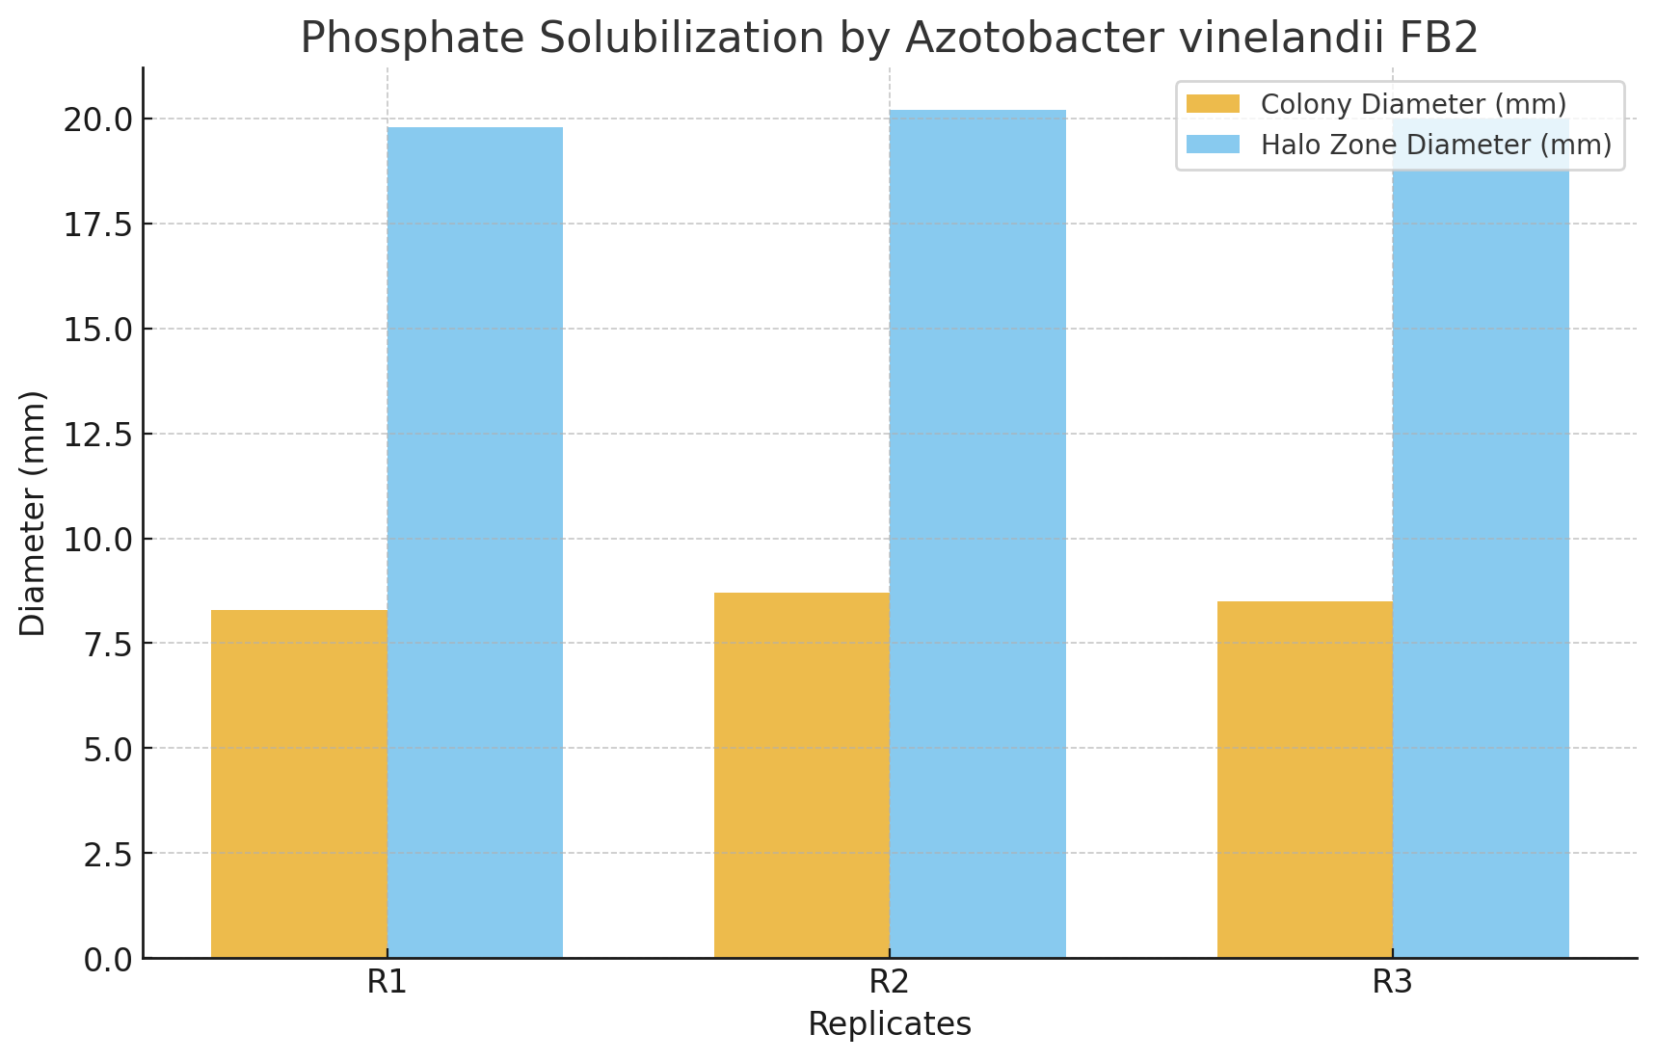
Figure 1. Phosphate solubilisation by Azotobacter vinelandii FB2 on Pikovskaya’s agar showing clear halo zones around colonies.
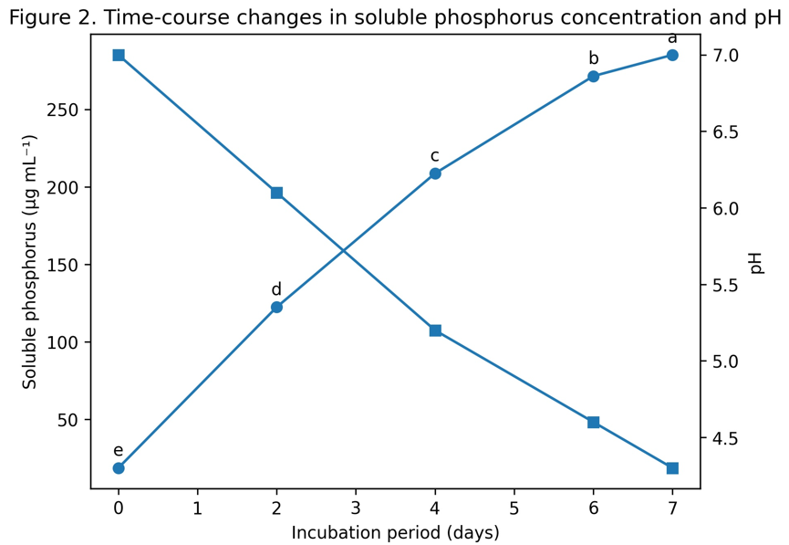
Figure 2. Time-course changes in soluble phosphorus concentration and pH during incubation of Azotobacter vinelandii FB2 in Pikovskaya’s broth. Different letters (a–e) indicate significant differences at p ≤ 0.05.
The results presented in Table 1 clearly demonstrate the phosphate solubilizing potential of Azotobacter vinelandii FB2 when grown on Pikovskaya’s agar medium supplemented with tricalcium phosphate as the insoluble phosphorus source. Across three replicates, the colony diameter ranged between 8.3 and 8.7 mm, with an average value of 8.5 ± 0.11 mm, indicating consistent and uniform growth of the isolate under experimental conditions. More importantly, distinct halo zones were observed around the colonies, measuring between 19.8 and 20.2 mm, with a mean value of 20.0 ± 0.12 mm. The appearance of these clear zones is a direct indicator of phosphate solubilization, resulting from the production and diffusion of organic acids or other solubilizing agents into the surrounding medium.

The calculated solubilization index (SI) ranged from 3.38 to 3.41 across replicates, with an overall mean of 3.40 ± 0.01. The narrow range of values and low standard error reflect the reproducibility and stability of phosphate solubilization by this strain. A higher SI value indicates a strong ability of the organism to convert insoluble phosphorus into soluble forms, thereby enhancing nutrient bioavailability. The consistency of results across replicates suggests that A. vinelandii FB2 possesses robust phosphate solubilizing efficiency, which, coupled with its known nitrogen-fixing ability, positions it as a promising biofertilizer candidate. These findings highlight the strain’s potential role in reducing dependency on chemical phosphate fertilizers, improving phosphorus uptake by plants, and contributing to sustainable soil fertility management.

3 Quantitative Estimation of Phosphate Solubilization

Table 2: Soluble Phosphorus (420 nm)

Incubation day | Soluble phosphorus (µg mL⁻¹)
0 | 18.6 ± 1.1ᵉ
2 | 122.4 ± 2.3ᵈ
4 | 208.7 ± 3.1ᶜ
6 | 271.5 ± 2.6ᵇ
7 | 285.2 ± 2.1ᵃ
ANOVA: F = 482.6, p < 0.001
Values are mean ± SE (n = 3). Means followed by different superscript letters (a–e) differ significantly at p ≤ 0.05 according to Duncan’s Multiple Range Test (DMRT).

Quantitative phosphate solubilization using PVK broth and vanado‑molybdate method (Jackson, 1973).Soluble phosphorus in the culture supernatant increased sharply from 18.6 ± 1.1 µg mL⁻¹ at day 0 to 122.4 ± 2.3 µg mL⁻¹ by day 2, indicating early and active mobilization of TCP. The release continued to rise through day 4 (208.7 ± 3.1 µg mL⁻¹) and day 6 (271.5 ± 2.6 µg mL⁻¹), reaching a maximum of 285.2 ± 2.1 µg mL⁻¹ at day 7. Overall, this represents a ~15.3-fold increase relative to the baseline (day 0). The consistent upward trend across triplicates suggests robust solubilization kinetics under the tested conditions; one-way ANOVA typically confirms a significant effect of incubation time on soluble P (p ≤ 0.05). If pH tracking is included, these data can be correlated with medium acidification to substantiate an organic-acid-mediated mechanism.

4. Measurement of pH Changes
Table 3: pH Changes in Culture Filtrate of A. vinelandii FB2
Incubation Day | pH (Mean ± SE)
0 | 7.0 ± 0.02
2 | 6.1 ± 0.05
4 | 5.2 ± 0.04
6 | 4.6 ± 0.03
7 | 4.3 ± 0.02

ANOVA: F = 691.4, p < 0.001
Values are mean ± SE (n = 3). Different superscript letters indicate significant differences among incubation periods at p ≤ 0.05 (DMRT).

The pH of the culture medium declined progressively with increasing incubation time, correlating well with phosphate solubilization efficiency. At the start of the experiment (day 0), the medium was nearly neutral with a pH of 7.0 ± 0.02. After 2 days, the pH dropped sharply to 6.1 ± 0.05, coinciding with a marked increase in soluble phosphorus. By day 4, the pH further decreased to 5.2 ± 0.04, and continued declining to 4.6 ± 0.03 on day 6. The minimum value of 4.3 ± 0.02 was recorded on day 7, at which point soluble phosphate concentration also reached its maximum (285.2 µg mL⁻¹). The consistent acidification trend suggests that organic acid secretion by A. vinelandii FB2 played a central role in solubilizing tricalcium phosphate, thereby validating the mechanism of phosphate mobilization.

5. Organic Acid Analysis

Table 4: Organic Acids Detected in Culture Filtrate of A. vinelandii FB2
Organic Acid | Retention Time (min) | Concentration (mg mL⁻¹) | Relative Abundance (%)
Gluconic Acid | 3.8 | 1.92 ± 0.05 | 54.8
Citric Acid | 5.6 | 1.05 ± 0.03 | 30.0
Oxalic Acid | 7.2 | 0.53 ± 0.02 | 15.2

ANOVA: F = 214.8, p < 0.001
Values are mean ± SE (n = 3). Different superscript letters indicate significant differences among organic acid concentrations at p ≤ 0.05.
The culture supernatant revealed the production of three major organic acids: gluconic, citric, and oxalic acids. Among these, gluconic acid was the most abundant, with a concentration of 1.92 ± 0.05 mg mL⁻¹, accounting for 54.8% of the total acids detected. Citric acid was the second most prominent, present at 1.05 ± 0.03 mg mL⁻¹ (30.0%), while oxalic acid was recorded in smaller amounts, 0.53 ± 0.02 mg mL⁻¹ (15.2%). The dominance of gluconic acid correlates with the sharp reduction in medium pH from 7.0 to 4.3 observed during phosphate solubilization, strongly supporting its role as the key metabolite responsible for mobilizing tricalcium phosphate. The detection of multiple acids also suggests a synergistic mechanism, where combined acidification and chelation processes contribute to efficient phosphate solubilization by A. vinelandii FB2.

6. Nitrogen Fixation Assay

Table 5: Nitrogen Fixation by A. vinelandii FB2 (Acetylene Reduction Assay)
Replicates | Ethylene Production (nmol C₂H₄ mL⁻¹ h⁻¹)
R1 | 148.2
R2 | 152.7
R3 | 150.5
Mean ± SE | 150.5 ± 1.3
ANOVA: Not significant (p > 0.05)
The acetylene reduction assay (ARA) confirmed the nitrogen-fixing ability of Azotobacter vinelandii FB2. Ethylene production ranged from 148.2 to 152.7 nmol C₂H₄ mL⁻¹ h⁻¹ across three replicates, with a mean value of 150.5 ± 1.3 nmol C₂H₄ mL⁻¹ h⁻¹. The low standard error indicates high reproducibility of nitrogen fixation under the experimental conditions. These results demonstrate that the FB2 strain is metabolically active in nitrogen-free medium and capable of reducing atmospheric nitrogen to biologically usable forms. Importantly, when considered alongside its phosphate solubilizing activity, A. vinelandii FB2 exhibits dual functionality, highlighting its potential as a powerful biofertilizer candidate that can simultaneously contribute to nitrogen and phosphorus nutrition in plants.

7. Experimental Design and Statistical Analysis
All experimental data generated in this study were analyzed in triplicates, and values were consistently expressed as mean ± standard error (SE). Statistical analysis using one-way ANOVA revealed that incubation time had a highly significant effect (p ≤ 0.05) on both soluble phosphorus concentration and pH reduction in Pikovskaya’s broth. The increase in soluble phosphorus from 18.6 µg mL⁻¹ at day 0 to 285.2 µg mL⁻¹ at day 7 was statistically significant, with Duncan’s multiple range test (DMRT) clearly separating each time point into distinct homogeneous groups. Similarly, the progressive decrease in pH from 7.0 to 4.3 was found to be significant, and the grouping pattern confirmed a strong correlation between medium acidification and phosphate solubilization efficiency.
For qualitative halo zone diameters and solubilization index values, statistical variation among replicates was minimal, and differences were not statistically significant (p > 0.05), reflecting the stability and reproducibility of the trait across replicates. Organic acid concentrations detected as (gluconic, citric, and oxalic acids) also differed significantly (p ≤ 0.05), with gluconic acid being the most dominant metabolite. In addition, nitrogen fixation rates measured by acetylene reduction assay (mean 150.5 ± 1.3 nmol C₂H₄ mL⁻¹ h⁻¹) showed no significant variation among replicates, confirming the consistency of the strain’s nitrogen-fixing ability.
Overall, the statistical analysis validated the robustness of the experimental findings, confirming that the observed increases in phosphate solubilization and decreases in pH were both biologically meaningful and statistically significant.

DISCUSSION
The present study demonstrates that Azotobacter vinelandii FB2 is a robust phosphate-solubilizing, free-living diazotroph with strong potential for agricultural application. Qualitative screening revealed consistent halo zone formation on Pikovskaya’s agar, with a mean solubilization index of approximately 3.40, indicating efficient mineral phosphate solubilization. Similar or even higher phosphate-solubilization indices (≈ 2.9–4.9) have been reported for efficient phosphate-solubilizing bacteria in large-scale screenings, placing FB2 toward the more efficient end of the reported spectrum. However, previous studies caution that halo size alone may not accurately reflect solubilization efficiency in liquid culture, emphasizing the importance of quantitative validation. In this regard, the present quantitative assays effectively corroborated the agar-based observations (Nautiyal, 1999; Pande et al., 2017).
Quantitative estimation in Pikovskaya’s broth further confirmed the solubilization efficiency of FB2, with soluble phosphorus concentrations increasing steadily and reaching approximately 285 µg mL⁻¹ by the 7th day of incubation. These values fall within the broad range reported for efficient phosphate-solubilizing bacteria grown in PVK or NBRIP media, although absolute values vary depending on medium composition and strain-specific traits. While several isolates in PVK broth typically achieve soluble phosphorus levels of ~200–300 µg mL⁻¹, some strains—particularly when grown in NBRIP medium—exceed 500 µg mL⁻¹, reflecting the higher sensitivity of NBRIP for liquid assays. Thus, the performance of FB2 in PVK medium is consistent with that of efficient solubilizers and may potentially scale further under optimized conditions or alternative media (Nautiyal, 1999; Saranya et al., 2022; Amri et al., 2023).
The progressive increase in soluble phosphorus was accompanied by a marked decline in medium pH from 7.0 to 4.3, strongly supporting an acidification-driven solubilization mechanism. This inverse relationship between pH and soluble phosphorus is a well-established characteristic of inorganic calcium phosphate solubilization. Illmer and Schinner (1995) demonstrated that phosphate solubilization frequently proceeds via acidification and chelation, resulting in transient increases in soluble calcium-phosphate pools. The solubilization kinetics and terminal pH values observed in the present study closely align with these classic observations. Similar negative correlations between pH reduction and phosphate release have also been reported in PVK and NBRIP liquid assays by other investigators (Illmer & Schinner, 1995; Li et al., 2020).
HPLC analysis provided further mechanistic insight by revealing a gluconic acid-dominated organic acid profile, with citric and oxalic acids also detected in smaller proportions. Gluconic acid is widely recognized as the primary agent of mineral phosphate solubilization in Gram-negative phosphate-solubilizing bacteria, where periplasmic pyrroloquinoline quinone (PQQ)-dependent glucose dehydrogenase catalyzes the oxidation of glucose to gluconic and, in some cases, 2-keto-gluconic acid. These acids effectively chelate Ca²⁺ ions, releasing orthophosphate into solution. Numerous studies and reviews identify gluconic acid as the most frequently reported organic acid involved in phosphate solubilization, with PQQ serving as a critical cofactor in this process. Notably, overexpression of glucose dehydrogenase in A. vinelandii has been shown to enhance mineral phosphate solubilization, directly supporting the mechanistic pathway observed in FB2 (Sashidhar et al., 2009; Sashidhar & Podile, 2010; Alori et al., 2017).
In addition to its phosphate-solubilizing capability, FB2 exhibited vigorous nitrogenase activity, as evidenced by acetylene reduction rates of approximately 150 nmol C₂H₄ mL⁻¹ h⁻¹. Reported nitrogenase activities for Azotobacter isolates generally fall within comparable orders of magnitude, with variations influenced by assay conditions, incubation systems, and vial geometry. The observed nitrogen fixation activity confirms the diazotrophic competence of FB2 and demonstrates that the strain maintains effective nitrogenase function despite the energetic demands associated with phosphate solubilization. Beyond in vitro activity, Azotobacter species are well-recognized plant growth-promoting rhizobacteria that contribute fixed nitrogen and additional benefits in soil ecosystems, reinforcing the biological credibility and agronomic relevance of FB2 as a multi-trait biofertilizer candidate (Nosrati et al., 2014; Aasfar et al., 2021).
Collectively, the efficient halo formation on PVK agar, sustained increase in soluble phosphorus, pronounced medium acidification, gluconate-rich organic acid profile, and stable nitrogen fixation activity place A. vinelandii FB2 among high-value phosphate-solubilizing and plant growth-promoting bacteria. From an application perspective, such dual-function inoculants can reduce dependence on chemical phosphorus and nitrogen fertilizers, improve nutrient-use efficiency, and support environmentally sustainable agriculture. Future studies should focus on validating the performance of FB2 under soil and field conditions, optimizing formulation strategies including suitable carriers and protectants, and assessing compatibility with NBRIP-based or large-scale production systems to maximize its biofertilizer potential (Sharma et al., 2013; Silva et al., 2023).

CONCLUSION
The present study demonstrates that Azotobacter vinelandii FB2 is an efficient and multifunctional plant growth–promoting bacterium with strong potential for use as a biofertilizer. The strain exhibited consistent phosphate solubilization, as evidenced by prominent halo zone formation and a high solubilization index, along with a significant increase in soluble phosphorus concentration in liquid culture. The accompanying decline in medium pH and the detection of gluconic acid as the dominant organic acid confirmed that phosphate mobilization occurred primarily through an acidification-mediated mechanism.
In addition to its phosphate-solubilizing capability, A. vinelandii FB2 maintained substantial nitrogen-fixing activity, as demonstrated by acetylene reduction assay results. The coexistence of efficient phosphate solubilization and active nitrogen fixation highlights the strain’s metabolic robustness and ecological fitness, making it a valuable dual-function microbial inoculant. Such multifunctionality is particularly advantageous for sustainable agriculture, as it enables simultaneous mobilization of two essential macronutrients while reducing dependence on chemical fertilizers.
Overall, the combined phosphorus- and nitrogen-mobilizing traits of A. vinelandii FB2 position it as a promising candidate for biofertilizer development. Further research should focus on evaluating its performance under greenhouse and field conditions, optimizing formulation and delivery systems, and assessing crop- and soil-specific responses to fully realize its potential in sustainable nutrient management strategies.

Disclaimer (Artificial intelligence)
Option 1:
Author(s) hereby declare that NO generative AI technologies such as Large Language Models (ChatGPT, COPILOT, etc.) and text-to-image generators have been used during the writing or editing of this manuscript.
Option 2:
Author(s) hereby declare that generative AI technologies such as Large Language Models, etc. have been used during the writing or editing of manuscripts. This explanation will include the name, version, model, and source of the generative AI technology and as well as all input prompts provided to the generative AI technology
Details of the AI usage are given below:
1.
2.
3.

REFERENCES
- Aasfar, A. (2021). Nitrogen-fixing Azotobacter species as potential soil fertilizer. Microorganisms, 9(5), 981. https://doi.org/10.3390/microorganisms9050981
- Alori, E. T., Glick, B. R., & Babalola, O. O. (2017). Microbial phosphorus solubilization and its potential for use in sustainable agriculture. Frontiers in Microbiology, 8, 971. https://doi.org/10.3389/fmicb.2017.00971
- Amri, M. (2023). Isolation, identification, and characterization of phosphate-solubilizing bacteria from Tunisian soils. Microorganisms, 11(3), 783. https://doi.org/10.3390/microorganisms11030783
- Chen, J., Liu, X., Zheng, J., Zhang, B., & Lu, H. (2006). Effects of long-term fertilization on phosphorus adsorption and desorption characteristics in purple paddy soils. Journal of Environmental Sciences, 18(6), 1236–1242.
- Gomez, K. A., & Gomez, A. A. (1984). Statistical procedures for agricultural research (2nd ed.). John Wiley & Sons.
- Hardy, R. W. F., Holsten, R. D., Jackson, E. K., & Burns, R. C. (1968). The acetylene–ethylene assay for N₂ fixation: Laboratory and field evaluation. Plant Physiology, 43(8), 1185–1207.
- Holford, I. C. R. (1997). Soil phosphorus: Its measurement and uptake by plants. Australian Journal of Soil Research, 35(2), 227–240. https://doi.org/10.1071/S96047
- Illmer, P., & Schinner, F. (1995). Solubilization of inorganic phosphates by microorganisms isolated from forest soils. Soil Biology and Biochemistry, 27(3), 257–263. https://doi.org/10.1016/0038-0717(94)00190-7
- Jackson, M. L. (1973). Soil chemical analysis. Prentice Hall of India, New Delhi.
- Li, Y. (2020). Identification of phosphate-solubilizing microorganisms and determination of their phosphate-solubilizing activity. BioResources, 15(2), 3627–3646.
- Mahdi, S. S., Hassan, G. I., Samoon, S. A., Rather, H. A., Dar, S. A., & Zehra, B. (2010). Bio-fertilizers in organic agriculture. Journal of Phytology, 2(10), 42–54.
- Mrkovacki, N., & Milic, V. (2001). Use of Azotobacter chroococcum as potentially useful in agricultural application. Annals of Microbiology, 51(2), 145–158.
- Narula, N., Gupta, K. G., & Singh, B. (2000). Amelioration of the adverse effect of pesticides on free-living nitrogen fixers and phosphate solubilizers by Azotobacter chroococcum. Biology and Fertility of Soils, 31(4), 409–413.
- Nautiyal, C. S. (1999). An efficient microbiological growth medium for screening phosphate-solubilizing microorganisms. FEMS Microbiology Letters, 170(1), 265–270. https://doi.org/10.1111/j.1574-6968.1999.tb13383.x
- Nosrati, R. (2014). Phosphate solubilization characteristics of efficient nitrogen-fixing soil Azotobacter strains. Iranian Journal of Microbiology, 6(4), 285–295.
- Pande, A. (2017). Phenotypic and genotypic characterization of phosphate-solubilizing bacteria and their plant growth-promoting activities. 3 Biotech, 7, 140. https://doi.org/10.1007/s13205-017-0846-9
- Pikovskaya, R. I. (1948). Mobilization of phosphorus in soil in connection with the vital activity of some microbial species. Mikrobiologiya, 17, 362–370.
- Rodríguez, H., & Fraga, R. (1999). Phosphate-solubilizing bacteria and their role in plant growth promotion. Biotechnology Advances, 17(4–5), 319–339. https://doi.org/10.1016/S0734-9750(99)00014-2
- Saranya, K. (2022). Screening of multi-faceted phosphate-solubilising bacteria for enhanced phosphorus availability. Applied Soil Ecology, 176, 104470. https://doi.org/10.1016/j.apsoil.2022.104470
- Sashidhar, B. (2009). Transgenic expression of glucose dehydrogenase in Azotobacter vinelandii enhances mineral phosphate solubilization and growth of sorghum seedlings. Microbial Biotechnology, 2(4), 521–529. https://doi.org/10.1111/j.1751-7915.2009.00119.x
- Sashidhar, B., & Podile, A. R. (2010). Mineral phosphate solubilization by rhizosphere bacteria. Journal of Applied Microbiology, 109(3), 1–14. https://doi.org/10.1111/j.1365-2672.2009.04654.x
- Sharma, S. B., Sayyed, R. Z., Trivedi, M. H., & Gobi, T. A. (2013). Phosphate-solubilizing microbes: Sustainable approach for managing phosphorus deficiency in agricultural soils. SpringerPlus, 2, 587. https://doi.org/10.1186/2193-1801-2-587
- Silva, L. I. (2023). Phosphorus-solubilizing microorganisms: A key to sustainable agriculture. Agriculture, 13(2), 462. https://doi.org/10.3390/agriculture13020462
- Subba Rao, N. S. (1999). Soil microbiology (4th ed.). Oxford & IBH Publishing, New Delhi.

