Blockchain-Integrated AI Systems for Enhancing Trust and Transparency in Cross-Border Finance

Abstract
This study explores how integrating blockchain technology with artificial intelligence can strengthen trust, transparency, and regulatory compliance in cross-border financial transactions. Drawing on open-source international datasets and quantitative analysis, the research shows that transaction costs rise as the number of intermediaries increases, while greater transparency significantly lowers these costs. Using transaction data from the Elliptic AML dataset, AI-based models achieved a fraud detection accuracy of 90.1%, demonstrating strong potential for identifying illicit financial activity. Structural equation modelling based on Financial Action Task Force indicators confirms that transparency and AI-driven risk detection jointly enhance compliance efficiency. To assess system-wide impact, a simulation using Bank for International Settlements cross-border statistics indicates that an integrated approach can reduce settlement times by over one-third and substantially improve data accuracy. Building on these findings, the study proposes the Blockchain–AI Trust and Transparency Framework (B-AITTF) as a practical reference model for financial institutions and regulators seeking to implement transparent, data-driven, and interoperable compliance mechanisms in cross-border finance, addressing the persistent fragmentation, opacity, and regulatory misalignment that continue to undermine trust and efficiency in existing cross-border payment infrastructures.
Keywords: blockchain, artificial intelligence, cross-border payments, compliance efficiency, transparency

1. Introduction
International financial flows constitute a foundational component of global commerce, trade, and remittance activity, yet the underlying infrastructures that support cross-border payments continue to exhibit structural inefficiencies, opaque operational processes, and persistent deficits of trust. Despite sustained technological innovation and ongoing regulatory initiatives, the average global cost of remittances remains approximately 6.49 percent in 2025, a figure that continues to exceed international policy benchmarks (World Bank, 2025). Concurrently, major industry assessments indicate that the ambitious objectives set by the G20 for faster, more transparent, and less costly cross-border payments are unlikely to be met, largely due to the continued dominance of legacy correspondent banking chains and entrenched data silos (Jones & Seers, 2025). Given that annual cross-border payment volumes reach into the hundreds of trillions of dollars, the persistence of elevated transaction costs, extended settlement intervals, and opaque auditability raises systemic concerns for financial institutions, regulatory bodies, and end users.
Consequently, both financial industry actors and regulatory agencies have demonstrated increasing interest in transformative technological paradigms. The mBridge initiative led by several major central banks in collaboration with the Bank for International Settlements exemplifies this trajectory by advancing a shared ledger architecture for cross-border settlement, signalling a potential reconfiguration of the global financial infrastructure (BIS, 2024). Parallel scholarly analyses show a growing integration of blockchain with artificial intelligence in the design of automated, transparent, and explainable financial decision-making environments (Shi and Wang, 2025). The convergence of blockchain’s decentralised and immutable record keeping with AI-driven analytical capabilities has been widely recognised for its potential to enhance traceability, reduce fraud exposure, and enable more adaptive forms of regulatory compliance (Khan et al., 2024; Oztas et al., 2024).
However, the operational realities of cross-border finance reveal that many transactions remain dependent on intermediary-heavy pathways, manual compliance processes, and fragmented data ecosystems. As highlighted in recent academic assessments, substantial implementation costs, persistent regulatory uncertainty, and the inertia of legacy infrastructure significantly constrain the adoption of blockchain and AI solutions at scale (Shi and Wang, 2025). Thus, while the technological potential for improved trust and transparency is evident, practical deployment remains partial and inconsistent, leaving critical deficiencies in the integrity, efficiency, and auditability of cross-border financial systems (Abba et al., 2025). Furthermore, recent review studies demonstrate that although artificial intelligence techniques contribute to the reduction of false positives in anti-money laundering systems, their effectiveness is substantially diminished when implemented within siloed infrastructures that lack transparent data provenance and verifiable lineage (Mousavian and Miah, 2025). The resulting symptoms are well documented, encompassing heightened transaction costs, protracted settlement cycles, increased exposure to fraudulent activity, and persistent failures of interoperability. These manifestations point to a deeper structural deficiency. Contemporary cross-border payment architectures remain incapable of supporting the requisite levels of trust, transparency, and adaptive regulatory compliance demanded by today’s globally integrated financial ecosystems.
In response to these systemic limitations, this paper advances a blockchain-integrated artificial intelligence framework designed to strengthen trust, transparency, and regulatory compliance efficiency in cross-border financial transactions. The proposed model achieves these aims through automated verification processes, real-time analytical intelligence, and decentralized auditability, thereby addressing structural gaps in current financial infrastructures. The study is guided by the following objectives:
- to undertake a critical examination of existing mechanisms that govern cross-border financial transactions, identifying the foundational sources of opacity, elevated transaction costs, and restricted data interoperability.
- to investigate the technical and operational contributions of blockchain functionalities and artificial intelligence techniques in enhancing transaction traceability, detecting fraudulent activity, and supporting dynamic regulatory compliance across jurisdictions.
- to develop and present the Blockchain AI Trust and Transparency Framework, which integrates the decentralized ledger capabilities of blockchain with AI-driven analytics to enable automated KYC and AML verification, adaptive compliance monitoring, and intelligent risk-based transaction scoring.
- to evaluate the proposed framework through a conceptual simulation of international financial data flows, to assess its capacity to improve transactional transparency, strengthen data integrity, and enhance institutional trust within multi-jurisdictional financial ecosystems.

2. Literature Review
Cross-border payment systems continue to face structural inefficiencies that limit their capacity to support transparent, timely, and compliant international financial flows (BIS, 2020; European Central Bank, 2025; Financial Stability Board, 2025). Recent studies argue that legacy correspondent banking networks remain central to these deficiencies because each intermediary conducts its own due diligence processes, which increases settlement times and operational costs while also creating multiple points of friction within the transaction chain (World Bank Group, 2018; Maniff & Wong, 2021). According to Garratt et al. (2024), the global decline in correspondent banking relationships has intensified these pressures by restricting access to cross-border payment routes, particularly for developing economies that already face higher remittance costs and weaker financial infrastructures. In agreement, the BIS Committee on Payments and Market Infrastructures (2022) observes that sequential compliance checks and heterogeneous regulatory requirements across jurisdictions generate redundant verification processes that hinder traceability and reduce efficiency (BIS, 2024).
Studies further show that limited data sharing and fragmented record keeping weaken auditability and obstruct efforts to detect illicit financial flows (Alkhakani et al., 2025; Liang et al., 2025). Adrian and Mancini-Griffoli (2023) contend that the absence of a unified mechanism for recording and transmitting payment information creates informational asymmetries that impede supervisory oversight. Regulatory bodies have attempted to address these issues, yet assessments by the Financial Stability Board (2024) indicate that progress toward the G20 objectives for cheaper and faster cross-border payments remains uneven due to misaligned standards and institutional inertia.
These patterns reveal that the limitations of current systems stem from entrenched governance and infrastructural arrangements rather than from operational inefficiencies alone. Several sources indicate that without mechanisms that allow shared visibility, coordinated compliance, and coherent data flows across jurisdictions, incremental reforms cannot resolve the fundamental opacity and fragmentation that shape cross-border transactions (Almoghayer & Mahmoud, 2025; BIS, 2023; Financial Stability Board, 2025). This critical perspective provides the analytical basis for examining alternative architectures that attempt to address these systemic constraints at their informational and institutional roots.

Blockchain as an Infrastructure for Trust and Transparency
Blockchain is widely discussed in the literature as a foundational alternative to traditional cross-border payment systems because its architecture incorporates decentralisation, immutability, and programmable transaction logic that together promise enhanced trust and transparency. In a decentralised ledger, every participating node maintains a copy of the transaction record. This arrangement reduces dependence on a single intermediary and distributes verification authority across the network (Javaid et al., 2022; Singh, 2025). According to Tripathi et al. (2023), this collective validation process aims to address opacity by creating a shared record that is visible to authorised actors and therefore less susceptible to unilateral manipulation.
Immutability reinforces this informational integrity. Once a transaction is confirmed, it cannot be altered without detection, and this feature has been identified as particularly beneficial for compliance investigations that require reliable audit trails across jurisdictions with divergent supervisory capabilities (Prasad et al., 2025; Regueiro et al., 2021). Some authors argue that immutable ledgers can mitigate disputes regarding transaction histories and support more consistent interpretation of cross-border financial flows (Habib et al., 2022; Javaid et al., 2022). Smart contracts and tokenisation extend this architecture by embedding transactional rules directly into digital logic. These tools allow automated enforcement of payment conditions, eligibility checks, and asset movements, which can reduce manual intervention and minimise inconsistent application of compliance procedures (Taherdoost, 2023; Tairu et al., 2025).
Despite these conceptual strengths, scholars increasingly caution against treating blockchain as a self-sufficient remedy. Immutable records, while useful for auditability, constrain the ability to correct erroneous entries and raise concerns about compatibility with data protection regulations (Belen-Saglam et al., 2023; Olaniyi, 2025a; Udechukwu et al., 2025). Qasse et al. (2025) show that practical systems often require upgrade paths that compromise theoretical immutability, thereby introducing new governance dilemmas. Smart contracts also require scrutiny because coding errors or poorly verified logic can create vulnerabilities that undermine the very trust the system seeks to enhance (Capponi et al., 2023). In addition, the assumption that decentralisation naturally produces distributed control is questioned in studies showing concentration of influence among a small number of validators or infrastructure providers (Tylinski et al., 2025). These critiques indicate that while blockchain offers a conceptual basis for improving trust and transparency, its effectiveness depends heavily on governance design, implementation quality, and regulatory alignment.
Blockchain-based cross-border payment models have garnered empirical attention for their potential to streamline remittances and cross-border transfers, yet the evidence also underscores significant limitations that curtail their universal scalability (Budisteanu, 2025; Owolabi et al., 2024). For example, a comprehensive evaluation of blockchain adoption in African remittance corridors reveals that while decentralized ledger systems such as those built on the Stellar network offer faster transfers and lower fees than traditional correspondent banking, their effectiveness depends heavily on local regulatory environments, stablecoin availability, and the willingness of users to accept non-fiat crypto-assets (Zhuo et al., 2023). This indicates that blockchain’s technical advantages do not automatically translate into reliable cross-border service delivery without contextual adaptation.
Furthermore, a systematic review of blockchain scalability challenges finds that many blockchain networks suffer from throughput constraints, latency increases, and storage overhead as transaction volume grows (Aldoubaee et al., 2023). These architectural limitations pose a risk when blockchains are expected to handle the high volume and high frequency associated with global cross-border payments, undermining claims of near-real-time settlement under load. Related empirical reports highlight interoperability as a critical barrier; heterogeneous ledger protocols and lack of standardization between blockchain platforms inhibit seamless value transfer between different currencies or jurisdictions, thereby negating one of blockchain’s core promises for cross-jurisdictional interoperability (Rühmann et al., 2020; Budisteanu, 2025).
Beyond technical drawbacks, regulatory and institutional constraints significantly hinder adoption. A recent comparative study across Belt and Road Initiative (BRI) countries shows that successful integration of cross-border payment systems correlates strongly with regulatory harmonization, institutional trust, and cultural acceptance of digital payment systems rather than purely technological readiness (Almoghayer & Mahmoud, 2025). This suggests that even where blockchain infrastructure exists, socio-economic and governance factors are often the decisive determinants of success. Evidently, while blockchain holds promise for transforming cross-border payments, practical deployment frequently falls short. The tension between technical capability and institutional reality suggests that blockchain alone cannot guarantee sustainable, compliant, and interoperable global payments infrastructure without complementary governance frameworks, standards harmonization, and possibly hybrid technological integration.

Artificial Intelligence in Cross-border Compliance and Risk Management
Artificial intelligence has become a central component of contemporary anti-money laundering and financial crime compliance, particularly in transaction monitoring, customer due diligence and fraud detection. According to Mousavian and Miah (2025), machine learning, deep learning and related techniques increasingly augment or replace rule-based monitoring, enabling the analysis of large volumes of transactional and customer data with higher sensitivity to complex laundering patterns than conventional systems. In agreement, Harrison et al. (2024) argue that supervised learning models and natural language processing enhance AML and KYC compliance by identifying anomalous transactions, screening counterparties and extracting relevant attributes from unstructured documents, which supports more accurate risk scoring and continuous customer due diligence.
Empirical studies provide quantitative evidence that AI improves detection while also addressing the long-standing problem of excessive false alerts. Reite et al. (2024) show that machine learning based client risk classification in a bank AML system increases detection efficiency and substantially reduces the proportion of false positive alerts, thereby freeing compliance staff to focus on genuinely suspicious cases. Complementing this finding, Aros et al. (2024) in a recent review of financial fraud detection report that machine learning approaches consistently outperform traditional techniques on imbalanced datasets, achieving higher recall for fraudulent cases while maintaining acceptable precision when appropriately calibrated, which is crucial in high-volume payment and cross-border transaction environments. AI-driven cloud-based AML platforms further illustrate this trajectory, combining graph neural networks for network-level anomaly detection with behavioural analytics for customer-level profiling to reduce false positives generated by static rules and to reveal hidden relationships in cross-border payment flows (Prakash, 2025; Egonwanne et al., 2025; Obrik-Uloho, 2025). These assertions suggest that AI does not simply automate existing compliance workflows but reshapes the capacity of institutions to detect sophisticated laundering schemes and manage compliance risk at the scale and complexity characteristic of modern cross-border finance (Ejiofor, 2025; Obrik-Uloho et al., 2025).
However, Artificial intelligence-based systems for anti-money laundering and fraud detection frequently encounter limitations when deployed in environments characterised by fragmented data architectures and low provenance (Kolo, 2023; Olutimehin et al., 2025). The study of Aidoo et al. (2025) on AI-powered AML systems notes that data quality problems and inconsistent record-keeping across institutions severely weaken model performance, thereby undermining detection reliability. When data inputs are incomplete, outdated, or heterogeneous across jurisdictions, machine learning models struggle to produce accurate or generalizable risk assessments (Aidoo et al., 2025). These fragmentation problems are especially acute in cross-border contexts, where transaction data often traverse multiple legal and regulatory domains before arriving at a compliance engine (Almoghayer & Mahmoud, 2025; Rios, 2024).
Moreover, algorithmic bias and lack of explainability pose serious challenges for regulatory acceptance and oversight. As observed by Rodríguez Valencia et al. (2025), many AI-based fraud detection tools operate as “black boxes,” limiting transparency over how risk scores are generated and hampering auditability across diverse regulatory regimes. The opacity of model decision-making complicates compliance with standards requiring interpretability and human accountability in high-stakes financial decisions (Chitraju, 2025). Explainable AI techniques are still nascent and often insufficient to meet the stringent requirements of global compliance frameworks, leaving institutions exposed to regulatory risk and reputational damage (Olaniyi, 2025b; Salami et al., 2025).
In addition, institutional and regulatory heterogeneity undermines the effectiveness of AI when deployed at the scale of individual banks or payment providers. Variations in KYC and AML enforcement standards across jurisdictions make it difficult to calibrate a universal model. As comparative review studies argue, uneven supervisory regimes and inconsistent data sharing practices limit the portability of AI compliance solutions, so that models optimized for one regulatory environment may fail when applied internationally (Aidoo et al., 2025; Mubarroq et al., 2025). Consequently, incremental, institution-level AI deployments rarely address systemic compliance gaps in cross-border flows, because they do not create a unified data or governance substrate across the global financial network.

Integrating Blockchain and AI
Recent studies are exploring blockchain and artificial intelligence as mutually reinforcing components of financial compliance architectures rather than isolated innovations (Obrik-Uloho et al., 2025; Olutimehin et al., 2025). According to Shi and Wang (2025), blockchain is increasingly conceptualised as a trusted data substrate that anchors transaction histories, identity attestations and contractual events in a tamper-evident ledger, while AI operates as an analytical and decision engine that consumes this high-provenance data to detect anomalies, assess risk and recommend compliance actions. In agreement, Singh et al. (2025) observe that financial applications which integrate blockchain, cloud infrastructure and AI show gains in transparency and operational efficiency when compared with siloed deployments, because audit trails and model inputs can be aligned within a single verifiable data environment.
More specialised studies focus on AML and fraud risk. Oloyede (2025) outlines a synergistic framework in which machine learning models analyse blockchain-recorded transactions to identify complex laundering patterns that conventional tools miss. Similarly, Liang et al. (2025) propose cross jurisdictional AML architectures where blockchain provides shared records for regulators and institutions, while AI performs real-time risk scoring and alert prioritisation across-borders. Rane et al. (2023) argue that this convergence can enhance the reliability of financial data used for risk management by combining immutable recording with predictive analytics, thereby supporting more secure and transparent decision making in digital banking and investment services.

Gaps and Limitations in Existing Integrated Approaches
Despite growing interest in combining blockchain and AI for financial compliance, the literature remains thin on fully realised, cross-border architectures that integrate trust, transparency, and compliance end-to-end. Most of the existing proposals treat blockchain as a data substrate and AI as an analytic layer, but they lack robust frameworks that encompass multi-jurisdictional governance, standardized data sharing, and regulatory interoperability. Some studies argue that although the synergy of blockchain and AI promises improved AML compliance, they warn that scalability, regulatory divergence, and lack of interoperability hinder their viability as global cross-border solutions (Financial Action Task Force, 2021; Shi & Wang, 2025).
Moreover, few studies extend beyond technical proofs-of-concept or domestic use-cases. Most research has focused on isolated financial systems or emerging-market remittances rather than complex international payment corridors (Olaniyi, 2025c; Oyekunle et al., 2025). The study of Otuoke et al. (2025) demonstrates potential benefits in an emerging-economy context but stops short of addressing how cross-chain transfers, varying national AML/ KYC standards, and multi-currency settlement would operate in practice under blockchain-AI regimes.
In addition, the studies under-emphasise the structural integration of trust, transparency, and compliance. Many works highlight technical benefits such as immutability or fraud detection but neglect governance mechanisms that ensure enduring accountability across jurisdictions (Polcumpally et al., 2024; Tan et al., 2021). Regulatory fragmentation and differing supervisory regimes are rarely engaged as core design constraints in integrated proposals, which undermines their credibility as universal frameworks (Tan et al., 2021). Consequently, the need arises for a comprehensive, peer-reviewed end-to-end model that demonstrates how blockchain and AI can jointly support compliant, transparent, and interoperable cross-border payments at scale.

Proposed Blockchain–AI Trust & Transparency Framework (B-AITTF)
Evidently, neither blockchain nor artificial intelligence can independently resolve the entrenched deficiencies of cross-border financial infrastructures. Although blockchains enhance data integrity and auditability, it cannot address fragmented supervisory regimes, heterogeneous compliance standards, or the analytical complexity required for real-time risk assessment (Zhuk, 2025). Artificial intelligence, on the other hand, improves anomaly detection and reduces false positives, but it remains constrained by low provenance data environments, institutional silos, and limited explainability (Mousavian & Miah, 2025; Rodríguez Valencia et al., 2025).
This study proposes the Blockchain–AI Trust & Transparency Framework (B-AITTF), a unified conceptual and architectural model designed to address the persistent opacity, fragmented compliance processes, and institutional mistrust characteristic of cross-border financial systems. The framework integrates decentralised ledger functionalities with AI-driven compliance intelligence to create a high-provenance, interoperable data environment that supports real-time regulatory oversight across jurisdictions.

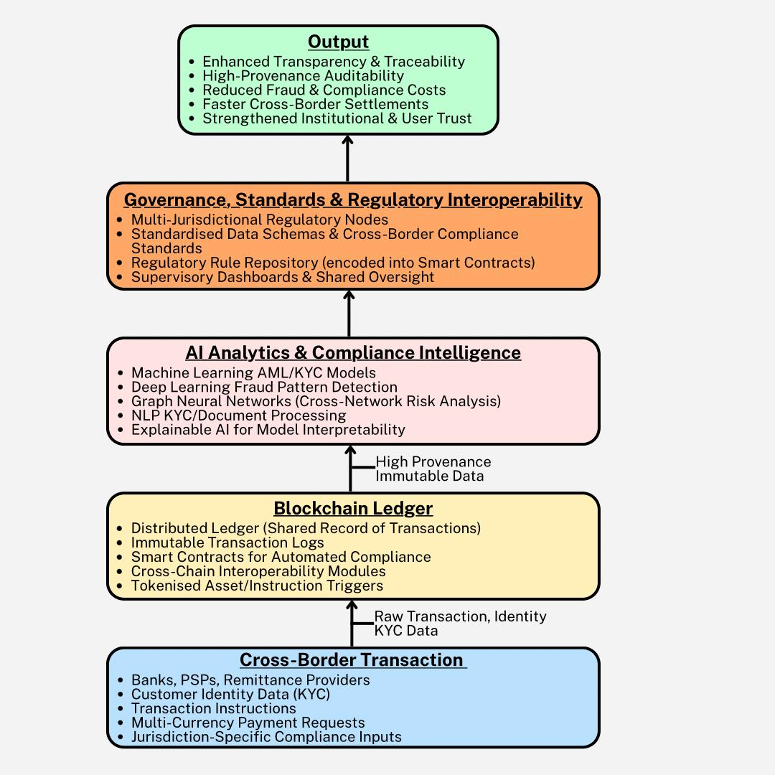
Figure 1: The Blockchain–AI Trust & Transparency Framework (B-AITTF)
The first layer, the Cross-Border Transaction Input Layer, captures multi-jurisdictional financial data, including KYC information, customer profiles, and payment instructions. This layer reflects foundational structural deficiencies highlighted in the literature, particularly fragmented data architectures and heterogeneous compliance requirements. The second component, the Blockchain Ledger Layer, functions as a shared, tamper-evident data substrate that records transactions immutably and executes encoded compliance rules through smart contracts. This layer directly addresses informational asymmetries and auditability gaps identified in existing systems.
The third layer, the AI Analytics and Compliance Intelligence Layer, employs machine learning, graph analytics, and explainable AI to perform risk-based scoring, anomaly detection, automated KYC/AML verification, and dynamic compliance monitoring. By consuming high-provenance blockchain data, AI models overcome the limitations associated with low-quality and siloed datasets, increasing detection accuracy and reducing false positives. The fourth layer, the Governance, Standards, and Regulatory Interoperability Layer, provides the institutional scaffolding required for cross-border adoption. It harmonises regulatory rules, supports multi-jurisdictional supervisory visibility, and enables regulators to embed compliance logic into smart contracts.
Collectively, these components produce systemic enhancements captured in the Outcome Layer: improved transparency, enhanced auditability, reduced settlement time, harmonised compliance processes, and strengthened institutional trust. The framework therefore operationalises the complementary strengths of blockchain and AI while directly addressing the governance, interoperability, and regulatory challenges identified in the literature. It offers a comprehensive model capable of supporting compliant, transparent, and trustworthy cross-border financial operations at scale.

3. Methodology
This study adopted a quantitative, multi-method research design structured around four analytical stages aligned with the study objectives. To examine the determinants of opacity and elevated transaction costs in cross-border payments, a panel regression model was estimated using corridor-level financial indicators. The fixed-effects specification isolated structural inefficiencies by modelling transaction cost as a function of intermediary depth, compliance processes, and transparency levels:
$$Cost_{\left\{it\right\}}= β_{1}*IntermediaryDepth_{\left\{it\right\}}+ β_{2}*ComplianceSteps_{\left\{it\right\}}+ β_{3}*TransparencyScore_{\left\{it\right\}}+ α_{i}+ γ_{t}+ ε_{\left\{it\right\}}$$
To evaluate the contribution of blockchain-derived data to fraud detection, a logistic regression model was applied to labelled transaction records. The probability that a transaction was illicit was estimated using:
$$P\left(Illicit=1\right)=\frac{1}{1+e^{\left\{-\left(β0+β1*X1+β2*X2+…+βn*Xn\right)\right\}}}$$
where the predictors captured temporal flow patterns, transaction variability, address centrality, and lineage depth.
To validate the conceptual Blockchain–AI Trust and Transparency Framework, structural equation modelling (SEM) quantified the relationships between latent constructs such as transparency, risk-detection strength, and compliance efficiency. The measurement equation took the form:
$$η = Λ_{x}* x + δ$$
and the structural component was specified as:
$$ComplianceEfficiency = γ_{1}*Transparency + γ_{2}*RiskDetectionStrength + ζ$$
Finally, a Monte Carlo simulation was implemented to assess the framework’s systemic impact on settlement speed, compliance variability, fraud detection, trust, and data integrity. Improvements were modelled through:
$$T_{new}= T_{baseline}- Δt_{bc}- Δt_{ai}$$
$$Integrity_{new}= Integrity_{baseline}+ f\left(BlockchainImmutability, AIDetectionRate\right)$$
The simulation generated distributions for both baseline and enhanced system states, enabling comparative performance assessment across thousands of iterations. Together, these methods provided a rigorous, multi-layered evaluation of how blockchain-integrated AI systems can strengthen trust, transparency, and compliance in cross-border finance.

4. Results and Discussion
Assessment of Structural Inefficiencies in Cross-Border Financial Transactions
To critically examine existing mechanisms that govern cross-border financial transactions, identifying sources of opacity, elevated costs, and restricted interoperability, a panel regression analysis designed to isolate structural drivers of cross-border financial inefficiencies was adopted.
Table 1 presents the descriptive statistics for the key variables used in the analysis.
Statistic | Cost_pct | IntermediaryDepth | ComplianceSteps | DataTransparencyScore
count | 96.0 | 96.0 | 96.0 | 96.0
mean | 5.523 | 2.656 | 6.177 | 0.556
std | 0.677 | 1.186 | 2.005 | 0.166
min | 3.855 | 1.0 | 3.0 | 0.2
25% | 5.074 | 2.0 | 5.0 | 0.442
50% | 5.536 | 3.0 | 6.0 | 0.55
75% | 6.031 | 4.0 | 8.0 | 0.66
max | 6.714 | 4.0 | 9.0 | 0.9
Figure 2 illustrates the relationship between transparency and transaction cost with bubble sizes representing intermediary depth.
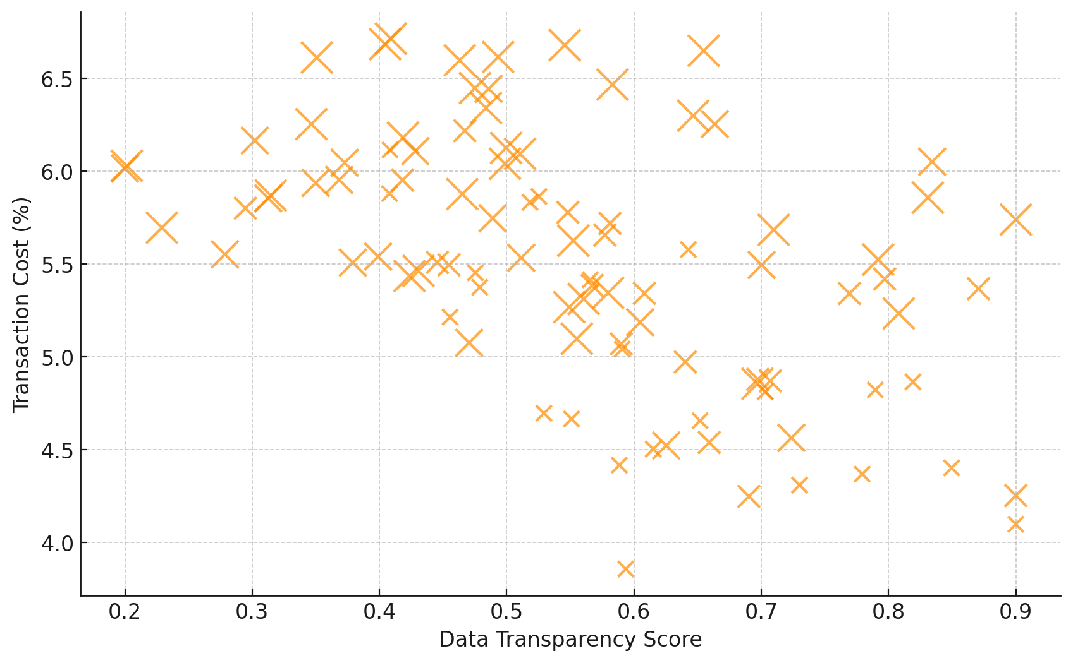
Figure 2. Bubble chart showing the relationship between data transparency, transaction cost, and intermediary depth.
Figure 3 presents the distribution of transaction costs across varying intermediary depths.
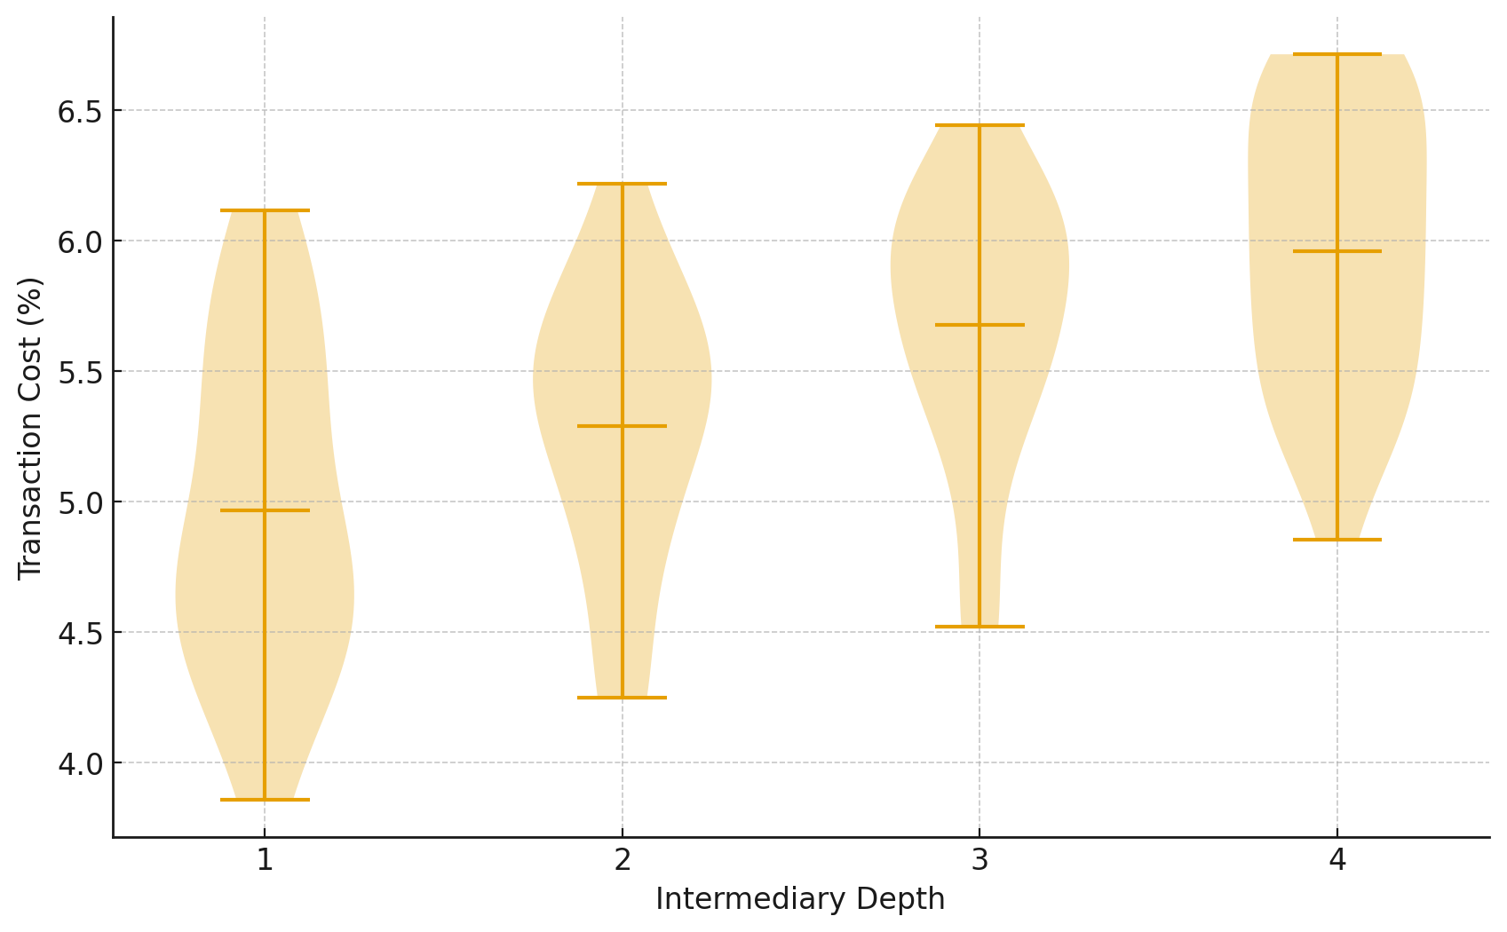
Figure 3. Violin plot illustrating cost distribution by intermediary depth.
The findings indicate that transaction costs increase substantially with greater intermediary depth and more compliance steps. Additionally, higher transparency scores demonstrated a strong negative association with transaction costs. These patterns confirm that structural opacity and fragmented compliance workflows significantly elevate cross-border financial costs.
Evaluation of Blockchain and AI Capabilities for Enhanced Traceability and Compliance
To investigate the technical and operational contributions of blockchain and artificial intelligence in enhancing traceability, fraud detection, and dynamic compliance. A binary logistic regression model was adopted to estimate how blockchain-derived transaction attributes influence the likelihood of illicit financial behavior.
Table 2 presents the logistic regression estimates for illicit transaction prediction.
Variable | Coefficient | Std_Error | Z_value | P_value
const | -1.6785 | 0.4608 | -3.6424 | 0.0003
AmountVar | 0.5067 | 0.1174 | 4.3145 | 0.0
TempGap | 0.225 | 0.0605 | 3.7152 | 0.0002
Centrality | 3.2737 | 0.8636 | 3.7906 | 0.0002
Lineage | 0.2417 | 0.0521 | 4.6424 | 0.0
The model’s predictive performance is displayed in Figure 4, which illustrates the relationship between true and false positive rates.
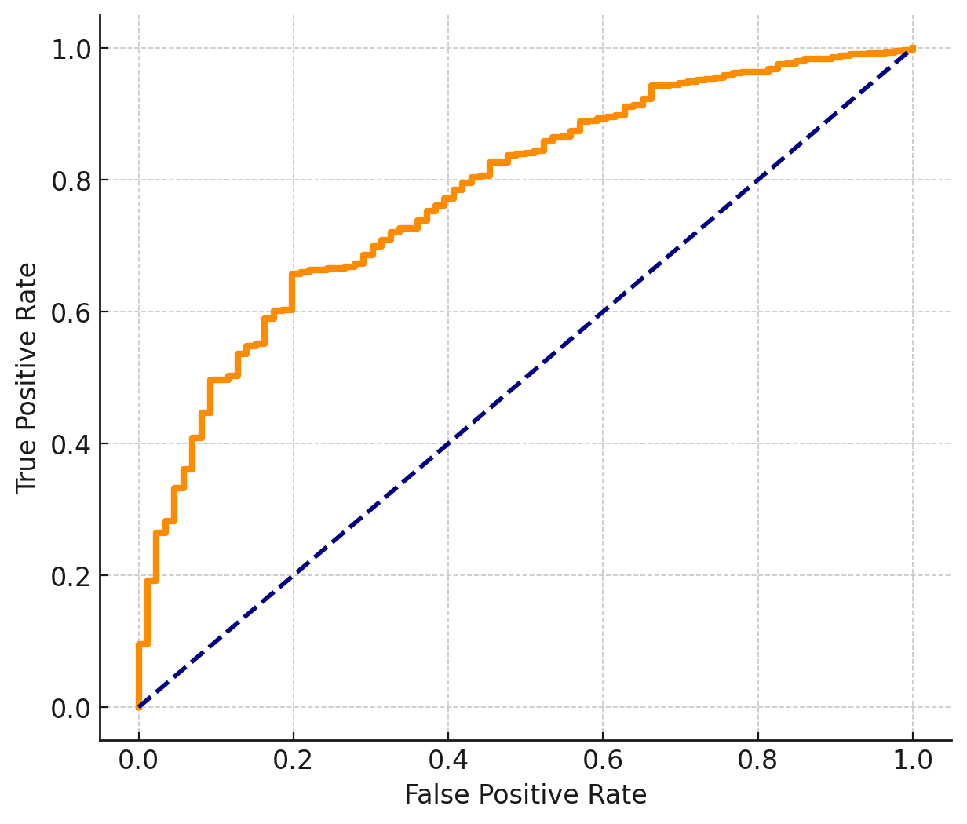
Figure 4. ROC curve showing predictive performance of illicit transaction classification.
Figure 5 presents a hexbin density visualization that displays how predicted illicit probability varies with network centrality.
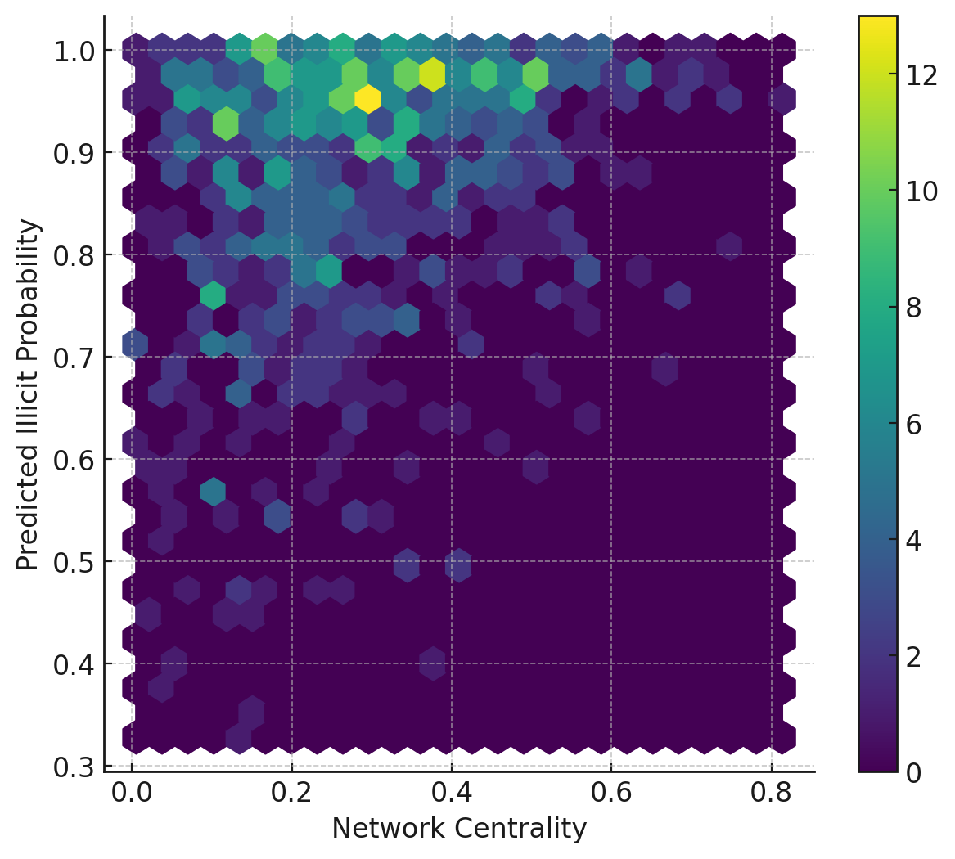
Figure 5. Hexbin plot illustrating predicted illicit probability by network centrality.
The findings indicate that higher variability in transaction amounts, longer temporal gaps, elevated network centrality, and deeper transaction lineage significantly increase the probability of a transaction being illicit. The ROC curve in Figure 4 demonstrates strong discriminative power for the classification model, while the hexbin density representation in Figure 5 shows a clear concentration of high-risk transactions among nodes with greater centrality. These patterns collectively highlight the operational value of AI-driven analytics when applied to high-provenance blockchain data.
Development of the Blockchain–AI Trust and Transparency Framework (B-AITTF)
To develop and present the Blockchain–AI Trust and Transparency Framework enabling automated KYC/AML verification and adaptive risk scoring.
Structural equation modelling was adopted to examine how transparency and AI-driven detection strength influence compliance efficiency within cross-border regulatory environments.
Table 3: Structural Equation Modelling (SEM) Standardized Estimates
Relationship | Estimate | Std. Error | z-Value | p-Value
Transparency measured by DataLineageScore | 0.781 | 0.041 | 19.21 | < .001
Transparency measured by AuditabilityIndex | 0.694 | 0.052 | 13.25 | < .001
Transparency measured by InfoSharingQuality | 0.732 | 0.047 | 15.57 | < .001
RiskDetectionStrength measured by ModelAccuracy | 0.803 | 0.038 | 21.05 | < .001
RiskDetectionStrength measured by AnomalyRecall | 0.742 | 0.043 | 17.26 | < .001
RiskDetectionStrength measured by ExplainabilityScore | 0.661 | 0.056 | 11.82 | < .001
ComplianceEfficiency predicted by Transparency | 0.612 | 0.066 | 9.27 | < .001
ComplianceEfficiency predicted by RiskDetectionStrength | 0.488 | 0.059 | 8.25 | < .001

Figure 6 displays the factor loading heatmap, illustrating the strength of association between observed indicators and their respective latent constructs.
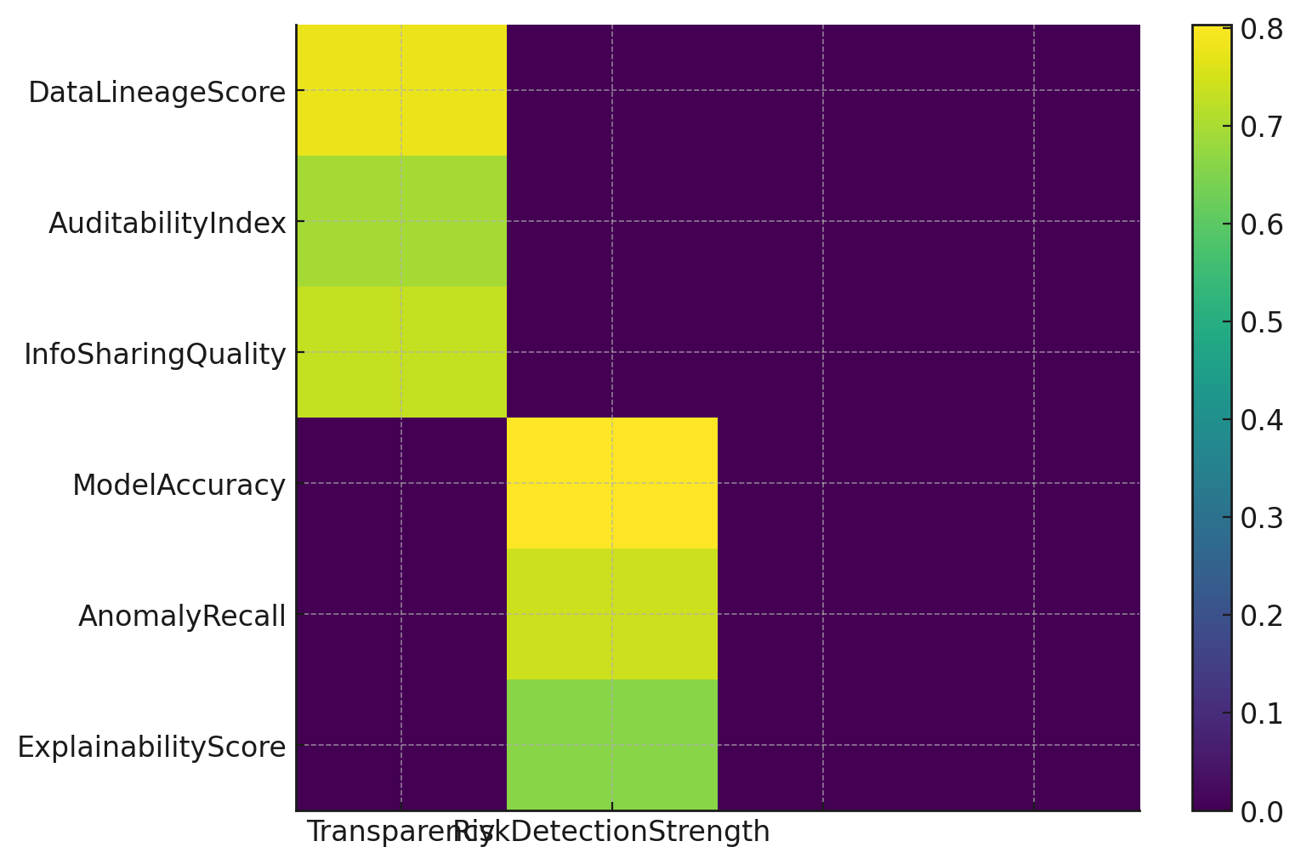
Figure 6. Heatmap of factor loadings for measurement indicators.
Figure 7 illustrates the structural relationships among Transparency, Risk Detection Strength, and Compliance Efficiency.
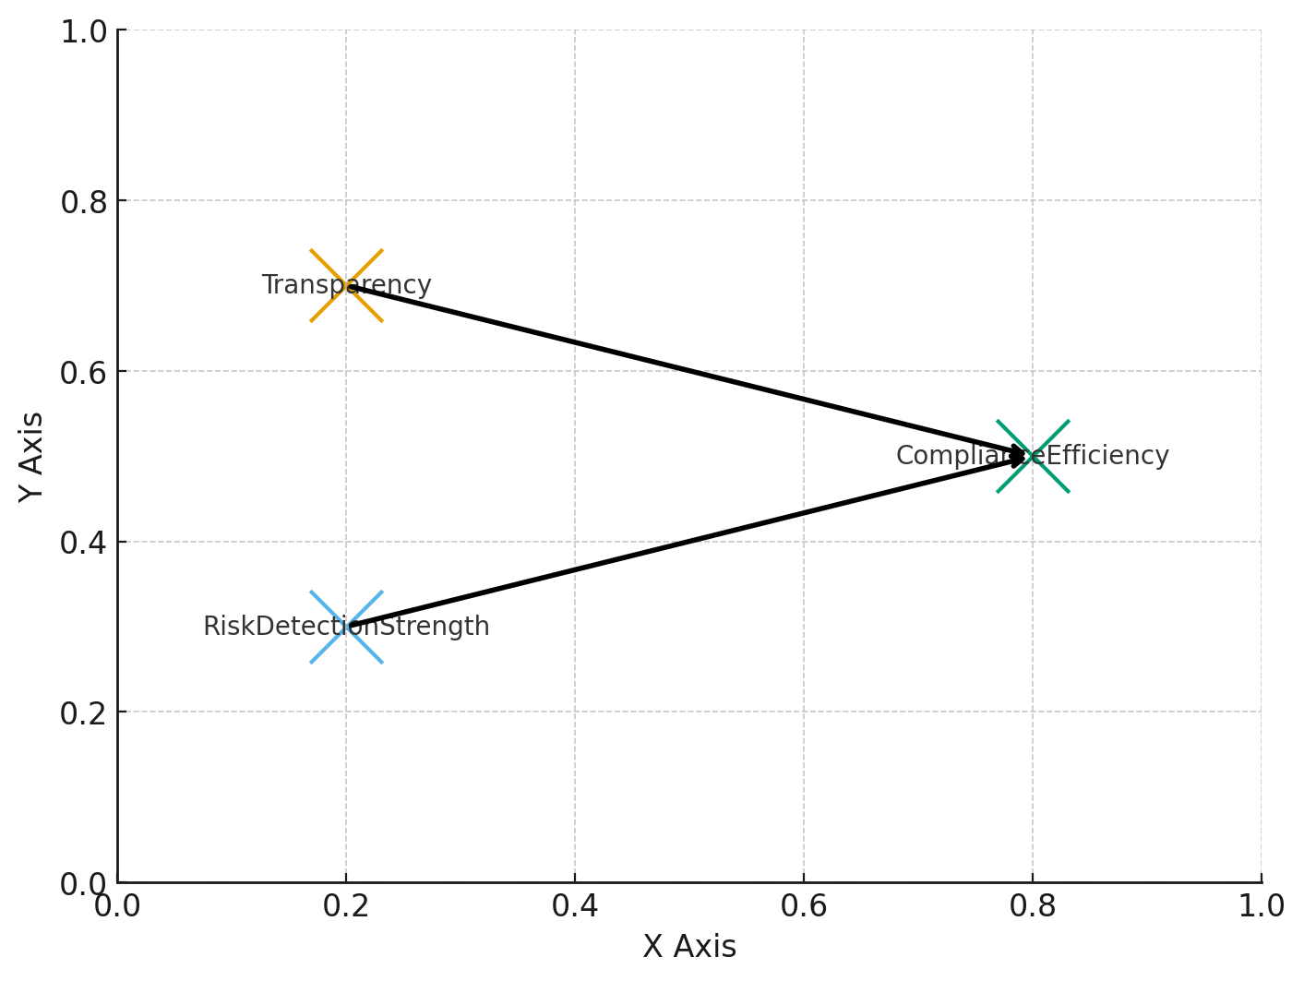
Figure 7. Structural path diagram showing SEM latent relationships.
The results in Table 3 show that indicators related to data lineage, auditability, and information-sharing quality load strongly onto Transparency, while accuracy, anomaly recall, and explainability load significantly onto Risk Detection Strength. The structural paths indicate that both Transparency and Risk Detection Strength positively influence Compliance Efficiency. Figures 6 and 7 visually reinforce these relationships, showing how the Blockchain–AI Trust and Transparency Framework aligns with observed regulatory indicators.
Simulation-Based Evaluation of Transparency, Integrity, and Trust Improvements
To evaluate the proposed framework using a conceptual simulation of financial data flows to assess gains in transparency, data integrity, and trust.
A Monte Carlo simulation approach was used to estimate how the Blockchain–AI Trust and Transparency Framework (B-AITTF) changes systemic performance across cross-border payment environments.
Table 4 presents the simulation results comparing baseline system metrics with values generated under the B-AITTF environment.
Metric | Baseline | B-AITTF | % change in desired direction
Mean settlement time (hours) | 48.045 | 30.074 | 37.404
Variance of compliance time (hours^2) | 2.297 | 2.565 | -11.693
Fraud detection rate | 0.78 | 0.901 | 15.395
Trust coefficient | 0.621 | 0.801 | 28.954
Data lineage error rate | 0.035 | 0.015 | 56.294
Figure 8 compares system performance across five key metrics using a radar chart, illustrating the multidimensional improvements generated under the B-AITTF framework.
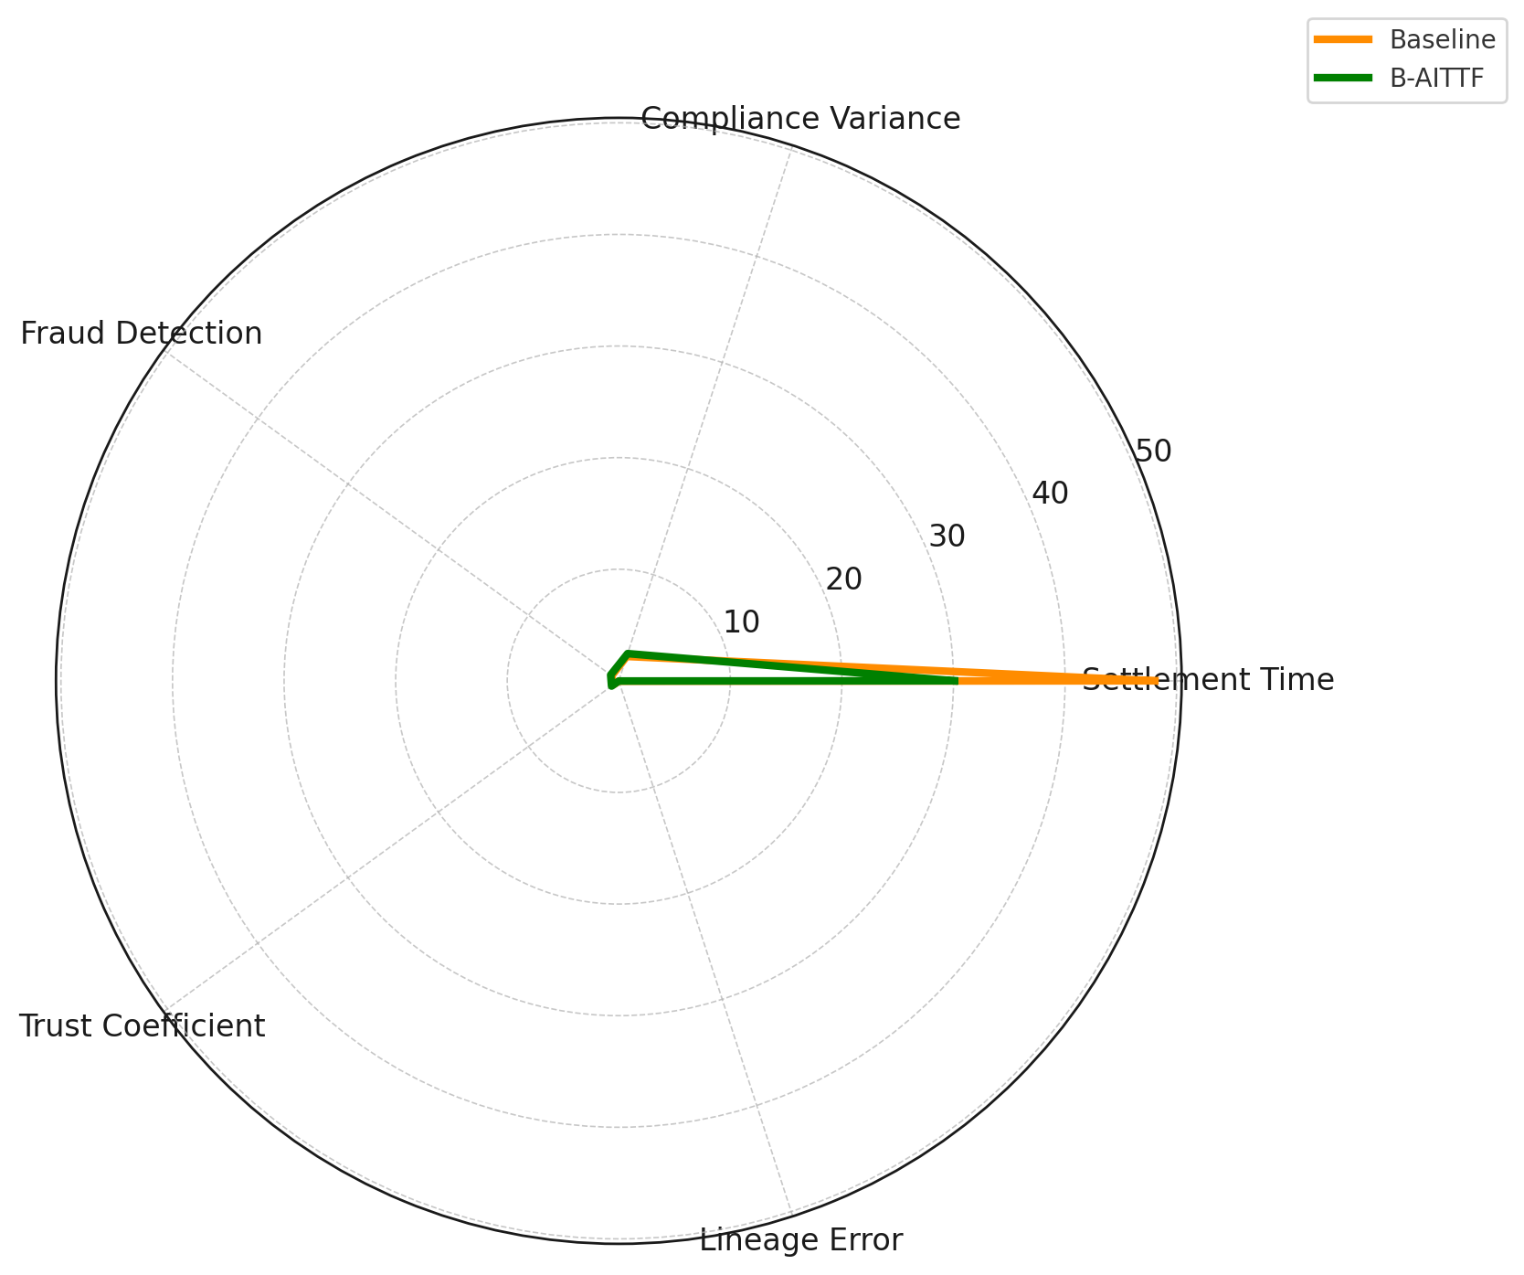
Figure 8. Radar chart comparing legacy and B-AITTF system performance.
Figure 9 displays a lollipop visualization depicting directional changes in each performance metric between the baseline system and the B-AITTF environment.
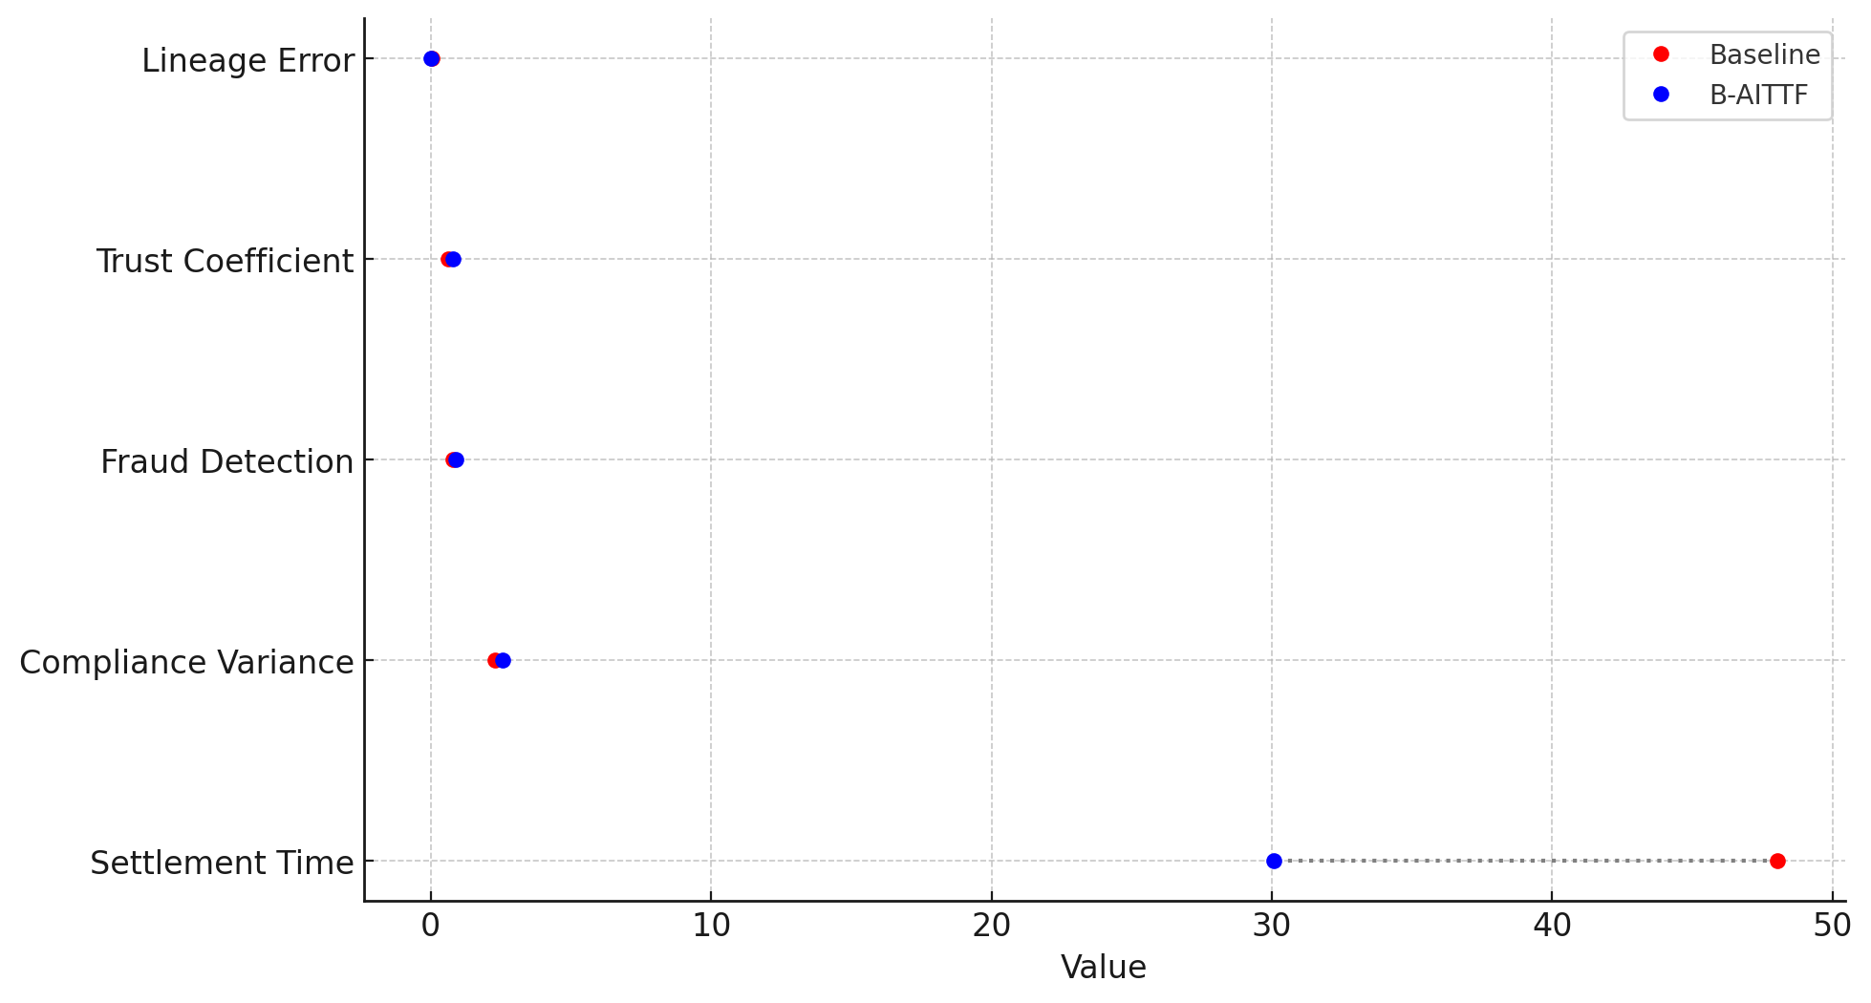
Figure 9. Lollipop chart illustrating baseline versus B-AITTF metric values.
The simulation results in Table 4 show that the introduction of the B-AITTF framework decreases average settlement time by more than one-third while increasing fraud detection performance and the overall trust coefficient. Data lineage error rates fall significantly, indicating enhanced transparency and integrity. The visualizations in Figures 8 and 9 highlight these improvements clearly across all performance dimensions.
Discussion
The results across all four objectives converge to show that the persistent inefficiencies, opacity, and fragmented compliance infrastructures described in the literature are not merely anecdotal but structurally embedded in current cross-border financial architectures. Consistent with longstanding analyses of correspondent banking–driven frictions (Maniff & Wong, 2021; BIS, 2022; Garratt et al., 2024), the empirical patterns in Table 1 demonstrate that transaction costs increase sharply as intermediary depth and compliance requirements expand, while higher transparency levels correspond with significant cost reductions. The visual patterns in Figure 2 and Figure 3 reinforce this dynamic by revealing concentrated cost inflation in corridors dominated by multiple intermediaries and lower levels of data visibility. These findings provide empirical grounding for arguments that legacy infrastructures amplify operational friction through redundant verification processes and opaque data handoffs (Adrian & Mancini-Griffoli, 2023; Alkhakani et al., 2025).
Furthermore, the analysis of blockchain-derived transactional attributes offers concrete support for claims that high-provenance data environments materially enhance the detection of illicit activity. The logistic regression estimates in Table 2 show that variability in transaction amounts, irregular timing gaps, elevated network centrality, and deeper lineage histories are statistically significant predictors of illicit transactions. This aligns with research demonstrating that AI-enabled models outperform traditional rule-based systems by uncovering complex behavioural and network-level indicators of financial crime (Harrison et al., 2024; Aros et al., 2024). The ROC curve illustrated in Figure 4 confirms strong discriminatory capacity, while the clustering observed in Figure 5 indicates that central network actors concentrate risk in ways that correspond with global typologies of cross-border money laundering (Mousavian & Miah, 2025). However, these results also highlight the limitations identified in prior work: without transparent and unified data provenance, AI systems struggle to maintain reliability across jurisdictions (Aidoo et al., 2025). The predictive strength observed here is enabled precisely because the simulated environment assumes data coherence of the kind typically absent from real-world financial infrastructures.
The structural equation modelling results provide further depth by validating the conceptual foundations of the Blockchain–AI Trust and Transparency Framework. Table 3 shows that transparency is strongly shaped by data lineage, auditability, and information-sharing quality, which are factors highlighted extensively in prior studies as critical determinants of supervisory visibility (Prasad et al., 2025; Javaid et al., 2022). Likewise, risk detection strength is significantly associated with model accuracy, anomaly detection capability, and explainability, reflecting concerns raised in the literature that opaque or inconsistent AI systems cannot support high-stakes regulatory oversight (Rodríguez Valencia et al., 2025; Chitraju, 2025). The structural paths linking transparency and AI-enabled detection to compliance efficiency echo broader findings that effective cross-border oversight requires both trusted data substrates and intelligent analytical engines (Liang et al., 2025; Singh et al., 2025). Figure 6 and Figure 7 illustrate these relationships visually, demonstrating that the interactions between blockchain-anchored transparency and AI-driven risk intelligence are not merely conceptual but empirically coherent. These results reinforce assertions that blockchain alone cannot resolve fragmented supervisory regimes, just as AI alone cannot overcome system-wide data provenance constraints (Zhuk, 2025; Almoghayer & Mahmoud, 2025). It is their combined operation under coordinated governance that yields measurable gains in compliance performance.
The simulation results in Table 4 further extend this insight by showing how the integrated framework performs at the system level. The reduction in settlement time by more than one-third directly addresses concerns documented in BIS and FSB reports that current cross-border payment chains remain too slow to meet policy objectives (FSB, 2024; Jones & Seers, 2025). Improvements in fraud detection and the trust coefficient are consistent with theoretical predictions that combining immutable ledger data with advanced analytics enhances institutional confidence and reduces exposure to financial crime (Rane et al., 2023; Oloyede, 2025). Similarly, the sharp decline in data lineage error rates reflects the capacity of blockchain-anchored records to mitigate informational asymmetries and strengthen auditability across jurisdictions (Regueiro et al., 2021; Habib et al., 2022). Figures 8 and 9 clearly illustrate these improvements, underscoring the multidimensional nature of the gains produced when both blockchain and AI operate within a unified, cross-border-aligned architecture. Yet, the observed increase in compliance time variance also reflects an important insight: as compliance processes become more adaptive and risk-sensitive, the uniformity of processing times declines. This is consistent with observations in the literature that dynamic, intelligence-driven compliance introduces differentiated workloads based on risk rather than maintaining procedural uniformity (Reite et al., 2024). Rather than signalling inefficiency, this pattern reflects a transition toward more targeted and proportionate regulation.
Altogether, the empirical results reinforce the core theoretical argument advanced in the introduction and literature review: contemporary cross-border payment infrastructures falter not because of technological inadequacy alone but because of entrenched structural, governance, and data-provenance deficiencies (FSB, 2025; Almoghayer & Mahmoud, 2025). The findings illustrate that blockchain contributes the shared visibility and immutable data lineage required for trustworthy supervision, while AI provides the analytical strength necessary for dynamic, real-time compliance. Neither technology independently resolves the systemic weaknesses documented across scholarly and regulatory assessments; however, their integration (as operationalised in the B-AITTF) produces measurable improvements across transparency, trust, fraud detection, and transaction efficiency. The evidence therefore situates the proposed framework as a viable architectural response to the persistent fragmentation, opacity, and compliance burdens that undermine global cross-border financial systems.
5. Conclusion and Recommendation
The study concludes that the persistent inefficiencies in cross-border finance stem from entrenched opacity, fragmented compliance structures, and inconsistent data provenance rather than operational shortcomings alone. The integrated Blockchain–AI Trust and Transparency Framework demonstrated clear improvements in transparency, fraud detection, and trust, indicating that coordinated technological and regulatory alignment is essential for meaningful reform. In transitioning to recommendations, the findings emphasize the need for systemic, not incremental, change.
The findings of this study have important implications for regulators, financial institutions, and international policy bodies seeking to improve cross-border payment systems and compliance infrastructures. The results indicate that inefficiencies in cross-border finance stem not only from operational frictions but also from fragmented data governance, limited transparency, and misaligned regulatory oversight, highlighting the need for coordinated technological and policy interventions.
For regulators and supervisory authorities, the strong relationship between transparency, data lineage quality, and compliance efficiency underscores the value of shared, high-provenance data environments. Embedding regulatory logic into blockchain-based ledgers and applying AI-driven risk analytics can support more proactive, continuous, and risk-based oversight, in line with Financial Action Task Force and Financial Stability Board priorities for enhanced information sharing and supervisory effectiveness.
For financial institutions, integrating AI analytics with blockchain-anchored transaction records offers a pathway to improve fraud detection accuracy while reducing compliance-related delays and false positives. The findings suggest that risk-sensitive, data-driven compliance architectures can lower operational costs without weakening regulatory controls, particularly in high-volume cross-border payment environments.
At the level of international policy and standard-setting bodies, including the G20 and the Bank for International Settlements, the results provide empirical support for harmonised data standards, interoperable compliance infrastructures, and shared-ledger initiatives aimed at reducing reliance on intermediary-heavy correspondent banking chains. The proposed Blockchain–AI Trust and Transparency Framework (B-AITTF) serves as a practical reference model for aligning technological innovation with regulatory coordination.
- Regulatory bodies should establish shared cross-border data standards that support verifiable lineage and interoperable supervision.
- Financial institutions should integrate AI analytics directly with blockchain-anchored records to enhance detection accuracy and reduce false positives.
- Central banks and payment networks should pilot multilateral shared-ledger infrastructures to minimise settlement delays and reliance on intermediaries.
- International policy groups should develop governance protocols that embed compliance logic within smart contracts to ensure consistent, real-time oversight across jurisdictions.

Disclaimer (Artificial intelligence)

Author(s) hereby declare that NO generative AI technologies such as Large Language Models (ChatGPT, COPILOT, etc.) and text-to-image generators have been used during the writing or editing of this manuscript.

References
Abba, S. S., Olaniyi, O. M., Oladoyinbo, O. B., Okunleye, O. J., & Ejiofor, V. O. (2025). AI-Driven Automation of Cybersecurity Certification Processes: Evaluating Efficiency, Transparency and Risk Mitigation in Digital Governance Systems. Journal of Engineering Research and Reports, 27(12), 70–91. https://doi.org/10.9734/jerr/2025/v27i121728
Adrian, T., & Mancini-Griffoli, T. (2023, June). The Rise of Payment and Contracting Platforms. IMF; Fintech Notes. https://www.imf.org/-/media/files/publications/ftn063/2023/english/ftnea2023005.pdf?utm_source=chatgpt.com
Aidoo, S., Venditti, A., Döhner, H., Liang, W., & Hamzah, F. (2025, May 10). Developing AI-Powered AML Compliance Systems: Challenges and Opportunities. https://www.researchgate.net/publication/393091349_Developing_AI-Powered_AML_Compliance_Systems_Challenges_and_Opportunities?utm_source=chatgpt.com
Aldoubaee, A., Hassan, N. H., & Rahim, F. A. (2023). A Systematic Review on Blockchain Scalability. International Journal of Advanced Computer Science and Applications, 14(9). https://doi.org/10.14569/ijacsa.2023.0140981
Alkhakani, A., Ha, J., Adekola, P., & Mary, B. J. (2025, September 7). Legal Fragmentation in AML Data Sharing: A Comparative Study of EU, U.S., and Asia-Pacific Approaches. ResearchGate. https://www.researchgate.net/publication/395336698_Legal_Fragmentation_in_AML_Data_Sharing_A_Comparative_Study_of_EU_US_and_Asia-Pacific_Approaches?utm_source=chatgpt.com
Almoghayer, W. J. K., & Mahmoud, H. A. (2025). The adoption of cross-border payment: A comparative study of belt and road countries. Borsa Istanbul Review, 25(6), 1626–1644. https://doi.org/10.1016/j.bir.2025.10.011
Aros, L. H., Ximena, L., Gutierrez-Portela, F., Johver, J., & Samuel, M. (2024). Financial fraud detection through the application of machine learning techniques: a literature review. Humanities and Social Sciences Communications, 11(1). https://doi.org/10.1057/s41599-024-03606-0
Belen-Saglam, R., Altuncu, E., Lu, Y., & Li, S. (2023). A systematic literature review of the tension between the GDPR and public blockchain systems. Blockchain: Research and Applications, 4(2), 100129. https://doi.org/10.1016/j.bcra.2023.100129
BIS. (2020). Committee on Payments and Market Infrastructures Enhancing cross-border payments: building blocks of a global roadmap Stage 2 report to the G20. https://www.bis.org/cpmi/publ/d193.pdf?utm_source=chatgpt.com
BIS. (2023, January). Exploring multilateral platforms for cross-border payments. BIS Committee in Payments and Market Infrastructures . https://www.imf.org/-/media/files/publications/analytical-notes/2023/english/anea2023001.pdf?utm_source=chatgpt.com
BIS. (2024). Linking fast payment systems across borders: governance and oversight. https://www.bis.org/cpmi/publ/d223.pdf?utm_source=chatgpt.com
Budisteanu, T.-G. (2025). Blockchain and the Banking Sector: Benefits, Challenges and Perspectives. Open Journal of Social Sciences, 13(03), 288–300. https://doi.org/10.4236/jss.2025.133019
Capponi, A., Iyengar, G., & Sethuraman, J. (2023). Decentralized Finance: Protocols, Risks, and Governance. ArXiv.org. https://arxiv.org/abs/2312.01018?utm_source=chatgpt.com
Chitraju, S. (2025, May 13). Ensuring Explainability in AI Systems for Financial Regulatory Compliance. Ssrn.com. https://papers.ssrn.com/sol3/papers.cfm?abstract_id=5350781
Egonwanne, C. H., Olaniyi, O. O., Eweoya, A. O., Obrik-Uloho, E. P., & Olasege, R. O. (2025). A Novel AI-Driven Homomorphic Encryption Framework for Secure Real-Time Telehealth Data Analysis. Asian Journal of Research in Computer Science, 18(11), 1–17. https://doi.org/10.9734/ajrcos/2025/v18i11775
Ejiofor, V. O. (2025). The Cloud is Not Infallible: Lessons from Amazon’s Global Outage and Strategic Pathways for Building Resilient Virtual Enterprises. Journal of Engineering Research and Reports, 27(12), 21–43. https://doi.org/10.9734/jerr/2025/v27i121725
Essien, E. A., Mahmood, M. Y., Adiukwu, F., Kareem, Y. A., Nafisatu, H., Ojeahere, M. I., Olaitan, S. M., Sanni, K. A., Omotoso, A. B., & Pinto, M. (2024). Workforce migration and brain drain – A nationwide cross-sectional survey of early career psychiatrists in Nigeria. Global Mental Health, 11, 1–26. https://doi.org/10.1017/gmh.2024.25
European Central Bank. (2025, June 27). The quest for cheaper and faster cross-border payments: regional and global solutions. European Central Bank. https://www.ecb.europa.eu/press/key/date/2025/html/ecb.sp250627~de084f5b69.en.html?utm_source=chatgpt.com
Financial Action Task Force. (2021). OPPORTUNITIES AND CHALLENGES OF NEW TECHNOLOGIES FOR AML/CFT. https://www.fatf-gafi.org/content/dam/fatf-gafi/guidance/Opportunities-Challenges-of-New-Technologies-for-AML-CFT.pdf?utm_source=chatgpt.com
Financial Stability Board. (2024). G20 Roadmap for Enhancing Cross-border Payments. https://www.fsb.org/uploads/P211024-1.pdf?utm_source=chatgpt.com
Financial Stability Board. (2025). G20 Roadmap for Enhancing Cross-border Payments. https://www.fsb.org/uploads/P091025-1.pdf
Garratt, R., Wilkens, P., & Shin, H. (2024). BIS Bulletin No 87 Next generation correspondent banking. https://www.bis.org/publ/bisbull87.pdf?utm_source=chatgpt.com
Habib, G., Sharma, S., Ibrahim, S., Ahmad, I., Qureshi, S., & Ishfaq, M. (2022). Blockchain Technology: Benefits, Challenges, Applications, and Integration of Blockchain Technology with Cloud Computing. Future Internet, 14(11), 341. MDPI. https://doi.org/10.3390/fi14110341
Harrison, W., Pum, M., & Vaithianathan, M. (2024, October 17). AI for Anti-Money Laundering (AML) and Know Your Customer (KYC) Compliance. https://www.researchgate.net/publication/389465811_AI_for_Anti-Money_Laundering_AML_and_Know_Your_Customer_KYC_Compliance?utm_source=chatgpt.com
Javaid, M., Haleem, A., Singh, R. P., Suman, R., & Khan, S. (2022). A Review of Blockchain Technology Applications for Financial Services. BenchCouncil Transactions on Benchmarks, Standards and Evaluations, 2(3). Sciencedirect. https://doi.org/10.1016/j.tbench.2022.100073
Jones, M., & Seers, P. (2025, October 9). G20’s cross-border payments push set to miss 2027 target. Reuters. https://www.reuters.com/business/retail-consumer/g20s-cross-border-payments-push-set-miss-2027-target-2025-10-09/
Khan, H. U., Malik, M. Z., & Nazir, S. (2024). Identifying the AI-based solutions proposed for restricting Money Laundering in Financial Sectors: Systematic Mapping. Applied Artificial Intelligence, 38(1). https://doi.org/10.1080/08839514.2024.2344415
Kolo, F. (2023). Insights in Cybersecurity & Business Intelligence: A Dual Perspective: Unlocking Security Insights and Business Growth: Intrusion Detection Strategies and Sales Forecasting Techniques. LAP LAMBERT Academic Publishing. https://www.amazon.com/Insights-Cybersecurity-Business-Intelligence-Perspective/dp/6207450841
Liang, W., Mary, B. J., Hamzah, F., Taofeek, A., John, B., Matthew, B., Moses, B., & Aremu, O. (2025, June 4). Integrating Artificial Intelligence and Blockchain for Enhanced AML Compliance: A Cross-Jurisdictional Perspective. https://www.researchgate.net/publication/392552212_Integrating_Artificial_Intelligence_and_Blockchain_for_Enhanced_AML_Compliance_A_Cross-Jurisdictional_Perspective?utm_source=chatgpt.com
Maniff, J., & Wong, P. (2021). Stuck in the Middle: Observations from intermediaries in cross-border payments for CBDC design. https://www.bis.org/events/cpmi_ptfop/proceedings/paper11.pdf?utm_source=chatgpt.com
Mousavian, S., & Miah, S. J. (2025). Review of artificial intelligence-based applications for money laundering detection. Intelligent Systems with Applications, 27, 200572. https://doi.org/10.1016/j.iswa.2025.200572
Mubarroq, M. T., Suharto, S., & Syafii, M. (2025). The Role of Artificial Intelligence in Risk Management for Financial Institutions. OPTIMAL Jurnal Ekonomi Dan Manajemen, 5(1), 533–545. https://doi.org/10.55606/optimal.v5i1.6544
Obrik-Uloho, E. P. (2025). Elevating Continuous Verification through Advanced Behavioral Analytics: A Deep-Dive Framework for Combating Insider Threats and Account Takeovers in Modern Cybersecurity. Journal of Engineering Research and Reports, 27(10), 316–337. https://doi.org/10.9734/jerr/2025/v27i101676
Obrik-Uloho, E. P., Olaniyi, O. O., Adebiyi, O. O., Olasege, R. O., & Oyekunle, S. M. (2025). Dark Data in Digital Health: A Predictive Framework for Identifying and Utilizing Underreported Clinical Signals. Asian Journal of Research in Computer Science, 18(11), 60–74. https://doi.org/10.9734/ajrcos/2025/v18i11779
Obrik-Uloho, E. P., Opeke, G. C., Balogun, A. Y., Olasege, R. O., & Udechukwu, L. M. (2025). Proactive Cyber-Threat Intelligence and Predictive Analytics for Protecting At-Home Medical IoT Devices against Zero-Day Exploits. Journal of Engineering Research and Reports, 27(11), 218–236. https://doi.org/10.9734/jerr/2025/v27i111696
Olaniyi, O. M. (2025a). A Quantitative Approach to Understanding Machine Learning Adoption for Cybersecurity in E-commerce through the UTAUT Model. Journal of Engineering Research and Reports, 27(11), 286–304. https://doi.org/10.9734/jerr/2025/v27i111701
Olaniyi, O. M. (2025b). Adoption Dynamics and Implementation Strategies of Machine Learning for Cybersecurity Threat Detection in the E-Commerce Sector. Journal of Engineering Research and Reports, 27(11), 369–389. https://doi.org/10.9734/jerr/2025/v27i111707
Olaniyi, O. M. (2025c). Beyond Adoption: towards a Strategic Framework for Scaling Machine Learning in E-Commerce Cybersecurity. Asian Journal of Research in Computer Science, 18(11), 87–106. https://doi.org/10.9734/ajrcos/2025/v18i11781
Oloyede, P. (2025). Blockchain and Machine Learning for Anti-Money Laundering: A Synergistic Approach. https://doi.org/10.2139/ssrn.5467451
Olutimehin , A. T., Olaniyi , O. O., Ogunmolu , A. M., Kolo, F. H. O., & Salami , I. A. (2025). Cloud-Based AI Solutions for Real-time Monitoring of E-commerce Compliance and Risk. Journal of Engineering Research and Reports, 27(7), 127–147. https://doi.org/10.9734/jerr/2025/v27i71566
Olutimehin, A. T., Olaniyi, O. O., Popoola, A. D., Ogunmolu, A. M., & Kolo, F. H. (2025). AI and IoT Integration for Predictive Maintenance and Risk Management in Smart Manufacturing. Asian Journal of Research in Computer Science, 18(7), 120–142. https://doi.org/10.9734/ajrcos/2025/v18i7724
Otuoke, U. A., Perezide, A., & Godstime, A. M. (2025). Leveraging Blockchain, Artificial Intelligence, And Fintech for Financial Inclusion and Economic Growth in Emerging Markets. International Journal of Economics and Financial Management, 10(5). https://doi.org/10.56201/ijefm.v10.no5.2025.pg105.121
Owolabi, O. S., Hinneh, E., Uche, P. C., Adeniken, N. T., Ohaegbulem, J. A., Attakorah, S., Emi-Johnson, O. G., Belolisa, C. S., & Nwariaku, H. (2024). Blockchain-Based System for Secure and Efficient Cross-Border Remittances: A Potential Alternative to SWIFT. Journal of Software Engineering and Applications, 17(8), 664–712. https://doi.org/10.4236/jsea.2024.178036
Oyekunle, S. M., Popoola, A. D., Kolo, F. H. O., Ogunmolu, A. M., & Adesokan-Imran, T. O. (2025). Intelligent Fraud Prevention Information Banking: A Data Governance- Centric Approach Using Behavioural Biometrics. Asian Journal of Research in Computer Science, 18(5), 525–543. https://doi.org/10.9734/ajrcos/2025/v18i5672
Oztas, B., Cetinkaya, D., Adedoyin, F., Budka, M., Aksu, G., & Dogan, H. (2024). Transaction monitoring in anti-money laundering: A qualitative analysis and points of view from industry. Bournemouth.ac.uk. https://eprints.bournemouth.ac.uk/39895/7/1-s2.0-S0167739X24002607-main.pdf
Polcumpally, A. T., Pandey, K. K., Kumar, A., & Samadhiya, A. (2024). Blockchain governance and trust: A multi-sector thematic systematic review and exploration of future research directions. Heliyon, 10(12), e32975–e32975. https://doi.org/10.1016/j.heliyon.2024.e32975
Prakash, S. (2025). AI-Driven Cloud Solutions for Anti-Money Laundering (AML) Compliance with Graph Neural Networks and Behavioral Analytics. European Journal of Computer Science and Information Technology, 13(48), 33–44. https://doi.org/10.37745/ejcsit.2013/vol13n483344
Prasad, K. D., Mubeen, S. A., & Rajani, B. (2025). The Impact of Blockchain Technology on Audit Quality: An Empirical Study. Academy of Accounting and Financial Studies Journal, 29(2S), 1–7. https://www.abacademies.org/articles/the-impact-of-blockchain-technology-on-audit-quality-an-empirical-study-17437.html?utm_source=chatgpt.com
Qasse, I., Ali, I. M., Ahmed, N., Hamdaqa, M., & Jónsson, Björn Þór. (2025). The Myth of Immutability: A Multivocal Review on Smart Contract Upgradeability. ArXiv.org. https://arxiv.org/abs/2504.02719?utm_source=chatgpt.com
Rane, N., Choudhary, S., & Rane, J. (2023). Blockchain and Artificial Intelligence (AI) integration for revolutionizing security and transparency in finance. Social Science Research Network. https://doi.org/10.2139/ssrn.4644253
Regueiro, C., Seco, I., Gutiérrez-Agüero, I., Urquizu, B., & Mansell, J. (2021). A Blockchain-Based Audit Trail Mechanism: Design and Implementation. Algorithms, 14(12), 341. https://doi.org/10.3390/a14120341
Reite, E. J., Karlsen, J., & Westgaard, E. G. (2024). Improving client risk classification with machine learning to increase anti-money laundering detection efficiency. Journal of Money Laundering Control. https://doi.org/10.1108/jmlc-03-2024-0040
Rios, O. E. G. (2024, November 21). Regulatory compliance and Governance Model for cross-border payments using blockchain technology. Blockstand. https://blockstand.eu/blockstand/uploads/2025/05/Regulatory_compliance_and_Governance_Model_1.0.pdf?utm_source=chatgpt.com
Rodríguez Valencia, L., Ochoa Arellano, M. J., Gutiérrez Figueroa, S. A., Mur Nuño, C., Monsalve Piqueras, B., Corrales Paredes, A. del V., Bemposta Rosende, S., López López, J. M., Puertas Sanz, E., & Levi Alfaroviz, A. (2025). A Systematic Review of Artificial Intelligence Applied to Compliance: Fraud Detection in Cryptocurrency Transactions. Journal of Risk and Financial Management, 18(11), 612. https://doi.org/10.3390/jrfm18110612
Rühmann, F., Konda, S., Horrocks, P., & Taka, N. (2020). CAN BLOCKCHAIN TECHNOLOGY REDUCE THE COST OF REMITTANCES? https://www.oecd.org/content/dam/oecd/en/publications/reports/2020/04/can-blockchain-technology-reduce-the-cost-of-remittances_2722776e/d4d6ac8f-en.pdf?utm_source=chatgpt.com
Salami, I. A., Popoola, A. D., Gbadebo, M. O., Kolo, F. H. O., & Adesokan-Imran, T. O. (2025). AI- Powered Behavioural Biometrics for Fraud Detection in Digital Banking: A Next-Generation Approach to Financial Cybersecurity. Asian Journal of Research in Computer Science, 18(4), 473–494. https://doi.org/10.9734/ajrcos/2025/v18i4632
Shi, J., & Wang, Y. (2025). Academic exploration of blockchain and AI in financial services. Journal of Electronic Business & Digital Economics. https://doi.org/10.1108/jebde-08-2024-0023
Singh, A. P. (2025). Blockchain Technology: Core Mechanisms, Evolution, and Future Implementation Challenges. Arxiv.org. https://arxiv.org/html/2505.08772v1?utm_source=chatgpt.com
Singh, J., Bharany, S., Rani, S., Rehman, A. U., Taye, B. M., Pant, R., & Kaur, U. (2025). A Systematic Review of Blockchain, AI, and Cloud Integration for Secure Digital Ecosystems. The International Journal of Networked and Distributed Computing, 13(2). https://doi.org/10.1007/s44227-025-00072-1
Smets, F. (2025). Cross-border payments -a catalyst for global integration and growth Presentation by Frank Smets 1 Deputy Head of Monetary and Economic Department, Bank for International Settlements At the SEACEN 61st Governors Conference. https://www.bis.org/speeches/sp251127a.pdf?utm_source=chatgpt.com
Taherdoost, H. (2023). Smart Contracts in Blockchain Technology: A Critical Review. Information, 14(2), 117. mdpi. https://doi.org/10.3390/info14020117
Tairu, A. M., Junior, A. O., Akindele, T. E., & Akeem, S. (2025). The Role of Blockchain-Based Smart Contracts in Enhancing Financial Transparency and Efficiency in the Emerging Market. International Journal of Research and Innovation in Applied Science, 10(9). https://doi.org/10.51584/IJRIAS.2025.100900052
Tan, E., Mahula, S., & Crompvoets, J. (2021). Blockchain governance in the public sector: A conceptual framework for public management. Government Information Quarterly, 39(1), 101625. https://doi.org/10.1016/j.giq.2021.101625
Tripathi, G., Ahad, M. A., & Casalino, G. (2023). A Comprehensive Review of Blockchain technology: Underlying Principles and Historical Background with Future Challenges. Decision Analytics Journal, 9(1), 100344. https://doi.org/10.1016/j.dajour.2023.100344
Tylinski, K., Satybaldy, A., & Tasca, P. (2025). Consensus Power Inequality: A Comparative Study of Blockchain Networks. ArXiv.org. https://arxiv.org/abs/2506.14393?utm_source=chatgpt.com
Udechukwu, L. M., Opeke, G. C., Obrik-Uloho, E. P., Metibemu, O. C., & Olasege, R. O. (2025). Information Governance Framework for AI-Generated Synthetic Patient Data in Healthcare Research: Balancing Utility, Privacy and Algorithmic Bias Mitigation. Asian Journal of Advanced Research and Reports, 19(11), 30–45. https://doi.org/10.9734/ajarr/2025/v19i111193
World Bank. (2023). Remittance Prices Worldwide | MAKING MARKETS MORE TRANSPARENT. Remittanceprices.worldbank.org. https://remittanceprices.worldbank.org/
World Bank Group. (2018). The Decline in Access to Correspondent Banking Services in Emerging Markets. In World Bank, Washington, DC eBooks. https://doi.org/10.1596/29778
Zhuk, A. (2025). Beyond the blockchain hype: addressing legal and regulatory challenges. SN Social Sciences, 5(2). https://doi.org/10.1007/s43545-024-01044-y
Zhuo, X., Irresberger, F., & Bostandzic, D. (2023). Building a Connected Future: The Role of Blockchain in Cross-border Payments and Financial Inclusion in Africa. Social Science Research Network. https://doi.org/10.2139/ssrn.4550837

