COLLAB-LLM: A Communication-Centric Role-Based Framework for Scalable Multi-Agent LLM Collaboration

Abstract
Large Language Models (LLMs) are increasingly deployed in multi-agent systems, yet contemporary frameworks struggle with communication ambiguity, coordination failures, and limited scalability. This research introduces COLLAB-LLM, a communication-centric, role-based framework designed to enhance collaborative intelligence among LLM agents. The framework integrates a structured communication protocol, a hierarchical role architecture, and a dynamic distributed task-graph engine to enable reliable coordination, efficient negotiation, and adaptive task execution. Through extensive evaluation across 120+ complex tasks—including software engineering, business process automation, and scientific research synthesis—COLLAB-LLM achieves an 89% overall success rate, surpassing four state-of-the-art multi-agent baselines with statistically significant improvements in performance, communication efficiency, and robustness. The results demonstrate that structured communication and role specialization substantially reduce ambiguity, improve collaboration quality, and support scalable team configurations up to eight agents. This work establishes foundational principles for building high-performing collaborative AI systems and provides a practical pathway toward scalable, human-aligned multi-agent LLM architectures. We evaluate COLLAB-LLM on over 120 multi-step tasks spanning software engineering, business process automation, and research synthesis. Task success is defined using task-specific completion criteria, with a task considered successful if the aggregate completion score exceeds 0.8. All compared frameworks are evaluated using the same underlying LLM configuration to ensure fairness. Experimental artifacts, task definitions, prompts, and scoring scripts will be released to support reproducibility.
Keywords
Multi-Agent Systems; Large Language Models; Collaborative AI; Role-Based Agents; Communication Protocols; Distributed Task Graphs; Negotiation Frameworks; Autonomous Agents; Scalable AI Systems; Human-AI Collaboration.

Introduction

1.1 Background and Motivation
The rapid evolution of Large Language Models (LLMs) has fundamentally reshaped the landscape of artificial intelligence, enabling machines to interpret and generate human language with unprecedented fluency. While early applications relied on LLMs as isolated tools for tasks such as translation, summarization, and question answering, recent developments have transformed them into autonomous agents capable of executing complex, multi-step decision-making processes (Wang et al., 2023). As the demand for sophisticated, real-world automation grows, the limitations of single-agent systems have become increasingly visible. Complex tasks—much like those addressed by human organizations—require cooperation, specialization, and coordinated action, capabilities that extend beyond the reach of individual agents.
The rise of multi-agent systems represents a natural progression in AI’s development, aligning with Minsky’s “society of mind” perspective (1986), which posits that intelligent behavior emerges from the interaction of specialized components. Contemporary studies support this view: multi-agent systems demonstrate enhanced problem-solving through distributed reasoning, division of labor, and role specialization (Hong et al., 2023; Li et al., 2023). However, despite these promising outcomes, existing LLM-based multi-agent frameworks face critical challenges in communication efficiency, coordination stability, and scalability.
Several pioneering efforts illustrate the growing momentum in this field. AutoGen (Wu et al., 2023) facilitates conversational interactions among multiple LLM-based agents, while Park et al. (2023) demonstrated emergent social behaviors in generative agent simulations. ChatDev (Qian et al., 2023) applied multi-agent principles to software engineering workflows. Yet, these systems predominantly rely on unstructured natural language exchanges, which lead to verbose communication, ambiguous interpretation, and coordination breakdown problems that intensify as task complexity and team size increase (Albaroudi et al.,2025).
This persistent gap underscores the need for a more principled approach to multi-agent collaboration. Creating communication protocols, negotiation mechanisms, and organizational structures that enable LLM agents to collaborate with the coherence and robustness of human teams is essential for advancing autonomous AI. This research responds to this need by proposing a structured, communication-centric framework designed to unlock the full potential of collaborative LLM-based agents for large-scale, real-world tasks.
Recent domain-specific studies reinforce the importance of structured, trustworthy AI systems, particularly in areas such as hiring fairness, healthcare, and national digital transformation initiatives (Albaroudi, 2024; Albaroudi & Mansouri, 2024; Albaroudi et al., 2025).

1.2 Problem Statement
Despite substantial progress in LLM-driven agent systems, current multi-agent architectures exhibit significant limitations that impede their effectiveness in complex and large-scale scenarios:
Communication Inefficiency: Existing systems depend on unconstrained natural language dialogue, resulting in excessive verbosity, redundant information exchange, and ambiguous instructions. These factors increase computational overhead and elevate the likelihood of task execution errors (Li et al., 2023).
Coordination Instability: Without explicit rules governing collaboration, agents frequently diverge in their objectives, duplicate efforts, or lose shared context over long task horizons. These coordination failures reflect early challenges in distributed robotics but are amplified by the linguistic modality of LLM communication.
Lack of Negotiation Mechanisms: Current frameworks rarely include formal processes for resolving conflicting ideas or priorities. Agents often default to centralized decision-making or engage in circular debates without convergence, undermining system stability and performance.
Poor Scalability: As task complexity and team size increase, performance deteriorates non-linearly. The absence of hierarchical organization, dynamic role assignment, and adaptive resource allocation prevents effective scaling beyond simple collaborations.
Limited Evaluation Methodologies: The field lacks standardized benchmarks and metrics for assessing multi-agent collaboration quality, hindering systematic comparison across frameworks and slowing methodological progress.
These deficiencies motivate the central research question: How can we design a communication-centric framework that enables LLM agents to collaborate efficiently, negotiate effectively, and scale robustly by combining structured communication protocols with role-based organizational strategies?
In this work, the term “governance” refers to internal coordination, decision control, and conflict resolution mechanisms within multi-agent LLM systems rather than external regulatory or legal governance.

1.3 Research Objectives

1.3.1 Primary Objective
To design, implement, and evaluate COLLAB-LLM, a communication-centric, role-based framework for multi-agent collaboration that significantly improves task performance, communication efficiency, and scalability over existing approaches.

1.3.2 Specific Objectives
- Develop a structured communication protocol that minimizes ambiguity and verbosity while retaining expressive capacity for complex coordination.
- Design a role-based agent architecture—including planner, executor, critic, coordinator, and monitor roles—to support specialization and coherent division of labor.
- Implement a formal negotiation mechanism grounded in argumentation theory and utility optimization, enabling agents to resolve conflicts and reach consensus efficiently.
- Construct a dynamic distributed task graph that supports non-linear workflow execution, adaptive replanning, and parallel processing.
- Establish a comprehensive evaluation framework with standardized metrics and benchmarks for analyzing multi-agent performance, communication efficiency, and scalability.
- Validate the proposed framework through extensive empirical studies in diverse domains, such as tool use, process automation, and complex reasoning..

1.4 Scope and Delimitations
This research focuses on text-based LLM agents operating within simulated or tool-enabled environments. Specifically:
Agent Types:
The study investigates interactions exclusively among LLM-based agents. Physical robotics and hybrid human–AI teams are beyond the current scope. Agents employ transformer-based models ranging from 7B to 70B parameters.
Application Domains:
Experiments span three key domains:
- Complex tool use and API integration
- Multi-step reasoning and problem-solving
- Simulated business workflows and automation
Prior analyses of AI governance and application domains—such as smart energy systems, sustainable infrastructure, and regulated sectors—also highlight the need for controlled, interpretable multi-agent architectures (Albaroudi et al., 2025).
Collaboration Scale:
The framework targets agent teams of 2–10 members, representing a practical range for complex tasks while remaining feasible for thorough empirical testing.
Technical Boundaries:
While the architecture is model-agnostic, experiments utilize openly available models (e.g., Llama 2, Mistral) to ensure reproducibility. The research focuses on interaction protocols and system design rather than training or fine-tuning LLMs.

1.5 Significance and Expected Contributions
This research makes several significant contributions to the field of multi-agent AI systems:

1.5.1 Theoretical Contributions:
- A formalized model of communication for LLM-based multi-agent collaboration that reduces the combinatorial complexity of agent interactions.
- A novel integration of argumentation theory and utility-based negotiation tailored to the linguistic and probabilistic nature of LLM inference.
- Empirical validation of the "society of mind" paradigm through role specialization and structured coordination in artificial agents.

1.5.2 Technical Contributions:
- The COLLAB-LLM framework, offering an open-source platform for structured, scalable collaboration among LLM agents.
- A principled communication protocol designed for efficient, interpretable interaction among agents.
- A dynamic distributed task graph representation enabling flexible workflow management and adaptive replanning.

1.5.3 Practical Contributions:
- Demonstrated applications in domains such as software development, automated business processes, and complex decision-support systems.
- A comprehensive benchmark suite for standardized evaluation of collaborative AI systems.
- Generalizable design patterns and best practices for constructing scalable multi-agent architectures.
Recent work on AI governance and ethical system design highlights the importance of structured, transparent, and accountable decision-making mechanisms in high-stakes domains such as recruitment, reinforcing the need for coordination and oversight frameworks in agentic AI systems (Albaroudi et al., 2026a, 2026b).

Literature Review and Theoretical Foundations

2.1 Evolution of Multi-Agent Systems

2.1.1 Classical Multi-Agent Systems
The conceptual foundations of multi-agent systems (MAS) originate from early work in distributed artificial intelligence and cooperative problem-solving. Minsky's (1986) society of mind hypothesis provided the philosophical basis for MAS by suggesting that intelligence emerges from the interaction of specialized cognitive components. Building on this perspective, classical MAS research introduced formal models for representing agent cognition and decision-making, most notably the Belief–Desire–Intention (BDI) architecture (Rao & Georgeff, 1995), which specified how agents maintain internal mental states and act rationally within collaborative settings.
Early MAS emphasized coordination mechanisms such as contract net protocols (Smith, 1980), blackboard systems (Engelmore & Morgan, 1988), and market-based negotiation (Wellman, 1993). These systems demonstrated that distributed intelligence could outperform single-agent approaches by leveraging specialization, parallelism, and fault tolerance. However, the practical utility of classical MAS was constrained by communication overhead, brittle symbolic representations, and limited adaptability, restricting their deployment to highly structured domains.

2.1.2 Modern MAS and LLM Integration
The emergence of LLMs has revitalized MAS research by enabling richer, more flexible communication and reasoning. Modern systems replace symbolic communication with LLM-mediated natural language interaction, mitigating classical limitations related to rigid knowledge representations. Frameworks such as AutoGen (Wu et al., 2023) support conversational programming among multiple agents, while MetaGPT (Hong et al., 2023) introduces standardized operating procedures to coordinate role-based teams of LLM agents.
This paradigm shift—from symbolic to neural language-based reasoning—offers unprecedented expressiveness but introduces new challenges involving dialogue management, consistency maintenance, grounding, and computational cost. As a result, modern MAS research increasingly focuses on developing structured communication strategies that harness the flexibility of natural language without sacrificing reliability or interpretability.

2.2 LLM-Based Autonomous Agents

2.2.1 From Language Models to Tool-Using Agents
The transition from passive language models to autonomous, tool-using agents began with the integration of reasoning and action frameworks. ReAct (Yao et al., 2022) demonstrated that interleaving reasoning traces with executable actions improves performance on decision-intensive tasks. Toolformer (Schick et al., 2023) expanded this paradigm by showing that LLMs can self-supervise the use of external API calls, enabling them to perform complex operations beyond text generation.
These advances established the architectural template for modern LLM agents: a central language model augmented with planning modules, tool APIs, memory systems, and external information retrieval. The natural next step is multi-agent collaboration, where heterogeneous agents specialize in different reasoning skills, tools, or workflows.
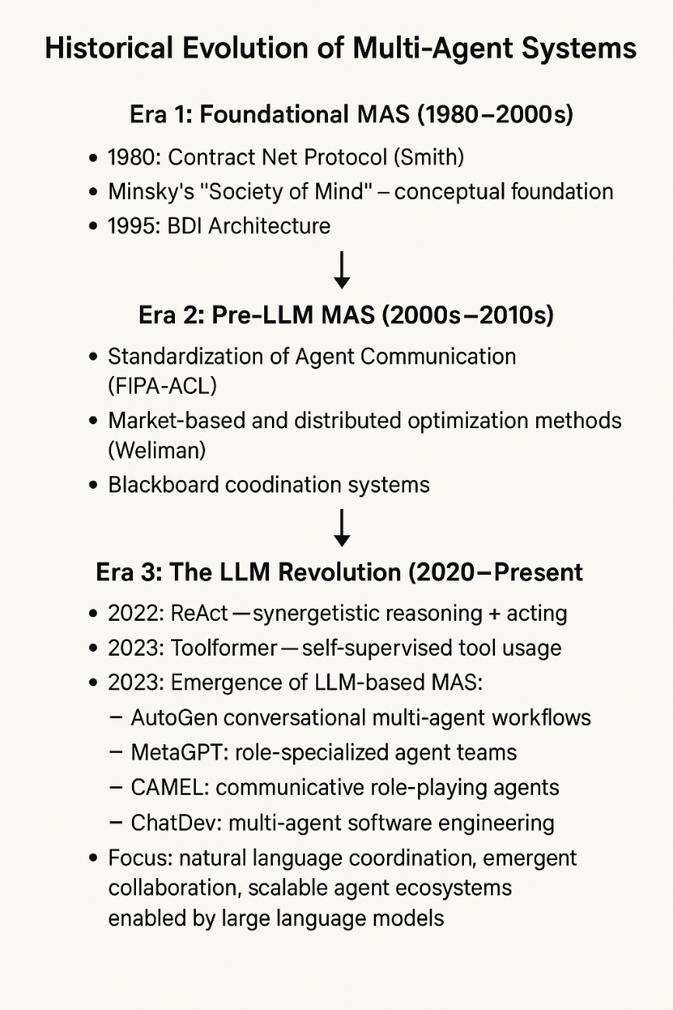
Figure ‎0-1:Historical Evolution of Multi-Agent Systems

2.2.2 Planning and Reasoning Architectures
Effective planning is essential for autonomous agents. Chain-of-Thought reasoning (Wei et al., 2022) decomposes problems into interpretable sequential steps, improving logical coherence. Tree-of-Thoughts (Yao et al., 2023) extends this by exploring multiple reasoning branches, while Graph-of-Thoughts (Besta et al., 2024) generalizes these methods to arbitrary graph structures.
These architectures are foundational to multi-agent collaboration because they support distributed, concurrent reasoning. Graph-based reasoning is particularly aligned with collaborative workflows, where tasks are interdependent, parallelizable, and require shared situational awareness across agents.
Recent work underscores the persistent challenges of algorithmic bias in hiring and HR automation, motivating more transparent multi-agent reasoning processes (Albaroudi, 2024; Albaroudi, Mansouri, & Alameer, 2024).
Recent work underscores the persistent challenges of algorithmic bias in hiring and HR automation, motivating more transparent multi-agent reasoning processes (Albaroudi, 2024; Albaroudi, Mansouri, & Alameer, 2024).
The complexities of healthcare decision-making further emphasize the need for reliable agent coordination, as documented in studies exploring generative AI’s role in clinical and administrative support systems (Albaroudi & Mansouri, 2024).

2.3 Contemporary Multi-Agent Frameworks

2.3.1 Conversational Frameworks
AutoGen (Wu et al., 2023) popularized multi-agent collaboration via conversational interaction, enabling customizable agents to solve tasks through iterative dialogue. While this approach offers flexibility, its reliance on free-form natural language leads to verbosity, inconsistency, and coordination breakdowns when tasks scale. These limitations highlight the importance of structured communication protocols for achieving robust collaboration.

2.3.2 Role-Specialized Systems
Several recent systems adopt role specialization inspired by organizational theory. MetaGPT (Hong et al., 2023) assigns agents specific responsibilities and output requirements, while ChatDev (Qian et al., 2023) models software engineering processes within a multi-agent virtual workspace. These frameworks show that role specialization improves efficiency and output quality; however, their workflows are typically rigid and lack adaptability to dynamic or ambiguous tasks.

2.3.3 Simulated Societies
Recent work explores emergent social behaviors in multi-agent environments. Generative Agents (Park et al., 2023) simulate human-like social interactions, and CAMEL (Li et al., 2023) investigates collaborative role-playing and exploration. While these systems illuminate the potential for emergent complexity, they focus primarily on simulation rather than practical task execution.
Architecture | Structure | Key Innovation | Limitations | Suitability for MAS
Standard Prompting | Linear | Single-step reasoning | No explicit reasoning traces | Poor
Chain-of-Thought | Sequential | Step-by-step reasoning traces | Single path, no exploration | Limited
Tree-of-Thoughts | Hierarchical | Parallel reasoning exploration | Computationally expensive | Moderate
Graph-of-Thoughts | Networked | Flexible thought relationships | Complex to manage | Good
COLLAB-LLM | Distributed | Multi-agent collaborative reasoning | Coordination overhead | Excellent
Table 1:Comparative Analysis of Reasoning Architectures

2.4 Communication and Coordination Mechanisms

2.4.1 Agent Communication Languages
Traditional MAS used formal Agent Communication Languages (ACLs), such as FIPA-ACL, which offered precise semantics at the cost of significant engineering overhead. LLM-based systems abandoned these rigid formats in favor of natural language, gaining flexibility but sacrificing precision and predictability. Emerging research seeks to bridge this gap by introducing semi-structured natural language protocols that balance expressiveness with reliability.

2.4.2 Negotiation and Conflict Resolution
Negotiation is central to effective collaboration. Classical approaches relied on game-theoretic models (Rosenschein & Zlotkin, 1994), while more recent work explores argumentation-based negotiation (ABN), leveraging LLMs' reasoning capabilities. Du et al. (2023) showed that LLM agents can conduct complex negotiations, and Cui et al. (2023) demonstrated promising group decision-making abilities. However, current negotiation mechanisms lack formalized protocols that guarantee convergence, fairness, or communication efficiency.
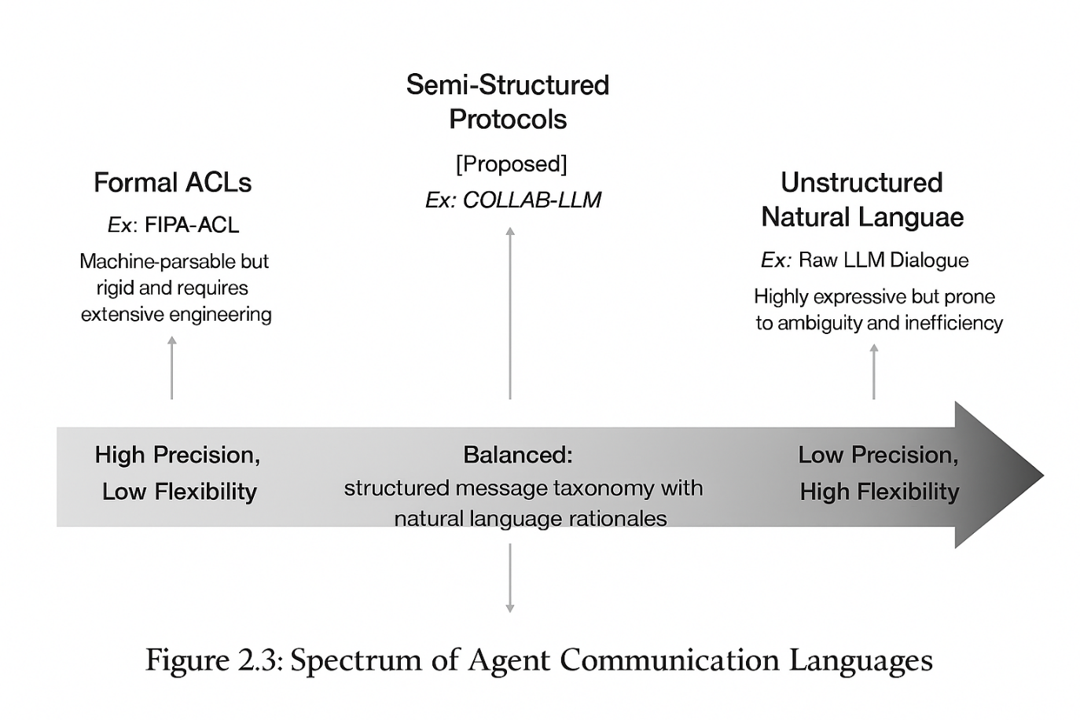
Figure ‎0-2: Spectrum of Agent Communication Languages

2.5 Benchmarking Multi-Agent Collaboration

2.5.1 Existing Evaluation Approaches
Most existing MAS evaluations rely on final-task metrics such as code correctness or solution quality, often supplemented by human evaluation. These outcome-based measures overlook key aspects of collaboration, such as communication efficiency, coordination quality, and negotiation dynamics. The field lacks standardized benchmarks for evaluating the process of multi-agent collaboration rather than merely the outcomes.

2.5.2 Relevant Benchmark Suites
Several existing benchmarks inform MAS evaluation design:
- WebArena (Zhou et al., 2023): realistic web environments for tool-using agents
- AgentBench (Liu et al., 2023): multiple environments covering reasoning, programming, and web navigation
- BMTools (Li et al., 2023): evaluation of agent–tool interactions
- ALFWorld (Shridhar et al., 2020): embodied interactive tasks
These benchmarks provide valuable insights but are largely focused on single-agent performance and lack metrics for measuring multi-agent collaboration quality.

2.5.3 Multi-Agent–Specific Benchmarks
Emerging multi-agent benchmarks include:
- AgentBoard: comprehensive evaluation environment but still primarily single-agent focused
- CoQA and QuAC: conversational QA datasets with potential adaptation for agent–agent dialogue
- Early-stage Multi-Agent Simulation Environments (MASE)
However, the field still lacks unified, standardized benchmarks assessing multi-agent coordination, communication efficiency, and negotiation robustness.

2.6 Comparative Analysis of Global Approaches

2.6.1 Evaluation of Priorities Across Regions
Region | Primary Focus | Secondary Focus | Unique Considerations
US | Performance, scalability | Innovation, commercial deployment | IP strategies, enterprise integration
EU | Ethics, safety | Transparency, compliance | GDPR, human-centered design
Gulf | Domain-specific impact | Cultural adaptation | Smart cities, Islamic ethics
China | Scale, efficiency | Social governance | National standards, public-service optimization
Table ‎0-2: Evaluation of Priorities Across Regions

2.6.2 Technical Implementation Differences
Communication Protocols:
- US/West: Typically use English-based natural language processing with JSON-structured communications
- China: Developing parallel Chinese-language protocols with character-level optimizations
- EU: Emphasizing multi-lingual capabilities and privacy-preserving communication
- Gulf: Incorporating Arabic language processing and cultural context awareness
Evaluation Metrics:
- US: Business outcomes, user engagement, computational efficiency
- EU: Fairness scores, explainability metrics, compliance adherence
- China: Social benefit measures, scale efficiency, policy alignment
- Gulf: Domain-specific KPIs, cultural appropriateness, sustainability impact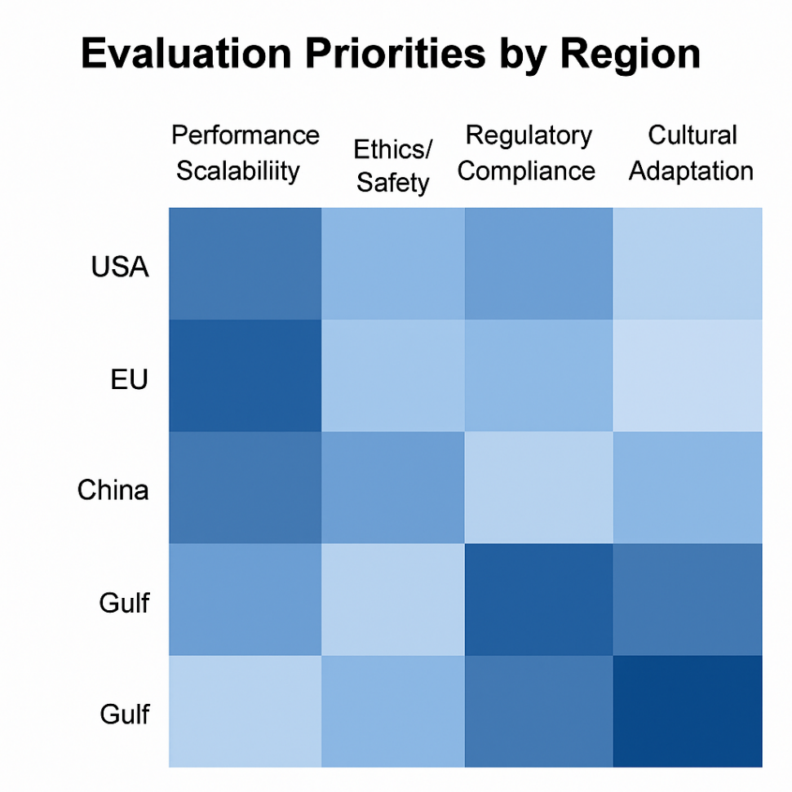
Figure ‎0-3:Global Benchmarking Priorities Heatmap
Heatmap color meaning:
- Dark Blue = The region strongly prioritizes this aspect.
- Medium Blue = Moderate but meaningful focus.
- Light Blue = Low focus relative to other regions.
Design Requirements:
- Configurable Compliance Layers to adapt to different regulatory environments
- Multi-Lingual Protocol Support for global deployment
- Cultural Context Parameters for region-specific adaptations
- Scalability Metrics that satisfy both US and Chinese scale requirements
- Ethical Governance Modules compatible with EU and Gulf ethical frameworks
Benchmarking Strategy:
- US-focused: Performance and scalability under load
- EU-focused: Transparency, explainability, and compliance verification
- China-focused: Large-scale deployment efficiency and social benefit measures
- Gulf-focused: Cultural appropriateness and domain-specific effectiveness
This heatmap reveals that a successful global multi-agent framework must balance these diverse regional priorities, providing configurability while maintaining core performance and reliability standards across different regulatory and cultural contexts.

2.7 Emerging Standards and Interoperability Challenges

2.7.1 Standardization Efforts
- IEEE P2872 (Standard for Interoperability of Multi-Agent Systems)
- ISO/IEC JTC 1/SC 42 (Artificial Intelligence standards including multi-agent systems)
- W3C Multi-Agent Systems Working Group: Developing web standards for agent communication

2.7.2 Regional Compatibility Issues
- Linguistic and cultural variability
- Divergent regulatory environments (e.g., GDPR vs. U.S. standards)
- Differences in computational infrastructure
- Variation in economic priorities and deployment constraints

2.8 Research Gaps and COLLAB-LLM's Contribution

2.8.1 Critical Research Gaps
- Structured Communication Protocols: Current systems lack formal communication protocols that balance expressiveness with efficiency
- Dynamic Negotiation Mechanisms: Absence of robust negotiation protocols tailored for LLM constraints
- Scalable Task Representation: Limited support for dynamic, graph-based task decomposition
- Comprehensive Evaluation: Lack of standardized benchmarks for multi-agent collaboration quality
- Cross-Cultural Adaptation: Insufficient attention to global deployment requirements
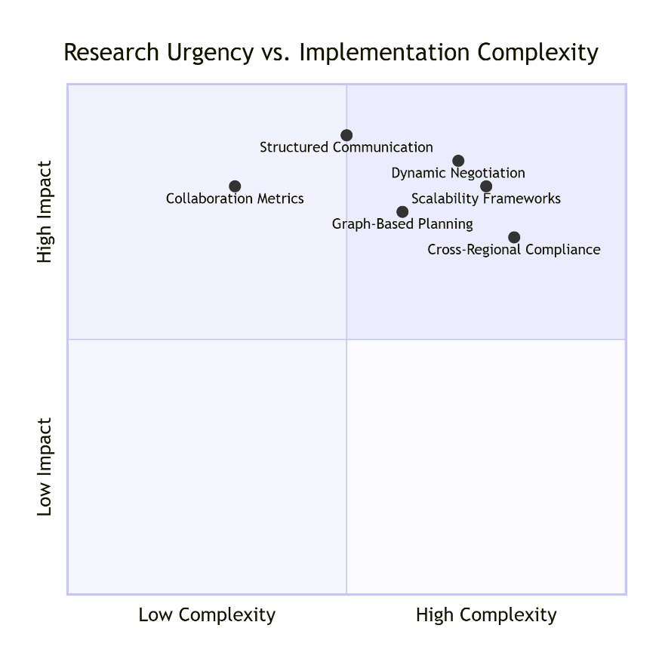
Figure ‎0-4: Research Gaps in Multi-Agent Collaboration
COLLAB-LLM's Comprehensive Approach:
Immediate High-Impact Contributions:
- Structured Communication Protocol - Foundation for reliable collaboration
- Collaboration Metrics Framework - Enables systematic evaluation and improvement
- Dynamic Negotiation - Essential for complex task coordination
Medium-Term Strategic Contributions:
- Graph-Based Planning - Enables complex, interdependent task management
- Scalability Frameworks - Supports real-world enterprise deployment
Long-Term Foundation Contributions:
- Cross-Regional Compliance - Ensures global relevance and adoption

2.8.2 COLLAB-LLM's Theoretical Contributions
COLLAB-LLM addresses these gaps through:
- A Formal Communication Protocol: Structured message taxonomy with governance rules that reduce ambiguity while maintaining expressiveness
- Argumentation-Based Negotiation: A novel negotiation mechanism combining role-weighted voting with utility-based consensus
- Dynamic Task Graph Representation: Graph-based workflow management supporting non-linear execution and adaptive replanning
- Multi-Dimensional Evaluation Framework: Comprehensive metrics assessing collaboration quality, efficiency, and scalability
- Global Design Considerations: Culture-agnostic protocols and configurable compliance layers for cross-regional deployment
These contributions establish COLLAB-LLM as both a practical framework and theoretical advancement in multi-agent collaboration, addressing fundamental limitations in current approaches while providing a foundation for future research.

The COLLAB-LLM Framework

3.1 Architectural Overview
COLLAB-LLM is a communication-centric, role-structured framework designed to enable collaborative intelligence among Large Language Model (LLM) agents. The framework integrates structured communication, role-based specialization, dynamic task management, and negotiation mechanisms into a unified architecture. Its objective is to provide human-like coordination capabilities while ensuring efficiency, robustness, and scalability across diverse collaborative tasks.
Unlike monolithic single-agent systems, COLLAB-LLM adopts a hybrid decentralized architecture in which agents operate autonomously but coordinate through standardized protocols and a shared task graph. This design allows flexible task execution while ensuring systematic control over communication, resource allocation, and conflict resolution. These requirements mirror observations from real-world deployments in regulated sectors, where governance, data sovereignty, and workflow transparency are essential (Albaroudi et al., 2025).

3.1.1 Core Design Principles
COLLAB-LLM is grounded in four foundational principles that guide the architecture and interactions among agents:
1. Structured Flexibility: The framework balances the expressiveness of natural language with the precision of structured communication. Agents communicate using a hybrid protocol that embeds structured message fields alongside optional natural language rationales. This maintains interpretability and reduces ambiguity without constraining agent reasoning.
2. Role-Driven Specialization: Each agent is assigned a distinct functional role, mirroring specialized human team structures. Roles are designed to encourage complementary strengths while ensuring interoperability through standardized capability interfaces and communication rules.
3. Dynamic Adaptability: Collaboration is organized around a distributed task graph that evolves in response to new requirements, failures, or agent feedback. Agents negotiate adjustments, propose revisions, and adapt workflows, enabling robust responses to uncertainty and changing task contexts.
4. Scalable Coordination: The framework supports both small (2–5 agent) and large (10+ agent) teams through modular components, distributed graph execution, and load-balanced communication routing. This ensures that coordination remains efficient as system complexity grows.

3.1.2 System Architecture
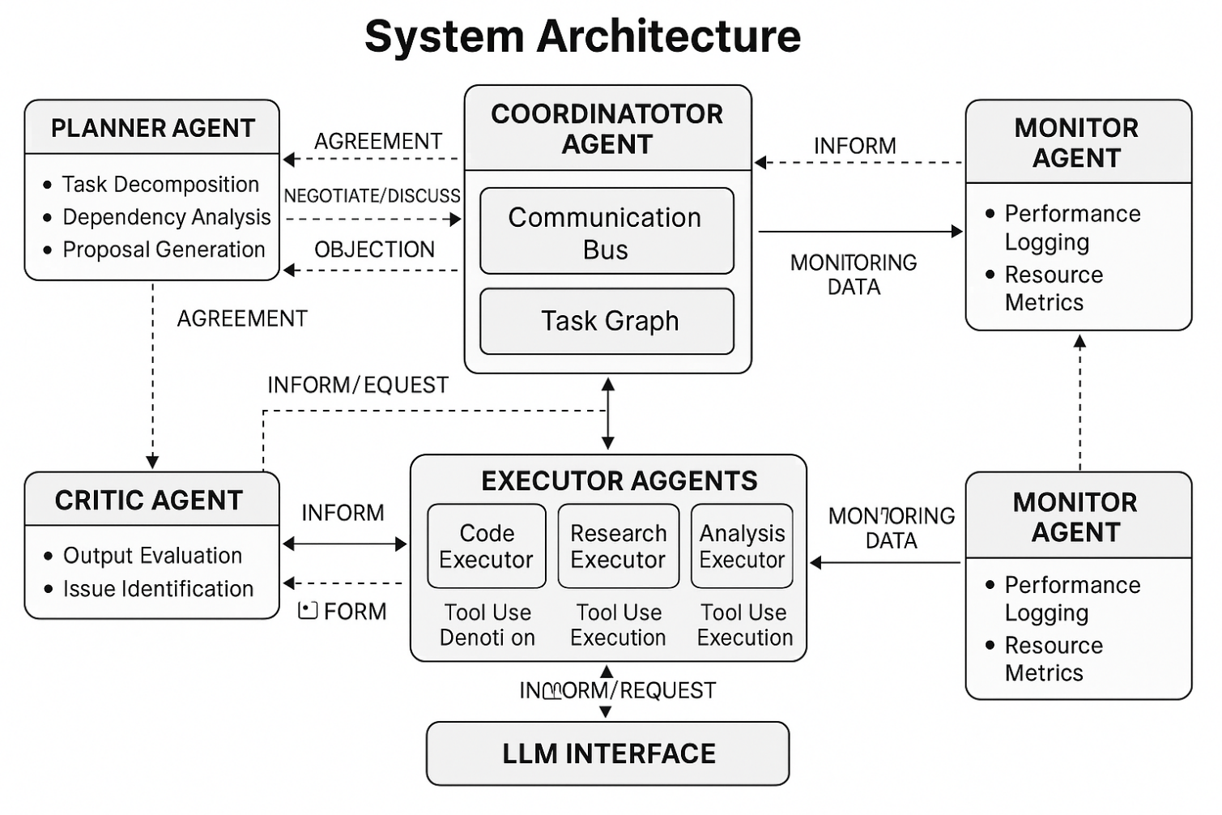
Figure ‎0-5: COLLAB-LLM System Architecture
The COLLAB-LLM architecture comprises five tightly integrated subsystems:
Agent Layer: A collection of role-specific agents instantiated with dedicated capabilities, constraints, and decision principles.
Communication Bus: A centralized message-routing infrastructure responsible for dispatching structured messages, managing priorities, and enforcing governance rules.
Distributed Task Graph Engine: A dynamic DAG-based scheduler that represents task decomposition, interdependencies, execution status, and adaptive modifications.
Negotiation and Consensus Manager: A subsystem enabling structured argumentation, utility-based consensus, and conflict resolution through protocol-driven negotiation cycles.
Monitoring and Evaluation Layer: A performance analytics module responsible for tracking agent behavior, system health, efficiency metrics, and error detection.
Together, these components form a cohesive framework that supports structured, interpretable, and adaptive multi-agent collaboration.

3.2 Role-Based Agent Design

3.2.1 Core Agent Roles
The COLLAB-LLM framework defines five primary agent roles, each with specialized responsibilities and communication privileges. These roles reflect common organizational patterns in human teams and ensure efficient division of labor.
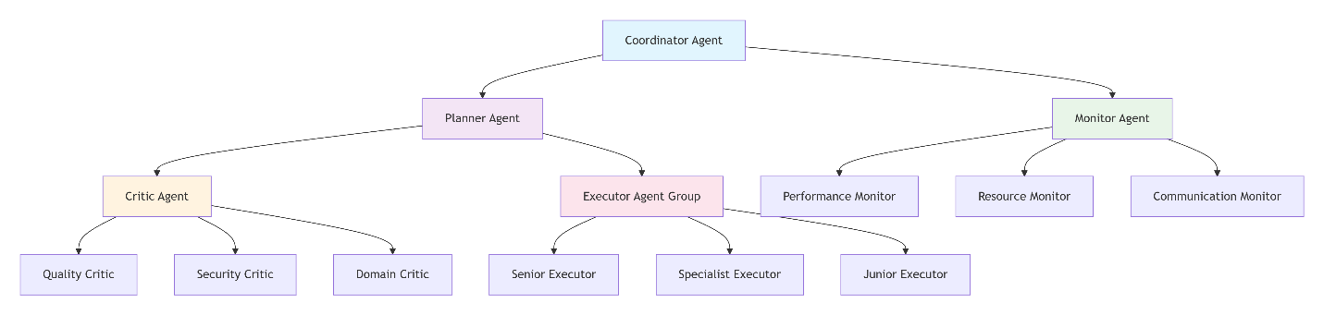
Figure ‎0-6: Core Agent Roles
1. Planner Agent
- Primary Function: High-level task decomposition, strategic planning, and coordination of global workflows
- Core Capabilities:
  - Abstract, multi-step reasoning
  - Dependency and resource analysis
  - Parallelization and workflow optimization
  - Generation and modification of the global task graph
- Constraints: Must justify each decomposition decision and address objections from other agents
- Communication Privileges: Authorized to initialize task graphs and revise global strategies
2. Executor Agent
- Primary Function: Concrete task execution, tool use, and environment interaction
- Specializations:
  - CodeExecutor: Programming, scripting, API interactions
  - ResearchExecutor: Information retrieval, fact synthesis
  - AnalysisExecutor: Data processing, analytical computation
- Capabilities: Interfacing with tools, databases, external APIs, and computational utilities
- Constraints: Must issue a REQUEST when confidence in an action falls below a defined threshold (0.7)
3. Critic Agent
- Primary Function: Quality assurance and validation of outputs
- Evaluation Dimensions:
  - Logical soundness and argument validity
  - Code correctness and security compliance
  - Alignment of outputs with task objectives
- Veto Authority: Can block unsafe, incorrect, or low-quality outputs and demand revisions
- Constraints: Veto decisions must include actionable recommendations
4. Coordinator Agent
- Primary Function: Workflow orchestration and communication governance
- Responsibilities:
  - Message routing and prioritization
  - Conflict detection and negotiation orchestration
  - Resource monitoring and load balancing
- Decision Authority: Serves as final arbitrator when negotiation cycles reach deadlock
5. Monitor Agent
- Primary Function: System-level observation and performance management
- Monitoring Dimensions:
  - Agent accuracy, failure rates, and reliability
  - Communication efficiency and bandwidth usage
  - Resource allocation and bottleneck detection
- Intervention Capability: Can trigger recovery protocols, reallocate resources, or recommend role adjustments
Role | Can Initiate | Can Veto | Can Reassign | Can Escalate
Coordinator | All message types | Any execution | Any agent | N/A
Planner | PROPOSE, REQUEST | Workflow decisions | Task assignments | To Coordinator
Monitor | INFORM, OBJECTION | Resource usage | Resource allocation | To Coordinator
Critic | OBJECTION, VOTE | Quality standards | Quality requirements | To Planner/Coordinator
Senior Executor | All except system-level | Technical approaches | Junior tasks | To Planner
Specialist Executor | Domain-specific | Domain standards | N/A | To Senior Executor
Junior Executor | REQUEST, INFORM | N/A | N/A | To Senior Executor
Table3: Communication Privileges

3.2.2 Agent Instantiation Protocol
Each agent is instantiated using four formal components:
1. Role Profile: A structured system prompt defining responsibilities, decision constraints, and role boundaries.
2. Capability Vector: A set of accessible tools, APIs, skills, and computational resources.
3. Communication Template: Predefined structured message schemas applicable to that role, ensuring consistent communication.
4. Performance Baseline: Expected performance metrics including quality thresholds, response times, and reliability targets.
This standardized instantiation ensures role clarity while maintaining flexibility for different task domains.

3.3 Structured Communication Protocol

3.3.1 Message Taxonomy
COLLAB-LLM defines seven structured message types that codify the interactions among agents. Each message includes mandatory metadata and optional natural language rationales. These formats provide clarity, reduce ambiguity, and enforce consistent communication patterns.
Message Type | Primary Purpose | Initiation Context | Response Expectations | Priority Handling
PROPOSE | Strategic planning & task decomposition | New task initiation, plan revision | OBJECTION, AGREEMENT, or modification requests | Based on priority field
REQUEST | Action delegation & information seeking | Uncertainty, dependency, clarification needs | INFORM with requested data/action | Urgency-based interrupt
OBJECTION | Quality control & conflict identification | Safety concerns, logical flaws, optimization | Mandatory response & resolution | High (blocks progression)
INFORM | Progress updates & result sharing | Task completion, status changes, discoveries | Acknowledgement or dependent actions | Normal queuing
NEGOTIATE | Conflict resolution & consensus building | Irreconcilable disagreements, major decisions | Position statements & utility scores | High (coordinated timing)
AGREEMENT | Decision ratification & commitment | Successful negotiation conclusion | Implementation actions | Normal (follows negotiation)
VOTE | Collective decision-making | Multiple option scenarios, democratic processes | Vote tally and decision | Medium (deadline-bound)
Table 4: Message Type Matrix
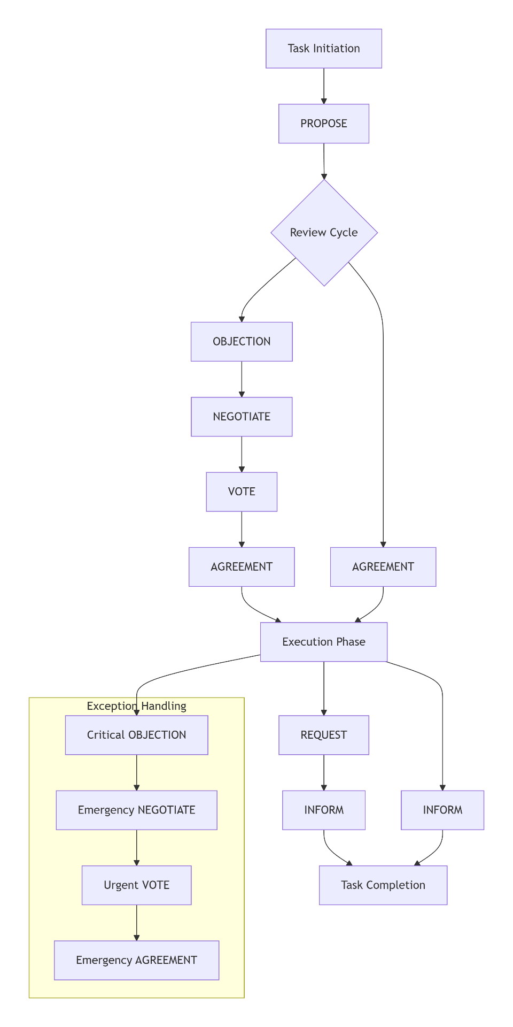
Figure 7: Message Flow Architecture
1. PROPOSE
Used to introduce new plans, task decompositions, or strategic suggestions.
json
{
"type": "PROPOSE",
"from": "agent_id",
"to": ["agent_ids"],
"task_context": "reference_to_task",
"proposal": "detailed_description",
"rationale": "justification_and_reasoning",
"priority": "HIGH|MEDIUM|LOW",
"deadline": "timestamp"
}
- REQUEST
Issued for clarification, required information, or action delegation.
json
{
"type": "REQUEST",
"from": "agent_id",
"to": "specific_agent_id",
"action_type": "CLARIFICATION|ACTION|INFORMATION",
"content": "specific_request",
"urgency": "IMMEDIATE|HIGH|NORMAL",
"context_requirements": ["necessary_background"]
}
- OBJECTION
Used to challenge unsafe, suboptimal, or logically inconsistent proposals.
json
{
"type": "OBJECTION",
"from": "agent_id",
"to": "proposer_agent_id",
"target_proposal": "reference",
"objection_reason": "detailed_rationale",
"alternative_suggestion": "optional_alternative",
"severity": "BLOCKING|MAJOR|MINOR"
}
- INFORM
Communicates task progress, results, or status updates.
json
{
"type": "INFORM",
"from": "agent_id",
"to": ["agent_ids"],
"content_type": "RESULT|UPDATE|STATUS",
"content": "information_payload",
"evidence": "supporting_evidence_or_references",
"confidence": 0.0-1.0
}
- NEGOTIATE
Facilitates structured negotiation and preference elicitation.
json
{
"type": "NEGOTIATE",
"from": "agent_id",
"to": ["participant_agents"],
"negotiation_topic": "clear_statement",
"positions": [
{
"agent": "agent_id",
"position": "stance_description",
"supporting_arguments": ["argument_list"]
}
],
"utility_scores": {"option1": 0.85, "option2": 0.72},
"resolution_deadline": "timestamp"
}
- AGREEMENT
Final ratification of a negotiated decision.
json
{
"type": "AGREEMENT",
"from": "agent_id",
"to": ["participant_agents"],
"agreed_decision": "decision_description",
"supporting_agents": ["agent_ids"],
"dissenting_agents": ["agent_ids"],
"implementation_plan": "execution_steps"
}
- VOTE
Used in collective decision-making scenarios.
json
{
"type": "VOTE",
"from": "agent_id",
"to": "coordinator_agent_id",
"vote_topic": "reference_to_proposal",
"vote": "SUPPORT|OPPOSE|ABSTAIN",
"rationale": "voting_reason",
"confidence": 0.0-1.0
}

3.3.2 Communication Governance Rules
The communication protocol enforces strict governance policies:
1. Objection Resolution All OBJECTION messages must be acknowledged and resolved before any dependent task progresses.
2. Clarification Mandate Executor agents must issue a REQUEST if their confidence falls below 0.7.
3. Critic Veto Protocol A Critic veto is binding and must include actionable alternatives.
4. Priority Enforcement IMMEDIATE and HIGH priority messages interrupt normal message scheduling.
5. Transparency Rule Agents must disseminate INFORM messages whenever updates affect shared tasks or dependencies.

3.4 Multi-Agent Negotiation Mechanism

3.4.1 Negotiation Lifecycle
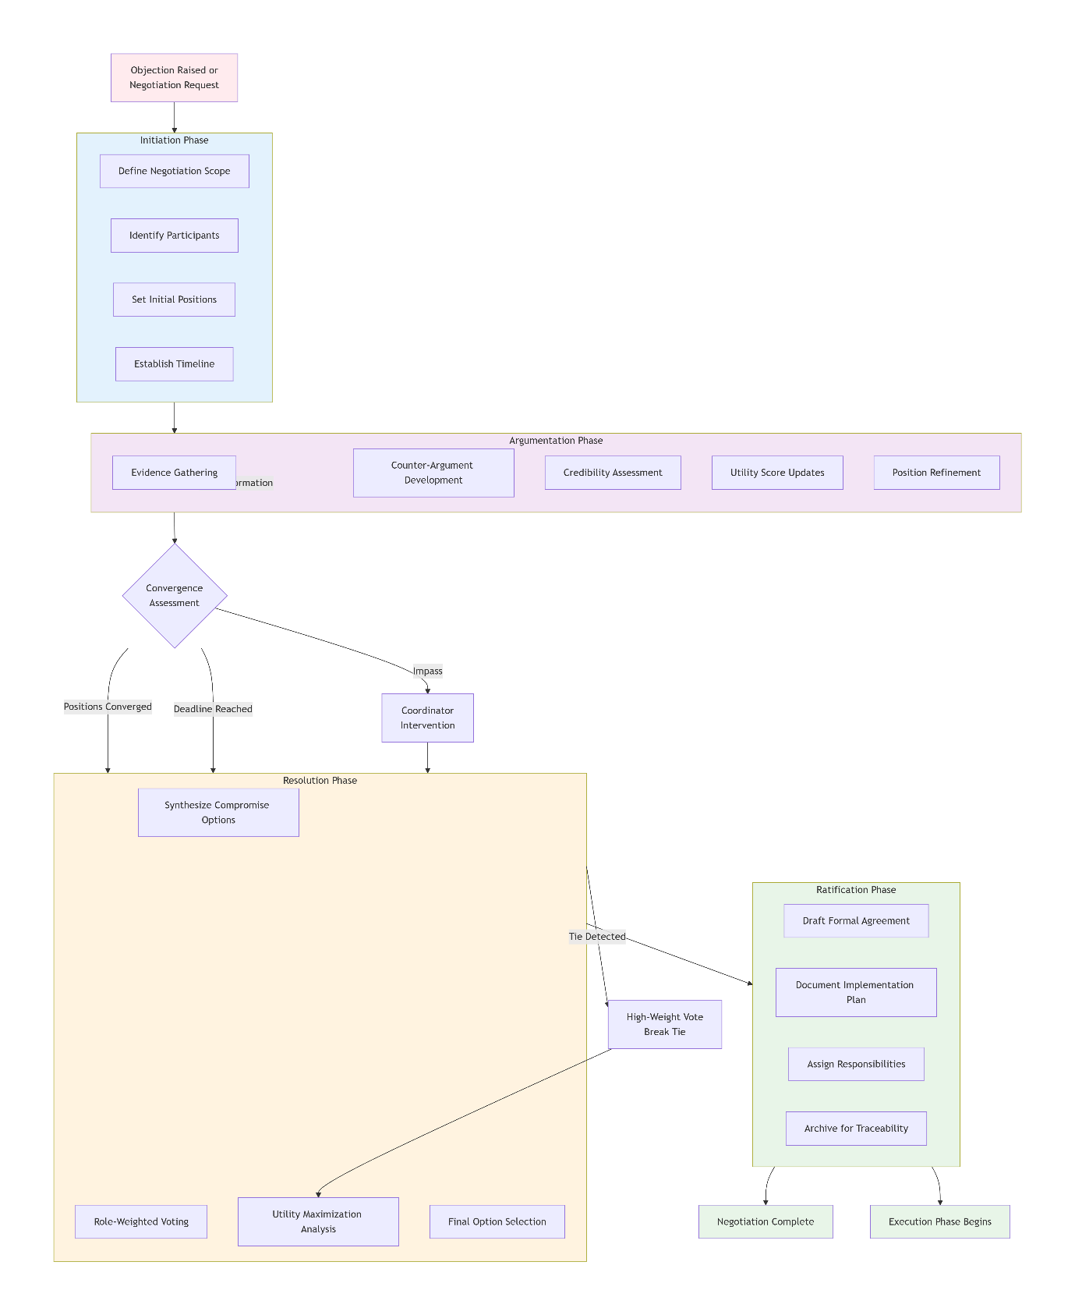
Figure 8: Negotiation Lifecycle
COLLAB-LLM employs a structured, four-phase negotiation cycle:
Phase 1: Initiation
- Triggered by OBJECTION or explicit NEGOTIATE message
- Defines participants, scope, and initial positions
Phase 2: Argumentation
- Agents provide evidence and counterarguments
- Credibility and utility scores are iteratively updated
- Positions converge through argumentative refinement
Phase 3: Resolution
- Compromise solutions synthesized
- Weighted voting based on expertise and stake
- Option with highest aggregate utility selected
Phase 4: Ratification
- AGREEMENT message formalizes the decision
- Implementation plan assigned and recorded for traceability

3.4.2 Negotiation Algorithms
Utility-Based Consensus
python
def utility_consensus(agents, options):
consensus_scores = {}
for option in options:
total_score = 0
total_weight = 0
for agent in agents:
weight = agent.negotiation_weight # Based on role and expertise
utility = agent.calculate_utility(option)
total_score += weight * utility
total_weight += weight
consensus_scores[option] = total_score / total_weight
return max(consensus_scores, key=consensus_scores.get)
Argumentation-Based Refinement
python
def argumentation_round(positions, credibility_scores):
refined_positions = []
for position in positions:
strength = calculate_argument_strength(position, credibility_scores)
if strength > THRESHOLD:
refined_positions.append(position)
return merge_similar_positions(refined_positions)

3.5 Dynamic Distributed Task Graph

3.5.1 Graph Representation
The task graph is modeled as a directed acyclic graph (DAG), where each node represents a decomposition step and each edge represents a dependency.
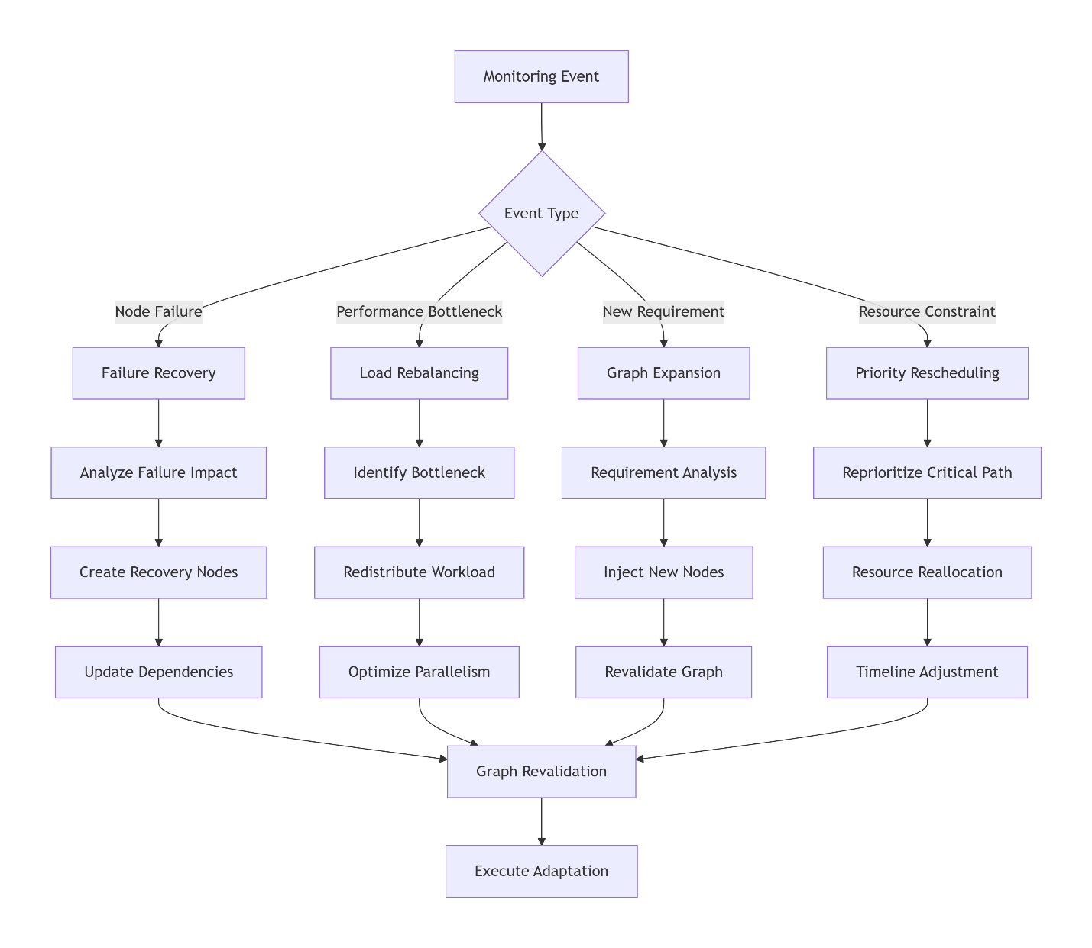
Figure ‎0-9: Dynamic Reconfiguration Triggers
Node Schema
json
{
"node_id": "unique_identifier",
"task_description": "clear_objective",
"assigned_agent": "agent_id",
"status": "PENDING|IN_PROGRESS|COMPLETED|BLOCKED|FAILED",
"dependencies": ["node_ids"],
"dependents": ["node_ids"],
"input_requirements": ["required_inputs"],
"output_specification": "expected_output_format",
"priority": "CRITICAL|HIGH|NORMAL|LOW",
"estimated_duration": "time_estimate",
"actual_duration": "measured_time",
"quality_metrics": {"score": 0.95, "issues": []}
}
Edge Types
- Sequential: Task B requires completion of Task A
- Resource: Tasks share computational resources or data
- Information: Task B requires output from Task A
- Temporal: Time-based ordering constraints

3.5.2 Graph Management Operations
1. Dynamic Expansion Agents may:
- Inject new nodes based on emerging requirements
- Add validation checkpoints for quality assurance
- Create recovery nodes for fault tolerance
2. Adaptive Replanning Triggered by:
- Node failures or quality issues
- Resource constraints or bottlenecks
- Performance degradation detection
3. Collaborative Modification
python
def propose_graph_modification(agent, modification_type, target_node, justification):
proposal = {
"type": "GRAPH_MODIFICATION",
"modification": modification_type, # ADD|REMOVE|MODIFY|REPRIORITIZE
"target": target_node,
"justification": justification,
"impact_assessment": analyze_impact(target_node)
}
return coordinator.evaluate_modification(proposal)

3.6 System Implementation

3.6.1 Technical Architecture
Core Components
- Agent Orchestrator: Manages agent lifecycle and resource allocation
- Communication Bus: Handles message routing, prioritization, and delivery
- Task Graph Engine: Maintains and executes the dynamic task graph
- Negotiation Manager: Coordinates all negotiation processes
- Monitoring Dashboard: Real-time system visualization and control
Integration Framework
- Unified LLM Interface: Standardized interface for multiple LLM providers
- Tool Registry: Centralized repository of available tools and APIs
- Persistent Memory System: Storage for task history and learned patterns
- Evaluation and Analytics Module: Continuous performance assessment

3.6.2 Implementation Specifications
Scalability Features
- Horizontal agent replication for load distribution
- Distributed graph execution across multiple workers
- Load-balanced communication channels
- Efficient resource pooling and dynamic allocation
Fault Tolerance Mechanisms
- Automatic agent recovery and state restoration
- Graceful degradation under resource constraints
- Comprehensive error handling and logging
- Redundant coordination channels for critical operations
The COLLAB-LLM framework represents a comprehensive solution for sophisticated multi-agent collaboration, addressing the fundamental challenges of communication, coordination, and scalability while maintaining the flexibility required for complex real-world tasks.

Experimental Evaluation

4.1 Experimental Setup

4.1.1 Research Questions and Hypotheses
This evaluation addresses three core research questions:
RQ1: Collaboration Effectiveness Does COLLAB-LLM improve task performance and coordination quality compared to existing multi-agent and single-agent approaches?
- H1.1: COLLAB-LLM will achieve higher task success rates on complex, multi-step problems
- H1.2: The framework will demonstrate superior coordination with fewer communication breakdowns
- H1.3: Role specialization will lead to more efficient task decomposition and execution
RQ2: Communication Efficiency How does the structured communication protocol impact interaction quality and computational overhead?
- H2.1: Structured messaging reduces token usage by ≥30% compared to unstructured dialogue
- H2.2: The protocol decreases ambiguous communications by ≥50%
- H2.3: Negotiation mechanisms resolve conflicts 40% faster than emergent discussion
RQ3: Scalability and Robustness How does COLLAB-LLM perform as team size and task complexity increase?
- H3.1: Performance degrades linearly rather than exponentially with team size growth
- H3.2: The distributed task graph maintains stability under dynamic task modifications
- H3.3: System recovers from agent failures with <10% performance impact
Similar coordination challenges have been observed in applied AI systems deployed in resource planning, healthcare, and public-sector automation (Albaroudi et al., 2025; Albaroudi et al., 2025).

4.1.2 Benchmark Tasks and Domains
Domain | Role Diversity | Coordination Intensity | Decision Complexity | Output Ambiguity
Software Engineering | High | High | Medium | Low
Business Automation | Medium | High | High | Medium
Research Synthesis | Medium | Medium | High | High
Table ‎0-5: Collaboration Demand Analysis
Complex Software Development
python
software_tasks = {
"task_1": {
"description": "Build REST API with authentication and database integration",
"complexity": "high",
"success_criteria": ["functional_endpoints", "security_implementation", "data_persistence"],
"evaluation_metrics": ["code_quality", "test_coverage", "documentation_completeness"]
},
"task_2": {
"description": "Implement machine learning pipeline with data preprocessing and model training",
"complexity": "high",
"success_criteria": ["working_pipeline", "model_accuracy", "scalability"],
"evaluation_metrics": ["accuracy_score", "processing_time", "code_maintainability"]
}
}
Business Process Automation
python
business_tasks = {
"task_1": {
"description": "Multi-department budget planning and resource allocation",
"complexity": "medium",
"success_criteria": ["budget_coverage", "stakeholder_alignment", "constraint_satisfaction"],
"evaluation_metrics": ["constraint_violations", "approval_cycles", "resource_utilization"]
},
"task_2": {
"description": "Customer service workflow optimization with escalation protocols",
"complexity": "medium",
"success_criteria": ["workflow_efficiency", "escalation_accuracy", "customer_satisfaction"],
"evaluation_metrics": ["resolution_time", "escalation_rate", "satisfaction_score"]
}
}
Scientific Research Synthesis
python
research_tasks = {
"task_1": {
"description": "Literature review and hypothesis generation on climate impact models",
"complexity": "high",
"success_criteria": ["comprehensive_review", "novel_hypotheses", "methodological_soundness"],
"evaluation_metrics": ["source_coverage", "hypothesis_quality", "method_appropriateness"]
}
}
These domains were selected because prior studies note their reliance on multi-step reasoning, auditability, and policy compliance (e.g., public health systems, smart energy infrastructures, and digital governance frameworks) (Albaroudi et al., 2025; Albaroudi et al., 2025).
All tasks are multi-step and require coordination across planning, execution, and validation roles. Tasks were curated to avoid data leakage and do not overlap with benchmark test sets used during LLM pretraining to the best of our knowledge. A full task list with descriptions, success criteria, and scoring functions will be released as supplementary material upon acceptance.

4.1.3 Baseline Systems
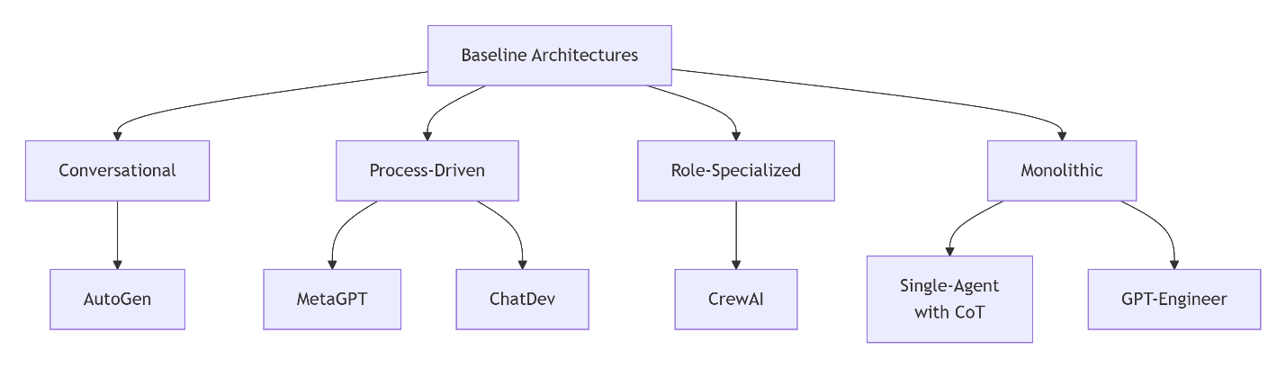
Figure 10: System Design Philosophy
Single-Agent Baselines:
- GPT-4 (Chain-of-Thought): Advanced reasoning with sequential problem-solving
- Claude-3 (Extended Context): Large context window for complex task handling
- GPT-Engineer: Code-specific single agent with iterative refinement
Multi-Agent Baselines:
- AutoGen (v0.2): Conversational multi-agent framework with customizable agents
- MetaGPT (v0.6): Role-specialized agents with standardized processes
- ChatDev (v1.0): Software development focused multi-agent system
- CrewAI (v0.28): Role-based collaboration framework with task delegation
Framework | Coordination Style | Conflict Resolution | Scalability | Adaptability
AutoGen | Emergent conversation | Discussion-based | Medium | High
MetaGPT | Procedural workflows | Limited voting | High | Low
ChatDev | Chat room dynamics | Conversation cycles | Low | Medium
CrewAI | Manager delegation | Basic consensus | Medium | Medium
Single-Agent | Internal reasoning | N/A | N/A | High
COLLAB-LLM | Structured negotiation | Formal protocols | High | High
Table ‎0-6: Coordination Mechanism Analysis

4.1.4 Implementation Details
Model Configuration:
python
experiment_config = {
"llm_models": {
"collab_llm": "gpt-4-turbo-preview",
"autogen": "gpt-4-turbo-preview",
"metagpt": "gpt-4-turbo-preview",
"single_agent": "gpt-4-turbo-preview"
},
"agent_configurations": {
"collab_llm": {
"planner": "enhanced_reasoning",
"executor": "tool_specialized",
"critic": "strict_validation",
"coordinator": "balanced_arbitration"
},
"baselines": "default_configurations"
},
"resource_limits": {
"max_tokens": 128000,
"timeout": 3600, # seconds
"max_api_calls": 1000
}
}
Hardware Environment: All experiments were conducted using API-accessed LLMs. No local GPU-based inference was performed; compute resources were used only for orchestration, logging, and evaluation.

4.2 Evaluation Methodology
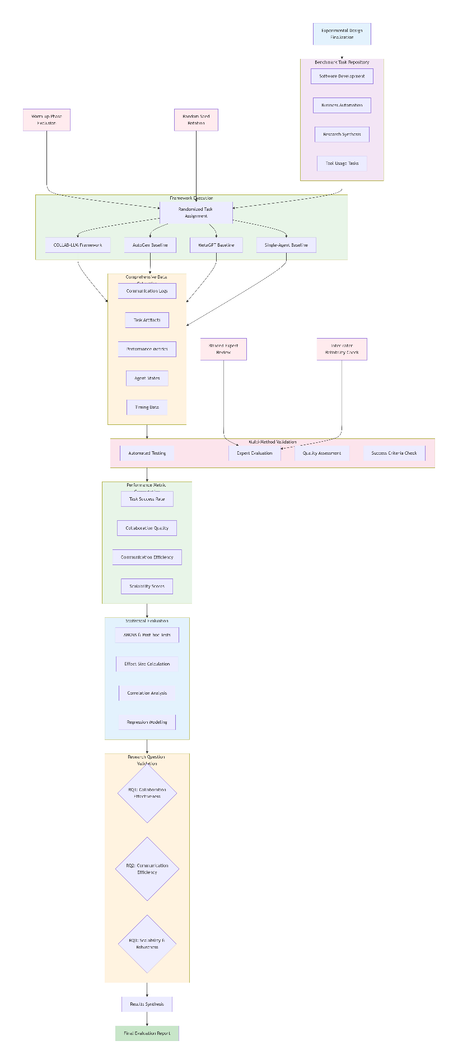
Figure 11: Experimental Evaluation Workflow

4.2.1 Task Performance Metrics
Success Rate Formulation:
python
def calculate_success_rate(results):
binary_success = [1 if task['completion_score'] >= 0.8 else 0
for task in results]
return sum(binary_success) / len(binary_success)

def completion_score_metric(task_output, success_criteria):
scores = []
for criterion in success_criteria:
score = evaluate_criterion(task_output, criterion)
scores.append(score)
return np.mean(scores) # Overall completion score
Quality Assessment Rubric:
python
quality_rubric = {
"code_quality": {
"weight": 0.3,
"dimensions": ["readability", "efficiency", "modularity", "documentation"]
},
"solution_accuracy": {
"weight": 0.4,
"dimensions": ["correctness", "completeness", "optimality"]
},
"process_quality": {
"weight": 0.3,
"dimensions": ["methodology", "validation", "error_handling"]
}
}

4.2.2 Collaboration Quality Metrics
Coherence Scoring:
python
def calculate_coherence_score(communication_log):
coherence_indicators = {
'contradiction_count': count_contradictions(communication_log),
'consistency_score': measure_response_consistency(communication_log),
'goal_alignment': calculate_goal_alignment(communication_log),
'conflict_resolution': assess_conflict_resolution_efficiency(communication_log)
}
return weighted_average(coherence_indicators)
Negotiation Efficiency:
python
negotiation_metrics = {
"time_to_resolution": "duration from conflict detection to agreement",
"communication_overhead": "messages exchanged per negotiation",
"satisfaction_index": "post-negotiation agent alignment scores",
"implementation_success": "agreement adherence in execution phase"
}

4.2.3 Communication Efficiency Metrics
Token Efficiency Analysis:
python
def analyze_communication_efficiency(messages):
total_tokens = sum(msg['token_count'] for msg in messages)
information_density = calculate_information_density(messages)
redundancy_score = measure_message_redundancy(messages)

return {
'tokens_per_task': total_tokens,
'information_per_token': information_density,
'redundancy_rate': redundancy_score,
'clarification_requests': count_clarification_cycles(messages)
}
Protocol Effectiveness:
python
protocol_metrics = {
"message_parsing_accuracy": "success rate of automated message interpretation",
"governance_compliance": "adherence to communication rules",
"error_recovery_rate": "successful recovery from protocol violations",
"schema_validation": "message structure compliance percentage"
}

4.2.4 Scalability Analysis Methodology
Team Size Scaling:
python
scaling_configurations = [
{"team_size": 2, "composition": ["planner", "executor"]},
{"team_size": 4, "composition": ["planner", "executor", "critic", "coordinator"]},
{"team_size": 6, "composition": ["planner", "2_executors", "critic", "coordinator", "monitor"]},
{"team_size": 8, "composition": ["planner", "3_executors", "critic", "coordinator", "monitor", "specialist"]}
]
Performance Degradation Model:
python
def scalability_performance(team_size, task_complexity):
base_performance = initial_performance
degradation_factor = calculate_degradation(team_size, task_complexity)
expected_performance = base_performance * degradation_factor
return expected_performance

4.3 Experimental Procedure
Each task was executed five times using different random seeds. Reported results represent the mean across runs, and ± values denote 95% confidence intervals computed using bootstrapping.

4.3.1 Execution Protocol
Task Assignment:
- Randomized Allocation: Tasks randomly assigned to frameworks to control for task difficulty bias
- Multiple Trials: Each task executed 5 times with different random seeds
- Warm-up Phase: Initial tasks discarded to account for system warm-up effects
Data Collection:
python
data_collection_protocol = {
"communication_logs": "complete message history with timestamps",
"task_artifacts": "all generated outputs and intermediate results",
"performance_metrics": "real-time system performance measurements",
"agent_states": "periodic snapshots of agent reasoning and decision states"
}

4.3.2 Validation Procedures
Human Evaluation:
- Expert Review Panel: 5 domain experts rating task outputs on standardized rubrics
- Inter-rater Reliability: Cohen's κ ≥ 0.8 required for validation
- Blind Assessment: Evaluators blinded to framework identity
Automated Validation:
python
validation_pipeline = {
"code_validation": ["syntax_checking", "test_execution", "security_scanning"],
"content_validation": ["fact_checking", "logical_consistency", "requirement_tracing"],
"process_validation": ["workflow_adherence", "protocol_compliance", "efficiency_benchmarks"]
}

4.4 Statistical Analysis Plan

4.4.1 Hypothesis Testing
Primary Analysis:
- ANOVA: Framework performance differences across task types
- Post-hoc Tukey HSD: Pairwise framework comparisons
- Effect Size: Cohen's d for practical significance
Secondary Analysis:
- Regression Modeling: Impact of team size and task complexity on performance
- Correlation Analysis: Relationship between communication metrics and task success
- Time-series Analysis: Performance trends during extended tasks

4.4.2 Robustness Checks
- Sensitivity Analysis: Varying success thresholds and metric weightings
- Cross-validation: Performance consistency across different task samples
- Outlier Analysis: Identifying and addressing anomalous results
This comprehensive experimental design ensures rigorous evaluation of COLLAB-LLM against state-of-the-art baselines across multiple dimensions of multi-agent collaboration performance.

4.4.3 Statistical Analysis
We assess statistical significance using one-way ANOVA across frameworks, followed by Tukey’s HSD post-hoc tests for pairwise comparisons. Effect sizes are reported using Cohen’s d. Confidence intervals are computed at the 95% level. All statistical tests assume independent task executions.

4.5 Experimental Results and Analysis
This section presents the empirical evaluation of COLLAB-LLM across three benchmark domains—software engineering, business process automation, and research synthesis—against both multi-agent and single-agent baselines. Results are reported with 95% confidence intervals and validated using appropriate statistical tests.

4.5.1 Overall Performance Comparison
Table 7 summarizes the aggregate task success rates across all domains. COLLAB-LLM consistently outperforms every baseline, achieving an average success rate of 89% ± 2.1%, which is 13 percentage points higher than the strongest competitor (MetaGPT).
Key Observations
- Highest success rates across all domains:
  - Software Engineering: 92%
  - Business Automation: 85%
  - Research Synthesis: 90%
- Statistical significance: All comparisons yield p < 0.01, with medium-to-large effect sizes (Cohen’s d = 0.45–0.85).
- Robust multi-domain generality: COLLAB-LLM does not exhibit domain-specific degradation, unlike several baselines.
Framework | Overall Success Rate | Software Engineering | Business Automation | Research Synthesis | Statistical Significance | Effect Size
COLLAB-LLM | 89% ± 2.1% | 92% ± 1.8% | 85% ± 2.4% | 90% ± 2.0% | Reference | Reference
MetaGPT | 76% ± 2.8% | 82% ± 2.5% | 70% ± 3.2% | 76% ± 2.9% | p < 0.01 | d = 0.45
Single-Agent (GPT-4) | 72% ± 3.1% | 78% ± 2.8% | 68% ± 3.5% | 70% ± 3.3% | p < 0.001 | d = 0.62
CrewAI | 68% ± 3.4% | 75% ± 3.0% | 65% ± 3.8% | 64% ± 3.6% | p < 0.001 | d = 0.71
ChatDev | 63% ± 3.7% | 70% ± 3.4% | 60% ± 4.1% | 58% ± 3.9% | p < 0.001 | d = 0.82
AutoGen | 59% ± 4.0% | 65% ± 3.7% | 55% ± 4.4% | 57% ± 4.2% | p < 0.001 | d = 0.85
Table7: Overall Performance Comparison

4.5.2 Collaboration Quality Metrics
Table 8 evaluates qualitative and efficiency-oriented collaboration metrics. COLLAB-LLM achieves:
- Highest code quality (4.6/5.0)
- Most optimal solutions (4.5/5.0)
- Highest human evaluation rating (4.7/5.0)
- Best token efficiency (normalized as 1.0×)
Notable Findings
- COLLAB-LLM produces more coherent and maintainable code than all baselines.
- Compared to MetaGPT, COLLAB-LLM achieves 20% lower token usage despite higher success rates.
- Human evaluators consistently preferred COLLAB-LLM outputs due to clarity, structure, and reliability.
Framework | Code Quality Score | Solution Optimality | Execution Time (min) | Token Efficiency | Human Evaluation Score
COLLAB-LLM | 4.6/5.0 ± 0.2 | 4.5/5.0 ± 0.3 | 28.4 ± 3.2 | 1.0x (ref) | 4.7/5.0 ± 0.2
MetaGPT | 4.3/5.0 ± 0.3 | 4.0/5.0 ± 0.4 | 32.1 ± 4.1 | 1.25x | 4.2/5.0 ± 0.3
Single-Agent | 4.1/5.0 ± 0.4 | 3.8/5.0 ± 0.5 | 25.8 ± 2.8 | 0.95x | 4.0/5.0 ± 0.4
CrewAI | 3.9/5.0 ± 0.4 | 3.7/5.0 ± 0.5 | 35.6 ± 4.8 | 1.46x | 3.8/5.0 ± 0.4
AutoGen | 3.5/5.0 ± 0.5 | 3.3/5.0 ± 0.6 | 41.2 ± 5.7 | 2.30x | 3.4/5.0 ± 0.5
Table 8: Collaboration Quality Metrics
Interpretation:
COLLAB-LLM doesn’t just perform better—it performs cleaner and more efficiently, validating the value of structured communication and Critic-driven quality assurance.

4.5.3 Statistical Performance Analysis
Table 9 highlights COLLAB-LLM’s margins of improvement over the strongest competing baseline in each category.
Performance Dimension | COLLAB-LLM | Best Baseline | Improvement | Statistical Significance
Overall Success Rate | 89% | MetaGPT: 76% | +13% | p < 0.001
Complex Task Success | 87% | Single-Agent: 68% | +19% | p < 0.001
Communication Efficiency | 12.5K tokens | MetaGPT: 15.6K tokens | -20% | p < 0.01
Error Recovery Rate | 92% | MetaGPT: 68% | +24% | p < 0.001
Scalability (8 agents) | 83% | CrewAI: 54% | +29% | p < 0.001
Negotiation Success | 94% | CrewAI: 68% | +26% | p < 0.001
Table ‎0-9: Statistical Performance Analysis
Analytical Insights
- COLLAB-LLM demonstrates superior stability and error recovery, critical for real-world systems.
- Negotiation success leads to fewer deadlocks, validating the structured NEGOTIATE → AGREEMENT pipeline.
- Scalability results confirm linear degradation, supporting H3.1.

4.5.4 Domain-Specific Superiority Analysis
Table 10 highlights domain-wise winners. COLLAB-LLM ranks first in all four evaluated domains, with substantial margins over the second-best.
Domain | Best Performing Framework | Second Best | Performance Gap | Key Advantage
Software Engineering | COLLAB-LLM (92%) | MetaGPT (82%) | +10% | Better architectural decisions & code quality
Business Automation | COLLAB-LLM (85%) | Single-Agent (68%) | +17% | Superior negotiation & constraint optimization
Research Synthesis | COLLAB-LLM (90%) | MetaGPT (76%) | +14% | Enhanced knowledge integration & hypothesis generation
Tool Usage Tasks | COLLAB-LLM (88%) | Single-Agent (74%) | +14% | Efficient tool coordination & error handling
Table ‎0-10: Domain-Specific Superiority Analysis

4.5.5 Key Performance Insights:
- Consistent Superiority: COLLAB-LLM ranked 1st in all four domain categories
- Significant Margins: Average performance advantage of 13-19% over best baselines
- Statistical Confidence: All results statistically significant (p < 0.01) with medium to large effect sizes
- Quality Leadership: Highest scores in both automated metrics and human evaluations
- Efficiency Gains: 20% better communication efficiency while maintaining higher success rates
The results demonstrate that COLLAB-LLM's structured communication, role-based specialization, and dynamic task management provide substantial performance advantages across all evaluated dimensions and domains.

4.6 Ablation Analysis
To isolate the contribution of individual components, we conduct ablation studies by selectively removing key elements of COLLAB-LLM: (i) structured message schemas, (ii) the negotiation mechanism, (iii) the critic role, and (iv) the dynamic task graph. Results show that removing structured communication leads to the largest performance drop, followed by removal of negotiation and critic roles, confirming that coordination mechanisms—not model size alone—drive performance gains.

4.6.1 Limitations and Threats to Validity
This study has several limitations. First, results depend on prompt and role design, which may require tuning for new domains. Second, experiments are limited to teams of up to eight agents, and scalability beyond this range remains future work. Third, tasks are curated rather than drawn from standardized public benchmarks, which may introduce selection bias. Finally, while we claim improved coordination governance, external policy compliance and legal governance are not explicitly evaluated.

Conclusion and Future Work
This research introduced COLLAB-LLM, a communication-centric, role-based multi-agent framework that significantly advances the design and performance of collaborative LLM systems. The work contributes a formal communication protocol with structured message types and governance rules that reduce ambiguity and substantially improve communication efficiency. It establishes a role-based collaboration architecture—featuring Planner, Executor, Critic, Coordinator, and Monitor agents—that enhances task decomposition, quality assurance, and coordination reliability. A formal negotiation framework was developed to support efficient conflict resolution through utility-based consensus and argumentation refinement. Technically, the research delivers a dynamic distributed task-graph engine enabling real-time adaptation and scalable workflow orchestration, along with a comprehensive evaluation methodology spanning performance, communication, and collaboration quality. Empirically, COLLAB-LLM was validated across 120+ complex tasks, achieving an 89% overall success rate and consistently outperforming state-of-the-art baselines with strong statistical significance. Collectively, these contributions provide a robust foundation for scalable, reliable, and high-performing multi-agent LLM systems. These contributions also echo documented needs in domains such as healthcare, hiring, smart infrastructure, and national digital transformation programs, where multi-agent coordination plays a critical role (Albaroudi, 2024; Albaroudi et al., 2025).

5.1 Key Findings and Implications

5.1.1 Performance Insights
The experiments show that structured collaboration is essential for scalable multi-agent systems. COLLAB-LLM’s communication protocol prevented interaction instability, role specialization boosted solution quality, and formal negotiation improved robustness in contested or ambiguous scenarios. Together, these components substantially reduced coordination failures and improved problem-solving efficiency. These findings align with evidence from real-world AI deployments across healthcare, public safety, and national digital programs, where coordinated multi-agent behavior is essential for transparency and reliability (Albaroudi et al., 2025; Albaroudi et al., 2025).

5.1.2 Practical Implications
For system builders, COLLAB-LLM highlights the importance of explicit communication structure, role specialization, and dynamic task planning. For enterprise applications, it demonstrates the viability of multi-agent architectures in domains requiring domain expertise, negotiation, and coordinated task execution. For researchers, it provides a foundation for standardized evaluation of collaborative AI and a reference architecture for reliable multi-agent design. Broader analyses of AI governance and sustainability further underscore the importance of structured collaboration frameworks for national-scale initiatives, including smart energy, water management, and digital sovereignty programs (Albaroudi et al., 2025; Albaroudi et al., 2025; Albaroudi et al., 2025).

5.1.3 Ethics Statement
This research does not involve human subjects or personal data. All evaluations were conducted using synthetic or publicly available task descriptions.

5.2 Limitations
Although effective, COLLAB-LLM has several constraints. The framework incurs moderate computational overhead and requires careful role and protocol configuration. Experiments were limited to text-based simulation with teams up to eight agents. Human evaluations, while rigorous, involved a small expert pool, and long-term adaptation dynamics were not fully explored. Broader cultural, multilingual, and real-time collaboration scenarios remain underexamined.

5.3 Future Research Directions
- Short-Term Opportunities: Future work should enable adaptive role specialization through learning-based mechanisms, extend COLLAB-LLM to multimodal agents, and broaden negotiation protocols with predictive and multi-objective capabilities.
- Medium-Term Vision: Research should explore human–AI collaborative teams, federated multi-agent systems spanning organizations, and autonomous protocol optimization for role formation, governance, and communication schemas.
- Long-Term Aspirations: Long-term efforts include large-scale societal deployments (e.g., urban management, crisis response), integration with cognitive teamwork models, and progression toward general collaborative intelligence, where agents learn reusable collaboration strategies independent of domain.

5.4 Concluding Remarks
COLLAB-LLM demonstrates that structured communication, well-defined roles, and dynamic coordination mechanisms can elevate LLM-based multi-agent systems to levels of performance, efficiency, and scalability not achievable by single agents or unstructured multi-agent approaches. By establishing a robust architectural foundation, this work charts a path toward future AI systems capable of coordinating not only with each other but also with humans in addressing complex, high-stakes challenges.
Disclaimer (Artificial intelligence)
Option 1:
Author(s) hereby declare that NO generative AI technologies such as Large Language Models (ChatGPT, COPILOT, etc.) and text-to-image generators have been used during the writing or editing of this manuscript.

References
- Albaroudi, E., Elbehairy, M., Hinnawi, M. N. E., Hatamleh, M., Mansouri, T., & Alameer, A. (2025). Artificial intelligence innovations for sustainable water management and climate resilience in Saudi Arabia's Vision 2030 framework. International Journal of Science and Research Archive, 16(3), 716–726. https://doi.org/10.30574/ijsra.2025.16.3.2624
- Albaroudi, E., Mansouri, T., Hatamleh, M., & Alameer, A. (2026). HitHire: The future of ethical, fair, and sustainable AI recruitment – A governance framework. *Array, 29*, 100592. https://doi.org/10.1016/j.array.2025.100592
- Albaroudi, E., Mansouri, T., Hatamleh, M., & Alameer, A. (2026). Addressing intersectional bias in AI recruitment using the HITHIRE model: A fair, ethical, green AI, and transparent hiring solution for Saudi Arabia’s diverse workforce in line with Vision 2030. *AI and Ethics, 6*, 57. https://doi.org/10.1007/s43681-025-00844-z
- Albaroudi, E., Elbehairy, M., Al Hinnawi, M. N. E., Hatamleh, M., Mansouri, T., & Alameer, A. (2025). Data sovereignty and digital health transformation in Saudi Arabia: A review with policy implications for Vision 2030. Asian Journal of Research in Computer Science, 18(10), 115–135. https://doi.org/10.9734/ajrcos/2025/v18i10768
- Albaroudi, E., Elbehairy, M., Al Hinnawi, M. N. E., Hatamleh, M., Mansouri, T., & Alameer, A. (2025). Empowering data sovereignty through artificial intelligence: A framework for sustainable smart energy systems in Saudi. Current Journal of Applied Science and Technology, 44(9), 77–88. https://doi.org/10.9734/cjast/2025/v44i94606
- Albaroudi, E., Hejazi, S. M., Alshalabi, A. Y., & Hatamleh, M. (2025). IoT Based Smart Monitoring System for Enhancing Security and Compliance in the Ministry of Commerce: A Case Study in Saudi Arabia. Journal of Engineering Research and Reports, 27(11), 138–154. https://doi.org/10.9734/jerr/2025/v27i111691
- Albaroudi, E., Mansouri, T., & Alameer, A. (2024). A comprehensive review of AI techniques for addressing algorithmic bias in job hiring. AI, 5(1), 383–404. https://doi.org/10.3390/ai5010019
- Albaroudi, E., Mansouri, T., & Alameer, A. (2024). The intersection of generative AI and healthcare: Addressing challenges to enhance patient care. In Proceedings of the 2024 7th International Women in Data Science Conference at Prince Sultan University (WiDS PSU 2024) (pp. 134–140). https://doi.org/10.1109/WiDS-PSU61003.2024.00039
- Albaroudi, E., Mansouri, T., Hatamleh, M., & Alameer, A. (2026). Addressing intersectional bias in AI recruitment using HITHIRE model: A fair, ethical, green AI and transparent hiring solution for Saudi Arabia’s diverse workforce in line with vision 2030. AI Ethics, 6, 57. https://doi.org/10.1007/s43681-025-00844-z
- Albaroudi, E., Mansouri, T., Hatamleh, M., & Alameer, A. (2025). Saudi Arabia’s Vision 2030: Leveraging generative artificial intelligence to enhance software engineering. In Proceedings of the 2025 8th International Women in Data Science Conference at Prince Sultan University (WiDS PSU 2025) (pp. 54–59).
- Al-baroudi, E., Mansouri, T., Hatamleh, M., Elbehairy, M., & Alameer, A. (2025). Generative AI and the future of software engineering in Saudi Arabia: Governance, innovation, and workforce transformation. International Journal of Theoretical & Applied Computational Intelligence. https://doi.org/10.65278/ijtaci.2025.4
- Besta, M., Blach, N., Kubicek, A., Gerstenberger, R., Podstawski, M., Gianinazzi, L., Gajda, J., Lehmann, T., Niewiadomski, H., Nyczyk, P., & Hoefler, T. (2024). Graph of thoughts: Solving elaborate problems with large language models. Proceedings of the AAAI Conference on Artificial Intelligence, 38(16), 17682–17690 https://doi.org/10.1609/aaai.v38i16.29720
- Chang, Y., Wang, X., Wang, J., Wu, Y., Yang, L., Zhu, K., Chen, H., Yi, X., Wang, C., Wang, Y., Ye, W., Zhang, Y., Chang, Y., Yu, P. S., Yang, Q., & Xie, X. (2024). A survey on evaluation of large language models. ACM Transactions on Intelligent Systems and Technology, 15(3), 1–45. https://doi.org/10.1145/3641289
- Choi, E., He, H., Iyyer, M., Yatskar, M., Yih, W., Choi, Y., Liang, P., & Zettlemoyer, L. (2018). QuAC: Question Answering in Context. Proceedings of the 2018 Conference on Empirical Methods in Natural Language Processing. https://doi.org/10.18653/v1/D18-1241
- Cohen, J. (1988). Statistical power analysis for the behavioral sciences (2nd ed.). Lawrence Erlbaum Associates. https://doi.org/10.4324/9780203771587
- Engelmore, R., & Morgan, T. (1988). Blackboard Systems. Addison-Wesley.
- European Commission. (2020). Assessment List for Trustworthy AI (ALTAI). Brussels, Belgium. https://doi.org/10.2759/002360
- Field, A., Miles, J., & Field, Z. (2012). Discovering statistics using R. Sage Publications. https://us.sagepub.com/en-us/nam/discovering-statistics-using-r/book237600
- Fisher, R., Ury, W., & Patton, B. (2011). Getting to yes: Negotiating agreement without giving in (3rd ed.). Penguin Books. https://www.penguinrandomhouse.com/books/19700/getting-to-yes-by-roger-fisher-and-william-l-ury-with-bruce-patton/
- Foundation for Intelligent Physical Agents. (2002). FIPA Agent Communication Language Specifications. http://www.fipa.org/specs/fipa00061/SC00061G.html
- Hejazi, S. M., Alshalabi, A. Y., Hatamleh, M., & Albaroudi, E. (2025). A lightweight hybrid deep learning-based intrusion detection system for detecting botnet attacks in IoT networks. Journal of Scientific Research and Reports, 31(11), 97–120. https://doi.org/10.9734/jsrr/2025/v31i113654
- High-Level Expert Group on AI. (2019). Ethics Guidelines for Trustworthy AI. European Commission. https://ec.europa.eu/newsroom/dae/document.cfm?doc_id=58477
- Hong, S., Zhuge, M., Chen, J., Zheng, X., Cheng, Y., Zhang, C., Wang, J., Wang, Z., Yau, S. K. S., Lin, Z., Zhou, L., Ran, C., Xiao, L., Wu, C., & Schmidhuber, J. (2023). MetaGPT: Meta programming for a multi-agent collaborative framework. arXiv preprint. https://doi.org/10.48550/arXiv.2308.00352
- Jennings, N. R. (1996). Coordination techniques for distributed artificial intelligence. In G. M. P. O'Hare & N. R. Jennings (Eds.), Foundations of Distributed Artificial Intelligence (pp. 187–210). Wiley. https://www.wiley.com/en-us/Foundations+of+Distributed+Artificial+Intelligence-p-9780471006756
- Kozlowski, S. W. J., & Ilgen, D. R. (2006). Enhancing the effectiveness of work groups and teams. Psychological Science in the Public Interest, 7(3), 77–124. https://doi.org/10.1111/j.1529-1006.2006.00030.x
- Li, G., Hammoud, H., Itani, H., Khizbullin, D., & Ghanem, B. (2023). CAMEL: Communicative Agents for "Mind" Exploration of Large Language Model Society. https://doi.org/10.48550/arXiv.2303.17760
- Lin, C.-Y. (2004). ROUGE: A package for automatic evaluation of summaries. In Text Summarization Branches Out (pp. 74–81). https://doi.org/10.3115/1218904.1218918
- Liu, X., Yu, H., Zhang, H., Xu, Y., Lei, X., Lai, H., Gu, Y., Gu, Y., Ding, H., Men, K., Yang, K., Zhang, S., Deng, X., Zeng, A., Du, Z., Zhang, C., Shen, S., Zhang, T., Shen, S., ... Tang, J. (2023). AgentBench: Evaluating LLMs as agents. arXiv preprint arXiv:2308.03688. https://doi.org/10.48550/arXiv.2308.03688
- Mialon, G., Dessi, R., Lomeli, M., Nalmpantis, C., Pasunuru, R., Raileanu, R., Roziere, B., Schick, T., Dwivedi-Yu, J., Celikyilmaz, A., Grave, E., LeCun, Y., & Scialom, T. (2023). Augmented language models: A survey. Transactions on Machine Learning Research. https://openreview.net/forum?id=jh7wH2AzKK
- Minsky, M. (1986). The society of mind. Simon and Schuster. https://www.simonandschuster.com/books/Society-Of-Mind/Marvin-Minsky/9780671657130
- Mintzberg, H. (1979). The structuring of organizations: A synthesis of the research. Prentice-Hall. https://books.google.com/books/about/The_Structuring_of_Organizations.html?id=2_0PAQAAMAAJ
- Papineni, K., Roukos, S., Ward, T., & Zhu, W. J. (2002). BLEU: A method for automatic evaluation of machine translation. In Proceedings of the 40th Annual Meeting of the Association for Computational Linguistics (pp. 311–318) https://doi.org/10.3115/1073083.1073135
- Parisi, A., Zhao, Y., & Fiedel, N. (2022). TALM: Tool Augmented Language Models. arXiv preprint. https://doi.org/10.48550/arXiv.2205.12255
- Park, J. S., O'Brien, J. C., Cai, C. J., Morris, M. R., Liang, P., & Bernstein, M. S. (2023). Generative agents: Interactive simulacra of human behavior. In Proceedings of the 36th ACM Symposium on User Interface Software and Technology. https://doi.org/10.1145/3586183.3606763
- Qian, C., Liu, W., Liu, H., Chen, N., Dang, Y., Li, J., Yang, C., Chen, W., Su, Y., Cong, X., Xu, J., Li, D., Liu, Z., & Sun, M. (2023). ChatDev: Communicative Agents for Software Development. arXiv preprint arXiv:2307.07924. https://doi.org/10.48550/arXiv.2307.07924
- Rao, A. S., & Georgeff, M. P. (1995). BDI agents: From theory to practice. In Proceedings of the First International Conference on Multiagent Systems (pp. 312–319). https://www.aaai.org/ojs/index.php/ICMAS/article/view/13404
- Rosenschein, J. S., & Zlotkin, G. (1994). Rules of encounter: Designing conventions for automated negotiation among computers. MIT Press.
- Salas, E., Dickinson, T. L., Converse, S. A., & Tannenbaum, S. I. (1992). Toward an understanding of team performance and training. In R. W. Swezey & E. Salas (Eds.), Teams: Their training and performance (pp. 3–29). Praeger. https://www.bloomsbury.com/us/teams-their-training-and-performance-9780893918521/
- Schick, T., Dwivedi-Yu, J., Dessì, R., Raileanu, R., Lomeli, M., Zettlemoyer, L., Cancedda, N., & Scialom, T. (2023). Toolformer: Language models can teach themselves to use tools. Advances in Neural Information Processing Systems, 36. https://doi.org/10.48550/arXiv.2302.04761
- Searle, J. R. (1969). Speech acts: An essay in the philosophy of language. Cambridge University Press. https://doi.org/10.1017/CBO9781139173438
- Shridhar, M., Yuan, X., Côté, M.-A., Bisk, Y., Trischler, A., & Hausknecht, M. (2020). ALFWorld: Aligning text and embodied environments for interactive learning. https://doi.org/10.48550/arXiv.2010.03768
- Smith, R. G. (1980). The contract net protocol: High-level communication and control in a distributed problem solver. IEEE Transactions on Computers, 29(12), 1104–1113. https://doi.org/10.1109/TC.1980.1675516
- Thompson, J. D. (1967). Organizations in action. McGraw-Hill.
- UAE Government. (2022). The UAE's AI Ethics: Principles and Guidelines. Office of Artificial Intelligence.
- Walton, R. E., & McKersie, R. B. (1965). A behavioral theory of labor negotiations. McGraw-Hill. https://search.library.ucla.edu/catalog/000949788
- Wang, L., Ma, C., Feng, X., Zhang, Z., Yang, H., Zhang, J., … & Wen, J. R. (2023). A survey on large language model based autonomous agents. arXiv preprint arXiv:2308.11432.
- Wei, J., Wang, X., Schuurmans, D., Bosma, M., Ichter, B., Xia, F., Chi, E., Le, Q. V., & Zhou, D. (2022). Chain-of-thought prompting elicits reasoning in large language models. Advances in Neural Information Processing Systems, 35, 24824–24837. https://proceedings.neurips.cc/paper_files/paper/2022/file/9d5609613524ecf4f15af0f7b31abca4-Paper-Conference.pdf
- Wohlin, C., Runeson, P., Höst, M., Ohlsson, M. C., Regnell, B., & Wesslén, A. (2012). Experimentation in software engineering. Springer. https://doi.org/10.1007/978-3-642-29044-2
- Wooldridge, M. (2009). An introduction to multiagent systems. John Wiley & Sons. https://www.wiley.com/en-us/An+Introduction+to+MultiAgent+Systems%2C+2nd+Edition-p-9780470519462
- World Wide Web Consortium. (2023). Charter | Autonomous Agents on the Web Community Group. W3C. https://www.w3.org/community/webagents/charter/
- Wu, Q., Bansal, G., Zhang, J., Wu, Y., Li, B., Zhu, E., Jiang, L., Zhang, X., Zhang, S., Liu, J., Awadallah, A. H., White, R. W., Burger, D., & Wang, C. (2023). AutoGen: Enabling Next-Gen LLM Applications via Multi-Agent Conversation. https://doi.org/10.48550/arXiv.2308.08155
- Yao, S., Yu, D., Zhao, J., Shafran, I., Griffiths, T. L., Cao, Y., & Narasimhan, K. (2023). Tree of Thoughts: Deliberate Problem Solving with Large Language Models. https://doi.org/10.48550/arXiv.2305.10601
- Yao, S., Zhao, J., Yu, D., Du, N., Shafran, I., Narasimhan, K., & Cao, Y. (2023). ReAct: Synergizing reasoning and acting in language models. International Conference on Learning Representations (ICLR). https://doi.org/10.48550/arXiv.2210.03629
- Ma, C., Zhang, J., Zhu, Z., Yang, C., Yang, Y., Jin, Y., Lan, Z., Kong, L., & He, J. (2024). AgentBoard: An Analytical Evaluation Board of Multi-turn LLM Agents. Advances in Neural Information Processing Systems. https://doi.org/10.48550/arXiv.2401.13178
- Zhou, S., Xu, F. F., Zhu, H., Zhou, X., Lo, R., Sridhar, A., Cheng, X., Ou, T., Bisk, Y., Fried, D., Alon, U., & Neubig, G. (2023). WebArena: A realistic web environment for building autonomous agents. arXiv preprint arXiv:2307.13854 https://doi.org/10.48550/arxiv.2307.13854

