A CONTEXT-AWARE AND MOBILITY-AWARE OFFLOADING FRAMEWORK FOR MOBILE AD HOC CLOUD ENVIRONMENTS

Original Research Article

.
ABSTRACT

This study was conducted to tackle the problem of mobility and context-aware decision-making to improve the performance and efficiency of the mobile cloud. A Context-Aware Decision framework was implemented on the Android platform to make context-aware decisions. The context data gathered from the mobile devices’ sensors were used to make decisions that improved energy efficiency and reduced the execution time. The parallel execution of tasks, selection of optimal mobile devices, and the incorporation of the Handoff algorithm improved execution time and reduced energy consumption when computation was offloaded. The results showed that the adopted methodology achieved about 94.5 % and 66.6 % reduction in the frequency of reassignment of tasks when compared with the Random Device Selection (RDS) and Optimal device Selection (ODS) frameworks respectively.

Keywords: Mobile cloud computing, mobile ad hoc cloud, context aware decision, offloading

1. INTRODUCTION

A cloud of mobile devices (mobile ad hoc cloud) has the potential to be used for data-intensive computing and providing seamless service similar to our traditional desktop computers and servers. Mobile ad hoc cloud (MAC) is a collection of mobile devices in the vicinity willing to share their resources such that they are expected to manage the cloud, authenticate the users, monitor the resources, and schedule the tasks besides executing the application [1-4]. However, the limitations in the use of peer devices to execute computationally intensive tasks include: battery life, storage, low bandwidth, mobility, cost of cellular data, and data privacy [5-9].
Globally, data-intensive computing and seamless service provisioning across a cloud of mobile devices are gaining the attention of researchers and businesses. However, mobile nodes constituting the cloud are resource-constrained and mobile in nature. Also, the mobile device needs to learn about the capabilities of its environment, and various contexts and adapt its remote computation decisions accordingly to improve the quality of service. The design of intelligent mobility management techniques that support user mobility and at the same time provide seamless service is one of the major issues faced in mobile cloud [8]. The device needs to learn about the capabilities of its environment, various contexts and adapt its remote computation decisions accordingly. To solve some of these problems, the migration of tasks to more powerful devices known as offloading has been adopted by many researchers [10-15]. Computation offloading involves the process of migrating tasks to more powerful devices to help in the execution of tasks [13].
Offloading does not always guarantee a better improvement in performance [2, 13-14]. The offloading of tasks to unstable nodes can lead to serious performance degradation due to node departures and intermittent connectivity of the wireless medium and user frustrations as a result of interrupted services from the cloud [16-19]. Therefore, the decisions to offload must be well thought out to ensure that the benefits of offloading outweigh that of the local execution of tasks. The idle resources of these devices can actually be pooled together in a collaborative way to carryout compute and data intensive tasks that could not otherwise be carried out by a single device. Hence, there is need for effective handoff mechanisms. The aim of this study is to design and implement a context aware decision framework for a mobile ad hoc cloud to tackle mobility problems. This will enhance seamless service provisioning in the mobile cloud.

2. material and methods

The following step-by-step procedures were employed in the study: resource discovery, collection of contextual information, selection of optimal mobile device(s), offloading, and handoff process (Fig. 1).
1. Resource Discovery: This is the process whereby the mobile device requesting a service (the master node) scans and discovers other mobile devices within its vicinity that own idle resources. The master device initiating the task would first identify mobile devices that could potentially form a mobile cloud. At this discovery phase, the master broadcasts a solicitation message indicating the intent and the scope of the task, and nearby mobile devices willing will be enlisted to offer their resource or services with an incentive.
2. Collection of Contextual Information: The sensors of the mobile devices such as GPS, Wi-Fi, and Bluetooth, etc. can be utilized for data gathering. At this stage, the mobile surrogates exchange their unique identifiers with the master who maintains a list of all the unique identifiers and the tasks assigned to them, other contextual information such as the device capabilities (memory, CPU, battery status), the network conditions (bandwidth, throughput, signal strength), user preferences, location, time and other relevant information are collected at this phase stored in the context database and coordinated by the context profiler.
3. Selection of Optimal Mobile Device: This is the selection process whereby the contextual information gathered is used as input to our proposed decision algorithm. The optimal mobile devices that meet the set criteria are then chosen as the resource providers or surrogates.
4. Offloading: Offloading is the process whereby the partitioned tasks are migrated to the nearby selected mobile devices for parallel processing. The offloading decision algorithm makes offloading decisions that will save energy and increase service availability for the users.
5. Handoff Process: As soon as the sub tasks are offloaded, the handoff is triggered to monitor the energy consumption and the wireless medium for possible disconnections. The handoff module decides whether to trigger the handoff from one resource to another if a given threshold is violated, in order to provide seamless service for the users. The hand off process involves the following steps as depicted by the flow diagram (Fig. 2).

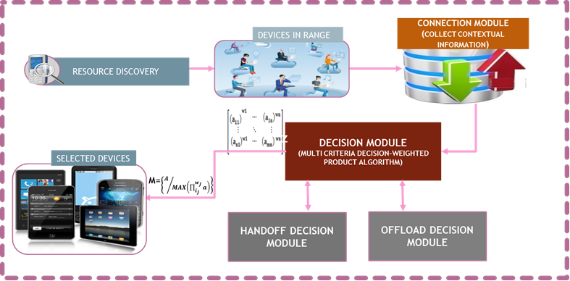

Fig. 1. Methodology
Fig. 2. Handoff execution flow
2.1 Context Aware Decision Framework

We proposed a context aware decision framework that profiles various dynamic contexts of the devices especially at runtime and make decisions that will improve and optimize the performance of the ad hoc cloud.

2.2 Framework Components

We provided an overview of our framework to address the issue of context-aware decision-making in an ad hoc mobile cloud to solve mobility-related problems as well as improve energy efficiency, stability, and availability of the mcloud. Our proposed context-aware decision framework consisted of the following: discovery module, context manager, decision engine, task manager, communication manager, and ad hoc mobile cloud (Fig. 3).
1. Resource Discovery Module: This module scans for and discovers the available mobile devices in the proximity of the client. The discovery module via the communication manager can interact with these devices and get the necessary information to form the ad hoc cloud, such as devices’ capabilities, network characteristics, user preferences, and program attributes.
2. Context Manager: This module provides context sensitivity, it manages, coordinates, and keeps track of dynamic context at run time such as the signal strength, battery level, and other dynamic parameters of the ad hoc cloud. It consists of a context monitor and context database which communicate with each other. The context monitor senses any changing context and saves the state of the data collected in the context database. The context of mobile devices plays a significant role in the decision-making process. The information is used by the decision engine.
3. Decision Engine: The decision engine undertakes the decision-making for the system. It is the core component of our framework. It consists of the cost estimation, offload decision, and handoff decision (Fig. 4). The cost estimation entails analyzing the cost in terms of energy efficiency, time, monetary, etc. The offload decision is going to be based on the outcome of the cost estimation, either local execution or remote offload to the peer devices in the vicinity. The handoff decision is triggered when mobility-related metrics like the Received signal strength Indication (RSSI), and the battery level have exceeded a set threshold. This module executes our proposed algorithms for optimal mobile device selection and handoff execution.
4.Task Manager: The partitioning, scheduling, and execution of the task is handled by the task manager. This module consists of the offload handler which deals with the execution and the synchronization of the operations between the client (master device) and the surrogate devices and a handoff handler which executes the handing over of execution from one mobile device to another under unstable conditions.
5.Communication Handler: It provides the basis for interaction in the ad hoc mobile cloud and it uses wireless network technologies such as Wi-Fi and Bluetooth. It helps in the sending and receiving of results and discovery of resources.
6. Ad Hoc Mobile Cloud: The ad hoc mobile cloud is formed by a collection of the optimal mobile devices in the vicinity of the client. The task is offloaded to the cloud formed by these devices which collaboratively provide resources for the processing of these tasks. They communicate and exchange information with each other and with the master device (the initiator of the task) and are networked through Mobile ad hoc network (MANET).

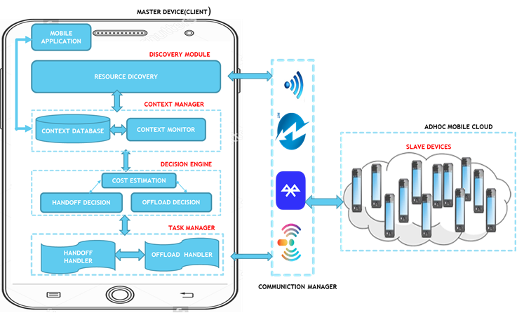
FIG. 3. CONTEXT AWARE DECISION FRAMEWORK
FIG. 4. SYSTEM FLOW CHART
2.3 Mobile ad hoc cloud model
Assumptions:
The following assumptions were made:
a. That all tasks are uniformly partitioned before being offloaded.
b. All nodes in the mobile cloud are randomly distributed and connected in an ad hoc way.

Let M = (m1,m2,…., mn) be a set of available mobile devices in the mobile ad hoc cloud, a given node mn has a CPU speed , λ and link congestion level, α [20].
mn={λ, α} Ɐmn є M (1)

2.4 Task model
For a given task, t, generated by an application, we model the tasks being offloaded as independent and can be partitioned into subtasks for parallel execution [20]. Thus,
t = $(S_{i}$ $C_{i}$ $T_{i})$ (2)
Where, $S_{i}$ is the size of the data being transferred, $C_{i}$ is the amount of computation (number of instructions executed and $T_{i}$ is the time constraint.

2.5 Calculation of Energy Consumption
For the offloadable tasks it is mandatory that the energy consumption for offloading should not be greater when compared with not offloading in order to maximize the full benefits of offloading [21].
This implies that:
${ E}_{local}$ - $E_{off}$ > 0 (3)
Where, $E_{local}$ is energy expended for local execution and $E_{off}$ is energy expended in offloading.
According to Shi et al [21], the energy consumption of executing a task consists of two parts: computation energy and communication energy.

Computation energy is the energy used for processing the task. It is given by:
$E_{comp}$ = $E_{e}$ * I (4)
Communication energy is the energy expended when the two nodes interact. The communication energy is proportional to the amount of data transmitted or received;
$E_{comm}$ =$H_{J}$ * ( $E_{t }$ + $E_{T}$ ) *I (5)
Where, $H_{J}$ is the hop count from the source node to the destination node.
The total task energy, E_{task}, consumed is a summation of both $E_{comm}$ and $E_{comp}$ ${ E}_{task}$ = $\sum_{j=1}^{n}{E_{comp}E_{comm}}$ (6)

2.6 Calculation of Completion Time
The completion time of a task consist of three parts [21]:
- Waiting time: this is how long it takes before a task is executed.
- Processing time: The time taken to execute a task at a given processing node.
- Transmission time: The time required to transfer data from the client to the surrogates.
The processing time is given by:
${ T}_{process}$ = $\frac{I}{MIPs}$ (7)
The transmission time is given by:
${ T}_{transmit}$ =${(H}_{j}- I)$ x $\frac{S_{i} }{B}$ (8)
Where B is the Bandwidth

The task completion time is therefore the summation of the three parts
$T_{complete}$ ₌ $\sum_{i=1}^{n}{T_{trans}T_{proc}T_{wt}}$ (9)

A task is successfully scheduled if it is completed before its deadline; otherwise, it is failed. That is:
$T_{complete}$ < $T_{i}$ (10)

Task Completion Rate = $\frac{number of completed task}{N}$ (11)
Where $N$ is the total number of tasks.

Average energy per successful task = $\frac{total energy }{n}$ (12)
Where n is the number of successful task.

2.7 Resource Selection Using Weighted Product Method Algorithm
The weighted product Method (WPM), is a Multi Criteria Decision Making methodology used to make decision when faced with multiple criteria and alternatives. The details of the WPM algorithm used for decision making process for the selection of optimal mobile device for service provisioning in the ad hoc mobile cloud is presented below:
Step 1: Identify the criteria and the alternatives. The system considers Laptop, tablet and mobile phones (mobile devices) as alternatives for resource providers. The number ranging from (1 to …N). The mobile devices requesting for services for offloading of computation are the clients and the providers of these services are called the surrogates. Also, the following criteria or attributes were considered for decision making: Battery level, Cost (in terms of energy used for computation and communication), Signal strength, Time, and Bandwidth.
Step2: Determine and assign weights using analytic hierarchy process (AHP) and perform the pair wise comparison of the attributes. The pairwise comparison yields the matrix, A_{w,}
A_{w} = $\left[\begin{matrix}a_{11} & ⋯ & a_{15} \\ ⋮ & ⋱ & ⋮ \\ a_{51} & ⋯ & a_{55}\end{matrix}\right]$ ,$a_{nn}$=1/$a_{nm}$ (13)

- Step 3: Using AHP scale, we Set the values for the weighting criteria using an interval on scale of '1-9', followed by the normalization of the criteria weights (C_{w}) as shown in Table 1.
We obtained a normalized weighted criteria matrix such that:
$\sum_{i=1}^{n}{C_{wi}}$ =1 (14)
Where C_{w}i is the weight of the ith criteria and is given by the formula:
C_{w}i = $\frac{W_{i}}{{\sum{C}}_{wi}}$ (15)
- Step 4: do the normalization for both the alternative matrix and the criteria matrix. That is;
${AC}_{w}$ =$\prod_{j=1}^{n}{{Aw}^{cw}}$ (16)
where j = 1 to n.
The resulting matrix is given by:
${AC}_{w}$ = $\left[\begin{aligned}\begin{matrix}{\begin{aligned} \\ \left(a_{11}\right)\end{aligned}}^{w1} & ⋯ & {\left(a_{1n}\right)}^{ wn} \\ ⋮ & ⋱ & ⋮ \\ {\left(a_{n1}\right)}^{w1} & ⋯ & {\left(a_{mn}\right) }^{wn}\end{matrix} \\ \end{aligned}\right]$ (17)
Having obtained the normalized matrix, we apply the Weighted Product Method in ranking and the selection of the optimal alternative.
- Step 5: The final step is to perform the ranking whereby the row with the highest product of elements is selected.
Thus the resulting decision matrix M is given by:
M = {A | max (∏${\left(a\right)}_{ij}^{wj}$ )} (18)

Table 1. Scale used for pair wise comparison (Source: [22], [23]
Intensity of importance | Definition
1 | Equal Importance
3 | Moderate Importance
5 | Strong Importance
7 | Very strong Importance
9 | Extreme Importance
2,4,8 | They are used for intermediate values when there are thresholds you are not sure of
Reciprocals of the above | If activity A has one of the above numbers assigned to it when compared with activity B, then B has the reciprocal value when compared with A.
1.1 – 1.9 | When elements are close and nearly indistinguishable

3. results

3.1 Implementation

The Context and Mobility Aware Decision (CaMAD) framework was designed and implemented on an android platform (android studio version 2.2.3). The experimental set up consists of peer mobile devices with one serving as the master and the other(s) serving as the slave device(s). These devices communicate through the use of Wi-Fi network. The master device carried out the task partitioning based on the number of discovered devices before assigning the task to achieve parallel execution of task, monitors the signal strength and the battery level to enable it to determine the need for the migration of execution to another peer device. The interface consisted of three buttons that provided the options to either “load as Master” “Load as slave” “Load as a single device”. The master device selected any file size of choice, partitions it based on the number of discovered devices that satisfies the given criteria and offloads computation unto them. The application was tested with files of various sizes with multiple devices, single device and on the master (i.e. local execution without offloading). The experimental test bed consisted of three mobile devices, with one serving as the master and the others as slave. The device configurations were as follows:

- Master device: Samsung Galaxy (GT-190601): Processor- 4x ARM Cortex-A7 @1.20GHz, Android version 4.4.4, RAM-952MB
- Slave 1: TECNO-C8 (TECHNO-C8): Processor- 4x ARM Cortex-A53 @1.30GHz, Android version 5.0 RAM- 921MB
- Slave 2: TECNO-C8 (TECHNO-C8): Processor- 4x ARM Cortex-A53 @1.30GHz, Android version 5.0 RAM- 921MB.

3.2 Performance Evaluation

The performance of the system was evaluated using the following metrics: energy consumption and total execution time (Round Trip Time).
- Energy Consumption: The battery level was used to determine the estimated value of energy consumed by the developed framework. The battery level before the computation was offloaded to the peer devices and after the results of the computations were sent back was measured and logged the difference in both the master device and slave device(s) as shown in Figure 5.
- Time: The time was measured by summing up the time taken to send a task from the master device, the execution time on the slave devices and the time taken to return the results to the initiator i.e. the master device which is considered as the Round Trip Time (RTT) (Figure 6). There was about 75.04 % gain in time when computation was offloaded to multiple devices when compared with local execution.
- The impact of different Offloadee Selection and Node Mobility: The effects of offloadee selection and node mobility on frequency of reassignment of task is shown in Figure 7. The adopted Handoff algorithm ensured that node departures was reduced to the barest minimum. The methodology was able to achieve 94.45 % reduction in the frequency of reassignment compared with Random Device Selection and a 66.6 % reduction in the frequency of reassignment compared with Optimal Device Selection.

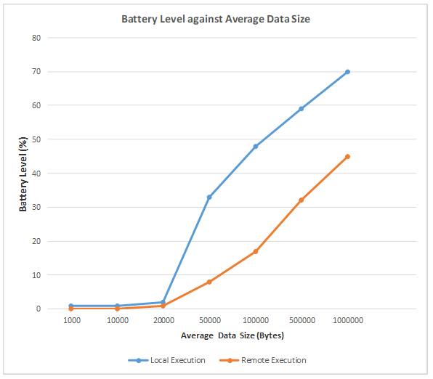
FIG. 5. BATTERY LEVEL AGAINST AVERAGE DATA SIZE

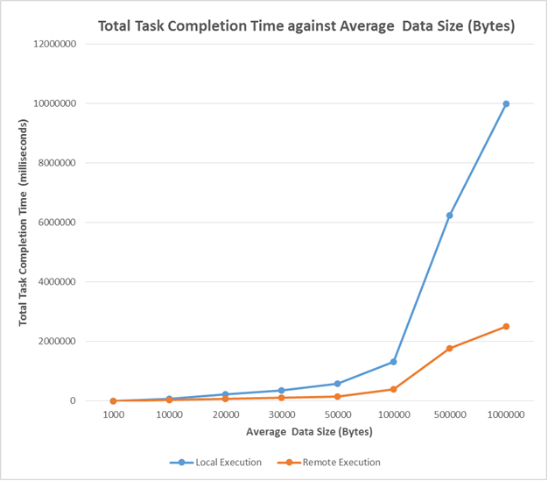
FIG. 6. TOTAL TASK COMPLETION TIME (MILLISECONDS) AGAINST AVERAGE DATA SIZE (BYTES)

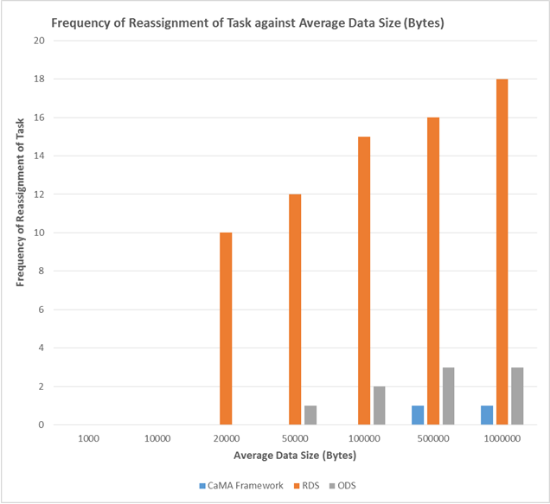
FIG. 7. FREQUENCY OF REASSIGNMENT OF TASK AGAINST AVERAGE DATA SIZE (BYTES)
Note: RDS= Random Device Selection, ODS = Optimal Device Selection, CaMA = Context and Mobility Aware

4. discussion
The results from this study indicated the development of a system model that makes adaptive and proactive decisions and monitors changes in different contexts to make energy-efficient decisions while achieving an overall performance improvement in the mobile cloud. The results suggest that ad hoc mobile cloud has the potential to be used for data-intensive computing and seamless service provisioning if mobility problems of the mobile cloud are tackled. The stability-aware and a status-aware mobile device selection method employed in this study stored the status and the historical characteristics of each mobile device, evaluated the stability of each mobile device, and finally selected an optimal mobile device for the task execution. It is important to note that the offloadee selection and node mobility had a significant effect on the frequency of reassignment of tasks. Improved performance of the cloud (execution time and energy consumption) was achieved by parallel execution of tasks, optimal offloadee selection, and the incorporation of the handoff algorithm when computation was offloaded. The review of Akherfi et al. [24] suggested that introducing a middleware-based architecture that optimizes the offloading algorithm has the potential to offer more solutions and improve the efficiency of the mobile cloud. Using a computation offloading-based system in a mobile cloud computing context (Android and Hadoop environment), Xia et al. [25] reported improved energy efficiency and reduced application execution time of smartphones. In another study [26] used a min-cost offloading partitioning (MCOP) algorithm under different cost models and mobile environments and reported a stable method with low time complexity. The proposed algorithm was reported to have the potential to significantly reduce execution time and energy consumption through optimal distribution of tasks between mobile devices and cloud servers.

5. Conclusion

The results from this study showed that the parallel execution of tasks, selection of optimal mobile devices, and the incorporation of the Handoff algorithm improved execution time and reduced energy consumption when computation was offloaded. Nonetheless, the effects of using different wireless technologies on data of different kinds and sizes and how it can affect decision-making in an ad hoc mobile cloud as well as the development of different incentive models or schemes for the peer devices offering their resources for computation are suggested for further studies. Also, an energy-efficient security scheme should be provided for the data sent over the network.

Disclaimer (Artificial intelligence)
Option 1:
Author(s) hereby declare that NO generative AI technologies such as Large Language Models (ChatGPT, COPILOT, etc.) and text-to-image generators have been used during the writing or editing of this manuscript.

References
- Yaqoob, I., Ahmed, E., Gani, A., Mokhtar, S., Imran, M., & Guizani, S. (2016). Mobile ad hoc cloud: A survey. Wireless Communications and Mobile Computing, 16(16), 2572-2589. https://doi.org/10.1002/wcm.2709
- Mach, P., & Becvar, Z. (2017). Mobile Edge Computing: A Survey on Architecture and Computation Offloading. IEEE Communications Surveys & Tutorials. https://doi.org/10.1109/COMST.2017.2682318
- Islam, A., Kumar, A., Mohiuddin, K., Yasmin, S., Khaleel, M. A., & Hussain, M. R. (2020). Efficient resourceful mobile cloud architecture (mRARSA) for resource demanding applications. Journal of Cloud Computing, 9, 1-21. https://doi.org/10.1186/s13677-020-0155-6
- Jin, X., Hua, W., Wang, Z., & Chen, Y. (2022). A survey of research on computation offloading in mobile cloud computing. Wireless Networks, 28(4), 1563-1585. https://doi.org/10.1007/s11276-022-02920-2
- Zhou, B., Dastjerdi, A. V., Calheiros, R. N., Srirama, S. N., & Buyya, R. (2015). mCloud: A context-aware offloading framework for heterogeneous mobile cloud. IEEE Transactions on Services Computing, 10(5), 797-810. https://doi.org/10.1109/TSC.2015.2511002
- Ismail, M., El-Rashidy, N., & Abdel-aziz, N. M. (2022). Mobile cloud database security: problems and solutions. Fusion: Practice and Applications, 7(1), 15-29. https://doi.org/10.54216/FPA.070102
- Srilakshmi, U., Alghamdi, S. A., Vuyyuru, V. A., Veeraiah, N., & Alotaibi, Y. (2022). A secure optimization routing algorithm for mobile ad hoc networks. IEEE Access, 10, 14260-14269. https://doi.org/10.1109/ACCESS.2022.3144679
- Agrawal, R., Faujdar, N., Romero, C. A. T., Sharma, O., Abdulsahib, G. M., Khalaf, O. I., Mansoor, R. F., & Ghoneim, O. A. (2023). Classification and comparison of ad hoc networks: A review. Egyptian Informatics Journal, 24(1), 1-25. https://doi.org/10.1016/j.eij.2022.10.004
- Krishnamoorthy, V. K., Izonin, I., Subramanian, S., Shandilya, S. K., Velayutham, S., Munichamy, T. R., & Havryliuk, M. (2023). Energy saving optimization technique-based routing protocol in Mobile ad-hoc network with IOT Environment. Energies, 16(3), 1385. https://doi.org/10.3390/en16031385
- Ahmed, E., Gani, A., Khan, M. K., Buyya, R., & Khan, S. U. (2015). Seamless application execution in mobile cloud computing: Motivation, taxonomy, and open challenges. Journal of Network and Computer Applications, 52, 154-172. https://doi.org/10.1016/j.jnca.2015.03.001
- Zhou, A., Wang, S., Li, J., Sun, Q., & Yang, F. (2016). Optimal mobile device selection for mobile cloud service providing. The Journal of Supercomputing. https://doi.org/10.1007/s11227-016-1704-0
- Aliyu, A., Abdullah, A. H., Kaiwartya, O., Madni, S. H. H., Joda, U. M., Ado, A., & Tayyab, M. (2020). Mobile cloud computing: Taxonomy and challenges. Journal of Computer Networks and Communications. https://doi.org/10.1155/2020/2547921
- Maray, M., & Shuja, J. (2022). Computation Offloading in Mobile Cloud Computing and Mobile Edge Computing: Survey, Taxonomy, and Open Issues. Mobile Information Systems, 2022(1), 1121822.
- Sheikh, B., Butt, A., & Hanif, J. (2023). Mobile Cloud Computing: A Survey on Current Security Trends and Future Directions. Engineering Proceedings, 32(1), 22. https://doi.org/10.3390/engproc2023032022
- Kanwal, A., Amjad, T., & Ashraf, H. (2024). Framework for Agent-Based Multistage Application Partitioning Algorithm in Mobile Cloud Computing. SN Computer Science, 5(4), 330. https://doi.org/10.1007/s42979-024-0600-2
- Rahimi, M. R., Venkatasubramanian, N., & Vasilakos, A. V. (2013). MuSIC: Mobility-Aware Optimal Service Allocation in Mobile Cloud Computing. 2013 IEEE Sixth International Conference on Cloud Computing. https://doi.org/10.1109/CLOUD.2013.100
- Hu, H., Wang, Q., Hu, R. Q., & Zhu, H. (2021). Mobility-aware offloading and resource allocation in a MEC-enabled IoT network with energy harvesting. IEEE Internet of Things Journal, 8(24), 17541-17556. https://doi.org/10.1109/JIOT.2021.3081983
- Zheng, F. Y., Huang, S. L., Zhang, T. W., Yang, F. J., Yang, F. L., & Yeo, C. K. (2022). Distributed algorithm for computation offloading in mobile edge computing considering user mobility and task randomness. The Journal of Supercomputing, 78(10), 12476-12504. https://doi.org/10.1007/s11227-022-04383-w
- Song, C., Tao, J., Gao, Y., Xu, Y., Sun, W., & Wang, H. (2024). Particle Swarm Optimization with Latin Hypercube Sampling for Mobility-Aware Task Offloading in D2D-Assisted MEC Networks. Research Square. https://doi.org/10.21203/rs.3.rs-4105847/v1
- Zhou, A., Wang, S., Li, J., Sun, Q., & Yang, F. (2016). Optimal mobile device selection for mobile cloud service providing. The Journal of Supercomputing, 72, 3222-3235. https://doi.org/10.1007/s11227-016-1704-0
- Shi, T., Yang, M., Li, X., Lei, Q., & Jiang, Y. (2016). An energy-efficient scheduling scheme for time-constrained tasks in local mobile clouds. Pervasive and Mobile Computing, 27, 90-105. https://doi.org/10.1016/j.pmcj.2015.07.005
- Saaty, T.L. (2008). Decision making with the analytic hierarchy process. International journal of services sciences, 1, 83-98.https://doi.org/10.1504/IJSSCI.2008.017590
- Alexander, M. (2012). Decision-making using the analytic hierarchy process (ahp) and jmp® scripting language. In The SouthEast SAS Users Group Conference (SESUG), SESUG Inc.
- Akherfi, K., Gerndt, M., & Harroud, H. (2018). Mobile cloud computing for computation offloading: Issues and challenges. *Applied Computing and Informatics*, *14*(1), 1–16. https://doi.org/10.1016/j.aci.2016.11.002
- Xia, F., Ding, F., Li, J., Kong, X., Yang, L. T., & Ma, J. (2014). Phone2Cloud: Exploiting computation offloading for energy saving on smartphones in mobile cloud computing. Information Systems Frontiers, 16, 95-111. https://doi.org/10.1007/s10796-013-9458-1
- Wu, H., Knottenbelt, W., Wolter, K., & Sun, Y. (2016). An optimal offloading partitioning algorithm in mobile cloud computing. In Quantitative Evaluation of Systems: 13th International Conference, QEST 2016, Quebec City, QC, Canada, August 23-25, 2016, Proceedings 13 (pp. 311-328). Springer International Publishing. https://doi.org/10.1007/978-3-319-43425-4_21

