Effect of Polypropylene Container Color on the Stability of Lutein and Zeaxanthin in Palm Oil under Sunlight Exposure

Abstract
This study evaluated the effect of polypropylene (PPE) containers of different colors (black, blue, yellow, and white) on the stability of lutein and zeaxanthin in palm oil under sunlight exposure. Lutein and zeaxanthin, essential carotenoids with significant antioxidant and eye health benefits, are prone to degradation when exposed to UV light and oxygen. The Baseline carotenoid concentrations were measured initially, with samples analyzed every 30 days over a 60-day exposure period. Containers were exposed to direct sunlight for seven hours daily (9:00 AM – 4:00 PM). Each PPE container color was analyzed in true duplicates for both day 30 and day 60 resulting in a total of 4 treatment per PPE color. This gives a total number of 16 sample treatments. Statistical analysis using ANOVA, with significance levels set at 0.05, revealed significant differences in carotenoid stability among the PPE containers over time.
Results showed that black PPE containers provided the highest retention of both lutein and zeaxanthin, with no significant degradation over the 60-day period (p > 0.05), maintaining levels close to the baseline. In contrast, blue PPE exhibited moderate protection, while white and yellow containers demonstrated significant declines in carotenoid levels, with lutein and zeaxanthin concentrations reduced by more than half by 60 days (p < 0.05). The comparison between 30-day and 60-day values further highlighted the protective effect of black PPE, with statistically significant reductions in these carotenoids observed only in the lighter-colored containers (p < 0.05).
These findings emphasize the importance of UV-blocking packaging, particularly black PPE, in preserving these carotenoids in palm oil. Using UV-resistant containers can enhance the shelf life and nutritional value of carotenoid- rich oils, ensuring product quality throughout storage and distribution. This research provides a basis for improved packaging strategies in the palm oil industry to meet the growing consumer demand for nutrient-stable functional foods.

KEYWORDS: Palm Oil, Sunlight Exposure, UV, PPE color

Introduction
Palm oil (Elaeis guineensis) is one of the most widely produced and utilized vegetable oils globally, not only for its economic value but also for its rich content of bioactive compounds, including carotenoids such as lutein and zeaxanthin. These carotenoids are particularly important for human health, as they play crucial roles in eye protection and serve as potent antioxidants. Lutein and zeaxanthin accumulate in the macula of the retina, where they act as natural filters for harmful blue light, reducing oxidative stress and potentially lowering the risk of age-related macular degeneration (AMD) and cataracts (Landrum and Bone, 2001; Bone et al., 1997). Epidemiological studies have also linked these carotenoids with lower risks of various chronic diseases, including certain types of cancers (Park et al., 1998).
However, the stability of lutein and zeaxanthin in palm oil is compromised, mainly due to their conjugated diene system, by environmental factors such as UV light, oxygen, and heat, all of which accelerate degradation processes. Research shows that UV radiation, in particular, induces generations of peroxides, oxidative reactions in carotenoids, causing structural breakdown and loss of nutritional value (Ng and Tan, 1998; Darnoko et al., 2000; Okogbenin et al.,2017). Studies on other carotenoid-rich oils indicate that carotenoid degradation can reach up to 50% under light exposure, underscoring the need for effective protective strategies to preserve these bioactive compounds (Khachik et al., 1992).
A current trend in many African markets shows an increase in the storage, marketing, and transport of palm oil in white PPE containers (plate 1). This practice can result in the gradual loss of carotenoids like lutein and zeaxanthin due to increased exposure to UV light, ultimately diminishing the nutritional quality and health benefits of palm oil by the time it reaches consumers.

Given the susceptibility of carotenoids to degradation, finding effective ways to preserve lutein and zeaxanthin during storage and transport is critical for the palm oil industry. Polypropylene (PPE) containers, widely used for food storage due to their durability and cost-effectiveness, offer a potential solution. Among various colors of PPE, darker shades such as black are known to provide greater UV-blocking capabilities, which could reduce carotenoid breakdown during light exposure (Lietz and Henry, 1997). While there is limited research on the effect of PPE color on carotenoid stability in palm oil, previous studies have shown that darker packaging materials are generally more effective in preventing nutrient degradation in light-sensitive products (Ng et al., 1998; Lau et al., 2003). By testing different colors of PPE containers under sunlight exposure, this study seeks to determine the most effective packaging color for preserving carotenoids in palm oil (Colín-Chávez et al., 2014).
The primary aim of this study is to evaluate the impact of PPE container color on the stability of lutein and zeaxanthin in palm oil under sunlight exposure over a two-month period. Specifically, the objective is to determine if there is a statistically significant difference in the mean concentrations of lutein and zeaxanthin among different PPE containers (black, white, blue, yellow) at 30 days and 60 days. Additionally, comparisons are made between each time point and the baseline to assess degradation.
By achieving these objectives, this research contributes to the broader field of food storage technology and functional food preservation (Lietz et al., 1997). Given the increasing consumer demand for high-quality, health-promoting oils, this study's findings could help improve the nutritional stability and marketability of palm oil products, particularly those rich in carotenoids (Maoka, 2003; Landrum et al., 1997).
In summary, this study provides critical insights into the importance of using UV-blocking materials, especially black PPE containers, to maintain the integrity and health benefits of carotenoid-rich palm oil during storage and transport.
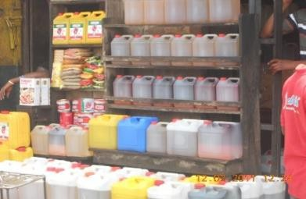
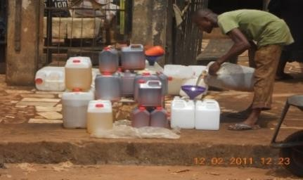

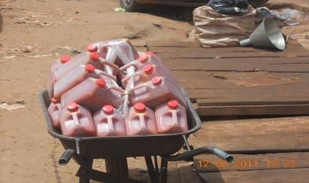
Plate 1: Mode of marketing, selling and transportation of palm oil in major markets in Africa

Methodology

Experimental Design
This study involved assessing the effect of polypropylene (PPE) containers of different colors (black, yellow, blue, and white) on the stability of carotenoids, particularly lutein and zeaxanthin, in palm oil.
Freshly milled palm oil was obtained from Oil mill Division, NIFOR. At a temperature of 40ºC, the oil was continuously stirred as equal volumes (250ml) were dispensed into two liters PPE containers. Duplicate containers were prepared for each treatment group to allow for destructive sampling, meaning that once a container was opened for analysis, it would not be reused. This approach ensured the integrity of the results by preventing contamination or repeated exposure effects.
Containers were exposed to direct sunlight for seven hours daily (9:00 AM – 4:00 PM) (see plate 2) The exposure period lasted for sixty days. Samples were analyzed every thirty days to monitor lutein and zeaxanthin levels and detect trends in degradation over time. A baseline analysis of the palm oil’s initial lutein and zeaxanthin concentrations was conducted prior to exposure to establish reference values.
Each type of PPE container was prepared in sufficient duplicates to ensure that once a sample was opened for analysis, it was discarded. This ensured the oil’s quality was not altered by repeated handling.

Methodology for the Extraction and Quantification of Lutein and Zeaxanthin
Sample Preparation
- Extraction Process: The palm oil sample underwent a saponification process to isolate carotenoids. Approximately 10 g of palm oil was mixed with 60 mL of absolute ethanol, followed by the addition of 0.5 g of Butylated Hydroxytoluene (BHT) as an antioxidant and 10 mL of potassium hydroxide (KOH, 50% w/v). The mixture was then heated in a water bath at 100°C for one hour to hydrolyze the triglycerides.
- Carotenoid Extraction: After saponification, the carotenoid-rich fraction was extracted by adding 100 mL of a diethyl ether/hexane mixture (50:50 v/v) to the sample. This extraction was repeated until all non-saponified materials were recovered. The organic layer was washed with distilled water until neutral, dried over anhydrous sodium sulfate, and evaporated under reduced pressure to obtain a dried extract of lutein and zeaxanthin.

HPLC Setup and Injection Details
- Column and Instrumentation: The dried extract was reconstituted and analyzed using High-Performance Liquid Chromatography (HPLC) equipped with a YMC C30 column specifically chosen for its efficiency in separating carotenoids. This column is highly effective for complex plant matrices, allowing for clear separation of xanthophylls like lutein and zeaxanthin (YMC Co., Ltd.).
- Injection Volume: 10.00 µL of each sample solution was injected into the HPLC system to ensure adequate sensitivity for detecting carotenoids present in small concentrations.
- Run Time: The HPLC analysis was set to a 15-minute run time, optimized for efficient separation and quantification of lutein and zeaxanthin without extended column wear.

Acquisition and Detection
- Acquisition Method: The "YMC cassava" method was selected for analysis, optimized for cassava and similar plant-based matrices, with a setup suitable for carotenoid analysis. The HPLC was operated in an isocratic mode, maintaining a stable solvent composition to achieve optimal separation.
- Detection Parameters: A Photodiode Array (PDA) detector was employed at a wavelength of 450 nm, a maximum absorbance range for lutein and zeaxanthin. This wavelength allowed precise monitoring of the carotenoid peaks as they eluted, ensuring reliable detection and quantification (Darnoko et al., 2000).
- Processing Method: The samples were processed using the "YMC method 450," a validated protocol that aligns retention times and elution profiles with known standards for lutein and zeaxanthin. This method is suited for high-performance separation of carotenoids, particularly in plant and oil matrices, ensuring reproducibility and consistency in measurements (Lietz and Henry, 1997).

Data Analysis
- Total number of replicate per treatment is two (duplicate).
- The quantification of lutein and zeaxanthin was conducted by comparing the peak areas from the sample chromatograms with those of known standards. The PDA’s spectral data allowed confirmation of each peak based on specific absorbance maxima, with lutein and zeaxanthin identified and quantified accurately from baseline measurements.
- ANOVA was performed at two levels of significance, α = 0.05 to examine the robustness of the observed differences.
- Post-Hoc Analysis: Where ANOVA shows significant differences, a Tukey’s Honest Significant Difference (HSD) test for multiple comparisons was conducted to identify which specific container color groups differ from each other.
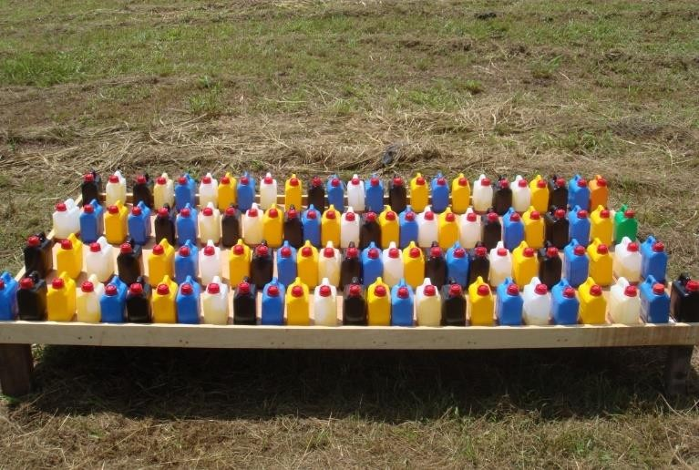
Plate 2: Experimental Design

Results
Table 1: Lutein Concentration (µg/g) in Palm Oil Stored in Different PPE Containers
Time (Days) | Container Color | Lutein (µg/g) (Mean ± SEM) | Significance Compared to Baseline | Significance Compared to Other Colors
Baseline | - | 7.49 ± 0.035 | - | -
30 | White | 3.43 ± 0.046 | p<0.05 | Lower concentration than Black, Blue (p<0.05) but higher concentration than Yellow (p<0.05)
 | Yellow | 2.33 ± 0.065 | p<0.05 | Lowest concentration than Black, Blue and White (p<0.05)
 | Black | 6.70 ± 0.033 | p>0.05 | Highest concentration than Yellow, Blue and White (p<0.05)
 | Blue | 4.52 ± 0.059 | p<0.05 | Lower concentration than Black (p<0.05) but higher concentration than Yellow and Blue (p<0.05)
60 | White | 1.74 ± 0.022 | p<0.05 | Lower concentration than Black, Blue (p<0.05) but higher concentration than Yellow (p<0.05)
 | Yellow | 1.37 ± 0.019 | p<0.05 | Lowest concentration than Black, Blue and White (p<0.05)
 | Black | 6.00 ± 0.033 | p>0.05 | Highest concentration than Yellow, Blue and White (p<0.05)
 | Blue | 3.62 ± 0.065 | p<0.05 | Lower concentration than Black (p<0.05) but higher concentration than Yellow and Blue (p<0.05)

Table 2: Zeaxanthin Concentration (µg/g) in Palm Oil Stored in Different PPE Containers
Significance Compared Significance Compared to Other Colors to Baseline
Time | Container | Zeaxanthin (µg/g)
(Days) | Color | (Mean ± SEM)
Baseline | - | 43.44 ± 2.31
30 | White | 19.95 ± 0.06
 | Yellow | 21.70 ± 0.96
 | Black | 42.56 ± 0.69
 | Blue | 31.85 ± 0.42
60 | White | 8.78 ± 0.07
 | Yellow | 9.18 ± 0.13
 | Black | 42.62 ± 0.04

- -

p<0.05 Lowest concentration compared to Black Blue and Yellow (p<0.05)

p<0.05 Lower values compared to Black, Blue (p<0.05) but higher value compared to white ((p < 0.05))

p>0.05 Highest concentration compared to Blue White, Yellow (p<0.05)

p<0.05 Lower values compared to Black (p<0.05) but higher value compared to White and Blue (p < 0.05))

p<0.05 Lowest concentration compared to Black Blue and Yellow (p<0.05)

p<0.05 Lower values compared to Black, Blue (p<0.05) but higher value compared to white ((p < 0.05))

p>0.05 Highest concentration compared to Blue White, Yellow (p<0.05)

Time (Days)
Container Color
Zeaxanthin (µg/g) (Mean ± SEM)
Significance Compared Significance Compared to Other Colors to Baseline

Blue 27.20 ± 0.064 p<0.05 Lower values compared to Black (p<0.05) but higher value
compared to White and Blue (p < 0.05))

90%
80%
70%
60%
Percentage loss
50%
40%
30%
20%
10%
0%
Lutein Zeaxanthin Lutein Zeaxanthin Lutein Zeaxanthin Lutein Zeaxanthin White Yellow Blue Black

Baseline to Day 30
Axis Title
Day 30 to Day 60
Baseline to Day 60

Figure 1: Percentage Loss of Lutein and Zeaxanthin in Different PPE Containers Over Time

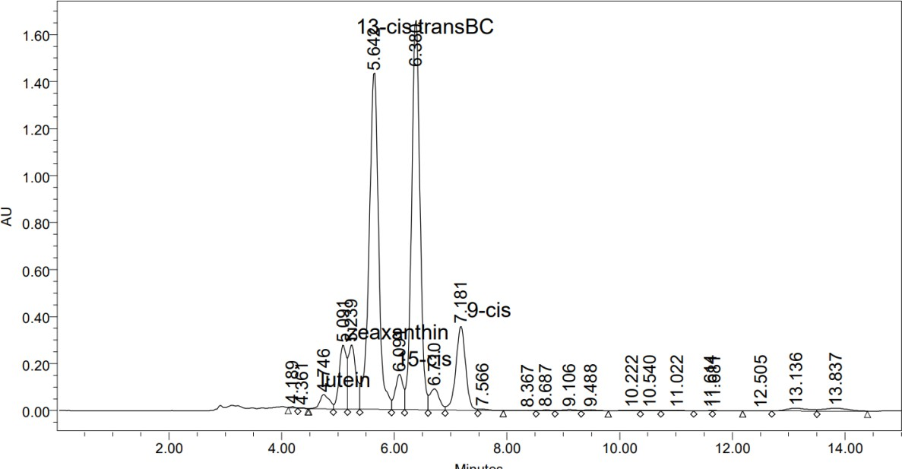
Figure 2. High-Performance Liquid Chromatography (HPLC) chromatogram showing the separation of carotenoids and related compounds of a baseline sample. Prominent peaks include those for lutein (4.746 min) and zeaxanthin (5.091 min), with additional peaks corre sponding to other carotenoid isomers such as 13-cis (5.644 min) and trans-BC (6.388 min). The retention times highlight the distinct elution profiles of each compound under the analysis conditions, allowing for precise identification and quantification.

Results at both 30 days and 60 days of exposure, shows differences (p<0.05) in Zeaxanthin levels among the different PPE containers (Table 2). Analysis reveals that Black PPE consistently shows the highest (p < 0.05) Zeaxanthin retention, with higher (p<0.05) levels than yellow and white PPE containers. Blue PPE retains Zeaxanthin moderately well (p<0.05) compared to white and Yellow PPE but less (p < 0.05) than black PPE. Also, at both time stamps (30 days and 60 days) only Zeaxanthin levels in black PPE containers show minimal degradation relative to the baseline (p>0.05), indicating effective protection. However, Zeaxanthin levels in blue, yellow and white containers are significantly lower than the baseline (p<0.05), suggesting that lighter PPE colors are less effective in preserving lutein (Table 2). A similar pattern is also observed in lutein levels (table 1). However, worthy of note is the lutein levels in yellow PPE, which showed consistent lower values (p<0.05) than lutein levels in white PPE (Table 2). This was different in Zeaxanthin levels which showed a reverse pattern (i.e. higher Zeaxanthin levels (p<0.05) in yellow PPE than in whit PPE
As illustrated in Figure 1, the lutein concentration in white PPE showed a significant decline over time, decreasing by 54% from 7.49 µg/g at baseline to 3.43 µg/g after 30 days. Yellow PPE experienced an even greater initial decline, with a 69% reduction from 7.49 µg/g to 2.33 µg/g over the same period. From day 30 to day 60, lutein levels in white PPE further declined by 49% (from 3.43 µg/g to 1.74 µg/g), while yellow PPE dropped an additional 41% (from 2.33 µg/g to 1.37 µg/g). The total decrease in lutein concentration from baseline to day 60 was 77% in white PPE and 82% in yellow PPE. These high rates of degradation indicate that both white and yellow PPE provided insufficient UV protection, with yellow PPE exhibiting the highest overall degradation. The cumulative exposure to UV light in these lighter-colored containers accelerated lutein degradation, leading to substantial losses by day 60.
In blue PPE, lutein levels declined moderately. There was a 40% reduction from baseline, with levels dropping from
7.49 µg/g to 4.52 µg/g by day 30. Between day 30 and day 60, lutein in blue PPE declined by an additional 20%, falling from 4.52 µg/g to 3.62 µg/g. This resulted in an overall reduction of 52% from baseline to day 60. The blue PPE provided moderate protection, slowing lutein degradation compared to white and yellow PPE. However, degradation continued over time, suggesting that while blue PPE offers some UV protection, it is less effective for long-term storage than black PPE.
In contrast, black PPE exhibited minimal degradation. Lutein levels declined by only 11% from baseline to day 30, reducing slightly from 7.49 µg/g to 6.70 µg/g. From day 30 to day 60, lutein levels in black PPE decreased by a further 10%, from 6.70 µg/g to 6.00 µg/g. The total decline in lutein from baseline to day 60 was only 20%. This minimal decrease highlights black PPE's strong UV-blocking capacity, which significantly slowed degradation rates and preserved lutein levels near baseline over the 60-day period.
For zeaxanthin, similar trends were observed. In white PPE, zeaxanthin levels decreased by 54% from 43.44 µg/g at baseline to 19.95 µg/g at day 30. Yellow PPE experienced a comparable decline, with a 50% reduction from 43.44 µg/g to 21.70 µg/g. From day 30 to day 60, zeaxanthin in white PPE declined by an additional 56% to reach 8.78 µg/g, while yellow PPE saw a further decrease of 58%, ending at 9.18 µg/g. Overall, zeaxanthin levels fell by 80% in white PPE and 79% in yellow PPE from baseline to day 60. These significant losses underscore the inadequate protective capabilities of white and yellow PPE against UV exposure, with both containers allowing accelerated degradation, especially between day 30 and day 60.
Zeaxanthin in blue PPE declined more gradually, with a 27% decrease from baseline to day 30, reducing from 43.44 µg/g to 31.85 µg/g. Between day 30 and day 60, zeaxanthin levels dropped an additional 15%, ending at 27.20 µg/g. This equates to a total decrease of 37% from baseline to day 60. Although blue PPE offered moderate protection, slowing down the rate of degradation compared to white and yellow PPE, it was still insufficient to fully prevent significant losses over the 60-day period.
In black PPE, zeaxanthin levels exhibited negligible degradation. From baseline to day 30, zeaxanthin levels declined by only 2%, from 43.44 µg/g to 42.56 µg/g. Remarkably, between day 30 and day 60, zeaxanthin levels remained stable, increasing slightly to 42.62 µg/g (a change that was not statistically significant). The total loss in zeaxanthin

from baseline to day 60 was approximately 2%, confirming black PPE’s exceptional UV-blocking ability and its effectiveness in preserving carotenoid content over extended exposure.

Discussion
The general trend across all containers clearly shows that black PPE container consistently preserved carotenoid levels close to baseline values over both 30 and 60 days, indicating strong protection against UV light. These results emphasize that black containers are highly effective for storing carotenoid-rich oils, as they minimize exposure to damaging wavelengths. Previous research supports the use of black or dark-colored containers to protect carotenoids from photodegradation, as these colors absorb and block the majority of UV light, preventing the oxidative damage that leads to nutrient loss (Okogbenin et al, 2017; Landrum and Bone, 2001; Lau et al., 2003).
The blue PPE container provided moderate protection, which slowed the degradation rate but still allowed noticeable reductions in carotenoid concentrations over time. Though it retained higher(p<0.05) carotenoids than white and yellow PPE, it still showing a significant (p < 0.05) decline from baseline values, as shown in both Table 2 (zeaxanthin) and Table 1 (lutein). This aligns with studies that have shown blue and green packaging materials provide intermediate levels of UV protection, better than transparent or light-colored materials but not as effective as opaque or black options. Blue color might filter out some harmful wavelengths but not to the extent required to fully stabilize carotenoids over long storage periods (Lietz and Henry, 1997).
White and yellow PPE containers exhibited the highest rates of degradation for both lutein and zeaxanthin, with significant losses from 30 to 60 days (figure 1). This suggests that these containers allow excessive light exposure, leading to accelerated oxidative breakdown as storage time increases. These findings are consistent with the literature, which shows that carotenoids are highly susceptible to UV-induced degradation, particularly in transparent or lightly colored containers (Ng and Tan, 1998; Darnoko et al., 2000). Unexpectedly, white PPE demonstrated greater lutein stability than yellow PPE, despite an initial assumption that yellow PPE would better protect the carotenoids due to its darker color as seen in Zeaxanthin concentrations. Several reasons might be responsible for this.
One of such reason is may be due to the wavelength-specific vulnerability of lutein. Carotenoids, particularly lutein, are sensitive to shorter wavelengths of light (e.g., blue and violet light), which can accelerate oxidative degradation. Yellow PPE may block certain light wavelengths but still allow damaging short-wavelength light to penetrate, potentially exacerbating lutein degradation. White PPE, on the other hand, scatters or diffuses light more evenly across the spectrum, possibly reducing exposure to specific wavelengths that would otherwise accelerate photodegradation (Shao et al., 2012).
Another reason may be as a result of thermal effects and light absorption. Yellow PPE may absorb more light and retain more heat than white PPE, particularly if it is a deeper or more saturated yellow. The increase in temperature within yellow PPE containers could lead to a higher rate of thermal-induced oxidation of lutein compared to the relatively cooler conditions in white PPE. Thermal stress is known to accelerate the breakdown of carotenoids in oils, especially when coupled with light exposure (Ng and Tan, 1998). Thus, white PPE’s reflective properties may have indirectly contributed to the higher retention of lutein by reducing heat buildup inside the container.
The unexpected result of higher lutein retention in white PPE compared to yellow PPE can be attributed to the complex interactions between light wavelengths and thermal effects in each container. As indicated by Tables 1 and 2, white PPE’s reflective properties may have contributed to reduced lutein degradation, whereas yellow PPE may have allowed more specific wavelengths that accelerate photodegradation.
These findings suggest that while yellow PPE may appear intuitively more protective than white PPE due to its darker color, the specific light-filtering and thermal characteristics of the material play a critical role in carotenoid stability. The results indicate that black PPE is the most reliable choice for preserving carotenoids in light-exposed environments, followed by blue PPE, with yellow and white PPE being less effective.

Conclusion
The results of this study provide valuable insights for the palm oil industry and broader food packaging sectors. The choice of container color and material can significantly influence the shelf life and quality of carotenoid- rich oils and other light-sensitive products. By using black PPE containers, producers can potentially extend the shelf life of palm oil products while ensuring the retention of key nutrients, particularly those with known health benefits like lutein and zeaxanthin.
Further research is needed to investigate the impact of other environmental factors, such as temperature fluctuations and humidity, on carotenoid stability in different types of packaging. Additionally, studies focusing on the economic feasibility and environmental impact of black PPE usage could help optimize packaging solutions that balance quality preservation with sustainability. Research on alternative packaging materials that offer similar UV protection, such as biodegradable options with UV-blocking properties, would be valuable for industries seeking sustainable approaches.

Disclaimer (Artificial intelligence)
Option 1:
Author(s) hereby declare that NO generative AI technologies such as Large Language Models (ChatGPT, COPILOT, etc.) and text-to-image generators have been used during the writing or editing of this manuscript.
Option 2:
Author(s) hereby declare that generative AI technologies such as Large Language Models, etc. have been used during the writing or editing of manuscripts. This explanation will include the name, version, model, and source of the generative AI technology and as well as all input prompts provided to the generative AI technology
Details of the AI usage are given below:
1.
2.
3.

References
- Bone, R. A., Landrum, J. T., Friedes, L. M., Gomez, C. M., Kilburn, C. D., & Menendez, E. (1997). Distribution of lutein and zeaxanthin stereoisomers in the human retina. Experimental Eye Research, 64, 211- 218.
- Darnoko, D., Cheryan, M., Moros, E., Jerrel, J., & Perkins, E. G. (2000). Simultaneous HPLC analysis of palm carotenoids and tocopherols using a C30 column and photodiode array detector. Journal of Liquid Chromatography & Related Technologies, 23(12), 1873-1885.
- Khachik, F., Beecher, G. R., & Goli, M. B. (1992). Separation and identification of carotenoids and their oxidation products in the extracts of human plasma. Analytical Chemistry, 64, 2111-2122.
- Landrum, J. T., Bone, R. A., Joa, H., Kilbourn, M. D., Moore, L. L., & Sprague, K. E. (1997). A one-year study of the macular pigment: The effect of 140 days of lutein supplementation. Experimental Eye Research, 65, 57-62.
- Landrum, J. T., & Bone, R. A. (2001). Lutein, zeaxanthin, and the macular pigment. Archives of Biochemistry and Biophysics, 385, 28-40.
- Lau, H. L. N., Choo, Y. M., Ma, A. N., & Chuah, C. H. (2000). An improved and efficient method for analyzing palm oil and other vegetable oils. In Proceedings of the PIPOC 2000 International Palm Oil Congress - Chemistry and Technology Conference (pp. 457-460).
- Lau, H. L. N., Choo, Y. M., Ma, A. N., & Chuah, C. H. (2003). An improved and efficient method for analyzing palm oil and other vegetable oils. In Proceedings of the PIPOC 2003 International Palm Oil Congress - Chemistry and Technology Conference (pp. 457-460).
- Lietz, G., & Henry, C. J. K. (1997). A modified method to minimize losses of carotenoids and tocopherols during HPLC analysis of red palm oil. Food Chemistry, 60, 109-117.
- Maoka, T. (2003). Analysis of carotenoids by combined HPLC, UV-visible absorption spectrometry, and APCI mass spectrometry. Lipid Technology, 15(2), 39-41.
- Ng, J. H., & Tan, B. (1998). Analysis of palm oil carotenoids by HPLC with diode array detection. Journal of Chromatographic Science, 26, 463-469.
- Okogbenin, E. A., Uadia, P. O., Obibuzor, J. U., Okunwaye, T., & Onyia, D. C. (2017, September 27). The role of coloured polypropylene containers on sunlight-mediated oxidation of palm oil. Paper presented at the Chemical Society of Nigeria Conference, Auchi, Nigeria.
- Park, J. S., Chew, B. P., & Wong, T. S. (1998). Dietary lutein from marigold extract inhibits mammary tumor development in BALB/c mice. Journal of Nutrition, 128, 1650.

- Shao, Y., Zhang, J., & Liu, J. (2012). Effects of light exposure and packaging on the stability of carotenoids in oils. Journal of Food Science and Technology, 47(4), 376-382.
- YMC Co., Ltd. (n.d.). Guides for method development and applications of YMC columns for carotenoid analysis. YMC Co., Ltd. Retrieved from https://www.ymc.co.jp
- Colín-Chávez, C., Vicente-Ramírez, E.B., Soto-Valdez, H. et al. The Release of Carotenoids from a Light-Protected Antioxidant Active Packaging Designed to Improve the Stability of Soybean Oil. Food Bioprocess Technol 7, 3504–3515 (2014). https://doi.org/10.1007/s11947-014-1359-x

