Case report
Infectious Bovine Keratoconjunctivitis in a Calf: A Case Report on Successful Therapeutic Management
Abstract
This case report describes the successful management of Infectious Bovine Keratoconjunctivitis (IBK) in an 8-month-old male calf weighing 300 kg presenting with conjunctival inflammation, blepharospasm, excessive lacrimation, and corneal clouding. Following bacteriological examination and antibiotic sensitivity testing, Moraxella bovis was identified as the causative agent and demonstrated sensitivity to oxytetracycline, which directly guided the therapeutic choice. Treatment with a combination of topical tetracycline eye drops and parenteral oxytetracycline resulted in marked clinical improvement within five days, with complete resolution of clinical signs by day 15 post-treatment. This case highlights the importance of prompt diagnosis and the use of antibiotic sensitivity testing to ensure targeted therapy, thereby improving treatment outcomes and reducing economic losses and animal welfare concerns associated with IBK in cattle production.
Key words
Infectious Bovine Keratoconjunctivitis (IBK), Moraxella bovis, Oxytetracycline, Cattle, Therapeutic management
Introduction
Infectious Bovine Keratoconjunctivitis (IBK), or pinkeye disease, is a significant ocular disease affecting cattle worldwide, posing both welfare and economic concerns (Dennis & Kneipp, 2021; Kneipp, 2021). This painful condition is characterized by lacrimation, blepharospasm, photophobia, and conjunctivitis (Dewell et al., 2014; Kneipp, 2021). If left untreated, IBK can lead to corneal scarring and permanent blindness (Irby & Angelos, 2018; Kneipp, 2021), resulting in substantial economic losses due to reduced weaning weights (Dennis & Kneipp, 2021).
This disease is primarily associated with Moraxella bovis and other bacteria (Dickey et al., 2016; Dickey et al., 2018; Gupta et al., 2023), with additional pathogens potentially contributing to its development (Loy et al., 2021). The face fly (Musca autumnalis) plays a significant role in transmitting M. bovis. Additionally, ocular and nasal discharges from infected animals can harbor the pathogens, facilitating direct transmission through animal-to-animal contact, contaminated equipment, and animal handlers ((Brown, 1998).
While IBK isn't typically fatal, it has substantial economic consequences, including reduced weight gain, lower milk production, increased treatment costs, and market penalties due to eye damage and blindness (Postma et al., 2008; O’Connor et al., 2012). The annual economic burden of IBK is estimated to be $150 million in the United States (Hansen, 2001) and $22 million in Australia (Kizilkaya et al., 2013). Notably, calves and immunologically naïve cattle are particularly susceptible to the infection (Takele and Zerihun, 2000; Postma et al., 2008; Kizilkaya et al., 2013; ).
Infectious bovine keratoconjunctivitis is initiated when Moraxella bovis adheres to the corneal epithelium via pili, enabling colonization (Brown, 1998). Following attachment, the bacterium produces RTX cytotoxins and hemolysins, damaging epithelial cells, disrupting corneal integrity, and inducing an inflammatory response characterized by neutrophil infiltration, corneal edema, and ulcer formation (Postma et al., 2008). Other pathogens, including Moraxella bovoculi and opportunistic microorganisms, may contribute to disease severity and progression (Loy et al., 2021). Environmental stressors like ultraviolet radiation, dust, and mechanical irritation predispose the cornea to infection, while face flies facilitate transmission between animals (Brown, 1998). These factors contribute to progressive corneal opacity, ulceration, and potential permanent visual impairment if left untreated (Loy et al., 2021).
Given IBK's economic and welfare implications, effective diagnosis, treatment, and management strategies are crucial for cattle producers. To contribute to the existing knowledge and inform best practices, this case report aims to provide further insight into the disease's clinical presentation, diagnosis, and management, with a focus on a confirmed case that highlights the importance of effective prevention and treatment strategies.
Case presentation
Case History
On August 13, 2025, the University of Maiduguri Veterinary Teaching Hospital (UMVTH), Nigeria Large Animal Unit received a call for an ambulatory service at a farm in Old Maiduguri, with a chief complaint of a calf with watery discharge from the eye and loss of appetite.
Clinical examination
Clinical examination: Ocular examination revealed characteristic signs of Infectious Bovine Keratoconjunctivitis, such as conjunctival inflammation, blepharospasm, excessive tearing, corneal clouding, and conjunctival redness (Figures 1 & 2). Systemic parameters, such as temperature, pulse, and respiratory rates, were within normal ranges, indicating localized infection. Further investigation revealed that the animal had been previously treated by a herdsman with unsatisfactory results, and the owner was unable to provide details about the treatment protocol. Given the poor response to previous treatment and the patient's condition, bacteriological examination and antibiotic sensitivity testing were performed to identify the most effective antibiotic and optimize treatment.
Sample collection:
After the animal was restraint, a sterile microbiological swab was used to collect samples from the cornea and conjunctiva regions via an impression smear. The collected samples were then subjected to bacteriological examination and antibiotic sensitivity testing at the University of Maiduguri, Veterinary Microbiology Laboratory to guide targeted treatment.
Laboratory examination
The samples collected were inoculated onto 5% sheep blood agar and incubated aerobically at 37°C for 24 hours. The plates were then examined for characteristic growth patterns of Moraxella spp., following established protocols (Juni & Bøvre, 2015)
The isolated bacteria formed characteristic haemolytic colonies on blood agar, exhibiting a clear zone of haemolysis, with a distinctive pattern of agar corrosion at the edges of the colonies, and some colonies displayed surface-spreading growth. Gram staining revealed Gram-negative bacteria, which appeared as diplococci or paired rods. The organism was non-motile and tested positive for catalase and oxidase, which is consistent with the properties of Moraxella bovis.
The isolates were then assessed for antibiotic sensitivity using the Kirby-Bauer disc diffusion method, in accordance with the Clinical and Laboratory Standards Institute (CLSI) guidelines (2023). After incubation at 37°C for 24 hours, the zones of inhibition were measured and interpreted according to CLSI M100 guidelines (2023). The results indicated that the organism was highly sensitive to chloramphenicol, nalidixic acid, oxytetracycline (OTC), ampicillin, and linezolid, but was resistant to streptomycin. In this case, oxytetracycline was selected on the basis of its availability, cost and broad spectrum of activity.
Treatment
In this particular case, a combination of topical and parenteral treatments was provided, which included topical tetracycline HCl eye ointment (TetraCare®, India) applied three times a day for five days and a 5% oxytetracycline injection (Limoxin®, Netherlands) administered intramuscularly at a rate of 10 mg/kg body weight for three days, in addition to an 8 mL multivitamin injection for 5 days (Introvit®, Netherlands). The animal reacted well to the antibiotic treatment, demonstrating significant clinical improvement within five days of treatment. Notably, epiphora, corneal opacity, and scar tissue formation were observed in the central part of the eye, suggesting progressive healing (Figure 4). The complete recovery of the condition was observed on day 15 posttherapy (Figure 5).
Discussion and conclusion
Effective disease management relies on surveillance and early detection, particularly for contagious diseases such as Infectious Bovine Keratoconjunctivitis (IBK), where vaccine options are limited. IBK is an economically important disease of cattle, that can infect 80% of a herd within three weeks, highlighting the need for prompt intervention (Jeyabal et al., 2013). Prompt treatment of IBK is crucial for favourable outcomes in affected animals, reducing bacterial shedding and the risk of transmission to other cattle, thereby promoting overall herd health.
Treatment approaches for IBK typically involve topical, systemic, and subconjunctival routes. In this case report, a combination of topical and systemic treatments with oxytetracycline injection and tetracycline eye drops yielded a successful outcome. Systemic therapy using oxytetracycline can penetrate the lacrimal glands and nasal passages, achieving therapeutic concentrations in the cornea and intraocular tissues because of its lipophilic nature (Slatter et al., 1982). Previous studies have demonstrated the efficacy of parenteral oxytetracycline administration in eliminating M. bovis in calves with IBK (Smith et al., 1985; Starke et al., 2007). Additionally, topical ointments can achieve increased 'contact' time because of increased viscosity and sustained release of the drug. This treatment approach aligns with existing research, highlighting the importance of combined systemic and topical therapies in managing IBK effectively.
Following treatment, the corneal opacity regressed, with favourable improvement in lacrimation and vascularization within 5 days and complete healing by day 15. This outbreak of IBK occurred during the rainy season, coinciding with an increased fly population, which likely contributed to the transmission and spread of the disease. Face flies (Musca autumnalis) are known vectors of M. bovis, the bacterium that causes IBK. Proper hygiene, effective manure management, and fly control measures are essential components of IBK prevention strategies, as the breeding of flies in accumulated manure and dung can significantly increase the fly burden and facilitate disease transmission.
Ethical Approval
Animal Ethic committee approval has been collected and preserved by the author(s)
Disclaimer (Artificial intelligence)
Author(s) hereby declare that NO generative AI technologies such as Large Language Models (ChatGPT, COPILOT, etc.) and text-to-image generators have been used during the writing or editing of this manuscript.

References
- Brown, M. H. (1998). Infectious bovine keratoconjunctivitis: A review. Veterinary Record, 143(14), 379–384.
- CLSI. (2023). Performance standards for antimicrobial susceptibility testing. Clinical and Laboratory Standards Institute.
- Dennis, E. J. & Kneipp, M. (2021). A review of global prevalence and economic impacts of infectious bovine keratoconjunctivitis. Veterinary Clinics of North America: Food Animal Practice, 37, 355-369.
- Dewell, R. D., Millman, S. T., Gould, S. A., Tofflemire, K. L., Whitley, R. D., Parsons, R. L., Rowe, E. W., Liu, F., Wang, C. & O’Connor, A. M. (2014). Evaluating approaches to measuring ocular pain in bovine calves with corneal scarification and infectious bovine keratoconjunctivitis-associated corneal ulcerations. Journal of Animal Science, 92, 1161-1172.
- Dickey, A. M., Loy, J. D., Bono, J. L., Smith, T. P., Apley, M. D., Lubbers, B. V., DeDonder, K. D., Capik, S. F., Larson, R. L., White, B. J., Blom, J., Chitko-McKown, C. G. & Clawson, M. L. (2016). Large genomic differences between Moraxella bovoculi isolates acquired from the eyes of cattle with infectious bovine keratoconjunctivitis versus the deep nasopharynx of asymptomatic cattle. Veterinary Research, 47, 31.
- Dickey, A. M., Schuller, G., Loy, J. D. & Clawson, M. L. (2018). Whole genome sequencing of Moraxella bovoculi reveals high genetic diversity and evidence for interspecies recombination at multiple loci. PLOS ONE, 13, e0209113.
- Gupta, S., Kuehn, L. A. & Clawson, M. L. (2023). Early detection of infectious bovine keratoconjunctivitis with artificial intelligence. Veterinary Research, 54, 122.
- Hansen, R. (2001). New tools in the battle against pinkeye. In Nevada Livestock Production Annual Update (pp. 5-8).
- Irby, N. L. & Angelos, J. A. (2018). Ocular diseases. In Rebhun’s Diseases of Dairy Cattle (3rd ed.).
- Kizilkaya, K., Tait, R. G., Garrick, D. J., Fernando, R. L. & Reecy, J. M. (2013). Genome-wide association study of infectious bovine keratoconjunctivitis in Angus cattle. BMC Genetics, 14, 23.
- Kneipp, M. (2021). Defining and diagnosing infectious bovine keratoconjunctivitis. Veterinary Clinics of North America: Food Animal Practice, 37, 237-252.
- Loy, J. D., Brodersen, B. W., & Clawson, M. L. (2021). Component causes of infectious bovine keratoconjunctivitis in cattle. Journal of Animal Science, 99(1),
- Loy, J. D., Clothier, K. A. & Maier, G. (2021). Component causes of infectious bovine keratoconjunctivitis-non-Moraxella organisms in the epidemiology of infectious bovine keratoconjunctivitis. Veterinary Clinics of North America: Food Animal Practice, 37, 295-308.
- O'Connor, A., Shen, H., Wang, C. & Opriessnig, T. (2012). Descriptive epidemiology of Moraxella bovis, Moraxella bovoculi and Moraxella ovis in beef calves with naturally occurring infectious bovine keratoconjunctivitis (Pinkeye). Veterinary Microbiology, 155(3-4), 374-380.
- Postma, G. C., Carfagnini, J. C. & Minatel, L. (2008). Moraxella bovis pathogenicity: An update. Comparative Immunology, Microbiology and Infectious Diseases, 31(5), 449-458.
- Postma, G. C., Carfagnini, J. C., & Minatel, L. (2008). Moraxella bovis pathogenicity: An update. Veterinary Microbiology, 132(3–4), 215–223.
- Takele, G. & Zerihun, A. (2000). Epidemiology of infectious keratoconjunctivitis in cattle in South-east Ethiopia. Journal of Veterinary Medicine, Series B, 47(7), 509-517.
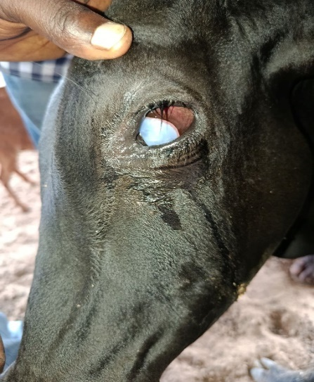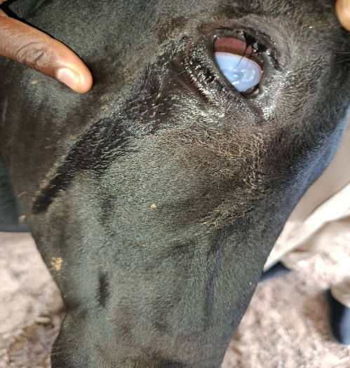
Figure 1 Figure 2
Figures 1 and 2 show the left and right eyes affected, respectively, on the day of presentation

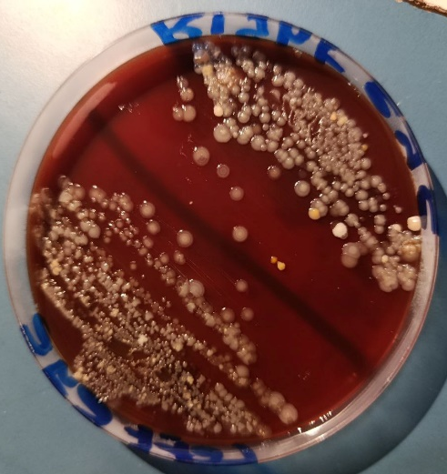
Figure 3. Bacterial growth on a blood agar plate
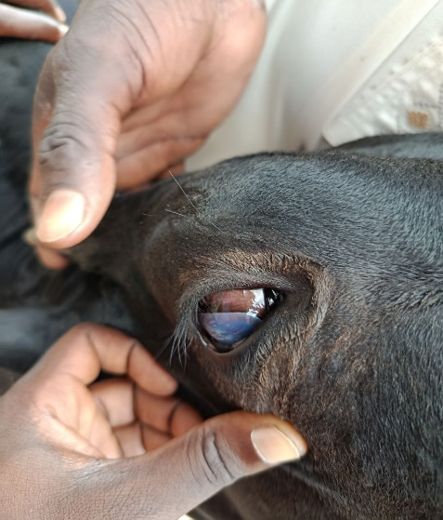
Figure 4. Animal on day 5 post treatment
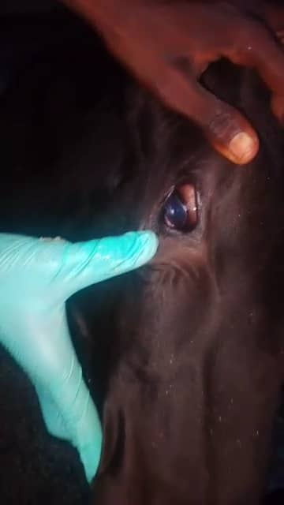
Figure 5. Animal after complete recovery on day 15 post treatment

