Morphological Characterization and Distribution Survey of Endangered Adansonia digitata Linn. Tree species in Ten Districts of Uttar Pradesh, India

ABSTRACT
Adansonia digitata, is a exquisite endangered tree species in India. This tree has been declared as heritage site (according to biodiversity board, U.P.) in many districts such as Sichora village Mahoba, Hamirpur, kintoor Barabanki,Jhusi Pryagraj,district Industrial center Sultanpur and Nawab Wajid Ali Shah zoological Garden Lucknow. According to the prevalent legend in Kintoor Barabanki Sichora,Mahoba, Hamirpur, Sultanpur, Chandrashekhar Azad Park, Prayagraj. Adansonia digitata trees are recognized as the sacred Parijat and kalpavriksha or wishing tree of Indian mythology. The unique shape and external structure of this tree's trunk have attracted environmentalists, botanists, research scholar and tourists over the past few years. The districts were selected based on the prevalence of Adansonia digitata species. This paper represent data on the number, age, included distribution Adansonia digitata trees, girth size, flowering and fruiting period ; and recorded parameters such as fruit shape, fruit size, fresh fruit weight, dry fruit weight, number of seeds per fruit, pulp weight, and seed weight, seed coloured and seed length from the 13 study sites. The survey was conducted from November 24, 2012 to December 15, 2025. A total of 27 (15 flowering and 12 non flowering) Adansonia digitata trees were recorded from 13 study sites across 10 districts of Uttar Pradesh. The 07 fruiting trees were recorded at 5 locations (study sites). The percentage of fruiting trees was very less 25.92%. Almost it was travelled over 5000 kilometres during this fieldwork. Approximately 50,000 photographs of Adansonia digitata were taken from the 13 study sites during the Survey period. The main centre of research work was I.P. (P.G.) College first campus, Bulandshahr and Panchvati, Numaish Ground Bulandshahr.Very limited populations of this valuable tree species were recorded in Uttar Pradesh. The survey conducted on this tree species at 13 study sites across 10 districts of Uttar Pradesh will provide accurate information in the future.

Key Words: -Adansonia digitata, Endangered,Heritage, Survey, Uttar Pradesh.

INTRODUCTION
Adansonia digitata'Kalpavriksha' is an endangered tree in India. It is not native to India, it is native to Africa. It is the national tree of Madagascar. Its populations are limited in Uttar Pradesh state. There are many reasons for this, like as global warming, habitat loss, lack of awareness, deforestation, industrialization, urbanization, climate change, due to anthropogenic activities, low percentage of fruit (pod) production, low germination etc. Adansonia digitata are revered tree in many Indian states such as Rajasthan, Gujarat, Madhya Pradesh, and Uttar Pradesh etc. It is a heritage tree declared in some locations of Uttar Pradesh, hence its conservation need and awareness are very important. It is a deciduous,massive and majestic tree up to 25 m high, which may live for hundreds of years (Gebauer et al., 2002). Its role as a landmark and social hub further cements its position as a cultural and practical centrepiece (Theophilus Deenadayal and Tarun Jain 2024). The remarkable, long-lived baobab tree has a short, swollen trunk with a girth of up to about 28 m, ending in thick, wide-spreading branches that carry a large, round canopy reaching a height of up to 25 m (Sidibe and Williams 2002). The fruits are capsules with a woody, hard shell and many seeds embedded in a whitish powdery fruit pulp.

Almost all parts of baobab are useful for human beings (Wickens and Lowe 2008). Adansonia digitata L. belongs to the Malvaceae family and is generally known as the Baobab, Dead rat tree, Elephant Tree, Upside-Down Tree, Khurasani Imli, Tamarind Baobab, Hathion ka jhad, Gorakh Chinch, Gorakh Imli, Kalpavriksh, Parijat tree, Bottle tree, The tree of life, Monkey bread tree, Sour gourd, Cream of tartar tree, Gorakshi tree etc. Adansonia digitata species are hermaphrodite with both male and female reproductive structures in the same flower. The bud of the flower is the size (length about 6.2 cm, width 6.2 cm, weight 73 g) and shape of a golf ball and is covered by a green velvet type protective layer (five calyx). Adansonia digitata flower is unique very large (length about 15 cm, width about 17.2 cm and fresh flower weight about 69 g.) number of stamens (about 380 to 425) attached to a central column (staminal tube length; 4.2 cm), that are visited at night by honey bees and other insects to take nectar. Adansonia digitata flower have along style (4.5-8.2 cm) extends from the top of the ovary, growing through and projecting beyond the staminal tube. The ovary is ovoid (egg-shaped) and typically has 8 to 10 locules. The ovary is also covered in fine hairs. The length of the peduncle recorded 32 cm. in I. P. (P.G) College, Bulandshahr and baobabs flower have a greater peduncle recorded 87 cm in Gulistan e Syed Aligarh Muslim University, Aligarh (the peduncle (stalk) that attaches the flower, and later the fruit, to the branch). Baobab fruit pulp is traditionally used against diarrhoea, scurvy, cough, dysentery, small pox and measles. Several scientific studies have been performed such as on its anti-diarrheic properties (Tal- Dia et al., 1997). one of the most remarkable trees of the world (Pakenham (2002) High baobab abundance in many settlement sites inAfrica suggests a strong relationship between trees and people (Duvall 2007).The baobabs play an important biological role in the conservation of ecosystems of which lemurs, fruit bats, sunbirds, and hawk moths are important constituents (Baum, 1996). It was purposely conducted to identify farmers’ varieties of the fruit and characterize them based on Baobab is one of the most importance trees of the world (Bynum and Bynum 2014). Despite its ecological and cultural significance, Adansonia digitata L. faces multiple threats. Climate change, deforestation, and overharvesting are among the primary challenges identified by Dhillion and Gustad (2004).
emphasized the importance of combining traditional knowledge with scientific approaches to ensure the tree’s long-term survival. Initiatives such as seed banking and agroforestry practices have been recommended as effective measures to preserve baobab populations (Venter & Witkowski, 2011) The fruit has a hard stony shell and is covered with small green velvety hair. Their shape can vary from globose, ellipsoid and fusiform. Large fruit can weigh over 778.0 g and contain more than 180 seeds; smaller fruit can be only a about 18 to 25 seeds. The kidney-shaped seeds of Adansonia digitata fruit have a hard seed coat, which is not readily separated from the kernel. The endosperm has a roasted gram-like taste. A survey conducted on the morphology and distribution of Adansonia digitata at 13 study sites across 10 districts of Uttar Pradesh will provide valuable information in the future.

Material and Methods
Mahoba and Hamirpur districts are located in the Bundelkhand region of Uttar Pradesh, have a red soil, dry deciduous forests,semi-arid tropical monsoon climate, characterized by scorching summers (42-46°C), monsoon season (June-Sept) rainfall (70-100 cm average for Bundelkhand), winters (10-15°C).Mahoba (approx. 25.28°N, 79.87°E) sits around 214 meters (702 ft) in elevation, part of the lower Bundelkhand plateau, while Hamirpur (around 25.95°N, 80.15°E) is generally lower, with an average elevation of about 80 meters (260 ft), both lying in the southern plains of Uttar Pradesh near the Yamuna and Betwa riversThe districts of Prayagraj, Raebareli, Lucknow, Sultanpur, and Barabanki are all located in the vast, fertile Gangetic Plain of Uttar Pradesh, generally falling within the central or eastern plain zoneshot summers (41-47°C+) and cool winters (7- 10°C).Prayagraj latitude 25°26′09″N longitude 81°50′47″E altitude 322 ft , Lucknow latitude 26°51′ N longitude 80°57′E altitude 404 ft , Sultanpur latitude 26°15′30″N longitude 82°04′20″E altitude 312 ft Rae Bareli latitude 26°23′22″N longitude 81°23′56″E altitude 393 ft, Barabanki latitude26°56′Nlongitude 81°13′E altitude 410 ft. Aligarh, Bulandshahr, and Ghaziabad are districts in Western Uttar Pradesh, located in the fertile Ganga-Yamuna Doab (plain), characterized by alluvial soil. The survey was conducted from 24 November 2012 to 15 December 2025.The age of the trees was estimated based on information from local elderly people, gardeners, and Google internet searches. The circumference of the tree trunk was measured by first wrapping a thread around the trunk and then measuring the length of the thread with a measuring tape. During the survey, a Nikon D 5600 camera and a Realme mobile model RMX3381 were used for photography. The fruit on each tree was counted during the survey. Three fruits were plucked from the fruit-bearing tree, tagged, and packed in a bag. After the journey, the weight of the fruits was recorded using an electronic balance model no. CAH-323 in the Department of botany I.P. P.G. College, Bulandshahr. The weight of the dried, mature fruit was also recorded using electronic balance. After, the dried fruits were broken and the weight of the seeds, with pulp, was recorded. The pulp+seeds were washed with water to remove the pulp, and the weight of the dried seed was recorded. The methodology encompasses detailed field observations, morphological Characterization and distribution data collection, ensuring a comprehensive understanding of the tree’s role in its 13 sites, 10 districts of Uttar Pradesh.

RESULTS and discusssion

A total of 27 Adansonia digitata L. Trees were recorded during the survey from 13 study sites across ten districts of Uttar Pradesh. 15 trees were recorded as producing flowers and twelve trees were recorded as non producing flowers at 13 study sites. (Table No.1 Fig. No 2 - 25). The 7 fruit produced trees were recorded at five study sites (Table No. 2, Fig. No.10,13,14,15 and 21). The percentage of fruiting trees was very low 07/27=25.9%. Interesting was the observation of morphological characteristics and distribution that during the flowering and fruiting period in 13 sites of 10 districts Uttar Pradesh state. (Fig. 3-27). The survey data and results on Adansonia digitata indicate that its population is very low in Uttar Pradesh. Our exploratory results indicated fruit and seed morphological characteristics (Table No 1-3 Fig.-10, 13, 14, 15 and 21 ). Globose shape (sichora village), ellipsoid shape (Aligarh, Bulandshahr and Ghaziabad) and fusiform shape ( Lucknow) fruits were recorded at study sites. Fruit and seed characteristics for the seven trees five study sites are summarized in Table 1-3 and Fig. 27. Our results show phenotypic differences in all morphological characteristics (Table No. 1-4 and Fig. 3-27). Largest no of fruits (298) per tree recorded From site I.P. College first campus Bulandshahr, Greatest no of seeds (177±3.0) per fruit recorded from site Sichora village Mahoba, largest fresh/dry fruit weight (778.0 g/200. 3 g) fruit weight recorded from site Gulistan e Syed Aligarh, Greatest length and fruit width were measured fusiform 35.16 ± 7.5 cm. Nawab Wajid ali Shah Zoological Garden, Hazratganj, Lucknow and greatest width 9.46 ± 0.35 cm. in globose fruits from sites Sichora village Mahoba respectively. Results summarized in fruit produced sites 1. Sichora village Kabrai, Mahoba ( fruit shape; globose, length; mean 15.56±0.30 cm, width; 9.46±0.35cm, fresh fruit weight; 685.7g, fruit dry weight; 174.3g, number of seeds per fruit177±3.0, Seed weight with pulp 0.599 g, single seed weight 0.315 g, seed coloured black, single seed length 0.8 cm.) 2. Nawab Wajid Ali Shah Zoological Garden Hazratganj Lucknow, (fruit shape, Fusiform; length; 35.16 ±7.5 cm, width; 6.93± 0.66 cm ± fresh fruit weight; 570.3g, fruit dry weight; 144.9g, number of seeds per fruit mean114± 19, Seed weight with pulp 0.690, single seed weight 0.489 g, seed coloured dark brown, seed length; 1.1cm. ). 3. Gulistan e Syed Aligarh Muslim University, Aligarh (fruit shape Ellipsoid; length; mean17.23 ± 0.92 cm, width; mean7.56± 0.20 cm, fresh fruit weight; 778.0 g, fruit dry weight; 200.3 g., number of seeds per fruit mean135±13, Seed weight with pulp 0.450, seed weight 0.278 ). 4. I.P. P.G. College Bulandshahr (fruit shape Ellipsoid; length; 15.4± 0.26 cm, width; 6.63± 0.47 cm, fresh fruit weight; 557.0g, fruit dry weight; 135.9g Number of seeds per fruit mean 86± 25, Seed weight with pulp 0.658 g, seed weight 0.490 g). 5. Manav Aushadhiya Park Raj Nagar sector- 4 Ghaziabad. (fruit shape Ellipsoid; length; 13.73±1.61cm, width; mean 6.3± 0.36 cm, fresh fruit weight; 405.0 g, fruit dry weight; 102.0 g number of seeds per fruit mean 76± 13, Seed weight with pulp0.436 g , seed weight 0.253 g (Table 1, 2 and 3 Fig. No 27).For morphological characteristics, of trees showing in (Table 1-3 and fig 3-27) the highest values were several times higher than means of trees exhibiting low values for the respective characteristic. Damaged trees were also recorded from study sites of Uttar Pradesh (Table No. 4). Supported and relative research Von Breitennbach (1985) distinguished four principal growth phases in the development of Adansonia digitata: sapling phase (up to 10–15 years), cone phase (up to 60–70 years), bottle phase (up to 200–300 years) and an old age phase (up to 500–800 years). Initially the trees grow extremely fast, especially in the cone phase, but very slowly during the greater part of their life. Reported that Maheshwari J.K. (1971) Some specimens are also found planted inland near Lucknow and at Allahabad, Patna, Samalkot, Agra, Rewa, fatehpur, Barrackpore, Bijapur, Avadh, Aurangabad, Hyderabad, Melghat ( Amraoti district) and Ranchi. In Sudan, flowering was found to occur between May and July and fruiting extends from August to October (Al Amin 1990). It doesn’t occur in areas where sand is deep and sensitive to water logging and frost. It has been reported mostly from semi-arid localities (Salim et al., 2012). The trees that bore flowers and fruits were recorded, and three fruits were plucked. Researchers measured parameters such as the number of trees, trunk thickness, age, fruit length, fruit weight, and fruit size, number of seeds, seed weight with pulp, and seed weight without pulp. The results revealed that the fruit of the Little information is available on fruit yield of baobab trees in Sudan and Kenya. In Kordofan, Sudan, Gebauer (unpublished data) counted fruits of six mature trees which resulted in an average of 381 fruits per tree with a range between 145 and 595 fruits per tree. These results established with the support of the previous research done in various countries such as in Kenya, Muchiri and Chikamai (2003) assessed baobab trees in Kibwezi. Fruit counts of the 25 randomly selected trees yielded between 12 and 2675 fruits per tree with an average of 360 fruits per tree. According to the interviewed 64 tree owners, average number of fruits per tree was 707 with a range of 140–1800 fruits per tree. However, alternate bearing, removal of immature fruits, e.g. by baboons, and early harvests of mature fruits are challenges to accurate yield assessments. Substantial variability in fruit size and shape has been observed in A. digitata for Sudan and Kenya, with fruit shapes ranging from globose to fusiform. In Sudan, Gurashi and Kordofani (2014) categorized 486 fruit samples into 12 fruit shape classes. Gebauer and Luedeling (2013) described four distinctive fruit types, with significant differences in percentage of pulp per total fruit, ranging from 14 to21 %. Recent surveys in Kordofan recorded fruit lengths of up to 44 cm, widths of up to 15 cm and weights of up to 647 g. Considerable variation in the flavour of the creamy pulp is widely known and people commonly taste crushed fruits on localmarkets prior to purchasing them. Maundu et al. (1999) reported for Kenya that farmers can distinguish the taste of the fruits by the fruit shapes. Average fruit length and weight ranged from 9 to 30 cm and from 62 to 627 g,respectively, while the average proportion of pulp ranged from 7 to 34 % of total fruit weight. In a recentsurvey in Kilifi, Kenya, fruit lengths, widths and weights of up to 37 cm, 13 cm and 683 g, respectively were measure. However, fruit lengths of up to 54 cm reported by Wickens (1982) also reported a low within-tree morphological variability in capsule shape of baobabs in Benin and suggested a high heritability of this trait. The present findings showed that the DBH of baobab trees at the study sites agree with the earlier studies showed by Baum, (1995) and Gebauer et al. (2002) in Sudan. The current study reported that fruit size was found to be within the range (13.24-18.29 cm length, 7.27-9.4 cm wide). The result is inconsistent Munthali et al., (2012) fruits from Malawi who reported (11.9 - 16.5 cm length and 6.8 -7.6 cm width) and Assogbadjo et al., (2006) in Benin (16.8-20.7 cm length, 6.2 -8.3 width).The dendrometic results were also significantly different (P≤ 0.05) between studied population/locations. Trees from ElbGerri site were smallest and shortest in DBH and height, respectively. Fruits from Elroseies site were have the largest values (long; 18.29 cm±5.72, width; 9.40 cm ±2.13 and heavy; 264.17g. ±99.23). There was a trend that the heavier the fruit, the greater the number of seeds. The pulp weight percentage was found to be significantly higher both at El Mansora site and KourTaggat than others study sites. Gurashi, and Kamal F. Elkhalifa (2022). Variances in fruit morphology influence be connected to differences in ecological sites between baobabs from Blue Nile and KordofanAs a consequence, many tree species are threatened and disappear more and more from their natural ecosystems. The present study focuses on the endangered tree species Adansonia digitata Linn.conserve in 13 study sites of Uttar Pradesh.

Table-1
Morphological characteristics and Distribution of Adansonia digitata L.in thirteen study sites of Uttar Pradesh.
S.No. | Study sites | Districts of Uttar Pradesh | Approximate Age. | No of A. digitatareported | Girth sizein Meters | Flowering | Flowering Period | Fruiting
1. | Jhunsi | Prayagraj | 800 | 01 | 18.2 | Yes | July to September | Nil
2. | Chandrahekhar Azad Park | Prayagraj | 400 | 01 | 8.25 | Yes | July to October | Nil
3. | Kintoor | Barabanki | 1000 | 01 | 13.3 | Yes | July to September | Nil
4. | Nawab Wajid ali Shah Zoological Garden, Hazratganj | Lucknow | 150 | 01 | 10.1 | Yes | July to September | Yes
5. | Indira Gandhi Memorial Botanical Garden | Raebareli | 17 | 07 | 1.0,1.1,1.5,1.15, 1.30, 1.45,1.50 | Not | ---------- | Not
6. | District Industry Center | Sultanpur | 800 | 01 | 13.5 | Yes | July to October | Not
7. | Sichora village Kabrai | Mahoba | 2000 | 01 | 13.2 | Yes | June to August | Yes
8 | Jai Bhadrakali mata Temple | Hamirpur | 1000 | 01 | 11.3 | Yes | June to August | Not
9. | Gulistan e Syed A.M.U. | Aligarh | 25 | 02 | 2.51, 2.05 | Yes  Third time | July to December | Yes  Ist. Time,2 trees
10. | I.P.(P.G.)Colllege,First Campus | Bulandshahr | 35 | 01 | 3.17 | Yes  Ist Time | July to October | Yes  Ist Time
11. | Panchvati Numaish ground | Bulandshahr | 17 | 01 | 1.58 | Yes  Ist Time | July to October | Not
12. | Manav Aushadhiya Park Raj nagar sector- 4 | Ghaziabad | 20 | 05 | 2.25,2.30,1.20,1.15,1.0  3 tree recorded non flowers tree | Yes,  Third time,  Only 2 trees | July to December | Yes  Second time  Only-2 trees
13. | City Forest | Ghaziabad | 16 | 04 | 2.20,1.53,1.30,1.38  2 tree recorded non flowers | Yes,  Second time,  Only 2 trees | July to October | Not
 | Total |  |  | 27 |  | Total Flowering tree recorded 15 and non flowering trees recorder 12

Table- 2.
Fruit characteristics (Fruits no, fruit shape, fruit width, length, fruit fresh/dry weight, pulp weight, seed weight and taste of pulp) of Adansonia digitata L.in five fruiting sites
S.No. | Study sites | Districts of Uttar Pradesh | Number of fruits reported/ tree | Fruit shape | Fruits width  (cm) | Fruit Length  (cm) | Fresh Fruit weight  (g) | Dry Fruit weight  (g) | Number of seeds per fruit  (g) | Seed weight with pulp  (g) | Seed weight  (g) | Taste of pulp
1. | Sichora village near kabrai | Mahoba | 87 | Globose | 9.46± 0.35 | 15.56 ±030 | 685.7 | 174.3 | 177±3.0 | 0.599 | 0.315 | sour and Sweet
2. | Nawab Wajid ali Shah Zoological Garden, Hazratganj | Lucknow | 270 | Fusiform | 6.93±0.66 | 35.16 ± 7.5 | 570.3 | 144.9 | 114± 19 | 0.690 | 0.489 | sour and Sweet
3. | Gulistan e Syed A.M.U. Campus | Aligarh | 220 | Ellipsoid | 7.56± 0.20 | 17.23 ± 0.92 | 778.0 | 200.3 | 135±13 | 0.450 | 0.278 | Very slightly sour
4. | I.P. (P. G.) College, First Campus | Bulandshahr | 298 | Ellipsoid | 6.63± 0.47 | 15.4± 0.26 | 557.0 | 135.9 | 86± 25 | 0.658 | 0.490 | Very slightly sour
5. | Manav Aushadhiya Park Raj nagar sector- 4 | Ghaziabad | 130 | Ellipsoid | 6.3±0.36 | 13.73±1.61 | 405.0 | 102.0 | 76.0± 13 | 0.436 | 0.253 | Very slightly sour
Mean 76.0± 13 SD

Table- 3.
Seed characteristics (Seed coloured and seed length) of Adansonia digitata L. in five sites

S.No. | Study sites | Districts of Uttar Pradesh | Seed coloured | Seed length cm
1. | Sichora village near kabrai | Mahoba | Black | 0.8
2. | Nawab Wajid ali Shah Zoological Garden, Hazratganj | Lucknow | Dark Brown | 1.1
3. | Gulistan e Syed A.M.U. Campus | Aligarh | Light brown | 1.1
4. | I.P. ( P. G.) College, First Campus | Bulandshahr | Light brown | 1.1
5. | Manav Aushadhiya Park Raj nagar sector- 4 | Ghaziabad | Light brown | 0.9

Table- 4.
Heritage and Cultural Significance of Adansonia digitata L. in Uttar Pradesh State

S.No. | Heritage sites (declared by Biodiversity Board U.P.) | Districts of Uttar Pradesh | Damaged part of Adansonia digitata tree | Adansonia digitata tree known as
1. | Jhunsi | Prayagraj | Trunk | Kalpvriksh
2. | Chandrahekhar Azad Park | Prayagraj |  | Kalpvriksh
3. | Kintoor | Barabanki | Trunk | Parijaat ( Revered Tree)
4. | District Industry Center | Sultanpur | Trunk | Kalpvriksh
5. | Sichora village Kabrai | Mahoba | Trunk | Kalpvriksh
6. | Jai Bhadrakali mata Temple | Hamirpur |  | Kalpvriksh (wish fulfilling tree)

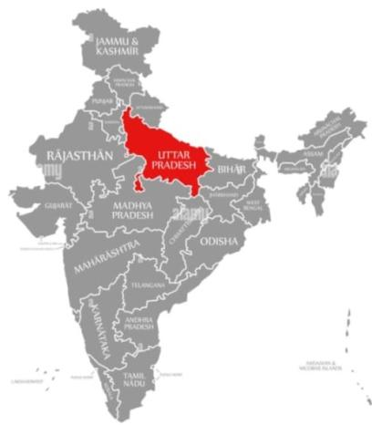
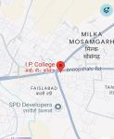
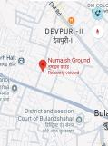
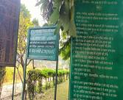
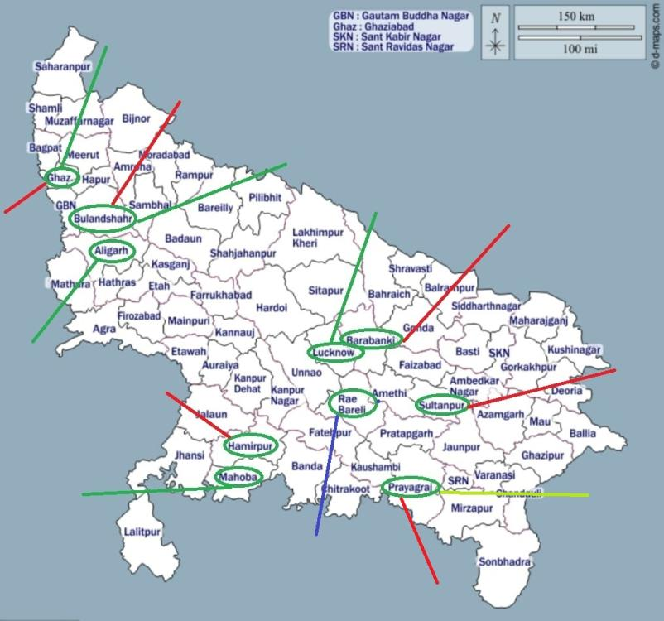
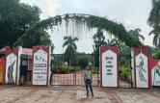
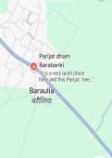
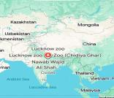
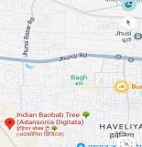
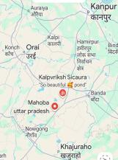
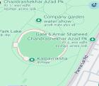
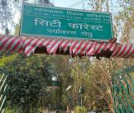
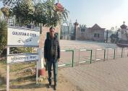
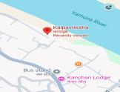
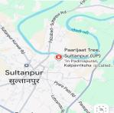
m
Fig. 1.Map of India
Fig. 2.Uttar Pradesh Map presenting location of 13 study sites of Adansonia digitata Linn.

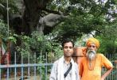
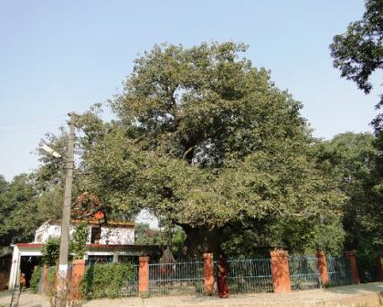
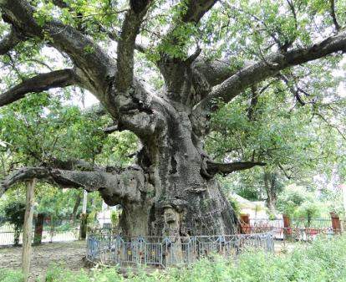
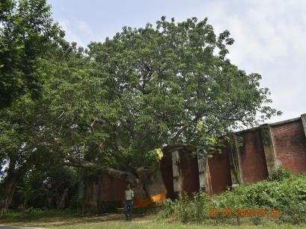
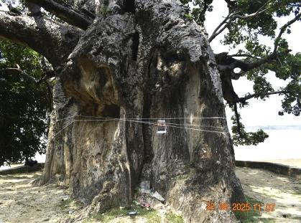
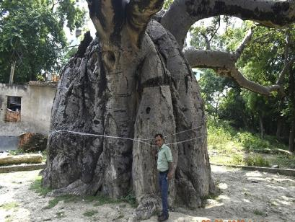
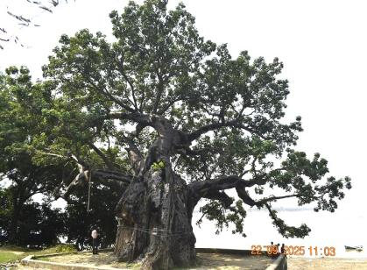
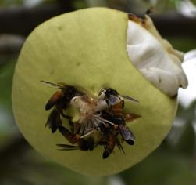
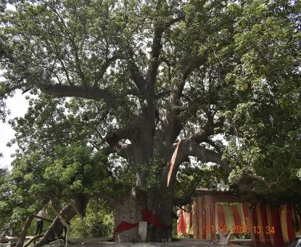
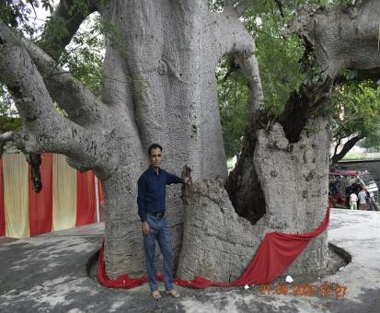
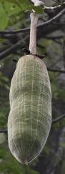
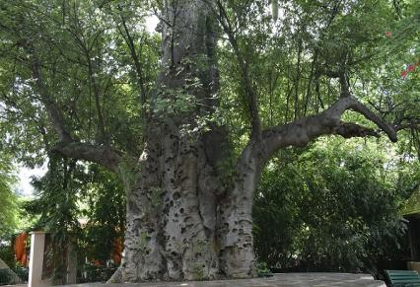
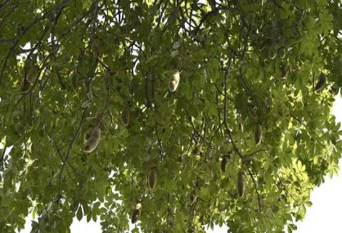
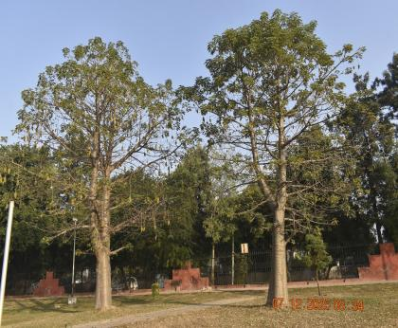
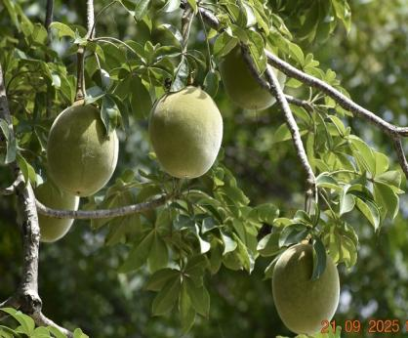
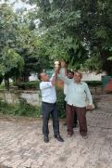
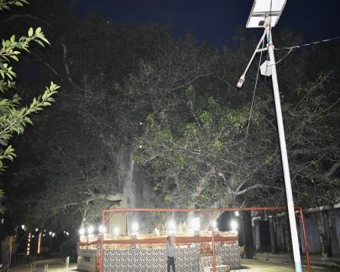
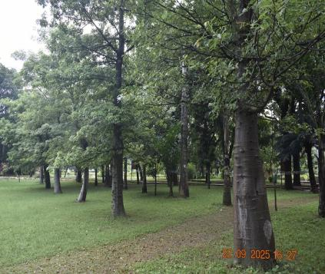
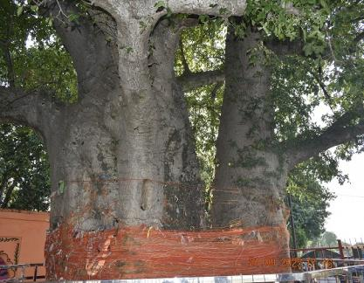
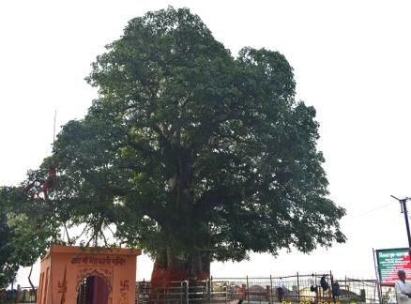
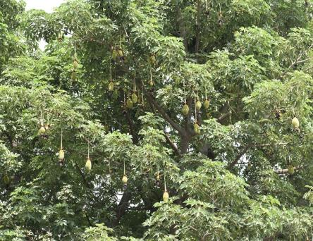
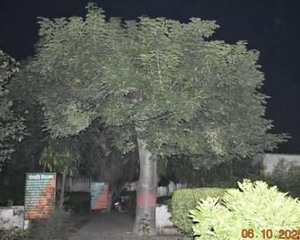
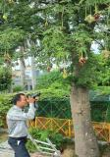
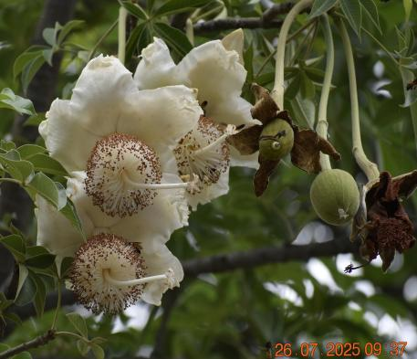
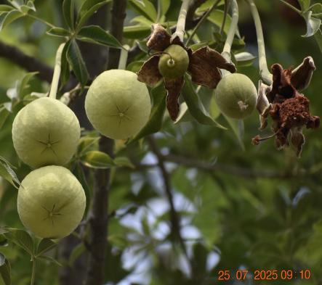
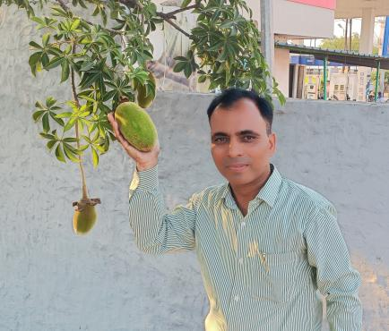
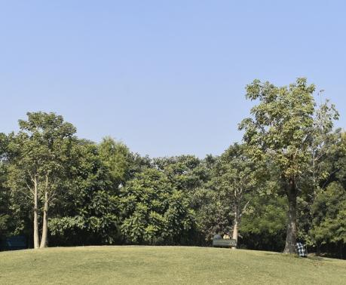
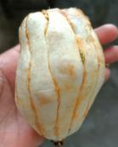
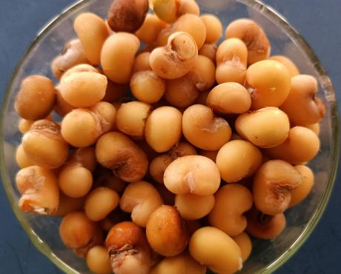
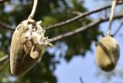
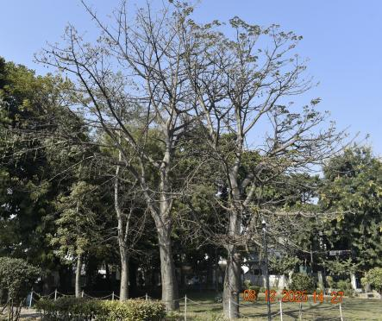

Fig. 7. Adansonia digitata tree located in Kintoor Barabanki. Photo Dr. Yashwant Rai 24 November 2012

Fig. 8.View of Adansonia digitata Trunk located in Kintoor Barabanki. Photo Dr. Yashwant Rai 16 August 2013

Fig. 5. View of Termite damaged trunk of Adansonia digitata in Jhusi Pryagraj. Photo Dr. Yashwant Rai
Fig .6. View of Adansonia digitata tree located in Chandrashekhar azad Park, Prayagraj.
Fig. 4.18.2 meters Measuring the circumference of the Adnsonia digitata tree trunk with measuring tap.
Jhusi Pryagraj.
Fig. 3. 700 years old Adansonia digitata tree located in Jhusi Prayagraj. Dr. Yashwant Rai

Fig. 12.View of dameged trunk of Adansonia digitata tree located in Sichora village, Mahoba. Photo Dr. Yashwant Rai

Fig. 10. Fusiform shape fruits hanging from the branches of the Adansonia digitata tree in Nawab Wajid Ali Shah Zoological Garden, Lucknow. Photo Dr. Yashwant Rai

Fig. 13.View of Globose shape fruits hanging from the branches of the Adansonia digitata tree in Sichora village, Mahoba. Photo Dr. Yashwant Rai
Fig. 14. Two Adansonia digitata tree located in Gulistan e Syed, Aligarh. Photo Dr. Yashwant Rai

Fig. 9. Adansonia digitata tree located in Na wab Wajid Ali Shah Zoological Garden, Lucknow. Photo Dr. Yashwant Rai
Fig. 11. View of Adansonia digitata tree located in Sichora village, Mahoba. . Photo Dr. Yashwant Rai
Fig. 16. First time recorded Adansonia digitata tree located in Numaish Ground, Bulandshahr. Photo Dr. Yashwant Rai

Fig. 15. First time recorded Fruits hanging from the branches of the Adansonia digitata tree at IP College. Photo Dr. Yashwant Rai
Fig. 19. Adansonia digitata tree located in Sultanpur. Photo Dr. Yashwant Rai Photo Dr. Yashwant Rai

Fig. 20. First time recorded View of seven young Adansonia digitata tree located in Indira Gandhi Memorial Botanical Garden Raebareli. Photo Dr. Yashwant Rai

Fig.18.11 Meters Trunk ofAdansonia digitata tree located in Hamirpur. Photo Dr. Yashwant Rai

Fig. 17.1000 years old Adansonia digitata tree located in Hamirpur. Photo Dr. Yashwant Rai
Fig. 21. First time recorded Five Adansonia digitata tree located in Manave park Rajnagar sector -4 Ghaziabad. Photo Dr. Yashwant Rai

Fig. 22. First time recorded Four Adansonia digitata trees located in City Forest Park Ghaziabad. Photo Dr. Yashwant Rai

Fig. 24. Flowers hanging on branches of Adansonia digitata in in I. P.( P.G.) College, FirstCampus ,BSR. Photo Dr. Yashwant Rai

Fig. 23.Mature buds hanging from the branches of the Adansonia digitata treein I. P. College, Bulandshahr. Photo Dr. Yashwant Rai

Fig. 26.View of without shell immature fruit and without pulp Immature seeds . Photo Dr. Yashwant Rai

Fig. 25.Immature fruits bearing on branches of Adansonia digitatain I. P.( P.G.) College, First Campus, Bulandshahr.

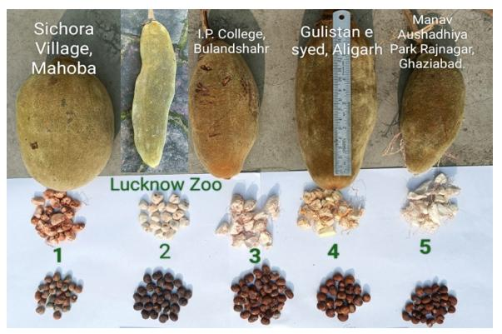

Fig. 27.Fruit characteristics assessed on Adansonia digitata trees in 1. Sichora village Mahoba,2. Nawab Wajid Ali Shah Zoological Garden Lucknow 3. I. P. (P.G.) College First campus Bulandshahr.4. Gulistan e Syed Aligarh,5. Manav Park Rajnagar sector – 4 Ghaziabad, State Uttar Pradesh. Photo Dr. Yashwant Rai

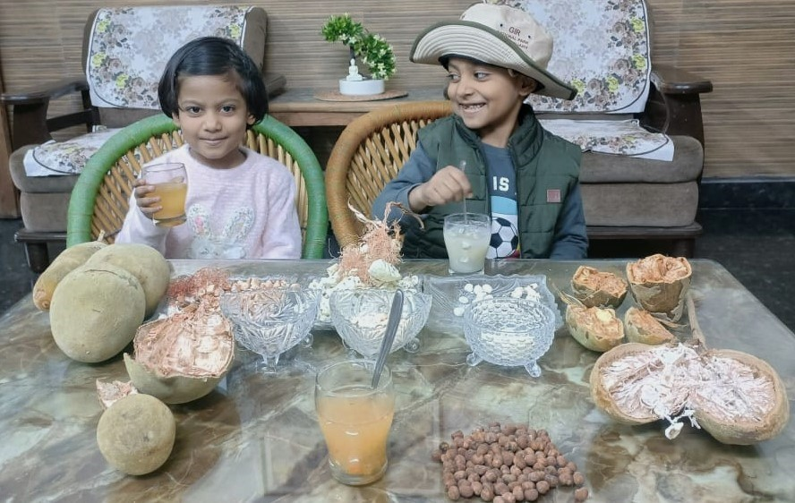

Figure 28. Children enjoying a drink made from the pulp of Adansonia digitata fruits . Photo Dr. Yashwant Rai

Conclusion

It is concluded that the aim of the present study is to spread awareness towards conservation of endangered tree Adansonia digitatal. in those areas where the plant is now rarely found. This research work will also prove to be of immense usefulness for the conservation of iconic monuments tree species in the Uttar Pradesh state. Since this plant is beneficial for humans in many ways, therefore it is required that wide propagation and conservation of this plant should be carried out, in order to ensure that future generations can benefit from it.

COMPETING INTERESTS DISCLAIMER:
Authors have declared that they have no known competing financial interests OR non-financial interests OR personal relationships that could have appeared to influence the work reported in this paper.

Disclaimer (Artificial intelligence)
Option 1:
Author(s) hereby declare that NO generative AI technologies such as Large Language Models (ChatGPT, COPILOT, etc.) and text-to-image generators have been used during the writing or editing of this manuscript.
Option 2:
Author(s) hereby declare that generative AI technologies such as Large Language Models, etc. have been used during the writing or editing of manuscripts. This explanation will include the name, version, model, and source of the generative AI technology and as well as all input prompts provided to the generative AI technology
Details of the AI usage are given below:
1. Nil
2.Nil
3.Nil

References

- Assogbadjo, A. E., Kyndt, T., Sinsin, B., Gheysen, G., & Van Damme, P. (2006). Patterns of genetic and morphometric diversity in baobab (Adansonia digitata) populations across different climatic zones of Benin (West Africa). Annals of Botany, 97(5), 819–830. https://doi.org/10.1093/aob/mcl043
- Baum, D. A. 1996. The ecology and conservation of the baobab of Madagascar, Primate Report, Vol 46, No 1, 311–327.
- Baum, D. A. (1995). A systematic revision of Adansonia digitata (Bombacaceae). Annals of the Missouri Botanical Garden, 82(3), 440-470. https://doi.org/10.2307/2399893V
- Bynum H, Bynum W (2014). Remarkable plants that shape our world. Thames and Hudson Ltd in association with Royal Botanic Gardens Kew, UK.
- Dhillion SS, Gustad G. (2004) Local management practices influence the viability of the baobab (Adansonia digitata L.) in different land use types, Cinzana, Mali. Agric Ecosyst Environ.;101(1):85-103. https://doi.org/10.1016/j.agee.2003.09.007

- El-Amin, H. M. (1990). Trees & shrubs of the Sudan. Ithaca Press. https://www.cabidigitallibrary.org/doi/10.1079/CABICOMM_19910653795
- Duvall CS (2007) Human settlement and baobab distribution in south-western Mali. J Biogeogr 34:1947–1961

- Gebauer, J., El-Siddig, K., & Ebert, G. (2002). Baobab (Adansonia digitata L.): A review on a multipurpose tree with promising future in the Sudan. European Journal of Horticultural Science, 67(4), 155-160. https://doi.org/10.1079/ejhs.2002/7085
- Gebauer, J., & Luedeling, E. (2013). A note on baobab (Adansonia digitata L.) in Kordofan, Sudan. Genetic Resources and Crop Evolution, 60, 1587–1596. https://doi.org/10.1007/s10722-013-9964-5
- Gurashi, N. A., & Kordofani, M. A. Y. (2014). Morphological variation in fruit shapes of Adansonia digitata L. from Blue Nile and North Kordofan States, Sudan. Journal of Forest Products & Industries, 3(2), 106–111. http://researchpub.org/journal/jfpi/archives.html
- Maheshwari J.K. (1971)The baobab tree: Disjunctive Distribution and conservation, Biological conservation vol.-4 Applied science Publishers England pp 57-60
- Maundu PM, Ngugi GW, Kabuye CHS (1999) Traditional food plants of Kenya. National MuseumsofKenya.http://www.fastonline.org/CD3WD_40/CD3WD/AGRIC/H1093E/EN/B567_7.HTM#B567_7_9.
- Muchiri, M. N., & Chikamai, B. N. (2003). Testing techniques to assess fruit yield: the case of baobab (Adansonia digitata) from the drylands of Kenya. In J. Wong, F. Ndeckere-Ziangba, & D. Pouakouyou (Eds.), Summary of six case study reports as a contribution to development of practical techniques to assess non-wood forest product resources. Non-wood forest products program, working paper, FOPW/03/6. Food and Agriculture Organization of the United Nations. https://www.fao.org/tempref/docrep/fao/010/y9375b/y9375b00.pdf
- Munthali, C. R. Y., Chirwa, P. W., & Akinnifesi, F. K. (2012). Phenotypic variation in fruit and seed morphology of Adansonia digitata L. (baobab) in five selected wild populations in Malawi. Agroforestry Systems, 85(2), 279–290. https://doi.org/10.1007/s10457-012-9500-1
- Gurashi, N. A., & Elkhalifa, K. F. (2022). Variations in Morphometrics of Fruits, Seed and Dendrometric Measurements of Adansonia digitata L. in Sudan. Journal of Forestry and Natural Resources, 1(2), 13-20. https://doi.org/10.20372/vpvwjj48
- Pakenham T (2002) Remarkable trees of the world. Printer Trento S.r.l, Italy

- Lewington, A., & Parker, E. (1999). Ancient trees: Trees that live for a thousand years.
- Salim, A. S., Simons, A. J., Orwa, C., Chege, J., Owuor, B., & Mutua, A. (2012). Adansonia digitata. Agroforestree database a tree species reference and selection guide. International Centre for Research in Agroforestry. https://www.worldagroforestry.org/treedb/AFTPDFS/Adansonia_digitata.PDF
- Sidibe, M., & Williams, J. T. (2002). Baobab, Adansonia digitata L. International Centre for Underutilised Crops. https://books.google.com/books/about/Baobab_Adansonia_Digitata_L.html?id=2002
- Tal-Dia A. et al. (199f7): A Baobab solution for the prevention and treatment of acute dehydration in infantile diarrhea.
- Deenadayal, T., & Jain, T. (2024). Ecological, cultural, and morphological analysis of a singular Adansonia digitata L. tree in Devadurga Taluk, Raichur District Karnataka India. International Journal of Home Science*, *10*(3), 464-470. https://doi.org/10.22271/23957476.2024.v10.i3g.1738
- Venter SM, Witkowski ETF. (2011)Baobab (Adansonia digitata L.) fruit production in communal and protected areas of southern Africa. For Ecol Manage.;261(3):630-639. https://doi.org/10.1016/j.foreco.2010.11.018

- Von Breitenbach, F. (1985) Aantekeninge oor diegroeitempo van aangeplante kremetartbome (Adansonia digitata) en opmerkinge ten opsigte van lewenstyd,groeifases en genetiese variasie van die spesie. J. Dendrol.5, 1–21.
- Wickens, G. E. (1982). The baobab—Africa’s upside-down tree. Kew Bulletin, 37, 173–209. https://doi.org/10.2307/4109961
- Wickens, G. E., & Lowe, P. (2008). The baobabs: Pachycauls of Africa, Madagascar and Australia. Springer Science + Business Media, B.V. https://doi.org/10.1007/978-1-4020-6431-9

