Original Research Article
Runoff and Sediment Yield Analysis at Ariqua Watershed, Tekeze Basin, Ethiopia

Abstract
Ethiopia’s main issues are the degradation of land and water resources. SWAT2012, a physically based watershed model, was used to this work to analyze runoff and sediment yield analysis in the Ariqua watershed. Estimating the runoff, analyzing the sediment yield, and prioritize the most erodible sub- watersheds were the main objectives of this research. A 30 x 30 m DEM (Digital Elevation Model), a soil map, and a land use map were utilized to set up the model for simulation. The daily recorded weather data from 1991 to 2015 were used as input to the model.
For the SWAT simulation, daily stream flow and sediment data from 2001 to 2015 were used. Both automated and manual calibration methods were used to calibrate the model. Calibration took place throughout the frist six years (2006 – 2011), where as validation was place during the remaining years (2012-2015). To assess the model’s performance, sensitivity analysis, model calibration, and validation were also carried out. Thirteen sensitive parameters were identified for flow of which runoff curve number for SCS moisture condition (CN2) was the most sensitive one and ten sensitive parameters were identified for sediment of which soil erodibility factor (USLE_K) was the most sensitive. Model calibration and validation were assessed using Nash Sutcliffe (ENS) and the coefficient of determination (R²). Both showed a good model performance agreement (model of fitness) between the simulated and measured monthly flow and sediment yield. The 15-years average observed and simulated stream flow created according the model prediction result, was 137 m³/s and 124 m³/s, respectively, while the sediment yield was 12.54 ton/ha/yr and 13.92 ton/ha/yr. Sub-watersheds (SWT-23) and (SWT-20) produced high stream flow rates of 383.5 m³/s and 287.3 m³/s, respectively, out of the 23 sub-watersheds.

Key words: SWAT model, Runoff, Sediment yield, and Ariqua watershed

- Introduction

Water resources are extremely important renewable resources that are essential to any society's growth and existence. Food security, industrial advancements, and human health and welfare all depend on sufficient quantities of water of appropriate quality. On the other hand, excessive water causes socioeconomic harm and fatalities from flooding. Human stewardship of water resources is essential to the vitality of natural ecological systems. Assessing and managing the amount and quality of water resources both spatially and temporally is necessary for their proper use [4].
The separation and movement of soil particles from their initial location downstream by erosion agents like wind and water is known as soil erosion. It is a typical feature of landscape evolution. When cover material most likely vegetation decreases, erosion becomes more severe. The quality of the soil, land, and water resources that humans rely on for survival is seriously impacted by this issue. Soil erosion is now widely acknowledged as a significant agricultural and environmental issue. The fertility and nutrient content of the top soil decline as a result of erosion forces like wind and water. Eventually, this leads to a decrease in productivity. Food insecurity results from physical soil and nutrient losses because over 85% of the nation's population depends on agriculture for a living [10]. Soil erosion in the basin as a whole has been caused by a number of social, economic, and political factors, including rapidly growing populations, deforestation, over cultivation, expansion of cultivation at the expense of lands under communal use rights (grazing and woody biomass resources), cultivation of marginal and steep lands, and overgrazing.
The proposed Ariqua watershed, which is upstream of the Tekeze dam reservoir areas, is threatened and severely challenged by the issue of land degradation because it produces high runoff discharges and imposes a massive sediment yield. If the upper watershed is not treated with suitable watershed management interventions and strategies, this could reduce the water storage capacity of the dam reservoir [11]. The development of an integrated watershed management plan based on hydrological simulation studies utilizing appropriate modeling techniques is therefore imperative. This study aims to estimate the soil loss and runoff yield of the Ariqua watershed using the Soil and Water Assessment Tool (SWAT) model in conjunction with remote sensing and ArcGIS, taking into account the hydrological behavior of the watershed and the applicability of the existing models for the solutions of the aforementioned problems. The best and most sustainable land use and management alternatives in the region can be found by estimating the monthly, seasonal, and long-term runoff yield. As a result, the results of this study can be utilized to plan and carry out efficient development and management of land and water resources.
The Soil and Water Assessment Tool (SWAT) model can be applied to vast un-gauged watersheds and can simulate hydrological processes with a reasonable level of accuracy, according to the examination of the model's suitability to local situations. [14] assessed the SWAT model's suitability for analyzing how topography, land use, soil, and climate affect stream flow, soil erosion, and sediment yield and came to the conclusion that the model is sufficiently accurate. [5] also demonstrated it by applying SWAT over the whole Blue Nile. The SWAT model was chosen for this study out of all the hydrological models because it showed promise for simulation, particularly in agricultural watersheds. The SWAT model is calibrated, validated, and its suitability for simulating runoff and sediment output from the Ariqua watershed is evaluated using the time series data on rainfall, runoff, and sediment yield that are available at the catchment's stream gauging station.

Consequently, one of the most crucial strategies for resolving the aforementioned issue is watershed management, which lowers land degradation, enhances vegetation cover, and boosts the watershed area's production. In line with this, the present study was designed with runoff and siltation from the watershed of Ariqua was initiated with the estimate potential runoff and sediment yield and prioritize sub-watershed with respect to sedimentation of the specified area.

2.Material and methods

  - Description of the study area

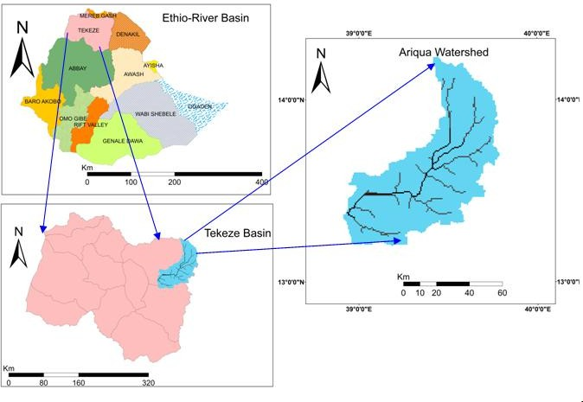This study was conducted in the Ariqua watershed (Fig. 1), Tekeze basin, which is found in the central zone, Tigray Region. Ariqua watershed is also one of the three sub-catchments of Giba sub-basin of Tekeze basin. The watershed having an area of 519,618.38 ha, and it is situated between 13⁰ 00' N to 14⁰ 00' N latitude and 38⁰ 00' E to 39⁰ 00' E longitude with an average elevation of 1764 meter above sea level. It is found at a distance of 180 km from Mekelle.

Fig 1. The study area’s location map

The average monthly temperature varies between 14 ⁰C and 27 ⁰C throughout the year, while the average annual rainfall is 555.33 mm. The watershed's slope lies between the area's flat and undulating topography. Generally this area is being used for agriculture.

  - Method of data collection

The Ministry of Water, Irrigation, and Electricity [11] provided the shape file of the study area's primary soil types and land use data. ArcGIS10.1 software was used to create the study area's soil map. The National Meteorological Service Agency (NMSA) provided daily climate data, rainfall, maximum and minimum temperatures, relative humidity, wind speed, and sunlight hours during a 25-year period from January 1991 to December 2015. The mean annual rainfall data were used in five adjacent metrological stations of the study area for analysis of runoff and sediment yield (H/selam, Mekelle , Samre, Yechila and Wukro).

The SWAT model has been calibrated and validated using hydrological data, accessible stream flow and sediment yield data from the watershed gauging station. The average monthly stream flow discharge and sediment yield data (2001-2015) for the sub-basin's gauging station (Ariqua gauging station), which has continuous records for a considerable amount of time, were thus gathered from the MoWIE.

Digital Elevation Model (DEM), digital stream network, land use and land cover map, and soil map are among the spatial data. The high resolution DEM (30 X 30 m) was obtained from online elevation databases of the SRTM(http://earthexplorer.usgs.gov/). The DEM used as input for SWAT model. The watershed's runoff and sediment transport are impacted by land use and cover. The MoWIE department of GIS provided the 2015 land use and land cover data for this study as a shape file.

  - SWAT Hydrological Model

The Soil and Water Assessment Tool (SWAT) is a watershed, or river basin, scale model. SWAT was used to predict the long-term effects of land management practices on water, sediment, and agricultural chemical yields in large, complex watersheds with a variety of soil types, land uses, and management strategies. SWAT needs detailed information about the topography, vegetation, weather, soil characteristics, and land management techniques used in the watershed. SWAT uses input data to directly predict the physical processes related to crop development, water movement, sediment movement, fertilizer cycling, etc. It simulates a very huge basin and is computationally efficient. The SWAT model, created by [1], is now widely recognized as a reliable transdisciplinary watershed model. SWAT uses the Modified Universal Soil Loss Equation (MUSL) 14 to estimate and simulate the sediment production [16].
Sed = 11.8 x (Q_{surf} x q_{peak} x area_{hru})^{0.56} x K_{USLE} x C_{USLE} x LS_{USLE} x C_{FRG} (1)

Where, area_{hru} is the area of the HRU (ha), Q_{surf} is the surface runoff volume (mm /ha), q_{peak} is the peak runoff rate (m³/s), Sed is the sediment yield on a given day (metric tons), K_{USLE} is the soil erodibility factor, C_{USLE} is the cover and management factor, LS_{USLE} is the support practice factor are obtained from the Universal soil loss Equations and C_{FRG} is the coarse fragment factor.

2.4 Inputs for Hydrological Model

The Digital Elevation Model (DEM), land use and land cover, and soils are among the geographic resources required for the ArcSWAT2012 model. For the model to forecast stream flow and for calibration, daily observed climate data, river discharge and sediment concentration data are also necessary. The watershed was first divided into sub-basins using the model. The user may either supply specified sub-basins or let SWAT use the DEM to automatically delineate the watershed and sub-basins. Hydrologic response units (HRUs) were created by dividing the geographical area inside a sub-basin. HRUs are sections of a sub-basin with distinct soil characteristics, slope range, and land use [12].

- Result and discussion

3.1 Slope and Digital Elevation Model (DEM)

One of the primary inputs for the SWAT model is the DEM. DEM, which describes the elevation of any point in a given area at a specific spatial resolution, defines the topography. The STRM dataset (Fig. 2) was used to process the DEM data. DEM data was projected into the projected coordinate system prior to being loaded into the ArcSWAT interface. The Arc tool box operation in ArcGIS was used to project the DEM data. UTM _ other GCS _Adindan UTM zone 37 N are the anticipated coordinate system parameters of the study area.

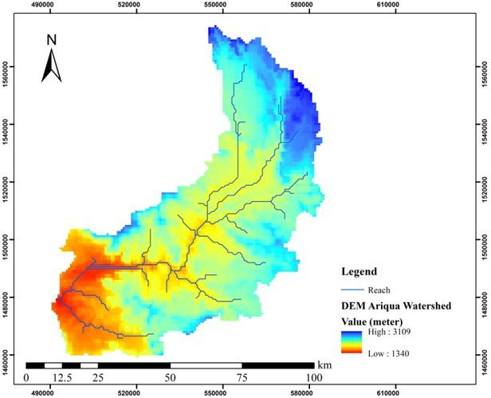  Fig 2. DEM of Ariqua watershed | 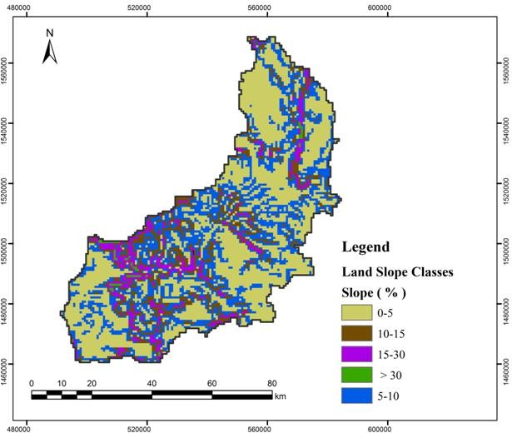  Fig 3. Slope classification

The slope was categorized as falling within the reasonable range during the development of HRU. As a result, the slope was divided into five classes in order to reduce complexity, use manageable data, and take the area's steepness into consideration. 0–5%, 5–10%, 10–15%, 15–30%, and above 30% were the classes (Fig. 3). The map of the region's slopes was developed based on these classes. Based on [6] slope classes, 10.82 % of the area has more than 30 % slope and between 15 – 30 % slope covers 13.5 % of the watershed. Approximately 75.68% of the watershed is covered by the region between the slope range of 0% and 15%. This region is typically used for farming.

3.2 land use, land cover and Soil types

The soils in the study area could be grouped in to five major categories based on the FAO/UNSCO-ISRIC soil classification. Table 1 and Fig. 4 indicate the primary soils in the area. 237 HRUs were created, based on the threshold percentage values. So, the slope, soil and land use maps should be 100% overlaid to create HRUs that had similar hydrological condition. Table 2 and Fig. 5 show the area covered by each form of land use within the watershed.
Table1. Major soil types of the watershed
Type of Soil | SWAT Code | Area in Ha | Coverage (%)
Lithic Leptosols | LP_li | 188,101.85 | 36.20
Chromic Cambisols | CM_cr | 144,817.64 | 27.87
Eutric Leptosols | LP_eu | 136,555.71 | 26.28
Vertic Cambisols | CM_vr | 7,794.28 | 1.50
Rendezic Leptosols | LP_rz | 42,348.90 | 8.15
Total |  | 519,618.38 | 100.00

Table 2. land use and land cover of the watershed
Type of Land Use | SWAT Code | Area in Ha | Coverage (%)
Shrubs land | RNGB | 112,445.42 | 21.64
Grazing Land | RNGE | 175,890.82 | 33.85
Cultivated Land | AGRC | 209,925.83 | 40.40
Bare Land | SWRN | 16,056.21 | 3.09
Plantation | ALFA | 155.89 | 0.03
Natural Forest | FRSE | 1,714.74 | 0.33
Water | WATR | 467.66 | 0.09
Wood Land | FRST | 2,961.82 | 0.57
Total |  | 519,618.38 | 100.00

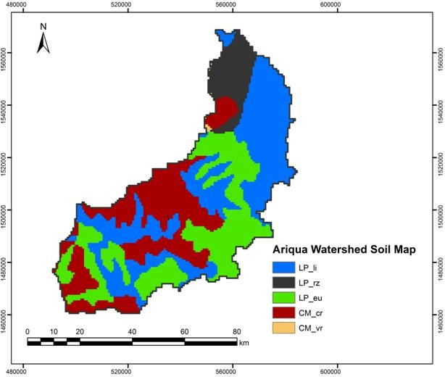  Fig 4. Major soil group map | 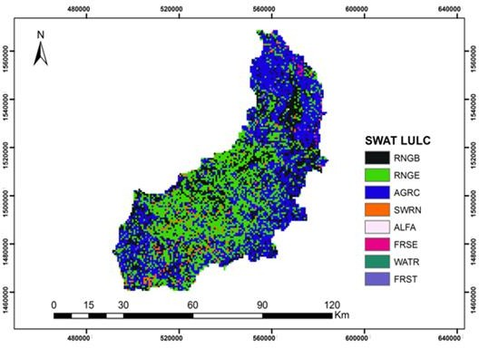  Fig 5. Land use map

3.3 Simulation of stream flow

    - Sensitivity analysis

Though there were 28 sensitivity parameters in SWAT model; around 13 parameters are effective for monthly flow simulation analysis with the category of sensitivity ranging being extremely high to very low. Runoff curve number for SCS: moisture condition II (CN2), evaporation soil compensation factor (ESCO), water available capacity (mm water/mm soil), (Sol AWC), shallow aquifer for "revap" (mm) (Revapmin), and soil depth for each layer (SOL Z) were found to be the most sensitive parameters in runoff simulation (Table 3). However, in runoff yield modeling, characteristics like average steepness slope (HRU_SLP), plant uptake compensation factor (EPCO), and average slope length (SLSUBBSN) were found to be least sensitive.
Table 3. Results of the flow sensitivity analysis
SWAT Variable Bounds/Ranges t-stat¹ P- value² Rank Sensitivity class
Code
CN2 Runoff curve number for SCS 35 – 98 -29.6 0.00 1 High
Moisture condition II
ESCO Evaporation of Soil 0-1 -8.51 0.00 2 High
compensation factor
SOL AWC Water Available capacity 0-1 -6.08 0.00 3 High
(mm water/mm soil)
Revapmin Shallow aquifer for 1.0 -24 4.15 0.00 4 High
" revap" (mm)
SOL_Z Soil depth for each layer +25 -2.85 0.00 5 High
CANMX Maximum canopy storage 0-100 1.6 0.13 6 Medium
Blai Leaf area index for crops 0- 2000 1.44 0.16 7 Medium
GW Revap Ground water "revap" 0-1 -1.35 0.21 8 Medium
Coefficient
GWQMN Shallow aquifer for return 0-5000 -1.18 0.23 9 Medium
Flow (mm)
CH K2 Main Channel 0.01-50 -1.15 0.26 10 Medium
Conductivity (mm/hr)
HRU_SLP Average steepness of slope 0- 90 0.75 0.82 11 Small
EPCO Plant uptake compensation 0-1 0.37 0.87 12 Small
Factor
SLSSUBBN Average slope length 10-150 0.01 0.92 13 Small
¹The sensitivity is measured by t-statistic; a sensitive parameter is indicated by larger absolute values;
²The sensitivity's significance is determined by p-values; a value near zero indicates more significance.

3.3.2 Calibration of Stream Flow

The model was performed using stream flow data from the Ariqua watershed for fifteen years, from January 1, 2001 to December 31, 2015. As a result, the calibration was carried out using stream flow data period of six years, from January 1, 2006, to December 31, 2011. The calibration result of stream flow within observed and simulated monthly flow (R² & ENS) is put in (Fig. 6). When calibrating to acceptable ranges, the statistical criteria should be applied. He assumed an adequate calibration for hydrology at a D <± 25%, R² > 0.6, and ENS > 0.5, according to the SWAT developers in [13].


Flow (m3/s)
800
700
600
500
400
300
200
100
0
Observed
Simulated
Time (Month)
Jan-06 May-06 Sep-06 Jan-07 May-07 Sep-07 Jan-08 May-08 Sep-08 Jan-09 May-09 Sep-09 Jan-10 May-10 Sep-10 Jan-11 May-11
Sep-11
R² = 0.89 ENS = 0.61

Fig 6. Average monthly observed and simulated flow calibration results (2006-2011)

    - Validation of stream flow

The observed data from 2012 to 2015 was used to validate the SWAT model for runoff. In order to further analyze the model's performance, the validation involves the model with the same parameter set against an independent set of data series. The model was validated using the three statistical goodness of fitness (Fig. 7).


Flow (m3/s)
Observed

Simulated
800
700
600
500
400
300
200
100
0
Time ( Month)
Jan-12 Mar-12 May-12 Jul-12 Sep-12 Nov-12 Jan-13 Mar-13 May-13 Jul-13 Sep-13 Nov-13 Jan-14 Mar-14 May-14 Jul-14 Sep-14 Nov-14 Jan-15 Mar-15 May-15 Jul-15 Sep-15 Nov-15
R² = 0.79 ENS = 0.67

Fig 7. Average monthly observed and simulated flow validation results (2012-2015)

3.4. Sediment Yield Simulation

The amount of sediment that is removed out of a watershed or sub-watershed is named as sediment yield. Because it can be compared to existing observed data sets, this value is used for model calibration and validation.

3.4.1. Sensitivity analysis

To determine the factors influencing sediment yield, sensitivity analysis was done. USLE soil erodibility factor (USLE_K), land cover and management factor (USLE_C), USLE support practice factor (USLE_P), and channel re-entrainment linear parameter (SPCON) were the most sensitive factors for erosion simulations. Sediment concentration in the lateral flow and ground water flow (LD_SED), channel erodibility factor (CH_COV1), and channel re-entrainment exponent parameter (SPEXP) were shown to be relatively sensitive parameters for sediment yield. However, the average depth of the main channel (CH_D), average length of the slope (SLSHBBSN), and average steepness of the slope (HRU/SLP) were less sensitive parameters. The amount of sediment from a catchment (from upland) and the channel (in stream sediment) was calculated using these sediment parameters. There were seven parameters most sensitive parameters identified that significantly affect sediment yield (Table 4).
Table 4. Results of sediment sensitivity analysis
SWAT parameter Variation t-stat¹ P- value² Rank Sensitivity
Code range class
USLE_ K Soil erodibility factor USLE 0-0.35 6.01 0.00 1 High
USLE_C Cover or management USLE 0-0.35 4.09 0.00 2 High
Practice factor
USLE_P USLE conservation practice 0-1 3.26 0.00 3 High
factor
SPCON Channel linear factor 0.0001-0.01 -2.84 0.00 4 High
Sediment routing
SPEXP Channe exponential factor 1-1.50 1.71 0.21 5 Medium
sediment routing
CH_COV1 Channel erodibilty factor 0-0.20 1.53 0.142 6 Medium
(cm/h/pa)
LAT_SED Sediment concentration in 0-2 1.35 0.136 7 Medium
lateral flow and ground
water flow
SLSSUBBN Average length of slope 10-150 -1.32 0.92 8 Small
HRU/SLP Average steepness of slope 0-1 -1.30 1 9 Small
CH_D Average depth of main 0-30 1.0 0.85 10 Small
channel
¹The sensitivity is measured by t-statistic; a sensitive parameter is indicated by larger absolute values;
²The sensitivity's significance is determined by p-values; a value near zero indicates more significance.

Calibration of sediment yield

The SWAT model was calibrated from sediment yield by comparing the monthly measured sediment yield from the Ariqua watershed from 2006 to 2011 with the monthly model simulated sediment yield. Monthly adjustments were made to observed sediment yields, and monthly simulation runs were carried out to compare the modeling output with the measured monthly discharge at the Ariqua watershed outlet (Fig. 8). R² and ENS contain the goodness of fitness (Fig. 8).

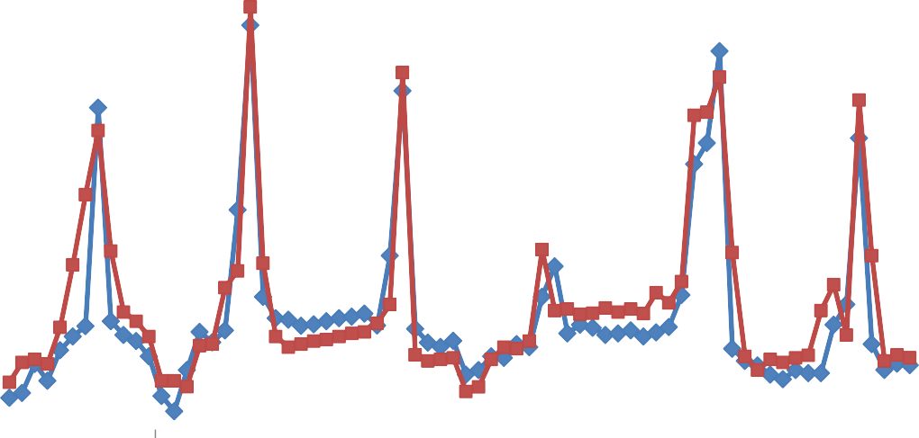
Sediment Yield (ton/ha)
Observed
Simulated
30
25
20
15
10
5
0
Time ( Month)
Jan-06 May-06 Sep-06 Jan-07 May-07 Sep-07 Jan-08 May-08 Sep-08 Jan-09 May-09 Sep-09 Jan-10 May-10 Sep-10 Jan-11 May-11
Sep-11
R² = 0.87 ENS = 0.72

Fig 8. Calibration result of monthly observed and simulated sediment yield (2006-2011)

Validation of sediment yield

During the validation period, there was good agreement between simulated and observed sediment (Fig. 9). The SWAT model was validated for runoff and sediment yield from the observed data of January 2012 to December 2015 using independent observed data that was not used in sediment calibration to validate sediment yield without making further adjustments of sensitive parameters.


Sediment yield (ton/ha)
30
25
20
15
10
5
0
Observed
Simulated
Time ( Month)
Jan-12 Mar-12 May-12 Jul-12 Sep-12 Nov-12 Jan-13 Mar-13 May-13 Jul-13 Sep-13 Nov-13 Jan-14 Mar-14 May-14 Jul-14 Sep-14 Nov-14 Jan-15 Mar-15 May-15 Jul-15 Sep-15 Nov-15
R² = 0.81 ENS = 0.59

Fig 9. Validation result of monthly observed and simulated sediment yield (2012–2015)

  - Spatial distribution of sediment yield and stream flow sources areas

The model was used for 15 years, from 2001 to 2015, following calibration and validation. The Ariqua watershed's simulation output stream flow and sediment yield for each sub-watershed area were identified using this model. One of the many tasks SWAT can perform when modeling runoff is the spatial analysis of possible sediment yield areas and runoff. Fig. 10 shows the spatial distribution of stream flow by sub-basin in m³/s. The annual average observed and simulated stream flow generated was 137 m³/s and 124 m³/s, respectively, as shown Fig. 10 below. Sub-watersheds (SWT-23) and (SWT-20) generated the highest discharge rates, 383.2 m³/s and 287.3 m³/s, respectively, according to the spatial distribution (Fig. 10), whereas catchments (SWT-2) and (SWT-11) produced the lowest discharge rates, 13.54 m³/s and 14.61 m³/s, respectively. Thus, the excessive discharge was caused by the soil's characteristics, steep slopes, and agricultural areas without conservation measures.

Similarly, the average yearly observed and simulated suspended sediment yield over a 15-year period was 12.54 tons/ha/yr and 13.92 tons/ha/yr, respectively. Fig. 11 shows the model's simulated spatial distribution of sediment yield for the Ariqua watershed. Fig. 11 shows that of the 23 sub-watersheds, (SWT-23) and (SWT-16) produced every high annual average sediment yield. These sub-watersheds require immediate intervention to minimize sediment loss from the watershed, as they exceed the allowable limit (2–18 tons/ha/yr) in the Tigray case, Medego watershed [8, 9]. This indicated that soil erosion is a serious issue in the study area. This means that the first conservation priority for sub-watershed (SWT-23) is required.

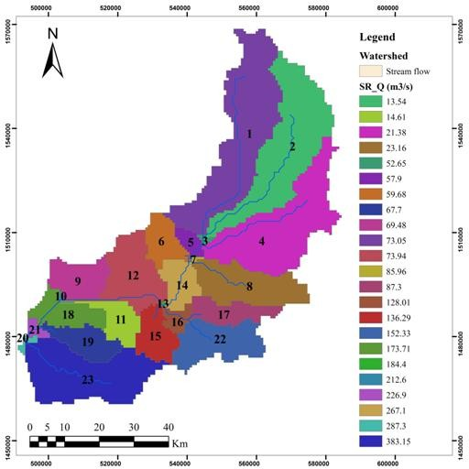  Fig 10. Simulated average annual stream flow by sub-watershed (m³/s) | 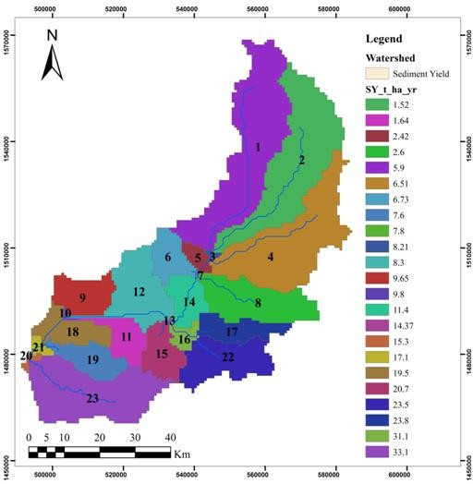  Fig 11. Average yearly simulated sediment yield by sub-watershed (ton/ha/yr)

4. Conclusion

Understanding the biophysical, hydrological, and hydraulic problems and suggesting appropriate intervention measures to control degradation, improve land and water productivity, and enhance ecological and environmental functions in developing countries are serious challenges due to the lack of pertinent information and data, as the main focus of this study is dependent on runoff and sediment yield analysis of the Ariqua watershed characteristics.

The physically based hydrological model was used to simulate the watershed's runoff and sediment yield over its hydrological response. The most sensitive variables in runoff simulation, according to the stream flow sensitivity analysis, were runoff curve number for SCS: moisture condition II (CN2), evaporation soil compensation factor (ESCO), water available capacity (mm water/mm soil) (SOL AWC), and soil depth for each layer (SOL_Z).

The most sensitive variables for sediment yield were the soil erodibility factor (USLE_K), land cover and management factor (USLE_C), support practice factor (USLE_P), and channel linear factor for sediment routing (SPCON). On the other hand, runoff and sediment yield were less sensitive to average length of slope (SLSHBBSN), plant uptake compensation factor, and average steepness slope (HRU/SLP).

The SWAT model suitability and performance assess using the calibration and validation statistics. The validation period was four years (2012-2015) while the calibration period was six years (2006-2011). As a result, it was shown that the measured and simulated monthly stream flow and sediment yield good agreement (R² = 0.89 and ENS = 0.61) for calibration, (R² = 0.79 and ENS = 0.67) for validation, and (R² = 0.87 and ENS = 0.72) for calibration, (R² = 0.81 and ENS = 0.59) for validation, respectively. According to the statistical model evaluation criteria, the model performance in simulating stream flow and sediment yield during calibration and validation was within an acceptable range.

The Ariqua watershed currently has an average annual sediment yield of 13.92 tons/ha/yr and an annual stream flow of 124 m³/sec after the calibration. The seasonal variability of stream flow and sediment yield from the individual sub-basins indicates that maximum stream flow and sediment yield were observed during heavy rainfall seasons (July to September). There is a direct relationship between runoff and sediment yield, meaning that sediment yield is a function of runoff and other processes occurring in the watershed.

6. References

- Arnold, J. G., Srinivasan, R., Muttiah, R. S., & Williams, J. R. (1998). Large Area Hydrologic Modeling and Assessment Part I: Model Development. Journal of the American Water Resources Association, 34(1), 73-89. https://doi.org/ 10.1111/j. 1752-1688.1998.tb05961.x
- Brhane, G., & Mekonen, K. (2009). Estimating Soil Loss Using Universal Soil Loss Equation (USLE) for soil conservation planning at medego watershed, Northern Ethiopia.Journal of American Science*, *5*(1),58-69.https://www.Jo famerican science.org/journals/am-sci/0501/100556brhane.pdf
- Dilnesaw Shibru. 2006. Modeling of Hydrology and Soil Erosion of Upper Awash River Basin. PhD Dissertation,University of Bonn, Germany.http://www.stiftung-fiat- panis.de/images/PF/PF2004_01.pdf.
- Easton, Z. M., Fuka, D. R., White, E. D., Collick, A. S., Ashagre, B. B., McCartney, M., Awulachew, S. B., & Ahmed, A. A. (2010). A multi basin SWAT model analysis of runoff and sedimentation in the Blue Nile, Ethiopia. Hydrology and Earth System Sciences, 14, 1827–1841. https://doi.org/10.5194/hess-14-1827-2010
- FAO. (2006). Guidelines for soil description, 4th edition. Rome: FAO. https://www.fao.org/4/a0541e/a0541e.pdf
- Federal Democratic Republic of Ethiopia. Ministry of Water, Irrigation and Electricity. (2019). Environmental and Social Impact Assessment Summary Report for TekezeHumeraIrrigationProject.https://www.afdb.org/sites/default/files/document s/environmentalandsocial-impact-assessment-summary-report-tekeze-humera- irrigation-project.pdf
- Gebreyesus Brhane and Kirubel M. 2009. Estimating Soil Loss Using Universal Soil Loss Equation (USLE) for soil conservation planning at medego watershed, Northern Ethiopia. Journal of American Science, 200 (5) : 58-69 .https:// www.jofamericanscience.org/journals/am-sci/0501/10_0556_brhane.pdf.
- Hurni, H. (1985). Erosion-productivity-conservation systems in Ethiopia. In Proceedings 4th International Conference on Soil Conservation (pp. 654-674). Maracay, Venezuela. https://doi.org/10.7892/boris.77547

- Lulseged Tamene. D. (2005). Reservation siltation in Ethiopia: Causes, sources areas and
Management options. Ecology and Development Series No. 30. https://books. google.com/books?id=MYMKQGVrTwC&printsec=frontcover&source=gbs_ge_ summary_r&c ad=0#v=onepage&q&f=false
- MoWIE (Ministry of Water, Irrigation and Electricity). 2015. Environmental Impact Assessment Report for Tekeze Humera,IrrigationProject,AddisAbeba,Ethiopia. https://www.epa.gov.et/images/PDF/ESIAWIC/ESIATekeze%20Humera%20Irri gation%20Project.pdf.
- Neitsch, S. L., Arnold, J. G., Kiniry, J. R., & Williams, J. R. (2005). Soil and Water Assessment Tool theoretical documentation: Version 2005. U.S. Department of Agriculture, Agricultural Research Service, Grassland, Soil and Water Research Laboratory; and Texas A&M University, Black land Research Center. https://swat.tamu.edu/media/1292/swat2005theory.pdf
- Santhi, C., Arnold, J. G., Williams, J. R., Dugas, W. A., Srinivasan, R., & Hauck, L. M. (2001). Validation of the SWAT model on a large river basin with point and nonpoint sources. Journal of the American Water Resources Association, 37(5), 1169-1188. https://doi.org/10.1111/j.1752-1688.2001.tb03630.x
- Setegn, S. G. (2008). Hydrological and sediment yield modelling in Lake Tana Basin, Blue Nile Ethiopia. (PhD Dissertation). Royal Institute of Technology (KTH), Sweden. https://kth.diva-portal.org/smash/get/diva2:14005/FULLTEXT01.pdf

- Williams, J.R. and Berndt, H.D. 1995. Sediment Yield Prediction Based on Watershed Hydrology.Transactions of the ASAE. American Society of Agricultural Engineers (Gen Ed), 20(6):1100-1104. https://doi.org/10.13031/2013.35710.

