Case Report
Infantile hemangioma in the Beard distribution : A case report from the Albert Royer Children's University Hospital Center

Abstract
Infantile hemangiomas (IH) are benign vascular tumors characterized by endothelial cell proliferation. Most IH are small and regress spontaneously without requiring treatment. However, depending on their size or location, some IH can cause significant complications, particularly segmental cervicofacial IH, hepatic IH, and subglottic IH. Infants with segmental facial IH are at risk of developing PHACES syndrome (20–30% of cases). The diagnosis of PHACES syndrome is based on the presence of a segmental infantile hemangioma larger than 5 cm associated with one major criterion or two minor criteria (Table 1). Ulceration is the most common complication, affecting approximately 16% of patients. It can cause pain, bleeding, secondary infection, functional impairment, and unsightly scarring. The discovery of propranolol has revolutionized treatment over the last decade. Propranolol can be administered on an outpatient basis in most infants, with the most commonly used dosage being 1–2 mg/kg/day in divided doses. Other more selective beta-blockers such as atenolol may be considered. Laser therapy may also be used for residual hemangiomas with fibro-adipose tissue remnants. Surgery is indicated for disfiguring hemangiomas or those resistant to multiple treatments. We report the case of a 3‑month‑old infant admitted to the neonatal unit of the Albert Royer Children's Hospital for ulceration of the mandibular region extending to the peri‑auricular area, measuring 10 cm in length, with a fibrinous and necrotic base, bordered by an angiomatous plaque and associated with almost complete destruction of the lower lip and right earlobe. This ulceration was associated with sternal agenesis, suggesting PHACES syndrome. She was treated with propranolol at 2 mg/kg/day for 6 months. Complications such as ulceration, secondary infection, and disfigurement were noted. This clinical case highlights the importance of early diagnosis of IH to avoid complications. Spontaneous regression is possible, but for high‑risk forms, oral propranolol remains the first‑line treatment.

Introduction
Infantile hemangiomas (IH) are the most common benign tumors in infants, with a prevalence of 5–10% (1). Segmental IH accounts for approximately 13% of cases (2,3). Most are small, resolve spontaneously, and do not require treatment. Nevertheless, some are considered high-risk and require specific management (hemangiomas larger than 5 cm regardless of location, or larger than 2 cm on the face or scalp)(4). Infants with segmental facial IH are at risk of developing PHACES syndrome (20–30% of cases), hence the need for systematic screening (cerebral vascular anomalies, posterior fossa malformations, coarctation of the aorta or other cardiac defects, sternal malformations, ocular involvement)(3). The diagnosis of PHACES syndrome is based on the presence of a segmental infantile hemangioma larger than 5 cm associated with one major criterion or two minor criteria (Table 1) (5). The lower cervicofacial location, or “beard distribution,” is particularly dangerous because it is associated with an increased risk of subglottic hemangioma, which must be detected and treated early as it can cause acute, life-threatening respiratory distress (4). Ulceration is the most common complication of IH and can lead to significant morbidity, including pain, bleeding, secondary infection, functional impairment, and scarring (3).
Through this observation, we report the case of a 3-month-old infant who presented late for consultation with a large infantile hemangioma at the stage of ulceration, necrosis, superinfection, and malnutrition. This case emphasizes the importance of early screening and timely management of IH to optimize outcomes and prevent severe complications.

Case Présentation
We report the case of a 3-month-old female infant hospitalized in the neonatal unit of the Albert Royer Children's Hospital for cervicofacial ulceration. She was born to second-degree consanguineous parents and is the youngest of two siblings. The 22-year-old mother reported no relevant family history.
The first clinical manifestations appeared at 2 weeks of age, beginning with confluent erythematous plaques that gradually spread (Figure 1).
Clinical findings included:
- A large ulceration of the mandibular region extending to the peri-auricular area, measuring 10 cm in length, with a fibrinous and necrotic base, and almost complete destruction of the lower lip and right earlobe (Figure 2).
- sternal agenesis (Figure 3).
- Signs of infection and malnutrition.
Vital signs and the remainder of the clinical examination (neurological, cardiovascular, pulmonary, ENT) were normal.
Laboratory tests revealed:
- Hyperleukocytosis (24,410/mm³, predominantly neutrophils).
- Thrombocytosis (1,055,000/mm³).
- Hypochromic microcytic anemia (Hb 7.9 g/dl).
- Elevated C-reactive protein (96 mg/L).
- Normal fasting glucose, electrolytes, and renal function.
Swabbing of the ulcerations isolated Staphylococcus aureus, susceptible to vancomycin and resistant to amoxicillin-clavulanic acid.
Additional investigations performed:
Nasofibroscopy to rule out subglottic hemangioma.
Ophthalmological examination to exclude ocular anomalies.
Cardiac and vascular Doppler ultrasound to assess for cardiovascular malformations.
Brain CT scan (in the absence of MRI) to evaluate posterior fossa anomalies.
Abdominal ultrasound to exclude visceral involvement.
All complementary examinations were normal.
The diagnosis of PHACES syndrome was established based on the combination of a large segmental cervicofacial hemangioma and sternal agenesis.
Treatment administered:
Intravenous vancomycin (60 mg/kg/day for 7 days).
Enteral nutrition via nasogastric tube.
Daily local care with chlorhexidine.
Oral propranolol (2 mg/kg/day), initiated after 7 days of antibiotics and continued for 6 months.
The outcome was favorable after just 2 months of treatment, marked by complete healing of the ulceration (Figure 4) and good weight gain.

Outcome:
The clinical course was favorable after two months of treatment, including one month of hospitalization followed by close outpatient monitoring—initially monthly, then every three months. This regimen resulted in complete healing of the ulceration (Figure 4) and satisfactory weight gain.
Discussion :
Infantile hemangiomas affect approximately 5% of full-term newborns and must be distinguished from congenital hemangiomas (CH), which resemble IH clinically but differ immunohistochemically (CH are GLUT1-negative, whereas IH are GLUT1-positive) (6). Risk factors for IH include placental abnormalities, prematurity, and low birth weight (2).
Segmental hemangiomas account for ~13% of IH. Cervicofacial hemangiomas are classified into four segments (S1–S4): S1 (frontotemporal), S2 (maxillary), S3 (mandibular), and S4 (frontonasal) (2,4). In our patient, the facial hemangioma extended over the mandibular region (segment S3), hence its name “beard hemangioma.”
Ulceration is the most common complication, affecting ~16% of patients (7). Ulcerated cervicofacial IH with necrosis should prompt consideration of other tropical ulcerations, particularly noma. In our patient, the early vascular signs (erythematous plaque at 2 weeks) and absence of immunodeficiency supported the diagnosis of IH. Ulceration can lead to secondary infection, pain, bleeding, and cosmetic sequelae (8).
PHACES syndrome is defined by the presence of a segmental IH >5 cm associated with one major criterion or two minor criteria (Table 1) (5). In our patient, the diagnosis was based on the combination of a large cervicofacial hemangioma and sternal agenesis. Beard hemangiomas are associated with subglottic hemangiomas in ~30% of cases, highlighting the importance of early ENT evaluation with nasofibroscopy, as performed in our patient, which was normal(4).
A complete assessment, including cardiac ultrasound, brain imaging, abdominal Doppler ultrasound, and ophthalmological examination, was conducted in accordance with recommendations to rule out other organ involvement present in PHACES syndrome.
Most IH can be managed conservatively. However, for high-risk cases, propranolol has revolutionized treatment. It is administered orally, usually 2–3 mg/kg/day in divided doses, with close monitoring for hypoglycemia, bradycardia, and hypotension. More selective beta-blockers such as atenolol show promise. For persistent lesions, corticosteroids or sirolimus may be considered (9). Other options include imiquimod or laser therapy for small, superficial IH. Surgery is reserved for disfiguring or treatment-resistant lesions (6,10,11).
The favorable outcome observed after two months of propranolol therapy is consistent with the American Academy of Pediatrics (AAP) guideline, which recommends close monitoring and treatment for at least six months in high‑risk cases. In our patient, the diagnosis was made at the stage of complication (ulceration and necrosis), after which she was placed under regular surveillance with weekly visits during the initiation phase and monthly follow‑up thereafter. This monitoring allowed appropriate dose adjustments and ensured a favorable evolution without further complications (4).

Conclusion:
This clinical case highlights the importance of early diagnosis and a multidisciplinary approach in the management of high-risk infantile hemangiomas. While spontaneous involution is possible for small lesions that only require monitoring, large hemangiomas or those located in critical areas such as the face, subglottic region, or liver can lead to severe complications and functional sequelae.
The discovery of propranolol has revolutionized treatment, offering rapid and effective regression of lesions. In our patient, therapy initiated after the onset of complications led to complete healing within two months, in line with international recommendations that advocate treatment for at least six months with regular follow-up.
Other therapeutic options, including selective beta-blockers such as atenolol, corticosteroids, sirolimus, laser therapy, or surgery, may be considered depending on the clinical context. Nevertheless, propranolol remains the first-line treatment for high-risk infantile hemangiomas, with an overall favorable prognosis when diagnosis and management are timely.

REFERENCES
1. Pr N. Dupin (Paris), Pr B. Cribier (Strasb ourg), P. Vabres (Dijon) PLM (Angers), Groupe. Referentiels des collèges de dermatologie. 7 eme. elsevier Masson, éditeur. 2017. 35 p.
2. Barreau M, Dompmartin A. [Cutaneous infantile hemangiomas]. Arch Pediatr. juin 2017;24(6):592‑6.
3. Enjolras O. Anomalies vasculaires superficielles (« angiomes »). EMC - Pédiatrie. 1 mai 2004;1(2):129‑51.
4. Krowchuk DP, Frieden IJ, Mancini AJ, Darrow DH, Blei F, Greene AK, et al. Clinical Practice Guideline for the Management of Infantile Hemangiomas. Pediatrics. janv 2019;143(1):e20183475.
5. Hicks ED, Hameed M, Shahare H, Jones-Brooks P, Wong K, Filipek J, et al. A Multimodal Approach to a Complex PHACES Patient With Progressive Infantile Hemangioma: A Case Report and Review of Literature. Cureus. 17(3):e80261.
6. Léauté-Labrèze C, Harper JI, Hoeger PH. Infantile haemangioma. Lancet. 1 juill 2017;390(10089):85‑94.
7. Açikgöz A, Sakallioglu U, Ozdamar S, Uysal A. Rare benign tumours of oral cavity--capillary haemangioma of palatal mucosa: a case report. Int J Paediatr Dent. juin 2000;10(2):161‑5.
8. Chamlin SL, Haggstrom AN, Drolet BA, Baselga E, Frieden IJ, Garzon MC, et al. Multicenter prospective study of ulcerated hemangiomas. J Pediatr. déc 2007;151(6):684‑9, 689.e1.
9. Sebaratnam DF, Rodríguez Bandera AL, Wong LCF, Wargon O. Infantile hemangioma. Part 2: Management. J Am Acad Dermatol. déc 2021;85(6):1395‑404.
10. Callahan AB, Yoon MK. Infantile hemangiomas: A review. Saudi J Ophthalmol. juill 2012;26(3):283‑91.
11. Alcántara-González J, Boixeda P, Truchuelo-Díez MT, Pérez-García B, Alonso-Castro L, Jaén Olasolo P. Infantile hemangiomas treated by sequential application of pulsed dye laser and Nd:YAG laser radiation: a retrospective study. Actas Dermosifiliogr. 2013;104(6):504‑11.

Disclaimer (Artificial intelligence)

Author(s) hereby declare that NO generative AI technologies such as Large Language Models (ChatGPT, COPILOT, etc.) and text-to-image generators have been used during the writing or editing of this manuscript.

Table 1 : Diagnostic criteria for phaces syndrome
Major criteria | Minor criteria
Arterial: anomalies of major cerebral or cervical, stenosis, occlusion, dysplasia. hypoplasia, persistent carotid-vertebrobasilar anastomosis | Arterial: aneurysm of cerebral arteries arteries
Structural brain: posterior fossa anomalies:  Dandy-Walker complex, unilateral or bilateral cerebral dysplasia or hypoplasia | Structural brain: midline anomaly, malformation of cortical development, neuronal migration disorder
Cardiovascular: aortic arch anomalies.  aneurysm, an aberrant origin of the subclavian artery | Cardiovascular: ventricular septal defect, right aortic arch
Ocular: posterior segment anomaly, retinal vascular anomalies | Ocular: anterior segment anomalies, cataracts, sclerocornea, microphthalmia
Ventral or midline: sternal defect, sternal cleft | Ventral or midline: hypopituitarism, ectopic thyroid, midline sternal papule

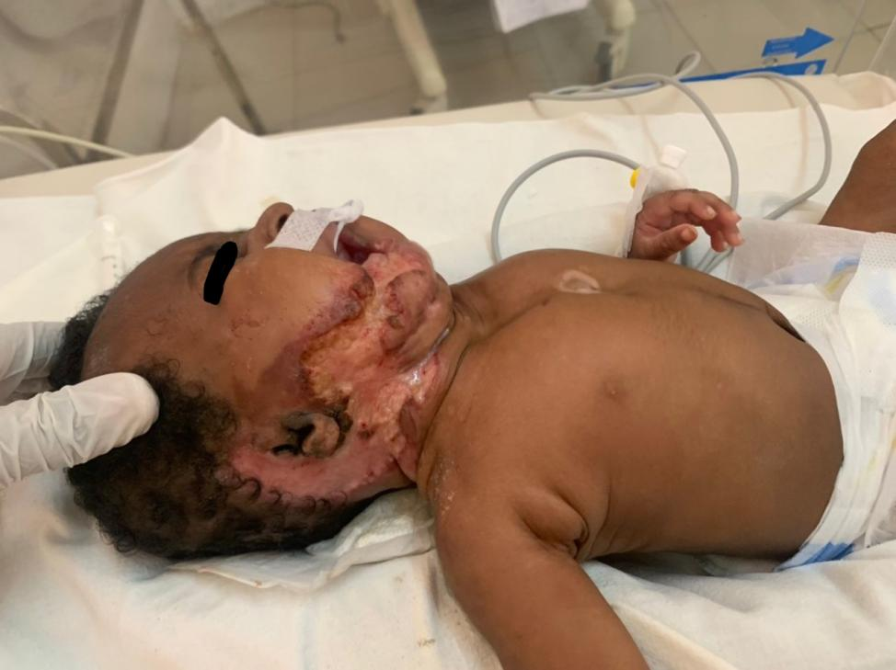
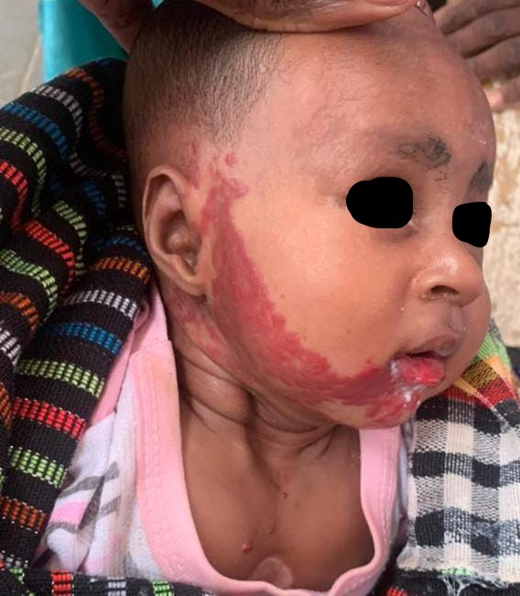

Figure 1 : Annular erythematous plaque Figure 2 : Ulceration with necrosis

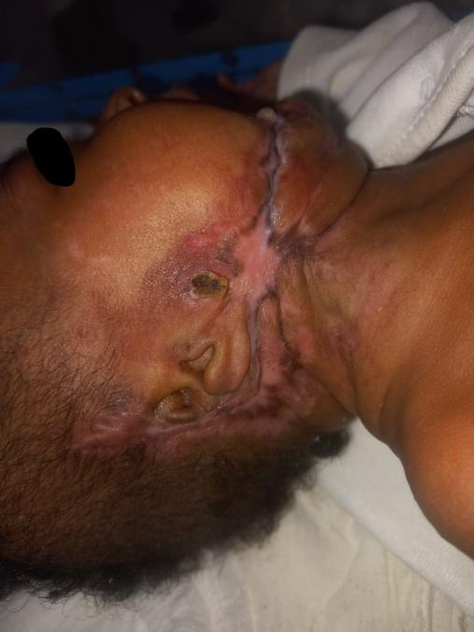
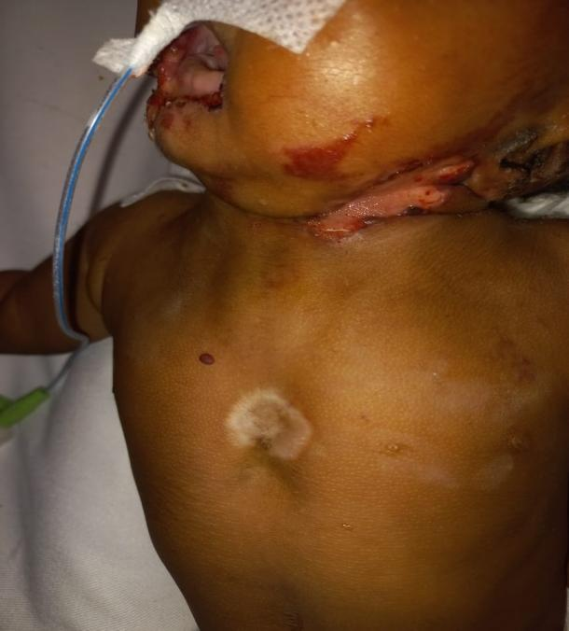

Figure 3 : Sternal agenesis Figure 4: progress after 2 months of treatment

