Case report
Fibrodysplasia ossificans progressiva: A case report from Albert Royer Children's University Hospital

Abstract:
Progressive ossifying fibrodysplasia (FOP) is a rare genetic connective tissue disorder characterized by congenital abnormalities of the big toe and progressive ectopic ossification. It is marked by the formation of extraskeletal bone and is considered a fundamental disorder of osteochondrogenesis. Despite its well-documented global prevalence, one case per two million inhabitants, FOP remains underreported in the African literature. This study aims to discuss the clinical, evolutionary, and diagnostic aspects of this rare disease by presenting a case in Albert Royer Children’s University Hospital. We report the case of a 7-year-old boy, born to second-degree consanguineous parents, with normal psychomotor development and no significant family or perinatal history. He was presented with painful swellings of the cervical–dorsal region and upper limbs, which first appeared at 18 months of age as hard nodules on the posterior neck. Over the years, the swellings spread to the trunk and upper limbs, becoming increasingly debilitating and causing difficulty in walking. The diagnosis of FOP was made on clinical and radiological grounds which showed heterotopic ossification with bone bridges. He was placed on symptomatic treatment with regular follow-ups every 6 months.
Keywords: progressive ossifying myositis, congenital abnormalities, type 1 activin A receptor, bone morphogenetic protein, diarthrodial joints

Introduction
Progressive ossifying fibrodysplasia (FOP), also known as progressive ossifying myositis, is an extremely rare genetic disorder characterized by the formation of extraskeletal bone, but which could rightly be considered a fundamental disorder of osteochondrogenesis. The latter causes abnormal formation of articular cartilage, abnormal specification of diarthrodial joints, growth plate dysplasia, formation of osteochondromas, heterotopic endochondral ossification, and early arthropath (1). In FOP, an activating heterozygous mutation encoding the type 1 activin A receptor (ACVR1), which is a type I bone morphogenetic protein (BMP) receptor, is responsible for the osteochondrodysplasia that causes the developmental phenotypes and subsequent characteristics of this disease. These alterations affect various systems, including inflammation, innate immunity, hypoxia detection, wound healing, aging, thermal and mechanical thresholds, pain sensitivity, skeletal growth, diarthrodial joint structure, joint function and outcome, and (2).
Clinically, FOP is mainly reported as isolated cases, and research into its pathogenesis and therapeutic strategies remains limited.(3). It is often misdiagnosed, leading to unnecessary biopsies and surgical procedures that aggravate the disease. Therefore, knowledge of the clinical characteristics of FOP by all physicians, surgeons, and pediatricians is essential for early diagnosis and optimal management.
Despite its well-documented global prevalence, FOP remains underreported in the African literature. This underrepresentation of data highlights a probable underdiagnosis and justifies the interest of our work. Through this observation, we aim to contribute to the African literature by describing the clinical, evolutionary, and diagnostic aspects of this rare disease.

Case presentation
This is a 7-year-old boy with no significant family or perinatal history, born to second-degree consanguineous parents, the seventh of seven children, all alive and well, with good psychomotor development.
He was admitted to our department for painful swelling in the cervical-dorsal region and upper limbs. These initial symptoms appeared at the age of 18 months, beginning with hard swellings located on the back of the neck, which led to several consultations at various hospitals and even the use of traditional treatments. Over the years, the swellings spread to the trunk and upper limbs, becoming increasingly debilitating and causing difficulty in walking. The multiple consultations did not lead to a diagnosis, resulting in normal laboratory tests and essentially symptomatic treatment.
Three years later, the patient was referred to the pediatric endocrinology department at the Albert Royer Children's Hospital for better care.
On admission, the following were noted:
- Multiple painful, stony swellings of varying sizes, located at:
- the cervical region, with stiffness and limited neck movement
- both shoulder blades and the front of the arms, limiting shoulder movement to 30°
- the back, associated with marked scoliosis
Figure 1 shows diffuse ossification with various bone bridges.
- Bilateral congenital hallux valgus, as illustrated in Figure 2
- Other signs: difficulty walking, brachyphalangia.
An X-ray of the skeleton confirmed the diagnosis by showing multiple extraosseous ossifications
In the spine:
- Cervical-dorsal spinal straightness
- Scoliosis with left convexity
- Bony streaks in the cervical-dorsal-lumbar and sacral soft tissues forming actual bony bridges between the occiput and the last sacral vertebra. These bony bridges have a clear center in places.
In the thorax : ossification of the soft tissues forming scapulocostal and intercostal bone bridges in places, giving the appearance of costal bifurcation. Figure 3 is a thoracoabdominal X-ray from the front and side showing the bone bridges and scoliosis
In the lower limbs:
- Enlargement of the femoral necks and the tip of the left tibia
- Pedunculated bone growths on the distal metaphyses of the right femur and proximal metaphyses of the right tibial diaphysis
- Bilateral coxa valga
Figure 4 is a frontal X-ray of the pelvis and lower limbs showing the various abnormalities described.
In the upper limbs: band-like bone casts forming bilateral scapuloulnar bone bridges, more pronounced on the left side.
Figure 5 is an X-ray of the upper limbs showing scapulohumeral bone bridges.
In the extremities:
- Feet: hallux valgus
- Short, triangular appearance of the first phalanges, which are trapezoidal
- Hypoplasia of the middle phalanges of the 2nd, 3rd, 4th, and 5th rays

- Hand:
- Shortness of the metacarpal and proximal phalanx of the first rays
- Hypoplasia of the middle phalanges of the 2nd and 5th rays.
- Delayed bone maturation with a bone age of 4 years at the age of 5
Figure 6 is a front and side view X-ray of the hands illustrating the various abnormalities of the fingers.
In total, the diagnosis of FOP was made on clinical and radiological grounds, as genetic testing was not available in our setting.
The patient was placed on symptomatic treatment and his family was informed of the disease. Advice on preventing minor trauma was provided. The patient is monitored regularly in our department every 6 months.

Discussion:
FOP is a connective tissue disorder characterized by congenital abnormalities of the big toe and progressive ectopic ossification. It is a rare and debilitating genetic disorder that does not specifically affect any particular gender, race, or geographic region. (3,4)
According to data from the International FOP Association, the average age of patients presenting with the first symptoms of FOP is 5.4 years, and the average age of definitive diagnosis of FOP is 7.5 years. (5)
In our patient, the age of onset of the disease was 18 months, but the diagnosis was not made until the age of 5, demonstrating the lack of awareness of the disease among some clinicians.
Heterotopic ossification usually begins in the cervical paravertebral muscles and then spreads from the axial axis to the limbs and from proximal to distal sites. Scoliosis is common due to asymmetrical heterotopic bones connecting the trunk and pelvis. (6)
The first signs found in our patient were congenital hallux valgus, heterotopic ossification, and scoliosis.
The fusion of the ossicles in the ear causes conductive hearing loss, which is a common feature associated with this condition. (7,8). Progressive episodes of heterotopic ossification lead to ankylosis of all major joints of the axial and appendicular skeleton, rendering movement impossible. By the second decade of life, most patients with FOP are confined to bed or a wheelchair. (7,9)
The most common cause of death in FOP is restrictive respiratory failure (4).
The diagnosis is based primarily on clinical criteria, including congenital malformations of the big toe, progressive ectopic ossification, and anatomical changes during the course of the disease. (10)
X-rays of the skeleton, CT scans, or even magnetic resonance imaging can confirm the diagnosis by showing heterotopic ossification.
Genetic testing can detect the ACVR1 gene mutation. This could not be performed on our patient due to the parents' financial difficulties.
FOP must be differentiated from other similar conditions, including progressive bone heteroplasia, Albright's hereditary osteodystrophy, cutaneous osteoma, ankylosing spondylitis, Still's disease, Klippel-Feil syndrome, brachydactyly, sarcoma, and desmoid tumor.(4,11)
Treatment is primarily symptomatic and palliative, including anti-inflammatory drugs, psychological support, and trauma prevention.
New therapies targeting ACVR1 include hypoxia-inducible factor 1α inhibitors to inhibit ectopic ossification, ACVR1 kinase inhibitors (LDN 212454) to reduce ectopic ossification, and activin A-neutralizing antibodies to effectively suppress ectopic ossification, offering the possibility of developing highly selective and specific drugs for the treatment of FOP. However, it should be emphasized that these measures only delay or slow the progression of the disease and do not effectively stop or reverse it. Some authors suggest that low-dose radiation therapy at an early stage of ectopic ossification may be effective, while others propose that retinoid agonists may effectively suppress ectopic ossification. With regard to gene therapy for FOP, research is progressing in several directions, but has not yet reached the stage of clinical application. (12)
Current therapeutic strategies for FOP emphasize early diagnosis, trauma prevention, and functional rehabilitation. [8-10]. Appropriate rehabilitation aims to improve lung function, strengthen muscle strength, and increase joint mobility, thereby improving quality of life in the advanced stages of the disease.
During the fibroproliferative phase, anti-angiogenic drugs and endothelial growth factor inhibitors may be used. During the ossification phase, abnormal expression of bone morphogenetic protein 4 (BMP-4) leads to cartilage formation and subsequent ectopic calcification. Therefore, BMP-4 inhibitors, bisphosphonates, may have some therapeutic effects, although their efficacy remains limited and controversial. [11].

Conclusion
Fibrodysplasia ossificans progressiva is an extremely debilitating disease that significantly reduces life expectancy. Despite significant scientific advances, FOP remains poorly understood by clinicians and diagnosis remains a challenge. Understanding the pathophysiology, particularly the involvement of the ACVR1 gene, has led to the emergence of promising targeted therapies. However, current management remains symptomatic and preventive in order to avoid trauma and inflammatory flare-ups.

Disclaimer (Artificial intelligence)

Author(s) hereby declare that NO generative AI technologies such as Large Language Models (ChatGPT, COPILOT, etc.) and text-to-image generators have been used during the writing or editing of this manuscript.

Références
1. Kaplan FS, Al Mukaddam M, Stanley A, Towler OW, Shore EM. Fibrodysplasia Ossificans Progressiva (FOP): A Disorder of Osteochondrogenesis. Bone. nov 2020;140:115539.
2. Kaplan FS, Shore EM, Pignolo RJ. Fibrodysplasia ossificans progressiva emerges from obscurity. Trends Mol Med. févr 2025;31(2):106‑16.
3. Hsiao EC, Di Rocco M, Cali A, Zasloff M, Al Mukaddam M, Pignolo RJ, et al. Special considerations for clinical trials in fibrodysplasia ossificans progressiva (FOP). Br J Clin Pharmacol. juin 2019;85(6):1199‑207.
4. Kaplan FS, Zasloff MA, Kitterman JA, Shore EM, Hong CC, Rocke DM. Early Mortality and Cardiorespiratory Failure in Patients with Fibrodysplasia Ossificans Progressiva. J Bone Joint Surg Am. mars 2010;92(3):686‑91.
5. Mantick N, Bachman E, Baujat G, Brown M, Collins O, De Cunto C, et al. The FOP Connection Registry: Design of an international patient-sponsored registry for Fibrodysplasia Ossificans Progressiva. Bone. avr 2018;109:285‑90.
6. Mahboubi S, Glaser DL, Shore EM, Kaplan FS. Fibrodysplasia ossificans progressiva. Pediatr Radiol. mai 2001;31(5):307‑14.
7. Lanchoney TF, Olmsted EA, Shore EM, Gannon FA, Rosen V, Zasloff MA, et al. Characterization of bone morphogenetic protein 4 receptor in fibrodysplasia ossificans progressiva. Clin Orthop Relat Res. janv 1998;(346):38‑45.
8. Levy CE, Lash AT, Janoff HB, Kaplan FS. Conductive hearing loss in individuals with fibrodysplasia ossificans progressiva. Am J Audiol. juin 1999;8(1):29‑33.
9. Talbi S, Aradoini N, Mezouar IE, Abourazzak FE, Harzy T. Myositis ossificans progressive: case report. Pan Afr Med J. 2016;24:264.
10. Acharya S, Joshi S, Chaulagain R. Fibrodysplasia Ossificans Progressiva: A Case Report. J Nepal Health Res Counc. 4 juill 2018;16(2):245‑7.
11. Falliner A, Drescher W, Brossmann J. The spine in fibrodysplasia ossificans progressiva: a case report. Spine (Phila Pa 1976). 15 déc 2003;28(24):E519-522.
12. Qi L, Guo Y. Fibrodysplasia Ossificans Progressiva: A Case Report. Cureus. 16(3):e55528.
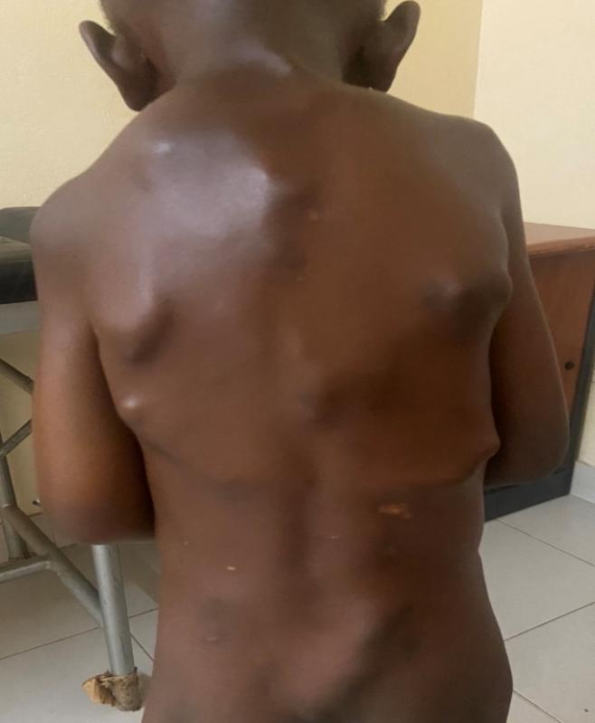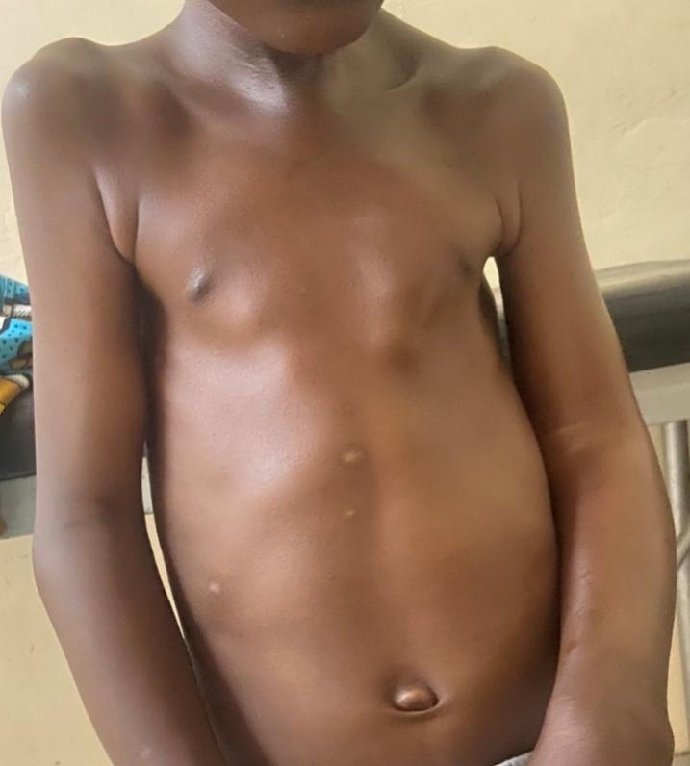 Figure 1: Anterior and posterior heterotopic ossification of the cervicothoracic region

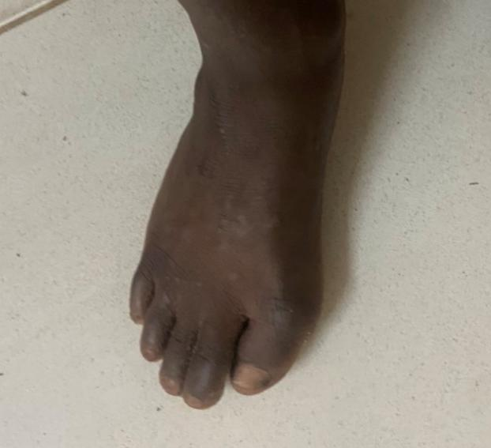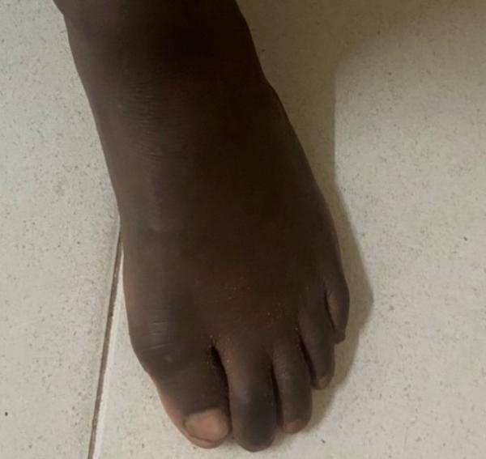
Figure 2 : Hallux valgus with deviation of the big toe toward the other toes

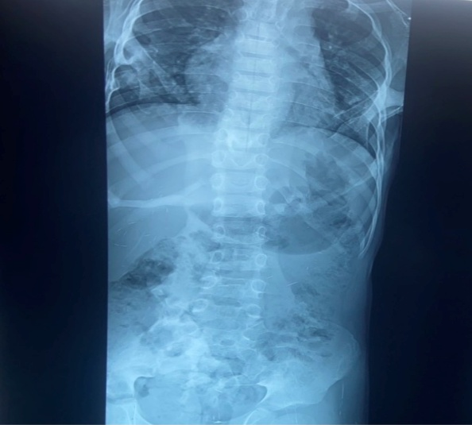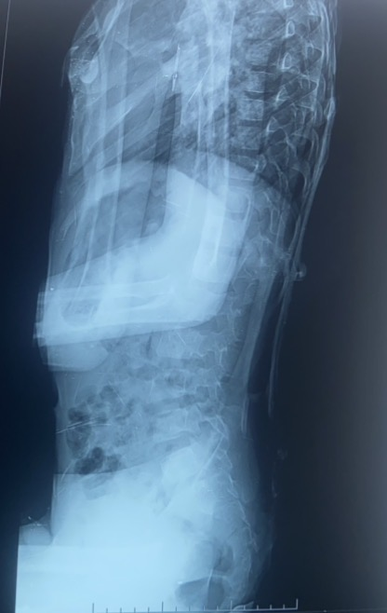
Figure 3: Frontal and lateral chest and abdominal X-ray showing scoliosis and bone bridge
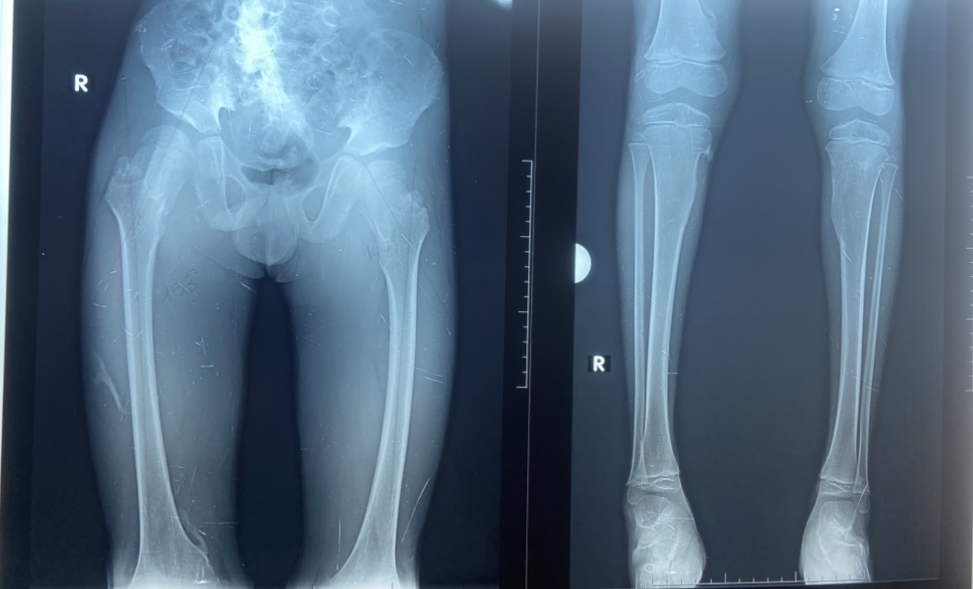
Figure 4: Frontal X-ray of the pelvis and lower limbs showing enlargement of the femoral neck and left tibial tip, and a bony pedicle at the proximal metaphysis of the right tibial diaphysis.

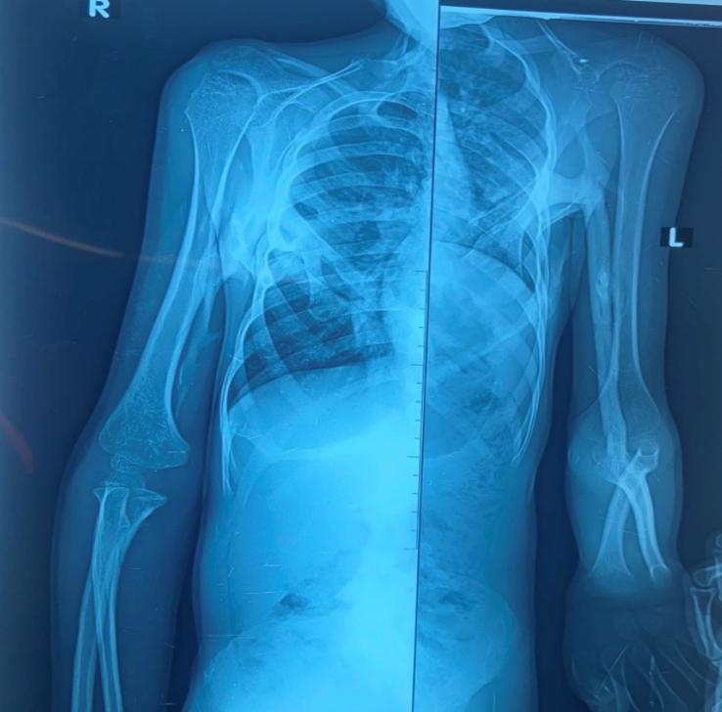
Figure 5: Frontal X-ray of the upper limbs showing a scapuloulnar bone bridge
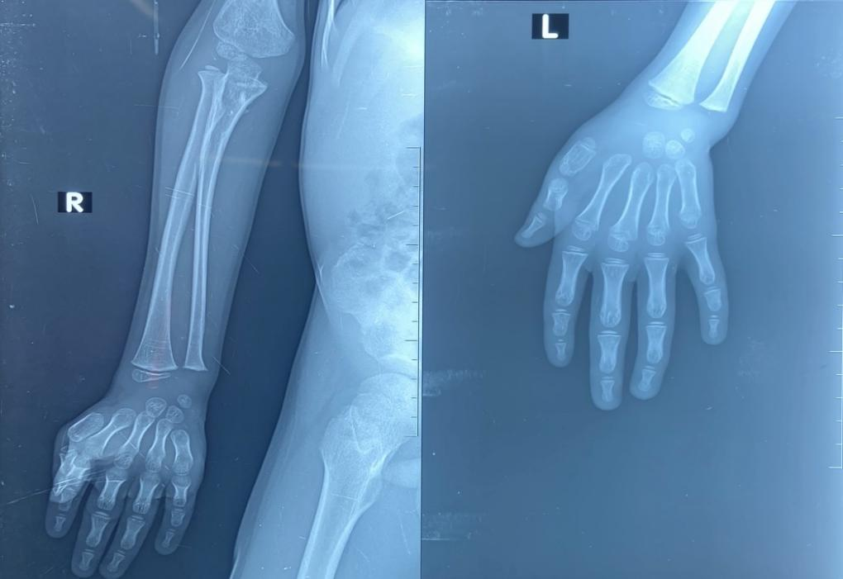
Figure 6 : Frontal X-ray of the hand showing brachydactyly

