Case report

Multifocal Tuberculosis in an Infant: A Rare Case at the University Hospital of Dakar

Abstract
Introduction
Tuberculosis is an infectious disease caused by Mycobacterium tuberculosis complex and primarily affects the lungs. It is defined as multifocal tuberculosis (MFT) when at least two non-contiguous extrapulmonary sites are involved, with or without pulmonary involvement. Pediatric tuberculosis accounts for approximately 9–12% of all tuberculosis cases. We report the case of a 30-month-old infant with multifocal tuberculosis hospitalized at the University Hospital of Dakar.
Case presentation
A 30-month-old infant presented with polymorphic symptoms including weight loss, apathy, and persistent fever. Diagnosis was delayed due to atypical clinical presentation and inconclusive initial investigations. Tuberculosis was confirmed after 27 days of hospitalization through computed tomography findings and a positive Xpert MTB/RIF test performed on gastric aspirate. The child received antituberculous therapy and nutritional rehabilitation but died four months later.
Conclusion
This case highlights the diagnostic challenges associated with multifocal tuberculosis in young children and emphasizes the importance of thorough clinical assessment and early therapeutic decision-making.
Keywords: child, tuberculosis, hospital, Dakar

Introduction
The WHO African Region had approximately 322,000 children and adolescents (<15 years) who developed tuberculosis in 2022, representing about one third of global cases in this age group. About two thirds of these cases are not diagnosed or notified, meaning that a large number of affected children do not receive care. Each year, an estimated 75,000 children in Africa could die from tuberculosis [1]. Tuberculosis (TB) is an infectious disease caused by Mycobacterium tuberculosis complex, most commonly affecting the lungs. It is defined as multifocal tuberculosis when at least two non-contiguous extrapulmonary sites are involved, with or without pulmonary involvement [2]. Pediatric tuberculosis represents approximately 9–12% of all TB cases worldwide [1]. Regardless of age, multifocal forms remain uncommon and account for about 9–10% of extrapulmonary localizations [3,4]. They usually occur in immunocompromised patients but may also affect immunocompetent individuals. The multifocal presentation is often misleading and may delay diagnosis [5]. The prognosis of multifocal tuberculosis is poor, with reported mortality rates ranging from 16% to 25% [6].
We report the case of a male infant admitted for feeding refusal, in whom a diagnosis of multifocal tuberculosis involving pulmonary, abdominal, lymph node, and central nervous system (CNS) sites was established.
Case Presentation
A 30-month-old male infant with previously normal psychomotor development was admitted for weight loss, apathy, and staring episodes. According to the mother, vaccination status was up to date, although this could not be clearly verified. The child was exclusively breastfed until the age of 6 months, then complementary feeding was introduced but partially refused. Breastfeeding was therefore continued until 24 months, then abruptly stopped and the child was given cereals, which he did not accept well in a low socioeconomic context.
On admission, anthropometric measurements showed a weight of 10 kg (weight-for-age < 3rd percentile), height of 90 cm (height-for-age between the 25th and 50th percentiles), mid–upper arm circumference of 10 cm, and head circumference of 48 cm. Vital signs were as follows: temperature 38.2 °C, heart rate 152 beats/min, respiratory rate 19 breaths/min, and capillary blood glucose 0.65 g/L.
Physical examination revealed focal clonic seizures affecting the right side of the body, which resolved after injectable phenobarbital. The general condition was severely impaired (WHO stage 4), with severe acute malnutrition associated with angular cheilitis and bilateral nutritional edema of the hands and lower limbs, as well as clinical anemia. Abdominal examination showed distension with multiple enlarged lymph nodes of varying sizes, firm, mobile, non-inflammatory, and non-fistulizing. Enlarged lateral cervical lymph nodes were also noted. The Bacillus Calmette–Guérin (BCG) scar was absent. A rapid diagnostic test for malaria was negative.
On a biological level, Cerebrospinal fluid (CSF) analysis was initially normal (white blood cells <1 cell/mm³, glucose 0.48 g/L, protein 0.18 g/L). Complete blood count showed leukocytosis (15,054/mm³) with neutrophil predominance (80%), microcytic hypochromic anemia (hemoglobin 6 g/dL, MCV 69.2 fL, MCH 21.3 pg), platelet count 445,000/mm³, and C-reactive protein (CRP) of 183 mg/L. Urine culture, Xpert MTB/RIF on gastric aspirate, and viral serologies were negative.
A chest X-ray was requested but could not be performed due to financial constraints.
The child was started on empirical antibiotic therapy with injectable cefotaxime and gentamicin. Nutritional rehabilitation with F75 therapeutic milk was initiated. Fever was managed with symptomatic measures including undressing and paracetamol.
On day 27 of hospitalization, fever persisted and there was no improvement in the general condition despite antibiotic therapy. The child had been fed almost exclusively with F75 during hospitalization. The parents were able to afford the chest and abdominal computed tomography (CT) scan that was performed (Figures 1, 2, and 3), and a new Xpert MTB/RIF test on gastric fluid was carried out, which proved positive.
CT findings were consistent with multifocal tuberculosis. Antituberculous treatment was initiated using a fixed-dose combination of rifampicin (R), isoniazid (H), pyrazinamide (Z), and ethambutol (E) (RHZE).
On day 28, clinical deterioration was observed with persistent fever, altered consciousness (pediatric Glasgow Coma Scale score of 9/15), decerebrate rigidity, and neck stiffness. Brain CT (Figure 3) revealed space-occupying lesions suggestive of tuberculomas, associated with left parietal edema and mild hydrocephalus. Fundoscopic examination was normal. Corticosteroid therapy (prednisolone) was added.
By day 35 of hospitalization (9 days after initiation of antituberculous therapy), the patient became afebrile, but neurological impairment persisted with a Glasgow score of 9/15 and persistent decerebrate rigidity. Body weight remained at 10 kg. Nutritional management with F75 was continued, as transition to F100 led to diarrhea.
The final diagnosis was multifocal tuberculosis associated with severe acute malnutrition. A slight clinical improvement was observed, with the child crying when hungry, although neurological rigidity persisted. Feeding was subsequently changed from F75 to enriched porridge, which was better tolerated.
After 50 days in hospital, the child was discharged and referred to his local health center for further tuberculosis treatment, with weekly follow-up visits scheduled at our facility. The patient was not brought to his appointments, so he could not be monitored after his discharge. He was brought to the hospital by his parents four months later, deceased. The circumstances of his death could not be clarified.
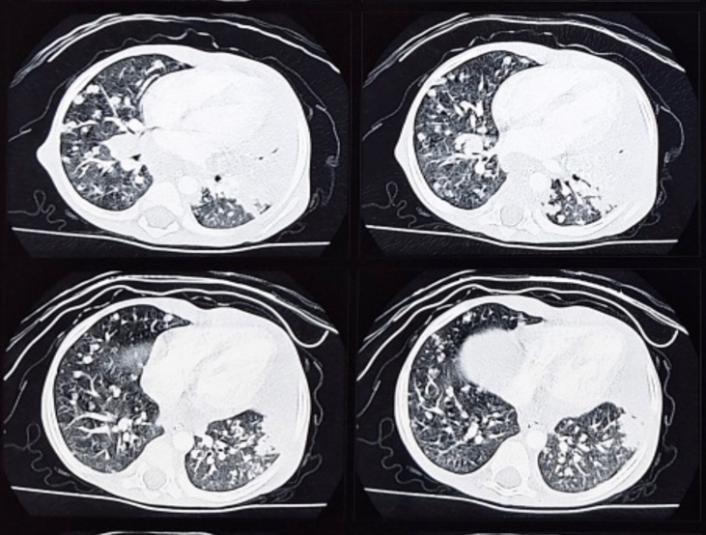

Figure 1 : Axial chest CT scan (lung window) showing ground-glass opacities, alveolar consolidation, and interstitial involvement.
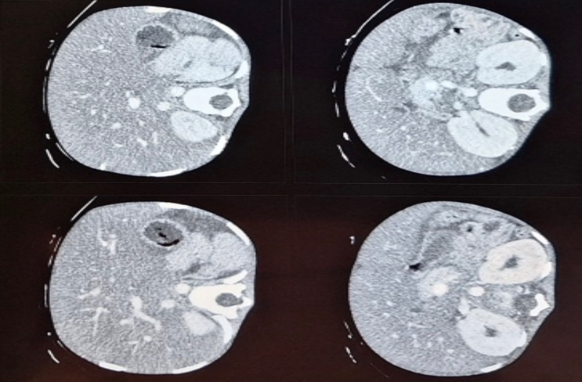
Figure 2 Axial abdominal CT scan showing multiple hypodense focal lesions in the liver and spleen.

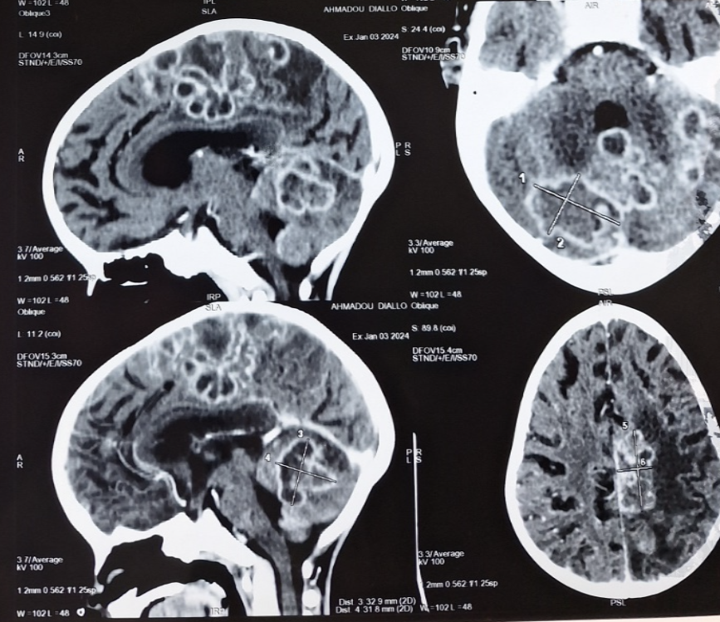
Figure 3 : Brain CT, axial sections showing hypodense lesions with ring enhancement suggestive of tuberculomas, associated with ventricular dilatation.
Table 1 : Summary of clinical evolution
Days | Clinical findings | Paraclinical investigations | Treatment
J8 | Persistent fever, poor general condition, abdominal distension with lymphadenopathy | CBC: WBC 18,044/mm³ (66% neutrophils), Hb 5.2 g/dL, MCV 63.1 fL, MCHC 29.2%, platelets 234,000/mm³; CRP 181 mg/L; blood cultures negative | Ceftriaxone , F75 ,  Paracetamol
J13 | Persistent fever, no clinical improvement | CSF: 95 cells/mm³ (82% lymphocytes, 14% non-degenerated neutrophils, 4% degenerated neutrophils); protein 0.54 g/L; glucose 0.69 g/L; bacteriology and virology negative | Ceftriaxone , F75 ,  Paracetamol
J21 | Persistent fever, poor condition | CSF: 27 cells/mm³ (4% neutrophils, 93% lymphocytes, 3% monocytes); protein 1.56 g/L; glucose 0.13 g/L; bacteriology and virology negative | Ceftriaxone , F75 ,  Paracétamol
J27 | Persistent fever, poor condition | Thoraco-abdominal CT: left upper lobe alveolar consolidation, multiple pulmonary nodules; fatty hepatomegaly; homogeneous splenomegaly; necrotic thoraco-abdominal lymphadenopathy; mild peritoneal and pericardial effusion. Xpert MTB/RIF on gastric aspirate: positive (rifampicin-sensitive) | F75, paracetamol, anti-TB treatment (RHZE)
J28 | Persistent fever, altered consciousness (GCS 9/15), decerebrate rigidity, neck stiffness | Brain CT: multiple ring-enhancing cerebellar and left hemispheric lesions with left parietal edema, mild hydrocephalus | F75, paracetamol, RHZE, prednisolone
CSF: cerebrospinal fluid ; PNA: non-degenerated polymorphonuclear leukocytes ; PA : degenerated polymorphonuclear leukocytes

Discussion
Pediatric tuberculosis represents a major diagnostic challenge, particularly when associated with severe malnutrition, as illustrated by our case. The wide spectrum of clinical manifestations and the often nonspecific nature of symptoms make the diagnosis of multifocal tuberculosis especially difficult in young children. Pérez-Vélez highlighted that clinical variability and nonspecific features significantly complicate diagnosis in this age group [7].
In our patient, initial manifestations included seizures, staring episodes, weight loss, apathy, and persistent fever—symptoms that may easily be attributed to other common pediatric conditions. Such atypical presentations may mask tuberculosis, especially in malnourished children [8,9]. Moore et al. have shown that malnourished children may present with severe forms of TB but with attenuated or atypical inflammatory responses [8].
Severe acute malnutrition plays a critical role in diagnostic difficulty. Malnutrition impairs immune function and alters inflammatory responses, leading to less pronounced or atypical clinical signs of tuberculosis [8,9]. This immune dysfunction contributes to diagnostic delay and increases the risk of severe complications and mortality [9,10].
Another major diagnostic challenge is the limited sensitivity of rapid diagnostic tests. Although Xpert MTB/RIF is a valuable tool for detecting Mycobacterium tuberculosis, its sensitivity in children remains limited, with microbiological confirmation achieved in only 15–50% of pediatric cases [9,11]. In our patient, the initial Xpert test on gastric aspirate was negative and became positive only after several days, emphasizing the need for sustained clinical suspicion in the presence of persistent severe symptoms.
Early initiation of antituberculous therapy is essential to improve outcomes. In our case, treatment initiation was delayed due to the absence of early microbiological confirmation and the nonspecific initial presentation. Such delays are known to worsen prognosis, particularly in young children at high risk for disseminated disease, as highlighted by Carvalho et al. [9].
Central nervous system involvement represents one of the most severe forms of tuberculosis, associated with high morbidity and mortality, reaching up to 50% in some series [9]. In our patient, delayed diagnosis contributed to the development of cerebral tuberculomas, significantly worsening the prognosis.
Finally, the patient’s death four months after discharge underscores the persistent challenges of pediatric tuberculosis management in resource-limited settings. This case highlights the importance of rigorous patient monitoring, but also the need for support when patients are experiencing financial difficulties in order to reduce mortality.
Conclusion: this case emphasizes the need for a proactive and integrated approach to the diagnosis and management of pediatric tuberculosis, particularly in malnourished children and in low-resource settings. Early clinical suspicion, timely initiation of antituberculous therapy, and close follow-up are essential to improve outcomes and reduce the high morbidity and mortality associated with multifocal tuberculosis in children.
Limitations of this case report:
The information regarding this child's vaccinations was not very precise. We relied on the mother's statements.
We were very limited in our investigations due to the parents' financial difficulties.
Conflicts of interest
The authors have declared that there are no conflicts of interest.
Ethical considerations
Our study complied with ethical guidelines, as hospital authorization was obtained prior to submission of this case. No subjective judgments that could compromise moral integrity were made. The medical record was reviewed confidentially on site. Free and informed consent was obtained from the parents.
Artificial intelligence
The authors hereby declare that NO generative AI technology such as large language models (ChatGPT, COPILOT, etc.) and text-to-image generators were used in the writing or revision of this manuscript.

Références
- World Health Organization. Tuberculosis in children. Cairo: WHO Regional Office for the Eastern Mediterranean; [cited 2024 May 20]. Available from: https://www.emro.who.int/fr/tuberculosis/strategy/children-tb.html
- Ngakoutou, R., Joseph, M., Ahmet, A., Dieudonne, D., Mbainadji, L., Toralta, J., & Mahamat Ali, B. (2024). Aspects Épidémiologiques, Cliniques et Évolutifs de la Tuberculose Multifocale à N'djamena. HEALTH SCIENCES AND DISEASE, 25(2 Suppl 1), 48-52. https://doi.org/10.5281/hsd.v25i2 Suppl 1.5245
- Rezgui, A., Ben Fredj, F., Mzabi, A., Karmani, M., & Laouani, C. (2016). Tuberculose multifocale chez les immunocompétents. Pan African Medical Journal, 24, 13. https://doi.org/10.11604/pamj.2016.24.13.6030
- Kpossou, A. R., Adjadohoun, S., Diallo, K., Sokpon, C. N. M., Kpangon, A. A., & Kodjoh, N. (2021). Multifocal tuberculosis simulating multimetastatic colon cancer in an immunocompetent black African patient: a case report. Pan African Medical Journal https://doi.org/10.11604/pamj.2021.39.167.26879
- Di Renzo, C., Tabrizian, P., Kozuch, D. E., Fiel, M. I., & Schwartz, M. E. (2020). Abdominal tuberculosis mimicking cancer clinically and on fluorodeoxyglucose (FDG)-positron emission tomography (PET) imaging: A two-case series. American Journal of Case Reports. https://doi.org/10.12659/AJCR.918901
- Maâlej S, Greb D, Bourguiba M, Fenniche S, Belhabib D, Drira I, et al. [Multifocal tuberculosis]. Rev Mal Respir. 2006;23(1):48. French. https://doi.org/10.1016/s0761-8425(06)71822-8
- Perez-Velez, C. M., & Marais, B. J. (2012). Tuberculosis in children. New England Journal of Medicine. https://doi.org/10.1056/NEJMra1008049
- Moore, B. K., Graham, S. M., Nandakumar, S., Doyle, J., & Maloney, S. A. (2024). Pediatric Tuberculosis: A Review of Evidence-Based Best Practices for Clinicians and Health Care Providers. Pathogens, 13(6), 467. https://doi.org/10.3390/pathogens13060467
- Carvalho, I., Goletti, D., Manga, S., Silva, D. R., Manissero, D., & Migliori, G. (2018). Managing latent tuberculosis infection and tuberculosis in children. Pulmonology, 24(2), 106-114. https://doi.org/10.1016/j.rppnen.2017.10.007
- Gupta, K. B., Gupta, R., Atreja, A., Verma, M., & Vishvkarma, S. (2009). Tuberculosis and nutrition. Lung India, 26(1), 9-16. https://doi.org/10.4103/0970-2113.45198
- Detjen, A. K., DiNardo, A. R., Leyden, J., Steingart, K. R., Menzies, D., Schiller, I., Dendukuri, N., & Mandalakas, A. M. (2015). Xpert MTB/RIF assay for the diagnosis of pulmonary tuberculosis in children: A systematic review and meta-analysis. Lancet Respiratory Medicine, 3(6), 451-461. https://doi.org/10.1016/S2213-2600(15)00095-8

