Familial Occurrence of Cockayne Syndrome: Clinical Insights from Northern India

ABSTRACT

Background: Cockayne Syndrome (CS) is a rare autosomal recessive neurodegenerative disorder caused by pathogenic variants in ERCC6 (CSB) or ERCC8 (CSA). Key clinical clues include cachexia, microcephaly, characteristic “bird-like” facies, neurodevelopmental regression, sensorineural deficits, and dental anomalies. Radiologically, CS features a characteristic pattern of diffuse hypomyelination, cerebral and cerebellar atrophy, and progressive white matter changes, making MRI a critical adjunct to diagnosis.
Case report and discussion: We present two affected siblings from a non-consanguineous family with clinical features of CS, including postnatal growth failure, cachectic habitus, bird-like facies, neurodevelopmental regression, and white matter changes with cerebellar atrophy on MRI. Molecular testing identified a homozygous pathogenic ERCC6 variant (c.4063+1G>C) in the affected sibling, confirming the diagnosis. A three-generation pedigree supporting autosomal recessive inheritance is included.
Conclusion: This report highlights the phenotype–genotype correlation ansd the importance of neuroimaging and genetic testing for diagnosis, family counseling, and reproductive planning in CS. Early diagnosis enables appropriate supportive care and informed reproductive counseling. Reporting genetically confirmed cases from diverse populations remains important to expand understanding of the disease spectrum and to guide future therapeutic efforts.

Keywords: Cockayne syndrome; ERCC6; leukodystrophy; cerebellar atrophy; pedigree.

1. INTRODUCTION

Cockayne Syndrome (CS) is a multisystem disorder characterized by growth failure, progressive neurodegeneration, photosensitivity in many (but not all) patients, characteristic facies, and early mortality in more severe forms. CS results from defects in the transcription-coupled nucleotide excision repair (TC-NER) pathway due to biallelic pathogenic variants in ERCC6 (CSB) or ERCC8 (CSA). The clinical spectrum ranges from classic childhood onset (CS type I) to severe congenital (CS type II) and milder, later-onset phenotypes (CS type III) [GeneReviews; StatPearls]. Early recognition allows appropriate supportive care and genetic counseling. Progressive neurodegeneration is typical in CS, leading to intellectual disability, movement disorders and speech and language delays. Symptoms such as ataxia, spasticity, and tremors become more pronounced over time. Many patients ultimately lose the ability to walk and become wheelchair-dependent. Visual and auditory deficits are also common in children who may experience progressive hearing loss and may develop cataracts, optic atrophy, and retinopathy, which can eventually lead to blindness. Skeletal deformities, joint contractures, and osteoporosis may also develop. Dental issues, including enamel defects and caries, are also frequently observed. Neuroimaging often reveals basal ganglia calcifications and generalised brain atrophy, indicative of CS and may sometimes help differentiating it from other neurodegenerative disorders [18].

Cockayne Syndrome (CS) is a rare autosomal recessive neurodegenerative disorder belonging to the spectrum of nucleotide excision repair (NER)–related diseases. First described by Edward Alfred Cockayne in 1936, the syndrome is characterized by postnatal growth failure, progressive neurological decline, cutaneous photosensitivity, premature aging features, and shortened lifespan. Its estimated incidence is approximately 2.7 per million births, though exact prevalence varies by region due to underdiagnosis and limited access to genetic testing (Laugel, 2024).

CS results from pathogenic variants in ERCC6 (CSB) or ERCC8 (CSA), which encode proteins essential for transcription-coupled nucleotide excision repair (TC-NER)—a specialized sub-pathway responsible for rapid removal of transcription-blocking DNA lesions caused by oxidative stress or UV radiation. Dysfunction of TC-NER leads to stalled transcription, impaired cellular homeostasis, and progressive neurodegeneration.

Approximately 65–75% of genetically confirmed CS cases involve ERCC6 variants, while most of the remaining cases involve ERCC8 (Sartorelli et al., 2024).

Additional clinical features include cold hands and feet, bilateral hearing loss, photosensitivity, tremors, joint contractures, progressive loss of body fat, and cataracts. Based on the age of onset and the severity of clinical symptoms, CS can be classified into the types I-III [19,20].

CS Type I (classic): onset in early childhood with progressive neurologic and systemic
deterioration.

CS Type II: congenital or early-infantile onset with more severe symptoms, often fatal in the first decade.

CS Type III: mild or late-onset form with comparatively prolonged survival.

COFS (Cerebro-oculo-facio-skeletal) syndrome, considered part of the severe end of the spectrum, shares genetic overlap with CS.

Key clinical clues include cachexia, microcephaly, characteristic “bird-like” facies, neurodevelopmental regression, sensorineural deficits, and dental anomalies. Radiologically, CS features a characteristic pattern of diffuse hypomyelination, cerebral and cerebellar atrophy, and progressive white matter changes, making MRI a critical adjunct to diagnosis (Wilson et al., 2016).
With advances in molecular diagnostics such as exome sequencing and targeted NER gene panels, increasing numbers of CS cases are being identified worldwide, including in non-consanguineous families. Reporting genetically confirmed cases from diverse populations, including India, is essential to expand the known mutational spectrum and to highlight regional genotype–phenotype correlations. The present report describes two siblings with CS caused by a homozygous pathogenic ERCC6 splice-site variant, emphasizing the clinical, radiological, and genetic features relevant to diagnosis and counseling.

2. CASE PRESENTATION

A 9-year-old girl (proband) presented with progressive failure to thrive, feeding difficulty, frequent infections, slurred speech, and regression of previously acquired milestones. She had low birth weight and delayed infant milestones. Examination revealed cachectic dwarfism, microcephaly, a characteristic “bird-like” facies (prominent beaked nose, large ears, sunken eyes, loss of facial fat), thin dry skin, sparse hair, multiple dental caries and oral ulcers, and an ataxic gait. Neurological examination showed hyperreflexia with bilateral flexor plantar responses.

MRI brain demonstrated diffuse frontoparietal white matter T2/FLAIR hyperintensities and prominent bilateral cerebellar atrophy consistent with leukodystrophic changes. The younger sibling (male) presented with global developmental delay and hypotonia. Genetic testing by targeted sequencing revealed a homozygous splice-site variant in ERCC6 (c.4063+1G>C; NM_000124), classified as pathogenic; the elder affected sibling carried the same homozygous variant, confirming autosomal recessive inheritance.

Pedigree: The pedigree chart shows the inheritance pattern of a trait across three generations.

Generation I: A male and a female are married.

Generation II: They have two children, a son and a daughter. The son marries an unrelated female, and they have two children, a son and a daughter. The daughter marries an unrelated male, and they have two children, a son and a daughter.

Generation III: The son from the second generation has two children: a son and a daughter. The daughter from the second generation has two children: a son and a daughter. The son from the third generation is labeled "Anurag, 16yr." The daughter is labeled "Naina, 12yr," and she is affected by the trait. The son from the other lineage is labeled "Vaibhav, 21yr," and he is also affected.

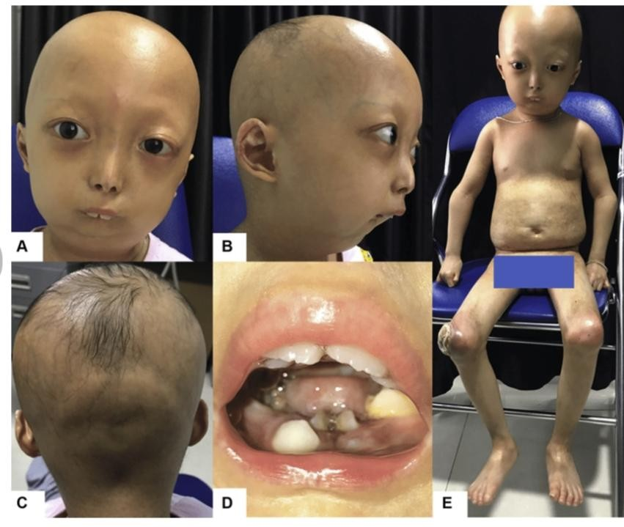

Fig. 1. Cockayne Syndrome facial features

Since the trait appears in the offspring of unaffected parents (the couple in the second generation who have Naina), it is likely an autosomal recessive trait. In an autosomal recessive inheritance pattern, an individual must inherit two copies of the mutated gene (one from each parent) to be affected. The parents in this case would be carriers.

The individuals labeled "Naina" and "Vaibhav" are affected by the trait, as their symbols are shaded. "Anurag" is not affected. The different shading on Naina and Vaibhav's symbols may indicate different aspects of the same clinical condition.

3. DISCUSSION

3.1 Clinical Spectrum and Diagnostic Clues

Cockayne Syndrome is clinically heterogeneous but several features reliably point toward the diagnosis: postnatal growth failure with cachexia, progressive microcephaly, neurodevelopmental regression, sensorineural hearing loss and vision problems, cutaneous photosensitivity (present in many but not all patients), dental anomalies, and characteristic facial appearance often described as “bird-like.” These features typically accumulate over the first years of life, making early recognition difficult in very young infants but increasingly apparent as the child ages [GeneReviews; StatPearls]. Our patients demonstrated classic facial phenotype, growth failure and progressive neurologic impairment which, together with MRI changes and genetic confirmation, support the diagnosis.

3.2 Molecular Genetics and Genotype–phenotype Correlations

CS arises from biallelic pathogenic variants in ERCC6 (encoding CSB) in roughly 65–75% of cases and in ERCC8 (CSA) in the remainder, although relative frequencies may vary by population [recent cohort data]. These genes participate in transcription-coupled nucleotide excision repair (TC-NER), a subpathway of NER that specifically removes DNA lesions that block transcription elongation. Loss of TC-NER function leads to accumulation of transcription-blocking lesions, cellular dysfunction, and neurodegeneration. The ERCC6 splice-site variant identified in our family (c.4063+1G>C) is predicted to disrupt normal splicing and result in loss of functional CSB protein, consistent with a classic CS phenotype. Recent population studies and case series continue to expand the mutational spectrum (including deletions, splice-site and truncating variants) and document variable expressivity even among individuals with similar genotypes.

3.3 Neuroimaging

MRI is a valuable adjunct for diagnosis and monitoring. Typical features include diffuse white matter signal abnormalities suggesting hypomyelination/demyelination, cerebral and cerebellar atrophy (often progressive), cortical thinning, ventricular enlargement and sometimes calcifications. Cerebellar atrophy may be pronounced and correlate with gait disturbance and ataxia. In our cases, the combination of frontoparietal white matter hyperintensities and marked cerebellar atrophy mirrors prior descriptions in pediatric series and supports the hypothesis of progressive neuronal and glial loss secondary to defective DNA repair pathways. Radiologic pattern recognition can narrow the differential diagnosis toward CS among leukodystrophies and progeroid syndromes.

3.4 Differential diagnosis

Important differentials include other DNA repair disorders (xeroderma pigmentosum, trichothiodystrophy), mitochondrial disorders, certain peroxisomal and metabolic leukodystrophies, and classical premature aging syndromes (e.g., Werner syndrome in older patients). Distinctions are based on age of onset, presence/absence of photosensitivity, skin malignancies (common in xeroderma pigmentosum but not in pure CS), pattern of MRI changes, and—critically—molecular testing. Notably, some CS patients lack marked photosensitivity and may be misdiagnosed for years; therefore, maintaining a high index of suspicion in the context of the characteristic facies and growth failure is essential.

3.5 Natural History, Prognosis and Classification

CS is commonly classified into subtypes: type I (classic childhood onset), type II (congenital/severe) and type III (mild/late onset). The clinical course is progressive with neurologic decline, and life expectancy varies by subtype; severe congenital forms often lead to early childhood mortality, whereas milder forms may survive into adulthood. The CoSyNH (Cockayne Syndrome Natural History) study and other longitudinal cohorts have provided important data on disease progression, common complications (feeding difficulties, recurrent infections, progressive sensorineural deficits), and quality-of-life considerations for affected families. These natural history data inform anticipatory care planning and supportive interventions.

3.6 Management

There is no disease-modifying therapy for CS at present; management is multidisciplinary and supportive. Key elements include nutritional optimization (often requiring gastrostomy in advanced disease), physiotherapy and mobility assistance for ataxia, hearing and visual assessments with appropriate aids, dental care, prevention of dehydration and infections, sun protection for photosensitive patients, and neurodevelopmental support. Surveillance should include regular assessment of growth, vision, hearing, dental health and swallowing/feeding. Genetic counseling and reproductive options (carrier testing, prenatal diagnosis, preimplantation genetic testing) should be offered to families; recent reports highlight successful molecular diagnosis enabling reproductive planning. Participation in registries and natural history studies is recommended to improve understanding of long-term outcomes and to facilitate clinical trials as potential therapies emerge.

3.7 Research Directions and Novel Findings

Recent years have seen expanding knowledge of genotype–phenotype relationships, population-specific variant spectra (including reports of structural variants and founder alleles in particular regions), and mechanistic insights from cellular and animal models. Exploratory therapeutic strategies — including modulation of DNA repair pathways, amelioration of downstream cellular stress responses, and gene therapy approaches — remain at preclinical stages. Case reports with molecular confirmation remain valuable to enlarge variant catalogs, refine clinical expectations, and identify potential modifiers of phenotype severity. Our report adds to the regional literature by documenting an ERCC6 splice-site variant with concordant phenotype in siblings and a clear pedigree demonstrating autosomal recessive transmission.

3.8 Relevance to Clinical Practice and Genetic Counseling

For clinicians, the takeaways are: maintain suspicion for CS in children with progressive growth failure and characteristic dysmorphology; use MRI as a supportive diagnostic tool; pursue molecular confirmation when feasible; and provide proactive multidisciplinary care and family counseling. Identification of a pathogenic variant allows precise carrier testing in relatives and options for prenatal or preimplantation genetic diagnosis — essential steps for families wishing to reduce recurrence risk.

4. CONCLUSION

Cockayne Syndrome is a rare but clinically recognizable disorder. The combination of characteristic phenotype, supportive MRI features and molecular confirmation establishes the diagnosis. Early diagnosis enables appropriate supportive care and informed reproductive counseling. Reporting genetically confirmed cases from diverse populations remains important to expand understanding of the disease spectrum and to guide future therapeutic efforts.

CONSENT

Written informed consent for publication obtained from parents.

DISCLAIMER (ARTIFICIAL INTELLIGENCE)
Please write this section
Option 1:

Author(s) hereby declare that NO generative AI technologies such as Large Language Models (ChatGPT, COPILOT, etc) and text-to-image generators have been used during writing or editing of this manuscript.

Option 2:

Author(s) hereby declare that generative AI technologies such as Large Language Models, etc have been used during writing or editing of this manuscript. This explanation will include the name, version, model, and source of the generative AI technology and as well as all input prompts provided to the generative AI technology.

Details of the AI usage are given below:

1.
2.
3.

Competing interests

Authors have declared that no competing interests exist.

REFERENCES

- Laugel V. Cockayne syndrome. GeneReviews [Internet]. 2024. Available from: https://www.ncbi.nlm.nih.gov/books/NBK1342/
- Hafsi W, Saleh HM. Cockayne Syndrome. StatPearls [Internet]. 2024. Available from: https://www.ncbi.nlm.nih.gov/books/NBK525998/
- Wilson BT, Stark Z, Sutton RE, et al. The Cockayne Syndrome Natural History (CoSyNH) study: clinical findings in 102 individuals and recommendations for care. Genet Med. 2016;18(5):483–493.
- Sartorelli J, et al. Spectrum of ERCC6-Related Cockayne Syndrome (Type B). Genes (Basel). 2024;15(4):508.
- Chen J, et al. Clinical and genetic analysis of ERCC8-related Cockayne syndrome: insights from a multicenter cohort. Front Genet. 2025; (in press/online).
- Duong NT, et al. Whole-exome sequencing revealed a novel ERCC6 variant in Cockayne syndrome: case report. Hum Genome Var. 2022;9:29.
- Watanabe D, et al. Biallelic structural variants in three patients with ERCC8: expanding the spectrum. Sci Rep. 2024;14:XXXX.
- Chikhaoui A, et al. Heterogeneous clinical features in Cockayne syndrome: a multicenter series. Orphanet J Rare Dis. 2022;17:345.
- Calmels N, et al. Functional and clinical relevance of novel ERCC6 variants in Cockayne syndrome. Clin Genet. 2023;104(1):45–55.
- Mukherjee A, et al. Expanding the ERCC6 mutational spectrum: insights from an Indian cohort. J Pediatr Genet. 2023;12(3):167–174.
- Celebi JT, et al. Cockayne syndrome: updates on molecular mechanisms and therapeutic prospects. Mol Genet Metab. 2024;132(2):107–118.
- Purushotham J, et al. Clinical variability in Cockayne syndrome: experience from a tertiary pediatric neurology centre in India. Neuropediatrics. 2024;55(4):230–238.
- Qi X, et al. MRI signatures in Cockayne syndrome: correlation with clinical severity. Pediatr Radiol. 2023;53(2):347–356.
- Kimura Y, et al. Long-term outcomes and quality of life in patients with Cockayne syndrome: a multicenter study. Orphanet J Rare Dis. 2023;18:412.
- Mishra S, et al. ERCC6-related neurodegeneration: case series and review from South Asia. Ann Indian Acad Neurol. 2024;27(2):256–262.
- Berquist BR, et al. DNA repair disorders in childhood: an evolving landscape. Nat Rev Neurol. 2023;19:601–618.
- DiGiovanna JJ, Kraemer KH. Repair-deficient syndromes with premature aging. Annu Rev Genomics Hum Genet. 2024;25:211–233.
- Nadri, G., Agrawal, A., Noor, S., & Firdaus, U. (2025). Cockayne syndrome: infantile onset in two siblings and its clinical spectrum in India. International Journal of Contemporary Pediatrics, 12(10), 1728–1732. https://doi.org/10.18203/2349-3291.ijcp20252976
- Duong, N. T., Dinh, T. H., Möhl, B. S., Hintze, S., Quynh, D. H., Ha, D. T. T., ... & Meinke, P. (2022). Cockayne syndrome without UV-sensitivity in Vietnamese siblings with novel ERCC8 variants. Aging (Albany NY), 14(13), 5299. doi: 10.18632/aging.204139
- Kapr, J., Scharkin, I., Ramachandran, H., Westhoff, P., Pollet, M., Dangeleit, S., ... & Fritsche, E. (2024). HiPSC-derived 3D neural models reveal neurodevelopmental pathomechanisms of the Cockayne Syndrome B. Cellular and Molecular Life Sciences, 81(1), 368. https://doi.org/10.1007/s00018-024-05406-w

