Outcomes of intramedullary fixation of surgical implant generation network (SIGN) nail in fractures of tibia at Eastern Regional Referral Hospital, Bhutan

Abstract

Background
Tibial bone fractures are the most common type of long bone fractures, primarily affecting the most productive age groups in developing countries. The SIGN nail is commonly used implant to treat these fractures. While its use among tibial fractures in other countries have shown good patient outcome or recovery, its effectiveness has not been evaluated in Bhutan. Therefore, the primary objective of this study was to assess the treatment outcome of patients with tibial fractures treated with the SIGN intramedullary nail at Eastern Regional Referral Hospital (ERRH) in Bhutan.

Methods
All patients with acute tibial fractures who underwent intramedullary nailing at Eastern Regional Referral Hospital in Bhutan over a 15-year period (2009-2024) were retrospectively identified. Medical records and radiography were reviewed from the SIGN Online Surgical database. Patients were followed up with clinical examination and radio graphs at 6 weeks, 3 & 6 months, one year after surgery. The data were analyzed using SPSS version 21.

Results
A total of 445 patients with tibial fractures were managed with intramedullary SIGN nailing during the study period. The mean age of the patients was 36 years (ranged: 13 to 76 years). A majority of the fracture cases occurred in males (67.9%, n=302). Road traffic accidents were the commonest mode of injury (48.3%, n=215) followed by falls (28.3%, n=126) and work related injuries (18.2%, n=81). Closed fractures accounted for 80.7% (n = 356). (Table 1) Within the open fracture group, Gustilo-Anderson grade 2 (6.3%) and grade 1 (5.8%) fractures were more common compared to grades 3a (3%) and 3b (4%).Fractures were almost evenly distributed between sides.The mean time to surgery was 12.8 days.
Fracture union was achieved in 97% of fractures with an average time to union of 21.5weeks. Nonunion occurred in 10 [2.24%] patients. Infection occurred in 4.5% [20] patients. Open fractures had higher rate of complications than the closed fractures. In the multivariate logistic model, patients with open fracture were 4 times more likely to have complications (OR=4; p = 0.02).There were no statistically significant differences in complication rates between the closed and open reduction of fractures during intramedullary nailing.

Conclusion
The SIGN intramedullary nail is an effective and reliable treatment for tibial fractures, yielding good outcomes. Its use does not require a fluoroscopic machine, making it an ideal implant for resource-limited settings.

Key words: Intramedullary nailing, nonunion, fracture reduction, fluoroscopy

Introduction
Trauma is a global epidemic which has been given more importance very recently.(1) “Traumatic injuries including the musculoskeletal injuries mostly occur in developing countries”.(2)
Tibia bone fractures are the most common fractures of the long bones.(3) The incidence of tibia shaft fractures are 16.9/100,000 per year and is more common among the male person.(6) This is because of subcutaneous nature of the anteromedial surface of tibia with minimal soft tissue coverage.(4) Therefore, tibia bone is susceptible to severe bone and soft tissue injury in high energy trauma.(5)
Different mechanisms of injury results in different patterns of tibia bone fractures. High energy mechanism of injuries such as road traffic accident, penetrating injuries, crush injuries and three point bending injuries produce a transverse or comminuted diaphyseal fracture. Indirect mechanism such as torsional, low energy injuries leads to spiral, non-displaced, minimally comminuted fractures with little or no soft tissue damage.(6) (7)
In Bhutan, there are no recent data on prevalence of traumatic injuries. A study carried out on the burden of injuries at Jigme Dorji Wangchuk National Referral Hospital, Thimphu,Bhutan in 2012 by |Dr.Richard and his colleagues showed falls as major mechanism of injuries.(8) With expansion of road networks and increased number of motor vehicles, road traffic accidents are on the rise leading to increased number of traumatic fractures. The recent peak in construction industry have also resulted in drastic increase in number of cases. At the rural setting, work related injuries are common which causes the injuries. However, the turn out for the follow-up of operative patients are very poor. This could be due to low literacy level, financial problems and number of days to travel to the nearest health center.
“Tibia bone fractures are difficult to treat in developing countries mainly due to lack of access to the implants”.(9) The Surgical Implant Generation Network (SIGN) Standard IMN has played a crucial role in providing uninterrupted implants for intramedullary fixation of both tibia and femur bone fractures in the developing countries including Bhutan. The network provided SIGN intramedullary interlocking nails along with its instrument set, free of cost to the Eastern Regional Referral Hospital (ERRH), Bhutan in 2009 which was facilitated with the assistance of Dr Sameul Baker who was a health volunteer overseas to Bhutan.(Fig 1) “The SIGN intramedullary nail is solid stainless steel nail, designed for the treatment of long bone fractures in low resource settings as it can be used without image intensifier”.(10) (11).The people of Bhutan has been hugely benefitted by these implants for the treatment of long bone fractures.
This is the first study in the country to assess the effectiveness of SIGN implant for fixation of tibia bone fractures. Our primary outcome was to assess the clinical outcomes of intramedullary nailing of tibia fractures in terms of union and infection with intramedullary SIGN nail at Eastern Regional Referral Hospital from 2009 till 2024.

Methods
Objectives
To evaluate the clinical outcomes of tibial fractures treated with Surgical Implant Generation Network (SIGN) nail at Eastern Regional Referral Hospital from 1st June 2009 till 31st January 2024.

Study Area
This study was conducted at the Orthopaedic Department of the Eastern Regional Referral Hospital (ERRH) in Bhutan. ERRH's Orthopaedic Department is the second oldest in the country, following the Jigme Dorji Wangchuk National Referral Hospital. As a 150-bed teaching hospital, ERRH serves as a referral center for six districts in eastern Bhutan.

Study Design and Study Period
A retrospective review was conducted using data from the SIGN Online Surgical Database (SOSD) on intramedullary fixation of tibial fractures at the Eastern Regional Referral Hospital from 1st June 2009 to 31st January 2024. Signed consent for data use was obtained from the SIGN organization based in United States of America.

Study Variables
Demographic information like age and gender is incorporated. The kinds of fractures, trauma mechanisms, fracture realignment, related injuries, nail dimensions, and screws count were obtained from the online SIGN database. Complications like infection, nonunion, shortening, and rotational deformities were evaluated as well

Data Collection Tools and Procedures
In this research, we employed the SIGN Online Surgical Database (SOSD) to retrospectively identify every patient who experienced tibial shaft fractures and underwent treatment with an intramedullary SIGN nail at ERRH.
Demographics of patients, mechanisms of injury, surgical methods, and complications after surgery were documented. Surgical details encompassed the duration from injury to fixation, reduction method (open or closed), along with the dimensions and length of the implant.
We analyzed radiographs to categorize fractures, examine deformity, and review radiographic healing. Open fractures were categorized based on the Gustilo-Anderson classification system. Postoperative images and follow-up scans were assessed for alignment in both coronal and sagittal planes.
Fracture union was defined as the absence of tenderness at the fracture site during weight-bearing, along with radiographic evidence of callus bridging at least three cortices on two different views. Nonunion was defined as a tibial fracture that failed to unite within nine months and showed no radiographic signs of healing for three consecutive months.
Malunion, nonunion, and postoperative complications such as wound infection or dehiscence, etc. were assessed. Malunion was defined as angulation greater than 5 degrees in any plane. Nonunion was defined as a lack of radiologic progression between 6 to 9 months. Deep wound infection was characterized by the need for surgical debridement due to a purulent wound or osteomyelitis, requiring antibiotic treatment.

Statistical Analysis
Statistical analysis was performed using SPSS version 21. Demographic characteristics are reported with percentages and means for continuous variables. Statistical significance was assumed at the P < 0.05 level. Multivariate logistic regression analysis was used to determine whether there was a significant difference in union rates between open and closed fractures, as well as between closed and open fracture reduction techniques.
Management
At admission, all fractures were initially immobilized with a posterior leg splint either from the other referral hospital or at our emergency department. Open fractures of Gustilo-Anderson grade 2 and above underwent initial debridement and temporary external fixation, followed by definitive treatment with nailing after soft tissue settling. All fractures were treated with solid intramedullary interlocking SIGN nails, and patients were followed up with clinical and radiological examinations at 6 weeks, 3 months, 6 months and 1 year.

Operative intervention
All nailing procedures were performed under spinal anesthesia. The patients were positioned supine, and a tourniquet was inflated to 350 mmHg. A 5 cm longitudinal incision was made over the anterior knee, extending from the inferior pole of the patella to the tibial tuberosity. Trans patellar approach was used identify the insertion point. (Fig 2) Reaming was performed manually using tactile sensation, and the length of the nail was determined by the reamer. Closed reduction was achieved using traction and maintained with circumferential esmarch compression. Open reduction were done in cases with irreducible closed reduction and proximal tibial fractures. The interlocking nails were inserted with the aid of an aiming device, and the procedure was completed successfully without the use of fluoroscopy.

Results
A total of 445 patients with tibial fractures were managed with intramedullary SIGN nailing during the study period. The mean age of the patients was 36 years [ranged: 13 to 76 years). A majority of the fracture cases occurred in males (67.9%, n=302). 80.7% (356) had closed fractures, while 19.3% (86) presented with open fractures. (Table 1) Within the open fracture group, Gustilo-Anderson grade 2 (6.3%) and grade 1 (5.8%) fractures were more common compared to grades 3a (3%) and 3b (4%).Fractures were almost evenly distributed between sides, with 50.8% (226) occurring on the right side and 49.2% (219) on the left side. (Table 2)
Based on fracture location, 56.6% (252) were located in the distal one-third of the tibia, followed by 37.8% (168) in the middle one-third, 4% (18) in the proximal one-third, and 1.6% (7) were segmental fractures. Of the total cases, 83 % (n=371) underwent closed reduction]. The most commonly used nail diameter were 9mm and 10mm. (Table 3).The majority of nail length used were 320mm. (Table 4)
The fracture union rate without any events was around 85 %(378).There were only 10 (2.24%) reported cases of nonunion.(Table 5) 2 cases of interlocking screw breakage .15(3.4%) cases of superficial wound infection with 5 (1.1%) cases of deep wound infection.80%(8) of nonunion cases were in open fracture cases (p<0.05). Multivariate logistic regression analysis showed that the method of reduction (open vs. closed) was not a significant predictor of nonunion (p > 0.05). The infection rate was approximately 4.5%, with a significantly higher occurrence in open fractures (p < 0.05) (Table 6, 7)

Discussion
This research assessed the epidemiological characteristics of individuals with tibial diaphyseal fractures and results of IMN therapy. Our findings showed tibial diaphyseal fractures mainly in a young male demographic. Results are positive, showing minimal complication rates
The study population consisted predominantly of male patients reflecting the higher exposure of men to occupational and road traffic-related trauma.(12) (13) (14)This gender distribution aligns with global trends in trauma epidemiology(15) (16)indicating that tibial fractures are more prevalent in the younger, economically active population.(17)The predominance of males in our sample is consistent with previous studies.(18) (19)
“A bimodal age distribution with peaks at 20 and 50 years in tibial fractures supports the conformity of our sample (mean age: 36 years) with global trends. In contrast, in high-income countries, the average is closer to 40 years”.(20) “Traffic accidents are the leading trauma mechanism in our sample (48 %), whereas to the 70 % reported among Indian and Nepali populations”.(21)

Closed fractures constituted the majority (80.7%) of cases, while open fractures represented 19.3%.(22) Among open fractures, Gustilo-Anderson grade I and II fractures were more common than grade III fractures.(23) This finding suggests that while high-energy trauma contributes significantly to tibial fractures, a substantial proportion of injuries still result in relatively low-grade open fractures. These findings are comparable to the studies done among the developing countries.(21)The high rate of distal-third fractures (56.6%) correlates with biomechanical vulnerability and exposure to direct impact forces in this region.(20)
The mean time to surgery was 12.8 days, which is relatively longer than timelines reported in high-resource settings. Delayed surgical intervention in low-resource settings is often due to logistical challenges, availability of operating theaters, and resource limitations. Despite this delay, the overall nonunion rate was low (2.2%), highlighting the efficacy of SIGN nails in fracture stabilization and promoting union even in delayed presentations.
Nonunion was significantly higher in open fractures (80% of nonunion cases; p<0.05), underscoring the challenges of managing these injuries due to compromised vascularity, soft tissue damage, and infection risks. Infection was observed in approximately 4.4% of cases, predominantly in open fractures (p<0.05). These findings align with previous studies, where infection and nonunion are consistently reported as complications associated with open tibia fractures.
Closed reduction was performed in the majority of cases (83.4%), while open reduction was utilized in 16.6%. There was no statistically significant difference in nonunion rates between open and closed reduction (p>0.05), suggesting that both techniques, when appropriately indicated, can yield favorable outcomes.(Table 6) However, the decision for open reduction often reflects more complex fracture patterns and associated failed closed reductions.
The most commonly used nail diameters were 9mm and 10mm, with 320mm being the most frequently used nail length (51.7%). This indicates a standardized approach to implant selection at ERRH, tailored to fracture type and patient anatomy.
The outcomes of this study reinforce the utility and reliability of SIGN nails in managing tibial fractures, particularly in resource-limited settings where access to intraoperative imaging is limited. The low rate of nonunion and acceptable infection rates highlight the effectiveness of this system in promoting fracture healing and minimizing complications

Conclusion
SIGN intramedullary nailing is an effective and reliable treatment modality for tibial fractures in resource-limited settings. While open fractures remain a challenge due to higher risks of infection and nonunion, the overall outcomes in this study are encouraging. Future research should focus on long-term functional outcomes and patient-reported satisfaction to further strengthen evidence supporting the use of SIGN nails in tibial fracture management.

Limitations
This study's retrospective design introduces inherent biases, including reliance on recorded data, which may lack completeness. Additionally, variables such as comorbidities, smoking status, and fracture classification details (e.g., AO/OTA classification) were not included.
Acknowledgment
I would like to thank the SIGN organization for generously providing us with free implant sets and implant refills around the clock, as well as granting access to their surgical online database for use in our research. I am also deeply grateful to Dr. Samuel R. Baker for facilitating the first SIGN nail services at our institute—this would not have been possible without his invaluable support. Finally, I extend my sincere appreciation to all the co-authors for their valuable contributions to this work.
Ethical Approval and Consent
Signed consent for data use from SIGN Online Surgical Database (SOSD) was obtained from the SIGN organization based in United States of America. Ethic approval and site clearance for the study was approved by the institutional review board.
Disclaimer (Artificial intelligence)

Author(s) hereby declare that NO generative AI technologies such as Large Language Models (ChatGPT, COPILOT, etc.) and text-to-image generators have been used during the writing or editing of this manuscript.

References
1. Peden M, McGee K, Sharma G. The injury chart book: a graphical overview of the global burden of injuries. Geneva World Health Organ. 2002;5.
2. Gosselin RA, Spiegel DA, Coughlin R, Zirkle LG. Injuries: the neglected burden in developing countries. Bull World Health Organ. 2009;87(4):246–246a.
3. Stewart KAA, Groen RS, Kamara TB, Farahzad MM, Samai M, Cassidy LD, et al. Traumatic injuries in developing countries: report from a nationwide cross-sectional survey of Sierra Leone. JAMA Surg. 2013;148(5):463–9.
4. Azar FM, Canale ST, Beaty JH. Campbell’s operative orthopaedics. Elsevier Health Sciences; 2020.
5. Johner R, Stäubli HU, Gunst M, Cordey J. The point of view of the clinician: a prospective study of the mechanism of accidents and the morphology of tibial and fibular shaft fractures. Injury. 2000;31:45–93.
6. McBirnie J. The epidemiology of tibial fractures. J Bone Joint Surg Br. 1995;77(3):417–21.
7. Nantulya VM, Reich MR. The neglected epidemic: road traffic injuries in developing countries. Bmj. 2002;324(7346):1139–41.
8. Gosselin RA, Dorji S, Drukpa P. The burden of injuries at the Jigme Dorji Wangchuck National Referral Hospital in Thimphu, Bhutan. Int J Surg. 2012;10(2):69–72.
9. Klok JA. Tibial shaft. Evidence‐Based Orthop. 2011;541–8.
10. Stephens KR, Shahab F, Galat D, Anderson D, Whiting PS, Lundy DW, et al. Management of distal tibial metaphyseal fractures with the SIGN intramedullary nail in 3 developing countries. J Orthop Trauma. 2015;29(12):e469–75.
11. Haonga BT, Zirkle LG. The SIGN nail: factors in a successful device for low-resource settings. J Orthop Trauma. 2015;29:S37–9.
12. Stergiou-Kita M, Mansfield E, Bezo R, Colantonio A, Garritano E, Lafrance M, et al. Danger zone: Men, masculinity and occupational health and safety in high risk occupations. Saf Sci. 2015;80:213–20.
13. Biswas A, Harbin S, Irvin E, Johnston H, Begum M, Tiong M, et al. Sex and gender differences in occupational hazard exposures: a scoping review of the recent literature. Curr Environ Health Rep. 2021;1–14.
14. Biswas A, Harbin S, Irvin E, Johnston H, Begum M, Tiong M, et al. Differences between men and women in their risk of work injury and disability: A systematic review. Am J Ind Med. 2022;65(7):576–88.
15. Bergh C, Wennergren D, Möller M, Brisby H. Fracture incidence in adults in relation to age and gender: a study of 27,169 fractures in the Swedish Fracture Register in a well-defined catchment area. PloS One. 2020;15(12):e0244291.
16. Wang H, Liu H, Wu J, Li C, Zhou Y, Liu J, et al. Age, gender, and etiology differences of sports-related fractures in children and adolescents: A retrospective observational study. Medicine (Baltimore). 2019;98(4):e13961.
17. Larsen P, Elsoe R, Hansen SH, Graven-Nielsen T, Laessoe U, Rasmussen S. Incidence and epidemiology of tibial shaft fractures. Injury. 2015;46(4):746–50.
18. Pontin JCB, Damasceno APC, Souza HJM de, Rocco IS, Fração OC, Matsunaga FT. PERFIL EPIDEMIOLÓGICO DE PACIENTES COM FRATURA DA DIÁFISE DA TÍBIA TRATADOS EM UM HOSPITAL DE NÍVEL TERCIÁRIO. Acta Ortopédica Bras. 2024;32:e279748.
19. Puccetti VLYA, De Miranda FL, De Figueiredo CCN, Medeiros KA de A, Leonhardt M de C, Silva J dos S, et al. Risk factors at non-union of tibial fracture treated with intramedullary nail. Acta Ortopédica Bras. 2024;32(2):e278581.
20. Bhandari M, Guyatt G, Walter SD, Tornetta III P, Schemitsch EH, Swiontkowski M, et al. Randomized trial of reamed and unreamed intramedullary nailing of tibial shaft fractures: by the Study to Prospectively Evaluate Reamed Intramedullary Nails in Patients with Tibial Fractures (SPRINT) Investigators. JBJS. 2008;90(12):2567–78.
21. Acharya BM, Tamrakar R, Devkota P, Thakur AK, Shrestha SK. Outcome of tibial diaphyseal fracture fixation with Surgical Implant Generation Network (SIGN) nail. J Patan Acad Health Sci. 2019;6(2):5–11.
22. Amin MQ, Ahmed A, Imran M, Ahmed N, Javed S, Aziz A. TIBIAL SHAFT FRACTURES;: EPIDEMIOLOGY, A 5-YEAR STUDY IN GHURKI TRUST TEACHING HOSPITAL, PAKISTAN. Prof Med J. 2017;24(01):75–81.
23. Weber CD, Hildebrand F, Kobbe P, Lefering R, Sellei RM, Pape HC, et al. Epidemiology of open tibia fractures in a population-based database: update on current risk factors and clinical implications. Eur J Trauma Emerg Surg. 2019;45:445–53.

Tables

Characteristics N (%)
Age (years)
< 20 39 (8.9%)
21-50 334 (75%)
51-70 67 (15%)
>70 5 (1.1%)
Sex
Male 302 (67.9%)
Female 143 (32.1%)
Modes of Injury
Falls 126 (28.3%)
RTA 215 (48.3%)
Work related injuries 81 (18.2%)
Sports injuries 23 (5.2%)
Table 1: Demographic details of the patient

Fracture Number Percentage
Site
Right 219 49.2%
Left 226 50.8%
Types
Closed 359 80.7%
Open:
Gustilo I 26 5.8%
Gustilo II 28 6.3%
Gustilo IIIA 14 3.1%
Gustilo IIIB 18 4%

Location
Distal 252 56.6%
Middle 168 37.8%
Proximal 18 4%
Segmental 7 1.6%

Table 2: Types of Fractures of Tibia
 |  | Frequency | Percent | Valid Percent | Cumulative Percent
 | Closed | 371 | 83.4 | 83.4 | 83.4
 | Open | 74 | 16.6 | 16.6 | 100.0
 | Total | 445 | 100.0 | 100.0

Table 3: Types of fracture reduction

Nail Millimeter (mm) N (%)
280mm 87 (19.6%)
Length 300mm 96 (21.6%)
320mm 230 (51.7%)
340mm 32 (7.2%)
8mm 96 (21.6%)
9mm 159 (35.7%)
10mm 164 (36.9%)
Diameter 11mm 23 (5.2%)
12mm 3 (7%)
Table 4: Nail size and length used for Tibia fracture fixation

 |  | Frequency | Percent | Valid Percent | Cumulative Percent
 | Closed | 2 | 20 | 20.0 | 20.0
 | Gustilo II | 4 | 40.0 | 40.0 | 60.0
 | Gustilo IIIa | 4 | 40.0 | 40.0 | 100.0
 | Total | 10 | 100.0 | 100.0

Table 5: Percentage variation of nonunion in different types of fractures

Variable | Adjusted Odds Ratio (95% CI) | p Value
Open fracture | 4.00 (1.30–12.30) | 0.02
Method of reduction (open vs. closed) | 1.20 (0.45–3.20) | 0.68
Deep wound infection | 3.80 (1.10–13.50) | 0.03
Superficial wound infection | 1.40 (0.50–4.10) | 0.54
Table 6: Multivariate logistic regression analysis of factors associated with Nonunion

Variable | Adjusted Odds Ratio (95% CI) | p Value
Open fracture | 3.70 (1.60–8.60) | 0.01
Method of reduction (open vs. closed) | 1.10 (0.50–2.30) | 0.80

Table 7: Multivariate Logistic Regression Analysis of Factors Associated with Infection

Figures

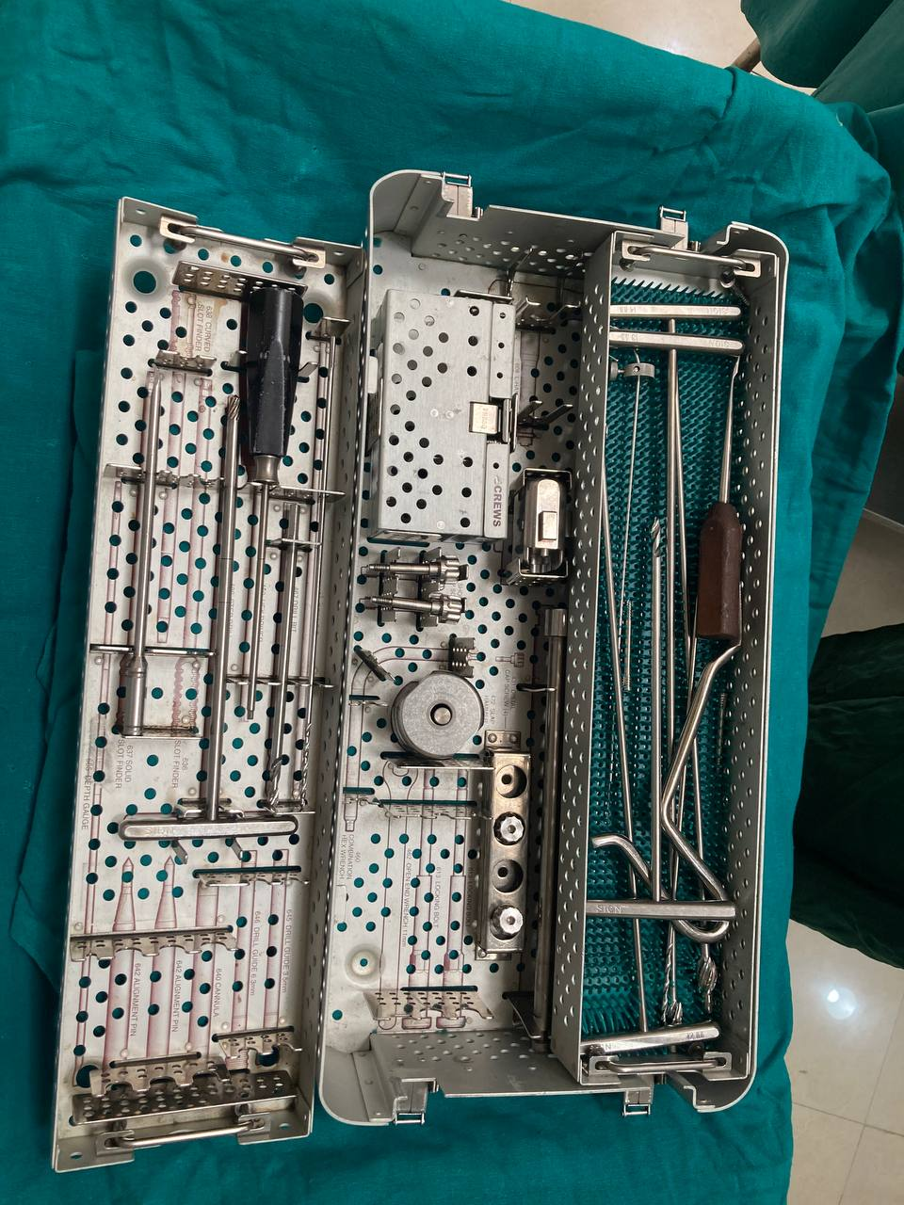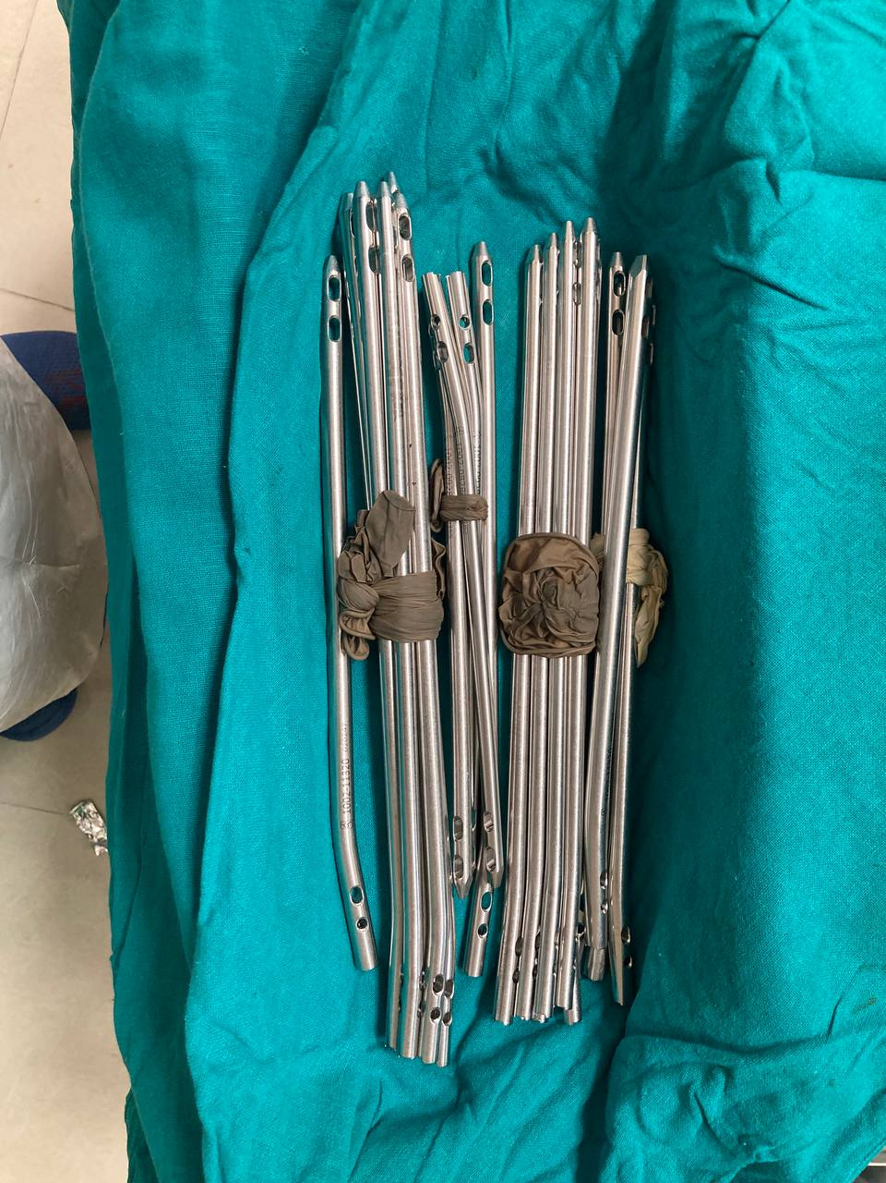
Fig 1: One of SIGN nail set donated to ERRH since 2009. (Initiative taken by Dr Sam Baker)

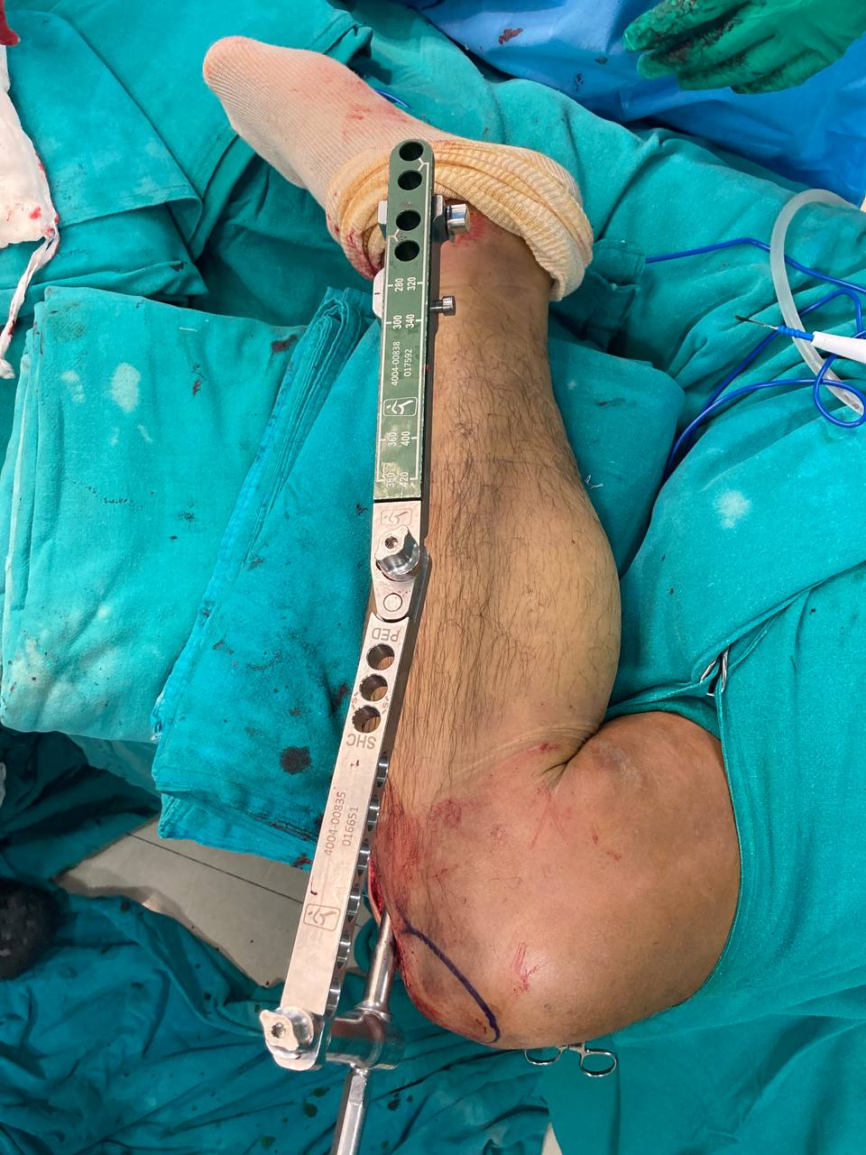

Fig 2: Aiming device being used for inserting interlocking screws after the intramedullary nail insertion
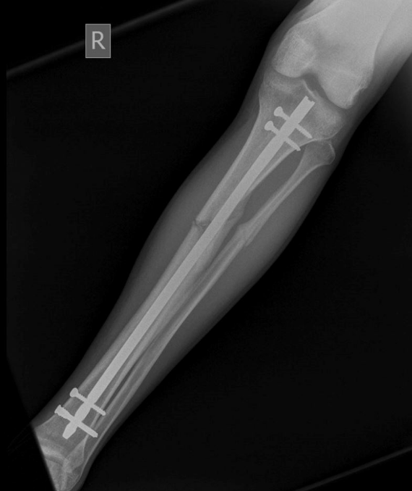

Fig 3: Post-operative X ray with Intramedullary SIGN nail.

