Integrated Analysis of Glioblastoma: Unravelling Molecular Signatures Across Diverse Datasets for Enhanced Diagnosis

ABSTRACT
Background: Glioblastoma Multiforme (GBM) presents significant diagnostic and therapeutic challenges due to its complex molecular pathogenesis. Current diagnostic methods often fail to detect early molecular signatures critical for timely intervention. This study integrates microarray and RNA-Seq datasets from both serum and tissue samples to explore differentially expressed genes (DEGs) and protein-protein interaction networks, aiming to identify robust biomarkers and understand the molecular underpinnings of GBM.
Methods: Utilizing microarray datasets (GSE116520, GSE90604) and RNA-Seq datasets (GSE165595, GSE228512) from both brain tissue and serum samples, this study conducted integrative differential gene expression analysis using limma and DESeq2 packages. Functional annotation and gene ontology analyses were performed with DAVID and ShinyGO tools. Protein-Protein Interaction (PPI) networks were constructed using the STRING database and analysed via Cytoscape to identify central hub genes.
Results: The analysis and cross-technology validation highlighted 1,051 common DEGs across tissue datasets, with 87 upregulated and 255 downregulated. Notably, three genes, MAST3, ADAM11, and PTPRK, were consistent across tissue and serum datasets, suggesting their utility as non-invasive biomarkers. Functional annotation identified critical biological processes and pathways disrupted in GBM, such as cell division, angiogenesis, and cell adhesion. The PPI network analysis identified central hub genes, offering insights into the molecular interactions contributing to GBM pathophysiology.
Conclusion: This study underscores a complex network of molecular interactions pivotal to GBM pathophysiology. The identified DEGs and pathways provide a foundation for developing diagnostic panels and therapeutic targets, emphasizing the need for further research to translate these biomarkers from bench to bedside.
Keywords: Glioblastoma Multiforme, differentially expressed genes, PPI network, functional enrichment, molecular signatures, microarray, RNA-Seq, Bioinformatics.

INTRODUCTION
Cancers originate from genetic mutations or random variation in genes that regulate cellular functions, frequently leading to the activation of oncogenes or the inhibition of tumour suppressor genes, which results in the uncontrolled growth of abnormal cell populations and the development of tumours (Nia, Munn and Jain, 2020). Primary brain tumours arise from cells within the Central Nervous System (CNS), with gliomas being the most prevalent type among these neoplasms (Wu, L. et al., 2022). The most common subtype of gliomas, astrocytoma, has been classified by the World Health Organisation (WHO) into grades I through IV, with Glioblastoma Multiforme (GBM) being assigned WHO grade IV (Wesseling and Capper, 2018). GBM exhibits the most advanced malignant characteristics, representing the most frequent and aggressively malignant form of the tumour and comprising approximately half of all glioma diagnoses (Chen et al., 2023). This diagnosis carries a daunting prognosis, as survival post-diagnosis is typically measured in months rather than years (Lopes et al., 2021), making its pathology morbidity a major cause of cancer-related mortality and morbidity (Cao et al., 2021).
Despite the critical urgency surrounding GBM, current diagnostic methods often fail to detect early molecular signatures essential for timely intervention. While imaging techniques are utilized in diagnosing CNS tumours, they often necessitate invasive histopathological analysis to specifically differentiate tumour types (Łukaszewicz-Zając, Dulewicz and Mroczko, 2021). This limitation inherent in existing methods underscores the critical need for developing new diagnostic approaches, specifically non-invasive biochemical markers, to enhance early detection and treatment strategies (Łukaszewicz-Zając, Dulewicz and Mroczko, 2021). Molecular diagnostics holds significant promise for capturing the genetic picture of GBM, but leveraging it fully requires pinpointing the exact genes and markers that are consistently present across diverse sample types.
This study directly addresses this vital gap by utilizing an integrative analysis of microarray and RNA-Seq datasets from both serum and tissue samples. The central research question guiding this study is: "What are the molecular signatures of GBM across RNA-Seq and microarray datasets from transcriptomics studies, and how can these enhance diagnostic methodologies?". The primary aim is to explore the changes in gene expression and, through an integrative approach, identify the genes that may play vital roles in the pathogenesis of GBM, thereby aspiring to enhance how GBM is diagnosed, making it more precise and potentially less invasive.
To achieve this, the study outlines specific objectives: to analyse publicly available datasets (Kruthika et al., 2019; Gulluoglu et al., 2018; Hwang et al., 2022; Mut et al., 2023) to identify differentially expressed genes (DEGs) in GBM; to determine overlapping DEGs between microarray and RNA-Seq technologies to ensure the robustness and reliability of the identified genetic markers; and critically, to pinpoint common DEGs found in datasets derived from both tissue and serum samples, which could be instrumental in developing non-invasive diagnostic methods for GBM. Furthermore, functional enrichment and Kyoto Encyclopaedia of Genes and Genomes (KEGG) pathway analyses were performed on the identified DEGs, and a Protein-Protein Interaction (PPI) network was constructed to identify central hub genes using Cytoscape software. The resulting findings lay a foundation for developing diagnostic panels and therapeutic targets. This research represents a significant stride in the global effort to demystify GBM, pioneering a path toward improved diagnostic accuracy and personalized treatment strategies.

METHODOLOGY
  - 2.1 Schematic Presentation of the Study
Fig 1 illustrated the Schematic Presentation of the Study
NCBI GEO
Microarray Technology
RNA-Seq Technology
GSE116520
GSE90604
GSE228512
GSE165595
Identification of DEGs using limma
Identification of DEGs using DESeq2
Identification of common DEGs
Functional Enrichment Analysis
Construction of PPI network
Identification of hub genes by MCC and Degree on Cytoscape
Figure 1: Schematic presentation of methods used in the study.
2.2 Searching and Selection of Datasets
Series matrix files of two microarray datasets (GSE116520 (Kruthika et al., 2019) , GSE90604 (Gulluoglu et al., 2018) ), and two RNA-Seq datasets (GSE165595 (Hwang et al., 2022) , GSE228512 (Mut et al., 2023) ) were selected and used in this study. The microarray datasets and the RNA-Seq datasets were obtained from GEO database (https://www.ncbi.nlm.nih.gov/geo/). The datasets were selected using the following criteria: (1) the study was performed in humans; (2) the study was designed using the case-control method (3) the dataset presented at least two samples for each condition, that is, case and control. Further investigation was done to know the level of concordance of DEGs that exists between the datasets from the brain tissue and the RNA-Seq serum dataset.
The platforms for the microarray datasets were based on GPL10558 Illumina HumanHT-12 V4.0 expression bead chip for the GSE116520 and GPL17692 Affymetrix Human Gene 2.1 ST Array for GSE90604. The platforms for the RNA-Seq datasets were based on GPL20301 Illumina HiSeq 4000 and GPL16791 Illumina HiSeq 2500 for the GSE165595 and GSE228512, respectively. GSE116520 dataset included thirty-four GBM brain tissue tumour samples and eight non-neoplastic brain tissue. The GSE90604 dataset contained sixteen frozen GBM tumour samples, seven fresh frozen healthy brain tissue samples, one normal human astrocyte cell line and one human foetal astrocyte cell line. The GSE165595 comprised twenty-four low grade glioma brain tissue sample with their paired normal tissue samples and fifteen GBM brain tissue samples with the paired normal tissue sample. The dataset of GSE228512 included seventy-two GBM serum samples and twenty-three healthy control serum samples. Only the GBM samples and the healthy or control samples from the datasets were used in this study. The datasets from brain tissue and the RNA-Seq serum dataset were combined in this study to investigate the level of concordance of DEGs that exists between the datasets from the two different sample sources. A summary of this is found in Table 1 below.
Table 1: A summary of all datasets used this study.
MICROARRAY DATASETS
GEO ACCESSION NO | GBM SAMPLES | CONTROL | TOTAL
GSE116520 | 34 | 8 | 42
GSE90604 | 16 | 7 | 23
RNA-SEQ DATASETS
GEO ACCESSION NO | GBM SAMPLES | CONTROL | TOTAL
GSE165595 | 15 | 15 | 30
GSE228512 | 72 | 23 | 95

2.3 Data Pre-processing
In differential gene expression analysis, it is always important to normalize and correct the data to be used to remove any systemic and technical biases that may affect the gene expression data. This also helps in accounting for differences in library size between samples. The GSE116520 dataset had a constant value (1) added to all counts and then passed through the “voom” limma function. GSE90604 was log transformed to normalize the dataset. The two datasets were equally passed through the limma’s standard normalization using the ‘lmFit’ function. The count data in GSE165595 was rounded up to integers since ‘DESeqDataSetFromMatrix’ function in DESeq2 expects count data to be integers. Given the reliance on heterogeneous public datasets, potential batch effects and data variability were implicitly considered through the use of established normalization routines integral to the limma and DESeq2 pipelines, thereby mitigating systematic and technical biases.
2.4 DEGs Analysis
Analysis of the microarray datasets was conducted with the use of the limma (Linear Models for Microarray Analysis) package (version 3.58.1) in R. Limma package is a popular tool for the analysis of gene expression microarray data. Expression counts from the microarray platforms were obtained and the limma pipeline was applied for background correction, normalization, and differential expression. A gene was considered significantly differentially expressed if the adjusted p-value was < 0.01.
Differential expression between conditions (GBM and healthy) for the two RNA-Seq datasets was assessed with negative binomial models using the R/Bioconductor library DESeq2 Version 1.42.0 in R Studio statistical environment. This updated version of DESeq2 utilises the gene-specific shrinkage estimation for dispersion and fold change (Love, Huber and Anders, 2014) DESeq2 is a widely used tool for the detection of DEGs in RNA-Seq experiments. Gene expression counts were obtained, and the DESeq2 pipeline was employed for normalisation, statistical testing, and identification of DEGs. Differential expression was assessed based on adjusted p-value of < 0.01. The significantly expressed genes were subsequently categorised into upregulated (log2FC > 0.5) and downregulated (log2FC < -0.5) genes. Volcano plots were made to visualise the significantly expressed genes used in this study.
Validation of the datasets from microarray technology with that from RNA-Seq technology was done by identifying the common DEGs between the datasets from the two technologies. The DEGs identified from the microarray datasets derived from brain tissue were validated with the RNA-Seq datasets from brain tissue. Further investigation was done to know the level of concordance of DEGs that exists between the datasets from the brain tissue and the RNA-Seq serum dataset. These were visually represented using Venny 2.1 (https://bioinfogp.cnb.csic.es/tools/venny/), an interactive tool for list comparison using Venn diagrams.
2.5 Functional Annotation and Gene Ontology Analysis
Functional annotation and enrichment analysis of the identified differentially expressed genes (DEGs) were conducted to gain insights into their biological functions. The Database for Annotation, Visualization, and Integrated Discovery (DAVID) tool (2021 update) was employed for this purpose. DAVID is a bioinformatics resource that provides functional annotation and enrichment analysis for a set of genes (Sherman et al., 2022) . The list of common DEGs obtained from the differential expression analysis of the Tissue datasets (GSE116520, GSE90604, and GSE165595) was submitted to the DAVID tool for further analysis. The gene list included the upregulated and downregulated genes that exhibited significant differential expression.
Analysis in DAVID was performed using default settings, and functional annotation charts were generated to summarize the enriched biological terms associated with the input gene list. Gene Ontology (GO) terms, including Biological Process (BP), Molecular Function (MF), Cellular Component (CC), and Kyoto Encyclopaedia of Genes and Genomes (KEGG) pathway were investigated. Statistical significance was determined based on Benjamini-Hochberg adjusted p-value. Enriched terms with a p-value < 0.05 were considered statistically significant. The result from the DAVID analysis were interpreted to understand the overrepresented biological terms and functions among the DEGs, providing valuable insights into the underlying biological processes affected by the experimental conditions. The upregulated and downregulated genes were also passed through the ShinyGO tool (version 0.77) for graphical network visualization of the GO terms enriched by the DEGs. ShinyGO is a free web-based application that provides researchers with an intuitive, graphical interface allowing them to gain insight into gene sets (Ge, Jung and Yao, 2020) .
2.6 Protein-Protein Interaction (PPI) Network Analysis and Hub Genes Selection
To investigate potential interactions among the differentially expressed genes (DEGs), a Protein-Protein Interaction (PPI) network was constructed. The STRING (Search Tool for the Retrieval of Interacting Genes) database (version 12.0) (https://string-db.org/) was utilized for this analysis. STRING is a comprehensive resource that integrates known and predicted protein interactions, providing insights into functional relationships among proteins (Szklarczyk et al., 2019) . The list of DEGs obtained from the differential expression analysis of the tissue datasets was submitted to the STRING database to retrieve interaction data. The interactions included both experimentally validated and predicted interactions, contributing to a comprehensive view of the protein interaction network (Szklarczyk et al., 2023) . STRING analysis was performed with default parameters. The resulting interaction network was visualized and analysed using Cytoscape (https://cytoscape.org/) for better interpretation. The PPI network obtained from STRING was imported into Cytoscape (version 3.10.1) for visualization and analysis. Cytoscape is a versatile platform for the integration and analysis of biological networks (Doncheva et al., 2022) Nodes in the network represented proteins, and edges represented interactions between them. The Cytoscape plug-in, CytoHubba (version 0.1), was used to identify two sets of top twenty hub genes each. CytoHubba provides eleven topological analysis methods including Degree, Edge Percolated Component (EPC), Maximum Neighbourhood Component (MNC), Density of Maximum Neighbourhood Component (DMNC), Maximal Clique Centrality (MCC) and six centralities (Bottleneck, EcCentricity, Closeness, Radiality, Betweenness, and Stress) based on shortest paths. The identification of the top twenty hub genes from CytoHubba was determined based on their Maximal Clique Centrality (MCC) and Degree. The two were used because studies have found that two different methods score the network in different ways and usually get different sets of genes (Chin et al., 2014) . It is also reasonable to use more than one method for getting essential genes since the biological network is heterogenous (Chin et al., 2014) . The top twenty genes within the two methods were identified and overlapped and the genes that appeared in the overlap were considered more central within the PPI network.
RESULTS
3.1 Differential Gene Expression Analysis
3.1.1 Microarray Analysis (limma)
Microarray datasets GSE116520 and GSE90604 were analysed using the limma package in R (version 3.58.1). The analysis included background correction, normalization, and identification of differentially expressed genes (DEGs) between glioblastoma (GBM) samples and respective controls. The platforms GPL10558 and GPL17692 were utilized for GSE116520 and GSE90604, respectively.
The limma pipeline revealed a total of 11, 658 and 5,109 genes with distinct expression levels for datasets GSE116520 and GSE90604, respectively. Among these, 5,070 were upregulated and 3,984 downregulated for GSE116520 while GSE90604 had 543 upregulated and 1,248 downregulated DEGs. Visualization of these DEGs is presented in the volcano plots in Figure 3. Venn analysis using Venny 2.1 was performed to identify 1,865 DEGs between the two datasets (Figure 4).

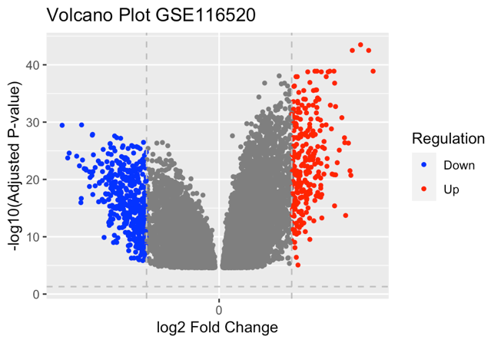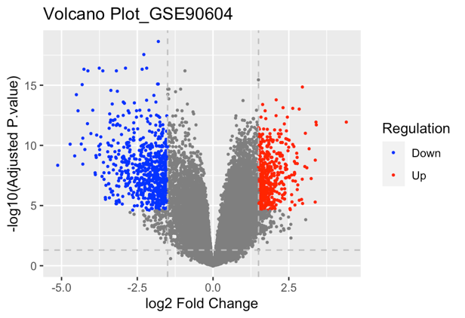
B
A
Figure 2: Volcano plots showing DEGs for GSE116520 (A) and GSE90604 (B)
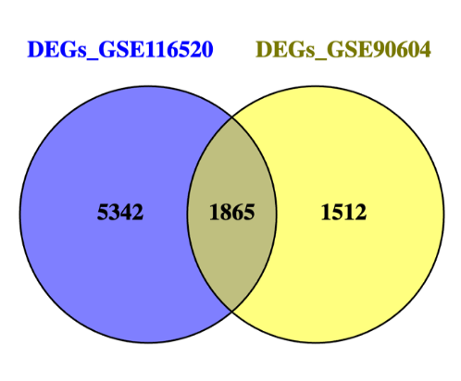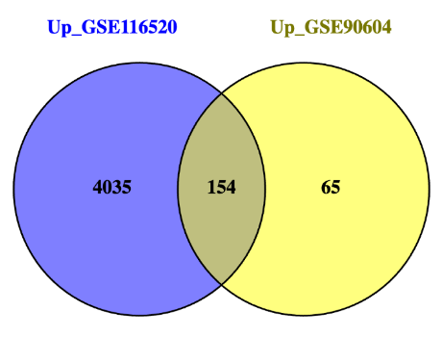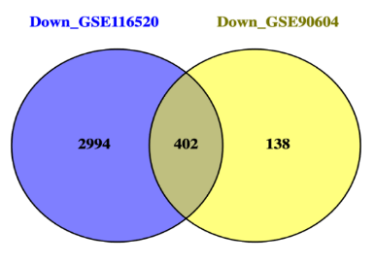
B
C
A
Figure 3: Venn diagram showing common DEGs (A), common upregulated DEGs (B) and common downregulated DEGs (C) between the two microarray datasets.
3.1.2 RNA-Seq Analysis (DESeq2)
RNA-Seq datasets GSE165595 and GSE228512 (from serum) were analysed using DESeq2 (version 1.42.0) in R Studio. Negative binomial models were applied for differential gene expression analysis between GBM and control samples. Platforms GPL20301 and GPL16791 were used for GSE165595 and GSE228512, respectively.
The DESeq2 analysis resulted in the identification of 3,399 DEGs in GSE165595 and two hundred DEGs in GSE228512. GSE165595 had 513 upregulated and 1,248 downregulated DEGs while GSE228512 had thirty-one upregulated and 169 downregulated DEGs. The volcano plots (Figure 4) effectively visualized these DEGs.
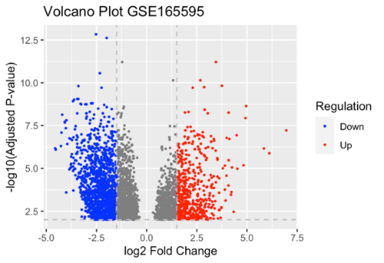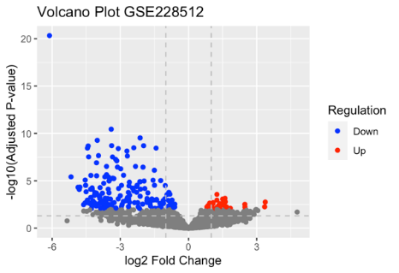
B
A
Figure 4: Volcano plots showing DEGs for GSE165595 (A) and GSE228512 (B)
3.1.3 Validation of Datasets and Concordance Analysis
Venny 2.1 was used to compare the DEGs from both microarray and RNA-Seq brain tissue datasets. This comparison aimed to validate the microarray results using RNA-Seq data. The analysis revealed a subset of DEGs common to both technologies (Figure 5), suggesting a robust set of genes associated with GBM. 1,051 genes were found to be common DEGs among the datasets from tissues (GSE116520, GSE90604, GSE165595). Out of these, 87 were found to be upregulated and 255 downregulated. The level of concordance of DEGs that exists between the datasets from the brain tissue and the RNA-Seq serum was also visualized using Venny 2.1 (Figure 6). Three genes, MAST3, ADAM11, and PTPRK were found to be common DEGs between the datasets from brain tissue and serum.
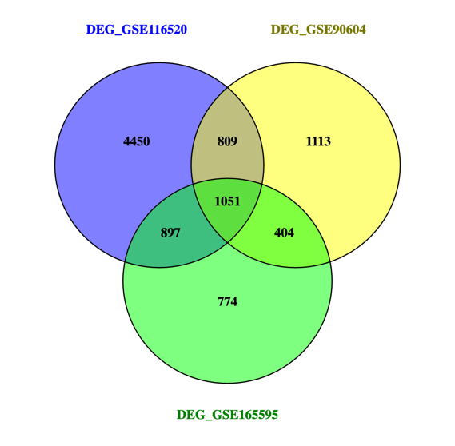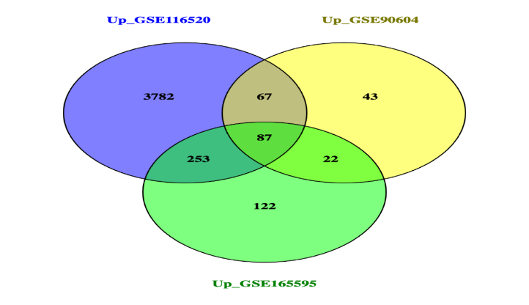
B
A
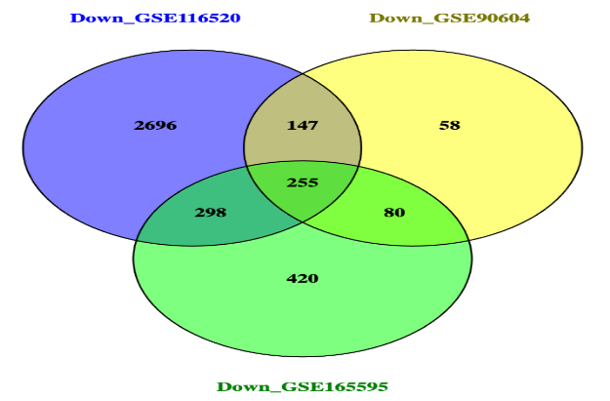
C
Figure 5: Venn diagram showing common DEGs (A), common upregulated DEGs (B) and common downregulated DEGs (C) between the datasets from brain tissue.
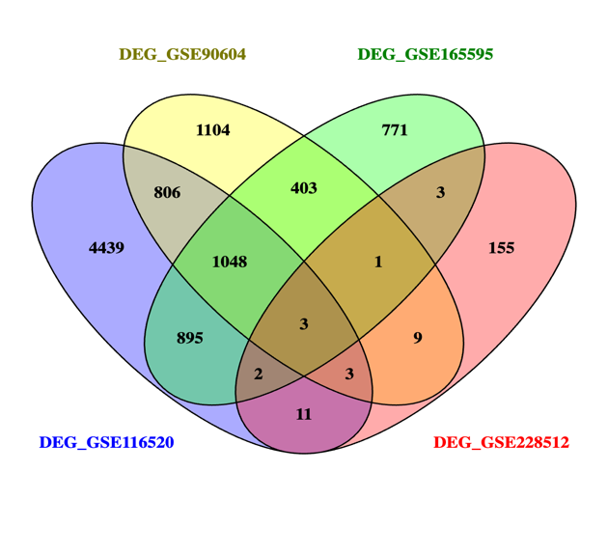
Figure 6: Venn diagram showing common DEGs between the datasets from brain tissue and the dataset from serum (GSE228512).
3.2 Functional Annotation and Gene Ontology Analysis
The DAVID tool was instrumental in elucidating the biological relevance of the identified DEGs. The analysis uncovered several enriched biological processes (BP), molecular functions (MF), and cellular components (CC), in addition to key KEGG pathways. These terms provided insight into the underlying mechanisms of GBM pathogenesis. The ShinyGO tool was also utilized to create graphical representations of these enriched GO terms, further enhancing our understanding of the DEGs' roles. The list of upregulated and downregulated DEGs from the datasets from brain tissue (GSE116520, GSE90604, and GSE165595) was submitted to the DAVID tool for functional annotation and enrichment analysis to identify GO terms and pathways activated or repressed by these DEGs. The result of the GO analysis shows that the common upregulated genes from the brain tissue datasets were enriched in GO BP terms such as cell division, angiogenesis, cell adhesion, extracellular matrix organization, positive regulation of cell population proliferation etc, (Figure 7). The upregulated genes were enriched in GO CC terms such as extracellular matrix, basement membrane, endoplasmic reticulum lumen, interstitial matrix, apical plasma membrane, collagen trimer, collagen type IV trimer, etc, (Figure 8).
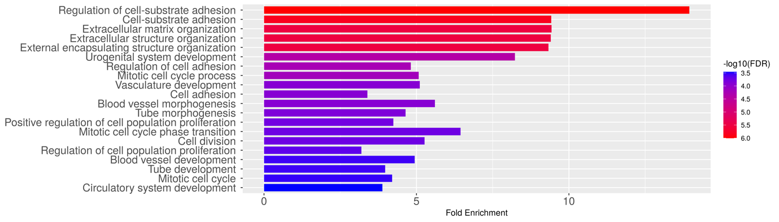
Figure 7: Top 20 biological process terms enriched by the upregulated genes in the tissue datasets. The BP terms in red colour are significantly enriched with a P-value < 0.05, adjusted using the FDR (false discovery rate) method.

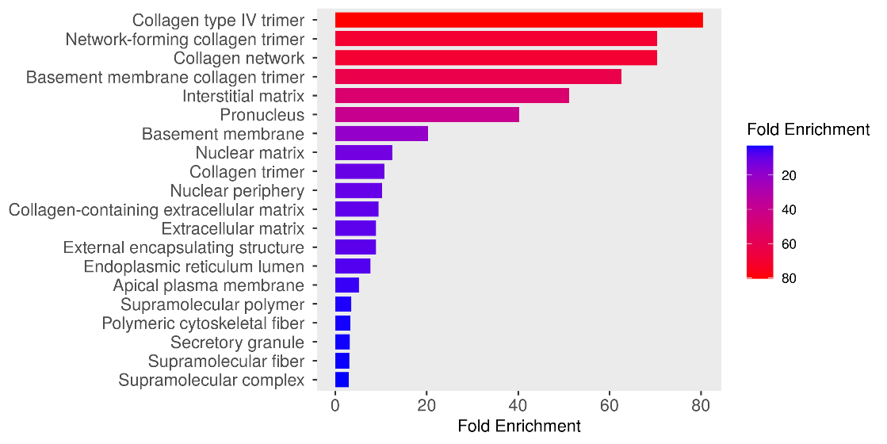
Figure 8: Top 20 cellular component terms enriched by the upregulated genes in the tissue datasets.
GO MF terms such as extracellular matrix structural constituent, collagen binding, chaperone binding, proteoglycan binding, metalloendopeptidase inhibitor activity, etc, were enriched by the tissue datasets upregulated DEGs. Top 20 MF terms enriched are highlighted in (Figure 9).
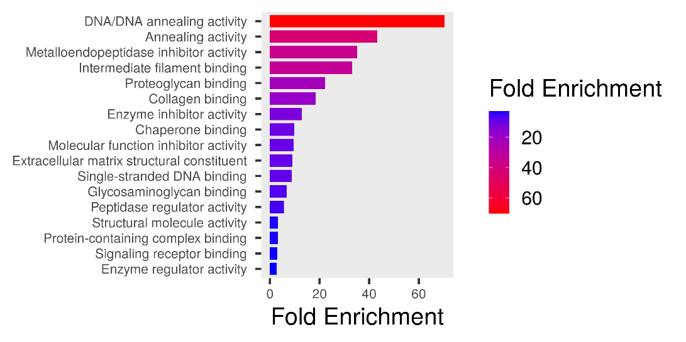
Figure 9: Top 20 molecular function terms enriched by the upregulated genes in the tissue datasets.
Pathways enriched by the upregulated DEGs from the tissue datasets (Figure 11) included PI3K-Akt signalling pathway (Figure 11), Pathways in AIDS (Figure 13), ECM-receptor interaction, small cell lung cancer, AGE-RAGE signalling pathway in diabetic complications, Focal adhesion, Relaxin signalling pathway, Bladder cancer, Proteoglycans in cancer, Cell cycle, MAPK signalling pathway, etc.
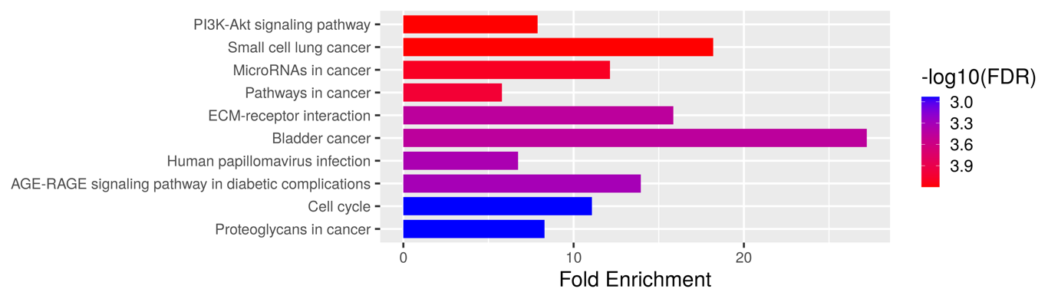
Figure 10: Top 10 pathways enriched by the upregulated genes in the tissue datasets The first four pathways in red colour are significantly enriched with a P-value < 0.05, adjusted using the FDR (false discovery rate) method.
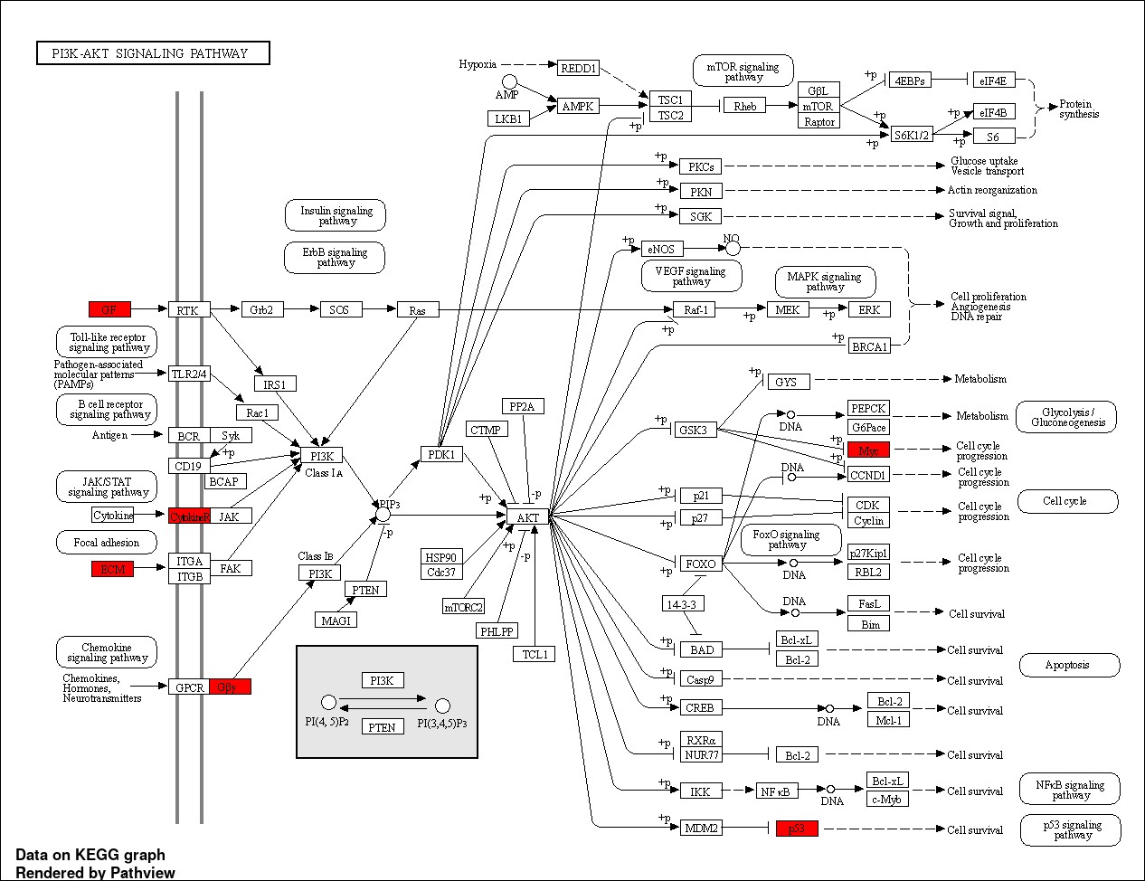
Figure 11: The PI3K-AKT signalling pathway downloaded from the KEGG database. The genes highlighted in red colour are highly expressed in this pathway and are implicated in GBM as discovered in this study.
The PI3K/Akt pathway plays a central role in regulating vital functions such as cell growth, proliferation, metabolic processes, and blood vessel formation, with a significant role in GBM development (Barzegar Behrooz et al., 2022) . PTEN, a key inhibitor of this pathway, is often deleted on chromosome 10 in GBM. The recent discovery of genetic modifications in the PI3K/AKT pathway across various cancers has led to the development of pathway inhibitors, marking a breakthrough in cancer-targeted therapies (Jiang, N. et al., 2020) .
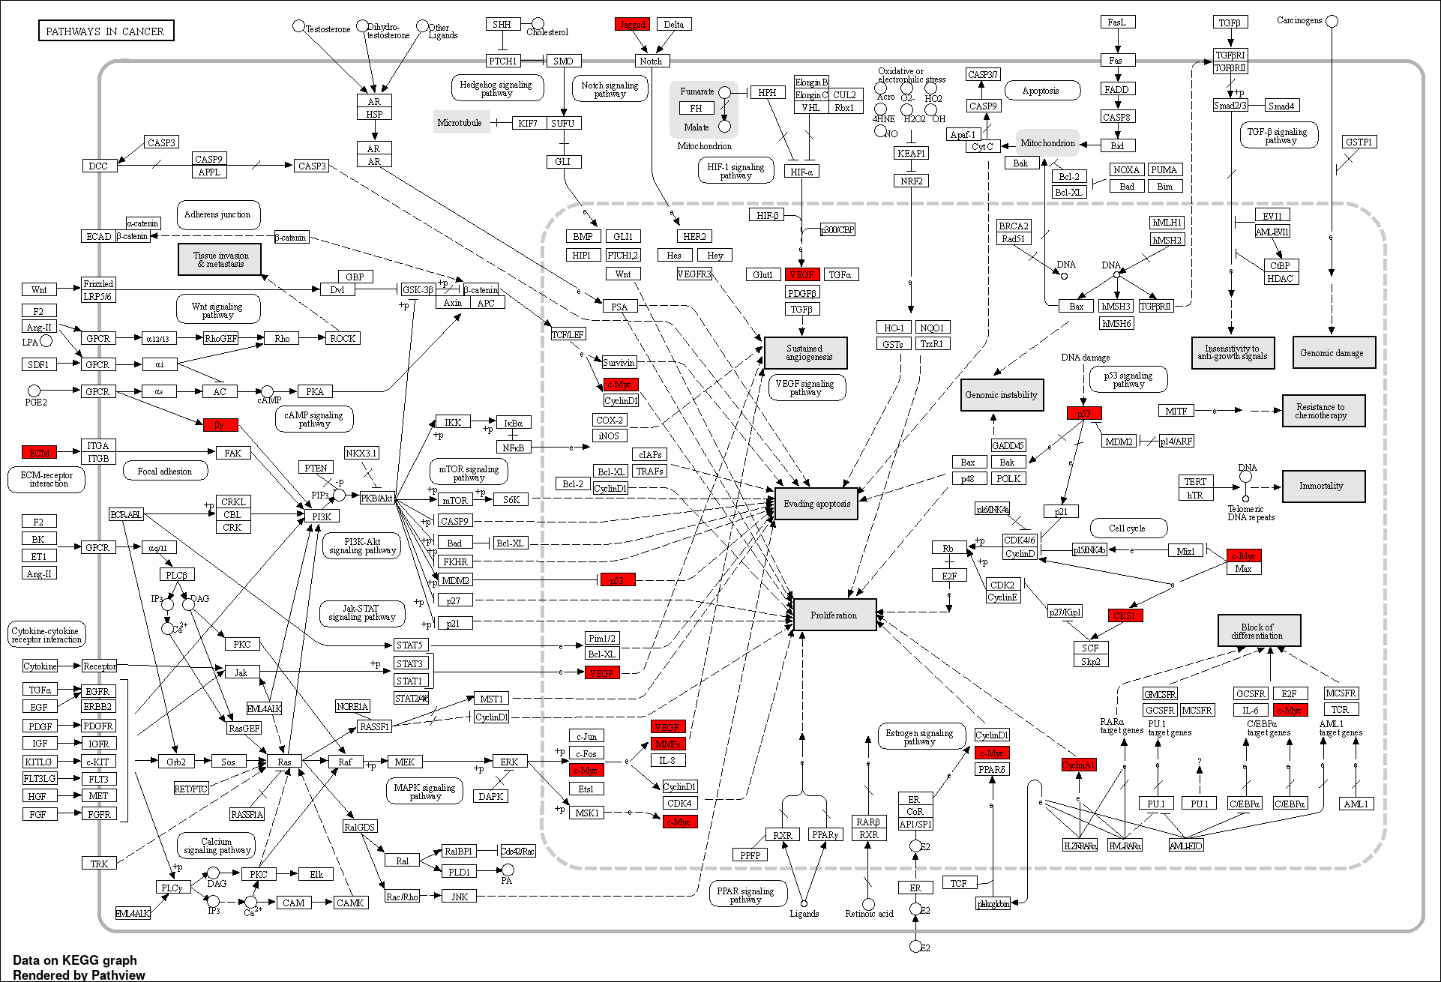
Figure 12: The Pathways in Cancer signalling pathway downloaded from the KEGG database.
The 'Pathways in Cancer' encompasses a complex network of signalling cascades that are pivotal in the initiation and progression of various cancers, including Glioblastoma Multiforme (GBM).
The pathways in which the common downregulated DEGs (Figure 13) in the tissue datasets are enriched include GABAergic synapse, Morphine addiction, Nicotine addiction, Retrograde endocannabinoid signalling, Glutamatergic synapse, Circadian entrainment, Long-term potentiation, Amphetamine addiction, cAMP signalling pathway, Insulin secretion, etc.
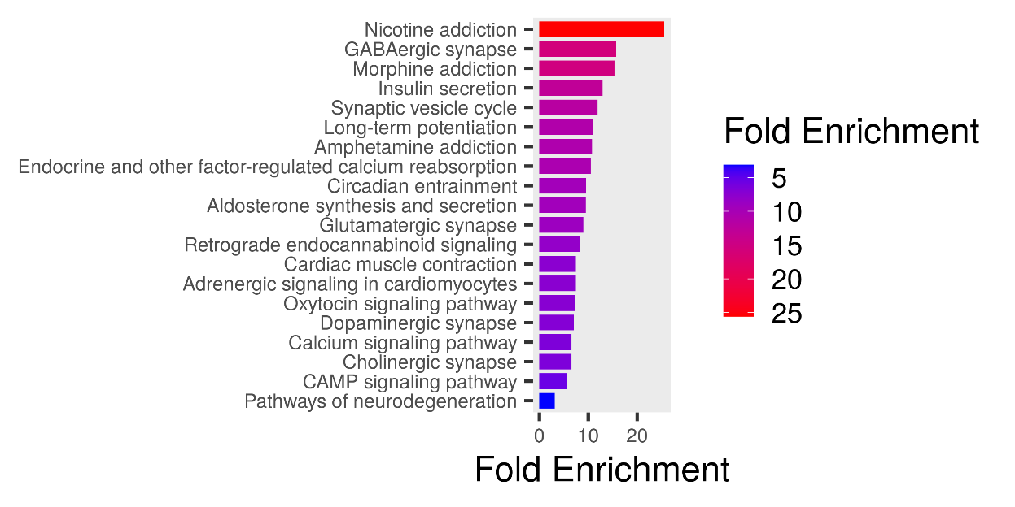
Figure 13: Top 20 pathways enriched by the downregulated genes in the tissue datasets.
3.3 Protein-Protein Interaction (PPI) Network Analysis
3.3.1 STRING Database
A Protein-Protein Interaction (PPI) network was constructed using the STRING database (version 12.0) separately for the 87 common co-occurring upregulated and 255 downregulated DEGs from the tissue datasets. Keeping the default settings, the list of DEGs was submitted to STRING for interaction data retrieval. The resulting interaction network included both experimentally validated and predicted interactions. As shown in Figure 14 and Figure 15, the PPI network consisted of 87 nodes and 249 edges and 253 nodes and 887 edges (after removal of disconnected nodes). This extensive network enhances our understanding of the biological functions and interactions among potential drug targets and associated proteins within a broader systemic context (Feng, Wang and Wang, 2017) .
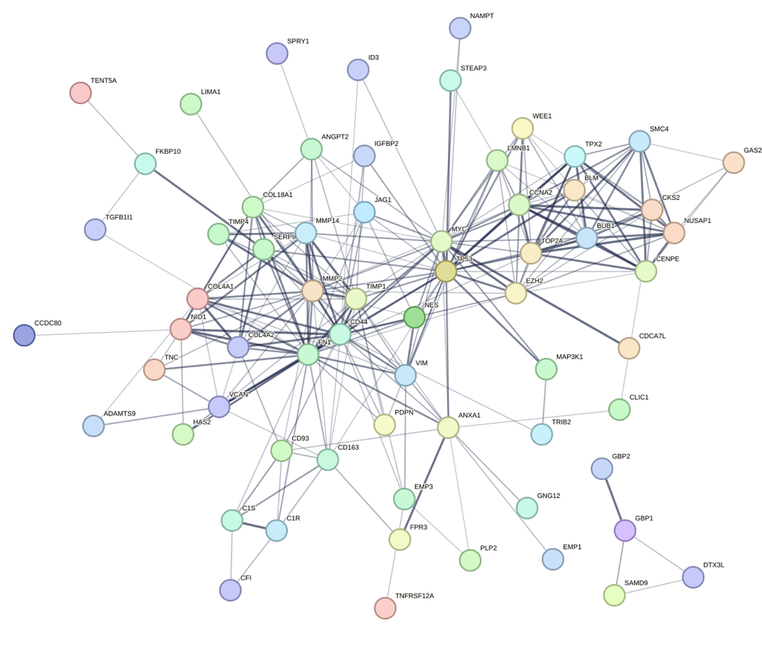

Figure 14: PPI network of the common upregulated DEGs in the tissue datasets.
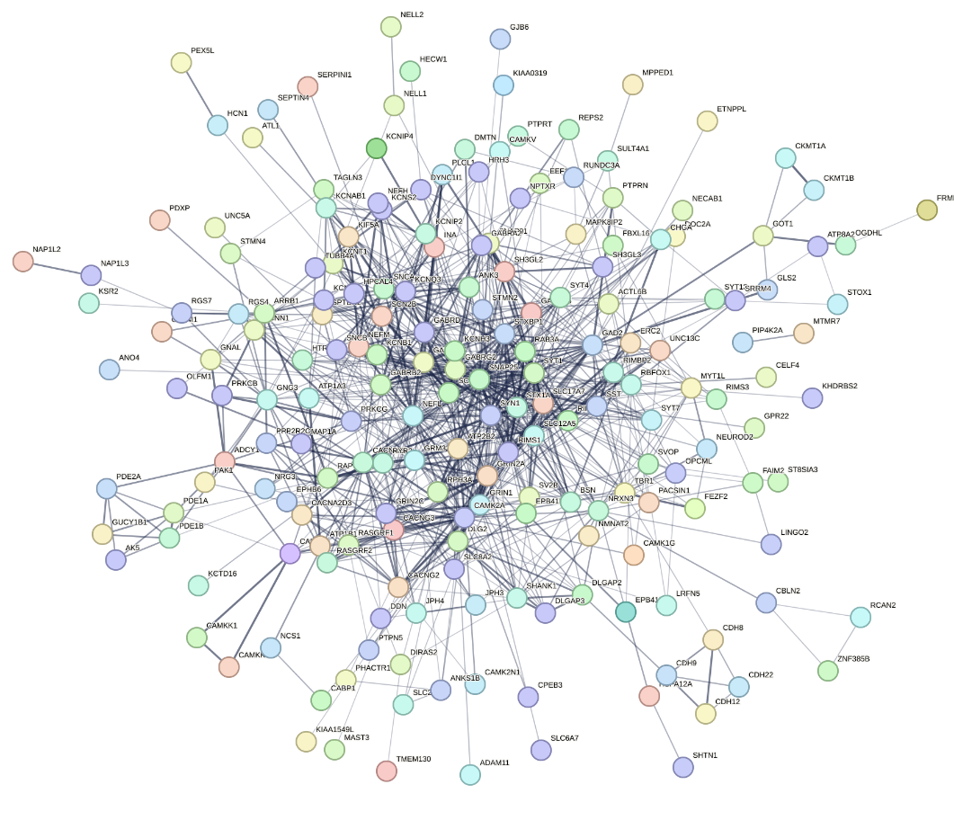
Figure 15: PPI network of the common downregulated DEGs in the tissue datasets.
3.3.2 Cytoscape Analysis and Identification of Hub Genes
The resulting PPI network for the upregulated tissue DEGs was analysed using Cytoscape. CytoHubba plug-in (version 0.1) was employed for the identification of top hub genes within the PPI network. The CytoHubba tool was used in filtering the genes based on Maximal Clique Centrality (MCC) (Figure 16A) and Degree (Figure 16B) ranking methods. Two sets of top twenty hub genes were identified based on these ranks. Table 2 shows the nodes and their ranks as ranked by the different topological analysis methods in CytoHubba. The PPI network for the downregulated genes was also analysed using Cytoscape.
The downregulated tissue genes, as measured by the MCC and Degree ranking methods, were additionally identified using CytoHubba. Figure 17 shows the interaction between the top 20 downregulated genes based on the above criteria. In this study, genes with high MCC and high Degree were considered as hub genes. Seventeen hub genes (BUB1, CCNA2, TOP2A, EZH2, CENPE, TPX2, NUSAP1, CKS2, FN1, TP53, MMP2, CD44, MYC, TIMP1, VIM, COL4A1, MMP14) with increased expression which are implicated in GBM were identified. Similarly, sixteen hub genes (GABRG2, SLC12A5, CAMK2A, GABRB2, GRIN1, GABRA1, GAD2, GRIN2A, SYT4, SYN1, SLC17A7, SNAP25, NEFL, SYT1, RAB3A, STXBP1) with decreased expression were identified.
Table 2: The top 20 genes in the upregulated tissue datasets were ranked using MCC and Degree in Cytoscape. The score is a measure of the nodes and reflect the importance of nodes based on network attributes. This helps researchers identify vital elements in biological networks, crucial for understanding regulatory mechanisms and identifying potential targets for drug discovery.
 | By MCC |  | By Degree
Rank | Name | MCC Score | Name | Degree Score
1 | BUB1 | 44208 | FN1 | 54
2 | CCNA2 | 44208 | TP53 | 52
3 | TOP2A | 44208 | CD44 | 50
4 | EZH2 | 43368 | MYC | 48
5 | CENPE | 41904 | MMP2 | 44
6 | TPX2 | 41760 | TIMP1 | 38
7 | NUSAP1 | 41184 | EZH2 | 30
8 | SMC4 | 41064 | BUB1 | 28
9 | CKS2 | 40345 | CCNA2 | 28
10 | FN1 | 8653 | TOP2A | 28
11 | TP53 | 8250 | ANXA1 | 24
12 | MMP2 | 7920 | VIM | 24
13 | CD44 | 7288 | COL4A1 | 24
14 | MYC | 6805 | COL18A1 | 22
15 | TIMP1 | 4652 | MMP14 | 22
16 | VIM | 3612 | CENPE | 22
17 | COL4A1 | 3002 | NUSAP1 | 22
18 | MMP14 | 2544 | TPX2 | 20
19 | NES | 2160 | CKS2 | 20
20 | COL4A2 | 1806 | CD163 | 20

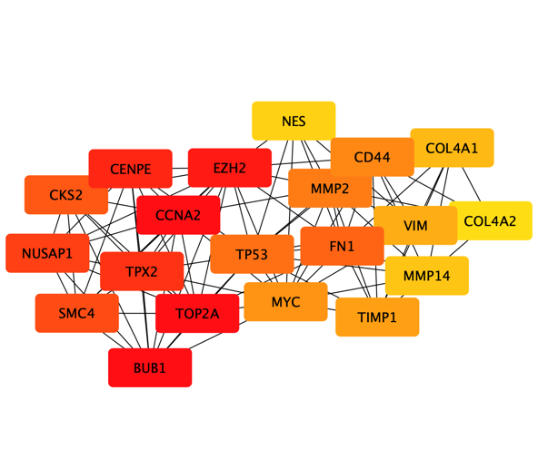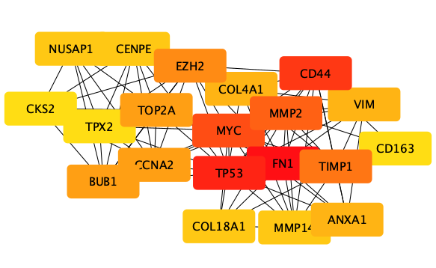
A
B
Figure 16: A network showing top 20 upregulated tissue genes ranked by MCC (A) and Degree (B) methods. Those in darker colour (red) are proteins with high node score or high degree of interaction.

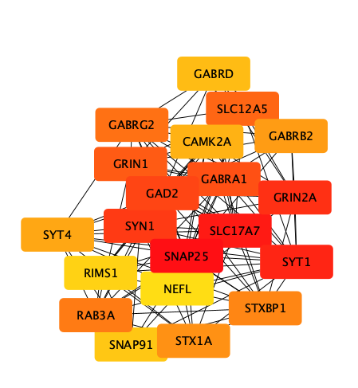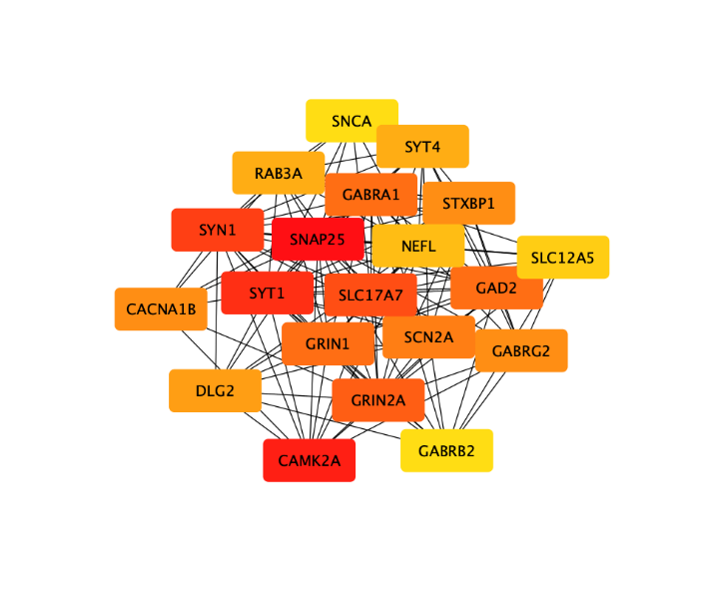
A
B
Figure 17: A network showing top 20 downregulated tissue genes ranked by MCC (A) and Degree (B) methods. The red colour in both A and B indicates a high node score.

DISCUSSION
Glioblastoma, a notably aggressive brain tumour, presents limited treatment options and poor prognosis for patients. Recent advances in multi-omics and genomic analysis have revealed detailed molecular signatures of this cancer type. This study used two microarray datasets from brain tissues (GSE116520, GSE90604) and two RNA-Seq datasets (GSE165595 from brain tissues and GSE228512 from serum samples), employing both microarray and RNA-Seq technologies. This approach enabled the identification of differentially expressed genes (DEGs) providing new insights into GBM pathology and potential biomarkers for diagnosis. The combination of these technologies allowed for a thorough analysis, enhancing the reliability of the findings by cross-validating DEGs across platforms and reducing platform-specific biases (Hawkins, Hon, and Ren, 2010). Furthermore, the study incorporated brain tissue and serum samples to explore shared biomarkers for GBM, expanding the scope of potential diagnostic markers.
This study's pivotal discovery is the identification of 1,051 common DEGs across both microarray and RNA-Seq tissue datasets, validated across these technologies. This extensive group of DEGs encompasses genes previously linked to GBM pathogenesis, like TOP2A, MYC, and EZH2 (Jiang, L. et al., 2020), alongside potential novel genes for future research. The partial alignment of DEGs between tissue and serum datasets highlights the promise of serum markers for non-invasive GBM diagnosis. Notably, genes such as MAST3, ADAM11, and PTPRK appear in both tissue and serum, suggesting their release into the bloodstream from tumour cells and their potential as accessible GBM biomarkers. This finding is significant, reflecting the increasing focus on liquid biopsies for cancer detection and monitoring (Ronvaux et al., 2022).
The functional annotation of upregulated and downregulated DEGs highlighted critical biological processes and pathways disrupted in GBM. The enrichment of upregulated genes in processes such as cell division, angiogenesis, and cell adhesion underscore the aggressive nature of GBM, characterized by rapid proliferation and invasive growth (Hsu et al., 2021; Su et al., 2022) . Pathway enrichment analysis via the KEGG database revealed that genes with increased expression were enriched in pathways such as the extracellular matrix (ECM)-receptor interaction, cell cycle, PI3K-Akt signalling pathway, relaxin signalling pathway, focal adhesion, etc. The rigidity of the ECM is thought to influence the invasive behaviour of GBM cells by modulating actomyosin contractility, according to recent studies (Serafim et al., 2021) . The overrepresentation of genes in the ECM-receptor interaction and MAPK signalling pathways further suggests that targeting the tumour microenvironment could be a promising approach. The PI3K-Akt pathway is recognized for its role in promoting glioma cell survival by inhibiting apoptotic processes (Wang, Jiabin et al., 2022) . The PI3K-Akt signalling pathway provides potential targets for therapeutic intervention. These pathways have been implicated in other cancers (Braicu et al., 2019; Noorolyai et al., 2019; Sun et al., 2020; Guo et al., 2022) , and their significance in GBM could lead to repurposing existing drugs or developing novel treatments. Downregulated genes in pathways such as GABAergic synapse and retrograde endocannabinoid signalling may reflect the neurological dysfunction associated with GBM (Ali et al., 2018) . Calcium signalling is known for its diverse roles in the signalling pathways that regulate the proliferation and movement of GBM cells (Kabir and Apu, 2022) These findings align with current understanding of GBM biology and suggest new avenues for targeted therapy.
The PPI network analysis, which identified central hub genes, offers insights into the molecular interactions that may contribute to GBM pathophysiology. The hub genes, ranked by MCC and Degree, could be critical drivers of the disease process. This study identified 17 upregulated hub genes (BUB1, CCNA2, TOP2A, EZH2, CENPE, TPX2, NUSAP1, CKS2, FN1, TP53, MMP2, CD44, MYC, TIMP1, VIM, COL4A1, MMP14) and 16 downregulated hub genes (GABRG2, SLC12A5, CAMK2A, GABRB2, GRIN1, GABRA1, GAD2, GRIN2A, SYT4, SYN1, SLC17A7, SNAP25, NEFL, SYT1, RAB3A, STXBP1).
Budding uninhibited by benzimidazoles 1 (BUB1), a gene crucial for the spindle assembly checkpoint, plays a key role in mitotic regulation and chromosome distribution (Huang et al., 2021). Studies by Chen et al., (2020), which corroborates with this study, have found increased BUB1 expression in GBM tissues compared to controls, indicating its potential impact on GBM progression and is commonly associated with poor prognosis and reduced overall survival in glioma patients. This is linked to its role in spindle assembly and chromatid segregation. Disrupting spindle assembly checkpoint activity has been shown to increase glioblastoma cells' sensitivity to anti-mitotic treatments (Tannous et al., 2013; Kessler et al., 2018). Therefore, targeting BUB1 could be an effective strategy for GBM treatment, focusing on its involvement in cell division.
Cell cyclin A2 (CCNA2), a gene typically active in cells undergoing division, shows heightened levels in glioblastoma cases (Doan et al., 2019) . It has been characterized as a protein that contributes to cancer progression (Shekhar et al., 2019) . Moreover, higher expression levels of CCNA2 in glioblastoma patients have been linked to a reduced overall survival rate (Yang, L. et al., 2020) . Recent research has pointed to CCNA2 as a potential factor in exacerbating the severity of cancer, including tendencies for recurrence, spread, and resistance to chemotherapy (Fischer et al., 2016) . In their investigation, Jiang, A. et al., (2022) reported that CCNA2 plays a role in the growth, invasiveness, and diversification of GBM, suggesting its utility as a new and viable target for both diagnosis and treatment.
The enhancer of zeste homologue 2 (EZH2), a vital part of the polycomb repressive complex 2 (PRC2) (Cyrus et al., 2019) , functions as a histone methyltransferase in mammalian cells, specifically adding trimethyl groups to histone H3 at lysine 27 (H3K27me3) (Wang, Xiaohai, Brea and Yu, 2019). Extensive research indicates EZH2's significant role in cancer development, influencing cell proliferation, apoptosis, epithelial-mesenchymal transition (EMT), invasion, and drug resistance in gliomas and other cancers (Zhang, Yanyang et al., 2017; Rastgoo et al., 2018; Zhang, Mingyuan, Duan and Sun, 2019). Therapeutic approaches targeting EZH2, through small-molecule inhibitors or RNA interference, have shown efficacy in reducing cancer cell growth and tumour formation (Yamagishi and Uchimaru, 2017) . Wang, X., Brea, and Yu (2019) highlighted EZH2's role in repressing tumour suppressor genes, thus promoting cell cycle, cell proliferation, and invasion, all contributing to cancer progression. Inhibiting EZH2 expression or activity in hematopoietic stem and progenitor cells increases natural killer (NK) cell precursors and mature cells, enhancing their anti-tumour activity (Bugide, Green and Wajapeyee, 2018). Therefore, EZH2 inhibitors are seen as promising therapeutic agents for cancer treatment.
Topoisomerase II alpha (TOP2A) gene is responsible for producing a DNA topoisomerase, which is essential for managing and modifying the topological structure of DNA during transcription. This enzyme, located in the nucleus, plays a critical role in several cellular processes, including the condensation of chromosomes, segregation of chromatids, and alleviation of the torsional strain encountered during DNA transcription and replication (Zhou, T. et al., 2018) . Gielniewski et al., (2023) in their study revealed an elevated expression of TOP2A in glioma cases than in normal tissues, which was found to inversely correlate with the survival rates of patients. This suggests that it play a vital role in glioma’s development and progression. The gene's regulatory influence on other gene expressions further underscores its potential as a key factor for predicting or treating gliomas (Farsi and Allahyari Fard, 2023) . Given TOP2A's fundamental cellular roles and its link to glioma pathogenesis, it stands out as a promising therapeutic target. Understanding its dysregulation in gliomas could lead to new treatment strategies, offering hope for better management of this aggressive brain cancer. Future research focusing on TOP2A's function and interactions could unveil deeper insights into GBM pathogenesis, guiding targeted therapy development.
Tumour Suppressor Protein (TP53) gene encodes the p53 protein, a transcription factor integral to cellular homeostasis, often deregulated in cancers like GBM (Zhang, Ying et al., 2018) . Under normal conditions, p53 activity is regulated by MDM2 and MDM4 through ubiquitination and degradation (Wade, Li and Wahl, 2013) . Stress signals such as DNA damage disrupt this interaction, leading to p53 activation. P53 functions in cell cycle regulation, apoptosis, and maintaining genome integrity, earning it the name "Guardian of the Genome” (Zhang, Ying et al., 2018) . Recent studies have expanded p53's role to include regulation of metabolism, stemness, autophagy, and immunity (Zhang, Ying et al., 2018) . In GBM, p53 pathway deregulation, particularly through TP53 missense mutations, is common (Olafson et al., 2020) . Ham et al., (2019) highlighted that the gain-of-function (GOF) mutant TP53 are implicated in GBM progression by promoting proliferation, tumour forming ability, invasiveness and blood vessel formation and that inhibition of the p53 GOF mutant suppressed progression of cancer. Mutated p53 in GBM correlates with increased invasiveness, proliferation, stem-like properties, and resistance to DNA-damaging drugs. Targeting p53 mutations is crucial in precision medicine, with reactivating wild type (wt) p53 as a potential therapeutic strategy (Song, Y. et al., 2019)
Fibronectin 1 (FN1) is a member of the Fibronectin (FN) family which is a glycoprotein with a high molecular weight. FN1 plays a crucial role in cellular mechanisms and diseases such as GBM (Song, J. et al., 2021) . It contributes to the formation of extracellular matrix and modulates the PI3K/AKT signalling pathway and has the functions of regulating cell adhesion, growth, and differentiation, promoting cell migration and proliferation, as well as ion exchange and information transfer (Xu, 2021) . Disruption of FN1 expression has been shown to curb cell growth, enhance apoptosis and cellular aging, and reduce cellular movement and invasiveness by inhibiting the PI3K/AKT pathway (Jing-Ping, 2018) . These insights confirm FN1's regulatory influence on glioma cell behaviour, indicating its potential as a target for therapeutic intervention in GBM treatment.
Cluster of differentiation 44 (CD44), a versatile glycoprotein, is essential for regulating cellular functions like migration, proliferation, programmed cell death, and new blood vessel formation, thus maintaining cellular and tissue equilibrium (Si et al., 2020) . High expression of CD44 is an indicator of poor prognosis in GBM. Its expression is noted in a spectrum of cancer types, reflecting its critical role in cancer development (Liu et al., 2020) . Within glioblastoma, CD44's interaction with hyaluronic acid and other molecules aids in cell migration, contributing to the malignancy's invasive nature (Wu, G. et al., 2020) . In their study, Xu, Stamenkovic, and Yu (2010) demonstrated that CD44 depletion impedes glioblastoma progression and primes the cells to be more responsive to cytotoxic treatments, while also indicating CD44's regulatory role over the Hippo signalling pathway in these tumour cells. This positions CD44 as a potential target for GBM treatments that aim to impede tumour growth and spread. Ongoing research into how CD44 affects cellular mechanisms in glioblastoma is expected to reveal new therapeutic approaches and contribute to more personalized treatments based on individual genetic profiles.
Matrix metallopeptidase 2 and 14, encoded by MMP2 and MMP14, are zinc-dependent endopeptidase enzymes critical for degrading type IV collagen in the extracellular matrix, playing roles in various normal and pathological processes, including glioma development (Zhou, W. et al., 2019) . Their increased expression has been linked to the severity and spread of brain tumours, with studies suggesting that the absence of MMP2 and MMP14 improves overall survival in GBM (Sincevičiūtė et al., 2018; Rajesh et al., 2019; Wang, Tianyu et al., 2021) . Sincevičiūtė et al., (2018) in their research suggested that MMP2's critical influence on tumour development positions it as a valuable marker for early detection of GBM, while also noting its significant role in promoting the creation of new blood vessels within tumours, indicating a dual function in oncogenesis and angiogenesis. Research on and designing of drugs that can inhibit MMP2 and MMP14 are already being investigated and can be potential treatment option for GBM (Karimi et al., 2023) .
Tissue inhibitor of metalloproteinase 1 (TIMP1) also known as Fibroblast Collagenase Inhibitor, is a protein coding gene that produces a protein that functions as an endogenous inhibitor of matrix metalloproteinases, a group of enzymes that break down the extracellular matrix (Yang, Y. et al., 2021) . TIMP1 is therefore involved in tumour invasion and growth. Jung et al., (2006) showed that TIMP1 interacts with the cell surface protein CD63 to activate the MAPK signalling pathway and suggested that their interaction could contribute to chemotherapeutic resistance. Originally recognized as an innate suppressor of matrix metalloproteinases (MMPs), the TIMP1 gene is involved in critical pathways including HIF-1 signalling and IL6-mediated events, playing a role in extracellular matrix organization (Han et al., 2021) . Beyond inhibiting MMPs, TIMP1 serves multiple roles within the tumour microenvironment, influencing tumour progression, cell proliferation, and exerting anti-apoptotic effects in various types of cancer. Elevated levels of TIMP1 have been associated with poor prognosis and shorter overall survival in GBM patients (Aaberg-Jessen et al., 2018) . From the foregoing, targeting the TIMP1 gene or pathways in which it is involved could be novel therapeutic intervention to improve the prognosis and management of GBM.
MYC protein emerged as a hub gene in this study. The MYC gene family, which includes MYCN, MYCC, and MYCL, are prominent oncogenes implicated in the development of various cancers including GBM (Masso-Valles, Beaulieu and Soucek, 2020) . MYC, functioning as a transcription factor, partners with nucleophosmin (NPM) to influence cellular proliferation and division. The MYC-NPM complex facilitates MYC's interaction with specific promoter genes, leading to the transcription of proteins essential for cell transformation (Kim, Cho and Park, 2015) . MYC's regulatory influence is notable: genes moderately expressed without MYC are significantly upregulated in its presence (Cencioni et al., 2023) . In glioblastoma multiforme (GBM), MYC is vital for the self-renewal of neural stem cells and sustaining their tumour-forming potential. GBMs with elevated MYC and MYCN expression suggest these genes as therapeutic targets (Borgenvik et al., 2021) . MYC's identification as a hub in protein-protein interaction networks underscores its significance in GBM's molecular pathology. Therefore, targeting MYC pathways could be a promising GBM therapeutic approach, but the intricacies of MYC's roles across various cellular functions necessitate further study to fully understand its part in GBM's onset and progression. Such insights may lead to novel targeted treatments to enhance GBM patient care.
Targeting protein for Xenopus kinesin-like protein 2 (TPX2) is identified as a microtubule-associated protein, essential for spindle assembly as it facilitates the attachment of the COOH-terminal domain of Xenopus kinesin-like protein 2 to microtubules. It is also known to align with spindle microtubules during the M-phase, observable both in live cells and controlled laboratory conditions (Albadari and Li, 2023) . Van Gijn and team, in their study, stated that reduced expression of TPX2 leads to genomic instability and programmed cell death of cancer cells (van Gijn et al., 2019) . High expression levels of TPX2 have been associated with GBM and usually contribute to the regulation of cell cycle (Vriend and Klonisch, 2023) . Ognibene and colleagues' recent investigation into curcumin's impact on DNA damage in neuroblastoma cell lines found increased levels of the TPX2 oncoprotein (Ognibene et al., 2019) . This indicates that an effective cancer treatment strategy might involve combining agents that target TPX2 pathways with conventional DNA-damaging drugs.
Centromere-associated protein E (CENPE) is a kinetochore motor enzyme that facilitates the alignment of chromosomes, secures spindle microtubules at kinetochores, and activates the spindle assembly checkpoint, playing a critical role in mitosis (Iegiani, Di Cunto and Pallavicini, 2021) . Interfering with CENPE’s function leads to chromosomes not aligning correctly, blocks the attachment of microtubules to kinetochores, and causes cells to halt during mitosis (She et al., 2020; Craske and Welburn, 2020) Suppressing CENPE in paediatric high-grade glioma cell lines, whether used alone or combined with temozolomide (TZM), has been observed to curtail cell growth and trigger a pause in the cell cycle (Liang et al., 2016). Iegiani and team (2021) stated that molecules such as Syntelin, PF-2771, Compound-A, and the allosteric inhibitor GSK923295 have been proposed as inhibitors of CENPE. The collective evidence points to CENPE as a promising therapeutic target in the treatment of GBM by disrupting microtubule stabilization and interfering with the mitotic process.
COL4A1. Collagen IV is predominantly located in the basal lamina and is a key component of the brain's collagen. It forms part of the basement membrane encasing vascular endothelial cells. Its structure arises from six different genes, designated as COL4A1 to COL4A6, which encode the various chains of collagen IV (Quinlan and Rheault, 2021) . Physical compaction in glioma cells, causing changes in shape and size, increases collagen IV expression and upregulates angiogenic factors, thereby contributing to the progression of GBM (Wang, Yi, Ichinose and Nakada, 2022) . COL4A1's association with shorter overall survival in glioma patients has been reported, as its inhibition reduces glioma cell proliferation and migration, marking it as a poor prognostic indicator in glioma. Inhibiting COL4A1 presents a potential therapeutic approach for the management and treatment of GBM.
Vimentin (VIM), a crucial type III intermediate filament protein, significantly contributes to cellular migration, growth, and division. Although primarily a cytoplasmic protein, VIMentin also appears in the extracellular matrix and on the cell surface (Chen et al., 2023) . Initial research has indicated that high Vimentin expression in glioblastoma patients correlates with notably shorter overall survival and poorer outcomes compared to those with low VIMentin levels (Zhao, J. et al., 2018) . Vimentin, recognized as a key epithelial-mesenchymal transition marker, has been found in various cancers such as lung, oral squamous cell carcinoma, prostate, breast, malignant melanoma, and brain tumours, with numerous studies confirming its role as a pro-invasion molecular marker, thereby positioning it as a viable therapeutic target in GBM treatment (Chen et al., 2023) . Vimentin contributes to TMZ resistance in GBM, with high expression levels potentially reducing TMZ effectiveness (Lin et al., 2016) . Noh et al. (2016) developed the 86C monoclonal antibody, targeting CSV-activated rapid internalization of the 86C-VIMentin complex, which induces apoptosis in GBM cells. Furthermore, vimentin 's role as a Nogo receptor (NgR) regulator, affecting glioma cell migration and invasion, is highlighted. Knockdown of VIMentin could enhance NgR maturation, thus inhibiting GBM progression (Kang et al., 2019) . This positions VIMentin as a crucial biomarker and therapeutic target in GBM management.
Nucleolar and spindle-associated protein 1 (NUSAP1), a 55-kD microtubule-associated protein, plays an essential role in the progression of mitosis and the formation and stability of the mitotic spindle (Li et al., 2023) . NUSAP1 shows a marked increase in expression in GBM, suggesting its potential as a molecular marker and target for intervention in GBM. Higher levels of NUSAP1 have been linked to enhanced proliferation, migration, and invasion of GBM cells (Zhao, Y. et al., 2020; Hu et al., 2022) . NUSAP1's involvement in cancer progression may be linked to the activation of the hedgehog signalling pathway (Wu, X. et al., 2017) . Research by Zhao et al. suggests that NUSAP1 enhances resistance to chemotherapy drugs such as temozolomide and doxorubicin via its SAP domain. These demonstrate the therapeutic relevance of silencing NUSAP1 in GBM.
Microtubule-Associated Serine/Threonine 3 (MAST3) is one of the three DEGs found common between the tissue and serum datasets. MAST3 is a member of the MAST kinase family which are characterized by three evolutionarily conserved protein domains, defining their modular structure. Studies have demonstrated that MAST3 interacts with the lipid phosphatase PTEN (Phosphatase and Tensin homolog), which plays a crucial role in regulating cell growth and survival, marking it as a significant tumour suppressor in humans (Rumpf et al., 2023) . MAST3 also plays an important role in the regulation of PP2A in the striatum of the brain. It inhibits the activity of PP2A in the striatum of the brain by phosphorylating serine 46 of ARPP-16 (cAMP-regulated phosphoprotein of molecular weight 16 kDa) (Andrade et al., 2017) . PP2A is critical in regulating cell cycle, signal transduction, cell growth, cell differentiation, and transformation, with its activity being linked to various diseases such as neurodegenerative disorders and cancer (Sandal et al., 2021) . MAST3 has also been identified as interacting with the essential tumour suppressor, Adenomatous Polyposis Coli (APC) (Rumpf et al., 2023) . Based on these findings, targeting MAST3 in GBM patients can be a novel therapeutic intervention.
ADAM11 is a member of the 'A disintegrin and metalloproteases' (ADAMs) family, which are transmembrane proteins related to the matrix metalloproteinases (MMPs) superfamily (Łukaszewicz-Zając, Dulewicz and Mroczko, 2021) . ADAMs are involved in various pathological conditions, including cardiovascular diseases, malignancies, and CNS disorders like brain tumours, with a role in degrading the extracellular matrix and contributing to CNS tumour invasion. Their functions include cell proliferation, migration, angiogenesis, and survival. As a non-proteolytic ADAM, ADAM11 is vital in neural development and synaptic functions (Hsia et al., 2019) . Giovanna et al., (2016), noted that ADAM11 has limited impact on cell growth and consistent expression in both low- and high-grade gliomas. However, the relationship between ADAM11 and GBM requires further research for a clearer understanding.
Protein tyrosine phosphatase–receptor type K (PTPRK), part of the protein tyrosine phosphatase receptor family, acts as a tumour suppressor. Lv et al., (2023) highlighted that its methylation increases tumour cell proliferation while reducing apoptosis. Additionally, PTPRK silencing leads to the activation of β-catenin in the Wnt pathway and destabilizes the E-cadherin/β-catenin complex, fostering epithelial-mesenchymal transition and decreasing cell adhesion. Wu, M. et al., (2019) found that PTPRK inhibits tumour growth by restraining epidermal growth factor receptor (EGFR) signalling. Thus, therapies enhancing PTPRK expression or activity may be effective against GBM.
The intersection of the above genes and other hub genes identified in this study with enriched pathways points to a complex network of interactions that underpin GBM, and monitoring and disrupting these networks could be key to effective diagnosis and treatment strategies.
The study's findings have significant translational potential. The DEGs and pathways identified could inform the development of diagnostic panels for early detection of GBM. Additionally, the hub genes could be explored as therapeutic targets. Future research should aim to validate these findings in clinical samples and assess their utility in prognostication and treatment monitoring. Moreover, the limited overlap of DEGs between tissue and serum highlights the need for further research to understand the dynamics of GBM markers in the bloodstream. The identification of MAST3, ADAM11, and PTPRK as common DEGs in both tissue and serum datasets suggests a crucial translational path. Future research must prioritize the experimental validation of these circulating biomarkers using sensitive techniques such as quantitative reverse transcription polymerase chain reaction (qRT-PCR) or Enzyme-Linked Immunosorbent Assay (ELISA) in an independent patient serum cohort to bridge the gap between bioinformatics discovery and clinical application.
Major Findings and Translational Outlook
The diagnosis of Glioblastoma Multiforme (GBM) is advancing, blending conventional methods with new techniques like biofluid-based biomarker detection, proteomics, and biosensor technologies. This research successfully identified differentially expressed genes (DEGs), including the critical overlapping serum markers MAST3, ADAM11, and PTPRK, by integrating microarray and RNA-Seq technologies, shedding light on GBM's pathology. Analysis of protein-protein interaction networks revealed the complex molecular interactions within GBM, suggesting the promise of targeted therapies through hub genes such as BUB1, CCNA2, and EZH2. This work marks a significant stride in understanding GBM's intricate biology and lays the groundwork for future precision oncology advancements by exploring biomarkers common to tissue and liquid biopsies, aiming for less invasive and more cost-effective diagnostic methods.

CONCLUSION
This study successfully conducted an integrated analysis of microarray and RNA-Seq datasets from both brain tissue and serum samples to unravel the complex molecular pathogenesis of Glioblastoma Multiforme (GBM),. By integrating data across technologies and sample types, the research identified 1,051 common differentially expressed genes (DEGs) across tissue datasets, validating a robust set of molecular signatures associated with GBM,. A crucial finding was the identification of three genes, MAST3, ADAM11, and PTPRK, that were consistently expressed in both tissue and serum datasets, suggesting their potential utility as non-invasive biomarkers for GBM diagnosis,,. Furthermore, functional annotation highlighted critical biological processes disrupted in GBM, such as cell division, angiogenesis, and cell adhesion,, with pathway analysis identifying the involvement of networks like the PI3K-Akt signaling pathway,. The Protein-Protein Interaction (PPI) network analysis provided insights into the complex molecular interactions central to GBM pathophysiology, leading to the identification of several central hub genes,. Overall, the identified DEGs and pathways offer a crucial foundation for developing enhanced diagnostic panels and personalized therapeutic targets, underscoring the vital need for subsequent research to translate these findings into clinical practice.
Future Directions
This study, despite its comprehensive integrative approach, encounters certain limitations. One significant constraint is the retrospective nature of the analysis, relying on public datasets that inherently vary in sample collection and processing methods, which may introduce variability. The diversity of the patient samples used, potentially harbouring distinct underlying conditions, could have influenced the findings. Moreover, the disproportionate ratio of GBM to normal brain samples may have impacted the statistical robustness of the dataset analysis. A crucial aspect that requires attention is the experimental validation of the biological relevance of the identified DEGs and biomarkers. Future studies should aim to mitigate these limitations, by utilizing samples from the same patients and ensuring a more balanced representation of sample types, to yield more comprehensive and insightful results.
Conference disclaimer:
Only abstract of this manuscript was previously presented and published in the conference: The 3rd International Electronic Conference on Biomolecules, Part of the International Electronic Conference on Biomolecules series. 23–25 April, Web Link of the proceeding: https://sciforum.net/paper/view/17215

Disclaimer (Artificial intelligence)
Option 1:
Author(s) hereby declare that NO generative AI technologies such as Large Language Models (ChatGPT, COPILOT, etc.) and text-to-image generators have been used during the writing or editing of this manuscript.

REFERENCES
- Aaberg-Jessen, C., Sørensen, M. D., Matos, A. L. S. A., Moreira, J. M., Brünner, N., Knudsen, A., & Kristensen, B. W. (2018). Co-expression of TIMP-1 and its cell surface binding partner CD63 in glioblastomas. BMC Cancer, 18(1), 270. https://doi.org/10.1186/s12885-018-4179-y
- Albadari, N., & Li, W. (2023). Survivin Small Molecules Inhibitors: Recent Advances and Challenges. Molecules, 28(3), 1376. https://doi.org/10.3390/molecules28031376
- Ali, F. S., Hussain, M. R., Gutiérrez, C., Demireva, P., Ballester, L. Y., Zhu, J. J., Blanco, A., & Esquenazi, Y. (2018). Cognitive disability in adult patients with brain tumors. Cancer Treatment Reviews, 65, 33-40. https://doi.org/10.1016/j.ctrv.2018.02.007
- Andrade, E. C., Musante, V., Horiuchi, A., Matsuzaki, H., Brody, A. H., Wu, T., Greengard, P., Taylor, J. R., & Nairn, A. C. (2017). ARPP-16 Is a Striatal-Enriched Inhibitor of Protein Phosphatase 2A Regulated by Microtubule-Associated Serine/Threonine Kinase 3 (Mast 3 Kinase). Journal of Neuroscience, 37(10), 2709-2722. https://doi.org/10.1523/JNEUROSCI.4559-15.2017.
- Barzegar Behrooz, A., Talaie, Z., Jusheghani, F., Łos, M. J., Klonisch, T., & Ghavami, S. (2022). Wnt and PI3K/Akt/mTOR Survival Pathways as Therapeutic Targets in Glioblastoma. International Journal of Molecular Sciences, 23(3), 1353. https://doi.org/10.3390/ijms23031353
- Borgenvik, A., Čančer, M., Hutter, S., & Swartling, F. J. (2021). Targeting MYCN in molecularly defined malignant brain tumors. *Frontiers in Oncology*, *10*, 626751. https://doi.org/10.3389/fonc.2020.626751
- Braicu, C., Buse, M., Busuioc, C., Drula, R., Gulei, D., Raduly, L., Rusu, A., Irimie, A., Atanasov, A. G., Slaby, O., Ionescu, C., & Berindan-Neagoe, I. (2019). A comprehensive review on MAPK: A promising therapeutic target in cancer. Cancers, 11(10), 1618. https://doi.org/10.3390/cancers11101618
- Bugide, S., Green, M. R., & Wajapeyee, N. (2018). Inhibition of Enhancer of zeste homolog 2 (EZH2) induces natural killer cell-mediated eradication of hepatocellular carcinoma cells. Proceedings of the National Academy of Sciences, 115(15), E3509–E3518. https://doi.org/10.1073/pnas.1802691115
- Cao, F., Fan, Y., Yu, Y., Yang, G., & Zhong, H. (2021). Dissecting prognosis modules and biomarkers in glioblastoma based on weighted gene Co-expression network analysis. Cancer Management and Research, 5477-5489. https://doi.org/10.2147/CMAR.S310346
- Cencioni, C., Scagnoli, F., Spallotta, F., Nasi, S., & Illi, B. (2023). The “Superoncogene” Myc at the Crossroad between Metabolism and Gene Expression in Glioblastoma Multiforme. International Journal of Molecular Sciences, 24(4), 4217. https://doi.org/10.3390/ijms24044217
- Chen, K. et al. (2023) 'Vimentin as a potential target for diverse nervous system diseases', Neural Regeneration Research, 18(5), pp. 969.
- Chen, X., Pan, Y., Yan, M., Bao, G., & Sun, X. (2020). Identification of potential crucial genes and molecular mechanisms in glioblastoma multiforme by bioinformatics analysis. Molecular Medicine Reports, 22(2), 859–869. https://doi.org/10.3892/mmr.2020.11160
- Cheng, Q., Li, J., Fan, F., Cao, H., Dai, Z.-Y., Wang, Z.-Y., & Feng, S.-S. (2020). Identification and Analysis of Glioblastoma Biomarkers Based on Single Cell Sequencing. Frontiers in Bioengineering and Biotechnology. https://doi.org/10.3389/fbioe.2020.00167
- Chin, C. H., Chen, S. H., Wu, H. H., Ho, C. W., Ko, M. T., & Lin, C. Y. (2014). cytoHubba: identifying hub objects and sub-networks from complex interactome. BMC Systems Biology https://doi.org/10.1186/1752-0509-8-S4-S11
- Craske, B., & Welburn, J. P. (2020). Leaving no-one behind: how CENP-E facilitates chromosome alignment. Essays in Biochemistry, 64(2), 313-324. https://doi.org/10.1042/EBC20190073
- Cyrus, S., Burkardt, D., Weaver, D. D., & Gibson, W. T. (2019). PRC2-complex related dysfunction in overgrowth syndromes: A review of EZH2, EED, and SUZ12 and their syndromic phenotypes. American Journal of Medical Genetics Part C: Seminars in Medical Genetics, 181(4), 519-531. https://doi.org/10.1002/ajmg.c.31754
- Doan, P., Musa, A., Candeias, N. R., Emmert-Streib, F., Yli-Harja, O., & Kandhavelu, M. (2019). Alkylaminophenol Induces G1/S Phase Cell Cycle Arrest in Glioblastoma Cells Through p53 and Cyclin-Dependent Kinase Signaling Pathway. Frontiers in Pharmacology, 10, 330. https://doi.org/10.3389/fphar.2019.00330
- Doncheva, N. T., Morris, J. H., Holze, H., Kirsch, R., Nastou, K. C., Cuesta-Astroz, Y., Rattei, T., Szklarczyk, D., von Mering, C., & Jensen, L. J. (2022). Cytoscape stringApp 2.0: Analysis and Visualization of Heterogeneous Biological Networks. Journal of Proteome Research, 22(2), 637-646. https://doi.org/10.1021/acs.jproteome.2c00651
- Farsi, Z., & Allahyari Fard, N. (2023). The identification of key genes and pathways in glioblastoma by bioinformatics analysis. Molecular & Cellular Oncology, 10(1), 2246657. https://doi.org/10.1080/23723556.2023.2246657
- Feng, Y., Wang, Q., & Wang, T. (2017). Drug target protein-protein interaction networks: A systematic perspective. BioMed Research International, 2017. https://doi.org/10.1155/2017/1289259
- Ferrer, V. P. (2023). MUC16 mutation is associated with tumor grade, clinical features, and prognosis in glioma patients. Cancer Genetics, 270-271, 22-30. https://doi.org/10.1016/j.cancergen.2022.11.003
- Fischer, M., Quaas, M., Steiner, L., & Engeland, K. (2016). The p53-p21-DREAM-CDE/CHR pathway regulates G2/M cell cycle genes. Nucleic Acids Research, 44(1), 164-174. https://doi.org/10.1093/nar/gkv927
- Ge, S. X., Jung, D., & Yao, R. (2020). ShinyGO: a graphical gene-set enrichment tool for animals and plants. Bioinformatics, 36(8), 2628-2629. https://doi.org/10.1093/bioinformatics/btz931
- Gielniewski, B., Poleszak, K., Roura, A.-J., Szadkowska, P., Jacek, K., Krol, S. K., Guzik, R., Wiechecka, P., Maleszewska, M., Kaza, B., Marchel, A., Czernicki, T., Koziarski, A., Zielinski, G., Styk, A., Kawecki, M., Szczylik, C., Czepko, R., Banach, M., Kaspera, W., Szopa, W., Bujko, M., Czapski, B., Zabek, M., Iżycka-Świeszewska, E., Kloc, W., Nauman, P., Cieslewicz, J., Grajkowska, W., Morosini, N., Noushmehr, H., Wojtas, B., & Kaminska, B. (2023). Targeted sequencing of cancer-related genes reveals a recurrent TOP2A variant which affects DNA binding and coincides with global transcriptional changes in glioblastoma. International Journal of Cancer. https://doi.org/10.1002/ijc.34631
- D'Abaco, G., Ng, K., Pera, M., Novak, U., & Kaye, A. H. (2006). ADAM22, expressed in normal brain but not in high-grade gliomas, inhibits cellular proliferation via the disintegrin domain. Neurosurgery, 58(1), 179-186. https://doi.org/10.1227/01.neu.0000192363.84287.8b
- Gulluoglu, S., Tuysuz, E. C., Sahin, M., Kuskucu, A., Yaltirik, C. K., Ture, U., Kucukkaraduman, B., Akbar, M. W., Gure, A. O., Bayrak, O. F., & Dalan, A. B. (2018). Simultaneous miRNA and mRNA transcriptome profiling of glioblastoma samples reveals a novel set of OncomiR candidates and their target genes. Brain Research, 1700, 199-210. https://doi.org/10.1016/j.brainres.2018.08.035
- Guo, Y., Ren, C., Huang, W., Yang, W., & Bao, Y. (2022). Oncogenic ACSM1 in prostate cancer is through metabolic and extracellular matrix-receptor interaction signaling pathways. American Journal of Cancer Research, 12(4), 1824–1842. https://www.ncbi.nlm.nih.gov/pmc/articles/PMC9014000/
- Ham, S. W., Jeon, H. Y., Jin, X., Kim, E. J., Kim, J. K., Shin, Y. J., Lee, Y., Kim, S. H., Lee, S. Y., Seo, S., Park, M. G., Kim, H. M., Nam, D. H., & Kim, H. (2019). TP53 gain-of-function mutation promotes inflammation in glioblastoma. Cell Death & Differentiation, 26(3), 409-425. https://doi.org/10.1038/s41418-018-0126-3
- Han, J., Jing, Y., Han, F., & Sun, P. (2021). Comprehensive analysis of expression, prognosis and immune infiltration for TIMPs in glioblastoma. *BMC Neurology*, *21*(1), 447. https://doi.org/10.1186/s12883-021-02477-1
- Hawkins, R. D., Hon, G. C., & Ren, B. (2010). Next-generation genomics: an integrative approach. Nature Reviews Genetics, 11(7), 476-486. https://doi.org/10.1038/nrg2795
- Hsia, H. E., Tüshaus, J., Brummer, T., Zheng, Y., Scilabra, S. D., & Lichtenthaler, S. F. (2019). Functions of 'A disintegrin and metalloproteases (ADAMs)' in the mammalian nervous system. Cellular and Molecular Life Sciences, 76, 3055-3081. https://doi.org/10.1007/s00018-019-03173-7
- Hsu, J.-F., Chu, S.-M., Liao, C.-C., Wang, C.-J., Wang, Y.-S., Lai, M.-Y., & Lin, Y.-J. (2021). Nanotechnology and nanocarrier-based drug delivery as the potential therapeutic strategy for glioblastoma multiforme: An update. Cancers, 13(2), 195. https://doi.org/10.3390/cancers13020195
- Hu, Y., Liu, Y., Wang, Y., Li, Y., Zhang, Y., Liu, J., Shi, J., Xie, T., Zhang, Y., Ma, J., & Dong, J. (2022). Knockdown of NUSAP1 inhibits cell proliferation and invasion through downregulation of TOP2A in human glioblastoma. Cell Cycle, 21(17), 1842-1855. https://doi.org/10.1080/15384101.2022.2074199
- Huang, Z., Wang, S., Li, Y., Li, J., Li, Y., Li, X., Li, Z., & Lin, J. (2021). Inhibition of BUB1 suppresses tumorigenesis of osteosarcoma via blocking of PI3K/Akt and ERK pathways. *Journal of Cellular and Molecular Medicine*, *25*(17), 8442-8453. https://doi.org/10.1111/jcmm.16805
- Hwang, T., Kim, S., Chowdhury, T., Yu, H. J., Kim, K. M., Kang, H., Won, J. K., Park, S. H., Shin, J. H., & Park, C. K. (2022). Genome-wide perturbations of Alu expression and Alu-associated post-transcriptional regulations distinguish oligodendroglioma from other gliomas. Communications Biology, 5(1), 62. https://doi.org/10.1038/s42003-022-03011-w
- Iegiani, G., Di Cunto, F., & Pallavicini, G. (2021). Inhibiting microcephaly genes as alternative to microtubule targeting agents to treat brain tumors. Cell Death & Disease. https://doi.org/10.1038/s41419-021-04259-6
- Jiang, A. et al. (2022) 'CCNA2 as an immunological biomarker encompassing tumor microenvironment and therapeutic response in multiple cancer types', Oxidative Medicine and Cellular Longevity, 2022
- Jiang, L., Zhong, M., Chen, T., Zhu, X., Yang, H., & Lv, K. (2020). Gene regulation network analysis reveals core genes associated with survival in glioblastoma multiforme. Journal of Cellular and Molecular Medicine, 24(17), 10075-10087. https://doi.org/10.1111/jcmm.15615
- Jiang, N., Dai, Q., Su, X., Fu, J., Feng, X., & Peng, J. (2020). Role of PI3K/AKT pathway in cancer: the framework of malignant behavior. Molecular Biology Reports. https://doi.org/10.1007/s11033-020-05435-1
- Jing-Ping, L. (2018) 'Effects of fibronectin 1 on cell proliferation, senescence and apoptosis of human glioma cells through the PI3K/AKT signaling pathway', Cellular Physiology and Biochemistry, 48(3), pp. 1382-1396.
- Jung, K., Liu, X. W., Chirco, R., Fridman, R., & Kim, H. R. C. (2006). Identification of CD63 as a tissue inhibitor of metalloproteinase‐1 interacting cell surface protein. The EMBO Journal, 25(17), 3934-3942. https://doi.org/10.1038/sj.emboj.7601281
- Kabir, F., & Apu, M.N.H. (2022). Multi-omics analysis predicts fibronectin 1 as a prognostic biomarker in glioblastoma multiforme. Genomics. https://doi.org/10.1016/j.ygeno.2022.110378
- Kang, Y. H., Han, S. R., Jeon, H., Lee, S., Lee, J., Yoo, S. M., Lee, M. S., & Lee, S. H. (2019). Nogo receptor–vimentin interaction: a novel mechanism for the invasive activity of glioblastoma multiforme. Experimental & Molecular Medicine, 51(10), 1–15. https://doi.org/10.1038/s12276-019-0332-1
- Karimi, N., Gholami, M., & Gholami, M. (2023). Bioinformatic analysis of MMP family members in GBM. Informatics in Medicine Unlocked, 39, 101240. https://doi.org/10.1016/j.imu.2023.101240
- Kessler, A. F., Frömbling, G. E., Gross, F., Hahn, M., Dzokou, W., Ernestus, R. I., Löhr, M., & Hagemann, C. (2018). Effects of tumor treating fields (TTFields) on glioblastoma cells are augmented by mitotic checkpoint inhibition. Cell Death Discovery, 4, Article 12. https://doi.org/10.1038/s41420-018-0079-9
- Khabibov, M., Garifullin, A., Boumber, Y. A., Khaddour, K., Fernandez, M. G., Khamitov, F. F., Khalikova, L. V., Kuznetsova, N., Kit, O. I., & Kharin, L. (2022). Signaling pathways and therapeutic approaches in glioblastoma multiforme (Review). *International Journal of Oncology*, *60*(6), 69. https://doi.org/10.3892/ijo.2022.5359
- Khoury, R., & Ghossoub, E. (2019). Diagnostic biomarkers of Alzheimer’s disease: A state-of-the-art review. Biomarkers in Neuropsychiatry, 1, 100005. https://doi.org/10.1016/j.bionps.2019.100005
- Kim, J., Cho, Y., & Park, J. (2015). The nucleolar protein GLTSCR2 is an upstream negative regulator of the oncogenic nucleophosmin-MYC axis. The American Journal of Pathology, 185(7), 2061-2068. https://doi.org/10.1016/j.ajpath.2015.03.016
- Kruthika, B. S., Jain, R., Arivazhagan, A., Bharath, R. D., Yasha, T. C., Kondaiah, P., & Santosh, V. (2019). Transcriptome profiling reveals PDZ binding kinase as a novel biomarker in peritumoral brain zone of glioblastoma. Journal of Neuro-Oncology. https://doi.org/10.1007/s11060-018-03051-5
- Li, D. et al. (2023) 'LINC01393, a Novel Long Non-Coding RNA, Promotes the Cell Proliferation, Migration and Invasion through MiR-128-3p/NUSAP1 Axis in Glioblastoma', International Journal of Molecular Sciences, 24(6), pp. 5878.
- Liang, M., Hsieh, T., Ng, K., Tsai, Y., Tsai, C., Chao, M., Liu, D., Chu, S., Chen, W., Liu, Y., Liu, R., Lin, S., Ho, D., Wong, T., Yang, M., & Wang, H. (2016). Downregulation of miR-137 and miR-6500-3p promotes cell proliferation in pediatric high-grade gliomas. Oncotarget, 7(15). https://doi.org/10.18632/oncotarget.7736
- Lin, L., Wang, G., Ming, J., Meng, X., Han, B., Sun, B., Cai, J., & Jiang, C. (2016). Analysis of expression and prognostic significance of vimentin and the response to temozolomide in glioma patients. Tumor Biology, 37, 15333-15339. https://doi.org/10.1007/s13277-016-5462-7
- Liu, W., Chen, J., Chen, J., Lin, J., Li, Y., Li, S., & Yuan, Y. (2020). CD44-associated radioresistance of glioblastoma in irradiated brain areas with optimal tumor coverage. Cancer Medicine, 9(1), 350-360. https://doi.org/10.1002/cam4.2714
- Lopes, M. B., Martins, E. P., Vinga, S., & Costa, B. M. (2021). The role of network science in glioblastoma. Cancers, 13(5), 1045. https://doi.org/10.3390/cancers13051045
- Love, M. I., Huber, W., & Anders, S. (2014). Moderated estimation of fold change and dispersion for RNA-seq data with DESeq2. Genome Biology, 15(12), 550. https://doi.org/10.1186/s13059-014-0550-8
- Łukaszewicz-Zając, M., Dulewicz, M., & Mroczko, B. (2021). A disintegrin and metalloproteinase (ADAM) family: Their significance in malignant tumors of the central nervous system (CNS). *International Journal of Molecular Sciences*, *22*(19), 10378. https://doi.org/10.3390/ijms221910378
- Lv, Z. et al. (2023) 'The role of receptor‐type protein tyrosine phosphatases in cancer', Precision Medical Sciences, 12(1), pp. 48-57.
- Massó-Vallés, D., Beaulieu, M., & Soucek, L. (2020). MYC, MYCL, and MYCN as therapeutic targets in lung cancer. Expert Opinion on Therapeutic Targets, 24(2), 101-114. https://doi.org/10.1080/14728222.2020.1723548
- Mut, M., Adiguzel, Z., Cakir-Aktas, C., Hanalioğlu, Ş., Gungor-Topcu, G., Kiyga, E., Isikay, I., Sarac, A., Soylemezoglu, F., Strobel, T., Ampudia-Mesias, E., Cameron, C., Aslan, T., Tekirdas, E., Hayran, M., Oguz, K. K., Henzler, C., Saydam, N., & Saydam, O. (2023). Extracellular-Vesicle-Based Cancer Panels Diagnose Glioblastomas with High Sensitivity and Specificity. *Cancers*, *15*(15), 3782. https://doi.org/10.3390/cancers15153782
- Nia, H. T., Munn, L. L., & Jain, R. K. (2020). Physical traits of cancer. Science, 370(6516), eaaz0868. https://doi.org/10.1126/science.aaz0868
- Noh, H., Yan, J., Hong, S., Kong, L.-Y., Gabrusiewicz, K., Xia, X., Heimberger, A. B., & Li, S. (2016). Discovery of cell surface vimentin targeting mAb for direct disruption of GBM tumor initiating cells. Oncotarget, 7(44), 72021-72032. https://doi.org/10.18632/oncotarget.12458
- Noorolyai, S., Shajari, N., Baghbani, E., Sadreddini, S., & Baradaran, B. (2019). The relation between PI3K/AKT signalling pathway and cancer. Gene, 698, 120–128. https://doi.org/10.1016/j.gene.2019.02.076
- Ognibene, M., Pirovano, M., Sessa, S., Cadamuro, M., Bizzarri, M., Caccuri, A.M., Pitolli, C., Felsani, A., D'Orazi, G., & Ciafrè, S.A. (2019). Role of GOLPH3 and TPX2 in neuroblastoma DNA damage response and cell resistance to chemotherapy. International Journal of Molecular Sciences, 20(19), 4764. https://doi.org/10.3390/ijms20194764
- Olafson, L. R., Gunawardena, M., Nixdorf, S., McDonald, K. L., & Rapkins, R. W. (2020). The role of TP53 gain-of-function mutation in multifocal glioblastoma. Journal of Neuro-Oncology, 147(1), 37–47. https://doi.org/10.1007/s11060-019-03318-5
- Quinlan, C., & Rheault, M. N. (2021). Genetic basis of type IV collagen disorders of the kidney. Clinical Journal of the American Society of Nephrology: CJASN, 16(7), 1101–1109. https://doi.org/10.2215/CJN.19171220
- Rajesh, Y., Biswas, A., Kumar, U., Das, S., Banerjee, I., Banik, P., Bharti, R., Nayak, S., Ghosh, S. K., & Mandal, M. (2019). Targeting NFE2L2, a transcription factor upstream of MMP-2: A potential therapeutic strategy for temozolomide resistant glioblastoma. Biochemical Pharmacology, 164, 1-16. https://doi.org/10.1016/j.bcp.2019.03.025
- Rastgoo, N., Pourabdollah, M., Abdi, J., Reece, D., & Chang, H. (2018). Dysregulation of EZH2/miR-138 Axis Contributes to Drug Resistance in Multiple Myeloma by Downregulating RBPMS. Leukemia. https://doi.org/10.1038/s41375-018-0140-y
- Rodriguez-Esteban, R., & Jiang, X. (2017). Differential gene expression in disease: a comparison between high-throughput studies and the literature. BMC Medical Genomics. https://doi.org/10.1186/s12920-017-0293-y
- Ronvaux, L., Riva, M., Coosemans, A., Herzog, M., Rommelaere, G., Donis, N., D'Hondt, L., & Douxfils, J. (2022). Liquid biopsy in glioblastoma. Cancers, 14(14), 3394. https://doi.org/10.3390/cancers14143394
- Rumpf, M., Pautz, S., Drebes, B., Herberg, F. W., & Müller, H.-A. J. (2023). Microtubule-Associated Serine/Threonine (MAST) Kinases in Development and Disease. International Journal of Molecular Sciences, 24(15), 11913. https://doi.org/10.3390/ijms241511913
- Sandal, P., et al. (2021). Protein phosphatase 2A – structure, function and role in neurodevelopmental disorders. Journal of Cell Science, 134(13), jcs248187. https://doi.org/10.1242/jcs.248187
- Serafim, R. B., da Silva, P., Cardoso, C., Di Cristofaro, L. F. M., Netto, R. P., de Almeida, R., Navegante, G., Storti, C. B., de Sousa, J. F., de Souza, F. C., Panepucci, R., Moreira, C. G., Penna, L. S., Silva Jr, W. A., & Valente, V. (2021). Expression profiling of glioblastoma cell lines reveals novel extracellular matrix-receptor genes correlated with the responsiveness of glioma patients to ionizing radiation. Frontiers in Oncology. https://doi.org/10.3389/fonc.2021.668090
- She, Z., Yu, K. W., Zhong, N., Xiao, Y., Wei, Y. L., Lin, Y., Li, Y. L., & Lu, M. H. (2020). Kinesin-7 CENP-E regulates chromosome alignment and genome stability of spermatogenic cells. Cell Death Discovery, 6(1), 25. https://doi.org/10.1038/s41420-020-0261-8
- Shekhar, R., Priyanka, P., Kumar, P., Ghosh, T., Khan, M. M., Nagarajan, P., & Saxena, S. (2019). The microRNAs miR-449a and miR-424 suppress osteosarcoma by targeting cyclin A2 expression. Journal of Biological Chemistry, 294(12), 4381-4400. https://doi.org/10.1074/jbc.RA118.005778
- Sherman, B. T., Hao, M., Qiu, J., Jiao, X., Baseler, M. W., Lane, H. C., Imamichi, T., & Chang, W. (2022). DAVID: a web server for functional enrichment analysis and functional annotation of gene lists (2021 update). Nucleic Acids Research, 50(W1), W216-W221. https://doi.org/10.1093/nar/gkac194
- Si, D., Yin, F., Peng, J., & Zhang, G. (2020). High expression of CD44 predicts a poor prognosis in glioblastomas. *Cancer Management and Research*, *12*, 769–775. https://doi.org/10.2147/CMAR.S233423
- Sincevičiūtė, R., Palepšienė, R., Ulozienė, I., Tamašauskas, A., Skauminas, K., Gintautaitė, V., Ugenskienė, R., Steponaitienė, R., Šiupšinskas, L., Kanapienis, A., Tunaitienė, V., & Aldonytė, R. (2018). MMP2 is associated with glioma malignancy and patient outcome. International Journal of Clinical and Experimental Pathology, 11(6), 3010-3018. https://doi.org/10.7754/ijcep.v11.i6.3010
- Song, J., Zhao, D., Sun, G., Yang, J., Lv, Z., & Jiao, B. (2021). PTPRM methylation induced by FN1 promotes the development of glioblastoma by activating STAT3 signalling. Pharmaceutical Biology, 59(1), 902-909. https://doi.org/10.1080/13880209.2021.1944220
- Song, Y., Zhang, L., Jiang, Y., Hu, T., Zhang, D., Qiao, Q., Wang, R., Wang, M., & Han, S. (2019). MTBP regulates cell survival and therapeutic sensitivity in TP53 wildtype glioblastomas. Theranostics, 9(20), 6019-6030. https://doi.org/10.7150/thno.35747
- Su, G., Wang, W., Xu, L., & Li, G. (2022). Progress of EGFL6 in angiogenesis and tumor development. International Journal of Clinical and Experimental Pathology, 15(11), 436-443. https://www.ncbi.nlm.nih.gov/pmc/articles/PMC9729941/
- Sun, L., Zhang, Y., Zhang, W., Lai, X., Li, Q., Zhang, L., & Sun, S. (2020). Green tea and black tea inhibit proliferation and migration of HepG2 cells via the PI3K/Akt and MMPs signalling pathway. Biomedicine & Pharmacotherapy. https://doi.org/10.1016/j.biopha.2020.109893
- Szklarczyk, D., Gable, A. L., Lyon, D., Junge, A., Wyder, S., Huerta-Cepas, J., Simonovic, M., Doncheva, N. T., Morris, J. H., Bork, P., Jensen, L. J., & von Mering, C. (2019). STRING v11: protein–protein association networks with increased coverage, supporting functional discovery in genome-wide experimental datasets. Nucleic Acids Research, 47(D1), D607-D613. https://doi.org/10.1093/nar/gky1131
- Szklarczyk, D., Kirsch, R., Koutrouli, M., Nastou, K., Mehryary, F., Hachilif, R., Gable, A. L., Fang, T., Doncheva, N. T., Pyysalo, S., Bork, P., Jensen, L. J., & von Mering, C. (2023). The STRING database in 2023: protein–protein association networks and functional enrichment analyses for any sequenced genome of interest. Nucleic Acids Research, 51(D1), D638-D646. https://doi.org/10.1093/nar/gkac1000
- Tannous, B. A., Kerami, M., Van der Stoop, P. M., Kwiatkowski, N., Wang, J., Zhou, W., Kessler, A. F., Lewandrowski, G., Hiddingh, L., Sol, N., Lagerweij, T., Wedekind, L., Niers, J. M., Barazas, M., Nilsson, R. J. A., Geerts, D., De Witt Hamer, P. C., Hagemann, C., Vandertop, W. P., Van Tellingen, O., Noske, D. P., Gray, N. S., & Würdinger, T. (2013). Effects of the selective MPS1 inhibitor MPS1-IN-3 on glioblastoma sensitivity to antimitotic drugs. Journal of the National Cancer Institute, 105(17), 1322-1331. https://doi.org/10.1093/jnci/djt168
- van Gijn, S. E., Wierenga, E., van den Tempel, N., Kok, Y. P., Heijink, A. M., Spierings, D. C. J., Foijer, F., van Vugt, M. A. T. M., & Fehrmann, R. S. N. (2019). TPX2/Aurora kinase A signaling as a potential therapeutic target in genomically unstable cancer cells. Oncogene, 38(6), 852-867. https://doi.org/10.1038/s41388-018-0470-2
- Vriend, J., & Klonisch, T. (2023). Genes of the Ubiquitin Proteasome System Qualify as Differential Markers in Malignant Glioma of Astrocytic and Oligodendroglial Origin. Cellular and Molecular Neurobiology, 43(4), 1425-1452. https://doi.org/10.1007/s10571-022-01261-0
- Wade, M., Li, Y., & Wahl, G. M. (2013). MDM2, MDMX and p53 in oncogenesis and cancer therapy. Nature Reviews Cancer, 13(2), 83-96. https://doi.org/10.1038/nrc3430
- Wang, J., et al. (2022). Identification of prognostic biomarkers for glioblastoma based on transcriptome and proteome association analysis. *Technology in Cancer Research & Treatment*, *21*, 15330338211035270. https://doi.org/10.1177/15330338211035270
- Wang, J., Dean, D. C., Hornicek, F. J., Shi, H., & Duan, Z. (2019). RNA sequencing (RNA-Seq) and its application in ovarian cancer. Gynecologic Oncology. https://doi.org/10.1016/j.ygyno.2018.10.002
- Wang, T., Zhang, Y., Bai, J., Xue, Y., Peng, Q., et al. (2021). MMP1 and MMP9 are potential prognostic biomarkers and targets for uveal melanoma. BMC Cancer. https://doi.org/10.1186/s12885-021-08788-3
- Wang, X., Brea, L. T., & Yu, J. (2019). Immune modulatory functions of EZH2 in the tumor microenvironment: implications in cancer immunotherapy. American Journal of Clinical and Experimental Urology, 7(2), 85–91. https://www.ncbi.nlm.nih.gov/pmc/articles/PMC6526357/
- Wang, Y., Ichinose, T., & Nakada, M. (2022). The role of collagens in glioma: A narrative review. Glioma, 5(2), 50-55. https://doi.org/10.4103/glioma.glioma_11_22
- Wesseling, P., & Capper, D. (2018). WHO 2016 Classification of gliomas. Neuropathology and Applied Neurobiology, 44(2), 139-150. https://doi.org/10.1111/nan.12432
- Wu, G., Song, X., Liu, J., Li, S., Gao, W., Qiu, M., Yang, C., Ma, Y., & Chen, Y. (2020). Expression of CD44 and the survival in glioma: a meta-analysis. Bioscience Reports, 40(4), BSR20200520. https://doi.org/10.1042/BSR20200520
- Wu, L. et al. (2022) 'Bioinformatics analysis identified RGS4 as a potential tumor promoter in glioma', Pathology, Research and Practice, 240, pp. 154225. Available at: https://doi.org/10.1016/j.prp.2022.154225
- Wu, M., Song, D., Li, H., Yang, Y., Ma, X., Deng, S., Ren, C., & Shu, X. (2019). Negative regulators of STAT3 signaling pathway in cancers. Cancer Management and Research, 11, 4957–4969. https://doi.org/10.2147/CMAR.S206175
- Wu, X., Xu, B., Yang, C., Wang, W., Zhong, D., Zhao, Z., He, L., Hu, Y., Jiang, L., Li, J., Song, L., & Zhang, W. (2017). Nucleolar and spindle associated protein 1 promotes the aggressiveness of astrocytoma by activating the Hedgehog signaling pathway. Journal of Experimental & Clinical Cancer Research, 36(1):127. https://doi.org/10.1186/s13046-017-0597-y
- Xu, B. (2021). Prediction and analysis of hub genes between glioblastoma and low-grade glioma using bioinformatics analysis. Medicine (Baltimore), 100(3), e23513. https://doi.org/10.1097/MD.0000000000023513
- Xu, Y., Stamenkovic, I., & Yu, Q. (2010). CD44 attenuates activation of the hippo signaling pathway and is a prime therapeutic target for glioblastoma. Cancer Research, 70(6), 2455-2464. https://doi.org/10.1158/0008-5472.CAN-09-2505
- Yamagishi, M., & Uchimaru, K. (2017). Targeting EZH2 in cancer therapy. Current Opinion in Oncology, 29(5), 375-381. https://doi.org/10.1097/CCO.0000000000000390
- Yang, L. et al. (2020) 'Bioinformatical analysis of gene expression omnibus database associates TAF7/CCNB1, TAF7/CCNA2, and GTF2E2/CDC20 pathways with glioblastoma development and prognosis', World Neurosurgery, 138, pp. e492-e514.
- Yang, Y., Feng, Q., Hu, K., & Cheng, F. (2021). Using CRISPRa and CRISPRi Technologies to Study the Biological Functions of ITGB5, TIMP1, and TMEM176B in Prostate Cancer Cells. Frontiers in Molecular Biosciences, 8, 676021. https://doi.org/10.3389/fmolb.2021.676021
- Zhang, M., Duan, W., & Sun, W. (2019). LncRNA SNHG6 promotes the migration, invasion, and epithelial-mesenchymal transition of colorectal cancer cells by miR-26a/EZH2 axis. OncoTargets and Therapy, 12, 3349–3360. https://doi.org/10.2147/OTT.S197433
- Zhang, Y., Yu, X., Chen, L., Zhang, Z., & Feng, S. (2017). EZH2 overexpression is associated with poor prognosis in patients with glioma. Oncotarget, 8(1), 565-573. https://doi.org/10.18632/oncotarget.13478
- Zhang, Y., Dube, C., Gibert, M., Cruickshanks, N., Wang, B., Coughlan, M., Yang, Y., Setiady, I., Deveau, C., Saoud, K., Grello, C., Oxford, M., Yuan, F., & Abounader, R. (2018). The p53 pathway in glioblastoma. Cancers, 10(9), 297. https://doi.org/10.3390/cancers10090297
- Zhao, J., et al. (2018). High expression of vimentin is associated with progression and a poor outcome in glioblastoma. Applied Immunohistochemistry & Molecular Morphology. https://doi.org/10.1097/PAI.0000000000000420
- Zhao, Y., He, J., Li, Y., Lv, S., & Cui, H. (2020). NUSAP1 potentiates chemoresistance in glioblastoma through its SAP domain to stabilize ATR. Signal Transduction and Targeted Therapy. https://doi.org/10.1038/s41392-020-0137-7.
- Zhou, T., Wang, Y., Qian, D., Liang, Q., & Wang, B. (2018). Over-expression of TOP2A as a prognostic biomarker in patients with glioma. International Journal of Clinical and Experimental Pathology. https://www.ncbi.nlm.nih.gov/pmc/articles/PMC6958105/
- Zhou, W., Yu, X., Sun, S., Zhang, X., Yang, W., Zhang, J., Zhang, X., & Jiang, Z. (2019). Increased expression of MMP-2 and MMP-9 indicates poor prognosis in glioma recurrence. Biomedicine & Pharmacotherapy. https://doi.org/10.1016/j.biopha.2019.109369

