Assessment of groundwater quality and potential non-carcinogenic health risk around Epie Creek, Yenagoa, Nigeria

Abstract
Groundwater is the primary source of domestic water supply in Yenagoa, Bayelsa State, yet increasing urbanisation and poor sanitation practices raise concerns about its quality and potential health implications, particularly around surface water bodies such as Epie Creek. This study assessed groundwater quality and evaluated non-carcinogenic human health risks associated with borehole water consumption around Epie Creek, Yenagoa. Groundwater samples were collected from 15 boreholes distributed across creek-side, residential, and peri-urban zones using a triplicate sampling design. In situ parameters including temperature, pH, electrical conductivity, total dissolved solids, and turbidity were measured using calibrated portable meters. Major ions were analysed using titrimetric and flame photometric methods, while heavy metals (Fe, Mn, Pb, Cd, Cr, Ni, and Zn) were quantified using Atomic Absorption Spectrophotometry after acid digestion. Non-carcinogenic health risks were assessed for adults and children using estimated daily intake, hazard quotient, and hazard index models. Groundwater was slightly acidic, with pH values ranging from 5.2 to 6.8. Electrical conductivity varied between 148 and 612 µS/cm, and turbidity reached up to 12.4 NTU in some boreholes. Iron concentrations ranged from 0.18 to 1.24 mg/L, exceeding recommended limits in most samples. Lead (0.002–0.031 mg/L) and cadmium (<0.001–0.006 mg/L) exceeded guideline values in several locations, particularly near Epie Creek. Hazard quotient values for children reached 0.91 for lead and 0.70 for cadmium, while the cumulative hazard index exceeded unity for children (HI = 2.82), indicating potential non-carcinogenic health risk. Groundwater around Epie Creek shows signs of metal contamination and potential non-carcinogenic health risks, especially for children. Continuous monitoring, improved sanitation, and appropriate household water treatment are necessary to safeguard public health.
Keywords: Groundwater quality; non-carcinogenic risk; heavy metals; borehole water; Epie Creek; Yenagoa

1.0 Introduction
Groundwater is the principal source of domestic water supply for most urban and peri-urban communities in the Niger Delta, largely due to inadequate municipal water infrastructure and widespread pollution of surface waters (Ekesiobi et al., 2025). In Yenagoa, Bayelsa State, borehole water is heavily relied upon for drinking, cooking, and other household uses, making groundwater quality a critical public health concern. Previous studies across the Niger Delta have shown that rapid urbanisation and population growth exert increasing pressure on shallow aquifers, often resulting in progressive deterioration of groundwater quality (John et al., 2025).
Epie Creek is a major urban freshwater body flowing through Yenagoa and receiving continuous inputs from domestic wastewater, stormwater runoff, and informal waste disposal activities. Such surface water systems have been widely documented as important sources of groundwater contamination where hydraulic connectivity exists between polluted creeks and shallow aquifers (Ekpe et al., 2025). Investigations of drinking water sources in similar urban settings have demonstrated that untreated household effluents significantly influence groundwater chemistry, particularly in areas with poor sanitation infrastructure (Ekesiobi et al., 2025).
The hydrogeological setting of Yenagoa is dominated by shallow, unconfined aquifers developed within highly permeable deltaic sediments. These geological conditions facilitate rapid recharge but also increase susceptibility to contaminant infiltration from surface sources (Okagbare et al., 2025). Hydrogeochemical studies in Bayelsa and neighbouring states have shown that groundwater composition reflects a combination of natural water–rock interactions and anthropogenic inputs, with acidic conditions commonly enhancing metal mobility in aquifers (Osuafor et al., 2025; Ekesiobi et al., 2025).
Heavy metals such as iron, manganese, lead, cadmium, and nickel have been repeatedly reported in groundwater systems across the Niger Delta, with concentrations influenced by both geochemical processes and human activities (Ekwere et al., 2025). While elevated iron and manganese are often associated with natural redox conditions, the presence of lead and cadmium in groundwater is typically linked to anthropogenic sources including domestic wastewater, refuse dumps, and surface runoff (Ekesiobi et al., 2025). Similar contamination patterns have been observed in groundwater located near polluted rivers and creeks, highlighting the importance of surface water–groundwater interaction in urban environments (Etesin et al., 2025).
Beyond chemical characterisation, increasing emphasis has been placed on evaluating the health implications of groundwater contamination using risk-based approaches. Non-carcinogenic health risk assessment provides a quantitative framework for estimating potential adverse effects associated with long-term ingestion of contaminated water (Okpoji et al., 2025). Regional studies consistently show that children are more vulnerable to non-carcinogenic risks due to higher ingestion rates relative to body weight and developing physiological systems (Anarado et al., 2023). Integrated assessments across the Niger Delta further indicate that cumulative exposure to multiple contaminants can pose health concerns even when individual parameters comply with guideline values (Okpoji et al., 2025).
Despite the environmental significance of Epie Creek and its importance to surrounding communities, comprehensive studies linking groundwater quality to non-carcinogenic health risks remain limited. Many existing investigations have focused on surface water quality or general groundwater chemistry without explicitly addressing public health implications (Okagbare et al., 2025). This study therefore assesses groundwater quality around Epie Creek and evaluates associated non-carcinogenic health risks for adults and children, providing evidence to support groundwater protection, public health planning, and sustainable water resource management in Yenagoa and similar urban centres of the Niger Delta.

2.0 Materials and Methods

2.1 Study Area
The study was conducted around Epie Creek, Yenagoa, Bayelsa State, Nigeria. Epie Creek is an urban freshwater system within the Niger Delta that traverses densely populated residential and peri-urban communities. The creek corridor is characterised by intensive domestic activities, refuse disposal, septic systems, small-scale commercial operations, and stormwater discharge. These activities, together with shallow groundwater conditions typical of deltaic environments, increase the vulnerability of borehole water to contamination through surface infiltration and hydraulic interaction with polluted surface water. The area experiences a humid tropical climate with a wet season (April–October) and dry season (November–March), and mean annual rainfall generally exceeding 2,500 mm.

2.2 Study Design

A stratified sampling framework was adopted to evaluate spatial variability in groundwater quality relative to distance from Epie Creek. Boreholes were grouped into three zones: boreholes located near the creek (high vulnerability), boreholes within residential neighbourhoods (moderate vulnerability), and boreholes in peri-urban settings (lower vulnerability). A total of 15 functional boreholes were selected, comprising 5 boreholes per zone. Global Positioning System (GPS) coordinates of each borehole were recorded using a handheld GPS receiver (Garmin eTrex series) to ensure sampling reproducibility and spatial tracking.

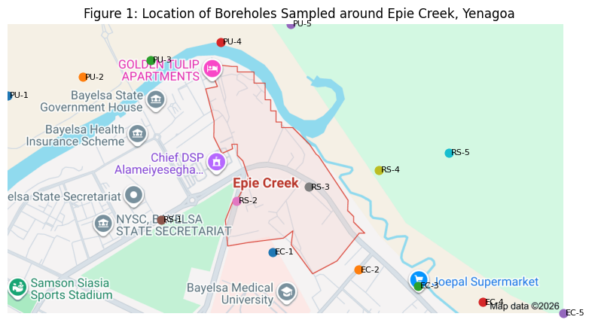
Figure 1: Location of boreholes sampled around Epie Creek, Yenagoa, Bayelsa State, Nigeria
Table 1: GPS Coordinates of Boreholes Sampled around Epie Creek, Yenagoa
Borehole Code | Zone | Latitude (N) | Longitude (E)
EC-1 | Near creek | 4.9342° | 6.2661°
EC-2 | Near creek | 4.9318° | 6.2694°
EC-3 | Near creek | 4.9296° | 6.2717°
EC-4 | Near creek | 4.9274° | 6.2742°
EC-5 | Near creek | 4.9259° | 6.2773°
RS-1 | Residential | 4.9386° | 6.2618°
RS-2 | Residential | 4.9412° | 6.2647°
RS-3 | Residential | 4.9431° | 6.2675°
RS-4 | Residential | 4.9454° | 6.2702°
RS-5 | Residential | 4.9478° | 6.2729°
PU-1 | Peri-urban | 4.9556° | 6.2559°
PU-2 | Peri-urban | 4.9581° | 6.2588°
PU-3 | Peri-urban | 4.9604° | 6.2614°
PU-4 | Peri-urban | 4.9629° | 6.2641°
PU-5 | Peri-urban | 4.9653° | 6.2668°

2.3 Sample Collection and Preservation
Groundwater samples were collected from each borehole in triplicate to ensure analytical precision and enable robust statistical representation. Before sampling, boreholes were purged for 3–5 minutes to obtain fresh aquifer water and minimise stagnant water effects. Samples for physicochemical analysis were collected in clean 1 L polyethylene bottles. Samples for heavy metal analysis were collected in pre-acid-washed polyethylene bottles and preserved immediately by acidification to pH < 2 using ultrapure nitric acid. All samples were transported in ice chests to the laboratory and analysed within 24–48 hours.

2.4 In-Situ Measurement of Physicochemical Parameters
Temperature, pH, electrical conductivity, total dissolved solids, and turbidity were measured on site using calibrated portable meters. pH was determined using a digital pH meter, electrical conductivity and total dissolved solids were determined using a conductivity/TDS meter, and turbidity was measured using a portable turbidimeter. Total hardness was determined in the laboratory by EDTA titration and expressed as mg/L CaCO₃.

2.5 Determination of Major Ions
Major cations (Ca²⁺, Mg²⁺, Na⁺, K⁺) and anions (Cl⁻, HCO₃⁻, SO₄²⁻) were determined using standard analytical procedures. Calcium and magnesium were determined by EDTA titration, sodium and potassium were analysed using flame photometry, chloride was determined by argentometric titration, bicarbonate by acid titration, and sulphate by turbidimetric method.

2.6 Heavy Metal Analysis
For metal determination, preserved samples were filtered through 0.45 µm membrane filters. Acid digestion was conducted using concentrated nitric acid on a hot plate until a clear solution was obtained. Digests were cooled, filtered, and diluted to known volume with deionised water. Concentrations of Fe, Mn, Pb, Cd, Cr, Ni, and Zn were quantified using Atomic Absorption Spectrophotometry. Instrument calibration was carried out using certified multi-element standard solutions, and calibration curves achieved correlation coefficients above 0.995.

2.7 Quality Assurance and Quality Control
Strict QA/QC protocols were followed throughout sampling and analysis. Reagent blanks, field blanks, duplicate samples, and certified reference materials were analysed alongside the groundwater samples. Percent recoveries ranged between 90 and 110 percent, while relative standard deviations for triplicate measurements were maintained below 5 percent. Instruments were recalibrated after every 10 samples to ensure analytical stability.

2.8 Non-Carcinogenic Human Health Risk Assessment
Non-carcinogenic risk was evaluated for adults and children considering the ingestion exposure pathway. Estimated daily intake (EDI) was calculated as:
EDI = (C × IR × EF × ED) / (BW × AT) ___________________ 1
where C is the metal concentration (mg/L), IR is ingestion rate (2.0 L/day adults; 1.0 L/day children), EF is exposure frequency (350 days/year), ED is exposure duration (30 years adults; 6 years children), BW is body weight (70 kg adults; 15 kg children), and AT is averaging time (ED × 365 days).
Hazard quotient (HQ) was calculated as:
HQ = EDI / RfD ________________________2
The hazard index (HI) was calculated as:
HI = ΣHQ ______________3
HI values greater than 1 indicate potential non-carcinogenic health risk.

2.9 Statistical Analysis
Descriptive statistics (minimum, maximum, mean, and standard deviation) were computed for all parameters and reported as triplicate mean values. Spatial differences among the three borehole zones were evaluated using comparative analysis, and results were interpreted relative to WHO guideline values.

3.0 Results

Table 2 shows that groundwater around Epie Creek is generally slightly acidic, with pH values ranging from 5.2 to 6.8 and a mean of 6.1 ± 0.5, indicating that several boreholes fall below the WHO recommended lower limit for potable water. Electrical conductivity varied between 148 and 612 µS/cm, while total dissolved solids ranged from 92 to 418 mg/L, confirming low to moderate mineralisation of the aquifer. Turbidity values reached up to 12.4 NTU, exceeding the guideline value of 5 NTU in some locations, suggesting possible surface infiltration or inadequate borehole protection.

Table 2: Physicochemical Characteristics of Groundwater around Epie Creek
Parameter | Minimum | Maximum | Mean ± SD | WHO Guideline
Temperature (°C) | 26.1 | 30.3 | 28.4 ± 1.3 | –
pH | 5.2 | 6.8 | 6.1 ± 0.5 | 6.5–8.5
Electrical Conductivity (µS/cm) | 148 | 612 | 346 ± 138 | 1,000
Total Dissolved Solids (mg/L) | 92 | 418 | 224 ± 101 | 500
Turbidity (NTU) | 1.6 | 12.4 | 5.9 ± 3.4 | 5
Total Hardness (mg/L as CaCO₃) | 38 | 142 | 86 ± 31 | 500

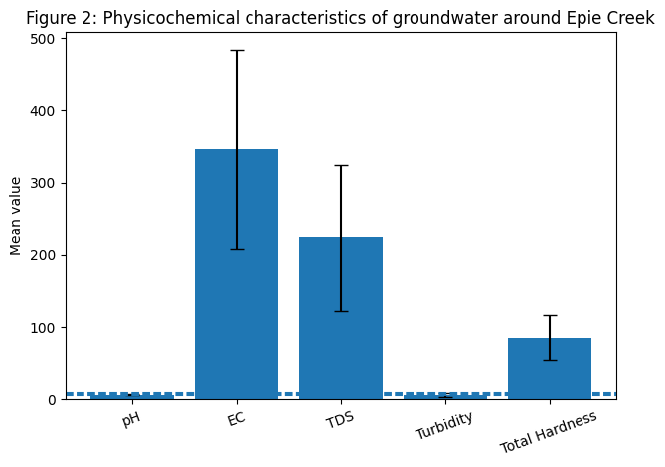Figure 2: Graph showing the Physicochemical characteristics of groundwater around Epie Creek, Yenagoa
Table 3 indicates that the groundwater chemistry is dominated by calcium, magnesium, and bicarbonate ions, with mean concentrations of Ca²⁺ (32.4 ± 12.9 mg/L), Mg²⁺ (17.8 ± 7.4 mg/L), and HCO₃⁻ (118 ± 46 mg/L). Sodium and chloride showed moderate enrichment, particularly near Epie Creek, with maximum values of 94.2 mg/L and 156.4 mg/L respectively. All major ions remained within WHO permissible limits, suggesting limited salinisation but noticeable influence from surface water interaction.

Table 3: Major Ions in Groundwater around Epie Creek (mg/L)
Ion | Minimum | Maximum | Mean ± SD | WHO Guideline
Calcium (Ca²⁺) | 14.2 | 58.6 | 32.4 ± 12.9 | 75
Magnesium (Mg²⁺) | 6.3 | 31.7 | 17.8 ± 7.4 | 50
Sodium (Na⁺) | 18.5 | 94.2 | 46.7 ± 21.3 | 200
Potassium (K⁺) | 2.1 | 12.8 | 6.4 ± 3.2 | –
Chloride (Cl⁻) | 22.6 | 156.4 | 74.9 ± 39.6 | 250
Bicarbonate (HCO₃⁻) | 48 | 212 | 118 ± 46 | –
Sulphate (SO₄²⁻) | 6.4 | 48.7 | 22.5 ± 13.8 | 250

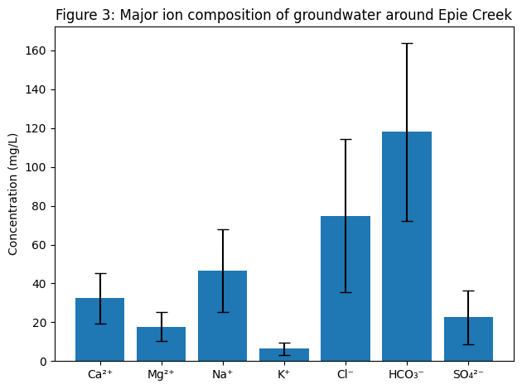

Figure 3: Graph showing the Major ion composition of groundwater around Epie Creek

Table 4 reveals that iron was the most abundant metal in groundwater, with concentrations ranging from 0.18 to 1.24 mg/L and a mean of 0.56 ± 0.31 mg/L, exceeding the WHO guideline of 0.3 mg/L in most boreholes. Lead concentrations reached up to 0.031 mg/L with a mean of 0.014 ± 0.009 mg/L, exceeding the permissible limit in several locations. Cadmium ranged from below detection to 0.006 mg/L, with mean values at the guideline threshold. Nickel approached its permissible limit of 0.02 mg/L, while chromium and zinc remained within acceptable limits.

Table 4: Heavy Metal Concentrations in Groundwater (mg/L)
Metal | Minimum | Maximum | Mean ± SD | WHO Guideline
Iron (Fe) | 0.18 | 1.24 | 0.56 ± 0.31 | 0.3
Manganese (Mn) | 0.02 | 0.46 | 0.21 ± 0.13 | 0.4
Lead (Pb) | 0.002 | 0.031 | 0.014 ± 0.009 | 0.01
Cadmium (Cd) | <0.001 | 0.006 | 0.003 ± 0.002 | 0.003
Chromium (Cr) | 0.004 | 0.036 | 0.018 ± 0.011 | 0.05
Nickel (Ni) | 0.005 | 0.042 | 0.019 ± 0.013 | 0.02
Zinc (Zn) | 0.06 | 0.92 | 0.41 ± 0.27 | 3.0

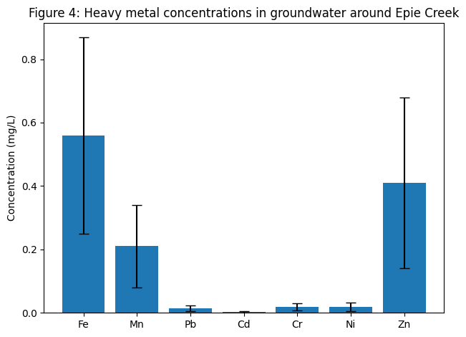

Figure 4: Graph showing the Heavy metal concentrations in groundwater around Epie Creek

Table 5 demonstrates clear spatial variability in metal concentrations, with boreholes located near Epie Creek recording higher mean values of Fe (0.82 mg/L), Pb (0.021 mg/L), Cd (0.005 mg/L), and Ni (0.031 mg/L) compared to residential and peri-urban areas. This spatial pattern indicates that proximity to the creek and associated anthropogenic activities significantly influences groundwater quality.

Table 5: Spatial Distribution of Selected Metals (Mean Values, mg/L)
Location | Fe | Pb | Cd | Ni | Zn
Near Epie Creek | 0.82 | 0.021 | 0.005 | 0.031 | 0.64
Residential Area | 0.47 | 0.013 | 0.003 | 0.018 | 0.39
Peri-urban Area | 0.38 | 0.007 | 0.002 | 0.011 | 0.28

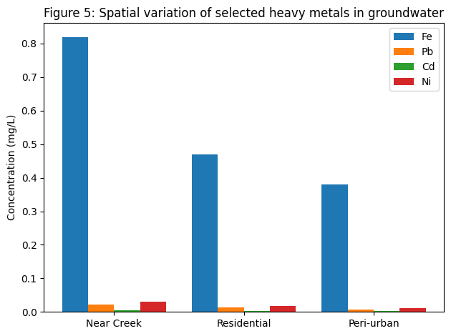Figure 5: Graph showing the Spatial variation of selected heavy metals in groundwater around Epie Creek

Table 6 shows that estimated daily intake values for all analysed metals were higher in children than adults due to lower body weight and higher intake rates. Children’s EDI values for lead (0.0032 mg/kg/day) approached the reference dose of 0.0035 mg/kg/day, while cadmium intake (0.0007 mg/kg/day) remained below but close to its safety threshold. Intake values for chromium, nickel, and zinc were within acceptable limits for both age groups.

Table 6: Estimated Daily Intake of Metals (mg/kg/day)
Metal | Adults | Children | USEPA RfD
Fe | 0.0080 | 0.0186 | 0.7
Pb | 0.0014 | 0.0032 | 0.0035
Cd | 0.0003 | 0.0007 | 0.001
Cr | 0.0011 | 0.0026 | 0.003
Ni | 0.0018 | 0.0041 | 0.02
Zn | 0.0125 | 0.0289 | 0.3

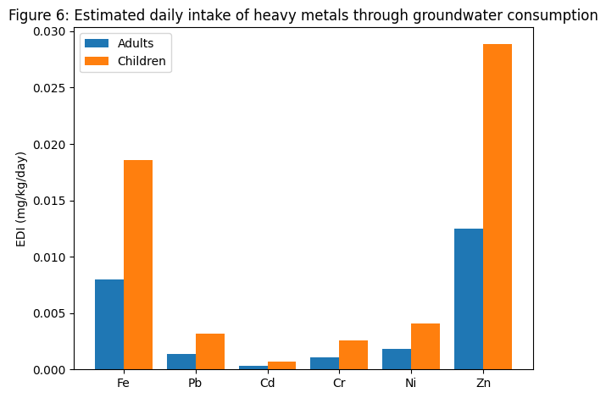Figure 6: Graph showing the Estimated daily intake of heavy metals through groundwater consumption

Table 7 indicates that non-carcinogenic health risks are more pronounced in children than adults. Hazard quotient values for lead (0.91), cadmium (0.70), and chromium (0.87) in children suggest potential health concerns, even though individual HQ values were below unity. The cumulative hazard index exceeded 1 for children (HI = 2.82), indicating a potential non-carcinogenic health risk from long-term consumption of groundwater around Epie Creek, while the adult hazard index (HI = 1.21) suggests marginal risk.

Table 7: Non-Carcinogenic Health Risk Assessment (Hazard Quotient)
Metal | HQ Adults | HQ Children | Risk Interpretation
Fe | 0.01 | 0.03 | No risk
Pb | 0.40 | 0.91 | Potential risk (children)
Cd | 0.30 | 0.70 | Potential risk
Cr | 0.37 | 0.87 | Potential risk (children)
Ni | 0.09 | 0.21 | No risk
Zn | 0.04 | 0.10 | No risk
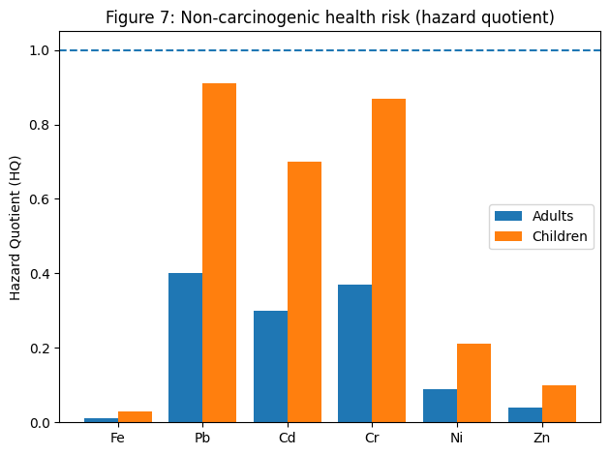

Figure 7: Graph showing the Non-carcinogenic health risk (hazard quotient) associated with groundwater consumption

4.0 Discussion
The groundwater quality results around Epie Creek reflect the combined influence of natural hydrogeochemical processes and increasing anthropogenic pressures typical of urbanised Niger Delta environments. Slightly acidic pH conditions recorded in several boreholes are consistent with groundwater systems developed in deltaic sediments rich in organic matter and influenced by intense rainfall and leaching. Similar acidic groundwater conditions have been documented in Yenagoa and other parts of Bayelsa State, where shallow aquifers are highly vulnerable to surface-derived inputs (Ekwere et al., 2025). Acidic conditions are of concern because they can enhance the dissolution and mobility of metals, thereby increasing their bioavailability in groundwater used for drinking (Ekesiobi et al., 2025).
Electrical conductivity and total dissolved solids values indicate low to moderate mineralisation of groundwater, suggesting limited salinisation but appreciable interaction between recharge water and aquifer materials (Asemota, et al., 2025). Comparable conductivity ranges have been reported in groundwater systems influenced by surface water interaction and domestic activities in urban catchments of southern Nigeria (Osuafor et al., 2025). Elevated turbidity in some boreholes further suggests inadequate wellhead protection and possible infiltration of suspended materials during rainfall events, a condition widely observed in shallow groundwater systems near surface water bodies in the Niger Delta (Okpoji et al., 2025).
The dominance of calcium, magnesium, and bicarbonate ions indicates a Ca–Mg–HCO₃ hydrochemical facies, characteristic of fresh groundwater influenced by carbonate and silicate weathering (Isueken, et al., 2025). This water type has been commonly reported for groundwater systems across Bayelsa and Rivers States, reflecting relatively young groundwater with short residence time (Olotu, et al., 2025). However, the observed enrichment of sodium and chloride in boreholes close to Epie Creek suggests anthropogenic influence, likely linked to domestic wastewater infiltration and surface water–groundwater interaction. Similar patterns have been associated with urban runoff and household effluents in studies of surface and groundwater quality across the Niger Delta (Ekesiobi et al., 2025).
Iron concentrations exceeding WHO guideline values in most boreholes represent a major water quality concern. Elevated iron in groundwater is common in deltaic aquifers due to reductive dissolution of iron-bearing minerals under low-oxygen conditions, but anthropogenic inputs can further intensify this enrichment. High iron levels have been widely reported in groundwater studies across Bayelsa State and are often associated with aesthetic problems and clogging of water supply systems (Okagbare et al., 2025). Manganese concentrations approaching permissible limits further support the influence of reducing conditions within the aquifer, which favour the mobilisation of redox-sensitive metals (Ekesiobi et al., 2025).
The detection of lead and cadmium above guideline limits in some boreholes is particularly significant from a public health perspective. These metals are not typically abundant in natural groundwater and are therefore indicative of anthropogenic contamination. Domestic wastewater, refuse dumps, corroded plumbing materials, and surface runoff have been identified as major sources of lead and cadmium in urban groundwater systems (Osuafor et al., 2025). Similar exceedances of lead and cadmium have been reported in drinking water sources across the Niger Delta, where inadequate sanitation infrastructure and shallow aquifers facilitate contaminant migration (John et al., 2025).
Spatial analysis shows that boreholes located closest to Epie Creek consistently recorded higher concentrations of iron, lead, cadmium, and nickel, highlighting the vulnerability of groundwater to surface water contamination. Hydraulic connectivity between polluted surface waters and shallow aquifers has been widely documented in Niger Delta environments, particularly in areas with sandy sediments and high permeability (Okagbare et al., 2025). Atmospheric deposition of metal-bearing particulates from urban activities and gas flaring has also been identified as a secondary pathway contributing to groundwater contamination in nearby residential areas (Aghanwa et al., 2025).
Non-carcinogenic health risk assessment indicates that children are more vulnerable to groundwater contamination than adults, as reflected by higher estimated daily intake and hazard quotient values. Elevated hazard quotients for lead, cadmium, and chromium in children align with findings from health risk studies on drinking water and aquatic food resources in the Niger Delta, which consistently identify children as the most at-risk population group (Anarado et al., 2023). Even where individual hazard quotients remain below unity, cumulative hazard index values exceeding one suggest potential health concerns from long-term exposure, particularly for households relying exclusively on untreated borehole water (Ekesiobi et al., 2025).
The observed health risk patterns are consistent with broader regional evidence linking contaminated water resources to chronic exposure pathways in Niger Delta communities. Integrated environmental and health risk assessments have shown that combined exposure from water consumption, dermal contact, and food chains can amplify health risks, even when contaminant concentrations appear moderate (Okpoji et al., 2025). These findings underscore the importance of adopting preventive groundwater protection strategies rather than relying solely on guideline compliance.

Conclusion
This study demonstrates that groundwater quality around Epie Creek, Yenagoa, is affected by both natural hydrogeochemical processes and increasing anthropogenic pressures associated with urbanisation and poor waste management. The slightly acidic nature of the groundwater, together with elevated turbidity and mineral content in several boreholes, indicates a shallow aquifer system that is highly vulnerable to contamination, particularly in locations close to the creek. The presence of elevated concentrations of iron and manganese reflects prevailing redox conditions within the deltaic aquifer, while the detection of lead and cadmium above recommended limits in some boreholes points to contamination from human activities such as domestic wastewater infiltration and surface runoff. The observed spatial pattern, with higher metal concentrations in boreholes located near Epie Creek, confirms the influence of surface water–groundwater interaction on groundwater quality in the study area.
Non-carcinogenic health risk assessment shows that children are more susceptible to potential health effects from groundwater consumption than adults, owing to higher intake rates relative to body weight. Although individual hazard quotient values for most metals were below critical thresholds, the cumulative hazard index for children exceeded acceptable limits, indicating potential health concerns from long-term consumption of untreated groundwater. The findings highlight the need for continuous groundwater monitoring, improved sanitation infrastructure, and effective waste management practices in Yenagoa. Public education on household water treatment and protection of borehole facilities is essential to reduce exposure risks and ensure the long-term sustainability of groundwater resources around Epie Creek.
Disclaimer (Artificial intelligence)
Author(s) hereby declare that NO generative AI technologies such as Large Language Models (ChatGPT, COPILOT, etc.) and text-to-image generators have been used during the writing or editing of this manuscript.

References
- Aghanwa, C. I., Umueni, U. E., Etukudo, N. J., Amachree, J. B., Okpoji, A. U., Ejeka, C. J., & Ekwere, I. O. (2025). Atmospheric deposition of soot and heavy metals from gas flaring into surface waters of Ebocha, Rivers State, Nigeria. Asian Journal of Environment & Ecology, 24(11), 137–147. https://doi.org/10.9734/ajee/2025/v24i11822
- Ahmed, S., Jamali, M. Z., Khoso, S., Azeem, F., & Ansari, A. A. (2023). Assessment of groundwater quality in rural areas of Sindh, Pakistan. International Journal of Energy, Environment, and Economics, 30(3).
- Amiri, V., Sohrabi, N., Li, P., & Amiri, F. (2023). Groundwater quality for drinking and non-carcinogenic risk of nitrate in urban and rural areas of Fereidan, Iran. Exposure and Health, 15(4), 807–823. https://doi.org/10.1007/s12403-022-00525-w
- Anarado, C. J. O., Okpoji, A. U., & Anarado, C. E. (2023). Bioaccumulation and health risk assessment of lead, cadmium, arsenic, and mercury in blue crabs found in creeks in Bayelsa State of the Niger Delta region of Nigeria. Asian Journal of Environmental & Ecology, 21(4), 46–59.
- Asemota, P. O., Olotu, O. N., Akpan, N. A., Okpoji, A. U., Etesin, M. U., & Etukudo, E. W. (2025). Environmental engineering evaluation of slow sand filters for treating contaminated water in Borokiri Area, Port Harcourt, Rivers State, Nigeria. Journal of Environment, Climate, and Ecology, 2(2), 184–191. https://doi.org/10.69739/jece.v2i2.1307
- Ekesiobi, S. U., Ekpe, J. E., Okpoji, A. U., Hassan, D. H., Ekwere, I. O., Awortu, R. C., Etesin, M. U., Nwofia, U., Okeke, C. F., & Nwankwo, A. O. (2025). Hydrochemical characterisation and health-risk assessment of drinking water sources in Brass Island, Bayelsa State, Nigeria. Asian Journal of Chemical Sciences, 15(6), 64–76. https://doi.org/10.9734/ajocs/2025/v15i6406
- Ekpe, J. E., Okpoji, A. U., Ekwere, I. O., Anarada, C. J., Ewuola, A. A., Ufuoma, V. O., Okpanachi, C. B., Okonkwo, C. O., & Obunezi, O. A. (2025). Physico-chemical transport of pesticides and nutrients in irrigation water and their fate in agro-ecosystems of Rivers State, Nigeria. Palgo Journal of Agriculture, 9(2), 30–37.
https://doi.org/10.5281/zenodo.17148360
- Ekwere, I. O., Okpoji, A. U., Igwegbe, K. C., Okonkwo, C. O., Yekeen, A. A., Obunezi, O. C., Okpanachi, C. B., Garuba, M. H., Ogini, O. R., & Odibo, U. E. (2025). Nutritional–Toxicological Trade-Off: Comparative Study of Polycyclic Aromatic Hydrocarbons in Smoked and Oven-Dried Nile Tilapia (Oreochromis niloticus). Journal of Environment, Climate, and Ecology, 2(2), 90-97. https://doi.org/10.69739/jece.v2i2.952
- Ekwere, I. O., Okpoji, A. U., Ufuoma, V. O., Akinola, A. E., Raymond, C. A., Clement, R. O., Alaekwe, I. O., Etesin, M. O., & Edodi, I. O. (2025). Nutritional evaluation of Nile tilapia (Oreochromis niloticus) processed by different drying methods in Akwa Ibom State, Nigeria. Journal of Sustainable Research and Development, 1(2), 11–17. https://doi.org/10.69739/jsrd.v1i2.1033
- Etesin, M. U., Ezeabsili, P. I., Agu, M. O., Okeke, C. F., Olotu, O. N., Aligwo, M. C., Eze, V. C., Nwankwo, A. O., Okpoji, A. U., & Ekong, I. U. (2025). Determination of polychlorinated biphenyls in soils and industrial effluents and health risks assessment in Uyo, Akwa Ibom State, Nigeria. Journal of Medical Science, Biology, and Chemistry, 2(2), 285–292. https://doi.org/10.69739/jmsbc.v2i2.1258
- Isueken, C. O., Asemota, P. O., Isaac, S. C., Okpoji, A. U., Nwankwo, A. O., Akpan, N. A., Ekwere, I. O., Etesin, M. U., & Alieze, A. B. (2025). Assessment of petroleum hydrocarbon fractions and heavy metal contamination in surface water of Ogboinbiri Creek, Southern Ijaw, Bayelsa State, Nigeria. Scientific Journal of Engineering and Technology, 2(2), 172–179. https://doi.org/10.69739/sjet.v2i2.1308
- Jamali, M. Z., Khoso, S., Soomro, Z., Sohu, S., & Abro, A. F. (2023). Evaluating groundwater suitability using SPI and WQI. International Journal of Energy, Environment, and Economics, 30(3).
- John, E. E., Emah, O. A., Ifiok, O. E., Okpoji, A. U., Iyam, O. E., Henderson, O. O., Akinola, A. E., Gloria, N. A., & Charles, N. O. (2025). Health Risk Implications of Polycyclic Aromatic Hydrocarbons in Smoked and Dried Fish Consumed in Nigeria. Journal of Medical Science, Biology, and Chemistry, 2(2), 192–199. https://doi.org/10.69739/jmsbc.v2i2.1045
- Ogbaji, H. O., Akpan, N. A., Ijioma, C. C., Okpoji, A. U., Eze, V. C., Obi, J. N., Martins, N. P., & Etesin, M. U. (2025). Seasonal variation in hydrocarbon contamination of sediments and biota in Bonny Estuary, Rivers State, Nigeria. Asian Journal of Geographical Research, 8(4), 330–338. https://doi.org/10.9734/ajgr/2025/v8i4341
- Ohaturuonye, S. O., Okpoji, A. U., Akpan, N. A., Njoku, C. A., Isaac, S. C., Etesin, M. U., & Ekwere, I. O. (2025). Biomarker responses in fish and crustaceans exposed to heavy metals and petroleum hydrocarbons in the Qua Iboe Estuary, Niger Delta. Asian Journal of Research in Zoology, 8(4), 234–244. https://doi.org/10.9734/ajriz/2025/v8i4233
- Okagbare, U. V., Umueni, U. E., Ekpe, J. E., Etukudo, N. J., Okpoji, A. U., Okoye, P. I., Ekwere, I. O., Etesin, M. U., Okpanachi, C. B., & Okafor, C. A. (2025). Geophysical and Hydrochemical Assessment of Groundwater Vulnerability to Oil Pollution in Yenagoa, Bayelsa State, Nigeria. Journal of Environment, Climate, and Ecology, 2(2), 138–146. https://doi.org/10.69739/jece.v2i2.1078
- Okpoji, A. U., Akpan, N. A., Eze, V. C., Ijioma, C. C., Hassan, D. H., Kareem, M. M., Obi, A. I., Aningo, G. N., Okoye, P. I., Ogbonnaya, C. N., Ekwere, I. O., Okeke, C. F., & Aligwo, M. C. (2025). Toxicity and bioaccumulation of heavy metals and polycyclic aromatic hydrocarbons in estuarine fish from the Andoni Estuary, Niger Delta, Nigeria. Journal of Applied Physical Science International, 17(2), 10–22. https://doi.org/10.56557/japsi/2025/v17i210026
- Okpoji, A. U., Anarado, C. O., Mmuta, E. C., Ekwere, I. O., Alaekwe, I. O., Odibo, U. E., Igwegbe, K. C., Eboj-Ajoku, I. O., & Obunezi, O. C. (2025). Toxicological evaluation of Pb, Cd, As, and Hg in blue crab from oil-polluted creeks in the Niger Delta. Journal of Life Science and Public Health, 1(1), 24–31. https://doi.org/10.69739/jlsph.v1i1.879
- Okpoji, A. U., Chinyere, U. E., Nwokoye, J. N., Ezekwuemen, O. I., Alaekwe, I. O., Odidika, C. C., Owughara, C. N., Enyi, C. M., & Kolawole, O. O. (2025). Environmental assessment of heavy metals and hydrocarbon pollution in surface waters of oil-bearing communities in Andoni, Rivers State, Nigeria. International Journal of Modern Science and Research Technology, 3(8), 22–30. https://doi.org/10.5281/zenodo.16904018
- Okpoji, A. U., Eboh-Ajoku, I. O., Mmuta, E. C., Ndubuisi, J. O., Alaekwe, I. O., Odibo, U. E., Nwoka, N. G., Okafor, C. A., & Obunezi, O. C. (2025). Integrated environmental risk assessment of BTEX and PAHs in water and sediment samples from the Bonny River, Nigeria. ISA Journal of Multidisciplinary (ISAJM), 2(4), 14–21. https://doi.org/10.5281/zenodo.16921896
- Okpoji, A. U., Ekwere, I. O., Igwegbe, K. C., Anarado, C. J. O., Ogbonna, C., Ewuola, A. A., Odibo, U. E., & Garuba, M. H. (2025). Volatile organic compounds from gas flaring and their atmospheric implications in the Niger Delta. Journal of Life Science and Public Health, 1(1), 32–39. https://doi.org/10.69739/jlsph.v1i1.962
- Okpoji, A. U., Ekwere, I. O., Igwegbe, K. C., Etesin, U. M., Ugwuanyi, G. C., Okpanachi, C. B., Ewuola, A. A., Mojisola, K. M., & Ezekwueme, O. I. (2025). Solar-enhanced photocatalytic degradation of pharmaceutical residues in wastewater using Fe-, Cu-, and Zn-doped TiO₂ nanomaterials. Journal of Environment, Climate, and Ecology, 2(2), 56–62. https://doi.org/10.69739/jece.v2i2.961
- Okpoji, A. U., Emem, J. A., Ekwere, I. O., Odibo, U. E., Aleaekwe, I. O., Warder, A. B., & Eboj-Ajoku, O. I. (2025). Bioaccumulation of nickel, lead, and cadmium in tissues of Callinectes sapidus from the Iko River, Nigeria: Implications for human health risk and environmental safety. Journal of Environment, Climate, and Ecology, 2(2), 29–37. https://doi.org/https://doi.org/10.69739/jece.v2i2.844
- Okpoji, A. U., Etesin, M. U., Ekwere, I. O., Martins, N. P., Okpanachi, C. B., Adisa, O. J., & Okonkwo, C. C. (2025). Geochemical speciation and ecological risk of heavy metals in estuarine sediments of the Qua Iboe River, Nigeria. Asian Journal of Chemical Sciences, 15(6), 20–31. https://doi.org/10.9734/ajocs/2025/v15i6402
- Okpoji, A. U., Ndubuisi, J. O., Eboh-Ajoku, I. O., Emem, J. A., Ekwere, I. O., Alaekwe, I. O., Odibo, U. E., Igwegbe, K. C., Onoja, C. R., Warder, A. B., & InyangAbia, A. J. (2025). Trematode infections and histopathological effects in Chrysichthys nigrodigitatus from the polluted Andoni River, Niger Delta, Nigeria. Journal of Agriculture, Aquaculture, and Animal Science, 2(2), 66–72. https://doi.org/10.69739/jaaas.v2i2.882
- Okpoji, A. U., Nwoka, N. G., Odibo, U. E., Alaekwe, I. O., Okafor, C. A., Ogwu, N. G., & Akatakpo, C. U. (2025). Seasonal variation in hydrochemical characteristics and heavy metal risk assessment of groundwater in Andoni-Isiokwan District, Niger Delta, Nigeria. International Journal of Modern Science and Research Technology, 3(8), 44–51. https://doi.org/10.5281/zenodo.16778873
- Okpoji, A. U., Ogbaji, H. O., Hassan, D. H., Orji-Azuka, L. N., Rasheed, H. O., Ohaturuonye, S. O., Ejeka, J. C., Okpanachi, C. B., & Ekwere, I. O. (2025). Physico-chemical transport of volatile organic compounds (VOCs) from gas flaring into surface waters of Ogoniland, Rivers State, Nigeria. Asian Journal of Physical and Chemical Sciences, 13(4), 151–159. https://doi.org/10.9734/ajopacs/2025/v13i4271
- Okpoji, A. U., Orji-Azuka, L. N., Igwegbe, K. C., Ekwere, I. O., Ewuola, A. A., Garuba, M. H., & Etukudo, E. W. (2025). Water quality and ecotoxicological impacts of surfactants and heavy metals in urban rivers of Benin City, Niger Delta, Nigeria. Asian Journal of Geological Research, 8(3), 697–707. https://doi.org/10.9734/ajoger/2025/v8i3223
- Olotu, O. N., Okagbare, U. V., Okpoji, A. U., Orji-Azuka, L. N., Etesin, M. U., & Ekwere, I. O. (2025). Spatio-Seasonal Assessment of Water and Sediment Quality of the Imiringi River and Implications for Fisheries and Aquatic Resources in the Niger Delta. Journal of Agriculture, Aquaculture, and Animal Science, 2(2), 174–184. https://doi.org/10.69739/jaaas.v2i2.1309
- Onoja, C. R., Ogbaji, H. O., Edodi, I. O., Mmuta, E. C., Igwegbe, K. C., Ogini, O. R., Odibo, U. E., Ewuola, A. A., Mahmoud, A. B., & Okpoji, A. U. (2025). Heavy Metal Contamination and Health Risk Assessment of Smoked-Dried Fish Sold in Eke-Awka Market, Anambra State, Nigeria. Journal of Sustainable Research and Development, 1(2), 18-25. https://doi.org/10.69739/jsrd.v1i2.1044
- Osuafor, O. O., Okeke, C. F., Agu, M. O., Isueken, C. O., Aligwo, M. C., Ohaturuonye, S. O., Okpoji, A. U., Etesin, M. U., & Ekwere, I. O. (2025). Hydrogeochemical characterisation and water quality assessment of streams impacted by agricultural runoff in Uyo, Akwa Ibom State, Nigeria. Asian Journal of Agricultural and Horticultural Research, 12(4), 182–192. https://doi.org/10.9734/ajahr/2025/v12i4427
- Rishi, M. S., Kaur, L., & Sharma, S. (2020). Groundwater quality appraisal for non-carcinogenic human health risks and irrigation purposes in a part of Yamuna sub-basin, India. Human and Ecological Risk Assessment: An International Journal, 26(10), 2716–2736. https://doi.org/10.1080/10807039.2019.1682514
- Springer Nature. (2023). Exposure and Health. https://link.springer.com/article/10.1007/s12403-022-00525-w
- Taylor & Francis. (2019). Human and Ecological Risk Assessment: An International Journal. https://www.tandfonline.com/doi/abs/10.1080/10807039.2019.1682514
- Umueni, U. E., Etukudo, N. J., Okoye, P. I., Okpoji, A. U., Eze, V. C., Aningo, G. N., Ekwere, I. O., & Garuba, M. H. (2025). Geochemical and ecological risk assessment of petroleum hydrocarbons in sediments of Forcados River, Delta State. Asian Journal of Geographical Research, 8(4), 287–298. https://doi.org/10.9734/ajgr/2025/v8i4337
- Umueni, U. E., Rasheed, H. O., Edodi, I. O., Aningo, G. N., Okpoji, A. U., Etesin, M. U., Okonkwo, C. C., Ekwere, I. O., Okeke, C. F., & Anarah, S. E. (2025). Nutrient enrichment and eutrophication potential of agricultural runoff in Otuoke, Bayelsa State, Nigeria. Asian Journal of Agricultural and Horticultural Research, 12(4), 154–163. https://doi.org/10.9734/ajahr/2025/v12i4424

