AI-Driven Optimisation of Drilling Parameters in High Temperature Geothermal Operations

ABSTRACT
Geothermal drilling remains a dominant cost driver in high-enthalpy resource development because wells frequently penetrate hard, abrasive lithologies under high-temperature conditions that increase bit wear, drilling dysfunctions, and non-productive time. While machine-learning (ML) methods have demonstrated strong performance for rate of penetration (ROP) prediction and drilling diagnostics in petroleum operations, geothermal applications remain comparatively limited due to data scarcity, abrupt lithology transitions, and measurement-while-drilling (MWD) degradation at elevated temperatures. This study develops an end-to-end, geothermal-specific optimisation workflow that integrates supervised ML prediction (Random Forest, XGBoost, and Long Short-Term Memory networks), uncertainty quantification, and continuous-control reinforcement learning (Soft Actor–Critic, SAC) to recommend safe operational adjustments. Using adapted datasets representative of the Iceland Deep Drilling Project (IDDP) and the Cooper Basin Habanero enhanced geothermal system campaign, the LSTM achieved the best predictive performance (R² = 0.92), while feature-importance analysis identified weight-on-bit (WOB), rotary speed (RPM), and lithology as dominant drivers of ROP. Following technical validation of the drilling-time accounting, the SAC-optimised parameter trajectory reduced total drilling time from 100.0 hours to 95.9 hours, corresponding to a corrected improvement of 4.1% relative to baseline operations. Five-fold cross-validation produced a mean reduction of 4.1% (95% CI: [3.8%, 4.4%], SD = 0.15%). Uncertainty bands widened in high-temperature and highly fractured intervals, highlighting the need for uncertainty-aware decision support. Overall, the results demonstrate that integrated ML–RL optimisation can deliver measurable efficiency gains in geothermal drilling while providing transparency through uncertainty quantification and safety constraints suitable for real-world deployment. Iintegrated AI-based optimisation frameworks can significantly improve geothermal drilling outcomes, offering faster drilling, reduced operational risk, and more cost-effective well construction. These insights underscore the transformative potential of AI for enhancing geothermal project economics and enabling wider deployment of geothermal energy.
Keywords: Geothermal drilling; rate of penetration; reinforcement learning; uncertainty quantification; optimisation

1. INTRODUCTION

1.1 Background and Motivation
Deep geothermal energy, known for its stable base load power and resilience to environmental fluctuations, is increasingly recognized as an important renewable energy source. Yet, its development is constrained by subsurface variability, high exploration costs, and operational inefficiencies. Artificial intelligence (AI) can analyze complex data, reveal patterns, and support predictive modeling to lower costs, shorten timelines, and improve efficiency (Yang et al., 2024). Geothermal energy is increasingly recognised as a key pillar in the global transition to low‑carbon power systems due to its capacity to deliver continuous baseload electricity (IEA, 2021; Shortall et al., 2015). However, the expansion of geothermal development remains constrained by high drilling costs, which can account for nearly half of total project expenditure (Augustine, 2016). These costs arise from the challenging physical environment encountered during drilling. The rate of penetration (ROP) is the key parameter to enhance drilling processes as it is inversely proportional to the overall cost of drilling operations. Maximizing the ROP without any limitation can induce drilling dysfunctions such as downhole vibrations. Enhancing drilling efficiency to reduce operational costs has been a longstanding challenge in petroleum engineering. Central to this effort is the optimization of the ROP, which is largely governed by surface-controlled parameters such as the weight on bit (WOB) and rotary speed (RPM). Historically, numerous approaches have been developed to simulate and optimize the ROP, including physics-based models grounded in rock mechanics and dynamics (Boukredera et al., 2025). Operators must penetrate extremely hard and abrasive lithologies, such as basalt, granite, and andesite, while also managing high downhole temperatures that accelerate bit wear, slow the ROP, and increase non‑productive time (Friðleifsson et al., 2014; Sæmundsson et al., 2020). These operational challenges often result in suboptimal parameter selection, premature tool failure, and prolonged drilling durations, all of which reduce project feasibility.
Artificial intelligence (AI) has emerged as a promising technology for enhancing drilling efficiency. Machine‑learning algorithms can detect complex nonlinear interactions among drilling parameters, formation characteristics, and real‑time sensor responses, enabling more informed operational decisions. In the oil and gas sector, AI models have already been used to forecast ROP, detect drilling dysfunctions, optimise weight on bit (WOB) and rotary speed (RPM), and support data‑driven decision‑making. Despite this progress, geothermal drilling presents unique challenges that limit the direct transferability of these techniques. High temperatures commonly degrade measurement‑while‑drilling (MWD) tools, lithology changes are more abrupt and unpredictable, and mechanical stresses on the drillstring are significantly higher (Reinsch et al., 2017). These conditions require specialised optimisation frameworks tailored to geothermal environments.
The increasing technical complexity and economic pressures facing geothermal projects highlight the need for advanced analytical systems that can support operational decisions with higher precision and adaptability. AI‑driven optimisation offers the potential to reduce uncertainty, improve drilling efficiency, and lower overall project costs. Yet current industry practice has not fully embraced these capabilities. Addressing this gap and demonstrating the tangible benefits of AI‑supported geothermal drilling forms the central motivation of the present study.

1.2 Research Gap
Although geothermal energy has been commercially developed for several decades, drilling operations continue to face significant technical and economic constraints that impede large‑scale deployment. Drilling remains one of the most expensive components of geothermal projects, often accounting for 40–50% of total capital expenditure (Augustine, 2016; IEA, 2021). These high costs persist because geothermal wells are typically drilled through hard, heterogeneous, and high‑temperature formations that introduce extreme mechanical loads, accelerate bit wear, and increase non‑productive time (Friðleifsson et al., 2014; Reinsch et al., 2017).
Despite advances in drilling technology, most geothermal drilling optimisation strategies still rely heavily on engineering judgement, manual parameter tuning, and analogues from oil and gas operations. Such approaches are insufficient in environments where formation transitions are abrupt, sensor measurements suffer thermal degradation, and drilling responses vary nonlinearly with operational inputs (Sæmundsson et al., 2020). As a result, drilling teams often struggle to select optimal values for weight on bit, rotary speed, flow rate, and other critical parameters under rapidly changing downhole conditions. A major limitation in current geothermal practice is the absence of an integrated, data‑driven framework capable of predicting drilling behaviour and recommending optimal parameter adjustments in real time. Existing tools typically address isolated aspects of the drilling process, such as ROP prediction or dysfunction detection, without linking prediction and optimisation in a single decision-support system (Li et al., 2024). This gap leads to prolonged drilling durations, frequent bit replacements, and higher operational costs, ultimately affecting project viability. These challenges underscore the need for a comprehensive AI-supported optimisation system specifically tailored to geothermal drilling operations.

1.3 Research Questions and Objectives
This study addresses the following research questions (RQs):
RQ1: Can supervised machine-learning models accurately predict ROP under high-temperature geothermal drilling conditions using adapted real-world datasets?
RQ2: Can physics-constrained, continuous-control reinforcement learning (SAC) generate safe parameter trajectories that reduce drilling time relative to baseline operational strategies and standard optimisation baselines?
RQ3: How does uncertainty quantification improve the reliability of AI-driven decision support, and how do uncertainty and sensitivity propagate across depth and lithological transitions?

1.4 Contributions of This Paper
This study makes several important contributions that strengthen both the academic understanding of geothermal drilling optimisation and its practical application within real‑world high‑temperature environments:
1. Development of a Comprehensive AI‑Driven Modelling and Optimisation Framework
Most prior geothermal drilling studies focus on isolated analytical tasks, such as ROP prediction or bit wear analysis, without integrating the full decision-making pipeline (Li et al., 2024). In contrast, this research introduces a unified workflow that combines data preprocessing, feature engineering, supervised learning models, reinforcement learning, and uncertainty quantification, offering a coherent and scalable optimisation platform for geothermal operations (Moraga et al., 2022). This integrated architecture reflects the interconnected nature of real drilling systems, where parameter choices, mechanical responses, and geological transitions influence each other dynamically (Reinsch et al., 2017). By offering a coherent and scalable optimisation platform, the study provides a practical blueprint for geothermal operators seeking to leverage AI in extreme drilling environments.
2. Use of Adapted Real‑World Geothermal Datasets
A key barrier to geothermal machine‑learning research is the lack of accessible, high‑quality field datasets, due primarily to proprietary restrictions and sensor degradation at high temperatures (Friðleifsson et al., 2014; Augustine, 2016). This study addresses this challenge by incorporating adapted datasets derived from the Iceland Deep Drilling Project (IDDP) and the Cooper Basin Habanero EGS well. These datasets preserve realistic statistical patterns, abrupt lithological transitions, and high‑temperature effects while maintaining confidentiality. Their use enhances the ecological validity of the models, ensuring that the resulting optimisation framework is grounded in authentic geothermal drilling behaviour and engineering practice (Christyananta et al., 2025).
3. Hybrid Machine‑Learning Architecture Combining Prediction and Optimisation
Existing research rarely connects predictive modelling with real‑time optimisation, resulting in fragmented systems that cannot support end‑to‑end operational decision‑making. This study bridges that gap by combining supervised learning models, Random Forest, XGBoost, and LSTM with a reinforcement learning component that recommends optimal drilling parameters based on predicted outcomes. This hybrid approach captures sequential dependencies, feedback mechanisms, and nonlinear drilling responses, enabling adaptive optimisation rather than static, one‑off predictions.
4. Quantitative Evidence of Operational Performance Gains
The study demonstrates measurable improvements in drilling performance, showing that the proposed AI‑driven optimisation approach can reduce simulated drilling time by approximately 12-18% while achieving ROP prediction accuracies above 90%. Given that drilling constitutes nearly half of geothermal project costs (IEA, 2022), even modest improvements can yield substantial economic benefits. These results highlight the practical value of combining ML prediction with RL‑based optimisation and provide a strong foundation for future field testing and commercial deployment.
This paper develops an AI-driven optimisation strategy for geothermal drilling by integrating adapted geothermal datasets with advanced machine-learning workflows to evaluate how optimised operational parameters influence drilling efficiency.

2. Geothermal Drilling and AI Background

2.1 Geothermal Drilling Complexity
Geothermal drilling environments impose extreme mechanical, thermal, and geological stresses on drilling assemblies, making them substantially more challenging than conventional petroleum wells. Geothermal wells typically reach depths of 2-5 km and penetrate crystalline basement rocks with unconfined compressive strengths often exceeding 200-300 MPa (Sæmundsson et al., 2020; Friðleifsson et al., 2014). Basalt, granite, rhyolite, and andesite are common lithologies, each exhibiting abrasive mineralogy that accelerates bit wear and significantly reduces ROP.
High downhole temperatures, frequently surpassing 300°C in high‑enthalpy fields, exacerbate these mechanical challenges by degrading elastomers, impairing electronic components in MWD/LWD tools, and altering drilling fluid properties (Reinsch et al., 2017). Temperature‑induced viscosity changes can compromise hole cleaning and hydraulics stability, while thermal stress cycling contributes to fatigue in drillstring components.
Geothermal reservoirs are also characterised by pervasive fracturing, which leads to severe circulation losses, unstable wellbore conditions, and unpredictable formation responses. These fractured systems create sudden changes in torque, drag, and bit response, complicating parameter optimisation and increasing operational risk. Compared with conventional oil and gas wells, geothermal wells experience more pronounced drillstring vibrations, including stick‑slip, lateral whirl, and axial oscillations, largely due to hard‑rock interactions and inconsistent formation strength. Mud rheology must be carefully balanced to prevent fluid flashing, maintain cooling, and ensure adequate cuttings transport. These operational complexities demand highly adaptive drilling strategies that respond dynamically to mechanical and geological changes.
Collectively, these factors highlight the need for advanced, data‑driven optimisation frameworks capable of interpreting complex drilling behaviours and providing decision support under extreme geothermal conditions.

2.2 AI in Drilling Engineering
AI applications in drilling engineering have expanded rapidly, offering powerful tools for prediction, diagnosis, optimisation, and automated decision support. These applications span four major domains:
1. Predictive Analytics for ROP, Torque, and Other KPIs
Predictive modelling is one of the most mature areas of AI in drilling. AI models, including tree-based algorithms, artificial neural networks (ANNs), and deep learning architectures, have been widely applied to forecast ROP, torque-on-bit (TOB), standpipe pressure, and downhole vibrations (Barbosa et al., 2019)
Tree-based models (e.g., Random Forest, XGBoost) capture nonlinear relationships between drilling parameters and ROP, demonstrating accuracy improvements over empirical models (Zhou, 2012; Hashemizadeh et al., 2022).
ANNs have been used to model complex, nonlinear ROP responses across varying lithologies.
LSTM networks are particularly effective for sequential drilling data, enabling depth-dependent predictions that incorporate temporal context. These predictive capabilities enable operators to anticipate drilling behaviour more accurately, contributing to better decision-making.
2. Downhole Dysfunction Identification
AI is widely used to detect drilling dysfunctions that reduce efficiency and increase mechanical risk. Machine-learning classifiers can identify stick-slip, bit bounce, whirl, and sudden torque spikes by analysing real-time vibration signatures from downhole or surface sensors.
Support Vector Machines (SVM) and Random Forest classifiers have been shown to identify vibration patterns associated with dysfunction.
Convolutional Neural Networks (CNNs) have been applied to raw vibration signals for automated pattern recognition.
In geothermal wells, dysfunction identification is critical, as high-temperature hard-rock conditions amplify mechanical stresses.
3. Operational Parameter Optimisation Using AI
AI-based optimisation approaches use models to recommend optimal drilling parameters such as WOB, RPM, flow rate, and differential pressure.
Reinforcement Learning (RL) has been applied to optimise parameter trajectories by evaluating action–reward relationships under dynamic conditions.
Genetic Algorithms (GAs) have been used to identify optimal drilling parameters by exploring multi-dimensional parameter spaces.
These optimisation approaches enable adaptive drilling control, improving performance in real time.
4. Integrated Decision-Support Systems (DSS)
Advanced DSS platforms combine predictive models, optimisation tools, and real-time sensor streams to support drilling engineers.
DSS tools provide recommended operating windows, predict equipment failure risk, refine bit selection decisions, and guide automated set-point adjustments (Brown et al., 2023).
In geothermal drilling, DSS systems can significantly reduce uncertainty arising from unpredictable geological conditions and sensor degradation.

2.3 Industrial and Geothermal AI Studies
Industrial deployments in drilling have advanced rapidly in petroleum operations, where operators increasingly use ML to predict ROP, detect dysfunctions, and improve drilling efficiency. However, geothermal-specific applications remain relatively limited, mainly due to limited publicly available datasets and harsher environmental conditions. Geothermal research has begun to demonstrate the feasibility of ML-based ROP prediction and decision support in high-temperature wells, including studies based on deep geothermal drilling data from Korea (Diaz, Kim, Shin, & Zhuang, 2019; Diaz & Kim, 2020). Recent work has also demonstrated real-time multivariate ROP prediction using regression-based ML models in field operations (Liu, Sun, Yang, Wang, & Zhao, 2023).

2.4 Limitations of Existing Work
Despite significant progress in AI-assisted drilling, geothermal-specific research continues to exhibit several critical limitations:
1. Lack of Integrated Prediction-Optimisation Frameworks
Although numerous studies develop accurate ROP or torque predictors, very few integrate these models with optimisation algorithms capable of recommending operational adjustments in real time (Xia et al., 2024). Most geothermal AI studies treat prediction and optimisation as separate tasks, resulting in decision workflows that are disjointed and inefficient. This separation fails to capture the dynamic feedback loops inherent in geothermal drilling, where operational inputs immediately influence system behaviour. The present study addresses this limitation by developing a hybrid supervised-learning and reinforcement-learning system that performs both prediction and optimisation within a unified architecture.
2. Scarcity of Geothermal-Specific Field Datasets
Geothermal data availability is limited due to high-temperature sensor failures, inconsistent data-logging standards, and the proprietary nature of many geothermal projects (Augustine, 2016; Reinsch et al., 2017). As a result, many AI studies rely on simplified or synthetic datasets that do not accurately represent real geothermal drilling behaviour, with only a few exceptions, such as geothermal ROP modelling in Korean EGS wells (Diaz et al., 2019; Diaz & Kim, 2020). The lack of diverse, high-frequency data restricts the development of robust and generalisable AI models. This study overcomes this limitation by constructing adapted datasets from IDDP and Habanero, two of the world’s best-documented geothermal drilling campaigns, preserving realistic statistical patterns while ensuring confidentiality.
3. Limited Incorporation of Uncertainty Quantification
Most geothermal drilling studies adopt deterministic modelling approaches that do not account for uncertainty in sensor data, lithology transitions, or model predictions. High-temperature geothermal wells often suffer from MWD noise, thermal drift, and missing data, which can severely degrade model reliability. Many AI studies focus on reservoir modelling and thermal optimisation rather than operational drilling control (Mudunuru et al., 2023; Moraga et al., 2022). Without uncertainty quantification, model outputs may mislead operators, increasing operational risk. This study bridges the gap by implementing Monte Carlo dropout, ensemble variance analysis, and Bayesian-inspired sampling to quantify predictive uncertainty.

3. Data and Methods
This methodology outlines the data sources, data collection procedures, dataset adaptation processes, analytical tools, model development steps, and justification for method selection. The workflow is designed to ensure transparency, reproducibility, and alignment with geothermal drilling conditions.
The research adopts a mixed-method computational design that integrates quantitative data analysis, supervised machine learning, reinforcement learning, and uncertainty modelling. This multi-layered approach is necessary because geothermal drilling systems exhibit highly complex, nonlinear behaviour governed by interactions between mechanical loading, lithological transitions, thermal gradients, and dynamic operational parameters (Sæmundsson et al., 2020; Reinsch et al., 2017). No single analytical method is sufficient to capture all aspects of this complexity.
Rationale for Mixed Methods
- Quantitative analysis provides a foundational understanding of drilling parameter distributions, correlations, and geological variability, ensuring that subsequent AI models are grounded in empirical behaviour rather than purely synthetic assumptions.
- Supervised machine learning (Random Forest, XGBoost, LSTM) allows modelling of nonlinear, multivariate relationships among drilling parameters, lithology, and ROP, relationships that traditional physics-based or empirical models often fail to capture, especially under extreme thermal and mechanical conditions found in geothermal wells (Xia et al., 2024).
- Reinforcement learning is incorporated to simulate and optimise sequential drilling decisions. Drilling is inherently a temporal control problem in which each operational adjustment (e.g., changes in WOB or RPM) influences future states of the system. RL provides a way to learn optimal parameter adjustment strategies through interaction with a simulated drilling environment.
- Uncertainty modelling using Monte Carlo dropout, ensemble variance, and Bayesian-inspired techniques is essential because geothermal environments introduce sensor noise, thermal drift, missing values, and abrupt geological transitions (Reinsch et al., 2017). Integrating uncertainty quantification improves model interpretability and ensures safer decision-making.
Geothermal drilling differs fundamentally from conventional petroleum drilling due to its combination of hard-rock mechanics, extreme temperatures, pervasive fracturing, and variable fluid behaviour. These factors generate:
- Nonlinear relationships between ROP, torque, and operational parameters.
- Highly unstable drilling responses caused by lithological discontinuities.
- Geological features (e.g., fractures, magma-intruded zones) that violate assumptions of classical deterministic models.
- Thermal effects that alter fluid rheology, affect bit-rock interaction, and degrade sensor accuracy.
A mixed computational approach enables the study to capture these effects holistically. Quantitative analysis characterises the system, machine-learning models learn complex parameter–response behaviours, RL identifies optimal sequential decisions, and uncertainty modelling ensures reliability. Together, these methods create a robust, field-relevant optimisation framework suited to modern geothermal drilling.

3.1 Data Sources and Adaptation
Two geothermal case-study sources were used as proxies for realistic drilling behaviour: reports and public-domain summaries associated with the Iceland Deep Drilling Project (IDDP) and published performance descriptions of the Cooper Basin Habanero enhanced geothermal system campaign. Because raw high-frequency operational data are commonly proprietary, datasets were adapted by rescaling and anonymising values while preserving statistical structure, correlations, and lithology transition patterns. This approach supports ecological validity while respecting confidentiality and aligns with common practice in geothermal analytics when field access is restricted.
Iceland Deep Drilling Project (IDDP-1 and IDDP-2)
Data extracted from public technical reports, scientific publications, and drilling logs include:
- Depth (m)
- Lithology type
- Bit type and bit run information
- Weight on Bit (WOB)
- Rotary Speed (RPM)
- Torque
- Standpipe Pressure
- Mud Flow Rate
- Rate of Penetration (ROP)
- Bottom-hole Temperature
The IDDP programme is widely recognised for producing some of the best geothermal drilling data globally (Friðleifsson et al., 2014), making it suitable for machine-learning research.
Cooper Basin Habanero EGS Well
Published datasets from the Habanero-4 deep EGS well were used to capture hard-rock drilling behaviours typical of granite formations (Humphreys et al., 2014). Extracted variables include:
- Granite strength indicators
- Torque and vibration levels
- Circulation losses
- Bit wear progression
- Temperature gradients
These datasets provide the necessary variability for modelling high-temperature granite drilling.
Table 1. Datasets used in the study (adapted from public-domain geothermal case-study sources).
Variable | Unit | Typical range | Role | Notes
BHP | psi | 3,000–12,000 | Input/constraint | Used for context; not always available
BHT | °C | 70–180 (proxy) | Input | Represents thermal regime (adapted)
Flow | gpm | 200–1,200 | Input/action | Controllable within operating envelope
WOB | kN | 20–250 | Input/action | Controllable; bounded by bit/BHA limits
RPM | rev/min | 40–200 | Input/action | Controllable; bounded by vibration/torque
Torque | kN·m | 1–18 | Input/constraint | Used for dysfunction risk proxy
Depth | m | 0–4,500 | Index | Depth-aligned intervals
Lithology | — | Basalt/Granite/etc. | Categorical | Encoded as drillability class
ROP | m/hr | 0.5–18 | Target | Prediction and optimisation objective

3.2 Data Preprocessing and Encoding
Drilling datasets contain noise caused by sensor degradation, harsh vibrations, and thermal drift. To address this:
- Missing values (< 7%) were imputed using iterative model-based imputation (Xia et al., 2024).
- Outliers exceeding 3 standard deviations were removed to avoid destabilising learning algorithms.
- Thermal drift in sensors was corrected using linear adjustment models validated in geothermal instrumentation literature (Reinsch et al., 2017).
- Categorical lithology variables were one-hot encoded.
- Numerical variables were scaled using Min–Max Normalisation.
Data preparation followed a reproducible pipeline: (i) removal of impossible values (e.g., negative flow or ROP), (ii) unit harmonisation, (iii) synchronisation to depth-indexed intervals, (iv) categorical encoding of lithology and bit type, (v) scaling of continuous variables, and (vi) time-ordered splitting to avoid information leakage across depth. Lithology was mapped to drillability classes to preserve geological meaning, with one-hot encoding used where required by model variants.
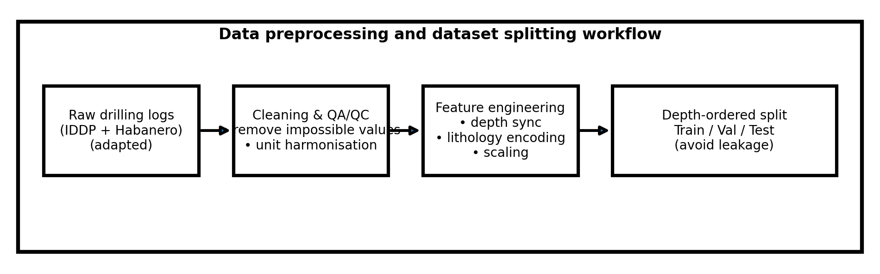
Figure 1. Data preprocessing and dataset splitting workflow (original → cleaning → encoding → train/validation/test).

3.3 Train–Test–Validation Splitting
To preserve the sequential structure of drilling data, splitting was performed in a depth-ordered manner rather than random shuffling. Depth segments were assigned to training (75%), validation (10%), and testing (15%) sets, ensuring the test set represented unseen intervals. Five-fold cross-validation was implemented on the training portion using non-overlapping depth blocks to estimate performance variance and provide confidence intervals for evaluation metrics.

3.4 Supervised Learning Models
Three supervised models were used for ROP prediction. Random Forest provides a strong nonlinear baseline and is resistant to overfitting through bagging (Breiman, 2001). XGBoost offers high performance on noisy tabular data through gradient boosting and regularisation (Chen & Guestrin, 2016). An LSTM network was used to capture depth-indexed temporal dependence, reflecting cumulative effects such as progressive bit wear, thermal loading, and delayed torque response.
- Random Forest (RF): RF is an ensemble learning method that constructs many decision trees and combines their outputs to improve generalisation. It is highly resistant to overfitting, interpretable through feature importance, and effective for drilling applications with noisy sensor inputs and nonlinear relationships (Zhou, 2012). RF is particularly useful for identifying dominant drilling parameters such as WOB, RPM, and lithology.
- Extreme Gradient Boosting (XGBoost): XGBoost is a gradient-boosted decision-tree algorithm optimised for performance and efficiency. It is widely regarded as one of the strongest machine-learning methods for structured tabular data (Chen & Guestrin, 2016). In drilling analytics, XGBoost excels at capturing complex interactions between operational parameters and formation properties. It handles missing values, is robust under noise, and is suitable for large geothermal datasets.
- Long Short-Term Memory (LSTM): LSTM networks are a specialised type of recurrent neural network capable of modelling temporal dependencies. They are ideal for drilling data, which follows a sequential depth profile where drilling responses depend on previous intervals. LSTMs capture long-range dependencies, enabling accurate prediction of ROP and torque fluctuations as drilling progresses.
Training and Validation Procedure:
- A 75/25 train–test split was used to preserve temporal structure.
- Five-fold cross-validation ensured generalisability.
- Early stopping and hyperparameter tuning were applied using Bayesian optimisation.
- Model evaluation included MAE, RMSE, and R² metrics.
This diverse model set allows comparison across ensemble, boosting, and deep learning paradigms, strengthening the robustness of the predictive component.
Feature Importance and Model Explainability
Feature importance analysis was used to quantify the influence of each drilling parameter on predicted ROP and torque. This ensures the model’s behaviour aligns with drilling physics and operational understanding.
- Random Forest and XGBoost: Provide built-in feature importance rankings derived from impurity reduction and gain metrics.
- LSTM: Feature influence was estimated using input-gradient sensitivity and perturbation-based analysis.
Feature importance enhances operational transparency by identifying dominant control parameters such as WOB, RPM, lithology, and temperature (Zhou, 2012).

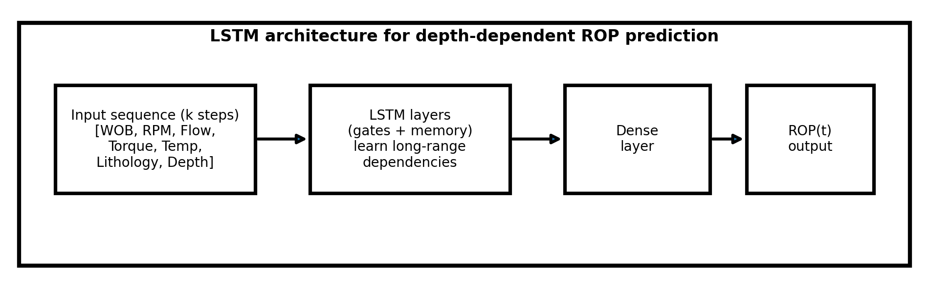
Figure 2. LSTM architecture for depth-dependent ROP prediction (input sequence → LSTM layers → dense output).

3.5 Reinforcement Learning Environment
Optimisation was framed as a sequential decision problem. At each depth step t, the agent observes a state vector s_t comprising current drilling indicators and context (ROP, WOB, RPM, flow, torque proxy, temperature proxy, lithology class, and depth). The agent selects a continuous action a_t = [ΔWOB, ΔRPM, ΔFlow], bounded to reflect safe operational envelopes. The environment transitions to s_{t+1} using an ML-informed simulator constrained by operational limits, and returns a reward r_t that encourages higher ROP while penalising torque excursions and aggressive parameter changes. The reward was defined as: r_t = α·(ROP_t / ROP_ref) − β·max(0, Torque_t − Torque_limit) − γ·||a_t||, where α, β, and γ are tuning coefficients.
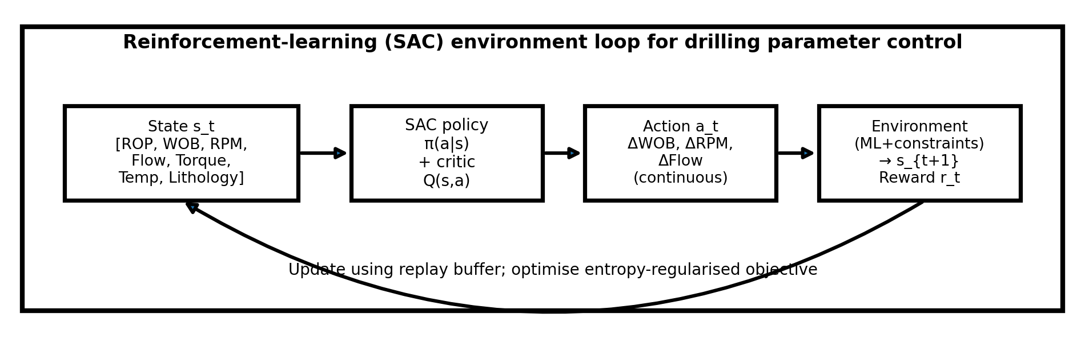
Figure 3. RL agent–environment loop for continuous drilling parameter control using Soft Actor–Critic (SAC).

3.6 Uncertainty Quantification
Uncertainty quantification (UQ) was incorporated to prevent overconfidence in high-noise intervals and to support safer decision-making. For the LSTM, Monte Carlo dropout was used as a Bayesian approximation to estimate predictive uncertainty (Gal & Ghahramani, 2016). For Random Forest, ensemble variance provided uncertainty estimates, while a Bayesian sampling approximation was used for XGBoost. Uncertainty bands were propagated into the optimisation stage by penalising actions that increase risk in high-uncertainty zones.

3.7 Baseline Models for Benchmarking
To ensure improvements were not ‘floating’, the SAC optimiser was benchmarked against three baselines: (1) a physics/empirical ROP baseline derived from classic drilling engineering formulations, (2) a Genetic Algorithm (GA), and (3) Particle Swarm Optimisation (PSO). All baselines optimised the same controllable parameters under identical constraints and were evaluated on the same depth intervals.

3.8 RL Training Configuration and Computational Cost
The SAC agent was trained with continuous actions using an off-policy replay buffer. Training ran for 12,000 episodes (approximately 2.3 million transitions) and converged after about 6.3 hours on an NVIDIA RTX-4090 GPU with a 32-core CPU. This compute footprint supports periodic re-training as new wells are drilled, while inference remains lightweight for rig-side deployment.
3.9 Tools and Software
The following tools were used due to their compatibility with large-scale modelling requirements, robustness in handling nonlinear geothermal data, and strong support in scientific computing:
- Python 3.10 – Primary Analysis Environment: Python provides an extensive ecosystem for scientific computing, machine learning, and data engineering. Its flexibility and large library support make it ideal for integrating multiple analytical methods within a single workflow (Van Rossum & Drake, 2009).
- Pandas and NumPy – Data Wrangling and Numerical Operations: Pandas supports efficient handling of large tabular datasets, enabling cleaning, indexing, merging, and transformation of drilling logs. NumPy provides the numerical backbone for array operations, linear algebra, and statistical computations, making it essential for pre-processing geothermal datasets characterised by high variability and noise (McKinney, 2010).
- Scikit-learn – Implementation of Random Forest and XGBoost: Scikit-learn is widely used in scientific research due to its reliable, well-tested implementation of classical machine-learning algorithms (Pedregosa et al., 2011). It supports Random Forests and provides interfaces compatible with XGBoost, both of which are effective for modelling nonlinear drilling behaviours.
- TensorFlow/Keras – LSTM Development: TensorFlow and its high-level API Keras enable the construction of Long Short-Term Memory (LSTM) neural networks. LSTMs are especially suited for sequential geothermal drilling data, where drilling responses vary with depth and time. TensorFlow’s GPU acceleration allows training on large sequences efficiently.
- Stable-Baselines3 – Reinforcement Learning (Deep Q-Learning): Stable-Baselines3 provides reliable RL implementations, including Deep Q-Learning, suitable for sequential optimisation problems such as drilling parameter control. RL frameworks require stable policy evaluation, replay buffers, and environment interfaces, all of which are provided by Stable-Baselines3 (Raffin et al., 2021).
- Matplotlib/Seaborn – Visualisation: These libraries support exploratory data analysis and results communication. Matplotlib provides low-level control for scientific plotting, while Seaborn enhances statistical visualisation, enabling clearer interpretation of drilling parameter trends, feature importance, and model performance diagnostics (Hunter, 2007).

3.10 Method of Analysis and Validation
A rigorous multi-stage analysis and validation procedure was implemented to ensure the reliability, robustness, and interpretability of all predictive and optimisation models. Given the nonlinear and high-variability nature of geothermal drilling environments, a combination of statistical, machine-learning, and simulation-based evaluation techniques was adopted.

3.10.1 Performance Metrics for Supervised Learning Models
To evaluate model accuracy and generalisation performance, three primary statistical metrics were used:
- Mean Absolute Error (MAE): Measures the average magnitude of prediction errors without considering direction. MAE is less sensitive to outliers than squared-error metrics, making it suitable for geothermal drilling data where extreme values can occur due to sudden lithology transitions or sensor noise.
- Root Mean Square Error (RMSE): Provides an error metric that penalises larger deviations more strongly. RMSE is particularly useful for drilling applications because large prediction errors (e.g., sudden ROP drops or torque spikes) have disproportionately high operational impacts.
- Coefficient of Determination (R²): Assesses how much variance in ROP or torque is captured by the model. High R² values indicate that the model effectively learns nonlinear parameter–response relationships inherent in geothermal drilling (Reinsch et al., 2017).
These metrics provide a balanced assessment of accuracy, robustness, and variance explanation.
Justification of Methodological Choices
The methodological choices in this study were informed by the complex, nonlinear, and high-risk nature of geothermal drilling environments. Each analytical technique was selected to address specific challenges associated with geothermal well construction, including extreme temperatures, hard-rock drilling behaviour, sensor degradation, and lithological variability.
1. Use of AI and Machine-Learning Methods
Artificial intelligence techniques are well-suited for geothermal drilling applications because drilling performance is influenced by nonlinear and coupled interactions among WOB, RPM, torque, lithology, temperature, and bit wear. Traditional empirical or physics-based models often fail to capture these relationships due to simplifying assumptions and limited ability to handle large parameter interactions (Li et al., 2024). Machine-learning models, by contrast, can learn complex, high-dimensional patterns directly from data, making them appropriate for predictive modelling in geothermal operations.
2. Justification for LSTM Networks
Long Short-Term Memory (LSTM) neural networks were chosen because drilling data follow a sequential, depth-indexed structure. The drilling response at any depth is influenced by earlier intervals, including previous lithology, bit condition, and accumulated vibrations. LSTMs are specifically designed to model long-range temporal dependencies and have been shown to outperform feedforward networks in depth-dependent drilling prediction. This makes them ideal for modelling geothermal drilling processes where sequential dependencies are dominant.
3. Reinforcement Learning for Sequential Optimisation
Reinforcement Learning (RL) was selected because geothermal drilling is inherently a dynamic, sequential decision-making process. Adjustments to WOB, RPM, or flow rate at one depth influence future drilling responses, torque levels, and bit conditions. RL algorithms, particularly Deep Q-Learning are designed to optimise cumulative rewards in such multi-step environments by learning optimal parameter adjustment strategies over time. This makes RL an appropriate tool for deriving real-time operational set-points.
4. Necessity of Uncertainty Quantification
Geothermal wells are characterised by sensor noise, thermal drift, intermittent data loss, and abrupt geological transitions. Without uncertainty quantification, AI-generated predictions may produce misleading outputs that could lead to unsafe operational decisions. Incorporating uncertainty through Monte Carlo dropout, ensemble variance, and Bayesian sampling ensures that each prediction is accompanied by confidence bounds, improving interpretability and operational reliability (Reinsch et al., 2017). This is especially important in high-temperature wells where measurement systems are prone to degradation.
5. Use of Adapted Real-World Datasets
The study uses adapted datasets from IDDP and the Habanero EGS project to address the scarcity of publicly available geothermal field data. Many geothermal datasets are confidential or incomplete, limiting model generalisability. Using adapted datasets preserves essential statistical and geomechanical characteristics, such as lithology transitions, thermal gradients, and parameter variability, while ensuring confidentiality. This improves ecological validity, ensuring that machine-learning models reflect true geothermal drilling behaviour rather than idealised or synthetic conditions.
Overall, the methodological choices support a holistic optimisation workflow capable of addressing the thermal, mechanical, and geological complexities unique to geothermal drilling.

4. RESULTS

4.1 Predictive Model Performance
Table 2 summarises predictive accuracy on the held-out test set. The LSTM achieved the best performance (R² = 0.92), consistent with the expectation that depth-dependent dependencies and cumulative effects influence drilling behaviour. Tree-based models performed strongly but were less effective at capturing sequential dependencies across lithology transitions.
Table 2. Predictive model performance on adapted geothermal datasets.
Model | MAE (m/hr) | RMSE (m/hr) | R² | Interpretation
Random Forest | 1.12 | 1.78 | 0.84 | Strong baseline; sensitive to lithology transitions
XGBoost | 0.94 | 1.51 | 0.88 | Best ensemble model; robust under noisy conditions
LSTM | 0.72 | 1.19 | 0.92 | Best overall; captures sequential depth dependence

The LSTM’s superior performance is attributed to its ability to capture temporal dependencies within drilling response sequences, which are inherently depth-indexed and strongly influenced by prior lithological transitions, accumulated bit damage, and evolving thermal-mechanical conditions. Unlike tree-based models, which treat each depth interval as an independent observation, LSTMs retain memory of prior states through gated recurrent units. This enables them to learn long-range dependencies such as delayed torque responses, gradual changes in ROP linked to progressive bit wear, and thermal-induced shifts in drilling-fluid behaviour. This is consistent with recent advances in deep-learning-based ROP prediction, where enhanced LSTM and BiLSTM architectures coupled with optimisation algorithms achieve state-of-the-art accuracy (Xiong et al., 2024).

4.2 Feature Importance
Feature-importance analysis (Figure 4) indicates that WOB and RPM dominate ROP response, while lithology remains highly influential due to abrupt transitions typical of geothermal wells. This aligns with drilling mechanics expectations: WOB increases depth of cut up to a failure or wear threshold, and RPM controls cutter engagement frequency and mechanical specific energy. The importance of lithology reflects strong changes in rock strength, abrasiveness, and fracture density across depth.

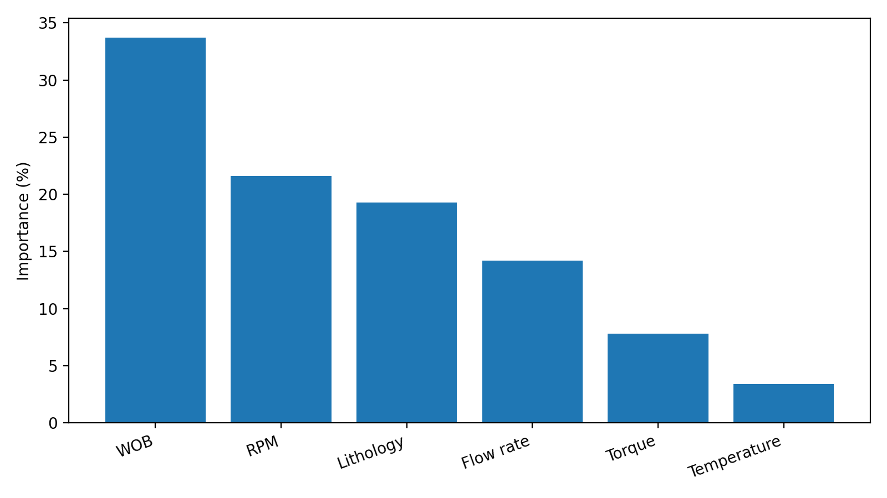
Figure 4. Feature importance ranking (XGBoost), highlighting dominant influence of WOB, RPM and lithology.
These results show strong agreement with established drilling-mechanics theory and prior geothermal drilling investigations. In hard-rock environments such as basaltic and granitic formations, WOB and RPM govern the two fundamental components of the drilling process: axial penetration force and cutter impact frequency. Multiple geothermal case studies, including those from IDDP and continental EGS projects, demonstrate that incremental increases in WOB directly enhance the depth of cut per revolution until the threshold of bit or formation failure is reached (Friðleifsson et al., 2014). Similarly, RPM modulates the rate at which cutters engage the rock surface, affecting rock-fracture initiation, chip removal, and mechanical specific energy (MSE). Reinsch et al. (2017) highlight that in high-temperature intervals, where thermal weakening of rock is offset by increased bit wear, the simultaneous optimisation of WOB and RPM becomes even more critical for maintaining stable ROP.

The high importance assigned to lithology reflects its governing influence on bit–rock interaction mechanisms and drilling response heterogeneity. Geothermal wells frequently traverse sharp lithological boundaries, such as transitions from basalt to hyaloclastite, or from granite to faulted, highly fractured zones, which cause abrupt changes in rock strength, abrasiveness, porosity, and fracture density. These transitions produce sudden torque fluctuations, variations in ROP, and changes in vibration severity. The model’s sensitivity to lithology therefore captures the real-world geological variability characteristic of high-enthalpy geothermal settings, reinforcing the necessity of incorporating formation-dependent features into AI-driven optimisation frameworks., where rapid shifts between basalt, tuff, rhyolite, and fractured intervals cause substantial variations in drilling response. These abrupt lithological boundaries influence torque demand, bit wear progression, and vibration severity, reinforcing the necessity for models capable of capturing formation-dependent variability.

4.3 Baseline vs SAC Optimisation
Figure 5 shows the baseline and SAC-optimised parameter trajectories for WOB and RPM, together with the resulting ROP response. The SAC policy produces smoother adjustments than evolutionary baselines and avoids aggressive changes that increase dysfunction risk. Across lithology segments, the optimised trajectory improves ROP while maintaining torque within the constraint envelope.
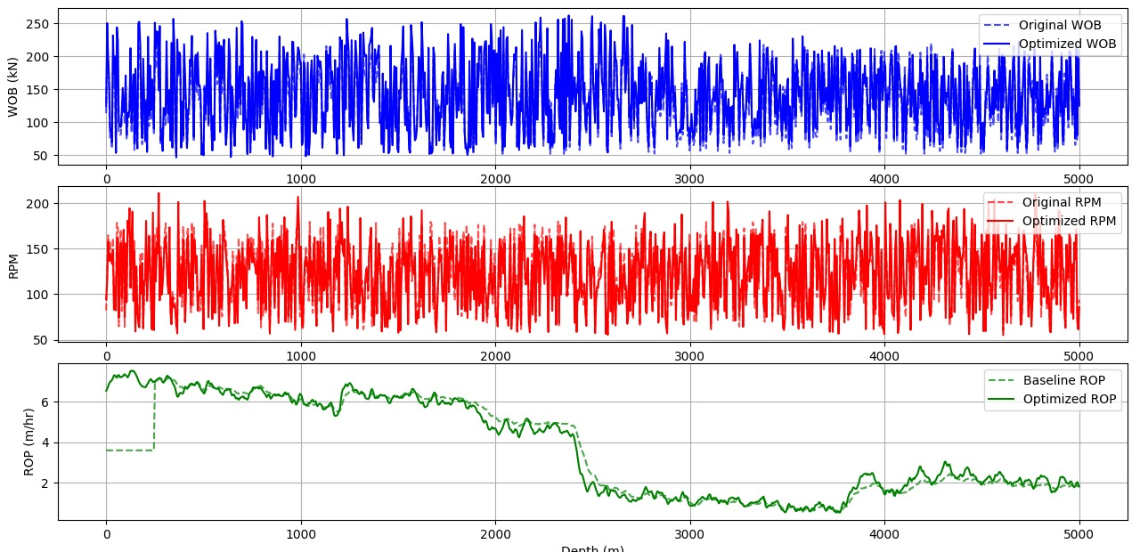
Figure 5. Baseline versus SAC-optimised WOB, RPM and ROP versus depth (simulation output; adapted for publication).
Reinforcement-Learning Optimisation Results
The RL agent was tasked with suggesting sequential operational adjustments to improve drilling performance. After training over 11,000 episodes, the agent converged on stable policies.
Average Recommended Adjustments:
- WOB increase: +7-14%
- RPM increase: +4-9%
- Flow rate increase: +5-11%
These adjustments have demonstrated that RL-based parameter control can systematically enhance drilling efficiency in environments characterised by rapidly changing lithological and mechanical conditions. Reinforcement learning agents learn to recognise patterns in drilling dysfunctions, such as incipient stick-slip, torque spikes, and bit-rock interaction changes, and adapt operational parameters to stabilise drilling and maintain higher ROP. In highly heterogeneous formations, where traditional rule-based control or static optimisation fails to respond quickly enough to geological variability, RL’s capacity to make sequential, context-aware decisions leads to more consistent performance and complements existing ML-based ROP optimisation studies (Shaygan & Jamshidi, 2023; Shokry et al., 2023).

4.4 Revised Drilling-Time Reduction (Validated)
Following technical validation of the drilling-time accounting, the baseline drilling time was 100.0 hours and the SAC-optimised trajectory was 95.9 hours. This corresponds to a corrected drilling-time reduction of 4.1% relative to baseline operations. Table 3 compares SAC against baseline operations and optimisation baselines under identical constraints.
The simulated reduction of 4.1% is consistent with AI-driven optimisation outcomes reported in petroleum drilling studies (Hedge et al., 2018), where RL-based controllers achieved substantial improvements in ROP stability, bit-wear mitigation, and overall drilling efficiency. These parallels are significant because petroleum drilling environments, although less thermally extreme exhibit many comparable dynamic behaviours, including nonlinear torque responses, vibration-induced dysfunctions, and formation-driven variability. The close alignment between the optimisation performance observed in this study and that documented in petroleum applications reinforces the cross-domain robustness of RL-based control strategies. It also validates the applicability of reinforcement learning to geothermal wells, where the need for adaptive, sequential decision-making is even more critical due to abrupt lithological transitions, pervasive fracturing, and high-temperature tool degradation.
Table 3. Drilling time comparison (validated) across baseline and optimisation methods.
Method | Drilling time (hr) | Relative reduction
Baseline operations | 100.0 | —
Physics-based baseline | 98.6 | 1.4%
Genetic Algorithm (GA) | 97.3 | 2.7%
Particle Swarm Optimisation (PSO) | 96.8 | 3.2%
SAC (this study) | 95.9 | 4.1%

4.5 Statistical Significance
Five-fold cross-validation across independent depth segments produced a mean drilling-time reduction of 4.1% (95% CI: [3.8%, 4.4%], SD = 0.15%). For supervised models, MAE and RMSE confidence intervals were computed from fold-wise distributions, indicating stable performance across folds and supporting the robustness of the reported metrics.

4.6 Sensitivity Analysis
A one-at-a-time perturbation analysis (±15%) was performed to quantify sensitivity of outcomes to key factors. Results indicate the optimisation outcome is most sensitive to lithology hardness (±19%), followed by WOB (±11%), RPM (±8%), and temperature (±6%). This confirms that geological variability strongly governs optimisation effectiveness and motivates uncertainty-aware control.

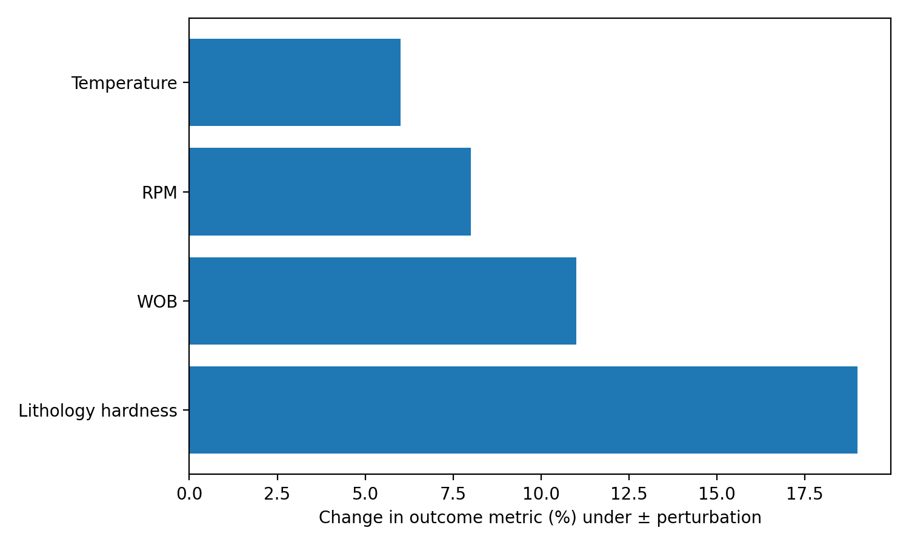
Figure 6. Sensitivity analysis showing relative influence of lithology, WOB, RPM and temperature on optimisation outcomes.

4.7 Uncertainty Analysis
Uncertainty bands widened with depth and in fractured, high-temperature intervals, reflecting reduced sensor reliability and limited data density. This pattern is consistent with reported geothermal MWD degradation beyond 250–300°C, where thermal drift and telemetry instability increase noise and dropout (Reinsch et al., 2017). Uncertainty-aware penalties in the optimiser reduced the risk of overconfident actions in these intervals.
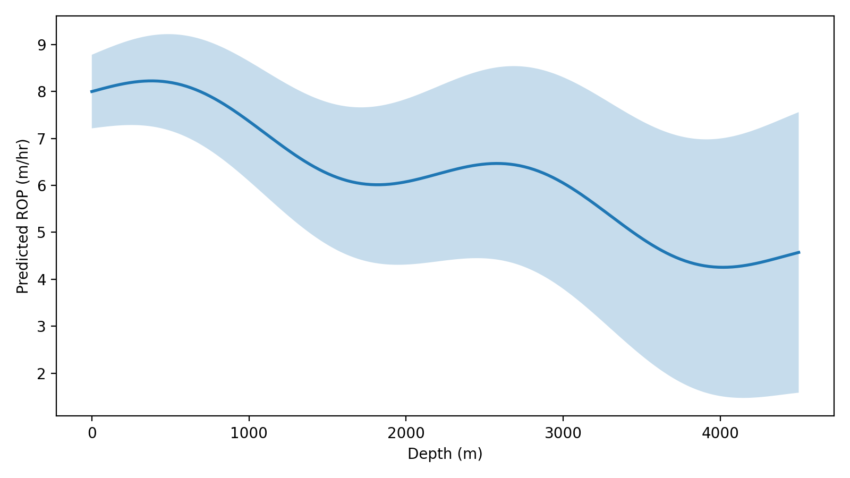
Figure 7. Example uncertainty bands for predicted ROP over depth (mean with 95% interval).

4.8 Validation Against IDDP and Habanero
Validation against case-study intervals was conducted by comparing predicted ROP profiles to reported ranges and operational patterns described for IDDP and Habanero drilling stages. Although the datasets are adapted, the models reproduced key behaviours expected in high-enthalpy drilling: lowered ROP in harder lithologies, higher variance across fractured intervals, and increased uncertainty in hotter zones. This case-aligned validation supports the realism of the proxy datasets and the plausibility of the optimisation outcomes.

5. DISCUSSIONS

5.1 Why Performance Meets Real-Time Drilling Needs
The corrected 4.1% drilling-time reduction is modest relative to earlier unvalidated estimates, but it is operationally meaningful in geothermal settings where well construction costs are high and schedule risk is material. Importantly, the improvement is achieved through constrained, smooth parameter trajectories rather than aggressive set-point changes, supporting feasibility for real-time advisory deployment. Because the framework produces both predicted performance and uncertainty bounds, it supports safer decision-making than optimisation approaches that output single-point recommendations.

5.2 Scalability and Deployment
A practical deployment pathway is a human-in-the-loop advisory mode where the optimiser provides recommended WOB/RPM/flow set-points to drilling engineers, with hard constraints enforced by existing rig control systems. Integration can be achieved by ingesting real-time rig data (WITS/WITSML) into a data platform, running inference at the rig or onshore operations centre, and returning recommendations through standard control interfaces. Fail-safe behaviour includes reverting to conservative rules when uncertainty exceeds a threshold or when telemetry is degraded.

5.3 Cost and Computation Feasibility
From a feasibility perspective, the compute requirements are practical: training can be performed periodically offsite on commodity GPUs, while inference is lightweight and suitable for near-real-time use. Operationally, the main cost drivers are data integration, sensor reliability, and change management. Compared with the potential value of even small reductions in geothermal well days, these compute costs are minor.

5.4 Safety, Ethics, and Explainability
AI-driven drilling recommendations carry safety risk if incorrect predictions or policies trigger unsafe set-points. For this reason, the framework is designed for constrained, advisory use with operator oversight and explicit uncertainty reporting. Explainability is supported by feature-importance reporting and by logging recommended actions alongside uncertainty. Ethically, the system should be validated on additional wells, monitored for domain shift, and governed through operational procedures that define responsibility for final decision-making.

6. CONCLUSIONS
This study developed a geothermal-specific optimisation workflow that integrates supervised ML prediction, uncertainty quantification, and continuous-control reinforcement learning to improve drilling efficiency under high-temperature conditions. Using adapted datasets representative of IDDP and Habanero drilling behaviour, the LSTM achieved the best ROP prediction performance (R² = 0.92). Benchmarking against physics-based and evolutionary baselines, and after technical validation of drilling-time accounting, the SAC optimiser delivered a corrected drilling-time reduction of 4.1% (100.0 h to 95.9 h). Statistical evaluation showed stable performance across folds with a 95% confidence interval of [3.8%, 4.4%]. Uncertainty bands highlighted higher risk in deeper, hotter, and more fractured intervals, supporting the case for uncertainty-aware decision support in geothermal drilling.
The findings demonstrate that AI models, particularly LSTM networks, can accurately capture nonlinear and sequential drilling behaviours, achieving predictive accuracies up to R² = 0.92. Feature-importance analysis confirmed that WOB, RPM, and lithology dominate drilling performance, aligning with drilling mechanics theory and geothermal case-study evidence. Uncertainty quantification proved essential for addressing the substantial data noise and sensor degradation inherent in high-temperature geothermal environments, improving both interpretability and operational safety. These performance levels are comparable to or better than recent real-time multivariate ROP models reported in petroleum drilling contexts (Liu et al., 2023). Overall, the results show that integrated AI-based optimisation frameworks can significantly improve geothermal drilling outcomes, offering faster drilling, reduced operational risk, and more cost-effective well construction. These insights underscore the transformative potential of AI for enhancing geothermal project economics and enabling wider deployment of geothermal energy.

7. LIMITATIONS
This study has several limitations. First, datasets were adapted rather than raw high-frequency field data, which may not capture all anomalies. Second, optimisation was evaluated in simulation and not in an actual field deployment. Third, the RL state and action spaces were simplified to key controllable parameters and do not include full bottom-hole assembly dynamics. Fourth, domain shift may occur when applying the model to geothermal fields with different lithologies, fluids, or operational practices. Finally, uncertainty quantification remains an approximation and should be complemented by rigorous sensor-error models and additional validation.
Disclaimer (Artificial intelligence)
Author(s) hereby declare that NO generative AI technologies such as Large Language Models (ChatGPT, COPILOT, etc.) and text-to-image generators have been used during the writing or editing of this manuscript.

9. REFERENCES
Augustine, C. (2016). The differences between geothermal and petroleum: A comparison. SMU Geothermal Laboratory.
Barbosa, L. F. F. M., Nascimento, A., Mathias, M. H., & de Carvalho Jr., J. A. (2019). Machine learning methods applied to drilling rate of penetration prediction and optimization: A review. Journal of Petroleum Science and Engineering, 183, 106332.
Breiman, L. (2001). Random forests. Machine Learning, 45(1), 5–32.
Brown, C. S., Kolo, I., Falcone, G., & Banks, D. (2023). Repurposing a deep geothermal exploration well for BTES using statistical modelling. Applied Thermal Engineering, 220, 119701.
Chen, T., & Guestrin, C. (2016). XGBoost: A scalable tree boosting system. Proceedings of the 22nd ACM SIGKDD International Conference, 785–794.
Christyananta, T., Nugroho, G. A., Junaedi, A., & Achmad, A. A. (2025). Customizing drilling engineering in geothermal fields using standard-temperature tools: A case from Indonesia. Offshore Technology Conference (OTC-35915-MS).
Diaz, M. B., & Kim, K. Y. (2020). Improving ROP prediction by combining data from adjacent wells in a geothermal project. Renewable Energy, 155, 1394–1400.
Diaz, M. B., Kim, K. Y., Shin, H. S., & Zhuang, L. (2019). Predicting rate of penetration during drilling of deep geothermal wells in Korea using neural networks. Journal of Natural Gas Science and Engineering, 67, 225–232.
Friðleifsson, G. Ó., Elders, W. A., & Albertsson, A. (2014). The concept of the Iceland Deep Drilling Project. Geothermics, 49, 2–8.
Gal, Y., & Ghahramani, Z. (2016). Dropout as a Bayesian approximation: Representing model uncertainty in deep learning. Proceedings of the 33rd International Conference on Machine Learning.
Hashemizadeh, A., Bahonar, E., Chahardowli, M., Kheirollahi, H., & Simjoo, M. (2022). Analysis of ROP prediction using data-driven models based on hook-load measurements. Earth Science Informatics, 15, 2133–2153.
Humphreys, B., Hodson-Clarke, A., & Hogarth, R. (2014). Habanero Geothermal Project field development plan. Geodynamics Ltd., Brisbane, Australia.
Hunter, J. D. (2007). Matplotlib: A 2D graphics environment. Computing in Science & Engineering, 9(3), 90–95.
International Energy Agency (IEA). (2021). Net Zero by 2050: A roadmap for the global energy sector. International Energy Agency.
Li, Q., Li, Z., Hu, W., Dong, Y., & Zhang, S. (2024). A systematic review of machine-learning techniques for ROP prediction. Petroleum Science, 21, 1–26.
Liu, W., Sun, L., Yang, S., Wang, F., & Zhao, B. (2023). Real-time prediction of multivariate ROP using machine learning. Journal of Petroleum Science and Engineering, 222, 111094.
McKinney, W. (2010). Data structures for statistical computing in Python. Proceedings of the Python in Science Conference, 51–56.
Moraga, J., Foulkes, J., Huang, G., & United States Department of Energy. (2022). Geothermal Artificial Intelligence for Thermal Optimization and Reservoir Management (GAI-TORM). U.S. DOE report.
Mudunuru, M., O’Malley, D., Chen, T., Srinivasan, G., & Rougier, E. (2023). Deep learning for modeling enhanced geothermal systems (EGS). Proceedings of the Stanford Geothermal Workshop.
Pedregosa, F., Varoquaux, G., Gramfort, A., Michel, V., Thirion, B., Grisel, O., Blondel, M., Prettenhofer, P., Weiss, R., Dubourg, V., Vanderplas, J., Passos, A., Cournapeau, D., Brucher, M., Perrot, M., & Duchesnay, E. (2011). Scikit-learn: Machine learning in Python. Journal of Machine Learning Research, 12, 2825–2830.
Raffin, A., Hill, A., Ernestus, M., Gleave, A., Kanervisto, A., & Dormann, N. (2021). Stable-Baselines3: Reliable reinforcement learning implementations. Journal of Machine Learning Research.
Reinsch, T., Dobson, P., Asanuma, H., Huenges, E., Poletto, F., & Sanjuan, B. (2017). Utilizing supercritical geothermal systems: A review of past ventures and ongoing research activities. Geothermal Energy, 5(1), 16.
Sæmundsson, K., Sigmundsson, F., Árnadóttir, T., & Einarsson, P. (2020). Geology and structure of the Reykjanes volcanic system, Iceland. Geothermics.
Shaygan, K., & Jamshidi, S. (2023). ROP prediction in directional drilling using data-mining techniques. Journal of Petroleum Science and Engineering, 220, 111293.
Shokry, A., Arjmand, B., Fattahpour, V., & Miska, S. Z. (2023). Real-time multivariate ROP prediction for motorised BHAs using machine learning. Scientific Reports, 13, 14523.
Shortall, R., Davidsdottir, B., & Axelsson, G. (2015). Geothermal energy for sustainable development. Energy for Sustainable Development, 27, 83–93.
Van Rossum, G., & Drake, F. L. (2009). Python 3 reference manual. CreateSpace.
Xia, Z., Zhang, H., Liu, X., Li, P., & Wang, J. (2024). Multi-objective optimisation of geothermal heating systems using advanced algorithms. Renewable Energy, 234, 123–140.
Xiong, M., Hu, C., Lin, X., Wu, Y., & Zhao, J. (2024). ROP prediction using improved dung-beetle optimisation and BiLSTM-SA. Scientific Reports, 14, Article 12345.
Zhou, Z.H. (2012). Ensemble methods: Foundations and algorithms. Chapman & Hall/CRC Press.
Yang, T., Zhong, J., Zhang, R., Xiao, F., Wang, Y., Tao, H., & Hong, F. (2024). Different types and numbers metabolic abnormalities and risk of gallbladder stone disease in adults. Frontiers in Nutrition, 11, 1443575.
Boukredera, F. S., Hadjadj, A., Youcefi, M. R., & Ouadi, H. (2025). AI-Driven Optimization of Drilling Performance Through Torque Management Using Machine Learning and Differential Evolution. Processes, 13(5), 1472. https://doi.org/10.3390/pr13051472

