Review Article
Low-Cost Agricultural Waste-Derived Adsorbents for Dye Removal from Wastewater: Source, Mechanism and sustainability Perspectives: A Critical Review

Abstract
The extensive use of synthetic dyes in textile, leather, paper, food, and medicinal industries has given rise to in the release of vastly colored wastewater, posing serious environmental and health anxieties. Conventional dye removal techniques, like chemical oxidation, membrane filtration, and coagulation–flocculation, often suffer from expensive operational, high-energy demand, and generation of secondary product as pollutants cause pollution. Now a day’s, agricultural waste materials have arisen as sustainable, inexpensive, and eco-friendly substitutes for dye removal from contaminated water. These wastes, together with fruit peels, crop residues, husks, shells, and stalks, are rich in cellulose, hemicellulose, lignin, and functional groups that improve their adsorption potential. This review comprehensively discusses the application of agricultural waste derived adsorbents for dye removal, concentrating on their sources, physicochemical properties, adsorption mechanisms and performance toward various grades of dyes. The effects of operational parameters like surface modification are critically analyzed. Also, regeneration potential, economic viability, and ecological sustainability of agricultural waste–based adsorbents are emphasized. The review emphasizes the role of agricultural waste valorization in wastewater treatment and its contribution toward circular economy and sustainable environmental management.
Keywords: Adsorption mechanisms, agricultural waste, biosorbents, dye removal, sustainability, wastewater treatment,
1. Introduction
Spontaneous development of industrialization and municipal have significantly enlarged the production of wastewater that polluted with synthetic dyes. Dyes are containing complex organic compounds intended to resist light, heat, and microbial degradation that makes them as insistent toxins in aquatic environments (Das, A. et.al., 2020). Though very low concentrations, dyes produce intense color to water bodies which cause reducing of light penetration and alter the photosynthetic activity, thus it disturbs aquatic ecosystems (Pereira, L. et.al., 2011). Besides, more of the dyes and their degradation products are toxic, mutagenic, and carcinogenic, posing severe risks to human health and biodiversity (Kusumlata, et.al., 2024).
The textiles, leather processing, paper manufacturing, cosmetics, and food processing industries are the major givers to dye loaded effluents (Singh, B.P. et.al, 2020). It is assessed that a significant fraction of dyes used during industrial dispensation is vanished directly into wastewater streams. The effective treatment of wastewater with dye contaminants, therefore relics a major environmental challenge (Lin, J. et.al.2023).
Several physical, chemical, and biological treatment techniques have been discovered for dye removal, together with progressive oxidation processes, photocatalysis, membrane separation, coagulation–flocculation, and biodegradation (Bal, G. et.al., 2022). Though these methods can realize high removal efficiencies, but their extensive application is limited by drawbacks like high capital cost, complex operation, generation of toxic sludge, and efficient for certain types of dye. Amid these techniques, adsorption has gained significant consideration owing to its simplicity, high efficacy, and flexibility to a wide range of dyes (AlAqad, K. M. et.al, 2025).
Activated carbon is commonly familiar as an effective adsorptive; yet, its high production and regeneration costs restrict on use of commercial scale (Ismail, B.M. 2025). For the mitigation of such limitation the attraction of researchers attracts toward substitute as economical adsorptive derived from natural and waste materials (Akhtar, M.S. et.al., 2024). For this purpose, agricultural waste shows an abundant, renewable, and budget source that can be successfully employed for dye removal. Materials like rice husk (Singh, S. et.al.2024), wheat straw, banana peel, orange peel, sugarcane bagasse, coconut shell, sawdust, and corn cob have established auspicious adsorption potential for different dye molecules (Kiran, M. et.al., 2025).
The application of agricultural waste that applied in wastewater treatment not only offers an inexpensive solution but also discourses waste disposal issues and encourages sustainable resource management. By the suitable physical or chemical alteration, the adsorption efficacy of these materials can be significantly boosted (Satyam, S. et.al.2024). This review purposes to scientifically examine recent advances in the use of agricultural waste–based adsorbents for dye removal, emphasized their mechanisms, advantages, limitations, and future prospects in sustainable wastewater treatment.
This review aims to summarize agricultural wastes used in dye adsorption, knowing about the modification/activation methods that that improved its performance, clarify adsorption mechanisms and kinetics. At end it also compares adsorption capacities and efficiencies with some agricultural waste adsorbents and also disused about their limitation and future prospective about research.
2. Agricultural Wastes as Adsorbents
Agricultural waste adsorbents are a class of natural adsorbents, which are easily available. Inexpensive, required less processing and have effective potential for removal of pollutants. The adsorbents that derived from agricultural waste such as fruit waste, plant waste and bio adsorbents (Rathi, B.S. et.al.2021; Kundu, D. et.al, 2024). Solid forms of agricultural wastes are economical and plentiful availability of resources. Some other agricultural wastes as sugarcane bagasse, rice husk, oil palm shell, cotton waste, cashew nut shell, banana peel, almond shell, sawdust and wood chips, coconut skell and husk etc. can be applied in effectively elimination of dye pollutants in wastewater (Singh, M. et.al., (2025). The agricultural residues contain hydroxyl, carboxyl, amine and phenolic functional group which are interacting capability with dye molecules by H-Bonding, electrostatic attraction and π-π interactions. Such wastages can be directly applied off after the alteration of physical, chemical and thermal that improved the surface area and adsorption performance (Gonçalves, J. O. et.al.2025). Few agricultural wastes are illustrated as follow:
2.1 Rice Husk and Husk Ash
Rice husk and husk ash contains sufficient amount of silica and lignocellulosic components, once it chemically activated with acids or bases, its porosity increases, significantly that improve adsorption of cationic dyes such as methylene blue, crystal violet azo dyes. These are excellent, inexpensive, plentiful availability and eco-friendly natural adsorbents having high efficiency for the removal of dye pollutants from contaminated water through physical adsorption, ion exchange and surface complexation mechanism, through pre-treatment or activation can be enhanced their removal efficiency and facilitate them for the treatment of textile effluents shown in Figure1 (Mladenovic, N., et.al.2020).
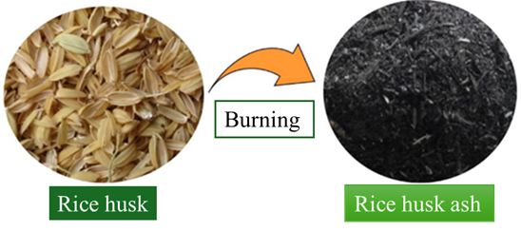
Figure1. Conversion of rice husk into rice husk ash
2.2 Sugarcane Bagasse
Sugarcane bagasse is extensively used for the elimination of dyes from wastewater because it is an abundant agricultural byproduct with a wide surface area and active functional groups that can easily bind to dye molecules. It serves as a natural, economical biosorbent and a precursor for activated carbon, offering an alternative to costly activated charcoal. Its porous structure and the presence of hydroxyl (-OH) and carboxyl (-COOH) functional groups facilitate dye removal through mechanisms such as electrostatic attraction, hydrogen bonding, and complexation. The removal efficiency of sugarcane bagasse can be further enhanced by pretreatment with phosphoric acid or thermal activation process is shown in Figure 2., which increase the surface area and the number of active binding sites (Sharma, P. et.al.2024).
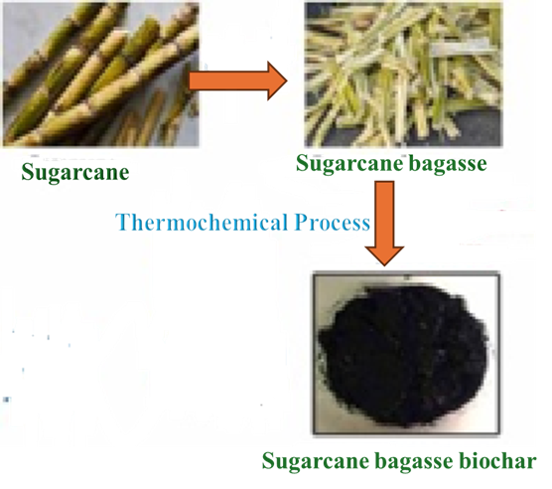
Figure 2. Biochar preparation by sugarcane
2.3 Coconut Husk and Shell
Coconut husk and shell are admirable, inexpensive, and eco-friendly adsorptive materials with great potential for removing dyes from wastewater. Due to the porous structure of coconut husk, it behaves like a sponge, offering a wide surface area and numerous binding sites that effectively interact with dye molecules such as Crystal Violet and Methylene Blue. This spontaneous adsorption phenomenon makes coconut-based materials a sustainable substitute for expensive commercial adsorbents. These materials can be used directly or modified through acid/base treatment or conversion into activated carbon, which enhances their performance in treating textile and industrial effluents. Such modifications significantly improve their removal capacity, making them efficient for traditional applications (Chan, A. A. et.al, 2024) shown in Figure 3.
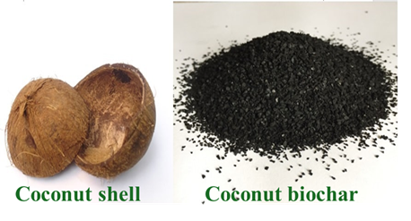
Figure3. Coconut shell and biochar
2.4 Banana Peel and Other Fruit Wastes
Banana peels contain enormous number of polysaccharides and pectin that very useful for biosorption of anionic and cationic dyes. By the chemical modifications with NaOH enhanced adsorption through improving of surface charge properties. Banana peels and other fruit wastes such as orange, pomegranate peels are much effective, inexpensive and sustainable natural adsorbents that applicable for removal of dyes from wastewater it utilizes their amusing functional groups as hydroxyl, carboxyl that binds pollutants through physical and chemical adsorption (Amalina, F. et.al., 2022), which makes them auspicious substitutes to costly treatments. These bio- adsorbents can be processed as washed, dried, ground and reused, offering an eco-friendly resolution for the treatment of textile and industrial effluent, as high removal potential frequently attained within short contact times and optimal pH conditions.
2.5 Sawdust and Wood Chips
Sawdust and wood chips derived from various timber which can adsorb dyes such as malachite green after alteration. By the surface treatment of with acids or bases that removed extractives which opens pores and enhanced the adsorption capacities shown in Figure 4 (Mahmood, G.E., et.al., 2025). These are effective, economical and eco-friendly materials that frequently applied for the removal of dyes from contaminated water by adsorption, leveraging their pours and functional groups hydroxyl and carboxyl that involve in binding of dye molecules that phenomenon often improved through physical and chemical modifications and optimized conditions as pH and contact time. They behave as competent natural adsorbents which can be used as alternative to conventional methods for treatment of industrial effluents (Bondarev, A. et.al., 20200.
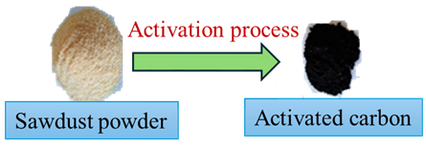
Figure4: Sawdust activated in activated carbon
3. Modification and Activation Techniques
Agricultural wastes are often tailored to enhance adsorption capacity. Common approaches as Chemical activation with (H₃PO₄, KOH, ZnCl₂) that improved the surface area and pore volume shown in Figure 5.
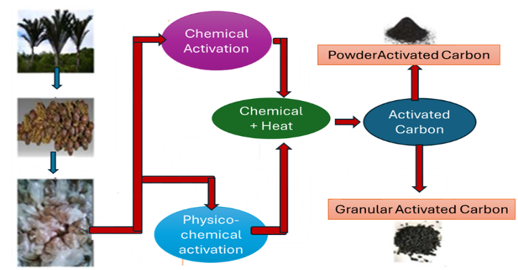
Figure5: Process conversion of agricultural waste in activated carbon
Chemical activation of agro-waste carried out by using H₃PO₄, KOH, and ZnCl₂ is a widely used method to convert agricultural waste (lignocellulosic biomass) into activated carbon (AC) with a wide surface area and tailored pore structure (Ramachandran, S. et.al., 2025).
This process is chosen over physical activation in many cases since it allows for simultaneous carbonization and activation at lower temperatures and took shorter times, resultant contains higher carbon yields and larger porosity. There are following steps involved in this process as
- Preparation: Grinding and sieving of the used agricultural waste such as fruit shells, rice husks.
- Impregnation: Soaking the grinding and sieving biomass in a solution of the activating agent as $H_{3}{PO}_{4}$, KOH, or ${ZnCl}_{2}$ for a certain period at about 24 hours, to permit the chemical to penetrate into the structure (Ivbanikaro, A. E. et.al.,2023).
- Thermal Activation (Carbonization): Heating the impregnated material in nitrogen gas atmosphere at temperatures ranging from 400°C to 800°C.
- Washing and Drying: After that washed the resulting carbonized activated carbon materials with acid (e.g., HCl) and then distilled water until a neutral pH is attained to remove remaining chemicals and impurities, followed by drying.
It can be further active by passing of carbon dioxide steam through the carbonized materials that enhanced the surface energy and adsorptive sites. Their selective binding of specific dye classes can be improved by the grafting with amine or thiol groups.
4. Removal of dye from waste water: Inexpensive, economical, ecofriendly agricultural waste based adsorbents extensively applied in dye removal from wastewater and the process involved following mechanism as:
4.1. Adsorption Mechanisms
The dye removal through adoption process by using agricultural waste from dye contaminated water given in Figure 6 (Amalina, F. et.al., 2022; Nath, A. et.al., 2021; Nath, A. et.al., 2022) that involved Multiple mechanisms govern dye biosorption, including:
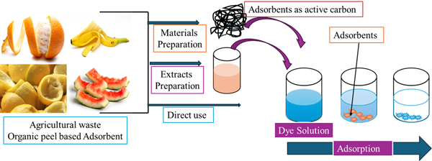
Figure 6: Adsorption process of various fruits peel for dye removal
4.1.1. Electrostatic interactions
Electrostatic interactions between charged dyes and surfaces involve attraction with opposite
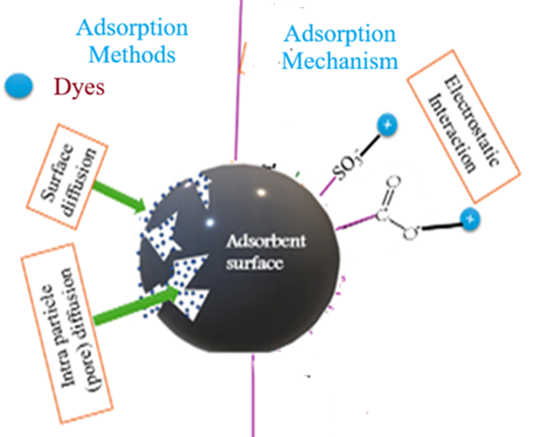
Figure7: Electrostatic interactions mechanism for dye removal
charges or repulsion with same charges and are a primary force in adsorption, that governed by pH and ionic potential often governing other forces such as van der Waals or H-bonding, e.g. an anionic clay surface attracts cationic dyes via electrostatic attraction, leading to dye removal, whereas same charge interactions cause repulsion, necessitating other mechanisms like size exclusion. These interactions are crucial for dye removal in wastewater treatment, with pH changes altering surface charge, thus controlling adsorption efficiency mechanism is shown in Figure7 and 8 (Garg, S. et.al., 2025).
    - Hydrogen bonding
Agricultural waste–based adsorbents are composed of organic compounds containing functional groups such as hydroxyl (–OH) and carboxylic (–COOH) groups, which act as active sites on the adsorbent surface and readily bind dye molecules. The presence of these functional groups enables interactions with the functional groups present in dye structures through several binding mechanisms. For instance, cationic dyes interact with anionic adsorbent surfaces via electrostatic attractions, while oxygen atoms on the adsorbent surface can form hydrogen bonds with nitrogen atoms present in dye molecules shown in Figure 8(Garg, S. et.al., 2025).
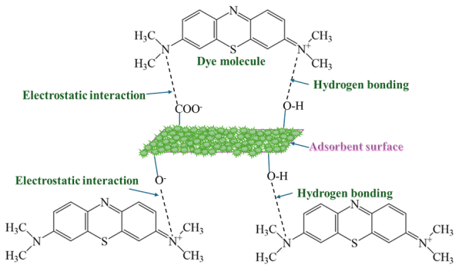
Figure8: Electrostatic and hydrogen bonding in dye removal with agricultural waste
4.1.3. Van der Waals forces: These are weak forces that have short-range attractive forces which obtained in between all molecules. In the situation of dye adsorption, van der Waals forces promotes the physical attachment of dye molecules with the surface of adsorbent. This type of interaction is classically reversible and consequences in multilayer adsorption (Freundlich isotherm) shown in Figure 8. These forces strength can be altered by temperature and dye’s molecule size; larger molecules generally show stronger van der Waals interactions (El Meziani, S. et.al., 2025).
4.1.4. π–π stacking interactions:
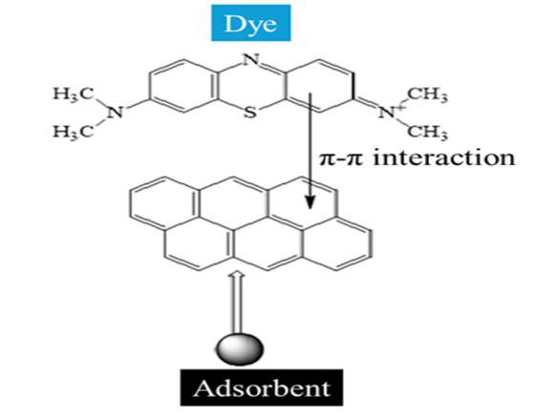
Figure9: π-π interaction mechanism in dye removal

The dye’s which consists of aromatic compounds that contains delocalized $π$-electrons within their ring structures. Agricultural waste, particularly after carbonization into biochar or activated carbon, develops a surface rich in graphitic basal planes with its own delocalized 𝜋-electrons. The parallel arrangement (stacking) of the aromatic rings in the dye molecules with those on the adsorbent surface creates strong $π$–$π$ interactions, which significantly improved the adsorption of dye contains aromatic compounds represented in Figure 9 (El Meziani, S. et.al., 2025).
  - Complexation Mechanism:
This mechanism involves through interaction between adsorbent’s surface functional contains electron pair and electron acceptor dye molecules or metal ions that form stable complexes on the surface of materials, e.g. hydroxyl (-OH) and amine (-NH₂) groups on adsorbent materials complex with dyes like Congo Red. This is a specific complexation in which a metal ion in the treatment materials attached with two or more coordinated atoms having strong attractions in the same molecule of the dye or ligand that formed heterocyclic ring structure shown in Figure 10 (Ahmad Aftab, R. et.al., 2024)
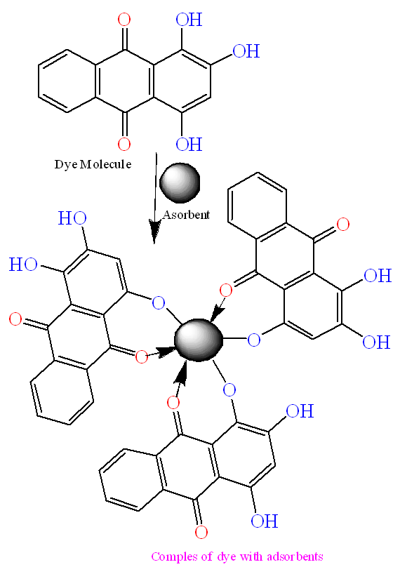
Figure 10: Complexation process of adsorbents with dye
5. Adsorption Isotherms and Kinetics
5.1. Adsorption Isotherms (Equilibrium)
These models can explain about the capacity of adsorbent at a fixed temperature which shows how much dye is adsorbed vs. its concentration in the solution, some of the isotherm’s study in removal of dye as:
5.1.1. Langmuir Model: this model explains a single layer of dye molecules adsorbed on the surface and that adsorption methods are reversible and homogeneous these are explained by the given equation 1&2. (Islam, M. A., et.al.2025; Mahdi,N. I.et.al., 2023).
q_{e}= q_{m}K_{L}Ce/(1+K_{L}Ce) ------------------------ 1
Ce/q_{e} = 1 / 𝑞_{m} K_{L} + 𝐶e/ 𝑞m -------------------------------2
Where qm is in (mg. g⁻¹) & KL (mL.mg⁻¹) are Langmuir constants; q_{e =} amount of dye adsorbed on the adsorbent (mg/g) and $C_{e}$is concentrations of dye at equilibrium (mg/L)
5.1.2. Freundlich Model: This model suggests multilayer adsorption on heterogenous surface of adsorbents, it is common for complex natural materials such as clays (Saadi, R. et.al., 2025). The Freundlich model for dye adsorption defines the relationship between adsorbed amount of dye and its equilibrium concentration using the equation, non-linear isotherms for dye are given in equation 3 & 4.
$q_{e}=K_{f}C_{e}^{\frac{1}{n}}$ ---------------------------------------- 3
its linear form
$ln(q_{e})=ln(K_{f})+\frac{1}{n}ln(C_{e})$----------------------------- 4
- where $q_{e}$= dye adsorbed per adsorbent mass (mg/g), $C_{e}$= equilibrium dye concentration (mg/L), and $K_{f}$is the capacity) and $n$=heterogeneity are empirical constants, with $n>1$indicating favourable adsorption on heterogeneous surfaces, commonly used for dyes and activated carbon (Mahdi, N. I.et.al., 2023).
5.1.3. Temkin Model: this mode explains about the heat adsorption that represents about the interactions between adsorbent and adsorbate (Musah, M. et.al., 2022; Souli, L. et. al., 2025)
The Temkin model for dye removal uses the equation 5& 6
$q_{e}=Bln(K_{T})+Bln(C_{e})$ -------------------------------------------5
or its common linear form
$q_{e}=Bln(C_{e})+A^{'}$----------------------------------------------------6
where $q_{e}$ = adsorbed dye (mg/g), $C_{e}$ = equilibrium concentration (mg/L), $R$ = gas constant,$T$ is temp (K), $b_{T}$ is the heat of adsorption, $K_{T}$= equilibrium constant, and $B=\left(\frac{RT}{b_{T}}\right)$ is the heat of adsorption that indicates the interactions between adsorbate/adsorbent.
Table1: Comparison of various Agricultural waste use as adsorbent for removal of methylene orange dye removal from textile effluent
Adsorbent | Chemical for activation | Rate of Adsorption (mg/g) | Effectiveness (%) | Accepted Isothermal model | Kinetic model | References
Pomelo peels | H₃PO₄  KOH | 141  680 | 94.6 | Freundlich Langmuir | PSO | (Zhang, et.al.,2020)  (Li et.al.,2016)
wood of Acacia mangium | KOH | 181 | 90.5 | – | PSO | (Danish, et.al.,2018)
Walnut peels | ZnCl₂ | 180 | 95 | Langmuir | PSO | (Hajialigol,S.et.al., 2019)
Thapsiatran stagana stems |  | 118.10 | 91.4 | Langmuir | PSO | (Machrouhi, et.al.,2019)
Watermelon rind | H₂SO₄ | 27 | 85 | Langmuir | PSO | (Bhattacharjee et.al.,  2020a) (Üner, et.al.,2016)
Coffee ground waste | – | 658 | – | Freundlich | PSO | (Rattanapan et.al.,2017)
Wheat straw | - | 304.2 | - | Langmuir | PSO | (Senthil, et.al.,2020)
Pisum sativum peels | Fe₃O₄ | - | 96 | - | - | (Prasad, C. et.al.,2017)
Rambutan peels | ZnO | .- | 84 | - | . - | (Reza, M.S. et.al.,2020)
Orange peels | H₂SO₄ | - | 99 | Langmuir | PSO | (Daful et.al., 2018)
Fibers of banana pseudo-stem | –– | 88.5 | - | Freundlich | PSO | (Saigl, et.al,2021)
Durian seeds | H₃PO₄ | 384.62 | 92.5 | Freundlich | PSO | (Ahmed et.al.,2020
Atemoya shell | K₂CO₃ | 435.25 | 64 | Langmuir | PSO | (Khan et.al.,2018)
Annona squamosa seed. | - | 40.48 | 82.81 | Langmuir, Freundlich, Temkin model | PSO | (Khan et.al.,2018

Several agricultural wastes show better resemblance with the pseudo-second-order kinetic model, representing chemisorption predominance. Langmuir model fitting recommends monolayer adsorption with finite adsorption sites on activated biosorbents. Some agricultural waste as adsorbents and their dye removal model, adsorption capacity, efficiency and kinetics are given in Table 1.
6. Challenges and Limitations
Although agricultural waste induced as an emerging adsorbent toward the adsorption of various contaminants including dye but it faces various challenges:
- Variability in composition: There are various varieties of agricultural crops are available at the earth and their developments also depends on the climate so that its composition are also depends on geographical and seasonal factors. Hence it can’t uniformly use.
- Lower adsorption capacities: Agricultural waste have lower adsorption potential as compared with commercial activated carbon unless well modified.
- Regeneration and reuse: Its desorption studies are limited; efficient regeneration without loss of capacity is needed.
7. Future Research Directions
For developments of agricultural waste that favourable to the advance practical applications as:
- Consistent etiquettes for preparation and characterization of biosorbents.
- Incorporation with collective treatment systems (e.g., constructed wetlands, membrane bioreactors).
- Life-cycle valuations and cost investigation to compare with conventional adsorbents.
- Advancements of smart materials (magnetic biosorbents) for easy recovery.
- Investigation of real industrial effluents rather than synthetic dye solutions.
8. Conclusions
Low-cost agricultural wastes derived adsorbents obtained from, peals of various fruits and vegetables represent sustainable, economical and competent adsorbents for dye removal from wastewater. These adsorbents have ecofriendly nature and easily degraded by microbial action. Through suitable alteration, these constituents can compete unadventurous activated carbon. Their use makes straight with globular economy principles, valorising waste into appreciated treatment media. Since a sustainability viewpoint the agricultural wastages valorization inefficient adsorbents facilitate in circular economy value by mitigating waste removal, make inexpensive treatments and reducing trust on non-renewable resources. Forthcoming study should emphasis on grading up, improving renaissance approaches, and dealing with real industrial effluents to move toward industrial deployment.
Disclaimer (Artificial intelligence)
Author(s) hereby declare that NO generative AI technologies such as Large Language Models (ChatGPT, COPILOT, etc.) and text-to-image generators have been used during the writing or editing of this manuscript.

References:
Ahmad Aftab, R., Yusuf, M., Ahmad, F., Danish, M., Zaidi, S., Vo, D. V. N.,et.al. (2024). Green Technology Approach Towards the Removal of Heavy Metals, Dyes, and Phenols from Water Using Agro‐based Adsorbents: A Review. Chemistry–An Asian Journal, 19(19), e202400154. doi.10.1002/asia.202400154
Ahmed, S., Aktar, S., Zaman, S., Jahan, R.A. & Bari, M.L., (2020). Use of natural bio-sorbent in removing dye, heavy metal and antibiotic-resistant bacteria from industrial wastewater. Appl. Water Sci. 10 (5), 1–11. doi.10.1007/s13201-02001200-8
Akhtar, M. S., Ali, S., & Zaman, W. (2024). Innovative Adsorbents for Pollutant Removal: Exploring the Latest Research and Applications. Molecules, 29(18), 4317. https://doi.org/10.3390/molecules29184317
AlAqad, K. M., Abdelnaby, M. M., Tanimu, A., Abdulazeez, I., & Elsharif, A. M. (2025). Adsorbent materials for water treatment: A review of current trends and future challenges. Environmental Pollution and Management, 2, 1-13. https://doi.org/10.1016/j.epm.2024.12.003
Amalina, F., Abd Razak, A. S., Krishnan, S., Zularisam, A. W., & Nasrullah, M. (2022). Dyes removal from textile wastewater by agricultural waste as an absorbent – A review. Cleaner Waste Systems, 3, 100051. https://doi.org/10.1016/j.clwas.2022.100051
Bhattacharjee, C., Dutta, S., & Saxena, V. K. (2020). A review on biosorptive removal of dyes and heavy metals from wastewater using watermelon rind as biosorbent. Environmental Advances, 2, 100007. https://doi.org/10.1016/j.envadv.2020.100007
Bal, G., & Thakur, A. (2021). Distinct approaches of removal of dyes from wastewater: A review. Materials Today: Proceedings, 50, 1575-1579. https://doi.org/10.1016/j.matpr.2021.09.119
Bal, G., & Thakur, A. (2021). Distinct approaches of removal of dyes from wastewater: A review. Materials Today: Proceedings, 50, 1575-1579. https://doi.org/10.1016/j.matpr.2021.09.119
Chan, A. A., Raman, A. A. A., Chong, W. L., & Buthiyappan, A. (2024). Graphene oxide impregnated activated carbon derived from coconut shell through hydrothermal carbonization for cationic dye removal: Adsorptive performance, kinetics, and chemistry of interaction. Journal of Cleaner Production, 437, 140655. https://doi.org/10.1016/j.jclepro.2024.140655
Daful, A.G.& Chandraratne, M.R. (2018). Biochar production from biomass waste-derived material. Encycl. Renew. Sustain. Mater. doi.10.1016/B978-0-12803581-8.11249-4
Danish, M., & Ahmad, T. (2018). A review on utilization of wood biomass as a sustainable precursor for activated carbon production and application. Renewable and Sustainable Energy Reviews. https://doi.org/10.1016/j.rser.2018.02.003
Das, A., & Dey, A. (2020). P-Nitrophenol-Bioremediation using potent Pseudomonas strain from the textile dye industry effluent. Journal of Environmental Chemical Engineering, 8(4), 103830. https://doi.org/10.1016/j.jece.2020.103830
El Meziani, S., Agnaou, H., El Haddaj, H., Boumya, W., Barka, N., & Elhalil, A. (2025). Sustainable adsorption technologies for textile dye removal: Advances in biomass-derived and magnetically modified activated carbons. Cleaner Chemical Engineering. https://doi.org/10.1016/j.clce.2025.100210
Garg, S., Rumjit, N. P., Arora, P., & Ahmed, S. (2025). Biochar-based solutions for sustainable dye treatment and agricultural waste management. Journal of Material Cycles and Waste Management, 27, 1283–1301. https://doi.org/10.1007/s10163-025-02201-y
Gonçalves, J. O., Leones, A. R., de Farias, B. S., da Silva, M. D., Jaeschke, D. P., Fernandes, S. S., & Pinto, L. A. D. A. (2025). A comprehensive review of agricultural residue-derived bioadsorbents for emerging contaminant removal. Water, 17(14), 2141. https://doi.org/10.3390/w17142141
Hajialigol, S.& Masoum, S. (2019). Optimization of biosorption potential of nano biomass derived from walnut shell for the removal of Malachite Green from liquids solution: Experimental design approaches. J. Mol. Liq. 286, 110904. doi. 10.1016/ j. molliq.2019. 110904
Islam, M. A., Choudhury, J. T., Hossain, F., Hossain, F. B., & Uddin, M. T. (2025). Competitive Langmuir Model for Dye Mixture Adsorption: Disagreement between Theoretical Ground and Application Condition. Langmuir, 41(1), 216-230. https://doi.org/10.1021/acs.langmuir.4c03340
Ismail, B. M., Zayed, A. M., Roshdy, M. A., Rafea, M. A., & Mohamed, F. M. (2025). Statistical modeling of mutagenic azo dye adsorption on bagasse activated carbon. Scientific Reports, 15(1), 20112. https://doi.org/10.1038/s41598-025-04240-9
Ivbanikaro, A. E., Okonkwo, J. O., Sadiku, E. R., & Maepa, C. E. (2023). A review on the current approach for the sustainable production of nanocomposites from agricultural wastes and their application for the adsorption of organophosphate flame retardants. Polymers and Polymer Composites, 31, 09673911231181270. https://doi.org/10.1177/09673911231181270
Kiran, M., Haq, F., Mehmood, S., & Aziz, T. (2025). Innovative Biosorbents from Agro-Waste: Advancing Sustainable Solutions for Heavy Metal, Dye, and Organic Pollutant Removal. Journal of Chemical Engineering Research Updates, 12, 1–33. https://doi.org/10.15377/2409-983X.2025.12.1
Khan, E. A., Shahjahan, & Khan, T. A. (2018). Adsorption of methyl red on activated carbon derived from custard apple (Annona squamosa) fruit shell: Equilibrium isotherm and kinetic studies. Journal of Molecular Liquids, 249, 1195–1211. https://doi.org/10.1016/j.molliq.2017.11.125
Kundu, D., Sharma, P., Bhattacharya, S., Gupta, K., Sengupta, S., & Shang, J. (2024). Study of methylene blue dye removal using biochar derived from leaf and stem of Lantana camara L. Carbon Research, 3(1), 22. https://doi.org/10.1007/s44246-024-00108-1
Kusumlata, Ambade, B., Kumar, A., & Gautam, S. (2024). Sustainable Solutions: Reviewing the Future of Textile Dye Contaminant Removal with Emerging Biological Treatments. Limnological Review, 24(2), 126-149. https://doi.org/10.3390/limnolrev24020007
Li, H., Sun, Z., Zhang, L., Tian, Y., Cui, G., & Yan, S. (2016). A cost-effective porous carbon derived from pomelo peel for the removal of methyl orange from aqueous solution. Colloids and Surfaces A: Physicochemical and Engineering Aspects, 489, 191–199. https://doi.org/10.1016/j.colsurfa.2015.10.041
Lin, J., Ye, W., Xie, M., Seo, D. H., Luo, J., Wan, Y., & Van der Bruggen, B. (2023). Environmental impacts and remediation of dye-containing wastewater. Nature Reviews Earth & Environment, 4(11), 785-803. https://doi.org/10.1038/s43017-023-00489-8
Machrouhi, A., Alilou, H., Farnane, M., El Hamidi, S., Sadiq, M., Abdennouri, M., Tounsadi, H., & Barka, N. (2019). Statistical optimization of activated carbon from Thapsia transtagana stems and dyes removal efficiency using central composite design. Journal of Science: Advanced Materials and Devices, 4(4), 544–553. https://doi.org/10.1016/j.jsamd.2019.09.002
Mahdi, N. I., Falih, M. S., Abbas, R. F., Waheb, A. A., & Rahi, A. A. (2023). Removal of Brilliant Green Dye from Aqueous Solutions Using Multi-walled Carbon Nanotubes (MWCNTs): Linear and Nonlinear Isotherm Models and Error Analysis. Nature Environment and Pollution Technology, 22(4), 1931-1940. https://doi.org/10.46488/NEPT.2023.v22i04.019
Mahmoud, G. E., Mahdy, A. G., & El Refay, H. M. (2025). Utilizing cheap sawdust by-products of the timber industry waste to assess adsorption kinetics for improved cationic dye pollutant removal. Chemical Papers, 79, 1689-1705. doi. 10.1007/s11696-025-03883-2
Mladenovic, N., Makreski, P., Tarbuk, A., Grgic, K., Boev, B., Mirakovski, D., Toshikj, E., Dimova, V., Dimitrovski, D., & Jordanov, I. (2020). Improved dye removal ability of modified rice husk with effluent from alkaline scouring based on the circular economy concept. Processes, 8(6), 653. https://doi.org/10.3390/pr8060653
Musah, M., Azeh, Y., Mathew, J. T., Umar, M. T., Abdulhamid, Z., & Muhammad, A. I. (2022). Adsorption kinetics and isotherm models: A review. Caliphate Journal of Science and Technology, 4(1), 20-26. https://doi.org/10.4314/cajost.v4i1.3
Nath, A., Mishra, A., & Pande, P. P. (2021). A review on natural polymeric coagulants in wastewater treatment. Materials Today: Proceedings, 46(14), 6113-6117. https://doi.org/10.1016/j.matpr.2020.03.551
Nath, A., Mishra, A., Pande, P. P., & Shankar, R. (2022). Synthesis of disaccharide-based xanthates for the removal of some heavy metals from aqueous solutions. Iranian Journal of Chemistry and Chemical Engineering, 41(4), 1137-1150. https://doi.org/10.30492/IJCCE.2021.127412.4123
Prasad, C., Yuvaraja, G., & Venkateswarlu, P. (2017). Biogenic synthesis of Fe3O4 magnetic nanoparticles using Pisum sativum peels extract and its effect on magnetic and Methyl orange dye degradation studies. J. Magn. Magn. Mater., 424, 376–381. https://doi.org/10.1016/j.jmmm.2016.10.084
Pereira, L., & Alves, M. (2011). Dyes—Environmental Impact and Remediation. In Environmental protection strategies for sustainable development (pp. 111-162). Springer Netherlands. https://doi.org/10.1007/978-94-007-1591-2_4
Ramachandran, S., Gupta, A., Mayilswamy, N., Nighojkar, A., & Kandasubramanian, B. (2025). Multifaceted applications of dye-saturated biochar: Agronomic amelioration, thermochemical valorization, and catalytic efficacy in advanced environmental remediation paradigms. Cleaner Chemical Engineering. https://doi.org/10.1016/j.clce.2025.100164
Rathi, B. S., & Kumar, P. S. (2021). Application of adsorption process for effective removal of emerging contaminants from water and wastewater. Environmental Pollution, 280, 116995. https://doi.org/10.1016/j.envpol.2021.116995
Rattanapan, S., Srikram, J., & Kongsune, P. (2017). Adsorption of methyl orange on coffee grounds activated carbon. Energy Procedia, 138, 949–954. https://doi.org/10.1016/j.egypro.2017.10.064
Reza, M. S., Yun, C. S., Afroze, S., Radenahmad, N., Bakar, M. S. A., Saidur, R., Taweekun, J., & Azad, A. K. (2020). Preparation of activated carbon from biomass and its' applications in water and gas purification, a review. Arab Journal of Basic and Applied Sciences, 27(1), 208–238. https://doi.org/10.1080/25765299.2020.1766799
Saadi, R., Saadi, Z., Fazaeli, R., & Fard, N. E. (2015). Monolayer and multilayer adsorption isotherm models for sorption from aqueous media. Korean Journal of Chemical Engineering, 32(5), 787-799. https://doi.org/10.1007/s11814-015-0053-7
Saigl, Z.M. & Ahmed, A.M. (2021). Separation of rhodamine b dye from aqueous media using natural pomegranate peels. Indones. J. Chem. 21 (1), 212–224. doi.10.22146/ijc.58592
Satyam, S., & Patra, S. (2024). Innovations and challenges in adsorption-based wastewater remediation: A comprehensive review. Heliyon, 10(9), e29573. https://doi.org/10.1016/j.heliyon.2024.e29573
Senthil, C., & Lee, C. W. (2020). Biomass-derived biochar materials as sustainable energy sources for electrochemical energy storage devices. Renewable and Sustainable Energy Reviews. https://doi.org/10.1016/j.rser.2020.110464
Sharma, P., Sharma, S., Sharma, S. K., Jain, A., & Shrivastava, K. (2024). Review on recent advancement of adsorption potential of sugarcane bagasse biochar in wastewater treatment. Chemical Engineering Research and Design, 206, 428-439. https://doi.org/10.1016/j.cherd.2024.04.055
Singh, B. P., & Srivastava, P. (2020). Overview of Textile and Leather Industries Waste Treatment Processes. International Journal of Current Microbiology and Applied Sciences, 9(12), 1334-1353. https://doi.org/10.20546/ijcmas.2020.912.164
Singh, M., Kumar, N., Gupta, A., Palai, I., Kumari, A., & Arshi, A. M. K. (2025). A comprehensive review on utilization of agricultural waste for reinforced structural products: A sustainable perspective. Bulgarian Chemical Communications, 57(Special Issue B), 05-16. https://doi.org/10.34049/bcc.57.B.A0001
Singh, S., & Kumar, N. (2024). Removal of Dyes from Waste Water Using Low‐Cost Adsorbents. In Macromolecular Symposia, 413(5), 2400156. doi.10.1002/masy.202400156.
Souli, L., Djemoui, A., Benkouider, T., Haiouani, K., Djemoui, D., Souadia, A., Derouiche, Y., Lahrech, M. B., Messaoudi, M., Hegazy, S., Alsalme, A., & Barhoum, A. (2025). Adsorptive dye removal using surfactant-exfoliated montmorillonite/crosslinked tetramethacrylate composites. Materials Chemistry and Physics, 333, 130320. https://doi.org/10.1016/j.matchemphys.2024.130320
Üner, O., Geçgel, Ü., & Bayrak, Y. (2016). Adsorption of methylene blue by an efficient activated carbon prepared from citrullus lanatus rind: kinetic, isotherm, thermodynamic, and mechanism analysis. Water, Air, & Soil Pollution. https://doi.org/10.1007/s11270-016-2949-1
Zhang, H., Xu, F., Xue, J., Chen, S., Wang, J., & Yang, Y. (2020). Enhanced removal of heavy metal ions from aqueous solution using manganese dioxide-loaded biochar: Behavior and mechanism. Scientific Reports, 10(1), 6067. https://doi.org/10.1038/s41598-020-63000-z

