Study of Methylene Blue from Water
Solution adsorption onto mesoporous silica (SiO₂) synthesised from
Clay via a Mineral Sol.

ABSTRACT :
Background : Methylene blue (BM), whose toxic effects are not immediately apparent, can, in the long term, cause damage to the cardiovascular, central nervous, dermatological, gastrointestinal, genitourinary, and haematological systems in humans. It is therefore essential to eliminate this dye from wastewater.
Aims: The present study aims to investigate the elimination of methylene blue from water solution by adsorption on mesoporous silica.
Study Design : This study was conducted using a batch method for the treatment of aqueous methylene blue solution through the adsorption technique.
Place and Duration of Study: Département de Chimie, Université de N’Djamena, from August 2025 to October 2025.
Methodology: This study aims to remove a synthetic dye, specifically methylene blue, using mesoporous silica (nanometer-sized amorphous silica) synthesised via a colloidal route. The adsorption technique is implemented by examining the influence of pH, temperature, and dye concentration under various experimental conditions. During the experiments, a fixed mass of adsorbent was introduced into different beakers containing 50 mL of the colored solution and then subjected to continuous stirring for 180 minutes at 25 °C. The effects of the experimental parameters on the adsorption process were also investigated in this work.
Results: Synthesised SiO2 has a pHpzc of 7,57. An optimal pH of 8 was determined at 25 °C, resulting in 99.079% dye removal. Equilibrium was reached after 10 minutes of contact with a removal rate of 99.63%. With a mass of 40 mg of the adsorbent, 99.65% of the dye was removed. The Langmuir isotherm accurately describes the experimental data, while the pseudo-second-order kinetic model more precisely describes the adsorption behaviour.
Conclusion : This mesoporous silica (SiO2) synthesised via a Mineral Sol is a promising candidate for the remediation of wastewater pollution.

Keywords : mesoporous silica, adsorption, methylene blue, water solution

1. INTRODUCTION :
Dyes released into wastewater from various industrial sectors — including textiles, leather, paper and pulp, plastics, and the food industry — constitute major sources of environmental pollution, notably by reducing light penetration in aquatic systems and consequently impairing photosynthesis. Moreover, some of these dyes exhibit toxic, mutagenic, or carcinogenic properties, thereby increasing risks to both ecosystems and human health. Methylene blue (BM), whose toxic effects are not immediately apparent, can, in the long term, cause damage to the cardiovascular, central nervous, dermatological, gastrointestinal, genitourinary, and haematological systems in humans. It is therefore essential to eliminate this dye from wastewater [1]. It can induce eye burns, which can result in irreversible damage to human and animal eyes. Its inhalation can induce respiratory problems, and its intake causes a burning feeling, nausea, vomiting, sweating, and excessive cold sweat [22] . Organic dyes in industrial wastes pose a serious danger to human health and the environment due to their high toxicity [2,3]. Therefore, it is urgent to find a solution to eliminate dyes from wastewater [23]. Various techniques, such as chemical oxidation, membrane separation, coagulation-flocculation, and ion exchange, have been reported for the removal of dyes present in industrial wastewater [2–4]. However, their high cost, poor environmental compatibility, and several other constraints have led researchers to favour biological processes, which use living or inert biomass for dye removal, over the previously mentioned techniques. [5–7]. Other materials used for dye adsorption have also been identified; among them are eggshells, clays and activated carbons [8–14]. Its significant adsorption potential for mineral and organic materials, the presence of –OH groups on its surface, and its abundance in nature make silica one of the most widely used compounds in the removal of pollutants.[1 ]. This work presents the evaluation of a mesoporous silica (SiO₂), synthesised via a mineral-sol route, for the adsorption of a cationic dye under various experimental conditions, including contact time, pH, initial dye concentration, and adsorbent quantity. The adsorption process was also analysed using kinetic models and adsorption isotherms.

2. Materials and Methods
2-1 Materials
The products and materials used in this study include: amorphous silica (SiO₂) synthesised via a mineral process, exhibiting a specific surface area of ​​619 m²·g⁻¹, a mean pore diameter of 2.6 nm, and a pore volume of 0.405 cm³·g⁻¹. The X-ray diffraction (XRD) pattern of the mesoporous silica is shown in Figure 1 [15]. Methylene blue (MB), a cationic dye with the molecular formula C₁₆H₁₈N₃SCl and a molar mass of 319.85 g·mol⁻¹; A Cary 100 UV-Visible spectrophotometer (Varian, USA), operating at room temperature (23–25 °C) and equipped with a dual-beam device, was used for the analyses. A Metrohm 692 pH meter (Herisau, Switzerland) was also used. The aqueous solutions were prepared from distilled water, and the pH values ​​were determined using sodium hydroxide (NaOH, 0.1 M, 98%) and hydrochloric acid (HCl, 0.1 M, 37%).
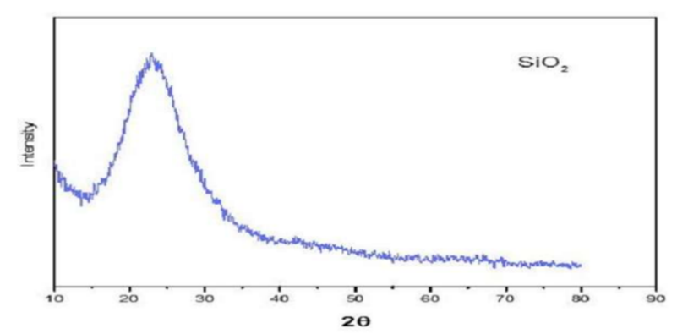

Figure 1 : Spectrum of mesoporous silica

2-2 METHOD
Adsorption experiments were performed batchwise under various conditions of initial pH, temperature, and dye concentration. A fixed mass of adsorbent was added to beakers containing 50 mL of methylene blue solution (50 mg·L⁻¹). After pH adjustment, the suspensions were stirred for 180 min at 25 °C using a multi-station stirrer. The absorbance of the filtered solutions was measured by UV-visible spectrophotometry at the wavelength corresponding to the maximum absorbance of the dye (λ = 664 nm). The adsorption capacity and removal efficiency of methylene blue were determined according to equations (1) and (2), respectively.

$q_{e}=(co-ce)×\frac{v}{m}$ (1)

$R=\frac{(co-ce)}{co}×100$ (2)

qₑ: Equilibrium adsorption capacity (mg·g⁻¹)
C₀: Initial dye concentration (mg·L⁻¹)
Cₑ: Dye concentration at equilibrium (mg·L⁻¹)
m: Mass of adsorbent used (g)
V: Volume of the dye solution (L)

2-2-1 Sorption isotherms :
50 mg of adsorbent were added to 50 mL of dye solution, at concentrations ranging from 50 to 500 mg·L⁻¹, in order to study the adsorption isotherms. A contact time of 24 h was used to allow the system to reach equilibrium. The resulting experimental data were fitted to Langmuir (Equation (3)) and the Freundlich (Equation (4)) isotherm models. The parameters obtained from isotherm modelling provide important insights into the adsorption mechanism, surface properties, and adsorbent–adsorbate affinities. Among the various models, we selected the two most significant: the Langmuir model and the Freundlich model. The Langmuir model is particularly useful for describing the monomolecular adsorption of a solute, forming a monolayer on the surface of an adsorbent. The Freundlich model takes into account multilayer adsorption and is particularly well-suited to describing reversible processes on heterogeneous surfaces. It is commonly used to represent systems where the adsorbent surface is energetically non-uniform.

$\frac{1}{q_{e}}=\frac{1}{q_{m}}+\frac{1}{k_{1}{×q}_{m}}×\frac{1}{c_{e}}$ (3)
K_{L} is the Langmuir equilibrium constant (L mg-1),
q_{m} represents the maximum adsorption capacity of the adsorbent (mg g-1),
q_{e} (mg g-1): amount of dye adsorbed at equilibrium.
$\ln{q_{e}=\ln{k_{f}=\frac{1}{n}}\ln{c_{e}}}$ (4)
The Freundlich constants, K_{F} (mg g-1) and n .
Slope: 1/n is a measure of the surface heterogeneity.
2- 2-2-Kinetics studies :
Kinetic modelling allows us to understand the mechanisms involved in the adsorption process. Pseudo-first-order and pseudo-second-order models are commonly used [16]. The pseudo-first-order model assumes that the rate of occupancy of adsorption sites is proportional to the number of unoccupied sites. The pseudo-second-order model stipulates that adsorption follows second-order kinetics and involves chemisorption as the rate-limiting step. Equations (5) and (6) represent the two models, respectively.

ln (qe — qt) = ln qe — k1.t (5)

1/qt = 1/K2.qe² + (1/qe).t (6)

qt : Colorant adsorbé au temps t (mg g⁻¹) ;
qe : Colorant adsorbé à l'équilibre (mg g⁻¹)
k1 (min-1) et k2 (g mg-1 min-1) : Caractéristiques de la constante de vitesse d'équilibre des modèles de pseudo-premier ordre et de pseudo-second ordre, respectivement.

3. RESULTS AND DISCUSSION
3-1-The Point of Zero Charge :
To determine the pH range in which the adsorbent exhibits the best dye removal efficiency, the zero charge point (pHPZC) was determined. The zero charge point corresponds to the pH at which the net surface charge of the adsorbent is zero; it constitutes a fundamental physicochemical parameter of the phenomena occurring at the surface of adsorbents. Thus, for pH values ​​above the pHPZC, the surface of the adsorbent becomes negatively charged, which promotes increased electrostatic attraction with the positively charged methylene blue (MB) molecules [1 and 17]. Synthesised SiO₂ has a pHpzc of 7,57.
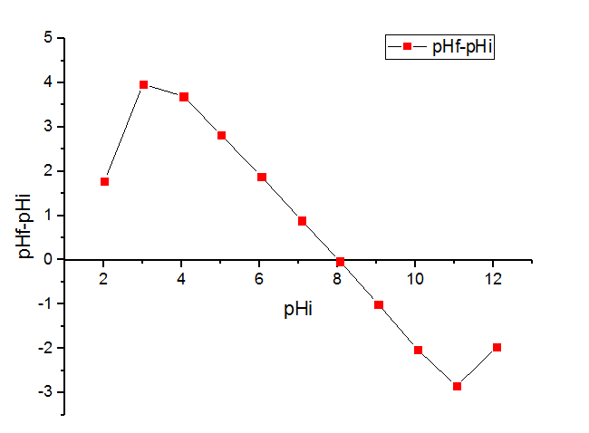

Figure2. The pH of point zero charge (pH_{PZC}) of silica
3-2-Effect of pH :
After determining the zero-charge point, the dye adsorption efficiency as a function of pH variation was verified over a pH range of 3 to 12. pH values ​​were varied and held constant during the equilibrium period. The results show that a removal rate of 99.079% was achieved at pH 8. Therefore, the optimal pH for maximum dye removal is 8.

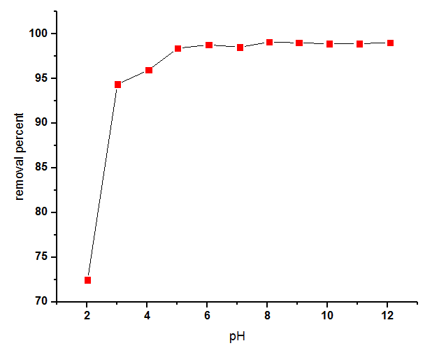

Figure 3 : Effect of pH ; Mass = 50 mg, C₀ [MB] = 50 mg L-1, V = 50 mL.

3-3 The effect of adsorbent amount :
To determine the optimal adsorbent mass, absorbance measurements were performed for different masses ranging from 10 mg to 100 mg. Figure 4 shows that the dye removal rate increases with increasing adsorbent mass up to 40 mg. Beyond this value, a decrease in the curve is observed, a phenomenon that can be attributed to the saturation of the active sites. Thus, the optimal adsorbent mass is 40 mg, corresponding to the value at which the dye removal rate is maximal, 99,65%.
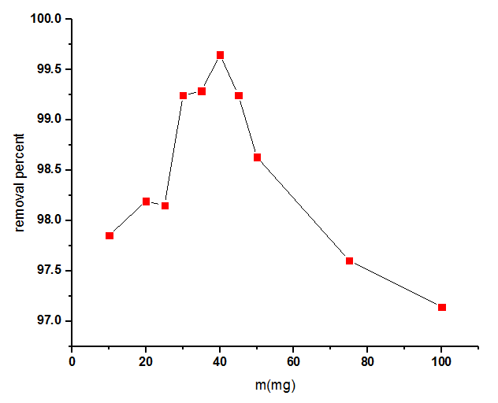

Figure 4 : Effect of silicate mass on the efficiency of removing MB.

3-4 - The effect of adsorbent :
To determine the optimal adsorbate concentration, various concentrations were subjected to adsorption tests. Results obtained over a methylene blue concentration range of 10 to 500 mg·L⁻¹ show that a maximum removal rate of 97.57% is achieved at a concentration of 50 mg·L⁻¹. Above this value, removal efficiency decreases, then stabilises in the 100 to 200 mg·L⁻¹ range before dropping to 69.75%. The shape of the curve shown in Figure 5 indicates that at low dye concentrations, adsorption is particularly efficient due to the high availability of pores and active sites on the adsorbent surface. Conversely, a progressive increase in dye concentration leads to saturation of the adsorption sites, which hinders the adsorption process.

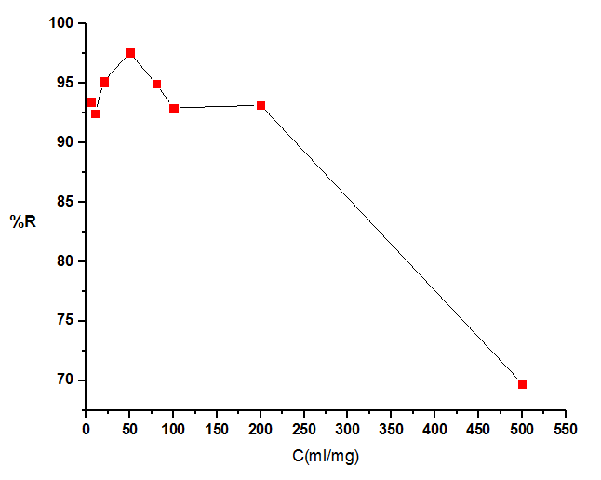

Figure 5.Effect of initial dye concentration on the adsorption of MB

3.5. The effect of adsorption time :
The dye and the adsorbent were brought into contact to determine the time required to reach adsorption equilibrium. Over a time interval of 0 to 200 minutes, the tests revealed that the adsorption process is particularly rapid, with equilibrium being reached after only 10 minutes of contact( fig.6). Adsorption thus follows a rapid kinetic profile. This rapid adsorption observed during the first few minutes is explained by the high availability of pores and active sites on the surface of the adsorbent, which become progressively saturated as the amount of adsorbed dye increases.

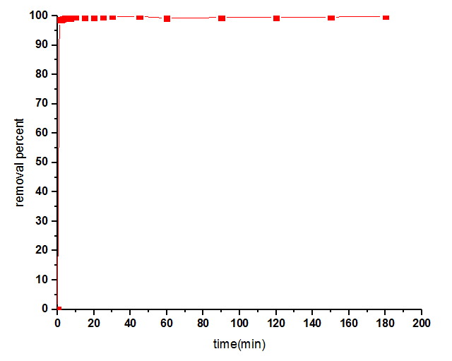

Figure 6 . Effect of contact time on the adsorption of MB onto boehmite (γ-AlOOH)

3-6 Kinetic Studies
To identify the kinetic model best suited to the nano-silica–methylene blue system, two kinetic models were applied: a pseudo-first-order model and a pseudo-second-order model. The correlation coefficients obtained were R² = 0.092 and R² = 0.99, respectively, as illustrated in Figures 7 and 8 and summarised in Table 1. Consequently, the pseudo-second-order model more accurately describes the experimental adsorption data. This result suggests that the rate of the adsorption process is primarily controlled by a chemisorption mechanism. [18- 19].

3-7 Equilibrium Studies:
Experimental data fitted to the Langmuir and the Freundlich isotherm models indicate that the Langmuir model is better suited than the Freundlich model (Figure 10). Consequently, the adsorption process relies on the formation of monolayers and is characterised by the homogeneity of adsorption sites on the surface of the adsorbent. The corresponding parameters are summarised in Table 2 [20].

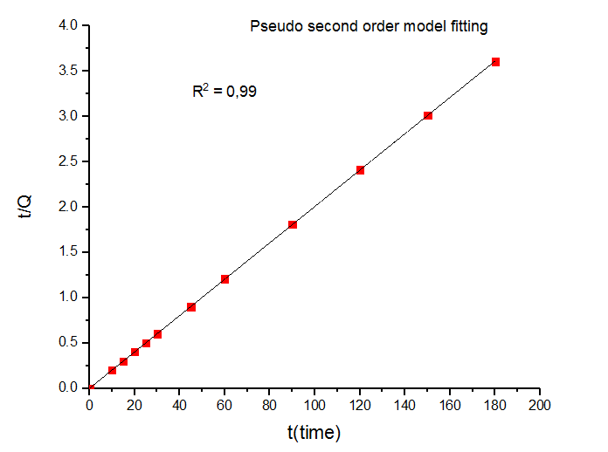
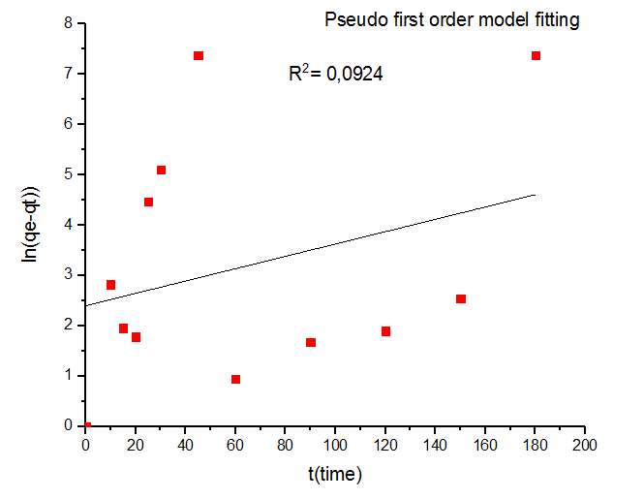

Figure 7. Plots of the pseudo-first-order Figure 8. Plot of the pseudo-second order
Table 1 : Pseudo-first order vs Pseudo-second order model
Order | Pseudo-first order | Pseudo-second order
R² | 0.092 | 0.99
K | 0.0000068 | 0.39
q_{e} | 11.0074 mg/g | 49.85 mg/g

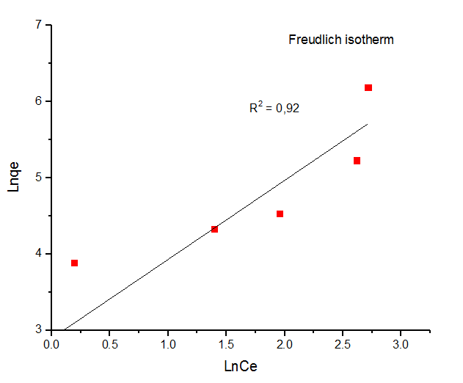
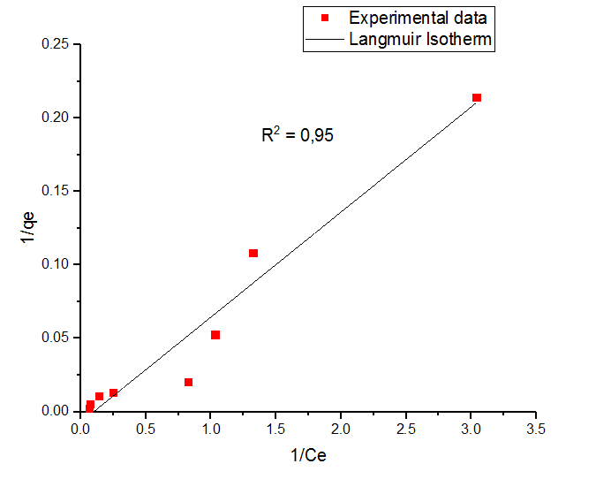

Figure 9. Langmuir model Figure 10. Freundlich model.

Table 2 : Langmuir vs Freundlich isotherm
Langmuir isotherm Freundlich isotherm
R² | K_{L} (l/mg) Q_{max} (mg/g) R_{L} R² 1/n n K_{f}
0.95 | 0.098 142.65 0.99 0.92 1.03 0.96 781.78

4. CONCLUSION :
The adsorption capacity of nano-silica (SiO₂) for methylene blue was demonstrated. The results show good agreement with the Langmuir isotherm model, while the adsorption kinetics are satisfactorily described by the pseudo-second-order model, suggesting a chemisorption-dominated adsorption mechanism. These observations confirm the potential of silica synthesised by this mineral process as an effective adsorbent material for the treatment of wastewater contaminated by organic dyes.

Disclaimer (Artificial intelligence)
Author(s) hereby declare that NO generative AI technologies such as Large Language Models (ChatGPT, COPILOT, etc.) and text-to-image generators have been used during the writing or editing of this manuscript.

5. REFERENCES :
- Kushwaha, A. K., Gupta, N., & Chattopadhyaya, M. C. (2014). Enhanced adsorption of methylene blue on modified silica gel: equilibrium, kinetic, and thermodynamic studies. Desalination and Water Treatment, 52(22-24), 4527-4537. https://doi.org/10.1080/19443994.2013.803319
- Srinivasan, A., & Viraraghavan, T. (2010). Decolorization of dye wastewaters by biosorbents: a review. Journal of Environmental Management, 91(10), 1915-1929. https://doi.org/10.1016/j.jenvman.2010.05.003 ;
- Younes, S. B., Bouallagui, Z., & Sayadi, S. (2012). Catalytic behavior and detoxifying ability of an atypical homotrimeric laccase from the thermophilic strain Scytalidium thermophilum on selected azo and triarylmethane dyes. Journal of Molecular Catalysis B: Enzymatic, 79, 41-48. https://doi.org/10.1016/j.molcatb.2012.03.017
- Salimi, F., Rahimi, H., & Karami, C. (2019). Removal of methylene blue from water solution by modified nano-goethite by Cu. Desalination and Water Treatment. https://doi.org/10.5004/dwt.2019.22922
- Yagub, M. T., Sen, T. K., Afroze, S., & Ang, H. M. (2014). Dye and its removal from aqueous solution by adsorption: a review. Advances in Colloid and Interface Science, 209, 172–184. https://doi.org/10.1016/j.cis.2014.04.002 ;
- Park, C., Lee, M., Lee, B., Kim, S.-W., Chase, H. A., Lee, J., & Kim, S. (2007). Biodegradation and biosorption for decolorization of synthetic dyes by Funalia trogii. Biochemical Engineering Journal, 36(1), 59–65. https://doi.org/10.1016/j.bej.2006.06.007
- Taha, M., Adetutu, E., Shahsavari, E., Smith, A., & Ball, A. (2014). Azo and anthraquinone dye mixture decolourization at elevated temperature and concentration by a newly isolated thermophilic fungus, Thermomucor indicae-seudaticae. Journal of Environmental Chemical Engineering, 2(1), 415–423. https://doi.org/10.1016/j.jece.2014.01.015 .
- Cornell, R. M., & Schwertmann, U. (2003). Dissolution. In *The iron oxides: Structure, properties, reactions, occurrences and uses* (2nd ed., pp. 297–344). Wiley-VCH. https://doi.org/10.1002/3527602097
- Kumar, P. S., Sivaranjanee, R., Vinothini, U., Raghavi, M., Rajasekar, K., & Ramakrishnan, K. (2014). Adsorption of dye onto raw and surface modified tamarind seeds: isotherms, process design, kinetics and mechanism. Desalination and Water Treatment, 52, 2620–2633. https://doi.org/10.1080/19443994.2013.792016 . ;
- Kumar, P. S., Pavithra, J., Suriya, S., Ramesh, M., & Kumar, K. A. (2015). Sargassum wightii, a marine alga is the source for the production of algal oil, bio-oil, and application in the dye wastewater treatment. Desalination and Water Treatment, 55(5), 1342–1358. https://doi.org/10.5004/dwt.2015.00800 ;
- Mathivanan, V., Geetha Manjari, S., Ineya, R., Saravanathamizhan, R., Senthil Kumar, P., & Ramakrishnan, K. (2016). Enhanced photocatalytic decolorization of reactive red by sonocatalysis using TiO2 catalyst: factorial design of experiments. Desalination and Water Treatment, 57(15), 7120–7129. https://doi.org/10.1080/19443994.2014.983182
- Salimi, F., Eskandari, M., & Karami, C. (2017). Investigation of methylene blue adsorption in wastewater using nano-zeolite modified with copper. *Desalination and Water Treatment*, *85*, 206–214. https://doi.org/10.5004/dwt.2017.21248
- Salimi, F., Tahmasobi, K., Karami, C., & Jahangiri, A. (2017). Preparation of Modified nano-SiO2 by Bismuth and Iron as a novel Remover of Methylene Blue from Water Solution. Journal of the Mexican Chemical Society, 61(3), 250–259. https://doi.org/10.29356/jmcs.v61i3.351
- Yaya, I. M., Valery, D. T., & Abdellah, E. (2025). Adsorption of Methylene Blue from Water Solution on Mesoporous Pseudoboehmite (γ-AlOOH) Synthesized Via a Mineral Route. Advances in Nanoparticles, 14, 142-157. https://doi.org/10.4236/anp.2025.144009
- Yaya, I. M. N., Ech-Chahad, G., Mohammed, A., & Arkhis, A. (2020). Synthesis and Characterization of Silica from Clay via a Mineral Sol. Research Journal of Chemistry and Environment, 24(4), 68-72. https://africaresearchconnects.com/paper/1bdf9545d2ef2046fb281f24533c85cf0bd1b32e2dbdc80e3fa88f9abdc33c65/
- Revellame, E. D., Fortela, D. L., Sharp, W., Hernandez, R., & Zappi, M. E. (2020). Adsorption kinetic modeling using pseudo-first order and pseudo-second order rate laws: A review. Cleaner Engineering and Technology. https://doi.org/10.1016/j.clet.2020.100032
- El-Sayed, H. A., Ibrahim, M. S., & Hassan, A. M. (2024). Adsorption of methylene blue on amorphous nanosilica: Kinetic, isotherm, and thermodynamic studies. Environmental Nanotechnology, Monitoring & Management, 24, 101131.
- Sun, Y., Ding, C., Cheng, W., & Wang, X. (2014). Simultaneous adsorption and reduction of U(VI) on reduced graphene oxide-supported nanoscale zerovalent iron. Journal of Hazardous Materials, 280, 399–408. https://doi.org/10.1016/j.jhazmat.2014.08.023
- Ciopec, M., Davidescu, C. M., Negrea, A., Grozav, I., Lupa, L., Negrea, P., & Popa, A. (2012). Adsorption studies of Cr(III) ions from aqueous solutions by DEHPA impregnated onto Amberlite XAD7 – Factorial design analysis. Chemical Engineering Research and Design, 90, 1660–1670. https://doi.org/10.1016/j.cherd.2012.01.016
- .
Danesh, N., Hosseini, M., Ghorbani, M., & Marjani, A. (2016). Fabrication, characterization and physical properties of a novel magnetite graphene oxide/Lauric acid nanoparticles modified by ethylenediaminetetraacetic acid and its applications as an adsorbent for the removal of Pb(II) ions. Synthetic Metals, 220, 508-523. https://doi.org/10.1016/j.synthmet.2016.07.025

- Sardi, A., Bounaceur, B., Mokhtar, A., Boukoussa, B., Abbes, M. T., Chaibi, W., ... & Abboud, M. (2023). Kinetics and thermodynamic studies for removal of trypan blue and methylene blue from water using nano clay filled composite of HTAB and PEG and its antibacterial activity. Journal of Polymers and the Environment, 31(12), 5065-5088.
- Aaddouz, M., Azzaoui, K., Akartasse, N., Mejdoubi, E., Hammouti, B., Taleb, M., ... & Alshahateet, S. F. (2023). Removal of methylene blue from aqueous solution by adsorption onto hydroxyapatite nanoparticles. Journal of Molecular Structure, 1288, 135807.
- Yilmaz, M. S. (2022). Graphene oxide/hollow mesoporous silica composite for selective adsorption of methylene blue. Microporous and Mesoporous Materials, 330, 111570.

