Identification of Three Bacterial Strains Isolated from Textiles Sewage and Observation of their Biodegradation Efficiency

Abstract
Azo dyes represent a significant proportion of synthetic dyestuffs (70% of the world) and create immense environmental problems because of their toxic, mutagenic, and carcinogenic properties. Congo Red (CR) an azo dye acidic in character used extensively in the textile industry for being recalcitrant and toxic degradation products. The present study was designed to assess the biodegradation and decolorization capability of bacteria isolated from dye polluted wastewater collected from BSCIC industrial area. Three isolates (Yellow, Cream, and White) were found as Micrococcus sp., Proteus sp. and Staphylococcus sp from the confirmed result of Biochemical test produced by each isolate used independently and consortium. The yellow and cream isolates were gram-positive, while the white isolate was gram-negative. Functional analysis showed they varied in carbohydrate fermentation, motility and enzymatic activity. The bacterial community was found to be most efficient for decolorization at a concentration of 100 mg L⁻¹ CR in static condition within 48 hr incubation, pH range: pH 7–7.8 and temperature is 37 °C; the mechanism of this decolorization process has been explained through azo reductase that break azo bond. These results underline the potential of native bacterial consortia for low-cost and sustainable management strategies for azo dye–contaminated wastes, with implications relevant to yeast enzyme production at industrial scale by means of advanced biotechnological processes.

Keywords:
Congo red, Bacterial strains, Azo dyes, Textiles sewage, and Biodegradation

Introduction
Despite its importance to economy, textile industrialization heavily deteriorates the environment through discharging wastewater, solid waste, air pollution and noise and other pollutants (Halepoto et al., 2022). Wastewater generated in textile industry usually contains suspended solids, biodegradable organics, toxic components such as phenols, heavy metals, nutrients and sulphates and grease (Tufekci et al., 2007). Untreated wastewater is made up of sewage, industrial effluents and storm-water runoff which has health and eco-system threats (Owhonka et al., 2021; Tariq and Mushtaq, 2023). Traditional method of treatment uses microorganisms – aerobic, anaerobic and facultative for biodegradation of the contaminants (Aragaw, 2011).

The R–N=N–R group is the characteristic feature of azo compounds, which are among the most common synthetic dyes (IUPAC, 1997), since they are cheap and stable and can produce a large variety of colors (Morin-Crini et al., 2019). But these characteristics contribute to persistence and environmental toxicity. CR is a widely used azo dye possessing high affinity to cellulose, is being withdrawn for its toxicity and carcinogenic effect (Hernández-Zamora et al., 2019; Siddiqui et al., 2023). Mutagenic effects are due to the dyes and their degradation products i.e. aromatic amines, thus untreated disposal can be hazardous.

The microbial bioremediation remains as a promising option to effectively decrease polluting compounds (Pinheiro et al., 2022). Microbial degradation is environmentally friendly and economical process compared to the physical and chemical degradations, which usually result in residues (Stolz, 2001) with having side effects (Ngo and Guo, 2022). Different microorganisms are capable of degrading dyes, but bacteria have been proven to be the most efficient ones though azo reductase enzymes by breakdown of an azo bond being the main reason for decolorization and detoxification (Romero et al., 2020; Abbas et al., 2020; Ajaz et al., 2019). Textile wastewater itself serves as a prime source for isolating potential dye-biodegrading bacteria (Kushvaha et al., 2022; Adebajo et al., 2016).

Therefore, we studied here bacterial strains isolated from textile effluents in regard to their anaerobic CR degrading capability at different concentrations. Although esterases involved in microbial azo dye decolourization have been identified from many parts of the world, locally adapted strains have received less attention. This study investigates use of native bacteria for eco-friendly CR wastewater remediation.

Materials and Methods
Liquid Medium Assay Source of Samples
For liquid medium assay Textile wastewater samples were collected from the Bangladesh Small and Cottage Industries Corporation (BSCIC) industrial area, Rajshahi, Bangladesh.

Isolation and Purification of Bacterial Strains
The plate count method was used to develop isolates. One mL of wastewater was combined with 99 ml of sterile distilled water diluted serially until 10⁻⁶ units. From dilution (0.1 ml) of water from each dilution was plated onto a yeast extract-nutrient agar plates containing yeast extract (10 g L⁻¹), NaCl (5 g L⁻¹), peptone (5 g L⁻¹) and agar (20 g L⁻¹). The plates were incubated at 37 °C for 24 hr and three different morphologically shaped colonies were detected. The resulting colonies isolated by the method of streak plate, and were biochemically characterized for preliminary identification.

Species-Level Identification
For definite identification, 16S rRNA gene sequencing targeting the hypervariable regions which are known to give species level signatures was performed. Concurrently, the species status of the isolates was further confirmed by biochemical characterization. Based on these analyses, the yellow strain was identified as Micrococcus sp., the cream strain as Staphylococcus sp., and the white strain as Proteus sp.

Bacterial Growth Determination
Growth of individual isolates and their consortium was monitored using the turbidometric method. Three loops of 48 h-old cultures were inoculated into 100 ml of sterile nutrient broth in conical flasks and incubated at 37 °C. Growth was measured at 660 nm using a spectrophotometer at regular time intervals to generate growth curves.

Decolourization of Congo Red by Monocultures and Consortium
Three pure isolates (Proteus sp., Micrococcus sp., and Staphylococcus sp.) were tested individually and in consortium for their ability to decolourize Congo Red (CR). Nutrient broth (250 ml) supplemented with CR at different concentrations (50–250 mg L⁻¹) was sterilized and inoculated with five loops of bacterial cultures. Cultures were incubated statically at 37 °C, and 5 ml aliquots were collected every 12 h. Samples were centrifuged at 10,000 rpm for 5 min, and the supernatant was analyzed at 497 nm. A standard calibration curve (5–20 ppm CR) was prepared to quantify residual dye concentration. Decolourization efficiency was calculated as:
Congo red dye decolourization % $=\frac{Initial conc. of dye - residual conc. of dye}{Initial conc. of dye}×100$

16s rRNA gene sequencing:
Bacterial identification was based on the 16s rRNA gene amplified with primers that hybridize to regions complementary to conserved sequences spaced before and after the gene. Sequencing of the PCR product was used to obtain the complete figure comprising nine hypervariable regions (V1–V9). These regions are characterized by typical sequence patterns specific for defined bacterial taxa. Which could be compared to reference databases for confident identification of the bacterium at genus and species levels.

Laboratory Treatment of Dye with Bacterial Cultures

Solid Medium Assay
The media were prepared by dissolving yeast extract and peptone in distilled water, adjusting pH to 7.3–7.5 and sterilizing using an autoclave (121°C/15 psi for 20 min). Under aseptic conditions, sterile media were prepared and dispensed into Petri plates. Each dish was inoculated with 100 μl of bacterial suspension followed by 20 μl of CR saturated solutions. The culture plates were incubated at 37°C for 24 hr and then the decolourization zones were recorded.
Single bacterial colonies were inoculated into nutrient broth (100 ml) supplemented with CR dye (50–200 mg L⁻¹). Flasks were incubated at 37°C, and samples were taken every 12 hr. After centrifugation (10,000 rpm for 5 min) the supernatant was analyzed spectrophotometrically at a wavelength of 660 nm. After that it was tested with a general standard calibration curve (50–200 mg L⁻¹ CR) for analysis of residual dye concentrations and the decolourization efficiency was calculated as previously reported by Decena and Barraquio, 2004.

Serum Bottle Assay
Dye decolourization in sealed system 12 sterilized serum bottles were used for the study of dye decolourization in a sealed condition. For all strains of bacteria, 3 bottles were challenged with CR dye (50 mg L⁻¹) and plugged using rubber stoppers. After 7 days of incubation at 37°C, alterations in dye colour were followed visually and spectrophotometrically (Table 1). The relationship between concentration of CR dye and the volume of bacterial culture in a mixture is given in the table. With increasing CR volume, the total bacterial culture volume decreases and thus leads to different dye-bacteria relationships. This configuration is applied to see the efficiency of bacteria in terms of bio degradation at different concentrations of CR. In general, the higher bacterial yield in relation to dye, the more efficient decolorization occurs, suggesting that bacteria are capable of degrading the dye. By trying out these various ratios, the tolerance and degradation limits of CR dye by bacterial strain are measured.

Table-1. Solution of Azo dye (CR) and isolated bacterial culture in LB liquid medium
Azo dye | Solutions of congo red (ml) | Pure  bacterial culture (ml)
Congo red | 1 | 99
Congo red | 1.5 | 98.5
Congo red | 2 | 98
Congo red | 2.5 | 97.5

Results

In the present study, indigenous bacterial strains were isolated from mixed culture collected from dye-contaminated waste water of Silk Industrial Area in Rajshahi, Bangladesh. This area does not possess a wastewater treatment plant, and unprocessed effluents (with numerous azo dyes) are directly dumped into the environment. Since similar dyes are toxic and mutagenic, the project aimed at the isolation of bacterial strains having potential to decolourize while monitoring their growth and treatment efficiency. The study is divided into the following three sections: isolation and characterization of bacterial strains, treatment assays and dye decolourization.

Isolation and Maintenance of Mixed Bacterial Cultures
Plating the acclimatized mixed culture on nutrient agar revealed distinct bacterial colonies after 48 h of incubation. The three isolates are singly cocci, also called monococci with single and isolated spherical shapes. Morphological differences were used for preliminary differentiation of isolates. Three distinct colony types were observed (Fig. 1):
- Yellow strain: round, smooth colonies with a distinct yellow pigmentation (Fig. 1A).
- Cream strain: round colonies with a cream-colored appearance (Fig. 1B).
- White strain: compact, sticky, and granular colonies with an off-white coloration (Fig. 1C).
These isolates were subsequently purified and maintained for further biochemical and functional characterization. Cell density was also estimated during the plating process to determine the relative abundance of each colony type.
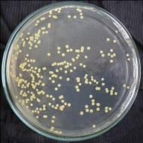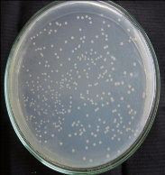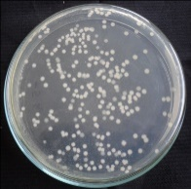
A B C
Fig-1: Figure shows the nature of colony of Yellow (A), Cream (B) and White (C) on agar plate

16S rRNA gene sequencing

The 16S rRNA gene was successfully amplified from the Yellow, Cream, and White bacterial strains, with clear bands on agarose gel confirming good DNA quality. The purified DNA was then sequenced at Dhaka University. Sequence analysis accurately identified the strains as LCYW by comparing unique 16S rRNA gene sequences, a molecular method that targets conserved and variable regions to reliably classify bacteria at the genetic level.
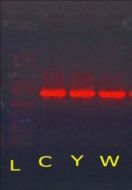

Fig 2: Gel run of the PCR product

Treatment of Azo Dye (Congo Red) by Isolated Bacterial Cultures

The decolorization potential of three bacterial strains (Yellow, Cream, White) isolated from textile wastewater in Rajshahi was tested against the azo dye Congo Red (CR) under anaerobic conditions at 37 °C over 7 days. All strains grew on dye-impregnated agar plates within 24 hours, showing tolerance to CR. Each strain created clear decolorization zones around the dye discs, indicating active dye degradation, with strong potential for CR treatment in lab conditions.

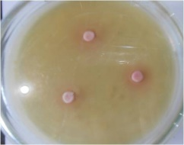
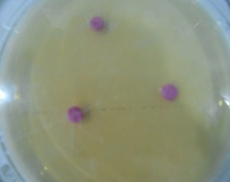
A A B
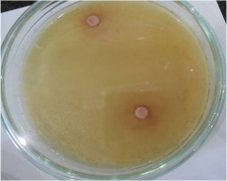
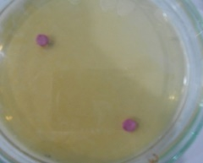

C D
After Incubation (24 hrs)
Before Incubation
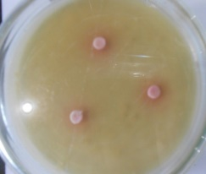
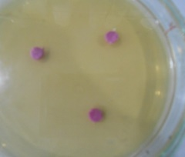
E F
After Incubation (24h)
Before Incubation

Fig 3: Decolourization of Congo Red (20 μml d⁻¹) by Isolated in plate (A) Before incubation of Yellow Strain, (B) After incubation of Yellow Strain (C) Before incubation of white Strain, (D) After incubation of White Strain, (E) Before incubation of cream Strain, (F) After incubation of cream Strain.
The CR disc was set on the agar plate and before that 100 μml of Yellow, Cream, and White strain was spread to the three Petridish. After 24 hrs incubation at 37⁰C, congo red disc was fate. That means the bacteria broke the azo dyes N=N bond and biodegradation occurred (Fig 4).
3.3 Decolourization of Congo Red (50 mg L⁻¹) by isolated three strains
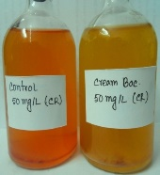
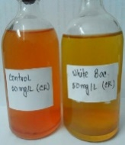
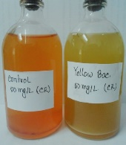
C
B
A

Fig 4: Degradation of dye containing Azo dye (Congo red) after 4 days of incubation period
The dye-containing medium (50 mg L⁻¹) was treated with individual bacterial cultures, and the effects were monitored over an incubation period of 0–4 days. A gradual decline in bacterial growth rate was observed over time. Among the tested strains, the cream-colored strain exhibited the highest level of dye decolorization, reaching 88%, indicating the cleavage of azo bonds (–N=N–) responsible for dye-associated pollution. The color of the medium changed progressively during the experimental period (Fig. 5).
Whereas, the white strain showed the lowest decolorization with less than 5% up to a little over 20% during three days. The yellow strain initially decolorized as well as the cream strain did by the close of 2nd day, but gradually lost efficiency thereafter substantially on 3rd day. The cream strain in general emerged being the most efficient for dye degradation and therefore was considered as a candidate for bioremediation purposes.
Fig 5: Decolourization of Congo Red (50 mg L⁻¹) by isolated three strains
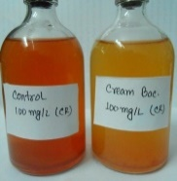
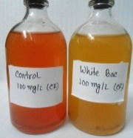
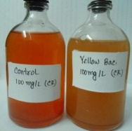
Decolourization of Congo Red (100 mg L⁻¹) by isolated three strains

C
B
A

Fig 6: Decolorization of Congo red (100 mg L⁻¹) by Yellow (A), Cream (B), White (C) after 4 days incubation
The growth medium containing the dye (100 mg L-1) was inoculated with single strains and their decolorization of the dye was determined after 0–4 days incubation. The bacterial growth rate decreased slowly over time. The cream-coloured isolate (Fig. 1) was the most efficient decolorizer with 79% decolourisation by the 72nd hour being achieved. This indicates the degradation of azo bonds (–N=N–) which are mainly liable for the dye stability and pollution effect. The color of the medium changed gradually during the experiment (Fig. 6, 7).
At the end of day two, all strains achieved near equivalent levels of decolorization. The decolorization rate of white strain was almost constant and relatively low, but the rates of both cream and yellow strains were progressively increased. The cream-like strain performed better than the others, achieving the largest decolorization percentage after 72 h.
Fig 7: Decolourization of Congo red (100 mg L⁻¹) by isolated three strains after 4 days incubation
Decolourization of Congo Red (150 mg L⁻¹) by isolated three strains
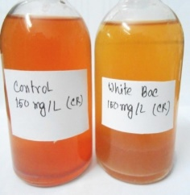
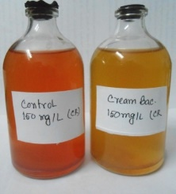
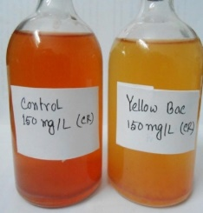
C
B
A
Fig 8: Decolorization of Congo red (150 mg L⁻¹) by Yellow (A), Cream (B), White (C) after 4 days incubation
The dye medium (150 mg L⁻¹) was individually inoculated with bacterial isolates and decolorization was determined at 0–4 days of incubation. Bacterial growth rate of all the strains decreased progressively with prolonged incubation period, indicating a suppressive effect of the dye on bacterial proliferation. The cream isolate proved to be the most effective and showed a decolorization of 71% at the end of the investigation. The enhanced combination is probably due to its enzymatic ability to break the azo bonds (–N=N–), the predominant chromophoric groups in many synthetic dyes and a major cause of their resistance, which leads to environmental damage.
The color was decolorized gradually over time, which indicated that dye degradation rather than pure adsorption of the dye had taken place (Fig. 8, 9). Although some other strains exhibited low to moderate decolorizing activity, the cream versus cream strain always had higher activity, suggesting that it is a potential candidate for bioassay of azo dye bearing effluents. These results demonstrate the strain-specific diversity in dye mineralization indicating that the cream strain has an effective metabolic route for the reduction of azo bond and dye mineralization.
Fig 9: Decolourization of Congo Red (150 mg L⁻¹) by isolated three strains after 4 days incubation at 37°C.
Decolourization of Congo Red (200 mg L⁻¹) by isolated three strains
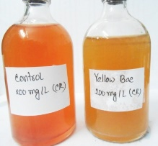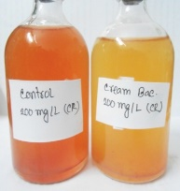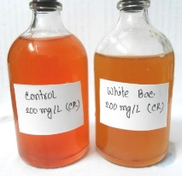
C
B
A

Fig 10: Decolorization of Congo red (200 mg L⁻¹) by Yellow (A), Cream (B), White (C) after 4 days incubation
Single bacteria cultures were inoculated into the dye-containing medium (200 mg L⁻¹), and decoloring activities of these strain preparations were monitored from an incubation time of 0–4 days. The bacterial growth rate is lowered with increasing incubation time, indicating an inhibition of microbial growth by the dye. The cream isolate had the best decolorization efficiency compared to other isolates with 53% at the end of experiment. This is representative of the enzymatic break of azo bonds (–N¼N–), which are the main chromophoric group for both the persistency and polluting potential associated with synthetic dyes. The gradual loss of the yellowish color of the medium also substantiated degradation of dye (Fig. 10, 11).
Decolorization percentages for the three strains were 11% (white strain), 29% (yellow strain) and 41% (cream strain) at 48th hr. The decolorization capacity of the white and yellow strains was slightly improved up to 18% and 34%, respectively, at the end of incubation period. On the other hand, activity of cream culture still remained relatively high and reached decoloring rate of 53%. Taken together, these results indicated a distinct strain-specific difference in dye degradation efficiency, with the cream isolate emerging as a potential recipient in terms of bioremediation of azo dyes.
Fig 11: Decolourization of Congo Red (200 mg L⁻¹) by isolated three strains after 4 days incubation at 37°C
Decolourization of Congo Red (50 mg L⁻¹) by resting cells of isolated three strains
The decolorizing capabilities of the three bacterial isolates (yellow, cream and white) for Congo Red (50 mg L⁻¹) were evaluated utilizing resting cell systems over four days incubation time (Fig. 12). The cream-colored isolate was the most efficient decolorizer among all strains. Its decolorization content of 24, 49 and 67% were obtained at the intervals of 12, 24 and after 72 hours. The constant activity during 24 hr shows that the cream strain has an efficient multienzyme system to degrade Congo Red azo bonds (–N=N–).
The yellow strain showed intermediate levels of performance, decolorizing 14% at 12 hr and increasing to a maximum of 43% by 72 hours. Its activity was always lower than that of the cream strain, indicating declined ability for azo bond breakdown or a slower metabolic role in dye degradation.
The white strain showed the lowest potential for Congo Red removal. Decolorization began at 3% after 12 hours and increased gradually to 31% within 72 hours. This limited activity implies weaker enzymatic mechanisms or poor adaptation to dye-containing conditions.

Fig 12: Decolourization of Congo Red 50 mg L⁻¹) by resting cells of isolated three strain after 4 days incubation at 37°C
The dye containing media was treated by single bacterial culture and observed the effect in the incubation period of 0-4 days (Fig 12).
Triple Sugar Iron (TSI) Test Results
The Triple Sugar Iron (TSI) test was employed as shown in table 2 and fig 13 to examine carbohydrate utilization, gas formation, and hydrogen sulfide production. Interpretation was based on characteristic changes in the butt and slant. A yellow butt with a red slant indicated glucose fermentation only, while a completely yellow slant and butt demonstrated the fermentation of lactose and/or sucrose in addition to glucose. In contrast, a red slant with a red butt suggested the absence of carbohydrate fermentation.
Gas production was identified by the appearance of bubbles, cracks, or displacement of the agar. Hydrogen sulfide generation was confirmed by blackening of the medium, resulting from the interaction of H₂S with ferrous salts, producing insoluble ferrous sulfide. The presence of this black precipitate indicated the organism’s ability to reduce sodium thiosulfate to H₂S.
Table 2: The results of the TSI test can be summarized as the table below:
Test | Yellow Strain | Cream Strain | White strain
Glucose fermentation | + | + | +
Lactose fermentation | - | + | -
Hydrogen sulfide (H₂S) | - | - | +

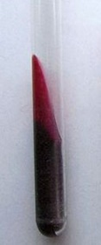
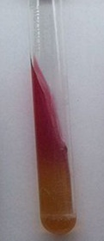
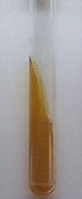
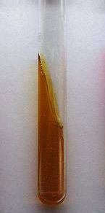

White strain
Yellow strain
Cream strain
Control

Fig-13: Triple sugar iron (TSI) test of the samples. Yellow butt and pink slant of the cream strain & white strain showed that they were glucose fermenting bacteria. Yellow butt and yellow slant of the yellow strain showed that they were sucrose fermenting bacteria. The hydrogen sulfide (H₂S) was not produced. The hydrogen sulfide (H₂S) producing capability of white strain was indicated by black precipitate.
Motility Test Results
The motility test (Table 2; Fig. 14) and the control strain E. coli DH5-α showed clear differences among the isolates. The white strain and DH5-α exhibited growth radiating away from the inoculation line, indicating motility. In contrast, the yellow and cream strains displayed growth restricted to the stab line without further spreading, confirming them as non-motile. In summary, the white strain was motile, whereas the yellow and cream strains were non-motile.
Table 3: The result of motility test
Test | Yellow Strain | Cream Strain | White Strain
Motility | Gram - | Gram - | Gram +

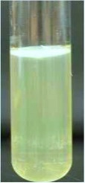
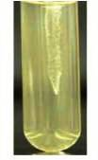
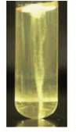
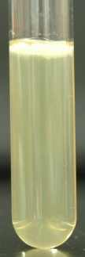

White strain (Gram+)
Yellow strain (Gram -)
Cream strain (Gram -)
Control

Fig 14: Motility test of the samples.

Discussion
In this study, a bacterial strain was successfully isolated from the Rajshahi Silk Industrial Area and assessed for its ability to decolourize the azo dye Congo Red (CR). The isolation of microorganisms from dye-contaminated wastewater suggests their natural adaptation to survive under toxic conditions. This adaptation could improve their ability for the bioremediation of textile effluents. Related findings have been indicated by Meerbergen et al. (2018). They provided the same identification of dye-degrading strains isolated from industrial sludge.

Our result showed that the isolate could be used to decolourize CR, thus corroborating earlier reports of azo dye degradation by microbial cultures; both the mixed and single can also effectively treat it (Pearce et al., 2003). Brown and Laboureur (1983) demonstrated the importance of chemical structure of dyes, and in particular its chromophoric groups for biodegradability. For example mono-, di- and poly-azo dyes are usually decolourised to a significant extent, while dyes with anthraquinone chromophores tend to show more variable degradation. These structural differences may account for the difference in decolourization efficiency noted in this work.

Decolourization of azo dyes by microorganisms has been identified as cost-effective and eco-friendly method due to low sludge production and renewability (Kalyani et al., 2008). Although several fungi, yeasts, actinomycetes (Meerbergen et al., 2018) and algae have been described as dye degraders (Parshetti et al., 2007), bacteria are usually more efficient they proliferate faster and adapt to a wider range of conditions. But some bacterial strains would not fully mineralize azo dye and still leave hazardous aromatic amines as intermediates. That's why a consortium of microbes is often more efficient, since we get the beneficial cooperation between different strains that can attack either parent dye molecules or their intermediate byproducts (Khehra et al., 2005; Forgacs et al., 2004).

In the current study, bacterial growth was continuously upregulated throughout the incubation period where decolourization of CR occurred slowly. This is indicative that the azo bond (–N=N–) which is mainly responsible for the stability and colour of azo dyes is cleaved. Decolourization efficiency depended on the initial concentration; the lower dyes were degraded more effectively than those with higher concentrations. Findings has similarity with previous research, which suggested that increased dye concentration has an inhibitory effect on both microbial growth and enzyme activity leading to reduced decolourization rate (Sahasrabudhe and Pathade 2011; Kalyani et al., 2008). On the other hand, adaptation of bacterial cultures to dyes has been reported to increase tolerance and degradation rates (Kalyani et al., 2008).

Temperature was also a key factor in decolourization performance. Decolourization was substantial even for experiments performed at 37°C, indicative of the optimal growth temperatures of most bacteria. This was similar to other studies which reported maximum azo dye degradation between 35-45°C (Pearce et al., 2003). Loss of efficiency at higher temperature is generally attributed to low cell viability or the inactivation of azo reductase enzymes. Nevertheless, a few reports suggest that azo reductases might be stable up to 60 °C, and fixed bacterial systems can extend this range due the stability of the cells inside a stable microenvironment (Pearce et al., 2003).

This study demonstrates that bacterial isolates from dye-contaminated areas have potential to degrade azo dyes like CR. Single strains, however, suffer from poor efficiencies at elevated dye concentrations. This demonstrates the benefit of using microbiome in industrial waste management with high effluent, as the synergistic metabolic pathways allow further degradation and detoxification. Application of such biological systems is said to be promising for tackling the ever present dye contamination problem in textile effluent, providing an environmental and a green alternative to currently practiced chemical and physical treatment procedures (Rajaguru et al., 2000).

Conclusion
The isolated bacterial strains from Silk Industrial Area of Rajshahi, Bangladesh showed high decolourization efficiency of azo dye Congo Red, suggesting that the strains are well adapted to dyed-polluted environments and have potential for bioremediation. The study also provides evidence that single bacterial strains can accomplish successful dye biodegradation in a setup of controlled lab condition as a cost competitive, environmentally benign approach to conventional physico-chemical treatment techniques.
In future studies, the strains should be further identified by species name and fully characterized biochemically and molecularly to elucidate their metabolic pathways for practical purposes. Upon further validation, these microbial agents may be applied to wastewater treatment plants for the attenuating dye contamination and protecting aquatic life, while also aiding water reuse in industry.
Acknowledgments
The authors would like to thank their respective organizations for providing general support for this study.
Disclaimer (Artificial intelligence)
Option 1:
Author(s) hereby declare that NO generative AI technologies such as Large Language Models (ChatGPT, COPILOT, etc.) and text-to-image generators have been used during the writing or editing of this manuscript.

References

- Abbas, A., Banat, F., & Abdelghani, E. (2020). Heterologous expression of azoreductase-encoding gene from Bacillus spp. and its catalytic function in azo dye degradation. Applied Microbiology and Biotechnology, 104(2), 653-664. https://doi.org/10.1007/s00253-020-10731-1
- Ajaz, M., Aslam, Z., & Ahmad, S. (2019). Microbial degradation of azo dyes: Review on recent advancements. Environmental Science and Pollution Research, 26, 33666–33684. https://doi.org/10.1007/s11356-019-06731-4
- Aragaw, T. A. (2021). Functions of various bacteria for specific pollutants degradation and their application in wastewater treatment: a review. International Journal of Environmental Science and Technology, 18(7), 2063-2076. https://doi.org/10.1007/s13762-020-03022-2
- Brown, D., & Laboureur, P. (1983). The degradation of dyestuffs: Part I Primary biodegradation under anaerobic conditions. Chemosphere, 12(3), 397–404. https://doi.org/10.1016/0045-6535(83)90114-5
- Decena ALA, Barraquio WL (2004) Congo red decolorization by bacteria. In: Microbiology and biotechnology evolving trends and time. Proc 33rd PSM Annu Conv Sci Meet, pp 29–30.
- Forgacs, E., Cserháti, T., & Oros, G. (2004). Removal of synthetic dyes from wastewaters: a review. Environment International, 30(7), 953–971. https://doi.org/10.1016/j.envint.2004.02.001
- Halepoto, H., Gong, T., & Memon, H. (2022). Current status and research trends of textile wastewater treatments—A bibliometric-based study. Frontiers in Environmental Science, 10, 1042256. https://doi.org/10.3389/fenvs.2022.1042256
- Hernández-Zamora, M., & Martínez-Jerónimo, F. (2019). Congo red dye diversely affects organisms of different trophic levels: a comparative study with microalgae, cladocerans, and zebrafish embryos. Environmental Science and Pollution Research International. https://doi.org/10.1007/s11356-019-04589-1
- IUPAC. (2009). Azo compounds. In *Compendium of chemical terminology* (2nd ed., "Gold Book") https://doi.org/10.1351/goldbook.A00560
- Kalyani, D. C., Patil, P. S., Jadhav, J. P., & Govindwar, S. P. (2008). Biodegradation of reactive textile dye Red BLI by an isolated bacterium Pseudomonas sp. SUK1. Bioresource Technology, 99(11), 4635–4641. https://doi.org/10.1016/j.biortech.2007.06.058
- Khehra, M. S., Saini, H. S., Sharma, D. K., Chadha, B. S., & Chimni, S. S. (2005). Comparative studies on potential of consortium and constituent pure bacterial isolates to decolorize azo dyes. Water Research, 39(20), 5135–5141. https://doi.org/10.1016/j.watres.2005.09.033
- Meerbergen, K., Willems, K. A., Dewil, R., Van Impe, J., Appels, L., & Lievens, B. (2018). Isolation and screening of bacterial isolates from wastewater treatment plants to decolorize azo dyes. Journal of Bioscience and Bioengineering, 125(4), 448–456. https://doi.org/10.1016/j.jbiosc.2017.11.008
- Morin-Crini, N., et al. (2019). Applications and environmental impact of azo dyes industry. Environmental Chemistry Letters, 17(3), 1245-1255. https://doi.org/10.1007/s10311-019-00916-0
- Ngo, H. H., & Guo, W. (2022). Microbial degradation of azo dyes: An eco-friendly approach. Biotechnology Advances, 50, 107769. https://doi.org/10.1016/j.biotechadv.2021.107769
- Owhonka, A., Fubara, E. F., & Justice, O. B. (2021). Wastewater Quality- It's Impact on the Environment and Human Physiology: A Review. International Journal of Advance Research and Innovation, 9(4), 43-58. https://doi.org/10.51976/ijari.942107
- Parshetti, G. K., Kalme, S. D., Gomare, S. S., & Govindwar, S. P. (2007). Biodegradation of Reactive Blue 25 by Aspergillus ochraceus NCIM-1146. Bioresource Technology, 98(18), 3638–3642. https://doi.org/10.1016/j.biortech.2006.11.017
- Pearce, C. I., Lloyd, J. R., & Guthrie, J. T. (2003). The removal of colour from textile wastewater using whole bacterial cells: a review. Dyes and Pigments, 58, 179–196. https://doi.org/10.1016/S0143-7208(03)00064-0
- Pinheiro, L. R. S., Gradíssimo, D. G., Xavier, L. P., & Santos, A. V. (2022). Degradation of Azo Dyes: Bacterial Potential for Bioremediation. Sustainability, 14(3), 1510. https://doi.org/10.3390/su14031510
- Rajaguru, P., Kalaiselvi, K., Palanivel, M., & Subburam, V. (2000). Biodegradation of azo dyes in a sequential anaerobic–aerobic system. Applied Microbiology and Biotechnology, 54(2), 268–273. https://doi.org/10.1007/s002530000322
- Romero, E., Savino, S., Fraaije, M. W., & Lončar, N. (2020). Mechanistic and crystallographic studies of azoreductase AzoA from Bacillus wakoensis A01. ACS Chemical Biology, 15(2), 504-512. https://doi.org/10.1021/acschembio.9b00970
- Sahasrabudhe M, Pathade G (2011) Decolorization of C.I. Reactive Yellow 145 by Enterococcus faecalis strain YZ66. J Sci Res 3:403–414.
- Siddiqui, M. R., et al. (2023). Investigation on Congo Red toxicity and environmental impact. Journal of Hazardous Materials, 442, 130062. https://doi.org/10.1016/j.jhazmat.2022.130062
- Stolz, A. (2001). Basic and applied aspects in the microbial degradation of azo dyes. Applied Microbiology and Biotechnology, 56(1-2), 69-80. https://doi.org/10.1007/s002530100686
- Tariq, A., & Mushtaq, A. (2023). Untreated wastewater reasons and causes: A review of most affected areas and cities. International Journal of Chemical and Biochemical Sciences, 23(1), 121-143. https://www.iscientific.org/journals/ijcbs/
- Tüfekci, N., Sivri, N., & Toroz, İ. (2007). Pollutants of textile industry wastewater and assessment of its discharge limits by water quality standards. Turkish Journal of Fisheries and Aquatic Sciences, 7(2).

