Viscum capitellatum Sm. (Santalaceae): A New Addition to the Parasitic Flora of Eastern Ghats, India

Abstract

Viscum capitellatum Sm. (Santalaceae) is here reported for the first time from the Eastern Ghats of India, adding a new parasitic element to the flora of Odisha. The species was collected during a floristic survey conducted in November 2025 in the Semiliguda Range of the Koraput Forest Division, where it was observed hyperparasitizing Scurrula cordifolia growing on Mangifera indica. Detailed examination of collected material confirmed its identity as V. capitellatum, a species previously known from Sri Lanka and the southern Indian states of Karnataka, Kerala and Tamil Nadu. The present record extends its distribution northwards into the Eastern Ghats. The species is a small, evergreen, monoecious, semi-parasitic herb characterised by dense branching, swollen nodes, cylindrical internodes, and variably developed leaves that are often reduced to minute scales. Its distinctive cymose inflorescences arise from leaf axils. Male flowers bear two free perianth lobes with sessile stamens, while female flowers possess conical, valvate perianth lobes and an inferior ovary. The smooth green drupes are ellipsoid to ovoid, narrowed below the persistent perianth rim. Present communication provides a comprehensive taxonomic account of V. capitellatum, including its description, diagnostic characters, habitat details, photographs, and herbarium documentation (APRFH-204). The new distributional record enhances understanding of the genus Viscum in India and highlights the parasitic diversity of the Eastern Ghats, a region still underexplored for mistletoe flora.

Keywords: Viscum; Deomali; Koraput; Odisha; New addition

Introduction
The genus Viscum L. is variously estimated to comprise about 120 species (Nickrent 1997), 150 species (Mabberley 2017) or 113 species (POWO, 2025), distributed in southern Europe, throughout tropical Africa (Adesina et al., 2013) and eastwards to tropical and subtropical Asia, Malesia, and Australia (Zube and Widmer, 2009; Lim et al., 2016; Maul et al., 2019). In India, about 15 species are present, of which 4 are endemic. In Odisha, about 3 species of Viscum have been reported (Viscum articulatum, Viscum monoicum and Viscum orientale) (Saxena and Brahmam, 1995). Members of this genus are characterised by having green stems, leafy or leafless, basic inflorescence unit that is a simple cyme (triad), which is usually 3-flowered. The inflorescences are subracemose, sessile or pedunculate, terminal or axillary (Sanjai and Balakrishnan, 2006; Sahu et al., 2018). Their presence can be found in multiple habitat types, such as dense wet evergreen forests, moist deciduous forests, open lands, and disturbed areas. They are adapted to live from sea level to 2500 m altitude (Sardesai et al., 2019).
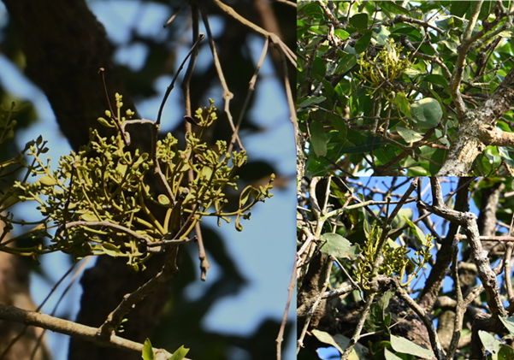

Figure 1: Habitat of Viscum capitellatum
During a survey of flowering plants in the Koraput district in November 2025, the authors came across an interesting parasitic species belonging to the genus Viscum, in Semiliguda Range, Koraput Forest Division on 22nd November 2025 (18° 38' 16.42" N, 083° 00' 11.28" E, 1044 m elevation; Plate 1), hyperparasiting on Scurrula cordifolia on Mangifera indica (The collected specimen was growing on Scurrula cordifolia, which in turn was growing on a mango tree). After critical study on the collected specimens, the species has been identified as Viscum capitellatum Sm., a species that is not been reported from Odisha earlier (Figure 1). A detailed description and a photo plate have been provided to aid in identifying the species. The voucher specimen of Viscum capitellatum is deposited in the Biodiversity and Conservation Lab, Ambika Prasad Research Foundation, Odisha [APRFH-204].
Taxonomic treatment
Viscum capitellatum Sm. in Rees, Cyclop. 37: Viscum no. 18. 1817; DC., Prodr. 4: 279. 1830; Wight & Arn., Prodr. 380. 1834; Hook.f., FL Brit. India 5: 225. 1886, p. p.; Trimen, Handb. FL Ceylon 3: 471. 1895; Gamble, Indian Timbers 584. 1902; Brandis, Indian Trees 552. 1906; T. Cooke, Fl. Pres. Bombay 2: 552. 1906, p. p.; Talbot, For. Fl. Pres. Bombay 2: 421, t. 480. 1911; Gamble, FL Pres. Madras 7: 1257, 1258. 1925, p. p.; C.E.C. Fischer in Rec. Bot. Surv. India 11(1): 171. 1926; Danser in Blumea 4: 309, t. 2. 1941; R.S. Rao in J. Indian Bot. Soc. 36(2): 166. 1957; Wiens in Dassan. & Fosberg, Revised FL Ceylon 6: 418. 1987.
Description
It is a small, evergreen, monoecious, semi-parasitic herb, generally reaching up to 15 cm in length. The plant shows dense branching, with the lower portions exhibiting opposite and wide-angled (divaricate) branch pairs, while the upper regions become almost umbellate. Nodes are noticeably swollen and support whorled branch clusters. Internodes are cylindrical or slightly flattened, smooth, and measure about 4.0 – 6.0 × 0.2 - 0.6 cm. Leaves are opposite and sessile, but commonly appear only on young shoots. They may be fully developed, greatly reduced to minute scales, or absent, giving many plants a leafless appearance. When present, the leaves are thick, dull green, and vary from round-ovate to obovate or narrowly spathulate. They are entire, rounded at the tip, tapering at the base, and often folded lengthwise or rolled, typically 1.0- 2.8 × 0.5 - 0.9 cm. The inflorescences are cymose and arise from the leaf axils, rarely appearing at branch tips. Up to six may occur on a single node. Each inflorescence sits on a short peduncle, about 3.0 mm long, which terminates in a boat-shaped bract-cup enclosing three flowers, usually a central male flower flanked by two female flowers. Occasionally, as many as five flowers may occur, or the male flower may be missing, resulting in all-female inflorescences. In such cases, the central female flower bears its own miniature bract-cup. A secondary inflorescence may sometimes replace the central flower. Male flowers are sessile, slightly compressed at the base, and obovate, around 2.0 × 1.0 mm. They have two free perianth lobes with serrated margins, each bearing a single sessile stamen attached to its inner surface. Anthers are two-celled and small, about 0.8 × 0.8 mm. A pistillode is absent. Female flowers are narrow, elongate, about 2.5 × 1.0 mm, and subtended by small bracts. They possess three free, conical, valvate perianth lobes. Staminodes are lacking. The ovary is inferior, with indistinct ovules, a very short style, and a conical stigma. The fruit is a smooth, shiny green drupe, ellipsoid to ovoid, distinctly narrowed just below the persistent perianth rim (Figure 1 & 2).
Flowering & Fruiting: February - July.
Distribution: Sri Lanka, India (Karnataka, Kerala, Tamil Nadu), and Odisha (Present collection).
Hosts: Scurrula cordifolia (Wall.) G.Don, Mangifera indica L. and Ficus benjamina L.
Specimen examined: India, Odisha, Koraput Forest Division, Semiliguda Range (18° 38' 16.42" N, 083° 00' 11.28" E, 1044 m elevation), 22nd November 2025, Sweta Mishra & Sanjeet Kumar, 0204 (APRFH) (Figure 3).
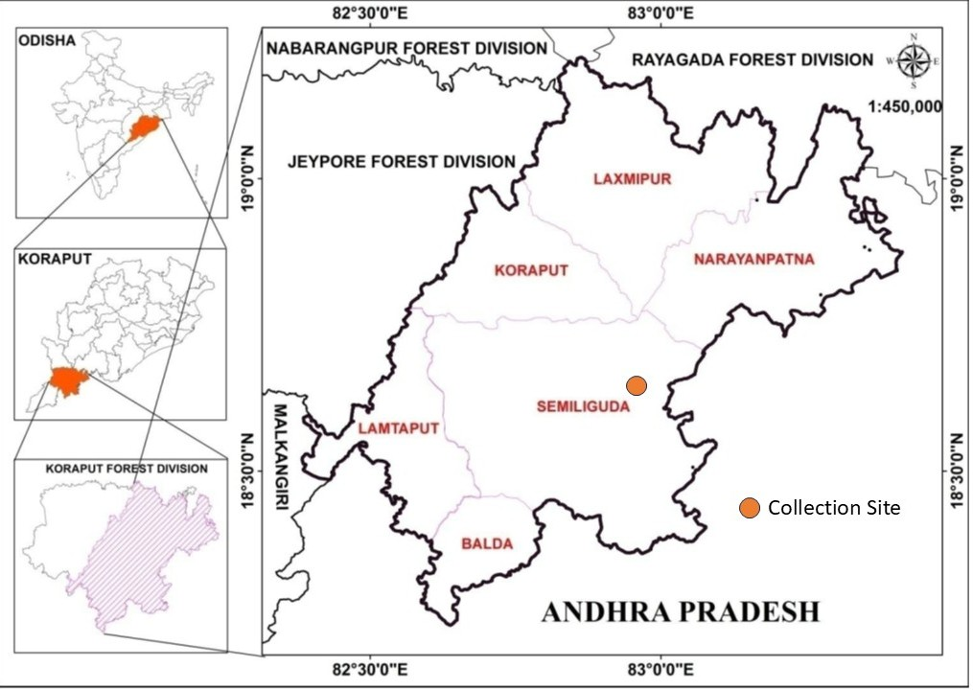
Plate 1: Geographical area of collected site of specimen

Conservation status: The authors recorded the collected specimen from three mango trees and one Ficus benjamina. Interestingly, in all instances the specimen was found growing on Scurrula cordifolia, a parasitic epiphytic plant. The limited number of individuals observed indicates that conservation of the host trees is crucial for the conservation of the collected specimen, and further exploratory studies are required to assess its conservation status in the Eastern Ghats, India.

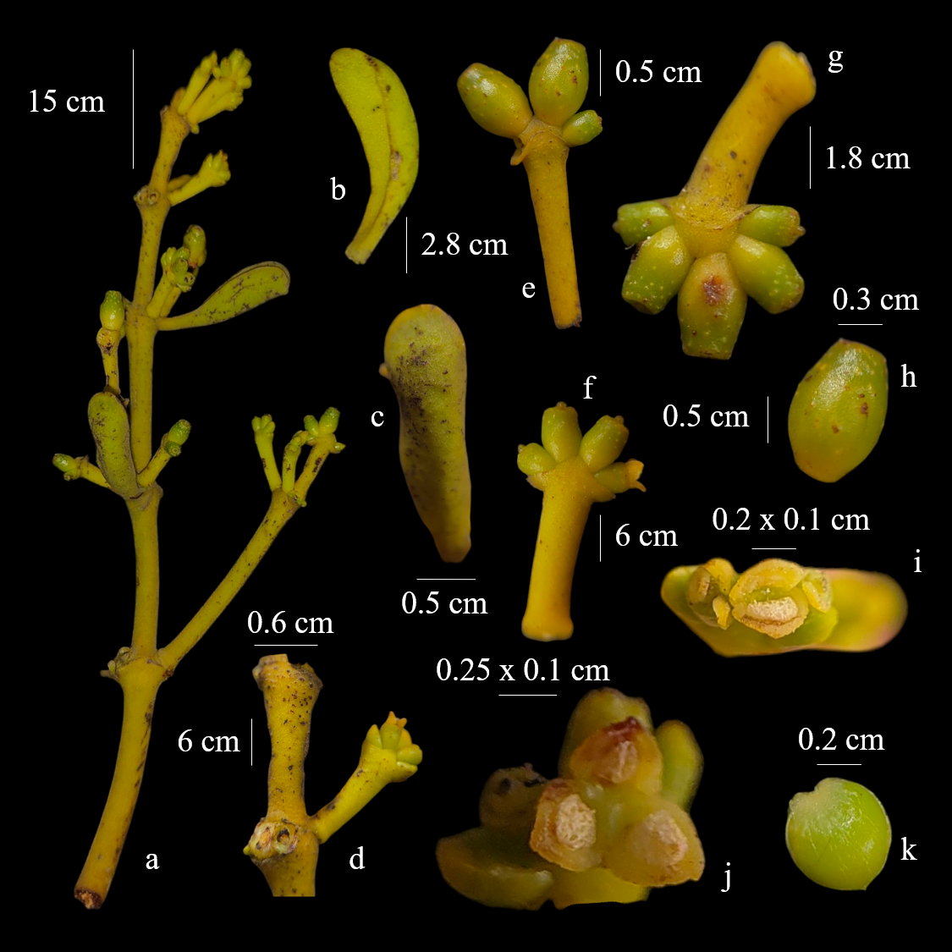

Figure 2: Viscum capitellatum – a) Whole plant; b & c) Leaf; d) Nodes; e & g) Fruits; f) Inflorescence; h) Fruit; i) Male flower; j) Female flower; k) Seed
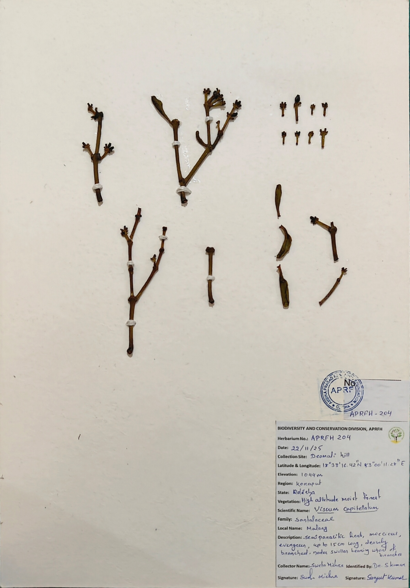
Figure 3: Herbarium of V. capitellatum

Conclusion
The present study documents Viscum capitellatum Sm. as a new addition to the parasitic flora of the Eastern Ghats and the first record of this species from Odisha state, India. Its occurrence in the Semiliguda Range, hyperparasitizing Scurrula cordifolia on Mangifera indica, extends the known geographical range of the species beyond its previously reported southern Indian distribution. The detailed morphological description, illustrations, and herbarium documentation provided here will aid in accurate identification and future taxonomic work. This finding emphasises the biological richness of the Eastern Ghats and highlights the need for continued floristic exploration to uncover the still under-documented parasitic plant diversity of the region.
Acknowledgement
Authors are thankful to the Divisional Forest Officer (DFO), Koraput Forest Division, Koraput, Odisha and field staffs.
Disclaimer (Artificial Intelligence)
Authors hereby declare that no generative AI technologies such as Large Language Models and text-to-image generators have been used during the writing or editing of this manuscript.
References
- Adesina SK, Illoh HC, Johnny II and Jacobs IE. (2013). African mistletoes (Loranthaceae); ethnopharmacology, chemistry and medicinal values: an update. Afr J Tradit Complement Altern Med. 10(4):161-70. doi: 10.4314/ajtcam.v10i4.26.
- Lim YC, Rajabalaya R, Lee SH, Tennakoon KU, Le QV, Idris A, Zulkipli IN, Keasberry N and David SR. (2016). Parasitic Mistletoes of the Genera Scurrula and Viscum: From Bench to Bedside. Molecules. 21(8): 1048. https://doi.org/10.3390/molecules21081048
- Mabberley, D. J. (2017). Mabberley’s Plant-book: A portable dictionary of plants, their classification and uses. Cambridge University Press. https://doi.org/10.1017/9781316335581
- Maul K, Krug M, Nickrent DL, Müller KF, Quandt D and Wicke S. (2019). Morphology, geographic distribution, and host preferences are poor predictors of phylogenetic relatedness in the mistletoe genus Viscum L. Molecular Phylogenetics and Evolution. 131: 106–115. https://doi.org/10.1016/j.ympev.2018.10.041
- Nickrent, D. L. (1997). The Parasitic Plant Connection. http://www.parasiticplants.siu.edu
- POWO (2025). Plants of the World Online. Facilitated by the Royal Botanic Gardens, Kew. https://powo.science.kew.org/taxon/urn:lsid:ipni.org:names:552295-1. Retrieved 13 December 2025
- Royal Botanic Gardens, Kew. (2019). Plants of the World Online. http://www.plantsoftheworldonline.org/
- Sahu SC, Kumar S and Singh NR. (2018). Parasitic Plants of Odisha. Ambika Prasad Research Foundation.
- Sanjai, V. N., & Balakrishnan, N. P. (2006). A revision of Indian Viscaceae. Rheedea, 16(2), 73–109. https://doi.org/10.22244/rheedea.2006.16.02.01
- Sardesai, M. M., Gaikwad, S. P., & Yadav, S. R. (2019). Viscum sahyadricum (Viscaceae), a New Species from the Western Ghats of India. Edinburgh Journal of Botany, 76, 369–376. https://doi.org/10.1017/S096042861900012X
- Saxena HO and Brahmam M. (1995). The Flora of Orissa. Volume 3. Orissa Forest Development Corporation Limited, Bhubaneswar and Regional Research Laboratory, Bhubaneswar, Odisha, India.
- Zuber D and Widmer A. (2009). Phylogeography and host race differentiation in the European mistletoe (Viscum album L.). Molecular Ecology. 18(9): 1946–1962. https://doi.org/10.1111/j.1365-294x.2009.04168.x

