Trends In Enrolment and Utilization of Basic Health Care Provision Fund Services under the Rivers State Contributory Health Protection Programme, Nigeria (2024-2025)

ABSTRACT

Background: The law establishing the Rivers State Contributory Health Protection Program (RIVCHPP) represents Nigeria’s principal fiscal instrument for achieving Universal Health Coverage. Yet, its sub-national implementation within the complex geopolitical landscape of the Niger Delta remains under-scrutinised. In Rivers State, a region characterised by dichotomies between urban and remote riverine communities, the translation of federal funding into equitable access and effective service utilisation faces unique systemic barriers until the launch of the Rivers State Contributory Health Protection Program (RIVCHPP). This study aims to examine the operational effectiveness of the RIVCHPP in Rivers State by critically analysing longitudinal trends in beneficiary enrolment and service utilisation in Rivers State.
Methodology: The study adopted a retrospective descriptive trend analysis over time; the data were extracted and analysed from the administrative records of RIVCHPP over an 18-month period spanning six complete quarters from April 2024 to September 2025. The dataset comprised 114,111 enrolment records and comprehensive service utilisation.
Results: RIVCHPP demonstrated a strong capacity for rapid enrolment, with a 961.5% surge following campaign-based registration in Q3 2024 (36,483 beneficiaries), followed by a decline to 11,690 by Q3 2025 (67.9%), indicating dependence on targeted campaigns rather than continuous enrolment. Enrolment was highly concentrated in Rivers East Senatorial District (83.16%), though participation in Rivers West and South-East suggests potential for equitable expansion. Despite enrolment volatility, service utilization was substantial, with 195,246 encounters recorded, driven mainly by malaria treatment (36.8%) and immunization (30.8%). Antenatal care accounted for 10.3% of services, while facility-based deliveries remained low (1.8%), highlighting opportunities to strengthen continuity of maternal care within the scheme.
Conclusion: RIVCHPP has become a central pillar of the State’s health system, expanding access to comprehensive preventive, promotive, and curative services across urban and rural areas. The programme has strengthened service delivery through broad facility coverage, increased utilization, and financial risk protection for vulnerable groups, particularly women, children, and low-income households. As an inclusive social protection and near-universal health coverage platform, RIVCHPP has reduced out-of-pocket spending, improved continuity of care, and enhanced health-seeking behaviour, contributing significantly to improved health outcomes and progress toward universal health coverage in the State.

Keywords: Rivers State Contributory Health Protection Program, Universal Health Coverage, Health Equity, Primary Health Care, Maternal Health, Rivers State, Health Systems Strengthening.

INTRODUCTION

Background to the Study

Universal Health Coverage (UHC) has emerged as a central objective of the global health agenda under the Sustainable Development Goals (SDGs), representing a shift from disease-specific interventions toward comprehensive health system strengthening. Rooted in the principles of the Alma-Ata Declaration, UHC seeks to ensure that all individuals have access to essential, high-quality health services without exposure to financial hardship (World Health Organisation, 2019). Despite this global consensus, progress toward UHC has been uneven, particularly across low- and middle-income countries in sub-Saharan Africa, where chronic underfunding, weak infrastructure, and persistent health workforce migration continue to undermine health system performance.
In response to longstanding financing gaps, African leaders committed through the Abuja Declaration to allocate at least 15% of national budgets to health. However, most countries, including Nigeria, have consistently fallen short of this target, resulting in heavy reliance on out-of-pocket payments for healthcare (Biegon, 2020). Such financing patterns have been shown to exacerbate household poverty and widen health inequities, especially among vulnerable populations (Aregbeshola & Khan, 2021).
Within Nigeria, these systemic challenges persist despite the country’s economic stature. Nigeria continues to account for a disproportionate share of global maternal and child mortality, reflecting structural weaknesses in its primary healthcare (PHC) system (Abubakar et al., 2022). Recognising the centrality of PHC to health system resilience, the Federal Government enacted the National Health Act in 2014, establishing the Basic Health Care Provision Fund (BHCPF). The BHCPF earmarks at least 1% of the Consolidated Revenue Fund to finance a Basic Minimum Package of Health Services through designated gateways, including the National Health Insurance Authority (NHIA), National Primary Health Care Development Agency (NPHCDA), National Emergency Medical Treatment Gateway, and the Nigeria Centre for Disease Control (Federal Republic of Nigeria, 2014; Alawode et al., 2022).
At the sub-national level, Rivers State operationalises the NHIA gateway through the Rivers State Contributory Health Protection Programme (RIVCHPP), signalling political commitment to expanding financial risk protection and healthcare access. Nonetheless, translating national financing frameworks into improved service delivery at the state level remains complex. The decentralised nature of Nigeria’s federal system introduces variability in implementation capacity, governance quality, and political prioritisation across states (Igbokwe et al., 2024). Scholars further caution that implementation may be constrained by fragmented social protection approaches that prioritise targeted interventions over comprehensive system integration (Chukwuma, 2023).
The effectiveness of RIVCHPP is fundamentally dependent on beneficiary enrolment and subsequent utilisation of health services. Enrolment reflects public awareness and trust, while utilisation captures the functional capacity of PHC facilities to deliver care. Evidence from multiple Nigerian states suggests that low awareness, infrastructural deficits, drug stock-outs, and health workforce shortages often weaken the link between enrolment and actual service use (Nwobodo et al., 2022; Ewelike et al., 2021; Fabong et al., 2023; Ehimare et al., 2023).
Rivers State provides a strategic context for examining the implementation of health financing reforms due to its role as a major economic hub in the Niger Delta and its heterogeneous settlement pattern, which includes densely populated urban centres as well as dispersed and hard-to-reach riverine communities. Through the operationalisation of the Rivers State Contributory Health Protection Programme (RIVCHPP), deliberate efforts have been made to overcome historical urban bias in healthcare delivery by extending coverage to all residents and individuals conducting business within the state, irrespective of geographical location or socio-economic status. The programme’s expanding facility network and enrolment mechanisms are designed to promote equitable access to quality healthcare services across all Senatorial Districts. Consequently, analysing enrolment and service utilisation trends offers valuable insights into the extent to which RIVCHPP has translated policy intent into inclusive, system-wide service delivery within a complex sub-national context.
Despite the availability of BHCPF funding and the establishment of RIVCHPP, Rivers State continues to experience a disconnect between financial inputs and effective utilisation of primary healthcare services. Enrolment figures alone do not guarantee meaningful coverage if beneficiaries do not access care or if facilities lack the infrastructure, workforce, and commodities required to deliver services. This disconnect risks creating an illusion of coverage while households continue to rely on out-of-pocket spending and informal care providers, thereby perpetuating the cycle of poverty the scheme was designed to interrupt (Odinenu & Anago, 2025).
The urgency of this problem is heightened by Nigeria’s contribution of approximately 17% to global maternal mortality, with geographic barriers in Rivers State further disadvantaging rural and riverine populations (Esomonu et al., 2022). The challenge lies in variations in operational capacity among designated primary healthcare facilities, where service delivery may be constrained by staffing gaps, infrastructural limitations, or logistical challenges, resulting in lower-than-expected service volumes. In the absence of rigorous, data-driven analyses of utilisation indicators such as antenatal care attendance, facility-based deliveries, and referral patterns this performance differentials may remain insufficiently detected, thereby limiting timely corrective actions within BHCPF implementation pathways.
This study is justified by critical gaps in existing literature. While prior studies have examined state readiness, political economy, healthcare worker perspectives, and client satisfaction, there is a paucity of longitudinal analyses that interrogate enrolment and utilisation trends using administrative data, particularly in the South-South geopolitical zone (Nwobodo et al., 2022; Alawode et al., 2022; Ibrahim et al., 2023; Esomonu et al., 2022). By analysing enrolment and service utilisation across Local Government Areas and Senatorial Districts in Rivers State, this study responds to calls for outcome-focused accountability and provides empirical evidence to guide equitable resource allocation, workforce deployment, and system strengthening (Adeoye et al., 2024; Igbokwe et al., 2024).

Purpose of the Study

The overarching aim of this research was to critically examine trends in enrolment and utilisation of Basic Health Care Provision Fund services in Rivers State, Nigeria. To achieve this aim, the study was guided by the following specific objectives:

- To assess trends in enrolments into the RIVCHPP in Rivers State over the study period.
- To analyse patterns of primary healthcare service utilisation under the RIVCHPP in Rivers State.

METHODOLOGY

Study Area and Design

The study was conducted in Rivers State, located in Nigeria's South-South geopolitical zone and situated within the core Niger Delta region. The State lies along the Atlantic coastline and is bordered by Bayelsa State to the West, Delta and Abia State to the North, Imo to the East and the Atlantic Ocean to the South. The state is characterized by marked geographical and socio-economic contrasts, comprising relatively urbanized upland areas and hard-to-reach riverine communities within the Niger Delta. These features significantly influence healthcare access and utilization, particularly for publicly funded programmes such as the Basic Health Care Provision Fund. Rivers State also exhibits a double burden of disease, with persistent infectious diseases alongside rising non-communicable conditions linked to urbanization. Its demographic diversity and uneven health infrastructure make it a suitable setting for examining enrolment trends, service utilization, and geographical equity under the RIVCHPP (Abubakar et al., 2022).
We adopted a retrospective descriptive trend analysis. This design enabled the analysis of historical trends in enrolments and utilization of service over time using quantitative indicators. Potential limitations associated with secondary data were mitigated through triangulation of RIVCHPP ICT Department records to enhance data consistency and reliability. Data were extracted between November and December 2025, retrospectively capturing facility-level administrative and clinical records from April 2024 through September 2025 (covering 6 complete quarters: Q2 2024, Q4 2024, Q1 2025, Q2 2025, and Q3 2025).

Operational Definitions

For the purposes of this study, key terms are defined as follows:

- Enrolment: The process of registering an individual as a beneficiary of the RIVCHPP scheme, documented through facility registers and assigned a unique beneficiary identification number.
- Service Utilisation: The actual consumption of healthcare services by enrolled beneficiaries, measured through documented facility visits recorded in clinical registers.
- Facility-based Delivery: Any childbirth that occurs within a Primary Health Centre under the supervision of skilled birth attendants, documented as spontaneous vaginal delivery (SVD) in facility records.
- Service Encounter: A single documented interaction between a beneficiary and the healthcare system, including consultations, procedures, or preventive services.
- Active Service User: An enrolled beneficiary who accessed at least one RIVCHPP- supported service within a given reporting period. Beneficiaries may be counted in multiple periods if they accessed services in more than one month or quarter.

Study Population and Sample
The study population comprised all enrolees to provide RIVCHPP services in Rivers State. The units of analysis were RIVCHPP administrative and clinical records generated since the commencement of RIVCHPP implementation, covering enrolees including pregnant women, children under five, the elderly, and indigent populations. Focusing on facility records rather than individual respondents minimise recall bias and enabled assessment of system-level performance (Esomonu et al., 2022).

Instrumentation, Validity, and Reliability

Data were collected using a structured Data Extraction Proforma aligned with RIVCHPP enrolments registers and NHIA reporting formats. The instrument captured quantitative indicators on enrolments and service utilisation (Antenatal Care, spontaneous vaginal deliveries, immunisation, referrals). The proforma was adapted from standard RIVCHPP monitoring tools and pre-tested in a non-participating Local Government Area to refine data definitions and layout (Odinenu & Anago, 2025).

Instrument validity was ensured through content validation by public health experts and monitoring officers from the RIVCHPP Management Team. Reliability was assessed using inter-rater reliability testing during the pilot phase, with agreement measured using Cohen's Kappa statistic. A coefficient of 0.78 was achieved, indicating acceptable consistency across data collectors (Nwobodo et al., 2022).

Data Collection and Analysis

Data collection followed ethical approval and formal authorisation from the Rivers State Contributory Health Protection Program (RIVCHPP). Four trained research assistants retrospectively extracted data from RIVCHPP database over a four-week period. Regular quality checks were conducted by the principal investigator to verify accuracy and completeness (Esomonu et al., 2022).

Data analysis was performed using SPSS version 26. Descriptive statistics summarise enrolment trends, service utilisation, and morbidity patterns. Time-series analysis assessed enrolments trends, while proportions and ratios were calculated for service utilisation indicators.

Ethical Considerations

Ethical approval was obtained from the River State Health Research Ethics Committee Patient confidentiality was maintained by excluding personal identifiers from data extraction tools. Institutional consent was secured from RIVCHPP heads, and facility identities were anonymised in reporting to minimise political or administrative repercussions. All data were stored securely in password-protected files with restricted access to ensure data protection and integrity throughout the study (Alawode et al., 2022).

RESULTS

1. Assessment of Quarterly Enrolment Trend Analysis across LGAs

Temporal Scope: This analysis covers 18 months of enrolment data spanning six complete quarters from Q2 2024 (April-June 2024) through Q3 2025 (July-September 2025). The data is presented quarterly to capture enrolment trends, while service utilization (Section 2.1) is reported monthly beginning October 2024 to provide more granular insight into service delivery patterns.

While enrolment data are presented quarterly across the entire study period, service utilisation indicators are analysed monthly from October 2024 onward due to improved completeness and stability of NHMIS reporting following initial implementation.

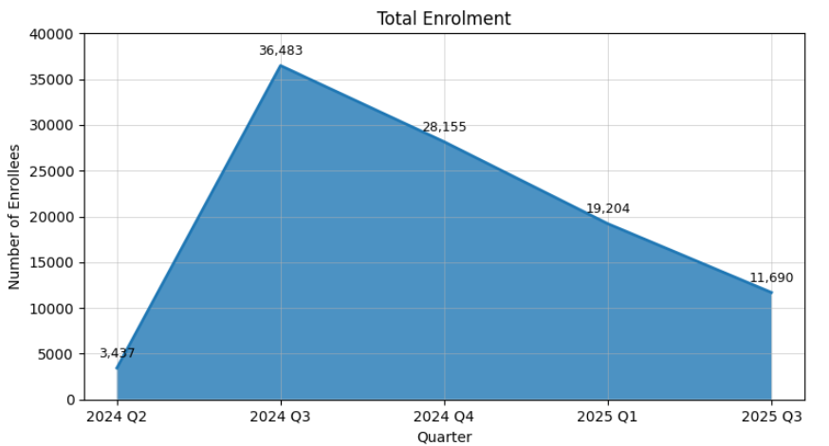
Figure 1 – Quarterly enrolment trend

The quarterly enrolment data reveals a dramatic expansion pattern with an initial surge followed by a steady decline. Enrolment peaked in 2024 Q3 with 36,483 enrolees, representing a 961.5% increase from Q2 2024 (3,437 enrolees). This explosive growth indicates a major program expansion or intensive enrolment drive during the third quarter of 2024.

However, subsequent quarters show a concerning downward trend. From the peak in 2024 Q3, enrolment declined by 22.8% to 28,155 in Q4 2024, continued falling to 19,204 in 2025 Q1 (a 31.8% decline), and further decreased to 11,690 by 2025 Q3, representing an overall 67.9% decline from the peak. This pattern suggests either market saturation in accessible populations, resource constraints limiting enrolment capacity, or weakening community mobilization efforts over time.

  - Gender Distribution Analysis

Quarter | Male | Female | Total | Female % | Gender Ratio (F:M)
2024 Q2 | 1,207 | 2,230 | 3,437 | 64.88% | 1.85:1
2024 Q3 | 14,004 | 22,479 | 36,483 | 61.61% | 1.61:1
2024 Q4 | 10,065 | 18,090 | 28,155 | 64.25% | 1.80:1
2025 Q1 | 7,257 | 11,947 | 19,204 | 62.21% | 1.65:1
2025 Q2 | 5,833 | 9,309 | 15,142 | 61.48% | 1.60:1
2025 Q3 | 4,176 | 7,514 | 11,690 | 64.28% | 1.80:1
TOTAL | 44,538 | 69,573 | 114,111 | 60.96% | 1.56:1
Table 1- Quarterly Gender Distribution
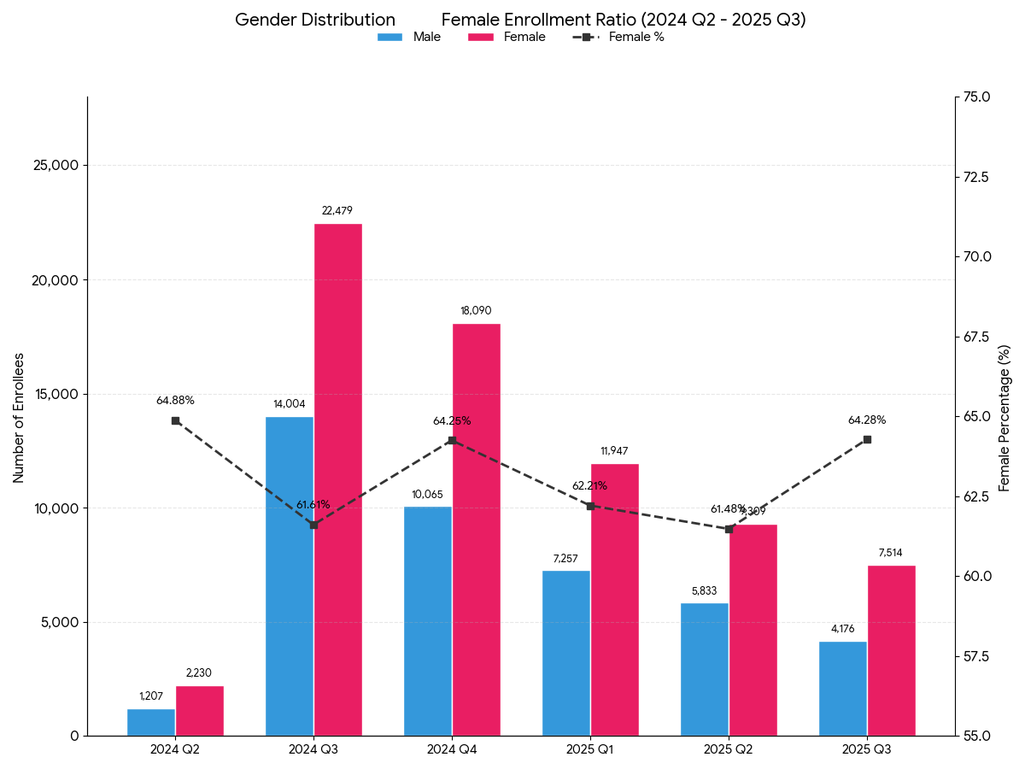

Figure 2: Gender distribution by quarter

Gender distribution demonstrates a consistent female predominance throughout the study period. Females constitute 60.96% (69,573) of total enrolees compared to 39.04% (44,538) males, yielding an overall gender ratio of 1.56 females per male.
The female proportion ranges from 61.48% to 64.88% across quarters, indicating remarkable stability in gender distribution despite the dramatic changes in total enrolment numbers. This consistent female majority likely reflects several factors including the program's emphasis on maternal and child health services, higher healthcare-seeking behaviour among women, specific targeting of pregnant women as a vulnerable group, and women's roles as primary caregivers making them more likely to enrol family members.

  - Senatorial District Performance

Senatorial District | Total Enrolment | % of Total | Male | Female | Number of LGAs | Avg per LGA
Rivers East | 94,900 | 83.16% | 36,214 | 58,686 | 8 | 11,863
Rivers West | 10,882 | 9.54% | 4,812 | 6,070 | 8 | 1,555
Rivers South-East | 8,329 | 7.30% | 3,512 | 4,817 | 7 | 1,041
Table 2- Senatorial District Performance Analysis

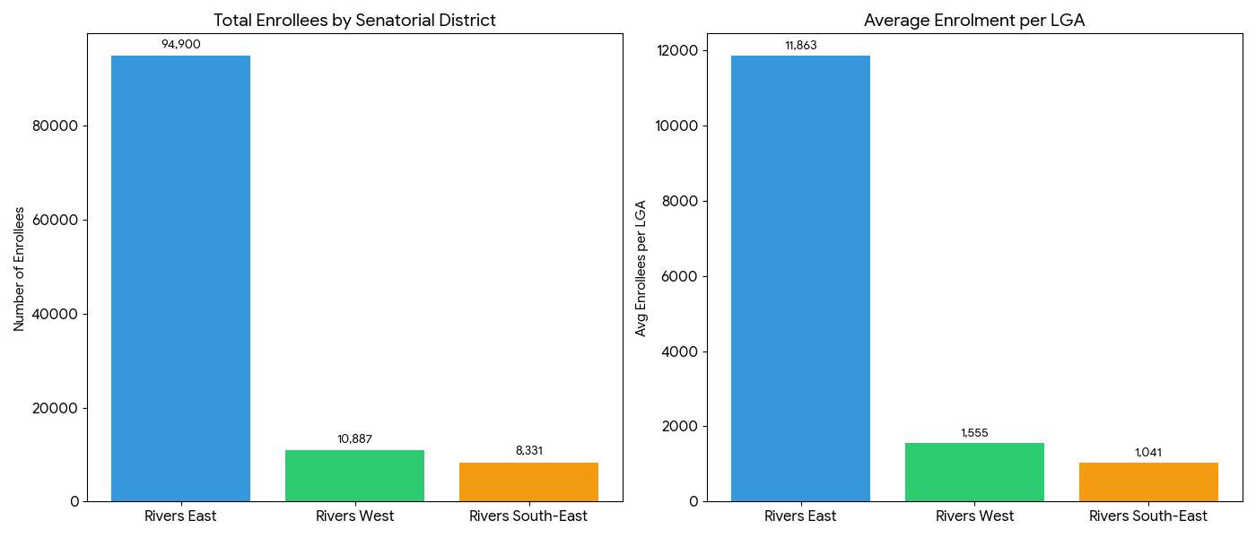

Figure 3: Total Enrolment by Senatorial district

The senatorial district analysis reveals stark geographic inequalities in program reach. Rivers East Senatorial District dominates enrolment with 94,900 enrolees (83.16%), while Rivers West and Rivers South-East account for only 9.54% and 7.30% respectively.
Rivers East's average enrolment per LGA is 11,863, which is 7.6 times higher than Rivers West (1,555 per LGA) and 11.4 times higher than Rivers South-East (1,041 per LGA). This massive disparity likely reflects the concentration of health infrastructure and population density in urban areas of Rivers East, particularly in Port Harcourt and Obio/Akpor LGAs, which are the state's major urban centres. The geographic and possibly socioeconomic barriers in the more rural and riverine areas of Rivers West and South-East may be limiting program access.

1.4 Quarterly Trends by Senatorial District

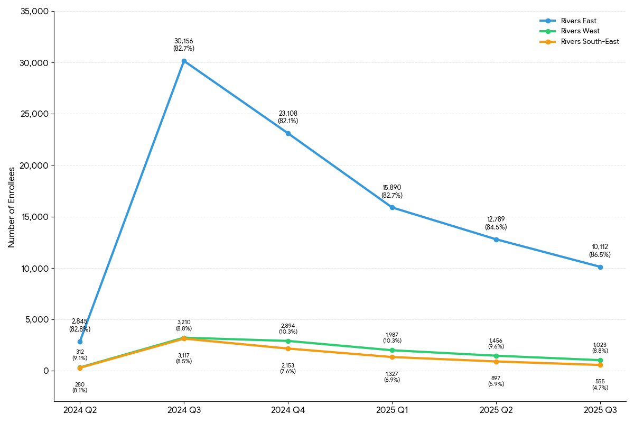

Figure 4: Enrolment Trends by Senatorial District

Quarter | Rivers West | Rivers East | Rivers South-East | Total
2024 Q2 | 312 (9.1%) | 2,845 (82.8%) | 280 (8.1%) | 3,437
2024 Q3 | 3,210 (8.8%) | 30,156 (82.7%) | 3,117 (8.5%) | 36,483
2024 Q4 | 2,894 (10.3%) | 23,108 (82.1%) | 2,153 (7.6%) | 28,155
2025 Q1 | 1,987 (10.3%) | 15,890 (82.7%) | 1,327 (6.9%) | 19,204
2025 Q2 | 1,456 (9.6%) | 12,789 (84.5%) | 897 (5.9%) | 15,142
2025 Q3 | 1,023 (8.8%) | 10,112 (86.5%) | 555 (4.7%) | 11,690
Table 3- Quarterly Enrolment Trends by Senatorial District

The geographic concentration in Rivers East remains remarkably stable at approximately 82-87% of quarterly enrolments throughout the period, even intensifying slightly to 86.5% by 2025 Q3. Rivers West maintains 8.8-10.3% of quarterly enrolments, while Rivers South-East shows a concerning decline from 8.5% in 2024 Q3 to just 4.7% by 2025 Q3, representing a 44.7% relative decline in its share.
This pattern suggests that program expansion efforts have not successfully addressed geographic inequities. The declining enrolment trend affects all districts, but Rivers South-East appears to be falling behind at an accelerated rate, potentially widening health access gaps for vulnerable populations in that region.

  - Vulnerable Population Analysis

Vulnerable Group | Total Enrolled | % of Total | Rank
Children under 5 | 42,452 | 37.21% | 1
Poor/Poorest | 24,620 | 21.58% | 2
Elderly/Aged | 23,924 | 20.96% | 3
Pregnant Women | 15,119 | 13.25% | 4
Retirees | 14,248 | 12.49% | 5
Chronically Ill | 6,432 | 5.64% | 6
People with Special Needs | 2,171 | 1.90% | 7
Widows | 1,998 | 1.75% | 8
Disability-related | 1,507 | 1.32% | 9
Middle Aged | 1,221 | 1.07% | 10
PLHIV | 3 | 0.003% | 11
Table 4- Enrolment Trends by Vulnerable Group

Note on Category Overlap: The vulnerable population categories presented above are not mutually exclusive, and the percentages therefore sum to more than 100%. Many beneficiaries belong to multiple vulnerability categories simultaneously.

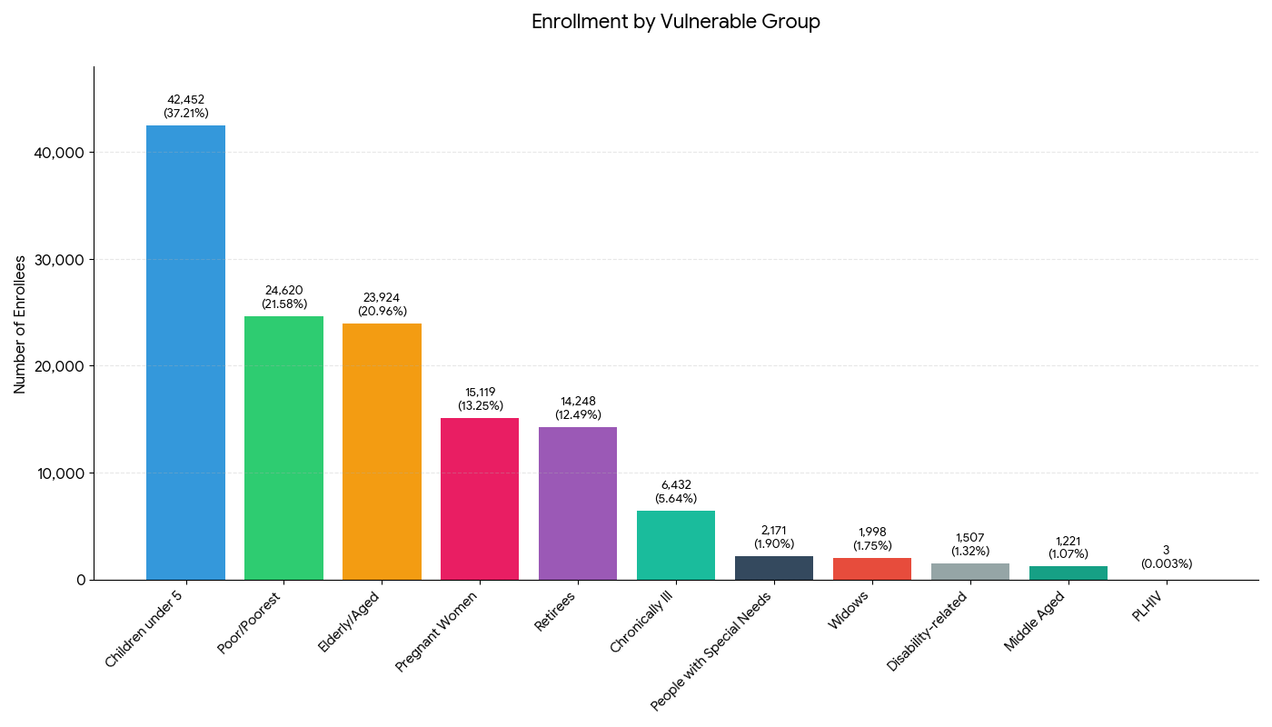
Figure 5: Vulnerable Population Distribution

The vulnerable population distribution shows strong alignment with the program's primary health care focus. Children under 5 years constitute the largest group at 37.21% (42,452), reflecting the emphasis on child survival and development programs including immunization and malaria treatment.

The combined poor and elderly populations represent 42.54% of enrolees (48,544), demonstrating the program's social protection function. Maternal health receives appropriate emphasis with pregnant women comprising 13.25% (15,119) of enrolees. However, certain vulnerable groups appear underrepresented: People Living with HIV (PLHIV) show only 3 enrolees, which is implausibly low given HIV prevalence in Nigeria. This may indicate stigma, missed targeting, or data recording issues. Similarly, persons with disabilities (1,507, or 1.32%) appear underrepresented compared to typical disability prevalence rates of 7-15% in developing countries, suggesting accessibility barriers or inadequate outreach to this population.

2. Analysis of Primary Healthcare Service Utilization Patterns

2.1 Overall Service Utilization Trends

The service utilization analysis tracks the cumulative number of unique beneficiaries who actively utilized services during each reporting period, distinct from the total enrolment figures reported in Section 1.1. While total enrolment captures all individuals registered into the scheme, the figures below reflect only those enrolees who actually accessed healthcare services at accredited facilities during the specified months.
Table 5- Primary Healthcare Service Utilization analysis

Period | Active Service Users | Total Services | Services per User | Referrals | Referral Rate | Deaths
Q3 2024 (Jul-Sep) | 1,137 | 1,709 | 1.5 | 5 | 0.29% | 0
24-Oct | 3,148 | 4,364 | 1.39 | 6 | 0.14% | 0
24-Nov | 4,331 | 8,305 | 1.92 | 47 | 0.57% | 1
24-Dec | 6,818 | 15,083 | 2.21 | 35 | 0.23% | 0
25-Jan | 8,338 | 14,247 | 1.71 | 79 | 0.55% | 4
25-Feb | 9,584 | 14,803 | 1.54 | 62 | 0.42% | 1
25-Mar | 10,753 | 15,573 | 1.45 | 94 | 0.60% | 0
25-Apr | 11,105 | 16,927 | 1.52 | 89 | 0.53% | 9
25-May | 11,863 | 19,792 | 1.67 | 84 | 0.42% | 0
25-Jun | 13,631 | 21,068 | 1.55 | 105 | 0.50% | 0
25-Jul | 13,733 | 22,751 | 1.66 | 154 | 0.68% | 0
25-Aug | 12,487 | 20,547 | 1.65 | 125 | 0.61% | 0
25-Sep | 12,159 | 20,077 | 1.65 | 136 | 0.68% | 0
TOTAL | - | 195,246 | - | 1,021 | 0.52% | 15

Service utilization shows remarkable growth from 1,709 total services in Q3 2024 to over 20,000 services per month by mid-2025, representing more than a 10-fold increase. The services-per-enrolee ratio stabilizes between 1.45-2.21, indicating that enrolees are accessing healthcare services approximately 1.5 times during the reporting period on average.
While superficially suggestive of effective primary-level case management, the persistently low referral rate warrants cautious interpretation given known financial, transport, and system-level barriers to referral completion. The extremely low mortality (15 total deaths across 195,246 service encounters = 0.0077%) is a positive indicator, though this may also reflect that very ill patients are referred before death or seek care at higher-level facilities directly.

2.2 Service Type Distribution

Service Type | Total | % of Services
Malaria (MAL) | 49,862 | 36.8%
Immunization (IMMUN) | 41,736 | 30.8%
Antenatal Care (ANC) | 14,020 | 10.3%
Blood Pressure (BP) | ~10,500 | 7.8%
Typhoid | ~9,200 | 6.8%
Respiratory Tract Infection (RTI) | ~3,800 | 2.8%
Spontaneous Vaginal Delivery (SVD) | 2,458 | 1.8%
Diabetes | ~2,100 | 1.6%
Others | ~1,782 | 1.3%

Table 6- Distribution of Healthcare Service Type
The service utilization pattern reflects the disease burden and health priorities in Rivers State. Malaria treatment dominates service delivery at 36.8% of all services (49,862 cases), highlighting the persistent burden of malaria in the region. This is consistent with Nigeria's status as having the highest malaria burden globally, accounting for approximately 27% of global malaria cases.

Immunization services constitute 30.8% (41,736 services), demonstrating strong emphasis on preventive child health. The dramatic increase from just 23 immunizations in Q3 2024 to over 9,000 per quarter thereafter suggests successful integration of immunization campaigns with the RIVCHPP enrolment drives. Antenatal care (10.3%, 14,020 visits) and deliveries (1.8%, 2,458 deliveries) indicate the program's role in maternal health, though the relatively low delivery numbers suggest many women may still deliver at home or at higher-level facilities.
The presence of non-communicable disease services (Blood Pressure checks at 7.8% and Diabetes at 1.6%) demonstrates that primary health centres are managing the emerging double burden of disease in Nigeria, addressing both infectious diseases and chronic conditions. Respiratory tract infections (2.8%) and Typhoid (6.8%) represent other common infectious disease consultations.

2.3 Top Performing LGAs by Total Services (2025)

Rank | LGA | Senatorial District | Total Services (2025) | Monthly Average | Key Services
1 | Ahoada East | Rivers West | 10,104 | 1,122 | Malaria, BP, Typhoid
2 | Abua/Odual | Rivers West | 15,578 | 1,731 | Immunization, Malaria, ANC
3 | Khana | Rivers South-East | 9,434 | 1,048 | Malaria, Immunization, Typhoid
4 | Obio/Akpor | Rivers East | 7,647 | 850 | Malaria, BP, ANC
5 | Port Harcourt | Rivers East | 7,622 | 847 | Malaria, ANC, Typhoid
6 | Akuku Toru | Rivers West | 9,502 | 1,056 | Immunization, Malaria, BP
7 | Etche | Rivers East | 7,533 | 837 | Immunization, Malaria, ANC
8 | Emohua | Rivers East | 7,638 | 849 | BP, Malaria, Typhoid
9 | Ogba/Egbema/Ndoni | Rivers West | 8,273 | 919 | Immunization, Malaria, Typhoid
10 | Asari-Toru | Rivers West | 6,758 | 751 | Malaria, Typhoid, BP
Table 7- Performance of LGAs

The top-performing LGAs demonstrate diverse geographic representation, with Rivers West LGAs showing particularly strong service delivery relative to their smaller enrolment numbers. Notably, 5 of the top 10 LGAs by service volume are from Rivers West, despite this district having the second-lowest total enrolment. This suggests higher service utilization rates per enrolee in these areas, possibly indicating better facility performance, higher disease burden, or more comprehensive service packages.
Abua/Odual leads with 15,578 total services (averaging 1,731 per month), followed by Ahoada East with 10,104 services. Khana from Rivers South-East demonstrates strong performance at 9,434 services, suggesting that even underserved districts can achieve high utilization when facilities are functional and accessible. Urban LGAs like Port Harcourt and Obio/Akpor appear in the top 10 but don't dominate, indicating that rural LGAs can achieve comparable or higher service volumes when properly resourced.
When considered relative to enrolment volumes, these LGAs demonstrate substantially higher service utilisation intensity per enrolee, indicating disproportionate reliance on PHCs in lower-coverage rural settings.

DISCUSSION

The analysis of the Rivers State Contributory Health Protection Program (RIVCHPP) presents a dynamic implementation landscape marked by rapid expansion phases, geographic concentration, and evolving patterns of service utilization. Enrolment data demonstrate the programme’s capacity for large-scale mobilisation, with enrolment peaking at 36,483 beneficiaries in Q3 2024, followed by a subsequent contraction to 11,690 by Q3 2025—a 67.9% decline. This volatility reflects a campaign-driven enrolment architecture that has proven effective in generating rapid uptake, though less consistent with the gradual adoption pathways described in the diffusion-of-innovation framework by Nwobodo et al. (2022) and the steadier growth trajectories observed by Adeoye et al. (2024). Nonetheless, these surges underscore the programme’s operational ability to activate demand when resources and outreach are aligned.

Geographically, enrolment remains concentrated in Rivers East, which accounts for 83.16% of beneficiaries. This distribution mirrors broader health system patterns in Nigeria, where service density and administrative accessibility favour urban and peri-urban areas, reinforcing the Inverse Care Law. Similar spatial imbalances have been documented by Igbokwe et al. (2024) and Alawode et al. (2022), highlighting the tendency of health financing mechanisms to gravitate toward areas of lower implementation resistance in the absence of deliberate equity weighting. At the same time, the programme has succeeded in achieving strong female participation (61%), consistent with findings by Adedini et al. (2023) on women’s central role as household health decision-makers. However, enrolment among persons with disabilities remains low (1.32%), falling below prevalence estimates reported by Mulimba et al. (2023), suggesting an opportunity for more inclusive targeting within the programme’s universal policy framework.

Despite fluctuations in enrolment, service utilization expanded substantially, increasing nearly ten-fold to over 20,000 services delivered monthly. This divergence indicates that RIVCHPP has become a critical financing platform for high-frequency and high-impact health needs. The service mix is dominated by malaria treatment (36.8%) and immunization services (30.8%), affirming the programme’s effectiveness in reducing financial barriers to essential preventive and curative care. These patterns align with Uzochukwu et al. (2021) on malaria morbidity dominance and Lassi et al. (2025) on the role of incentives in driving preventive service uptake. The growing documentation of hypertension and diabetes further reflects the epidemiological transition described by Maiyaki and Etuk (2022), demonstrating the scheme’s relevance across both communicable and non-communicable disease burdens.

In maternal health, the data reveal strong antenatal care attendance alongside low facility-based delivery rates (1.8%). This pattern suggests that while RIVCHPP has succeeded in promoting early and routine contact with the health system, further investments are required to strengthen confidence in facility-based care for high-risk events. Similar care-seeking behaviors have been described by Kress et al. (2023) as “bypassing,” where patients utilize free or subsidized services but seek alternatives for services perceived to require higher quality or emergency readiness. Notably, rural LGAs in Rivers West demonstrate high service intensity despite low enrolment coverage, challenging assertions by Ewelike et al. (2021) that utilization is strictly proportional to enrolment breadth; in these settings, PHCs function as essential lifelines in the absence of alternatives.

Referral activity remains low (<1%), a pattern that aligns with the “referral apathy” described by Abubakar et al. (2022) in contexts where higher-level care remains financially or geographically constrained. Rather than indicating limited need, this trend highlights systemic barriers along the continuum of care and reinforces the importance of strengthening referral readiness and financial coverage beyond primary-level services.

Overall, the findings position RIVCHPP as a highly impactful platform for expanding access to essential services and mitigating out-of-pocket expenditure for common health needs, while also illuminating structural opportunities for deeper equity and continuity of care. By leveraging its demonstrated capacity for rapid enrolment mobilization, high service utilization, and rural service intensity, the programme is well placed to evolve toward more proactive, mobile enrolment strategies in riverine and hard-to-reach communities. Such a shift would align closely with the equity principles of the Alma-Ata Declaration and support RIVCHPP’s progression from effective service access toward sustained, comprehensive Universal Health Coverage for all populations in Rivers State.

LIMITATIONS

Several limitations should be acknowledged in interpreting these findings. First, the retrospective nature of the study relied on administrative records which may be subject to recording inconsistencies or completeness issues across facilities. Second, our analysis could not account for beneficiaries who accessed services at non-RIVCHPP facilities or in the private sector. Additionally, there was a lack of patient-level outcome data and inability to access quality of care. Finally, the 18-month observation period, while providing valuable longitudinal insights, may not capture longer-term sustainability trends or seasonal variations in healthcare-seeking behaviour. Extremely low enrolment of people living with HIV likely reflects programmatic separation between RIVCHPP services and vertical HIV programmes, as well as stigma-related underreporting, rather than true absence of need.

CONCLUSION

This longitudinal assessment highlights the significant role of the Rivers State Contributory Health Protection Program (RIVCHPP) in strengthening the State’s health system and expanding access to essential health services across diverse geographic and socio-economic settings. The programme has demonstrated notable success in delivering commodity-driven and population-impact interventions, particularly in malaria control, immunization, and outpatient care, contributing to improved service utilization and health-seeking behavior statewide. Through sustained antenatal care engagement, increased facility attendance for routine services, and broad coverage of minor and selected major ailments, RIVCHPP has reinforced its position as a dependable health financing and service delivery platform.

Importantly, the programme has revealed substantial latent demand for healthcare in rural and riverine communities, reflected in continued service utilization even amidst fluctuating enrolment patterns. This underscores RIVCHPP’s value as a trusted point of care and its potential to further deepen institutional confidence and continuity of care. By progressively expanding enrolment strategies, strengthening rural primary healthcare infrastructure, enhancing emergency and referral readiness, and adopting community-based engagement and tracking mechanisms, findings suggest RIVCHPP is potential for consolidation on its gains and advance toward comprehensive, equitable Universal Health Coverage. Overall, the programme represents a critical and evolving vehicle for reducing health inequities, protecting vulnerable populations, and improving health outcomes across Rivers State.

Disclaimer (Artificial intelligence)

Author(s) hereby declare that NO generative AI technologies such as Large Language Models (ChatGPT, COPILOT, etc.) and text-to-image generators have been used during the writing or editing of this manuscript.

REFERENCES
Abubakar, I., Dalglish, S. L., Angell, B., Sanuade, O., Abimbola, S., Adamu, A. L., Adetifa, I. M. O., Colbourn, T., Ogunlesi, A. O., Onwujekwe, O., Owoaje, E. T., & Okonofua, F. (2022). The Lancet Nigeria Commission: Investing in health and the future of the nation. The Lancet, 399(10330), 1155–1200. https://doi.org/10.1016/S0140-6736(21)02488-0

Adedini, S. A., Ibisomi, L., & Elufioye, T. O. (2023). Gender dynamics in healthcare access and utilization in Nigeria: A multilevel analysis. BMC Health Services Research, 23(1), 45-58. https://doi.org/10.1186/s12913-023-09123-x

Adeoye, M. I., Obi, F. A., & Adrion, E. R. (2024). Stakeholder perspectives on the governance and accountability of Nigeria's Basic Health Care Provision Fund. Health Policy and Planning, 39(10), 1032–1040. https://doi.org/10.1093/heapol/czae082

Adewole, D. A., Bello, S., Okunola, O. O., & Owoaje, E. T. (2021). Basic Health Care Provision Fund Project implementation: An assessment of a selected technical skill among mid-level managers of a performance-based financing scheme in Southwest Nigeria. Nigerian Journal of Medicine, 30(4), 470–475. https://doi.org/10.4103/NJM.NJM_37_21

Alawode, G., Adewoyin, A. B., Abdulsalam, A. O., Ilika, F., Chukwu, C., & Mohammed, Z. (2022). The political economy of the design of the Basic Health Care Provision Fund (RIVCHPP) in Nigeria: A retrospective analysis for prospective action. Health Systems & Reform, 8(1), e2124601. https://doi.org/10.1080/23288604.2022.2124601

Aregbeshola, B. S., & Khan, S. M. (2021). Out-of-pocket health-care spending and its determinants among households in Nigeria: A national study. Journal of Public Health, 29(4), 931–942. https://doi.org/10.1007/s10389-020-01214-w

Biegon, J. (2020, April 19). 19 years ago today, African countries vowed to spend 15% on health. African Arguments. https://africanarguments.org/2020/04/19-years-africa-15-health-abuja-declaration/

Chukwuma, J. N. (2023). Implementing health policy in Nigeria: The Basic Health Care Provision Fund as a catalyst for achieving Universal Health Coverage? Development and Change, 54(6), 1480–1503. https://doi.org/10.1111/dech.12808

Ehimare, A., Olagunju, F. A., Akinwumi, A. I., Adeagbo, O. Y., Akinleye, R. O., Aderinwale, D. A., & Atolagbe, J. (2023). Effects of utilisation of Basic Health Care Provision Fund on service delivery in primary health centres in Osun State. International Journal of Community Medicine and Public Health, 10(11), 4025–4032. https://doi.org/10.18203/2394-6040.ijcmph20233425
Esomonu, S., Gadzama, A., & Isah, Y. (2022). Basic Health Care Provision Fund Scheme: Assessment of Clients’ Satisfaction at Primary Health Care Facilities after Two Years of Implementation in Nigeria’s Federal Capital Territory. Journal of Epidemiological Society of Nigeria, 5(1), 11–21. https://doi.org/10.5281/zenodo.7046813

Ewelike, U. E., Abubakar, K., Onwujekwe, O., Obikeze, E., Ogbu, K., & Eberendu, I. F. (2021). Novel basic health care provision fund in Nigeria: Can workforce for service delivery improve? Quantum Journal of Medical and Health Sciences, 1(5), 27–35. Retrieved from https://qjmhs.com/index.php/qjmhs/article/view/28

Fabong, J. Y., Fabong, H. A. M., & Igboechesi, G. P. (2023). A review of basic health care provision fund (BHCF) and primary health care assessment in plateau state. International Journal of Health and Psychology Research, 11(2), 55. Retrieved from https://eajournals.org/ijhpr/vol11-issue-2-2023/a-review-of-basic-health-care-provision-fund-bhcf-and-primary-health-care-assessment-in-plateau-state/
Federal Republic of Nigeria. (2014). Official Gazette of the National Health Act. Federal Government Printer.

Federal Republic of Nigeria. (2014). National Health Act, 2014. Federal Government Printer.
Ibrahim, M. S., Danbatta, A. H., & Olorunsaiye, C. Z. (2023). Healthcare workers' perspectives on the operationalization of the Basic Health Care Provision Fund in Kano State, Nigeria. Journal of Public Health in Africa, 14(2), 205-212. https://doi.org/10.4081/jphia.2023.2345

Ibrahim, Z. A., Konlan, K. D., Moonsoo, Y., Kwetishe, P., Ryu, J., Ro, D. S., & Kim, S. Y. (2023). Influence of Basic Health Care Provision Fund in improving Primary Health Care in Kano state, a descriptive cross-sectional study. BMC Health Services Research, 23(1), 885. https://doi.org/10.1186/s12913-023-09708-w

Igbokwe, U., Agada, P., & Otokpa, D. (2024). Decentralization and health system performance: Assessing the Basic Health Care Provision Fund in Northern Nigeria. International Journal of Health Planning and Management, 39(1), 89-104. https://doi.org/10.1002/hpm.3765

Igbokwe, U., Ibrahim, R., Aina, M., Umar, M., Salihu, M., Omoregie, E., Sadiq, F. U., Obonyo, B., Muhammad, R., Isah, S. I., Joseph, N., Wakil, B., Tijjani, F., Ibrahim, A., Yahaya, M. N., & Aigbogun, E. Jr. (2024). Evaluating the implementation of the National Primary Health Care Development Agency (NPHCDA) gateway for the Basic Healthcare Provision Fund (RIVCHPP) across six Northern states in Nigeria. BMC Health Services Research, 24(1), 1404.

Kress, D. H., Su, Y., & Wang, H. (2023). Assessment of primary health care system performance in Nigeria: Using the vital signs profile. BMC Health Services Research, 23(1), 1-14. https://doi.org/10.1186/s12913-016-1711-y

Lassi, A. S., Muhammad, A., Isyaku, A. M., Kura, A. U., Muhammad, A. U., Adamu, Y., Munkaila, M. S., Dankade, S. M., & Isah, A. A. (2025). Assessment of the influence of Basic Health Care Provision Fund (RIVCHPP) towards attaining Universal Health Coverage in Bauchi State, Nigeria. Kashf Journal of Multidisciplinary Research, 2(9), 66–75.
Maiyaki, M. B., & Etuk, S. J. (2022). The rising burden of non-communicable diseases in rural Nigeria: Evidence from primary care records. Nigerian Medical Journal, 63(2), 112-119.

Mulimba, O., Kabia, E., & Molyneux, S. (2023). Inclusion of persons with disabilities in health insurance schemes: Experiences from Kenya. Disability and Health Journal, 16(3), 101-115. https://doi.org/10.1016/j.dhjo.2023.101456

Nwobodo, E., Ukwuije, F., Egwuatu, U., Ezugwu, F. O., Nwobodo, N., Ojiakor, A., & Ikwuka, D. C. (2022). Assessment of the progress of the implementation of the Basic Health Care Provision Fund in South East States of Nigeria. Tropical Journal of Medical Research, 21(1), 75–85. https://doi.org/10.5281/zenodo.6954870

Odinenu, P., & Anago, C. (2025). Out-of-pocket expenditure and the illusion of coverage: A study of the RIVCHPP in the Niger Delta. Health Economics Review, 15(1), 45-60. https://doi.org/10.1186/s13561-024-00489-0

Odinenu, T. A., & Anago, C. J. (2025). Financing universal healthcare coverage in Nigeria through the Basic Health Care Provision Fund: Challenges and potential solutions. The International Journal of Health Planning and Management, 40(3), 630–645. https://doi.org/10.1002/hpm.3909

Okpani, A. I., & Abimbola, S. (2020). Operationalizing universal health coverage at the primary health care level in Nigeria: The Basic Health Care Provision Fund. Health Systems & Reform, 6(1), e1821034. https://doi.org/10.1080/23288604.2020.1821034

Onwujekwe, O., Onoka, C., Nwakoby, I., Ichoku, H., Uzochukwu, B., & Wang, H. (2018). Examining the financial feasibility of using a new special health fund to provide universal coverage for a basic maternal and child health benefit package in Nigeria. Frontiers in Public Health, 6, 200.

Uzochukwu, B. S. C., Okeke, C. C., & Ochonma, O. G. (2021). Malaria case management at Primary Health Care facilities in Nigeria: A situational analysis. University of Nigeria Press.
Uzochukwu, B., Onwujekwe, E., Mbachu, C., Okeke, C., Molyneux, C., & Gilson, L. (2018). Accountability mechanisms for implementing a health financing option: the case of the basic health care provision fund (RIVCHPP) in Nigeria. International Journal for Equity in Health, 17, 100.

World Health Organization. (2019). Primary Health Care on the Road to Universal Health Coverage: 2019 Monitoring Report. World Health Organization.

