Supine vs prone positioning without belly board for rectal cancer : a practical dosimetric study in a resource-limited setting

Abstract
Background:
This study aimed to evaluate the impact of patient positioning on dose distribution to the bowel and bladder in rectal cancer patients in a setting without access to a belly board or advanced techniques such as Intensity-Modulated Radiotherapy (IMRT).
Methods:
Between July and October 2014, 20 consecutive rectal cancer patients were prospectively enrolled. Computed Tomography (CT) simulations were performed with a full bladder in two positions: prone (without a belly board) and supine. Three-dimensional conformal radiotherapy (3D-CRT) plans delivering 46 Gy in 23 fractions were generated. Bowel volumes receiving 5-Gy increments (V5–V45) and bladder dose parameters were compared between positions.
Results:
The mean Planning Target Volume (PTV), bowel, and bladder volumes were similar between prone and supine positions (PTV: 1000.78 vs 1006.21 cm³, p=0.84; bowel: 752.04 vs 750.32 cm³, p=0.97; bladder: 225.48 vs 244.16 cm³, p=0.26). Across all dose levels (V5–V45), no statistically significant differences were observed in bowel or bladder irradiation.
Conclusion:
Although these findings do not introduce new dosimetric concepts, they provide practical evidence supporting the use of the supine position with a full bladder in preoperative 3D-CRT for rectal cancer, particularly in centers lacking a belly board or access to IMRT. Supine positioning offers comparable bowel sparing, improved patient comfort, and better reproducibility, making it a feasible alternative in resource-limited settings.
Keywords: Bladder dose, bowel dose, dose–volume histogram, prone position, rectal cancer,resource-limited setting, supine position, 3D-CRT.

Introduction
Patients with rectal cancer are often treated in the prone position to minimize the volume of small bowel included in the pelvic radiation field. Various strategies have been proposed to further reduce small bowel exposure, including treatment with a full bladder and the use of displacement devices, such as the belly board, which allows the abdominal contents to fall anteriorly [1,2].
The supine position is commonly used when prone positioning is not feasible, such as in patients with obesity or a colostomy. Supine positioning is generally more comfortable for patients and allows for more reproducible treatment setups. Although prone and supine positioning may result in small dosimetric differences, their clinical significance remains uncertain [3,4].
The objective of this study was to compare Dose-Volume Histogram (DVH) parameters of the bowel and bladder between supine and prone positions without the use of a belly board in patients with locally advanced rectal cancer.

Materials and Methods
Study design and patients
This was a prospective, single-center study conducted between July and October 2014. Eligible patients had histologically confirmed rectal adenocarcinoma without distant metastases, no history of prior pelvic radiotherapy, and no previous abdominal or pelvic surgery. Diagnosis was established by colonoscopy with biopsy, and tumor staging was performed according to the Union for International Cancer Control (UICC) Tumor, Nodes, Metastasis (TNM classification). For tumor localization, the distance of the lowest margin of the tumor from the anal verge was measured. Tumors were classified as low (≤5 cm from the anal verge), mid (5–10 cm), or high (≥10 cm). The study protocol was approved by the Institutional Review Board (IRB) of the National Oncology Institute, Rabat, Morocco.
CT simulation
Patients were instructed to completely empty their bladder, then drink 1000 ml of water and wait 40 minutes before simulation. In the prone position, patients were positioned with arms raised above the head, without immobilization devices. An anal marker was placed at the anal margin. CT simulation was performed with 5-mm slice thickness, covering from the superior border of the fifth lumbar vertebra to the level of the small trochanters. Immediately after prone imaging, patients were repositioned supine with knee and ankle supports, arms resting on the chest, and a second CT scan was performed using the same parameters.
Target delineation
Two treatment plans were generated for each patient : one in the supine position and one in the prone position. CT scans were imported into the treatment planning system (TPS ,Monaco® , Elekta Synergy), using a three-dimensional conformal radiotherapy (3D-CRT) technique. Treatment plans were designed for delivery on an Elekta linear accelerator using 6- and 18-MV photon beams, and dose calculations were performed with the Monte Carlo algorithm.
Target volumes were delineated according to international consensus guidelines [5–9]. The gross tumor volume (GTV) included the macroscopic tumor and any involved lymph nodes. The clinical target volume (CTV) corresponded to the GTV plus a 10-mm margin and included the posterior bladder wall, the mesorectal subsite, the presacral space, and the internal iliac lymph nodes. The upper border of the CTV was set at the S1–S2 interspace for cases without mesorectal fascia involvement and without pathological nodes on MRI. When lymph node involvement was detected, the cranial border was extended to the bifurcation of the common iliac arteries. If the anal sphincter was directly invaded, it was included in the CTV, and the entire ischiorectal fossa was delineated in cases of extensive infiltration.The planning target volume (PTV) was defined by adding a uniform 10-mm margin around the CTV to account for setup uncertainties.Organs at risk (OARs) included the bladder and bowel. The bowel was contoured as the peritoneal cavity encompassing both small and large bowel loops. It extended superiorly four slices above the most superior PTV slice and inferiorly to the rectosigmoid junction or any bowel within the PTV. The bladder was delineated by its external wall.
Figure 1 illustrates the transverse computed tomography (CT) slices for a representative patient, showing the delineation of target volumes and organs at risk in both prone and supine positions. The bladder is depicted in white, the right and left femoral heads in light and dark blue, respectively, and the mesorectal subsite in orange. The gross tumor volume (GTV), clinical target volume (CTV), and planning target volume (PTV) are displayed in yellow, red, and green, respectively, allowing visual comparison of target coverage between the two treatment positions.

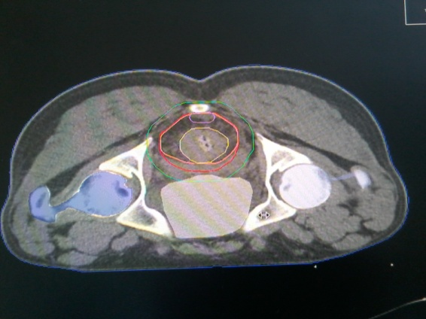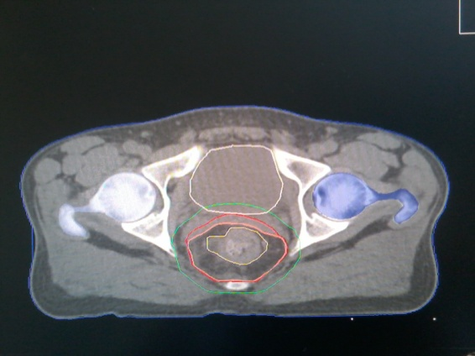
(a) (b)
Figure 1. Transverse CT slices : bladder (white), right femoral head (light blue), left femoral head (dark blue). The mesorectal subsite is outlined in orange. Target volumes are shown as follows: GTV (yellow), CTV (red), and PTV (green), in prone (a) and supine (b) positions.
Figure 2 presents axial CT images from another patient, illustrating the contoured bowel loops (in magenta), presacral space (in pink), and internal iliac lymph node CTV (in light blue) in both prone and supine positions. This figure highlights the overall similarity in bowel distribution between the two positions and visually supports the quantitative dosimetric comparison performed in this study.

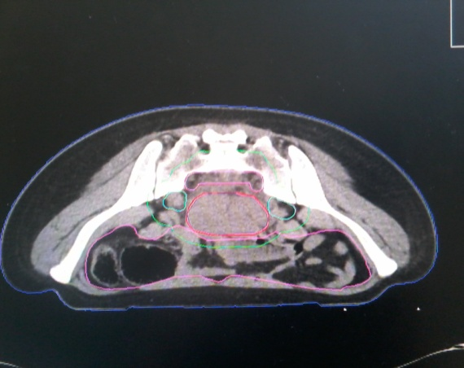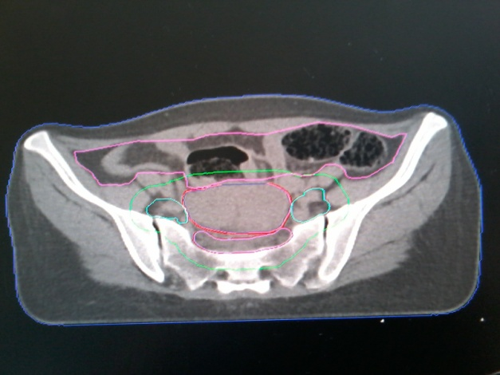
(a) (b)
Figure 2. Axial CT slice of another patient showing the total bowel (magenta), presacral space (pink), internal iliac lymph node CTV (light blue), CTV (red), and PTV (green), in prone (a) and supine (b) positions.
Treatment planning
Three-dimensional conformal radiotherapy (3D CRT) was used in this study because intensity-modulated radiotherapy (IMRT) was not available in our institution at the time. Preoperative radiotherapy (RT) was delivered in daily fractions of 2 Gy, five days per week, to a total pelvic dose of 46 Gy in 23 fractions. Treatment was performed using linear accelerators that produced photon energies between 6 and 18 megavolts (MV). The radiation fields were designed to include the rectum and pelvic lymph nodes located below the bifurcation of the common iliac arteries. Beam arrangements and wedge weightings were optimized to ensure adequate coverage of the planning target volume (PTV), maintaining a dose distribution between 95 % and 107 % of the prescribed dose.Dose–volume histogram (DVH) parameters were recorded for all patients. These included the mean volumes of the PTV, bladder, and bowel, as well as the minimum, maximum, and mean doses delivered to the PTV and to the organs at risk (OARs). The bowel volumes receiving 5 Gy, 10 Gy, 15 Gy, 20 Gy, 25 Gy, 30 Gy, 35 Gy, 40 Gy, and 45 Gy (V5–V45) were also calculated. All patients were ultimately treated in the prone position.
Statistical analysis
Statistical analyses were performed using SPSS software. Means of bowel and bladder volumes were compared using paired Student’s t-tests. Normal distribution was confirmed with the Kolmogorov–Smirnov test. A p-value <0.05 was considered statistically significant.
Results
A total of 20 patients were included in the study, of whom 13 (65%) were female. The median age was 51 years (range, 31–74 years). The majority of tumors, 16 patients (80%), were located in the lower rectum. Patient characteristics are summarized in Table 1.
Table 1. Patient characteristics
Patient | Sex | Age (years) | Stage | Tumor site
1  2  3  4  5  6  7  8  9  10  11  12  13  14  15  16  17  18  19  20 | M  M  F  F  F  F  M  F  F  M  M  M  F  F  F  F  F  F  M  F | 59  53  40  64  58  59  59  63  74  47  36  54  34  42  35  64  55  53  31  40 | T3N2b M0  T3N1b M0  T3N1a M0  T3N1a M0  T3N1b M0  T3N1a M0  T3N1a M0  T3N1a M0  T3N1b M0  T4N1b M0  T3N1a M0  T3N1a M0  T3N1c M0  T3N2a M0  T3N0 M0  T3N0 M0  T3Nx M0  T3N1b M0  T3N2b M0  T4N0 M0 | Low rectum  Low rectum  Low rectum  Low rectum  Low rectum  Mid rectum  Low rectum  Mid rectum  Low rectum  Low rectum  Low rectum  Low rectum  Low rectum  Low rectum  Low rectum  Mid rectum  Mid rectum  Low rectum  Low rectum  Low rectum
The mean bowel volume was 752.04 cm³ (range, 434.34–1108.82 cm³) in the prone position and 750.32 cm³ (range, 256.69–1260.33 cm³) in the supine position. The mean bladder volume was 225.48 cm³ (range, 65.52–656.17 cm³) in the prone position and 244.16 cm³ (range, 83.41–797.57 cm³) in the supine position. The mean planning target volume (PTV) was 1000.78 cm³ (range, 756.07–1365.56 cm³) in the prone position and 1006.21 cm³ (range, 768.14–1215.30 cm³) in the supine position, as shown in Table 2.
Table 2 : Comparisons of mean volumes to PTV and organs at risk between prone and supine position.
Volumes(cm3) | Prone position | Supine position | p
PTV | 1000.78 | 1006.21 | 0.84
Bowel | 752.04 | 750.32 | 0.97
Bladder | 225.48 | 244.16 | 0.26

No statistically significant differences were observed in the mean bowel volume (p = 0.97), bladder volume (p = 0.26), or PTV (p = 0.84) between the two positions. Dose distributions to the organs at risk (OARs) are presented in Table 3.

Table 3. Comparison of mean doses to OAR between prone and supine positions
OAR | Dose type | Prone (Gy) | Supine (Gy) | p-value
Bowel | Mean dose  Maximum dose  Minimum dose  Mean dose  Maximum dose  Minimum dose | 19.05  47.06  0.81  29.40  46.34  16.47 | 20.05  47.33  2.33  31.16  47.24  16.99 | 0.607  0.604  0.240  0.017  0.077  0.408

There was no significant difference in mean bowel dose between the prone and supine positions (p = 0.607). Dose–volume comparisons revealed slightly larger differences at lower dose levels (V5, V10, and V15), although these differences were not statistically significant. Across all dose levels from 5 Gy to 45 Gy, no significant variations were observed between the prone and supine positions (Table 4).
Table 4. Dose–volume distribution in the total bowel in prone and supine positions
Dose (Gy) | Mean bowel volume – prone (cm³) | Mean bowel volume – supine (cm³) | p-value
5  10  15  20  25  30  35  40  45 | 647.19  552.20  463.18  258.03  200.36  167.58  141.02  115.30  71.32 | 679.04  616.92  453.13  283.77  196.44  162.16  135.15  112.52  77.35 | 0.50  0.15  0.85  0.054  0.85  0.79  0.74  0.84  0.65
Table 5 summarizes the dose–volume distribution to the bladder in both treatment positions. Similar to the bowel findings, no statistically significant differences were observed at any dose level from 5 Gy to 45 Gy, although slightly higher bladder doses were noted in the supine position. These differences remained minor and clinically irrelevant.
Table 5. Dose–volume distribution in the bladder in prone and supine positions
Dose (Gy) | Mean bladder volume – prone (cm³) |  | Mean bladder volume – supine (cm³) | p-value
5  10  15  20  25  30  35  40  45 |  | 225.48  225.48  219.99  156.18  116.65  101.66  89.72  77.16  47.14 | 244.16  244.16  237.33  182.77  146.84  131.53  119.25  105.56  67.54 | 0.260  0.260  0.290  0.060  0.075  0.088  0.054  0.095  0.130

Discussion
Preoperative radiotherapy for rectal cancer has traditionally been delivered using three-dimensional conformal radiotherapy (3D-CRT), most often in the prone position with a belly board (BB). This setup was designed to reduce the irradiated volume of the small bowel and thereby minimize gastrointestinal toxicity. However, the supine position is increasingly used in clinical practice, as it offers greater patient comfort, easier setup, and improved reproducibility, although concerns remain about its impact on bowel sparing [2]. Several dosimetric and clinical studies have confirmed that the use of a belly board can significantly reduce the irradiated small bowel volume in both 3D-CRT and IMRT techniques [11–16].
Nevertheless, the present analysis showed no significant difference in bowel irradiation between prone and supine positions when a BB was not used. This observation is consistent with randomized and prospective series reporting that supine positioning, in the absence of a BB, achieves similar bowel sparing compared with prone positioning, while providing smaller setup deviations and better patient tolerance [3,18]. Some studies, however, have reported that the supine position may increase low-dose bowel exposure. Drzymala et al. [4] observed significantly larger irradiated bowel volumes at V5 and V10 in the supine position, although these differences disappeared at higher dose levels. This suggests that the clinical impact of positioning may depend on the dose range considered and on the contouring method, particularly when delineating individual bowel loops.
Comparative planning analyses have demonstrated that IMRT and VMAT reduce clinically relevant bowel doses compared with conventional 3D-CRT, particularly at intermediate and high dose levels, translating into lower acute gastrointestinal toxicity in some series [10,19–21,24–26]. Mok et al. [10] specifically reported that IMRT significantly improves clinically relevant small bowel dose parameters in rectal carcinoma, highlighting the dosimetric advantages of highly conformal techniques.
More recent planning studies comparing IMRT with 3D-CRT have consistently confirmed this benefit, demonstrating that the majority of organ-at-risk (OAR) parameters were significantly more favorable in IMRT plans than in 3D-CRT plans. The largest difference was observed in bladder V40 values (with reductions of up to 51.2%) in favor of IMRT [27].
These dosimetric advantages are further supported by a comparative planning study by Mirzaeiyan et al., which evaluated whole pelvic radiotherapy for prostate cancer. Their work, which included both dosimetric and radiobiological analyses (such as NTCP models), concluded that Helical Tomotherapy (an advanced form of IMRT) provided superior organ-at-risk sparing compared with 3D-CRT, while maintaining adequate target coverage. This reinforces the principle that intensity-modulated techniques offer a clinically significant benefit in reducing the volume of healthy tissue receiving high doses, potentially translating into lower toxicity rates [28].
In this context, the relative benefit of a BB is attenuated, as modern highly conformal techniques combined with daily image guidance often achieve comparable or superior bowel sparing in the supine position, while maintaining setup reproducibility and patient comfort [12,19]. Recent data also confirm similar findings in rectal cancer patients treated with highly conformal techniques in the supine position [26].
Nonetheless, in institutions where 3D-CRT is still the standard, or where high-dose small bowel avoidance is critical, prone positioning with a BB may remain advantageous and should be considered on a case-by-case basis [1].
The small bowel and bladder continue to represent the most important dose-limiting structures in pelvic radiotherapy. The small bowel demonstrates both serial and parallel behavior: small irradiated volumes may trigger focal complications, whereas larger irradiated volumes correlate with higher risks of acute toxicity [20–21]. Multiple clinical studies have established dose–volume relationships, showing that parameters such as V15 and mean small bowel volume are strongly associated with the risk of grade ≥3 diarrhea in patients receiving chemoradiotherapy [20–23].
While our results are consistent with previously published data, they do not provide novel dosimetric insights. However, they confirm that, even with standard 3D-CRT techniques, supine positioning with a full bladder achieves bowel protection comparable to prone positioning. This approach improves patient comfort, enhances setup reproducibility, and is easily applicable in routine practice, particularly in centres where advanced techniques or belly boards are not available [17,18].
Our study thus provides practical evidence supporting the adoption of supine positioning in daily clinical workflow under resource-limited conditions.

Limitations of the study
This study was limited by its small sample size and the use of conventional 3D CRT techniques rather than modern approaches such as IMRT or VMAT. Prone positioning with a belly board has been shown in other studies to provide better small bowel sparing. However, these techniques were not available in our institution at the time of the study.
Conclusion
Our study confirms that supine positioning with a full bladder provides comparable bowel sparing to prone positioning without a belly board in preoperative 3D-CRT for rectal cancer. Although these findings do not introduce new concepts, they are particularly relevant in our setting, where advanced techniques such as IMRT or Volumetric Modulated Arc Therapy (VMAT) are not available. Supine positioning is therefore a practical, safe, and patient-friendly alternative that can be readily implemented using the resources available in our institution.

What is already known and what this study adds
The supine position with a full bladder is a feasible treatment setup for rectal cancer patients when a belly board is unavailable. In our institution, patients were initially treated in the prone position without immobilization devices. This study demonstrated that supine positioning with a full bladder provides bowel sparing comparable to the prone position, leading to a change in routine clinical practice in our center.

List of abbreviations
BB: Belly Board
CT: Computed Tomography
CTV: Clinical Target Volume
DVH: Dose–Volume Histogram
GTV: Gross Tumor Volume
IMRT: Intensity-Modulated Radiotherapy
MRI: Magnetic Resonance Imaging
OAR: Organs at Risk
PTV: Planning Target Volume
RT: Radiotherapy
3D CRT: Three-Dimensional Conformal Radiotherapy
TNM: Tumor, Nodes, Metastasis
VMAT: Volumetric Modulated Arc Therapy
Competing interests
The authors declare no competing interests.
Ethics statement
At the time of the study (2014), formal approval from an institutional ethics committee was not routinely required in our institution for dosimetric planning studies that did not alter patient management. All patients provided informed consent for the use of their anonymized data for research purposes. Patient confidentiality was strictly maintained throughout the study.
Disclaimer (Artificial intelligence)
Author(s) hereby declare that generative AI technologies were used during the preparation of this manuscript exclusively for language editing and improvement of clarity and grammar.
The AI tool used was:
- Name: ChatGPT
- Developer / Source: OpenAI
- Model/version: latest available version at the time of use
The authors take full responsibility for the content of the manuscript and confirm that the use of AI did not involve data analysis, interpretation of results, generation of scientific conclusions, or creation of original scientific content.
Details of AI usage :
- Correction of English language, grammar, and style.
- Rephrasing of sentences to improve clarity and readability.
- Assistance in structuring paragraphs without altering scientific meaning.

References
- Gallagher, M. J., Brereton, H. D., Rostock, R. A., Zero, J. M., Zekoski, D. A., Poyss, L. F., Richter, M. P., & Kligerman, M. M. (1986). A prospective study of treatment techniques to minimize the volume of pelvic small bowel with reduction of acute and late effects associated with pelvic irradiation. International Journal of Radiation Oncology*Biology*Physics, 12(9), 1565–1573. https://doi.org/10.1016/0360-3016(86)90279-8
- Nijkamp, J., Doodeman, B., Marijnen, C., Vincent, A., & van Vliet-Vroegindeweij, C. (2012). Bowel exposure in rectal cancer IMRT using prone, supine, or a belly board. Radiotherapy and Oncology, 102(1), 22–29. https://doi.org/10.1016/j.radonc.2011.05.076
- Frøseth, T. C., Strickert, T., Solli, K. S., et al. (2015). A randomized study of the effect of patient positioning on setup reproducibility and dose distribution to organs at risk in radiotherapy of rectal cancer patients. Radiation Oncology, 10, 217. https://doi.org/10.1186/s13014-015-0524-3
- Drzymala, M., Hawkins, M. A., Henrys, A. J., Bedford, J., Norman, A., & Tait, D. M. (2009). The effect of treatment position, prone or supine, on dose-volume histograms for pelvic radiotherapy in patients with rectal cancer. British Journal of Radiology, 82(976), 321–327. https://doi.org/10.1259/bjr/57848689
- Myerson, R. J., Garofalo, M. C., El Naqa, I., Abrams, R. A., Apte, A., Bosch, W. R., Das, P., Gunderson, L. L., Hong, T. S., Kim, J. J. J., Willett, C. G., & Kachnic, L. A. (2009). Elective clinical target volumes for conformal therapy in anorectal cancer: A radiation therapy oncology group consensus panel contouring atlas. International Journal of Radiation Oncology*Biology*Physics, 74(3), 824–830. https://doi.org/10.1016/j.ijrobp.2008.08.070
- Ng, M., Leong, T., Chander, S., Chu, J., Kneebone, A., Carroll, S., Wiltshire, K., Ngan, S., & Kachnic, L. (2012). Australasian Gastrointestinal Trials Group (AGITG) contouring atlas and planning guidelines for intensity-modulated radiotherapy in anal cancer. International Journal of Radiation Oncology*Biology*Physics, 83(5), 1455–1462. https://doi.org/10.1016/j.ijrobp.2011.12.058
- Joye, I., et al. (2015). Clinical Target Volume Delineation for Rectal Cancer Radiation Therapy: Time for Updated Guidelines? Int J Radiat Oncol Biol Phys, 91(4), 690–691. https://doi.org/10.1016/j.ijrobp.2014.11.006
- Roels, S., Duthoy, W., Haustermans, K., Penninckx, F., Vandecaveye, V., Boterberg, T., & De Neve, W. (2006). Definition and delineation of the clinical target volume for rectal cancer. International Journal of Radiation Oncology Biology Physics, 65(4), 1129–1142. https://doi.org/10.1016/j.ijrobp.2006.02.050
- Huertas, A., Marchal, F., Peiffert, D., & Créhange, G. (2013). Radiothérapie préopératoire des cancers du rectum : volumes cibles. Cancer Radiother. https://doi.org/10.1016/j.canrad.2013.06.041
- Mok, H., Crane, C. H., Palmer, M. B., Briere, T. M., Beddar, S., Delclos, M. E., Krishnan, S., & Das, P. (2011). Intensity modulated radiation therapy (IMRT): differences in target volumes and improvement in clinically relevant doses to small bowel in rectal carcinoma. Radiation Oncology, 6, 63. https://doi.org/10.1186/1748-717X-6-63
- Wiesendanger-Wittmer, E. M., Sijtsema, N. M., Muijs, C. T., & Beukema, J. C. (2012). Systematic review of the role of a belly board device in radiotherapy delivery in patients with pelvic malignancies. Radiotherapy and Oncology, 102(3), 325–334. https://doi.org/10.1016/j.radonc.2012.02.004
- Cilla, S., Caravatta, L., Picardi, V., Sabatino, D., Macchia, G., Digesu, C., Deodato, F., Piermattei, A., Cellini, N., & Morganti, A. G. (2012). Volumetric modulated arc therapy with simultaneous integrated boost for locally advanced rectal cancer. Clinical Oncology (R Coll Radiol), 24(4), 261-268. https://doi.org/10.1016/j.clon.2011.07.001
- Cranmer-Sargison, G., Kundapur, V., Park-Somers, E., et al. (2013). Planning target volume margin evaluation and critical structure sparing for rectal cancer patients treated prone on a belly board. Clinical Oncology, 25(3), e17–e22. https://doi.org/10.1016/j.clon.2012.08.001
- Guerrero Urbano, M. T., Henrys, A. J., Adams, E. J., Norman, A. R., Bedford, J. L., Harrington, K. J., Nutting, C. M., Dearnaley, D. P., & Tait, D. (2006). Intensity-modulated radiotherapy in patients with locally advanced rectal cancer reduces volume of bowel treated to high dose levels. International Journal of Radiation Oncology*Biology*Physics, 65(3), 907–916. https://doi.org/10.1016/j.ijrobp.2005.12.056
- Liu, M., Liu, B., Wang, H., Ding, L., Shi, Y., Ge, C., Su, X., Liu, X., & Dong, L. (2015). Dosimetric comparative study of 3 different postoperative radiotherapy techniques (3D-CRT, IMRT, and RapidArc) for II–III stage rectal cancer. Medicine (Baltimore), 94(1), e372. https://doi.org/10.1097/md.0000000000000372
- Kılıç, D., Çatlı, S., Ülger, Ş., & Kapucu, L. Ö. (2015). Is there any impact of PET/CT on radiotherapy planning in rectal cancer patients undergoing preoperative IMRT? Turkish Journal of Medical Sciences, 45(1), 129–135. https://doi.org/10.3906/sag-1312-149
- Koeck, J., Kromer, K., Lohr, F., et al. (2017). Small bowel protection in IMRT for rectal cancer: A dosimetric study on supine vs. prone position. Strahlentherapie und Onkologie, 193(7), 578–588. https://doi.org/10.1007/s00066-017-1107-z
- Rajeev, K. R., Menon, S. S., Beena, K., Holla, R., Kumar, R. R., & Dinesh, M. (2014). A comparative study of set up variations and bowel volumes in supine versus prone positions of patients treated with external beam radiation for carcinoma rectum. Journal of Cancer Research and Therapeutics, 10(4), 1015–1020. https://doi.org/10.4103/0973-1482.138021
- Robertson, J. M., Lockman, D., Yan, D., & Wallace, M. (2008). The dose-volume relationship of small bowel irradiation and acute grade 3 diarrhea during chemoradiotherapy for rectal cancer. *International Journal of Radiation Oncology*Biology*Physics*, *70*(2), 413–418. https://doi.org/10.1016/j.ijrobp.2007.06.066
- Gunnlaugsson, A., Kjellén, E., Nilsson, P., Bendahl, P.-O., Willner, J., & Johnsson, A. (2007). Dose-volume relationships between enteritis and irradiated bowel volumes during 5-fluorouracil and oxaliplatin-based chemoradiotherapy in locally advanced rectal cancer. Acta Oncologica, 46(6), 937–944. https://doi.org/10.1080/02841860701317873
- Kavanagh, B. D., Pan, C. C., Dawson, L. A., Das, S. K., Li, X. A., Ten Haken, R. K., & Miften, M. (2010). Radiation dose-volume effects in the stomach and small bowel. *International Journal of Radiation Oncology*Biology*Physics*, *76*(3 Suppl), S101–S107. https://doi.org/10.1016/j.ijrobp.2009.05.071
- Baglan, K. L., Frazier, R. C., Yan, D., Huang, R. R., Martinez, A. A., & Robertson, J. M. (2002). The dose-volume relationship of acute small bowel toxicity from concurrent 5-FU-based chemotherapy and radiation therapy for rectal cancer. International Journal of Radiation Oncology, Biology, Physics, 52(1), 176–183. https://doi.org/10.1016/s0360-3016(01)01820-x
- Minsky, B. D., Conti, J. A., Huang, Y., et al. (1995). Relationship of acute gastrointestinal toxicity and the volume of irradiated small bowel in patients receiving combined modality therapy for rectal cancer. Journal of Clinical Oncology, 13(6), 1409–1416. https://doi.org/10.1200/JCO.1995.13.6.1409
- Tho, L. M., Glegg, M., Paterson, J., Yap, C., MacLeod, A., McCabe, M., & McDonald, A. C. (2006). Acute small bowel toxicity and preoperative chemoradiotherapy for rectal cancer: Investigating dose-volume relationships and role for inverse planning. International Journal of Radiation Oncology*Biology*Physics, 66(2), 505–513. https://doi.org/10.1016/j.ijrobp.2006.05.005
- Bartlett, G. K., Njeh, C. F., Huang, K. C., DesRosiers, C., & Guo, G. (2023). VMAT partial arc technique decreases dose to organs at risk in whole pelvic radiotherapy for prostate cancer when compared to full arc VMAT and IMRT. Medical Dosimetry. https://doi.org/10.1016/j.meddos.2022.09.003
- Soussy, K., Ait Erraisse, M., Hassani, W., El Ayachi, Z., Khalfi, S., Hassouni, K., & Touria, B. (2019). Étude dosimétrique comparative entre une irradiation conformationnelle tridimensionnelle ou avec modulation d’intensité des cancers du rectum. *Cancer/Radiothérapie*, *23*(6–7), 831–832. https://doi.org/10.1016/j.canrad.2019.07.103
- Bakkal BH, Elmas O. Dosimetric comparison of organs at risk in 5 different radiotherapy plans in patients with preoperatively irradiated rectal cancer. Medicine (Baltimore). 2021 Jan 8;100(1):e24266. doi: 10.1097/MD.0000000000024266. PMID: 33429836; PMCID: PMC7793361.
- Mirzaeiyan M, Akhavan A, Amouheidari A, Adibi A, Hemati S, Etehadtavakol M, Khanahmad H, Shokrani P. Dosimetric and Radiobiological Comparison of Three-Dimensional Conformal Radiotherapy and Helical Tomotherapy in Whole Pelvic Radiotherapy of Prostate Cancer Patients. J Biomed Phys Eng. 2025 Aug 1;15(4):333-340. doi: 10.31661/jbpe.v0i0.2301-1587. PMID: 40904331; PMCID: PMC12402409.

