Review Article

Description of Prejudices and Deprivations in Selected Filipino Novels in English

.

ABSTRACT

Aims: This review article examines the frequent themes of prejudice and deprivation experienced by women in selected Filipino novels written in English. Literature serves as a powerful medium for reflecting, interrogating, and critiquing societal norms, particularly those that sustain gender inequality and patriarchal structures.
Study design: The study employed a qualitative method and descriptive design appropriate for analysis of the five selected Filipino novels in English, such as Three Filipino Women by F. Sionil Jose, Magdalena by Cecilia Manguerra Brainard, The Gangster of Love by Jessica Hagedorn, Recuerdo by Cristina Pantoja Hidalgo, and Women in the House by Erma Cuizon.
Place and Duration of Study: The study was conducted at Batangas State University, Main Campus, Pablo Borbon, Batangas City, Philippines, from May 2024 to December 2025.
Methodology: The unit of analysis consisted of carefully selected textual segments from the novels, including character dialogues, narrative descriptions, key events, interactions, and internal monologues that explicitly or implicitly portray women’s experiences of prejudice and deprivation. The analysis employed deductive and descriptive coding from the lines of each novel, with predefined codes drawn from gender studies and social inequality frameworks to identify patterns related to objectification, sexism, gender inequality, social stratification, and socioeconomic deprivation.
Results: Findings reveal that the novels consistently depict the dehumanization of women, frequently reducing them to physical appearance, sexual attributes, or socially imposed roles that serve male interests. Women characters are portrayed as lacking agency, autonomy, and subjectivity, as seen in the experiences of Keiko, Malu, Ester, Magdalena, and Asuncion. The narratives further expose pervasive gender inequality manifested through restricted social mobility, limited leadership opportunities, inadequate legal protection, and constrained decision-making power. Various forms of sexism—ambivalent, hostile, interpersonal, and institutional—reinforce patriarchal norms, while social stratification and socioeconomic deprivation intensify women’s vulnerability by limiting access to education, employment, housing, healthcare, and financial stability.
Conclusion: The study concludes that these novels vividly portray the cyclical nature of prejudice and deprivation faced by women, underscoring literature’s vital role in exposing systemic gender-based oppression and fostering social awareness and critical reflection on women’s enduring struggles in patriarchal societies.

Keywords: deprivation, prejudices, objectification, socioeconomic deprivation, social stratum
1. INTRODUCTION
Literature has long been an effective standard for mirroring societal norms, values, and human experiences. It portrays the complexities of human emotions and the socio-political context, often revealing primary hostilities and conflicts. As a faithful reproduction of man’s experiences blended into one harmonious expression of human life in a language and technique of the subject matter (Kahayon et al., 1989) literature is an intense realization of human life (Croghan, 1975). It is a criticism of life (Arnold, 1959), which means that literature is a recreation of a historic past in a social landscape of a particular moment in time. This deep in thought quality of literature is a critical tool for understanding historical and contemporary issues, as it not only chronicles events but interprets the human condition through the lens of narrative and character development.
Further, literature offers a reflective investigation of marginalized voices and experiences, bringing to light the battles and victories of those often overlooked by conventional discourse. It portrays diverse perspectives, fosters empathy, and provides a deeper understanding of different cultures and societal issues. Literature lights up personal and political views to challenge existing norms and encourage critical reflection, making it a vital resource for both personal and societal growth.
The relationship between literature and society is reciprocal, with literature both shaping and being shaped by societal norms and values. It serves as a cultural reflection, providing insight into the cultural, economic, and political conditions that have been passed down from generation to generation. Further, literature can critique existing power structures, question social injustices, and advocate for change. This active engagement stresses the role of literature as not merely a reflection of society but also a catalyst for social transformation. Tan (1996) stated that literature is life; it presents human experiences in various forms, such as sensations, moods, attitudes, thoughts, and events in an interrelated series, and invites its readers to generalize.
Novels, as a literary genre, offer a unique and appealing way to investigate complex social issues. The approval of the development of complex plots and multidimensional characters provides a rich tapestry through which authors can address themes such as prejudice, deprivation, and social inequality. As noted by Nussbaum (1997), novels foster an emotional engagement that encourages readers to empathize with characters and their struggles, making them an effective medium for social critique and moral reflection. This depth of action supports readers in realizing the distinctions of societal issues, adopting a more inclusive understanding of the human experience.
Moreover, the complexities of human emotions, relationships, and societal issues are delved into in novels, offering readers a window into the human condition. Fully developed characters with distinct personalities, motivations, as well as backstories are featured in novels to allow readers to connect with and understand them on a deeper level. The novel as a literary genre has a rich history, evolving from earlier forms of storytelling and reflecting cultural and social influence.
Understanding the context of gender inequality reflected in the novels, specifically in addressing the issues of deprivation and prejudice against women, is significant in literature. These literary depictions not only shed light on the lived experiences of women but also challenge readers to reflect on the societal structures that continue to discriminate. Through scrutiny of these themes, literature can contribute to greater awareness and a more detailed understanding of the complexities of gender relations, promoting empathy and encouraging societal change.
Themes in literature are crucial because they provide depth, meaning, and connection to universal human experiences. They make stories more relatable and impactful. They serve as the underlying messages or central ideas. They make a story cohesive, and readers are allowed to reflect on their own lives and the world around them. Themes can make relatable narratives by exploring universal truths, societal issues, or personal growth. They can prompt reflection and inspire change. According to Abrams (2010) deprivation devalues people and affect their opportunities, their social resources, self -worth and motivation, and their engagement with wider society while prejudice according to Allport (1958) is an aversive or hostile attitude towards a person who belongs to a group, simply because he belongs to that group, and is therefore presumed to have the objectionable qualities ascribed to the group. Andersen (2015) points out that because of these issues, women in most professional fields have established networks of support, both for professional advancement and personal support. Literature commonly depicts the struggles of women against deprivation and prejudice through their battles for autonomy, respect, and equality through novels. These narratives clarify the pervasive impact of gender discrimination, showcasing the resilience and determination of women to overcome societal barriers. This kind of portrayal points out the ongoing relevance of the issues, even as societal norms develop.
The depiction of women facing deprivation and prejudice focuses on both historical and contemporary challenges. These narratives provide a critical lens through which the complexities of gender relations and social stratification are examined, offering insights into ways women explore and resist oppressive structures. The portrayal of these struggles in novels depicts the ongoing fight for gender equality and the necessity of addressing deep-rooted societal biases.
The portrayal of the struggles of women in literature endeavors to focus on and address the universal issues that continue to affect women globally. These literary works served as a mirror to society, reflecting the injustices that women endure, and inspiring readers to become more socially conscious and positive in advocating for gender equality. The depth and variety of these narratives confirm that the conversation about women's rights and societal roles remains relevant and impactful.
These are various norms why this review article necessary. It provides a thorough understanding of how gender issues are embedded in literary work. It also presents how literature can serve as a vehicle for social commentary and change, demonstrating the power of narrative to influence perceptions and inspire action. It discloses the core dynamics of deprivations and prejudices and proposes strategies for addressing these challenges within educational contexts through a thorough analysis of the novels. It enhances literary analysis and contributes to educational practices that emphasize critical thinking and social awareness.

STATEMENT OF THE PROBLEM

In the wide-ranging body of literary studies scrutinizing novels as images of social realities, there is a necessity for a more intensive and consolidative analysis of how deprivation and prejudice against women are represented in literary works. Whereas previous studies have often addressed feminism, character development, or historical contexts separately, fewer scholarly works have systematically examined how novels portray women’s experiences of deprivation and prejudice as interrelated social conditions shaped by cultural, economic, and political forces.
Furthermore, although literature has been extensively known as a powerful medium for social assessment and transformation, how novels illumine the lived realities of women—particularly their skirmishes for autonomy, dignity, and equality—have not been adequately explored in review-based literary research. This gap bounds an inclusive understanding of how periodic literary themes of deprivation and prejudice function as critiques of embedded gender norms and biased social structures.
Hence, it seeks to address this gap by examining and investigating selected novels with portrayals of women’s experiences of deprivation and prejudice. Specifically, it aims to scrutinize how these themes are characterized, how they echo societal conditions, and how they impact readers’ awareness of constant gender inequalities. The study presents the role of literature not only as a reflection of society but also as a catalyst for critical reflection, empathy, and social change.

General Objective:
To examine how five selected Filipino novels in English depict experiences of prejudice and deprivation in women, particularly in relation to objectification, gender inequality, sexism, social stratum, and socioeconomic deprivation.

Specific Objectives:
- To identify the forms of prejudice and deprivation experienced by women characters in five selected Filipino novels English.
- To analyze how experiences of objectification, gender inequality, and sexism are depicted in the novels in the female characters.
- To examine how social stratum and socioeconomic deprivation shape lived experiences and social positions in the selected novels in the woman characters.
- To interpret how these literary portrayals reflect patriarchal structures, power relations, and sociocultural realities affecting women in Philippine society.
- To determine how the depiction of struggles in the novels contributes to social awareness and critical understanding of gender inequality in woman characters.
Research Questions
- What forms of prejudice and deprivation are experienced by women characters in the five selected Filipino novels in English?
- How are objectification, gender inequality, and sexism portrayed in the novels of woman characters?
- How do social stratum and socioeconomic deprivation influence the experiences, opportunities, and agency of women characters?
- How do these portrayals reflect the sociocultural and patriarchal conditions present in Philippine society?
- How do the representations of struggles of women in the novels contribute to a deeper understanding of gender-based injustices and social inequality?

METHODOLOGY
The study utilized a descriptive qualitative research design to investigate the depiction of prejudice and deprivation experienced by women in five selected Filipino novels written in English. The descriptive qualitative research is appropriate for studies that intend to provide a comprehensive and contextualized understanding of social phenomena as denoted in texts and narratives (Christensen et al., 2015). This approach allows for an in-depth interpretation of the lived experiences of women as projected through literary characters, actions, dialogues, and narrative situations.
Qualitative research is a field of inquiry that cuts across disciplines and subject matters, enabling the exploration of meanings, patterns, and sociocultural realities embedded in texts (Denzin & Lincoln, 2015). In this study, the qualitative approach facilitated the examination of recurring cycles of objectification, gender inequality, sexism, social stratification, and socioeconomic deprivation as portrayed in the novels.
The corpus of the study consisted of five Filipino novels written in English, purposively selected based on the following criteria: (1) The novels were written by Filipino authors and published in English, (2) The narratives prominently feature women characters (3) The novels depict issues related to prejudice, deprivation, and gender-based inequality, (4)The texts are recognized in Philippine literary discourse and are accessible for academic analysis, and (5)
The novels represent diverse historical and sociocultural contexts in Philippine society. Based on these criteria, the following novels were selected: Three Filipino Women by F. Sionil Jose (1999), Magdalena by Cecilia Manguerra Brainard (2016), The Gangster of Love by Jessica Hagedorn (1996), Recuerdo by Cristina Pantoja-Hidalgo (1996), and Women in the House by Erna M. Cuizon (2006).
The unit of analysis in this study consisted of textual segments from the novels, including character dialogues, narrative descriptions, key events and interactions, and internal monologues related to women’s experiences. These segments were selected when they explicitly or implicitly depicted instances of prejudice or deprivation affecting women characters.
The study utilized deductive and descriptive coding to analyze the textual data. Deductive coding involved the use of predefined codes derived from the research objectives and theoretical concepts related to gender studies and social inequality (Palys et al., 2014). These initial codes are the Objectification, Gender inequality, Sexism, Social stratum, and Socioeconomic deprivation
Descriptive coding was then applied to label specific manifestations of each category (e.g., denial of autonomy, hostile sexism, lack of education, financial hardship). This allowed the researcher to capture nuanced and context-specific representations of women’s experiences. Coding was conducted through repeated close readings of the novels to ensure consistency and depth of interpretation. Textual segments were categorized under relevant codes, and patterns across the novels were identified and compared.
Moreover, percentages presented in the tables were used descriptively, not statistically, to indicate the relative frequency of specific forms of prejudice and deprivation across the selected novels. The purpose of using percentages was to provide a clearer comparative overview of recurring patterns and thematic prominence. They do not imply generalization beyond the corpus but serve as supporting indicators to complement qualitative interpretation.

Data Analysis
Data analysis involved organizing coded data into thematic categories aligned with the research objectives. These themes were then interpreted in relation to sociocultural and patriarchal structures reflected in Philippine society. Cross-textual comparison was conducted to identify similarities and variations in the portrayal of women’s experiences across the novels.

Data Availability
This article does not include any studies with human participants conducted by any of the authors. The five selected novels served as the primary qualitative data for the coding process. The study performed immersive and systematic reading of each text, closely analyzing and interpreting the lines of the authors to identify repeated patterns, thematic depictions, and rhetorical features appropriate to the study. This analytical method guaranteed that the interpretations were built on the textual evidence presented by the authors. Additionally, the use of multiple novels allowed for a richer comparative viewpoint, increasing the depth and validity of the findings of the study.
results and discussion

- Descriptions of Prejudices and Deprivations in Selected Filipino Novels in English.
The five selected English Filipino novels depicted prejudices, a negative attitude concerning women, and deprivation, the lack of fundamental basic needs provided to women. These prejudices and deprivations experienced by Filipino women are illustrated in terms of objectification, gender inequality, sexism, social stratum, and socioeconomic deprivation. The understudy of the novels echoes the struggles of women within a male-controlled society and the multifaceted challenges women face through their experiences, thereby focusing on the need for greater awareness and understanding of their plight.
1.1.Objectification. It probes into how cultural, social, and institutional forces contribute to the devaluation and dehumanization of women, often reducing them to their physical appearance, sexual attributes, or roles of men.
The five selected novels depict women characters being viewed and treated as objects, stripped of agency and emotional depth, solely for the gratification of male characters. The portrayals of objectification in the novels are elaborately linked to the experiences of these women. They probe into the feminine portraits depicted by the authors, showcasing how women are objectified through the denial of autonomy, instrumentality, and denial of subjectivity.
Table 1 presents the description of objectification.
Table 1
Descriptions as to Objectification

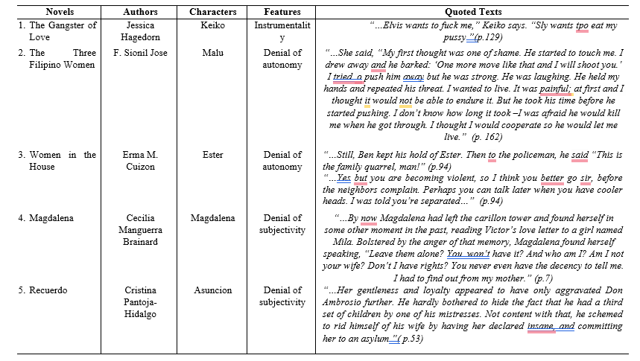

In the novel Gangster of Love by Jessica Hagedorn, the female character who demonstrates objectification in the form of instrumentality is Keiko. She experiences being treated as a mere object rather than as a subject with her agency, emotions, and perspectives. Keiko serves as a device for sexual gratification for someone based on her physical attributes. She is an object for fulfilling sexual desires, having stripped away any recognition of her individuality or humanity, shrinking her existence to mere bodily functions that serve the pleasures of others. The worthiness of her as a woman is often measured by her ability to fulfill male desires. The absence of consideration for personal feelings of Keiko or consent portrays a significant aspect of objectification—her autonomy and subjectivity are entirely disregarded. This scenario of instrumentality dehumanizes her, making her an object in the eyes of those who seek to exploit her. It aligns with the argument of Zurbriggen (2011) that the key element of sexual objectification was a transformation of women from fully human and deserving of the human rights of “well being and freedom” to people of a lesser status, without the full moral stature of a human being.
In the novel Three Filipino Women by F. Sionil Jose, Malu is the female character who experienced denial of autonomy; she was treated as someone incapable of making her own choices or acting on her own will, thereby reducing her to a passive state controlled by others. She chooses to defend the rights of other people, reject the privileged lifestyle she enjoys, and experience sexual abuse from a man. The endurance of her relative to the emotional and physical pain brought about by her deliberate decision to cooperate to survive demonstrates the severity of this objectification
In the novel Women in the House by Erna M. Cuizon, the character who experienced objectification is Ester as she struggles with the physical control of her husband through the denial of her autonomy. Her heated argument with her husband is weakened as a mere family quarrel despite the intervention of a policeman. The physical control of the husband of Ester over her, combined with his attempt to underestimate her ability, conquers Ester’s free will. The response of the policeman to resolve the matter privately rather than addressing Ester’s denial of autonomy reflects a societal tendency to downplay the incident.
In the novel Magdalena by Cecilia Manguerra Brainard, the character who experienced objectification through the denial of subjectivity is Magdalena, as she struggles to assert her identity and rights within a marriage where her emotions and experiences are systematically disregarded. The discovery of the infidelity of her husband through her mother depicts a lack of transparency and communication that further challenges her subjectivity. The actions of the husband exhibit a deep disregard for her autonomy and feelings. She is not treated as an equal partner but as someone who is irrelevant. This denial of subjectivity is a profound form of objectification, as it disdains the emotional and psychological presence of Magdalena, reducing her to a mere function of the will of her husband. Objectification has a sinister nature where the existence and mental state of women are manipulated and controlled to serve the interests of those in power.
In the novel Recuerdo by Cristina Pantoja-Hidalgo, the woman character who faced objectification through the denial of subjectivity is Asuncion. She experienced blatant infidelity and hardhearted schemes by her husband. The emotions and rights are entirely neglected. The actions of her husband erase the subjectivity and declare Asuncion insane. Her identity and autonomy are being nullified, treating her as an obstacle to be removed rather than a person with her essential worth. This denial of subjectivity is further heightened by Asuncion’s gentleness and loyalty, which are used against her, pestering her husband and prompting even more severe measures to marginalize her. This situation harshly reveals the sinister nature of such objectification.
It conforms to the statement of Tiggemann & Andrew (2012) Women are constantly being dehumanized and reduced to objects to be groped, harassed, catcalled and evaluated — and some men feel comfortable doing all of those things and then boasting about it, or deny it by mocking the appearance of the women as unworthy of their assaults.
1.2 Gender inequality. The disparities and unfair treatment women face in various aspects of life are termed gender inequality. Gender inequality is described in the novels in terms of forms such as the workplace, legal protection, and social distinction.
Table 2 presents description as to gender inequality.
Table 2
Descriptions as to Gender Inequality
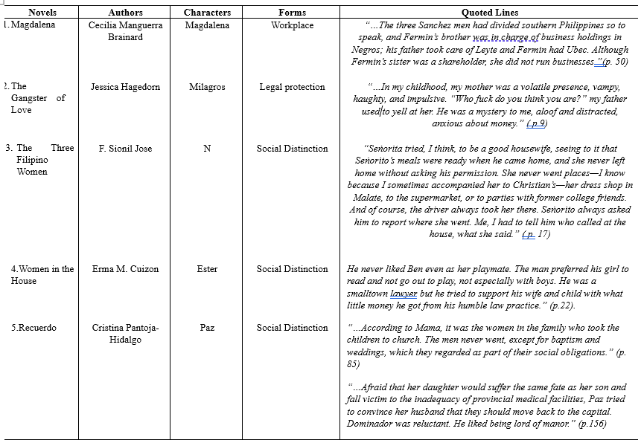

Magdalena is the woman character who experienced gender inequality in to workplace in the novel. She is eliminated from the management roles, which reveals the division of business responsibilities among the Sanchez men. This confirms the pervasive gender biases in professional settings and the lack of opportunities for women to exercise authority and influence in professional environments. It points out the structural barriers that prevent women from advancing to leadership positions and mirrors a form of workplace gender inequality where the potential and capabilities of women are overlooked due to embedded patriarchal norms that favor male dominance in economic affairs.
In the novel Gangster of Love, the woman character who faced gender inequality in legal protection is Milagros. She flees to San Francisco with her children to escape from her husband due to a lack of legal protection against him. The uneven and violent nature of Milagros’ husband, characterized by yelling and a dismissive attitude, features her lack of legal protection from domestic abuse.
In the novel Three Filipino Women, the character who manifests gender inequality as to social distinction is Narita as she is hampered to her role as a housewife and controlled by her husband. The primary duties revolve around domestic tasks and seeking permission from her husband to leave the house.
This scenario presents a patriarchal setup where the movements and social interactions of women are closely monitored. It strengthens their servility and lack of independence. The constant surveillance and reporting of Narita’s activities to her husband illustrate the lack of trust and the inherent power imbalance in their relationship. It conforms to account of Shang (2022) that gender inequality is the result of gender bias and social norms that restrict women’s rights and opportunities, it leads to lower welfare for women.
In the novel Women in the House, Ester represents the controlling nature of familial and societal distinctions placed on women and the preference of the father over her daughter to engage in reading rather than playing, especially with boys. This reflects the restrictive social norms that dictate appropriate behavior for women. This situation also points out the broader issue of how societal norms and parental expectations shape the opportunities and behaviors of young girls. The control of the father over the activities of his daughter depicts the inescapable influence of patriarchal norms in shaping gender roles and maintaining social distinctions that disadvantage women.
In the novel Recuerdo, the women character who shows gender inequality as to social distinction in terms of decision-making power and influence within the family is Paz. Her inability to convince her husband to prioritize their daughter’s health and move to a place with better medical facilities illustrates the limited agency women often have in making important family decisions.
It supports the statement of Soken-Huberty (2025) that women, girls, transgender people and gender-diverse people face the most discrimination, which affects their access to good education, jobs, healthcare, legal protections and much more.
1.3 Sexism. This refers to a form of discrimination or gender bias. It is a belief or behavior that one gender, typically men, is superior to another, typically women. This discrimination manifests in various forms, affecting women’s lives in multiple domains such as social, economic, political, and personal. Women characters in the novel are described according to the types of sexism, which include ambivalent, hostile, interpersonal, and institutional.
Table 3 presents description as to sexism.

Table 3
Descriptions as to Sexism
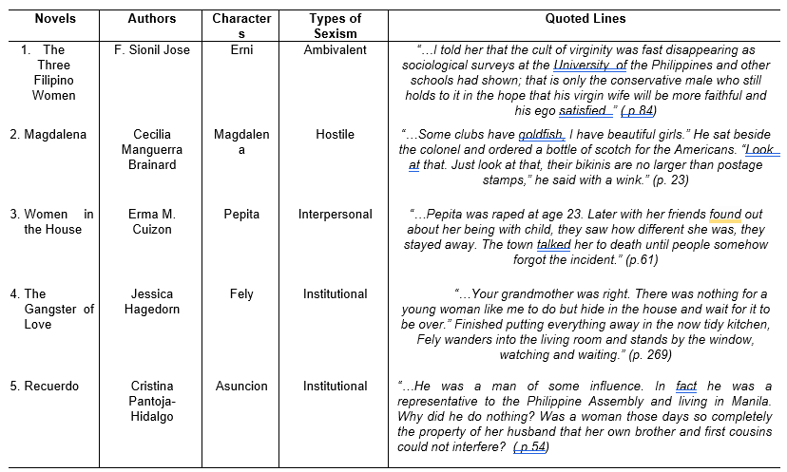

The novel Three Filipino Women is a representation of the offensive representation of Ermi, showcasing the aspect of sexism that deprives the woman character of her entirety. Ermi is the woman character that embodies ambivalent sexism, a hostile attitude toward women, and seemingly positive but patronizing beliefs, reinforcing traditional gender roles and inequality.
The novel Magdalena portrays women as commodities, a reflection of the societal attitudes during the Philippine-American War. Female prostitutes are stereotyped as alluring, intended to provide satisfaction and pleasure to the customers. They have poorly clothed bodies, which makes men disregard their personhood and autonomy. They are valued primarily for their physical appearance and sexual appeal to men. Hostile sexism is evident in the way men position themselves as entitled to consume the bodies of women as part of their leisure activities.
In the novel Women in the House, the woman character who experiences gender inequality is Pepita, a victim of rape at a young age but she strives to continue her life with decency. The response of Pepita’s friends and the broader community reflects a judgmental and discriminatory attitude toward her, exacerbating her trauma through social isolation. This reaction portrays a lack of empathy and support, instead placing blame on the victim and treating her as an outcast for circumstances beyond her control.
In the novel Gangster of Love, Fely is the woman character who manifests gender inequality as she reflects on her past, showcasing the limited options available to young women, where she is advised to hide in the house during challenging times. This scene reflects deeply ingrained societal beliefs that the primary territory of women is the home, and their primary function is to maintain it. Fely reflected institutional sexism where she is described meticulously tidying the kitchen and then standing passively by the window, waiting. This scene describes how institutionalized gender roles constrain women's activities and ambitions, reducing their lives to cycles of domesticity and passivity
1.4 Social stratum. Society’s categorization of its people into rankings based on factors like wealth, income, education, family background, and power is termed social stratum or stratification. They influence access to resources and opportunities and maintain social order by defining roles and expectations within different hierarchical levels. Women characters’ prejudices and deprivations in the novels are described based on this society’s categorization.
Table 4 presents description as to social stratum.
Table 4
Descriptions as to Social Stratum
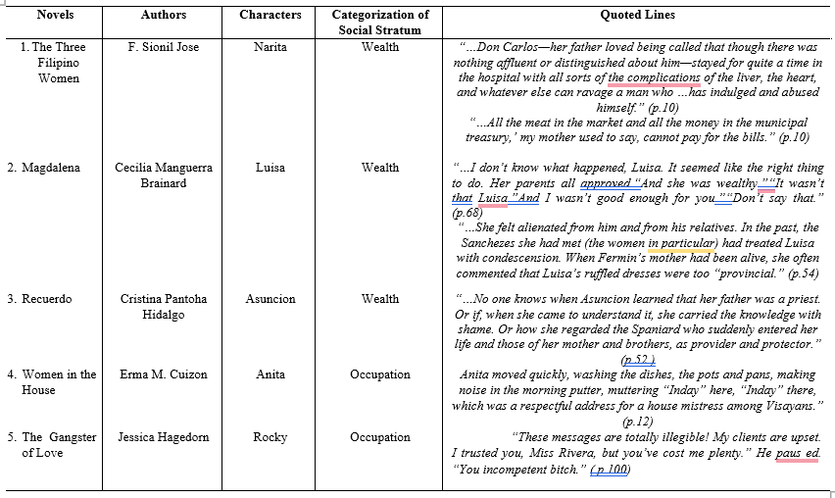

A social stratum in the novel Three Filipino Women is portrayed as being influenced by wealth, as reflected in the character of Narita. Their lack of money to support and pay for the hospitalization of her father clearly shows the impact of wealth on the quality of life of a person. They experience financial desperation due to the limitation of financial resources. From the perspective of the social stratum, it shows how wealth or its absence determines access to healthcare and influences social standing. The lack of wealth directly impacts the ability of Narita’s family to manage the health crises of her father, revealing the broader societal implications of economic inequality.
The novel Magdalena described the situation of Luisa, where wealth played a pivotal role in parental approval, and how economic status can affect personal and familial decisions. The approval of wealthy parents implies the social capital that comes with wealth, making the person an attractive prospect irrespective of other qualities. Luisa being poor is not accepted in the social hierarchies based on economic status, which causes her feelings of inferiority. Wealth as a factor of social stratum shapes social dynamics and perceptions. Economic disparity affects romantic relationships, familial attitudes, and societal expectations. Luisa’s experience of alienation from her affluent husband and his relatives has a profound impact on her socio-economic status, personal relationships, and social acceptance. Her background is considered lower by those in the higher social stratum. Luisa is treated unfairly by his husband’s family due to her belonging to a low economic status. This indicates how wealth shapes social hierarchies and individual identities.
In the novel Recuerdo, Asuncion is the woman character who struggles to reconcile with her identity for societal acceptance. The affluence and privileged status of the father contrast sharply with the likely modest circumstances of her mother, underscoring how wealth influences one’s position within the rigid colonial social hierarchy. The impact of wealth as a factor in Asuncion’s social stratum is further reflected in the emotional and psychological burden she carries. The ambiguity surrounding her feelings—whether shame, resentment, or indifference—highlights how economic disparity between her parents affects her sense of belonging and identity.
Occupation as a factor of social stratum is evident in the novel Women in the House through Anita’s role, which is confined to specific tasks and social expectations. As a domestic worker, she is assigned the tasks of washing dishes and pots, which are typically associated with lower-status occupations. The use of Inday, a typical name for a housemaid maid in contrast with her actual duties, reflects a social dynamic where occupational roles are both acknowledged and masked by cultural terms of respect. This disparity between the title and the tasks depicts the social hierarchy inherent in domestic work. This shows how occupation shapes social identity and interactions, reinforcing the stratification based on the perceived value and status of different types of work.
In the novel The Gangster of Love, Miss Rivera receiving a harsh rebuke from her superior shows the power dynamics and expectations tied to occupational roles as factor of social stratum. The criticism of her work, intensified by the derogatory insult, presents the weakness of employees in subordinate positions, especially women. This interaction not only reflects the pressure and scrutiny faced by workers but also the gendered nature of workplace discrimination and hostility. Occupation determines the power dynamics and respect individuals receive within a professional setting
1.5 Socioeconomic deprivation. This refers to the condition of lacking economic resources and social benefits that are considered essential for a decent quality of life. It encompasses a range of hardships including insufficient income, poor housing, lack of access to education and healthcare, unemployment, and social exclusion. Factors of socio- economic deprivation given focus in the study are the following: income, education, financial hardship and unemployment.
Table 5 presents descriptions as to socioeconomic deprivation.

Table 5
Descriptions as to Socioeconomic Deprivation
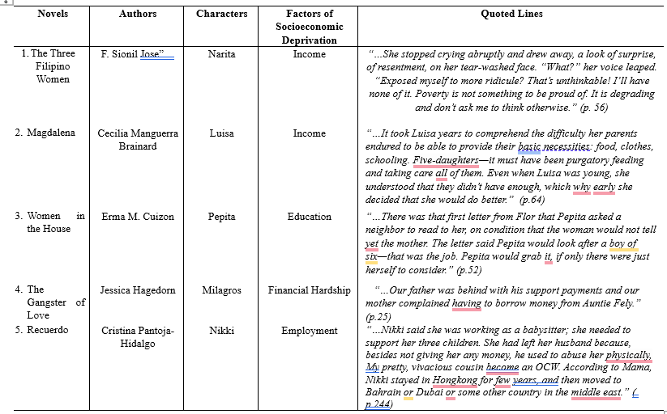

The novel Three Filipino Women, which depicts the factor of income in relation to socioeconomic deprivation, is exemplified by Narita. She strongly emphasized the importance of alleviating hardship and vividly demonstrated the impact of socioeconomic deprivation. The refusal to be further ridiculed for her financial status illustrates the societal pressure and internalized feelings of inadequacy that accompany economic deprivation. The phrase "Poverty is not something to be proud of" reflects a broader societal view that equates financial hardship with personal failure, thus illuminating how income deprivation can lead to social isolation and emotional distress. It also reveals the internal conflict and resentment Narita feels toward her socioeconomic situation.
In the novel, Magdalena Luisa is the character who portrays socio-economic deprivation in terms of income. She realized that her parents have difficulties and struggles in providing their necessities in life. Her parents have to strive hard to take good care of them financially. Luisa experiences severe income deprivation with her family, manifested in their struggle to meet their basic needs such as food, clothing, and education. The early recognition of their financial struggles and her subsequent determination to improve her situation depict the long-term impact of income deprivation on individual aspirations and family dynamics.
In the novel Women in the House, the woman character who experienced socioeconomic deprivation as to lack of education is Pepita. She does not know how to read, but wants to have a job. She is only limited to being hired as a caretaker because she lacks the needed education to land a good job. She does not have good employment opportunities. Needing the help of a neighbor to read a letter for her indicates a limited educational attainment on personal autonomy and employment prospects. The job opportunity that is described as “caring for a young boy” reflects the types of employment accessible to those with limited education.
In the novel Gangster of Love, the woman character who manifests socioeconomic deprivation through financial hardship is Milagros. She experienced financial hardship in terms of housing quality as she has difficulty of paying rent while living in the United States with her children. She lacks financial support from her husband and has to borrow money from her relatives. Milagros' borrowing of money from a relative shows the lack of financial resources and the reliance on extended family networks for economic support. This is often a hallmark of income deprivation. Milagros’ financial hardship affects her family relationships, which puts her under so much stress and strain.
In the novel Recuerdo, the woman character who manifests socioeconomic deprivation in relation to employment is Nikki. She embodies the hardships of poverty in her life. She works as a babysitter to provide her children with the basic needs. She works abroad as an overseas contract worker to alleviate her poverty and to better support her family.
It supports the statement of Williams (2021) that some men, whether family members, potential funders, possible mentors, or business partners, believe that women do not really belong in the entrepreneurial world. This is a stereotype that women are not good with money, thus they are less acknowledged to run start-ups.

4. Conclusion
The five selected Filipino novels in English vividly portrayed the cycles of prejudices and deprivations faced by women. These narratives reflect how women are subjected to various forms of objectification: instrumentality, denial of autonomy, and denial of subjectivity; gender inequality: social distinction, workplace and legal protection; sexism: ambivalent, hostile, institutional, and interpersonal; social stratification: wealth and occupation; and socioeconomic deprivation. income, housing quality, employment, and education.

Definitions

Deprivation. The term refers to the condition of a system, community, or region lacking the necessities of a society or community (Sarkar, 2014). In the study, the term pertains to withholding the woman characters in their rights to uphold themselves.

Objectification. The term refers to the framework of understanding, researching, and intervening to improve women’s life in a sociocultural context that sexually objectifies the female body and equates a woman’s worth with her body’s appearance and sexual functions (Szymanski et al., 2011). As used in the study, the term pertains to the irrational behavior and perception of women as mere objects.

Prejudice. This term refers to positive or negative evaluations or judgments on the fact of their membership in the group, and not necessarily because of a particular characteristic of individual members (Feldman, 2010). In the context of the study, it is the portrayal of unreasonable feelings, opinions, attitudes, and hostility among women.

Sexism. The term refers to a belief that one sex is innately superior to the other (Macionis, 2012). As used in the study, the term refers to the discriminatory and prejudicial beliefs and practices directed against one of the two sexes, usually women.
Socio-economic Deprivation. The term pertains to the lack of social and economic benefits which are necessities of a society or community or in a broader sense of a region (Sen, 2014). As used in the study the term refers to the inability of the woman character to elevate her quality of living.

Social Stratum. The term refers to the unequal distribution of wealth, power, and privilege between men and women (Macionis, 2012). As used in the study, it refers to the level or class to which people are assigned according to their social status, education, and income.

Disclaimer (Artificial intelligence)
Author(s) hereby declare that NO generative AI technologies such as Large Language Models (ChatGPT, COPILOT, etc.) and text-to-image generators have been used during the writing or editing of this manuscript.

Reference
Abrams, D. (2010). Processes of prejudice: Theory, evidence and intervention. Equality and Human Rights Commission. https://www.equalityhumanrights.com/sites/default/files/research-report-56-processes-of-prejudice-theory-evidence-and-intervention.pdf
Allport, G. W. (1954). The nature of prejudice.
Andersen, M. L., & Witham, D. H. (2015). *Thinking about women: Sociological perspectives on sex and gender*. Pearson Education. https://books.google.com/books/about/Thinking_about_Women.html?id=2_1ACgAAQBAJ
Arnold, Matthew. Principles of Literary Criticisms. Macmillan, 1959.
Brainard, C. M. (2016). *Magdalena*. University of Santo Tomas Publishing House. https://ustph.ust.edu.ph/magdalena.html
Christensen, L. B., Johnson, R. B., & Turner, L. A. (2015). Research methods, design, and analysis. Pearson Education. https://www.pearson.com/uk/educators/higher-education-educators/product/Christensen-Research-Methods-Design-and-Analysis-Global-Edition-12th-edition/9781292068466.html
Croghan, R. V. (1975). The development of Philippine literature in English (since 1900). Alemar-Phoenix Publishing House. https://catalogue.nla.gov.au/Record/2502117
Cuizon, E. M. (2006). Woman in the House. University of Santo Tomas Publishing House.
Denzin, N. K., & Lincoln, Y. S. (Eds.). (2017). The SAGE handbook of qualitative research (5th ed.). SAGE Publications. https://us.sagepub.com/en-us/nam/the-sage-handbook-of-qualitative-research/book243978
Hidalgo, Cristina Pantoja. Recuerdo: A Novel. University of the Philippines Press, 1996.
José, F. S. (1992). Three Filipino Women. Random House. https://www.penguinrandomhouse.com/books/200000/three-filipino-women-by-f-sionil-jose-9780307830289/
Kahayon, A. H., Zulueta, C. A., Santiago, E. M., & Robielos, N. M. (1989). Philippine literature: Choice selections from a historical perspective. National Book Store. https://openlibrary.org/works/OL15860011W/Philippine_literature
Nussbaum, M. C. (1998). Cultivating humanity: A classical defense of reform in liberal education. Harvard University Press. https://www.hup.harvard.edu/catalog.php?isbn=9780674179493
Palys, T., & Atchison, C. (2014). Research decisions: Quantitative, qualitative, and mixed methods approaches (5th ed.). Nelson Education.
Shang, B. (2022). Tackling gender inequality: Definitions, trends, and policy designs. International Monetary Fund. Retrieved from
https://www.elibrary.imf.org/view/journals/001/2022/232/article-A001-en.xml
Soken-Huberty, E. (2025). 13 causes of gender inequality. Human Rights Careers. https://www.humanrightscareers.com/issues/causes-gender-inequality/.
Tan, Arsenia B. Introduction to Literature. 3rd ed., Academic Publishing Corporation, 1996.
Tiggemann, M., & Andrew, R. (2012). Clothes make a difference: The role of self-objectification. Sex Roles, 66(9-10), 646–658. https://doi.org/10.1007/s11199-011-0085-3
Williams, A. (2021). Why women are poorer than men and what we can do about it. Penguin Books. https://www.penguin.co.uk/books/310/310979/why-women-are-poorer-than-men-and-what-we-can-do-about-it/9780241433164.html

Zurbriggen, E. L., Ramsey, L. R., & Jaworski, B. K. (2011). Self- and partner-objectification in romantic relationships: Associations with media consumption and relationship satisfaction. Sex Roles, 64, 449-462. https://doi.org/10.1007/s11199-011-9933-4

