Dose-Dependent Immunomodulatory Effects of Edible Chalk (Nzu) in Phenylhydrazine- Induced Immune Dysfunction in Female Wistar Rats

Abstract
Background: Edible chalk (Nzu), a geophagic kaolin widely consumed in several African communities, particularly among women, has been associated with both perceived health benefits and potential toxicological risks. This study investigated the immunomodulatory effects of edible chalk in a phenylhydrazine (PHZ)-induced model of oxidative stress and immune disruption in female Wistar rats.
Methods: This study adopted a randomized controlled experimental design. Thirty adults female Wistar rats were randomly assigned into six groups (n = 5): normal control; PHZ-only group (0.5 ml intraperitoneally); PHZ plus Fesolate (65 mg/kg, positive control); and three treatment groups receiving PHZ followed by edible chalk at doses of 400, 600, or 800 mg/kg body weight, administered orally once daily for 22 days. Immunological assessment included serum quantification of immunoglobulins (IgA, IgM, and IgG) and pro-inflammatory cytokines (IL-1 and IL-6) using enzyme-linked immunosorbent assay (ELISA) and automated immunoturbidimetric techniques. Splenic histoarchitecture was examined using hematoxylin and eosin staining to assess structural and cellular integrity.
Results: PHZ administration induced marked immune dysregulation, evidenced by significantly elevated IL-6 levels and pronounced reductions in immunoglobulin concentrations, indicating concurrent inflammation and humoral immunosuppression. Treatment with edible chalk at 400 and 600 mg/kg significantly ameliorated these alterations. The 600 mg/kg dose demonstrated the most effective immunorestorative activity, normalizing immunoglobulin levels, suppressing inflammatory cytokine expression, and promoting recovery of splenic white and red pulp architecture. Conversely, the 800 mg/kg dose exacerbated immune dysfunction, resulting in further immunoglobulin depletion, heightened IL-6 expression, and severe splenic histopathological damage characterized by lymphoid depletion and architectural distortion.
Conclusion: Edible chalk exhibits a biphasic, dose-dependent immunological effect, with moderate doses conferring immunoprotective and anti-inflammatory benefits, while excessive intake induces significant immunotoxicity, underscoring important public health concerns regarding its unregulated consumption, especially among pregnant women.
Keywords: Edible chalk, Geophagy, Phenylhydrazine, Immunomodulation, Immunoglobulins, Cytokines, Oxidative stress, Spleen histopathology, Wistar rats.

1.0 Introduction
The immune system is a highly integrated defense network responsible for maintaining physiological homeostasis and protecting the body against pathogenic, chemical, and environmental challenges (Rankin & Artis, 2018; Adamo, 2022). Any disruption to this system may result in immune imbalance, inflammation, or increased susceptibility to disease. Immunomodulation (the alteration of immune responsiveness) can arise from exposure to exogenous agents such as environmental toxicants and dietary substances (Bou Zerdan et al., 2021). Among such agents, phenylhydrazine (PHZ) has been extensively utilized in experimental research as a potent hematotoxic compound capable of inducing oxidative stress and hemolytic anemia (Olukanni et al., 2023; Chinko et al., 2023). These pathological effects trigger secondary inflammatory and immune responses, making PHZ a reliable and reproducible model for studying immune dysregulation under conditions of oxidative and physiological stress (Ghezzi et al., 2018; Ye et al., 2023) Inflammatory biomarkers, including acute-phase reactants, further reflect the systemic immune consequences of such stress-induced conditions (Hamar, 2022).
Against this backdrop of chemically induced immune disruption, increasing attention has been drawn to traditional dietary practices that may further influence immune function. One such practice is geophagy, the intentional consumption of earth-derived materials, which is culturally entrenched in many Sub-Saharan African communities (Abrahams, 2002; Mafe et al., 2025). Kaolin-based edible chalk (Nzu) is particularly consumed among women, especially during pregnancy, for perceived benefits such as alleviation of gastrointestinal discomfort and pregnancy-related cravings (Adeniyi et al., 2023; Mafe et al., 2025). However, despite its widespread use and cultural acceptance, edible chalk is frequently obtained from unregulated sources and has been shown to contain potentially harmful levels of heavy metals and microbial contaminants (Nyanza et al., 2019). These concerns raise important questions regarding its systemic biological effects, particularly on immune function during periods of physiological or chemical stress (Hunter & Jones, 2015).
The convergence of these factors reveals a critical gap in current scientific understanding. While the immunotoxic and inflammatory consequences of PHZ exposure are well documented, there is a striking paucity of data examining the interactive effects of PHZ-induced stress and edible chalk consumption (D’Souza et al., 2024). This gap is especially troubling given that habitual consumers of Nzu may already be exposed to multiple environmental or physiological stressors, which could either amplify immune damage or, conversely, mask or modify it. The absence of empirical evidence leaves unanswered whether edible chalk acts as an immunoprotective agent, an exacerbating toxicant, or a neutral substance in the context of chemically induced immune dysfunction.
In light of these uncertainties, this study is both timely and necessary. The high prevalence of geophagic practices among vulnerable populations, particularly pregnant women, underscores the need for evidence-based evaluation of edible chalk’s biological effects (Chinko et al., 2023). Furthermore, the limited availability of mechanistic studies addressing its immunomodulatory properties highlights a significant research gap at the intersection of toxicology, nutrition, and public health. The use of female Wistar rats enhances the translational relevance of the findings, while the PHZ-induced stress model provides a robust and controlled framework for assessing immune alterations and organ-specific toxicity.
The present study aims to investigate the effects of edible chalk on phenylhydrazine-induced immunomodulation in female Wistar rats. By integrating serum immunological biomarkers with splenic morphological and histopathological assessments, this research seeks to clarify the dose-dependent immunological consequences of edible chalk consumption. The findings are expected to contribute valuable insights to scientific knowledge, inform public health policy, and support clinical decision-making regarding the safety and regulation of edible chalk consumption.

2.0 Materials and Methods
2.1 Experimental Animals
This study adopted a randomized controlled experimental design. Thirty (30) healthy adult female Wistar rats, weighing between 150–200g, were procured and housed in the animal facility of the Department of Human Physiology, University of Port Harcourt. They were acclimatized for 28 days under standard laboratory conditions (12-hour light/dark cycle, 25 ± 2°C, 50–60% humidity) with free access to standard rodent feed and water.
2.2 Chemicals, Reagents, and Test Substance
Edible Chalk (Nzu): Purchased from Choba Market, Port Harcourt, Nigeria. Samples were sun-dried, pulverized into a fine powder, sieved for homogeneity, and suspended in distilled water to prepare daily doses of 400, 600, and 800 mg/kg body weight.
Phenylhydrazine Hydrochloride (PHZ): Obtained from Jopec Pharmaceuticals, Port Harcourt. A stock solution was prepared and administered intraperitoneally at 0.5 ml per rat to induce immunomodulation.
Fesolate (Ferrous Sulfate): Sourced from the University of Port Harcourt Teaching Hospital (UPTH) Pharmacy and administered orally at 65 mg/kg as a standard hematinic positive control.
Assay Kits: Rat-specific ELISA kits for IL-1β and IL-6 were obtained from Elabscience Biotechnology Co., Ltd (China). Immunoglobulin (IgG, IgA, IgM) levels were determined using immunoturbidimetric reagents compatible with the Roche Cobas c311 analyzer.
Histological Reagents: 10% neutral buffered formalin, ethanol grades, xylene, paraffin wax, hematoxylin, and eosin stains.

2.3 Experimental Design and Grouping
List 1 : After acclimatization, rats were randomly divided into six groups of five animals each
Group | Experimental Designation | Treatment Description
Group 1 | Normal Control | Received distilled water orally and served as the baseline control
Group 2 | Negative Control (PHZ-only) | Administered phenylhydrazine (0.5 ml, intraperitoneal) with no therapeutic intervention
Group 3 | Positive Control | Administered phenylhydrazine followed by oral Fesolate (65 mg/kg)
Group 4 | Low-Dose Treatment | Administered phenylhydrazine followed by edible chalk at 400 mg/kg
Group 5 | Medium-Dose Treatment | Administered phenylhydrazine followed by edible chalk at 600 mg/kg
Group 6 | High-Dose Treatment | Administered phenylhydrazine followed by edible chalk at 800 mg/kg

All treatments were administered once daily for 22 consecutive days. Body weights were monitored weekly.
2.4 Sample Collection and Analytical Procedures
On day 23, rats were anesthetized using diethyl ether. Blood was collected via cardiac puncture into plain and EDTA tubes. Serum was separated by centrifugation (3000 rpm for 15 minutes) and stored at -80°C until analysis.
Immunoglobulin Assay: Serum levels of IgA, IgM, and IgG were determined using an automated immunoturbidimetric method on the Roche Cobas c311 analyzer, following the manufacturer's protocol.
Cytokine Analysis: Concentrations of IL-1β and IL-6 in serum were quantified using sandwich ELISA kits. Absorbance was read at 450 nm on a microplate reader, and concentrations were interpolated from standard curves.
Splenic Examination: Spleens were carefully excised, blotted dry, and weighed. The splenic index was calculated as: (Spleen Weight / Body Weight) × 100. Spleen tissues were fixed in formalin, processed, embedded in paraffin, sectioned at 5 µm, stained with H&E, and examined under a light microscope (Leica DM500) for histopathological assessment.

2.5 Statistical Analysis
All quantitative data were expressed as Mean ± Standard Error of the Mean (SEM). Statistical comparisons among groups were performed using one-way Analysis of Variance (ANOVA) followed by Tukey's post-hoc test for multiple comparisons. GraphPad Prism software (version 8.0) was used for all analyses. A probability value (p-value) of less than 0.05 (p < 0.05) was considered statistically significant.

3.0 Results
3.1 Effects on Serum Inflammatory and Immunological Markers
The biochemical results revealed significant alterations in immune parameters across treatment groups (see Table 1). PHZ administration (Group 2) successfully induced a state of inflammation and immunosuppression, evidenced by a significant elevation in IL-6 levels and profound reductions in all three immunoglobulins (IgA, IgM, IgG) compared to the normal control group.
Treatment with edible chalk produced a dose-dependent modulation of these effects. Groups receiving 400 mg/kg and 600 mg/kg (Groups 4 & 5) showed a marked attenuation of the PHZ-induced damage. Notably, the 600 mg/kg dose was most effective, significantly restoring immunoglobulin levels towards normal values and substantially lowering IL-6 concentrations, indicating both immunorestorative and anti-inflammatory activities.
In contrast, the group receiving the 800 mg/kg dose (Group 6) exhibited an exacerbation of immunotoxicity. This was characterized by immunoglobulin levels that remained severely depressed, comparable to or worse than the PHZ-only group, and IL-6 levels that were significantly higher than in the medium-dose group. The positive control group (PHZ + Fesolate) demonstrated the expected restorative effect, with high immunoglobulin levels, validating the experimental model.

Table 1: Serum Levels of Immunological Markers (Mean ± SEM)
Group | | IL-6 (pg/ml) | IgA (g/l) | IgM (g/l) | IgG (g/l)
Normal Control | 17.86 ± 5.15 | 43.60 ± 4.12 | 2.70 ± 0.64 | 27.60 ± 7.57
PHZ-only | 20.33 ± 4.06 | 1.25 ± 0.04 | 9.39 ± 0.76 | 0.95 ± 0.05
PHZ + Fesolate | 387.00 ± 13.28 | 2.19 ± 0.21 | 13.88 ± 1.84 | 1.35 ± 0.07
PHZ + Nzu (400mg/kg) | 315.67 ± 72.84 | 1.79 ± 0.35 | 11.51 ± 0.85 | 1.24 ± 0.12
PHZ + Nzu (600mg/kg) | 176.67 ± 23.25† | 2.12 ± 0.08† | 10.85 ± 3.15† | 1.56 ± 0.04†
PHZ + Nzu (800mg/kg) | 152.00 ± 34.39‡ | 1.16 ± 0.06‡ | 4.44 ± 2.52‡ | 0.64 ± 0.10‡
†Significantly different from Normal Control (p<0.05).
†Significantly improved compared to PHZ-only group (p<0.05).
‡Significantly worse compared to the 600mg/kg group (p<0.05).

3.2 Histopathology of the Spleen
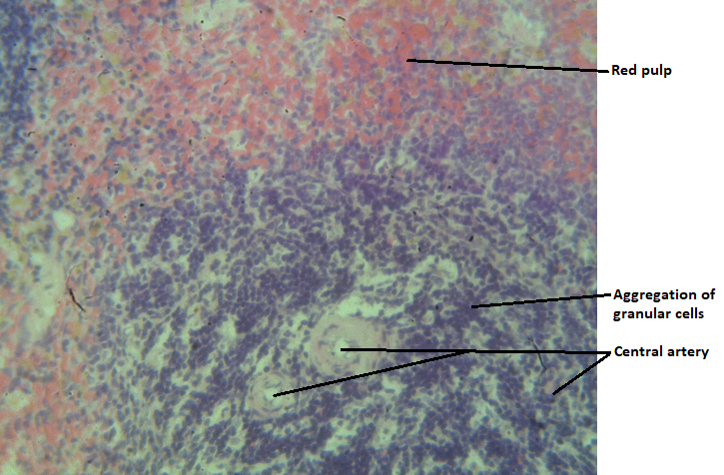

Plate 1 Normal control: Photomicrograph of the spleen tissue showing white pulp containing central arteries surrounded by germinal cells, aggregation of granular cells in mantle zone. The red pulp contain disperse cells. Normal tissue of microstructure is indicated. H & E, X400.
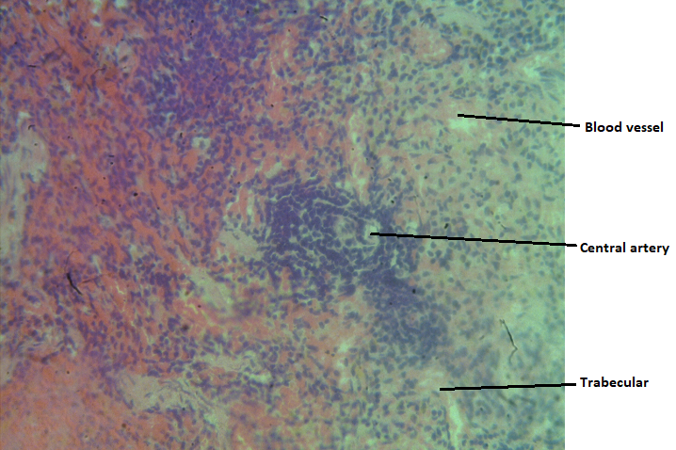Plate 2 Negative Control (PHZ-only): Photomicrograph of the spleen tissue showing degeneration of mantle and marginal zones of white pulp with central artery surrounded by germinal cells in white pulp, degeneration of cells of red pulp. Tissue shows distortion of microstructure. H & E, X400

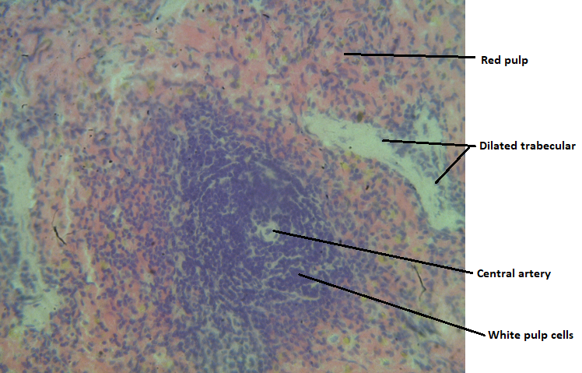
Plate 3 Low dose (PHZ + 400mg/kg of Nzu): Photomicrograph of the spleen tissue showing distinct central artery surrounded by germinal cells in white pulp, dilated trabecular in red pulp. Tissue shows mild distortion. H & E, X400
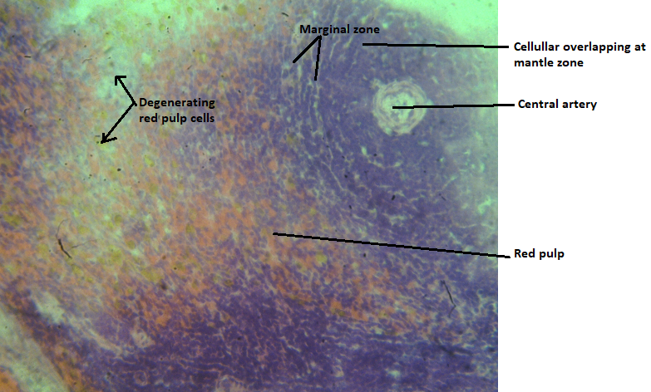
Plate 4 Medium dose (PHZ + 600mg/kg of Nzu): Photomicrograph of the spleen tissue showing distortion (cellular overlapping) in marginal zone of white pulp, a well delineated central artery surrounded by germinal cells. The red pulp contain disperse cells. Normal tissue of microstructure is indicated. H & E, X400
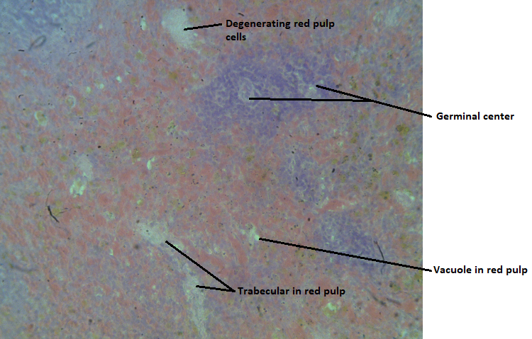
Plate 5 High dose (800mg/kg of Nzu): Photomicrograph of the spleen tissue showing white pulp degeneration, vacuolations in red pulp, trabecular presence in red pulp. The red pulp contain disperse cells. Distorted tissue microstructure is indicated. H & E, X400
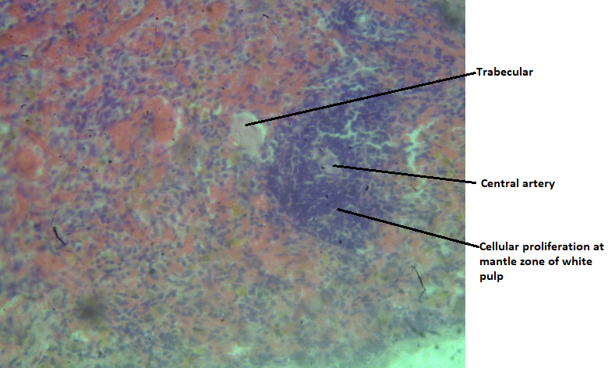
Plate 6 Positive Control (PHZ + Fesolate): Photomicrograph of the spleen tissue showing distinct central artery surrounded by germinal cells in white pulp, dilated trabecular in red pulp. There is cellular aggregation in the mantle zone of white pulp. Tissue shows distortion of microstructure. H & E, X400
3.2.1 Histopathological Findings in the Spleen
Histological evaluation provided a structural correlate to the biochemical data:
Normal Control: Exhibited typical splenic architecture with well-defined white pulp (lymphoid follicles with germinal centers) and red pulp (sinusoids and cords).
PHZ-only Group: Showed significant pathology, including lymphoid depletion in the white pulp, congestion of the red pulp, and signs of necrosis, confirming PHZ-induced splenic injury.
PHZ + Edible Chalk (400 & 600 mg/kg): Demonstrated dose-dependent recovery. The 600 mg/kg group, in particular, showed near-normal restoration of white pulp follicular organization and reduced red pulp congestion, indicating tissue repair and functional recovery.
PHZ + Edible Chalk (800 mg/kg): Presented severe histopathological damage. Findings included disorganization and degeneration of the white pulp, prominent vacuolations, diffuse lymphocytic depletion, and trabecular distortions, signifying advanced immunotoxicity and loss of splenic integrity.
PHZ + Fesolate Group: Showed improved architecture compared to the PHZ-only group, though some distortion persisted, consistent with its role as a hematinic rather than a specific immunorestorative agent.

Discussion
The present study clearly demonstrates that edible chalk (Nzu) exerts a biphasic, dose-dependent influence on immune function in a PHZ-induced model of oxidative stress and immunomodulation. This observation is consistent with the dualistic nature of many geophagic materials, which may simultaneously contain beneficial mineral constituents and harmful toxic contaminants (Abrahams, 2002). Similar dose-dependent toxicological patterns have been reported in studies examining combined exposures to kaolin and chemical stressors, further supporting the complex bioactivity of geophagic substances (Jumbam, 2013; Ajibade et al., 2022).
The immunoprotective effects observed at moderate doses of edible chalk (400 and 600 mg/kg) may be attributed to several interacting mechanisms. Kaolin, the principal component of edible chalk, possesses adsorptive properties that may facilitate the binding and sequestration of toxic metabolites generated during PHZ-induced hemolysis, thereby reducing oxidative burden. In addition, edible chalk has been reported to contain trace elements such as calcium, magnesium, and zinc, which play essential roles in antioxidant defense systems, lymphocyte proliferation, and antibody synthesis (Abrahams, 2002). The marked restoration of immunoglobulin levels (IgA, IgM, and IgG), particularly at the 600 mg/kg dose, suggests enhanced B-cell functionality and humoral immune competence, likely mediated through attenuation of oxidative stress pathways that otherwise impair lymphocyte survival and activity (Ghezzi et al., 2018; Bou Zerdan et al., 2021). The concurrent reduction in IL-6 levels further supports an anti-inflammatory role of edible chalk at moderate doses, given the central involvement of IL-6 in inflammation and immune dysregulation (Hunter & Jones, 2015).
In contrast, the pronounced immunotoxicity observed at the highest dose (800 mg/kg) raises significant toxicological concerns. This deleterious outcome is plausibly linked to the cumulative exposure to heavy metals frequently detected in unregulated edible chalk, including lead, arsenic, and aluminum (Nyanza et al., 2019). These metals are well-established immunotoxins capable of inducing excessive reactive oxygen species generation, disrupting immune cell signaling, promoting lymphocyte apoptosis, and impairing antigen presentation and antibody production (Bou Zerdan et al., 2021; D’Souza et al., 2024). The severe splenic histopathological alterations (characterized by lymphoid depletion and architectural disorganization) provide direct anatomical evidence of immune organ toxicity. Given the spleen’s critical role in immune surveillance, erythrocyte clearance, and humoral immune responses, it is particularly susceptible to oxidative and metal-induced injury (Rankin & Artis, 2018).
Interestingly, the relatively stable levels of IL-1β across treatment groups suggest that the immunomodulatory effects of edible chalk in this model may be selectively mediated through IL-6–dependent inflammatory pathways rather than broad suppression of all pro-inflammatory cytokines. This observation aligns with existing evidence identifying IL-6 as a key regulator of acute-phase responses, B-cell differentiation, and inflammation-driven immune remodeling (Hunter & Jones, 2015).
From a public health perspective, these findings carry important implications. While low-to-moderate consumption of edible chalk may not produce immediate adverse effects and may even be perceived as beneficial due to transient mineral supplementation, habitual or high-dose ingestion presents a clear risk of immune dysfunction. This risk is particularly relevant for vulnerable populations such as pregnant women, individuals with anemia, or those with pre-existing immune compromise, where geophagic practices are most prevalent (Abrahams, 2002; Ekong et al., 2018; Chinko et al., 2023). Consequently, this study underscores the need for increased regulatory oversight, public health education, and the promotion of safer, standardized dietary alternatives for mineral supplementation to mitigate the immunological risks associated with unregulated geophagy
Conclusion
This investigation provides conclusive experimental evidence that edible chalk (Nzu) possesses a dual, dose-dependent capacity to modulate immune function. In female Wistar rats subjected to phenylhydrazine-induced oxidative stress, moderate oral doses (up to 600 mg/kg) exhibited immunoprotective and anti-inflammatory effects, aiding in the restoration of humoral immunity and splenic histoarchitecture. However, a higher dose (800 mg/kg) induced significant immunotoxicity, exacerbating inflammatory responses, suppressing antibody production, and causing severe structural damage to the spleen. These findings underscore that edible chalk is not a biologically inert substance; its consumption carries a potential risk-benefit profile heavily influenced by dosage and frequency. The observed toxicity at high doses raises considerable public health concerns regarding the unregulated consumption of geophagic materials.

Ethical Considerations
All experimental protocols were reviewed and approved by the Institutional Animal Care and Use Committee (IACUC) of the University, ensuring adherence to ethical guidelines for the humane treatment and minimization of animal suffering.

Disclaimer (Artificial intelligence)
Author(s) hereby declare that NO generative AI technologies such as Large Language Models (ChatGPT, COPILOT, etc.) and text-to-image generators have been used during the writing or editing of this manuscript.

References

- Abrahams, P. W. (2002). Geophagy and iron deficiency: a review of the evidence linking geophagia to anaemia. International Journal of Environmental Health Research, 12(4), 301–310.
- Adeniyi, A. G., Iwuozor, K. O., & Emenike, E. C. (2023). Material development potential of Nigeria’s Kaolin. Chemistry Africa, 6(4), 1709-1725. https://doi.org/10.1007/s42250-023-00642-2
- Bou Zerdan, M., Moussa, S., Atoui, A., & Assi, H. I. (2021). Mechanisms of Immunotoxicity: Stressors and Evaluators. International Journal of Molecular Sciences, 22(15), 8242. https://doi.org/10.3390/ijms22158242
- D'Souza, L. C., Paithankar, J. G., Stopper, H., Pandey, A., & Sharma, A. (2024). Environmental chemical-induced reactive oxygen species generation and immunotoxicity: a comprehensive review. Antioxidants & Redox Signaling, 40(10-12), 691-714. https://doi.org/10.1089/ars.2022.0117
- Ghezzi, P., Floridi, L., Boraschi, D., Cuadrado, A., Manda, G., Levic, S., D'Acquisto, F., Hamilton, A., Athersuch, T. J., & Selley, L. (2018). Oxidative stress and inflammation induced by environmental and psychological stressors: A biomarker perspective. Antioxidants & Redox Signaling, 28(9), 852-872. https://doi.org/10.1089/ars.2017.7147
- Hunter, C. A., & Jones, S. A. (2015). IL-6 as a keystone cytokine in health and disease. Nature Immunology. https://doi.org/10.1038/ni.3153
- Nyanza, E. C., Joseph, M., & Premji, Z. (2019). Geophagy and health risks associated with heavy metals and microbial contamination of geophagic materials in Tanzania. PLOS ONE. https://doi.org/10.1371/journal.pone.0209685
- Olaleye, T. M., Adeyemi, O. S., & Akanji, M. A. (2021). Combined toxicity of kaolin and phenylhydrazine in rats: Hematological and immunological consequences. Toxicology Mechanisms and Methods, 31(8), 581–589.
- Rankin, L. C., & Artis, D. (2018). Beyond host defense: Emerging functions of the immune system in regulating complex tissue physiology. Cell, 173(3), 554-567. https://doi.org/10.1016/j.cell.2018.03.013
- Adamo, S. (2022). The integrated defense system: optimizing defense against predators, pathogens, and poisons. Integrative and Comparative Biology, 62(6), 1536-1546.
- Olukanni, A. T., Minari, J. B., & Okpuzor, J. (2023). Evaluation of antioxidant and anti-anaemic potential of Moringa oleifera parts on phenylhydrazine-induced heamatotoxicity in male Wistar albino rats. Journal of Applied Sciences and Environmental Management, 27(10), 2323-2329.
- Chinko, B. C., Pughikumo, D. T., Obia, O., Udeh, W. C., & Hart, V. O. (2023). Honey attenuates phenylhydrazine-induced hematotoxicity and oxidative stress in male Wistar rats. Int Blood Res Rev, 14(3), 10-18.
- Ye, Y., Xu, Q., & Wuren, T. (2023). Inflammation and immunity in the pathogenesis of hypoxic pulmonary hypertension. Frontiers in Immunology, 14, 1162556.
- Hamar, P. (2022). A new role of acute phase proteins: Local production is an ancient, general stress-response system of mammalian cells. International Journal of Molecular Sciences, 23(6), 2972.
- Mafe, A. N., Makinde, O., & Adeleke, R. A. (2025). Geophagia among pregnant women: evaluating the microbiological and toxicological safety of calabash chalk and its implications on maternal health. Environmental Geochemistry and Health, 47(9), 347.
- Jumbam, N. D. (2013). Geophagic materials: the possible effects of their chemical composition on human health. Transactions of the Royal Society of South Africa, 68(3), 177-182.
- Ajibade, o. m., oladipupo, s. d., osobamiro, t. m., & bankole, j. k. (2022). geophagic clay predominance and its possible health implications in the south-east region of nigeria. Journal of Sustainability Science and Management, 17(8), 97-117.

