Original Research Article
Spatio-Temporal Dynamics of Land Use/Land Cover and Agricultural Land Transformation in a Drought-Prone Region: Hura C.D. Block, Purulia, West Bengal (2017-2024)

Abstract
Land Use and Land Cover (LULC) changes are essential indicators of environmental transformation and anthropogenic pressure. This study examined the spatio-temporal dynamics of LULC and agricultural land transformation in the drought-prone Hura Block of Purulia District, West Bengal, India, from 2017 to 2024. Employing Sentinel-2 Level 2A satellite imagery and Geographic Information Systems (GIS), the study classifies major land cover categories such as cropland, built-up areas, tree cover, and rangeland and quantifies transitions through spatial overlay techniques and transition matrix analysis in ArcGIS. The findings revealed that croplands, although predominant (averaging 72.61% of the block’s area), experienced a significant decline, contracting to 63.86% by 2023. The reduction in cropland was primarily due to its conversion into rangeland (48.32%), followed by tree cover (35.67%) and built-up areas (13.96%). Built-up areas steadily expanded from 3.87% in 2017 to 5.54% in 2024, reflecting urbanization and infrastructure development in the region. Tree cover increased from 9.20% to 13.23% over the same period, largely due to land abandonment and ecological succession rather than afforestation. Rangelands exhibited volatility, absorbing substantial cropland outflow over the six-year study period. Overall, the findings underscore the dual trajectory of cropland contraction alongside the expansion of rangelands and built-up areas, driven by population pressure, unplanned development, and ecological processes such as the land degradation. These transitions threaten agricultural stability, food security, and the health of ecosystems. This study emphasizes the urgent need for integrated land management strategies that protect croplands, promote sustainable practices, and regulate urban growth to balance ecological conservation and socio-economic development.
Keywords: LULC, Change Detection, RS and GIS, Agricultural Land, Hura Block

1. Introduction:
Land Use and Land Cover (LULC) changes are crucial indicators of environmental transformation and anthropogenic impacts, particularly in regions undergoing rapid socio-economic development and increasing ecological pressure. These changes encapsulate the intricate interactions between natural processes and human activities, which affect biodiversity, ecosystem services, and regional climate patterns (Mondal and Zhang, 2018; Tripathi and Pathak, 2019; Karimov et al., 2023). Systematic monitoring of LULC dynamics is vital for understanding landscape evolution, guiding resource management, and informing sustainable development policies that harmonize economic growth with environmental conservation (Deka et al., 2019; Karale et al., 2024). The integration of remote sensing technologies and Geographic Information Systems (GIS) has markedly improved the capacity to detect, quantify, and visualize Land Use and Land Cover (LULC) changes with exceptional spatial and temporal precision (Jensen, 2016; Mashala et al., 2022). These tools facilitate the assimilation of multispectral satellite imagery using advanced spatial analysis techniques, thereby enabling comprehensive environmental assessments across various geographic scales (Alqurashi & Kumar, 2013; Karra et al., 2021). The Sentinel-2 satellite, noted for its high spatial resolution and extensive spectral range, has proven to be an especially effective platform for the detailed mapping of agricultural landscapes, forest cover, and water bodies, thereby supporting nuanced ecological and land management studies (Drusch et al., 2012; Phiri et al., 2020). Supervised classification algorithms, exemplified by the Maximum Likelihood Algorithm, have consistently demonstrated strong efficacy in categorizing land cover types by utilizing spectral reflectance patterns (Foody, 2002; Nasiri et al., 2022). The integration of spectral indices, such as the Normalized Difference Vegetation Index (NDVI), Soil-Adjusted Vegetation Index (SAVI), and Normalized Difference Water Index (NDWI), augments classification efforts by enhancing the differentiation of vegetation health, soil conditions, and water presence, respectively (Xu, 2006; Weng, 2012; Huang et al., 2020). This multi-index approach refines the delineation of critical land cover classes, including agricultural fields, forests, fallow land, and built-up areas, thereby improving the accuracy and reliability of LULC maps (Islam et al., 2021). Spatial overlay techniques, including map intersection and transition matrix analyses, offer robust frameworks for detecting and quantifying class-to-class transitions over time, thereby elucidating the magnitude and direction of land cover changes (Lu et al., 2004; Mawenda et al., 2020). These methodologies facilitate the identification of land conversion trends, such as agricultural expansion, urban sprawl, and deforestation, which are crucial for comprehending the underlying drivers and potential ecological consequences of land-cover change. Numerous studies in the Indian context have effectively utilized these techniques to evaluate agricultural land use dynamics, urban growth patterns, and ecological shifts, providing valuable insights into regional planning and environmental management (Fahad et al., 2020; Fayaz et al., 2020). The Hura Block in Purulia District, West Bengal, exemplifies the broader dynamics of LULC changes, having undergone substantial transformations in recent decades. Influential factors, such as evolving agricultural practices, population growth, infrastructural development, and ecological pressures, have collectively altered the landscape, impacting land productivity and environmental health (Roy and Mukherjee, 2018; Gope and Mistri, 2021; Das et al., 2022). The agricultural predominance of the region highlights the necessity for detailed spatio-temporal analyses to capture both seasonal and long-term land-use changes, assess land degradation trends, and identify areas susceptible to ecological stress. In light of these considerations, conducting a focused spatio-temporal assessment of LULC changes in the Hura Block from 2017 to 2024 is essential. This period facilitates the evaluation of recent trends influenced by policy shifts, technological advancements in agriculture, and socio-economic developments. This analysis seeks to elucidate the patterns of land transformation and the underlying drivers, including socio-economic factors, land management practices, and environmental constraints. These insights are crucial for developing sustainable land management strategies that enhance agricultural productivity while preserving ecological integrity. This study aims to achieve the following objectives: (i) to accurately map and classify the LULC of the Hura Block for the years 2017 and 2024 utilizing high-resolution satellite remote sensing data; (ii) to quantitatively assess the spatio-temporal changes in agricultural land use and other predominant land cover categories over the seven-year period; (iii) to identify the key patterns and drivers of LULC changes through GIS-based spatial analysis and change detection techniques; and (iv) to formulate actionable recommendations for sustainable land management and policy interventions tailored to the region’s agricultural and ecological context. These objectives align with broader efforts to integrate technological advancements in remote sensing with participatory land governance frameworks to promote resilient and adaptive landscapes in response to ongoing environmental and socio-economic challenges.
2. Materials and Methods:
2.1 Study Area: The Hura Block, situated in the eastern region of Purulia District, the westernmost district of West Bengal, encompasses an area of 382.21 square kilometers, constituting approximately 5 percent of the district's total area. It is geographically positioned between 23°13′20″N–23°27′10″N latitude and 86°38′22″E–86°49′20″E longitude (District Statistical Handbook, 2014). The block is bordered by the Puncha, Purulia-I, Raghunathpur, and Arsha blocks, with Hura town serving as its administrative center. The block comprises 10 gram panchayats, 116 villages, and one census town, with a population of 143,575 (Office of the Registrar General & Census Commissioner, India, 2011), which is predominantly reliant on agriculture. Topographically, it mirrors the undulating terrain of the Chotanagpur Plateau, characterized by red and lateritic soils of low fertility supplemented by alluvial tracts along the riverbanks. The climate is sub-humid monsoonal, receiving annual rainfall of 1,100–1,400 mm, primarily from June to September, with water resources dependent on the Kangsabati River and shallow aquifers. Within the regional context of the drought-prone Purulia District (6,259 sq. km), Hura occupies a transitional position linking the plateau uplands with Bankura District, traversed by State Highway 5, which facilitates connectivity and agricultural trade. Administratively, the block operates under the Purulia Sadar Subdivision within the Panchayati Raj system, with its headquarters in Hura Town, hosting key offices that influence rural development, agricultural modernization, and livelihood diversification.
2.2 Data Acquisition and Preprocessing: This study examines the changes in LULC from 2017 to 2024 in the Hura C.D. Block of the Purulia District, West Bengal. Satellite imagery was obtained from the Sentinel-2 Level 2A dataset accessed through the USGS Earth Explorer and Copernicus Open Access Hub. This dataset offers atmospherically corrected surface reflectance, ensuring its suitability for precise land-cover classification and change detection. The analysis was restricted to the designated Area of Interest (AOI), delineated using the official administrative boundary shapefiles of Hura C.D. Block. The raster datasets were clipped to the AOI and reprojected to the UTM WGS84 coordinate system to ensure spatial consistency. For compatibility with ESRI platforms, the Web Mercator Auxiliary Sphere (EPSG:3857) projection was used. Sentinel-2 imagery with a 10-meter spatial resolution, facilitated the detailed mapping of agricultural and ecological features. Multispectral raster data processed by the European Space Agency (ESA) were classified into distinct LULC categories within the ArcGIS environment, enabling consistent temporal comparisons and seamless integration with the GIS workflows. For preprocessing, cloud preprocessing post-monsoon scenes were selected to effectively capture the peak agricultural activity. Cloud and shadow pixels were masked using the Sentinel-2 Scene Classification Layer (SCL) to enhance classification accuracy and reliability.
Software and Tools:
- ArcGIS 10.8: Image pre-processing, spatial overlay, and cartographic production.
- Google Earth Pro: Visual validation, historical imagery comparison, and ground truth verification.
- Microsoft Excel: Data tabulation, statistical summary generation, and graphical representation of LULC change metrics.
2.3 LULC Classification and Accuracy Assessment: LULC data were obtained from Sentinel-2 Level-2A global land cover products, which offer atmospherically corrected surface reflectance and pre-classified thematic categories at a spatial resolution of 10 meters. These datasets, produced through advanced machine learning pipelines, provide globally consistent land cover classifications, including croplands, built-up areas, tree cover, rangelands, water bodies, bare ground, and flooded vegetation. For this study, the predefined categories were systematically harmonized into broader thematic groups such as agricultural land, forest, fallow land, built-up areas, and water bodies to accurately represent the predominant land-use dynamics in the block. This consolidation ensured analytical clarity and facilitated meaningful interpretation of rural and agricultural transitions. The utilization of pre-classified Sentinel-2 products conferred two primary advantages: (i)Standardization and comparability: Global datasets ensure methodological consistency across temporal and spatial dimensions, enabling reliable multi-year change detection. (ii) Efficiency and accuracy: Pre-classified maps circumvent potential biases inherent in manual supervised classification while maintaining a high thematic resolution suitable for local-scale analysis. Pixels corresponding to snow, ice, or persistent cloud cover were excluded to preserve classification reliability. The resulting LULC framework served as the foundation for subsequent change detection analysis, transition matrix development, and spatial interpretation of agricultural intensification, settlement expansion, and ecological degradation.
2.4 Classification Accuracy Assessment: Classification accuracy was assessed by comparing the outputs with Google Earth imagery, historical imagery, and ground-truth verification, thereby ensuring the reliability of the classified maps.
2.5 Spatio-temporal Change Detection Analysis: To investigate the spatio-temporal dynamics of LULC in the Hura Block, a structured change detection methodology was employed using Sentinel-2 imagery from 2017 to 2024. Annual LULC maps were generated with standardized attribute tables, and geometric analysis in ArcGIS was conducted to calculate the area and percentage coverage of each class. These maps were subsequently intersected to capture class-to-class transitions, facilitating the identification of stable and transformed zones within the study area. Change detection was executed through overlay operations to isolate conversion patterns, such as transitions from croplands to built-up areas or from forests to agriculture, by applying sequential comparisons (e.g., LULC 2017 vs. 2018, LULC 2018 vs. 2019, and so on). Transition matrices were generated to quantify the magnitude and direction of change, and comprehensive LULC change detection maps were produced to visualize the spatial distribution. These outputs highlighted zones of agricultural intensification, settlement expansion and ecological degradation during the study period.
3. Results
3.1 Land Use/Land Cover Dynamics (2017-2024):
The LULC statistics for Hura block, spanning the years 2017 to 2024 (Table 1; Fig. 1), demonstrated notable spatio-temporal variations across primary land cover categories. Croplands consistently predominated the landscape, with an average coverage of 27,752.31 hectares (72.61%), although their proportion exhibited significant fluctuations. The maximum extent of cropland was observed in 2017 (30,771.11 ha; 80.51%) and 2021 (30,465.60 ha; 79.71%), whereas a substantial decline was recorded in 2023 (24,406.36 ha; 63.86%), suggesting a contraction in agricultural land or its conversion to alternative land-use types. Built-up areas showed a steady increase, expanding from 1,480.20 ha (3.87%) in 2017 to 2,117.21 ha (5.54%) in 2024, indicating ongoing urbanization and infrastructural development. Tree cover also exhibited a positive trend, increasing from 3,514.49 ha (9.20%) in 2017 to 5,056.75 ha (13.23%) in 2024, suggesting afforestation and natural regeneration. Rangelands displayed high variability, peaking in 2019 (6,338.76 ha; 16.58%) and 2023 (7,584.29 ha; 19.84%), but contracting sharply in 2021 (1,452.52 ha; 3.80%), which may be associated with shifting cultivation practices or changes in the land management. Waterbodies remained relatively stable, averaging 403.83 ha (1.06%) with minor fluctuations. Bare ground was negligible throughout the study period, averaging only 1.01 ha (0.003%), with slight increases in 2022 (2.27 ha; 0.006%) and 2023 (2.03 ha; 0.005%). Flooded vegetation was virtually absent, with only sporadic occurrences (e.g., 0.93 ha in 2017 and 0.47 ha in 2024), underscoring the limited presence of wetlands in the block. Overall, the findings highlight the dynamic interplay between agricultural contraction, rangeland expansion, and urban growth, accompanied by a gradual increase in tree cover area. These transitions reflect both anthropogenic pressures and ecological responses, emphasizing the importance of sustainable land management strategies.

Table 1: Area Statistics of LULC Categories in Hura C.D. Block, Purulia District, West Bengal (2017–2024)
Year | Bare Ground | Built-up Area | Crops | Flooded Vegetation | Rangeland | Tree Cover | Waterbody
2017 | 1.48 (0.0039) | 1480.20 (3.8727) | 30771.11 (80.5084) | 0.93 (0.0024) | 2019.52 (5.2838) | 3514.49 (9.1952) | 433.27 (1.1336)
2018 | 1.36 (0.0036) | 1811.19 (4.7387) | 29452.38 (77.0581) | 0.01 (0.0000) | 2361.86 (6.1795) | 4215.53 (11.0293) | 378.67 (0.9907)
2019 | 0.43 (0.0011) | 1844.28 (4.8253) | 26254.35 (68.6909) | 0.00 (0.0000) | 6338.76 (16.5845) | 3481.08 (9.1078) | 302.09 (0.7904)
2020 | 0.31 (0.0008) | 2149.71 (5.6244) | 26437.50 (69.1701) | 0.02 (0.0001) | 5132.79 (13.4292) | 4070.00 (10.6486) | 430.66 (1.1268)
2021 | 0.00 (0.0000) | 2027.60 (5.3049) | 30465.60 (79.7091) | 0.02 (0.0001) | 1452.52 (3.8003) | 3905.77 (10.2189) | 369.49 (0.9667)
2022 | 2.27 (0.0059) | 2159.32 (5.6496) | 27536.22 (72.0447) | 0.01 (0.0000) | 3272.72 (8.5626) | 4750.86 (12.4300) | 499.60 (1.3071)
2023 | 2.03 (0.0053) | 2001.28 (5.2361) | 24406.36 (63.8559) | 0.02 (0.0001) | 7584.29 (19.8433) | 3844.09 (10.0575) | 382.93 (1.0019)
2024 | 0.21 (0.0005) | 2117.21 (5.5394) | 26694.96 (69.8437) | 0.47 (0.0012) | 3917.45 (10.2495) | 5056.75 (13.2303) | 433.95 (1.1354)
Mean | 1.0113 (0.0026) | 1948.8488 (5.0988) | 27752.3100 (72.6101) | 0.1850 (0.0005) | 4009.9888 (10.4915) | 4104.8213 (10.7397) | 403.8325 (1.0565)
Note: Values in hectares, with percentage in parentheses

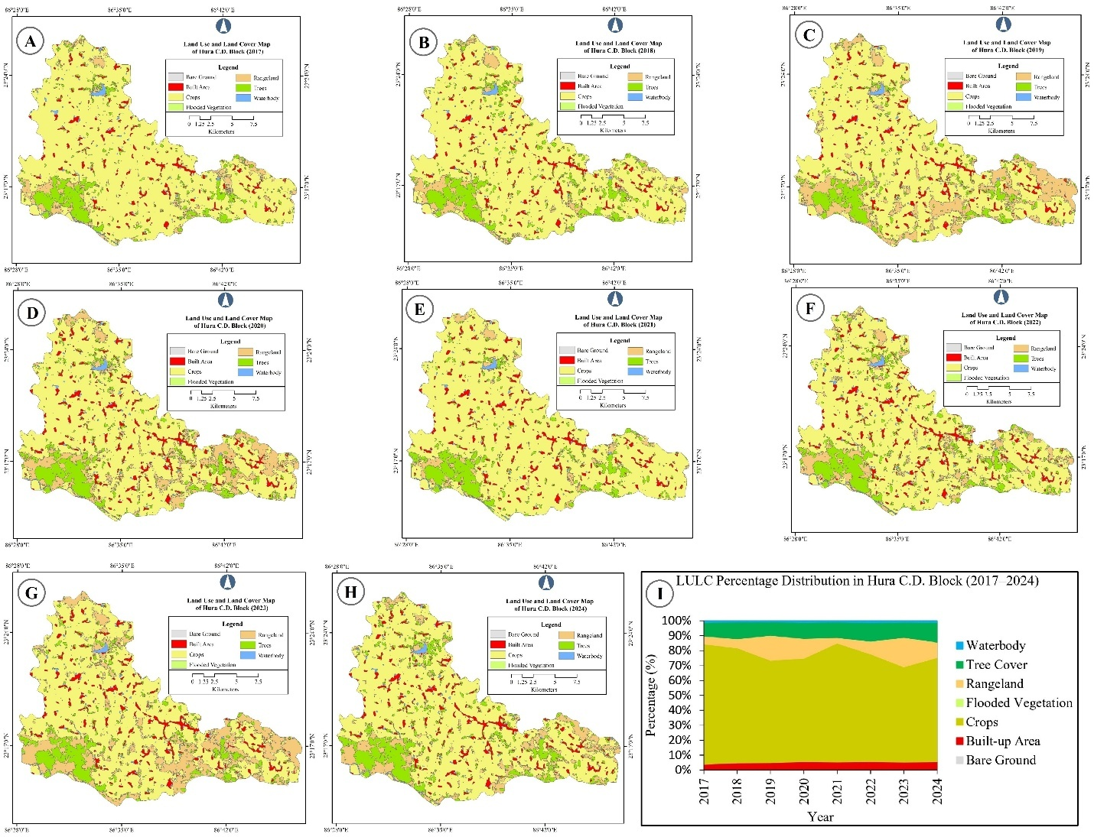
Figure 1: Temporal Dynamics of LULC in Hura block. Panels A to H represent annual LULC maps for the years 2017 to 2024, respectively. Panel I illustrates the temporal percentage distribution of LULC categories.
3.2 LULC Class Transitions: Outflow and Inflow Analysis:
The outflow–inflow statistics of the LULC categories (Table 2; Fig. 2 and 3) from 2017 to 2024 elucidated the dynamic transitions occurring across the landscape. Croplands exhibited the highest outflow throughout the study period, averaging 72.81%, with a maximum of 80.30% in 2017–18 and a minimum of 63.69% in 2023–24. This substantial outflow, coupled with relatively low inflow values (mean 4.75%), indicates a persistent contraction of agricultural land, likely due to its conversion into rangeland, built-up areas, or tree cover. The net change in cropland (–68.63%) underscores its declining dominance in the block’s land system. Rangelands displayed considerable variability, with outflow values ranging between 4.05% (2021–22) and 20.05% (2023–24), averaging 10.76%. Inflow values were also significant (mean 5.98%), peaking at 13.26% in 2018–19, suggesting that cropland and other categories were frequently transformed into rangeland. This dual pattern reflects shifting cultivation practices and land degradation processes, particularly in years of agricultural decline. Tree cover showed moderate but consistent outflow (mean 10.36%) alongside inflow (mean 2.06%), with notable inflow peaks in 2023–24 (3.75%) and 2021–22 (3.09%). These figures suggest gradual afforestation or regeneration, although the net change (–4.12%) indicates a slight overall reduction in tree cover over the period. In contrast, built-up areas demonstrated steady growth, with an outflow and inflow averaging 5.02% and 9.43%, respectively, culminating in a net positive change of +4.98%. This trend reflects the ongoing urban expansion and infrastructural development in the block. Waterbodies remained relatively stable, with outflow averaging 1.04% and inflow averaging 0.20%, resulting in a marginal net decline (–0.84%). Bare ground was negligible, with minimal fluctuations (mean outflow 0.003%), although a slight net increase (+0.09%) was observed. Flooded vegetation was virtually absent, with both outflow and inflow values close to zero, confirming the limited presence of wetland ecosystems in this study area. Overall, the outflow–inflow analysis revealed a clear contraction of croplands and tree cover, offset by the expansion of rangelands and built-up areas. These transitions highlight the combined influence of anthropogenic pressures, urbanization, and ecological processes, underscoring the need for sustainable land management strategies to balance agricultural productivity, ecological conservation, and developmental demands in Hura C.D. Block.
Table 2: Outflow and Inflow (%) of Different LULC in Hura C.D. Block, Purulia District, West Bengal (2017–2024)

Year | Bare Ground |  | Built-up Area |  | Crops |  | Rangeland |  | Tree Cover |  | Waterbody |  | Flooded Vegetation
Year | O | I | O | I | O | I | O | I | O | I | O | I | O | I
2017–18 | 0.0039 | 0.0024 | 3.8625 | 1.0664 | 80.2971 | 1.6073 | 5.5331 | 2.5115 | 9.1705 | 2.5722 | 1.1305 | 0.112 | 0.0024 | 0
2018–19 | 0.0035 | 0.0008 | 4.7263 | 0.55 | 76.8552 | 2.7713 | 6.4276 | 13.2599 | 10.9992 | 0.6653 | 0.9881 | 0.0507 | 0 | NA
2019–20 | 0.0011 | 0.0006 | 4.8127 | 1.0374 | 68.5112 | 5.3721 | 16.8032 | 6.3862 | 9.0835 | 2.2693 | 0.7883 | 0.3765 | 0 | 0.0001
2020–21 | 0.0008 | NA | 5.6096 | 0.4721 | 68.9893 | 11.3488 | 13.6568 | 0.5799 | 10.6196 | 1.2724 | 1.1238 | 0.1014 | 0.0001 | 0.0001
2021–22 | 0 | 0.006 | 5.291 | 0.8548 | 79.4984 | 1.1615 | 4.0549 | 5.7799 | 10.1916 | 3.0887 | 0.964 | 0.399 | 0.0001 | 0
2022–23 | 0.0059 | 0.0009 | 5.6346 | 0.4503 | 71.8559 | 2.5642 | 8.8046 | 12.48 | 12.3953 | 0.8317 | 1.3035 | 0.0951 | 0 | 0
2023–24 | 0.0053 | 0.5611 | 5.2224 | 61.5782 | 63.6897 | 8.4437 | 20.0523 | 0.8938 | 10.0311 | 3.7484 | 0.9992 | 0.2546 | 0.0001 | 0.0011
Mean | 0.0029 | 0.0953 | 5.0227 | 9.4299 | 72.8138 | 4.7527 | 10.7618 | 5.9845 | 10.3558 | 2.064 | 1.0425 | 0.1985 | 0.0004 | 0.0002
Min | 0 | 0.0006 | 3.8625 | 0.4503 | 63.6897 | 1.1615 | 4.0549 | 0.5799 | 9.0835 | 0.6653 | 0.7883 | 0.0507 | 0 | 0
Max | 0.0059 | 0.5611 | 5.6346 | 61.5782 | 80.2971 | 11.3488 | 20.0523 | 13.2599 | 12.3953 | 3.7484 | 1.3035 | 0.399 | 0.0024 | 0.0011
Net Change | 0.0923 |  | 4.9785 |  | –68.6328 |  | –4.1230 |  | –8.5775 |  | –0.8440 |  | –0.0002
Note: O-Outflow, I-Inflow, NA-Not Applicable

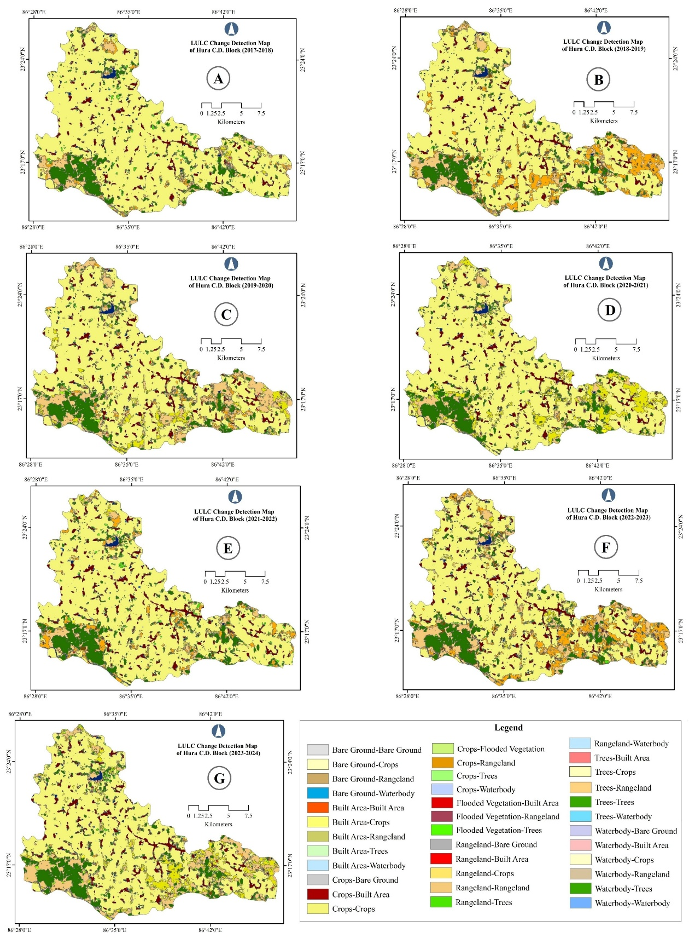
Figure 2: LULC Change Detection in Hura block (2017-2024). Panels A–G depict class-to-class land cover transitions across successive intervals.

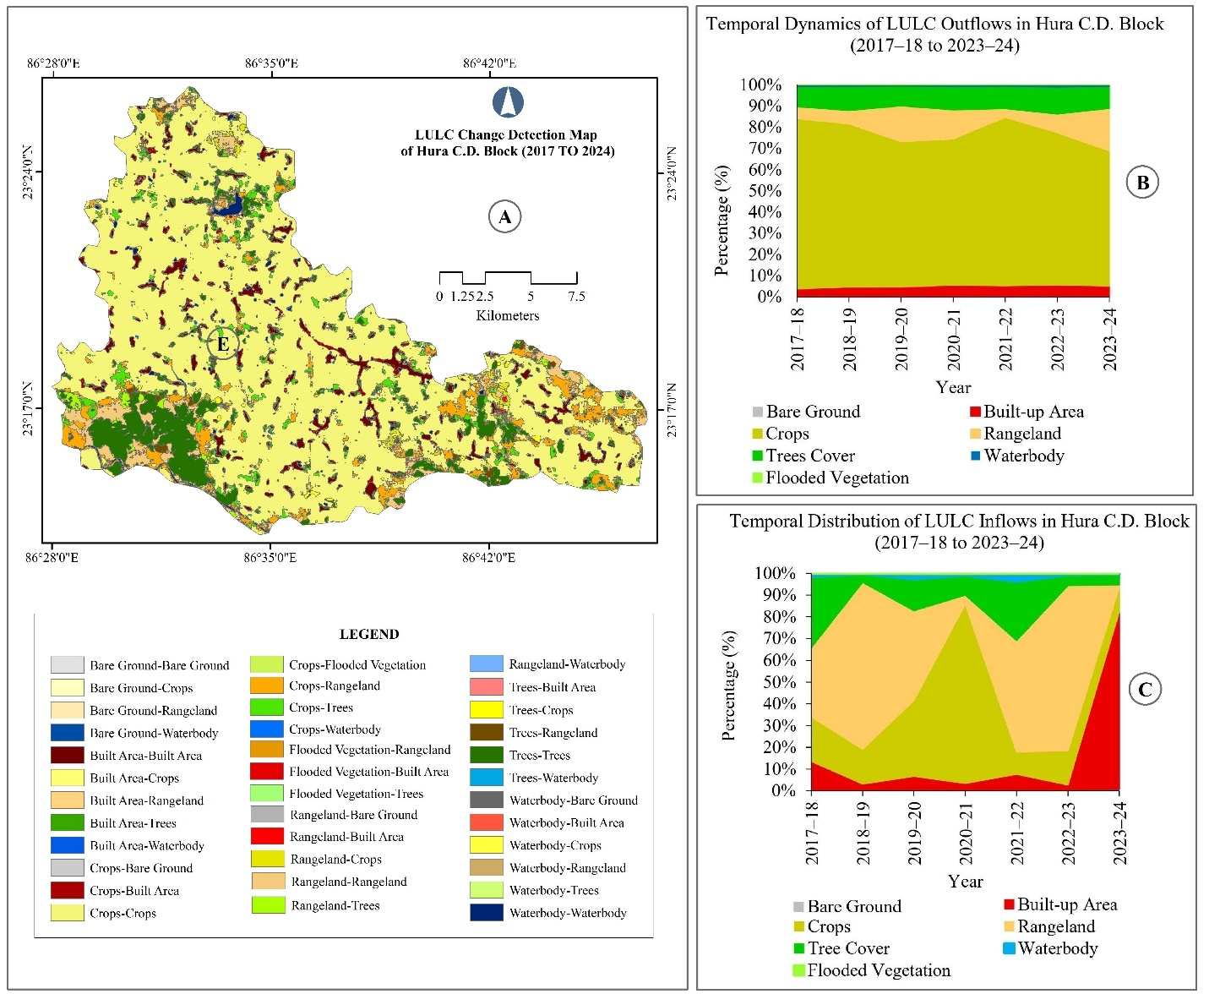
Figure 3: Spatial and Temporal Dynamics of LULC Transitions in Hura block (2017–2024). Panel A shows the cumulative LULC change detection map, while Panels B and C illustrate the temporal percentage distribution of outflows and inflows across major land cover categories.
3.3 Cropland Persistence and Conversion Dynamics:
The persistence and conversion dynamics of croplands in Hura C.D. Blocks (refer to Table 3; Fig. 4a & 4b) from 2017 to 2024 illustrate the complex interaction between agricultural stability, inflow from other land uses, and outflow to non-agricultural categories. On average, 25,552.96 hectares (66.86%) of land remained under continuous cultivation, highlighting the predominance of agriculture in the block. However, persistence decreased from 75.44% in 2017–18 to 61.37% in 2023–24, indicating a gradual decline in cropping stability over time. Cropland inflow from other categories was relatively modest, averaging 1,766.49 hectares (4.62%), although episodic gains were noted in 2020–21 (4,348.81 hectares; 11.38%) and 2023–24 (3,235.46 hectares; 8.47%), primarily from rangeland or transitional land use. Outflow from cropland was more substantial, averaging 2,348.66 hectares (6.14%), with particularly high losses in 2018–19 (3,876.24 hectares; 10.14%), 2021–22 (3,373.48 hectares; 8.83%), and 2022–23 (4,111.78 hectares; 10.76%). These figures underscore the vulnerability of croplands to conversion pressures, particularly during years of agricultural contraction. The net change values further emphasize this volatility. Positive gains were recorded in 2019–20 (+182.94 hectares; +0.48%), 2020–21 (+4,027.22 hectares; +10.54%), and 2023–24 (+2,288.10 hectares; +5.99%), while significant declines occurred in 2018–19 (–3,197.17 hectares; –8.36%), 2021–22 (–2,928.40 hectares; –7.66%), and 2022–23 (–3,129.21 hectares; –8.19%). The overall mean net change (–582.16 hectares; –1.52%) indicates a slight but persistent contraction of croplands during the study period. The residual LULC (persistent plus converted cropland) averaged 8,552.89 ha (22.38%), with an increasing trend from 6,835.77 ha (17.88%) in 2017–18 to 10,580.50 ha (27.68%) in 2023–24, suggesting that while persistence weakened, conversion inflows partially compensated for losses. This residual share reflects the dynamic balance between agricultural continuity and land-use transformation. Overall, the analysis demonstrated that the croplands in Hura C.D. Block have experienced declining persistence, episodic inflows, and recurrent outflows, resulting in fragile equilibrium. The findings indicate increasing land-use pressure from urbanization, rangeland expansion, and ecological transitions, underscoring the need for sustainable agricultural management and policy interventions to stabilize cropping systems in the region.
Table 3. Persistence, Conversion, Net Change and Residual LULC of Cropping Land in Hura C.D. Block, Purulia District, West Bengal (2017–2024)

Year | Cropping Land Persistence (Crops → Crops) | Cropping Land Inflow (Others → Crops) | Cropping Land Outflow (Crops → Others) | Cropping Land Net Change | Residual LULC (Persistent + Converted)
2017–18 | 28,834.75  (75.44) | 615.93  (1.61) | 1,934.55  (5.06) | –1,318.62  (–3.45) | 6,835.77  (17.88)
2018–19 | 25,574.19 (66.91) | 679.07  (1.78) | 3,876.24  (10.14) | –3,197.17  (–8.36) | 8,091.50  (21.17)
2019–20 | 24,377.36 (63.78) | 2,058.54  (5.39) | 1,875.60  (4.91) | +182.94  (+0.48) | 9,909.50  (25.93)
2020–21 | 26,114.74 (68.33) | 4,348.81  (11.38) | 321.59  (0.84) | +4,027.22  (+10.54) | 7,435.86  (19.45)
2021–22 | 27,089.64 (70.88) | 445.08  (1.16) | 3,373.48  (8.83) | –2,928.40  (–7.66) | 7,312.80  (19.13)
2022–23 | 23,422.37 (61.28) | 982.57  (2.57) | 4,111.78  (10.76) | –3,129.21  (–8.19) | 9,704.28  (25.39)
2023–24 | 23,457.68 (61.37) | 3,235.46  (8.47) | 947.36  (2.48) | +2,288.10  (+5.99) | 10,580.50  (27.68)
Mean | 25,552.96 (66.86) | 1,766.49  (4.62) | 2,348.66  (6.14) | –582.16  (–1.52) | 8,552.89  (22.38)
Note: Values in hectares, with percentage in parentheses

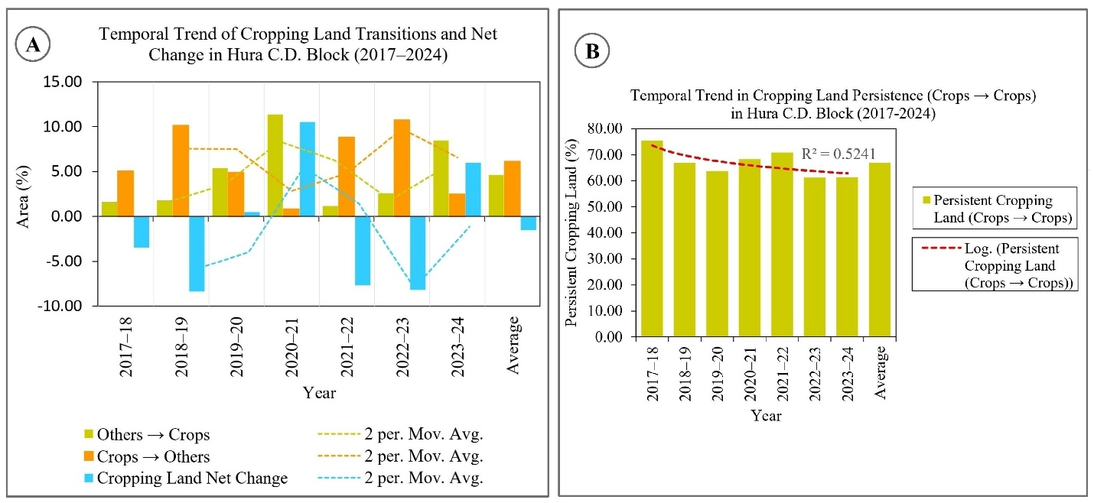
Figure 4: Temporal Trends in Cropping Land Transitions and Persistence in Hura block (2017–2024). Panel A illustrates annual inflow, outflow, and net change in cropping land area, while Panel B depicts cropping land persistence (Crops → Crops) with a fitted logarithmic trend.

Note: In Fig. 4A, moving averages are calculated from annual data, with the average column excluded from smoothing. In Fig. 4B, the trendline is fitted to annual data only, and the average column is excluded from regression analysis.
3.4 Analysis of Cropland Gains from Other LULC Classes:
The analysis of the conversion dynamics of non-cropland categories into cropland (Table 4; Fig. 5a) revealed significant temporal variability and identified the sources contributing to agricultural expansion in the region. On average, 597.54 ha of land were converted into croplands annually, with the largest proportion originating from rangelands (51.01%), followed by tree cover (33.78%), water bodies (8.49%), and developed areas (6.70%). Bare ground contributed minimally (0.02%), underscoring its limited role in the transformation of agricultural land. Rangelands consistently emerged as the predominant contributor to cropland conversion, particularly in 2019–20 (1,871.13 ha; 90.90%), 2020–21 (3,497.13 ha; 80.42%), and 2023–24 (2,999.96 ha; 92.72%), reflecting the widespread reclamation of grazing or degraded land for cultivation. Tree cover also played a substantial role in certain years, notably 2018–19 (380.06 ha; 55.97%) and 2022–23 (366.08 ha; 37.26%), suggesting deforestation or clearance of wooded areas to meet agricultural demand. Built-up areas contributed modestly but steadily, with notable peaks in 2020–21 (262.29 ha; 6.03%) and 2021–22 (92.93 ha; 20.88%), indicating peri-urban land adjustments or the reallocation of marginal settlements. Water bodies occasionally supplied cropland, with conversions reaching 90.55 ha (2.08%) in 2020–21 and 75.77 ha (7.71%) in 2022–23, indicating the encroachment of wetlands or seasonal waterlogged areas. Overall, the conversion pattern demonstrates that cropland expansion in Hura C.D. Block was primarily achieved through the reclamation of rangelands and clearance of tree cover, supplemented by smaller inflows from built-up areas and water bodies. These transitions reflect both anthropogenic pressures (urbanization, deforestation, and wetland encroachment) and agricultural intensification strategies, raising concerns about ecological sustainability. These findings underscore the need for balanced land management policies that safeguard rangelands and forest ecosystems while ensuring agricultural productivity.
Table 4: Conversion of Other LULC Classes into Cropping Land (ha, %) in Hura C.D. Block (2017–2024)

Year | Bare Ground → Crops | Built-up Area → Crops | Rangeland → Crops | Tree Cover → Crops | Waterbody → Crops | Total Conversion to Crops
2017-18 | 0.0081 (0.0013) | 46.4023 (7.5337) | 405.8402 (65.8909) | 108.5680 (17.6267) | 55.1089 (8.9473) | 615.9275 (100.0000)
2018-19 | 0.3153 (0.0464) | 79.5510 (11.7146) | 153.3269 (22.5788) | 380.0579 (55.9671) | 65.8221 (9.6929) | 679.0733 (100.0000)
2019-20 | 0.0050 (0.0002) | 45.4185 (2.2063) | 1871.1254 (90.8959) | 131.4188 (6.3841) | 10.5680 (0.5134) | 2058.5358 (100.0000)
2020-21 | 0.0554 (0.0013) | 262.2882 (6.0313) | 3497.1263 (80.4157) | 498.7908 (11.4696) | 90.5523 (2.0822) | 4348.8129 (100.0000)
2021-22 | 0.0000 (0.0000) | 92.9302 (20.8796) | 210.7027 (47.3408) | 133.7330 (30.0472) | 7.7106 (1.7324) | 445.0765 (100.0000)
2022-23 | 0.0080 (0.0008) | 149.0901 (15.1736) | 391.6143 (39.8563) | 366.0803 (37.2576) | 75.7727 (7.7117) | 982.5654 (100.0000)
2023-24 | 0.0000 (0.0000) | 79.5580 (2.4589) | 2999.9603 (92.7212) | 121.1533 (3.7445) | 34.7901 (1.0753) | 3235.4617 (100.0000)
Mean | 0.1319 (0.0221) | 40.0373 (6.7004) | 304.7961 (51.0089) | 201.8272 (33.7766) | 50.7428 (8.4920) | 597.5353 (100.0000)
Note: Values in hectares, with percentage in parentheses

3.5 Analysis of Cropland Loss to Other LULC Classes:
The conversion of croplands into other land use and land cover (LULC) categories (Table 5; Fig. 5b) demonstrates significant spatial reallocation, indicative of both anthropogenic pressures and ecological transitions. On average, 4,672.74 hectares of cropland were converted annually, with the largest proportion directed towards rangeland (48.32%), followed by tree cover (35.67%), built-up areas (13.96%), and smaller proportions into waterbodies (2.05%) and bare ground (0.0003%). Rangelands consistently absorbed the majority of cropland outflow, particularly in 2018–19 (3,530.71 ha; 91.09%) and 2022–23 (3,764.54 ha; 91.56%), underscoring the vulnerability of agricultural land to degradation or conversion into grazing areas. Tree cover also emerged as a major recipient, with notable peaks in 2017–18 (771.98 ha; 39.90%), 2021–22 (965.30 ha; 28.61%), and 2023–24 (487.18 ha; 51.43%), suggesting afforestation or natural regeneration processes in abandoned croplands. Although smaller in scale, built-up areas consistently expanded through cropland conversion, averaging 652.50 ha (13.96%), with significant contributions in 2017–18 (335.58 ha; 17.35%) and 2023–24 (176.63 ha; 18.64%), reflecting urbanization and infrastructural growth. Waterbodies accounted for minor but recurrent conversions, peaking in 2021–22 (141.30 ha; 4.19%), likely due to the inundation or reclamation of agricultural plots. Bare ground remained negligible throughout the period, with only trace values. Overall, the conversion pattern highlights a dual trajectory of cropland loss. Large-scale transformation into rangelands indicates land degradation and shifting cultivation pressures. Moderate but persistent conversion into tree cover and built-up areas reflects ecological succession and urban expansion. These transitions collectively indicate a gradual erosion of agricultural stability, with implications for food security, ecosystem services, and sustainable land management in the Hura C.D. Block.
Table 5: Conversion of Cropping Land into Other LULC Classes (ha, %) in Hura C.D. Block (2017–2024)

Year | Crops → Rangeland | Crops → Built-up Area | Crops → Bare Ground | Crops → Waterbody | Crops → Tree Cover | Total Conversion from Crops
2017–18 | 787.2209 (40.6927) | 335.5787 (17.3466) | 0.0266 (0.0014) | 39.7369 (2.0541) | 771.9790 (39.9048) | 1934.5522 (100.0000)
2018–19 | 3530.7110 (91.0861) | 145.3237 (3.7491) | 0.0073 (0.0002) | 12.2449 (0.3159) | 187.9486 (4.8487) | 3876.2355 (100.0000)
2019–20 | 1107.8707 (59.0674) | 246.0484 (13.1184) | 0.0038 (0.0002) | 104.2309 (5.5572) | 417.4499 (22.2568) | 1875.6036 (100.0000)
2020–21 | 105.3187 (32.7493) | 77.0332 (23.9538) | 0.0000 (0.0000) | 17.4228 (5.4177) | 121.8159 (37.8792) | 321.5905 (100.0000)
2021–22 | 1982.1131 (58.7558) | 284.7039 (8.4395) | 0.0577 (0.0017) | 141.2994 (4.1885) | 965.3035 (28.6145) | 3373.4777 (100.0000)
2022–23 | 3764.5421 (91.5551) | 106.4041 (2.5878) | 0.0266 (0.0006) | 30.8334 (0.7499) | 209.9704 (5.1066) | 4111.7765 (100.0000)
2023–24 | 237.5538 (25.0754) | 176.6269 (18.6442) | 0.0000 (0.0000) | 45.9458 (4.8499) | 487.1824 (51.4254) | 947.3573 (100.0000)
Mean | 2257.8771 (48.3202) | 652.5031 (13.9640) | 0.0137 (0.0003) | 95.7469 (2.0491) | 1666.6011 (35.6664) | 4672.7418 (100.0000)
Note: Values in hectares, with percentage in parentheses

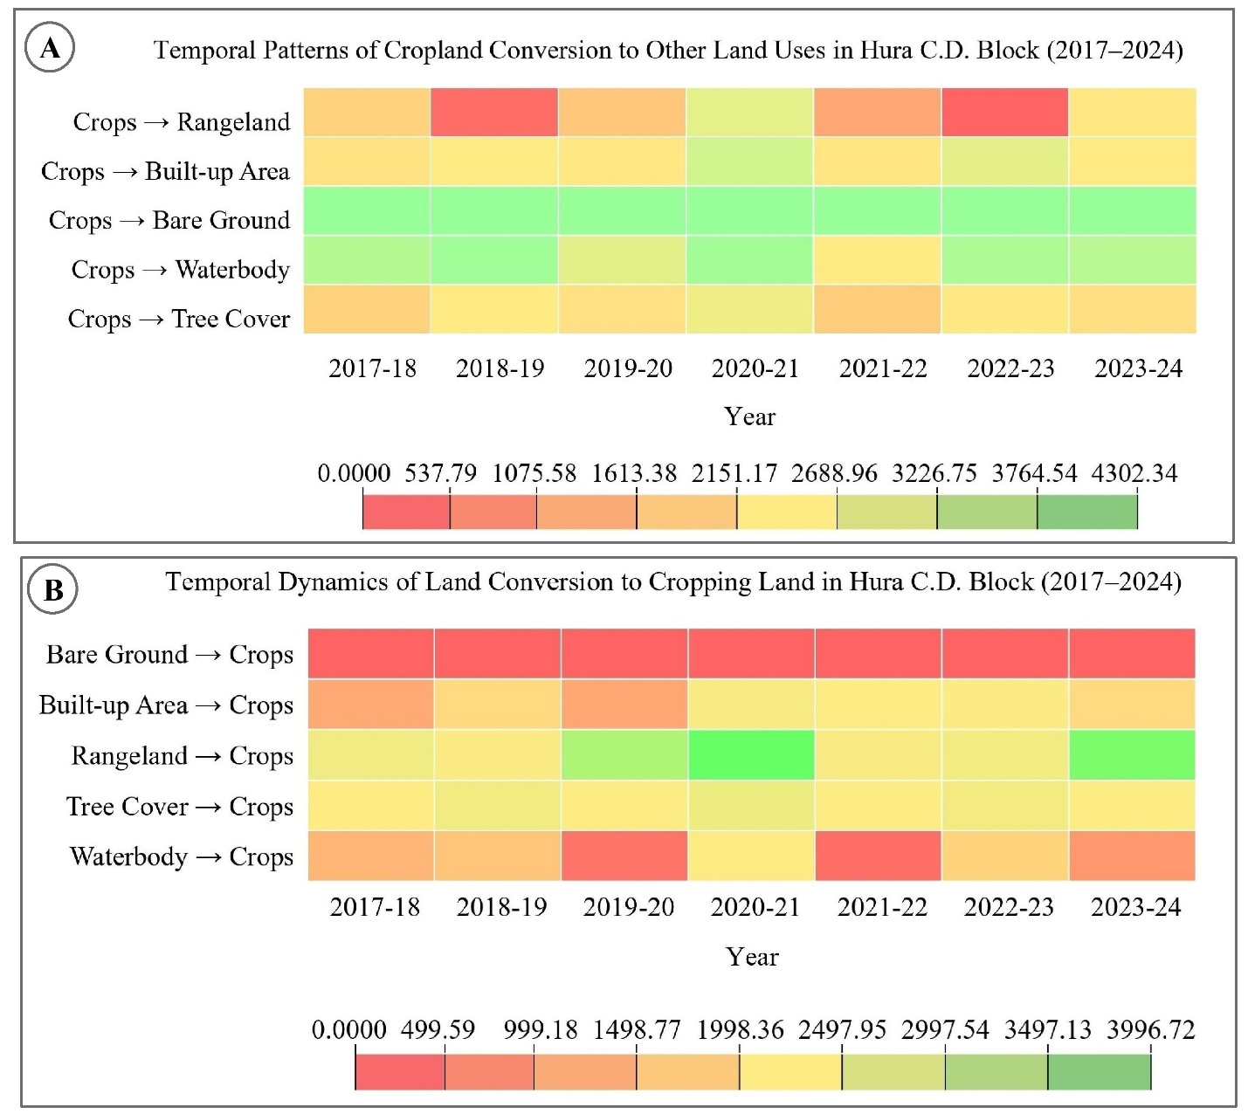
Figure 5: Temporal Heatmaps of Cropland Conversion Dynamics in Hura block (2017–2024). Panel A illustrates annual transitions from cropland to other land uses, while Panel B shows conversions into cropland from alternate land cover types.
4. Discussion
The analysis of LULC changes in the Hura block from 2017 to 2024 revealed a dynamic yet fragile equilibrium among cropland persistence, rangeland expansion, and urban growth. Although croplands remain predominant, their persistence has declined, with significant transitions to rangelands and tree cover types. This trend reflects both agricultural contraction and ecological transition, aligning with the broader findings in the Purulia District. Specifically, these changes are likely driven by increasing population pressure, shifting economic activities, and potential climate variability, which collectively contribute to degradation and land conversion (Das et al., 2022). Environmental degradation and the expansion of built-up areas underscore the impact of urbanization and infrastructure growth in the Purulia District. In the Hura Block, unplanned settlement expansion and infrastructural development, coupled with weak land-use regulations, have accelerated the conversion of croplands into built-up areas, complicating sustainable land management (Das, 2017). This directly connects to the research gap identified in the introduction, where the need for systematic monitoring of rural-urban transitions was emphasized. The observed gains in tree cover during certain years suggest afforestation or regeneration; however, the concurrent conversion of croplands into tree cover indicates land abandonment and ecological succession rather than planned forest management. This reflects socio-economic drivers such as declining agricultural profitability, migration, and policy gaps in forest governance. Thus, while tree cover gains appear positive, they may mask the underlying vulnerabilities of agricultural sustainability in the region. Rangeland dynamics exhibit volatility, absorbing substantial portions of cropland outflow during periods of agricultural decline. This volatility is consistent with regional studies that have highlighted shifting cultivation, soil degradation, and unsustainable land management practices as the primary drivers of LULC change in Purulia (Das et al., 2022). In the Hura Block, these processes are further exacerbated by climate variability, particularly erratic rainfall patterns, which reduce cropland stability and push marginal lands into the rangeland category. Waterbodies and flooded vegetation remain marginal, highlighting the limited role of wetlands in the land system of the block. However, their persistence is threatened by wetland encroachment and groundwater exploitation, both of which were identified in the introduction as critical anthropogenic pressures. Overall, the results indicate a dual trajectory: (i) contraction of croplands and tree cover and (ii) expansion of rangelands and built-up areas. These transitions are not merely descriptive outcomes but reflect the combined influence of anthropogenic drivers (population growth, urbanization, deforestation, and wetland encroachment) and ecological processes (succession, degradation, and climate variability). By explicitly linking observed changes to these drivers, this study addresses the research gap identified in the introduction, namely, the lack of integrated spatio-temporal assessments that connect LULC dynamics with underlying socio-economic and ecological pressures in the Hura block.
5. Conclusion:
Investigation of LULC changes in Hura C.D. Block from 2017 to 2024 revealed a gradual decline in agricultural stability, primarily due to the contraction of croplands, rangeland expansion, and urban development. Although occasional inflows into croplands have partially mitigated these losses, the overall trend indicates a decrease in agricultural persistence and an increase in drought vulnerability. These findings highlight the urgent need for integrated land management strategies that harmonize agricultural productivity, ecological conservation and developmental needs. By integrating remote sensing and GIS analysis with policy interventions, sustainable land-use planning can be realized in the Hura block. In the absence of such measures, the concurrent trends of cropland loss and rangeland expansion may exacerbate food security issues and ecological degradation in the region. In light of the observed dynamics, several measures are recommended to ensure sustainable land-use planning in the study area:
- Strengthening agricultural land protection: Strategic zoning regulations are vital for preserving agricultural land and fostering sustainable farming practices. Similarly, India's National Policy for Farmers (NPF 2007) underscores the importance of safeguarding croplands through coordinated land-use planning.
- Promoting sustainable rangeland management: Rangelands constitute approximately 40% of the Earth's terrestrial surface. To harmonize ecological sustainability with human needs, it is imperative to implement effective management strategies, such as soil conservation, regulated grazing, and agroforestry (Teague & Kreuter, 2020). Sustainable rangeland management is essential to prevent degradation and maintain ecosystem services.
- Afforestation and forest management: Research underscores the necessity for afforestation to be ecologically sustainable, as abandoning croplands may result in unforeseen consequences. Rewilding abandoned farmland frequently yields greater benefits in terms of biodiversity and resilience than afforestation (Holl et al., 2022; Wang et al., 2023).
- Urban planning and regulation: Policies designed to address urban sprawl emphasize the importance of systematic planning to prevent the loss of agricultural land and environmental degradation. Advocacy for compact urban planning frameworks has been proposed to reduce encroachment on croplands and ecological zones (Gumma et al., 2017; Sharma et al., 2024).
- Waterbody conservation: Wetlands and small water bodies are integral to the provision of essential ecosystem services, including the support of biodiversity and the maintenance of water balance. To protect these areas from degradation or encroachment, it is imperative to develop and effectively enforce conservation policies (Prasad, 2002; Harshvardhan, 2018).
- Community participation: Engagement with the community is crucial for integrating local knowledge, achieving equitable outcomes, and ensuring the long-term sustainability of land management practices. Such involvement cultivates a sense of ownership and responsibility among stakeholders, thereby aligning ecological objectives with livelihood needs (Saurav, 2024; Leena, 2024; Madhurya, 2025).
Disclaimer (Artificial Intelligence)
The authors hereby declare that no generative AI technologies such as Large Language Models (ChatGPT, COPILOT, etc.) and text-to-image generators have been used during the writing or editing of this manuscript.

Reference
- Mondal, P. P., & Zhang, Y. (2018). Research Progress on Changes in Land Use and Land Cover in the Western Himalayas (India) and Effects on Ecosystem Services. Sustainability, 10(12), 4504. https://doi.org/10.3390/su10124504
- Tripathi, R., Moharana, K.C., Nayak, A.D. et al. (2019). Ecosystem services in different agro-climatic zones in eastern India: impact of land use and land cover change. Environ Monit Assess, 191 (98). https://doi.org/10.1007/s10661-019-7224-7
- Karimov, Y., Musaev, I., Abobakirova, Z., Umarov, S., Mirzaeva, Z., & Mirzababayeva, S. (2023). Land use and land cover change dynamics of Uzbekistan: a review. E3S Web of Conferences, 421, 03007. https://doi.org/10.1051/e3sconf/202342103007
- Deka, J., Tripathi, O.P., Khan, M.L. et al. (2019). Study on land-use and land-cover change dynamics in Eastern Arunachal Pradesh, N.E. India using remote sensing and GIS. Tropical Ecology, 60, 199–208. https://doi.org/10.1007/s42965-019-00022-3
- Karale, O. S., Gavit, B. K., Bhat, A. G., Paradkar, V., Mukherjee, S., & Gupta, A. (2024). Analysing decadal land use land cover dynamics in the Sub-Upper Krishna Basin of Maharashtra, India using remote sensing and GIS. Journal of Experimental Agriculture International, 46(1), 87–95. https://doi.org/10.9734/jeai/2024/v46i12297
- Jensen, J. R. (2016). Introductory digital image processing: A remote sensing perspective (4th ed.). in Pearson series in Geographic Information Science [Book]. Pearson. https://scispace.com/pdf/introductory-digital-image-processing-a-remote-sensing-58kg9u3xz4.pdf
- Mashala, M. J., Dube, T., Mudereri, B. T., Ayisi, K. K., & Ramudzuli, M. R. (2023). A Systematic Review on Advancements in Remote Sensing for Assessing and Monitoring Land Use and Land Cover Changes Impacts on Surface Water Resources in Semi-Arid Tropical Environments. Remote Sensing, 15(16), 3926. https://doi.org/10.3390/rs15163926
- Alqurashi, A. F., & Kumar, L. (2013). Investigation of the use of remote sensing and GIS techniques to detect land use and land cover change: A review. The Egyptian Journal of Remote Sensing and Space Science , 16 (1), 13–18. http://dx.doi.org/10.4236/ars.2013.22022
- Karra, K., Kontgis, C., Statman-Weil, Z., Mazzariello, J.C., Mathis, M., and S. P. Brumby, S. P. (2021). Global land use / land cover with Sentinel 2 and deep learning. IEEE International Geoscience and Remote Sensing Symposium IGARSS, Brussels, Belgium, pp. 4704-4707. https://doi.org/10.1109/IGARSS47720.2021.9553499
- Drusch, M., Del Bello, U., Carlier, S., Colin, O., Fernandez, V., Gascon, F., Hoersch, B., Isola, C., Laberinti, P., Martimort, P., Meygret, A., Spoto, F., Sy, O., Marchese, F., & Bargellini, P. (2012). Sentinel-2: ESA’s Optical High-Resolution Mission for GMES Operational Services. Remote Sensing of Environment, 120, 25–36. https://doi.org/10.1016/j.rse.2011.11.026
- Phiri, D., Simwanda, M., Salekin, S., Nyirenda, V. R., Murayama, Y., & Ranagalage, M. (2020). Sentinel-2 Data for Land Cover/Use Mapping: A Review. Remote Sensing, 12(14), 2291. https://doi.org/10.3390/rs12142291
- Foody, G. M. (2002). Status of land cover classification accuracy assessment. Remote Sensing of Environment, 80(1), 185–201. https://doi.org/10.1016/s0034-4257(01)00295-4
- Nasiri, V., Deljouei, A., Moradi, F., Sadeghi, S. M. M., & Borz, S. A. (2022). Land Use and Land Cover Mapping Using Sentinel-2, Landsat-8 Satellite Images, and Google Earth Engine: A Comparison of Two Composition Methods. Remote Sensing, 14(9), 1977. https://doi.org/10.3390/rs14091977
- Xu, H. (2006). Modification of normalised difference water index (NDWI) to enhance open water features in remotely sensed imagery. International Journal of Remote Sensing, 27(14), 3025–3033. https://doi.org/10.1080/01431160600589179
- Weng, Q. (2012). Remote sensing of impervious surfaces in the urban areas: Requirements, methods, and trends. Remote Sensing of Environment, 117, 34–49. https://doi.org/10.1016/j.rse.2011.02.030
- Huang, C., Zhang, C., He, Y., Liu, Q., Li, H., Su, F., Liu, G., & Bridhikitti, A. (2020). Land Cover Mapping in Cloud-Prone Tropical Areas Using Sentinel-2 Data: Integrating Spectral Features with Ndvi Temporal Dynamics. Remote Sensing, 12(7), 1163. https://doi.org/10.3390/rs12071163
- Islam, H., Abbasi, H., Karam, A., Chughtai, A. H., Ahmed, Jiskani, M. (2021). Geospatial analysis of wetlands based on land use/land cover dynamics using remote sensing and GIS in Sindh, Pakistan. Science Progress, 104(2). doi:10.1177/00368504211026143
- Lu, D., Mausel, P., Brondízio, E., & Moran, E. (2004). Change detection techniques . International Journal of Remote Sensing, 25(12), 2365–2401. https://doi.org/10.1080/0143116031000139863
- Mawenda, J., Watanabe, T., & Avtar, R. (2020). An Analysis of Urban Land Use/Land Cover Changes in Blantyre City, Southern Malawi (1994–2018). Sustainability, 12(6), 2377. https://doi.org/10.3390/su12062377
- Fahad, K. H., Hussein, S., & Dibs, H. (2020). Spatial-Temporal analysis of land use and land cover change detection using remote sensing and GIS techniques. IOP Conference Series Materials Science and Engineering, 671(1), 012046. https://doi.org/10.1088/1757-899x/671/1/012046
- Fayaz, A., Shafiq, M. U., Singh, H., & Ahmed, P. (2020). Assessment of spatiotemporal changes in land use/land cover of North Kashmir Himalayas from 1992 to 2018. Modeling Earth Systems and Environment, 6(2), 1189–1200. https://doi.org/10.1007/s40808-020-00750-9
- Roy, A. and Mukherjee, S. (2018). Changing nature of forest resources and its impact on tribal livelihood: a study of Purulia District, West Bengal, India. International Journal of Management and Social Sciences Research (IJMSSR), 7(4). https://www.academia.edu/36805415/Changing_Nature_of_Forest_Resources_and_Its_Impact_on_Tribal_Livelihood_A_Study_of_Purulia_District_West_Bengal_India
- Gope, S. M., & Mistri, T. (2021). Settlement changes and its impact analysis through LULC of Lakhanpur & Rakhera Mouza in Hura C.D Block of Purulia District. Turkish Online Journal of Qualitative Inquiry (TOJQI), 12(8), 7671–7682. https://tojqi.net/index.php/journal/article/view/7932/5646
- Das, P., Bhunia, P., and Maiti, R. (2022). Assessment of Land Use and Land Cover Change in the Purulia District, India Using LANDSAT Data. In: Mandal, S., Maiti, R., Nones, M., Beckedahl, H.R. (eds) Applied Geomorphology and Contemporary Issues. Geography of the Physical Environment. Springer, Cham. https://doi.org/10.1007/978-3-031-04532-5_17
- Bureau of Applied Economics & Statistics. (2014). District statistical handbook: Purulia. Department of Statistics & Programme Implementation, Government of West Bengal. https://library.isical.ac.in/bib/95717
- Registrar General & Census Commissioner, India. (2014). Census of India 2011: Series 20 - Part XII-A & XII-B - District census handbook, Puruliya . Office of the Registrar General & Census Commissioner, India, Ministry of Home Affairs. https://censusindia.gov.in/nada/index.php/catalog/1354
- Das, P.K. (2017). Spatiotemporal Analysis of Environmental and Urban Change in Purulia District during the Period 2000 to 2010 Using Spectral Indices. International Journal of Emerging Technologies and Innovative Research, 4(8), 743-749. http://www.jetir.org/papers/JETIR1708113.pdf
- Teague, R., & Kreuter, U. (2020). Managing grazing to restore soil health, ecosystem function, and ecosystem services. Frontiers in Sustainable Food Systems, 4. https://doi.org/10.3389/fsufs.2020.534187
- Holl, K. D., Ashton, M. S., Bukoski, J. J., Culbertson, K. A., Curran, S. R., Harris, T. B., Potts, M. D., Valverde, Y. L., & Vincent, J. R. (2022). Redefining “abandoned” agricultural land in the context of reforestation. Frontiers in Forests and Global Change, 5. https://doi.org/10.3389/ffgc.2022.933887
- Wang, L., Pedersen, P.B.M. & Svenning, JC. (2023). Rewilding abandoned farmland has greater sustainability benefits than afforestation. npj biodivers 2(5). https://doi.org/10.1038/s44185-022-00009-9
- Gumma, M. K., Mohammad, I., Nedumaran, S., Whitbread, A., & Lagerkvist, C. J. (2017). Urban Sprawl and Adverse Impacts on Agricultural Land: A Case Study on Hyderabad, India. Remote Sensing, 9(11), 1136. https://doi.org/10.3390/rs9111136
- Sharma, M., Kumar, V., & Kumar, S. (2024). A systematic review of urban sprawl and land use/land cover change studies in India. Sustainable Environment, 10(1). https://doi.org/10.1080/27658511.2024.2331269
- Prasad, S.N., Ramachandra, T.V., Ahalya, N., Sengupta, T., Kumar, A., Tiwari, A.K., Vijayan, V.S., & Vijayan, L. (2002). Conservation of wetlands of India – a review. Tropical Ecology, 43(1), 173–186). https://wgbis.ces.iisc.ac.in/energy/water/paper/conservation_wetlands/Conservation_of_wetlands_of_India.pdf
- Harshvardhan (2018). Indian Wetlands & its conservation- a review. International Journal of Management, Technology and Engineering, 8(8), 319–320. https://ijamtes.org/gallery/40.aug%20ijmte%20%20-%20cw.pdf
- Saurav, S.K., Wason, M., Satyapriya, Bishnoi, S. and Sahu, S. (2024). Agricultural Resource Management in India: Community Based Strategies for Sustainability. International Journal of Agriculture, Environment and Biotechnology, 17(Sp), 255-261. https://www.researchgate.net/publication/383304514_Agricultural_Resource_Management_in_India_Community_Based_Strategies_for_Sustainability
- Leena, M. CH., Chaithanya, L. K., Saurav, S. K., and Sajjan, R. (2024). Agriculture Based livelihood Systems in Drylands - Challenges and Strategies. International Journal of Agriculture Environment and Biotechnology, 17(3). https://doi.org/10.30954/0974-1712.03.2024.10
- Madhurya, C. (2025). Rural Development by Promoting Sustainable Agriculture and Resource Management in India. International Journal of Humanities and Social Science Invention (IJHSSI), 14 (6), 14-18 https://www.ijhssi.org/papers/vol14(6)/14061418.pdf

