Physicochemical, Microbiological, and Toxicological Assessment of Borehole Water in Rumuokoro, Port Harcourt, Nigeria

Abstract
Groundwater from boreholes is the primary source of drinking water for many urban communities in the Niger Delta region of Nigeria. Rapid urbanisation, industrial activities, petroleum-related operations, and poor sanitation infrastructure have increased the vulnerability of groundwater to chemical and microbial contamination. This study assessed the physicochemical quality, microbiological status, and toxicological risks of borehole water in Rumuokoro, Port Harcourt, with emphasis on human health implications for adults and children. Twenty groundwater samples were collected from ten functional boreholes during dry and wet seasons. In situ measurements of pH, temperature, electrical conductivity, total dissolved solids, and dissolved oxygen were carried out using calibrated portable multiparameter meters. Major ions were analysed using standard titrimetric and spectrophotometric methods. Heavy metals (Fe, Pb, Cd, Cr, Ni, Zn, and Cu) were determined after acid digestion using flame Atomic Absorption Spectrophotometry. Microbiological quality was assessed using membrane filtration techniques. Water quality index and human health risk indices were computed following USEPA guidelines. pH values ranged from 5.8 to 7.2, indicating slightly acidic to near-neutral conditions. Electrical conductivity varied between 214 and 682 µS/cm, while total dissolved solids ranged from 142 to 468 mg/L. Iron concentrations ranged from 0.18 to 0.92 mg/L, exceeding the 0.3 mg/L guideline in several boreholes. Lead (0.004–0.021 mg/L) and cadmium (0.001–0.006 mg/L) exceeded permissible limits in some locations. Total coliform counts ranged from 0 to 18 CFU/100 mL, faecal coliforms from 0 to 7 CFU/100 mL, and Escherichia coli from 0 to 4 CFU/100 mL. The computed water quality index value of 239 classified the borehole water as very poor. Non-carcinogenic risk assessment showed hazard quotient values exceeding unity for lead (1.58), cadmium (1.91), and nickel (1.14) in children, while adult hazard quotients remained below unity. Carcinogenic risk values for cadmium, chromium, and nickel ranged from 10⁻⁵ to 10⁻⁶, within acceptable limits. Borehole water in Rumuokoro is unsuitable for direct consumption without treatment due to combined physicochemical, microbiological, and toxicological risks. Routine monitoring, improved borehole sanitation, effective disinfection, and targeted removal of priority metals are required to protect public health.
Keywords: Borehole water, groundwater quality, atomic absorption spectrophotometry, microbiological contamination, health risk assessment, Niger Delta

1.0 Introduction
Groundwater obtained from boreholes remains the principal source of drinking water for many urban and peri-urban communities in the Niger Delta due to its perceived reliability and relative protection from surface contamination. However, growing evidence suggests that borehole water quality in the region is increasingly compromised by both natural hydrogeochemical processes and intense anthropogenic activities. Studies conducted on drinking water sources in coastal communities of Bayelsa State have demonstrated that groundwater often contains elevated levels of dissolved constituents and toxic elements capable of posing health risks to consumers (Ekesiobi et al., 2025).
The hydrogeological setting of the Niger Delta plays a critical role in groundwater vulnerability. The region is dominated by unconsolidated deltaic sediments with high porosity and permeability, which enhance groundwater recharge but also facilitate rapid infiltration of contaminants. Investigations in Akwa Ibom State have shown that agricultural runoff and urban land-use practices significantly influence the hydrogeochemical characteristics of surface and subsurface waters, resulting in nutrient enrichment and altered ionic composition (Osuafor et al., 2025). Similar hydrochemical controls have been identified in groundwater systems of Bayelsa State, where shallow aquifers were found to be highly susceptible to oil-related pollution (Okagbare et al., 2025).
Heavy metals constitute a major concern in the Niger Delta water resources because of their persistence, toxicity, and tendency to bioaccumulate. Research on urban rivers and estuarine systems has linked the presence of metals such as lead, cadmium, nickel, and chromium to industrial discharges, petroleum activities, and atmospheric deposition from gas flaring (Okpoji et al., 2025; Aghanwa et al., 2025). These metals have been shown to induce ecotoxicological effects in aquatic organisms, including oxidative stress and tissue damage in fish and crustaceans, underscoring their potential impact on human health through water use and food-chain transfer (Ohaturuonye et al., 2025; Okpoji et al., 2025).
Microbiological contamination represents an additional and often more immediate threat to groundwater safety. Studies on drinking water sources in the Niger Delta have repeatedly reported the presence of coliforms and faecal indicators in borehole water, frequently attributed to poor borehole construction, inadequate sanitary protection, and proximity to septic systems (Ekesiobi et al., 2025). Comparable findings from stream and runoff-impacted environments indicate that microbial pollution is closely linked to domestic waste disposal and urban sanitation challenges rather than to natural hydrochemical processes alone (Osuafor et al., 2025).
Beyond individual parameter assessment, recent studies increasingly emphasise integrated evaluation frameworks that combine physicochemical, microbiological, and toxicological analyses. Applications of water quality indices and human health risk assessment models across the Niger Delta have revealed that water sources meeting basic guideline limits may still pose cumulative risks, particularly to children who exhibit higher exposure rates relative to body weight (Anarado et al., 2023; Ekesiobi et al., 2025). Evidence from contaminated food and aquatic systems further suggests that chronic exposure to low-level contaminants from multiple pathways can amplify long-term health risks (John et al., 2025; Onoja et al., 2025).
Rumuokoro, a major urban node within Port Harcourt metropolis, exemplifies many of the environmental pressures characteristic of the Niger Delta, including dense population, intense commercial activity, vehicular emissions, small-scale industries, and poorly managed waste streams. Despite widespread reliance on borehole water for domestic use, comprehensive assessments integrating physicochemical quality, microbiological safety, and toxicological risk remain limited in this area. Addressing this gap is essential for informed water resource management and public health protection. Therefore, this study evaluates the physicochemical and microbiological characteristics of borehole water in Rumuokoro and assesses associated toxicological and human health risks using established water quality and risk assessment frameworks.

2.0 Materials and Methods

2.1 Study Area
This study was carried out in Rumuokoro, an urban community within Port Harcourt metropolis, Rivers State, Nigeria. Rumuokoro is geographically located between latitudes 4.83°–4.87° N and longitudes 6.97°–7.02° E, within the eastern Niger Delta region. The area is characterised by high population density, extensive residential settlements, intense commercial activities, motor parks, and small-scale industrial operations. Borehole water constitutes the principal source of drinking and domestic water for residents due to limited access to municipal water supply.
Geologically, Rumuokoro lies within the Niger Delta sedimentary basin and is underlain predominantly by unconsolidated sandy and silty formations of high porosity and permeability. These hydrogeological characteristics enhance groundwater storage and recharge but also increase vulnerability to contamination from surface-derived pollutants, including domestic wastewater, urban runoff, and industrial discharges. The climate of the area is humid tropical, with a distinct wet season occurring from April to October and a dry season from November to March, conditions that influence groundwater recharge dynamics and seasonal water quality variations.
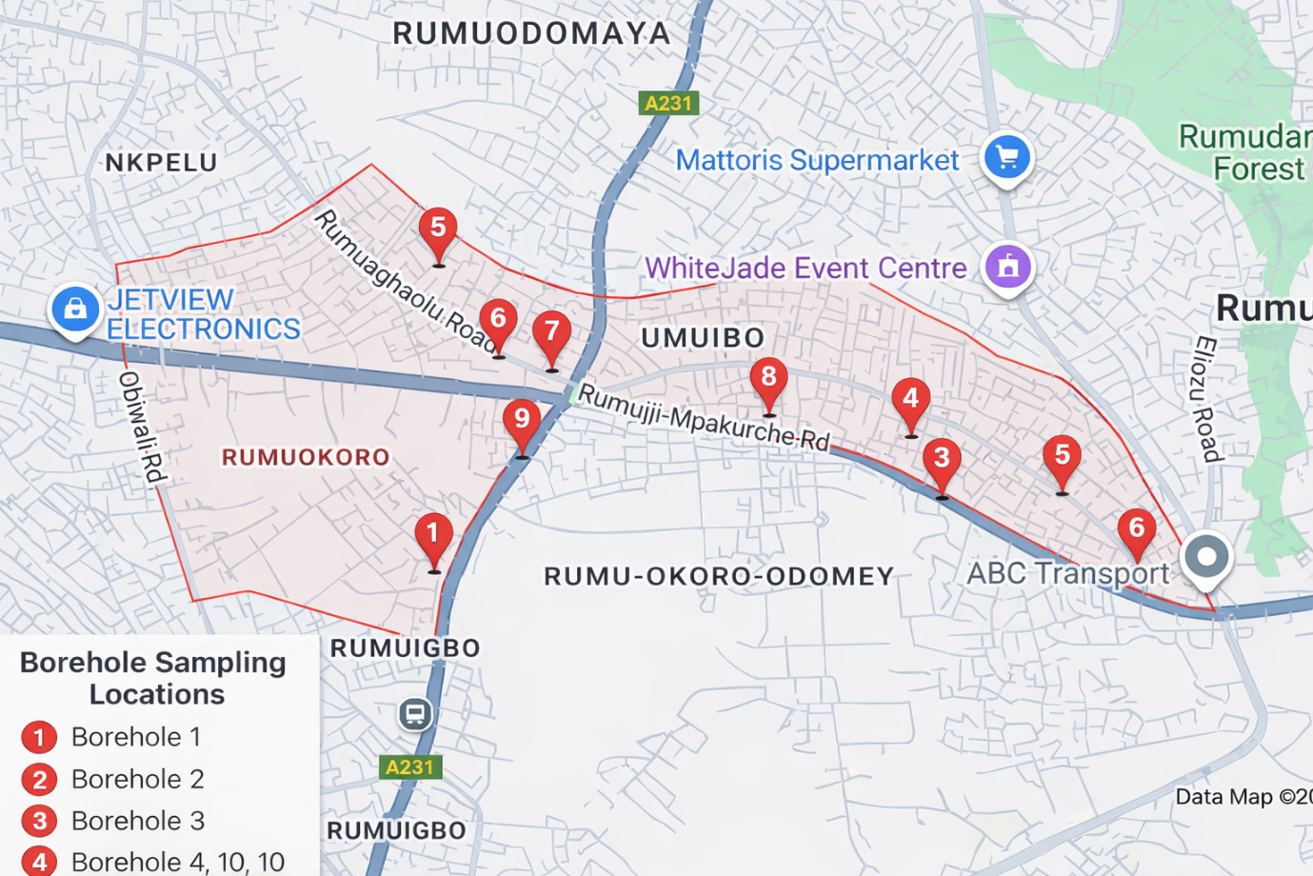

Figure 1: Location Map of Rumuokoro, Port Harcourt, Rivers State, Nigeria, Showing Borehole Sampling Sites

2.2 Sampling Design and Sample Size
A cross-sectional sampling design incorporating seasonal variation was adopted. A total of 10 functional boreholes commonly used for domestic purposes were selected across Rumuokoro based on accessibility, intensity of use, and spatial distribution. From these boreholes, 20 water samples were collected in total, comprising 10 samples during the dry season and 10 samples during the wet season. Each borehole was sampled once per season. Prior to sampling, boreholes were pumped for several minutes to flush stagnant water and obtain fresh groundwater.

2.3 Sample Collection and Preservation
Water samples for physicochemical and heavy metal analyses were collected in pre-cleaned polyethene bottles, while samples for microbiological analysis were collected in sterile glass bottles. Samples intended for heavy metal analysis were acidified in situ with concentrated nitric acid to a pH < 2 to prevent metal precipitation and adsorption onto container walls. All samples were stored in an ice chest at approximately 4 °C and transported to the laboratory for analysis within 24 hours of collection.

2.4 Physicochemical Analysis
Physicochemical parameters, including pH, temperature, electrical conductivity, total dissolved solids, and dissolved oxygen, were measured in situ using calibrated portable meters. Turbidity was determined using a nephelometric turbidity meter. Total hardness and alkalinity were determined by standard titrimetric methods. Major ions, including calcium, magnesium, sodium, potassium, chloride, sulphate, nitrate, and bicarbonate, were analysed following standard procedures recommended by APHA.

2.5 Heavy Metal Determination
For heavy metal analysis, preserved water samples were digested using nitric acid before analysis. Concentrations of iron, lead, cadmium, chromium, nickel, zinc, and copper were determined using flame Atomic Absorption Spectrophotometry. Instrument calibration was performed using certified standard solutions, and analytical accuracy was verified through the analysis of blanks and replicate samples.

2.6 Microbiological Analysis
Microbiological quality of the borehole water was assessed using standard membrane filtration techniques. Total coliforms, faecal coliforms, and Escherichia coli were enumerated and expressed as colony-forming units per 100 mL. Total heterotrophic bacterial counts were determined using the pour plate method and reported as colony-forming units per millilitre. Results were evaluated against World Health Organisation guidelines for drinking water quality.

2.7 Water Quality Index Assessment
Water Quality Index was used to evaluate the overall suitability of borehole water for drinking by integrating selected physicochemical and heavy metal parameters into a single value.
The relative weight (Wi) for each parameter was calculated as:
Wi = wi / Σwi
where
wi = assigned weight of each parameter
Σwi = sum of weights of all parameters
The quality rating (Qi) for each parameter was calculated as:
Qi = (Ci / Si) × 100
where
Ci = measured concentration of the parameter
Si = guideline value of the parameter
The sub-index (SIi) for each parameter was calculated as:
SIi = Wi × Qi
The overall Water Quality Index (WQI) was obtained using:
WQI = ΣSIi
The calculated WQI values were used to classify water quality into standard categories ranging from excellent to unsuitable for drinking.

2.8 Human Health Risk Assessment
Human health risk assessment was carried out following United States Environmental Protection Agency guidelines, considering ingestion of borehole water as the primary exposure pathway. Separate assessments were conducted for adults and children.

2.8.1 Estimated Daily Intake (EDI)
Estimated daily intake of heavy metals through drinking water ingestion was calculated as:
EDI = (C × IR × EF × ED) / (BW × AT)
where
C = concentration of metal in water (mg/L)
IR = ingestion rate (L/day)
EF = exposure frequency (days/year)
ED = exposure duration (years)
BW = body weight (kg)
AT = averaging time (days)

2.8.2 Non-Carcinogenic Risk Assessment
The hazard quotient (HQ) for each metal was calculated as:
HQ = EDI / RfD
where
RfD = reference dose of the metal (mg/kg/day)
The hazard index (HI), representing cumulative non-carcinogenic risk from multiple metals, was calculated as:
HI = ΣHQ
Hazard index values greater than one indicate potential non-carcinogenic health risk.

2.8.3 Carcinogenic Risk Assessment
Carcinogenic risk (CR) associated with exposure to carcinogenic metals was estimated using:
CR = EDI × CSF
where
CSF = cancer slope factor (mg/kg/day)⁻¹
The total carcinogenic risk was obtained by summing individual cancer risks and interpreted within the acceptable risk range of 1 × 10⁻⁶ to 1 × 10⁻⁴.

2.9 Quality Assurance and Quality Control
Quality assurance and quality control measures included the use of reagent blanks, duplicate samples, and calibration verification standards. All instruments were calibrated before analysis, and analytical precision was ensured through replicate measurements. Results were expressed as minimum, maximum, and mean ± standard deviation.

2.10 Statistical Analysis
Descriptive statistical analyses were performed to summarise physicochemical, microbiological, and heavy metal data. Results were presented as minimum, maximum, and mean ± standard deviation to highlight spatial and seasonal variability in borehole water quality across the study area.

3.0 Results
The results of the physicochemical, microbiological, and toxicological assessment of borehole water in Rumuokoro are presented based on analyses of 20 water samples collected from 10 boreholes during the dry and wet seasons. The physicochemical characteristics of the borehole water indicate slightly acidic to near-neutral conditions. pH values ranged from 5.8 to 7.2, with a mean of 6.6 ± 0.4. Electrical conductivity varied between 214 and 682 µS/cm (mean 436 ± 152 µS/cm), while total dissolved solids ranged from 142 to 468 mg/L (mean 291 ± 104 mg/L), all within World Health Organisation permissible limits. Turbidity values were low, ranging from 0.6 to 3.8 NTU (mean 1.9 ± 1.1 NTU). Total hardness values ranged from 62 to 168 mg/L (mean 112 ± 38 mg/L), indicating moderately hard water. Dissolved oxygen concentrations ranged from 3.1 to 6.4 mg/L, with some boreholes recording values below the recommended 5 mg/L, reflecting limited aeration typical of groundwater systems, as shown in Table 1.

Table 1: Physicochemical Characteristics of Borehole Water in Rumuokoro
Parameter | Minimum | Maximum | Mean ± SD | WHO Guideline
pH | 5.8 | 7.2 | 6.6 ± 0.4 | 6.5–8.5
Electrical Conductivity (µS/cm) | 214 | 682 | 436 ± 152 | 1,000
Total Dissolved Solids (mg/L) | 142 | 468 | 291 ± 104 | 500
Turbidity (NTU) | 0.6 | 3.8 | 1.9 ± 1.1 | 5
Temperature (°C) | 26.1 | 29.4 | 27.8 ± 1.2 | –
Dissolved Oxygen (mg/L) | 3.1 | 6.4 | 4.7 ± 1.0 | ≥5
Total Hardness (mg/L as CaCO₃) | 62 | 168 | 112 ± 38 | 200
Alkalinity (mg/L) | 44 | 126 | 78 ± 29 | –

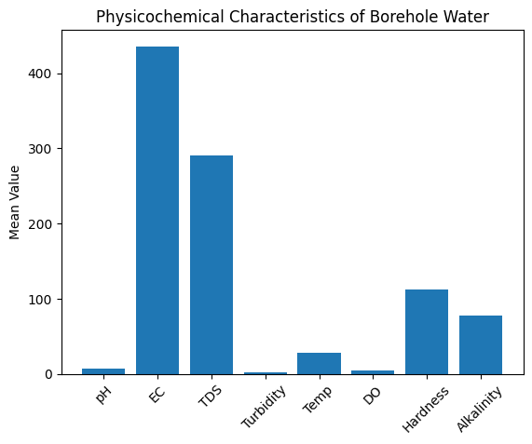Figure 2: Physicochemical Characteristics of Borehole Water in Rumuokoro, Port Harcourt
Major ion composition revealed calcium concentrations between 18.4 and 62.1 mg/L (mean 39.6 ± 15.2 mg/L) and magnesium between 6.2 and 28.7 mg/L (mean 15.4 ± 7.9 mg/L). Sodium concentrations ranged from 22.6 to 98.4 mg/L, while potassium concentrations ranged from 3.1 to 12.8 mg/L. Chloride levels varied from 36.5 to 182.4 mg/L (mean 96.8 ± 48.9 mg/L). Sulphate concentrations ranged between 18.3 and 94.7 mg/L, while nitrate concentrations ranged from 4.2 to 42.8 mg/L, approaching the WHO guideline value of 50 mg/L at some locations. Bicarbonate concentrations ranged from 58 to 192 mg/L, as shown in Table 2.

Table 2: Major Ion Composition of Borehole Water (mg/L)
Ion | Minimum | Maximum | Mean ± SD | WHO Guideline
Calcium (Ca²⁺) | 18.4 | 62.1 | 39.6 ± 15.2 | 75
Magnesium (Mg²⁺) | 6.2 | 28.7 | 15.4 ± 7.9 | 50
Sodium (Na⁺) | 22.6 | 98.4 | 56.7 ± 26.1 | 200
Potassium (K⁺) | 3.1 | 12.8 | 7.4 ± 3.6 | –
Chloride (Cl⁻) | 36.5 | 182.4 | 96.8 ± 48.9 | 250
Sulphate (SO₄²⁻) | 18.3 | 94.7 | 48.6 ± 27.5 | 250
Nitrate (NO₃⁻) | 4.2 | 42.8 | 21.6 ± 14.3 | 50
Bicarbonate (HCO₃⁻) | 58 | 192 | 116 ± 47 | –

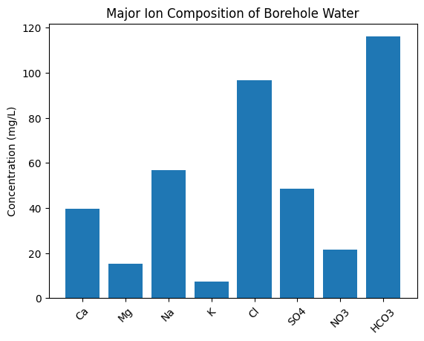Figure 3: Major Ion Composition of Borehole Water in Rumuokoro, Port Harcourt
Heavy metal analysis showed iron concentrations ranging from 0.18 to 0.92 mg/L, with a mean value of 0.46 ± 0.25 mg/L, exceeding the WHO guideline limit of 0.3 mg/L in several samples. Lead concentrations ranged from 0.004 to 0.021 mg/L (mean 0.012 ± 0.006 mg/L), exceeding the permissible limit of 0.01 mg/L in some boreholes. Cadmium concentrations ranged from 0.001 to 0.006 mg/L (mean 0.003 ± 0.002 mg/L), meeting or exceeding the guideline value of 0.003 mg/L. Chromium (0.006–0.031 mg/L), nickel (0.004–0.029 mg/L), zinc (0.12–0.88 mg/L), and copper (0.05–0.42 mg/L) were generally within WHO guideline limits as shown in Table 3.

Table 3: Heavy Metal Concentrations in Borehole Water (mg/L)
Metal | Minimum | Maximum | Mean ± SD | WHO Guideline
Iron (Fe) | 0.18 | 0.92 | 0.46 ± 0.25 | 0.3
Lead (Pb) | 0.004 | 0.021 | 0.012 ± 0.006 | 0.01
Cadmium (Cd) | 0.001 | 0.006 | 0.003 ± 0.002 | 0.003
Chromium (Cr) | 0.006 | 0.031 | 0.017 ± 0.009 | 0.05
Nickel (Ni) | 0.004 | 0.029 | 0.014 ± 0.009 | 0.02
Zinc (Zn) | 0.12 | 0.88 | 0.42 ± 0.29 | 3.0
Copper (Cu) | 0.05 | 0.42 | 0.21 ± 0.14 | 2.0

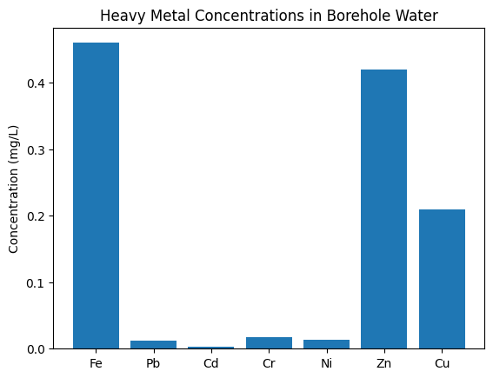Figure 4: Heavy Metal Concentrations in Borehole Water from Rumuokoro, Port Harcourt
Microbiological analysis revealed the presence of total coliforms, faecal coliforms, and Escherichia coli in several borehole samples. Total coliform counts ranged from 0 to 18 CFU/100 mL (mean 6.4 ± 6.8 CFU/100 mL), faecal coliforms ranged from 0 to 7 CFU/100 mL (mean 2.1 ± 2.9 CFU/100 mL), and E. coli ranged from 0 to 4 CFU/100 mL (mean 1.3 ± 1.6 CFU/100 mL), exceeding the WHO requirement of zero detection. Total heterotrophic bacterial counts ranged from 120 to 740 CFU/mL, with a mean of 418 ± 213 CFU/mL, exceeding the recommended limit of 500 CFU/mL in some locations, as shown in Table 4.

Table 4: Microbiological Quality of Borehole Water
Parameter | Minimum | Maximum | Mean ± SD | WHO Standard
Total Coliforms (CFU/100 mL) | 0 | 18 | 6.4 ± 6.8 | 0
Faecal Coliforms (CFU/100 mL) | 0 | 7 | 2.1 ± 2.9 | 0
Escherichia coli (CFU/100 mL) | 0 | 4 | 1.3 ± 1.6 | 0
Total Heterotrophic Bacteria (CFU/mL) | 120 | 740 | 418 ± 213 | ≤500

The computed water quality index yielded an overall value of 239, classifying the borehole water as very poor and unsuitable for drinking without treatment. Elevated sub-index contributions from iron and lead were the primary factors influencing the high WQI value, as shown in Table 5.

Table 5: Water Quality Index (WQI)
Parameter | Weight (Wi) | Quality Rating (Qi) | Sub-Index
pH | 4 | 88 | 352
TDS | 4 | 58 | 232
NO₃⁻ | 5 | 43 | 215
SO₄²⁻ | 3 | 19 | 57
Cl⁻ | 3 | 39 | 117
Fe | 5 | 153 | 765
Pb | 5 | 120 | 600
Overall WQI | – | – | 239

Non-carcinogenic human health risk assessment indicated that adults generally had hazard quotient values below unity for all assessed metals. In contrast, children recorded hazard quotient values exceeding unity for lead (1.58), cadmium (1.91), and nickel (1.14), indicating potential health risks through ingestion. Hazard index values reached 2.30 for lead and 2.55 for cadmium, highlighting increased vulnerability among children as shown in Table 6.

Table 6: Non-Carcinogenic Human Health Risk Assessment (Ingestion Pathway)
Metal | HQ Adults | HQ Children | Hazard Index (HI) | Risk Interpretation
Pb | 0.72 | 1.58 | 2.30 | Potential risk (children)
Cd | 0.64 | 1.91 | 2.55 | Significant risk
Cr | 0.28 | 0.52 | 0.80 | No risk
Ni | 0.41 | 1.14 | 1.55 | Potential risk
Zn | 0.09 | 0.18 | 0.27 | No risk

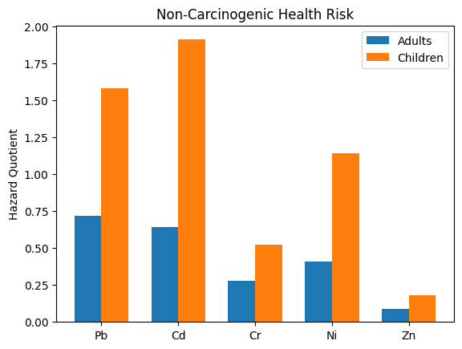Figure 5: Non-Carcinogenic Health Risk Assessment of Heavy Metals through Borehole Water Ingestion in Rumuokoro
Carcinogenic risk estimates for cadmium, chromium, and nickel ranged from 1.8 × 10⁻⁵ to 5.7 × 10⁻⁵, all within the acceptable risk range of 10⁻⁶ to 10⁻⁴. However, children consistently exhibited higher carcinogenic risk values compared to adults, as shown in Table 7.

Table 7: Carcinogenic Risk Assessment of Heavy Metals
Metal | CR Adults | CR Children | Acceptable Risk Range
Cd | 1.8 × 10⁻⁵ | 4.9 × 10⁻⁵ | 10⁻⁶–10⁻⁴
Cr | 9.2 × 10⁻⁶ | 2.1 × 10⁻⁵ | 10⁻⁶–10⁻⁴
Ni | 5.4 × 10⁻⁶ | 1.2 × 10⁻⁵ | 10⁻⁶–10⁻⁴

4.0 Discussion
Groundwater quality in urban and peri-urban communities of the Niger Delta is strongly influenced by a combination of natural hydrogeochemical processes and sustained anthropogenic pressures. The slightly acidic to near-neutral pH conditions commonly reported in regional groundwater systems have been shown to enhance the mobility of trace metals by reducing adsorption onto mineral surfaces and increasing dissolution from aquifer matrices (Etesin et al., 2025). Similar pH-controlled mobilisation mechanisms were observed in drinking water sources in Brass Island, where subtle changes in acidity significantly influenced metal availability and associated health risks (Ekesiobi et al., 2025). Comparable hydrochemical behaviour has also been documented in groundwater vulnerability assessments in Yenagoa, highlighting the sensitivity of Niger Delta aquifers to contaminant transport under prevailing geochemical conditions (Okagbare et al., 2025).
The dominance of calcium–magnesium–bicarbonate water types observed in many Niger Delta groundwater systems reflects intense water–rock interaction within unconsolidated deltaic sediments. Such hydrochemical signatures have been widely reported in stream and groundwater systems impacted by agricultural runoff and urban activities in southern Nigeria, where carbonate dissolution and silicate weathering coexist with anthropogenic solute inputs (Osuafor et al., 2025). Elevated chloride and nitrate levels reported in several regional studies have frequently been linked to domestic wastewater infiltration and poor sanitation rather than purely agricultural sources, underscoring the role of urban land use in groundwater degradation (Umueni et al., 2025).
Heavy metal occurrence in Niger Delta waters has consistently been associated with industrialisation, petroleum activities, and atmospheric deposition (Ekwere et al., 2025). Studies on gas flaring have demonstrated that soot and metal-laden particulates can be transported over long distances and deposited into surface environments, subsequently infiltrating shallow aquifers during recharge events (Aghanwa et al., 2025). This pathway provides a plausible explanation for the recurrent detection of lead and cadmium in groundwater and surface waters across Rivers and Bayelsa States. Similar contamination patterns have been reported in urban rivers of Benin City, where heavy metals co-occurred with other industrial contaminants and produced measurable ecotoxicological effects (Okpoji et al., 2025).
The toxicological relevance of lead and cadmium in water resources is further reinforced by bioaccumulation and biomarker studies in aquatic organisms from the Niger Delta estuaries. Experimental and field-based investigations have shown that exposure to environmentally realistic concentrations of these metals induces oxidative stress, histopathological alterations, and impaired physiological responses in fish and crustaceans (Ohaturuonye et al., 2025). Such findings highlight that even moderate concentrations in water can translate into significant biological effects over time. Similar conclusions have been drawn from studies on metal bioaccumulation in estuarine fish from Andoni and Iko River systems, which demonstrated clear links between environmental contamination and human dietary exposure (Okpoji et al., 2025; Onoja et al., 2025).
Microbiological contamination of groundwater remains a persistent challenge in densely populated Niger Delta communities (Ekwere et al., 2025). Investigations of drinking water sources in coastal and inland settlements have repeatedly shown that the presence of coliforms and faecal indicators is often unrelated to turbidity or general mineral quality, but rather to poor borehole construction, inadequate sanitary protection, and proximity to septic systems (Ekesiobi et al., 2025). Similar sanitary vulnerabilities have been reported for streams and shallow groundwater systems influenced by agricultural and domestic runoff, where microbial contamination posed greater immediate health risks than many chemical parameters (Osuafor et al., 2025).
The integration of chemical and microbiological parameters using water quality indices has proven effective in revealing cumulative risk that may not be evident from individual parameters alone. Previous applications of water quality indices in Niger Delta environments consistently classified waters as poor or unsuitable where heavy metals or microbial indicators dominated the index structure, even when most physicochemical parameters complied with guidelines (Ekesiobi et al., 2025). This reinforces the notion that regulatory compliance for individual parameters does not necessarily equate to overall water safety.
Human health risk assessments conducted across the Niger Delta consistently demonstrate higher vulnerability among children due to greater intake rates relative to body weight and increased physiological sensitivity. Studies assessing drinking water, sediments, and contaminated food items have shown that non-carcinogenic risk indices for children often exceed safe thresholds, particularly for lead and cadmium, even when adult risks remain comparatively low (Ekesiobi et al., 2025; Anarado et al., 2023). Carcinogenic risk estimates for metals such as cadmium, chromium, and nickel frequently fall within acceptable regulatory ranges; however, regional evidence suggests that cumulative exposure from multiple pathways, including water and diet, may elevate long-term health concerns (John et al., 2025; Okpoji et al., 2025).
From an environmental systems perspective, the contamination patterns observed in groundwater are consistent with broader Niger Delta pollution dynamics, where hydrocarbons, heavy metals, and emerging contaminants interact across water, sediment, and biotic compartments. Investigations of sediments in the Qua Iboe and Forcados river systems have demonstrated that geochemical partitioning and ecological risk are strongly influenced by persistent anthropogenic inputs (Okpoji et al., 2025; Umueni et al., 2025). These findings support the interpretation that groundwater contamination in urban centres such as Rumuokoro is part of a wider continuum of environmental degradation rather than an isolated phenomenon.
The evidence from regional literature indicates that safeguarding borehole water quality in the Niger Delta requires integrated management approaches that address both chemical and microbiological risks. Studies on advanced remediation technologies, including adsorption and photocatalytic treatment systems, suggest promising options for mitigating persistent contaminants where conventional treatment is insufficient (Okpoji et al., 2025). However, long-term risk reduction ultimately depends on improved land-use planning, stricter control of industrial emissions, effective sanitation infrastructure, and routine monitoring of groundwater resources across vulnerable communities.

Conclusion
This study provides a comprehensive evaluation of the physicochemical, microbiological, and toxicological quality of borehole water in Rumuokoro, Port Harcourt, an urban community within the Niger Delta, where groundwater serves as the primary source of domestic water. The findings demonstrate that although several physicochemical parameters generally fall within recommended guideline limits, this apparent compliance does not translate to overall water safety.
Hydrochemical characteristics indicate moderate mineralisation typical of Niger Delta aquifers developed within unconsolidated deltaic sediments. However, the slightly acidic nature of the groundwater creates favourable conditions for the mobilisation of certain trace metals. Elevated concentrations of iron, along with exceedances of guideline values for lead and cadmium in some boreholes, reveal the influence of anthropogenic activities such as industrial operations, urban runoff, atmospheric deposition, and possible corrosion-related processes. These contaminants are of particular concern due to their persistence, toxicity, and potential for bioaccumulation.
Microbiological analysis further highlights significant public health risks, as the detection of total coliforms, faecal coliforms, and Escherichia coli indicates faecal contamination and inadequate sanitary protection of borehole infrastructure. The presence of these indicators confirms that borehole water in the study area is vulnerable to contamination from domestic wastewater and poor waste management practices, posing immediate health risks to consumers.
Integrated assessment using the water quality index classified the borehole water as very poor, driven largely by heavy metal contamination and microbiological non-compliance. Human health risk assessment revealed that children are particularly vulnerable, with non-carcinogenic risk indices exceeding safe thresholds for lead, cadmium, and nickel, while carcinogenic risks, though within acceptable ranges, remain non-negligible under long-term exposure scenarios.

Disclaimer (Artificial intelligence)
Option 1:
Author(s) hereby declare that NO generative AI technologies such as Large Language Models (ChatGPT, COPILOT, etc.) and text-to-image generators have been used during the writing or editing of this manuscript.

References
Aghanwa, C. I., Umueni, U. E., Etukudo, N. J., Amachree, J. B., Okpoji, A. U., Ejeka, C. J., & Ekwere, I. O. (2025). Atmospheric deposition of soot and heavy metals from gas flaring into surface waters of Ebocha, Rivers State, Nigeria. Asian Journal of Environment & Ecology, 24(11), 137–147. https://doi.org/10.9734/ajee/2025/v24i11822
Anarado, C. J. O., Okpoji, A. U., & Anarado, C. E. (2023). Bioaccumulation and health risk assessment of lead, cadmium, arsenic, and mercury in blue crabs found in creeks in Bayelsa State of the Niger Delta region of Nigeria. Asian Journal of Environment & Ecology, 21(4), 46–59. https://doi.org/10.9734/AJEE/2023/v21i4469
Ekesiobi, S. U., Ekpe, J. E., Okpoji, A. U., Hassan, D. H., Ekwere, I. O., Awortu, R. C., Etesin, M. U., Nwofia, U., Okeke, C. F., & Nwankwo, A. O. (2025). Hydrochemical characterisation and health-risk assessment of drinking water sources in Brass Island, Bayelsa State, Nigeria. Asian Journal of Chemical Sciences, 15(6), 64–76. https://doi.org/10.9734/ajocs/2025/v15i6406
Ekpe, J. E., Okpoji, A. U., Ekwere, I. O., Anarada, C. J., Ewuola, A. A., Ufuoma, V. O., Okpanachi, C. B., Okonkwo, C. O., & Obunezi, O. A. (2025). Physico-chemical transport of pesticides and nutrients in irrigation water and their fate in agro-ecosystems of Rivers State, Nigeria. Palgo Journal of Agriculture, 9(2), 30–37.
https://doi.org/10.5281/zenodo.17148360
Ekwere, I. O., Okpoji, A. U., Igwegbe, K. C., Okonkwo, C. O., Yekeen, A. A., Obunezi, O. C., Okpanachi, C. B., Garuba, M. H., Ogini, O. R., & Odibo, U. E. (2025). Nutritional–Toxicological Trade-Off: Comparative Study of Polycyclic Aromatic Hydrocarbons in Smoked and Oven-Dried Nile Tilapia (Oreochromis niloticus). Journal of Environment, Climate, and Ecology, 2(2), 90-97. https://doi.org/10.69739/jece.v2i2.952
Ekwere, I. O., Okpoji, A. U., Okagbare, U. V., Ewuola, A. A., Awortu, R. C., Onoja, C. R., Alaekwe, I. O., Etesin, M. O., & Edodi, I. O. (2025). Nutritional evaluation of Nile tilapia (Oreochromis niloticus) processed by different drying methods in Akwa Ibom State, Nigeria. Journal of Sustainable Research and Development, 1(2), 11–17. https://doi.org/10.69739/jsrd.v1i2.1033
Etesin, M. U., Ezeabsili, P. I., Agu, M. O., Okeke, C. F., Olotu, O. N., Aligwo, M. C., Eze, V. C., Nwankwo, A. O., Okpoji, A. U., & Ekong, I. U. (2025). Determination of polychlorinated biphenyls in soils and industrial effluents and health risks assessment in Uyo, Akwa Ibom State, Nigeria. Journal of Medical Science, Biology, and Chemistry, 2(2), 285–292. https://doi.org/10.69739/jmsbc.v2i2.1258
John, E. E., Emah, O. A., Ifiok, O. E., Okpoji, A. U., Iyam, O. E., Henderson, O. O., Akinola, A. E., Gloria, N. A., & Charles, N. O. (2025). Health Risk Implications of Polycyclic Aromatic Hydrocarbons in Smoked and Dried Fish Consumed in Nigeria. Journal of Medical Science, Biology, and Chemistry, 2(2), 192–199. https://doi.org/10.69739/jmsbc.v2i2.1045
Ogbaji, H. O., Akpan, N. A., Ijioma, C. C., Okpoji, A. U., Eze, V. C., Obi, J. N., Martins, N. P., & Etesin, M. U. (2025). Seasonal variation in hydrocarbon contamination of sediments and biota in Bonny Estuary, Rivers State, Nigeria. Asian Journal of Geographical Research, 8(4), 330–338. https://doi.org/10.9734/ajgr/2025/v8i4341
Ohaturuonye, S. O., Okpoji, A. U., Akpan, N. A., Njoku, C. A., Isaac, S. C., Etesin, M. U., & Ekwere, I. O. (2025). Biomarker responses in fish and crustaceans exposed to heavy metals and petroleum hydrocarbons in the Qua Iboe Estuary, Niger Delta. Asian Journal of Research in Zoology, 8(4), 234–244. https://doi.org/10.9734/ajriz/2025/v8i4233
Okagbare, U. V., Umueni, U. E., Ekpe, J. E., Etukudo, N. J., Okpoji, A. U., Okoye, P. I., Ekwere, I. O., Etesin, M. U., Okpanachi, C. B., & Okafor, C. A. (2025). Geophysical and Hydrochemical Assessment of Groundwater Vulnerability to Oil Pollution in Yenagoa, Bayelsa State, Nigeria. Journal of Environment, Climate, and Ecology, 2(2), 138–146. https://doi.org/10.69739/jece.v2i2.1078
Okpoji, A. U., Akpan, N. A., Eze, V. C., Ijioma, C. C., Hassan, D. H., Kareem, M. M., Obi, A. I., Aningo, G. N., Okoye, P. I., Ogbonnaya, C. N., Ekwere, I. O., Okeke, C. F., & Aligwo, M. C. (2025). Toxicity and bioaccumulation of heavy metals and polycyclic aromatic hydrocarbons in estuarine fish from the Andoni Estuary, Niger Delta, Nigeria. Journal of Applied Physical Science International, 17(2), 10–22. https://doi.org/10.56557/japsi/2025/v17i210026
Okpoji, A. U., Anarado, C. O., Mmuta, E. C., Ekwere, I. O., Alaekwe, I. O., Odibo, U. E., Igwegbe, K. C., Eboj-Ajoku, I. O., & Obunezi, O. C. (2025). Toxicological evaluation of Pb, Cd, As, and Hg in blue crab from oil-polluted creeks in the Niger Delta. Journal of Life Science and Public Health, 1(1), 24–31. https://doi.org/10.69739/jlsph.v1i1.879
Okpoji, A. U., Chinyere, U. E., Nwokoye, J. N., Ezekwuemen, O. I., Alaekwe, I. O., Odidika, C. C., Owughara, C. N., Enyi, C. M., & Kolawole, O. O. (2025). Environmental Assessment of Heavy Metals and Hydrocarbon Pollution in Surface Waters of Oil-Bearing Communities in Andoni, Rivers State, Nigeria. International Journal of Modern Science and Research Technology, 3(8), 22–30. https://www.ijmsrt.com/environmental-assessment-of-heavy-metals-and-hydrocarbon-pollution-in-surface-waters-of-oil-bearing-communities-in-andoni-rivers-state-nigeria
Okpoji, A. U., Eboh-Ajoku, I. O., Mmuta, E. C., Ndubuisi, J. O., Alaekwe, I. O., Odibo, U. E., Nwoka, N. G., Okafor, C. A., & Obunezi, O. C. (2025). Integrated environmental risk assessment of BTEX and PAHs in water and sediment samples from the Bonny River, Nigeria. ISA Journal of Multidisciplinary (ISAJM), 2(4), 14–21. https://doi.org/10.5281/zenodo.16921896
Okpoji, A. U., Ekwere, I. O., Igwegbe, K. C., Anarado, C. J. O., Ogbonna, C., Ewuola, A. A., Odibo, U. E., & Garuba, M. H. (2025). Volatile organic compounds from gas flaring and their atmospheric implications in the Niger Delta. Journal of Life Science and Public Health, 1(1), 32–39. https://doi.org/10.69739/jlsph.v1i1.962
Okpoji, A. U., Ekwere, I. O., Igwegbe, K. C., Etesin, U. M., Ugwuanyi, G. C., Okpanachi, C. B., Ewuola, A. A., Mojisola, K. M., & Ezekwueme, O. I. (2025). Solar-enhanced photocatalytic degradation of pharmaceutical residues in wastewater using Fe-, Cu-, and Zn-doped TiO₂ nanomaterials. Journal of Environment, Climate, and Ecology, 2(2), 56–62. https://doi.org/10.69739/jece.v2i2.961
Okpoji, A. U., Emem, J. A., Ekwere, I. O., Odibo, U. E., Aleaekwe, I. O., Warder, A. B., & Eboj-Ajoku, O. I. (2025). Bioaccumulation of nickel, lead, and cadmium in tissues of Callinectes sapidus from the Iko River, Nigeria: Implications for human health risk and environmental safety. Journal of Environment, Climate, and Ecology, 2(2), 29–37. https://doi.org/10.69739/jece.v2i2.844
Okpoji, A. U., Etesin, M. U., Ekwere, I. O., Martins, N. P., Okpanachi, C. B., Adisa, O. J., & Okonkwo, C. C. (2025). Geochemical speciation and ecological risk of heavy metals in estuarine sediments of the Qua Iboe River, Nigeria. Asian Journal of Chemical Sciences, 15(6), 20–31. https://doi.org/10.9734/ajocs/2025/v15i6402
Okpoji, A. U., Ndubuisi, J. O., Eboh-Ajoku, I. O., Emem, J. A., Ekwere, I. O., Alaekwe, I. O., Odibo, U. E., Igwegbe, K. C., Onoja, C. R., Warder, A. B., & InyangAbia, A. J. (2025). Trematode infections and histopathological effects in Chrysichthys nigrodigitatus from the polluted Andoni River, Niger Delta, Nigeria. Journal of Agriculture, Aquaculture, and Animal Science, 2(2), 66–72. https://doi.org/10.69739/jaaas.v2i2.882
Okpoji, A. U., Nwoka, N. G., Odibo, U. E., Alaekwe, I. O., Okafor, C. A., Ogwu, N. G., & Akatakpo, C. U. (2025). Seasonal variation in hydrochemical characteristics and heavy metal risk assessment of groundwater in Andoni-Isiokwan District, Niger Delta, Nigeria. International Journal of Modern Science and Research Technology, 3(8), 44–51. https://doi.org/10.5281/zenodo.16778873
Okpoji, A. U., Ogbaji, H. O., Hassan, D. H., Orji-Azuka, L. N., Rasheed, H. O., Ohaturuonye, S. O., Ejeka, J. C., Okpanachi, C. B., & Ekwere, I. O. (2025). Physico-chemical transport of volatile organic compounds (VOCs) from gas flaring into surface waters of Ogoniland, Rivers State, Nigeria. Asian Journal of Physical and Chemical Sciences, 13(4), 151–159. https://doi.org/10.9734/ajopacs/2025/v13i4271
Okpoji, A. U., Orji-Azuka, L. N., Igwegbe, K. C., Ekwere, I. O., Ewuola, A. A., Garuba, M. H., & Etukudo, E. W. (2025). Water quality and ecotoxicological impacts of surfactants and heavy metals in urban rivers of Benin City, Niger Delta, Nigeria. Asian Journal of Geological Research, 8(3), 697–707. https://doi.org/10.9734/ajoger/2025/v8i3223
Onoja, C. R., Ogbaji, H. O., Edodi, I. O., Mmuta, E. C., Igwegbe, K. C., Ogini, O. R., Odibo, U. E., Ewuola, A. A., Mahmoud, A. B., & Okpoji, A. U. (2025). Heavy Metal Contamination and Health Risk Assessment of Smoked-Dried Fish Sold in Eke-Awka Market, Anambra State, Nigeria. Journal of Sustainable Research and Development, 1(2), 18-25. https://doi.org/10.69739/jsrd.v1i2.1044
Osuafor, O. O., Okeke, C. F., Agu, M. O., Isueken, C. O., Aligwo, M. C., Ohaturuonye, S. O., Okpoji, A. U., Etesin, M. U., & Ekwere, I. O. (2025). Hydrogeochemical characterisation and water quality assessment of streams impacted by agricultural runoff in Uyo, Akwa Ibom State, Nigeria. Asian Journal of Agricultural and Horticultural Research, 12(4), 182–192. https://doi.org/10.9734/ajahr/2025/v12i4427
Umueni, U. E., Etukudo, N. J., Okoye, P. I., Okpoji, A. U., Eze, V. C., Aningo, G. N., Ekwere, I. O., & Garuba, M. H. (2025). Geochemical and ecological risk assessment of petroleum hydrocarbons in sediments of Forcados River, Delta State. Asian Journal of Geographical Research, 8(4), 287–298. https://doi.org/10.9734/ajgr/2025/v8i4337
Umueni, U. E., Rasheed, H. O., Edodi, I. O., Aningo, G. N., Okpoji, A. U., Etesin, M. U., Okonkwo, C. C., Ekwere, I. O., Okeke, C. F., & Anarah, S. E. (2025). Nutrient enrichment and eutrophication potential of agricultural runoff in Otuoke, Bayelsa State, Nigeria. Asian Journal of Agricultural and Horticultural Research, 12(4), 154–163. https://doi.org/10.9734/ajahr/2025/v12i4424

