Settlement Distribution and Coastal Vulnerability in the Andaman Islands: A Spatial Analysis
Abstract
The Andaman Islands, located in the Bay of Bengal, represent one of India’s most hazard-prone coastal environments. Their proximity to the Andaman–Sumatra subduction zone exposes them to recurrent seismic activity, tsunamis, and coastal flooding. This study employs Geographic Information System (GIS) techniques to analyse the spatial distribution of settlements and to assess coastal vulnerability. Using open-source datasets, including digital elevation models (DEM), tsunami event points, population density, and built-up areas, multi-hazard vulnerability maps were generated. Buffer zones of 500 m, 1 km, and 2 km were created around tsunami points to represent varying degrees of risk, while elevation data below 10 m were classified as highly susceptible. The overlay of these datasets reveals that several major settlements, particularly around Port Blair, fall within critical hazard zones. The results emphasise the essential role of GIS in disaster preparedness, coastal planning, and building resilient island communities.
Keywords: Coastal vulnerability, GIS, Tsunami, Andaman Islands, Settlement mapping, Disaster risk reduction

1. Introduction
Coastal regions are among the most dynamic and densely populated environments on Earth, yet they face growing exposure to natural hazards such as tsunamis, cyclones, and coastal flooding. The Andaman Islands, part of the Andaman and Nicobar archipelago, lie within a tectonically active zone where the Indian and Burmese plates converge, making them highly susceptible to seismic and tsunami-related events (Toushif et al., 2020; Mondal et al., 2024). The catastrophic 2004 Indian Ocean tsunami devastated large parts of the archipelago, causing massive loss of life and infrastructure, and highlighting the islands’ extreme vulnerability (Kohl et al., 2005; Sathiya Bama et al., 2020).
Over the past two decades, rapid urban growth, increasing population pressure, and infrastructural expansion have intensified coastal occupation, particularly in low-lying areas. Many settlements are located on reclaimed land and coastal plains that are less than 10 m above mean sea level, making them extremely prone to inundation during tsunami events (Ali et., 2020; Chakraborty et al., 2021). Therefore, understanding the spatial relationship between settlement distribution and hazard exposure is essential for disaster risk reduction and sustainable land-use planning. Geographic Information Systems (GIS) provide an effective framework for integrating spatial datasets such as elevation, land use, and population to analyse vulnerability patterns (Malczewski et al., 2004; Mageswaran et al., 2021). By combining topographic, demographic, and hazard information, GIS-based analysis can identify high-risk zones and support informed decision-making in coastal management. The present study applies GIS techniques to evaluate settlement vulnerability in the Andaman Islands and proposes spatial strategies for improving disaster resilience.
2. Objectives
- To map coastal settlements across the Andaman Islands using GIS.
- To delineate tsunami buffer zones and assess their spatial overlap with human settlements.
- To identify and classify elevation zones below 10 m as highly vulnerable to inundation.
- To integrate all layers to produce a final vulnerability map supporting disaster management and planning.
3. Literature Review
Many researchers have explored coastal vulnerability and tsunami risk in the Andaman and Nicobar Islands, especially after the devastating 2004 Indian Ocean tsunami. Andrade et al. 2014, conducted one of the earliest GIS-based assessments of tsunami vulnerability in South Andaman. Their study found that areas located below 10 meters in elevation and within one kilometre of the coastline were the most severely affected. This research laid the foundation for subsequent studies that focused on mapping and understanding the spatial patterns of vulnerability in the region.
Several findings revealed that low-lying coastal plains and reclaimed lands were particularly prone to flooding and damage. Similarly, Dharanirajan et al. (2007) analysed post-tsunami conditions using IRS satellite data and highlighted the importance of integrating remote sensing and GIS techniques for accurate disaster monitoring and future planning. Beyond the Andaman Islands, several other studies have examined coastal hazards along India’s eastern coast. (Nageswara Rao et al., 2008) assessed cyclone and coastal hazards along the Andhra Pradesh coast using GIS-based buffer analysis, while (Sood et al., 2025) developed a multi-hazard vulnerability framework for the Chennai coast. A Fuzzy Analytical Hierarchical Process (FAHP) based Multi-Criteria Decision Making (MCDM) approach was utilised to demonstrate how GIS can effectively integrate different environmental and human factors to assess risk more precisely. Under the ISRO Coastal Zone Studies program, pointed out that island and coastal regions lying below 10 meters are especially vulnerable to extreme coastal events such as tsunamis and storm surges. Supporting this view, NOAA (2015) provided tsunami hazard assessment guidelines that identify coastal areas below 10 meters elevation as critical zones for early warning systems and evacuation planning. Together, these studies form a strong scientific background for the present research. Building on their findings, the current study focuses specifically on understanding how settlement distribution overlaps with tsunami-prone areas in the Andaman Islands using GIS-based techniques. This work aims to map and visualise the most vulnerable zones, providing insights that can support disaster preparedness, safe urban planning, and long-term coastal resilience
4. Study Area
The Andaman Islands are located between 10°30′ N and 13°41′ N latitudes and 92°12′ E and 93°57′ E longitudes, forming a chain of tropical islands in the Bay of Bengal. The region is characterised by hilly terrain in the interior and narrow coastal plains along the shoreline, much of which is fringed by mangroves and coral reefs that act as natural barriers against storm surges (Andrade et al., 2014). The islands experience a humid tropical climate with an annual rainfall exceeding 3,000 mm and are frequently affected by earthquakes and tsunami events due to their proximity to the Andaman–Sumatra subduction zone (IMD, 2016).
This study focuses on South Andaman, particularly the Port Blair region, which serves as the administrative capital and hosts the major settlements. Previous studies indicate that coastal areas of Port Blair and surrounding villages, such as Garacharma and Bambooflat, lie at elevations below 10 m above mean sea level, making them highly vulnerable to tsunami inundation (Ali et al., 2020). According to the NOAA (2015) tsunami hazard guidelines, coastal zones located below 10 m elevation and within 1-2 km of the shoreline should be classified as critical areas for hazard preparedness and evacuation planning.
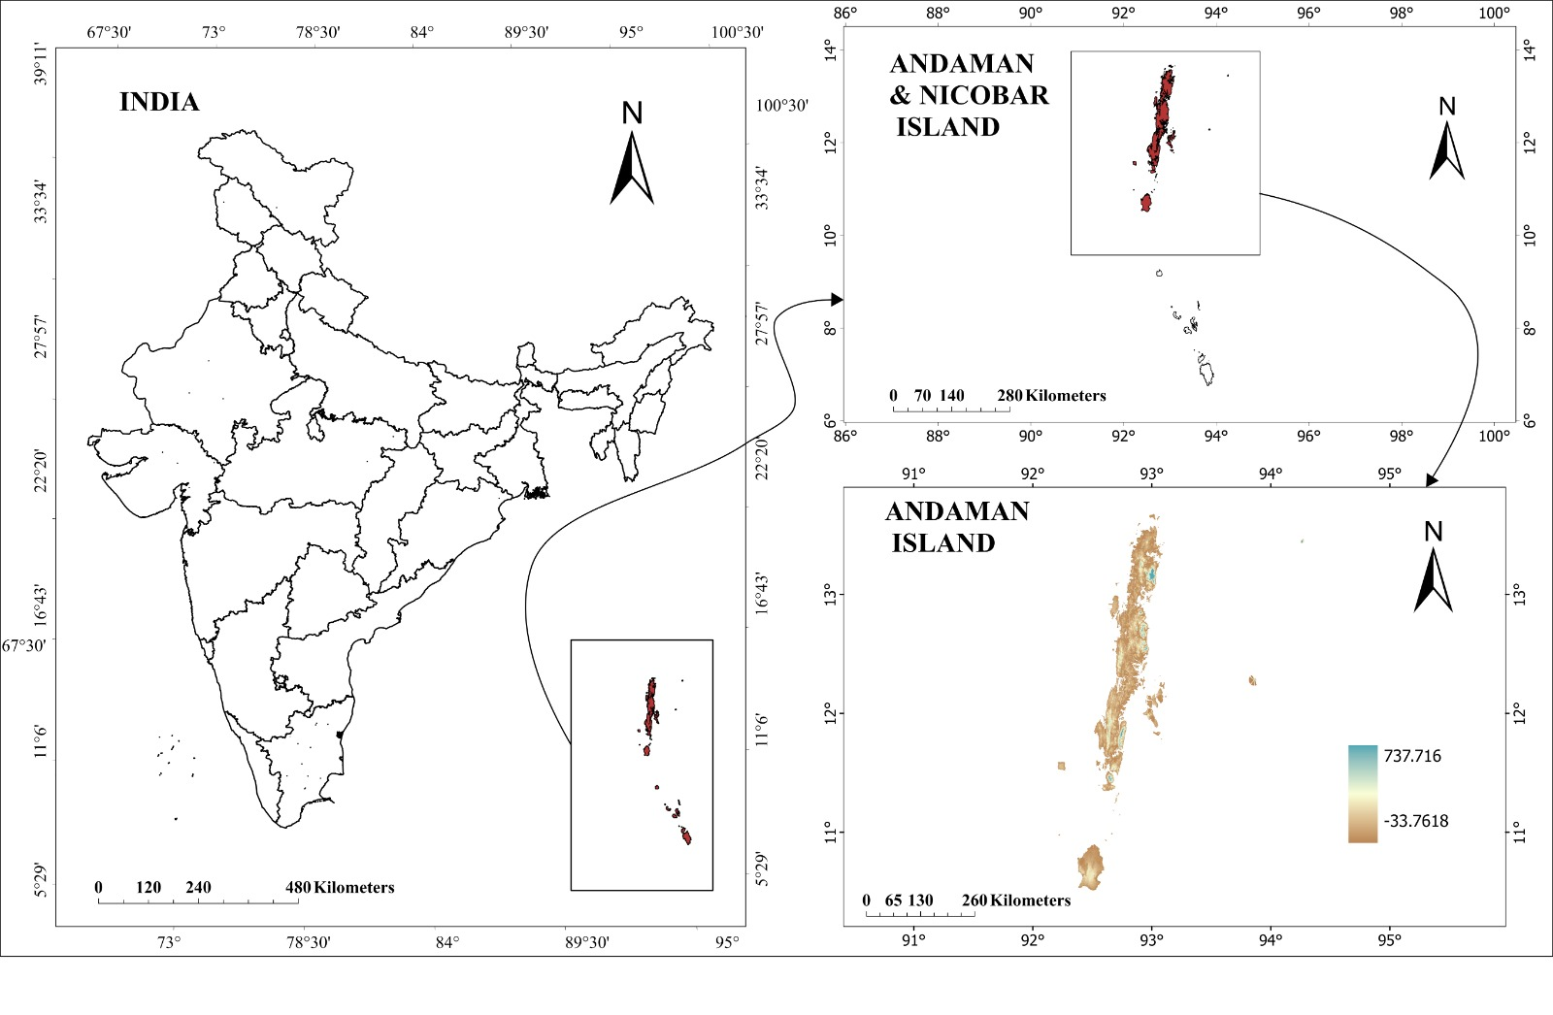
Fig 1 Location of the Study area
5. Methodology

Table 1: Data Type and Their Sources

Data Type | Source | Description
Digital Elevation Model (DEM) | Shuttle Radar Topography Mission (SRTM, 30 m) | Used to extract elevation and identify low-lying areas.
Tsunami Event Points | NCEI/WDS Global Historical Tsunami Database  Shoreline and land use–land cover changes along the 2004 tsunami-affected South Andaman coast (Ghadamode et al., 2024) | Historical tsunami locations and intensity data.
Built-up Areas | Copernicus Global Human Settlement Layer  (GHS_BUILT_S_E2025_GLOBE_R2023A_54009_100, Release R2023A) | Spatial extent of urban development.
The study followed a step-by-step approach within a GIS environment to prepare, analyse, and map spatial data related to tsunami hazard vulnerability in the Andaman Islands. To begin with, all spatial datasets were converted to a common coordinate reference system (WGS 84 UTM Zone 46 N) to ensure proper spatial alignment. The datasets were then clipped to the boundary of the Andaman Islands so that the analysis was confined strictly to the study area. Information on historical tsunami events was collected from the NCEI/WDS Global Historical Tsunami Database and further verified using published research and available maps. The verified tsunami locations were digitised in a Python-based GIS workspace to create a separate tsunami point layer, which served as the primary input for hazard zonation and subsequent analyses.
These tsunami points were used to generate buffer zones at distances of 500 m, 1 km, and 2 km. The buffers represent varying levels of potential tsunami impact, with areas closer to the coastline and event locations considered more vulnerable than those farther away. Elevation was analysed using a Digital Elevation Model (DEM) to identify low-lying areas susceptible to inundation. Using the Raster Calculator, areas below 10 m elevation were extracted using the expression Con ("Fill_M_DEM" < 10, 1). Areas lying below this threshold were treated as highly vulnerable, as they are more likely to be affected during tsunami events.
To assess exposure, the settlement layer was overlaid with the tsunami buffer zones and the elevation-based vulnerability map. This overlay analysis helped to identify settlements located within high-risk zones and provided insights into the extent of population exposure. Finally, the results from all analyses were integrated to prepare thematic maps showing tsunami buffers, low-elevation zones, and overall settlement vulnerability. These maps form the main visual outputs of the study and offer a clear spatial understanding of tsunami risk across the Andaman Islands.
6. Results
6.1 Buffer Zone Analysis
The tsunami buffer analysis reveals a clear spatial gradient of risk around coastal settlements in the study area, with vulnerability decreasing progressively with distance from the coastline. The analysis highlights distinct exposure patterns within the three buffer zones, reflecting variations in settlement density, land use, and proximity to the shoreline.
The immediate zone (0–500 m) represents the most critical risk area and includes highly urbanised coastal locations such as Port Blair, Haddo, and Phoenix Bay. These areas are directly exposed to tsunami inundation due to their proximity to the coast and low elevation. The concentration of administrative functions, transport infrastructure, and dense residential settlements within this zone significantly increases potential human and economic losses during tsunami events.
The moderate zone (500 m–1 km) comprises semi-urban and peri-urban areas, including settlements such as Garacharma. Although these areas are relatively farther from the shoreline, they remain vulnerable to tsunami impacts, particularly wave run-up, backflow, and flooding through low-lying channels and drainage networks. Expansion of residential areas and critical infrastructure into this zone has further increased exposure levels, highlighting the need for planned development and effective early-warning mechanisms.
The peripheral zone (1–2 km) includes smaller villages and inland settlements that are less likely to experience direct inundation. However, these areas may still be affected by secondary impacts such as damage to roads, power supply, communication networks, and emergency access routes. In many cases, this zone plays a crucial role during disasters, serving as potential evacuation and relief areas for populations displaced from high-risk coastal zones.
Overall, the buffer zone analysis underscores the importance of distance from the coastline as a key determinant of tsunami risk. It provides a spatial framework for prioritising disaster preparedness measures, evacuation planning, and land-use regulation, particularly in rapidly urbanising coastal areas of the Andaman Islands.
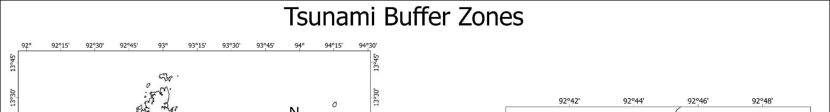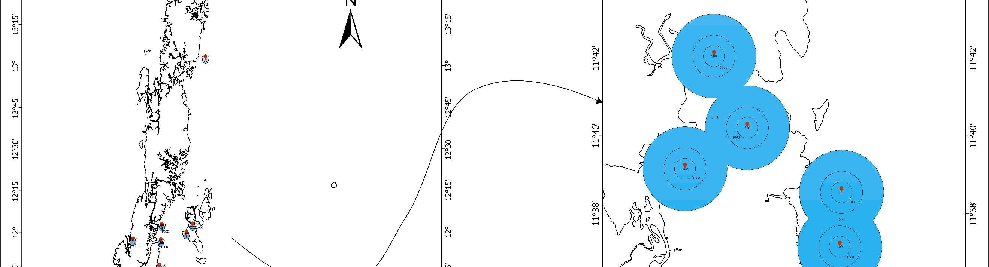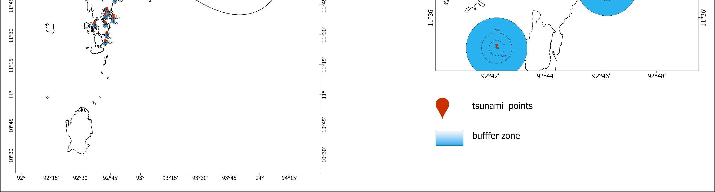
Figure 2. Tsunami Buffer Zones in South Andaman. The inset panel (square box) does not indicate an area of interest per se; it illustrates how the tsunami buffer zones are formed.
6.2 Elevation Analysis
The DEM-based elevation model indicated that approximately 40% of South Andaman lies below 10 m. These low-lying areas correspond closely with zones impacted during the 2004 tsunami. The most vulnerable areas include Port Blair’s coastal neighbourhoods, Sippighat, Bambooflat, and parts of Wandoor.
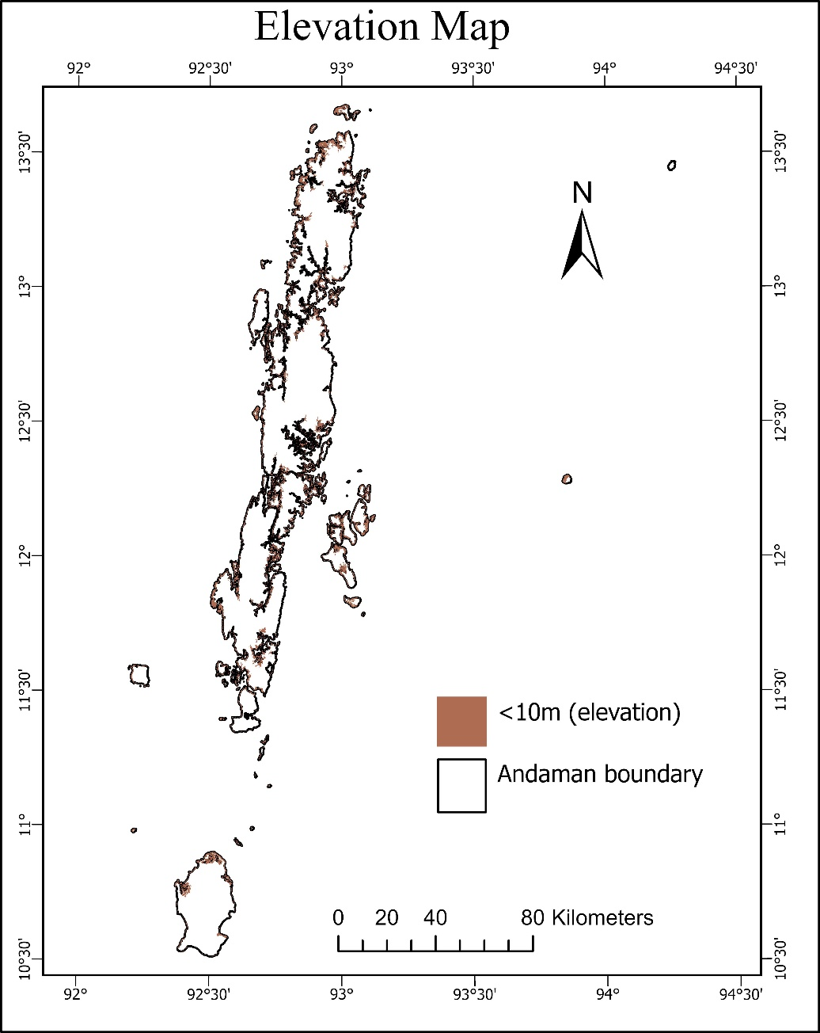
Figure 3. Elevation Map Showing Areas below 10 m

6.3 Composite Vulnerability Mapping
By integrating elevation and buffer data, a composite vulnerability map was generated. Settlements are classified into low, moderate, and very high based on density. Settlements that meet both criteria below 10 m elevation and within 1 km of tsunami points are classified as high risk. The results show that the eastern coastline and the southern fringes of Port Blair are most vulnerable, while inland hilly regions are relatively safer.
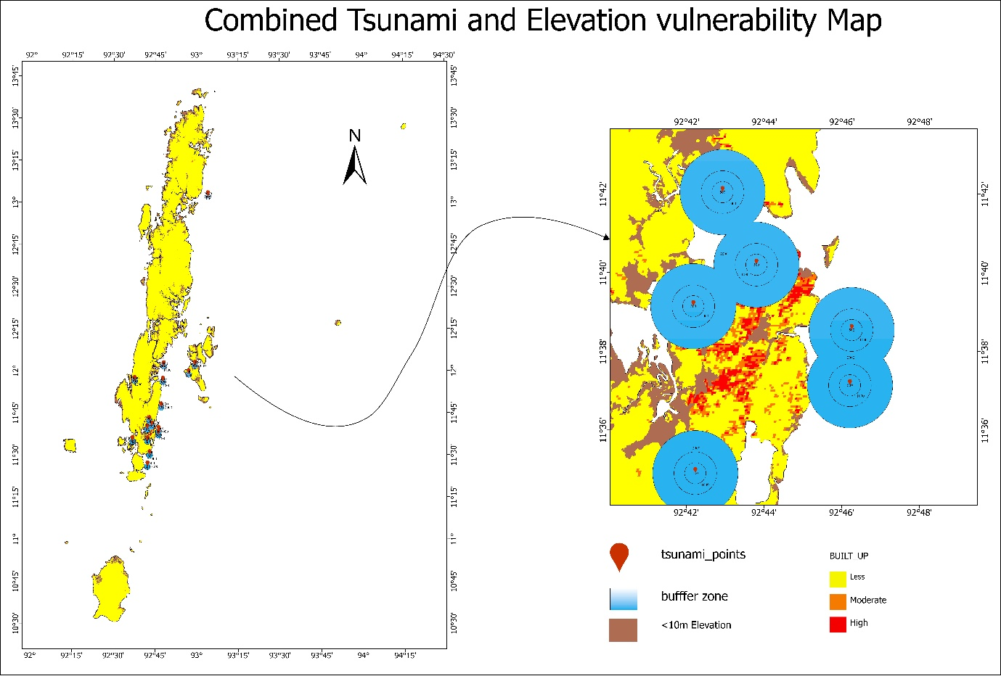
Figure 4. Composite tsunami and elevation susceptibility map of the total Andaman and Nicobar Islands. The inset panel (square box) does not indicate an area of interest; it illustrates how the tsunami buffer zones are formed and how they overlap the built-up density and low elevation areas.
7. Discussion
The findings show that there is a high spatial correlation between settlement density and physical vulnerability; most high-density settlements were found in the most prone areas to hazards (coastal areas). This trend is indicative of the increasing strain of urbanisation on the vulnerable coastal environments, which have been widely recorded in literature on tsunami vulnerability studies, with the use of GIS and remote sensing methods (Tika et al., 2025). Concentration of settlements in the low-lying coastal areas further increases the exposure to tsunami inundation, especially in the insular setting where evacuation routes and response time are limited. Past studies have established that the low elevation is a critical level that controls the tsunami inundation and related damage, and coastal regions lower than about 10 m above mean sea level were particularly vulnerable to floods (Malczewski et al., 2004; Anfuso et al., 2021). In the current study, these results are supported by the use of recent spatial data, and it is observed that the combination of elevation and distance to historical tsunami epicentres provides a more detailed and spatially descriptive risk profile. Similar investigations underline that the height and distance to the shore are still the most commonly used physical factors of tsunami effects, especially when intertwined through overlay analysis based on GIS (Tika et al., 2025). The analysis of settlement distribution is also enhanced by the use of the built-up density of the Global Human Settlement Layer (GHSL). GHSL framework provides a remotely sensed world-consistent image of built-up surfaces and has been used extensively as a proxy of human settlement distribution and exposure particularly in data-deficient areas (Pesaresi et al., 2016), and established that spatially intense, continuous, and clustering built-up areas are a reliable way of capturing the pattern of settlement concentration and can be used to aid in exposure assessment in the absence of fine census data.
In the current research, the visual overlapping of the high-density patches of the GHSL built-up and the tsunami buffer zones illustrates the high level of interdependence between the physical hazards process and the human occupation pattern, which supports the appropriateness of GHSL data in the analysis of tsunami vulnerability. As demonstrated in this study, GIS can be used to effectively map the hazard-prone areas spatially and provide the evidence based decision making in managing risks in coastal areas. The ability of vulnerability frameworks based on GIS to determine safe developmental areas in the future, plan evacuation routes, and rank high-risk settlements is well known (Tika et al., 2025). Combined with rapid methods of tsunami hazard approximation, e.g. machine-learning-based surrogate models, GIS-derived vulnerability layers can also contribute to better preparedness by enabling more specific and rapid response plans (Ramalingam et al., 2025).
However, the present study is primarily concentrated on physical vulnerability. The latest discoveries that have been made in research on tsunami risks highlight the significance of combining physical exposure with early warning effectiveness and response capacity. Research on early warning systems against tsunamis indicates that the high accuracy of hazard detection is not always adequate because vulnerable groups do not receive early warnings or have a means to evacuate them. (Elbehiri et al., 2025). Furthermore, unionised earthquake-tsunami early warning structures depict that minimising warning time is particularly significant to near-shore tsunamis to densely populated coastlines (Rea et al., 2025). In this respect, the addition of socio-economic aspects in terms of income level, building materials, population movement and easy access to emergency services would provide a more inclusive risk assessment and facilitate the analysis as part of the developing multidimensional tsunami vulnerability models.
8. Applications and Policy Implications
The findings of this study have several important applications for disaster management and sustainable coastal planning in the Andaman Islands. By identifying high-risk settlements, the study supports more effective disaster preparedness through targeted evacuation planning and the development of early-warning systems. The vulnerability maps can guide urban planners and local authorities in enforcing coastal zoning regulations and strengthening building codes to minimise exposure in hazard-prone areas. Furthermore, safer inland zones located at elevations above 20 meters can be prioritised for resettlement and new infrastructure development, reducing population pressure along the vulnerable coastline. Environmental management also plays a key role, as the protection and restoration of natural barriers such as mangrove forests and coral reefs can significantly reduce wave energy and coastal erosion. In addition, the maps and spatial data generated in this study can be used for community awareness programs, educational outreach, and local training workshops to enhance public understanding of disaster risk and promote a culture of preparedness among island residents.
9. Conclusion
This study demonstrates the usefulness of GIS-based analysis in assessing coastal settlement vulnerability in the Andaman Islands. The integration of elevation and tsunami buffer zones effectively highlights the settlements most at risk from coastal hazards. Port Blair and its adjoining coastal villages emerged as the most vulnerable due to their low elevation and high population density. The findings reinforce the necessity for risk-sensitive urban planning, strengthened disaster management systems, and the incorporation of hazard data into future development projects. By adopting spatial analysis as a planning tool, decision-makers can enhance resilience, reduce exposure, and safeguard communities from future coastal disasters. GIS offers not only analytical precision but also a visual framework for communicating risk, making it an essential component of sustainable coastal management and policy formulation in the Andaman Islands.

Disclaimer (Artificial intelligence)

Author(s) hereby declare that NO generative AI technologies such as Large Language Models (ChatGPT, COPILOT, etc.) and text-to-image generators have been used during the writing or editing of this manuscript.

References
- Ali, M. E. (2020). Urbanisation in India: Causes, growth, trends, patterns, consequences & remedial measures. https://doi.org/10.13140/RG.2.19007.05284
- Andrade, V., Rajendran, K., & Rajendran, C. P. (2014). Sheltered coastal environments as archives of paleo-tsunami deposits: Observations from the 2004 Indian Ocean tsunami. Journal of Asian Earth Sciences. https://doi.org/10.1016/j.jseaes.2014.08.029
- Anfuso Melfi, G., Postacchini, M., Di Luccio, D., & Benassai, G. (2021). Coastal sensitivity/vulnerability characterization and adaptation strategies: A review.
- Dharanirajan, K., Kasinatha Pandian, P., Gurugnanam, B., Narayanan, R. M., & Ramachandran, S. (2007). An integrated study for the assessment of tsunami impacts: A case study of South Andaman Island, India using remote sensing and GIS. Coastal Engineering Journal, 49(3), 229–266. https://doi.org/10.1142/s0578563407001617
- Ehrlich, D., Kemper, T., Pesaresi, M., & Corbane, C. (2018). Built-up area and population density: Two essential societal variables to address climate hazard impact. Environmental Science & Policy, 90, 73–82.
- Elbehiri, H. S., Hara, T., Hamama, I., Nishikawa, Y., & Yamamoto, M. Y. (2025). Seismoacoustic monitoring of eastern Mediterranean earthquakes toward a tsunami early warning system for Egypt. Scientific Reports, 15(1), 37158.
- Ghadamode, V., Kondarathi, A. K., Pandey, A. K., & Srivastava, K. (2024). Shoreline and land use–land cover changes along the 2004-tsunami-affected South Andaman coast: Understanding changing hazard susceptibility. Natural Hazards and Earth System Sciences, 24(9), 3013–3033.
- India Meteorological Department (IMD). (2015). Climatological tables of observatories in India (1981–2010). Government of India, Ministry of Earth Sciences, New Delhi. https://www.imdpune.gov.in/library/library.html
- Kelman, I., Mercer, J., & Gaillard, J. C. (2012). Indigenous knowledge and disaster risk reduction. Geography, 97(1), 12–21.
- Kohl, P. A., O’Rourke, A. P., Schmidman, D. L., Dopkin, W. A., & Birnbaum, M. L. (2005). The Sumatra-Andaman earthquake and tsunami of 2004: The hazards, events, and damage. Prehospital and Disaster Medicine, 20(6), 355–363. https://doi.org/10.1017/s1049023x00002880
- Malczewski, J. (2004). GIS-based land-use suitability analysis: A critical overview. Progress in Planning, 62(1), 3–65. https://doi.org/10.1016/j.progress.2003.09.002
- Nageswara Rao, K., Subraelu, P., Venkateswara Rao, T., Hema Malini, B., Ratheesh, R., Bhattacharya, S., Rajawat, A. S., & Ajai. (2008). Sea-level rise and coastal vulnerability: An assessment of Andhra Pradesh coast, India through remote sensing and GIS. Journal of Coastal Conservation, 12(4), 195–207. https://doi.org/10.1007/s11852-009-0042-2
- Ragu Ramalingam, N., Johnson, K., Pagani, M., & Martina, M. (2024). Advancing nearshore and onshore tsunami hazard approximation with machine learning surrogates. Natural Hazards and Earth System Sciences Discussions, 2024, 1–32.
- Rea, R., Scala, A., Bernardi, F., Elia, L., Lorito, S., Colombelli, S., & Zollo, A. (2025). Feasibility study of an integrated earthquake and tsunami early warning system. Scientific Reports.
- Sood, A., Vignesh, K. S., & Prapanchan, V. N. (2025). Multi-hazard vulnerability zone identification using GIS-based fuzzy AHP and MCDM techniques. Natural Hazards, 121(7), 8501–8539. https://doi.org/10.1007/s11069-025-07125-2
- Tika, N., Paksi, N. R., & Muhammad, D. (2025). Advancing tsunami vulnerability modelling: A systematic review and bibliometric analysis of remote sensing and GIS applications. European Journal of Geography, 16(2), 75–95.
- Toushif, J., Dharanirajan, K., & Sohel, R. Lehar cyclone hazard impact assessment for South Andaman using remote sensing and GIS.
- United States National Tsunami Hazard Mitigation Program. (2015). Maritime planning and preparedness guidelines – Version 5 (7-12-15). National Weather Service. https://www.weather.gov/media/nthmp/Maritime_Guidelines_v5_2015.pdf
- Chakraborty, S., Majumdar, D., Sahoo, S., & Saha, S. (2021). Assessment of future coastal risk zones along the Andaman coast to strengthen sustainable development. Environmental Earth Sciences, 80(18), 637.
- Mondal, B., Bhomia, R. K., Saha, A. K., & MacKenzie, R. A. (2024). Assessment of coastal and mangrove vulnerability in the Andaman Island, Indian Ocean. Geoscience Frontiers, 15(5), 101820.
- Mageswaran, T., Sachithanandam, V., Sridhar, R., Mahapatra, M., Purvaja, R., & Ramesh, R. (2021). Impact of sea level rise and shoreline changes in the tropical island ecosystem of Andaman and Nicobar region, India. Natural Hazards, 109(2), 1717-1741.
- Sathiya Bama, V. P., Rajakumari, S., & Ramesh, R. (2020). Coastal vulnerability assessment of Vedaranyam swamp coast based on land use and shoreline dynamics. Natural Hazards, 100(2), 829-842.

