Original Research Article
Soil erosion-based sub-basin prioritization in an Intermittent River Basin Using Morphometric Analysis: A case study of Jirgo River Basin,
Central India

Abstract
River basins provide essential ecological services, yet their management remains inadequate, particularly for intermittent rivers. Despite the growing application of geomorphological tools, morphometric-based sub-basin prioritization studies remain limited for intermittent river basins in Central India, creating a significant research gap in understanding erosion susceptibility and resource management in such hydrological settings. Limited financial and human resources further hinder effective planning and conservation efforts. Prioritizing sub-basins based on morphometric analysis is a strategic approach to ensuring the sustainable management of these water systems. This study conducted a comprehensive morphometric analysis of the Jirgo River basin in Mirzapur, Uttar Pradesh, India, covering approximately 640 sq. km across the Upper Vindhyan range and the marginal Ganga plain. The analysis examined twenty-two morphometric parameters, including linear, areal, and relief aspects, across five delineated sub-basins to assess their susceptibility to soil erosion. Results revealed drainage density values ranging from 0.55 to 2.04, indicating highly permeable subsoil conditions, dense vegetation cover, and coarse drainage texture. These characteristics suggest low relief, high infiltration capacity, reduced surface runoff, and significant groundwater potential throughout the basin. However, the elevated ruggedness number (0.42) and relief ratio (5.83) indicate the basin's vulnerability to soil erosion processes. Through morphometric prioritization analysis based on twenty-two parameters, the Barhi Nadi sub-basin was identified as high-risk, while Kalkalia Nala and Jaugarh Nadi exhibited medium risk, and Magardaha Nala and Chakra Nala showed low risk of soil erosion. The assessment indicates that soil erosion susceptibility, limited surface flow, minimal relative relief, an underdeveloped drainage network, and an elongated basin configuration characterize the Jirgo Basin. These findings provide a scientific basis for decision-makers to implement targeted soil conservation measures and develop effective sub-basin management strategies to mitigate soil erosion and enhance basin sustainability.

Keywords: Morphometric parameters, Intermittent Rivers, Sub-Basin prioritization, Soil erosion, Remote Sensing and GIS.

INTRODUCTION
Water resource management has become increasingly critical in regions characterized by intermittent river systems—waterways that alternate between periods of flow and dryness. These rivers contain running water during specific seasons, particularly following significant rainfall but frequently dry up during drier periods (Kalogianni, 2017). These intermittent rivers and ephemeral streams (IRES) do not maintain consistent flow throughout the year (Datry, 2017). Water and land resources face unprecedented pressure due to growing global populations and increasing development demands (Schumm, 1956). This pressure is especially acute in India, where effective management and conservation of these finite resources have become imperative for sustainable development (Bharath et al., 2020; Nooka et al., 2005; Kudner et al., 2020). River basins in semi-arid and arid regions face particularly severe challenges, as surface water scarcity compounds the effects of over-exploitation, altering river flows, sediment loads, and basin morphology (Sreedevi et al., 2013; Singh et al., 2021).
River basins represent foundational erosional landscape features where land and water bodies distinctly intersect (Rai et al., 2017; Arulbalaji and Padmalal, 2020). They play essential roles in soil and water conservation, with proper basin management mitigating numerous environmental challenges, including drought, flooding, soil degradation, and diminished sustainable yield (Poongodi et al., 2018; Rahmati et al., 2019). Effective management strategies require a comprehensive understanding of basin characteristics and dynamics.
Morphometric analysis has emerged as a powerful quantitative approach for characterizing drainage basin features and addressing key issues in hydrological studies (Singh et al., 2021). This methodology enables the prioritization of micro-basins for targeted water resource management interventions (Thomas et al., 2010; Singh et al., 2014; Chandrashekar et al., 2015). The technique involves the evaluation of essential drainage parameters, including stream ordering, basin area and perimeter, drainage density (Dd), bifurcation ratio (Rb), stream length ratio (RL), and relief ratio (Rh) (Moid et al., 2019; Sahu et al., 2023; Ali et al., 2024). Modern approaches utilize Digital Elevation Models (DEMs), Geographic Information System (GIS) tools, and specialized mathematical equations to enable precise measurement and computation of basin parameters, enhancing hydrological modelling and watershed management strategies (Thomas et al., 2012; Sujatha et al., 2013). Recent advances in remote sensing and GIS technologies have revolutionized morphometric analysis capabilities. Several studies have demonstrated the efficacy of these tools. Rai et al. (2017) utilized ASTER DEM data to characterize the Son River basin, while Panda et al. (2019) analyzed the Ken River basin using SRTM DEM and topographical maps. Singh et al. (2023) employed these technologies for sub-watershed prioritization in the Shyamari River Basin. Abdelgawad et al. (2024) mapped flood hazards in Egypt's Red Sea Region using GIS-based morphometric analysis. Similarly, Khandour and Bensefia (2024) evaluated morphometric characteristics in the Boussaada Wadi Sub-Basin in Algeria. These technologies consistently outperform conventional data-processing techniques in managing land and water resources (Rao et al., 2010; Prakash et al., 2019; Arulbalaji & Padmalal, 2020; Mahala, 2020). Integrating Remote Sensing with GIS and GPS technologies improves the management of land and water resources, outperforming conventional data-processing techniques (Rao et al., 2010; Rai et al., 2017).
Despite these advances, a significant research gap exists in applying comprehensive morphometric analysis to intermittent river systems in Central India, particularly concerning soil erosion risk assessment and sub-basin prioritization. The Jirgo River Basin, located in the Vindhyan Range, is an ecologically significant yet vulnerable intermittent river system that has not been adequately studied using modern geospatial techniques. This study addresses this gap by utilizing remote sensing and GIS technology to compute various morphometric parameters (linear, areal, and relief aspects) of the Jirgo River Basin and prioritize its sub-basins based on soil erosion risk through morphometric analysis. The findings provide essential insights to stakeholders in water resource planning and basin management while contributing to a broader understanding of intermittent river systems in the semi-arid regions of Central India.

STUDY AREA
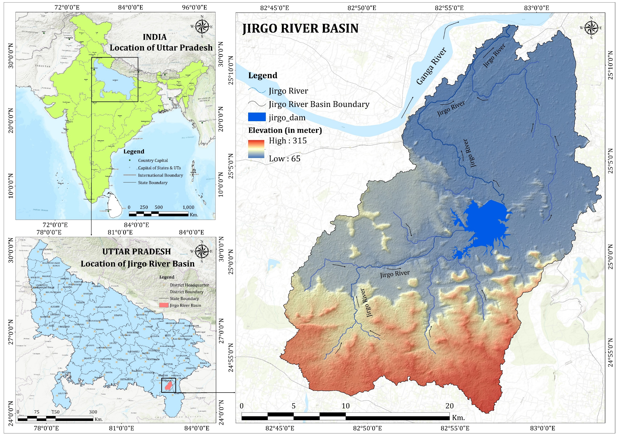
The Jirgo River Basin is situated in the middle Ganga plain. The river originates in Marihan tehsil and flows through Chunar in Mirzapur District before joining the River Ganga. The river spans a total length of 180 km. Geographically, the basin extends from 24°51′N to 25°12′N latitude and 82°44′E to 83°05′E longitude (Figure 1). A significant feature of the basin is the Jirgo Dam (also known as Jirgo Lake), which was constructed in 1959 and is crucial in supporting aquatic biodiversity and maintaining the riverine ecosystem. The surrounding landscape is characterized by dense, rich forests that provide habitats for diverse plant and animal species. This ecosystem also serves as the traditional homeland for several tribal and indigenous communities, making it ecologically and culturally significant.
Figure 1 Location map of the Study Area

METHOOLOGY

DATA COLLECTION
Topographical maps on a 1:50000 scale were procured from the Survey of India and served as a fundamental reference for drainage delineation. These sheets were subsequently georeferenced using ArcGIS software to establish precise coordinates aligned with the Universal Transverse Mercator (UTM) projection system. To derive the Digital Elevation Model (DEM), high-resolution Shuttle Radar Topography Mission (SRTM) 30 m data were obtained from the United States Geological Survey (USGS) Earth Explorer portal (https://earthexplorer.usgs.gov/). The Jirgo River Basin boundary was delineated by integrating SOI toposheet information and DEM-based hydrological modelling. Before analysis, the DEM underwent pre-processing, including sink filling and hydrological corrections, to eliminate depressions and ensure accurate flow direction modelling (Table 1). The refined DEM was subsequently used for the extraction, computation, and spatial analysis of morphometric parameters, forming the basis for hydrological inferences and sub-basin prioritization. All morphometric analyses followed established methodological frameworks (Horton, 1945; Strahler, 1964) to ensure analytical rigour and consistency with existing literature.
Table 1. Data used in the study
Sl. No. | Data | Details of Data | Source
1. | Toposheets | 63L/1, 63L/13, 63O/4, 63K/16 | Survey of India (SOI), Dehradun, India
2. | SRTM DEM | 1 Arc (30m) | https://earthexplorer.usgs.gov/

EXTRACTION OF THE DRAINAGE NETWORK
Conventional techniques for mapping drainage networks and watershed boundaries using topographic maps are time-consuming and labour-intensive, especially for extensive river systems. To overcome these limitations, a GIS-based automated approach was employed in this study to extract the drainage network and sub-basin delineation accurately. A combination of the Shuttle Radar Topography Mission (SRTM) Digital Elevation Model (DEM) and Survey of India (SOI) toposheets was used to establish a spatial database and compute morphometric parameters. To ensure spatial accuracy, the SOI toposheets were georeferenced, mosaicked, and geometrically corrected. DEM-based hydrological tools in ArcGIS were then applied to delineate the drainage network, involving sequential processing through fill sinks, flow direction, flow accumulation, stream definition, stream order, and stream-to-feature tools. A threshold value was set to define stream initiation, a critical factor in ensuring alignment between extracted and actual drainage patterns (Arulbalaji & Padmalal, 2020; Mueller, 1968). Higher threshold values yield sparse drainage networks, whereas lower values increase stream density, requiring repetitive adjustments to optimize accuracy (A.U. et al.,2021; Mueller, 1968). Later, the watershed tool available in the ArcGIS spatial analyst toolbar was used to extract the boundary of the Jirgo Basin from the SRTM DEM data. The extracted stream network was validated by overlaying it onto the SOI toposheets and performing a visual comparison to ensure consistency. Discrepancies were resolved by refining the threshold value and re-executing the extraction process (Said et al., 2018; Javed et al., 2011). For a comprehensive morphometric analysis, the Jirgo River Basin was further segmented into sub-basins through strategic pour point placement based on stream confluence patterns and topographic characteristics (Bharath et al., 2021; Said et al., 2018).

COMPUTATION OF MORPHOMETRIC PARAMETERS
Morphometric analysis provides critical insights into a river basin's physiographic and hydrological characteristics that influence surface runoff, infiltration, and soil erosion (Bharath et al., 2021). Using SRTM DEM data and GIS software, various morphometric indices were computed and further classified into linear, areal, and relief aspects following established methodologies (Horton, 1932, 1945; Strahler, 1964). All the morphometric parameters were computed using the mathematical equations outlined in Table 2.

PRIORITIZATION OF SUB-BASIN
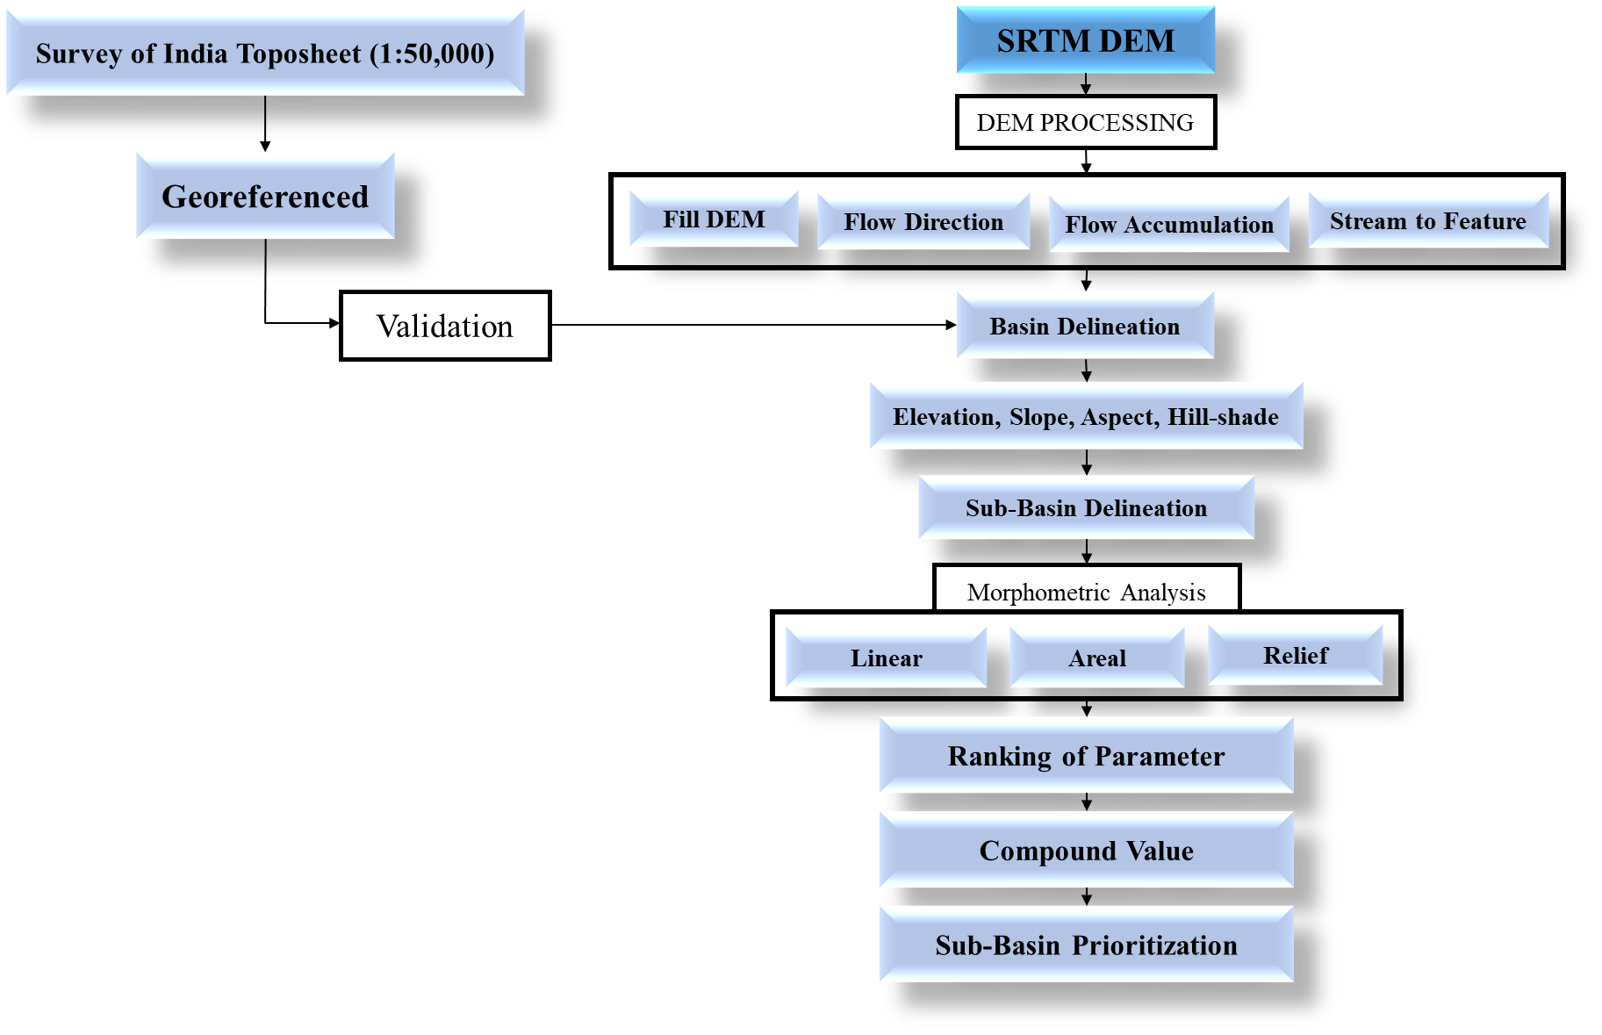
Sub-basin prioritization was conducted using the compound parameter (Cp) method, a widely recognized approach for ranking basins based on erosion and flooding susceptibility (Gajbhiye et al., 2013; Malik et al., 2019). This method integrates multiple morphometric parameters categorized into linear, areal, and relief aspects, each influencing the erosion potential differently. Linear and relief parameters, such as drainage density, bifurcation ratio, and relief ratio, exhibit a positive correlation with erosion, while areal parameters like elongation ratio and circularity ratio show an inverse relationship, with lower values indicating higher erosion risk. Each sub-basin was ranked based on its morphometric characteristics, with higher ranks assigned to more erosion-prone values. The compound parameter (Cp) value was calculated as the mean rank of all morphometric parameters, with lower Cp values indicating higher priority sub-basins in need of intervention (Malik et al., 2019; Sutradhar & Mondal, 2022). Subsequently, GIS-based spatial analysis was utilized to categorize the sub-basins into high, medium, and low-priority zones, facilitating targeted conservation measures such as afforestation, soil conservation, and groundwater recharge to enhance basin resilience. The Methodological Framework of this entire study is illustrated in Figure 2.
Figure 2 Methodological Framework of the Study

Table 2. Formulae for computing morphometric parameters
S.N. | Parameters | Formula | Unit | Reference
Linear Parameters
 | Stream Order (U) | Hierarchy-based ranking of streams. | Dimensionless | Strahler (1952)
 | No. Of streams ($N_{u}$) | N_{u} = N1+N2+...+Nn (Total no of streams of the basin) | Dimensionless | Horton (1945)
 | Length of streams ($L_{u}$) | Total Length of the stream segments of that particular order | Km | Horton (1945)
 | Mean stream length ($L_{sm}$) | $$L_{sm}=L_{u}/N_{u}$$ | Km | Strahler (1964)
 | Bifurcation ratio ($R_{b}$) | $$R_{b}=N_{u}/N_{u+1}$$  $N_{u}$ =Total number of stream segments of order ‘u’  $N_{u+1}$= Total Number of stream segments of the next higher order | Dimensionless | Schumm (1956)
 | Mean bifurcation ratio ($R_{bm}$) | $$R_{bm}=\sum{R_{b}}/n$$ | Dimensionless | Strahler (1964)
 | Stream Length ratio ($L_{ur}$) | $$L_{ur}=L_{u}/L_{u-1}$$  $L_{u}$= Total stream length of order ‘u  $L_{u-1}$= Total stream length of next lower order | Dimensionless | Horton (1945)
 | Rho Coefficient (ρ) | $$ρ =R_{slm}/R_{bm}$$ | Dimensionless | Horton (1945)
 | Mean Stream Length ratio ($R_{slm})$ | $$R_{slm}=\sum{L_{ur}/n}$$ | Dimensionless | Strahler (1964)
 | Drainage density ($D_{d}$) | $$D_{d}=L_{u}/A$$  A = area of the basin. | Km⁻¹ | Horton (1932)
 | Stream Frequency ($F_{s}$) | $$F_{s}=\sum{N_{u}}/ A$$ | Km⁻² | (Horton 1945)
 | Texture ratio (T) | $$T=N_{u}/ P$$  P = perimeter of the basin | Dimensionless | Horton (1945)
 | Infiltration Number ($I_{f}$) | $$I_{f}=F_{s}/D_{d}$$ | Dimensionless | Faniran (1968)
 | Length of overland flow ($L_{of}$) | $$L_{of}=1/({2D}_{d})$$ | Km | Horton (1945)
 | Drainage Intensity ($D_{i}$) | $$D_{i}=F_{s}/D_{d}$$ | Dimensionless | Faniran (1968)
Areal Parameters
 | Basin area (A) | GIS analysis / DEM | Km² | Schumm (1956)
 | Basin length ($L_{b}$) | $$L_{b}={1.312 A}^{0.568}$$ | Km | Schumm (1956)
 | Perimeter (P) | GIS analysis / DEM | Km | Schumm (1956)
 | Circularity ratio ($R_{c}$) | $$R_{c}=12.57(A/P^{2})$$ | Dimensionless | Miller (1953)
 | Elongation ratio ($R_{e}$) | $$R_{e}=(1.128 A^{0.5})/L_{B}$$ | Dimensionless | Schumm (1956)
 | Form Factor ($F_{f}$) | $$F_{f}=A/L_{b}^{2}$$ | Dimensionless | Horton (1932)
 | Compactness constant ($C_{c}$) | $$C_{c}=0.282P/A^{0.5}$$ | Dimensionless | Gravelius (1914)
 | Shape factor ($S_{f}$) | $$S_{f}=L_{b}^{2}/A$$ | Km | Nookaratnam (2005)
 | Constant of channel maintenance (C) | $$C=1/D_{d}$$ | Dimensionless | Horton (1945)
 | Lemniscate's (k) | $$k=L_{b}^{2}/4A$$ | Dimensionless | Chorley (1957)
 | Fitness ratio ($R_{f}$) | $$R_{f}=Cl/P$$  Cl = Length of Basin Perimeter | Dimensionless | Melton (1957)
 | Standard sinuosity index ($S_{si}$) | ${ S}_{si}=Ci/Vi$  Ci = channel index  Vi = valley index | Dimensionless | Mueller (1968)
Relief Parameters
 | Basin relief (H) | H = Z–z  Z = Elevation of the highest point in the basin  z = Elevation of the lowest point in the basin | Meter | Strahler (1952)
 | Relief ratio ($R_{h}$) | $$R_{h}=H/L_{b}$$ | Meter | Schumm (1956)
 | Gradient ratio (Rg) | $$DI =H/Z$$  Z= Elevation of the highest point in the basin | Dimensionless | Schumm (1956)
 | Ruggedness Number ($R_{n}$) | $$R_{n} =H × D_{d}$$ | Dimensionless | (Strahler, 1957)  Patton and Baker (1976)

RESULTS AND DISCUSSION
Using SRTM DEM data and the ArcGIS platform, the Jirgo River Basin was delineated and further divided into five sub-basins: Kalkalia Nala, Barhi Nadi, Magardaha Nala, Jaugarh Nadi, and Chakra Nala (Figure 3). The morphometric parameters were computed using standardized methods and formulae (Table 2), and the resulting values are presented in Tables 3, 4, and 5. The morphometric analysis of these sub-basins provides essential insights into the hydrological behaviour of the watershed, including drainage patterns, permeability, and stream health, as well as establishing relationships with underlying lithological features. The prioritization of sub-basins based on morphometric characteristics identifies areas requiring immediate conservation efforts, particularly those exhibiting higher drainage density, steep slopes, and lower infiltration capacity.
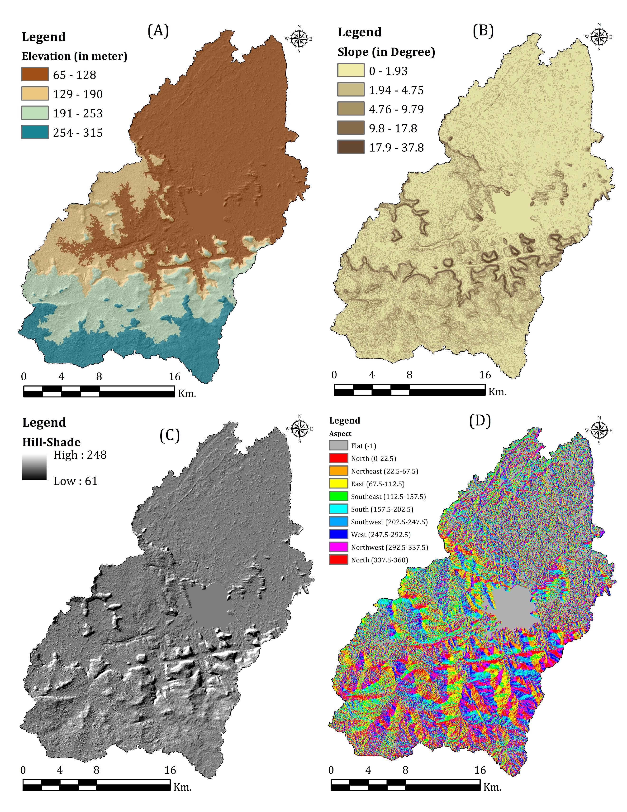
Water flows along the steepest descent, with the highest mean basin slopes observed in the Barhi and Magardaha regions. This highlights the ecohydrological significance of the upper catchments in shaping the stream network development, surface runoff dynamics, and flood generation processes (Fig. 3). The midstream zone, predominantly composed of granite formations and tropical deciduous forests, plays a critical role in regulating streamflow velocity, influencing soil erosion rates, sediment deposition, and hydrograph responses. Notably, west-facing slopes, receiving intense solar radiation during the afternoon, exhibit higher temperatures than their east-facing counterparts, which remain relatively sheltered. Hadley (1961) emphasized that the slope aspect induces microclimatic variations that substantially influence hillslope processes and the evolution of drainage basins. Moreover, aspect maps are an essential tool for analyzing the spatial distribution of vegetation types across landscapes (Singh et al., 2014). The shaded relief representation used in Fig. 3 captures the variation in elevation and slope, where lighter shades denote higher altitudes, and darker shades indicate lower elevations or shadowed areas. Such detailed topographic depictions are vital for understanding the basin morphology and developing informed watershed management strategies.

Figure 3 Elevation map (A), slope map (B), hill shade map (C), and aspect map (D) of the study area

MORPHOMETRIC ANALYSIS OF JIRGO RIVER BASIN AND SUB-BASIN

LINEAR ASPECT
Parameters | Basin and Sub-Basins
Parameters | Jirgo River | Kalkalia Nala | Barhi Nadi | Magardaha Nala | Jaugarh Nadi | Chakra Nala
Stream number (N_{u}) | 1048 | 298 | 213 | 57 | 69 | 68
1st order (Nu₁) | 802 | 229 | 165 | 42 | 51 | 51
2nd Order (Nu₂) | 189 | 52 | 38 | 11 | 12 | 13
3rd Order (Nu₃) | 42 | 12 | 7 | 3 | 5 | 3
4th Order (Nu₄) | 11 | 4 | 2 | 1 | 1 | 1
5th Order (Nu₅) | 3 | 1 | 1
6th Order (Nu₆) | 1
Stream length (L_{u}) | 1105.57 | 216.03 | 253.41 | 29.92 | 27.10 | 21.21
1st order (Lu₁) | 419.22 | 162.60 | 239.72 | 20.75 | 19.37 | 16.53
2nd Order (Lu₂) | 160.02 | 35.49 | 9.06 | 6.65 | 3.07 | 2.79
3rd Order (Lu₃) | 369.21 | 16.17 | 3.55 | 1.88 | 3.98 | 1.51
4th Order (Lu₄) | 62.91 | 1.07 | 0.54 | 0.64 | 0.68 | 0.38
5th Order (Lu₅) | 61.23 | 0.7 | 0.54
6th Order (Lu₆) | 32.98
Bifurcation ratio (R_{b}) | 19.21 | 15.73 | 15.26 | 10.47 | 11.65 | 11.25
Nu₁/Nu₂ (Rb₁) | 4.24 | 4.40 | 4.34 | 3.81 | 4.25 | 3.92
Nu₂/Nu₃ (Rb₂) | 4.50 | 4.33 | 5.42 | 3.66 | 2.40 | 4.33
Nu₃/Nu₄ (Rb₃) | 3.81 | 3.00 | 3.50 | 3.00 | 5.00 | 3
Nu₄/Nu₅ (Rb₄) | 3.66 | 4.00 | 2.00
Nu₅/Nu₆ (Rb₅) | 3.00
Stream Length ratio ($L_{ur}$) | 4.37 | 1.4 | 1.58 | 0.94 | 1.63 | 0.96
Lu₂/Lu₁ (Lb₁) | 0.38 | 0.22 | 0.04 | 0.32 | 0.16 | 0.17
Lu₃/Lu₂ (Lb₂) | 2.31 | 0.46 | 0.39 | 0.28 | 1.30 | 0.54
Lu₄/Lu₃ (Lb₃) | 0.17 | 0.07 | 0.15 | 0.34 | 0.17 | 0.25
Lu₅/Lu₄ (Lb₄) | 0.97 | 0.65 | 1.00
Lu₆/Lu₅ (Lb₅) | 0.54 | 0.00 | 0.00
Mean stream length (L_{sm}) | 1.05 | 0.72 | 1.18 | 0.52 | 0.39 | 0.31
Mean bifurcation ratio (R_{bm}) | 3.84 | 3.93 | 3.81 | 3.49 | 3.88 | 3.75
Mean Stream Length ratio (R_{slm}) | 2.35 | 5.85 | 9.14 | 3.19 | 4.30 | 3.91
Rho Coefficient (ρ) | 0.61 | 1.49 | 2.40 | 0.91 | 1.11 | 1.04
Drainage density (D_{d}) | 1.72 | 1.28 | 2.04 | 0.98 | 0.7 | 0.55
Stream Frequency (F_{s}) | 1.64 | 1.77 | 1.72 | 1.88 | 1.79 | 1.80
Texture ratio (T) | 6.09 | 3.34 | 3.38 | 2.00 | 1.79 | 2.09
Infiltration Number (I_{f}) | 2.82 | 2.27 | 3.51 | 1.84 | 1.25 | 0.99
Length of overland flow (L_{o}) | 0.29 | 0.39 | 0.25 | 0.51 | 0.71 | 0.91
Drainage Intensity (D_{i}) | 0.95 | 1.38 | 0.84 | 1.92 | 2.56 | 3.27
Table 3. Linear Aspect of the Jirgo river basin and sub-basins

Stream order (u)
Hierarchically classifying streams is fundamental for understanding a drainage basin's structural and hydrological characteristics. In this study, Strahler's (1964) stream ordering method was applied, where the smallest unbranched channels were designated as first-order streams, and higher-order streams formed at the junction of lower-order streams (Leopold et al., 2020). The Jirgo River Basin exhibits a sixth-order drainage system, with most streams classified as first or second-order. The highest stream frequency was observed in these lower-order streams, gradually decreasing with the increasing stream order. A total of 1,048 streams were identified within the basin, distributed as follows: 802 (76.5%) first-order streams, 189 (18%) second-order streams, 42 (4%) third-order streams, 11 (1%) fourth-order streams, 3 (0.3%) fifth-order streams, and a single sixth-order stream (0.1%) (Table 3, Figure 3). The prevalence of lower-order streams indicates significant surface runoff and an early stage of basin development, characterized by steeper gradients and reduced infiltration capacity. As the highest-order stream, the main channel is essential in regulating drainage discharge and sediment movement within the basin (Haghipour & Burg, 2014).
Stream numbers (N_{u})
The stream number (Nu) measures the total number of stream segments in a particular order within a drainage basin. It serves as a critical indicator of the hydrological characteristics of the region (Yadav et al., 2014). This provides insights into the watershed's surface runoff behaviour, infiltration capacity, and overall geomorphological stability. A higher number of first-order streams typically signifies more excellent permeability and highly erodible topography, often associated with steep slopes and active erosion processes. Lower-order streams, on the other hand, have shorter lengths and are found in regions with steeper gradients and finer textures, indicating a youthful geomorphic stage.
This study computed the order-wise stream number using GIS-based techniques to ensure precision in drainage network analysis (Figure 4 and Table 3). The Jirgo River Basin has 1,048 streams, including 802 first-order, 189 second-order, 42 third-order, 11 fourth-order, three fifth-order, and one sixth-order stream. The dominance of first-order streams indicates that the basin's upper reaches are highly erodible, leading to significant downstream sediment transport (Singh and Awasthi, 2011). These erosional processes influence surface runoff characteristics in the lower reaches, contributing to hydrological variability and watershed responses. Understanding stream number distribution is essential for efficient watershed management, soil erosion control, and sustainable water resource planning.

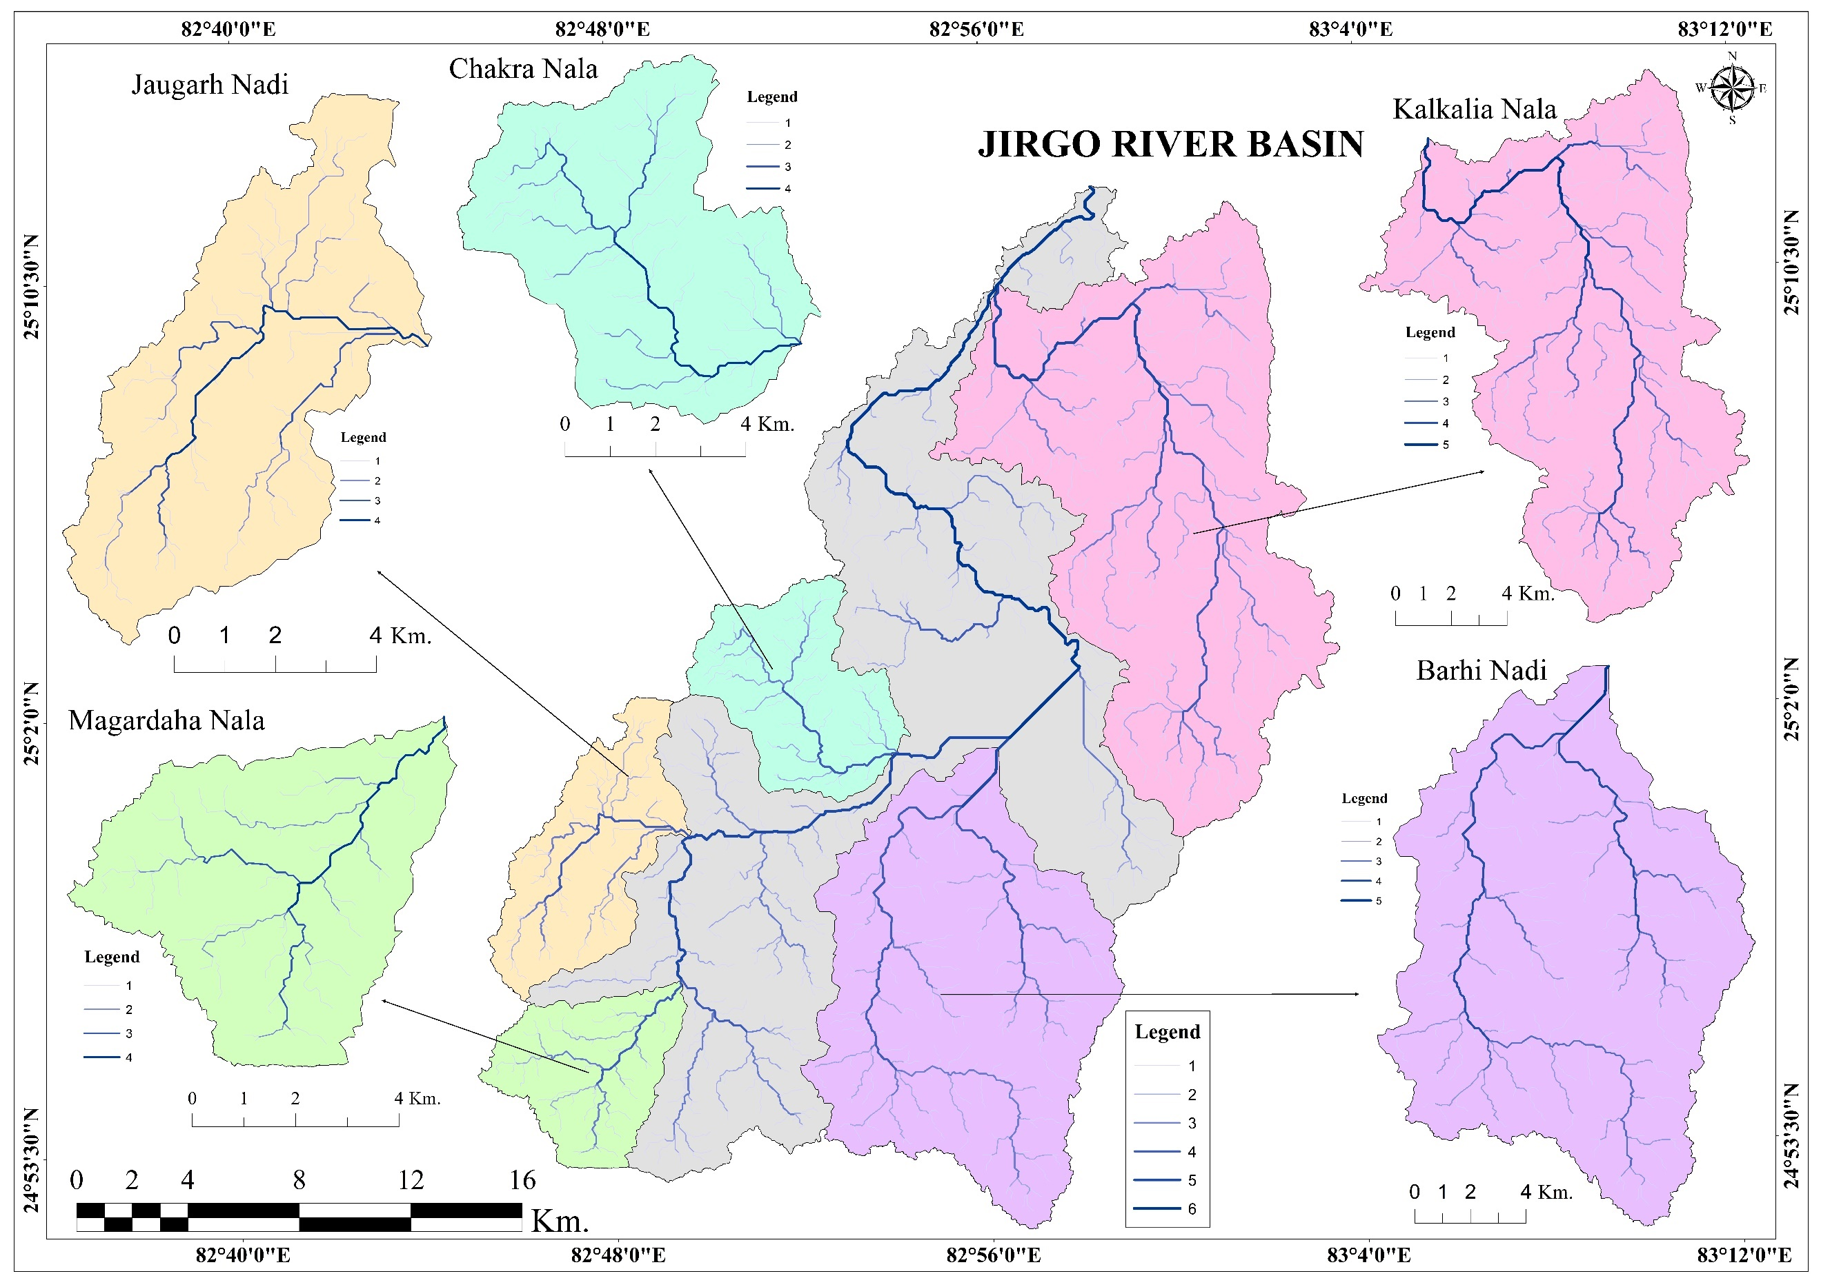
Length of streams (L_{u})
Figure 4 Stream order map of the study area
The Jirgo River Basin follows Horton's "law of stream length," displaying a geometric relationship between stream orders. Stream length is a fundamental morphometric parameter that provides insight into the characteristics of the drainage network and underlying lithology. Longer streams typically develop in permeable bedrock regions, while shorter streams indicate less permeable terrains with steeper gradients. First-order streams contribute the most cumulative length, ensuring a better drainage distribution than higher-order streams. The Jirgo Basin has a total stream length of 1105.57 km, with significant sub-basins like Kalkalia Nala (216.03 km), Barhi Nadi (253.41 km), Magardaha Nala (29.92 km), Jaugarh Nadi (27.10 km), and Chakra Nala (21.21 km). The variation in stream length across the basin reflects differences in slope, lithology, and hydrological response, which aids sub-basin prioritization and watershed management.
Mean Stream Length (L_{sm})
The mean stream length (L_{sm}) is an essential morphometric parameter that reflects the drainage network's characteristics compared to basin surface features. It is calculated by dividing the total length of all streams in a given order by the number of stream segments. L_{sm} increases with stream order and is affected by basin size and topography. Lower L_{sm} values indicate mountainous terrain, while greater values can be observed in plateaus and plains. The Jirgo River Basin exhibits an overall L_{sm} of 1.05 km, with sub-basin values ranging from 0.31 km to 1.71 km, indicating gentle slopes, modest drainage gradients, and a coarse surface texture.
Bifurcation ratio (R_{b})
The bifurcation ratio (R_{b}) is an essential morphometric parameter representing the ratio of the number of streams in a given order to those in the following order. Higher R_{b} values indicate more significant changes in stream frequency, implying substantial structural control and a heavily dissected terrain, whereas lower values indicate fewer structural disturbances and a more uniform topography. R_{b} levels in the Jirgo River Basin range from 3.00 to 3.50, with sub-basins fluctuating according to geological and lithological factors. Specifically, Kalkalia Nala, Barhi Nadi, Magardaha Nala, Jaugarh Nadi, and Chakra Nala show R_{b} values between 3.00–4.40, 2.00–5.42, 3.00–3.81, 2.40–5.00, and 3.00–4.33, respectively. Higher R_{b} values in downstream areas suggest increased dissection due to lithological heterogeneity and active structural control, whereas lower values indicate a relatively stable terrain with minimal external influence.
Mean Bifurcation Ratio (R_{bm})
The mean bifurcation ratio (R_{bm}) is the average bifurcation ratio across all stream orders and provides insight into a drainage basin's structural complexity and geological parameters. In this study, the R_{bm} values for the Jirgo River Basin and its subbasins ranged from 3.49 to 3.93 (Table 3). These results indicate a predominantly natural drainage system, implying minimal structural disturbance. A lower R_{bm} usually indicates a homogeneous lithology with little structural effect, whereas a larger value may indicate geological control over drainage development. The computed R_{bm} values for each subbasin provide an essential foundation for hydrological evaluation and subbasin priority.
Stream Length ratio ($L_{ur}$)
The stream length ratio (L_{ur}) is a key morphometric parameter that reflects the relationship between successive stream orders and provides insight into basin evolution and hydrological characteristics. According to Horton's law (1945), the mean stream length in a basin follows a geometric progression that increases with stream order. The Jirgo River Basin exhibits an upward trend in L_{ur} values (Table 4), indicating a progressive increase in stream length across higher orders. Relief, slope, and topography variations among sub-basins affect Rᵣ, affecting surface runoff, discharge patterns, and erosion intensity (Singh & Singh, 1997). The Jirgo Basin appears to be at a late young stage of geomorphic development, where the terrain is being shaped by active erosional processes based on the observed fluctuations (Sreedevi et al., 2004). These results are essential for determining sub-basin prioritization for sustainable management, sediment transport dynamics, and watershed stability.
Mean Stream Length Ratio (R_{slm})
The Mean Stream Length Ratio (R_{slm}) is a crucial morphometric indicator that reveals the stream segment elongation and geological/structural influences on drainage development. Among the studied sub-basins, Barhi Nadi showed the highest R_{slm} (9.14), indicating a well-established drainage system with elongated streams likely shaped by structural elements. Kalkalia Nala (5.85) and Jaugarh Nadi (4.30) exhibit relatively high values, suggesting moderate geological resistance and topographical variations. Magardaha Nala (3.19) and Chakra Nala (3.91) fall in the intermediate range, balancing structural influences and fluvial processes.
Rho coefficient (ρ)
The Rho coefficient (ρ) is a crucial morphometric parameter that ties drainage density to a basin's physiographic development and storage capacity, as well as the level of drainage network maturity (Horton, 1945). It is defined as the stream length ratio to bifurcation ratio and substantially impacts water retention potential and flood response (Potter, 1957). In this study, sub-basins Barhi and Kalkalia had higher Rho values, indicating more storage capacity, with the Barhi sub-basin being the most effective at retaining surface water. However, the average Rho coefficient for the Jirgo River Basin remained low, particularly in Magardaha Nala, Jaugarh Nadi, and Chakra Nala, indicating poor water retention. However, Kalkalia Nala and Barhi Nadi demonstrated relatively high Rho values, indicating better hydrological stability and storage potential.
Drainage density (D_{d})
Drainage density (D_{d}), defined as the total length of streams per unit area within a basin, is a key indicator of landscape dissection and runoff potential (Horton, 1945; Potter,1957). A higher D_{d} suggests more significant surface runoff, lesser infiltration, and increased erosion susceptibility, whereas a lower D_{d} indicates increased infiltration and decreased runoff (Prasad, 2008). Strahler (1964) discovered that basins with steep slopes and high relief had lower drainage densities, but soil permeability and the resistance of underlying materials also influenced D_{d}. The Jirgo River Basin has a computed drainage density of 1.72 km/km², indicating a moderately permeable subsurface with intermediate drainage characteristics and low to moderate relief (Fig. 5). High D_{d} levels are usually associated with weak, impermeable lithology, sparse vegetation, and increased erosion danger, whereas low values suggest stable terrain with well-developed infiltration capacity.
Stream Frequency (F_{s})
Stream frequency (Fs) is the total number of streams per unit area in a watershed, reflecting the drainage density and surface runoff potential. Among the given sub-basins, Magardaha Nala has the highest stream frequency (1.88), indicating a well-drained basin with a higher runoff potential and less infiltration. Jaugarh Nadi (1.79) and Chakra Nala (1.80) also exhibit high stream frequency, suggesting moderate drainage efficiency. Kalkalia Nala (1.77) and Barhi Nadi (1.72) indicate lower drainage density and potentially higher infiltration rates. These stream frequency variations help understand watershed hydrology, erosion potential, and flood susceptibility, which are crucial for sustainable river basin management and land-use planning.
Texture ratio (T)
The texture ratio (T) represents the drainage texture of the river basin. Higher values indicate rugged terrain with dense stream networks, whereas lower values indicate smoother topography. Jirgo River has the highest texture ratio (6.09), suggesting a highly dissected landscape with intense drainage activity. Kalkalia Nala (3.34) and Barhi Nadi (3.38) have moderate drainage texture, reflecting semi-rugged terrain. Magardaha Nala (2.00), Jaugarh Nadi (1.79), and Chakra Nala (2.09) have lower texture ratios, suggesting smoother landscapes with fewer stream channels. These variations highlight lithology, slope, and rainfall differences, influencing erosion, runoff, and hydrological characteristics.
Infiltration Number (I_{f})
The Infiltration Number (I_{f}) measures how well river basins absorb water, affecting groundwater recharge and runoff. Barhi Nadi has the highest value (3.51), indicating excellent permeability and recharge potential. Kalkalia Nala (2.27) show moderate infiltration capacity. Magardaha Nala (1.84) displays reduced absorption, while Jaugarh Nadi (1.25) and Chakra Nala (0.99) have the
lowest values, suggesting minimal infiltration and higher runoff. These differences likely result from soil composition, vegetation, and underlying geology variations, influencing water availability and erosion patterns across these basins.
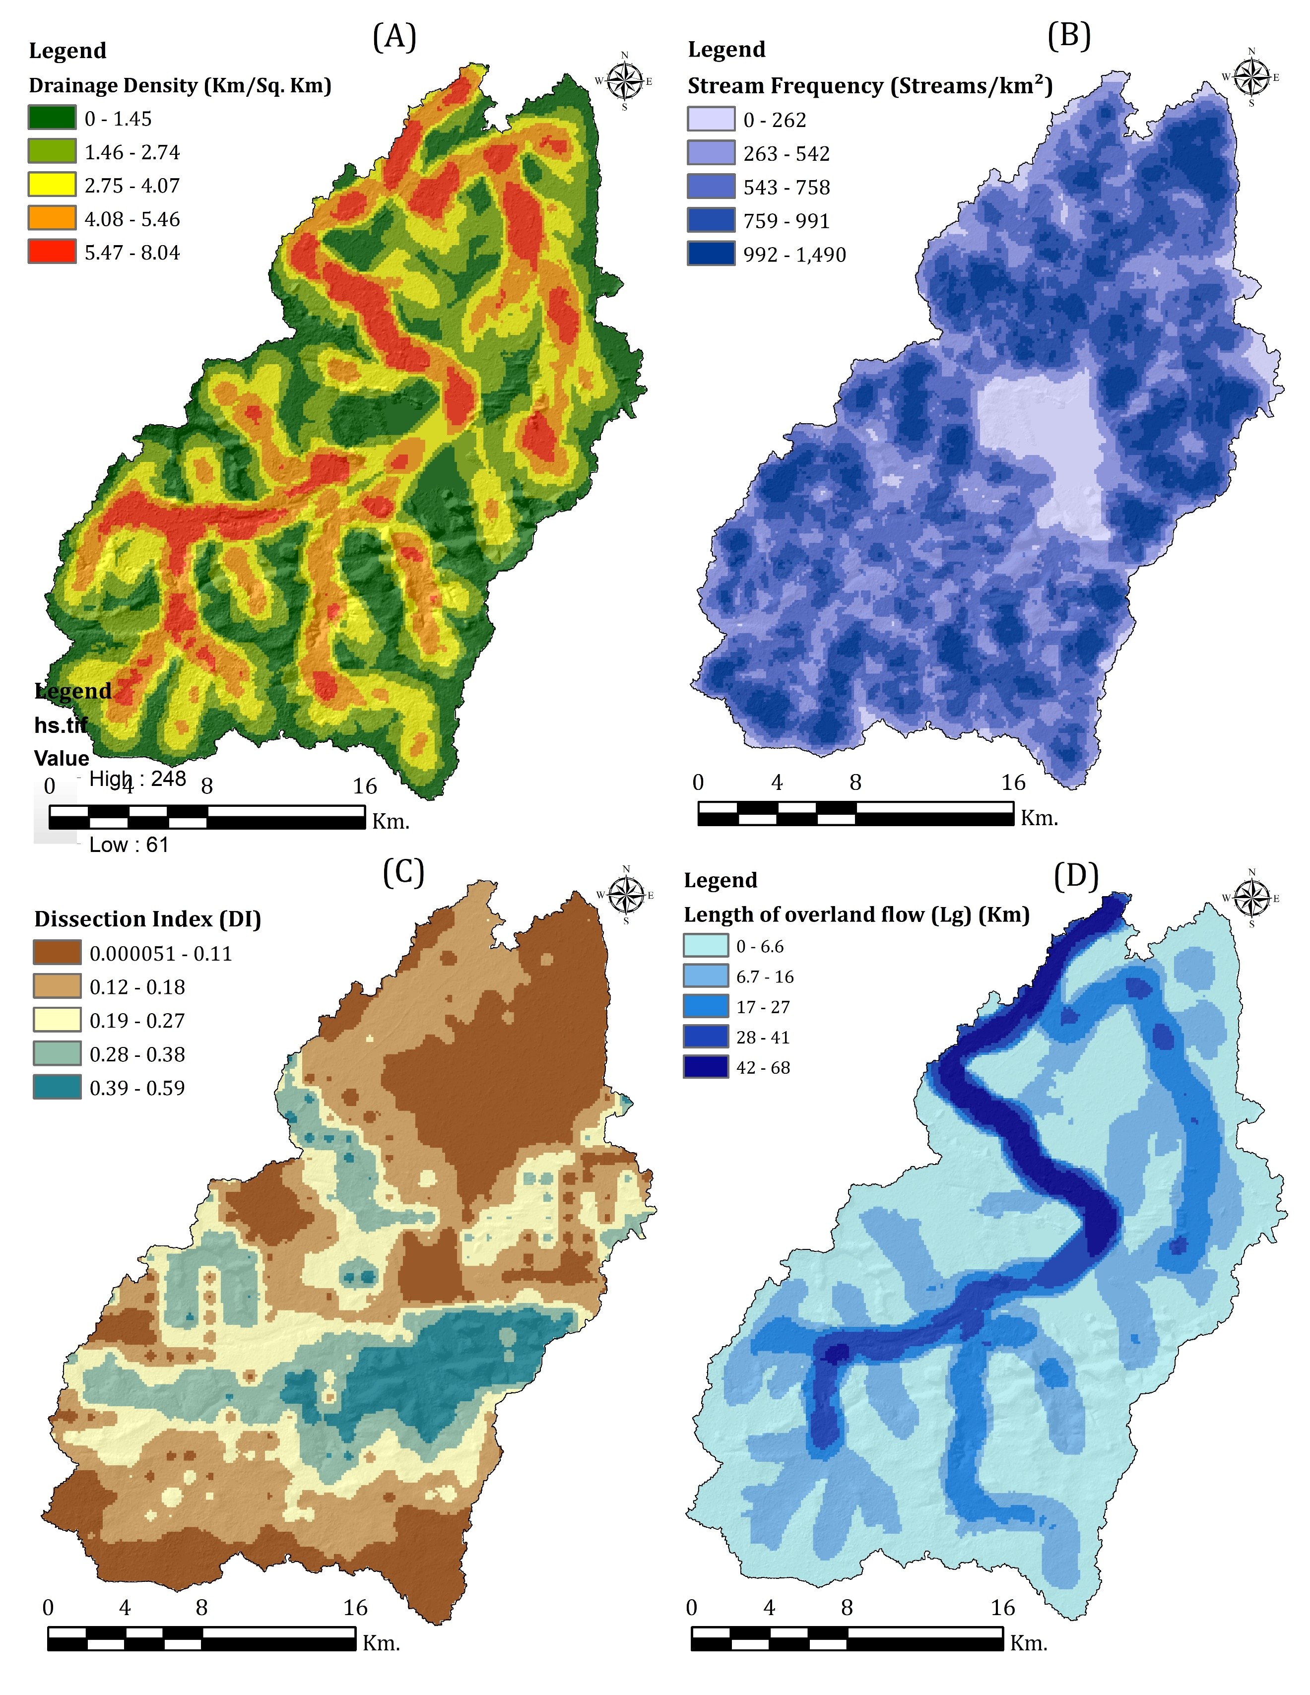
Figure 5 Drainage density map (A), stream frequency map (B), dissection index map (C), and length of overland flow map (D) of the study area
Length of overland flow (L_{o})
Overland flow (Lo) length measures how far water travels before reaching a stream, affecting runoff patterns and water absorption (Horton,1932, 1945). In the Jirgo River Basin (Lo=0.29), tributary values vary considerably. Barhi Nadi has the lowest Lo (0.25), indicating rapid drainage and likely steeper terrain. Chakra Nala shows the highest (0.91), suggesting slower flow over gentler slopes. Kalkalia Nala (0.39), Magardaha Nala (0.51), and Jaugarh Nadi (0.71) have moderate values (Fig. 5). Shorter Lo values typically result in faster runoff with infiltration, while longer values promote groundwater recharge. These differences significantly impact erosion, sediment movement, and water availability throughout the basin's ecosystem.
Drainage Intensity (D_{i})
Drainage Intensity (D_{i}) is a key morphometric parameter quantifying the relationship between stream frequency and drainage density within a basin. A higher D_{i} value indicates a well-drained landscape with increased runoff, while lower values suggest higher infiltration and reduced surface runoff. In the Jirgo River basin, the overall D_{i} was 0.95. Among the sub-basins, Kalkalia Nala has a D_{i} of 1.38, indicating a slightly dissected terrain, whereas Barhi Nadi records the lowest value (0.84), implying less dissection and better infiltration. Magardaha Nala (1.92), Jaugarh Nadi (2.56) and Chakra Nala (3.27) show higher D_{i,} reflecting a rugged topography with rapid runoff. These variations in D_{i} influence erosion, water retention and landform evolution within the basin.

AREAL ASPECT
Basin Area (A), Basin Length (L_{b}) and Basin Perimeter (P)
The Drainage area (A) is a crucial morphometric parameter directly affecting hydrological responses, such as runoff generation and peak discharge. Larger basins with higher relief typically exhibit more significant discharge, affecting flood magnitude and water availability. Chorley et al. found that basin size had an inverse relationship with maximum flood discharge per unit area. The Jirgo River Basin spans 640.65 km² and includes sub-basins of varied sizes (Table 4): Kalkalia Nala (168.73 km²), Barhi Nadi (123.63 km²), Magardaha Nala (30.37 km²), Jaugarh Nadi (38.60 km²), and Chakra Nala (37.88 km²).
The basin length (L_{b}), or the longest dimension of the drainage basin, is critical for understanding hydrological flow characteristics. The Jirgo Basin covers 42.04 km, with sub-basins varying between 7.89 km to 23.01 km. Similarly, the basin perimeter (P), which defines the boundaries of the drainage area, is 171.84 km long, while the perimeter of the sub-basins ranges from 28.50 km to 89.17 km.
Table 4. Areal Aspect of the Jirgo River Basin and its sub-basin
AREAL ASPECTS OF THE JIRGO RIVER BASIN AND SUB-BASINS
Parameters | Jirgo River | Kalkalia Nala | Barhi Nadi | Magardaha Nala | Jaugarh Nadi | Chakra Nala
Basin area (km²) | 640.65 | 168.73 | 123.63 | 30.37 | 38.60 | 37.88
Basin length (km) | 42.04 | 23.01 | 17.33 | 7.89 | 11.94 | 8.43
Perimeter (km) | 171.84 | 89.17 | 62.92 | 28.50 | 38.48 | 32.56
Circularity ratio | 0.27 | 0.26 | 0.39 | 0.46 | 0.32 | 0.44
Elongation ratio | 0.68 | 0.64 | 0.72 | 0.79 | 0.59 | 0.82
Form Factor | 0.36 | 0.32 | 0.41 | 0.49 | 0.27 | 0.53
Compactness constant | 1.93 | 1.95 | 1.61 | 1.47 | 1.76 | 1.50
Shape factor | 2.76 | 3.14 | 2.43 | 2.05 | 3.69 | 1.88
Constant of channel maintenance | 0.58 | 0.78 | 0.49 | 1.02 | 1.43 | 1.82
Lemniscate's ratio | 2.76 | 3.14 | 2.43 | 2.05 | 3.69 | 1.88
Fitness ratio | 0.37 | 0.36 | 0.43 | 0.33 | 0.31 | 0.35
Standard sinuosity index | 1.50 | 1.40 | 1.55 | 1.18 | 1.01 | 1.41

Circularity ratio (R_{c})
The circularity ratio (R_{C}) is a dimensionless metric that represents the ratio of a basin area to the area of a circle with the same perimeter (Miller,1953). R_{c} values vary from 0 (extremely elongated) to 1 (almost circular), indicating the basin's shape and hydrological response. This metric impacts various elements, including drainage density, stream frequency, geological structure, climate, relief, slope, and land use patterns. Higher R_{c} values usually indicate young highland basins with quick runoff and peak discharge during heavy rainfall, whereas lower R_{c} values suggest mature plateau-plain basins with moderate flow and reduced flood susceptibility. The Jirgo River Basin has an overall R_{c} of 0.27, with sub-basin values ranging from 0.26 to 0.46, indicating an extended basin morphology with moderate to low flood potential. Relatively low R_{c} values indicate active denudational processes, signifying a stable drainage system with controlled runoff and minimal flood risk.
Elongation ratio (R_{e})
The elongation ratio (R_{e}) is a dimensionless metric that describes the geometry of a drainage basin and is calculated as the ratio of the diameter of a circle with the same area as the basin to its maximum length (Munoth and Goyal, 2020). It ranges from 0 (highly elongated) to 1 (highly circular) and provides insights into the hydrological response of the basin. Higher R_{e} values indicate circular basins, which are more susceptible to flooding due to rapid runoff concentration. In comparison, lower values correspond to elongated basins, which are often associated with lower peak discharge and extended flow duration. In this study, the Jirgo River Basin has a R_{e} value of 0.68, with sub-basin values ranging from 0.59 to 0.82, indicating a predominantly elongated shape. This shows a smooth gradient, modest topographical relief, and a plateau-plain river system with a more evenly distributed flow, lowering flood risk and favouring groundwater recharge.
Form Factor (F_{f})
The form factor ratio, which represents the shape of a drainage basin, was computed by dividing the basin area by the square of its length. It ranges from 0 (highly elongated) to 1 (near-circular) and is a key indicator of the runoff characteristics. A lower form factor indicates an elongated basin with low peak flow and prolonged runoff, lowering flood risks. In contrast, a higher value suggests a circular basin with short duration and intense runoff, making it more flood-prone. The Jirgo River Basin has a form factor of 0.36, indicating an elongated shape and moderate runoff potential. Kalkalia Nala (0.32), Barhi Nadi (0.41), Magardaha Nala (0.49), Jaugarh Nadi (0.27), and Chakra Nala (0.53) exhibited varying degrees of elongation, which altered their respective hydrological responses. The elongated nature of these sub-basins suggests a gradual discharge pattern, which makes them more manageable in terms of flood mitigation.
Compactness constant (C_{c})
The compactness constant, defined as the ratio of a basin's perimeter to a circle of equal area (Horton, 1945; Potter, 1957), is a key indicator of basin morphology. This metric effectively quantifies deviations from the ideal circular shape and provides insights into hydrological and geomorphological properties. The Jirgo River Basin's compactness constant was 1.93, indicating a moderate divergence from circularity. Its sub-basins range from 0.53 in Chakra Nala, suggesting a more compact form, to 1.95 in Kalkalia Nala, reflecting more excellent elongation. These variations highlight the influence of geological and topographical factors on the basin configuration.
Shape factor (S_{f})
Shape factor is an essential parameter in geomorphological studies as it affects runoff patterns and sediment movement within a drainage basin (Prakash et al.,2019). The shape factor of the Jirgo River basin is 2.76, with variations in sub-basins such as Kalkalia Nala (3.14), Barhi Nadi (2.43), Magardaha Nala (2.0), Jaugarh Nadi (3.69), and Chakra Nala (1.88). These values suggest that Chakra Nala is less prone to erosion, whereas Jaugarh Nadi is at higher risk.
Constant of channel maintenance (C)
The constant of channel maintenance (C) measures the area required to sustain a drainage channel of one unit length and provides insights into the infiltration capacity and runoff characteristics (Munoth & Goyal,2020). Higher C values generally indicate lower-order streams, sparse vegetation, higher flood sensitivity, and continuous geomorphological change (Rahaman et al.,2015). The Jirgo River Basin has a C value of 0.58 km²/km, whereas sub-basins like Kalkalia Nala (3.34 km²/km), Barhi Nadi (3.38 km²/km), Magardaha Nala (2.00 km²/km), Jaugarh Nadi (1.79 km²/km), and Chakra Nala (2.09 km²/km) have higher values. This suggests a plateau-plain terrain with medium permeability, drainage density, soil infiltration, and surface runoff dynamics.
Lemniscate's Scale (k)
Lemniscate's scale (k) is a morphometric parameter that measures the proportion of watershed length along the mainstream to the total watershed area (Jothimani et al.,2020). This number is useful for analyzing watershed slopes and hydrological properties. The Lemniscate (k) value in the Jirgo River Basin is 2.76, whereas its sub-basins, Kalkalia Nala, Barhi Nadi, Magardaha Nala, Jaugarh Nadi, and Chakra Nala, have k values of 3.14, 2.43, 2.05, 3.69, and 1.88, respectively. These variations indicate that places with higher k values have a more elongated shape and potentially steeper slopes, influencing runoff dynamics and erosion susceptibility.
Fitness ratio (R_{f})
The fitness ratio, an essential morphometric statistic, is the ratio of the primary channel length to the watershed perimeter (Melton 1957). This measures the topographic suitability of a drainage basin, indicating its elongation and efficiency regarding water discharge (Rai et al., 2017a, 2017b; Rai et al., 2018). This study established the fitness ratio for the primary basin at 0.37, whereas the sub-basins Kalkalia Nala, Barhi Nadi, Magardaha Nala, Jaugarh Nadi, and Chakra Nala recorded values of 0.36, 0.43, 0.33, 0.31, and 0.36, respectively. These variations highlight the different erosion processes and structural controls that influence the morphometric characteristics of the basin.
Standard sinuosity index (S_{si})
The Standard Sinuosity Index (S_{si}) quantifies the deviation of a river from its straight course. It is expressed as the ratio of channel length to down valley distance, providing insight into the meandering nature of the channel. A straight channel has an index of 1; values between 1 and 1.5 indicate a sinuous course, while values between 1.5 and 4 show a meandering pattern. This indicator helps study river dynamics, sediment transport, and landscape change. The Jirgo River Basin has an overall sinuosity index of 1.50, indicating meandering. Sub-basins such as Barhi Nadi (1.55) and Chakra Nala (1.41) reinforce this trend, while others, such as Jaugarh Nadi (1.01), show slight variation. These differences reflect the distinct structural controls and hydrological processes that shape the basin's fluvial network.

RELIEF ASPECT
Table 5. Relief Aspect of the Jirgo River Basin and its sub-basin
RELIEF ASPECT OF JIRGO RIVER BASIN AND SUB-BASINS
Parameters | Jirgo River | Kalkalia Nala | Barhi Nadi | Magardaha Nala | Jaugarh Nadi | Chakra Nala
Basin relief (H) | 245 | 142 | 218 | 89 | 137 | 95
Relief Ratio ($R_{h}$) | 5.83 | 6.17 | 12.58 | 11.28 | 11.47 | 11.27
Gradient ratio (R_{g}) | 0.06 | 0.06 | 0.013 | 0.011 | 0.011 | 0.011
Ruggedness Number (R_{n}) | 0.42 | 0.18 | 0.44 | 0.09 | 0.10 | 0.05
Basin Relief (H)
Basin relief (H) is the elevation difference between a watershed's highest and lowest points, influencing stream gradient, erosion, and sediment movement. Higher basin relief is often linked with steeper slopes, more runoff, and more erosion potential, significantly affecting hydrological dynamics. The entire relief in the Jirgo River basin is 245 meters, with subbasins such as Kalkalia Nala (142 meters), Barhi Nadi (218 meters), Magardaha Nala (89 meters), Jaugarh Nadi (137 meters), and Chakra Nala (95 meters) having varying relief values (Table 5; Table 6; Figure 3). These changes influence local erosion severity, sediment yield, and watershed stability.

Table 6. Elevation and Area Distribution of Jirgo River Basin
Sl.No. | Elevation (in meters) | Area (Km²)
1 | 65 - 130 m. | 374.62
2 | 130- 190 m. | 75.11
3 | 190 - 250 m. | 108.28
4 | 250 - 315 m. | 82.62
Relief Ratio (R_{hl})
The relief ratio (Rh) quantifies basin steepness and erosion severity by dividing the maximum basin relief by the longest horizontal distance parallel to the mainstream. Higher Rh values suggest steeper slopes, faster runoff, and more tremendous erosive potential, which are common characteristics of hilly and circular basins. Larger basins, or plateaus, exhibit lower Rh values due to their softer slopes. The Rh value in the Jirgo River Basin is 5.83, with sub-basins such as Kalkalia Nala, Barhi Nadi, Magardaha Nala, Jaugarh Nadi, and Chakra Nala having Rh values of 6.17, 12.58, 11.28, 11.47, and 11.27, respectively, reflecting variations in topographic relief and hydrological response.
Ruggedness Number (R_{n})
The roughness number (R_{n}) measures basin relief and drainage density by combining slope steepness and length (Strahler A.N.,1964). Controlled by factors such as climate, geology, geomorphology, and vegetation, R_{n} influences the Stream Energy, runoff velocity, and flow patterns. Higher R_{n} values signify rugged terrain with higher peak discharge and accelerated erosion, whereas lower values indicate smoother landscapes with more stable hydrological conditions. The Jirgo River Basin has a R_{n} of 0.42, and its sub-basins, Kalkalia Nala (0.18), Barhi Nadi (0.44), Magardaha Nala (0.09), Jaugarh Nadi (0.10), and Chakra Nala (0.05), display varied degrees of basin maturity and denudation.

4.2 PRIORITIZATION OF SUB-WATERSHEDS
Prioritization of sub-basins is an essential step in watershed management because it allows conservation efforts to be allocated more efficiently by identifying regions prone to soil erosion and land degradation. This process involves the evaluation of various morphometric parameters to determine the relative vulnerability of different subbasins (Rahaman et al., 2015). The assessment focuses on linear, relief, and aerial factors, with greater drainage density values, stream frequency, relief ratio, and roughness number, indicating enhanced erosion susceptibility (Bharath et al., 2020; Singh et al., 2020). Lower values of aerial parameters, such as the elongation ratio, circularity ratio, and form factor, are also associated with increased erosion risk. A compound score was generated by assigning ranks based on these factors (Gajbhiye et al., 2013; Malik et al., 2019), allowing for the systematic classification of sub-basins from most significant to lowest priority. Sub-basins with the lowest compound values, indicating more erosion risk, receive top priority for conservation measures, while those with higher values rank lower. This prioritization framework makes it easier to strategically apply soil and water conservation measures, ensuring that resources are allocated to the sub-basins that require them most. These findings highlight the importance of focused watershed management in high-risk locations to reduce erosion, increase land productivity, and promote sustainable water resource use.
In the case of the Jirgo basin, twenty-two morphometric parameters out of thirty-one were utilized to evaluate erosion susceptibility, enabling the classification of sub-basins based on priority rankings (Table 7). Figure 6 illustrates that sub-basins such as Barhi Nadi, Kalkalia Nala, and Jaugarh Nadi demonstrate a higher susceptibility to erosion, necessitating immediate soil and water conservation measures to mitigate degradation and maintain the hydrological equilibrium. Conversely, sub-basins, such as Magardaha Nala, are classified within the medium-priority category, whereas Chakra Nala exhibits lower susceptibility and requires comparatively fewer interventions. Integrating morphometric analysis with field-based assessments ensures that conservation measures are strategically implemented, optimizing resource allocation and enhancing long-term watershed sustainability.
Table 7. Sub-basin prioritization of Jirgo Basin
Parameters | Kalkalia Nala |  | Barhi Nadi |  | Magardaha Nala |  | Jaugarh Nadi |  | Chakra Nala
L_{sm} | 0.72 | 2 | 1.18 | 1 | 0.52 | 3 | 0.39 | 4 | 0.31 | 5
R_{bm} | 3.93 | 1 | 3.81 | 3 | 3.49 | 5 | 3.88 | 2 | 3.75 | 4
Rslm | 5.85 | 2 | 9.14 | 1 | 3.19 | 5 | 4.30 | 3 | 3.91 | 4
ρ | 1.49 | 2 | 2.40 | 1 | 0.91 | 5 | 1.11 | 3 | 1.04 | 4
D_{d} | 1.28 | 2 | 2.04 | 1 | 0.98 | 3 | 0.70 | 4 | 0.55 | 5
Fs | 1.77 | 4 | 1.72 | 5 | 1.88 | 1 | 1.79 | 3 | 1.80 | 2
T | 3.34 | 2 | 3.38 | 1 | 2.00 | 4 | 1.79 | 5 | 2.09 | 3
I_{f} | 2.27 | 2 | 3.51 | 1 | 1.84 | 3 | 1.25 | 4 | 0.99 | 5
L_{Of} | 0.39 | 4 | 0.25 | 5 | 0.51 | 3 | 0.71 | 2 | 0.91 | 1
Di | 1.38 | 4 | 0.84 | 5 | 1.92 | 3 | 2.56 | 2 | 3.27 | 1
R_{C} | 0.26 | 1 | 0.39 | 3 | 0.46 | 5 | 0.32 | 2 | 0.44 | 4
Re | 0.64 | 2 | 0.72 | 3 | 0.79 | 4 | 0.59 | 1 | 0.82 | 5
F_{f} | 0.32 | 2 | 0.41 | 3 | 0.49 | 4 | 0.27 | 1 | 0.53 | 5
Cc | 1.95 | 5 | 1.61 | 3 | 1.47 | 1 | 1.76 | 4 | 1.50 | 2
S_{f} | 3.14 | 4 | 2.43 | 3 | 2.05 | 2 | 3.69 | 5 | 1.88 | 1
C | 0.78 | 2 | 0.49 | 1 | 1.02 | 3 | 1.43 | 4 | 1.82 | 5
k | 3.14 | 4 | 2.43 | 3 | 2.05 | 2 | 3.69 | 5 | 1.88 | 1
R_{f} | 0.36 | 3 | 0.43 | 5 | 0.33 | 2 | 0.31 | 1 | 0.35 | 4
S_{si} | 1.40 | 3 | 1.55 | 5 | 1.18 | 2 | 1.01 | 1 | 1.41 | 4
H | 142 | 2 | 218 | 1 | 89 | 5 | 137 | 3 | 95 | 4
R_{h} | 6.17 | 5 | 12.58 | 1 | 11.28 | 3 | 11.47 | 2 | 11.27 | 4
R_{n} | 0.18 | 2 | 0.44 | 1 | 0.09 | 5 | 0.10 | 3 | 0.05 | 4
Compound Value | 2.727 |  | 2.545 |  | 3.318 |  | 2.909 |  | 3.500
Final Rank | II |  | I |  | IV |  | III |  | V
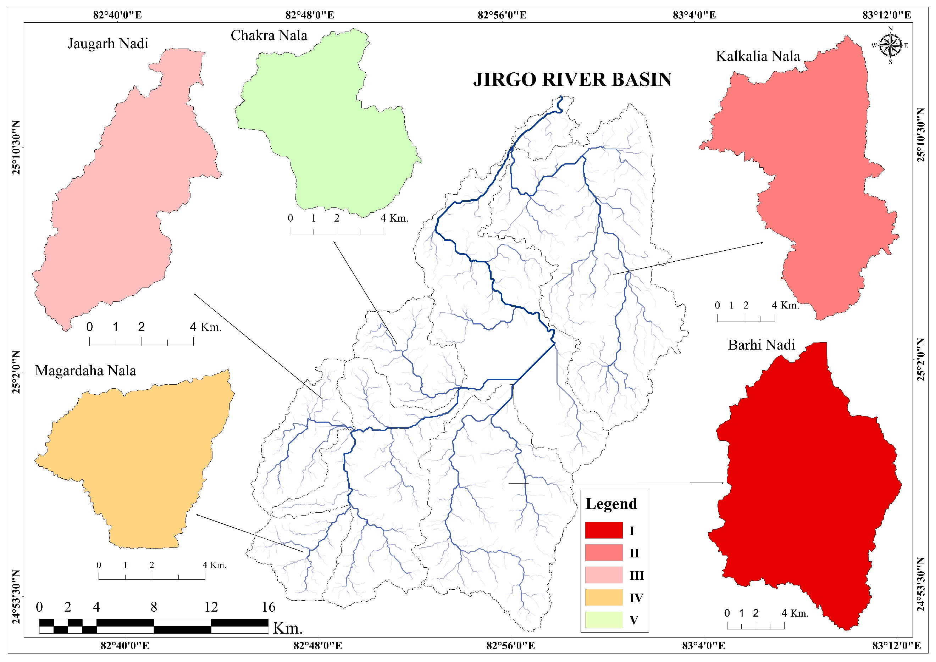
Figure 6. Prioritized sub-basin map of the Jirgo River basin
CONCLUSION
The present study highlights the importance of morphometric analysis in identifying basin characteristics and prioritizing sub-basins for prosperous soil and water conservation methods. Integrating GIS and remote sensing techniques has proven more efficient and precise than traditional methods in evaluating morphometric parameters. After assessing nineteen morphometric data points, this study effectively identified erosion-prone zones within the Jirgo River basin using the compound value approach. Prioritizing sub-basins based on soil erosion vulnerability helps decision-makers execute targeted conservation measures. The findings underscore the importance of drainage morphometry in sustainable basin management, which allows for more efficient resource allocation and cost-effective planning. This study addresses the issue of soil erosion–based sub-basin prioritization in an intermittent river system, which is an important and relatively under-studied topic in semi-arid regions of Central India. The application of morphometric analysis using GIS and remote sensing provides a cost-effective framework for watershed management in data-scarce environments. The study contributes useful baseline information for local planners and decision-makers involved in soil and water conservation. However, its scientific contribution is primarily regional. The analysis primarily relies on SRTM 30 m resolution DEM data, which, while suitable for regional-scale assessments, may not capture fine-scale topographic variations, particularly in low-relief or highly dissected terrain. Furthermore, the study focuses exclusively on morphometric parameters and does not explicitly incorporate climatic variables which can also significantly influence erosion processes. Future studies could include more environmental variables, such as land use and climate data, to improve the accuracy.

Data Availability Statement: All data and materials associated with this manuscript have been published with the paper. Data will be provided upon reasonable request.
Disclaimer (Artificial intelligence)
Option 1:
Author(s) hereby declares that NO generative AI technologies such as Large Language Models (ChatGPT, COPILOT, etc.) and text-to-image generators have been used during the writing or editing of this manuscript.

REFERENCE

- Ali, R., Sajjad, H., Masroor, M., Saha, T. K., Roshani, & Rahaman, M. H. (2024). Morphometric parameters based prioritization of watersheds for soil erosion risk in Upper Jhelum Sub-catchment, India. Environmental Monitoring and Assessment, 196(1), 82.https://doi.org/10.1007/s10661-023-12226-1
- Al-Saady, Y. I., Al-Suhail, Q. A., Al-Tawash, B. S., & Othman, A. A. (2016). Drainage network extraction and morphometric analysis using remote sensing and GIS mapping techniques (Lesser Zab River Basin, Iraq and Iran). Environmental Earth Sciences, 75(18), 1-23. https://doi.org/10.1007/s12665-016-6038-y
- Arnous, M. O., Aboulela, H. A., & Green, D. R. (2011). Geo-environmental hazards assessment of the north western Gulf of Suez, Egypt. Journal of Coastal Conservation, 15, 37-50. https://doi.org/10.1007/s11852-010-0118-z
- Arulbalaji, P., & Padmalal, D. (2020). Sub-Watershed Prioritization Based on Drainage Morphometric Analysis:A Case Study of Cauvery River Basin in South India. Journal of the Geological Society of India, 95(1), 25-35. https://doi.org/10.1007/s12594-020-1383-6
- Asode, A. N., Sreenivasa, A., & Lakkundi, T. K. (2016). Quantitative morphometric analysis in the hard rock Hirehalla sub-basin, Bellary and Davanagere Districts, Karnataka, India using RS and GIS. Arabian Journal of Geosciences, 9(5), 381.https://doi.org/10.1007/s12517-016-2414-x
- Balasubramani, K., Gomathi, M., Bhaskaran, G., & Kumaraswamy, K. (2019). GIS-based spatial multi-criteria approach for characterization and prioritization of micro-watersheds: a case study of semi-arid watershed, South India. Applied Geomatics, 11, 289-307.https://doi.org/10.1007/s12518-019-00261-y
- Bali, R., Agarwal, K. K., Nawaz Ali, S., Rastogi, S. K., & Krishna, K. (2012). Drainage morphometry of Himalayan Glacio-fluvial basin, India: hydrologic and neotectonic implications. Environmental Earth Sciences, 66, 1163-1174. https://doi.org/10.1007/s12665-011-1324-1
- Banerjee, A., Singh, P., & Pratap, K. (2017). Morphometric evaluation of Swarnrekha watershed, Madhya Pradesh, India: an integrated GIS-based approach. Applied Water Science, 7, 1807-1815. https://doi.org/10.1007/s13201-015-0354-3
- Bharath, A., Manjunatha, M., Tangadagi, R. B., & Preethi, S. (2020). Environmental assessment for rainwater harvesting at gitam campus. Journal of Green Engineering.https://www.researchgate.net/publication/343570000_Environmental_Assessment_for_Rainwater_Harvesting_at_GITAM_Campus
- Bhattacharya, R. K., Chatterjee, N. D., & Das, K. (2020). Sub-basin prioritization for assessment of soil erosion susceptibility in Kangsabati, a plateau basin: A comparison between MCDM and SWAT models. Science of the Total Environment, 734, 139474.https://doi.org/10.1016/j.scitotenv.2020.139474
- Biswas, S., Sudhakar, S., & Desai, V. R. (1999). Prioritisation of subwatersheds based on morphometric analysis of drainage basin: A remote sensing and GIS approach. Journal of the Indian Society of Remote Sensing, 27, 155-166. https://doi.org/10.1007/BF02991569
- Chorley, R. J. (1969). The drainage basin as the fundamental geomorphic unit. Water, earth and man (pp. 77-98). London, Methuen and Co. Ltd.
- Choudhari, P. P., Nigam, G. K., Singh, S. K., & Thakur, S. (2018). Morphometric based prioritization of watershed for groundwater potential of Mula river basin, Maharashtra, India. Geology, Ecology, and Landscapes, 2(4), 256-267.https://doi.org/10.1080/24749508.2018.1452482
- Clarke JJ (1966) Morphometry from map. Essays in geomorphology. Elsevier, New York, pp 235–274.
- Datry, T., Singer, G., Sauquet, E., Jorda-Capdevila, D., Von Schiller, D., Stubbington, R., Magand, C., Pařil, P., Miliša, M., Acuña, V., Alves, M., Augeard, B., Brunke, M., Cid, N., Csabai, Z., England, J., Froebrich, J., Koundouri, P., Lamouroux, N., Martí, E., Morais, M., Munné, A., Mutz, M., Pesic, V., Previšić, A., Reynaud, A., Robinson, C., Sadler, J., Skoulikidis, N., Terrier, B., Tockner, K., Vesely, D., & Zoppini, A. (2017). Science and management of intermittent rivers and ephemeral streams (SMIRES). Research Ideas and Outcomes. https://doi.org/10.3897/rio.3.e21774
- Farr, T. G., Rosen, P. A., Caro, E., Crippen, R., Duren, R., Hensley, S., Kobrick, M., Paller, M., Rodriguez, E., Roth, L., Seal, D., Shaffer, S., Shimada, J., Umland, J., Werner, M., Oskin, M., Burbank, D., & Alsdorf, D. (2007). The shuttle radar topography mission. Reviews of Geophysics, 45(2) https://doi.org/10.1029/2005RG000183
- Forkuor, G., & Maathuis, B. H. P. (2012). Comparison of SRTM and ASTER Derived Digital Elevation Models over Two Regions in Ghana – Implications for Hydrological and Environmental Modeling. In *Studies on Environmental and Applied Geomorphology* (pp. 219-240). IntechOpen. https://doi.org/10.5772/28951
- Gajbhiye, S., Pandey, A., & Mishra, S. K. (2013). Prioritizing erosion-prone area through morphometric analysis: an RS and GIS perspective. Applied Water Science, 4(1), 51–61.https://doi.org/10.1007/s13201-013-0129-7
- Hadley, R. F., & Schumm, S. A. (1961). Sediment sources and drainage-basin characteristics in upper Cheyenne River basin. US Geological Survey Water-Supply Paper, 1531. https://doi.org/10.3133/wsp1531
- Haghipour, N., & Burg, J. P. (2014). Geomorphological analysis of the drainage system on the growing Makran accretionary wedge. Geomorphology, 209, 111-132.https://doi.org/10.1016/j.geomorph.2013.11.030
- Hajam, R. A., Hamid, A., & Bhat, S. (2013). Application of Morphometric Analysis for Geo-Hydrological Studies Using Geo-Spatial Technology –A Case Study of Vishav Drainage Basin. Hydrology Current Research. https://doi.org/10.4172/2157-7587.1000157
- Horton, R. E. (1945). Erosional development of streams and their drainage basins; hydrophysical approach to quantitative morphology. Geological Society of America Bulletin, 56(3), 275-370. https://doi.org/10.1130/0016-7606(1945)56[275:edosat]2.0.co;2
- Hossain, F., & Moniruzzaman, D. M. (2021). Environmental change detection through remote sensing technique: A study of Rohingya refugee camp area (Ukhia and Teknaf sub-district), Cox's Bazar, Bangladesh. Environmental Challenges, 2, 100024.https://doi.org/10.1016/j.envc.2021.100024
- Jaiswal, R. K., Ghosh, N. C., Galkate, R. V., & Thomas, T. (2015). Multi Criteria Decision Analysis (MCDA) for Watershed Prioritization. Aquatic Procedia.https://doi.org/10.1016/j.aqpro.2015.02.201
- Jothimani, M., Abebe, A., & Dawit, Z. (2020). Mapping of soil erosion-prone sub-watersheds through drainage morphometric analysis and weighted sum approach: a case study of the Kulfo River basin, Rift valley, Arba Minch, Southern Ethiopia. Modeling Earth Systems and Environment, 6, 2377–2389. https://doi.org/10.1007/s40808-020-00820-y
- Kaliraj, S., Chandrasekar, N., & Magesh, N. S. (2015). Morphometric analysis of the River Thamirabarani sub-basin in Kanyakumari District, South west coast of Tamil Nadu, India, using remote sensing and GIS. Environmental Earth Sciences, 73, 7375–7401.https://doi.org/10.1007/s12665-014-3914-1
- Kaushik P, Ghosh P (2015a) 3D DEM delineation of Chambal river basin from SRTM data using remote sensing and GIS technol ogy. Int J Remote Sens Geosci 4(4):1–6
- Kaushik, P., & Ghosh, P. (2015). Geomorphic evolution of Chambal River origin in Madhya Pradesh using remote sensing and GIS. International Journal of Advanced Remote Sensing and GIS, 4(1), 1130–1141. https://doi.org/10.23953/cloud.ijarsg.127
- Khalkho, D., Tripath, M.P., Patel, S., Pandey, V.K., Nigam, G.K., & Kumar Love. (2017). Geospatial techniques for prioritization of sub-watersheds of hamp Watershed of upper Mahanadi Basin using morphometric analysis. Trends in Biosciences, 10(15), Print : ISSN 0974-8431, 2705-2713, 2017.
- Kumar, L., Khalkho, D., Pandey, V.K., Nigam, G.K., & Yatnesh, B. (2017). Site suitability analysis of water storage structures using remote sensing & GIS for a small watershed of Lormi block in Mungeli district, Chhattisgarh State. IJABR, 7(3), 495–503.https://www.scienceandnature.org/archive/IJABR_7(3)_2017/495-503.pdf
- Leopold, L. B., Wolman, M. G., & Miller, J. P. (1964). Fluvial processes in geomorphology. W. H. Freeman and Company. https://www.doverpublications.com/9780486845524/
- Magesh, N. S., Jitheshlal, K. V., Chandrasekar, N., & Jini, K. V. (2013). Geographical information system-based morphometric analysis of Bharathapuzha river basin, Kerala, India. Applied Water Science, 3(2), 467–477. https://doi.org/10.1007/s13201-013-00950
- Mahala, A. (2019). The significance of morphometric analysis to understand the hydrological and morphological characteristics in two different morpho-climatic settings. Applied Water Science, 10, Article 33. https://doi.org/10.1007/s13201-019-1118-2
- Malik, A., Kumar, A., & Kandpal, H. (2019). Morphometric analysis and prioritization of sub-watersheds in a hilly watershed using weighted sum approach. Arabian Journal of Geosciences, 12, 1-12. https://doi.org/10.1007/s12517-019-4310-7
- Morisawa, M. (1985). Rivers: Form and Process. Longman Group.https://books.google.com/books/about/Rivers.html?id=2_4PAQAAMAAJ
- Mueller, J. E. (1968). An introduction to the hydraulic and topographic sinuosity indexes. Annals of the Association of American Geographers, 58(2), 371–385.https://doi.org/10.1111/j.1467-8306.1968.tb00650.x
- Munoth, P., & Goyal, R. (2020). Hydromorphological analysis of Upper Tapi river sub-basin, India, using QSWAT model. Modeling Earth Systems and Environment.https://doi.org/10.1007/s40808-020-00821-x
- Nautiyal MD (1994) Morphometric analysis of drainage basin, district Dehradun, Uttar Pradesh. J Indian Soc Remote Sens 22(4):252–262
- Pareta, K., & Pareta, U. (2011). Quantitative morphometric analysis of a watershed of Yamuna basin, India using ASTER (DEM) data and GIS. International journal of Geomatics and Geosciences, 2(1), 248-269. https://www.semanticscholar.org/paper/Quantitative Morphometric-Analysis-of-a-Watershed-ParetaPareta/1111111111111111111111111111111111111111
- Pati JK, Malviya VP, Prakash K (2006) Basement re-activation and its relation to neotectonic activity in and around Allahabad, Ganga Plain. J Indian Soc Remote Sens 34:47–56
- Poongodi, R., & Venkateswaran, S. (2018). Prioritization of the micro-watersheds through morphometric analysis in the Vasishta Sub Basin of the Vellar River, Tamil Nadu using ASTER Digital Elevation Model (DEM) data. Data in brief.https://doi.org/10.1016/j.dib.2018.08.197
- Potter, P. E. (1957). A quantitative geomorphic study of drainage basin characteristics in the Clinch Mountain area, Virginia and Tennessee. V. C. Miller. *The Journal of Geology*, *65*(1), 112–113. https://doi.org/10.1086/626413
- Potter, P. E., & Miller, V. C. (1957). A Quantitative Geomorphic Study of Drainage Basin Characteristics in the Clinch Mountain Area, Virginia and Tennessee. The Journal of Geology, 65(1), 112-113. https://doi.org/10.1086/626413
- Prakash, K., Rawat, D., Singh, S., Chaubey, K., Kanhaiya, S., & Mohanty, T. (2019). Morphometric analysis using SRTM and GIS in synergy with depiction: a case study of the Karmanasa River basin, North central India. *Applied Water Science*, *9*(1), 1–10.https://doi.org/10.1007/s13201-018-0887-3
- Prasad, R. K., Mondal, N. C., Banerjee, P., Nandakumar, N. V., & Singh, V. S. (2008). Deciphering potential groundwater zone in hard rock through the application of GIS. Environmental Geology, 55, 467-475. https://doi.org/10.1007/s00254-007-0992-3
- Rahaman, S. A., Ajeez, S. A., Aruchamy, S., & Jegankumar, R. (2015). Prioritization of Sub Watershed Based on Morphometric Characteristics Using Fuzzy Analytical Hierarchy Process and Geographical Information System – A Study of Kallar Watershed, Tamil Nadu. Aquatic Procedia, 4, 1322-1330. https://doi.org/10.1016/j.aqpro.2015.02.172
- Rahmati, O., Samadi, M., Shahabi, H., Azareh, A., Rafiei-Sardooi, E., Alilou, H., Melesse, A.M., Pradhan, B., Chapi, K., & Shirzadi, A. (2019). SWPT: An automated GIS-based tool for prioritization of sub-watersheds based on morphometric and topo-hydrological factors. Geoscience Frontiers, 10(6), 2167–2175. https://doi.org/10.1016/j.gsf.2019.03.009
- Rai, P. K., Chandel, R. S., Mishra, V. N., & Singh, P. (2018). Hydrological inferences through morphometric analysis of lower Kosi river basin of India for water resource management based on remote sensing data. Applied Water Science, 8(1), 1–16.https://doi.org/10.1007/s13201-018-0660-7
- Rai, P. K., Chaubey, P. K., Mohan, K., & Singh, P. (2017). Geoinformatics for assessing the inferences of quantitative drainage morphometry of the Narmada Basin in India. Applied Geomatics, 9(3), 167-189. https://doi.org/10.1007/s12518-017-0191-1
- Rai, P. K., Mishra, V. N., & Mohan, K. (2017). A study of morphometric evaluation of the Son basin, India using geospatial approach. Remote Sensing Applications: Society and Environment, 7, 9-20. https://doi.org/10.1016/j.rsase.2017.05.001
- Rai, P. K., Mohan, K., Mishra, S., Ahmad, A., & Mishra, V. N. (2014). A GIS-based approach in drainage morphometric analysis of Kanhar River Basin, India. Applied Water Science.https://doi.org/10.1007/s13201-014-0238-y
- Rekha, B. V., George, A. V., & Rita, M. (2011). Morphometric analysis and micro-watershed prioritization of Peruvanthanam sub-watershed, the Manimala River Basin, Kerala, South India. Environmental Research, Engineering and Management, 57(3), 6–14.https://erem.ktu.lt/index.php/erem/article/view/472
- Resmi, M. R., Babeesh, C., & Achyuthan, H. (2019). Quantitative analysis of the drainage and morphometric characteristics of the Palar River basin, Southern Peninsular India; using bAd calculator (bearing azimuth and drainage) and GIS. Geology, Ecology, and Landscapes, 3(4), 295-307. https://doi.org/10.1080/24749508.2018.1563750
- Said, S., Siddique, R., & Shakeel, M. (2018). Morphometric analysis and sub-watersheds prioritization of Nagmati River watershed, Kutch District, Gujarat using GIS based approach. Journal of Water and Land Development, 39, 131–139. https://doi.org/10.2478/jwld-2018-0068
- Samal, D. R., Gedam, S. S., & Nagarajan, R. (2015). GIS based drainage morphometry and its influence on hydrology in parts of Western Ghats region, Maharashtra, India. Geocarto International, 30(7), 755–778. https://doi.org/10.1080/10106049.2014.978903
- Sangma, F., & Guru, B. (2020). Watersheds characteristics and prioritization using morphometric parameters and fuzzy analytical hierarchal process (FAHP): a part of lower Subansiri sub-basin. Journal of the Indian Society of Remote Sensing, 48, 473–496.https://doi.org/10.1007/s12524-019-01091-6
- Schumm, S. A. (1956). Evolution of drainage systems and slopes in badlands at Perth Amboy, New Jersey. Geological Society of America Bulletin, 67, 597–646.https://doi.org/10.1130/0016-7606(1956)67[597:eodsas]2.0.co;2
- Singh, A. P., Arya, A. K., & Singh, D. S. (2020). Morphometric Analysis of Ghaghara River Basin, India, Using SRTM Data and GIS. Journal of the Geological Society of India, 95, 169–178. https://doi.org/10.1007/s12594-020-1406-3
- Singh, D. S., & Awasthi, A. (2011). Implication of Drainage Basin Parameters of Chhoti Gandak River, Ganga Plain, India. Journal of the Geological Society of India, 78(4), 370–378. https://doi.org/10.1007/s12594-011-0102-8
- Singh, P., Gupta, A., & Singh, M. (2014). Hydrological inferences from watershed analysis for water resource management using remote sensing and GIS techniques. The Egyptian Journal of Remote Sensing and Space Sciences, 17(2), 111–121.https://doi.org/10.1016/j.ejrs.2014.09.003
- Singh, P., Prakash, K., Kumar, A., Kannaujiya, A. K., Deep, A., & Mohanty, T. (2023). GIS-based morphometric analysis with emphasis on hypsometric appraisal for sub-watershed prioritization: a case study of the Shyamari River Basin, Central India. Sustainable Water Resources Management, 9(4), 122. https://doi.org/10.1007/s40899-023-00900-8
- Singh, P., Thakur, J. K., & Singh, U. C. (2013). Morphometric analysis of Morar River Basin, Madhya Pradesh, India, using remote sensing and GIS techniques. Environmental Earth Sciences, 68, 1967–1977. https://doi.org/10.1007/s12665-012-1884-8
- Singh, S., Kanhaiya, S., Singh, A., & Chaubey, K. (2018). Drainage network characteristics of the Ghaghghar River Basin (GRB), Son Valley, India. Geology, Ecology, and Landscapes. https://doi.org/10.1080/24749508.2018.1525670
- Singh, S., Singh, A. K., Kumar, P., & Jaiswal, M. K. (2021). Morphotectonic analysis of the Bihar River, Madhya Pradesh, India. Proceedings of the Indian National Science Academy, 87(1), 163–174. https://doi.org/10.1007/s43538-021-00023-8
- Singh, V. G., & Singh, S. K. (2022). Analysis of geo-morphometric and topo-hydrological indices using COP-DEM: a case study of Betwa River Basin, Central India. Geology, Ecology, and Landscapes, 8(2), 1-28. https://doi.org/10.1080/24749508.2022.2097376
- Singh, W. R., Barman, S., & Tirkey, G. (2021). Morphometric analysis and watershed prioritization in relation to soil erosion in Dudhnai Watershed. Applied Water Science 11 (9): 151.
- Smith, K. G. (1950). Standards for grading texture of erosional topography. American Journal of Science, 248(9), 655-668. https://doi.org/10.2475/ajs.248.9.655
- Sreedevi, P. D., Owais, S. H. H. K., Khan, H. H., & Ahmed, S. (2009). Morphometric analysis of a watershed of South India using SRTM data and GIS. Journal of the Geological Society of India, 73, 543-552. https://doi.org/10.1007/s12594-009-0038-4
- Sreedevi, P. D., Sreekanth, P. D., Khan, H. H., & Ahmed, S. (2013). Drainage morphometry and its influence on hydrology in an semi arid region: using SRTM data and GIS. Environmental Earth Sciences, 70, 839-848. https://doi.org/10.1007/s12665-012-2172-3
- Sreedevi, P. D., Subrahmanyam, K., & Ahmed, S. (2005). Integrated approach for delineating potential zones to explore for groundwater in the Pageru River basin, Cuddapah District, Andhra Pradesh, India. Hydrogeology Journal. https://doi.org/10.1007/s10040-004-0375-8
- Srivastava, V. K. (1997). Study of drainage pattern of Jharia Coalfield (Bihar), India, through remote sensing technology. Journal of the Indian Society of Remote Sensing, 25, 41-46.
- Strahler, A. N. (1964). Quantitative geomorphology of drainage basin and channel networks. Handbook of applied hydrology.
- Strahler, A. N. (1964). Quantitative geomorphology of drainage basin and channel networks. Handbook of applied hydrology.
- Sujatha, E. R., Selvakumar, R., Rajasimman, U. A. B., & Victor, R. G. (2015). Morphometric analysis of sub-watershed in parts of Western Ghats, South India using ASTER DEM. Geomatics, Natural Hazards and Risk, 6(4), 326-341.https://doi.org/10.1080/19475705.2013.845114
- Sun, G., Ranson, K. J., Kharuk, V. I., & Kovacs, K. (2003). Validation of surface height from shuttle radar topography mission using shuttle laser altimeter. Remote Sensing of Environment, 88(4), 401-411. https://doi.org/10.1016/j.rse.2003.09.001
- Szabó, G., Singh, S. K., & Szabó, S. (2015). Slope angle and aspect as influencing factors on the accuracy of the SRTM and the ASTER GDEM databases. Physics and Chemistry of the Earth, Parts A/B/C. https://doi.org/10.1016/j.pce.2015.06.003
- Thomas, J., Joseph, S., Thrivikramji, K., Abe, G., & Kannan, N. (2012). Morphometrical analysis of two tropical mountain river basins of contrasting environmental settings, the southern Western Ghats, India. Environmental Earth Sciences, 66(8), 2353-2366.https://doi.org/10.1007/s12665-011-1457-2
- Umrikar, B. N. (2017). Morphometric analysis of Andhale watershed, Taluka Mulshi, District Pune, India. Applied Water Science. https://doi.org/10.1007/s13201-016-0390-7
- Waikar, M. L., & Nilawar, A. P. (2014). Morphometric analysis of a drainage basin using geographical informa tion system: A case study. Int J Multidiscip Curr Res, 2(2), 179–184.
- Waiyasusri, K., & Chotpantarat, S. (2020). Watershed Prioritization of Kaeng Lawa Sub-Watershed, Khon Kaen Province Using the Morphometric and Land-Use Analysis: A Case Study of Heavy Flooding Caused by Tropical Storm Podul. Water, 12(6), 1570. https://doi.org/10.3390/w12061570
- Yadav, S. K., Dubey, A., Szilard, S., & Singh, S. K. (2016). Prioritisation of sub-watersheds based on earth observation data of agricultural dominated northern river basin of India. Geocarto International, 33(4), 339-356. https://doi.org/10.1080/10106049.2016.1265592
- Yadav, S. K., Singh, S. K., Gupta, M., & Srivastava, P. K. (2014). Morphometric analysis of Upper Tons basin from Northern Foreland of Peninsular India using CARTOSAT satellite and GIS. Geocarto International, 29(8), 895-914. https://doi.org/10.1080/10106049.2013.868043

