Impact of Urbanisation on Land Use and Land Cover Changes in Bidar District, Karnataka: A 30 Year Analysis (1994–2024)

Abstract
This paper focuses on the effects of urbanisation on LULC change dynamics in Bidar District, Karnataka, over a period of 30 years (1994-2024), using multi-temporal Landsat satellite images. Landsat 5 satellite images and Landsat 8 OLI images underwent radiometric and geometric correction techniques, and classification was carried out using Maximum Likelihood supervised classification and Support Vector Machines (SVM). The accuracy of classification was assessed by using a Confusion Matrix and Kappa coefficient. Post-classification comparison of maps was adopted to measure temporal LULC change. Results indicate a significant increase in built-up land use by approximately 400 per cent (from 175 km² in 1994 to 871 km² in 2024), along with substantial decreases in forestland of about 61 per cent (from 948 km² to 369 km²). Agricultural and water bodies, on the other hand, experienced an initial reduction followed by a stabilisation phase in recent years. Agricultural lands show a fluctuating pattern, with minimum expansion in 2014 at a low of 219 km². Supplemental analysis using NDVI and LST also highlights a progressive reduction in vegetation strength and an enhanced urban heat island, respectively, due to urban expansion. Serious land use/cover transformations imposed grave environmental and socio-economic implications on Bidar, characterised by loss of biodiversity, changes in hydrological patterns, rising thermal stress, and burgeoning infrastructure and livelihood demands. This scientific investigation, thus, emphasises a holistic approach to sustainable land use management and urban expansion in the arid regions of Bidar, Karnataka.
Keyword: Urbanisation, Bidar, Land Use, Land Cover, LULC

Introduction
Urbanisation acts as the key driver for land use/land cover change. In the Indian scenario, the pace of urbanisation, which largely follows population growth, rural to urban migration, as well as the development of infrastructure, has enormously increased the transformation of agricultural land, forests, and water bodies into an increased built-up land cover. Even as the occurrence of such changes has been well-documented within the larger urban centres, the lack of information within medium-sized, drought-sensitive districts, which categorise land-directed livelihoods based on their high sensitivity to land change, continues to exist. To fulfil this research gap, this study proposes to quantify the extent of land change, which follows urbanisation, within the Bidar district of Karnataka, from the year 1994 to the year 2024, with a pre-set measurable framework.

This study incorporates a structured analytical framework to investigate the relationships between urbanisation, land use, and land cover change, as well as their environmental and socio-economic impacts. The extent and spatial patterns of land transformation due to urban expansion are considered through multi-temporal satellite-based LULC classification and post-classification change detection. Resulting LULC changes are further assessed with respect to key environmental indicators, such as vegetation condition, surface temperature variation, and changes in surface water extent, through the analysis of NDVI and LST. Additionally, the study also investigates socio-economic implications in terms of agricultural land availability, livelihoods, infrastructure pressure, and population dynamics. This step-by-step analytical framework provides a logical pathway of how land transformations driven by urban growth lead to tangible environmental and socio-economic changes.

Research Objective
The primary objective of this study is to analyse the impact of urbanisation on land use and land cover (LULC) patterns in Bidar District from 1994 to 2024. Specifically, the study has three major objectives.
- To assess the extent and nature of LULC changes driven by urbanisation using remote sensing and GIS techniques.
- To evaluate the environmental, social, and economic consequences of these changes, including effects on ecosystems, resources, and livelihoods.
- To examine the role of urbanisation in shaping the overall development trajectory of the district, identifying both opportunities and challenges.

Review of Literature
Global Perspective
Urbanisation and its consequences on land use and land cover (LULC) have been widely studied across the globe (Nuissl & Siedentop, 2021). Di Clemente et al. (2021) link urban growth with economic transformation, emphasising its role in reshaping landscapes and settlement structures. Murayama and Eastoque (2020) underline demographic shifts and infrastructural expansion as critical dimensions of urbanisation. Nuissi et al. (2021) highlight the ecological consequences, such as habitat loss, biodiversity decline, and heightened pollution levels.
Remote sensing and GIS have become indispensable tools for analysing LULC changes. Reis (2005), for instance, examined LULC dynamics in northeastern Turkey using Landsat data (1976–2000), indicating substantial urban expansion at the expense of agricultural and forest areas. Similarly, Fatemi and Narangifard (2019) employed multi-temporal Landsat imagery in Shiraz, Iran, revealing urban growth patterns that negatively affected vegetation cover and contributed to local heat island effects.
In Africa, Abebe et al., (2022) documented land conversion in Ethiopia, where farmland expansion and settlement growth displaced forests and grazing lands. They identified population pressure, insecure land rights, and climate variability as primary drivers (Fu & Weng, 2016). These studies collectively prove that urbanisation, though fostering socio-economic opportunities, poses severe risks to ecosystem stability.

National Perspective
Urbanisation in India presents a dual narrative of economic growth and ecological stress. Indian megacities like Delhi and Hyderabad exhibit severe LULC changes, with built-up areas expanding at the expense of forests and water bodies (Kamraju, 2016; Mohan et al., 2011). Ajmer and Pune report similar trends, emphasising unsustainable infrastructure and pollution (Chouhan & Kannan, 2019). Gaur and Singh (2023) advocate integrating machine learning with policy frameworks for sustainable urban modelling. Chouhan and Kannan (2019) focused on Ajmer city, Rajasthan, emphasising challenges of water scarcity, pollution, and land degradation linked to rapid population growth. Mundhe and Jaybhaye (2014) studied Pune’s urban expansion and stressed the need for sustainable land use planning. Kamraju (2016) illustrated how unchecked development in Hyderabad degraded lake ecosystems.
Studies and research in other regions also echo similar findings. Pratim Gogoi et al., (2019) analysed Odisha’s rising temperatures, linking them with land cover transformation. Das and Angadi (2020) examined the Barrackpore subdivision in West Bengal, correlating LULC changes with surface temperature variations. Collectively, these works underscore that although urbanisation facilitates industrialisation and employment growth, it simultaneously exacerbates environmental degradation, underscoring the imperative for sustainable urban planning in India.

Regional Focus on Bidar
Compared to India’s megacities, research on urbanisation in the Bidar district is limited. Seenipandian et al. (2016) employed remote sensing and GIS to assess land cover dynamics, showing that urban expansion is closely linked with declining agricultural productivity and the ecosystem. Mustafa and Prasad (2024) further demonstrated how high-resolution satellite imagery could effectively detect transformations in Bidar’s agricultural and forested landscapes.

Research Gap
Most of the studies on urbanisation and land use/land cover (LULC) change focus on global trends or major Indian cities and major Indian districts, while smaller districts like Bidar, which is considered one of the northernmost districts of Karnataka, remain underexplored despite their vulnerability to drought and dependence on agriculture. Existing research in Bidar has been limited in scope and timeframe, lacking comprehensive, long-term assessments that integrate environmental, social, and economic dimensions. In particular, there is little evidence on how urban expansion has influenced biodiversity, water resources, and rural livelihoods over the past three decades. This study addresses the gap by providing a systematic 30-year analysis (1994–2024) of LULC dynamics in Bidar, offering localised insights to support sustainable urban planning and policy.

Materials and Methods

Data Sources
Multi-spectral satellite imagery from the United States Geological Survey (USGS) was employed:
Satellite imagery: Landsat 5 (1994, 2004) and Landsat 8 OLI (2014, 2024).
Resolution: 30m; referencing system: WGS 1984, UTM Zone 43N.
Ancillary data: Survey of India’s Topographic maps, demographic statistics (bidar.nic.in), and land use data.

Table 1: Details about the database used in the study area
Acquisition date | Satellite Image | Path/Row | Resolution | Referencing System
09-03-1994 | Landsat 5 | 145/47 | 30m | WGS  1984  UTM ZONE  43^{O} N
09-03-2004 | Landsat 5 | 145/47 | 30m | WGS  1984  UTM ZONE  43^{O} N
13-04-2014 | Landsat 8 OLI | 145/47 | 30m | WGS  1984  UTM ZONE  43^{O} N
14-02-2024 | Landsat 8 OLI | 145/47 | 30m | WGS  1984  UTM ZONE  43^{O} N

Methodology
This research used multi-temporal Landsat data (Landsat 5 TM – 1994, 2004, Landsat 8 OLI – 2014, 2024) having 30 m resolution, obtained from the USGS. Land use/land cover classification was done by using Maximum Likelihood and Support Vector Machine classification techniques, assisted by ground truths, auxiliary maps, and high-quality reference images. There are five LULC classes mapped: built up, forest, agricultural plantation land, barren land, and water bodies. Change analysis was conducted using post-classification comparison techniques.

The medium spatial resolution of the Landsat data introduces certain difficulties in heterogeneous urban and peri-urban zones where the pixels may result in ambiguities of classification between the classes of urban and barren or sparse vegetated areas. The accuracy of the classification approach was estimated with the help of the confusion matrix and Kappa statistics, with an overall accuracy of more than 85 per cent.

Study Area
Bidar District (17.35°–18.25°N; 76.42°–77.39°E) spans 5,436 km² in northern Karnataka’s Deccan plateau. It is predominantly rural, with agriculture supporting over 1.2 million people. The district is characterised by semi-arid conditions, basaltic soils, and a dense river drainage system feeding into the Godavari and Krishna basins. Despite limited urbanisation (4.2% of total area), rapid population growth and development initiatives have spurred land conversion over the last three decades.

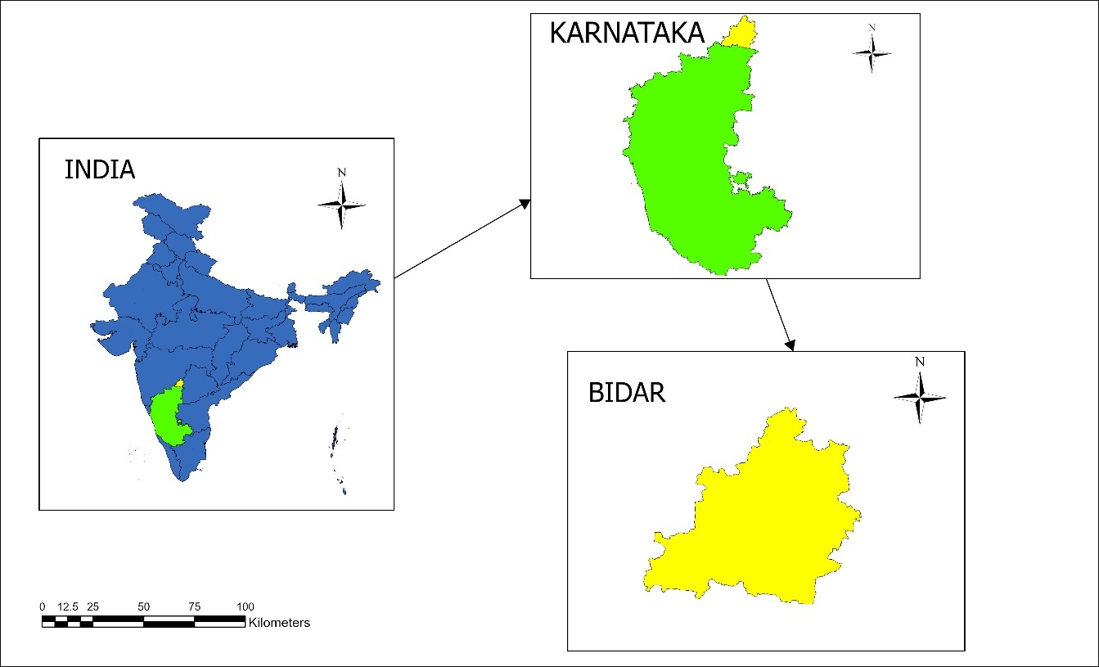
Figure 1: Location of the Study Area

Results and Discussion

Land Use and Land Cover Dynamics
Socio-Economic Impacts
As a consequence, land use and land cover change associated with urbanisation in Bidar District have had noticeable socio-economic impacts, especially in agriculture, population, infrastructure, and healthcare. Although the study does not use survey data, LULC change data with numerical statistics, along with secondary population data, serve as proxy techniques to evaluate these influences on a broadscale basis.
Agricultural Decline
Statistics on the data of LULC reveal a decrease in and fragmentation of agricultural land in the peri-urban area that mirrors the expansion of the built-up area. This decline in land area has significant effects on agricultural livelihoods in a district where agriculture is one of the dominant sources of employment. While data on yield and income have not been studied, the pattern of land conversion can be taken as a manifestation of increasing pressure on small and marginal farmers and changing livelihoods to non-farm sources.
Migration and Employment
Demographic statistics indicate a consistent level of urban population, which corresponds with the expansion of developed land. The level of increased rural-urban migration, as well as a shift in employment patterns from agricultural to construction and service sectors, seems to be evident. Although employment structure cannot be measured, as no primary employment data exists, the expansion around the points in the built-up areas offers indirect statistical evidence on employment migration.
Infrastructure Demand
The concentration of the expansion in space has led to an intensified demand for housing, transportation, water, and sanitation infrastructure. The rapid expansion in built-up areas, reflected in LULC change data, suggests that the development of infrastructure might not be keeping pace with expansion in built-up areas. These trends are more visible in the newly developed periphery areas, where the services might not yet have followed the land use change.
Health Risks
The resultant effects of environmental change due to urbanisation, for example, the decrease in NDVI and the increase in LST, have quantifiable effects on public health. The results of NDVI and LST show increased thermal stress and decreased ecological buffering capacity in the urbanised areas, which are understood to worsen health effects on diseases caused by heat and water. The health impacts were not statistically processed for analysis; the indicators, however, are used indirectly for health implications.

Class Name | 1994 | 2004 | 2014 | 2024
Barren | 472.21 | 536.68 | 568.84 | 765.87
Developed (Buildup) | 175.06 | 305.46 | 576.043 | 871.04
Forest | 948.13 | 735.71 | 380.83 | 369.41
Planted/Cultivated | 345.63 | 350.11 | 475.05 | 709.59
Water | 131.25 | 82.82 | 60.03 | 83.92

Table 2: Land Use categories and area in hectares (1994-2024)

Barren Lands from 1994-2024

The analysis of Figure 2 on barren land reveals a clear upward trend over the three decades from 1994 to 2024. In 1994, barren land accounted for 20 per cent, which gradually rose to 23 per cent in 2004 and 24 per cent in 2014. However, the most significant increase occurred in the last decade, with barren land expanding sharply to 33 per cent by 2024.

Figure 2. Change in the distribution of Barren Lands from 1994-2024 in Bidar District
This pattern indicates a phase of accelerated land degradation in recent years, likely driven by factors such as deforestation, unplanned urban expansion, mining, and the overexploitation of agricultural resources. The steady growth of barren areas poses serious concerns for sustainable land use, agricultural productivity, and ecological stability, underscoring the urgent need for effective land management and conservation measures.
Developed (Buildup) Lands from 1994-2024
The temporal analysis of developed (built-up) land between 1994 and 2024 reveals a marked and continuous increase, reflecting the accelerated pace of urban expansion in the study region. Built-up land constituted only about 10 per cent in 1994, rising moderately to nearly 16 per cent by 2004. A pronounced surge is evident in the subsequent decade, with the share increasing to 30 per cent in 2014 and further escalating to approximately 46 per cent by 2024.

Figure 3. Change in the distribution of the build-up area from 1994-2024 in Bidar District
This more than fourfold growth over three decades underscores the intensification of urbanisation processes, driven by demographic pressure, industrial growth, and infrastructural development. While such expansion signifies socio-economic transformation, it simultaneously poses critical challenges, including the conversion of agricultural and forest lands, increased ecological stress, and the need for sustainable urban planning interventions.
Forest Lands from 1994-2024
The spatio-temporal assessment of forest cover between 1994 and 2024 indicates a significant and continuous decline, underscoring the severity of land use transitions in the study area. In 1994, forest areas accounted for nearly 39 per cent of the total land, but this share decreased to 30 per cent by 2004, marking the beginning of a sharp downward trajectory. The trend persisted, with forest cover further shrinking to 16 per cent in 2014 and reaching only 15 per cent by 2024. This represents a loss of more than half of the forest area within three decades. Such a drastic reduction reflects the combined pressures of agricultural expansion, urbanisation, infrastructural growth, and unsustainable exploitation of natural resources. The decline in forest land not only signals ecological imbalance but also has critical implications for biodiversity conservation, climate regulation, and the livelihood security of dependent communities. These findings emphasise the urgent need for integrated land management strategies, reforestation programs, and policy interventions aimed at achieving sustainable land use and environmental resilience.

Figure 4. Change in the distribution of Forest area from 1994-2024 in Bidar District
Planted and Cultivated lands from 1994-2024

The temporal dynamics of planted and cultivated land between 1994 and 2024 reveal a progressive and sustained expansion, contrasting with the simultaneous decline in forest cover. In 1994, cultivated land occupied 18.38 per cent, which remained nearly stable at 18.62 per cent in 2004. A notable rise was observed in 2014, when the share increased to 25.26 per cent, followed by a substantial growth to 37.74 per cent in 2024.

Figure 5. Change in the distribution of planted and cultivated land from 1994-2024 in Bidar District

This near doubling of cultivated land within three decades reflects the intensification of agricultural activities, likely driven by population growth, food demand, and the conversion of forests and fallow lands into cropland. While this expansion signifies agricultural intensification and enhanced land utilisation, it also raises critical concerns regarding soil degradation, groundwater depletion, and the long-term sustainability of cultivation practices. The findings highlight the urgent need for balanced land use policies that reconcile agricultural productivity with ecological stability, ensuring food security without compromising environmental resilience.

Water resources from 1994 to 2024

The temporal distribution of water resources between 1994 and 2024 illustrates a fluctuating yet predominantly declining trend. In 1994, water bodies constituted 36.66 per cent of the total area, which sharply reduced to 23.13 per cent by 2004. The decline continued into 2014, reaching a minimum of 16.77 per cent, reflecting increasing anthropogenic pressure and the diversion of water bodies for agricultural and urban uses. However, a slight recovery is observed in 2024, with the share rising to 23.44 per cent, possibly due to the implementation of water conservation measures, improved irrigation management, or climatic variability influencing surface water availability.

Figure 6. Change in the distribution of water resources from 1994-2024 in Bidar District

Despite this partial rebound, the long-term reduction remains significant, highlighting the vulnerability of water resources under competing land use demands. These findings underscore the urgent requirement for integrated water resource management, including watershed development, wetland protection, and policy frameworks that balance human needs with ecological sustainability.

Overall Significance (2014–2024):
This decade represents a critical turning point where urbanisation and agricultural expansion reached their peak, leading to unprecedented conversion of natural ecosystems into human-dominated landscapes. While some recovery in water resources is noted, the overall pattern reveals trade-offs between development and environmental sustainability. The dominance of built-up and cultivated land indicates a transition towards anthropocentric land use, often at the cost of ecological balance.

Urban Expansion
The most striking change in Bidar District between 1994 and 2024 has been the rapid growth of developed land. Built-up areas expanded nearly fivefold, from 175.06 km² in 1994 to 871.04 km² in 2024. This growth was particularly concentrated in the northern and southwestern zones, where urban centres, industrial clusters, and transport networks expanded significantly. Such exponential urbanisation reflects the increasing demographic and economic pressures of the district. However, it also introduces new challenges in infrastructure provision and environmental sustainability.

Interpretation of Land Use and Land Cover in Bidar District, 2004
The land use and land cover pattern of Bidar district in 1994 reflects a landscape primarily dominated by agriculture, supported by a relatively less urbanised human footprint and more ecologically intact areas when compared with contemporary patterns. Planted and cultivated land occupies the largest proportion of the district, forming a continuous expanse across the northern, north-western, and central regions. This dominance indicates the strong agrarian character of Bidar during the period, with agriculture serving as the principal livelihood and shaping both the spatial and economic structure of the district. The agricultural fields appear uninterrupted over large stretches, suggesting limited fragmentation from built-up expansion at the time.
Forest cover, which is more prominent in the southern and southwestern parts of the district, formed a significant ecological belt in 1994. The forested areas appear relatively extensive and less fragmented than in later decades, indicating lower anthropogenic pressure and a comparatively intact natural landscape. These southern forests, interwoven with pockets of cultivation, represent zones where topography, soil characteristics, and moisture availability supported the persistence of natural vegetation. In contrast, the northern part of the district shows scattered and fragmented forest patches, implying earlier stages of forest conversion for cultivation.
The developed or built-up area in 1994 was limited in extent and appeared mainly around major settlements and administrative nodes. The built-up patches are smaller, more dispersed, and less compact than in later years—reflecting a predominantly rural settlement structure with slow rates of urbanisation. The eastern and southeastern sectors show slightly higher concentrations of developed land, corresponding to early peri-urban growth around Bidar town and adjoining transport corridors. The overall distribution of built-up land suggests minimal encroachment into agricultural zones at this time and a landscape still largely shaped by traditional rural habitation.
Barren land during 1994 appears in small, discontinuous patches across the district, primarily in the central and southwestern zones. These areas likely represent rocky surfaces, temporarily fallow land, or degraded patches within the agricultural matrix. Their limited spatial coverage indicates that most land was either actively cultivated or retained under natural vegetation, with relatively low levels of land degradation at the time. Water bodies, though scattered, form an important part of the district’s hydrological system. A significant reservoir in the central region and several smaller tanks in the southern and southeastern parts supported irrigation, livestock, and domestic needs. The northern part shows fewer water bodies, a pattern consistent with its more intensive agricultural land use.
Overall, the 1994 LULC map portrays the Bidar district as an agrarian-dominated landscape with relatively intact southern forest areas, limited built-up expansion, and moderate hydrological features. The spatial organisation—extensive cultivation in the north, larger forest blocks in the south, early-stage urban concentration in the east, and a diverse mix of land cover in the central region—reflects a comparatively balanced interaction between human use and natural systems during the period. This historical configuration offers important insights into long-term land-use transitions, highlighting how agricultural intensification and urban growth have progressively reshaped Bidar’s landscape in subsequent decades.

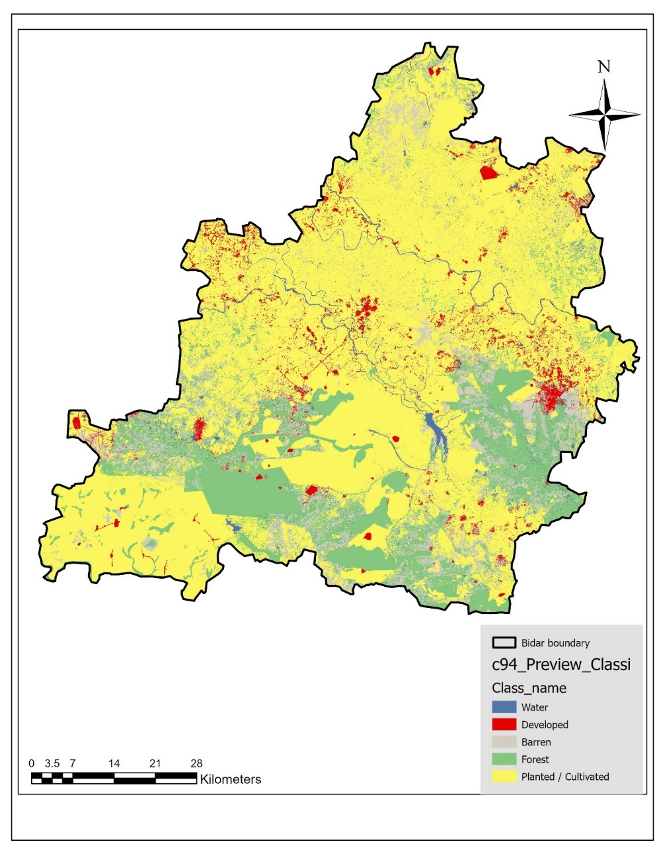
Figure 7 Land use and land cover of Bidar District-1994

Forest Loss
Parallel to urban expansion, forest cover witnessed a dramatic decline, shrinking by over 60 per cent from 948.13 km² in 1994 to 369.41 km² in 2024. Much of this loss was driven by the conversion of forest land for urban development and agricultural expansion. The reduction in forested areas has major ecological consequences. For instance, biodiversity depletion, disruption of hydrological systems, and weakened carbon sequestration capacity. This trend highlights the fragile balance between developmental needs and ecological preservation in the Bidar district.
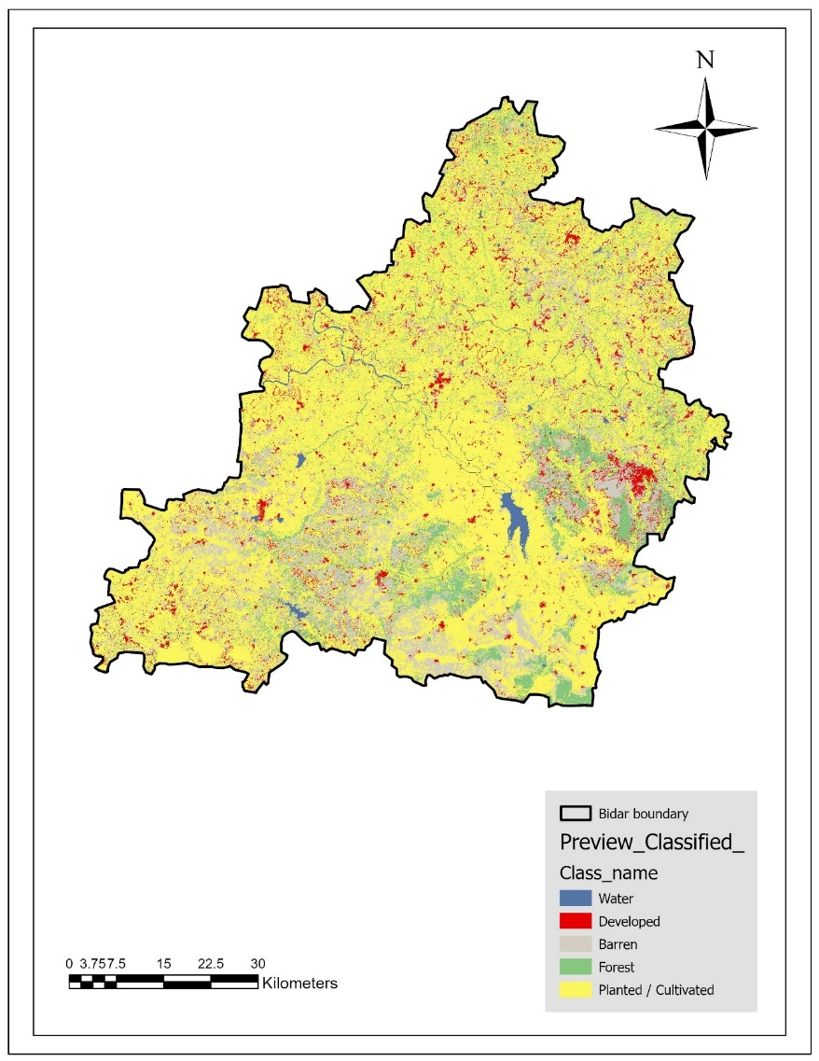
Figure 8 Land use and land cover of Bidar District-2004

Interpretation of Land Use and Land Cover in Bidar District, 2004
The land use and land cover pattern of Bidar district in 2004 shows that agricultural or cultivated land continues to dominate the landscape, appearing extensively across the district with a widespread distribution, particularly in the central, southern, and western regions. Built-up or developed areas are more prominent compared to earlier decades, with dense clusters visible around major urban centres and along transportation corridors, indicating continued urban expansion. Forest cover is fragmented and limited, occurring mostly in small patches scattered across the district, reflecting a landscape with low natural vegetation. Barren or uncultivated land appears in small, irregular pockets but is comparatively less dominant, suggesting increased land utilisation for agriculture. Water bodies are visible in the form of tanks and reservoirs, especially in the southern part, though they occupy a minimal proportion of the total area. Overall, the 2004 map reflects a landscape driven largely by agriculture, expanding settlements, and limited natural vegetation.

Comparison of Land Use and Land Cover Change from 1994 to 2004
A comparison of the 1994 and 2004 land use and land cover maps of Bidar district reveals notable shifts in landscape structure and the intensity of land utilisation over the decade. Cultivated or planted land, which was already widespread in 1994, expanded further by 2004, filling previously barren or sparsely vegetated patches and indicating an increase in agricultural activity. Built-up or developed areas show a marked rise, with new urban and peri-urban clusters becoming visible in 2004, particularly around major settlements and transport routes, suggesting population growth and spatial expansion of settlements. Forest cover, which existed in scattered patches in 1994, appears reduced and more fragmented by 2004, reflecting continued pressure on natural vegetation due to agriculture and development. Barren land shows a noticeable decline as many of these areas appear to have been converted to agricultural uses. Water bodies exhibit only minor changes between the two periods, though slight variations in size and distribution are visible. Overall, the comparison demonstrates a decade characterised by agricultural intensification, urban expansion, and gradual depletion of natural vegetation in the Bidar district.

Agricultural Shifts
Agricultural land in Bidar displayed a relatively stable but fluctuating trend. Cultivated land initially showed signs of decline in the early 2000s due to land diversion toward urban and barren uses. However, after 2014, a modest recovery was observed, with cultivated land increasing from 375.05 km² in 2014 to 379.59 km² in 2024. This partial rebound may be attributed to policy interventions promoting agricultural resilience and rural livelihoods, as well as community-level efforts to sustain farming in drought-prone conditions. Despite this, the long-term sustainability of agriculture remains under pressure from soil degradation and water scarcity.

Interpretation of Land Use and Land Cover in Bidar District, 2014
The 2014 land use and land cover map of Bidar district shows a landscape that is overwhelmingly dominated by cultivated or planted land, which covers almost the entire district with high spatial continuity. Compared to earlier decades, agriculture appears even more intensive, with very few open or unused spaces remaining. Built-up or developed areas have increased substantially, with dense clusters of red pixels indicating significant urban expansion, especially around major settlements and along transportation networks. The rise in developed land is particularly visible in the central, eastern, and southern parts of the district. Forest cover remains sparse and highly fragmented, restricted to small, dispersed patches mainly in the southwestern and southern regions, indicating continued reduction of natural vegetation. Barren land appears extremely limited, suggesting further conversion to agricultural or settlement uses. Water bodies are present in moderate patches, especially in the south-central area, but they occupy a relatively small portion of the district. Overall, the 2014 landscape reflects intensified agriculture, accelerated built-up expansion, and further depletion of natural vegetation.

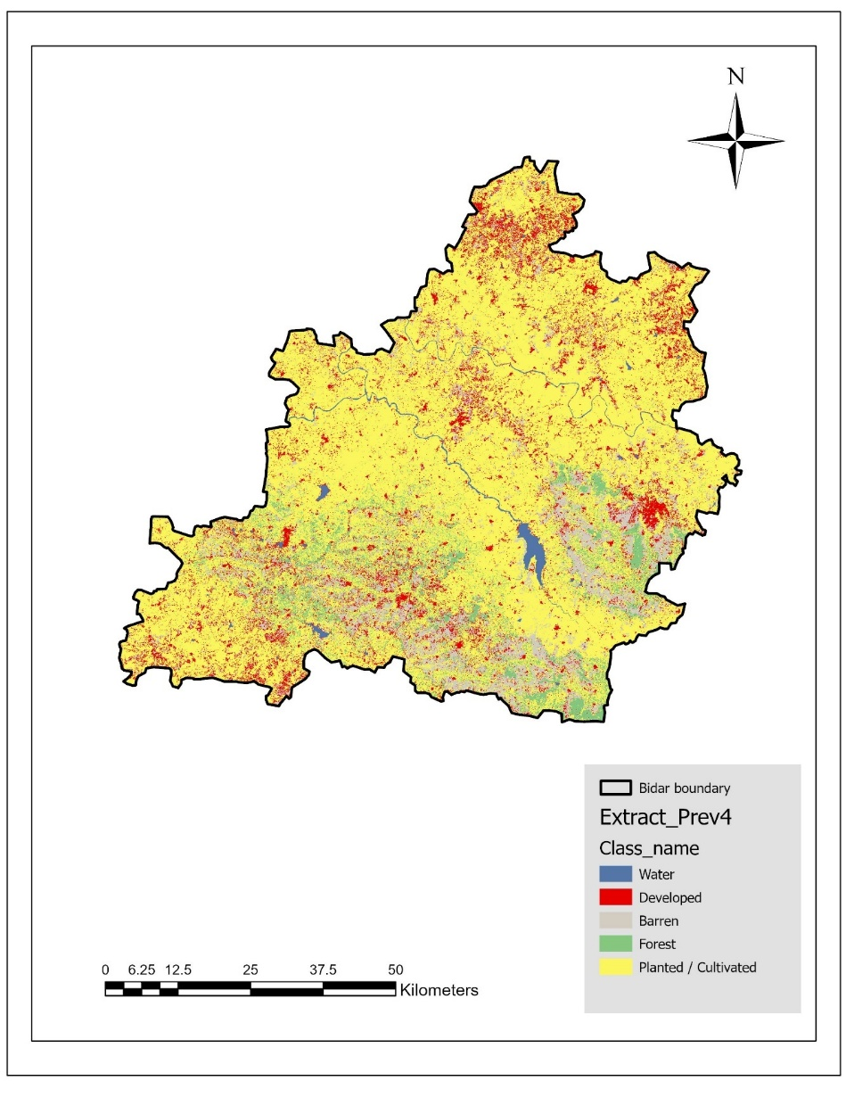
Figure 9 Land use and land cover of Bidar District-2014

Comparison of Land Use and Land Cover Change from 2004 to 2014
A comparison of the 2004 and 2014 maps reveals substantial land-cover transformation across the Bidar district over the 10 years. The most striking change is the marked increase in developed land, as built-up areas that were modestly scattered in 2004 have expanded significantly by 2014, indicating rapid urbanisation and peri-urban growth. Cultivated land, which was already dominant in 2004, has expanded even further, replacing many of the remaining barren patches and encroaching into areas previously under sparse vegetation. Forest cover shows a noticeable decline, with the already limited forested areas of 2004 becoming even more fragmented and reduced by 2014, highlighting continued pressure from agricultural expansion and human activity. Barren land has decreased further, becoming negligible in many regions as these areas were likely converted into agricultural fields or built-up zones. Water bodies show slight changes in shape and extent but remain relatively stable in distribution. Overall, the comparison indicates that the decade from 2004 to 2014 was characterised by significant urban expansion, intensification of agriculture, and a continued decline in natural vegetation cover in Bidar district.

Water Insecurity
Water bodies experienced one of the sharpest declines, decreasing by about 36 per cent between 1994 and 2024 (from 131.25 km² to 83.92 km²). The lowest point occurred in 2014, when water bodies shrank to just 60.03 km², before recovering slightly in 2024. The reduction reflects both climatic stress and anthropogenic pressures, including over-extraction, encroachment, and urban runoff. In a district already classified as drought-prone, this reduction in water resources has intensified vulnerability to water scarcity, threatening irrigation, drinking water supply, and ecosystem balance.

Interpretation of Land Use and Land Cover in Bidar District, 2024
The 2024 land use and land cover map of Bidar district shows a landscape overwhelmingly dominated by cultivated or planted land, which covers almost the entire district with remarkable spatial continuity. Agricultural expansion appears to have reached its peak, leaving very few uncultivated or open areas. Developed land has significantly intensified, with dense clusters of red pixels expanding around urban centres, major road networks, and peri-urban fringes, reflecting rapid urban growth and infrastructure development over the decade. Forest cover remains minimal and highly fragmented, continuing the declining trend observed in earlier years; only small patches of natural vegetation persist, primarily in the southern and southwestern regions. Barren land is nearly absent, indicating extensive land conversion into agricultural fields or built-up zones. Water bodies retain their general distribution, especially the major reservoir in the south-central part of the district, though minor variations in size and spatial extent are observable. Overall, the 2024 map reflects a district characterised by very high agricultural land use, significant urban expansion, and a substantially diminished natural vegetation cover.

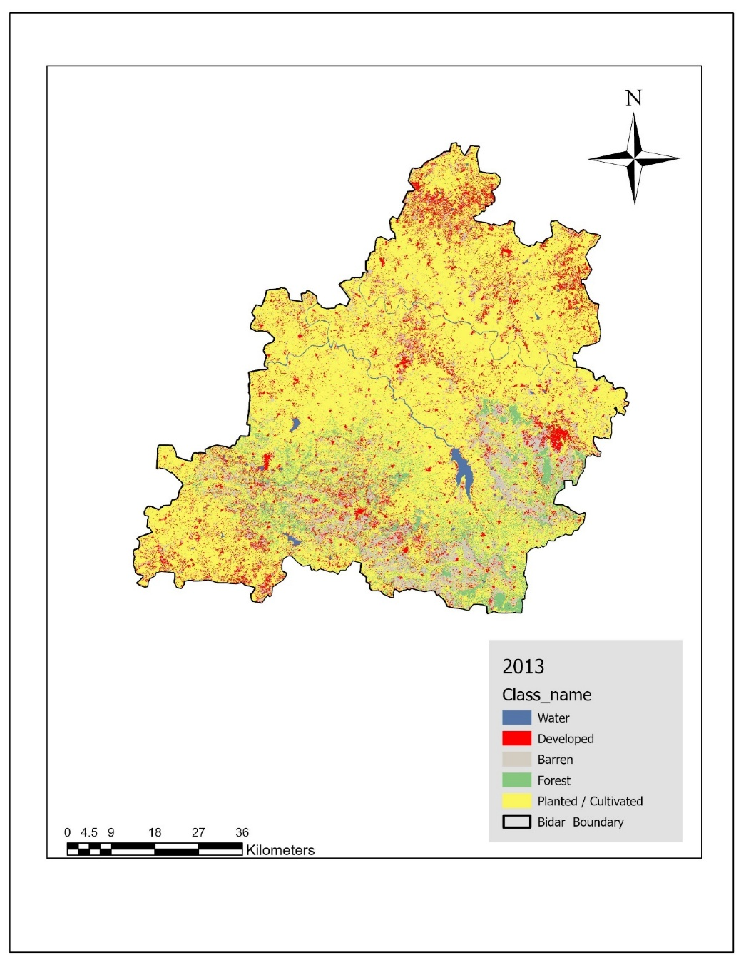
Figure 10 Land use and land cover of Bidar District-2024

Comparison of Land Use and Land Cover Change from 2014 to 2024
A comparison of the 2014 and 2024 maps reveals clear and continuing trends in land transformation in the Bidar district. Developed land shows a noticeable increase in 2024, with urban and peri-urban areas becoming more spatially dense and widespread than in 2014, indicating accelerated urbanisation over the decade. Cultivated land, already dominant in 2014, expands further in 2024, filling remaining open spaces and reducing barren or unused lands to almost negligible levels. Forest cover, which was already fragmented in 2014, shows further decline in 2024, with only small, isolated patches surviving, suggesting persistent deforestation pressures and conversion to agriculture or settlement. Barren land decreases even more, while water bodies remain generally stable, though with minor shifts in their spatial outline. Overall, the period from 2014 to 2024 is characterised by intensified agricultural land use, rapid expansion of built-up areas, and continued reduction of natural vegetation, reinforcing the long-term trajectory of human-driven landscape modification in Bidar district.

Discussion
The analysis of land use and land cover changes in Bidar district over the three decades from 1994 to 2024, integrating both spatial map interpretation and quantitative data, reveals a clear pattern of intensified human activity and progressive landscape transformation. The maps illustrate a steady conversion of natural land covers into agricultural and developed surfaces, while the numerical data strongly reinforce these observed spatio-temporal trends.
In 1994, Bidar displayed a relatively balanced landscape, with substantial forest cover (948.13 sq. km), moderate cultivated land (345.63 sq. km), and a mix of barren areas (472.21 sq. km). Over time, this balance shifted significantly. By 2004, the maps show expanded cultivated and built-up regions, mirrored in the data by an increase in cultivated land to 350.11 sq. km and built-up land to 305.46 sq. km. Forest cover simultaneously shrank to 735.71 sq. km, indicating increasing pressure on natural vegetation.
Between 2004 and 2014, these trends became more pronounced. The 2014 map depicts widespread agricultural dominance and expanding settlements, particularly along transport corridors and peri-urban zones. Quantitatively, the built-up area nearly doubled from 305.46 sq. km to 576.04 sq. km, reflecting rapid urbanisation. Cultivated land rose sharply to 475.05 sq. km. Forest cover fell drastically to 380.83 sq. km, confirming substantial deforestation and fragmentation observed in the map. Barren land also increased (568.84 sq. km), suggesting land degradation linked to overuse and seasonal fallowing.
By 2024, the combined spatial and numerical evidence indicates the most intense phase of landscape transformation. Cultivated land expanded dramatically to 709.59 sq. km, and built-up land surged to 871.04 sq. km, making urbanisation the dominant driver of land-use change. Forest cover reached its lowest extent at 369.41 sq. km, reduced to scattered, isolated patches. The 2024 map illustrates almost complete agricultural saturation with pockets of dense urban growth. Barren land peaked at 765.87 sq. km, raising concerns about soil degradation and ecological stress. Water bodies fluctuated, but their spatial extent in 2024 (83.92 sq. km) remained higher than in 2014, possibly due to reservoir maintenance, rainfall variations, or improved water management practices.
Overall, both the map-based observations and numerical data collectively reveal a district experiencing intense anthropogenic modification. Agricultural intensification, expansion of built-up areas, deforestation, and increasing barren land dominate the trajectory of change. These patterns highlight significant environmental challenges, including shrinking natural ecosystems, soil degradation, and unbalanced urban growth.

Conclusion

The present study presents an in-depth analysis related to land use/land cover (LULC) changes in the Bidar district, Karnataka, which has been induced by the process of urbanisation over an estimated period of 30 years, from 1994 to 2024. By integrating remote-sensing observation data with the use of geo-spatial analysis tools and subsequent application of accuracy-checked classification methods, this study presents an in-depth analysis related to the level of expansion in an urban setup and its effects on the environment in a semi-arid zone. The results obtained in this study show that the expansion in the built-up area has been happening at the cost of forest land, as well as water resources in this semi-arid zone.

The methodological effectiveness of the study resides in the consistent time dimension, accuracy of class identification and accuracy measures, and the combination of variables related to space, environment, and secondary socio-economic variables. Although research on the conceptual relationships and socio-economic processes is limited within the study because of the lack of primary social data, such limitations do not lessen the scientific value and relevance of the research results. Instead, such observations underscore significant research avenues related to future research efforts that may attempt to bring in the dynamics of household surveys and econometrics.

In general, this research tackles one of the most important issues in the context of urbanisation studies and land use/land cover change. This research is a significant scientific contribution to both urbanisation studies and land use/land cover change in semi-arid regions in India. This research is immediately useful for sustainable planning and the formulation of evidence-based policies.

Disclaimer (Artificial intelligence)

Option 1:

Author(s) hereby declare that NO generative AI technologies such as Large Language Models (ChatGPT, COPILOT, etc.) and text-to-image generators have been used during the writing or editing of this manuscript.

Option 2:

Author(s) hereby declare that generative AI technologies such as Large Language Models, etc. have been used during the writing or editing of manuscripts. This explanation will include the name, version, model, and source of the generative AI technology and as well as all input prompts provided to the generative AI technology

Details of the AI usage are given below:

1.

2.

3.

References
Abebe, G., Getachew, D., & Temesgen, A. (2022). Analysing land use/land cover changes and its dynamics using remote sensing and GIS in Gubalafito district, Northeastern Ethiopia. SN Applied Sciences, 4. https://doi.org/10.1007/s42452-021-04915-8
Chouhan, B., & Kannan, M. (2019). Impacts of Urbanization on Land Use Pattern and Environment: A Case Study of Ajmer City, Rajasthan. Asian Review of Social Sciences, 8, 87–91. https://doi.org/10.51983/arss-2019.8.1.1514
Das, S., & Angadi, D. P. (2020). Land use-land cover (LULC) transformation and its relation with land surface temperature changes: A case study of Barrackpore Subdivision, West Bengal, India. Remote Sensing Applications: Society and Environment, 19, 100322. https://doi.org/10.1016/j.rsase.2020.100322
Di Clemente, R., Strano, E., & Batty, M. (2021). Urbanization and economic complexity. Scientific Reports, 11(1), 3952. https://doi.org/10.1038/s41598-021-83238-5
Fatemi, M., & Narangifard, M. (2019). Monitoring LULC changes and its impact on the LST and NDVI in District 1 of Shiraz City. Arabian Journal of Geosciences, 12(4), 127. https://doi.org/10.1007/s12517-019-4259-6
Fu, P., & Weng, Q. (2016). A time series analysis of urbanization induced land use and land cover change and its impact on land surface temperature with Landsat imagery. Remote Sensing of Environment, 175, 205–214. https://doi.org/10.1016/j.rse.2015.12.040
Gaur, S., & Singh, R. (2023). A Comprehensive Review on Land Use/Land Cover (LULC) Change Modeling for Urban Development: Current Status and Future Prospects. Sustainability, 15(2), 903. https://doi.org/10.3390/su15020903
Gogoi, P., Vinoj, V., Swain, D., Roberts, G., Dash, J., & Tripathy, S. (2019). Land use and land cover change effect on surface temperature over Eastern India. Scientific Reports, 9. https://doi.org/10.1038/s41598-019-45213-z
Kamraju, M. (2016). Impact of Urbanization on Lakes: A Case Study of Hyderabad. 05.
Mohan, M., Pathan, S., Narendrareddy, K., Kandya, A., & Pandey, S. (2011). Dynamics of Urbanization and Its Impact on Land-Use/Land-Cover: A Case Study of Megacity Delhi. Journal of Environmental Protection, 2, 1274–1283. https://doi.org/10.4236/jep.2011.29147
Mundhe, N., & Jaybhaye, R. (2014). Impact of urbanization on land use/land covers change using Geo-spatial techniques. International Journal of Geomatics and Geosciences, 5(1), 50–60.
Murayama, Y., & Estoque, R. C. (2020). Urbanization: Concept, Mechanism, and Global Implications. In Y. Himiyama, K. Satake, & T. Oki (Eds), Human Geoscience (pp. 261–282). Springer. https://doi.org/10.1007/978-981-32-9224-6_19
Mustafa, M., & Prasad, P. R. C. (2024). Analysing the fragile islandscape of Ritchie’s Archipelago: Understanding land use changes, biodiversity loss, and tourism impacts on both the ecosystem and islanders. GeoJournal, 89(2), 51. https://doi.org/10.1007/s10708-024-11053-2
Nuissl, H., & Siedentop, S. (2021). Urbanisation and Land Use Change (pp. 75–99). https://doi.org/10.1007/978-3-030-50841-8_5
Seenipandian, K., Chandrasekar, N., & Kizhur, R. (2016). Mapping of coastal landforms and volumetric change analysis in the south west coast of Kanyakumari, South India using remote sensing and GIS techniques. Egyptian Journal of Remote Sensing and Space Science, 20. https://doi.org/10.1016/j.ejrs.2016.12.006

