Original Research Article

Eco-Urbanism of Bolpur-Shantiniketan: the legacy of the Brahmacharyashram of the Tagore

Abstract: Bolpur-Santiniketan is synonymous with Rabindranath Tagore. The urbanism of this town is quite different from that of other urban areas in India, as the Santiniketan ashram dwellers have close ties with nature in every aspect of life, influenced by the life & livelihood of Tagore & his philosophy. This tradition has a ripple effect, which either exists in the present-day Santiniketan or not, is the main question of this research. Literature surveys, observations, and visual ethnography helped in this context to find the answer. The output of this search is that the ecourban legacy of Tagore’s Bhramacharyashram still persists in a few pockets in Patha Bhavan & the core area of the ashram campus. Ashram as well as newly built-up area also bear the main ecourban tradition of Tagore, i.e., green architecture to some extent & also foster ecotourism.
Keywords: Santiniketan, Bhramacharyashram, ecourbanism, visual ethnography, green architecture

Introduction:
The term eco-urbanism first appeared in 1998 in a book by Architect and Planner Miguel Ruano, which defined it as “the development of multi-dimensional sustainable human communities within harmonious and balanced built environments”. Hippocrates, a Greek physician, has long discussed the impact of "air, waters, and places" on people's and communities' health. In "On Architecture," published in the middle of the 15th century, architect Leon Battista Albert stated that in order for cities to foster security, convenience, health, dignity, and enjoyment, the layout of streets and buildings should be tailored to the local environment. In the 1980s, interest in the ecological approach to urban planning and architecture began to grow. Many scholars, practitioners, and critics have added to the theory and application of ecological urbanism since 1984. A wide approach to urban planning and design is ecological urbanism. This method is associated with movements such as landscape urbanism (Mostafavi 2003), green architecture (Wines 2000), and sustainable design and planning (Calthorpe and Vander Ryn 1986; Newman et al. 2009). Mohsen Mostafari and Gareth Doherty (2010), who started an ecological urbanism project at the Harvard University Graduate School of Design, are the authors of modern pieces on this subject.
Ecological urbanism is the way to achieve life-sustaining and resilient cities, which are less costly to build and maintain (Spirn A.W. 2014, 560-66). This sustainable approach to urban development is incorporated into Richard Register's eco-cities in E. Howard's 19th-century Garden City concept. Kelvin Lynch also emphasized the social value that should be fostered in urban design by considering cities in relation to their natural surroundings and their regional context. He evaluated the sustainability of a city form (Lynch, 1981). In addition to providing a framework for addressing issues that endanger mankind, such as global warming and the energy crisis, ecourbanism attends to human requirements for health, safety, and a pleasant living (Spirn 2014, 560-66). Smart grids, water treatment, solid waste management, solar, and net-zero energy buildings are examples of green technologies that are integrated into eco-urbanism (Joss and Molella 2013, 115-16; Yigiteanlar and Lee 2014, 100-111). Principles established by ecological urbanism advocate for the optimal use of local materials and local energy (sun, wind, and rain) in construction to minimize reliance on conventional energy; the incorporation of natural ecosystems to promote biodiversity and provide residents access to nature for recreation. Eco-urbanism emphasizes low carbon emissions. Cities should be endowed with green spaces to stabilize temperature and humidity, as well as to reduce transportation costs and pollution. The majority of people choose public transportation over their own vehicles and live close to their places of employment, either on foot or by bicycle. Reusing and recycling products helps eco-urban towns manage garbage disposal and maintain jobs. Material throughput is reduced in these cities because their economies are labor-intensive rather than material- and energy-intensive. The Kyoto Protocol in 1997 significantly accelerated the focus on low-carbon cities. Building independent communities with well-defined business plans and strategies for long-term economic viability is a top priority for many eco-urban groups. The focus on community gardening and local agriculture is one noteworthy example (Premathala et al. 2013, 663-64).
Eco-urbanism has been implemented in several global locations. Swedish eco-cities, German eco-districts, and French eco-quartiers are a few examples. In the United States, eco-urbanism promotes heat island mitigation, local agriculture, green and blue infrastructure, and resource efficiency (Ecodistricts 2015; LEED 2015). China focused on technological aspects of the eco-urban project, such as utilizing solar energy, controlling excessive urbanization, and lowering greenhouse gas emissions. Eco-cities were first developed in India in 2001 by the Central Pollution Control Board and the Ministry of Environment and Forests. The primary goals are to reduce pollution, enhance environmental quality, save natural resources such as rivers and lakes, and promote sanitation (Dhanapal G, 2011).
Study Area:
The place where today’s Santiniketan (abode of peace) was was under the landlord of Raipur. It was an undulating, unploughed, barren land with some bushy trees and palm trees on the red lateritic soil. Santiniketan at its beginning was not a place; rather, it was only a two-storied building named Santiniketan Griho established by Maharshi Debendranath Tagore. Maharshi charmed by the tranquil environment of this solace, barren land when made frequent trips to Raipur. He purchased 20 bighas of land in 1863 from Bhubanmohan Sinha, the then landlord of Raipur. Then he started to green this arid region by removing the topmost layer of dry, gritty dirt and replacing it with fertile soil that had been brought in from afar (Mukhopadhyay 1952, 18). In order to establish outdoor education in the middle of nature and to strengthen the moral bond between humans and the natural world, Tagore established "Brahamacharyasram," a school modeled after Tapovan in ancient India, in 1901. 1918 saw the school's expansion into Viswa-Bharati, a university.
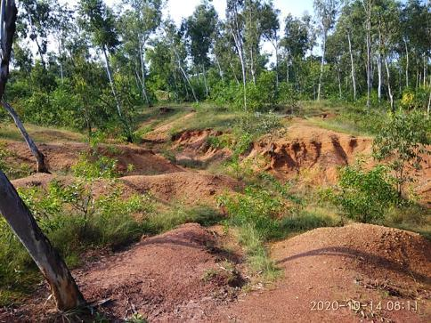
The topography of Santiniketan makes it different from the surrounding area, as Santiniketan is situated in the interfluvial region of the Ajay and the Kopai River. This area has a bulge with a height of 67 mt above sea level in the central part, which gradually declines to a height of 33 to 34 mt above sea level near the Ajay and Kopai River. This bulge in topography makes it like an island, separate from the surrounding areas. A large portion of this area is composed of lateritic soils. This laterite has a strong influence on the physiography of the area, mainly in the formation of the ravine land ‘Khoai’(plate 1). Due to this rolling upland topography, Santiniketan and its surroundings are well drained, and it is free from the flood-prone zone of the river Ajay, as surface run-off naturally drains towards the Kopai river (Mondal 2025, 12).

Plate 1– Khoai, the badland topography is not only a geographical landform, but also the cultural heritage of Santiniketan, as it has been immortalized in the writing of Tagore and the painting of Nandalal Basu, Ramkinkar Baij & so on. This area, along with tribal village Bonerpukur danga, Ballavpur danga & Sonajhuri haat, serves as the center of ecotourism.
Methodology:
How the Brahmacharyashram of Tagore and the nature-centered lifestyle in Santiniketan, carrying away ecourbanism of Bolpur-Santiniketan, is the main finding of this research. In this context, a literature survey supports the understanding of green architecture, nature-based learning, and the culture of ashram life. Additionally, interviews with notable individuals from Santiniketan provided insights into the evolving nature-centric lifestyle of the ashram. Conversely, the modern eco-urban perspective was examined through observations of nature in relation to urban life. Another key methodology utilized in this research is visual ethnography, which involves studying visual forms and systems through photographs, drawings, video clips, etc., in connection with culture (Banks 1998, 9-14). In sociology and social anthropology, photographs serve as a tool for exploring society (Bateson and Mead, 1942). Photographs act as a silent voice and language of communication (Walker 1993), conveying complex and multiple ideas. Images are intertwined with our daily lives, lifestyles, cultures, and societies (Pink 2006). Therefore, the analysis and study of images are crucial for understanding culture and society. In this study, still photographs have been employed as a method to express an eco-urban perspective.

Result & discussion:
Eco-urbanism of the Study Area: Santiniketan, the brainchild of Tagore in association with Bolpur, has practiced eco-urbanism since its initiation, though eco-urbanism is a recent movement. The principles of eco-urbanism, set by eco-urbanism schools in the 20th century, were practiced by Tagore, one of the great environmentalists, in his Santiniketan during that period. Tagore supported ecological growth and sustainability. In his voice, human existence and the natural world were seen as essential components of one whole. He is a profound ecologist in this regard (Marsh 2017). The Upanishads shaped his perspective on eco-ethical living (Chandra 2018, 85). Rabindranath founded the Brahmacharyashram school in Santiniketan in 1901, and it was a pioneer in the field of education. With its outdoor classes under the trees, this school is a perfect example of the traditional Indian traditions that previously thrived in the ancient Indian forest. Educational model of Tagore aimed at the cultivation of feeling (Bodher Tapasya/Sadhana) instead of the education of intellect (Modi 2015, 107) and emphasized naturalism and aestheticism. He inspires students to know their surroundings-rocks, soil, birds, flowers, trees, etc., practically, not by bookish knowledge. They could feel the beauty, flavor, and smell of nature through this nature study, which gave birth to respect for nature in the students’ minds. Gardening was very important, and children had to participate in it as a small plot of land was allotted to a child, and he had to grow vegetables or flowers in it (Mukhopadhyay 1952). Influenced by Tapovan of ancient India, Rabindranath furnished his Brahmacharyashram in an ecocentric way, as there were rows of tall Sal trees in the southern extremity, mango groves in the east, and in the west were palm trees, as well as in the north were groves of amloki (gooseberry) (plates 2 & 3).
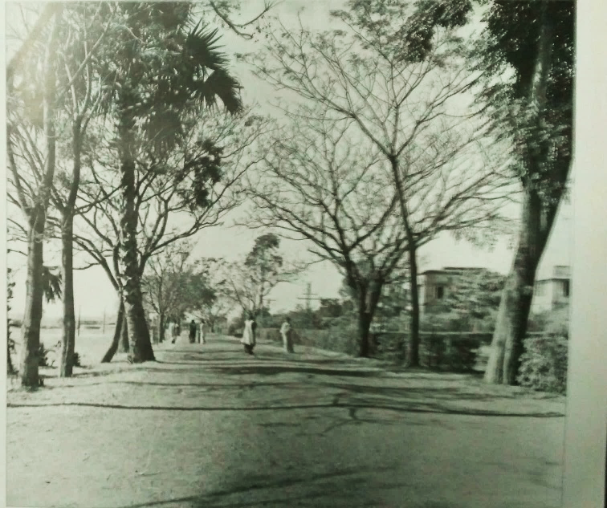
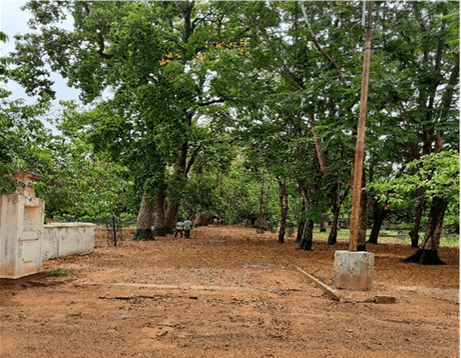
Plate – 2(Saha 2008, plate 3) & 3, tranquil, serene Brahmacharyashram during Tagore & present day, is encompassed by rows of trees. The shadow intense Sal Bithi & row of other trees not only have aesthetic values but also a positive impact on the microclimate. The ashram area with an unmetalled road covered with red earth soil still bears Tagore’s approach of sustainable use of nature & natural resources.
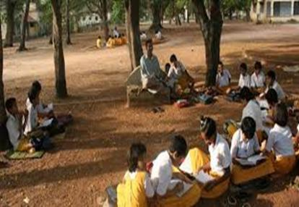
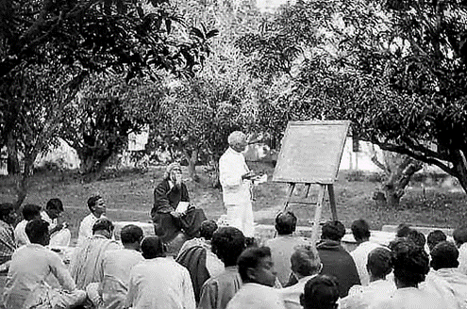
Visva-Bharat, the extended part of the Brahmacharyashram, is different from other educational institutions as here nature and seasons are celebrated instead of religious festivals. Nature study and celebration of different seasons are ways to become one with nature. His educational concept advocated for a student's life to be in harmony with all existence. He asserts that children possess an active subconscious mind akin to a tree, enabling them to absorb nourishment from their environment. The five fundamental elements of the Universe—Kshiti (earth), Op (water), Tej (heat), Marut (air), and Byom (space)—are personified and venerated through the recitation of Vedic mantras. Open-air classrooms (Plate-4 & 5), harmonized with the chattering of birds, seasonal physiological changes of trees, red soil, and the early breeze, foster a bond between students and nature. Festivals are celebrated here, giving priority to the environment. Vrikshoropona; tree plantation ceremony, Holokarshana; ploughing ceremony, Basanta Utsav; festival of spring – all are celebrated to worship and cherish Nature, which was started by the great environmentalist Tagore. In Tagore’s view, education could not be complete without knowing one's cultural roots. He wants to expand the relationship with the neighboring village and tribal community, the outcome of which is Sriniketan. The fundamental premise of the Sriniketan education was in its teaching of handicrafts, including leather work, weaving, book binding, needlework, pottery, wood carving, lacquer crafts, durric making, and block printing.
Plate 4(source- Rabindra Bhavan archive) & 5, the first one is of open-air education started by Tagore in the Brahmacharyashram to learn from our great teacher, Nature. It is not only effective for the all-around development of the young child, but also reduces the consumption of electricity, making the students environmentally conscious. The second one is of the present-day Patha Bhavana. Teaching, going on beneath the trees, reflects the attachment of children’s mind, soul, with soil, air, and other aspects of nature.
Patrick Geddes stated that the city was envisioned as 'organic', evolving in conjunction with its environment. Geddes presented an evolutionary concept wherein the city functioned as an ecosystem, a constructed milieu capable of positively impacting the social organism it encompassed. The evolutionary theme is pertinent to Santiniketan, as the term represents a depiction of a peaceful, serene natural setting that profoundly impacts the lives of the local populace. To Tagore, Santiniketan was a living creature with its soul, i.e., Nature. Iconic song of Tagore “Amader Santiniketan, amader sob hote apon, tar akash vora kole moder dole hriday dole (She is our own, the darling of our hearts, our Santiniketan, our dreams are rocked in her arms, her face is a fresh wonder of love every time we see her, for she is our own, the darling of our hearts……)” brings this identity. It evolved from bare barren land to today’s Santiniketan in association with Nature. The plan of the Santiniketan campus was prepared by Patrick Geddes, was in synergy with nature. Field survey, according to him, is necessary before planning. In this sphere, his philosophy is matched with the Tagorian philosophy of nature study. By gathering knowledge about physiography, climate, flora and fauna, soil, and the culture of the people, he prepared the plan so that the biodiversity of the area remains unchanged.
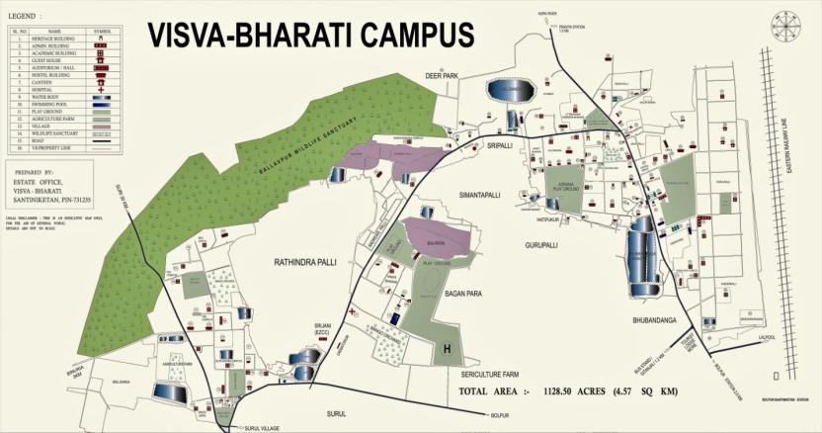
Plate 6 ( www.visvabharati.ac.in), Campus map of Viswa-Bharati depicts the ecocentric nature of the area with the presence of Ballavpur Wildlife Sanctuary and deer park on the northwestern part of the campus. It was established in 1977 with an area of 200 hectares. There are three large water bodies within this sanctuary, namely jheel no 1, 2, and 3, which invite a large number of migratory birds in winter seasons. Architectural planning of Santiniketan, which was started almost a hundred thirty-five years back, has stood out aesthetically & philosophically & reflects the man-nature relationship (Biswas and Mete 2014, 85) which is also operational in today’s campus environment. The flavor of art and culture was established in the ashram’s living style. Painting and sculpting in the architectural environment of the ashram is the pathway of today’s architectural environment of Bolpur-Santiniketan and its surroundings. Traditional folk architecture and green architecture were adopted in the campus, a hundred years before today's green architecture movement (Ahmad 2020,192). Uttayarayan complex comprises Udayan, Konark, Shyamali, Punashcha, and Udichi grew up horizontally keeping in mind the unhindered horizon line of Santiniketan landscape and in tune with the wave-like undulation of the Khoai (Biswas and Mete 2014, 83).
Eco-urbanism demands the self-sustainability of cities, which is in tune with Tagore, as he always emphasized the self-reliance and self-sustenance of villages. In this connection, Sriniketan is the outcome of his philosophy, where various training programmes on cottage industry (woodcraft, book binding, leather work, weaving, etc.), agriculture, and animal husbandry were given to the neighboring villages of Santiniketan- Sriniketan so that they became self-sufficient in the economy. The Co-operative Bank was another initiative of his by which ashram dwellers and people of its hinterland became self-reliant. Amar Kuthir, a society for rural development, gives opportunities to rural people to work in handicraft manufacturing units, mainly in making batik clothes, kantha stitch items, and leather bags.
Santiniketan, from the time of Tagore, co-exists with the Santhal who were settled in the vicinity of the Ashram in Balipara, Pearson Palli, Andrews Palli, Baganpara, and Kaliganj. The presence of these tribal areas, like pockets within the core area of Viswa-Bharati, fosters folk culture. This tribe still practiced their traditional livelihood through collecting wood and leaves from the Khoai area as well as from the ashram area. Some of them are still engaged in agricultural practices, while others have shifted to labor in hotels, lodges, and resorts.
Green architecture as part of ecourbanism: The architecture of Santiniketan harmoniously coexists with nature, demonstrating the value of cultural, social & ecological sustainability(Banerjee 2024, 112). Tagore conceived the architecture of Santiniketan as a synthesis of art, craft, science, technology, and nature. Structures were erected using indigenous materials such as mud and wood, with open verandahs to optimize sun illumination and airflow. Konark, Shyamali, and Kalo Bari were constructed in accordance with the principles of eco-urbanism, utilizing local resources such as mud and optimizing the use of solar and wind energy. Tal-O-Dhaj- (plate-7) a thatched mud house encompassing a Tal (palm) tree without destroying it, constructed by Tagore, reflects his eco-urbanistic view. Mud house Shyamali (plate-8), built with earthen water pots plastered with mud, was very comfortable to stay during summer as the air passing through these pots reduces the heat of the house. This house, with both its walls as well as roof made of mud, was a model house for the villagers. Kintara Kasahara, the Japanese craftsman and landscape designer, had constructed the Japanese tree house over the Pakur tree in Surul Kuthibari for Tagore. Gardening is a part of ashramik life, as in front of every building, there is a beautiful garden of seasonal flowers. Rabindranath created gardens in both Japanese and Italian styles. The Japanese-style artificial lake "Pampa Lake" (plate 9) was constructed inside the "Chitrabhanu" studio and surrounded by a garden. Rathindranath Tagore, a renowned gardener and the son of Rabindranath, created the Uttarayan garden pattern. He transported trees from other regions of the world that had climates comparable to Santiniketan's and planted them in Uttarayan. The Sausage tree, Rhodesian Wisteria from tropical Africa, the Caribbean Trumpet tree from Latin America, and the African Tulip from Equatorial Africa were among them (Modi 2005,97).

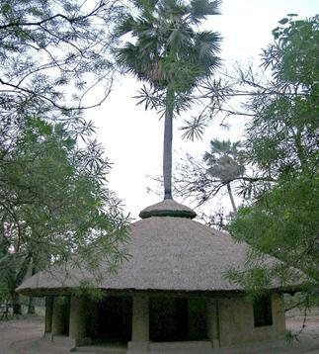
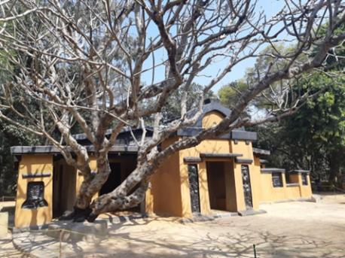
Plate 8 – Shyamali Plate 7 – Tal o Dhaj
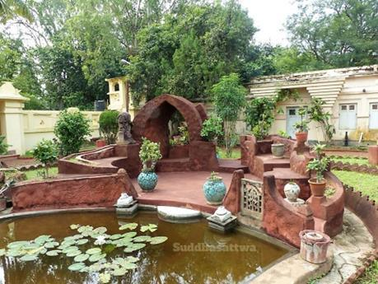
Plate 9- Pampa Lake
Recent Urbanism of the Study Area – How far Ecocentric?
Tagore’s Shantiniketan has changed in many aspects with the passage of time. It has got its wider horizontal expansion with sprawling towards the south and consequently merging with Bolpur, as well as towards the north and east by encroaching on agricultural land and the barren land of Khoai. Migrants of cosmopolitan culture have changed the culture of the area to some extent, but still now the lives of the people are eco-centric. Eco-urbanism deserves the fostering of biodiversity. The presence of Ballavpur Reserve Forest, Loha Bandh, Lal Bandh, and Bhuvan Danga Canal in this urban area maintains the biodiversity of the area. In the inner city as well as in the sprawling area, most of the buildings are structured with open verandahs for the passage of wind and solar light. Even some houses are built only with bricks without plaster or cement, which acts as a natural air conditioner and reduces energy consumption. Almost all houses are still ornamented with a well-decorated garden of seasonal flowers (plates 10, 11, 12 &13).
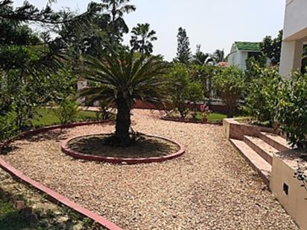
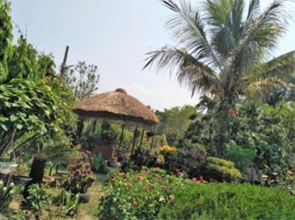
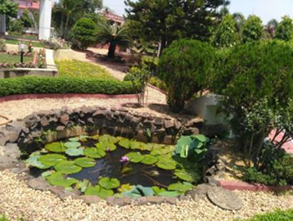
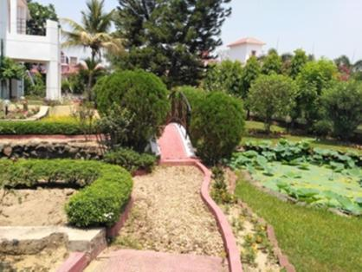
Plates 10, 11,12 & 13 portray ecourban senses of the urban dweller. All these are in the residential area of the newly built Prantik area, where most of the houses are ornamented with the lush green gardens of trees, a gravel path, a small pond, along with huge open spaces, synchronizing with the aesthetic sense of Tagore.
Green architecture or folk architecture applied by Tagore in Shantiniketan through use of local materials like mud, bamboo, earthen pot etc. for building construction cannot be seen in Viswa- Bharati campus and its surrounding in the present day, except few home stay, restaurant, lodge like Sakuntala atithinibas, Ram Shyam village resort, Karugram etc. constructed with mud, wood, bamboo, earthen pots etc. The color of the buildings also changes from saffron to many with the fade away as the red earth road of Khoai due to urbanization. Sanibarer Onno Haat- a weekly market in Khoai symbolizes the marketplace of rural areas where local artists sell their products of kantha stitch, batik, wooden, leather, and terracotta work. This haat became more popular than in the past with the addition of tribal dance in connection with Dhamsa Madol (tribal instrument) and expanded in dimension. In this land of Tagore, we can hear Baul songs here and there, which is one of the richest folk traditions of rural Bengal.
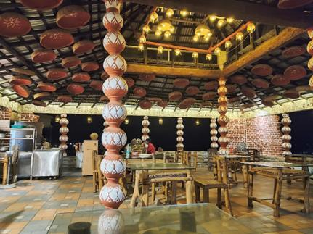
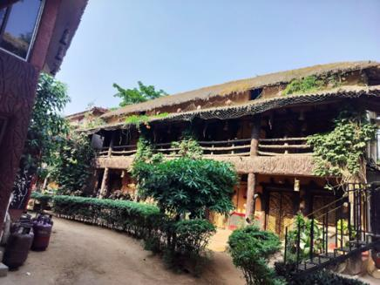

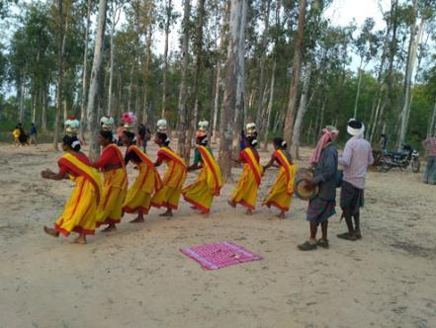
Plates 14 & 15; the first one reveals the interior of Sakuntala village resort, which uses earthen pots, bamboo as decorative items, while the second one is of the exterior of Ram Shyam village resort, also made up of mud, bamboo, with a thatched roof which acts as a natural AC. For building materials & decorative items, they use locally available resources. Lotas leaves, bronze plates & dishes are used to serve food to keep the area plastic-free & sustainable.
Plates 16 & 17; the great environmentalist, Rabindranath Tagore, wants to make the people of Santineketan self-reliant through various activities of Sriniketan. Self-reliancy is one of the principles of ecourbanism. The first picture of the Khoai Haat brings the shred of evidence of where, in that haat, local artisans sell their products. In this hat, local tribal people also express their cultural heritage to the tourists, through which they can earn money & also foster eco-cultural tourism.
A bicycle is an important vehicle of transport in Bolpur- Santiniketan. Old ashram dwellers, a few teachers still paddled cycles to go to their workplace, the market. Rickshaw is also a very popular mode of transport in this town, which was recently modified to an E-rickshaw. All these are eco-friendly and reduce carbon emissions. Both the urbanites and tourists travel in these public transports.
Conclusion:
Retrospective image of Santiniketan from Brahmacharyashram to recent Santiniketan reveals the ecourban perspective of the urban area. Change is inevitable in accordance with the journey of time. Santiniketan is not an exception to that. Santiniketan – the abode of peace, maintained tranquility & serenity. The main pillars of ecourbanism of this area are green architecture, cultural tourism & nature-based learning. This has been changed due to rapid urbanization. Nature-based learning is now confined to Patha Bhavana & Kala Bhavana only, the Core area of Santiniketan & the newly built-up area in Prantik, Surul still maintain calmness. Nature, culture & Tagore are the main attractions for tourists throughout the year. So the number of hotels, lodges, homestays & resorts is being built up, which follows green architecture for exterior as well as interior decoration & also for building materials. So, in conclusion, if local urban administrative & local people abide the Tagore’s philosophy of man-nature harmony, then Santiniketan will be the ‘Santiniketan - adobe of peace’ & also an ecourbanism legacy will be continued.

Disclaimer (Artificial intelligence)
I, Madhumita Sen, hereby declare that NO generative AI technologies such as Large Language Models (ChatGPT, COPILOT, etc.) and text-to-image generators have been used during the writing or editing of this manuscript.

References:
- Ahmed, S. (2020). The nectar of architecture: Tagore’s architectural cognizances in Santiniketon. BAB Journal of FSMVU Faculty of Architecture and Design, 1 (2), pp. 184-206. https://dergipark.org.tr/tr/download/article-file/1233202
- Banerjee, A. (2024). Rathindranath Tagore and the Uttarayana–Santiniketan-Evolution of the Landscape System and its Contemporary Relevance. Ind. J. of Landscape Systems and Ecological Studies, 47(1), 109-120.https://r.search.yahoo.com/_ylt=Awr1UVSBP1lpFAIAv7O7HAx.;_ylu=Y29sbwNzZzMEcG9zAzEEdnRpZAMEc2VjA3Ny/RV=2/RE=1768666241/RO=10/RU=https%3a%2f%2fwww.ilee.org.in%2fArchivePdf%2fChapter8_7.pdf/RK=2/RS=Ctn3WTJy5luMtoMQuhWZNdpoyz8-
- Banks, M. (1998). Visual anthropology: Image, object and interpretation. In J. Prosser (Ed.), Image-based research: A sourcebook for qualitative researchers (pp. 9–23). Taylor & Francis. https://www.routledge.com/Image-based-Research-A-Sourcebook-for-Qualitative-Researchers/Prosser/p/book/9780750706490
- Bateson, G., & Mead, M. (1942). Balinese character: a photographic analysis. Special publications of the New York Academy of Sciences, Vol. 2. Retrieved from https://monoskop.org/images/8/8d/Bateson_Gregory_Mead_Margaret_Balinese_Character_A_Photographic_Analysis.pdf
- Biswas, P., & Mete, J. (2014). The Architectural Style of Shantiniketan. Journal of Education & Social Policy. http://jespnet.com/journals/Vol_1_No_2_December_2014/12.pdf
- Calthorpe, P., & Vander Ryn, S. (1986). Sustainable Communities - A New Design Synthesis for Cities, Suburbs, and Towns. Sierra Club Books. Bulletin of Science, Technology & Society, 6(4). https://doi.org/10.1177/027046768600600454
- Chandra, S. (2018). Ecotourism in and around Santiniketan: Challenges and Potentialities. Gitanjali & Beyond, 2(1), 79-111. https://doi.org/10.14297/gnb.2.1.79-111
- Dhanapal, G. (2011). Eco-cities for India. Sustainability Outlook. https://www.sustainabilityoutlook.in/content/eco-cities-india
- EcoDistricts. (2015). Homepage of EcoDistricts. http://ecodistricts.org/
- Joss, S., & Molella, A. P. (2013). The eco-city as urban technology: Perspectives on Caofeidian International Eco-City (China). Journal of Urban Technology, 20(1), 115–137. https://doi.org/10.1080/10630732.2012.735411
- LEED. (2015). Homepage of LEED-ND. Retrieved from http://www.usgbc.org/articles/getting-know-leed-neighborhooddevelopment.
- Lynch, K.(1981). A Theory of Good City Form. Cambridge: MIT Press. https://archive.org/details/goodcityform00lync
- Marsh, C. (2013). The once and future village: From Tagore’s rural reconstruction to transition towns. In I. Ahmed, M. Dubey, & V. Sikri (Eds.), Contemporizing Tagore and the World (pp. 407-422). The University Press Limited. http://159.65.136.82/shop/9789845061209-contemporarising-tagore-and-the-world-11883
- Modi, S. M. (2015). Embodied knowledge of landscape: accommodating ongoing subjective experience in the presentation of heritage landscape (Doctoral dissertation). University of Illinois at Urbana-Champaign. https://hdl.handle.net/2142/78340
- Mondal, J. (2025). Geological characteristics and its influences on the topography: A case study on Santiniketan and its surroundings. International Journal of Geography, Geology and Environment, 7(6): 05-13. https://www.doi.org/10.22271/27067483.2025.v7.i6a.368
- Mostafavi, M., & Najle, C. (Eds.). (2003). Landscape urbanism: A manual for the machinic landscape. Architectural Association. https://searchworks.stanford.edu/view/5400000
- Mostafavi, M., & Doherty, G. (2016). (Eds.). Ecological urbanism. Lars Müller Publishers. https://www.lars-mueller-publishers.com/ecological-urbanism-0
- Mukhopadhaya, P. K. (1952). Santineketan-Visva-Bharati. Kolkata. Visva-Bharati Press. https://archive.org/details/in.ernet.dli.2015.339410
- Newman, P., Beatley, T., & Boyer, H. (2009). Resilient Cities: Responding to Peak Oil and Climate Change. Island Press. https://islandpress.org/books/resilient-cities-second-edition
- Pink, S. (2006). The future of visual anthropology: Engaging the senses. Routledge. https://doi.org/10.4324/9780203003596
- Premalatha, M., Tauseef, S. M., Abbasi, T., & Abbasi, S. A. (2013). The promise and the performance of the world’s first two zero-carbon eco-cities. Renewable & Sustainable Energy Reviews, 25, 660–669. https://doi.org/10.1016/j.rser.2013.05.011
- Spirn, A. W. (2014). Ecological Urbanism: A Framework for the Design of Resilient Cities. In F. O. Ndubisi (Ed.), The Ecological Design and Planning Reader. Island Press. https://doi.org/10.5822/978-1-61091-491-8_50
- Yigitcanlar, T., & Lee, S. H. (2014). Korean ubiquitous-eco-city: A smart-sustainable urban form or a branding hoax?. Technological Forecasting and Social Change, 89, 100-114. https://doi.org/10.1016/j.techfore.2013.08.034
- Walker, R. (1993). Finding a silent voice for the researcher: Using photographs in evaluation and research. In M. Schratz (Ed.), Qualitative voices in educational research (pp. 72-92). Routledge. https://doi.org/10.4324/9781003008064-8
- Wines, James, and Philip Jodidio. 2000. Green Architecture. Köln, New York: Taschen. https://www.scribd.com/document/695712201/Architecture-Design-Series-James-Wines-Philip-Jodidio-Green-Architecture-the-Art-of-Architecture-in-the-Age-of-Ecology-Taschen-2000
\

