Assessment of Land use/land cover and Normalized Difference Vegetation Index of Darrang District, Assam

Abstract:
Normalized Difference Vegetation Index (NDVI) is a quantitative tool which utilizes satellite based observations to evaluate the condition and coverage of vegetation. Land use refers to how humans use land for activities such as settlements, agriculture etc and Land cover describe the physical material present on the earth like water bodies, forest etc. The aim of the study is to examine the latest status of Normalized Difference Vegetation Index (NDVI) and Land Use and Land Cover (LULC) of the District. Darrang District, which is situated in the middle of Assam and towards north of river Brahmaputra has been considered as the location for the study. It extends in between 20.9 N to 26.96 N latitudes and 91.45 E to 92.22 E longitudes. The boundaries of Darrang District are, in the northern side Udalguri district, in the southern side River Brahmaputra, Morigaon & Kamrup District, in the eastern side Sonitpur District and in the western side Kamrup District. During conducting the study, Landsat 8 Operational Land Imager/ Thematic Infrared Sensor (OLI_TIRS) for the year 2025 has been taken from the USGS (United States Geological Survey). Towards carrying out the classification on supervised mode with maximum likelihood method, ERDAS IMAGINE software was utilized to categorize the Land Use and Land Cover (LULC) map. By using the ArcGIS 10.8 software, the bands 4 (red) and band 5 (near-infrared) were utilized from Landsat 8 satellite imagery to carry out the Normalized Difference Vegetation Index (NDVI) analysis. The result shows that Normalized Difference Vegetation Index (NDVI) values have been found between -0.09 and 0.40 for the year 2025, which indicates sparse vegetation or moderately green cover during dormant seasons. The result also shows that from the total area cover by Darrang District, land under agriculture occupies the largest portion at 42.47%, followed by built-up areas at 23.98%. The Plantations cover the smallest area at 2.16%, followed by forest cover at 4.82%. Land Use and Land Cover (LULC) studies offer decision–makers a better understanding of changing land-use patterns for effective planning, while Normalized Difference Vegetation Index (NDVI) studies provide crucial data on vegetation health to support sustainable ecosystem and resource management choices.
Keywords: NDVI, LULC, Darrang District, GIS.

1. INTRODUCTION:
The Normalized Difference Vegetation Index (NDVI) is popularly utilized to evaluate the remote sensing imagery data, particularly for determining the presence and condition of green vegetation in a specified region. By applying Normalized Difference Vegetation Index (NDVI) using multispectral datasets, this enables the identification and mapping of various land-cover features, including areas covered by water, urban zones, vegetation, and areas with dense plant growth (Somayajula et al., 2020). A satellite sensor records the entire visible spectrum as separate bands, which can be used to identify different features once the Normalized Difference Vegetation Index (NDVI) technique is applied. These bands are defined by their wavelengths, typically around 1 μm. (Gandhi et al., 2015). Elevated Normalized Difference Vegetation Index (NDVI) readings generally signal that vegetation is thriving and abundant, which makes the index a useful tool for evaluating crop performance, guiding forest management, and detecting environmental change. (Singgalen et al., 2024). Vegetation in any specific location plays a important role in preserving environmental integrity, particularly in the face of ongoing climate change (Guo et al., 2014). In the 21st century, changes in climate and the environment, together with increasing human activities, have greatly transformed vegetation distribution on the Earth’s surface (Mehmood et al., 2024), intensifying risks to environmentally fragile areas. Vegetation, being a core component of land-based ecosystems, plays a major role in maintaining environmental balance (Chen et al., 2023). Additionally, it contributes to cleansing the air of pollutants and dust, moderating temperatures to levels suitable for organisms, and maintaining the natural cycles of minerals and organic matter in the soil, which in turn helps prevent soil erosion. (Al-Ameri et al., 2024).
Land use refers to how humans use land for activities such as settlements, agriculture etc and Land cover describe the physical material present on the earth like waterbodies, forest etc (Lambin et al.2001). Land Use and Land Cover (LULC) assessments assist in understanding the influence of natural processes and human actions such as urban growth, deforestation, and agricultural intensification. Land Use and Land Cover (LULC) approaches are necessary to examine spatial patterns and temporal dynamics of landscapes (Pelorosso et al., 2021). Accurately evaluating land cover (the natural features of the Earth) and land use (how humans interact with the land) is essential for understanding past developments and predicting future trends (Goldewijk et al., 2004). Understanding of both the aspects is vital for evaluating environmental health, resource planning, and sustainable development (Coqueia et al., (2024). Integrating remote sensing with other geospatial technologies—such as Geographic Information Systems (GIS) and machine learning—can enhance the accuracy and practical use of Land Use and Land Cover (LULC) assessments. To fully capitalize on remote sensing in Land Use and Land Cover (LULC) research, future work should prioritize improving classification techniques, strengthening data-integration processes, and addressing limitations related to spatial and spectral resolution. Although remote sensing has greatly advanced Land Use and Land Cover (LULC) monitoring and management, continued scientific and technological development is needed to tackle existing challenges. Strengthening cross-disciplinary cooperation and applying innovative technologies will play a key role in making Land Use and Land Cover (LULC) change detection more accurate and supporting more effective sustainable land-use planning. (Ambhore et al., 2025)
In addition, Use of Geospatial technologies, such as satellite imagery, remote sensing, and Geographic Information Systems (GIS) enable researcher workers and decision-makers to monitor gradual changes over time, predict future trends, and evaluate their environmental and socio-economic impacts.(Selcuk et al., 2003). An effective land management approach must align development objectives with environmental preservation to ensure sustainability over the long term.
This paper attempts to assess the latest Land Use and Land Cover (LULC) status of the study area and to examine the latest Normalized Difference Vegetation Index (NDVI) status of the study area.
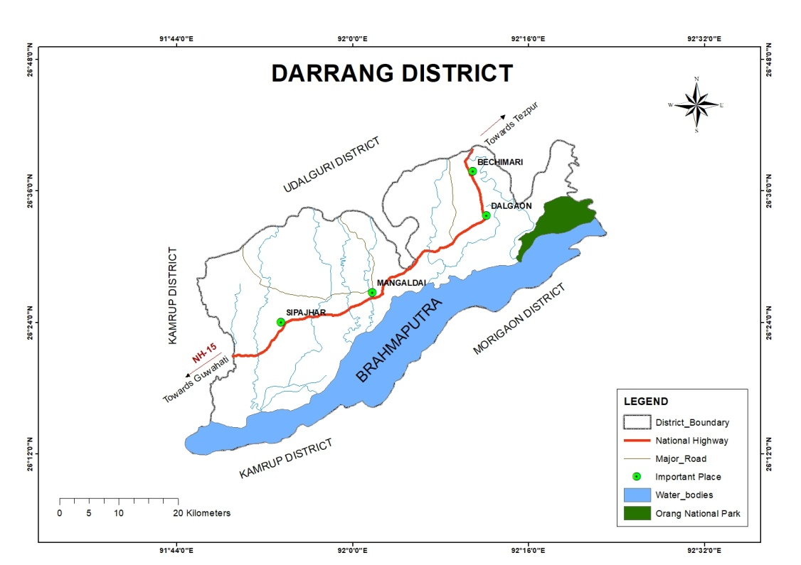
2 STUDY AREA:
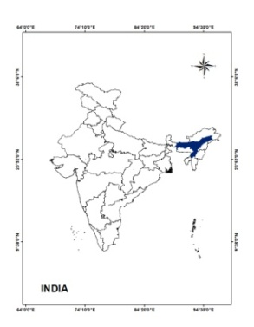

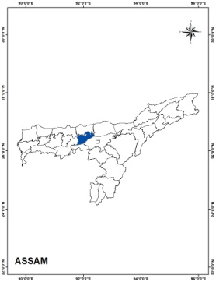

Fig.1 Locational Map.

Location of the study area: Darrang District, which is situated in the middle of Assam and towards north of river Brahmaputra has been considered as the location for the study. It extends in between 20.9 N to 26.96 N latitudes and 91.45 E to 92.22 E longitudes. The boundaries of Darrang District are, in the northern side Udalguri district, in the southern side River Brahmaputra, Morigaon & Kamrup District, in the eastern side Sonitpur District and in the western side Kamrup District. Total 1585.00 sq/km of area is covered by the district. The distance to the district from the state capital Dispur Guwahati is 68km. The district Comprises 5 Nos. Development Block and 5 Nos. Revenue Circle. (District Irrigation Plan Darrang, Assam).
Drainage: The river Brahmaputra is the main river in the boundary of the south of the district flows from the east to west direction. The other tributaries of the Brahmaputra are Barnadi, Nanoi, Saktola, Nowanodi, Mangaldai, Dhansiri, which are the main tributaries flowing through the district and the rivers are perennial in nature. (District Irrigation Plan Darrang, Assam).
Climate: The Sub-tropical monsoonal climate prevails in the study area, having the average temperature range between 28°C to 34°C during summer and in between 10°C to 25 °C during winter. (District Irrigation Plan Darrang,Assam).
Soil: The type of the district’s soil are mainly old alluvial to new alluvial, and textures are mainly Sandy loam and have clayey soil mostly at low lying areas. (District Irrigation Plan Darrang,Assam).
Population: As per the census done in 2011, the population status of Darrang district are: Total population – 928500, Population Density per sq/km – 856 ( State average is 398), Variation of population from 2001-2011 is 22.19 % more than last several decades,Total population residing in the rural areas - 94%,Total population residing in the urban areas – 5.98 % (state average is 14.1%)(District Census Handbook,2011).As per religious point of view,the population status is 58% are Hindu, 35 % are Muslim and less than 1% are other minority communities (District Irrigation Plan Darrang,Assam).

3. METHODOLOGY:
The entire methodology for the preparation of this paper is based on collection and analysis of satellite imagery. Landsat 8 Operational Land Imager/ Thematic Infrared Sensor (OLI_TIRS) for the year 2025 has been collected from the United States Geological Survey (USGS). Towards carrying out the classification based on supervised mode with maximum likelihood method, ERDAS IMAGINE software has been utilized for categorize the Land Use and Land Cover (LULC) map. Accuracy assessment has been done for validating the digitally classified images. For accuracy assessment ground truth reference data were taken from Google Earth Pro. By using the ArcGIS 10.8 software, the bands 4 (red) and band 5 (near-infrared) were utilized from Landsat 8 satellite imagery to carry out the Normalized Difference Vegetation Index (NDVI) analysis (Table 1and fig. 2).
Table1: Satellite data details
Year | Satellite Imagery | Resolution | Path/Row | Acquisition Date
2025 | Landsat_8 OLI_TIRS | 30 m | 136/042 | 17th-February-2025

Satellite Imagery

Landsat 8 OLI_TIRS(2025)

Band composite Band 4 & 5

LULC Classification NDVI map

Calculation of Area using Arc GIS Software
Fig. 2- Flow chart indicating data analysis.
4. ANALYSIS AND FINDINGS:
4.1 Land Use and Land Cover (LULC):
The detailed Land Use and Land Cover (LULC) classes (2025) on the study area has been represented in fig. 3 and the respective area coverage against Land Use and Land Cover (LULC) classes has been indicated in the table 2 .As per the information indicated in table 2 and fig.3, the area under the respective Land Use and Land Cover (LULC) class categories are: 126.43 km² (7.88%) under water bodies, 681.15 km² (42.47%) under agriculture, 384.7 km² (23.98%) under settlements, 77.31 km² (4.82%) under forest cover, 34.57 km² (2.16%) under plantation, and 299.81 km² (18.69%) under sandbars. Out of the area coverage under different Land Use and Land Cover (LULC) classes the maximum area is coved by agriculture681.15 km² (42.74 %) and minimum coverage by plantation34.57 km²(2.16 %). The total area coverage under different classes are (1603.97 km²).
Table:2. Total geographical area and percentage under LULC
LULC Class | Area in km2 | Area in %
Water Bodies | 126.43 | 7.88
Agriculture | 681.15 | 42.47
Settlements/ built-up | 384.7 | 23.98
Forest cover | 77.31 | 4.82
Plantation | 34.57 | 2.16
Sandbar | 299.81 | 18.69
Total | 1603.97 | 100

4.2 Accuracy Assesement :
Accuracy assessment in image classification refers to the process of determining how well a classified image corresponds to real-world features. This is achieved by comparing the classification results with reference data obtained from reliable sources such as field observations, previously published classified images, or Google Earth Pro. The assessment is commonly performed using a confusion matrix, which summarizes the relationship between the predicted classes and the actual ground truth data. Key evaluation metrics derived from this matrix include Overall Accuracy (OA), User’s Accuracy (UA), Producer’s Accuracy (PA), and the Kappa coefficient. (Congalton et al., 1991). These procedures help identify classification errors and assess the reliability of the classification results.

Table 3: Accuracy assessment of land use and land cover map of Darrang District
LULC Class | Water Bodies | Agriculture | Settlement | Forest cover | Plantation | Sandbar | Row total | User's accuracy
Water Bodies | 29 | 0 | 0 | 0 | 0 | 2 | 31 | 93.55%
Agriculture | 0 | 25 | 1 | 0 | 0 | 2 | 28 | 89.29%
Settlement/Built-up | 0 | 0 | 30 | 0 | 0 | 0 | 30 | 100.00%
Forest cover | 0 | 2 | 0 | 27 | 0 | 0 | 29 | 93%
Plantation | 0 | 0 | 0 | 0 | 32 | 0 | 32 | 100%
Sandbar | 2 | 1 | 0 | 0 | 0 | 27 | 30 | 90%
coloum total | 31 | 28 | 31 | 27 | 32 | 31 | 180
Producer's accuracy | 93.55% | 89.29% | 96.77% | 100% | 100% | 87.09%
Overall accuracy | 94%
Kapa coefficient | 0.93

The accuracy assessment has been done by using the following formula:-

$Overall Accuracy=\frac{Total Number of correctly Classified Pixels \left(Diagonal\right)}{ Total Number of Reference Pixels}$ × 100
$$Kappa Coefficient \left(T\right)=\frac{\left(TS × TCS\right)-∑\left(Column Total×Row Total\right)}{TS² - ∑\left(Column Total-Row Total\right)}$$

The Overall Accuracy and the Kappa Coefficient are 94% and 0.93 respectively (Table-3).

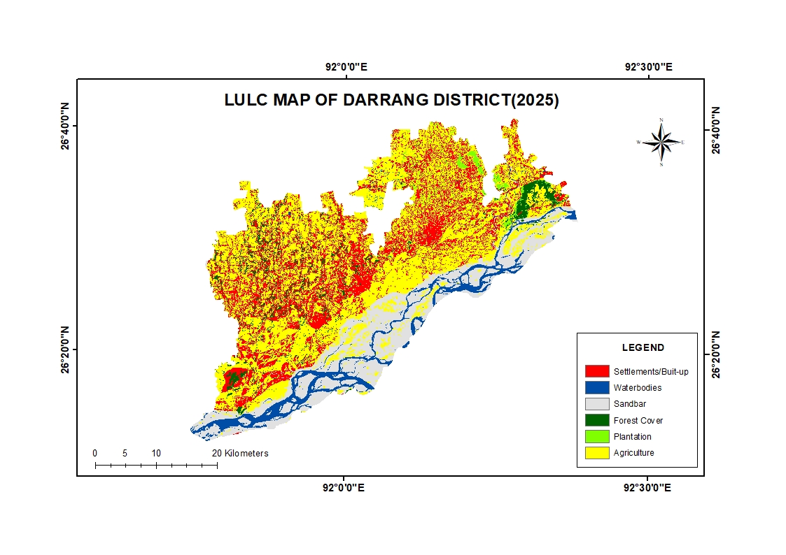

Fig.3 : LULC Map of Darrang District,2025
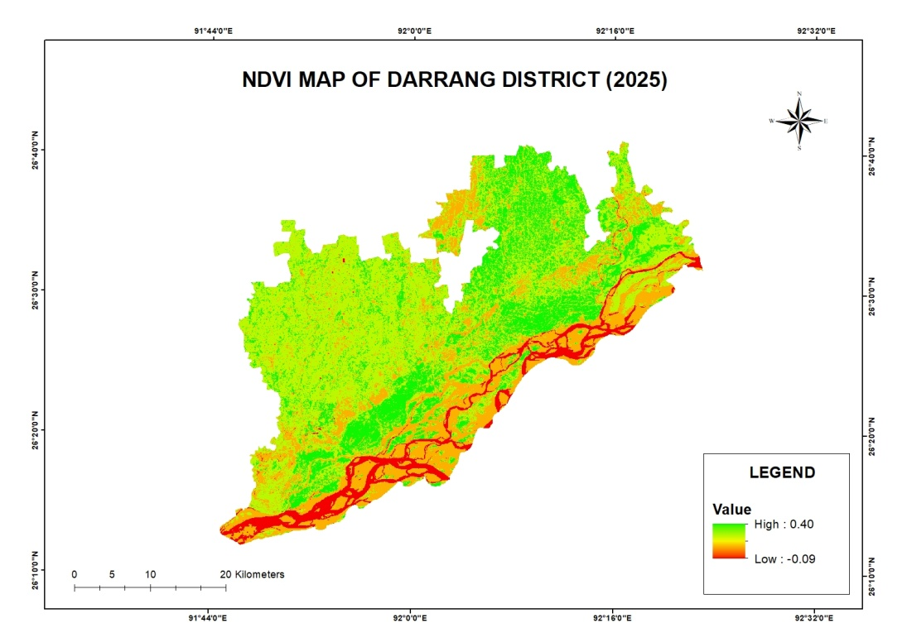

Fig.4 : NDVI map of Darrang District, 2025

4.3 Normalized Difference Vegetation Index(NDVI) of the study area :
The Normalized Difference Vegetation Index (NDVI) is popularly utilized to evaluate the remote sensing imagery data, particularly for determining the presence and condition of green vegetation in a specified region. By applying Normalized Difference Vegetation Index (NDVI) using multispectral datasets, this enables the identification and mapping of various land-cover features, including areas covered by water, urban zones, vegetation, and areas with dense plant growth (Somayajula et al., 2020). The different range of Normalized Difference Vegetation Index (NDVI) value and the characterized pictorial view of Normalized Difference Vegetation Index (NDVI) index for the year 2025 has been shown in fig.4. Normalized Difference Vegetation Index (NDVI) index values have been found between -0.09 and 0.40 for the year 2025. Normalized Difference Vegetation Index (NDVI) values span from −1 to 1, with readings near zero generally associated with built-up or urban regions, negative values suggesting water bodies, and positive readings corresponding to areas of dense vegetation (Sahana et al. 2016; Babalola and Akinsanola 2016).
The following formula has been used for extraction of Normalized Difference Vegetation Index (NDVI)

NDVI= (NIR-RED)/(NIR+RED)

Where, the Red band refers to band 4, which captures visible light, while the Near-Infrared (NIR) band corresponds to band 5 on the Landsat 8 OLI_TIRS sensor.
The Normalized Difference Vegetation Index (NDVI) is a numerical measure derived from the visible and near-infrared portions of the electromagnetic spectrum. Healthy plants typically absorb most of the light in the visible range while reflecting a high amount of near-infrared radiation. In contrast, vegetation that is weak or sparse reflects more visible light and less near-infrared energy, and bare soil shows relatively balanced reflectance in both ranges. Since scientists have well-established knowledge of how plants reflect light across these wavelengths, Normalized Difference Vegetation Index (NDVI) is computed using the red and near-infrared bands captured by satellites. A higher difference between these two reflectance values indicates thicker, healthier vegetation.(Kumar et al., 2024

5.CONCLUSION:

This study evaluates the latest status of Normalized Difference Vegetation Index (NDVI) and Land Use and Land Cover (LULC) of Darrang District. As per the objective (i),the finding reveals that maximum area covered by land under agriculture (681.15 km²) followed by settlements (384.7 km²), sandbar (299.81km²), water bodies (126.43 km²) and minimum area covered by plantation (34.57 km²) followed by forest cover (77.31 km²). As per objective (ii), the result shows that the ranges of Normalized Difference Vegetation Index (NDVI) values have been found between -0.09 and 0.40 for the year 2025, which indicates sparse vegetation or moderately green cover during dormant seasons. Many other relevant aspects can be analyzed for the study area using Geospatial technology which may be helpful for the future academician and planners. Land Use and Land Cover (LULC) studies offer decision–makers a better understanding of changing land-use patterns for effective planning, while Normalized Difference Vegetation Index (NDVI) studies provide crucial data on vegetation health to support sustainable ecosystem and resource management choices.

Disclaimer (Artificial intelligence)
Option 1:
Author(s) hereby declare that NO generative AI technologies such as Large Language Models (ChatGPT, COPILOT, etc.) and text-to-image generators have been used during the writing or editing of this manuscript.
Option 2:
Author(s) hereby declare that generative AI technologies such as Large Language Models, etc. have been used during the writing or editing of manuscripts. This explanation will include the name, version, model, and source of the generative AI technology and as well as all input prompts provided to the generative AI technology
Details of the AI usage are given below:
1.
2.
3.
REFERENCES:

- Al-Ameri, R. A., Sabah, N., & Al-Baaj, G. A. J. (2025). Computing and predicting the vegetation cover using NDVI under the conditions of climate change for the period 2000–2024: A case study of Karbala City, Iraq. International Journal of Advanced Trends in Engineering and Technology, 10(1), 5–12. https://www.dvpublication.com/
- Lahane, R., Manza, R. R., Ambhore, S., & Katkade, S. (2025). Remote sensing and GIS for LULC change detection: A review of techniques and findings. International Journal for Research in Applied Science and Engineering Technology, 13(7), 175-183. https://doi.org/10.22214/ijraset.2025.72941
- Babalola, O. S., & Akinsanola, A. A. (2016). Change detection in land surface temperature and land use land cover over Lagos Metropolis, Nigeria. Journal of Remote Sensing & GIS, 5(3), 1–7. https://doi.org/10.4172/2469-4134.1000171
- Borah, S. (2024). The statistical correlation between normalized difference vegetation index and land surface temperature in the Charaideo District of Assam, India. Ecology, Environment & Conservation, 30(4), 1899-1906. https://doi.org/10.53550/EEC.2024.v30i04.071
- Bora, R., & Bora, A. K. (2024). Population pressure and changing land use land cover in Morigaon District, Assam, India: A geospatial analysis. Indian Journal of Science and Technology, 17(24), 2547–2556. https://doi.org/10.17485/IJST/v17i24.899
- Chen, J., Shao, Z., Deng, X., Huang, X., & Dang, C. (2023). Vegetation as the catalyst for water circulation on global terrestrial ecosystem. Science of the Total Environment, 895, 1-38. https://doi.org/10.1016/j.scitotenv.2023.165071
- Congalton, R. G. (1991). A review of assessing the accuracy of classifications of remotely sensed data. Remote sensing of environment, 37(1), 35-46. https://doi.org/10.1016/0034-4257(91)90048-B
- Coqueia, S., & Paca, A. (2024). Analysis Comparison of the Normalized Difference Vegetation Index (NDVI) of Vegetation Cover from 1996 to 2024 in the Concession Perimeter of SociedadeMineira de Catoca. International Journal of Scientific Research and Technology, 1 (12), 76-83. https://doi.org/10.5281/zenodo.14314870
- Gandhi, G. M., Parthiban, S., Thummalu, N., & Christy, A. (2015). Ndvi: Vegetation change detection using remote sensing and gis – A case study of Vellore District. Procedia Computer Science, 57, 1199-1210. https://doi.org/10.1016/j.procs.2015.07.415
- Garai, S., Khatun, M., Singh, R., Sharma, J., Pradhan, M., Ranjan, A., Rahaman, S. M., Khan, M. L., & Tiwari, S. (2022). Assessing correlation between rainfall, normalized difference vegetation index (NDVI), and land surface temperature (LST) in eastern India. Safety in Extreme Environments, 4(2), 119–127. https://doi.org/10.1007/s42797-022-00056-2
- Guo, B., Zhou, Y., Wang, S. X., & Tao, H. P. (2014). The relationship between normalized difference vegetation index (NDVI) and climate factors in the semiarid region: A case study in Yalu Tsangpo River basin of Qinghai-Tibet Plateau. Journal of Mountain Science, 11(4), 926-940. https://doi.org/10.1007/s11629-013-2902-3
- Hazarika, A., Saikia, J., &Saikia, S. (2024). Evaluating the scenario of urban blue-green space in Tezpur town of Assam using geo-technical approach. Acta Geophysica, 72(3), 1-21. https://doi.org/10.1007/s11600-024-01360-0
- Kumar, S. A., Saradhi, B. V., & Rajesh, M. (2024). Extraction Of Vegetation From Satellite Image Using Ndvi And Change Detection Of Vegetation--A Matlab Approach, Ananthapur District, Andhra Pradesh, India. Frontiers in Health Informatics, 13(8), 3626-3634. https://www.healthinformaticsjournal.com/index.php/fhi/article/view/3626
- Klein Goldewijk, K., &Ramankutty, N. (2004). Land cover change over the last three centuries due to human activities: The availability of new global data sets. GeoJournal, 61(4), 335-344. https://doi.org/10.1007/s10708-004-5050-z
- Lambin, E. F., Turner, B. L., Geist, H. J., Agbola, S. B., Angelsen, A., Bruce, J. W., Coomes, O. T., Dirzo, R., Fischer, G., Folke, C., George, P. S., Homewood, K., Imbernon, J., Leemans, R., Li, X., Moran, E. F., Mortimore, M., Ramakrishnan, P. S., Richards, J. F., … Xu, J. (2001). The causes of land-use and land-cover change: Moving beyond the myths. Global Environmental Change, 11(4), 261–269. https://doi.org/10.1016/S0959-3780(01)00007-3
- Liu, M., Hu, Y., Chang, Y., He, X., & Zhang, W. (2009). Land use and land cover change analysis and prediction in the upper reaches of the Minjiang River, China. Environmental management, 43(5), 899-907. https://doi.org/10.1007/s00267-008-9263-7
- Machahary, J. (2024). Spatio-Temporal Detection of Land Use/Land Cover Changes in Kokrajhar District of Assam. International Journal of Innovative Technology and Exploring Engineering (IJITEE), 13(6), 1-8. https://doi.org/10.35940/ijitee.F9872.13060524
- Mehmood, K., Anees, S. A., Rehman, A., Tariq, A., Zubair, M., Liu, Q., Rabbi, F., Khan, K. A., & Luo, M. (2024). Exploring spatiotemporal dynamics of NDVI and climate-driven responses in ecosystems: Insights for sustainable management and climate resilience. Ecological Informatics, 80, 1-16. https://doi.org/10.1016/j.ecoinf.2024.102532
- Niyogi, D., Mahmood, R., & Adegoke, J. O. (2009). Land-Use/Land-Cover Change and Its Impacts on Weather and Climate. Boundary-Layer Meteorology, 133(3), 297–298. https://doi.org/10.1007/s10546-009-9437-8
- Pawe, C. K., &Saikia, A. (2018). Unplanned urban growth: land use/land cover change in the Guwahati Metropolitan Area, India. GeografiskTidsskrift-Danish Journal of Geography, 118(1), 88-100. https://doi.org/10.1080/00167223.2017.1405357
- Pelorosso, R., Apollonio, C., Rocchini, D., &Petroselli, A. (2021). Effects of land use-land cover thematic resolution on environmental evaluations. Remote Sensing, 13(7), 1232. https://doi.org/10.3390/rs13071232
- Sahana, M., Ahmed, R., & Sajjad, H. (2016). Analyzing land surface temperature distribution in response to land use/land cover change using split window algorithm and spectral radiance model in Sundarban Biosphere Reserve, India. Modeling Earth Systems and Environment, 2(2), 81. https://doi.org/10.1007/s40808-016-0135-5
- Selçuk, R. E. I. S., Nişancı, R., Uzun, B., Yalçın, A., İnan, H., &Yomralıoğlu, T. (2003). Monitoring Land-Use Changes by GIS and Remote Sensing Techniques: Case Study of Trabzon. In Proceedings of 2nd FIG Regional Conference, Marrakech, Morocco. https://www.fig.net/figtree/pub/morocco
- Singgalen, Y. A. (2024). Spatio-temporal analysis through NDVI, NDBI, and SAVI using Landsat 8/9 OLI. Journal of Computer System and Informatics, 5, 815-831. https://doi.org/10.47065/josyc.v5i4.5735
- Singh, R. P., Singh, N., Singh, S., & Mukherjee, S. (2016). Normalized Difference Vegetation Index (NDVI) Based Classification to Assess the Change in Land Use/Land Cover (LULC) in Lower Assam, India. International Journal of Advanced Remote Sensing and GIS, 5(10), 1963-1970. https://doi.org/10.23953/cloud.ijarsg.74
- Somayajula, A., Kiranmai, V. A., Ghai, D., & Kumar, S. (2020). A Review on Classification of Land Use/Land Cover change assessment based on the Normalized Difference Vegetation Index. ournal of Critical Reviews, 7(14), 2416-2431.
- Twisa, S., &Buchroithner, M. F. (2019). Land-use and land-cover (LULC) change detection in Wami River Basin, Tanzania. Land, 8(9), 136. https://doi.org/10.3390/land8090136

