Original Research Article

Ecological Distribution and Trophic Dynamics of Carnivorous Fishes Across Salinity Gradient in Ashtamudi Lake, Southwest India

Abstract
Ashtamudi Lake is a Ramsar-designated protected estuarine ecosystem where salinity levels strongly influence which species live in different areas. This study investigated the distribution and feeding ecology of 20 carnivorous fish species out of 97 total fish species found across three sites with different salinity levels. Species richness (S=28) was highest at the Kidapram site, a freshwater transition zone, highlighting its importance as a diverse habitat. Indicator Species Analysis identified key species like Dussumieria acuta and Liza parsia that showed strong preferences for specific transition zone habitats, indicating good habitat quality. Food web analysis revealed complex feeding relationships connecting bottom-dwelling organisms with surface water species. Large carnivorous fish such as Sphyraena jello and Caranx ignobilis play important roles in controlling the food web. Energy flow through the system varies seasonally, with zooplankton populations peaking during the monsoon season at Kidapram, providing a major seasonal food source. Additionally, planktivorous fish selectively feed on certain zooplankton sizes, which changes the zooplankton community structure. These results show that carnivorous fish communities are shaped primarily by habitat variety, salinity gradients, and food availability. This information is essential for monitoring and managing this important tropical coastal ecosystem sustainably.
Keywords: Carnivorous fishes, Salinity gradient, Trophic dynamics, Indicator Species Analysis, Estuarine biodiversity, Ashtamudi Lake.

1. Introduction
Ashtamudi Lake, located along the southwest coast of India and designated as a Ramsar wetland of international importance, represents a highly productive tropical estuarine ecosystem with considerable biological diversity (Vimal Raj et al., 2014). The lake consists of an interconnected mosaic of marine, brackish, and freshwater zones that are strongly influenced by seasonal monsoon-driven river inflow and periodic tidal exchange with the Arabian Sea (Qasim & Gopinathan, 1969). These hydrological processes generate pronounced spatial and temporal salinity gradients within the estuary, which act as natural ecological filters regulating species distribution, physiological adaptation, and community organization. Such gradients play a critical role in structuring fish assemblages, particularly carnivorous fishes that respond to changes in prey availability, habitat complexity, and physicochemical conditions across the estuarine continuum. Understanding how these salinity-driven habitats influence the distribution and trophic dynamics of carnivorous fishes is therefore essential for evaluating ecosystem functioning and fisheries sustainability in Ashtamudi Lake (Mattila & Bonsdorff, 1989; Vijayan, 2024).
This study examines how different salinity levels shape where carnivorous fish live and what they eat in Ashtamudi Lake. Three zones - Neendakara (mainly marine), Puthenthuruth (a mix of tidal and brackish), and Kidapram (where brackish meets freshwater) - to represent the range of salinity found in the estuary and to observe changes in fish communities and their feeding habits. Previous research in the lake has documented the presence of several euryhaline species such as Channa striata, Etroplus suratensis, and Mugil cephalus, which exhibit physiological adaptations to salinity fluctuations and play important roles in connecting trophic levels (Jayaram, 2010; Nakkrasae et al., 2015; Mohanty & Panda, 2020). By looking at the types of carnivorous fish and their prey, such as zooplankton and bottom-dwelling organisms, this research helps explain the role of predators in the estuary and offers important information for managing fisheries and habitats in coastal wetlands.
2. Materials and methods
The present study conducted during February 2022 to April 2023 along the three ecologically distinct ecosites within the Ashtamudi Lake wetland system, situated on the southwest coast of India. The three selected ecosites collectively capture the spatial heterogeneity of the Ashtamudi estuary, making them suitable for examining habitat-linked variation in population of the fishes and trophic dynamics. A georeferenced map of the study area indicating the geographical position of the selected ecosites - Neendakara, Puthenthuruth, and Kidapram is presented in Figure 1, offering a visual overview of the lake’s ecological zonation and sampling framework. This spatial representation highlights the gradient from marine to freshwater influence and serves as a foundational reference for interpreting the ecological data collected during the study.
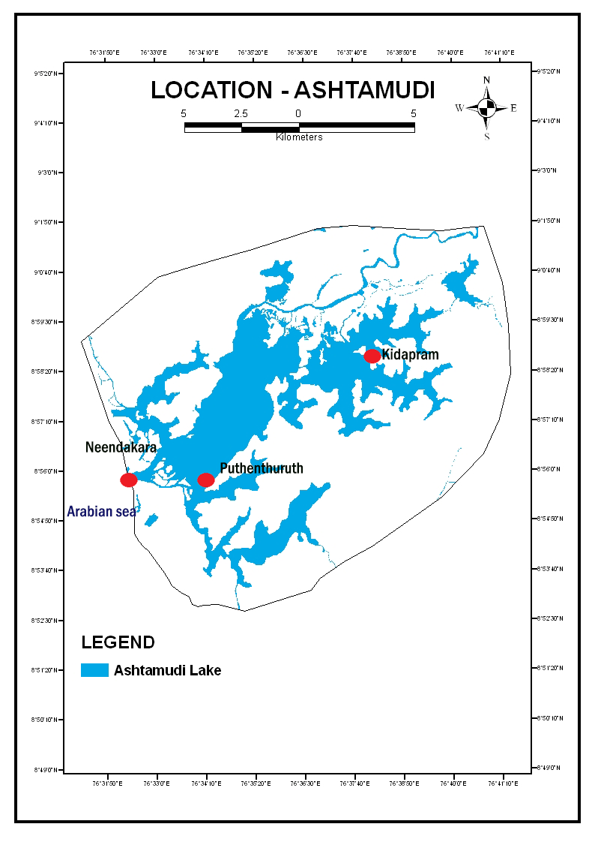
Figure 1. Study Location in the Ashtamudi Wetland
Fish sampling and analysis were conducted seasonally using a combination of traditional and standardized fishing methods, including gill nets, cast nets, and drag nets, with the assistance of local fishermen to ensure representative spatial coverage of the study area (Talwar & Jhingran, 1991). All collected specimens were identified using standard taxonomic keys (Day, 1878; Jayaram, 2010), and total length (TL) was measured for each individual. Identified carnivorous fishes were subsequently classified into two size-based functional groups: small-bodied species (<50 cm TL) and large-bodied species (≥50 cm TL). This classification was adopted to account for ontogenetic shifts in feeding strategy and functional role, as body size strongly influences gape limitation, prey selection, and trophic position. Small-bodied fishes are generally restricted to planktonic and small invertebrate prey, whereas large-bodied fishes are capable of exploiting larger crustaceans and fish prey, functioning as apex or near-apex piscivores within the estuarine food web (Villéger et al., 2017). Water quality parameters such as pH, Temperature and Salinity were measured at each sampling point using a calibrated multiparameter probe and standard methods (APHA, 2005).
Key ecological indices - species richness (S), Shannon-Wiener index (H′), Simpson’s index (1-D), Pielou’s evenness (J′), and Margalef’s richness index (d), were calculated to evaluate fish diversity and community structure, and Indicator Species Analysis (ISA) was performed to identify habitat-specific taxa using PAST 4.3 (Shannon & Weaver, 1963). Trophic interactions and predator-prey dynamics were inferred from field observations, published dietary information, and trait-based assessments of prey size and feeding guilds, and were visualized using Sankey and network diagrams generated in SankeyMATIC (a web-based visualization tool).
3. Results and discussions
The three study locations were suitably selected to represent the lake’s salinity range and associated habitat gradients. The first site, Neendakara (N 08°56′7.2″, E 76°32′24.0″), located at the marine-dominated southern region of the lake with salinity 35.69%, having strong tidal exchange with the Arabian Sea results in high salinity influence. The second site, Puthenthuruth (N 08°55′55.6″, E 76°33′10.1″), represents a transitional zone characterized by intermediate salinity levels with 26.70%, semi-enclosed water flow higher organic productivity. The third site, Kidapram (N 08°59′57.7″, E 76°36′7.3″), is located in the upper ranges of the estuary having frequent freshwater inflows, creating a low-salinity with 5.86%. This nutrient-rich area favourable to benthic accumulation and macrophyte growth. Along with fish collection, field observations and in-situ environmental measurements were recorded during each seasonal event to determine habitat preference of species and salinity tolerance. The microhabitat of the members was characterized by dominant substrate type like muddy, sandy, intermediate, and the habitat associated vegetation such as mangroves or submerged aquatic vegetation. Habitat preference was assigned by substantiating the capture location data with existing ecological literature (Elliott et al., 2007).
3.1. Composition and Trophic Roles of Fish Assemblages
A total of 97 fish species representing 41 families were recorded from the study area, surrounding a wide range of freshwater, estuarine, and marine habitats. Habitat distribution analysis revealed that 29 species were exclusive to freshwater, 39 were restricted to marine environments and 29 exhibited euryhaline behaviour, thriving across varying salinity zones. Among these, 20 species were identified as carnivorous, including both small-bodied and large-bodied predators distributed across all habitat types (Fig. 2). Notable carnivorous taxa such as Channa striata, Caranx ignobilis, Sphyraena jello, and Epinephelus tauvina were occupying distinct ecological niches, indicating strong habitat partitioning influenced by salinity gradients and prey availability. Families such as Mugilidae, Gobiidae, and Clupeidae demonstrated high ecological plasticity, with species like Mugil cephalus, Tachysurus maculatus, Leiognathus equulus, and Lutjanus fulviflamma occurring across all three habitat types. This overlap reflects the transitional and dynamic nature of Ashtamudi Lake, designed by strong estuarine influence coupled with seasonal freshwater intrusion, which collectively support a diverse and complex fish community of different trophic status.
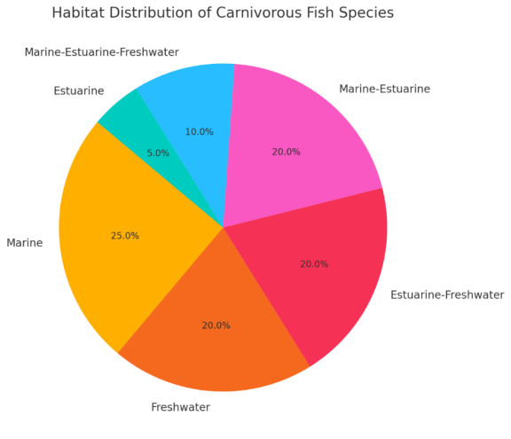
Figure 2. Pie chart showing the habitat distribution of carnivorous fish species
The dominance of marine and estuarine adapted species reflects the salinity gradient, particularly in sites with higher tidal exchange, while the presence of freshwater species such as Anabas testudineus, Channa striata, and Puntius filamentosus. emphasizes the freshwater connectivity of upper zones. Overall, this diverse habitat representation underscores the ecological heterogeneity and complexity of fish assemblages in the Lake.
Trophically, planktivorous and carnivorous fishes constituted over 65% of the total species, indicating strong top-down regulatory potential. Carnivorous species were classified into small-bodied forms like Etroplus suratensis and Channa punctata, and large-bodied predators such as Sphyraena jello, Caranx ignobilis, and Epinephelus tauvina. This division reflects a functional grouping that accounts for the well-documented ontogenetic diet pattern in predatory fish. Stomach content analysis of fishes (including juveniles of the large-bodied species) reflected a dominance of benthic and planktonic invertebrates, confirming their functional role as trophic link between herbivory and secondary carnivores. Large carnivores exhibited broad spatial distribution, especially in marine influenced zones, whereas small carnivores were more localized and abundant in brackish and freshwater transitional areas, indicating size and habitat-mediated niche partitioning within the trophic hierarchy.
3.2. Species Richness and Diversity Indices
Fish diversity varied across the ecosites, with Kidapram recording the highest species richness (S = 28), followed by Puthenthuruth (S = 21) and Neendakara (S = 16). Corresponding diversity indices showed similar trends: Shannon-Wiener index (H′) ranged from 2.773 (Neendakara) to 3.332 (Kidapram); Simpson's index (1-D) ranged from 0.938 to 0.964; and Margalef's index (d) peaked at Kidapram (8.103), indicating a richer and more heterogeneous fish assemblage (Table 1). Although evenness (J′ = 1.0) was uniformly high across sites, suggesting equitable distribution, an ANOVA on Shannon-Wiener and Simpson’s indices revealed statistically significant differences (p < 0.05) between sites, particularly between Neendakara and Kidapram.
Table 1. Species Richness and Diversity Indices of fishes in selected sites
Study Sites | Species Richness (S) | Shannon-Wiener Index (H') | Simpson's index (1–D) | Pielou’s evenness (J′) | Margalef's index (d)
Neendakara | 16 | 2.773 | 0.938 | 0.996 | 5.41
Puthenthuruth | 21 | 3.045 | 0.952 | 0.998 | 6.569
Kidapram | 28 | 3.332 | 0.964 | 0.995 | 8.103

3.3. Indicator Species Analysis
Indicator Species Analysis (ISA) identified several taxa with strong site fidelity and significant indicator values. Notably, Dussumieria acuta (IndVal = 0.81), Sardinella fimbriata (0.79), Ehirava fluviatilis (0.75), and Liza parsia (0.69) showed high associations with specific ecosites, underscoring their potential as bioindicators for environmental monitoring. These species were predominantly found in estuarine to brackish habitats and were sensitive to fluctuations in salinity and organic matter availability (Fig. 3).
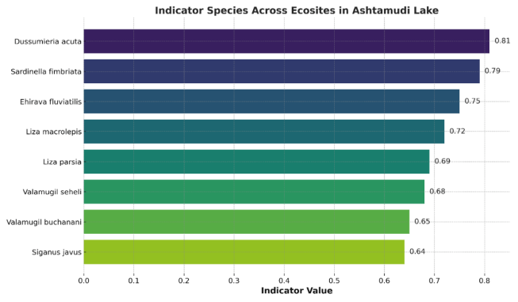
Figure 3. Indicator values computed for habitat-specific taxa across salinity zones
3.4. Trophic Interactions and Energy Flow
A Sankey diagram analysis quantified the biomass transfer pathways among prey groups (phytoplankton, zooplankton, detritus, benthos, small fish) and dominant fish guilds. Planktivorous species such as Valamugil seheli and Liza macrolepis showed strong linkages with phytoplankton and detritus, while carnivorous species like Sphyraena jello and Lutjanus johni were derived the majority of their energy biomass from the consumption of lower trophic levels, namely crustaceans and smaller fish. The analysis underscores the dominance of benthic-pelagic coupling as the primary mode of energy transfer, with zooplankton and small fish serving as critical intermediate trophic levels for higher-order carnivores (Fig. 4).
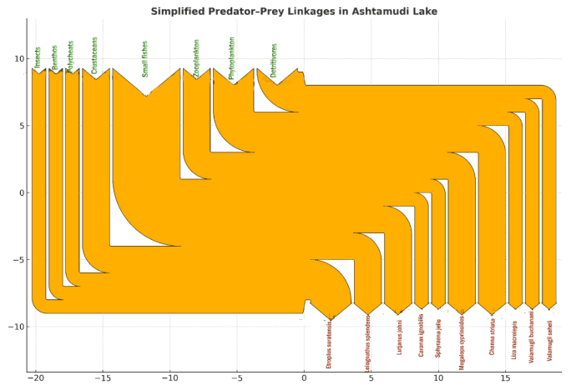
Figure 4. Sankey diagram illustrating biomass transfer and trophic level interaction
A detailed trophic interaction diagram (Fig. 5) illustrates specific predator-prey linkages among the recorded fish species, zooplankton, benthos and phytoplankton. This visual representation provides a clearer understanding of the ecological roles and feeding connectivity pattern among functional groups within the Ashtamudi wetland ecosystems.
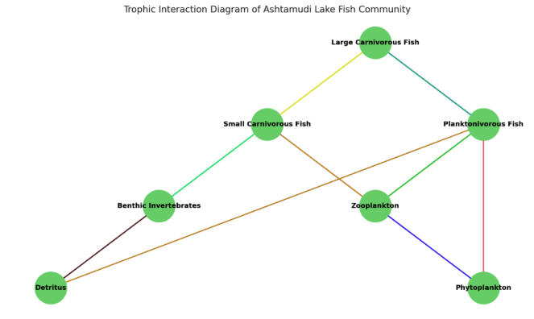
Figure 5. Trophic interaction diagram of predator-prey linkages
3.5. Prey Size Selection and Zooplankton Response
Field data and trait-based inference revealed that planktivorous fishes such as Dussumieria acuta, Sardinella fimbriata, Sardinella longiceps, Anodontostoma chacunda, Stolephorus indicus, S. commersonii, Thryssa malabarica, T. mystax, T. hamiltonii, Rasbora daniconius, Danio aequipinnatus, Puntius filamentosus, Liza macrolepis and Valamugil seheli were preferentially consumed small bodied zooplankton such as Bosmina, Ceriodaphnia, and rotifers, altering zooplankton community structure. In zones with higher plankton predation, large bodied zooplankton like Daphnia were rare. The dominance of fishes with narrow gill rakers suggested selective pressure on zooplankton size distribution.
Behavioural traits also influenced prey capture in such a way that, cladocerans with steady, slow swimming patterns were more vulnerable, while copepods, with rapid escape responses, were less frequently predated. This predator prey dynamic led to trophic reformation, particularly in Puthenthuruth and Kidapram, where zooplankton community shifted towards smaller and evasive taxa.
4. Discussions
Estuaries are ecotonal systems where interactions between freshwater inflow and marine tidal processes generate strong salinity gradients that structure habitats and biological communities. In Ashtamudi Lake, this environmental heterogeneity resulted in a diverse and dynamic fish assemblage dominated by planktivorous and carnivorous species, reflecting the system’s high productivity and trophic complexity. Carnivorous fishes play a pivotal ecological role as top-down regulators, responding sensitively to salinity fluctuations, prey availability, and substrate characteristics (Titelman & Kiørboe, 2003). The observed distribution patterns across marine, estuarine, and freshwater zones are consistent with global estuarine studies showing that salinity gradients act as ecological filters governing species composition, trophic positioning, and feeding strategies (Blaber, 2000; Whitfield & Elliott, 2002 Nakkrasae et al., 2015; Lampert, 1987).
Clear spatial differences in diversity and habitat conditions were evident across the lake. The transitional zones, particularly Kidapram, supported the highest species richness and ecological diversity due to the overlap of freshwater and estuarine taxa, a pattern widely reported from tropical estuaries with complex environmental mosaics (Elliott et al., 2007). In contrast, the marine-dominated Neendakara site exhibited comparatively lower diversity, characteristic of high-energy inlet regions that experience greater physical disturbance and reduced habitat stability (Talwar & Jhingran, 1991). Indicator Species Analysis further highlighted habitat specificity, with species such as Dussumieria acuta, Sardinella fimbriata, Ehirava fluviatilis, and Liza parsia showing strong associations with transitional estuarine conditions. The high indicator values of these species emphasize the ecological distinctiveness of the brackish zones and their sensitivity to salinity and organic productivity, reinforcing their value as bioindicators of estuarine health (Blaber, 2000; Elliott & Hemingway, 2002).
Trophic interaction models revealed a complex food web supported primarily by zooplankton, detritus, and small fishes, with multiple energy pathways enhancing system resilience. Planktivorous fishes such as Valamugil seheli, Liza macrolepis, Etroplus suratensis, and Siganus javus relied heavily on phytoplankton and detritus, reflecting the dominance of detritus-based energy flow typical of tropical estuaries. In contrast, higher-level predators including Sphyraena jello, Caranx ignobilis, and Lutjanus johni primarily consumed fish and crustaceans, exerting top-down control on lower trophic levels. Seasonal peaks in zooplankton abundance during the monsoon, particularly at Kidapram, provided critical feeding opportunities for planktivorous and juvenile fishes, reinforcing the nursery function of the estuary. Selective predation by planktivorous fishes appeared to Favor smaller, evasive zooplankton taxa, potentially altering grazing pressure on phytoplankton and influencing ecosystem stability. Together, these findings underscore the importance of salinity gradients, detrital pathways, and trophic coupling between benthic and pelagic compartments in sustaining fish production and ecological balance in Ashtamudi Lake, consistent with patterns observed in tropical estuarine systems worldwide (Blaber, 2000; Odum & Heald, 1975; Jeppesen et al., 2007).
5. Summary and conclusions
This study examined fish diversity and feeding relationships in Ashtamudi Lake, is a protected tropical estuary recognized under the Ramsar Convention. Out of 97 fish species recorded, 20 were carnivorous species, distributed across marine, estuarine, and freshwater zones. The analysis revealed clear patterns in how fish communities are organized based on environmental conditions, particularly salinity levels. Among the three selected location, Kidapram is a low-salinity transition zone, consistently showed the highest fish diversity, followed by Puthenthuruth. This confirms that transitional areas with mixed conditions support the most diverse fish communities. Indicator Species Analysis identified key species that are closely tied to specific habitats. Dussumieria acuta and Liza parsia showed strong preferences for estuarine and transitional zones with low-to-intermediate salinity levels. These findings demonstrate that habitat variety and salinity gradients are the main factors controlling where different fish species live in Ashtamudi Lake.
The food web analysis revealed how energy flows through the ecosystem. The estuary has a complex food web where energy from bottom-dwelling organisms and surface waters supports the fish community. Small fish and zooplankton are the primary food sources. Zooplankton numbers peaked during the monsoon season at Kidapram, providing a major seasonal food boost. Top predators like Sphyraena jello, Channa striata, and Caranx ignobilis play important roles in controlling the food web from the top down. Planktivorous fish selectively feed on larger zooplankton, which shifts communities toward smaller species. This research provides important baseline information about carnivorous fish and their ecological roles in Ashtamudi Lake. These findings are essential for developing sustainable fishery management practices and effective restoration plans for this important Ramsar wetland.
Data Availability Statement: The datasets generated and/or analysed during the current study are available from the corresponding author upon reasonable request.

Ethical Approval: This study involved no experiments on humans or animals. Field sampling of fishes and Microorganisms were carried out in accordance with institutional and national guidelines for research and biodiversity conservation.
Disclaimer (Artificial intelligence)
Option 1:
Author(s) hereby declare that NO generative AI technologies such as Large Language Models (ChatGPT, COPILOT, etc.) and text-to-image generators have been used during the writing or editing of this manuscript.
Option 2:
Author(s) hereby declare that generative AI technologies such as Large Language Models, etc. have been used during the writing or editing of manuscripts. This explanation will include the name, version, model, and source of the generative AI technology and as well as all input prompts provided to the generative AI technology
Details of the AI usage are given below:
1. Grammarly AI Tool: Used for spelling and grammar corrections
2. ChatGPT: Used for editing the manuscript

References
- Vimal Raj, R. V., Binushma Raju, S., Soumya, W., Shibu, A., Lekshmi, S., Shibu Vardhanan, Y., Sruthi, S., & Tresa Radhakrishnan. (2014). Aquatic bioresources of Ashtamudi Lake, Kerala. Journal of Aquatic Biology & Fisheries, 2(1), 297–303. https://keralamarinelife.in/
- American Public Health Association, American Water Works Association, & Water Environment Federation. (2005). Standard Methods for the Examination of Water and Wastewater (21st ed.). Washington, D.C. https://www.standardmethods.org/
- Blaber, S. J. M. (2000). Tropical estuarine fishes: Ecology, exploitation and conservation. Blackwell Science. https://doi.org/10.1002/9780470694985
- Day, F. (1878). The fishes of India: Being a natural history of the fishes known to inhabit the seas and fresh waters of India, Burma, and Ceylon. B. Quaritch. https://doi.org/10.5962/bhl.title.55567
- Griffith, R. W. (1974). Environment and salinity tolerance in the genus Fundulus. Copeia, 1974(2), 319-331. DOI: 10.2307/1442526.
- Jayaram, K. C. (2010). The Freshwater Fishes of the Indian Region (2nd ed.). Narendra Publishing House. https://www.nphindia.com/product/the-freshwater-fishes-of-the-indian-region-2ed/
- Jeppesen, E., Meerhoff, M., Jacobsen, B. A., Hansen, R. S., Søndergaard, M., Jensen, J. P., Lauridsen, T. L., Mazzeo, N., & Branco, C. W. C. (2007). Restoration of shallow lakes by nutrient control and biomanipulation-the successful strategy varies with lake size and climate. Hydrobiologia, 581, 269-285. DOI: 10.1007/s10750-006-0507-3.
- Lampert, W. (1987). Predictability in lake ecosystems: The role of biotic interactions. In W. Lampert & U. Sommer (Eds.), *Predictability in aquatic ecosystems* (Ecological Studies, Vol. 61, pp. 323-346). Springer. https://doi.org/10.1007/978-3-642-82857-0_23
- Mattila, J., & Bonsdorff, E. (1989). The impact of fish predation on shallow soft bottoms in brackish waters (SW Finland); an experimental study. Netherlands Journal of Sea Research, 23(1). DOI: 10.1016/0077-7579(89)90044-6
- Odum, W. E., & Heald, E. J. (1975). The detritus-based food web of an estuarine mangrove community. In L. E. Cronin (Ed.), *Estuarine Research, Volume I* (pp. 265-286). Academic Press. https://books.google.com/books/about/Estuarine_Research.html?id=2_4_AQAAIAAJ
- Elliott, M., & Hemingway, K. L. (2002). Fisheries Ecology of Estuaries. Oxford University Press.
- Qasim, S. Z., & Gopinathan, C. K. (1969). Tidal cycle and the environmental features of Cochin Backwater (a tropical estuary). Proceedings of the Indian Academy of Sciences, Section B, 69: 336-348. DOI: 10.1007/BF03051729
- Nakkrasae, L. I., Wisetdee, K., & Charoenphandhu, N. (2015). Osmoregulatory adaptations of freshwater air-breathing snakehead fish (Channa striata) after exposure to brackish water. Journal of Comparative Physiology B: Biochemical, Systemic, and Environmental Physiology, 185(5), 527-537. DOI: 10.1007/s00360-015-0902-z
- Mohanty, S.K., Panda, D. (2020). Correction to: Fish and Fisheries of Chilika: Post-Restoration Scenario. In: Finlayson, C., Rastogi, G., Mishra, D., Pattnaik, A. (eds) Ecology, Conservation, and Restoration of Chilika Lagoon, India. Wetlands: Ecology, Conservation and Management, vol 6. Springer, Cham. https://doi.org/10.1007/978-3-030-33424-6_17
- Shannon, C. E., & Weaver, W. (1963). The mathematical theory of communication. University of Illinois Press. https://www.press.uillinois.edu/books/?id=p02527254847
- Elliott, M., Whitfield, A. K., Potter, I. C., Blaber, S. J. M., Cyrus, D. P., Nordlie, F. G., & Harrison, T. D. (2007). The guild approach to categorizing estuarine fish assemblages: a global review. Fish and Fisheries, 8(3), 241–268. https://doi.org/10.1111/j.1467-2679.2007.00253.x
- Talwar, P. K., & Jhingran, A. G. (1991). Inland Fishes of India and Adjacent Countries (Vols. 1-2). Oxford & IBH Publishing Co. https://books.google.com/books/about/Inland_Fishes_of_India_and_Adjacent_Coun.html?id=2_4bAAAAYAAJ
- Titelman, J., & Kiørboe, T. (2003). Predator avoidance by nauplii. Marine Ecology Progress Series. https://doi.org/10.3354/meps247137
- Whitfield, A. K., & Elliott, M. (2002). Fishes as indicators of environmental and ecological changes within estuaries: A review of progress and some suggestions for the future. Journal of Fish Biology, 61(A): 229-250. https://doi.org/10.1111/j.1095-8649.2002.tb01773.x
- Villéger, S., Brosse, S., Mouchet, M., Mouillot, D., & Vanni, M. J. (2017). Functional ecology of fish: current approaches and future challenges. Aquatic Sciences 79(4): 783-80. https://doi.org/10.1007/s00027-017-0546-z
- Vijayan, S. Community Composition of Freshwater Fishes from Aquatic Streams and Rivers in the Western Ghats of South India. Journal of Materials and Environmental Science, 15(8); 1185-1200. https://www.jmaterenvironsci.com/Document/vol15/vol15_N8/JMES-2024-1508078-Vijayan.pdf

