Original Research Article

First record of congaturi Halfbeak, Hyporhamphus limbatus (Valenciennes 1847) from Siang river, Arunachal Pradesh, India (Teleostei: Hemiramphidae)

ABSTRACT
Hyporhamphus limbatus (Valenciennes) a congaturi halfbeak, belongs to the order Beloniformes and family Hemiramphidae and was originally described from Malabar coast of India by Cuvier and Valenciennes (1847). The species is euryhaline as well as potamodromous in nature. It has been reported from coastal brackish, fresh water rivers such as Ganges in India but it was never been reported from the Brahmaputra drainage or any rivers of Arunachal Pradesh. The present paper deals with the first record of Hyporhamphus limbatus from the Siang river of Arunachal Pradesh and extends the known distribution of geographical distribution towards far northeastern part of India.
Key words: First record, range extension, Hyporhamphus limbatus, Siang river, Arunachal Pradesh.
- INTRODUCTION
The halfbeaks fishes of family Hemiramphidae under the order Beloniformes are slender or elongated fishes with lower jaw extending far beyond the upper jaw in most of the species, Berra (2001). Under the family Hemiramphidae, Nelson et al. (2016) recognized a total of 67 valid species under 8 genera and under the genera Hyporhamphus(including Reporhamphus) a total of 40 species were recorded. Hyporhamphus limbatus was originally described as Hemiramphus limbatus by Valenciennes in Cuvier and Valenciennes (1847) from Malabar coast of India. Hyporhamphus limbatus, though it was first describe from Malabar coast of India, its range extends from the Persian Gulf to China along with mainland coast Asia Collette &Su (1986). In Asia, it is known from India, Sri Lanka, Myanmar, Thailand, China, Vietnam (Talwar &Jhingran 1991; Rainboth 1996; Datta Munshi & Srivastava 1998 and Ramanujam & Anbarasen 2007) and freshwater bodies of Cambodia and Mekong river of China (Lu et al. 2018).
The Siang River of Arunachal Pradesh, also known as Tibet Autonomous Region, China, originated from the Angsi glacier on the northern side of the Himalayas. The river enters Indian Territory near the Tuting area of Arunachal Pradesh, then flows southwards and ultimately gives off its contents into mighty Brahmaputra in Assam. It is one of the major drainage systems of central Arunachal and main tributary of river Brahmaputra. The river is endowed with rich ichthyo-diversity but the ichthyofaunal resources of the Siang River and its tributaries are poorly explored, Darshan et al. (2017).
Lots of work has been done in the field of ichthyofaunal research of lentic and lotic water bodies of Arunachal Pradesh. It begins with the early works of Choudhuri(1913) presented zoological reports of Abor expedition, extensive works of Hora (1921), Choudhury and Sen (1977), Sen (1999),Sen (2006), Geetakumari&Kadu (2011), Kadu& Das (2011),Tesia & Bordoloi (2012), Darshan et al. (2017),Jha(2020), Gurumayum (2023), Tamang & Das (2024) etc. Apart from them the most comprehensive works on the ichthyofaunal resources of state was done by Nath & Dey (2000) recorded total of 131 fish species, followed by Bagra et al. (2009) recorded 213 fish species, Gurumayum et al.(2016) reported a total of 259 fish species under 105 genera and Darshan et al.(2018) recorded 213 different fish species. But none of the earlier scholars have reported Hyporhamphus limbatusfrom any lotic and lentic water bodies of Arunachal Pradesh.
After scanning through the available literature, it is also evident that the halfbeak euryhaline fish species Hyporhamphus limbatuswas reported to be a frequent visitor of freshwater rivers Day (1878), Misra(1959), Srivastava(1967), Rainboth(1996), Datta Munshi & Srivastava(1988), Mondal & Kaviraj (2009), Sarkar et al. (2012), Sinha et al.(2014), Shayamsundar et al.(2017). But on further perusal of related literature, it is evident that the range distribution of Hyporhamphus limbatus had not been reported earlier from far upstream of the Brahmaputra river basin and its tributaries of Northeast India.
The present paper deals with the first record of Hyporhamphus limbatus (Valenciennes) from Siang river, Pasighat Arunachal Pradesh, India, and the range extension of geographical distributional of Hyporhamphus limbatus to north eastern region of India as a whole and Arunachal Pradesh in particular.

- MATERIALS AND METHODS
The halfbeak fish specimen was collected from the river Siang near the confluence point of Sibo Korong (stream) and Siang river at Pasighat (Figure.1) & (Figure.2) using a cast net. The collected fish specimen was preserved in 10% formalin solution and deposited in Jawaharlal Nehru College Museum of Fishes (JNCMF), Jawaharlal Nehru College, Pasighat, Arunachal Pradesh, India.
All morphometric measurements were taken from point to point on the lateral left side of the fish using digital vernier caliper and the data were recorded to the nearest millimeter. The body proportion was expressed as a percentage of standard length (SL) and the subunits of head are also separately presented in proportion of head length (HL).
All the morphometric and meristic data generated were compared with the standard references of Day (1878),Mishra (1959),Jayaram(1981) and Datta Munshi & Srivastava(1988).Identification was done following Day (1878 and 1889),Talwar&Jhingran (1991) and Collette (1984, 1999) FAO species identification sheets. Due to non-availability of museum specimens for comparison, the author used the published literature on meristic and morphometric data of Hyporhamphus limbatus Johny et al. (2016) and Collette (2004).

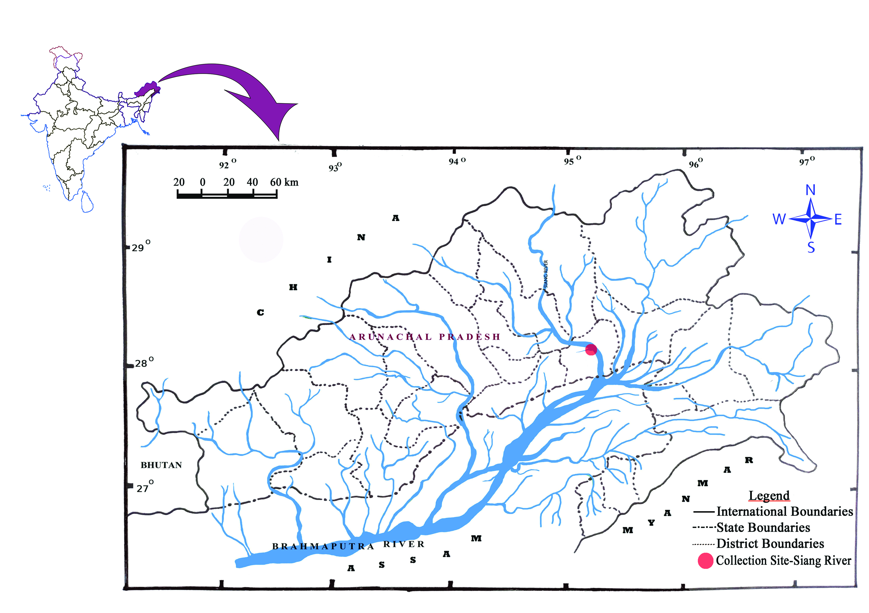

Figure 1. Map showing collection site (Siang river, Pasighat) of Hyporhamphus limbatus.

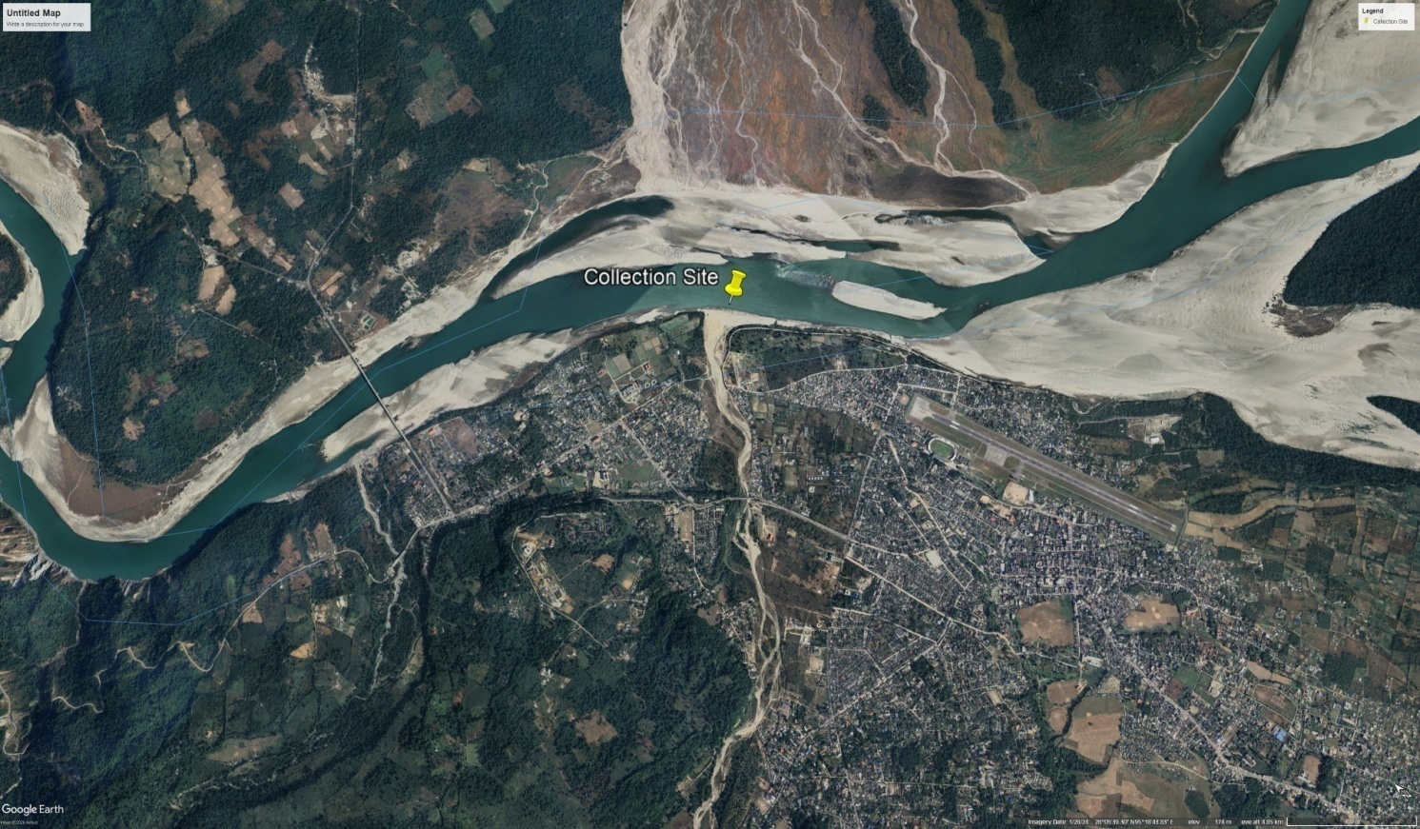

Figure 2. Satellite Map showing exact collection site at Siang river, Pasighat

- RESULTS

3.1.Systematic Account
Phylum-Chordata
Class – Actinopterygii
Order- Beloniformes
Family- Hemiramphidae

Hyporhamphus limbatus(Valenciennes,1846) (Figure. 3)
Hemiramphus limbatusValenciennes, in Cuvier and Valenciennes 1846,Hist. Nat. Poiss; 19:44 (type locality: India, Malabar Coast, Bombay and Pondicherry).
Hemiramphus limbatus Day 1877, Fishes of India; 516, Pl, 119; Day, 1889, Fauna Br. India, Fishes 1 :426.
Hemiramphus gaimardi Valenciennes Jones and Sujansinghani, 1954, Indian J. Fish., 1:264
Hemiramphus gorakhpurensisSrivastava 1967. Journal of Bombay Natural History Society 64(1): 93 (type locality: Gorakhpur, Uttar Pradesh).

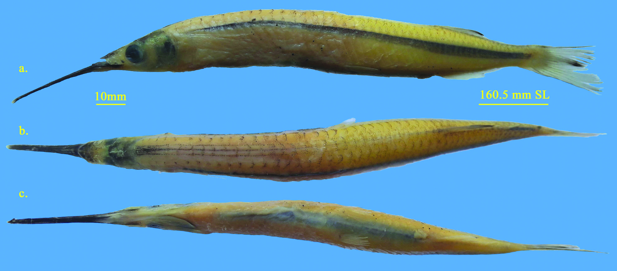
Figure 3. Hyporhamphus limbatus, JNCMF- 491,160.5 mm SL; Siang River, Pasighat, East Siang District, Arunachal Pradesh India. a. Lateral view; b. Dorsal view; c. Ventral view of body.

3.2. Material examined
JNCMF- 491, Standard Length: 160.5 mm;Collection Site: Siang River, near Sibo-Siang confluence at Pasighat, East Siang district Arunachal Pradesh, India. 28°05′39.30″N 95°18′43.83″E, altitude 150 m, Date of collection: 09 July 2019, collected by: Kento Kadu.
3.3. Description
Morphometric measurements and meristic counts are presented in Table.1. Body elongated, slightly cylindrical and somewhat compressed. Abdomen rounded not keeled. Dorsal profile is slightly curved, rising slowly from the tip of the snout to above the pectoral-fin origin and thereafter runs parallel to the body axis up to dorsal fin insertion point. Whereas ventral profile is slightly arched from below the tip of the snout to the base of the caudal fin. Mouth superior, Jaws unequal, lower jaw longer than upper jaw. The lower jaw greatly prolonged into a beak-like structure. Scaleless upper jaw appears triangular in dorsal view and its length slightly less than its width. The body is covered with moderate sized cycloid scales. Pre dorsal scales consist of 33 scales and 44 lateral line scales. Anal and dorsal fins base are covered with scales. Eyes are large, positioned slightly nearer to anterior portion of the head and not visible when observed from the dorsal. Pre-orbital ridge present. The pre-orbital canal is simple, lacking posterior branch. Nasal papilla fan shaped. Fins are without spines. Dorsal fin with 14 rays inserted in the posterior half nearer to the caudal origin. It originated slightly ahead of the anal fin. Pectoral fin with 11 rays inserted almost lateral portion of body, just behind the gills andwhen folded forward it reachesthe middle of orbit but not extending beyond the anteriormargin of the orbit. Ventral (Pelvic) fins are short with 6 rays, which are inserted posterior to mid body length and do not reach vent and anal fin origin. Anal fin with 14 raysinserted just behind dorsal fin origin vertically. The base length of anal fin is slightly shorter than the dorsal fin base length. Caudal fin is emarginated or slightly forked, lower lobe slightly longer than the upper lobe. Barbels absent.
In the preserved specimen dorsal profile is yellowish white while ventral profile is silvery white in colour. The lateral surface of body is silvery white. A dark blue-black lateral stripe runs in a mid lateral position which originated just near the insertion point of pectoral fins and widens posteriorly to the greatest near the vent. The body is devoid of any vertical bars on its lateral sides. Scales on dorsal profile are dappled with black, thus imparting a slight black colouration. Three spotted lines on the mid dorsal side commencing from occipital region and ending slightly ahead of dorsal fin origin. The fleshy tip of the elongated beak is reddish. Pectoral, pelvic, and anal fins are translucent with some pigments on the fin rays.
Table 1. Morphometric and Meristic data of Hyporhamphus limbatus, JNCMF- 491, 160.5 mm SL; Siang River, Pasighat, East Siang District, Arunachal Pradesh India.

Sl.No | Characters | In mm
1 | Total length | 186.5
2 | Standard body length | 160.5
In percentage (%) of standard Body length (160.5 mm)
3 | Head length (lower jaw tip) | 35.1
4 | Head length (upper jaw tip) | 15.6
5 | Snout length | 25.6
6 | Head height at eye | 6.3
7 | Head width at eye | 4.5
8 | Mouth gape | 3.8
9 | Eye diameter | 3.7
10 | Interorbital distance | 4.2
11 | Body depth at pelvic origin | 11.2
12 | Body width at pelvic origin | 7.5
13 | Pre dorsal fin length | 82.2
14 | Pre pectoral fin length | 38.6
15 | Pre pelvic fin length | 65.0
16 | Pre Anal fin length | 82.1
17 | Dorsal fin base length | 12.9
18 | Anal Fin Base length | 12.1
19 | Pectoral fin length | 12.8
20 | Pectoral l fin base length | 3.1
21 | Pelvic fin length | 6.9
22 | Pelvic l fin base length | 1.4
23 | Caudal fin length | 16.1
24 | Caudal peduncle length | 6.5
25 | Caudal peduncle height | 4.4
26 | Distance from Pelvic origin to anus | 15.8
27 | Distance from anus to anal fin origin | 1.7
In percentage (%) of standard head length (56.4 mm)
28 | Snout length | 73.0
29 | Head height at eye | 17.9
30 | Head width at eye | 12.8
31 | Mouth gape | 10.8
32 | eye diameter | 10.5
33 | Interorbital distance | 12.1
Meristic counts
D 14; P 11; V 6; A 14; C15 & LL 44

- DISCUSSION
A total of 36 species were recognized under the genus Hyporhamphus Gill by Collette (2004), out of which 11 are Indo-pacific marine species, whereas Nelson et al. (2016) recorded 40 species, including species of Reporhamphus. The present specimen shares similarity with most of the characters of Hyporhamphus limbatus. However, few morphological and meristic counts variation was observed, which may be due to differences in measuring techniques. Srivastava (1968) & Jayaram (1981) reported that dorsal fin arises slightly posteriors to an anal or dorsal inserted in between pelvic and anal fin origin. Whereas in present species, dorsal arises slightly ahead of anal when observed vertically. The same kind of dorsal fin insertion was also observed by (Mishra1959 and Datta Munshi & Srivastava 1988). The present specimen show very similar morphological characters with that of Nguyen et al. (2025). Further, the morphometric measurements & meristic counts of the present specimen fall within the range of morpho-meristic data of the H. limbatus recorded from the Wainganga river of Maharashtra by Wanjari et al. (2025).
After careful review of available literature, it is evident that the halfbeak fish species Hyporhamphus limbatus was never recorded from any water bodies of Arunachal Pradesh as well as from north eastern state of India. Hyporhamphus limbatusis basically a marine and euryhaline species, but their potamodromous behaviors toward freshwater is not new. The species was reported from ascending tidal rivers, ascending estuaries & freshwater by Day (1878) and Misra (1959) with a name of Hemirhamphus limbatus and Hemiramphus gaimardi. Jones & Sujansinghani (1954) recorded the species from Chilka lake, David (1954) from Hoogly river between Barrackpore & Nawabganj West Bengal. But the reporting of Hyporhamphus limbatus (as new species H. gorakhpurensis) from purely freshwater resources like Mahesharatal and river Rohini at Gorakhpur Uttar Pradesh by Srivastava (1967), clearly established the wide range of its distributions to freshwater rivers of India, followed by reporting of Hyporhamphus limbatus from purely freshwater zone of river BudhiGandak in Khagaria district of Bihar by Datta Munshi & Srivastava(1998) which further confirms the species inclination towards upstream migration of freshwater rivers, later on Mondal & Kaviraj (2009) also reported the Hyporhamphus limbatus from two flood plain lakes of Ichhamati river. Talwar & Jhingran (1991) have also reported the breeding behavior of Hyporhamphus limbatus in Chilka lake a brackish water or near the boundary of a brackish river. While working on the Freshwater fish diversity in the river Ganges (India), Sarkar et al. (2012) also reported Hyporhamphus limbatus from Ganga riverin in between Patna to Bhagalpur including Munger and also from a stretch of Ganga between Bhagalpur to Rajmahal including Khalegaon. Consortium of IITs, in its reports on GRB EMP flora and fauna of lower Ganga Farakka to Ganga sagar also reported Hyporhamphus limbatus from lower stretch of Ganga. Sinha et al. (2014) also recorded Hyporhamphus limbatus from the Ganga river at Bhagalpur and Rajmahal during their ichthyofaunal study in middle-lower stretch of the river Ganges. The report of Hyporhamphus limbatus from Panagal reservoir of Nalgonda district of Telangana state by Shayamsundar et al.(2017) is another evidence of its migratory behavior towards freshwater bodies. ICAR-CIFRI in its Midterm report (2019) also recorded the species from following stretch of Ganga viz. Bhagalpur, Balagrah,Tribeni, D Harbor & Frasergang.Rainboth(1996) also encountered Hyporhamphus limbatusfrom upstream of Mekong river as far as up to Stung river which also supports the possible upstream freshwater migration of species. Interestingly, Shrestha & Sabina (2008) reported Hyporhamphus limbatusfrom the Koshi & Narayani river of Nepal. Recently, Esamin et al. (2018) recoded Hyporhamphus limbatusfrom the Jamuna river of Bangladesh, which is directly connected to the Brahmaputra/Siang river of India. Recently, Wanjari et al. (2025) also reported three specimens of Hyporhamphus limbatusfrom the Wainganga river near Kardha village in Bhandra district of Maharashtra, India. From the above literature, it is evident that Hyporhamphus limbatus frequently used to visit the freshwater river, but it has never been reported from any water bodies of Arunachal Pradesh in particular and North East India in general. While compiling freshwater fishes of the Eastern Himalayas, Vishwanath (2021) did not reported the presence of H. limbatus from any drainage system of Eastern Himalayas. Some earlier scholars, such as Sen (1999), Nath & Dey (2000), Bagra et al.(2009), Gurumayum et al.(2016), Darshan et al.(2018), Gurumayum & Nath (2022) and Thoidingjam et al. (2023) did an extensive survey on ichthyofaunal diversity of Arunachal Pradesh, but none of these scholars has reported Hyporhamphus limbatus from any lotic and lentic water bodies of Arunachal Pradesh.
5. CONCLUSION
The present study provides the first recordof Hyporhamphus limbatus from the Siang river of Arunachal Pradesh and distribution range of the species upto upper reaches of the Brahmaputra drainage. The finding is a new addition to the fish species list of the state as well as the North Eastern region of India. However, the reasons for their broad upstream migration, especially in the Brahmaputra basin, are not known and further study in this direction is necessary. An in-depth study on habitat preferences, ecological dynamics, and migratory behavior of Hyporhamphus limbatus is necessary considering the ongoing climate changes.

DISCLAIMER (aRTIFICIAL INTELEGENCE)

The author hereby declares that no generative AI technologies such as Large Language Models (Chat GPT, COPILOT, etc) and text-to-image generators have been used during witting or editing of this manuscript.

REFERENCES
- Bagra, K., Kadu, K., Nebeshwar-Sharma, K., Laskar, B. A., Sarkar, U. K., & Das, D. N. (2009). Ichthyological survey and review of the checklist of fish fauna of Arunachal Pradesh, India. Check List, 5(2), 330-350.https://doi.org/10.15560/5.2.330.
- Berra, T. M. (2001). Freshwater fish distribution. Academic Press. https://doi.org/10.1016/b978-0-12-093156-9.x5026-4
- Chaudhuri, B. L. (1913). Zoological results of the Abor Expedition, 1911-12. XVIII. Fish. Records of the Indian Museum, 8, 243-257. https://doi.org/10.26515/rzsi/v8/i3/1913/163153.
- Choudhury, S., & Sen, N. (1977). On a collection of fish from Arunachal Pradesh with some new records. Newsletter Zoological Survey of India, 3(4), 217-223. https://faunaofindia.nic.in/.
- Collette, B.B. (1984).Hemirramphidae. In W. Fischer and G. Bianchi (Eds). FAO Species identification sheets for survey purpose. Western Indian Ocean fishing area 51. FAO, Rome. vol.2.
- Collette, B.B., &Su, J. (1986). The halfbeaks Pisces, Beloniformes, Hemiramphidae of the Far East.Proceeding of the Academy of Natural Sciences of Philadelphia. 138(1), 250-301.
- Collette, B. B. (1999). Hemiramphidae. Halfbeaks. In K. E. Carpenter & V. H. Niem (Eds.), FAO species identification guide for fishery purposes. The living marine resources of the Western Central Pacific. Volume 4. Bony fishes part 2 (Mugilidae to Carangidae) (pp. 2180-2196). FAO. https://www.fao.org/fishery/docs/CDROM/FAO_Species_Identification_Guide_for_Fishery_Purposes_The_Living_Marine_Resources_of_the_Western_Central_Pacific_Volume_4_Bony_fishes_part_2_Mugilidae_to_Carangidae.pdf.
- Collette, B. B. (2004). Family Hemiramphidae Gill 1859 Halfbeaks. California Academy of Sciences Annotated Checklists of Fishes, (22). https://www.calacademy.org/sites/default/files/Documents/ichthyology/annotated_checklists/Collette_2004_Hemiramphidae.pdf.
- Cuvier, G., & Valenciennes, A. (1847). Histoire naturelle des poissons. Tome dix-neuvième. Suite du livre dix-neuvième. BrochetsouLucioïdes. Livrevingtième. De quelquesfamilles de Malacoptérygiens, intermédiaires entre les Brochets et les Clupes. Histoire naturelle des poissons. https://doi.org/10.5962/bhl.title.12283.
- Darshan, A., Dutta, R., Abujam, S., & Das, D.N. (2017). First Record of Batasio Spilurus Ng from the Siang River of Arunachal Pradesh, Northeastern India (Teleostei: Bagridae). Journal of FisheriesSciences.com, 11(2), 021-027. https://www.itmedicalteam.pl/journals/journal-of-fisheries-sciences/volume-11-issue-2/first-record-of-batasio-spilurus-ng-from-the-siang-river-of-arunachal-pradesh-northeastern-india-teleostei-bagridae.
- Darshan, A., Abujam, S., & Das, D.N. (2018). Biodiversity of fishes in Arunachal Himalaya: Systematics, classification, and taxonomic identification. Academic Press. https://www.elsevier.com/books/biodiversity-of-fishes-in-arunachal-himalaya/singh/978-0-12-815556-1.
- Datta Munshi, J.S., & Srivastava, M.P. (1988). Natural History of Fishes and Systematics of Freshwater Fishes of India. Narendra Publishing House. https://nphindia.com/catalogue/natural-history-of-fishes-and-systematic-of-freshwater-fishes-of-india/.
- Day, F. (1878). The fishes of India: Being a natural history of the fishes known to inhabit the seas and fresh waters of India, Burma, and Ceylon. Bernard Quaritch.
- David, A. (1954). A preliminary survey of the fish and fisheries of a five-mile stretch of the Hooghly river near Barrackpore. Indian Journal of Fisheries, 1(1&2), 231-255. https://epubs.icar.org.in/index.php/IJF/article/view/11113.
- Easmin, M. N., Habib, A. H. M. S., Akter, S., & Majumder, K. (2018). Status and diversity of ichthyofauna of Jamuna river, Bangladesh. Jagannath University Journal of Life and Earth Sciences, 4(1), 12-24. https://jnu.ac.bd/journal/portal/archives/lifescience.jsp.
- Geetakumari, K., & Kadu, K. (2011). Badissingenensis, a new fish species (Teleostei: Badidae) from Singen River, Arunachal Pradesh, northeastern India. Journal of Threatened Taxa, 3(9), 2085-2089.https://doi.org/10.11609/JoTT.o2531.2085-9.
- Gurumayum, S. D., Kosygin, L., & Tamang, L. (2016). Ichthyofaunal diversity of Arunachal Pradesh, India: A part of Himalaya biodiversity hotspot. International Journal of Fisheries and Aquatic Studies, 4(2), 337-346. https://www.fisheriesjournal.com/archives/2016/vol4issue2/PartE/4-1-71.pdf
- Gurumayum, S. D. & Nath, K.P. (2022). A Checklist of threatened fishes of Arunachal Pradesh, India. Bulletin of Arunachal Forest research, 36(1&2), 31-39. http://sfribulletin.org.in/vol-36-issue-1&2-2022/
- Gurumayum, S. D. (2023). Endemic Fishes of Arunachal Pradesh, India with distribution and conservation ststus. Journals of the Inland fisheries Society of India, 54(1), 33-39. https://epubs.icar.org.in/index.phb/IJFSI/article/view/132391
- Hora, S.L. (1921). On some new record and rare species of fish from the Eastern Himalayas. Records of Indian Museum, 22(5), 731-744. https://www.biodiversitylibrary.org/item/109000#page/7/mode/1up.
- ICAR-CIFRI Midterm report (2019) Assessment of fish and fisheries of the Ganga river system for developing suitable conservation and restoration plan. 177 P.
- Jayaram, K.C. (1981). A handbook of the freshwater fishes of India, Pakistan, Bangladesh, Burma and Sri Lanka.Publsihed by Director ZSI, Calcutta. 475 +xxii P
- Jha,K.K.(2020).Schizothoraxsikusirumensis(teleostomi: cyprinidae: schizothrocinae), a new fish species from river SikuSirum, Arunachal Pradesh, India. Journal of Global Bioscience, 9(5), 7339-7351. www.mutagens.co.in/jgb/vol.09/05/090505.pdf
- Johny, S., Inasu, N.D., & Dominic, A.D. (2016). Morphometric and meristic characters of DayellaMalabarica (Day 1873) &HyporhamphusLimbatus (Val 1847). International Journal of Zoology Studies, 1(6), 33-37. https://www.zoologyjournals.com/download/1/6/1-6-10-101.pdf.
- Jones, S., &Sujansinghani, K. H. (1954). Fish and fisheries of the Chilka Lake with statistics of fish catches for the years 1948-1950. Indian Journal of Fisheries, 1(1&2), 256-344. https://epubs.icar.org.in/index.php/IJF/article/view/11115.
- Kadu, K., & Das, D. N. (2011). New record of freshwater erithistid catfish Conta conta (Hamilton, 1822) (Teleostei: Erethistidae) from Arunachal Pradesh (biodiversity hotspot), India. The Bioscan, 6(3), 413–416. https://thebioscan.com/index.php/pub/article/view/1852.
- Lu, Z., Zhu, K., Liu, L.,Liu, B.,Jiang, L., & Gong, L. (2018). Phylogenetic analysis of the complete mitochondrial genome of Hyporhampus limbatus (Beloniformes; Hemiramphidae). Mitochondrial DNA. Part B. 3(2), 1292-1293. https://doi.org/10.1080/23802359.2028.153242
- Misra, K. S. (1959). An aid to the identification of the common commercial fishes of India and Pakistan. Records of the Zoological Survey of India, 57(1-4), 1–320. https://doi.org/10.26515/rzsi/v57/i1-4/1959/161986.
- Mondal, D. K., &Kaviraj, A. (2009). Distribution of fish assemblages in two floodplain lakes of North 24-Parganas in West Bengal, India. Journal of Fisheries and Aquatic Science. 4(1),12-21.https://doi.org/10.3923/jfas.2009.12.21.
- Nath, P.,& Dey,S.C. (2000).Fish and Fisheries of North-East India (Arunachal Pradesh).Narendra Publishing House, Delhi.217 P.
- Nelson, J. S., Grande, T. C., & Wilson, M. V. H. (2016). Fishes of the world (5th ed.). John Wiley and Sons. https://doi.org/10.1002/9781119174844
- Nguyen, V.Q., Ly, V.V.,Nguyen, P.L.H.,Tran, L.T.C., Nguyen, Q.L., & Dinh, Q.M. (2025). Sex differentiation of Hyphorhampus limbatus based on Morphological traits and Regression Relationships of Some Measurements. Trends in Sciences, 22(6), 9734 (1-8). https://doi.org/10.48048/tis.2025.9734
- Rainboth, W. J. (1996). Fishes of the Cambodian Mekong. FAO Species Identification Field Guide for Fishery Purposes. FAO. https://www.fao.org/fishery/docs/CDROM/V8731E/V8731E00.HTM.
- Ramanujam, M. E., &Anbarasan, R. (2007). A preliminary report on the vertebrate diversity of the Kaliveli watershed region. Zoo’s Print Journal, 22(3), 2608-2616. https://www.zoosprint.zooreach.org/index.php/zp/article/view/1000.
- Sarkar, U. K., Pathak, A. K., Sinha, R. K., Sivakumar, K., Pandian, A. K., Pandey, A., Dubey, V. K., &Lakra, W. S. (2012). Freshwater fish biodiversity in the River Ganga (India): Changing pattern, threats and conservation perspectives. Reviews in Fish Biology and Fisheries, 22(1), 251-272. https://doi.org/10.1007/s11160-011-9218-6.
- Sen, N. (1999). On a collection of fishes from Subansiri and Siang Districts of Arunachal Pradesh. Records of the Zoological Survey of India, 97(1), 141-144. https://doi.org/10.26515/rzsi/v97/i1/1999/160261.
- Sen, T.K. (2006).Fauna of Arunachal Pradesh, State Fauna Series (Pisces). ZoologicalSurvey of India, Kolkata, Series 13(1), 317-396 pp.
- Sinha, B. (2019). Ichthyofauna of Lower Subansiri district, Arunachal Pradesh w.s.r. to Ranga River. Records of the Zoological Survey of India, 119(2), 128–164. https://doi.org/10.26515/rzsi/v119/i2/2019/142748.
- Sinha, R. K., Sinha, R. K., &Kedia, D. K. (2014). Spatial and temporal variation in Ichthyofaunal diversity in the middle–lower stretch of the river Ganges. In B. Ahmed & R. K. Sinha (Eds.), *Rivers for life: Proceedings of the international symposium on river biodiversity: Ganges-Brahmaputra-Meghna river system (pp. 241-255). IUCN. https://portals.iucn.org/library/node/45000.
- Shrestha, T. K., & Shrestha, S. (2008). Ichthyology of Nepal: A study of fishes of the Himalayan waters. Himalayan Ecosphere. https://agris.fao.org/agris-search/search.do?recordID=NP2009000001.
- Shyamsundar, R., Prasad, K.K., &Srinivasulu, C. (2017). Ichthyofauna of Udayasamudram Reservoir in Nalgonda District, Telangana State, India. Journal of Threatened Taxa. https://doi.org/10.11609/jott.3417.9.12.11087-11094.
- Srivastava, C.B. (1966). On a collection of fishes from Tirap Frontier division.Indian Journal of Zoological Society of India.18, 122-128.
- Srivastava, G. J. (1967). A new species of freshwater fish of the genus HemiramphusCuv. from Gorakhpur, Uttar Pradesh, India. Journal of the Bombay Natural History Society, 64(1), 93–94. https://biostor.org/reference/19818.
- Talwar, P.K., &Jhingran, A.G. (1991). Inland Fishes of India and Adjacent Countries, Volume 2. Oxford & IBH Publishing Company.
- Tamang, L. & Das, D.N. (2024). New freshwater fishes discovered in Arunachal Pradesh, India: an updated checklist and database in Rajiv Gandhi University of Museum of Fishes. Journal of Bioresources. 11(2), 72-80. https://doi.org/10.5281/zenodo.13284592
- Thoidingjam, K., Ngangbam, C., Irengbam, L., & Singh, K.R. (2023).A preliminary study of the fish diversity of Esat Siang and Lohit River of Pasighat and Tezu with the description of a New Garra species(Teleostei: Cyprinidae). Record of Zoological survey of India, 123(2s),601-612. https://doi.org/10.26515/rzrsi/v123/i2s/2023/172550
- Tesia, C. & Bordoloi, S. (2012). Ichthyofaunal diversity of Charju River, Tirap District, Arunachal Pradesh, India. Asian Journal of Experimental Biological Sciences, 3(1), 82-86. http://www.ajebs.com/.
- Vishwanath, W.(2021). Freshwater Fishes of the Eastern Himalayas. Academic Press (an imprint of Elsevier).
- Wanjari, R. N., Shah, T. H., Telvekar, P. A., &Mathialagan, D. (2025). New distribution record of the congaturiHalfbeakHyphorhampuslimbatus (Valenciennes, 1847) from Wainganga River of Maharashtra, India. National Academy Science Lett. https://doi.org/10.1007/s40009-025-061575-6

