Short Research Article

Profile of Fishing Communities in Karangsong Village, Indramayu District, Indramayu Regency, Indonesia

.
ABSTRACT

The lives of fishermen are characterised by uncertainty due to marine environmental dynamics, climate change, economic factors, and anthropogenic influences. The main challenges include poverty and economic inequality, especially for small-scale fishermen, fishery laborers, and traditional fishermen who have limited access to capital, technology, and productivity-supporting facilities. This study presents a profile and analyses the financial capital of Karangsong Village, aiming to develop sustainable livelihoods to improve the welfare and survival of fishermen. The research was conducted from December 1, 2024, to April 30, 2025. The method used was a Mixed Method (qualitative and quantitative) through questionnaires, interviews (expert judgment), and observations. This research employed purposive sampling following several criteria, with a total of 38 respondents. The data analysis method used quantitative and qualitative descriptive analysis, assisted by the use of a Likert scale. The dominant characteristics were age 25-35 years (57.89%), elementary school education (57.89%), and status as crew members (86.84%). The results showed that the financial capital condition of fishermen was in the moderate category with an average value of 2.72 (54.4%). The community income aspect obtained the highest score of 3.47 (69.47%) with the ability to diversify income through alternative jobs, followed by debt access with a value of 3.33 (66.58%), reflecting ease of access to both formal and informal financing sources. However, the investment aspect showed a low value of 1.74 (34.74%), indicating limitations in allocating income for long-term investments. This analysis reveals weaknesses in the form of minimal savings, low investment, and limited access to formal financial institutions. In conclusion, to support sustainable livelihoods for fishing communities, strategies are needed to improve financial literacy, facilitate access to microfinance, diversify non-fishery businesses, and educate about the importance of saving for long-term investments to increase the economic resilience of fishermen in facing seasonal income uncertainty.
Keywords: Financial Capital, Fishermen, Karangsong Village, Livelihood Development
1. INTRODUCTION
Fishing communities are facing a variety of challenges including declines in participation, reduced access to fish resources, ageing physical infrastructure, gentrification, competition from foreign imports, the “graying” or aging of their fleets, along with a host of environmental stressors. These factors can represent threats to the continued viability of individual fishing communities. Such communities are clearly in need of tools that will enable them to plan strategically and to be more proactive in charting a sustainable future (Richmond et al., 2019; Richmond & Casali, 2022). Sustainable livelihood is a multidimensional concept that emphasises balance across various aspects (Serrat 2017). The sustainable livelihood approach describes activities carried out by communities involving skills, resources, and activities needed to meet community living needs sustainably (Martopo et al. 2012). In the context of fishing communities, this concept refers to the ability to fulfil basic needs without compromising the ability of future generations, through responsible utilisation of marine resources, development of sustainable fishery enterprises, and improvement of socio-economic welfare. However, each aspect of life faces various obstacles that potentially create vulnerabilities, making understanding vulnerability crucial in formulating sustainable livelihood strategies. The fishery culture served as the economic backbone of many communities in the region. It provided income and employment for fishermen and their families, as well as supporting related industries such as fish processing and trade. Fishing communities developed their own distinct ways of life, often closely tied to the rhythm of the fishing seasons (Alieva et al., 2023; Hong & Grydehøj, 2022).
The lives of fishermen are characterised by uncertainty due to marine environmental dynamics, climate change, economic factors, and anthropogenic influences (Wahyono 2016). Coastal and rural communities are often characterised by three main traits: living in poverty, being underdeveloped in various aspects, and living in slum environments (Arwani 2021). These characteristics reflect the challenges faced in improving their standard of living. The main challenges include poverty and economic inequality, especially for small-scale fishermen, fishery laborers, and traditional fishermen who have limited access to capital, technology, and productivity-supporting facilities. Data from BPS Indramayu Regency (2015) show that the number of fishermen reached 40,545 fishing households, with 14.94% owners and 85.06% fishery laborers. The dominance of fishery laborers and small-scale fishermen contributes to low welfare levels due to limited assets.
This research aims to analyze the financial capital conditions of fishing communities in Karangsong Village, Indramayu District, Indramayu Regency. Furthermore, this research also analyses financial factors that cause low welfare levels among fishing communities in Karangsong Village.
2. material and methods
This research was conducted in Karangsong Village, Indramayu District, Indramayu Regency, as shown in Figure 1. The research was conducted from December 1, 2024, to April 30, 2025. The research used a mixed-method approach that combines quantitative and qualitative methods. Primary data collection was carried out through questionnaires, interviews, and participant observation, while secondary data was obtained from literature studies and documents from relevant agencies.
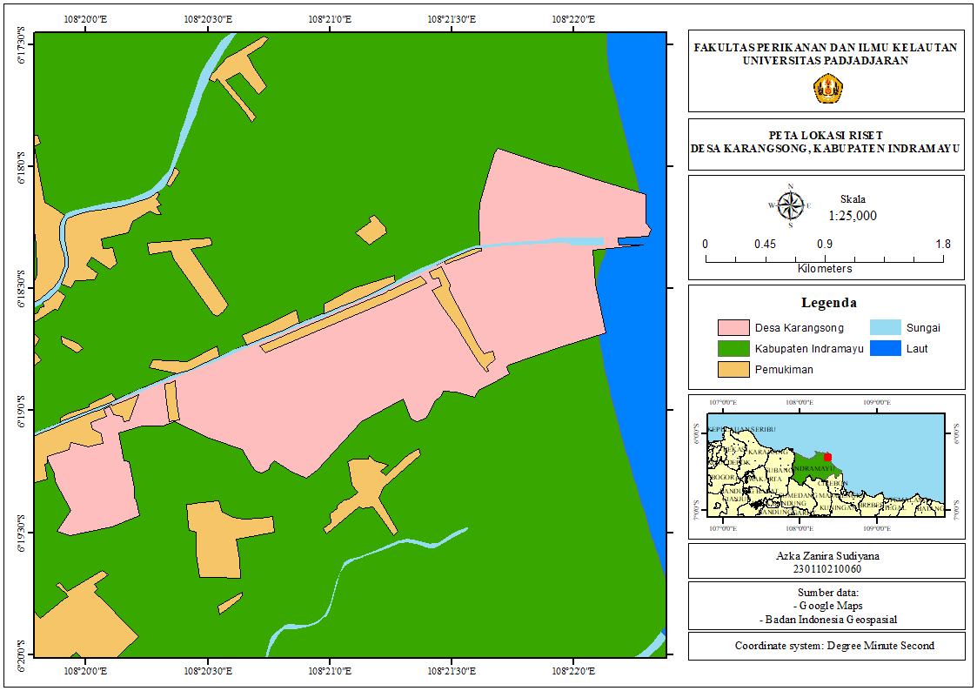
Figure 1. Map of Research Location
The research sample was determined using a purposive sampling technique with a minimum of 30 crew members (ABK) as heads of households. The research also applied an expert judgment technique through interviews with key informants from local government, village government, Joint Business Group (KUB) members, Fish Auction Place (TPI) managers, and individual fishermen representatives.
Data analysis used quantitative and qualitative descriptive approaches. Quantitative data from questionnaires was analyzed using a Likert scale to measure respondents' perceptions of financial capital and its variables. The final calculation was done with the following formula:
$$\%=\frac{TS}{X_{max}}×100\%$$
Based on the calculation, the percentage score interpretation criteria were derived according to the intervals in Table 1.
Table 1. Percentage Score Interpretation Criteria
Interval | Criteria
0% - 19,99% | Very Poor
20% - 39,99% | Poor
40% - 59,99% | Moderate
60% - 79,99% | Good
80% - 100% | Very Good
Qualitative data from interviews was analysed using Miles & Huberman's interactive model in Sugiyono (2018), including data collection, data reduction, data presentation, and conclusion drawing. Data validity was ensured through source triangulation to ensure the validity and dependability of research results.
3. results and discussion
3.1 Profile of Karangsong Village

The research was conducted in Karangsong Village, Indramayu District, Indramayu Regency, West Java Province. Geographically, Indramayu Regency is located between 107° 52' - 108° 36' East Longitude and 6° 15' - 6° 40' South Latitude. The Karangsong Village area has climate characteristics with annual rainfall of 200 mm/year and an average air temperature reaching 29°C. Karangsong Village has the following boundaries:
- North : Pabean Udik Village
- South : Tambak Village
- West : Paoman Urban Village
- East : Java Sea
Karangsong Village has an area of 410 Ha. It is located at an altitude of 0.5 meters above sea level, with flat topography. The land in the Karangsong Village area is designated for:
- Roads : 3,00 Ha
- Emerging Land : 20 Ha
- Public Buildings : 1,6 Ha
- Ponds/Aquaculture : 270 Ha
- Settlements/Residential Areas : 40.500 Ha
- Green Belt (Mangrove Tourism) : 30 Ha
- Cemetery : 3 Ha
The distance from the center of Karangsong Village Government activities is quite strategic, with the following orbital distances:
- Distance from the Sub-District Government Center : 3,00 Km
- Distance from the Admin City Government Center : 3,00 Km
- Distance from the Regency Government Center : 3,5 Km
The coastal area of Indramayu District, especially Karangsong Village, has tremendous potential in the marine and fisheries sector. The Fish Auction Place (TPI) in this village is recorded as the largest in Java Island in terms of marine product production. Fishing activities carried out by fishermen play a significant role in determining the quantity of fishery production, which in turn contributes to increasing community income (Hernawati et al. 2018). The geographical characteristics of Karangsong Village are marked by a pond area reaching 270 Ha, indicating the dominance of the fisheries sector in the local economic structure. In addition, Karangsong Village is a coastal area that has a well-maintained mangrove rehabilitation area (Purnamasari et al. 2015). The existence of a 30 Ha green belt designated for mangrove tourism shows the community's commitment to preserving coastal ecosystems through environmental rehabilitation and conservation efforts.
3.2 Monograph of Karangsong Village
A village monograph is a collection of data systematically and integrally compiled by the village government. This data includes general data containing social, economic, demographic, educational, socio-cultural, territorial data, as well as data on members of village government administrators. The population composition consists of gender, occupational composition, and education. The following is an explanation of the population composition in Karangsong Village, Indramayu District, Indramayu Regency. Table 2 shows the monograph of Karangsong Village with compositions based on gender, occupation, and education level.
Table 2. Population Composition of Karangsong Village Based on Occupation
Monograph | Composition | Number (People) | Persentase (%)
Gender | Male | 3.082 | 51,08
Gender | Female | 2.952 | 48,92
Occupation | Civil Servants | 98 | 1,62
Occupation | Military/Police | 8 | 0,13
Occupation | Retirees | 8 | 0,13
Occupation | Private Sector | 127 | 2,10
Occupation | Small Industries | 20 | 0,33
Occupation | Traders | 987 | 16,36
Occupation | Fishermen | 1805 | 29,91
Occupation | Farmers | 130 | 2,15
Occupation | Farm Laborers | 357 | 5,92
Occupation | Students (School) | 1891 | 31,34
Occupation | Students (University) | 57 | 0,94
Occupation | Ohers | 546 | 9,05
Education Level | Completed Kindergarten | 137 | 13,88
Education Level | Completed Elementary School | 422 | 42,76
Education Level | Completed Junior High School | 207 | 20,97
Education Level | Completed Senior High School | 122 | 12,36
Education Level | Higher Education | 99 | 10,03
Source: Karangsong Village Data 2024
The difference in the number of individuals by gender allows for an in-depth analysis of the social and demographic dynamics of a community. The population composition in Karangsong Village, Indramayu District, shows a total population of 6,034 people, with 3,082 people or 51.08% being male and 2,952 people or 48.92% being female. This illustrates that the male population dominates, with a slightly larger number compared to the female population. This male dominance has important implications for social dynamics in the fishing community.
Occupation refers to the work carried out by the community every day to meet their daily needs. This also has implications for community efforts and activities in sustainable livelihoods. The occupational composition of Karangsong Village is dominated by students (31.34%) and fishermen (29.91%). The fisheries sector is central to the village economy, as can be seen from the large percentage of fishermen, which accounts for almost a third of the total population of Karangsong Village. The percentage of traders (16.36%) indicates significant informal economic activity. Formal workforce sectors such as Civil Servants (1.62%), Military/Police (0.13%), and Retirees (0.13%), while informal sectors include private sector (2.10%), small industry (0.33%), farmers (2.15%), and farm laborers (5.92%). Other groups account for 9.05%. With a relatively small number of university students (0.94%), this reflects a still limited level of higher education.
The education level of the community in Karangsong Village is dominated by basic education levels. The data shows that the majority of the population, namely 422 people (42.76%), have completed education at the Elementary School level or equivalent. This figure illustrates that almost half of the population only has basic education as their highest level of education. The junior high school or equivalent level occupies the second position with 207 people (20.97%). Kindergarten graduates account for 137 people (13.88%). Residents who have completed senior high school or equivalent education are recorded at 122 people (12.36%). The number of residents who have pursued higher education, which is the lowest percentage, is 99 people (10.03%). This figure shows that access to or interest in higher education is still relatively limited among the people of Karangsong Village. Overall, there is a pattern of decreasing population numbers with increasing levels of education. This pattern may depict several factors, such as limited access to education, economic factors, or community preferences in pursuing formal education.
3.3 Respondent Characteristics
The measured respondent characteristics included age, education level, and boat ownership status. The total number of respondents obtained was 38 people. Based on the observation results, the respondent characteristics can be seen in Table 3.
Table 3. Respondent Distribution Based on Characteristics
Respondent Characteristics | Variable | Number (People) | Percentage (%)
Age (Years) | <25 | 4 | 10,53
Age (Years) | 25-35 | 22 | 57,89
Age (Years) | 36-45 | 7 | 18,42
Age (Years) | 46-55 | 3 | 7,89
Age (Years) | >55 | 2 | 5,26
Education Level | Elementary School | 22 | 57,89
Education Level | Junior High School | 11 | 28,95
Education Level | Senior High School | 5 | 13,16
Boat Ownerships Status | Crew Member | 33 | 86,84
Boat Ownerships Status | Boat Owner | 5 | 13,16
Fishermen's age has a significant influence on physical ability, experience, and technology adoption in fishing activities (Wahyudin 2011). The age characteristics of fishermen respondents in Karangsong Village are dominated by the productive age group, with the majority in the age range of 25-35 years (57.89%), followed by the 36-45 years group (18.42%), reflecting fishermen with optimal physical abilities, thus enabling more efficient and productive fishing operations. As many as 10.53% of respondents are under 25 years old. The age groups of 46-55 years and over 55 years at 7.89% and 5.26% respectively indicate the presence of experienced fishermen who can transfer traditional knowledge about fishing locations, navigation techniques, and weather predictions to younger fishermen.
Education influences fishermen's ability to adopt technology, access information, and manage fishery resources sustainably. Education level also affects the mindset and decision-making of fishermen in facing various socio-economic changes (Satria 2015). The education level of fishermen respondents in Karangsong Village shows that the majority (57.89%) have an elementary school education level, 28.95% completed junior high school, and only 13.16% reached senior high school level. This data illustrates that most fishermen (86.84%) have an education level below senior high school, reflecting challenges in community capacity development, particularly in the adoption of modern technology and sustainable fishery resource management.
Boat ownership status determines the position and role of fishermen in fishing activities and influences income distribution in capture fishery businesses (Zahri et al. 2025). Boat ownership status among fishermen respondents shows that the majority (86.84%) are Crew Members (ABK) working on boats sized >25 GT with fishing trips lasting 5-7 months. Only 13.16% of respondents are boat owners, with relatively small boat sizes (1-5 GT). This reflects that ABK fishermen face limited access to income control despite working on large-sized boats.
3.4 Financial Capital
Stable finances are the main foundation in building the economic resilience of fishermen households (Ellis 2000). Financial capital encompasses various financial resources that communities can use to achieve their livelihood goals, including income, investments, and access to loans or credit. Analysis results of the financial capital of Karangsong Village in Figure 2 and Table 4 show moderate results with a total average value of 2.72 (54.4%).
Table 4. Financial Capital Condition of Karangsong Village Fishermen
No | Financial Capital | Average | Percentage (%) | Description
1 | Community Income | 3,47 | 69,47 | Good
2 | Investment | 1,74 | 34,74 | Poor
3 | Access to Debt | 3,33 | 66,58 | Good
 | Total Average | 2,72 | 54,4 | Moderate

Figure 2. Financial Capital Diagram of Karangsong Village Fishermen
Community income achieved the highest value with a score of 3.47 (69.47%) in the good category, showing adequate ability to generate income from fisheries and marine activities. The fishing community develops income diversification through alternative jobs such as trading, part-time farming, and the tourism sector to overcome income uncertainty due to natural factors. The agricultural land ownership structure shows that the majority of farmer households (1,316 households) own less than 0.5 hectares of land, with 602 households owning no land at all. The existence of a 270-hectare pond area becomes a potential alternative source of income. Table 5 shows agricultural land ownership by the Karangsong Village community.
Table 5. Agricultural Land Ownership of Karangsong Village Community
No | Land Ownership | Amount
1 | Households Owning Agricultural Land | -
2 | Not Owning | 602 Households
3 | Owning Less Than 0,5 Ha | 1.316 Households
4 | Owning 0,5-1,0 Ha | 74 Households
5 | Owning More Than 1,0 Ha | 14 Households
6 | Fields | 24.750 Ha
7 | Dry Fields, Ponds | 270 Ha
Source: Karangsong Village Data 2024
Access to debt shows a good value with a score of 3.33 (66.58%), reflecting ease of access to both formal and informal financing sources. Loan mechanisms include informal systems with boat owners (with deductions from the next period's salary), advance salary withdrawal systems, and access to fishermen's cooperatives with low interest rates.
However, the investment aspect shows a poor value with a score of 1.74 (34.74%), indicating low ability to allocate income for long-term investments. Despite having savings, the amounts are relatively small and prioritized for daily needs or reserves when not going to sea. The low level of investment is related to limited access to formal financial institutions and low financial literacy, which potentially hampers long-term economic capacity improvement.
4. Conclusion
Analysis of the financial capital of Karangsong Village fishermen reveals weaknesses in the form of minimal savings, low investment, and limited access to formal financial institutions. To support sustainable livelihoods, strategies are needed to improve financial literacy, facilitate access to microfinance, diversify non-fishery businesses, and educate about the importance of saving for long-term investments. Strengthening this financial aspect will increase the economic resilience of fishermen in facing seasonal income uncertainty, thus ensuring the welfare and sustainability of fishermen's lives.

Disclaimer (Artificial intelligence)
Option 1:
Author(s) hereby declare that NO generative AI technologies such as Large Language Models (ChatGPT, COPILOT, etc.) and text-to-image generators have been used during the writing or editing of this manuscript.
Option 2:
Author(s) hereby declare that generative AI technologies such as Large Language Models, etc. have been used during the writing or editing of manuscripts. This explanation will include the name, version, model, and source of the generative AI technology and as well as all input prompts provided to the generative AI technology
Details of the AI usage are given below:
1.
2.
3.

References

Arwani, Z. 2021. Community Empowerment through Ecotourism Development in Karangsong Village, Indramayu, West Java. Jurnal Kommunity Online, 2 (1): 63-72.
Central Statistics Agency of Indramayu Regency. (2015). Indramayu Regency in Figures 2015. Central Statistics Agency of Indramayu Regency, Indramayu.
Ellis, F. 2000. Rural Livelihood and Diversity in Developing Countries. Oxford University Press, London (UK).
Hernawati, D. Chaidir, D.M., Meylani, V., and Putra, R. (2018). Potential Catch Yields and Abundance of Fish Resources in Karangsong Landing, Indramayu. Bioedusiana, 3 (2).
Purnamasari, R., Suprapto, D., Purwanti, F. (2015). Mangrove Ecotourism Development in Karangsong Village, Indramayu Regency. Diponegoro Journal of Maquares, 49 (4): 146-154.
Satria, A. (2015). Introduction to Coastal Community Sociology. Obor Indonesia Library Foundation.
Sugiyono, (2018). Qualitative and Quantitative Research Methods and R&D. Alfabeta, Bandung.
Fishermen's Social Issues: Efforts to Formulate Vulnerability Indicators Related to Climate Change Disasters. Indonesian Society Journal, 42 (2).
Wahyudin, Y. (2011). Characteristics of Coastal and Marine Resources in the Palabuhanratu Bay Area, Sukabumi Regency, Java. Bonorowo Wetlands, 1 (1): 19-32.
Zahri, S., Wasiyem, S., Fitri, N., Rangkuti, R. S., Rahmayani, & Maharani, M. N. (2025). Social Structure of Coastal Fishing Communities in Pantai Cermin District, Serdang Bedagai Regency. Antigen: Journal of Public Health and Nutritional Sciences, 3(1).

Richmond, L., Dumouchel, R., Pontarelli, H., Casali, L., Smith, W., Gillick, K., ... & Suarez, A. (2019). Fishing community sustainability planning: a roadmap and examples from the California coast. Sustainability, 11(7), 1904.

Richmond, L., & Casali, L. (2022). The role of social capital in fishing community sustainability: Spiraling down and up in a rural California port. Marine Policy, 137, 104934.

Alieva, D., Usmonova, G., Shadmanov, S., & Aktamov, S. (2023). Fishery culture, sustainable resources usage and transformations needed for local community development: the case of Aral Sea. Frontiers in Marine Science, 10, 1285618.

Hong, S. K., & Grydehøj, A. (2022). Sustainable island communities and fishing villages in South Korea: Challenges, opportunities and limitations. Sustainability, 14(24), 16657.

