Justification for The Inclusion of Computer Awareness in India Secondary School Curriculum

ABSTRACT

Objective: The present study is about computer awareness of a Krishna District in Andhra Pradesh limited to 160 students of IX class by using Normative Survey.
Quantitative Method: The questionnaire consisting of 40 items are collected by reading every question carefully and Statistical readings (mean, S.D. and C.R) were recorded considering few Hypotheses including inferences difference in the computer awareness of boys and girls, rural and urban and of government and private secondary school students respectively.
Results: The research found no significant difference in the computer awareness of boys and girls yet private school students are holding high awareness of computers than government school students. Similarly, the urban students have more knowledge towards computer awareness than rural students due to their exposure, facilities available, quality of teaching and learning activities etc.
Conclusion: The research found that the Secondary school students posses an average level (>50%) of computer awareness which need to be enhanced as many of the schools being equipped with computers, good lab facility, committed teachers, as to obtain latest information readily, as to make success the teaching learning process in daily life.

Keywords: Computer Awareness, Hypothesis, Secondary School, governance and social development

INTRODUCTION

The computer, a modern complex machine, now accomplishes things we never thought possible is an electronic device defined as a machine, which processes the given data to arrive at useful result. Computer is one of the creative inventions made in the human history which have been playing a significant role in every walk of human life such as teaching/education and social development, governance and social development, banking and business transactions, health sector, scientific investigations, space technology, management, payroll accounting, printing technology, telecommunications, library sciences, traffic control, travel and reservations, research and development, international networking, deference security and policing, etc ¹⁻⁵. That is why it is mandatory to have computer knowledge for sure. That is where the role of computer Education Schools comes in.

During the last 20 years, enlighten countries are looking towards increasing the strength of human thinking with the machine speed and power of the computer ⁶⁻⁷. The basis for many of the transformations that take place in the modern world is associated with the much more rapid flow of information and greater capacity for storage in computer. The predominance of computer in society indicates that students should have some exposure to computers to cope with the technological changes and informatics society of the future.

Computer technology in so short a span of time, it has managed to change our lives and the way we live. Life before the computer was slow, time-consuming and limited. With the computer technology, the opportunities for personal and professional improvement are limitless. Internet has transformed the way 21st century people way we live. The internet is probably the most important innovation in the field of communication. Computers are capable of automation, provided they are programmed correctly. Computers can communicate with other computers and can receive and send data in various forms like text, sound, video, graphics, etc.

The World is becoming more and faster paced. Technology has increased so much in the last few years and this trend looks like it will continue. It is so important to keep up with these emerging technologies and the skills that are required to properly use these new gadgets. As anybody can attest to, the nature of our working environments have changed drastically over the last twenty years. While every generation has different work skills that are emphasized, it's been unprecedented how quickly computer skills have gained prominence in recent years.

In view of the increasing importance of the computer, students who are the future citizens of the nation and will be employed in various walks of life cannot afford to keep themselves from this potential medium. The government has, therefore, decided to provide computer education to all the students. The Government of India launched many pilot projects to provide computer awareness and also learning through computers.

Computer Education needs to become a fundamental curriculum in schools and colleges worldwide. The central and state governments have taken tremendous efforts to implement ICT in the process of teaching and learning. The state government has introduced a computer course in the secondary schools. The success of any new programme on computer technology depends upon the support of students, parents, teachers and management. We have chosen this important topic aligned with the need of current requirement as all the fields with which we are supported in our life require knowledge of Computer. This study will be helpful not only for the teachers but also for the student who are the future of our country.

USES OF COMPUTERS IN SCHOOL

The use of computers in education is in its infancy. The power and usefulness of this popular tool are mainly due to its characteristics like speed, accuracy, diligence, versatility, power of remembering, etc which is bringing some exciting innovations to education like ⁸⁻¹¹:

- Computer as an educational aid to improve learner’s skills in academics.
- Computers have revolutionized the admission and examination system.
- Computers classify children by abilities and difficulties.
- Computers help in preparing time table, schedules etc.
- Computers allocate learning resources to individuals and groups.
- Computers maintain progress cards and preserve them confidentially.
- Computers engage the students in tutorial interaction and dialogue.
- Communication is done through emails, instant messaging or voice over.
- Computer helps children to do less memorizing of facts and information.

That is why it is mandatory to have computer knowledge for sure. That is where the role of computer education schools comes in. They can provide knowledge that is vital to conducting business, or just functioning day-to-day in our modern society.

SCOPE OF THE STUDY

The present study is confined to the computer awareness of secondary school students of IX class to a particular geographical area of Krishna District to facilitate appropriate sample selection and to avoid bias and prejudice. The sample is limited to 160 students only ¹²⁻¹⁴. After deciding about the sampling method, the population was divided into different strata. Before giving the tool to the students, the researcher explained the purpose of present investigation. Directions given on the cover sheet were read out to the students and specific instructions were given.

40 questions are being framed covering their school problems, having multiple choices and their answers are being collected as A, B, C and D from the students of study by reading every question carefully and students to respondents their response wanted without hesitation. After completion of the tool by the sample, they were collected to put to statistical treatment and variables which are chosen for this study is shown in Table 1 and Fig. 1.

Table 1: List of Variables Taken and Selected for the Study.
S N | VARIABLES CHOSEN | VARIABLE SELECTED
1. | Gender | Boy / Girl
2. | Location | Rural / Urban
3. | Management of the School | Government / Private
4. | Type of Institution | Aided / Unaided

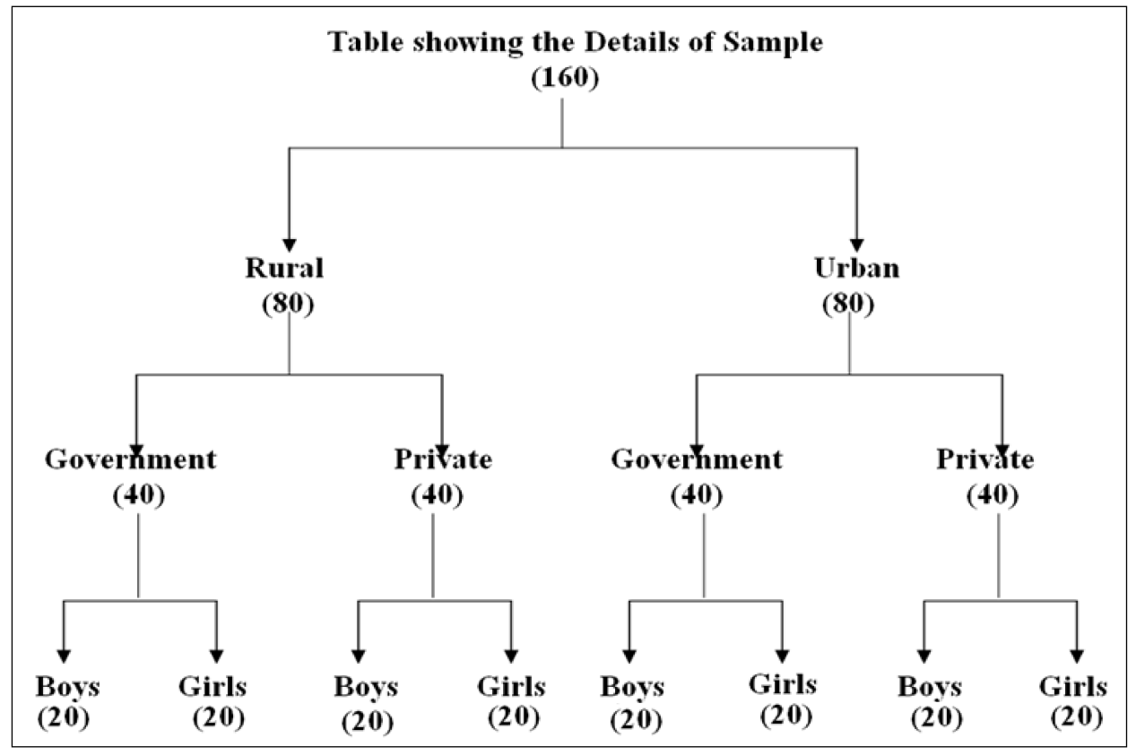
Fig. 1: Sampling Population Design taken for Study.

METHOD USED FOR THE STUDY

For the Present study Normative Survey of research was been taken which is useful in formulating hypotheses by the questionnaire taking in the consideration of various purposes and Peculiarity are the sampled which are objective and research-oriented. The questionnaire consisting of 40 items having Maximum possible score is ‘40’ and minimum possible score is ‘0’ to measure the computer awareness of secondary school students. Statistical procedures used for the study include Arithmetic Mean, Standard Deviation and Critical Ration respectively. For the present study the following hypotheses were framed and analyzed.

- Hypothesis 1 - Secondary schools students do not posses high level of computer awareness.
- Hypothesis 2 - There is no significant difference in the computer awareness of boys and girls of secondary school students.
- Hypothesis 3 - There is no significant difference in the computer awareness of rural and urban secondary school students.
- Hypothesis 4 - There is no significant difference in the computer awareness of government and private secondary school students.

Result & Discussion

The first step in analyzing the data is a critical examination of the assembled data which depends upon the respondent or the observer or the interviewer coding. After collecting the data from one hundred and sixty students through a research instruments, the analysis was performed keeping in view the objectives framed, hypotheses formulated, data collected, tool used etc of which the highest score or lowest score one can get is ‘26’ and ‘9’.

- Hypothesis 1 - To test the validity of the above hypothesis mean, S.D. and C.R. were computed and the results are tabulated as shown in Table 2.

Table 2: Level of Computer Awareness possessed by the Whole Sample.
Sample | Sample Size | Mean | Standard Deviation
Whole | 160 | 17.55 | 3.5

As per the mean value of the whole sample it was found that the computer awareness was at an average level in the secondary school students. As per the S.D. value of the whole sample, it was observed that the dispersion of score from the mean scores is moderate.

- Hypothesis 2 - To test the validity of the above hypothesis mean, S.D. and C.R. were computed and the results are tabulated as shown in Table 3.

Table 3: Comparison of Computer Awareness in Rural & Urban Schools.
S N | Variable | Sample  Size | Mean | S.D. | Difference  Between Means | S.E.D | C.R
1. | Rural | 80 | 17.93 | 3.97 | 0.77 | 0.55 | 2.40*
2. | Urban | 80 | 17.16 | 3.12 | 0.77 | 0.55 | 2.40*
*Significant at 0.05 levels*

From the above table, it is clear that there is a significant difference between the level of computer awareness possessed by rural and urban students. Both the sub-samples are with average computer awareness. The hypothesis that “There is no significant difference in the level of computer awareness possessed by urban and rural secondary school students” can be rejected.

- Hypothesis 3 - The validity of hypothesis 3 was tested by necessary calculations and the results are tabulated as shown in Table 4.

Table 4: Comparison of Computer Awareness of Pvt. & Govt. School.
S N | Variable | Sample Size | Mean | S.D. | Difference  Between Means | S.E.D | C.R
1. | Government | 80 | 16.92 | 3.74 | 1.25 | 0.543 | 2.31*
2. | Private | 80 | 18.17 | 3.12 | 1.25 | 0.543 | 2.31*
*Significant at 0.05 level*

It is evident from the table, that there is a significant difference in the level of computer awareness possessed by the students studying in private and government schools. The students studying in private schools are holding high computer awareness than that those of Government schools, but both the sub samples are with average computer awareness. The hypothesis that “There is no significant difference in the level of computer awareness possessed by the students of private and government secondary schools” can be rejected.

- Hypothesis 4 - The data of the sub-samples are computed to test the validity of the hypothesis and the results are tabulated as shown in Table 5.

Table 5: Comparison of Computer Awareness of Boys & Girls of School.
S N | Variable | Sample size | Mean | S.D. | Difference  Between Means | S.E.D | C.R
1. | Boys | 80 | 16.55 | 3.47 | 2 | 0.53 | 1.77*
2. | Girls | 80 | 18.55 | 3.24 | 2 | 0.53 | 1.77*
* Not Significant at 0.05 level*

It is evident from the table, that there is no significant difference in the level of computer awareness possessed by the boys and girls of secondary school students. The boy students are holding high computer awareness than that of girl students, but both the sub samples are with average computer awareness. The hypothesis that “There is no significant difference in the level of computer awareness possessed by boys and girls of secondary school students” can be accepted.

CONCLUSION

In present times everyone above 18 has to be preferably computer literate. A couple of weeks of training are more than enough. To an average educated, English speaking Indian, computer literacy is proving to be a major asset. Today a computer professional is the most sought after commodity here and abroad. Before proposing hypothesis, let's understand what has, in the first place, lead us to believe that every Indian kid will suffer and be left behind unless he or she is computer literate.

The research found that there is no significant difference in the computer awareness of boys and girls seen but private school students are holding high awareness of computers than government school students as they hold a better knowledge towards computers by having Computer laboratory, faculty etc which give them more advantage than Government school students. Similarly, the urban students have been holding more knowledge towards computer awareness than rural students due to their exposure, facilities available, quality of teaching and learning activities.

The research found that the Secondary school students posses an average level of computer awareness which should need to be enhanced as many of the schools are equipped with computers, good lab facility, committed teachers, as to obtain latest information readily, as to make success the teaching learning process in daily life.

FURTHER SCOPE OF RESEARCH

The present study brings to light new areas to be studied by the other researchers. The areas and variables which are not covered by this study may be put to test to enlighten the other associated factors of computer awareness like to extend various levels of education, like tertiary level of education large samples, to find out the role of parents, teachers and educational administrators in promoting computer awareness among the students, to identify teacher’s influence in computer awareness and relationship between computer awareness and academic achievement etc.

Disclaimer (Artificial intelligence)

Author(s) hereby declare that NO generative AI technologies such as Large Language Models (ChatGPT, COPILOT, etc.) and text-to-image generators have been used during the writing or editing of this manuscript.

REFERENCES

- Antony Stella V etal. Effectiveness of Computer Assisted Instruction with Special Reference to Under Achievers. Fifth Survey of Educational Research, New Delhi: NCERT. 1992, Vol. 1(1); Pg. 1388 - 1396.
- Arkin E. I. Teachers' attitudes towards computer technology use in vocabulary instruction. Doctoral Dissertation, Bilken University. 2003.
- A. Ramakrishna. S. Computer Education. Neelkamal Publications Pvt. Ltd. 2005.
- Nortons P. Introduction to Computers. Tata Mc Graw Hill Publishing Company Limited. 2006, Vol. 4(1); Pg. 5-90.
- Sheela etal. Knowledge of Information and Communication Technology (ICT) and Attitude towards Teaching ICT among Teacher Educators. Experiments in Education, Chennai: The SITU Council of Educational Research, 2006, Vol. 5(1); Pg. 5 - 11.
- Vijaya lakshmi B etal. Computer Education in High Schools. Edutracks Neelkamal Publiations. 2006, Vol. 5(5); Pg. 29 - 33.
- Rajasekhar S. Higher Secondary School Teachers Computer Knowledge and their Attitude towards Computer. 'Journal of All India Association for Educational Research. 2008, Vol 5(2); Pg. 98 - 110.
- TCO T. Pre-service Teachers Attitudes towards Computer Use: A Singapore Survey. Australasian Journal of Educational Technology. 2008, Vol. 24(4); Pg. 413-424.
- Mubashrah Jamil. Developing Curriculum of Computer Education for Prospective Teachers. International Journal of Social Science and Education. 2012, Vol. 2(2); Pg: 110 - 122.
- Santhoshini K. Awareness of Computer Knowledge among Xi Standard Students in Coimbatore District. I-manager’s Journal on School Educational Technology. 2016, Vol. 11(4); Pg: 18-25.
- Reena. Computer Awareness among Prospective Secondary School Teachers with Respect to Gender and Academic Stream. Scholarly Research Journal for Humanity Science & English Language. 2018, Vol. 6(30); Pg: 8378-8385.
- Dr. Vemula Muttu. Computer Awareness among the Secondary School Students” – A Study. International Journal of Humanities and Social Science Invention. 2020, Vol. 9(8); Pg: 11-19.
- Anjali Gupta. Study on Computer Awareness amongst the Secondary School Teachers of Ghaziabad Region Schools in Relation to Art and Science Faculties of Urban Area. Advance and Applied Research. Chapter ID: NSP/ICAAR-2023/A-32, Pg: 153-157.
- Atiqa Sirwal. Computer Awareness of Secondary School Teachers of District Kishtwar: A Study. Journal of Current Science & Humanities, 2024, Vol. 12(3); Pg: 15-23.

