Benchmarking Global Institutional AI Policies for Teaching and Learning: A Comparative Analysis for Higher Education Governance Enhancement

.
ABSTRACT

This study benchmarks global institutional artificial intelligence (AI) policies for teaching and learning in higher education and uses these comparisons to improve an existing AI policy at a university in Northern Mindanao, Philippines. Although AI policies are spreading rapidly in higher education, few studies have systematically compared Philippine policies with global standards, particularly in teaching and learning.
The study used qualitative benchmarking and document analysis. It reviewed AI policies and official guidance from ten top-ranked universities, chosen for their rankings, regional diversity, and public access. The analysis followed the OECD AI Principles and the NIST AI Risk Management Framework, focusing on ethics, governance, and risk management.
The findings show that institutions share similar ethical commitments, especially to human-centered AI, academic integrity, transparency, and responsible use. However, global institutions have more advanced governance by putting ethical principles into practice with formal risk assessments, oversight, and regular policy reviews. In contrast, the local policy is mostly based on principles.
The study concludes that while ethical standards for AI policy are becoming more global, the level of governance depends on each institution’s resources and regulations. It suggests a step-by-step policy improvement plan, starting with clear ethics, then adding risk mapping, governance structures, and ongoing review. The benchmarking framework offers a practical guide for universities aiming to improve AI governance in teaching and learning.

Keywords: Institutional AI policy, teaching and learning, higher education, academic integrity, transparency

1. INTRODUCTION

Generative artificial intelligence (GenAI) is changing higher education worldwide by influencing how teaching, learning, assessment, and academic work are carried out (Holmes et al., 2021; Tlili et al., 2023). Many universities are using artificial intelligence (AI) tools to make instruction more efficient, personalize learning, and expand access to knowledge (Zawacki-Richter et al., 2019). Still, researchers and policymakers have raised concerns about GenAI, including academic integrity, data privacy, transparency, algorithmic bias, and reduced human involvement in educational decisions (Nguyen et al., 2022). Critical scholars warn that artificial intelligence in education should not be seen as a neutral or unavoidable technology. Instead, it is a social and technical change that affects power, professional judgment, and accountability in education (Selwyn, 2019).
In response, international organizations and leading universities have developed AI governance frameworks that promote ethical, human-centered, transparent, and responsible use of AI in teaching and learning (OECD, 2019; UNESCO, 2021; Oncioiu & Bularca, 2025).
In the Philippines, higher education institutions are adopting AI technologies as part of national digital transformation efforts and new AI strategies in education (Co, 2025). While current regulations, especially those on data protection and quality assurance, offer basic safeguards, they do not provide detailed guidance for managing generative AI in teaching (Republic Act No. 10173, 2012; Villanueva, 2025; Tupaz, Tabeta, & Unarce, 2025). Because of this, AI policies in universities around the world differ greatly, as each institution interprets international AI standards and creates its own approach (Stracke et al., 2025; Parker, 2025; Oncioiu & Bularca, 2025). This lack of consistency highlights the need for better alignment with global AI governance standards and more benchmarking between institutions (UNESCO, 2023).
Locally, a private university in Northern Mindanao has taken the initiative by approving a Policy on the Ethical and Responsible Use of Generative Artificial Intelligence (Xavier University – Ateneo de Cagayan, 2024). The policy sets out key ethical principles, such as promoting the common good, academic integrity, inclusivity, privacy and data protection, accountability, and human oversight. It also lists prohibited practices like plagiarism, disinformation, and privacy violations, which are common pillars in higher education AI policy discussions (UNESCO, 2021, Nguyen et. al., 2022). While this policy provides a strong ethical base and shows the university’s commitment to responsible AI use, it mainly offers general guidance and does not clearly outline governance mechanisms, risk management steps, or specific implementation guidelines for teaching and learning. This gap is also seen in other university AI policies (Barus et al., 2025).
Although the institution has an approved policy on the ethical and responsible use of generative AI, there has not been a systematic review of how well this policy matches international AI governance frameworks and best practices in higher education (An et al., 2025; Barus et al., 2025). The policy also does not clearly explain how ethical principles are put into practice through governance structures, risk assessment, implementation steps, and ongoing policy review. These areas are highlighted in recent studies on GenAI governance in higher education (Alfiras, Emran, & Mohamed, 2025). Because of this gap, the institution may struggle to keep its AI policy comprehensive, practical, and able to adapt to the fast-changing landscape of generative AI technologies (Azevedo et al., 2025).
This study uses Institutional Theory, which looks at how organizations adopt policies because of outside pressures, not just for technical reasons (DiMaggio & Powell, 1983). Institutional Theory points to three main types of pressure: normative, which comes from professional standards and shared academic values; coercive, which comes from laws, regulations, and formal requirements; and mimetic, which happens when institutions copy the practices of leading peers during uncertain times (DiMaggio & Powell, 1983). In higher education, these pressures help explain why universities are aligning their AI policies with global frameworks and well-known institutions, though there are still differences in how detailed and mature these policies are (An et al., 2025).
To address this gap, the study uses a benchmarking approach to improve the university’s AI policy for teaching and learning, following international guidance on benchmarking in technology-enhanced higher education. The study compares the local policy with AI governance policies from top global universities, using internationally recognized frameworks, to find strengths, weaknesses, and areas for enhancement. The scope of the study is limited to institutional-level AI policies for teaching and learning at a higher education institution in Northern Mindanao. This focus matches recent calls to ground GenAI governance in real institutional settings instead of broad national strategies (An et al., 2025).This approach is important because generative AI is becoming more common in teaching, and there is a need for AI governance frameworks that are both locally relevant and globally aligned to support responsible innovation in Philippine higher education (UNESCO IESALC, 2025; Co, 2025).

2. methodology

2.1 Research Design

This study used qualitative benchmarking and document analysis to examine institutional artificial intelligence (AI) policies for teaching and learning in higher education. The normative and comparative design identified policy strengths, gaps, and opportunities for improvement by comparing the Northern Mindanao institutional AI policy with global best practices. The study focused on institution-level policy content and governance mechanisms, rather than individual behavior or technical AI system performance, in line with qualitative policy analysis methods.

2.2 Unit of Analysis

The unit of analysis was the institution-level AI policy or equivalent formally endorsed guidance for AI use in teaching and learning. Policies limited to individual courses, departments, pilot programs, or informal advisories were excluded to maintain consistency and comparability across cases.

2.3 Sampling Frame and Selection Strategy

The sampling frame included universities from the QS World University Rankings 2025 or 2026 (overall global rankings). The QS rankings served only as a tool for sampling and benchmarking, not as an analytical variable, because they are widely recognized and use several indicators such as academic reputation, employer reputation, faculty-student ratio, research impact, and internationalization (QS Quacquarelli Symonds, 2025).
From this list, the study chose the top ten global universities that met all the set inclusion criteria. The selection process took place in several stages to make sure it was transparent, rigorous, and could be repeated.

2.4 Global Ranking Criterion

To qualify for initial consideration, a university had to meet at least one of the following conditions:
- Appear within the global top 200 of the QS World University Rankings 2025 or 2026, or
- Appear within the top 20 universities of its respective QS regional ranking.
This dual criterion ensured representation of global leaders in higher education and included regionally prominent universities with strong capacity and influence. Using rankings this way aligns with previous research, which treats global rankings as a reference for institutional prominence rather than direct measures of quality or performance (Hazelkorn, 2015).

2.5 Regional Distribution Criterion

To reduce geographic bias and improve global representativeness, the study used a region-based selection strategy based on UNESCO’s regional groupings for education and higher education analysis, which are widely used in comparative education research to contextualize institutional diversity (UNESCO, 2015). The regions considered were:
- Africa
- Asia-Pacific
- Europe
- Latin America and the Caribbean
- North America
- Arab States / Middle East
The selection strategy required at least one university per region, where possible, and no more than three universities from any single region to prevent over-representation. If more universities in a region met all inclusion criteria than the allowed quota, the highest-ranked institutions were selected to ensure consistent benchmarking. If fewer eligible institutions were available, this limitation was documented and remaining slots were reallocated to regions with surplus candidates. This approach aligns with established practices in comparative higher education research that balance representativeness and analytical feasibility (Parry et al., 2021).

2.6 Publicly Available AI Policy Criterion

Universities could only be included in the final sample if they had an official, publicly available policy or formally approved guidance about using AI in teaching and learning. Eligible documents needed to:
- Discuss how AI is used in teaching, learning, assessment, or student work; and
- Include at least one of the following topics: academic integrity, generative AI tools, AI ethics, or AI-enabled learning technologies.
Accepted policies included institution-wide AI policies, academic integrity or teaching and learning policies with specific AI sections, or official guidance from recognized governance bodies like the provost’s office, academic senate, or teaching and learning center. Institutions were excluded if their AI-related content was only found in press releases, news updates, or informal web pages. Focusing only on formally approved and publicly available policy documents follows qualitative document analysis standards, which stress using authoritative texts that show institutional intent and governance instead of temporary communications (Cardno, 2021).

2.7 Final Selection of Benchmark Universities

Based on all criteria, the final benchmarking sample included the top ten global universities that met the ranking, regional distribution, and policy availability requirements.

Table 1. Top 10 Global Universities Selected for Benchmarking

Region | University | QS Status | Policy
North America | Massachusetts Institute of Technology | QS global top tier | MIT Guidance for Use of Generative AI Tools (2025)
North America | Harvard University | QS global top tier | Harvard University Guidelines for the Use of Generative AI  (Accessed 2026)
Europe | University of Oxford | QS global top tier | Guidance on Safe and Responsible Use of Generative AI Tools (2025)
Europe | Imperial College London | QS global top tier | Imperial College Generative AI Guidance (Accessed 2026)
Asia-Pacific | National University of Singapore | QS Asia leader | NUS Policy for Use of AI in Teaching and Learning (2024)
Asia-Pacific | University of Tokyo | QS Asia leader | Policy on the Use of AI Tools in Classes (2023)
North America | Columbia University | QS global top tier | Generative AI Policy (2026)
Oceania | Monash University | QS regional leader | Monash AI Policies and Guidelines (2025)
North America | University of British Columbia | QS global top tier | Guidelines for All Uses of GenAI in Teaching and Learning (Accessed 2026)
North America | University of California, Los Angeles | QS global top tier | UCLA Guiding Principles for Responsible Use (Accessed January 2026)

The institutional AI policy documents in Table 1 were collected from official university websites. They are publicly available and provide formally approved guidance on the use of artificial intelligence in teaching and learning at the time of analysis.
If there were several versions, the most recent one available during data collection was used.

2.8 Analytical Framework

Institutional AI policy documents were analyzed using two internationally recognized AI governance frameworks that address complementary dimensions of responsible artificial intelligence: the Organisation for Economic Co-operation and Development (OECD) AI Principles and the National Institute of Standards and Technology Artificial Intelligence Risk Management Framework (AI RMF).
The OECD AI Principles, adopted by OECD member and partner countries as the first intergovernmental standard on artificial intelligence, provide a normative framework for defining trustworthy and responsible AI. These principles emphasize five core areas: (1) human-centered values and fairness, (2) transparency and explainability, (3) robustness, safety, and security, (4) accountability, and (5) inclusive and sustainable societal benefit (OECD, 2019). For the purposes of this analysis, the OECD AI Principles served to evaluate whether institutional AI policies articulate clear ethical commitments and governance values regarding the use of generative AI in teaching and learning.
In addition to the ethical perspective, the NIST AI Risk Management Framework (AI RMF) offers a practical, operational approach for managing risks associated with AI systems throughout their lifecycle. Developed by the U.S. National Institute of Standards and Technology, the AI RMF assists organizations in identifying, assessing, mitigating, and governing AI-related risks in a structured manner (NIST, 2023). The framework is organized around four core functions: Map, Measure, Manage, and Govern. These functions collectively guide organizations in contextualizing AI use, evaluating potential risks, implementing mitigation strategies, and establishing oversight and continuous improvement mechanisms. In this analysis, the NIST AI RMF was applied to assess the extent to which institutional AI policies progress beyond ethical intent toward formal governance, risk assessment, and implementation mechanisms.
The OECD AI Principles and the NIST AI RMF together operationalized the benchmarking process by translating global ethical norms and risk governance expectations into concrete criteria for analyzing institutional AI policies in higher education.

2.9 Local Policy Document

The approved Policy on the Ethical and Responsible Use of Generative Artificial Intelligence of a Northern Mindanao university in focus served as the focal document for policy enhancement analysis (Xavier University - Ateneo de Cagayan, 2024). This policy was systematically compared with the AI policies and endorsed guidance of ten globally ranked universities to identify ethical alignment, governance gaps, and opportunities for improvement.

2.10 Ethical Considerations

The study relied exclusively on publicly available institutional policy documents and did not involve human participants, personal data, or identifiable information. As a result, formal ethical clearance was not required.

2.11 Data Analysis Procedure

The study used a structured qualitative document analysis and comparative benchmarking process, following established policy analysis methods (Cardno, 2021). The analysis took place in four main stages.
First, all institutional AI policy documents were collected, archived, and read in full to understand their scope, language, and intent. Only officially approved, institution-level documents about artificial intelligence in teaching and learning were included in the analysis.
Second, a deductive coding framework was created using two main sources: the OECD AI Principles and the NIST AI RMF. From these, the study identified categories such as human-centered values, academic integrity, accountability, inclusivity, robustness, risk mapping, risk mitigation, governance structures, and ongoing review mechanisms. These categories were used to compare policies across institutions.
Third, the researcher manually coded each policy document using a matrix-based qualitative comparison. Policy statements were examined to determine whether each analytical category was (a) explicitly addressed, (b) implicitly referenced, or (c) absent. Attention was given not only to the presence of ethical principles but also to whether these principles were operationalized through specific procedures, governance roles, or review mechanisms. Notes were kept to record how policy statements were interpreted and categorized using the OECD and NIST frameworks.
Fourth, the study compared findings across institutions to find common patterns, similarities, and differences. The results were then analyzed using Institutional Theory to explain why policies were similar or different, especially in terms of normative, mimetic, and coercive pressures.
All analysis was done manually using structured comparison tables and narrative summaries, not automated software, because there were only a few high-level policy documents. This method follows best practices in qualitative policy benchmarking and document analysis (Cardno, 2021).

2.12 Validity and Reliability

To improve analytical rigor and consistency, several validation strategies suited to qualitative document analysis were used. First, two internationally recognized frameworks, the OECD AI Principles and the NIST AI Risk Management Framework, were used for theoretical triangulation. This approach made sure that findings did not rely on just one analytical perspective.
Second, a standardized coding framework was used for all institutional documents. This reduced interpretive drift and improved internal consistency. Coding decisions followed clear definitions from the source frameworks, and analytic memos were kept to record interpretive judgments.
Third, cross-case comparison was used as a form of comparative validation. Patterns found in one institution were checked for similarities or differences in other cases. This approach made the conclusions more credible by relying on repeated patterns instead of single observations.
Finally, transparency was achieved by carefully documenting selection criteria, analytical steps, and how the frameworks were applied. This makes it possible for other researchers to replicate the study when examining institutional AI policies in higher education.

3. RESULTS AND DISCUSSION

This section presents the findings from the benchmarking analysis of institutional AI policies for teaching and learning. The study compared Northern Mindanao university’s approved policy with institution-level AI policies and guidance from ten globally recognized universities. Analysis used the OECD AI Principles to consider ethics, and the NIST AI RMF to assess risk governance. Institutional Theory, which includes normative, mimetic, and coercive pressures, helped explain why some policies are similar and others are different (OECD, 2019; NIST, 2023; DiMaggio & Powell, 1983).

3.1 Overview of Comparative Patterns

The analytical structure guiding the study is illustrated in table 2, which integrates ethical and risk governance dimensions into a unified benchmarking framework.

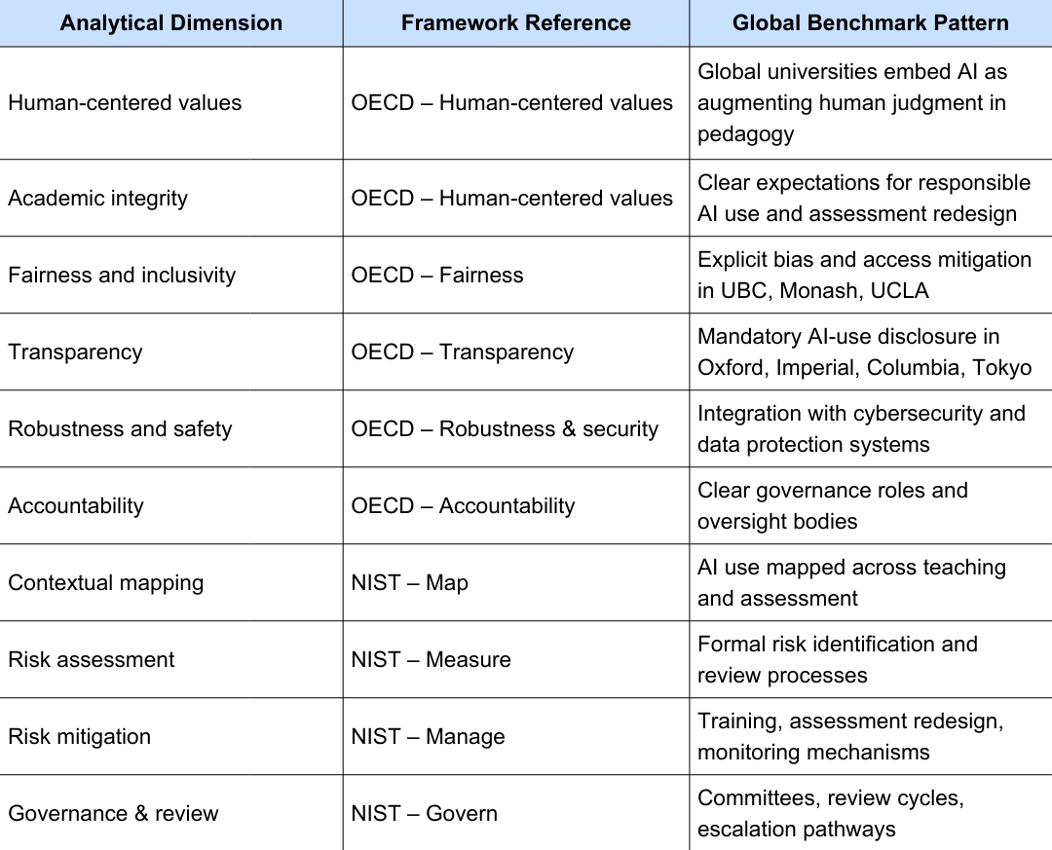

Table. 2. Analytical Framework for Benchmarking Global AI Policies in Teaching and Learning

Analysis of the benchmarked institutions revealed two distinct patterns. First, there was ethical convergence, characterized by consistent adoption of human-centered AI values, academic integrity principles, and transparency commitments. Second, there was variation in governance maturity, reflected in the uneven operationalization of these values into formal risk assessment, mitigation, and oversight mechanisms. These findings align with previous research indicating that early ethical adoption is often followed by slower development of governance structures in educational institutions (UNESCO, 2021; Zawacki-Richter et al., 2019; Williamson et al., 2020).

3.2 Ethical Alignment and Accountability: OECD-Based Findings

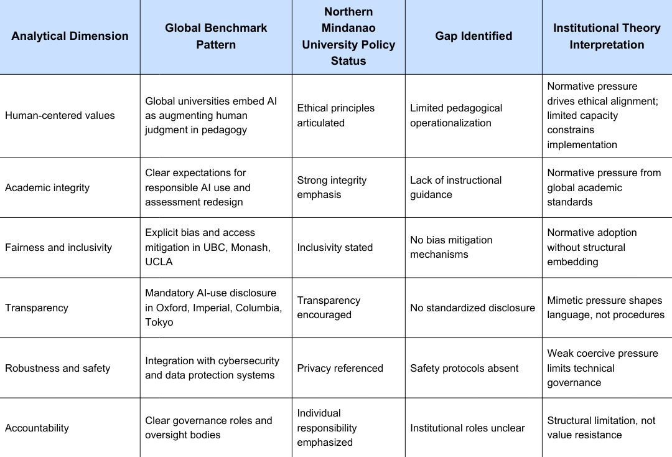

Table 3. Comparative Analysis of Ethical and Accountability Dimensions in Institutional AI Policies (OECD AI Principles)

3.2.1 Human-Centered Values and Academic Integrity

Table 3 presents comparative findings regarding OECD-type ethical dimensions. Most benchmark institutions explicitly state that AI should augment, rather than replace, human judgment and connect this principle to academic integrity in assessments and authorship policies (Floridi et al., 2018; European Commission, 2019). The Northern Mindanao policy similarly emphasizes responsible use of generative AI and academic honesty. In contrast, while global institutions frequently translate ethical principles into pedagogical guidance, such as assessment redesign and instructor templates, the local policy remains primarily principle-based and lacks operational detail for classroom implementation. This distinction has been highlighted in recent syntheses of AI adoption and governance in higher education (Zawacki-Richter et al., 2019; Crompton & Burke, 2023; Bond et al., 2024).
Interpretation (Institutional Theory): The pattern of shared ethical language reflects normative pressures, including shared professional values and disciplinary expectations that diffuse across higher education systems (DiMaggio & Powell, 1983). The limited operationalization in the local policy is likely due to resource, capacity, and contextual constraints rather than a rejection of ethical norms (Oncioiu & Bularca, 2025).

3.2.2 Fairness, Inclusivity and Transparency

Table 3 indicates that several benchmark universities, particularly those with established digital strategy offices, include explicit provisions for fairness, bias mitigation, and accessibility. Many of these institutions require or recommend disclosure of AI use in coursework. The Northern Mindanao policy affirms inclusivity and transparency in principle but generally lacks detailed procedures specifying who must disclose, how, and where. This observation aligns with findings that institutions often adopt disclosure and fairness language early, while standardization and technical controls are implemented at a later stage (Floridi et al., 2018; UNESCO, 2021).
Interpretation (Institutional Theory): This uptake is influenced by mimetic pressures, as institutions emulate perceived leaders during periods of uncertainty, often adopting similar policy language before developing the capacity to operationalize procedures (DiMaggio & Powell, 1983).

3.2.3 Robustness, Safety and Accountability Structures

In many benchmark institutions, AI policy is explicitly connected to data protection, cybersecurity, and institutional governance, including data classification rules and vendor risk processes. The local policy references privacy and responsible use but does not specify institutional oversight roles or safety escalation pathways. This indicates weaker coercive pressures, such as less prescriptive national or regulatory mandates, in the local context. This dynamic influences the pace at which governance arrangements become formalized (Williamson et al., 2020).

3.3 Risk Governance and Institutionalization: NIST-Based Findings

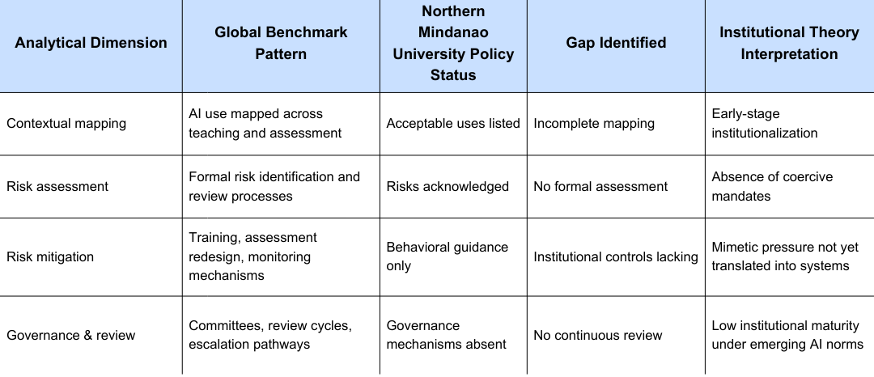

Table 4. Comparative Analysis of AI Risk Governance and Institutionalization Across Global and Local Policies (NIST AI RMF)

3.3.1 Map and Measure: Contextual Mapping and Risk Assessment

Table 4 presents comparative results aligned with the NIST AI RMF functions. Most global benchmark universities explicitly map AI use across teaching, assessment, and academic support, and establish processes for identifying and reviewing AI risks (NIST, 2023; Zawacki-Richter et al., 2019). In contrast, the Northern Mindanao policy specifies acceptable and prohibited uses but does not comprehensively map AI applications to pedagogical functions or specify periodic assessment processes.
This sequential pattern, in which awareness and mapping precede systematic measurement, reflects broader trends in educational technology adoption. Institutions typically first acknowledge risks and subsequently develop formal assessment tools (Williamson et al., 2020).

3.3.2 Manage and Govern: Mitigation, Oversight, and Continuous Improvement

Benchmark institutions commonly articulate mitigation strategies, such as faculty training, assessment redesign, monitoring, and vendor assessments, as well as governance practices including review cycles and oversight committees. The local policy emphasizes ethical behavior and user guidance but generally lacks institutional mechanisms for continuous governance and enforcement. This divergence is significant: while policy language can be rapidly harmonized across institutions, the institutionalization of governance structures, such as committees, audits, and reporting, requires organizational capacity and, in some cases, external mandates (UNESCO, 2021).
Interpretation through institutional theory suggests that mimetic and normative pressures lead to policy convergence in language, while coercive pressures, such as laws and accreditation standards, along with internal capacity, determine whether policies are operationalized as governance systems (DiMaggio & Powell, 1983).

3.4 Synthesis Across Cases and Policy Implications

Table 3 and 4 show that the Northern Mindanao university is becoming more ethically aligned with global peers, but its governance maturity is still developing. This should be seen as a step-by-step process of policy institutionalization, moving from awareness to definition and then to operationalization, rather than as a shortcoming. Recent international guidelines encourage both normative alignment and investment in governance capacity — a two-track response that local institutions may adapt incrementally (UNESCO, 2021; European Commission, 2019).
A main policy takeaway is that local policy should focus on practical governance steps that match the institution’s capacity. For example, setting up clear disclosure rules, doing regular risk reviews, and creating an advisory group across units are useful measures. This is more effective than trying to use complex governance models meant for bigger, better-funded universities (Williamson et al., 2020; Zawacki-Richter et al., 2019).

3.5 Summary of Key Findings

- Ethical convergence: The Northern Mindanao policy demonstrates alignment with core OECD values, including human-centeredness, integrity, and transparency, consistent with global benchmarks (OECD, 2019; Floridi et al., 2018).
- Governance divergence: Benchmark institutions exhibit more advanced operational mechanisms for risk assessment, mitigation, and review compared to the local policy (NIST, 2023; Williamson et al., 2020).
- Theoretical reading: Institutional Theory, encompassing normative, mimetic, and coercive pressures, accounts for both convergence and divergence. Policy development is shaped by prevailing norms, emulation, and regulatory or organizational constraints (DiMaggio & Powell, 1983).
- Practical next steps: A proportionate policy enhancement roadmap should prioritize disclosure procedures, defined use cases in teaching and assessment, periodic risk reviews, and the establishment of an advisory or oversight mechanism, in alignment with international guidance such as UNESCO (2021) and NIST (2023).

4. CONCLUSION

This study benchmarked institutional artificial intelligence (AI) policies for teaching and learning by comparing ten globally recognized universities with the policy of a higher education institution in Northern Mindanao. Using the OECD AI Principles and the NIST AI Risk Management Framework, and interpreting the results through Institutional Theory, the analysis reveals both convergence and divergence in the governance of AI within higher education systems.
There is a clear trend of institutions around the world agreeing on human-centered values, academic integrity, transparency, and fairness in how they use AI. Recent studies show that these ethical priorities are becoming the foundation of AI governance in higher education, especially as generative AI changes how students learn and are assessed (Marín et al., 2025). This agreement matches the UNESCO Recommendation on the Ethics of Artificial Intelligence, which stresses protecting human dignity, equity, and accountability in using AI (UNESCO, 2021).
Even though there is agreement on ethics, the study finds differences in how advanced governance is. Leading universities go beyond ethical statements by using formal risk assessments, mitigation plans, and regular reviews of their governance systems. In contrast, the Northern Mindanao university’s policy is mostly based on principles and does not have detailed ways to track AI use in teaching, carry out risk assessments, or set up ongoing oversight. This gap matches recent research, which shows that ethical guidelines often develop faster than practical governance, especially where rules are new and resources are limited (Pinho, 2025; Oncioiu & Bularca, 2025).
Using Institutional Theory, the analysis suggests that shared ethical commitments are shaped by social expectations, while less experienced institutions copy the language and frameworks of global peers when they are unsure. Differences in how governance is put into practice depend on factors like national rules, accreditation standards, and available resources for governance.
The results show that effective AI governance in higher education happens gradually. Stating ethical values is important, but it is not enough without systems that ensure accountability, ongoing risk management, and flexible learning processes. These findings suggest that policies should be improved step by step, with actions like regular risk reviews, clear mapping of how AI is used in teaching and assessment, and setting up oversight groups that fit the institution’s needs.
In summary, this study offers a clear model for comparing institutional AI policies and shows that while ethical standards are becoming more global, the level of governance still depends on local context. Future research should keep tracking new policy developments, especially in low- and middle-income countries, to make sure AI helps improve education quality, fairness, and sustainability.

Disclaimer (Artificial intelligence)

Author(s) hereby declare that NO generative AI technologies such as Large Language Models (ChatGPT, COPILOT, etc.) and text-to-image generators have been used during the writing or editing of this manuscript.

REFERENCES

Alfiras, M. I. I., Emran, A. Q., & Mohamed, A. M. (2025). Ethics and governance of generative AI in education: A systematic review on responsible adoption. Discover Education. https://doi.org/10.1007/s44217-025-01051-y
An, Y., Edwards, J., & McDonald, S. (2025). Investigating higher education institutions’ guidelines and policies for generative AI: A multi-institutional analysis. International Journal of Educational Technology in Higher Education, 22, 10. https://doi.org/10.1186/s41239-025-00507-3
Azevedo, L., Robles, P., Best, E., & Mallinson, D. J. (2025). Institutional policies on artificial intelligence in higher education: Frameworks and best practices for faculty. New Directions for Adult and Continuing Education, 2025(173), 87–99. https://doi.org/10.1002/ace.70013
Barus, O. P., Hidayanto, A. N., Handri, E. Y., Sensuse, D. I., & Yaiprasert, C. (2025). Shaping generative AI governance in higher education: Insights from student perception. International Journal of Educational Research Open, 8, 100452. https://doi.org/10.1016/j.ijedro.2025.100452
Bond, M., Khosravi, H., de Laat, M., Bergdahl, N., Negrea, V., Oxley, E. et al. (2024). A meta systematic review of artificial intelligence in higher education: A call for increased ethics, collaboration, and rigour. International Journal of Educational Technology in Higher Education, 21, Article 4. https://doi.org/10.1186/s41239-023-00436-z
Cardno, C. (2021). Policy Document Analysis: A Practical Educational Leadership Tool and a Qualitative Research Method. Educational Administration: Theory and Practice, 24(4), 623–640. https://doi.org/10.17762/kuey.v24i4.82
Co, S. J. (2025). Artificial intelligence in Philippine education: A narrative review of applications, perceptions, and challenges. International Research Journal of Science, Technology, Education, and Management, 5(2), 25–38. https://doi.org/10.5281/zenodo.15902950
Crompton, H., & Burke, D. (2023). Artificial intelligence in higher education: The state of the field. International Journal of Educational Technology in Higher Education, 20, Article 22. https://doi.org/10.1186/s41239-023-00392-8
DiMaggio, P. J., & Powell, W. W. (1983). The Iron Cage Revisited: Institutional Isomorphism and Collective Rationality in Organizational Fields. American Sociological Review, 48(2), 147–160. https://doi.org/10.2307/2095101
European Commission. (2019, April 8). Ethics Guidelines for Trustworthy AI. Shaping Europe’s Digital Future. https://digital-strategy.ec.europa.eu/en/library/ethics-guidelines-trustworthy-ai
Floridi, L., Cowls, J., Beltrametti, M., Chatila, R., Chazerand, P., Dignum, V. et al. (2018). AI4People — An ethical framework for a good AI society: Opportunities, risks, principles, and recommendations. Minds and Machines, 28(4), 689–707. https://doi.org/10.1007/s11023-018-9482-5
Hazelkorn, E. (2015). Rankings and the reshaping of higher education: The battle for world-class excellence (2nd ed.). Palgrave Macmillan. https://doi.org/10.1057/9781137446671
Holmes, W., Porayska-Pomsta, K., Holstein, K., Sutherland, E., Baker, T., Buckingham Shum, S. et al. (2022). Ethics of AI in education: Towards a community-wide framework. International Journal of Artificial Intelligence in Education, 32(3), 504–526. https://doi.org/10.1007/s40593-021-00239-1
Marín, Y. R., Cruz Caro, O., Carrasco Rituay, A. M., Guimac Llanos, K. A., Pérez, D. T., Sánchez Bardales, E. et al. (2025). Ethical challenges associated with the use of artificial intelligence in university education. Journal of Academic Ethics, 23, 2443–2467. https://doi.org/10.1007/s10805-025-09660-w
National Institute of Standards and Technology (NIST). (2023). Artificial Intelligence Risk Management Framework (AI RMF) 1.0. U.S. Department of Commerce. https://nvlpubs.nist.gov/nistpubs/ai/NIST.AI.100-1.pdf
Nguyen, A., Ngo, H. N., Hong, Y., Dang, B., & Nguyen, B.-P. T. (2022). Ethical principles for artificial intelligence in education. Education and Information Technologies, 28(4), 4221–4241. https://doi.org/10.1007/s10639-022-11316-w
Oncioiu, I., & Bularca, A. R. (2025). Artificial intelligence governance in higher education: The role of knowledge-based strategies in fostering legal awareness and ethical artificial intelligence literacy. Societies, 15(6), 144. https://doi.org/10.3390/soc15060144
Organisation for Economic Co-operation and Development (OECD). (2019). AI principles. https://www.oecd.org/en/topics/sub-issues/ai-principles.html
Parker, L. (2025). Comparative analysis of artificial intelligence policies in higher education. International Journal of Educational Technology in Higher Education. https://doi.org/10.1007/s10791-025-09745-5
Parry, E., Dickmann, M., & Morley, M. (2021). Balancing rigour and relevance: The case for complementary comparative management data sets. British Journal of Management, 32(4), 937–956. https://doi.org/10.1111/1467-8551.12405
Pinho, I., Costa, A. P., & Pinho, C. (2025). Generative AI governance model in educational research. Frontiers in Education, 10, Article 1594343. https://doi.org/10.3389/feduc.2025.1594343
Quacquarelli Symonds. (2025). QS World University Rankings. QS TopUniversities. https://www.topuniversities.com/world-university-rankings
Republic Act No. 10173. (2012). Data Privacy Act of 2012. National Privacy Commission. https://privacy.gov.ph/data-privacy-act/
Selwyn, N. (2019). Should robots replace teachers? AI and the Future of Education. (1st ed.) Polity Press.
Stracke, C. M., Nahar, N., Punzo, V., Massaro, S., Pappa, D., Di Grassi, A. et al. (2025). Artificial Intelligence policies for higher education: Manifesto for critical considerations and a roadmap. MAP Education and Humanities, 6, 61–73. https://doi.org/10.53880/2744-2373.2025.6.61
Tlili, A., Huang, R., Mustafa, M. Y., Zhao, J., Bozkurt, A., Xu, L., & Wang, H. (2023). Speaking of transparency: Are all artificial intelligence (AI) literature reviews in education transparent? Journal of Applied Learning & Teaching, 6(2), 1–12. https://doi.org/10.37074/jalt.2023.6.2.15
Tupaz, E. F., Tabeta, G. G., & Unarce, J. S. (2025, February 5). Philippines: NPC releases guidelines on AI systems. Gorriceta Africa Cauton & Saavedra. https://gorricetalaw.com/philippines-npc-releases-guidelines-on-ai-systems/
UNESCO. (2015). UNESCO science report: Towards 2030. United Nations Educational, Scientific and Cultural Organization. https://unesdoc.unesco.org/ark:/48223/pf0000235406
UNESCO. (2021). Recommendation on the Ethics of Artificial Intelligence. United Nations Educational, Scientific and Cultural Organization. https://www.unesco.org/en/artificial-intelligence/recommendation-ethics
UNESCO. (2023). Guidance for generative AI in education and research. United Nations Educational, Scientific and Cultural Organization. https://www.unesco.org/en/articles/guidance-generative-ai-education-and-research
United Nations Educational, Scientific and Cultural Organization, International Institute for Higher Education in Latin America and the Caribbean (UNESCO IESALC). (2025, January 30). The role of higher education in national artificial intelligence strategies: A comparative policy review. UNESCO IESALC. https://www.iesalc.unesco.org/en/articles/role-higher-education-national-artificial-intelligence-strategies-comparative-policy-review
Villanueva, M. C. (2025). Towards national standards: Comparative analysis of AI governance models in Philippine higher education. Ignatian International Journal for Multidisciplinary Research, 3(4), 543–565. https://doi.org/10.5281/zenodo.15212683
Williamson, B., Eynon, R., & Potter, J. (2020). Pandemic politics, pedagogies and practices: Digital technologies and distance education during the coronavirus emergency. Learning, Media and Technology, 45(2), 107–114. https://doi.org/10.1080/17439884.2020.1761641
Williamson, B., Macgilchrist, F., & Potter, J. (2023). Re-examining AI, automation and datafication in education. Learning, Media and Technology, 48(1), 1–5. https://doi.org/10.1080/17439884.2023.2167830
Xavier University — Ateneo de Cagayan. (2024, August 6). Memo U2425-003: Policy on the ethical and responsible use of generative artificial intelligence (GenAI). Xavier University. https://www.xu.edu.ph/memo/225-academic-year-2024-2025/6731-memo-u2425-003-policy-on-the-ethical-and-responsible-use-of-generative-artificial-intelligence-genai-at-xavier-ateneo
Zawacki-Richter, O., Marín, V. I., Bond, M., & Gouverneur, F. (2019). Systematic review of research on artificial intelligence applications in higher education – where are the educators? International Journal of Educational Technology in Higher Education, 16(1), 39. https://doi.org/10.1186/s41239-019-0171-0

