Exploring the Learning Management System Features and its Impact on the Oral Communication Skills of First Year College Students

Abstract
The teaching and learning process has been challenged due to the sudden shift in modality brought by the COVID-19 pandemic. Currently, in the Philippines, schools have shifted from purely online classes to hybrid setup, while some conduct classes purely onsite. With the continuous implementation of online classes, schools utilise learning management systems (LMS) to allow the teaching and learning process to proceed. This research aimed to explore the different features of the learning management system and how these impact the oral communication skills of first-year college students. The study was conducted in a private tertiary educational institution based in Manila where first-year college students were purposively tapped as respondents. Said students were taking the general education course Purposive Communication during the second term of the school year. Mixed-method design was employed, where two instruments were used to gather data from the respondents: a survey and an interview. Out of the respondents who consented to participate in the survey, ten (10) were randomly selected to take part in the online interview. Descriptive analysis and thematic analysis were used to provide answers to the research questions, which are about the features of the learning management system that aid students in honing their oral communication skills and how these LMS features impact the students’ enhancement of the said skill. The study aimed to significantly aid the educational institution where the study was implemented, professors handling Purposive Communication, and the student-respondents as they work on improving their oral communication skills.

Keywords: learning management system; oral communication; mixed-method design, online classes to hybrid setup, communication skills

1. INTRODUCTION
1.1. Background of the Study
As traditional education has changed with digital technology, online learning has shown swift development and growth. Due to the pandemic, classes shifted from traditional to hybrid modality. Learning Management Systems (LMS) empower the process of learning through online classrooms that are made available. These systems promote online collaboration, professional workshops, discussions, and communication. On the other hand, learning management systems allow teachers to facilitate and exemplify discussions, execute online activities, provide students with opportunities to acquire knowledge, and assist them in the process of teaching and learning. It is important for both teachers and students to be present online through the learning management systems employed for the teaching and learning process to become a success (Bradley, 2021). Because of its function of reducing foreign language anxiety, the use of digital technology has an important role in the process of teaching and learning. Hence, the use of digital platforms and the study of their impact on learners’ public speaking anxiety and performance in second language acquisition have been studied by many scholars in the field of language education. The study of Yaprak (2022) showed that the use of digital platforms had a significant function in increasing learners’ self-esteem and improving public speaking skills. This study is one of the many research projects that have attempted to prove how digital platforms affect the speaking skills of students.
Learning Management Systems (LMS) were used to meet the needs of both teachers and students during the COVID-19 pandemic. Previous studies probed how learning management systems were used to meet students’ needs during the pandemic. The study of Alturki and Aldraiweesh (2021) aimed to include an analysis of literature or recent studies conducted during the COVID-19 pandemic in terms of learning management system usage and attempted to ascertain the factors that influenced students’ engagement during the conduct of online classes. The ﬁndings exposed that the desire of students to use learning management systems had beneﬁcial effects on learning and involvement during the COVID-19 pandemic. Students’ perceived ease of use and utilization of the LMS also influenced their usage of learning management systems. In relation to this, the study of Terzioglu and Kurt (2022) highlighted the significance of immersing English language learners in collaborative learning platforms for them to augment their comprehension and verbal communication skills. The semi-experimental study they collaborated on explained the effects of an LMS on the speaking fluency and listening skills of the students who served as their respondents. The study adopted a pre and post-test research design. In addition, students’ perceptions regarding the impact of LMS on the aforementioned skills were probed through an interview and a questionnaire. The results showed that there was a notable difference between the two groups, as the experimental group had higher ratings than the control group in both listening skills and speaking fluency based on the results of the post-test. The respondents had a positive evaluation of LMS as a platform that allows for the improvement of oral communication skills that relate to both speaking and listening macroskills. This is one of the many studies that established the connection between learning management systems and oral communication skills.
Many studies support the claim that learning management systems aid in improving the speaking skills of students. An experimental study looked into the effectiveness of Moodle in learning. It focused on the Moodle-based Speaking Learning. The findings revealed that there is a need for teachers to comprehend the curriculum and be able to design learning management focusing on student-centered approach (Moodle-Based Speaking Learning Model, n.d.). With this, the study of Yamprayon and Jermtaisong (2021) aimed to scaffold learners to use the language in actual situations, including reading, writing, listening, and speaking macroskills. The study assessed the oral communication skills of students before and after being exposed to learning management systems. The research results disclosed that the respondents who were exposed to the non-traditional learning management system performed better than those who utilized the traditional LMS (Yamprayoon & Jermtaisong, 2021). The study implies that there is a need for educational institutions to use learning management systems to aid students in improving their oral communication skills.
One study aimed to pinpoint and review the studies that investigated students’ perceptions of the Blackboard program as a tool for learning English subjects, and also the effect of those perceptions on students’ actual use of the LMS called Blackboard. The study provided an overview of how Blackboard computer and internet-based virtual classes, which are platforms that are technology-based, were used by the students to address challenges related to English-speaking skills and described their speaking ability from the following perspectives: fluency, accuracy, and anxiety. The study found that the knowledge of students about the platform used resulted in a positive perception and in turn, effective use of the said platform. The platform also contributed to the process of learning English language speaking skills during the COVID-19 pandemic (Ismail Al-Oqaily et al., 2022). Another study aimed to explore the processes and students' techniques to work on online learning speaking skills using the learning management system named Google Classroom during the global pandemic. Several measures were employed to gather data from the respondents. The results showed that the process of acquiring speaking abilities using the said LMS was challenging for students who wanted to work on their speech communication skills. This was due to the short exposure of students to the said platform, thus implying that there is a need for students to be given ample time to be immersed in the said platform (Sahib et al., 2022).
A number of studies were conducted to improve the speaking skills of students. Learning management system was used in one study that attempted to aid in improving the oral communication skills of students. In this study which was conducted in 2020, information gaps were made available on an online learning website. These information gaps were also used to improve the oral communication skills of students; these were used as a basis for evaluation. It was revealed that the amount of student activities increased during the second cycle of learning, as shown by performance indicators, learning processes, and completeness rates. This means that the students' speaking skills improved from the first to the second level of the cycle (Syakur et al., 2020). In relation to this, another study pointed out that the swift development of computer and digital technologies has helped students in learning the English language. Video blogs have been getting the attention of educators as a tool in helping students hone their oral communication skills. The main focus of the study was to describe the roles of video blogs in improving the speaking skills of students. Mainly, the study highlighted how students perceived the aforementioned technological tool in aiding them in improving their oral communication skills. The results revealed that students’ take on the use of video blog to improve speaking skill is at an acceptable level through the use of various techniques. Furthermore, students improved their English communication skills through the use of said technological tool (Lestari, 2019). These studies point to the significance of LMS in affecting the oral communication skills of students. In the age of technology, it is a must for educators to regard technological tools as an aid in improving the skills of their students. In the case of language learning, a number of studies claimed that various technological tools could influence how students perform inside the classroom. The studies discussed pointed that LMS is a platform to be used for students to be aided in improving their oral communication skills, specifically when classes are conducted online or in a hybrid setup.

1.2. Significance of the Study
Because of the COVID-19 pandemic, a lot of universities executed teaching online by using various learning platforms such as web-based learning made possible by the use of learning management systems (LMS). With this, the study aimed to focus on the learning management system’s features that aid students in honing their oral communication skills. Additionally, the study aimed to determine the impact of the LMS on the oral communication skills of first-year college students. The study is timely since now that the globe is in the post-pandemic era, several educational institutions have decided to implement classes following the hybrid modality, which is composed of in-person and online sessions. In the Philippines, a number of schools have been conducting classes following this format. It is essential to uncover the different features of LMS that allow students to hone their oral communication skills. In relation to this, the study of Nguyen et al. (2021) revealed that a number of students expressed their negative attitude towards learning speech communication skills online during the global pandemic when they had to adjust to various issues linked to technology. With those challenges exposed, more interventions linked to the learning management system were expected to be created. Furthermore, the study is significant as this could provide an avenue for the school to understand the experiences of students. With this, they could propose ways which could further hone the students’ oral communication skills through the LMS. The findings of the study could also aid educators in improving their ways of utilizing the different features of the learning management system. Through the collaborative effort of the school and its educators, it would be possible for students to have a better learning experience mediated by the learning management system and its features that could result in the improvement of their oral communication skills.

1.3. Statement of the Problem
English is a course that requires a special learning structure during the global pandemic. There are several competencies that must be achieved in an online environment. This was highlighted in one study where the elements of language learning pedagogy were considered in designing and utilizing the different features of the learning management system (Ulfa et al., 2020). The study aimed to determine the features of the learning management that help students in honing their oral communication skills. In relation to this, the impact of the learning management system on the oral communication skills of the student-respondents was assessed.

1.4. Research Questions
The following are the research questions that the study aimed to answer:

1. What are the features of the learning management system that aid students in honing their oral communication skills?
2. What is the impact of the learning management system on the oral communication skills of first year college students?

1.5. Limitations
The study was conducted in one private institution that is based in Manila. With this, only the learning management system of the school was covered in this study. The study did not touch on other learning management systems that are used in other schools where online classes are conducted. First-year college students of the said private school served as the respondents of the study. Only the students who consented to take part in the study were asked to provide answers to the survey and interview questions. The study did not ask students from other year levels to take part nor did it require students from other institutions to answer the research questions. In relation to this, only the students of professors who agreed to take part in the study were asked to provide answers to the questions. The study ran during the second term of the current academic year and did not go over this as students take Purposive Communication for one term only. The researcher intended to conduct the study for one term only so that students who served as respondents would have the same pace in taking the course.

2. METHODOLOGY
2.1. Paradigm
Pragmatism is the research paradigm of the study. It combines positivist and constructivist principles. This is due to the nature of the research questions posed by the study, where both quantitative and qualitative designs were touched upon. Quantitative design is based on positivism while qualitative design lies on constructivism. As stated by Pawlikowski et al. in 2018, positivism revolves around observable traits in the society. Constructivism on the other hand banks on the assumption that human beings cannot be explored in one way as a phenomenon, according to Keong et al. (n.d.). The first research question posed by the study is all about the features of the learning management system that aid students in honing their oral communication skills. This employed a quantitative data collection method, particularly the survey instrument. The second research question posed by the study is all about the impact of the learning management system on the oral communication skills of first-year college students. This utilized a qualitative data collection method, particularly the interview. The nature of the research questions posed is the reason why pragmatism is the research paradigm of the study. As both qualitative and quantitative methods were used, pragmatism served as the paradigm of this study.

2.2. Design
Mixed-method design was employed in this study. It is an approach to research inquiry that collects both quantitative and qualitative data from respondents, combining the two forms of data, and utilizing various designs that may relate to philosophical underpinnings. The main point of this research design is that the integration of qualitative and quantitative data results in clear data that could answer the research questions. This goes beyond what could be provided by employing qualitative or quantitative design alone (The Three Approaches to Research, n.d.). Mixed-method design resides in the middle of quantitative and qualitative approaches as the elements of both research designs are incorporated. As stated by Poth and Searle (2022), the usefulness of mixed methods design is well-established. The significant elements of both research designs are incorporated from the planning to the execution stage of the research process. These were highlighted by Creswell and Plano-Clark as early as 2018. The study specifically employed the explanatory sequential design. It started with quantitative data collection and analysis. Results were then connected and explained by the qualitative data collection and analysis. The last component of this design is the interpretation of data which integrates both qualitative and quantitative data.

QUAN
Interpretation
Results connected and explained by
QUAL

Fig 1: Mixed-method design
2.3. Participants
The participants of this study were first year college students taking the purely online course Purposive Communication in a private institution based in Manila. The students were taking the said course from January to April of 2024. The said course is a general education subject in the tertiary level that aims to develop students’ communicative competence and enhance their cultural awareness through different multimodal activities that expose them to various cultures locally and globally. A purposive sampling technique was employed to complete respondents for this study. It is a sampling technique where the researcher relies on his or her decision when choosing respondents to complete the sample of the study (Purposive Sampling, n.d.). Out of the participants who answered the survey form, which was the first instrument used following the explanatory sequential design, a total of ten (10) students were interviewed via Zoom. The research participants were asked to sign the consent form in consideration of research ethics. They were reminded that the data they provide was for the sole purpose of this study. They were notified that they are free to withdraw from the study anytime. If a participant decided to withdraw one’s participation from the study, the data collected from him/her was automatically disposed.

2.4. Data Collection Instruments
Two data collection instruments were utilized to answer the two research questions: survey questionnaire and an interview. To answer the first research question which is all about the features of the learning management system that aid students in honing their oral communication skills, the questionnaire employed by Koh and Kan (n.d.) which is all about students’ perceptions of the learning management system’s satisfaction, quality, and utilization was modified to fit the context of the study. Likewise, Likert scale was used, where 5 means Strongly Agree, 4 means Agree, 3 means Neutral, 2 means Disagree, and 1 means Strongly Disagree. The first part of the survey form asked the respondents to provide details about their demographics. The following aspects of the learning management system were assessed: system quality, information quality, interaction quality, instructional quality, and learning quality. System quality and information quality items were all omitted in consideration of the study’s nature and were replaced by researcher-made items. For interaction quality, only four out of five items were retained. For instructional quality, only five out of eight items were retained. For learning quality, six out of nine items were retained. Below are the items that comprised the survey form that was distributed to the student-respondents:

Table1: System Quality
- The learning management system’s contents allow me to improve my oral communication skills.
- The learning management system’s submission bins and assignments let me enhance my oral communication skills.
- The learning management system’s discussion threads allow me to improve my oral communication skills.

Table 2: Information Quality
- The learning management system’s contents provide information or details that allow me to improve my oral communication skills.
- The learning management system’s submission bins and assignments contain information or details that let me enhance my oral communication skills.
- The learning management system’s discussion threads provide information or details that allow me to improve my oral communication skills.

Table 3: Interaction Quality
- The learning management system provides a good opportunity to collaborate with my peers.
- I think communicating with my lecturer through the learning management system is essential.
- I think communicating with my peers through the learning management system is important.
- The learning management system supports interactivity between learners by discussions, forums, etc.

Table 4: Instructional Quality
- The learning management system is valuable for learning from my classmates.
- The learning management system is valuable for posting and replying to discussion threads.
- The learning management system is valuable for turning in assignments.
- The learning management system is valuable for managing project collaborations.
- The learning management system is valuable for communicating with my peers.

Table 5: Learning Quality
- Learning activities foster instructor-student or student-student interaction.
- The learning management system has the potential to make the learning process more engaging and motivating.
- The online environment is conducive and enjoyable for learning.
- I find that the learning management system is a good educational platform that improves my learning.
- The learning management system helped me become more familiar with the contents of the course.
- Technologies are used creatively in ways that go beyond traditional ways of learning.

To answer the second research question which is about the influence of the learning management system on the oral communication skills of first year college students, questions were based and modified from the study authored by Nair and Ganeser (2020). The following questions were asked during the interview:

1. Did the learning management system you utilized help you in improving your oral communication skills?
2. What are the features of the learning management system you utilized that help you in improving your oral communication skills?
3. Did the learning management system allow you to boost your confidence?
4. How did the features of the learning management system impact your oral communication skills?
5. How did you use the features of the learning management system in enhancing your oral communication skills?

2.5. Data Collection Procedures
The data collection for this study started with the researcher communicating with the research ethics office of the school where the study was conducted. The researcher ensured that the needed consent and approval were secured from the said office before directly communicating with the respondents. The research instruments, research brief, and other necessary forms were forwarded to the said office for clearance. Once cleared, the researcher communicated with the professors handling the course Purposive Communication. The researcher asked for the instructors’ assistance so that the online survey form could be forwarded to the students. The respondents were given a month to participate in the survey. The form contained a consent page which required the students to decide whether they intend to participate in the study or not. Students who decided to participate were required to answer the survey questions. After a month, the survey form was closed. Once the time given to students to participate in the survey was over, the researcher randomly selected ten (10) students to be interviewed via Zoom to gather qualitative data in compliance with the explanatory sequential design of the study. The researcher sent email invites to the interviewees. Those who agreed to participate were provided another consent form. They were also asked to state their preferred Zoom interview schedule. An overview of interview questions was provided to the participants before the scheduled interview. The ten interviews took place within two weeks. Before the interview began, the participants were reminded that the interview process was for academic research purposes only. They were also reminded that during the interview, turning on their camera was not required. Their consent was once again asked before the online interview was recorded. After all interviews, the transcription was finalized by the researcher. Each of the interviewees was given a copy of the interview transcription. Once all transcriptions were approved, the researcher continued with the analysis of data. Following the explanatory sequential design, interpretation of data was done in consideration of both quantitative and qualitative data. The results of the study were forwarded to the faculty members who were handling the student-respondents for them to share with the students who participated. Likewise, the research ethics office of the school was provided with a copy of the research for them to be informed of its culmination and for them to also ascertain the results of the study.

2.6. Trustworthiness and Authenticity of the Study/Validity and Reliability
As stated by Rodwell in 1998, trustworthiness in qualitative research refers to the truth value, applicability, consistency, and neutrality of the results, while authenticity pertains to the degree to which the researcher covers the different perspectives or points of the research participants (Mauldin, 2020). For credibility to be achieved, the researcher provided the participants with the interview transcription before finalizing the analysis of results. This allowed the researcher to correct transcription entries if the participants say that there is a need to do so. For dependability to be achieved, the research procedures were strictly followed. If changes arise, these were recorded and accounted for. For confirmability to be achieved, the researcher consulted with another researcher for the results to be audited. For fairness to be achieved, the perspectives or answers of the respondents were all considered. In terms of the quantitative component of the study, validity was achieved by making sure that the survey instrument’s items all relate to what is being studied: the features of the learning management system and how these impact the oral communication skills of students. For reliability to be achieved, two research experts were asked to check the survey instrument prepared. Additionally, a brief pilot testing of survey instrument was conducted so that revisions may be done before the actual execution of data gathering.

2.7. Data Analysis
In consideration of the instruments that were utilized, the following were done to analyze the data that were gathered: descriptive analysis and thematic analysis. As this study employed a 5-point Likert scale survey questionnaire, weighted mean was used to analyze the gathered data. A weighted mean is similar to an average. Rather than contributing equally to the final average, some data points provide more weight compared to the other points. This method of analysis was utilized to determine the average which represents the participants’ mean responses to the survey items. This kind of analysis ensured individual estimates that are objective given that the responses possibly come from variances. In addition, the standard deviation was computed. According to NCEE Publications (n.d.), descriptive analysis determines patterns in data to answer inquiries about who, what, where, when, and to what extent. Furthermore, to analyze the results generated through the interview, the answers went through thematic analysis. This analysis was based on Willig and Rogers (2017) who delineated six phases when conducting thematic analysis, starting with familiarizing with the data, generating codes, constructing themes, reviewing potential themes, defining and naming themes, and finally, producing the report. The data gathered were then compared and further analyzed to provide answers to the research questions posed.

3. RESULTS
3.1. Quantitative Results
System Quality
Fig 2
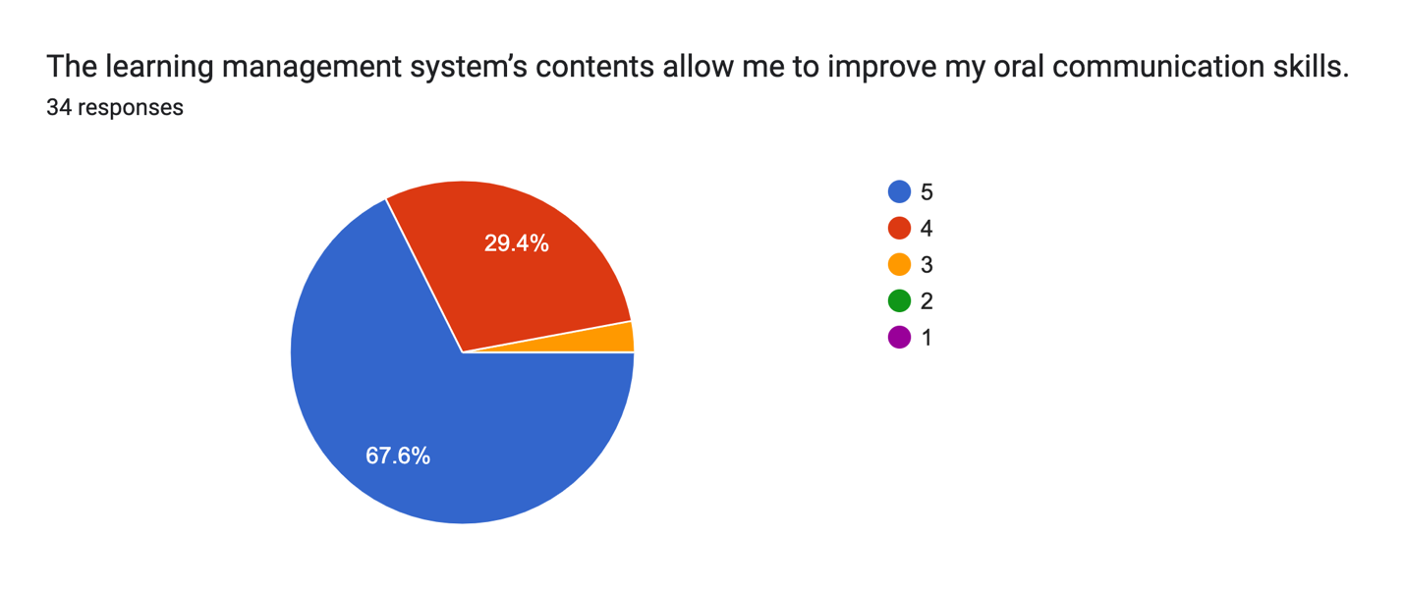
The learning management system (LMS) offers a variety of resources aimed at improving users' oral communication skills. The feedback reflects a high level of satisfaction, with 67.6% of participants rating the system a 5 and 29.4% rating it a 4. This indicates that the content effectively supports skill development, while only a small percentage rated it lower. Overall, the LMS is perceived as a valuable tool for enhancing oral communication capabilities.
Fig 3
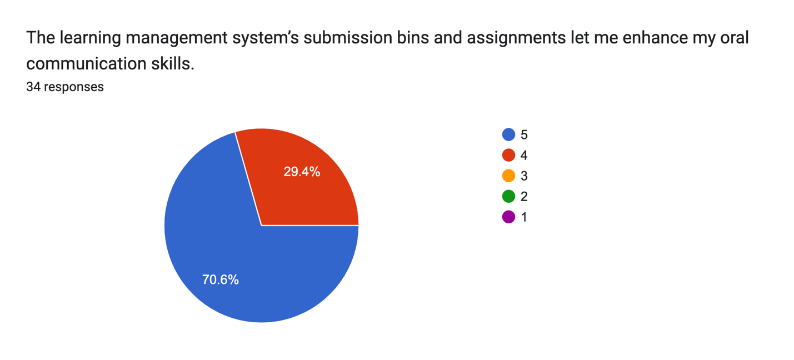
The learning management system (LMS) provides submission bins and assignments that significantly enhance users' oral communication skills. An impressive 70.6% of participants rated these features a 5, while 29.4% rated them a 4, indicating a strong positive response. With no lower ratings, it is clear that the assignments and submission process effectively support users in practicing and refining their communication abilities, making the LMS a valuable resource for skill development.

Fig 4
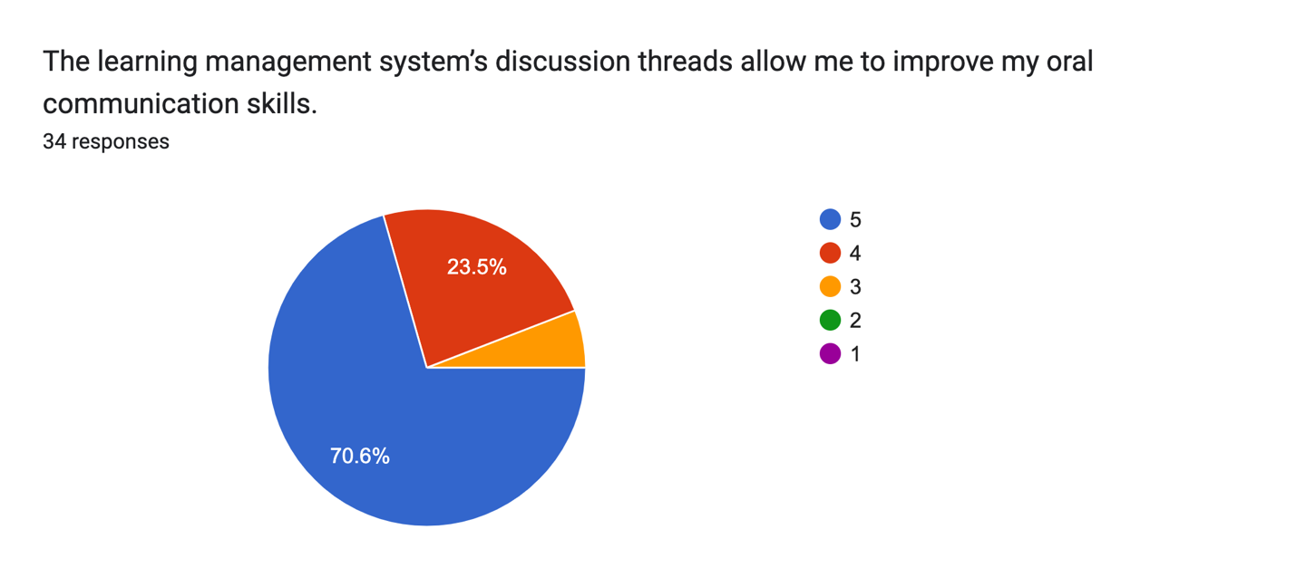
The learning management system (LMS) features discussion threads that greatly aid users in improving their oral communication skills. A significant 70.6% of participants rated this aspect a 5, while 23.5% gave it a 4, showcasing a strong overall satisfaction. With only 5.9% rating it a 3 and no lower scores, it is evident that these discussion threads provide an effective platform for engaging in dialogue and practicing communication, reinforcing their value in skill enhancement.
Information Quality

Fig 5
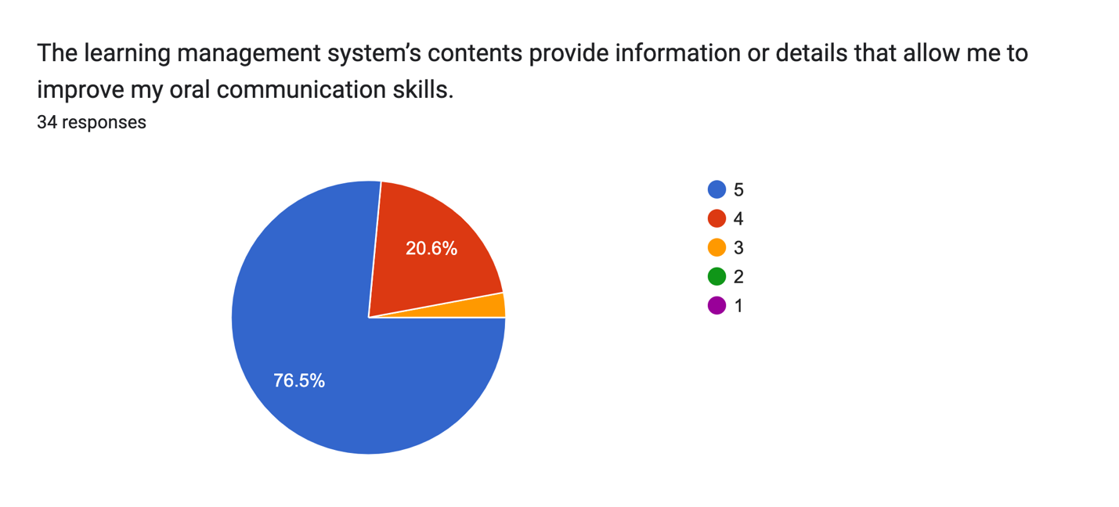
The learning management system (LMS) offers content that effectively provides information and details essential for improving users' oral communication skills. An impressive 76.5% of participants rated this content a 5, while 20.6% rated it a 4, indicating a strong positive reception. With only 2.9% giving it a score of 3 and no lower ratings, it is clear that the resources available in the LMS are highly regarded for their role in enhancing communication abilities.

Fig 6
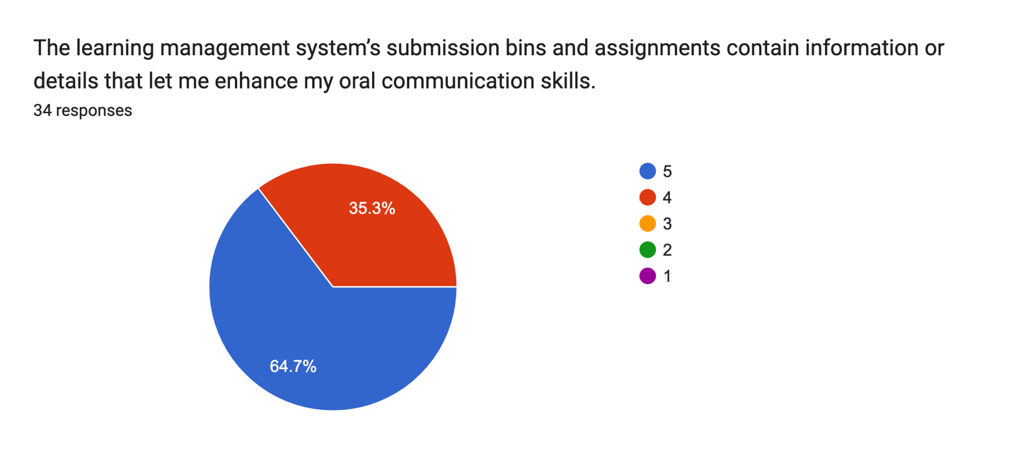
The learning management system (LMS) features submission bins and assignments that contain valuable information and details for enhancing users' oral communication skills. A notable 64.7% of participants rated these elements a 5, while 35.3% gave them a 4, demonstrating a strong overall approval. With no ratings below 4, it is evident that the assignments and resources provided are effective tools for users looking to improve their communication abilities.

Fig 7
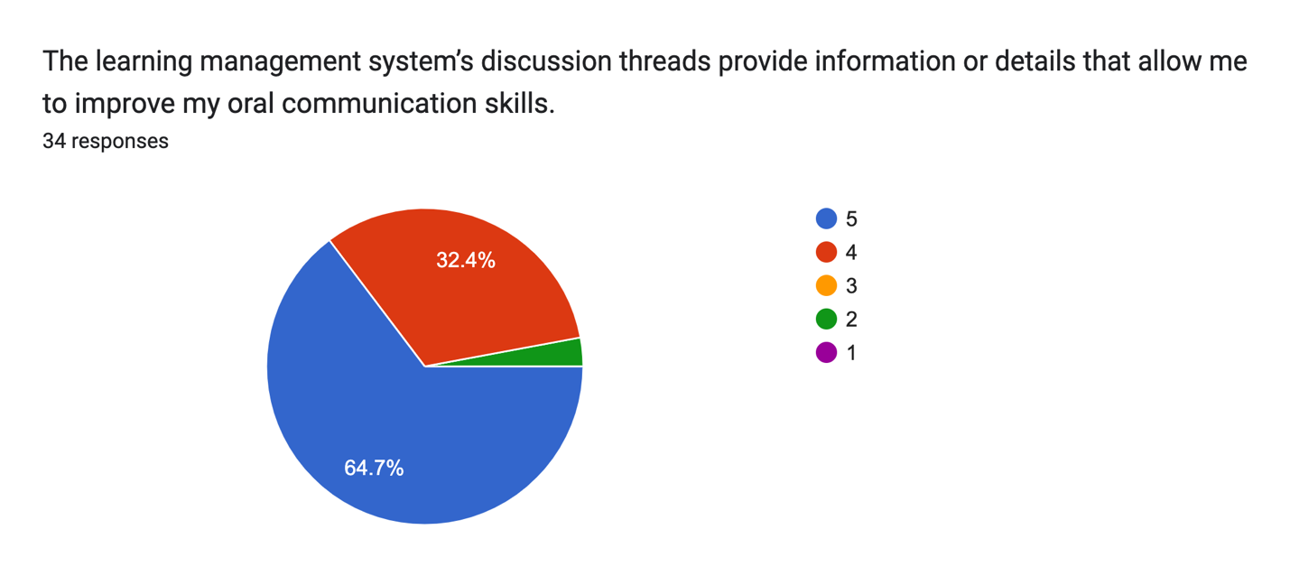
The learning management system (LMS) features discussion threads that offer valuable information and details for enhancing users' oral communication skills. A significant 64.7% of participants rated these threads a 5, and 32.4% rated them a 4, indicating strong overall satisfaction. With no ratings of 1 or 3 and only 2.9% giving it a 2, it is clear that the majority of users find the discussion threads effective in supporting their communication development.
Interaction Quality
Fig 8
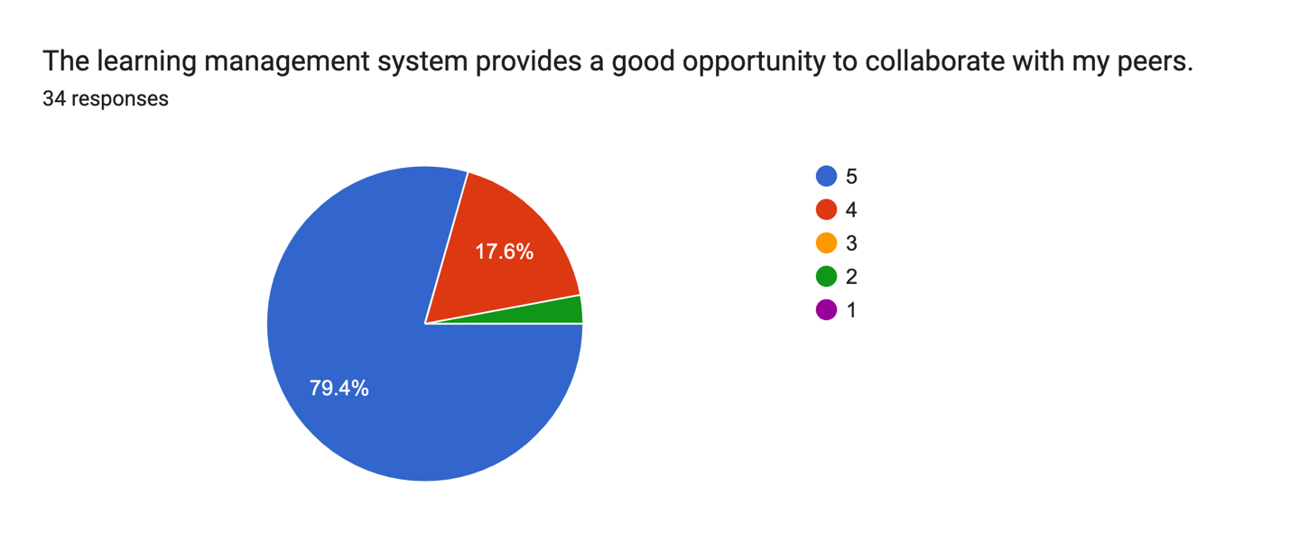
The learning management system (LMS) offers excellent opportunities for collaboration among peers, as reflected in user feedback. A substantial 79.4% of participants rated this aspect a 5, while 17.6% rated it a 4, demonstrating strong approval overall. With no ratings below 2 and no participants rating it a 1 or 3, it is evident that the LMS effectively fosters collaboration, enhancing the learning experience for users.

Fig9
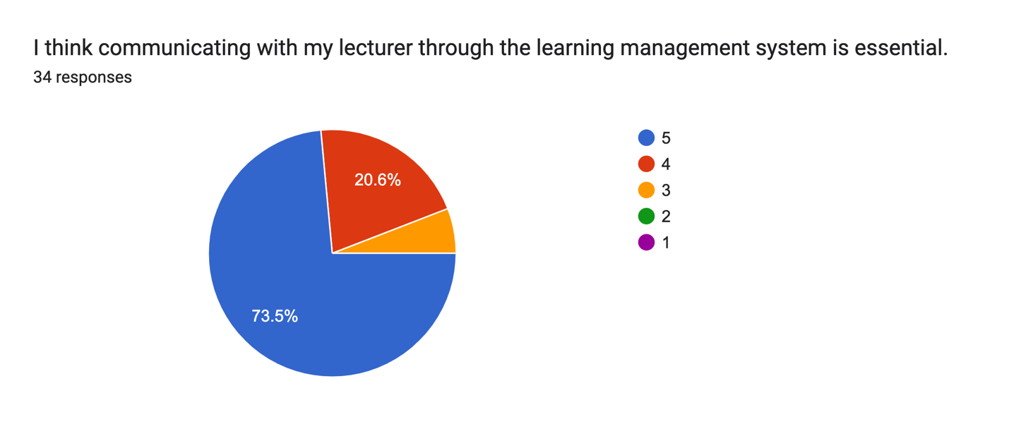

Users generally believe that communicating with their lecturer through the learning management system (LMS) is essential for their learning experience. A significant 73.5% rated this aspect a 5, while 20.6% rated it a 4, indicating strong support for the importance of this communication channel. With only 5.9% giving it a score of 3 and no lower ratings, it is clear that most participants recognize the value of engaging with their lecturer via the LMS to enhance their understanding and academic success.

Fig 10
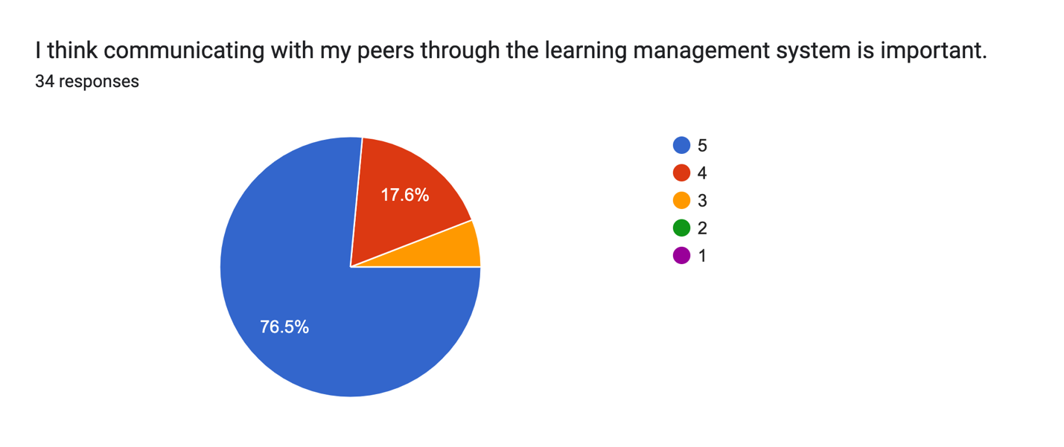

Participants overwhelmingly believe that communicating with peers through the learning management system (LMS) is important for their educational experience. An impressive 76.5% rated this aspect a 5, while 17.6% rated it a 4, reflecting strong overall support. With only 5.9% giving it a score of 3 and no lower ratings, it is evident that most users recognize the value of peer communication via the LMS in enhancing collaboration and learning outcomes.
Fig 11
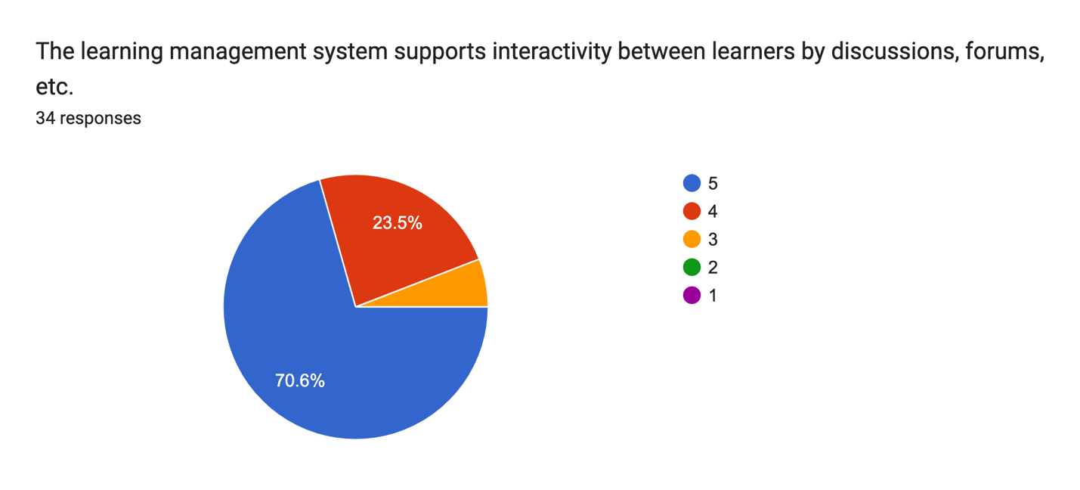
The learning management system (LMS) effectively supports interactivity among learners through features such as discussions and forums. A notable 70.6% of participants rated this aspect a 5, while 23.5% rated it a 4, indicating a strong appreciation for the platform's interactive capabilities. With only 5.9% giving it a score of 3 and no lower ratings, it is clear that most users find these interactive elements valuable for enhancing their learning experience and fostering engagement.

Instructional Quality

Fig 12
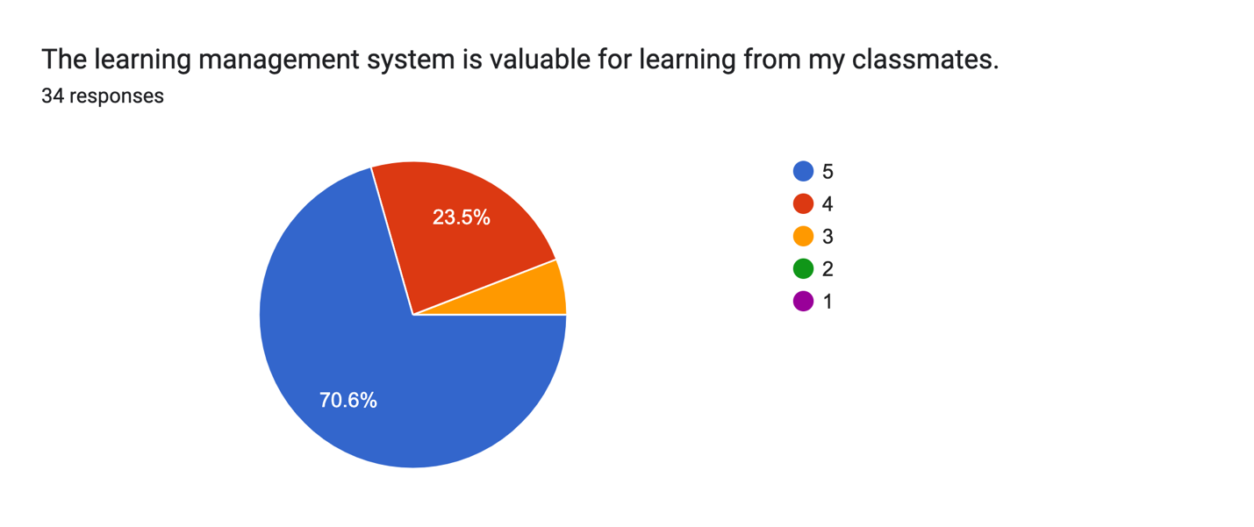
The learning management system (LMS) is regarded as a valuable resource for learning from classmates, as reflected in user feedback. A significant 70.6% of participants rated its value a 5, while 23.5% rated it a 4, demonstrating strong approval. With only 5.9% giving it a score of 3 and no lower ratings, it is clear that the majority of users appreciate the opportunities for collaborative learning and knowledge sharing that the LMS facilitates among peers.
Fig 13
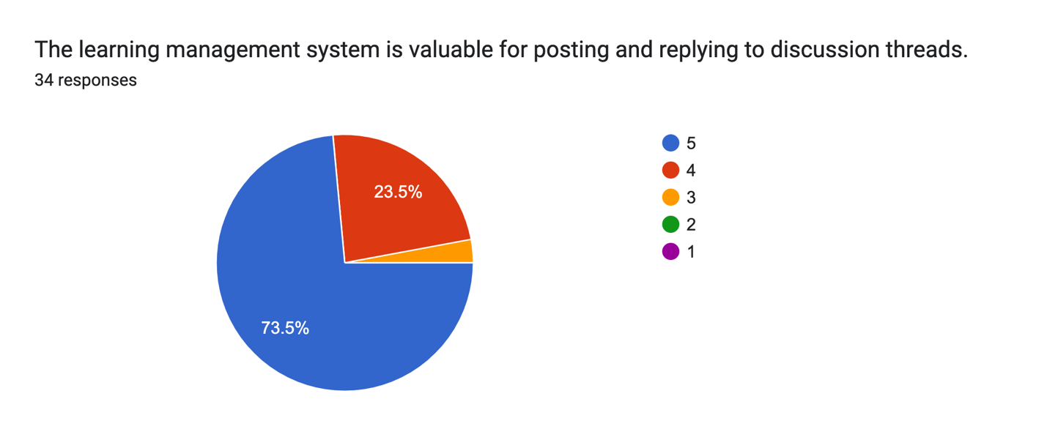
The learning management system (LMS) is considered valuable for posting and replying to discussion threads, as indicated by user ratings. An impressive 73.5% of participants rated this feature a 5, while 23.5% rated it a 4, reflecting a strong appreciation for its functionality. With only 2.9% giving it a score of 3 and no ratings lower than that, it is evident that most users find the discussion thread capabilities essential for engaging in meaningful dialogue and enhancing their learning experience.

Fig 14
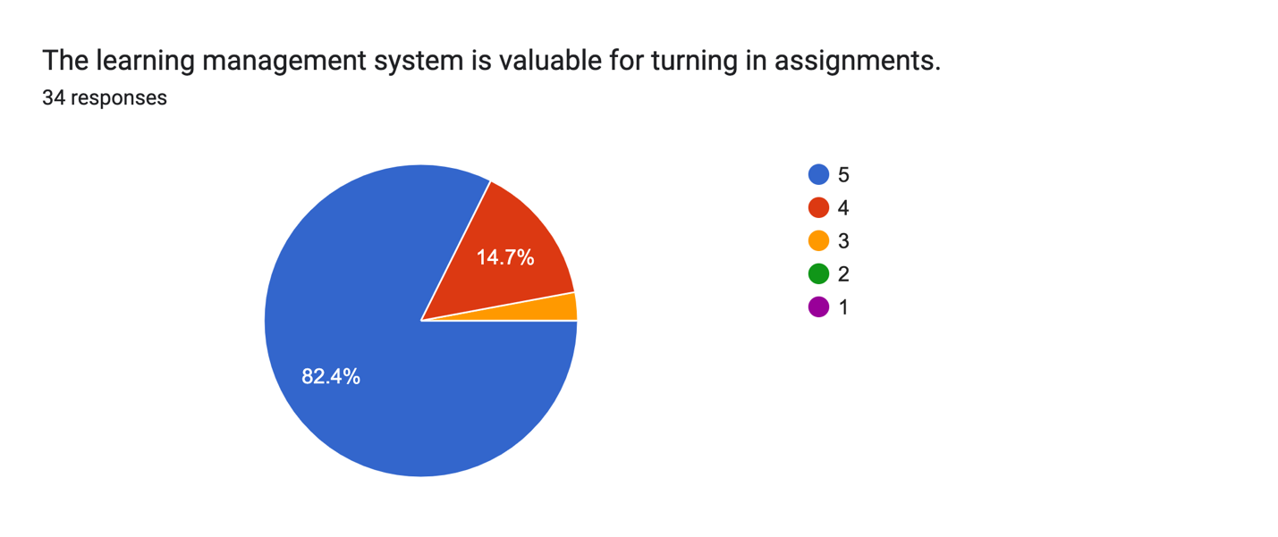
The learning management system (LMS) is deemed highly valuable for submitting assignments, as reflected in user ratings. An impressive 82.4% of participants rated this feature a 5, while 14.7% rated it a 4, showcasing strong satisfaction. With only 2.9% giving it a score of 3 and no lower ratings, it is evident that the majority of users find the assignment submission process efficient and beneficial for their academic progress.

Fig 15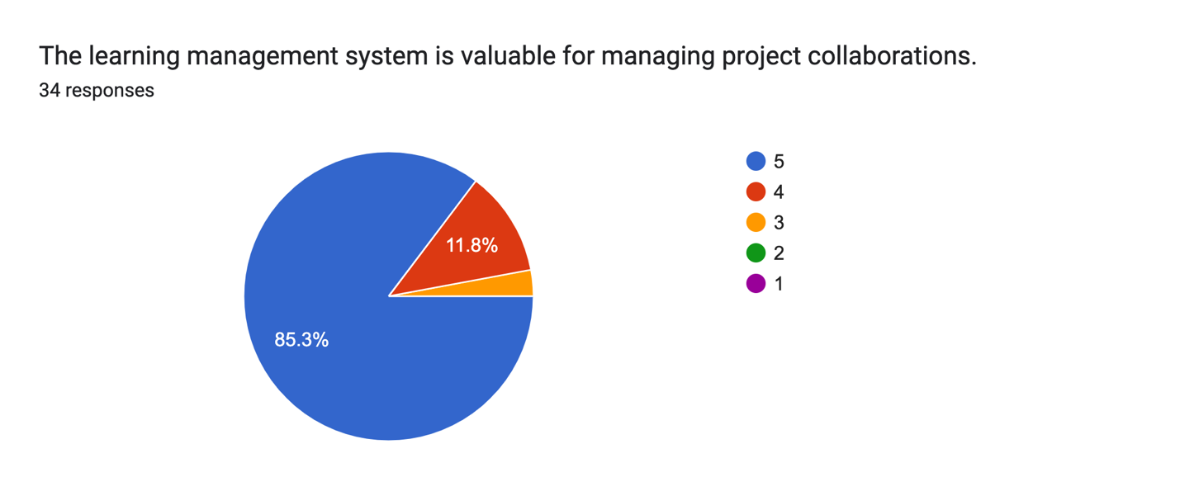
The learning management system (LMS) is regarded as highly valuable for managing project collaborations, according to user feedback. A notable 85.3% of participants rated this feature a 5, while 11.8% rated it a 4, indicating strong overall satisfaction. With only 2.9% giving it a score of 3 and no lower ratings, it is clear that the majority of users find the LMS effective in facilitating teamwork and coordination on projects, enhancing their collaborative learning experience.

Fig 16
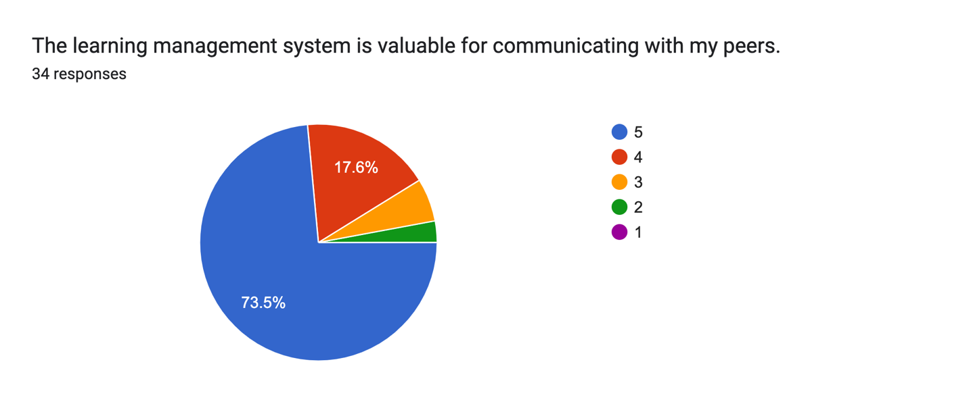
The learning management system (LMS) is seen as valuable for communicating with peers, as reflected in user ratings. A significant 73.5% of participants rated this aspect a 5, while 17.6% rated it a 4, demonstrating strong approval for its communication features. Although 5.9% rated it a 3 and 2.9% rated it a 2, there were no lower scores, indicating that most users appreciate the opportunities for peer interaction that the LMS provides, enhancing their collaborative learning experience.

Learning Quality
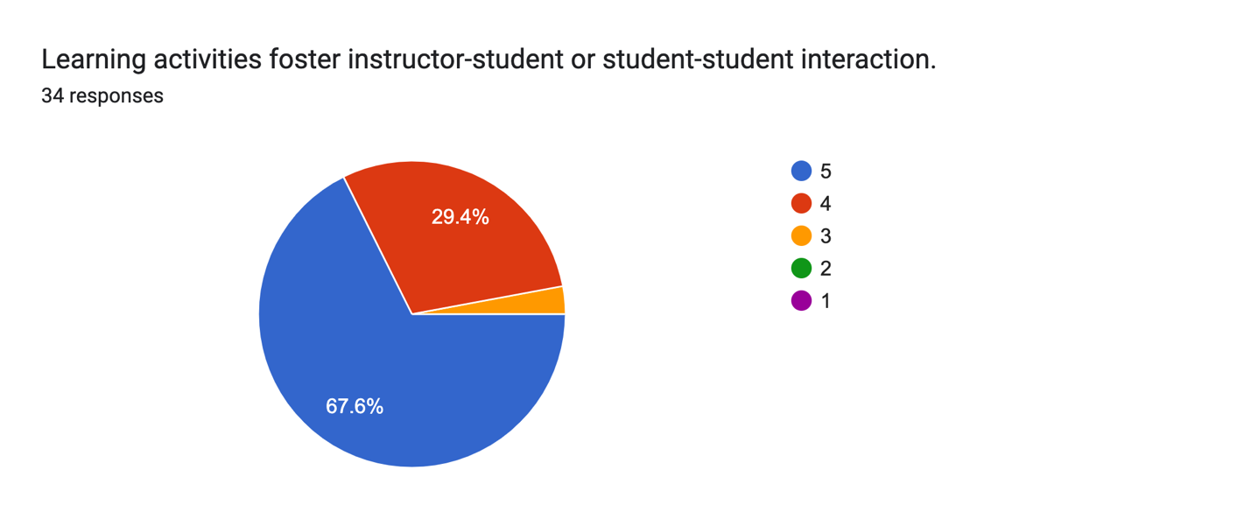
Fig 17
Learning activities within the system are recognized for fostering interaction between instructors and students, as well as among students themselves. A notable 67.6% of participants rated this aspect a 5, while 29.4% rated it a 4, indicating strong appreciation for the interactive opportunities provided. With only 2.9% giving it a score of 3 and no lower ratings, it is clear that most users find these activities effective in promoting engagement and collaboration within the learning environment.
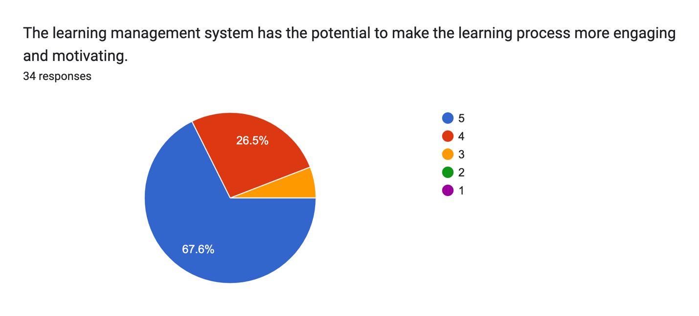
Fig 18

The learning management system (LMS) is perceived to have significant potential for making the learning process more engaging and motivating. A substantial 67.6% of participants rated this aspect a 5, while 26.5% rated it a 4, reflecting strong enthusiasm for its capabilities. With only 5.9% giving it a score of 3 and no ratings lower than that, it is evident that most users believe the LMS can enhance their learning experience by fostering greater engagement and motivation.
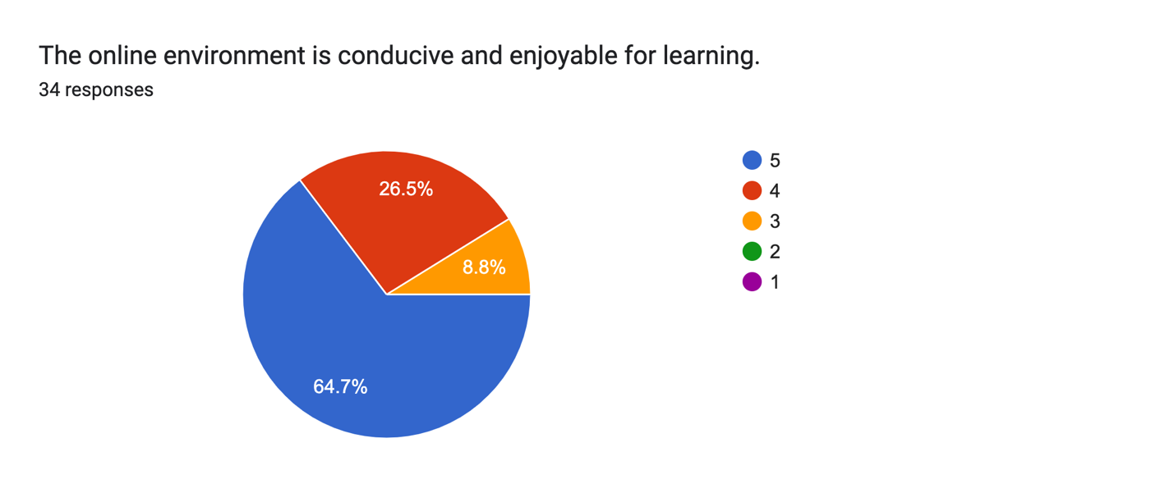
Fig 19
The online learning environment is viewed as conducive and enjoyable for learning, according to user feedback. A solid 64.7% of participants rated this aspect a 5, while 26.5% rated it a 4, indicating a generally positive reception. Although 8.8% rated it a 3, there were no lower ratings, suggesting that most users appreciate the online setting for its ability to create a favorable and engaging atmosphere for their educational experiences.
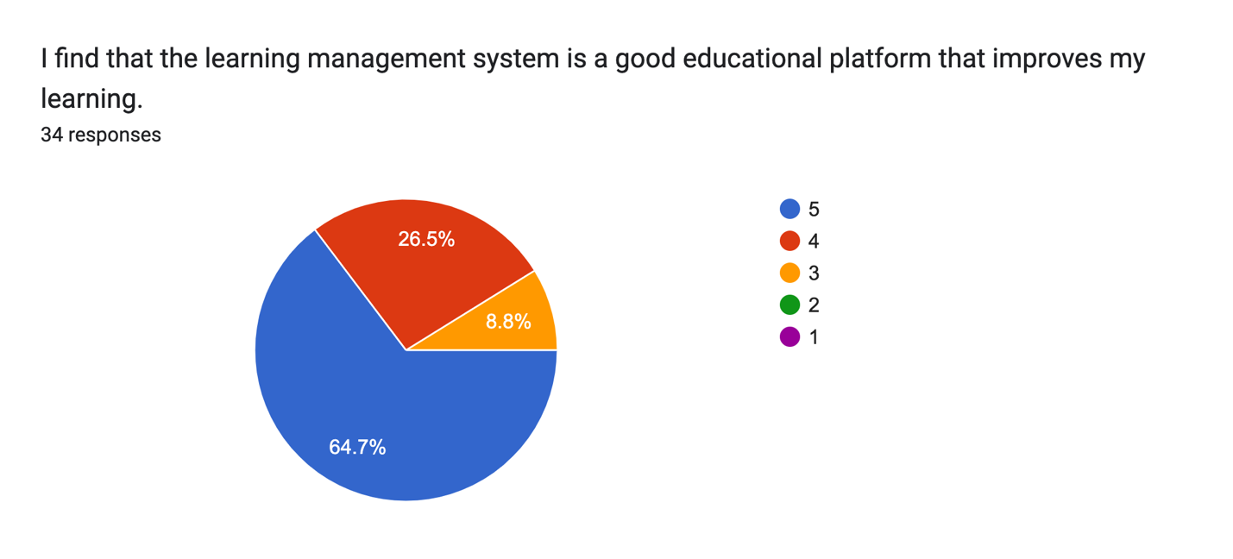
Fig 20
Users generally regard the learning management system (LMS) as a valuable educational platform that enhances their learning experiences. A notable 64.7% of participants rated it a 5, while 26.5% rated it a 4, indicating strong approval of its effectiveness. Despite 8.8% rating it a 3, there were no ratings lower than that, suggesting that the majority find the LMS beneficial in supporting their educational growth and improving their overall learning outcomes.
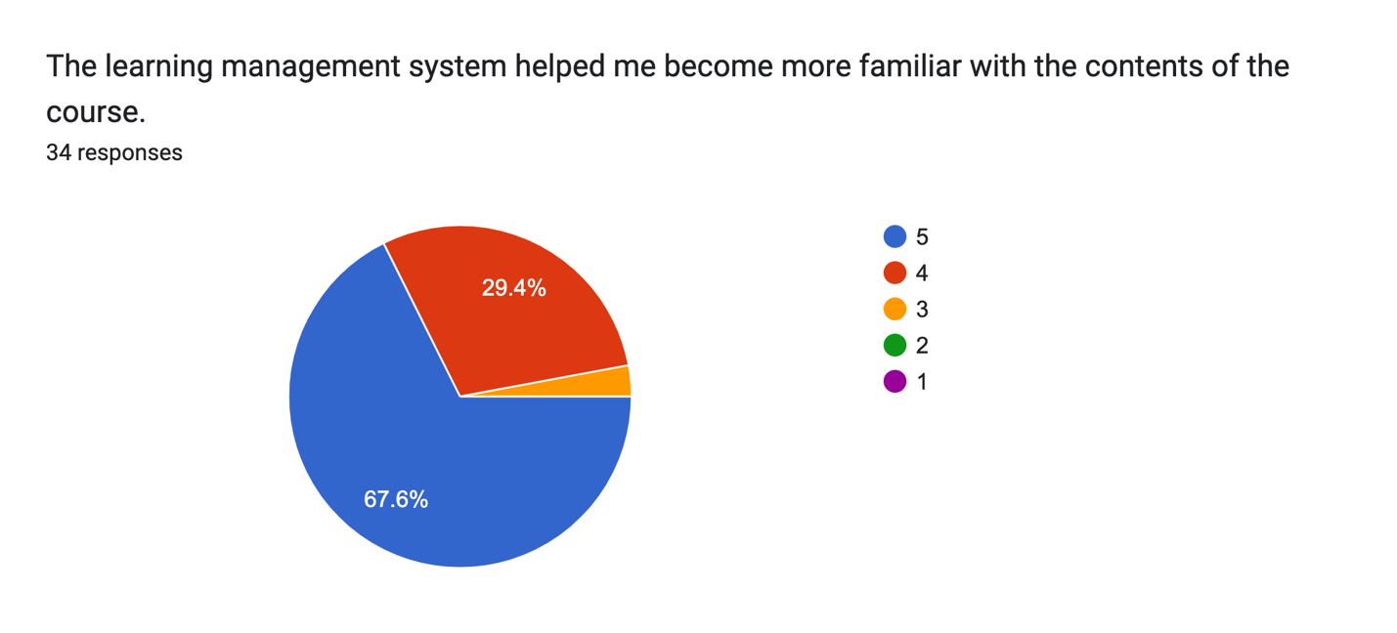
Fig 21
The learning management system (LMS) is seen as instrumental in helping users become more familiar with the course content. A significant 67.6% of participants rated this aspect a 5, while 29.4% rated it a 4, reflecting a strong consensus on its effectiveness. With only 2.9% giving it a score of 3 and no ratings lower than that, it is clear that most users appreciate how the LMS enhances their understanding and engagement with the course materials.

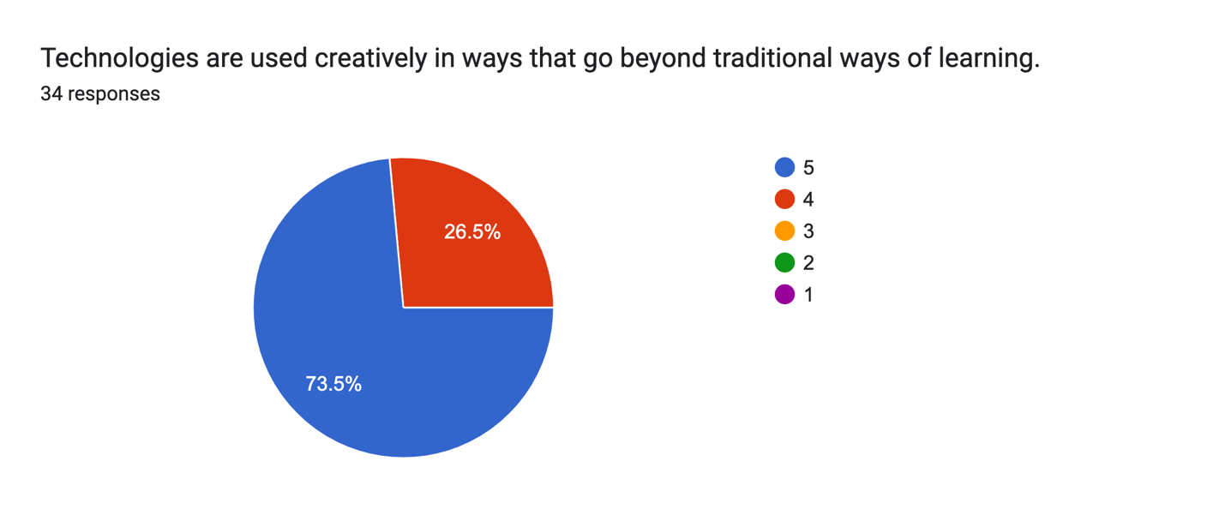

Fig 22
Users recognize that technologies are employed creatively within the learning management system (LMS), extending beyond traditional learning methods. An impressive 73.5% of participants rated this aspect a 5, while 26.5% rated it a 4, indicating strong appreciation for the innovative approaches taken. With no participants rating it lower than a 4, it is evident that most users value the creative use of technology in enhancing their learning experience and engagement.

  - Qualitative Results

Fig 23: Skill development through structured modules and performance improvement
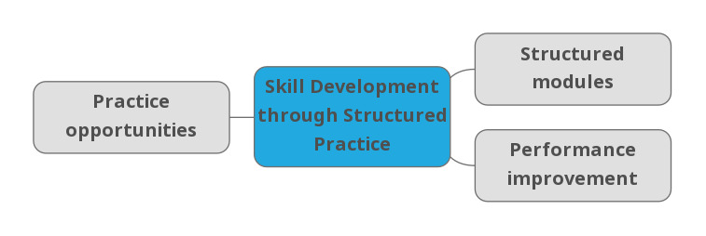
Theme 1: Skill Development through Structured Practice
The LMS functions as a scaffolded learning environment: its structured modules give students clear, sequenced guidance on what to study and practice, which makes skill-building more deliberate. Several respondents described this organization: “The structured modules provided clear guidance for me and opportunities for practice.” (Fifth respondent) and “The way it was fixed in a systematic way along with the content itself has helped in understanding and applying the lessons in oral communication.” (Second respondent). Built-in practice opportunities, such as rehearsals, topic presentations, and exercises, let students repeat tasks and refine delivery: “By participating in live presentations and getting feedback from peers, I could track my progress, and the interactive discussions provided a structured and supportive environment for continuous improvement.” (First respondent). As a result of scaffolding plus practice, students notice performance improvement in clarity, presentation skill, and task execution: “These features helped me spot areas to improve through peer critiques and live presentations, making my oral communication better.” (First respondent) and “It played a crucial role in enhancing different skills by providing opportunities for practice and improvement in a structured environment.” (Second respondent).

Fig 24: Interactive Peer Engagement
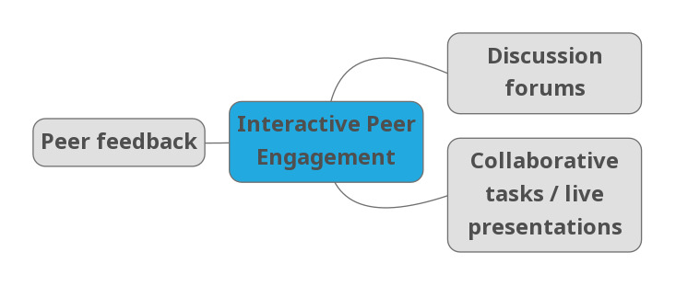
Theme 2: Interactive Peer Engagement
A central pathway for LMS impact is peer-to-peer interaction: discussion forums act as accessible spaces where students practice expressing ideas and simulate conversational exchange (“The feature…that I felt helped me a lot in practicing my oral communication skills was the discussion forum… it allowed me to communicate my thoughts and ideas as well as interact and learn from different students.” - Second respondent; “The interactive discussions…simulating real-life conversations.” - First respondent). Peer feedback furnishes targeted critiques that reveal weaknesses and offer alternative approaches: “The LMS had features like interactive discussions, peer feedback…which helped me practice speaking, receive helpful critiques…” (First respondent) and “Having constructive feedback can also help me to engage my skills regarding my future oral presentations.” (Third respondent). Finally, collaborative tasks and live presentations recreate the dynamics of real-time speaking and teamwork, increasing comfort with immediate response and cooperative communication: “By participating in live presentations and getting feedback from peers, I could track my progress.” (First respondent) and “actively participating during discussions, seeking feedback from other students regarding my presentation, and collaborating with other students that improve our skills as a team.” (Third respondent).
Fig 25: Process of feedback, assessment and self-regulation
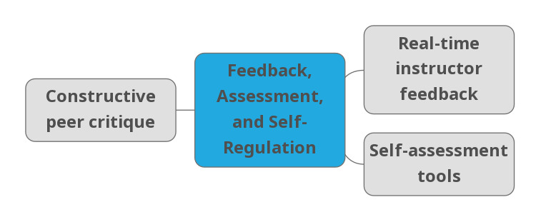
Theme 3: Feedback, Assessment, and Self-Regulation
Feedback loops and reflective tools in the LMS are key drivers of deliberate improvement. Real-time instructor feedback gives prompt, authoritative direction that students can act on immediately: “The real-time feedback from my professor was very helpful for me as It kept me motivated and focused on my progress to do better.” (Fifth respondent). Complementing that, constructive peer critique supplies multiple perspectives and concrete suggestions for revision: “These features helped me spot areas to improve through peer critiques and live presentations.” (First respondent) and “seeking feedback from other students regarding my presentation…improve our skills as a team.” (Third respondent). Finally, self-assessment tools (rubrics, opportunities to revisit recorded work, or feeds that let students monitor progress) cultivate metacognition and tracking: “I could track my progress, and the interactive discussions provided a structured and supportive environment for continuous improvement.” (First respondent) and “The system basically provided tools for me to use, allowing me to self-assess and learn how I could improve in areas I lack.” (Fifth respondent). Together these elements let students identify gaps, plan targeted practice, and measure gains over time.
Fig 26: Confidence, Accessibility, and Professional Communication
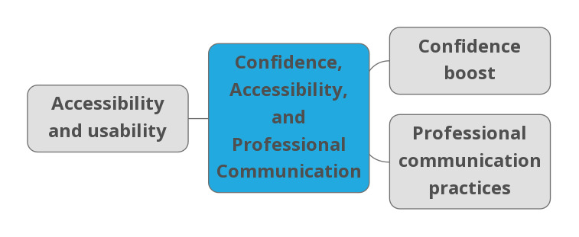
Theme 4: Confidence, Accessibility, and Professional Communication
Beyond technical skills, LMS features affect students’ attitudes and professional habits. Many respondents reported a confidence boost from practicing in a low-risk environment and receiving supportive feedback: “The interactive discussions and peer feedback made me more confident by simulating real-life conversations…” (First respondent) and “It helped me boost my confidence as I continued to work towards improvement.” (Fifth respondent). Accessibility and usability, intuitive navigation and inclusive design, lowered barriers to participation and increased engagement: “It was organized and very easy to use, so it made the learning accessible.” (Second respondent) and “The learning management system boosted my confidence through its accessibility and inclusivity.” (Second respondent). Finally, routine use of LMS communication tools encourages professional communication practices (polite tone, clear messaging, contacting instructors appropriately): the fourth respondent noted how using message threads and paging features led to more professional interactions: “Because of BigSky, I pick up and feel I can reach out to my instructors in a professional aspect,” and “I used the features in a way I can be more professional and engaging with others.” When platforms are usable and socially supportive, they not only teach technique but also shape the confidence and decorum needed for effective oral communication.
- DISCUSSION
The strong quantitative ratings for system quality, where a clear majority of students gave top marks to the LMS’s resources, submission features, and discussion tools, reflect students’ qualitative accounts of how the platform supported their learning. This finding is consistent with research demonstrating that LMS environments enhance learners’ communication skills by providing structured, interactive pathways for language practice (Terzioğlu & Kurt, 2022; Yamprayon & Jermtaisong, 2021). Students consistently described the platform’s clear layout and systematic sequencing as helpful in guiding their communication development step by step. Such structured design functions not only as technical support but also as an instructional scaffold that shapes consistent practice, clearer expectations, and gradual skill refinement. The high satisfaction with system efficiency echoes earlier studies showing that well-designed LMS interfaces can foster improvements in students’ speaking performance (Syakur et al., 2020).
Students’ high ratings for the clarity and usefulness of learning materials also align with their descriptions of how feedback and instructional content supported their learning progress. Quantitative data indicated that the LMS provided detailed and reliable materials, a finding that resonates with literature highlighting how LMS-based resources strengthen comprehension and promote more effective learning behaviors (Alturki & Aldraiweesh, 2021). Qualitatively, students explained that the platform’s materials and feedback features helped them monitor their progress, make adjustments, and target specific areas for improvement. This connection between numerical ratings and personal accounts supports the idea that high-quality information within LMS environments enables self-regulated learning by providing clear expectations and actionable guidance (Terzioğlu & Kurt, 2022).
The consistently strong scores for interaction quality parallel students’ descriptions of meaningful engagement with peers and instructors throughout the course. Quantitative satisfaction with communication features is consistent with students’ qualitative accounts of discussion forums, peer feedback, and collaborative tasks that created active spaces for exchanging ideas. Prior research similarly emphasizes that LMS-mediated interaction contributes to communication skill development by providing continuous opportunities for authentic practice and feedback (Terzioğlu & Kurt, 2022; Ismail Al-Oqaily et al., 2022). Students noted that these exchanges allowed them to simulate real conversational scenarios and refine their fluency, indicating that the LMS’s interaction tools were not merely functional but instrumental in shaping confidence and oral communication competence.
High ratings for instructional quality further support students’ qualitative reflections on how accessible activities and clear instructional processes facilitated their academic and personal development. Students described becoming more confident as they completed structured tasks, communicated with instructors, and engaged in collaborative projects, experiences consistent with findings that emphasize the importance of LMS-supported instructional design in helping students develop essential communication skills (Yamprayon & Jermtaisong, 2021; Lestari, 2019). The convergence of quantitative satisfaction and qualitative narratives indicates that well-designed instruction within LMS platforms fosters effective learning, smooth navigation, and the development of productive communication habits.
Finally, the positive ratings for learning quality reinforce themes emerging from interview data: students felt motivated, engaged, and supported as they worked on their oral communication skills. Consistent with previous research demonstrating that LMS platforms enhance learner performance and facilitate skill development through structured and interactive learning processes (Terzioğlu & Kurt, 2022; Syakur et al., 2020), the students in this study described meaningful progress resulting from regular practice, collaborative exchanges, and detailed feedback. The alignment between quantitative measures and qualitative experiences suggests that the LMS contributed not only to comprehension but also to holistic growth in confidence, fluency, and overall communication competence.
The triangulation of the results from the first and second research questions reveals a strong alignment between students’ quantitative ratings of the Learning Management System (LMS) and their qualitative experiences of skill development and engagement. Quantitative data showed consistently high satisfaction across all dimensions, system, information, interaction, instructional, and learning quality, indicating that students found the LMS highly effective in supporting the improvement of their oral communication skills. This is supported by the qualitative findings, which illustrate how these features contributed to students’ learning. The high ratings in system quality correspond with students’ descriptions of structured modules and practice opportunities that allowed them to develop their communication skills systematically and deliberately. Similarly, the positive responses regarding information quality align with the theme of feedback, assessment, and self-regulation, as students highlighted the usefulness of the LMS’s informative content, rubrics, and feedback tools in tracking progress and refining performance. The strong approval for interaction quality mirrors the theme of interactive peer engagement, where students emphasized the importance of discussion forums, peer feedback, and collaborative presentations in simulating real-life communication and enhancing their oral proficiency. Likewise, the favorable ratings in instructional quality correspond with the theme of confidence, accessibility, and professional communication, as participants noted how the LMS’s accessible design and opportunities for interaction with peers and instructors built their confidence and encouraged professionalism in their communication practices. Finally, the high scores in learning quality support the overall qualitative insight that the LMS creates an engaging, motivating, and supportive environment that promotes both cognitive and affective growth in oral communication. Together, these findings indicate that the LMS’s technical, instructional, and interactive features work cohesively to enhance learners’ oral communication competence through structured practice, meaningful interaction, feedback-driven improvement, and confidence building.
  - Conclusion
The converging results from both the quantitative ratings and qualitative accounts illustrate that the LMS functions not merely as a technical platform but as an integral part of students’ learning experience. Its organized structure, clear instructional pathways, and rich information resources appear to work together in shaping students’ communication development. Students’ high satisfaction with system, information, interaction, instructional, and learning quality is reflected in their own narratives about how these same features guided their practice, supported their self-regulation, and created opportunities for meaningful exchanges with peers and instructors. In this sense, the LMS does not operate in isolated components; instead, its various elements reinforce one another to create a coherent environment where students can steadily build their oral communication skills.
Taken together, the findings suggest that the LMS fosters not only technical ease and access to materials but also the conditions necessary for genuine skill growth. Students consistently described experiences of increased confidence, clearer expectations, and more deliberate learning, outcomes that parallel the consistently strong ratings across all quality dimensions. The system’s structured modules, informative feedback mechanisms, and interactive tools appear to translate into authentic learning moments that help students refine their proficiency and navigate communication tasks with greater assurance. Overall, the alignment between the numbers and the narratives underscores the LMS’s effectiveness as a pedagogically grounded space that supports both the cognitive and affective aspects of oral communication development.

Ethical Approval:

As per international standards or university standards written ethical approval has been collected and preserved by the author(s).

Consent
As per international standards or university standards, respondents’ written consent has been collected and preserved by the author(s).
Disclaimer (Artificial intelligence)
Option 1:
Author(s) hereby declare that NO generative AI technologies such as Large Language Models (ChatGPT, COPILOT, etc.) and text-to-image generators have been used during the writing or editing of this manuscript.
Option 2:
Author(s) hereby declare that generative AI technologies such as Large Language Models, etc. have been used during the writing or editing of manuscripts. This explanation will include the name, version, model, and source of the generative AI technology and as well as all input prompts provided to the generative AI technology
Details of the AI usage are given below:
1.
2.
3.

References
Alturki, U., & Aldraiweesh, A. (2021). Application of learning management system (LMS) during the COVID-19 pandemic: A sustainable acceptance model of the expansion technology approach. Sustainability, 13(19) https://doi.org/10.3390/su131910991
Bradley, V. M. (2021). Learning Management System (LMS) Use with Online Instruction. International Journal of Technology in Education, 4(1), 68–92. https://doi.org/10.46328/ijte.36
Gunawan, R. D., Sutisna, A., & Ana, E. F. (2024). Literature review: The role of learning management system (LMS) in improving the digital literacy of educators. Jurnal Inovasi Teknologi Pendidikan, 11(2), 116–123. https://doi.org/10.21831/jitp.v11i2.56326
Al-Oqaily, E. I., Bin Haji Salam, A. R., & Kew, S. N. (2022). The use of Blackboard in the practice of English-speaking skills among Saudi EFL learners during COVID-19. Arab World English Journal (AWEJ) 2nd Special Issue on Covid 19 Challenges https://doi.org/10.24093/awej/covid2.23
Lestari, N. (2019). Improving the Speaking Skill by Vlog (video blog) as Learning Media: The EFL Students Perspective. International Journal of Academic Research in Business and Social Sciences, 9(1), 915–925. https://doi.org/10.6007/IJARBSS/v9-i1/5490
Mauldin, R. L. (2020). 9.6 Analyzing qualitative data. In *Foundations of Social Work Research*. Mavs Open Press. https://mavmatrix.uta.edu/oer_mavsopenpress/4
Manan, N. A., Emzir, & Rahmat, A. (2020). Moodle-Based Speaking Learning Model. Journal of Physics: Conference Series, 1477(4), 042009. https://doi.org/10.1088/1742-6596/1477/4/042009
Nair Ganeser, A. (2020). A Study on Student's Perception towards Online Classes and Effectiveness in Enhancing Active Participation and Communication Skills. Universal Journal of Educational Research, 8(11B), 5958–5964. https://doi.org/10.13189/ujer.2020.082231
Loeb, S., Morris, P., Dynarski, S., Reardon, S., McFarland, D., & Reber, S. (2017). Descriptive analysis in education: A guide for researchers. National Center for Education Evaluation and Regional Assistance. http://ies.ed.gov/ncee/pubs/20174023/
Nguyen, T. C. B., & Lian, A. (2021). Exploring Challenges of Major English Students Towards Learning English Speaking Skills Online During Covid 19 Pandemic and Some Suggested Solutions. Proceedings of the AsiaCALL International Conference, 621, 135–144. https://doi.org/10.2991/assehr.k.211224.014
Oguguo, B. C. E., Nannim, F. A., Agah, J. J., Ugwuanyi, C. S., Ene, C. U., & Nzeadibe, A. C. (2021). Effect of learning management system on Student's performance in educational measurement and evaluation. Education and Information Technologies, 26(2), 1471–1483. https://doi.org/10.1007/s10639-020-10318-w
Poth, C. N., & Searle, M. (2022). Why a Focus on Integration and Complex Mixed Methods Evaluation Designs?: Introducing this Special Issue of the Canadian Journal of Program Evaluation. Canadian Journal of Program Evaluation, 36(3), 257–261. https://doi.org/10.3138/cjpe.73683
Purposive sampling. (n.d.). Research-Methodology.net. https://research-methodology.net/sampling-in-primary-data-collection/purposive-sampling/
Sahib, R., Yamin, A., Aulia, T., & Ayu, K. P. (2022). The existence of Google Classroom in online speaking skills learning by Papuan EFL students at the university level. AL-ISHLAH: Jurnal Pendidikan, 14(3), 3679–3692. https://doi.org/10.35445/alishlah.v14i3.1786
Syakur, A., Sugirin, S., Margana, M., Junining, E., & Sabat, Y. (2020). Improving English language speaking skills using “Absyak” on-line learning model for second semester in higher education. Budapest International Research and Critics in Linguistics and Education (BirLE) Journal, 3(2), 684–694. https://doi.org/10.33258/birle.v3i2.897
Terzioğlu, Y., & Kurt, M. (2022). Elevating English language learners’ speaking fluency and listening skill through a learning management system. SAGE Open. https://doi.org/10.1177/21582440221099937
Creswell, J. W. (2014). The three approaches to research. In *Research design: Qualitative, quantitative, and mixed methods approaches* (4th ed.). SAGE Publications. https://study.sagepub.com/creswellresearchdesign4e
Ulfa, S., Surahman, E., & Octaviani, H. I. (2020). Mobile Seamless Language Learning Framework to Improving Students’ Speaking Skills for Junior High Students during Pandemic Convid-19: A Case Study in Indonesian Context. Proceedings of the 1st International Conference on Information Technology and Education (ICITE 2020). https://doi.org/10.2991/assehr.k.201214.284
Yong, W. K., Husin, M. M., & Kamarudin, S. (2021). Understanding Research Paradigms: A Scientific Guide. The Journal of Contemporary Issues in Business and Government, 27(2), 5857–5865. https://doi.org/10.47750/cibg.2021.27.02.588
Koh, J. H. L., & Kan, R. Y. P. (2020). Perceptions of learning management system quality, satisfaction, and usage: Differences among students of the arts. Australasian Journal of Educational Technology https://doi.org/10.14742/ajet.5187
Willig, C., & Rogers, W. S. (2017). The SAGE Handbook of Qualitative Research in Psychology. The SAGE Handbook of Qualitative Research in Psychology. https://doi.org/10.4135/9781526405555
Yamprayoon, P., & Jermtaisong, R. (2021). Learning Management Based on Language Teaching for Communication Combined With Grouping Techniques to Develop Chinese Speaking Skills for Everyday Use of Secondary 4 Students. In Proceedings of the 6th UPI International Conference on TVET 2020 (TVET 2020) (pp. 336–340). Atlantis Press. https://doi.org/10.2991/assehr.k.210203.144
Yaprak, Z. (2022). The use of Canvas, a learning management system, to reduce EFL learners’ public speaking anxiety. International Journal of Progressive Education, 18(5), 333–347. https://doi.org/10.29329/IJPE.2022.467.20

