Adoption of Artificial Intelligence among Pre-Service Teachers of Administration Program in Indonesia: Confirmatory Composite Analysis

.
ABSTRACT

Aims: This study examined the determinants of the Adoption of Artificial Intelligence (ATAI) among pre-service teachers of administration programs in Indonesia by validating the effects of Technological Readiness (TR), Digital Literacy (DL), and Institutional Support (IS) through Confirmatory Composite Analysis within the Partial Least Squares Structural Equation Modeling (PLS-SEM) framework.
Methodology: A quantitative survey-based design applying PLS-SEM was employed to identify and validate both reflective and composite constructs of AI adoption. The research was conducted across teacher education institutions in Indonesia from January to June 2025. A total of 103 pre-service teachers enrolled in administration programs across Indonesian teacher education institutions participated in this study. Data were collected through a five-point Likert questionnaire measuring TR, DL, IS, and ATAI. Analyses were performed using SmartPLS 4 with the two-stage embedded and repeated indicators approaches. Measurement validity and reliability were confirmed via outer loadings, Average Variance Extracted (AVE), Composite Reliability (CR), and HTMT ratio. Structural relationships were tested using bootstrapping (5,000 resamples) with path coefficients, effect sizes (f²), R², and Q² statistics.
Results: DL strongly affected ATAI (β = 0.565; P = 0.000; f² = 0.401), while IS had a smaller but significant effect (β = 0.211; P = 0.014; f² = 0.056). TR showed no direct effect (β = –0.106; P = 0.137; f² = 0.021) but influenced DL (β = –0.227; P = 0.002; f² = 0.092). IS was the strongest predictor of DL (β = 0.630; P = 0.000; f² = 0.680). The model demonstrated moderate predictive accuracy, with substantial explained variance for ATAI and DL.
Conclusion: DL and IS are the principal predictors of AI adoption among pre-service teacher of administration program, while TR operates indirectly through DL. Strengthening digital literacy and institutional support is essential to promote sustainable AI integration in teacher education.

Keywords: Artificial Intelligence Adoption; Confirmatory Composite Analysis; Digital Literacy; Institutional Support; Technological Readiness; Pre-Service Teachers

1. INTRODUCTION

The rapid development of Artificial Intelligence (AI) is seen as one of the main drivers of transformation across various aspects of life, including the education sector. In the context of education, AI (Khalifa & Albadawy, 2024; Mustafa et al., 2024; Wang et al., 2024) is not only treated as a supporting tool for learning but also as a catalyst capable of revolutionizing instructional processes and bringing about new paradigms in the interaction between teachers, students, and learning resources. The application of AI in Indonesia (Syahruddin et al., 2025), particularly in the field of education, is still at an early stage. However, its potential is significant for enhancing the quality of learning, pedagogical effectiveness, and the readiness of the next generation of educators to meet 21st-century demands, making it a theme that deserves the attention of researchers.

This is particularly relevant for pre-service teachers of administration programs, who hold a strategic position in the process of integrating new technologies, including AI, into pedagogical practices. Moreover, administrative work itself is beginning to experience a paradigm shift with the adoption of AI-assisted processes (Madan & Ashok, 2023). The administrative sector is becoming a significant user of AI (Kuziemski & Misuraca, 2020; Medaglia et al., 2021). Although governments and companies have already issued guidelines for the use of AI in administration, such as the EU’s ethical guideline (Cannarsa, 2021) and UNESCO’s ethical AI (UNESCO, 2021), a deep understanding of AI adoption within the context of pre-service teachers of administration programs in Indonesia is urgently needed for further study.

Previous studies on technology acceptance in education have mostly been based on models such as the Technology Acceptance Model (Scherer et al., 2019) and the Unified Theory of Acceptance and Use of Technology (Xue et al., 2024). While these models have greatly contributed to understanding technology acceptance, research focus has tended to target contexts like language education (Xia et al., 2023), climate education (Rap & Blonder, 2024), agriculture (Zarafshani et al., 2020), electronics (Sholikah & Sutirman, 2020), and special education (Xia et al., 2023), and has focused primarily on students or practicing teachers, whereas research on pre-service teachers of administration programs remains very limited. Yet, the pre-service phase is a crucial period for developing pedagogical and professional readiness, especially in facing technological disruption. As found in a literature study (Mustafa et al., 2024), research on the theme of AI tends to be overly focused on China and the US, as well as on higher education in general, while special education targeting particular fields remains very limited. In addition, the limited research on AI adoption in this sector mostly employs confirmatory factor analysis (CFA), which is a covariance-based approach (Henseler & Schuberth, 2020). This approach is generally more suitable for reflective constructs, while in practice, constructs can naturally be either reflective or composite. Therefore, the use of Confirmatory Composite Analysis (CCA) based on Partial Least Squares Structural Equation Modeling (PLS-SEM) is considered more appropriate to achieve more accurate construct validity and reliability (Hair et al., 2022; Henseler & Schuberth, 2020).

This study was conducted to fill that gap by applying Confirmatory Composite Analysis to test the AI adoption model among pre-service teachers of administration programs in Indonesia. Through this approach, a more comprehensive understanding of AI adoption dimensions, both reflective and formative, can be obtained, thereby providing stronger theoretical and practical contributions. This study is expected to contribute to the theoretical domain by expanding the literature on technology adoption through the validation of the AI adoption construct using Confirmatory Composite Analysis, which is relatively new in educational research. In the practical domain, the results of this study can be used as a reference in designing technology-based curricula, developing digital competencies for pre-service teachers of administration programs, as well as formulating educational policies that are adaptive to AI developments, particularly in Indonesia.

2. methods

This study employs a quantitative approach with a survey method to identify and test the constructs of Artificial Intelligence adoption among pre-service teachers in Indonesia. Data analysis was carried out using Partial Least Squares Structural Equation Modeling (PLS-SEM) through the SmartPLS 4 software, which enables the application of Confirmatory Composite Analysis (CCA). The research population consists of pre-service teachers of administration programs in Indonesia who are currently undertaking teacher professional education. The sample was determined using purposive sampling, with respondents meeting the criteria of being in the final stage of either an undergraduate teacher education program or a teacher professional education program (PPG). The sample size was adjusted according to the recommendations of Hair et al. (2022) for PLS-SEM analysis, namely at least 10 times the maximum number of indicators in the reflective or formative constructs estimated in the model. The total of 103 respondents collected met this minimum criterion, allowing for adequate analysis. The research instrument was a structured questionnaire developed based on the adaptation of constructs from AI adoption models, starting from Technology Readiness (Parasuraman & Colby, 2015) and AI Technology Adoption (Abdullah & Almaqtari, 2024). Each indicator was measured using a five-point Likert scale, ranging from “strongly disagree” to “strongly agree.” Before being widely distributed, the instrument was validated through expert review to ensure content appropriateness.

The data analysis procedure was conducted using the SmartPLS 4 application. It began with the evaluation of the measurement model (outer model) using the embedded two-stage modeling approach to test the lower-order and then higher-order constructs (Sarstedt et al., 2019). This modeling utilized the repeated indicators approach to examine the outer loadings of the lower-order constructs, then saved the construct scores to obtain the outer loadings of the higher-order constructs (Hair et al., 2022; Sarstedt et al., 2019). For reflective constructs, convergent validity was tested through outer loading values (>0.70) and Average Variance Extracted (AVE) (>0.50). Internal reliability was evaluated using the values of Composite Reliability (CR) and Cronbach’s Alpha (≥0.70). Discriminant validity was examined using the Heterotrait-Monotrait Ratio (HTMT), with a threshold value below 0.90 for acceptance. For composite constructs, evaluation was performed through the significance of outer weights from bootstrapping results as well as multicollinearity tests using the Variance Inflation Factor (VIF) with a value < 5.00 as the standard. Next, the structural model (inner model) was evaluated. At this stage, the significance of the relationships between constructs was analyzed using path coefficient values obtained from 5,000 resampling bootstrapping. The model's quality was evaluated using the coefficient of determination (R²), effect size (f²), and predictive relevance (Q²). In addition, model fit was reported using the Standardized Root Mean Square Residual (SRMR).

3. results and discussion

3.1 Results

The results of the reliability and validity testing (table 1) of the constructs show that all instruments have met the criteria, both in lower-order and higher-order modeling. Starting from the lower-order, the value of Cronbach’s α > 0.700, with the lowest at dimension LD_1 (0.781) and the highest at dimension KT_3 (0.888). The value > 0.700, ranging from 0.790 (LD_1) to 0.900 (LD_2 & KT_3), and similarly, the composite reliability value is > 0.700, ranging from 0.867 (LD_3) to 0.927 (KT_3). This indicates that each construct has adequate composite reliability and can be trusted for use in structural model testing. Furthermore, the AVE value was found to be > 0.50, showing that each construct can explain more than 50 percent of the indicator variance, so convergent validity can be considered achieved, ranging from LD_3 (0.566) to KT_3 (0.762).

Table 1. Reliability and validity statistics

Var | Cronbach’s α | $$ρ_{A}$$ | CR $ρ_{C}$ | AVE
ATAI* | 0.839 | 0.839 | 0.925 | 0.861
ATAI_1 | 0.828 | 0.828 | 0.897 | 0.744
ATAI_2 | 0.871 | 0.878 | 0.907 | 0.663
DI | 0.795 | 0.806 | 0.879 | 0.708
KT* | 0.726 | 0.733 | 0.879 | 0.784
KT_3 | 0.895 | 0.900 | 0.927 | 0.762
KT_4 | 0.848 | 0.869 | 0.897 | 0.686
LD* | 0.885 | 0.890 | 0.921 | 0.743
LD_1 | 0.781 | 0.790 | 0.873 | 0.697
LD_2 | 0.888 | 0.900 | 0.915 | 0.642
LD_3 | 0.809 | 0.823 | 0.867 | 0.566
LD_4 | 0.858 | 0.858 | 0.904 | 0.701
*Italics used for higher-order construct values.

In higher-order modeling, it was found that Cronbach’s α > 0.700, with the lowest value in the KT dimension (0.726) and the highest in the LD dimension (0.885). The value > 0.700 is met, with the lowest in the KT dimension (0.733), > 0.700 with the lowest value in the KT dimension (0.879), and an AVE value > 0.50, with the lowest in the LD dimension (0.743). Higher-order modeling shows that the composite reliability is adequate and can be relied upon for use in structural model testing, and that each construct is able to explain more than 50 percent of the indicator variance.

Table 2. Discriminant validity assessment using the HTMT criterion

Var | ATAI_1 | ATAI_2 | DI | KT_3 | KT_4 | LD_1 | LD_2 | LD_3 | LD_4 | ATAI | KT
ATAI_1
ATAI_2 | 0.847
DI | 0.587 | 0.634
KT_3 | 0.145 | 0.167 | 0.121
KT_4 | 0.199 | 0.174 | 0.197 | 0.637
LD_1 | 0.730 | 0.647 | 0.643 | 0.160 | 0.123
LD_2 | 0.662 | 0.717 | 0.600 | 0.145 | 0.190 | 0.848
LD_3 | 0.647 | 0.516 | 0.585 | 0.190 | 0.149 | 0.767 | 0.766
LD_4 | 0.755 | 0.711 | 0.693 | 0.148 | 0.144 | 0.756 | 0.778 | 0.774
ATAI | - | - | 0.658 | 0.165 | 0.192 | 0.709 | 0.727 | 0.591 | 0.760
KT | 0.183 | 0.201 | 0.174 | - | - | 0.160 | 0.177 | 0.202 | 0.192 | 0.224
LD | 0.747 | 0.736 | 0.717 | 0.162 | 0.159 | - | - | - | - | 0.821 | 0.207

The results of the discriminant validity test using the HTMT criterion (table 2) show that all heterotrait-monotrait ratio values are below the threshold of 0.85 as recommended by Henseler et al. (2015). This indicates that each construct in the model has adequate discriminant validity. In other words, different constructs can be empirically distinguished, so there is no overlap in meaning between constructs. In more detail, the HTMT values between the constructs ATAI, DI, KT, and LD range from 0.162 to 0.821. The highest value is found in the relationship between ATAI and LD, with a score of 0.821, which remains below the maximum limit of 0.85, thus still meeting the criteria. This demonstrates that although there is conceptual proximity between these constructs, they can still be treated as separate constructs. The relatively low HTMT values in other construct combinations, such as between KT and DI (0.174) and KT and LD (0.207), further strengthen the evidence that discrimination between constructs is well maintained.

Table 3. Multicolinearity and Outer Loading

Item/ Var | VIF | Outer loading | Item/ Var | VIF | Outer loading | Item/ Var | VIF | Outer loading
ATAI_1_1 | 1.850 | 0.849 | KT_4_13 | 1.690 | 0.767 | LD_3_14 | 1.760 | 0.787
ATAI_1_2 | 2.200 | 0.889 | KT_4_14 | 2.170 | 0.865 | LD_3_15 | 1.820 | 0.816
ATAI_1_3 | 1.790 | 0.849 | KT_4_15 | 1.890 | 0.808 | LD_3_16 | 1.700 | 0.715
ATAI_2_4 | 3.350 | 0.879 | KT_4_16 | 2.060 | 0.867 | LD_4_18 | 2.650 | 0.853
ATAI_2_5 | 3.010 | 0.879 | LD_1_1 | 2.510 | 0.861 | LD_4_19 | 2.400 | 0.869
ATAI_2_6 | 2.000 | 0.797 | LD_1_2 | 2.180 | 0.882 | LD_4_20 | 2.160 | 0.831
ATAI_2_7 | 1.740 | 0.758 | LD_1_3 | 1.390 | 0.757 | LD_4_21 | 2.213 | 0.795
ATAI_2_9 | 1.770 | 0.748 | LD_2_4 | 2.890 | 0.843 | ATAI_1* | 2.089 | 0.929
DI_1_1 | 1.600 | 0.798 | LD_2_5 | 1.950 | 0.770 | ATAI_2* | 2.089 | 0.927
DI_1_2 | 1.880 | 0.873 | LD_2_6 | 2.730 | 0.864 | KT_3* | 1.480 | 0.870
DI_1_3 | 1.670 | 0.853 | LD_2_7 | 2.850 | 0.827 | KT_4* | 1.480 | 0.900
KT_3_10 | 4.410 | 0.927 | LD_2_8 | 1.740 | 0.703 | LD_1* | 2.298 | 0.854
KT_3_11 | 1.980 | 0.815 | LD_2_9 | 2.120 | 0.789 | LD_2* | 2.737 | 0.891
KT_3_12 | 3.120 | 0.879 | LD_3_10 | 2.170 | 0.722 | LD_3* | 2.111 | 0.836
KT_3_9 | 2.640 | 0.867 | LD_3_11 | 2.030 | 0.715 | LD_4* | 2.255 | 0.868
*Italics used for higher-order values.

Overall, the results of the HTMT analysis support the conclusion that this research model meets the requirements for discriminant validity. Thus, the constructs used can be assured to have clear conceptual distinctions and do not experience conceptual multicollinearity that could interfere with the interpretation of the results of the structural model.
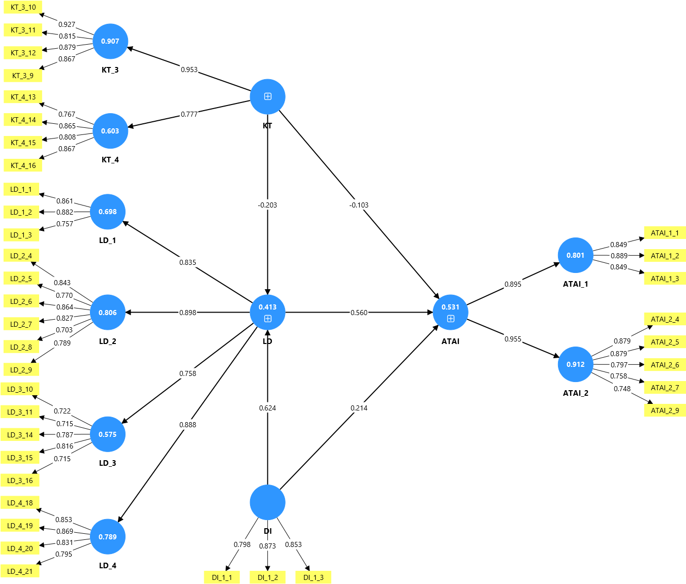

Figure 1. Repeated Indicator Approach Model

The results of the multicollinearity test (table 3) using the VIF value, with findings of VIF < 5.000, indicate that no multicollinearity issues were found in the analyzed model. In the lower-order modeling, the highest VIF was found in item ATAI_2_4 at 3.350 < 5.000, and in the higher-order model, the highest VIF was found in the LD_2 dimension at 2.737 < 5.000, indicating no multicollinearity issues were detected. Furthermore, the results of the factor testing showed outer loading values ranging from 0.715 to 0.927 (lower-order) and from 0.836 to 0.929 (higher-order). This indicates that each item reflects its dimension with a high category (outer loading > 0.700) in both the lower-order model (figure 1) and the higher-order model (figure 2).

Table 4. Path coefficients

Var | M | STD | T | P | F² | R² | R² adj | Q²
DI -> ATAI | 0.211 | 0.085 | 2.469 | 0.014 | 0.056
KT -> ATAI | -0.106 | 0.070 | 1.488 | 0.137 | 0.021
LD -> ATAI | 0.565 | 0.088 | 6.473 | 0.000 | 0.401
DI -> LD | 0.630 | 0.061 | 10.393 | 0.000 | 0.680
KT -> LD | -0.227 | 0.076 | 3.054 | 0.002 | 0.092
ATAI |  |  |  |  |  | 0.536 | 0.522 | 0.324
LD |  |  |  |  |  | 0.421 | 0.409 | 0.391

The results of the structural path testing (Table 4) show that the relationship between DI and ATAI is significant (M = 0.211, T = 2.469, P = 0.014). The F² value of 0.056 indicates that the effect of DI on ATAI is categorized as small. The relationship between KT and ATAI is not significant, with a p-value coefficient of 0.137. The relationship between LD and ATAI is significant, with a (M = 0.565, T = 6.473, P = 0.000). The obtained f² value is 0.401, indicating a large effect. Furthermore, the relationship between DI and LD is significant, with (M = 0.630, T = 10.393, and P = 0.000), and the resulting F² value is 0.680, showing a very large effect. The relationship between KT and LD is also found to be significant, with a coefficient (M = -0.227, T = 3.054, P = 0.002), and an F² value of 0.092, which indicates a small to medium effect.
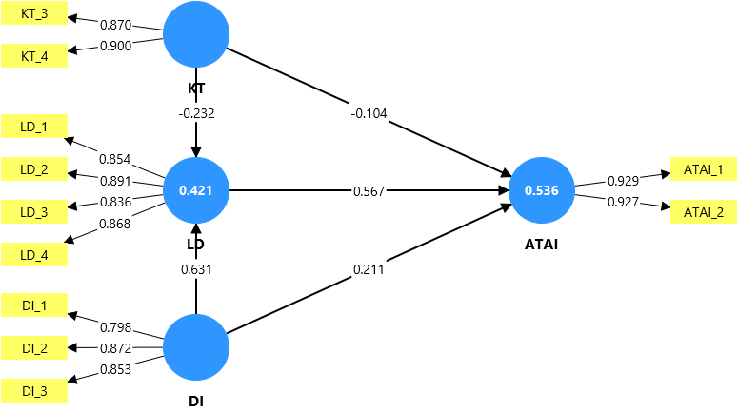

Figure 2. Model Embedded Two-Stage Approach

The R² value (figure 2) for ATAI is 0.536, with an adjusted R² = 0.522. This indicates that 53.6% of the variance in ATAI can be explained by DI, KT, and LD. The R² value for LD is 0.421 with an adjusted R² = 0.409, which means that 42.1% of the variance in LD can be explained by DI and KT. The Q² predict value for ATAI is 0.324, and for LD it is 0.391. Both values are above zero, indicating that the model has good predictive relevance.

3.2 Discussion

The research results show that LD serves as the main predictor in explaining ATAI. The path coefficient between LD and ATAI is statistically significant, with a mean of 0.565, a T-value of 6.473, and a p-value of 0.000. The obtained f² value of 0.401 indicates a strong effect. This demonstrates that the LD possessed by pre-service teachers of the administration program directly contributes to the increase in ATAI during the learning process. This finding is consistent with previous research emphasizing that the integration of technology in instructional design plays a crucial role in promoting the acceptance and utilization of digital innovations in educational settings (Scherer et al., 2019; Rap & Blonder, 2024). Other studies have also confirmed that the application of technology-based instructional design models is important for improving prospective teachers’ abilities to integrate digital innovation into their pedagogical practices (Ozden et al., 2024). In line with these findings, recent studies highlight that AI literacy, motivation, and educator confidence are factors influencing successful AI adoption in teacher education (Prilop et al., 2025). This finding is further strengthened by research showing that the level of digital literacy and self-efficacy of pre-service teachers significantly affects their attitudes and engagement, indicating that enhancing digital capacity is a key factor in bolstering the acceptance of AI-based innovation in teacher education (Getenet et al., 2024). Therefore, enhancing LD capacity can be considered the most strategic and effective approach for encouraging AI adoption among pre-service teachers of administration programs.

Furthermore, DI was found to have a significant effect on ATAI, albeit with a small effect size. Structural path testing results indicate that the relationship between DI and ATAI is significant, with a mean of 0.211, a T-value of 2.469, and a p-value of 0.014. Although the effect is classified as small—indicated by an f² value of 0.056—and its contribution is not as substantial as that of LD, this result still illustrates that institutional support is an important factor in driving the adoption of new AI-based technology. This finding is consistent with previous studies showing that policy support, available resources, and educational infrastructure are determining factors that reinforce the successful implementation of technology (Mustafa et al., 2024; Wang et al., 2024). Additionally, research based on the Technology Acceptance Model (TAM) framework has shown that institutional support in the form of training provision, resources, and policies directly or indirectly influences teachers’ intentions to adopt AI (Hazzan-Bishara et al., 2025). Other studies have also noted that institutional support in the form of resources, time, training, and rewards plays a critical role in encouraging educators to adopt AI-based learning, while limited institutional support constitutes a barrier to the adoption process (Gupta & Bhaskar, 2020). This finding strengthens the results of this study, namely that institutional readiness, policy support, and digital infrastructure policies have been proven to play essential roles in ensuring the sustainability of AI-based technology implementation (Anomah, 2025).

DI’s role was also found to be very strong in influencing LD. The relationship between DI and LD is significant, with a mean of 0.630, a T-value of 10.393, a p-value of 0.000, and an f² value of 0.680, indicating an extremely large effect. The high path coefficient and very large effect demonstrate that digital literacy is a primary factor in instructional design development. This indicates that the higher the digital literacy level of prospective teachers, the higher the quality of the instructional design produced, thus increasing their readiness to adopt AI (Nuangchalerm et al., 2024). This result aligns with research showing that the development of digital literacy does not solely depend on individual ability but also on continuous institutional support through policy, infrastructure, and organizational strategies integrated into the education system (Andersen et al., 2024). Another study confirmed that support through policy, infrastructure, and practical training are key factors in building digital literacy that fosters technology-based educational transformation and AI adoption (Aleksieva, 2025). This finding is also reinforced by research asserting that adequate institutional support can strengthen pre-service teachers’ digital literacy and create readiness for the implementation of AI-based technology (Liu et al., 2025).

On the other hand, KT did not demonstrate a significant direct effect on ATAI, with a mean value of -0.106, a T-value of 1.488, a p-value of 0.137, and a very small effect size as shown by an f² value of 0.021. This indicates that conceptual knowledge regarding technology does not automatically translate into the adoption of new AI-based technologies. Nevertheless, KT was found to have a significant effect on LD in a negative direction, as indicated by a mean value of -0.227, a T-value of 3.054, a p-value of 0.002, and a small to medium effect size as shown by an f² value of 0.092. This finding suggests that KT possessed by the respondents is not yet fully integrated into instructional design and may even be unsupported unless accompanied by strong digital literacy. This is in line with research stating that, in composite constructs, indicators can contribute differently—even in directions that are not always positive (Henseler & Schuberth, 2020). Other research has indicated that increasing digital literacy does not solely depend on conceptual technological knowledge, but also on learning support and psychological needs satisfaction, such as autonomy and competence in technology use. This explains why technological knowledge without adequate practice and support does not always contribute positively to the improvement of digital literacy or the adoption of new technology (Chiu et al., 2022). This result is consistent with other research asserting that teachers’ digital literacy is more effectively achieved through direct and collaborative learning experiences rather than merely through conceptual understanding of technology (Cosby et al., 2023).

The results of the structural model testing show that the R² value for the ATAI variable is 0.536, with an adjusted R² of 0.522, which means that 53.6% of the variance in ATAI can be moderately explained by KT, LD, and DI. Meanwhile, the R² value for LD is 0.421, with an adjusted R² of 0.409, indicating that 42.1% of the variance in LD can be substantially explained by KT and DI. These values indicate that the model has moderate explanatory power for ATAI and substantial for LD (Hair et al., 2021). Furthermore, the Q² predict value is 0.324 for ATAI and 0.391 for LD, showing that the model has good predictive relevance, so the model is not only valid for explaining the relationships between the tested variables but can also be used to predict future trends in AI adoption (Hair et al., 2021).

Overall, the results of this study show that LD and DI are the most influential factors in driving ATAI among pre-service teachers of administration programs in Indonesia. Conversely, KT does not contribute directly to ATAI; instead, it only plays a role through its relationship with LD. Thus, the practical implications of these findings emphasize the importance of strengthening digital literacy and institutional support through curriculum, facilities, and policies oriented toward integrating AI in learning. Meanwhile, KT should focus on more practical and contextual applications to align with the need to develop technology-based learning design.

4. Conclusion

This study was conducted to examine the adoption of Artificial Intelligence among pre-service teachers of administration programs in Indonesia using Confirmatory Composite Analysis through SmartPLS 4. The analysis results show that LD has proven to be the most dominant factor influencing ATAI with a large effect, while DI is found to have a significant effect both directly on ATAI and very strongly on LD. Conversely, KT does not have a direct influence on ATAI but is found to contribute to LD with a small to moderate effect. The moderate R² value for ATAI and substantial R² value for LD, as well as the positive Q² values, indicate that the model has adequate explanatory quality and predictive relevance. Based on these findings, it can be concluded that the success of Artificial Intelligence adoption in pre-service teacher of administration programs is more determined by the strengthening of LD and support from DI, while KT only plays an indirect role through its relationship with LD. Therefore, focusing on increasing digital literacy and adequate institutional support should be prioritized in developing curricula and educational policies, while technological knowledge needs to be directed toward practical aspects to strengthen LD and ultimately enhance ATAI.

Consent

As per international standards or university standards, Participants’ written consent has been collected and preserved by the author(s).

Disclaimer (Artificial intelligence)
Author(s) hereby declare that NO generative AI technologies such as Large Language Models (ChatGPT, COPILOT, etc.) and text-to-image generators have been used during the writing or editing of this manuscript.

References

Abdullah, A. A. H., & Almaqtari, F. A. (2024). The impact of artificial intelligence and Industry 4.0 on transforming accounting and auditing practices. Journal of Open Innovation: Technology, Market, and Complexity, 10(1), 100218. https://doi.org/10.1016/j.joitmc.2024.100218

Aleksieva, L. (2025). Preparing Pre-Service Teachers for the Digital Transformation of Education: Exploring University Teacher Educators’ Views and Practical Strategies. Education Sciences, 15(4), 1-38. https://doi.org/10.3390/educsci15040404

Andersen, L. B., Basballe, D. A., Buus, L., Dindler, C., Hansen, T. I., Hjorth, M., Iversen, O. S., Johannessen, C. M., Kanstrup, K. H., Lorentzen, R. F., Misfeldt, M., Musaeus, L. H., Nielsen, C. B., Petersen, M. G., Schrøder, V., & Slot, M. F. (2024). Infrastructuring digital literacy in K-12 education: A national case study. International Journal of Child-Computer Interaction, 42(1), 100697. https://doi.org/10.1016/j.ijcci.2024.100697

Anomah, S. (2025). Telematics and Informatics Reports Assessing the institutional readiness and capacity for AI adoption in public audit institutions in developing countries: evidence from Ghana. Telematics and Informatics Reports, 20(1), 100260. https://doi.org/10.1016/j.teler.2025.100260

Cannarsa, M. (2021). Ethics guidelines for trustworthy AI. In L. A. DiMatteo, A. Janssen, P. Ortolani, F. de Elizalde, M. Cannarsa, & M. Durovic (Eds.), The Cambridge Handbook of Lawyering in the Digital Age, 283–297. chapter, Cambridge: Cambridge University Press. https://doi.org/10.1017/9781108936040.022

Chiu, T. K. F., Sun, J. C. Y., & Ismailov, M. (2022). Investigating the relationship of technology learning support to digital literacy from the perspective of self-determination theory. Educational Psychology, 42(10), 1263–1282. https://doi.org/10.1080/01443410.2022.2074
966

Cosby, A., Fogarty, E. S., & Manning, J. (2023). Digital Literacy and Digital Self-Efficacy of Australian Technology Teachers. Education Sciences, 13(5). https://doi.org/10.3390/educsci13050530

Getenet, S., Haeusler, C., Redmond, P., Cantle, R., & Crouch, V. (2024). First-year Preservice Teachers’ Understanding of Digital Technologies and Their Digital Literacy, Efficacy, Attitude, and Online Learning Engagement: Implication for Course Design. Technology, Knowledge and Learning, 29(3), 1359–1383. https://doi.org/10.1007/s10758-023-09724-z

Gupta, K. P., & Bhaskar, P. (2020). Inhibiting and Motivating Factors Influencing Teachers’ Adoption of AI-Based Teaching and Learning Solutions: Prioritization Using Analytic Hierarchy Process. Journal of Information Technology Education: Research, 19(1), 693-723. https://doi.org/10.28945/4640

Hair, J. F., Hult, G. T. M., Ringle, C. M., & Sarstedt, M. (2022). A Primer On Partial Least Squares Structural Equation Modeling. SAGE Publications.

Hair, J. F., Hult, G. T. M., Ringle, C. M., Sarstedt, M., Danks, N. P., & Ray, S. (2021). Partial least squares structural equation modeling (PLS-SEM) using R (3rd ed.). Springer. https://doi.org/10.1007/978-3-030-80519-7_7

Hazzan-Bishara, A., Kol, O., & Levy, S. (2025). The factors affecting teachers’ adoption of AI technologies: A unified model of external and internal determinants. Education and Information Technologies, 30(11), 15043–15069. https://doi.org/10.1007/s10639-025-13393-z

Henseler, J., & Schuberth, F. (2020). Using confirmatory composite analysis to assess emergent variables in business research. Journal of Business Research, 120(1), 147–156. https://doi.org/10.1016/j.jbusres.2020.07.026

Khalifa, M., & Albadawy, M. (2024). Using artificial intelligence in academic writing and research: An essential productivity tool. Computer Methods and Programs in Biomedicine Update, 5(1), 100145. https://doi.org/10.1016/j.cmpbup.2024.100145

Kuziemski, M., & Misuraca, G. (2020). AI governance in the public sector: Three tales from the frontiers of automated decision-making in democratic settings. Telecommunications Policy, 44(6), 101976. https://doi.org/10.1016/j.telpol.2020.101976

Liu, D., Sun, Z., & Cui, Y. (2025). How institutional support enhances teacher engagement in online teaching: chain mediation effects of digital self-efficacy and negative emotions. Frontiers in Psychology, 16(1), 1–12. https://doi.org/10.3389/fpsyg.2025.1601764

Madan, R., & Ashok, M. (2023). AI adoption and diffusion in public administration: A systematic literature review and future research agenda. Government Information Quarterly, 40(1), 101774. https://doi.org/10.1016/j.giq.2022.101774

Medaglia, Rony, Gil-Garcia, J. Ramon, & Pardo, Theresa A. (2021). Artificial Intelligence in Government: Taking Stock and Moving Forward. Social Science Computer Review, 41(1), 123–140. https://doi.org/10.1177/08944393211034087

Mustafa, M. Y., Tlili, A., Lampropoulos, G., Huang, R., Jandrić, P., Zhao, J., Salha, S., Xu, L., Panda, S., Kinshuk, López-Pernas, S., & Saqr, M. (2024). A systematic review of literature reviews on artificial intelligence in education (AIED): a roadmap to a future research agenda. Smart Learning Environments,11(59), 1-33. https://doi.org/10.1186/s40561-024-00350-5

Nuangchalerm, P., Prachagool, V., Saregar, A., & Yunus, Y. M. (2024). Fostering Pre-Service Teachers’ AI Literacy through School Implications. Journal of Philology and Educational Sciences, 3(2), 77–86. https://doi.org/10.53898/jpes2024327

Ozden, S. Y., Yang, H., Wen, H., & Shinas, V. H. (2024). Reflections from a teacher education course built on the TPACK framework: Examining the impact of the technology integration planning cycle on teacher candidates’ TPACK development and practice. Social Sciences and Humanities Open, 9(2102), 100869. https://doi.org/10.1016/j.ssaho.2024.100869

Parasuraman, A., & Colby, C. L. (2015). An Updated and Streamlined Technology Readiness Index: TRI 2.0. Journal of Service Research, 18(1), 59–74. https://doi.org/10.1177/1094670514539730

Prilop, C. N., Mah, D. K., Jacobsen, L. J., Hansen, R. R., Weber, K. E., & Hoya, F. (2025). Generative AI in teacher education: Educators’ perceptions of transformative potentials and the triadic nature of AI literacy explored through AI-enhanced methods. Computers and Education: Artificial Intelligence, 9(1), 100471. https://doi.org/10.1016/j.caeai.2025.100471

Rap, S., & Blonder, R. (2024). Technology Acceptance When Teaching Climate Change. Journal of Science Education and Technology, May. https://doi.org/10.1007/s10956-024-10125-9

Sarstedt, M., Hair, J. F., Cheah, J. H., Becker, J. M., & Ringle, C. M. (2019). How to specify, estimate, and validate higher-order constructs in PLS-SEM. Australasian Marketing Journal, 27(3), 197–211. https://doi.org/10.1016/j.ausmj.2019.05.003

Scherer, R., Siddiq, F., & Tondeur, J. (2019). The technology acceptance model (TAM): A meta-analytic structural equation modeling approach to explaining teachers’ adoption of digital technology in education. Computers & Education, 128, 13–35. https://doi.org/10.1016/j.compedu.2018.09.009

Sholikah, M., & Sutirman, S. (2020). How technology acceptance model (TAM) factors of electronic learning influence education service quality through students’ satisfaction. TEM Journal, 9(3), 1221–1226. https://doi.org/10.18421/TEM93-50

Syahruddin, S., Saleh, M. S., Mailizar, M., Saleh, M. S., Habibi, A., & Alqahtani, T. M. (2025). Responsible AI in Indonesian higher education: A survey in sports education and public health programs. Social Sciences and Humanities Open, 11(March). https://doi.org/10.1016/j.ssaho.2025.101445

UNESCO. (2021). Ethics of Artificial Intelligence. UNESCO. https://unesdoc.unesco.org/ark:/48223/pf0000381137

Wang, S., Wang, F., Zhu, Z., Wang, J., Tran, T., & Du, Z. (2024). Artificial intelligence in education: A systematic literature review. Expert Systems with Applications, 252(PA), 124167. https://doi.org/10.1016/j.eswa.2024.124167

Xia, X., Chen, B., Feng, M., & Jing, Y. (2023). A Study on Educational Technology Acceptance of Special Education Teachers in Language Teaching Based on TAM Model. International Journal of Information and Education Technology, 13(10), 1591–1596. https://doi.org/10.18178/ijiet.2023.13.10.1966

Xue, L., Rashid, A. M., & Ouyang, S. (2024). The Unified Theory of Acceptance and Use of Technology (UTAUT) in Higher Education: A Systematic Review. SAGE Open, 14(1), 1–22. https://doi.org/10.1177/21582440241229570

Zarafshani, K., Solaymani, A., D’Itri, M., Helms, M. M., & Sanjabi, S. (2020). Evaluating technology acceptance in agricultural education in Iran: A study of vocational agriculture teachers. Social Sciences & Humanities Open, 2(1), 100041. https://doi.org/10.1016/j.ssaho.2020.100041

\

