Baseline Assessment of Priority Polycyclic Aromatic Hydrocarbons in Soils Surrounding the Rooppur Nuclear Power Plant, Bangladesh

ABSTRACT
Polycyclic aromatic hydrocarbons (PAHs) are found in soil sample which originates from various natural and anthropogenic activities like incomplete combustion of fossil fuels, natural fires, volcanic eruptions, thermal geological reactions, industrial processes etc. PAHs are thought to be carcinogenic and 16 unsubstituted PAHs have been marked as priority pollutants by USEPA. Rooppur Nuclear Power Plant (RNPP) is to be Bangladesh’s first nuclear power plant facility that has been under construction since November 2017, and has not been operational yet. This study aims to investigate the presence of four priority Polycyclic Aromatic Hydrocarbons (PAHs) in the soil samples collected from the proximity of Bangladesh's Rooppur Nuclear Power Plant (RNPP). Analysis of twelve soil samples collected from three different sites around the RNPP facility were evaluated for naphthalene, phenanthrene, anthracene, and fluorene contamination level by Gas Chromatography-Mass Spectrometry (GC-MS) technique. The analysis revealed PAH contamination, ranging from 0.81 ppb to 130.22 ppb across the study sites, exceeding the established permissible limits for Naphthalene (10 ppb) and 3-ring PAHs (30 ppb) in all sample areas. Pearson correlation analysis demonstrated significant linearity between Anthracene, Phenanthrene, and Fluorene (r>0.975, p<0.001), while Naphthalene’s mobility was shown by its presence at a significant depth of 36 m at the RNPP boring site. This study establishes a pre-operational baseline, suggesting that current contamination is primarily due to regional industrial activities and transportation emissions rather than nuclear facility operations.
Keywords: Polycyclic aromatic hydrocarbon, Soil contamination, GC-MS, Nuclear power plant, Pollution assessment

1. Introduction
Polycyclic Aromatic Hydrocarbons (PAHs) are a group of environmental pollutants with both natural and anthropogenic origins [Alegbeleye et al., 2017; WHO, 2010]. The compounds are mainly produced by the incomplete combustion processes and are commonly found in environmental matrices [Reizer et al., 2022]. The environmental health concern of the PAHs is especially due to their persistence and potential for bioaccumulation in soil systems and other such matrices [Wang et al., 2024].
The carcinogenic potential of some PAH compounds has led to their being listed as priority pollutants by all environmental health concerned agencies around the globe [Sharma et al., 2025]. On a global scale, such pollution is attributed to be the cause of 3 to 9 million premature deaths annually by the World Health Organization (WHO) [Akter et al., 2023]. The United States Environmental Protection Agency (USEPA/EPA) has listed sixteen individual PAHs as compounds of particular interest based on their reported health effects [Keith 2015.]. PAHs are considered to be mainly pyrolytic agents which pollute the environment coming from various sources including coal tar, crude oils, coal, and various petrogenic refinery products [Lake et al., 1979; Sporstol et al., 1983; Merrill et al., 1985]. Because of their low solubility and high hydrophobicity, PAHs readily get adsorbed by the organic systems and exhibits high mobility through most of the environmental matrices. Studies indicate that soil is a primary reservoir for PAHs, leading to contamination of the soil surface, resulting in their accumulation in soil matrices where they can persist for extended periods [Wilson et al., 1993; Lu et al., 2011; Wild et al., 1995]. Some countries have established guidelines for cleaning up soil contaminated with PAHs, and other techniques for decontaminating soil from PAHs have been documented in scientific literature [Rivas et al., 2006; Samanta et al., 2002; Alexander, 1994; Newman et al., 2004; Chaudhry et al., 2005]. This study specifically aimed to identify four priority polycyclic aromatic hydrocarbons (PAHs)- Naphthalene, Phenanthrene, Anthracene, and Fluorene from around the first nuclear powerplant on Bangladesh in Rooppur. In this preliminary environmental pollutant study, the selected four priority PAHs (naphthalene, phenanthrene, anthracene and fluorene) are relatively abundant, cover a range of ring numbers and physicochemical properties, and are commonly used as markers of mixed petrogenic and pyrogenic inputs in soils and sediments. Their higher volatility and mobility compared with heavier PAHs such as benzo(a)pyrene make them suitable indicators of early-stage contamination and vertical migration towards groundwater. (Revitt et al., 2014) Resource limitations in sampling volume and GC–MS run time also required focusing on a restricted set of compounds for baseline assessment. Although the Rooppur Nuclear Power Plant is still under construction and not yet emitting operational effluents, the site is embedded in a region with dense road traffic, export-processing industries and intensive construction activities, all of which are established PAH sources. (Trang et al., 2009) Thus characterizing the existing PAH levels in soils around the RNPP as a pre-operational baseline, allowing future differentiation between legacy contamination and any impacts associated with plant operation.
Research Objectives
This study focuses on four specific PAH compounds: naphthalene, phenanthrene, anthracene, and fluorene. These compounds were selected based on their inclusion in priority pollutant lists and their relevance to environmental health assessment. Our study aims to:
- Determine baseline PAH concentrations in soils around the RNPP site
- Assess spatial distribution patterns of PAH contamination
- Evaluate contamination levels relative to environmental guidelines
- Identify potential sources contributing to observed PAH levels

2. Materials and Methods

2.1. Study Area Description
Rooppur Nuclear Power Plant (RNPP) is located in the Pabna district's Ishwardi upazila, at latitude 24.1290° N, longitude 89.0715° E, at the elevation of 29.0 meters. All sampling locations lie within a radius of 900m RNPP site, as shown in Figure 1. This plant is located in the basin of the Ganges River, close to its main channel, called locally the Padma River, which eventually joins the Brahmaputra River. This is identified as one of the most important centers for industries as well as agriculture, hosting the Ishwardi export processing zone in close vicinity of the nuclear power plant. Industrial activities in this place include the manufacture of chemicals as well as fertilizers, textile production, tanning industries, along with several other manufacturing industries. This is historically distinguished for the production of garment accessories as well as raw materials, the yarn industry, as well as the worldwide manufacture of clothing items. Transportation infrastructures, including major highways as well as rail networks, further contribute to the potential PAH emission sources in the immediate vicinity.
During this survey, sampling was intentionally conducted at three sites around the Rooppur Nuclear Power Plant, which were chosen to reflect different conditions of the environment as well as the resulting potential impacts. These locations were designated as S-1, S-2, and S-3.
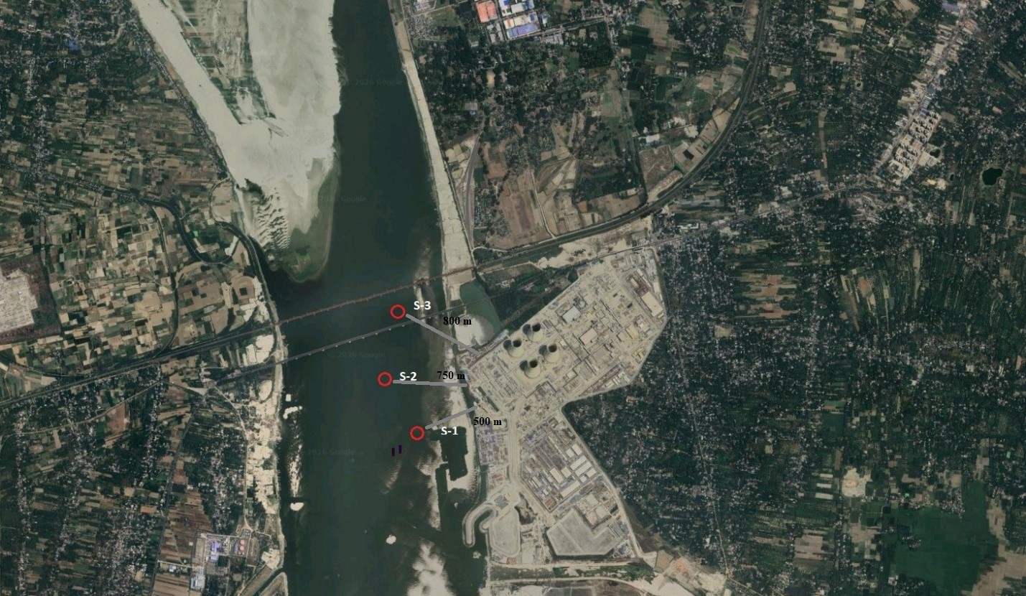
Figure-1: Sampling locations for the PAHs assessment study near the Rooppur Nuclear Power Plant (S-1, S-2, S-3).
S-1: The Power Plant's Boring Site
Identified as S-1, the site refers to the core boring location within the Rooppur Nuclear Power Plant's designated area. The sampling spot at S-1 was to provide a detailed understanding of the surface to subsurface level geological and hydrological attributes. Samples were systematically collected at multiple depths, starting from the immediate surface and extending down to a significant depth of 36 meters. This extensive vertical sampling allowed for the analysis of various conditions and the identification of any depth-dependent variations in the collected material.
S-2: The Padma River Site at Rooppur
Site S-2 is located along the nearest banks of the Padma River, adjacent to the power plant. Given the river's significant role in the local ecosystem and its potential as a pathway for environmental dispersion of pollutant materials, sampling at this location focused on the most relevant interfaces. So, the samples from the S-2 site were collected from both the surface areas, representing recent depositions or superficial water, and deep areas, which could indicate longer-term accumulation or influence from the riverbed.
S-3: The Hardinge Bridge Site
The third sampling location, S-3, refers to the Hardinge Bridge site. The Hardinge Bridge is a prominent landmark and a critical point along the Padma River, offering a different observation on the sedimentation characteristics further downstream or upstream from immediately nearest to the power plant.

2.2. Chemical Standards and Reagents
High-purity analytical standards for naphthalene, phenanthrene, anthracene, and fluorene were obtained from Sigma-Aldrich (purity ≥99.9%). HPLC-grade dichloromethane was sourced from BDH (United Kingdom), while acetone was purchased from Merck (Germany). Additional analytical reagents were procured from Merck and met analytical grade specifications.

2.3. Instrumentation and Analytical Conditions

2.3.1. GC-MS System Configuration
The analysis was conducted using a Varian 3800 gas chromatograph coupled with a Varian Saturn ion trap 2200 mass spectrometer. The system operated in total ion monitoring mode for comprehensive compound detection. A DB-5 capillary column (30 m × 0.25 mm I.D., 0.25 μm film thickness) was utilized in split mode injection (20%) and 0.2 μL samples were injected with 3 minutes solvent delay. Helium was used as carrier gas at 1.0 mL/min flow rate. Ionization was achieved through electron ionization (EI) mode. The transfer line and ion source temperatures were 280°C and 275°C respectively. Column temperatures were programmed as follows:
1. Initial temperature: The initial column temperature was set at 50°C and held for 1 minute
2. Ramp-1: Temperature was increased at a rate of 8°C/min to 200°C and held for 20 minutes
3. Ramp-2: Temperature was increased at a rate of 10°C/min to 280°C and held for 10 minutes
4. Injection port: Temperature was maintained at 250°C for the whole analysis

2.4. Analytical Quality Control

2.4.1. Calibration Standards
To enable the quantitative determination of the polycyclic aromatic hydrocarbon (PAH) components of the soil samples in consideration, specific components, i.e., Naphthalene, Anthracene, Phenanthrene, and Fluorene (NAPF), were selected as the key marker components for the calibration process.
Standard solutions were made in a high-grade dichloromethane solvent system. The four specific concentrations utilized for the calibration curve were 5 ppm, 2.5 ppm, 1.25 ppm, and 0.625 ppm. The calibration curves were derived by plotting the peak areas against the corresponding known concentrations of the reference compounds. This relationship, often expressed in the form of the linear regression equation, is used to estimate unknown NAPF concentrations in sample extracts, based on their peak areas. To ensure the integrity and suitability of the analytical system, a sample blank consisting solely of the solvent was injected to confirm the absence of any interfering peaks or contamination from the reagents or instrumentation. Additionally, a sample blind (often referred to as a matrix blank) was injected to assess any background signals or interferences introduced during the sample preparation steps. Moreover, to assess the accuracy and the precision of the method, wide-ranging recovery studies were also performed with three different standard concentrations in the spiked samples.

2.5. Sample Processing and Extraction

2.5.1. Sample Preparation
All of the collected samples underwent thorough inspection to remove debris, unwanted residue, and foreign materials. Samples were air-dried at 42°C for 4-5 days until consistent weight was achieved. Dried samples were homogenized and made into a powder using mechanical grinding to ensure representative subsampling. A precisely measured 10 grams of the processed soil sample is carefully introduced into a Soxhlet extraction apparatus and then charged with 100 mL of high-purity dichloromethane, The extraction process is carried out continuously for 8-10 hours, as supported by established methodologies [Lau et al., 2010; Saim et al., 1997].
The resulting solvent extract was filtered through Whatman filter paper to remove any particulate matter. The filtered extract is then transferred to a Kuderna-Danish (K-D) evaporator system. Using a controlled heating and evaporation process, the volume of the extract is carefully reduced to a final volume of approximately 1-2 mL. Concentrated extracts were sealed to resist evaporation and stored at -20°C until analysis. The methodologies for extracting benzo(a)pyrene and other PAHs have been thoroughly documented in numerous publications [Gan et al., 2009; Gupta et al., 1998; Budzinski et al., 1997].

2.5.2. Sample Clean-up
A silica gel clean-up column with 1 cm internal diameter was prepared. A Cotton plug was placed at the bottom of the clean-up column and 20 g pre-activated silica gel was placed right above the cotton plug in the column. Then 1.5 cm anhydrous sodium sulfate was layered above the silica gel and finally a thin sand layer was made on top of the anhydrous sodium sulfate layer. The column was conditioned with 5 mL of dichloromethane before sample application. Concentrated samples were loaded and eluted with 60 mL of dichloromethane. The collected eluent was concentrated using the K-D evaporator system, and the samples were ready to be analyzed using GC-MS.

2.6. GC-MS Analysis

2.6.1. Compound Identification
Analysis of the pre-concentrated samples was carried out using Gas Chromatography-Mass Spectrometry (GC-MS) in preestablished operating parameters. Upon the entry of the samples into the GC-MS instrument, chromatographic separation produced characteristic peaks for different PAH compounds. Each PAH compound was identified by comparing its retention time, observed in the sample chromatogram, with that of a known standard solution. The quantification of individual PAH compounds in the samples was determined by comparing their respective peak areas with the corresponding peak areas obtained from the known concentration of the standard solution. This methodology allowed for a precise determination of the concentration of each PAH present in the original samples.
Sample concentrations were calculated using the external standard method according to:
Sample strength: S = [(A_{s} - A_{b}) × C_{std}] / A_{std} — (Eq 1)
Where:
As = peak area of the samples
Ab = peak area of the blank sample
Astd = peak area of the standard solutions
Cstd = concentration of the standard solutions
Actual concentration of PAHs in (ppb): [(S × V) / 100 mL] × 1000 — (Eq 2)
Where:
S = concentration of PAHs
V = volume in Litres

2.6.2. Recovery Assessment
To assess the method recovery of PAHs, evaluation was conducted by spiking 12-meter-deep soil samples with known amounts of PAH standards of 2.5 ppm and 5.0 ppm. Subsequent analyses were performed using the identical methods applied to the original samples.
Recovery percentages were calculated as:
Recovery: (%):
RS = (Actual concentration of the sample spike area / concentration of the spike) × 100 % — (Eq 3)

3. Results and Discussion

3.1. Analytical Methodology and Characterization of PAHs
For accurate quantification of polycyclic aromatic hydrocarbons (PAHs), pre-concentrated samples underwent analysis using gas chromatography-mass spectrometry (GC-MS), a widely recognized and commonly employed technique for identifying and quantifying volatile and semi-volatile organic compounds [Urbancok., 2018; Biniecka et al., 2011; Kadokami et al., 2012]. This involved preparing calibration curves for each target PAH compound using a series of known concentrations (0.625, 1.25, 2.5, and 5 ppm). A standard curve for each compound was generated by plotting the chromatographic peak area against its corresponding concentration range. The detailed analytical characteristics, including detection limits, linearity, and precision, are comprehensively presented in Table 1, providing a thorough overview of the method's performance.
Table 1: Analytical Characteristics of calibration curves for the standard markers.
PAH component | Retention Time (min) | Range(µg/mL) | Regression equation | Detection limit (µg/mL) | R2 | Precision (%) (SD) (n = 5, 10 ng/mL)
 |  |  |  |  |  | Inter-day | Intra-day
Naphthalene | 10.36 | 2 - 1000 | y = 5030.9521x + 347.7103 | 2.5 | 0.989 | 0.64 | 0.29
Anthracene | 19.81 | 2.1 - 1000 | y = 1093.9199x - 78.7406 | 2.2 | 0.986 | 1.11 | 0.44
Phenanthrene | 19.78 | 2.2 - 1000 | y = 1093.9199x-78.7406 | 2 | 0.986 | 1.1 | 0.95
Fluorene | 16.68 | 2 - 1000 | y = 1607.7971x - 47.0551 | 2.1 | 0.995 | 0.71 | 0.9

To visualize the chromatographic separation and confirm the identity of the target PAHs, a comparison of the gas chromatogram with MS detection was performed using a 5ppm standard solution containing Naphthalene, Anthracene, Phenanthrene, and Fluorene. This was then compared with various sample solutions collected from different depths of soil samples, as depicted in Figure 1.
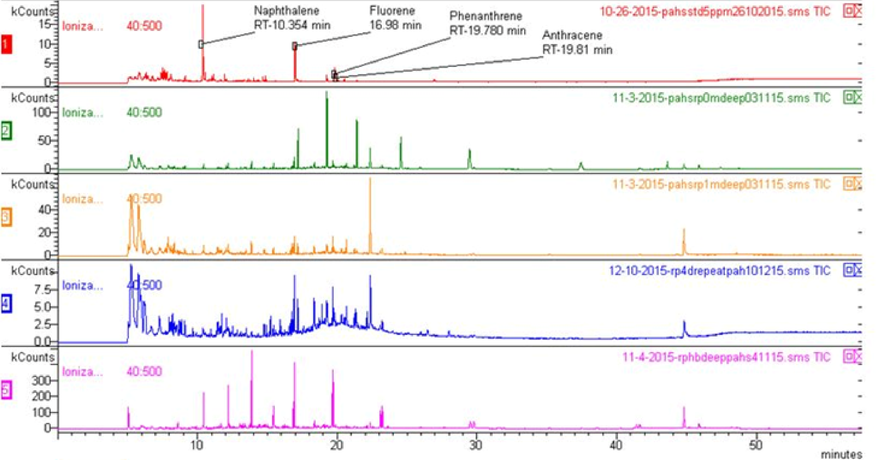

Figure-2: A typical overlay of GC-MS chromatograms of a standard solution and the soil samples collected from different sites.

This comparison demonstrated the retention times for the investigated polycyclic aromatic hydrocarbon (PAH) standards. Specifically, Naphthalene exhibited a retention time of 10.367 minutes, Anthracene at 19.81 minutes, Phenanthrene at 19.784 minutes, and Fluorene at 16.98 minutes. Method Detection Limit (MDL) ranged from 2.0 to 2.5 μg/mL, providing adequate sensitivity for environmental sample analysis.

3.2. PAH Distribution Patterns
3.2.1. Site S-1: RNPP Boring Area
The concentrations of individual PAHs across different sampling sites and depths are systematically presented in Table 2.
Table 2: Concentrations of individual PAHs at different sampling sites and depths.
Sampling site | Depths | Naphthalene  (ppb) | Anthracene  (ppb) | Phenanthrene  (ppb) | Fluorene  (ppb)
Rooppur Nuclear Power Plant boring site (S-1) | 0 m | 40.56 | 13.51 | 13.89 | 4.001
Rooppur Nuclear Power Plant boring site (S-1) | 1 m | 59.8 | 19.8 | 20.4 | < MDL
Rooppur Nuclear Power Plant boring site (S-1) | 2 m | 11.07 | < MDL | < MDL | < MDL
Rooppur Nuclear Power Plant boring site (S-1) | 3 m | 15.92 | < MDL | < MDL | < MDL
Rooppur Nuclear Power Plant boring site (S-1) | 4 m | 19.15 | < MDL | < MDL | < MDL
Rooppur Nuclear Power Plant boring site (S-1) | 8 m | 28.56 | < MDL | < MDL | < MDL
Rooppur Nuclear Power Plant boring site (S-1) | 12 m | 17.33 | < MDL | < MDL | < MDL
Rooppur Nuclear Power Plant boring site (S-1) | 36 m | 2.06 | < MDL | < MDL | < MDL
Rooppur at Padma River site (S-2) | Surface | 51.75 | 48.2 | 49.6 | 14.5
Rooppur at Padma River site (S-2) | Deep | 130.22 | 105.73 | 108.807 | 26.87
Hardinge Bridge site (S-3) | Surface | 0.81 | 87.14 | 89.674 | 17.29
Hardinge Bridge site (S-3) | Deep | 107.1 | 95.56 | 98.341 | 25.46

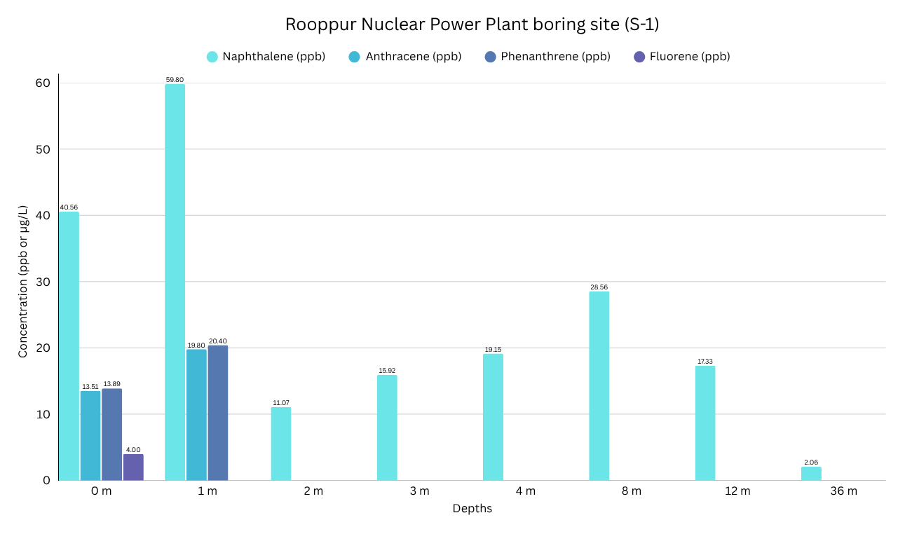

Figure-3: Concentrations of PAHs in the samples collected from the RNPP boring site (S-1).

From Figure 2, several key observations can be made regarding the distribution of individual PAHs at different depths.

From the figure-2, we remark that in the surface and shallow layers Naphthalene has the highest concentration at both 0 m (40.56 µg/L) and peaks dramatically at 1 m (59.8 µg/L). Phenanthrene is present significantly at 0 m (18.89 µg/L) and 1 m (20.4 µg/L). Anthracene is moderate at 0 m (13.5 µg/L) and rises at 1 m (11.07 µg/L). Fluorene is present only at 0 m (4 µg/L) and 1 m (0 µg/L) and undetectable afterward whereas in intermediate depths (2-8 m), Naphthalene is found at reduced concentrations and the others are below the minimum detection limit. In the deeper region, Naphthalene is the only compound detected. The contamination trend shows that naphthalene has the highest mobility and persistence, possibly due to its higher water solubility compared to the other PAHs. The presence of Naphthalene at 36 m raises concerns about its potential to contaminate deeper groundwater resources.
The presence of PAHs in sampling site S-1 can be attributed to several proximate causes:
- Proximity to Highway: The sampling site's location adjacent to a highway strongly implicates vehicular emissions as a primary source of PAHs. Roadside soils are known to accumulate significant levels of PAHs released from the combustion of fossil fuels in vehicles [Brugge et al., 2007; Liu et al., 2017; Patel et al., 2020].
- Nuclear Power Plant Construction: The ongoing construction of a nuclear power plant in the vicinity introduces another potential source. Concrete blocks and other materials commonly used in construction may contain PAHs, as indicated by reference, which could leach into the surrounding soil [ Patel et al., 2020; Irha et al., 2015; Li et al., 2024].
- Road Construction Materials: Additionally, the potential use of higher percentages of PAH substitution in road sub-bases, as referenced in, could serve as another substantial source of PAHs, contributing to the overall contamination of the soil [ Patel et al., 2020].
- Historical industrial activities: The diverse industrial operations that have historically been characteristic of the wider area. These past activities, spanning various sectors and often predating modern environmental regulations, have been shown to introduce PAHs into the local ecosystem [Islam et al., 2024].

3.2.2. Site S-2: Padma River Area
At sampling site S-2, two samples were collected, and the investigation revealed distinct PAH concentrations. In the surface soil, concentrations ranged from 14.5 ppb to 51.75 ppb, while in the deep soil samples, concentrations were notably higher, ranging from 26.87 ppb to 130.22 ppb. The quantitative amounts of different PAHs in both surface and deep soil samples collected from the Padma River sampling site are illustrated in Figure 3.
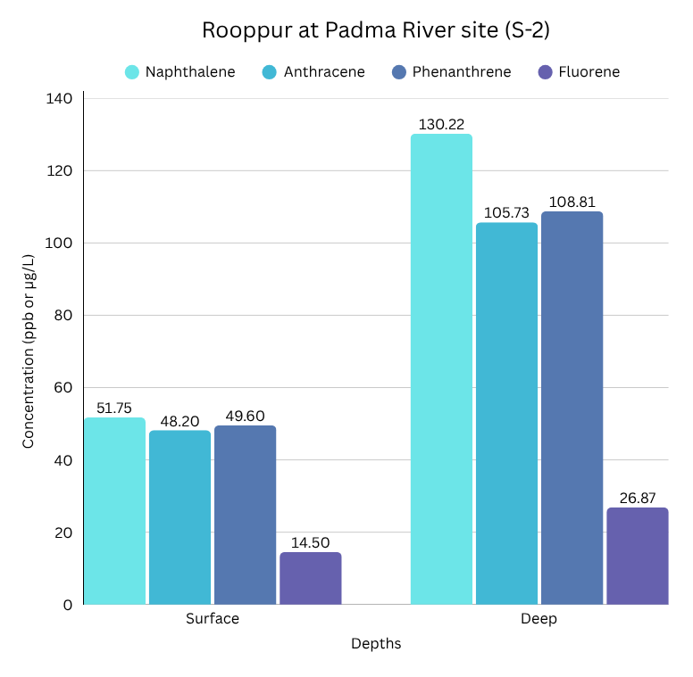
Figure-4: Concentrations of PAHs in the samples collected from the Padma River site (S-2).

A critical finding from S-2 is that deep soil samples consistently contained substantially higher PAH concentrations for all four investigated compounds. This observation strongly suggests a downward leaching or migration of PAHs from the surface layers into the deeper soil profiles. Furthermore, it points towards possible accumulation or limited degradation under subsurface conditions, particularly in anaerobic zones, which can significantly slow down PAH breakdown. The elevated deep soil concentrations also raise concerns about potential contamination from upstream industrial or anthropogenic sources that have managed to penetrate and accumulate in these deeper layers.
By analyzing individual PAHs concentrations, it was observed that Naphthalene yet again exhibited the highest concentration in both surface and deep samples, firmly establishing it as the most abundant and mobile contaminant in this site as well. Fluorene, while also more concentrated in deep soil compared to the surface, showed the lowest absolute levels among the four PAHs. This could imply either faster degradation rates for Fluorene in this environment or a lower initial input compared to the other compounds. The presence of highly polluted chemical industries located around the Padma River is a significant factor contributing to PAH contamination. It is highly probable that PAHs from industrial effluents contaminated the river water, which then gradually deposits and permeates into the deeper surface soil layers.

3.2.3. Site S-3: Hardinge Bridge Area
At sampling site S-3, situated near the Hardinge Bridge, the observed PAH concentrations in surface soil ranged from 0.81 ppb to 89.67 ppb, while deep soil samples exhibited concentrations from 25.46 ppb to 107.1 ppb. The specific amounts of different PAHs in surface and deep soil samples from this site are presented in Figure 4.
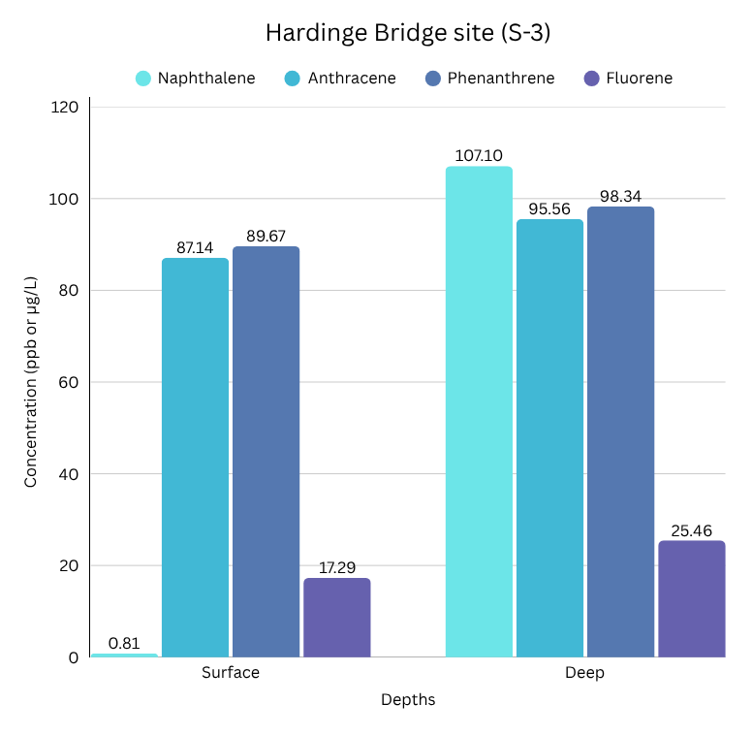

Figure-5: Concentrations of PAHs in the samples collected from the Hardinge Bridge site (S-3).

Sampling site S-3 displayed an unusual and notable pattern for Naphthalene. Its concentration was very low in the surface level (0.81 µg/L) but exceptionally high in the deeper level (107.1 µg/L). This drastic difference strongly indicates significant vertical migration of Naphthalene or points to a possible deep subsurface contamination source, such as leakage from underground infrastructure or a sediment-bound release.
Conversely, Phenanthrene and Anthracene maintained consistently high concentrations in both surface and deep layers, with only marginally higher concentrations observed in deep water. This suggests that these compounds are relatively stable and appear to be prevalent throughout the water column at this site. Fluorene, although present at lower overall concentrations, was still more concentrated in the deep layer, hinting at a similar vertical movement pattern as observed for Naphthalene, albeit at a lower magnitude.
The effluent reaching this site is likely a result of various human activities in the surrounding area. Furthermore, vehicle emissions, once dispersed by rainfall, can settle into the deeper soils, contributing to the PAH load. The presence of a railway station in the S-3 region represents another significant source of PAH contamination, as railway operations are known to release various organic pollutants into the environment [Wiłkomirski et al., 2011].

3.3. Comparative Site Analysis
Cross-site comparison reveals distinct contamination signatures (Figure 5):
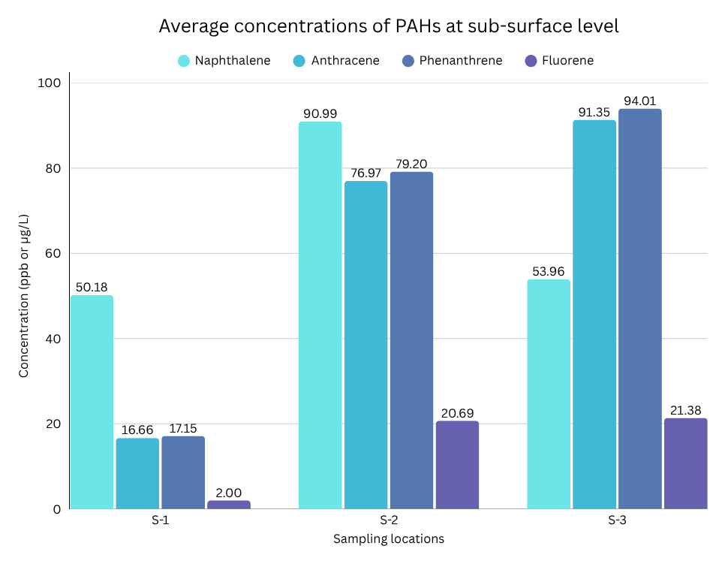
Figure-6: Average concentrations of PAHs in the samples collected from three different sites around RNPP.

3.3.1. Overall Concentrations of PAHs Across Sampling Sites
To provide a comprehensive overview of the contamination levels, Figure 5 illustrates the average concentrations of different PAHs across all three sampling sites. This comparative analysis reveals distinct contamination profiles for each site:
- Sampling Site S-1: This site exhibited the lowest overall contamination among the three investigated locations. Within S-1, Naphthalene consistently showed the highest average concentration (50.18 µg/L) among the four PAHs, reinforcing its pervasive nature. In contrast, Fluorene had a very low average concentration (2 µg/L), suggesting either limited input or rapid degradation in this specific environment.
- Sampling Site S-2: This site was characterized by high overall contamination, featuring a diverse range of PAHs at elevated levels, particularly in the deeper soil, as previously discussed.
- Sampling Site S-3: Sampling site S-3 was distinctly marked by a dominance of Phenanthrene and Anthracene, indicating that these compounds are the primary contaminants in this particular region, likely due to the specific sources identified earlier.
In summary, this extensive analysis of PAH distribution across different sampling sites and depths provides crucial insights into the sources, mobility, and persistence of these environmental contaminants. The findings highlight the varied impacts of localized anthropogenic activities and the complex interactions governing the fate of PAHs in different environmental matrices.

3.4 Analysis of PAH Relationships
To further evaluate the relationships between the target compounds and identify potential commonalities in their environmental fate, a Pearson correlation analysis was performed on the concentration data from all 12 soil samples (n = 12). The results, including correlation coefficients (r) and their associated p-values, are summarized in Table 3.
Table 3: Pearson correlation matrix for the four target PAHs across all sampling sites.
PAHs | Correlation value | p value | Degrees of freedom
Naphthalene- Anthracene | 0.703010154 | 0.010764399 | 10
Naphthalene- Phenanthrene | 0.703042821 | 0.01075914 | 10
Naphthalene- Fluorene | 0.745389901 | 0.005393527 | 10
Anthracene- Phenanthrene | 0.999999982 | 0 | 10
Anthracene- Fluorene | 0.978903494 | 3.17667E-08 | 10
Phenanthrene- Fluorene | 0.978879402 | 3.19472E-08 | 10

The statistical analysis revealed a strong positive correlation between Anthracene, Phenanthrene, and Fluorene (r>0.975, p<0.001). Such linearity suggests that these three compounds originate from the same primary emission sources in the Rooppur region, likely associated with the combustion of fossil fuels from the adjacent highway and regional industrial effluents. While Naphthalene showed a strong positive correlation with the other PAHs (r≈0.70, p<0.05), the strength of the relationship was noticeably lower than the correlations among the 3-ring compounds. This statistical divergence supports the observation that Naphthalene possesses higher environmental mobility and water solubility. Its ability to leach more into deeper soil layers, as evidenced by its unique presence at the 36 m depth at site S-1, results in a vertical distribution pattern that differs from the more sediment-bound 3-ring PAHs. The p-values keeping below the threshold of 0.05 confirms that the observed relationships are statistically significant and not the result of random variation. The degrees of freedom (df = 10) confirm the consistency of the analysis across the entire vertical and spatial sampling dataset. The analytical precision of the method, expressed as the standard deviation (SD) of five replicate injections (n = 5), remained consistently low across all target PAH markers. The recorded SD values, 0.64% for Naphthalene, 1.11% for Anthracene, 1.1% for Phenanthrene, and 0.71% for Fluorene demonstrate instrumental stability and reproducibility for the GC-MS system (Table 1). These low variance levels confirm that the concentration data obtained from the Rooppur sites are suitable for establishing a reliable pre-operational environmental baseline.

3.5. Environmental Significance
All detected PAH concentrations exceeded established permissible limits (naphthalene: 10 ppb, phenanthrene: 30 ppb, anthracene: 30 ppb, fluorene: 30 ppb), indicating widespread environmental contamination requiring attention [WHO., 2010].
Mobility and persistence considerations:
- Naphthalene's detection at 36 m depth demonstrates high environmental mobility.
- The compound's relatively high-water solubility compared to other PAHs explains its persistence in deeper soil layers.
- Potential groundwater contamination risks require ongoing monitoring.
Source attribution: The spatial distribution patterns suggest multiple contamination sources:
- Vehicle emissions from transportation corridors
- Industrial discharge from upstream operations
- Construction activities at the RNPP site
- Historical contamination from long-term industrial development

This baseline assessment provides essential data for ongoing environmental monitoring around the RNPP facility. The results demonstrate pre-existing PAH contamination primarily attributable to regional industrial activities and transportation emissions rather than nuclear facility operations.

3.6. Regional Comparison
Studies from urban and industrial areas of South and East Asia typically report individual soil PAH concentrations in the range of several tens to a few hundred ppb, with higher values near traffic corridors, river-adjacent industries and power-plant complexes. Recent measurements in Dhaka city road dust and surface soils document naphthalene, phenanthrene and anthracene concentrations that are comparable to, or higher than, those observed at the Padma River (S-2) and Hardinge Bridge (S-3) sites in the present study. When compared with these reports and with commonly cited guideline values for naphthalene (10 ppb) and 3-ring PAHs (30 ppb), all four target compounds in our samples fall within the upper portion of the concentration ranges reported for Asian regional environments (Wen-Jun Hong et al., 2016) Comparable or higher PAH levels have been documented in industrialized and traffic-dominated areas of neighboring countries such as India and China, where rapid urbanization and coal-based energy production contribute substantially to soil burdens. This indicates that the Rooppur region already experiences a level of PAH contamination similar to other densely industrialized and traffic-influenced areas in Asia, and underscores the need for continued monitoring as industrial activity and infrastructure around the nuclear power plant expand.

4. Conclusion
This work on investigation of four PAHs compounds around the Rooppur nuclear power plant were conducted as a part of the requirement of environmental pollutant level assessment. We analyzed the soil samples around the RNPP site and tried to understand the current contamination status of the mentioned PAHs namely Naphthalene, Anthracene, Phenanthrene and Fluorene. The results show that At Rooppur Nuclear Power Plant boring site (S-1), the concentrations of PAHs were found from the range of 4.0 to 40.56 ppb in 0 m as surface soil and <MDL to 59.8 ppb [below detection limit (MDL= 0.0002µg/L)] in various depths of soil samples. At the Rooppur Padma River site (S-2), the concentrations of PAHs were found from the range of 14.5 to 51.75 ppb in surface soil and 26.87 to 130.22 ppb in depth soil sample. At Hardinge Bridge site (S-3), the concentrations of PAHs were found from the range of 0.81 to 89.67 ppb in surface soil and 25.46 to 107.1 ppb in depth soil sample. The highest concentration 130.22 ppb among the investigated PAHs compounds was obtained at Rooppur at the Padma River site soil samples. The lowest concentration 0.81ppb was obtained at Hardinge Bridge site surface soil sample; this might be due to less pollution of the soil. The concentrations of investigated PAHs in soil samples were found over the permissible limits in all sample areas (naphthalene 10ppb, phenanthrene 30 ppb, anthracene 30 ppb and for fluorene 30 ppb). The recovery of the subjected PAHs of the investigation method was done by spiking the standards and results were found as Naphthalene- 77.5 %, Anthracene-93.5 %, Phenanthrene-96 % and Fluorene-45.6%. Future monitoring should prioritize longitudinal sampling and expanded PAH profiling to distinguish construction-phase baselines from long-term operational impacts. Additionally, integrating groundwater quality assessments with soil vertical migration studies will be critical for addressing and mitigating potential contamination of soil and water in the Rooppur region.
Competing Interests
The authors declare that they have no known competing financial interests or personal relationships that would influence this paper.
Disclaimer (Artificial intelligence)

Generative AI models were used solely for the purpose of improving readability and linguistics. The authors take full responsibility for the content and interpretation of the manuscript.

References:

(1) Akter, R.; Akbor, M. A.; Bakar Sidddique, M. A.; Shammi, M.; Rahman, M. M. Occurrence and Health Risks Assessment of Polycyclic Aromatic Hydrocarbons (PAHs) in Road Dust and Soil Samples at Dhaka City, Bangladesh. Case Stud. Chem. Environ. Eng. 2023, 7, 100304. https://doi.org/10.1016/j.cscee.2023.100304.
(2) Alegbeleye, O. O.; Opeolu, B. O.; Jackson, V. A. Polycyclic Aromatic Hydrocarbons: A Critical Review of Environmental Occurrence and Bioremediation. Environ. Manage. 2017, 60 (4), 758–783. https://doi.org/10.1007/s00267-017-0896-2.
(3) Alexander, M. Biodegradation and Bioremediation; San Diego : Academic Press, 1994.
(4) Biniecka, M.; Caroli, S. Analytical Methods for the Quantification of Volatile
Aromatic Compounds. TrAC Trends Anal. Chem. 2011, 30 (11), 1756–1770.
https://doi.org/10.1016/j.trac.2011.06.015.
(5) Brugge, D.; Durant, J. L.; Rioux, C. Near-Highway Pollutants in Motor Vehicle
Exhaust: A Review of Epidemiologic Evidence of Cardiac and Pulmonary Health Risks.
Environ. Health 2007, 6 (1), 23. https://doi.org/10.1186/1476-069X-6-23.
(6) Budzinski, H.; Jones, I.; Bellocq, J.; Piérard, C.; Garrigues, P. Evaluation of Sediment
Contamination by Polycyclic Aromatic Hydrocarbons in the Gironde Estuary. Mar. Chem.
1997, 58 (1), 85–97. https://doi.org/10.1016/S0304-4203(97)00028-5.
(7) Chaudhry, Q.; Blom-Zandstra, M.; Gupta, S.; Joner, E. J. Utilising the Synergy between
Plants and Rhizosphere Microorganisms to Enhance Breakdown of Organic Pollutants in the
Environment. Environ. Sci. Pollut. Res. Int. 2005, 12 (1), 34–48.
https://doi.org/10.1065/espr2004.08.213.
(8) Gan, S.; Lau, E. V.; Ng, H. K. Remediation of Soils Contaminated with Polycyclic Aromatic Hydrocarbons (PAHs). J. Hazard. Mater. 2009, 172 (2–3), 532–549. https://doi.org/10.1016/j.jhazmat.2009.07.118.
(9) Gupta, S.; Saksena, S.; Shankar, V. R.; Joshi, V. Emission Factors and Thermal Efficiencies of Cooking Biofuels from Five Countries. Biomass Bioenergy 1998, 14 (5), 547–559. https://doi.org/10.1016/S0961-9534(98)00010-5.
(10) Irha, N.; Reinik, J.; Jefimova, J.; Koroljova, A.; Raado, L.-M.; Hain, T.; Uibu, M.; Kuusik, R. PAHs in Leachates from Thermal Power Plant Wastes and Ash-Based Construction Materials. Environ. Sci. Pollut. Res. 2015, 22 (15), 11877–11889. https://doi.org/10.1007/s11356-015-4459-x.
(11) Islam, Md. N.; Zaman, S. U.; Hossain, Md. M.; Salam, A. Source Identification and Health Risk Assessment of Particle Phase Organic Compounds in Urban and Rural Areas of Bangladesh. E3S Web Conf. 2024, 485, 06005. https://doi.org/10.1051/e3sconf/202448506005.
(12) Kadokami, K.; Pan, S.; Hanh, D. T.; Li, X.; Miyazaki, T. Development of a Comprehensive Analytical Method for Semi-Volatile Organic Compounds in Sediments by Using an Automated Identification and Quantification System with a GC-MS Database. Anal. Sci. 2012, 28 (12), 1183–1189. https://doi.org/10.2116/analsci.28.1183
(13) Keith, L. H. The Source of U.S. EPA’s Sixteen PAH Priority Pollutants. Polycycl. Aromat. Compd. 2015, 35 (2–4), 147–160. https://doi.org/10.1080/10406638.2014.892886.
(14) Lake, J. L.; Norwood, C.; Dimock, C.; Robert, B. Origins of Polycyclic Aromatic Hydrocarbons in Estuarine Sediments. Geochim. Cosmochim. Acta 1979, 43 (11), 1847–1854. https://doi.org/10.1016/0016-7037(79)90033-4.
(15) Lau, E. V.; Gan, S.; Ng, H. K. Extraction Techniques for Polycyclic Aromatic Hydrocarbons in Soils. Int. J. Anal. Chem. 2010, 2010, 398381. https://doi.org/10.1155/2010/398381.
(16) Li, Y.-M.; Wang, Y.-C.; Zhang, H.-S.; Han, L.; Liu, Z.; Liu, Y.; Huang, L.; Zhan, J.-Y. Investigation of Thermal Desorption Characteristics and Pilot-Scale Study of Polycyclic Aromatic Hydrocarbons (PAHs)-Contaminated Soil during Cement Manufacturing. J. Mater. Cycles Waste Manag. 2024, 26 (3), 1633–1648. https://doi.org/10.1007/s10163-024-01915-9.
(17) Liu, A.; Ma, Y.; Deilami, K.; Egodawatta, P.; Goonetilleke, A. Ranking the Factors Influencing Polycyclic Aromatic Hydrocarbons (PAHs) Build-up on Urban Roads. Ecotoxicol. Environ. Saf. 2017, 139, 416–422. https://doi.org/10.1016/j.ecoenv.2017.02.011.
(18) Lu, XY., Zhang, T. & Fang, H.HP. Bacteria-mediated PAH degradation in soil and sediment. Appl Microbiol Biotechnol 89, 1357–1371 (2011). https://doi.org/10.1007/s00253-010-3072-7
(19) Merrill, E. G.; Wade, T. L. Carbonized Coal Products as a Source of Aromatic Hydrocarbons to Sediments from a Highly Industrialized Estuary. Environ. Sci. Technol. 1985, 19 (7), 597–603. https://doi.org/10.1021/es00137a003.
(20) Newman, L. A.; Reynolds, C. M. Phytodegradation of Organic Compounds. Curr. Opin. Biotechnol. 2004, 15 (3), 225–230. https://doi.org/10.1016/j.copbio.2004.04.006.
(21) Patel, A. B.; Shaikh, S.; Jain, K. R.; Desai, C.; Madamwar, D. Polycyclic Aromatic Hydrocarbons: Sources, Toxicity, and Remediation Approaches. Front. Microbiol. 2020, 11, 562813. https://doi.org/10.3389/fmicb.2020.562813.
(22) Reizer, E.; Viskolcz, B.; Fiser, B. Formation and Growth Mechanisms of Polycyclic Aromatic Hydrocarbons: A Mini-Review. Chemosphere 2022, 291, 132793. https://doi.org/10.1016/j.chemosphere.2021.132793.
(23) Revitt, D.M., Balogh, T. & Jones, H. Soil mobility of surface applied polyaromatic
hydrocarbons in response to simulated rainfall. Environ Sci Pollut Res 21, 4209–4219 (2014).
https://doi.org/10.1007/s11356-013-2231-7
(24) Rivas FJ. Polycyclic aromatic hydrocarbons sorbed on soils: a short review of chemical oxidation based treatments. J Hazard Mater. 2006 Nov 16;138(2):234-51. doi: 10.1016/j.jhazmat.2006.07.048. Epub 2006 Jul 27. PMID: 16973263.
(25) Saim, N.; Dean, J. R.; Abdullah, Md. P.; Zakaria, Z. Extraction of Polycyclic Aromatic Hydrocarbons from Contaminated Soil Using Soxhlet Extraction, Pressurised and Atmospheric Microwave-Assisted Extraction, Supercritical Fluid Extraction and Accelerated Solvent Extraction. J. Chromatogr. A 1997, 791 (1), 361–366. https://doi.org/10.1016/S0021-9673(97)00768-1.
(26) Samanta, S. K.; Singh, O. V.; Jain, R. K. Polycyclic Aromatic Hydrocarbons: Environmental Pollution and Bioremediation. Trends Biotechnol. 2002, 20 (6), 243–248. https://doi.org/10.1016/S0167-7799(02)01943-1.
(27) Sharma, P.; Saha, S.; Chatterjee, S.; Mandal, A. H.; Ghosh, S.; Saha, N. C.; Piccione, G.; Impellitteri, F.; Faggio, C. Toxicological and Physiological Impact and Bioremediation Strategies for Polycyclic Aromatic Hydrocarbons (PAHs). Chem. Ecol. 2025, 41 (6), 843–866. https://doi.org/10.1080/02757540.2025.2490035.
(28) Sporstol, Sigve.; Gjos, Nina.; Lichtenthaler, R. G.; Gustavsen, K. O.; Urdal, Kjell.; Oreld, Froydis.; Skei, Jens. Source Identification of Aromatic Hydrocarbons in Sediments Using GC/MS. Environ. Sci. Technol. 1983, 17 (5), 282–286. https://doi.org/10.1021/es00111a008.
(29) Trang T.T. Dong, Byeong-Kyu Lee. Characteristics, toxicity, and source apportionment of
polycylic aromatic hydrocarbons (PAHs) in road dust of Ulsan, Korea. Chemosphere,
Volume 74, Issue 9, 2009, Pages 1245-1253, ISSN 0045-6535,
https://doi.org/10.1016/j.chemosphere.2008.11.035
(30) Urbancok, D. Analysis and Monitoring of Odour and Semi-Volatile Organic Compounds in Different Environmental Matrices via Gas Chromatography-Mass Spectrometry. 2018. https://doi.org/10.32657/10356/73260.
(31) Wang, Z.; Meng, Q.; Sun, K.; Wen, Z. Spatiotemporal Distribution, Bioaccumulation, and Ecological and Human Health Risks of Polycyclic Aromatic Hydrocarbons in Surface Water: A Comprehensive Review. Sustainability 2024, 16 (23), 10346. https://doi.org/10.3390/su162310346.
(32) Wen-Jun Hong, Hongliang Jia, Wan-Li Ma, Ravindra Kumar Sinha, Hyo-Bang Moon,
Haruhiko Nakata, Nguyen Hung Minh, Kai Hsien Chi, Wen-Long Li, Kurunthachalam
Kannan, Ed Sverko, and Yi-Fan Li. Distribution, Fate, Inhalation Exposure and Lung
Cancer Risk of Atmospheric Polycyclic Aromatic Hydrocarbons in Some Asian
Countries. Environmental Science & Technology 2016 50 (13), 7163-7174, DOI:
10.1021/acs.est.6b01090

(33) WHO Guidelines for Indoor Air Quality: Selected Pollutants; WHO Guidelines Approved
by the Guidelines Review Committee; World Health Organization: Geneva, 2010.
(34) Wild, S. R.; Jones, K. C. Polynuclear Aromatic Hydrocarbons in the United Kingdom Environment: A Preliminary Source Inventory and Budget. Environ. Pollut. 1995, 88 (1), 91–108. https://doi.org/10.1016/0269-7491(95)91052-M.
(35) Wiłkomirski, B.; Sudnik-Wójcikowska, B.; Galera, H.; Wierzbicka, M.; Malawska, M.
Railway Transportation as a Serious Source of Organic and Inorganic Pollution. Water. Air.
Soil Pollut. 2011, 218 (1–4), 333–345. https://doi.org/10.1007/s11270-010-0645-0
(36) Wilson, S. C.; Jones, K. C. Bioremediation of Soil Contaminated with Polynuclear Aromatic Hydrocarbons (PAHs): A Review. Environ. Pollut. Barking Essex 1987 1993, 81 (3), 229–249. https://doi.org/10.1016/0269-7491(93)90206-4.

.
.

