Antibiotic Resistance in Environmental Microbiomes: Molecular Mechanisms, Implications and Mitigation Strategies

ABSTRACT
The ambient microbiome serves as a crucial reservoir for antibiotic resistance genes (ARGs), acting as a catalyst for their evolution and a pathway for global distribution. The discharge of antibiotic resistance genes (ARGs) from clinical and agricultural environments into ecosystems through wastewater, soil, and aquatic systems diminishes antimicrobial effectiveness and poses a significant One Health concern. This study consolidates existing knowledge about the emergence, persistence, and fate of antibiotic resistance genes in environmental compartments. It elucidates the molecular underpinnings of resistance, including horizontal gene transfer, efflux pumps, and enzymatic drug inactivation. It identifies significant ecological reservoirs, such as wastewater treatment facilities and manure-amended soils. The study assesses sophisticated molecular detection and surveillance technologies, ranging from droplet digital PCR to metagenomic sequencing, crucial for delineating the ambient resistome. The connections between environmental ARGs and human health hazards are outlined, with emphasis on exposure pathways and the growing clinical burden. Moreover, the research evaluates a range of mitigation and remediation measures designed to disrupt the resistance cycle. This includes engineered wastewater and potable water treatments, soil bioremediation via Verm remediation, and manure management, as well as innovative medicinal methods such as phage therapy, CRISPR-mediated gene editing, and fecal microbiota transplantation. This synthesis underscores the critical need for coordinated surveillance and targeted interventions within a comprehensive One Health framework to prevent the environmental spread of antibiotic resistance and safeguard public health.

Keywords: Antibiotic Resistance Genes (ARGs); Environmental Resistome; One Health; Wastewater Treatment; Public Health

1. Introduction
Alexander Fleming's discovery of penicillin in 1928 initiated a revolutionary period in modern medicine, significantly decreasing mortality from once incurable bacterial infections (Fig. 1) (Tan and Tatsumura, 2015). The ensuing "golden age" of antibiotic discovery, from the 1940s to the 1960s, cultivated the belief that infectious diseases had been vanquished. This optimism was ephemeral. The unyielding and frequently indiscriminate application of these miracle medications exerted substantial selective pressure, propelling the swift evolution and worldwide proliferation of antibiotic resistance (Hayden et al., 2016). Currently, antimicrobial resistance (AMR) represents a critical public health crisis of the 21st century, jeopardizing the effectiveness of our healthcare systems.
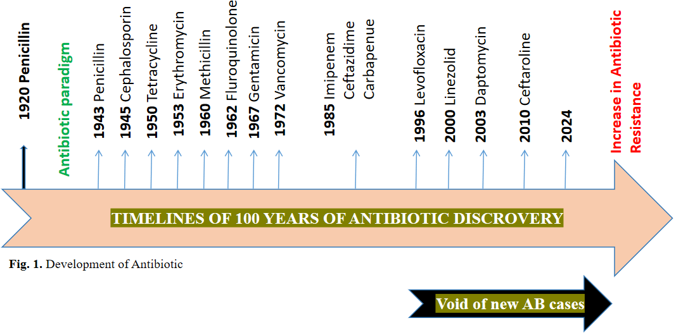
Figure 1. Historical timeline of antibiotic discovery and the emergence of resistance.
Antibiotic-resistant bacteria are responsible for more than 23,000, 58,000, 38,000, and 25,000 annual fatalities in the United States, India, Thailand, and the European Union, respectively (Boucher et al., 2009, Laxminarayan et al., 2013, ECDC, 2009). In the absence of coordinated intervention, this figure is anticipated to rise to 10 million deaths annually worldwide by 2050, surpassing cancer as a primary cause of mortality and causing severe economic repercussions (Holmberg et al., 1987). The emergence of multidrug-resistant pathogens, exemplified by the ESKAPE group (Enterococcus faecium, Staphylococcus aureus, Klebsiella pneumoniae, Acinetobacter baumannii, Pseudomonas aeruginosa, and Enterobacter species), has resulted in a situation where prevalent infections are increasingly becoming untreatable (de Kraker et al., 2016).
The clinical impact of AMR is evident; however, the significance of the environment as a key factor has only lately been completely recognized. Environmental matrices, such as soil, water, wastewater, and manure, actively engage with antibiotic residues and resistant bacteria originating from human and agricultural activities. They are dynamic, gene-dense ecosystems that function as extensive reservoirs and catalysts for the development of ARGs (Gillings et al., 2008, Baquero et al., 2019). The environmental resistome, encompassing all ARGs within a specific microbiome, signifies an ancient and varied genetic reservoir from which pathogens can obtain resistance through horizontal gene transfer (HGT) via mechanisms including conjugation, transformation, and transduction (Ebmeyer et al., 2021).
This ongoing interaction connects environmental and therapeutic contexts. Wastewater treatment facilities (WWTPs) serve as critical sites where urban and hospital effluents converge, facilitating optimal circumstances for genetic exchange between environmental and clinically significant microorganisms (Reygaert, 2018). Similarly, the application of antibiotic-contaminated manure in agriculture propagates resistance genes into soils and, via runoff, into aquatic ecosystems, establishing a widespread cycle of pollution (Annunziato, 2019).
Consequently, an exclusive emphasis on clinical resistance is inadequate. Addressing antimicrobial resistance necessitates a comprehensive "One Health" strategy that acknowledges the interconnectedness of human, animal, and environmental health. This review aims to consolidate the current knowledge regarding antibiotic resistance in environmental microbiomes. The research examines the molecular processes of resistance, identifies the main environmental reservoirs of ARGs, and assesses molecular approaches for their detection and monitoring. The paper critically analyzed the ramifications of environmental antimicrobial resistance on human health. It produced a thorough summary of novel mitigation measures to disrupt the transmission chain within these crucial environmental compartments.

2. Molecular mechanisms underlying antibiotic resistance
Pathogens have swiftly developed many defensive mechanisms against the effects of antimicrobial agents. Four principal groups encompass the fundamental mechanisms in bacteria that result in antibiotic resistance (Fig. 2) (Reygaert, 2018).
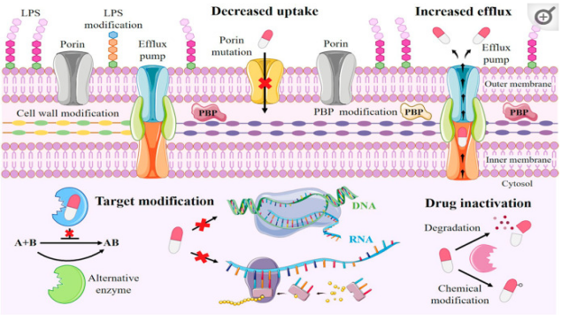
Figure 2. Schematic overview of the four principal molecular mechanisms of bacterial antibiotic resistance: 1) Limiting drug uptake (e.g., via porin modification or biofilm formation), 2) Active drug efflux via membrane pumps, 3) Target site modification (e.g., alteration of penicillin-binding proteins), and 4) Enzymatic drug inactivation (e.g., via β-lactamase hydrolysis).

2.1 Limiting drug uptake
This procedure is crucial for Gram-negative bacteria, which possess an outer membrane (OM) predominantly made of lipopolysaccharides (LPS), creating a hydrophobic barrier that renders most small pharmaceutical compounds ineffective. Consequently, porin proteins enable the passage of certain hydrophilic antibiotics across the outer membrane. Biofilms can develop that diminish antibiotic permeability by augmenting the thickness and adhesiveness of the biofilm matrix, which safeguards microorganisms from antibiotic infiltration and the host immune response (Reygaert, 2018).

2.2 Increase efflux
Drugs are expelled from cells through the overexpression of efflux pumps that rely on proton transport. In Staphylococcus aureus, the NorA efflux pump facilitates a robust resistance mechanism against fluoroquinolone antibiotics; the QacA MFS transporter expels cationic lipophilic agents, including biocides like benzalkonium chloride; and the LmrS MFS efflux pump exports various compounds, such as lincomycin, linezolid, chloramphenicol, and trimethoprim (Annunziato, 2019).

2.3 Target site modification
Multidrug-resistant bacteria frequently express numerous antibiotic resistance genes to cultivate extensive resistance to common antibiotics. Staphylococcus aureus obtained the mecA gene, which encodes the penicillin-binding protein PBP-2A, hence imparting resistance to methicillin and the majority of other β-lactam antibiotics. Nine PBPs are good candidates for targeted modification due to their involvement in the synthesis and assembly of peptidoglycan (Annunziato, 2019).

2.4 Drug inactivation
Modifications or deactivation of the antimicrobial agent are common resistance mechanisms in numerous pathogenic bacteria. As enzymes typically facilitate this process, important bacterial cell components remain unaltered, which is beneficial as it reduces the likelihood of fitness losses compared to alternative processes such as drug target mutation or modification. Antibiotic modification can be categorized into two primary mechanisms: chemical group transfer modification and antibiotic inactivation via degradation (Forsberg et al., 2015). Bacterial enzymes chemically degrade and neutralize antibiotics, representing the predominant mechanism of bacterial resistance. For example, β-lactamases predominantly hydrolyze β-lactam antibiotics, but other antimicrobial compounds have distinct chemical alterations (Reygaert, 2018). The catalog of identified β-lactamases is expanding; the Beta Lactamase Database documents more than 7,000 unique β-lactamases (Naas et al., 2017). In 2017, the WHO designated three "critical" priority infections, all of which were carbapenem-resistant (WHO, 2017). Carbapenems, including KPC (class A), NDM (class B), and OXA (class D), can hydrolyze penicillin, cephalosporins, and carbapenems (Tooke et al., 2019, Queenan and Bush, 2007). This significantly reduces the number of pharmaceuticals available to treat a specific illness.

3. Molecular methods for quantifying ARGs in the environment
Due to the prevalence of ARGs in aquatic environments, molecular techniques are required to investigate their occurrence, transit, and fate. Assessing environmental ARGs facilitates comprehension of their distribution, prevalence, and implications for public health.

3.1 Droplet digital polymerase chain reaction (ddPCR)
Droplet digital polymerase chain reaction (ddPCR) measures nucleic acids, such as ARGs, in water, soil, and sediments with exceptional sensitivity and precision. The technique partitions a substance into thousands of nanoliter-sized droplets to identify and detect nucleic acids at low quantities (Kokkoris et al., 2021). Owing to its capacity for absolute quantification without the necessity of reference curves, ddPCR may surpass quantitative polymerase chain reaction (qPCR) in environmental samples. It is crucial in intricate sample matrices where inhibitors may influence qPCR. Environmental samples exhibit chemical and biological complexity, complicating data interpretation. Consequently, ddPCR research using environmental materials necessitates customized approaches and optimal protocols to guarantee accuracy and consistency (Kokkoris et al., 2021). Notwithstanding environmental PCR inhibitors, ddPCR can precisely measure ARGs. This renders it an exceptional instrument for identifying environmental antibiotic resistance (Cavé et al., 2016).

3.2 Quantitative polymerase chain reaction (qPCR)
Real-time qPCR is the optimal technique for the detection and quantification of microorganisms in diverse environmental samples, including intricate matrices such as wastewater, soil, and sewage (Aw and Rose, 2012, Knappik et al., 2015). qPCR assays exhibit superior sensitivity, specificity, and rapidity compared to traditional culture-based methods (Colinon et al., 2013). As indicated in (Oster et al., 2014), it is pertinent for risk evaluation and surveillance of disease origins. Moreover, research by (Bae et al., 2015) illustrates its broad application in microbial ecology for clarifying the ecological functions of microorganisms in habitats and evaluating the distribution and prevalence of particular functional microbial groupings, as depicted in Fig. 3.

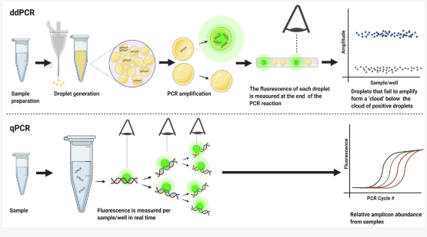
Figure 3. Comparative workflow of ddPCR and qPCR for the detection and quantification of
ARGs in complex environmental samples.
3.3 Metagenomic sequencing
This approach assesses ARGs present in water, soil, and sediments. It involves assembly algorithms that connect whole-metagenome sequencing (WMS) results with reference databases to identify and quantify ARGs. This approach is superior for evaluating the resistome in the environment, as it eliminates the need for culturing organisms (Daw Elbait et al., 2024). Furthermore, long-read metagenomic sequencing techniques, such as nanopore sequencing, have been employed to characterize ARGs and their adjacent elements. This approach evaluates the quantity, genetic loci, mobility potential, and associated bacterial hosts of ARGs in activated sludge and influent sewage to ascertain their fate (Dai et al., 2022).

3.4 Fluorescence in situ hybridization (FISH)
This technique effectively identifies and quantifies specific DNA or RNA sequences, including ARGs, in diverse environmental matrices such as water, soil, and sediments. The technique employs fluorescent probes that bind to complementary DNA sequences of the target ARGs in the sample. Upon binding, these probes can be seen and measured by fluorescence microscopy (Lee et al., 2021).
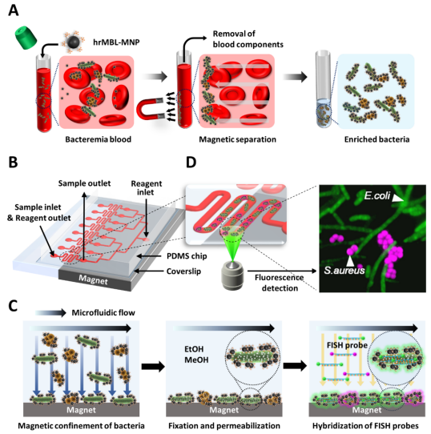
Figure 4. Schematic of a quantitative bacteremia identification method combining opsonin-coated magnetic nanoparticles (MNPs) for pathogen capture and microfluidic fluorescence in situ hybridization (μFISH) for the specific detection of ARG-associated nucleic acid sequences.

3.5 Mass spectrometry (MS) method
Quantifying ARGs in water, soil, and sediments requires mass spectrometry. The primary methods are: MS detects and quantifies small molecules associated with antibiotic resistance, not the genes (ARGs), making it an indirect yet efficient tool for studying antibiotic resistance. This entails accurately quantifying antibiotic residues and their transformation products in environmental matrices, which contribute to the selective pressure that increases ARGs (Wu et al., 2023). LC-MS/MS is capable of identifying and quantifying non-volatile, thermally unstable compounds, such as ARGs, in intricate environmental samples (Holton and Kasprzyk-Hordern, 2021). High-Resolution Mass Spectrometry is extensively employed in non-targeted screening to detect novel compounds and offer a comprehensive assessment of antibiotic exposure in certain contexts (Schulze and Kaserzon, 2024). Microplastics and nanoplastics, due to their potential as vectors, can be utilized to investigate antibiotic resistance genes (ARGs) by time-of-flight mass spectrometry (ToF-MS) and other techniques (Wu et al., 2023).

3.6 Hybridization-based techniques
Microarrays and other hybridization-based methods can quantify ARGs in water, soil, and sediments. These approaches use nucleic acid hybridization to detect and quantify ARG-corresponding DNA or RNA sequences. DNA microarray analysis is faster, more sensitive, and higher-throughput than other molecular methods. DNA microarrays can detect antibiotic resistance in isolates and provide comprehensive, therapeutically relevant information by detecting multiple ARGs in a single experiment (Gilbride et al., 2006). The microarray technique can uncover antibiotic resistance determinants in hours, reducing time and improving resistance detection (Antwerpen et al., 2007). The microarray technique has been extensively used to detect antibiotic resistance in Salmonella enterica (Guard-Bouldin et al., 2007), H. pylori (Chen et al., 2008), E. coli (Zhu et al., 2007a), and S. aureus (Zhu et al., 2007b, Spence et al., 2008).

4. Implications of AMR and ARGs to human health
Antivirals, antifungals, antibiotics, and antiparasitics are utilized to treat and prevent diseases in agriculture, aquaculture, animals, and humans. The therapeutic effectiveness of several antimicrobials is jeopardized by bacterial resistance. Superbugs exhibit resistance to antimicrobials. UNEP released the 2023 critical article "Bracing for Superbugs: Strengthening Environmental Action in the 'One Health' Response to Antimicrobial Resistance". Antimicrobial resistance (AMR) arises when bacteria, viruses, parasites, and fungi acquire resistance to antibiotics. Antibiotic resistance obstructs the management of prevalent bacterial illnesses globally. The Antimicrobial Resistance and Use Surveillance System (GLASS) 2022 study reveals concerning levels of resistance to common bacterial infections. Alarmingly, 42% of 76 nations exhibit resistance to third-generation cephalosporins in E. coli, while 35% demonstrate resistance to methicillin in Staphylococcus aureus. In 2020, E. coli urinary tract infections had a 20% reduction in sensitivity to ampicillin, co-trimoxazole, and fluoroquinolones
(Fernandez, 2022). The heightened utilization of carbapenems may induce resistance in other domains. When last-resort medications are ineffective, untreatable infections proliferate. The OECD projects that by 2035, last-resort antibiotic resistance will double compared to 2005 levels (Popoola et al., 2024). Robust antimicrobial stewardship and comprehensive worldwide surveillance are essential. The overuse of antimicrobials and environmental contamination can lead to microbial resistance in both individuals and ecosystems. Bacteria can develop resistance after exposure to resistant microbes in soil, water, and air. Humans can acquire AMR bacteria from food, drink, fungal spores, and various environmental factors. In 2019, drug-resistant illnesses globally resulted in 1.27 million fatalities. By the year 2050, an estimated 10 million individuals may succumb annually. Fig. 5 illustrates that unregulated antimicrobial resistance (AMR) might drive 24 million individuals into extreme poverty and diminish GDP by $3.4 trillion (Desai, 2018). The prevalence of HIV, malaria, tuberculosis, and viral antimicrobial resistance is increasing, posing a significant threat to human well-being.
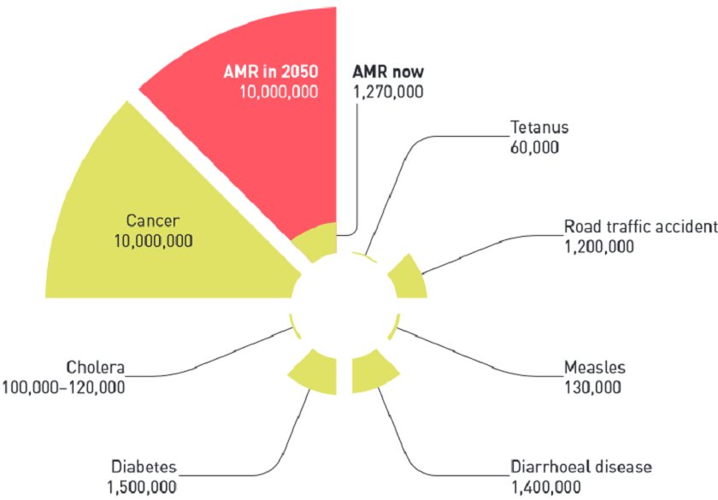
Figure 5. Projected global impact of AMR on human health.

5. Strategies to eliminate antibiotic resistance from the environment
To halt the progression and dissemination of antibiotic resistance, therapeutic strategies can eliminate antibiotic resistance genes by incapacitating the microorganisms that harbor them (Fig. 6).
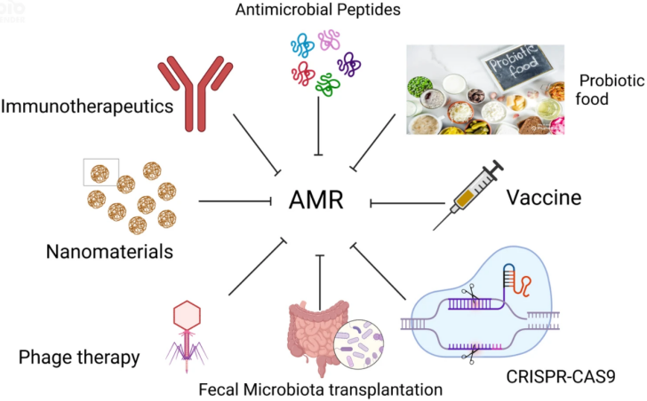
Figure 6. A multi-pronged strategy framework to counteract environmental antibiotic resistance.

5.1 Treatment for wastewater and drinking water
In wastewater treatment, anaerobic and anoxic processes in MBR systems successfully diminish ARG concentrations by reducing microbial bioactivity, while aerobic circumstances may elevate them. MBRs effectively accomplish substantial elimination of ARGs, with reported links between reductions in genes like tetW and intI1 and decreases in 16S rDNA (Du et al., 2015). Constructed wetlands eliminate drugs and ARGs via substrate adsorption and plant absorption (Chen et al., 2016, Barancheshme and Munir, 2018). The concentration of intI1 is closely associated with ARG levels in these wetlands, indicating the involvement of mobile genetic factors in their dissemination (Fang et al., 2017). Chlorination or UV/chlorination sequences effectively inactivate ARGs such as sul1 and tetG, with efficiency contingent upon dosage and contact duration (Sharma et al., 2016). Antimicrobial nanotechnology provides dual mechanisms: the liberation of toxic ions from nanoparticles and simultaneous assaults on ARBs and ARGs, showcasing efficacy against multidrug-resistant pathogens without promoting nanomaterial-resistant strains (Aruguete et al., 2013). Conventional physicochemical methods, such as coagulation with polyferric chloride (FeCl₃), are notably successful for drinking water treatment. They attain a 0.5-log to 3.1-log reduction in critical ARGs (sul1, sul2, tetO, tetW, tetQ, intI1), surpassing techniques like constructed wetlands or UV disinfection in treated wastewater effluent, while concurrently eliminating dissolved organic compounds and nutrients (Sanganyado and Gwenzi, 2019).

5.2 Soil treatment
Earthworms facilitate the elimination of antibiotics and ARGs in soil via Verm remediation. They introduce and disseminate particular antibiotic-degrading bacteria, including Microvirga and Sphingomonas, through their castings (Zhang et al., 2022). Earthworms markedly diminish the abundance of antibiotic resistance genes (ARGs) by modifying the bacterial community, inhibiting possible ARG hosts, and enhancing degraders such as Flavobacterium (Yang et al., 2021). Species such as Metaphire guillelmi expedite the decomposition of chlortetracycline and its metabolites, whereas earthworms enhance the degradation of oxytetracycline by augmenting ammonia-oxidizing bacteria (Pu et al., 2020). These activities collectively diminish selective pressure and restrict the proliferation of ARGs in soil.

5.3 Manure treatment
Modern animal farms utilize many waste management techniques to reduce the levels of antibiotics and antibiotic resistance genes (ARGs). Anaerobic digestion stabilizes waste, diminishes zoonotic bacteria by a minimum of one log, and produces methane (Checcucci et al., 2020). The integration of pasteurization pretreatment with anaerobic digestion (PPAD) improves the elimination of tetracyclines and augments methane production, with tetracycline levels decreasing from 17.238 to 0 and methane yield increasing from 244.07 to 254.06 over a technical digestion period of 20-25 days (T80) (Yin et al., 2020). Microwave (MW) radiation can treat dairy manure for 30 to 300 seconds at a frequency of 2450 MHz. The moisture removal rate (U) of dairy manure can attain 0.63 g of water/min/gram, hence diminishing ARGs such as sul1 and intI1 (Luo et al., 2021). Ultimately, thermophilic composting, especially when supplemented with biochar sourced from mushrooms or straw, is an efficacious approach for managing ARGs (Liu et al., 2021).

5.4 Therapies by phages or bacteriophages
The CRISPR-associated (Cas) gene editing tool is one of the latest advancements in gene therapy technology. It alters genes associated with antibiotic resistance or supplies recombinant phages with antibacterial proteins. Phages, however, cannot serve as empirical therapies for acute infections due to their specificity for particular host bacterial species. Libraries must often be updated to maintain their efficacy against antibiotic-resistant bacteriophages (Kumar et al., 2020). Spacers are short sequences that serve as CRISPR arrays and are integrated into bacterial genomes by bacteriophages or plasmids. The spacer guide RNAs will be employed by the Cas protein machinery to accurately target the invader's nucleic acid with analogous sequences (Kumar et al., 2021). CRISPR-Cas is a targeted method for antimicrobial resistance genes in plasmids and chromosomes. It is transmitted using phagemids and conjugative plasmids. A plasmid, pBD114, was engineered to target the kanamycin resistance gene aph-3. The plasmid was introduced into S. aureus RN4220 or RNK, leading to Cas9-mediated eradication of Staphylococci and additional bacterial species (Bikard et al., 2014). Nano-sized CRISPR complexes, comprising polymer-derivatized Cas9 and single guide RNA, have been employed to eradicate resistance genes, specifically targeting mecA, associated with methicillin resistance (Kang et al., 2017).

5.5 Therapies by probiotics
Probiotics have been identified to include antibiotic resistance genes (ARGs) such as vancomycin, rifampicin, streptomycin, bacitracin, and erythromycin (Liu et al., 2020, Stanley et al., 2022). Next-generation sequencing and genetic engineering are facilitating the creation of customized probiotics, or pharmabiotics, as biotherapeutic approaches to combat infection. These bioengineered probiotics can be meticulously engineered to provide medicinal substances, providing a precise alternative to traditional medication delivery systems (Kumar et al., 2021).

5.6 Fecal microbiota transplant (FMT)
Fecal microbiota transplantation (FMT) or human probiotic infusion entails the transfer of processed stool from a healthy donor to a recipient to reestablish the recipient's gut flora. It demonstrates therapeutic efficacy, especially for recurrent C. difficile infections (Khoruts et al., 2021). Fig. 7 depicts a two-phase process: the preparation of a donor slurry for cold storage in a stool bank, succeeded by its distribution to a patient through oral or rectal delivery (Kumar et al., 2020).
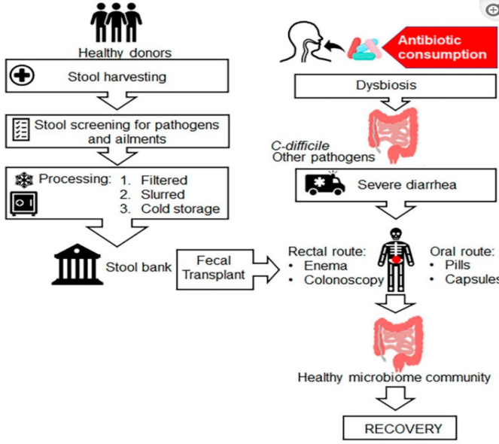
Figure 7. The two-phase clinical process of Faecal Microbiota Transplantation (FMT).
Addressing antibiotic resistance necessitates the implementation of preventative strategies and policies in conjunction with effective treatments to avert and manage infectious diseases (Kumar et al., 2013, Metz and Shlaes, 2014).

Conclusion
The escalating epidemic of AMR is intrinsically associated with environmental mechanisms that facilitate the development, persistence, and dissemination of ARGs. This work highlights that the environment functions not merely as a repository but as a dynamic reactor for resistance, with hotspots like WWTPs and agricultural soils serving as critical centers for gene exchange between environmental and clinical bacteria. The molecular mechanisms enabling this dispersion (horizontal gene transfer via mobile genetic elements, enzymatic drug inactivation, and efflux pumps) are now comprehensively elucidated, revealing a sophisticated resistome that predates the clinical use of antibiotics.
Advanced molecular techniques, including high-throughput qPCR, droplet digital PCR, and metagenomic sequencing, are indispensable for monitoring the resistome, offering the accuracy required to track the fate and dissemination of ARGs. The consequences for human health are urgent and severe, as ambient ARGs infiltrate clinical settings, compromising treatment options and elevating mortality rates.
A thorough mitigation strategy is being formulated. Engineered solutions for wastewater and drinking water treatment, such as advanced membrane bioreactors and better coagulation, can significantly diminish ARG loads. Terrestrial methods like vermicomposting for soil and pasteurization-integrated anaerobic digestion for manure interrupt the agricultural resistance cycle. Innovative biotherapeutic strategies encompass precision phage therapy, CRISPR-Cas gene editing to counteract resistance pathways, and fecal microbiota transplantation to reestablish microbial balance. Ultimately, addressing the environmental dimension of AMR requires a fundamental transformation towards proactive, integrated management within the One Health framework. Success depends on the integration of human, animal, and environmental health through ongoing monitoring, robust legislation, and the application of innovative remediation technologies from research to implementation. The evidence is clear: preserving the efficacy of our antibiotic resources requires a robust environmental strategy.
Limitations and Future Perspectives
This review consolidates existing knowledge on environmental antibiotic resistance, although it is essential to recognize various limitations in the field to inform future study and implementation.
The molecular approaches outlined, including metagenomic sequencing and qPCR, are potent yet not devoid of bias. The efficiency of DNA extraction can fluctuate markedly among various environmental matrices (e.g., soil versus wastewater), potentially distorting estimations of ARG abundance. Moreover, the majority of approaches identify genetically potential functional expression, constraining our comprehension of active resistance mechanisms in situ. The standardization of methods and the advancement of approaches that associate ARG presence with phenotypic resistance and host identity in intricate communities are essential requirements.
Numerous novel remediation technologies, such as enhanced oxidation processes, engineered nanomaterials, and CRISPR-based therapeutics, demonstrate potential in controlled research but encounter substantial obstacles for large-scale, real-world implementation. Challenges encompass elevated operational expenses, ecological repercussions (e.g., nanomaterial toxicity, disruption of vital microbiota), and the logistical intricacies of implementing such technologies across varied environments, such as expansive agricultural areas or massive wastewater systems. The enduring effectiveness and durability of nature-based solutions, such as built wetlands and Verm remediation, necessitate further comprehensive field validation.
Efforts to reduce ARGs may inadvertently affect critical ecosystem functioning. Aggressive disinfection in WWTPs may promote the emergence of more resilient diseases or harm beneficial microbial communities essential for nutrient cycling. Modifying soil microbiomes to prevent the spread of antibiotic resistance genes must be weighed against preserving soil fertility and plant vitality. A comprehensive evaluation of the ecological impact of any mitigation approach is essential.
Translating scientific information into effective policy and practical implementation presents a significant challenge. Implementing a comprehensive One Health approach necessitates exceptional coordination among environmental, agricultural, and public health sectors, frequently obstructed by isolated governance and disjointed finance. Moreover, the financial strain of modern treatment technologies might be excessive, particularly in low- and middle-income nations where the demands of antibiotic usage and environmental pollution are often most acute.
Overcoming these limitations requires a unified future research agenda aimed at standardizing monitoring methods, executing long-term pilot studies of mitigation technologies, conducting thorough risk-benefit calculations, and creating cost-effective, context-specific solutions. Ultimately, addressing the environmental aspect of AMR presents both scientific and technical challenges, as well as socio-economic and governance issues, underscoring the importance of the integrated One Health approach advocated in this review.

Disclaimer (Artificial intelligence)
Author(s) hereby declare that NO generative AI technologies such as Large Language Models (ChatGPT, COPILOT, etc.) and text-to-image generators have been used during the writing or editing of this manuscript.

References
- ANNUNZIATO, G. 2019. Strategies to overcome antimicrobial resistance (AMR) making use of non-essential target inhibitors: A review. International journal of molecular sciences, 20, 5844.
- ANTWERPEN, M. H., SCHELLHASE, M., EHRENTREICH-FÖRSTER, E., BIER, F., WITTE, W. & NÜBEL, U. 2007. DNA microarray for detection of antibiotic resistance determinants in Bacillus anthracis and closely related Bacillus cereus. Molecular and cellular probes, 21, 152-160.
- ARUGUETE, D. M., KIM, B., HOCHELLA, M. F., MA, Y., CHENG, Y., HOEGH, A., LIU, J. & PRUDEN, A. 2013. Antimicrobial nanotechnology: its potential for the effective management of microbial drug resistance and implications for research needs in microbial nanotoxicology. Environmental Science: Processes & Impacts, 15, 93-102.
- AW, T. G. & ROSE, J. B. 2012. Detection of pathogens in water: from phylochips to qPCR to pyrosequencing. Current opinion in biotechnology, 23, 422-430.
- BAE, H.-S., HOLMES, M. E., CHANTON, J. P., REDDY, K. R. & OGRAM, A. 2015. Distribution, activities, and interactions of methanogens and sulfate-reducing prokaryotes in the Florida Everglades. Applied and Environmental Microbiology, 81, 7431-7442.
- BAQUERO, F., COQUE, T. M., MARTÍNEZ, J.-L., ARACIL-GISBERT, S. & LANZA, V. F. 2019. Gene transmission in the one health microbiosphere and the channels of antimicrobial resistance. Frontiers in microbiology, 10, 2892.
- BARANCHESHME, F. & MUNIR, M. 2018. Strategies to combat antibiotic resistance in the wastewater treatment plants. Frontiers in microbiology, 8, 299736.
- BIKARD, D., EULER, C. W., JIANG, W., NUSSENZWEIG, P. M., GOLDBERG, G. W., DUPORTET, X., FISCHETTI, V. A. & MARRAFFINI, L. A. 2014. Exploiting CRISPR-Cas nucleases to produce sequence-specific antimicrobials. Nature biotechnology, 32, 1146-1150.
- BOUCHER, H. W., TALBOT, G. H., BRADLEY, J. S., EDWARDS, J. E., GILBERT, D., RICE, L. B., SCHELD, M., SPELLBERG, B. & BARTLETT, J. 2009. Bad bugs, no drugs: no ESKAPE! An update from the Infectious Diseases Society of America. Clinical infectious diseases, 48, 1-12.
- CAVÉ, L., BROTHIER, E., ABROUK, D., BOUDA, P. S., HIEN, E. & NAZARET, S. 2016. Efficiency and sensitivity of the digital droplet PCR for the quantification of antibiotic resistance genes in soils and organic residues. Applied microbiology and biotechnology, 100, 10597-10608.
- CHECCUCCI, A., TREVISI, P., LUISE, D., MODESTO, M., BLASIOLI, S., BRASCHI, I. & MATTARELLI, P. 2020. Exploring the animal waste resistome: the spread of antimicrobial resistance genes through the use of livestock manure. Frontiers in Microbiology, 11, 536406.
- CHEN, J., YING, G.-G., WEI, X.-D., LIU, Y.-S., LIU, S.-S., HU, L.-X., HE, L.-Y., CHEN, Z.-F., CHEN, F.-R. & YANG, Y.-Q. 2016. Removal of antibiotics and antibiotic resistance genes from domestic sewage by constructed wetlands: effect of flow configuration and plant species. Science of the Total Environment, 571, 974-982.
- CHEN, S., LI, Y. & YU, C. 2008. Oligonucleotide microarray: a new rapid method for screening the 23S rRNA gene of Helicobacter pylori for single-nucleotide polymorphisms associated with clarithromycin resistance. Journal of gastroenterology and hepatology, 23, 126-131.
- COLINON, C., DEREDJIAN, A., HIEN, E., BROTHIER, E., BOUZIRI, L., COURNOYER, B., HARTMAN, A., HENRY, S., JOLIVET, C. & RANJARD, L. 2013. Detection and enumeration of Pseudomonas aeruginosa in soil and manure assessed by an ecfX qPCR assay. Journal of Applied Microbiology, 114, 1734-1749.
- DAI, D., BROWN, C., BÜRGMANN, H., LARSSON, D. J., NAMBI, I., ZHANG, T., FLACH, C.-F., PRUDEN, A. & VIKESLAND, P. J. 2022. Long-read metagenomic sequencing reveals shifts in associations of antibiotic resistance genes with mobile genetic elements from sewage to activated sludge. Microbiome, 10, 20.
- DAW ELBAIT, G., DAOU, M., ABUOUDAH, M., ELMEKAWY, A., HASAN, S. W., EVERETT, D. B., ALSAFAR, H., HENSCHEL, A. & YOUSEF, A. F. 2024. Comparison of qPCR and metagenomic sequencing methods for quantifying antibiotic resistance genes in wastewater. Plos one, 19, e0298325.
- DE KRAKER, M. E., STEWARDSON, A. J. & HARBARTH, S. 2016. Will 10 million people die a year due to antimicrobial resistance by 2050? PLoS Medicine, 13, e1002184.
- DESAI, B. H. 2018. 14. United Nations Environment Program (UNEP). Yearbook of International Environmental Law, 29, 441-448.
- DU, J., GENG, J., REN, H., DING, L., XU, K. & ZHANG, Y. 2015. Variation of antibiotic resistance genes in a municipal wastewater treatment plant with A 2 O-MBR system. Environmental Science and Pollution Research, 22, 3715-3726.
- EBMEYER, S., KRISTIANSSON, E. & LARSSON, D. J. 2021. A framework for identifying the recent origins of mobile antibiotic resistance genes. Communications biology, 4, 8.
- ECDC, E. 2009. EMEA and SCENIHR (European Centre for Disease Prevention and Control, European Food Safety Authority, European Medicines Agency, and European Commission's Scientific Committee on Emerging and Newly Identified Health Risks), 2009. Joint Opinion on antimicrobial resistance (AMR) focused on zoonotic infections.
- FANG, H., ZHANG, Q., NIE, X., CHEN, B., XIAO, Y., ZHOU, Q., LIAO, W. & LIANG, X. 2017. Occurrence and elimination of antibiotic resistance genes in a long-term operation integrated surface flow constructed wetland. Chemosphere, 173, 99-106.
- FERNANDEZ, G. 2022. Turning the juggernaut. ELSEVIER SCI LTD THE BOULEVARD, LANGFORD LANE, KIDLINGTON, OXFORD OX5 1GB ….
- FORSBERG, K. J., PATEL, S., WENCEWICZ, T. A. & DANTAS, G. 2015. The tetracycline destructases: a novel family of tetracycline-inactivating enzymes. Chemistry & biology, 22, 888-897.
- GILBRIDE, K., LEE, D.-Y. & BEAUDETTE, L. 2006. Molecular techniques in wastewater: understanding microbial communities, detecting pathogens, and real-time process control. Journal of Microbiological Methods, 66, 1-20.
- GILLINGS, M., BOUCHER, Y., LABBATE, M., HOLMES, A., KRISHNAN, S., HOLLEY, M. & STOKES, H. 2008. The evolution of class 1 integrons and the rise of antibiotic resistance. Journal of bacteriology, 190, 5095-5100.
- GUARD-BOULDIN, J., MORALES, C. A., FRYE, J. G., GAST, R. K. & MUSGROVE, M. 2007. Detection of Salmonella enterica subpopulations by phenotype microarray antibiotic resistance patterns. Applied and environmental microbiology, 73, 7753-7756.
- HAYDEN, G. E., TUURI, R. E., SCOTT, R., LOSEK, J. D., BLACKSHAW, A. M., SCHOENLING, A. J., NIETERT, P. J. & HALL, G. A. 2016. Triage sepsis alert and sepsis protocol lower times to fluids and antibiotics in the ED. The American journal of emergency medicine, 34, 1-9.
- HOLMBERG, S. D., SOLOMON, S. L. & BLAKE, P. A. 1987. Health and economic impacts of antimicrobial resistance. Reviews of infectious diseases, 9, 1065-1078.
- HOLTON, E. & KASPRZYK-HORDERN, B. 2021. Multiresidue antibiotic-metabolite quantification method using ultra-performance liquid chromatography coupled with tandem mass spectrometry for environmental and public exposure estimation. Analytical and Bioanalytical Chemistry, 413, 5901-5920.
- KANG, Y. K., KWON, K., RYU, J. S., LEE, H. N., PARK, C. & CHUNG, H. J. 2017. Nonviral genome editing based on a polymer-derivatized CRISPR nanocomplex for targeting bacterial pathogens and antibiotic resistance. Bioconjugate chemistry, 28, 957-967.
- KHORUTS, A., STALEY, C. & SADOWSKY, M. J. 2021. Faecal microbiota transplantation for Clostridioides difficile: mechanisms and pharmacology. Nature Reviews Gastroenterology & Hepatology, 18, 67-80.
- KNAPPIK, M., DANCE, D. A., RATTANAVONG, S., PIERRET, A., RIBOLZI, O., DAVONG, V., SILISOUK, J., VONGSOUVATH, M., NEWTON, P. N. & DITTRICH, S. 2015. Evaluation of molecular methods to improve the detection of Burkholderia pseudomallei in soil and water samples from Laos. Applied and Environmental Microbiology, 81, 3722-3727.
- KOKKORIS, S., PAPACHATZAKIS, I., GAVRIELATOU, E., NTAIDOU, T., ISCHAKI, E., MALACHIAS, S., VRETTOU, C., NICHLOS, C., KANAVOU, A. & ZERVAKIS, D. 2021. ICU-acquired bloodstream infections in critically ill patients with COVID-19. The Journal of Hospital Infection, 107, 95.
- KUMAR, M., SARMA, D. K., SHUBHAM, S., KUMAWAT, M., VERMA, V., NINA, P. B., JP, D., KUMAR, S., SINGH, B. & TIWARI, R. R. 2021. Futuristic non-antibiotic therapies to combat antibiotic resistance: A review. Frontiers in microbiology, 12, 609459.
- KUMAR, S. B., ARNIPALLI, S. R. & ZIOUZENKOVA, O. 2020. Antibiotics in the food chain: The consequences for antibiotic resistance. Antibiotics, 9, 688.
- KUMAR, S. G., ADITHAN, C., HARISH, B., SUJATHA, S., ROY, G. & MALINI, A. 2013. Antimicrobial resistance in India: A review. Journal of natural science, biology, and medicine, 4, 286.
- LAXMINARAYAN, R., DUSE, A., WATTAL, C., ZAIDI, A. K., WERTHEIM, H. F., SUMPRADIT, N., VLIEGHE, E., HARA, G. L., GOULD, I. M. & GOOSSENS, H. 2013. Antibiotic resistance—the need for global solutions. The Lancet infectious diseases, 13, 1057-1098.
- LEE, M. S., HYUN, H., PARK, I., KIM, S., JANG, D.-H., KIM, S., IM, J.-K., KIM, H., LEE, J. H. & KWON, T. 2021. Quantitative fluorescence in situ hybridization (FISH) of magnetically confined bacteria enables rapid determination of early-stage human bacteremia. medRxiv, 2021.02. 19.21251962.
- LIU, B., YU, K., AHMED, I., GIN, K., XI, B., WEI, Z., HE, Y., & ZHANG, B. 2021. Key factors driving the fate of antibiotic resistance genes and controlling strategies during aerobic composting of animal manure: A review. Science of The Total Environment, 791, 148372.
- LIU, Y., CHENG, D., XUE, J., WEAVER, L., WAKELIN, S. A., FENG, Y. & LI, Z. 2020. Changes in microbial community structure during pig manure composting and its relationship to the fate of antibiotics and antibiotic resistance genes. Journal of hazardous materials, 389, 122082.
- LUO, T., WANG, Y. & PANDEY, P. 2021. The removal of moisture and antibiotic resistance genes in dairy manure by microwave treatment. Environmental Science and Pollution Research, 28, 6675-6683.
- METZ, M. & SHLAES, D. M. 2014. Eight more ways to deal with antibiotic resistance. Antimicrobial agents and chemotherapy, 58, 4253-4256.
- NAAS, T., OUESLATI, S., BONNIN, R. A., DABOS, M. L., ZAVALA, A., DORTET, L., RETAILLEAU, P. & IORGA, B. I. 2017. Beta-lactamase database (BLDB)–structure and function. Journal of enzyme inhibition and medicinal chemistry, 32, 917-919.
- OSTER, R. J., WIJESINGHE, R. U., HAACK, S. K., FOGARTY, L. R., TUCKER, T. R. & RILEY, S. C. 2014. Bacterial pathogen gene abundance and relation to recreational water quality at seven Great Lakes beaches. Environmental science & technology, 48, 14148-14157.
- POPOOLA, O. O., ADEPITAN, D. S., ADEYEMI, A. S., OLADERU, O. F. & YUSUFF, S. I. 2024. A national survey of the antibiotic use, self-medication practices, and knowledge of antibiotic resistance among graduates of tertiary institutions in Nigeria. Scientific African, 23, e01978.
- PU, Q., WANG, H.-T., PAN, T., LI, H. & SU, J.-Q. 2020. Enhanced removal of ciprofloxacin and reduction of antibiotic resistance genes by earthworm Metaphire vulgaris in soil. Science of the Total Environment, 742, 140409.
- QUEENAN, A. M. & BUSH, K. 2007. Carbapenemases: the versatile β-lactamases. Clinical microbiology reviews, 20, 440-458.
- REYGAERT, W. C. 2018. An overview of the antimicrobial resistance mechanisms of bacteria. AIMS microbiology, 4, 482.
- SANGANYADO, E. & GWENZI, W. 2019. Antibiotic resistance in drinking water systems: Occurrence, removal, and human health risks. Science of the Total Environment, 669, 785-797.
- SCHULZE, B. & KASERZON, S. L. 2024. Quality Assurance and Quality Control (QA/QC) for High-Resolution Mass Spectrometry (HRMS) Non-target Screening Methods. Springer.
- SHARMA, V. K., JOHNSON, N., CIZMAS, L., MCDONALD, T. J. & KIM, H. 2016. A review of the influence of treatment strategies on antibiotic-resistant bacteria and antibiotic resistance genes. Chemosphere, 150, 702-714.
- SPENCE, R. P., WRIGHT, V., ALA-ALDEEN, D. A., TURNER, D. P., WOOLDRIDGE, K. G. & JAMES, R. 2008. Validation of virulence and epidemiology DNA microarray for identification and characterization of Staphylococcus aureus isolates. Journal of Clinical Microbiology, 46, 1620-1627.
- STANLEY, D., BATACAN JR., R. & BAJAGAI, Y. S. 2022. Rapid growth of antimicrobial resistance: the role of agriculture in the problem and the solutions. Applied Microbiology and Biotechnology, 106, 6953-6962.
- TAN, S. Y. & TATSUMURA, Y. 2015. Alexander Fleming (1881–1955): discoverer of penicillin. Singapore Medical Journal, 56, 366.
- TOOKE, C. L., HINCHLIFFE, P., BRAGGINTON, E. C., COLENSO, C. K., HIRVONEN, V. H., TAKEBAYASHI, Y. & SPENCER, J. 2019. β-Lactamases and β-Lactamase Inhibitors in the 21st Century. Journal of molecular biology, 431, 3472-3500.
- WHO, O. 2017. One health. World Health Organization, 736.
- WU, P., WU, X., HUANG, Q., YU, Q., JIN, H. & ZHU, M. 2023. Mass spectrometry-based multimodal approaches for the identification and quantification analysis of microplastics in food matrix. Frontiers in Nutrition, 10, 1163823.
- YANG, S., ZHAO, L., CHANG, X., PAN, Z., ZHOU, B., SUN, Y., LI, X., WENG, L. & LI, Y. 2021. Removal of chlortetracycline and antibiotic resistance genes in soil by earthworms (epigeic Eisenia fetida and endogeic Metaphire guillelmi). Science of The Total Environment, 781, 146679.
- YIN, F., DONG, H., ZHANG, W., ZHU, Z. & SHANG, B. 2020. Additional function of pasteurisation pretreatment in combination with anaerobic digestion on antibiotic removal. Bioresource technology, 297, 122414.
- ZHANG, Y., SONG, K., ZHANG, J., XU, X., YE, G., CAO, H., CHEN, M., CAI, S., CAO, X. & ZHENG, X. 2022. Removal of sulfamethoxazole and antibiotic resistance genes in paddy soil by earthworms (Pheretima guillelmi): Intestinal detoxification and stimulation of indigenous soil bacteria. Science of The Total Environment, 851, 158075.
- ZHU, L.-X., WANG, D., ZHANG, G.-B., JIANG, D., ZHANG, Z.-W., ZHANG, Q., MITCHELSON, K. & CHENG, J. 2007a. Development of a base stacking hybridization-based microarray method for rapid identification of clinical isolates. Diagnostic microbiology and infectious disease, 59, 149-156.
- ZHU, L.-X., ZHANG, Z.-W., WANG, C., YANG, H.-W., JIANG, D., ZHANG, Q., MITCHELSON, K. & CHENG, J. 2007b. Use of a DNA microarray for simultaneous detection of antibiotic resistance genes among staphylococcal clinical isolates. Journal of Clinical Microbiology, 45, 3514-3521.

