Environmental Impacts of Secondarily Treated Wastewater Discharge on The Coastal Water Quality of Al-Awda Beach, Tobruk, Libya

.
ABSTRACT

Aims: This study aimed to assess the environmental impacts of wastewater discharge from the Tobruk wastewater treatment plant on the coastal water quality of Al-Awda Beach, northeastern Libya.
Study design: A spatio-temporal observational field study.
Place and Duration of Study: Al-Awda Beach, Tobruk City, Libya, during autumn 2022 and winter 2023.
Methodology: Seawater samples were collected in triplicates from six coastal sites representing a spatial gradient relative to the wastewater outfall. The treatment plant applies secondary treatment with low operational efficiency and an average daily discharge rate of approximately 18,000 m³/day. Site (5) was considered a relative reference site due to its distance from the direct discharge point. Physical, chemical, and microbiological parameters were analyzed following standard APHA and EPA methods. Statistical analyses included one-way ANOVA and Pearson correlation coefficients (R) using SPSS (version 25).
Results: Most physicochemical and microbiological parameters showed significantly elevated concentrations at sites close to the discharge point compared with the reference site (P ≤ .05). Ammonia, nitrite, phosphate, BOD, COD, and heavy metals (Cd, Cr, Pb, Fe) exceeded international coastal water quality guidelines. Strong positive correlations were observed between nutrients and oxygen-demand parameters, indicating wastewater as the dominant pollution source. Microbial indicators (E. coli and total coliforms) consistently exceeded recreational water standards, reflecting a substantial public health risk.
Conclusion: The discharge of secondarily treated wastewater with low treatment efficiency has caused marked degradation of coastal water quality at Al-Awda Beach. The findings highlight the urgent need for upgrading the treatment system and implementing sustainable coastal management strategies to mitigate environmental and health risks.

Keywords: Coastal pollution; Wastewater discharge; Heavy metals; Microbial contamination

1. INTRODUCTION

Wastewater treatment plants represent essential infrastructure for protecting environmental quality and public health by removing pollutants and pathogenic organisms from wastewater prior to its discharge into the environment. Nevertheless, the construction and operation of wastewater treatment plants may also result in adverse environmental impacts, including high energy consumption, emissions of gases and unpleasant odors, as well as the generation of liquid effluents and sludge. Consequently, conducting environmental impact assessments for wastewater treatment plants is of particular importance, especially in environmentally sensitive areas.
Coastal zones are among the most productive and socioeconomically valuable ecosystems, as they support biodiversity, fisheries, and recreational activities. However, rapid urban expansion in coastal cities, particularly in developing countries, has intensified pressures on these fragile ecosystems. The discharge of inadequately treated wastewater constitutes one of the major sources of coastal pollution (Owili, 2006), introducing excessive loads of organic matter, nutrients, heavy metals, and pathogenic microorganisms into marine environments.

Wastewater treatment systems face multiple challenges due to the reception of mixed-source wastewater containing diverse types and concentrations of pollutants. Conventional wastewater treatment plants require substantial resources in terms of energy, space, and technical expertise for effective operation. Additional challenges include insufficient maintenance, improper design affecting effluent quality standards, overloading resulting from population growth and increased water consumption, limited efficiency in removing emerging micro-pollutants, and elevated pathogen loads in treated effluents (Orate, 2017).

The disposal of wastewater is considered one of the most critical environmental problems confronting many developing countries, where wastewater treatment often does not receive the priority it deserves (Danazumi & Bichi, 2010). Treated or partially treated wastewater is commonly discharged into surrounding environments or reused for agricultural purposes, depending on climatic conditions, soil characteristics, and the level of technological development. In humid coastal regions, wastewater is frequently discharged into rivers or directly into marine waters. Despite the prevailing assumption that seawater possesses a high natural assimilative capacity, recent studies have demonstrated that continuous wastewater discharge into shallow coastal areas can overwhelm natural self-purification processes. This issue becomes particularly serious when discharge outfalls are located near bathing areas, leading to environmental degradation and increased risks to public health.
In Tobruk City, secondarily treated wastewater is discharged directly into Al-Awda Beach, a coastal area widely used for recreational activities. Therefore, the present study aims to provide a comprehensive environmental assessment of the impacts of wastewater discharge on the coastal water quality of Al-Awda Beach

2. material and methods

2.1 Study Area
Tobruk City is located on the northeastern Mediterranean coast of Libya within the Al-Batnan region Figure 1. The area is characterized by a semi-arid climate, limited freshwater resources, and environmentally sensitive coastal conditions. The Tobruk wastewater treatment plant is situated near the shoreline and discharges secondarily treated effluent directly into Al-Awda Beach at an average rate of approximately 18,000 m³/day.
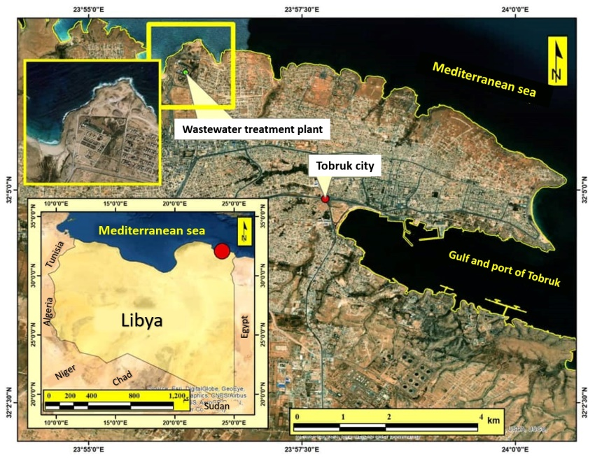
Figure 1 the geographical location of the study area

2.2 Sampling Design and Collection
A spatio-temporal sampling design was adopted. Seawater samples were collected from six sites during autumn 2022 and winter 2023 Figure 2. Sampling was conducted at a depth of 30 cm below the water surface and at distances of 5 m and 200 m from the shoreline. Each sample was collected in triplicate. Site (5) was designated as a relative reference site due to its location farther from the direct influence of the discharge point. The selection of these sites is based on scientific considerations related to coastal water movement and the dispersion of pollutants resulting from the direct discharge of wastewater into the sea. Additionally, choosing these distances helps minimize the potential impact of other pollution sources, such as stormwater runoff, which could interfere with the effectiveness of the wastewater treatment plant, thereby ensuring the accuracy and reliability of the results in assessing the impact of wastewater discharge on coastal water quality.
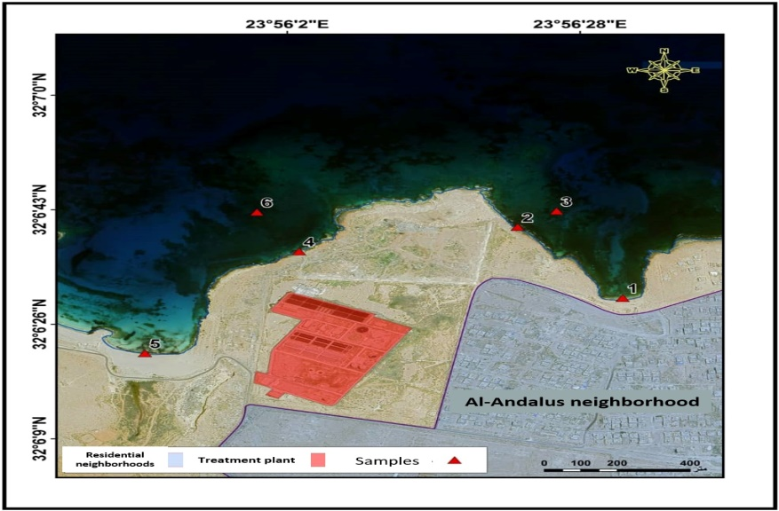
Figure 2 the spatial distribution of the six sampling sites along Al-Awda Beach.

2.3 Laboratory Analyses
Physical parameters (temperature, pH, electrical conductivity, and total dissolved solids) were measured in situ or immediately upon sample arrival at the laboratory. Nutrients (NH₃, NO₂⁻, PO₄³⁻), BOD, and COD were analyzed following standard APHA methods (APHA., 2003). Heavy metals (Cd, Cr, Pb, Fe) were quantified using flame atomic absorption spectrophotometry after acid digestion according to EPA Method 3050B (EPA.,1996). Microbiological analyses for E. coli and total coliforms were conducted using membrane filtration and most probable number (MPN) techniques.

2.4 Statistical Analysis
Data were statistically analyzed using SPSS version 25. One-way analysis of variance (ANOVA) was applied to test spatial and seasonal differences, while Pearson correlation coefficients (R) were used to examine relationships among physicochemical and biological variables. Statistical significance was set at P ≤ .05.
Figure 1 illustrates the geographical location of the study area, while Figure 2 shows the spatial distribution of the six sampling sites along Al-Awda Beach.
Table 1 summarizes the physicochemical and microbiological characteristics of seawater samples collected during autumn 2022 and winter 2023. Table 2 presents the the international guideline limits for coastal water quality used for comparison in this study

3. results and discussion

The results revealed pronounced spatial and seasonal variations in most investigated parameters (Table 1). Sites located near the wastewater discharge point exhibited significantly higher pollutant levels compared with the relative reference site (Site 5), confirming the direct influence of wastewater effluent on coastal water quality [Abualhin & El-Khuzundarc., 2022; Abugdera et al., 2018; Moore, 1991; Reopanichkul et al., 2010].

Table 1 the physicochemical and microbiological characteristics of seawater samples collected during autumn 2022 and winter 2023
Item | season | Sample 1 | Sample 2 | Sample 3 | Sample 4 | Sample 5 | Sample 6
T  c° | winter | *21 | 20 | *18.7 | *20.7 | *19 | *19
T  c° | autumn | *26.3 | *26.6 | *26.4 | *27 | *27 | *26.5
PH | winter | *8.1 | *8.1 | *8.1 | *8.1 | *7.9 | *7.9
PH | autumn | *8.5 | *8.4 | *8.4 | *8.6 | *8.4 | *8.5
TDS  ppm | winter | 39789 | 38239 | 39190 | 38896 | 39296 | 39883
TDS  ppm | autumn | *41261 | *38387 | 40551 | 40339 | 41877* | *41149
EC  mS/cm | winter | 59903 | 59162 | 58688 | 58848 | 58914 | 59495
EC  mS/cm | autumn | 61583 | 60283 | 62017 | 61033 | 62503 | 61417
NH3  mg/l | winter | *8.9 | *7.8 | *6.6 | *6.6 | *6 | *5.7
NH3  mg/l | autumn | *4 | *13.5 | *10.7 | *12.2 | *4.2 | *9.1
NO2  mg/l | winter | 14 | 14 | 12.6 | 12.3 | 12 | 13
NO2  mg/l | autumn | 11.5 | 11.4 | 12.3 | 10.8 | 12.1 | 11.7
PO4  mg/l | winter | 23.3 | 25.3 | 23 | *24.7 | *21.4 | 23
PO4  mg/l | autumn | 26.9 | *29.7 | 28.1 | 28.6 | *26.3 | 27.5
BOD  mg/l | winter | *205 | *275 | 204* | *254 | *156 | *147
BOD  mg/l | autumn | *194 | *321 | *234 | *384 | *190 | *211
COD  mg/l | winter | *369 | *402 | *306 | 324 | *262 | *248
COD  mg/l | autumn | *240 | *515 | *354 | *447 | *252 | *317
Cd  mg/l | winter | *5.8 | *6.9 | *4.5 | *5 | *4.9 | *4.8
Cd  mg/l | autumn | 2.5 | 2.5 | 2.3 | 2.5 | 2.4 | 2.6
Cr  mg/l | winter | *4 | *4.1 | *2.4 | *4 | *3.4 | *2.7
Cr  mg/l | autumn | 4.1 | 3.9 | 4 | 2.7 | 4 | 4.3
Pb  mg/l | winter | 1.8 | 1.5 | 1.3 | 1.5 | 1.5 | 1.7
Pb  mg/l | autumn | 1 | 1 | 0.8 | 0.9 | 1 | 0.9
Fe  mg/l | winter | *8.1 | *8 | *6.5 | *9.2 | *6.2 | *8.3
Fe  mg/l | autumn | *7 | *5.6 | *6.2 | *6.3 | *3.2 | *7.1
E.Coli  Mpn/100ml | winter | 10-100 | 150-250 | 120-220 | 150-250 | 10-100 | 100-200
E.Coli  Mpn/100ml | autumn | 0-10 | 250-450 | 200-400 | 10-100 | 0-10 | 10-100
Coliforn  Mpn/100ml | winter | 100-200 | 400-600 | 200-400 | 100-200 | 220-420 | 0-10
Coliforn  Mpn/100ml | autumn | 10-100 | 450-650 | 400-600 | 100-200 | 0-10 | 100-200
Significant at 0.05% level of significance*

3.1 Physical Parameters
Water temperature and pH showed seasonal variations consistent with climatic conditions rather than wastewater discharge effects (Table 1). Similar observations have been reported for Mediterranean coastal waters subjected to wastewater inputs (Jalgaif et al., 2018; Reopanichkul et al., 2010).

Measurements of Total Dissolved Solids (TDS) and Electrical Conductivity (EC) showed a slight decrease at the site adjacent to the sewage outfall, although they remained within the normal range for seawater. This decline is primarily attributed to a physical dilution effect, whereby secondary-treated wastewater—which is typically less saline than seawater—contributes to reducing the total concentration of dissolved ions near the mixing point (Mousa, 2021; Peng et al., 2019).

The results also reveal a statistically inverse relationship between TDS and EC values and the concentrations of organic pollutants and nutrients (such as COD, BOD, ammonia, and phosphate) originating from the same source, confirming that the shared pollution source is responsible for simultaneously elevating nutrient levels and reducing salinity through dilution, rather than being a result of purely biological activity. In winter, rainfall and increased surface runoff contribute to additional dilution of seawater ions, leading to lower TDS and EC values. In contrast, high temperatures and increased evaporation rates during hot seasons concentrate the dissolved ions, thereby raising both TDS and EC levels. Consequently, variations in these two parameters near the discharge point are ascribed to hydro-physical processes, namely dilution by wastewater and seasonal fluctuations.

3.2 Nutrients and Oxygen-Demand Parameters
Ammonia, nitrite, and phosphate concentrations exhibited a significant increase at sites immediately adjacent to the sewage outfall (Table 1), with the recorded mean values substantially exceeding the recommended guideline limits for coastal water quality (Table 2). This rise reflects the direct impact of secondary-treated wastewater discharge on the chemical properties of coastal waters, particularly in areas near the outfall characterized by low dilution and water renewal rates.
Statistical analysis results revealed strong positive correlations between nutrient concentrations on one hand and Biochemical Oxygen Demand (BOD) and Chemical Oxygen Demand (COD) values on the other, with correlation coefficients (R) exceeding 0.70. These strong relationships indicate that wastewater rich in organic matter is the primary source of pollution in the studied area, as non-biodegradable materials, such as certain types of alcohols, organic acids, metal ions, and cellulose present in high quantities in domestic and industrial wastewater, contribute significantly to elevated COD levels (Al-Qasir, 2012). These findings align with the study by Nergis et al. (2012), which showed COD concentrations in the Shatt al-Arab river reaching 788 mg/L during autumn and 529 mg/L in winter due to sewage pollution. Similarly, the study by Haebig et al. (2021) documented the spread of COD concentrations exceeding safe limits over an area of 4.72 km² from the discharge point
The study by Musa & Okonkwo (2017) demonstrated that the discharge of wastewater led to a deterioration in the water quality of the stream, rendering it unsuitable for both human consumption and aquatic life due to the elevated levels of pollutants. This indicates the limited capacity of the stream to recover from the pollution caused by industrial wastewater..
The elevated nitrite concentrations are attributed to the high levels present in the treated wastewater discharged into the sea, as nitrite, along with phosphate, is a key nutrient for algal and bacterial growth (Riley & Chester, 1971). The increase in these nutrients leads to excessive microbial growth, accompanied by substantial consumption of dissolved oxygen, creating conditions unsuitable for the survival of other marine organisms (Michael & Kennish, 1998). These results are consistent with the findings of Alibi et al. (2020), which recorded high nitrite concentrations of 26.4 mg/L in the waters of Rajish Bay, Tunisia, resulting from inadequate sewage treatment efficiency.
The study also showed that the highest ammonia concentrations were recorded in samples near the sewage outfall during autumn and winter, attributable to the decomposition of organic matter in the wastewater. Concentrations then gradually decreased with distance from the outfall due to dilution and seawater self-purification processes and the availability of oxygen required for ammonia oxidation. The safe limit for ammonia concentration in seawater is a subject of debate, with some studies indicating that toxic concentrations begin at 0.08 mg/L (Boardman et al., 2004), meaning all values recorded in this study exceed toxic thresholds. These findings agree with the study by Jalgaif (2018), which documented ammonia pollution in Tobruk Bay due to sewage discharge.

Table 2 the international guideline limits for coastal water quality used for comparison in this study
Maximum allowed | Item
30 | C
30 mg/l | BOD
250 mg/l | COD
200 MPN/100ml | Coliform
10 mg/l | NO2
0.1 mg/l | PO4
0.01 mg/l | Cd
0.1 mg/l | Cr
0.1 mg/l | Pb
0.1 mg/l | Fe
Source: (Moore, 1991)

3.3 Heavy Metals
The concentrations of Cd, Cr, Pb, and Fe exceeded permissible coastal water limits at most sampling sites (Tables 1 and 2), particularly during winter. This pattern reflects the limited efficiency of secondary treatment processes in removing heavy metals, as well as the contribution of urban runoff during rainfall events (Alam et al., 2002). Elevated heavy metal levels in coastal waters have been linked to bioaccumulation and toxic effects on marine organisms (Moore, 1991). clearly demonstrates the spatial gradient of heavy metal contamination, with the highest values recorded near the discharge point.

3.4 Microbiological Contamination and Public Health Implications
E. coli and total coliform counts exceeded recreational water standards at most sites, including the reference site (Table 1), indicating widespread microbial contamination. Similar trends have been reported in coastal areas receiving inadequately treated wastewater (Delille & Gleizon, 20003; Manini et al., 2022; Oladipo et al., 2022). The persistence of microbial indicators highlights the low efficiency of the treatment plant and poses significant public health risks through direct exposure and seafood consumption (ECC, 2002; Okuku et al., 2011).

4. Conclusion

The findings demonstrate that the continuous discharge of low-efficiency, secondarily treated wastewater has severely degraded the coastal water quality of Al-Awda Beach. Elevated nutrient loads, oxygen-demand parameters, heavy metals, and microbial indicators collectively indicate substantial environmental and health risks. Upgrading the treatment plant to tertiary treatment and relocating the outfall offshore are essential measures to protect the coastal ecosystem and public safety

Artificial Intelligence Disclosure:

We confirm that no artificial intelligence techniques were used in the preparation or editing of this research.

References

- Abualhin, K., & El-Khuzundar, S. (2022). The environmental impacts of wastewater discharge on the coastal water quality in the Gaza nearshore region. Environmental Studies, 24, 14–35.
- Abugdera, A. F., Faris, B. M., & Abugderha, M. M. (2018). Analytical study of environmental impact assessment for a wastewater treatment plant in Sabratha, Libya. International Journal of Scientific & Engineering Research, 9(5), 199–205. https://www.researchgate.net/publication/325600000_Analytical_Study_of_Environmental_Impact_Assessment_for_a_Wastewater_Treatment_Plant_in_Sabratha_Libya
- Alam, M. G. M., Snow, E. T., & Tanaka, A. (2003). Arsenic and heavy metal contamination of vegetables grown in Samta village, Bangladesh. Science of the Total Environment, 308(1–3), 83–96. https://doi.org/10.1016/S0048-9697(02)00651-4
- Alibi, S., Mehehi, S., Hassen, W., & Ben Mansour, H. (2020). Study of the physicochemical and bacteriological properties of the seawater of Rajish Beach in the city of Mahdia, Tunisia. Arabian Journal of Scientific Research, 1(2). https://doi.org/10.5339/ajsr.2020.9
- Al-Qasir, M. K. K. (2012). Environmental impact assessment of wastewater treatment project discharge on the water quality of the Diwaniyah River, Iraq (Master’s thesis). College of Science, University of Diwaniyah, Iraq.
- APHA. (1998). Standard methods for the examination of water and wastewater (20th ed.). American Public Health Association.
- Boardman, G. D., Starbuck, S. M., Hudgins, D. B., Li, X., & Kuhn, D. D. (2004). Toxicity of ammonia to three marine fish and three marine invertebrates. Environmental Toxicology, 19(2), 134–142. https://doi.org/10.1002/tox.20008
- Council of the European Communities. (1975). Council Directive of 8 December 1975 concerning the quality of bathing water (76/160/EEC). Official Journal of the European Communities, L 31, 1-7. https://eur-lex.europa.eu/legal-content/EN/TXT/?uri=CELEX:31976L0160.
- Danazumi، S. ; Bichi، M. (2010). Industerial Pollution and heavy metals Profile of Challawa river in Kano ، Nigeria. J. of applied Science in environmental sanitation،5(1) :23-29.
- Delille, D., & Gleizon, F. (2003). Distribution of enteric bacteria in Antarctic seawater surrounding the Port-aux-Français permanent station (Kerguelen Island). Marine Pollution Bulletin, 46(9), 1179–1183. https://doi.org/10.1016/S0025-326X(03)00164-4.
- Jalgaif, G. G. A., Idris, S. A. M., Maarouf, R. A. M., Attia, A. M., & El-Naggar, M. M. (2018). Determination of the sea waters quality of Tobruk-Libya Gulf. *International Journal of Environmental Chemistry, 2*(1), 1–9. https://doi.org/10.11648/j.ijec.20180201.12
- Manini, E., Baldrighi, E., Ricci, F., Grilli, F., Giovannelli, D., Intoccia, M., Casabianca, S., Capellacci, S., Marinchel, N., Penna, P., Moro, F., Campanelli, A., Cordone, A., Correggia, M., Bastoni, D., Bolognini, L., Marini, M., & Penna, A. (2022). Assessment of spatio-temporal variability of faecal pollution along coastal waters during and after rainfall events. Water, 14(3), 502. https://doi.org/10.3390/w14030502
- Moore, J. W. (1991). Inorganic contaminants of surface water: Research and monitoring priorities. Springer. https://doi.org/10.1007/978-1-4612-3004-5
- Mousa, R. A. (2021). Study of the effect of untreated sewage discharge on the characteristics of seawater and sediments on the coast of Zliten, western Libya. Journal of Marine Sciences and Environmental Technologies, 7(2), E21-E37. https://doi.org/10.59743/jmset.v7i2.16
- Musa, U., & Okonkwo, P. C. (2017). Assessment of effects of brewery waste water discharge and self purification potential of “Rafin Giya” stream in Kudenda industrial layout, Kaduna, Nigeria. Asian Journal of Environment & Ecology, 4(2), 1–9. https://doi.org/10.9734/AJEE/2017/35837.
- Nergis, Y., Sharif, M., Choudhry, A. F., Hussain, A., & Butt, A. (2012). Impact of industrial and sewage effluents on Karachi coastal water and sediment quality. Middle-East Journal of Scientific Research, 11(10), 1443–1454. https://doi.org/10.5829/idosi.mejsr.2012.11.10.63209
- Okuku, E. O., Ohowa, B. O., Mwangi, S. N., Munga, D., Kiteresi, L. I., Wanjeri, V. O., Okumu, S., & Kilonzo, J. (2011). Sewage pollution in the Coastal waters of Mombasa City, Kenya: A norm Rather than an Exception. International Journal of Environmental Research, 5(4), 865–874. https://doi.org/10.22059/ijer.2011.444
- Oladipo, O. O., Ilesanmi, T. M., & Olaleye, A. C. (2022). Environmental impact of abattoir waste discharge on the quality of water body and soil in Ado-Ekiti, Ekiti State. Asian Journal of Biotechnology and Bioresource Technology, 8(2), 1–6. https://doi.org/10.9734/ajb2t/2022/v8i230120
- Orate، F.(2017). Sewage and wastewater treatment plant performance: Challenges and the environmental impact
- Owili, M. A. (2003). Assessment of impact of sewage effluents on coastal water quality in Hafnarfjörður, Iceland. UNU-Fisheries Training Programme. https://www.grocentre.is/ftp/static/fellows/document/Owili2003.pdf
- Peng, J., Kumar, K., Gross, M., Kunetz, T., & Wen, Z. (2019). Removal of total dissolved solids from wastewater using a revolving algal biofilm reactor. Water Environment Research, 92(5), 766–778. https://doi.org/10.1002/wer.1273
- Reopanichkul, P., Carter, R. W., Worachananant, S., & Crossland, C. J. (2010). Wastewater discharge degrades coastal waters and reef communities in southern Thailand. Marine Environmental Research, 69(5), 287–296. https://doi.org/10.1016/j.marenvres.2009.11.011
- Riley, J. P., & Chester, R. (1971). Introduction to marine chemistry. Academic Press, London.
- U.S. Environmental Protection Agency. (1996). Method 3050B: Acid digestion of sediments, sludges, and soils. United States Environmental Protection Agency. https://www.epa.gov/sam/method-3050b-acid-digestion-sediments-sludges-and-soils.
- Wang, C., Wang, B., & Jiang, S. (2021). Discussion on the Selection and planning of Sewage Outfall Into the sea—a case of Gaoqi Sewage Treatment Plant. IOP Conference Series: Earth and Environmental Science, 831(1), 012059. https://doi.org/10.1088/1755-1315/831/1/012059

