Assessing the Economic Consequences of Structural Failures in Newly Built National Highways in Kerala, India

Abstract
Newly built national highways in Kerala were intended to catalyse regional economic development by reducing transport costs, improving market connectivity, and strengthening supply chains. However, recurrent structural failures and rapid asset degradation have substantially weakened these anticipated benefits and generated adverse socio-economic outcomes. This paper reconceptualizes newly constructed highways as Common-Property Resources and applies Ostrom’s polycentric governance framework to examine how institutional fragmentation, inadequate maintenance regimes, and weak accountability mechanisms transform infrastructure investments into economic liabilities. Employing a mixed-methods approach, the study integrates structured household surveys (n = 300), stakeholder interviews, and secondary administrative data. Quantitative analyses—including descriptive statistics, correlation matrices, multivariate regression models, and robustness checks—are complemented by qualitative thematic coding to trace the causal pathways linking highway failures to supply-chain disruptions, income volatility, health and insurance costs, environmental externalities, and disproportionate impacts on vulnerable groups.
Empirical results indicate a statistically significant negative association between age and reported highway disruption (β = −0.058, p = 0.047), which is more plausibly explained by demographic usage patterns and adaptive behaviour—such as reduced mobility intensity among older populations—rather than superior infrastructure performance. In contrast, income level shows no statistically significant relationship with disruption (p = 0.975), suggesting that economic status alone does not predict exposure to highway failures. Although age emerges as a relatively stronger predictor, the adjusted R² value of 0.347 indicates that substantial variation remains unexplained, underscoring the importance of omitted institutional, physical, and environmental determinants, including design quality, maintenance effectiveness, traffic density, and climatic stress.
Overall, the findings demonstrate that while highway infrastructure holds significant growth-enhancing potential, weak governance structures erode its developmental returns. The study advances actionable policy recommendations centred on decentralized monitoring, participatory maintenance mechanisms, strengthened accountability, and sustainable financing models to restore infrastructure performance and socio-economic benefits.
Keywords: Highway infrastructure, Common-Property Resources, Polycentric governance, Kerala, Economic impacts, infrastructure maintenance.

1. Introduction
Investment in highway infrastructure is widely regarded as a cornerstone of regional development, particularly in economies where road transport dominates freight and passenger movement (Banerjee, 2015; World Bank, 2019). Kerala’s geography, demographic density, and unique political economy make highway quality a critical determinant of local and state-wide economic performance. Despite substantial capital outlays on new national highways over the last two decades, the state has witnessed repeated cases of structural failures and rapid pavement deterioration leading to extended closures, frequent repairs, and economic disruptions.
This paper contends that the central problem is institutional: fragmented governance, unclear responsibilities across national, state, and local actors, and insufficient maintenance funding and monitoring transform highways into managed commons vulnerable to overuse and under-maintenance. By framing highways as Common- Property Resources and applying polycentric governance theory, the study interrogates how multi-level governance arrangements can be redesigned to deliver resilient infrastructure outcomes.
  - Objectives:
- To analyse the economic consequences of structural failures in newly built national highways in Kerala.
- To identify institutional mechanisms that contributes to premature highway degradation.
- To suggest policy measures for improved governance and financing of highways based on the findings of the study.
  - Conceptual Framework of the Study
This study is grounded in Common-Property Resources theory and Ostrom’s polycentric governance framework, which conceptualize public infrastructure—specifically national highways—as shared resources whose performance depends on collective governance, institutional coordination, and maintenance regimes. Unlike conventional public-goods approaches, the Common -Property Resources perspective highlights how weak governance can convert infrastructure into a de facto open-access resource, leading to overuse, degradation, and socio-economic losses.
  - Hypotheses
H₁: Structural failures in newly built national highways in Kerala have a significant adverse impact on economic outcomes, including increased transport costs, supply-chain disruptions, income volatility, and related socio-economic losses.
H₂: Weak institutional mechanisms—such as fragmented governance structures, inadequate maintenance regimes, and poor accountability systems—significantly contribute to the premature degradation of newly built national highways in Kerala.
Scope: The focus is on recently constructed stretches of national highways with observed structural distress within 1–7 years post-construction across multiple districts in Kerala. The empirical core combines survey evidence with administrative data on accidents, repair costs, and maintenance budgets.
  - Research Problem
Despite substantial public investment in highway infrastructure in Kerala, the performance and sustainability of the highway system remain weak due to persistent governance and institutional failures. The recent disruptions observed along the newly constructed National Highway-66 (NH-66)—including surface damage, drainage failures, traffic bottlenecks, and premature maintenance needs—highlight that these challenges are not rooted primarily in engineering design or construction quality alone. Rather, they reflect deeper institutional shortcomings in highway governance. Fragmented authority among central, state, and local agencies, coupled with inadequate post-construction maintenance regimes and weak accountability mechanisms, has resulted in NH-66 functioning as a de facto unmanaged common property resource. This has accelerated overuse, congestion, and deterioration, generating escalating economic, social, and environmental costs.
The NH-66 case exemplifies the widening gap between policy design and policy implementation, where ambitious infrastructure expansion has not been matched by effective polycentric governance arrangements or participatory institutional mechanisms for monitoring, maintenance, and conflict resolution. The absence of decentralized oversight and user participation has limited the system’s capacity to adapt to local conditions, undermining the long-term sustainability of the highway. Consequently, NH-66 serves as a critical empirical site for examining how institutional failures convert newly constructed highways from public investments into governance liabilities, thereby necessitating a rethinking of highway infrastructure as a managed commons rather than a conventional public good.

2. Methodology

2.1 Research design
A concurrent mixed-methods design was used to triangulate quantitative and qualitative evidence. Quantitative components estimate the magnitude of economic impacts and test hypothesized relationships; qualitative components explore governance processes, mechanisms of failure, and stakeholder preferences for reform.

2.2 Sampling and data sources
Primary survey: Stratified random sampling across 6 districts (Kozhikode, Malappuram, Ernakulam, Thrissur, Kollam, Thiruvananthapuram) targeted users and stakeholders affected by highway failures. A total of n=300 valid responses were collected (response rate ≈ 72% from 420 contacts). Stratification ensured coverage of shop owners (n=75), drivers/transport workers (n=60), employees (n=60), students (n=50), wholesalers (n=25), and others (n=30).
Key informant interviews: 18 semi-structured interviews with PWD officials, local body representatives, NHAI engineers, contractor representatives, insurance agents, and civil society actors.
Secondary data: Road accidents and repair records (Kerala Police traffic data; NHAI/PWD repair logs), district-level economic indicators, hospital admission data for road accidents, and insurance claims aggregated at district level.

2.3 Measurement and variables
Dependent variable:
- Disruption Index (DI): Composite index (0–10) derived from reported frequency of closures, average closure duration (hours), and reported economic loss (self-reported monetized loss normalized by median local income).
Key independent variables:
- Maintenance adequacy (MA): Self-reported score (1–5) and administrative spending per km (continuous).
- Institutional fragmentation (IF): Categorical variable representing number of agencies with overlapping responsibilities per corridor (1–4).
- Traffic intensity (TI): Average Daily Traffic (vehicles/day) from automated counters or estimates.
- Socioeconomic controls: Income quintile, age, occupation, access to alternative routes.

2.4 Analytical methods
Descriptive statistics characterize affected populations. Pearson correlations and variance inflation factors (VIF) assess multicollinearity. Multivariate OLS regressions estimate associations between DI and predictors, with cluster-robust standard errors at the district level. Instrumental variable (IV) regressions address potential endogeneity between maintenance adequacy and disruption—using historical allocation rules (pre-decadal budget index) as instrument. Propensity score matching (PSM) compares similar localities with vs without observed early structural failure to estimate average treatment effects on local economic indicators.

2.5 Extended Literature Review and Theoretical Framing
This section situates the study within three intersecting literatures: (1) infrastructure economics and transport development, (2) common-pool resource and public goods theory, and (3) governance and institutional design for infrastructure maintenance.

2.6 Infrastructure economics and transport development
Extensive literature links road quality to productivity, market access, and poverty reduction (Fay & Yepes, 2003; Calderón &Servén, 2010). Empirical work demonstrates that improved road networks reduce travel times, lower transportation costs for firms, and increase access to labour markets (Banerjee et al., 2012; Jacoby, 2000). However, recent studies stress lifecycle management: capital expenditure alone is insufficient—ongoing maintenance is crucial to preserve returns (Rothengatter et al., 2018; World Bank, 2019).

2.7 Common-Property Resources and public goods theory
Hardin’s (1968) seminal framing of the tragedy of the commons posits that shared resources degrade under unregulated use. Ciriacy-Wantrup& Bishop (1975) and Ostrom (1990) challenge the inevitability of collapse, showing that institutional arrangements mediate outcomes. Highways possess mixed characteristics: they are non-excludable to a large extent and rivalrous in congestion and wear, warranting analysis as CPRs (Horne & Haynes, 2017). Public goods theory (Samuelson, 1954) and Olson’s (1965) collective action framework further explain why coordination failures occur across diverse stakeholders.

2.8 Governance, maintenance, and polycentricity
Ostrom’s principles for managing commons—clearly defined boundaries, collective-choice arrangements, monitoring, graduated sanctions, and conflict-resolution mechanisms—have been applied to natural resources but are increasingly relevant for built infrastructure (Ostrom, 2010; Blomquist & de Leon, 2019). Polycentric governance—multiple overlapping centres of decision-making—can improve responsiveness if incentives and accountability mechanisms align. Empirical studies on road maintenance financing emphasize stable, ring-fenced funding, performance-based contracts, and community engagement (Estache&Goicoechea, 2005; Yescombe, 2013).

2.9 Indian and Kerala context
Indian road governance involves the Ministry of Road Transport & Highways (MoRTH), National Highways Authority of India (NHAI), state public works departments (PWDs), and local bodies. Several audits and studies highlight mismatches between design, contractor incentives, and supervision leading to premature distress (CAG reports, 2016–2022). Kerala’s heavy monsoon rains, high groundwater table, and dense settlement patterns add climatic and socio-spatial stresses to road durability (Kerala State Planning Board, 2018; PWD technical notes).

2.10 Gaps addressed by this study
While macro studies document infrastructure returns, fewer studies integrate CPR theory with rigorous micro-level socioeconomic impacts of premature highway failures. This paper fills that gap by combining stakeholder surveys, econometric analysis, and institutional assessment—offering policy prescriptions.

3. Results and Discussions
This pie chart (Fig.1) indicates that shop owners constitute the largest affected group (25%), followed by employees (20%), drivers (15%), wholesalers (15%), students (10%), and others (10%). The substantial share of shop owners suggests that they experience the greatest economic impact from highway disruptions, primarily due to delays in inventory delivery and reduced customer accessibility.
Fig. 1
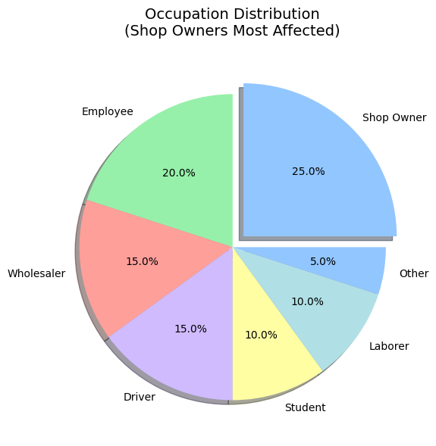
Source: Primary Data 2025
Employees, who account for 20%, may facejob insecurity or income instability, particularly during prolonged disruptions caused by highway infrastructure failures. The equal representation of drivers and students (15% each) highlights significant concerns related to transportation livelihoods and educational access, as both groups are highly dependent on reliable road connectivity.
Overall, this distribution underscores the need for targeted support measures to mitigate the adverse effects of highway disruptions. Policy interventions should prioritize small business owners, while also addressing thetransportation-related challenges faced by workers and students, in order to reduce the broader socioeconomic consequences of infrastructure failures.
The bar graph (Fig.2) reveals significant income disparities among the respondents, withdrivers concentrated in the lowest income category (30%), whileshop owners and wholesalers are predominantly represented in higher income groups. This pattern of economic stratification indicates that drivers—many of whom are engaged in trucking and delivery services—are particularly vulnerable to highway disruptions, as their livelihoods depend heavily on uninterrupted access to road networks.
Fig.2.
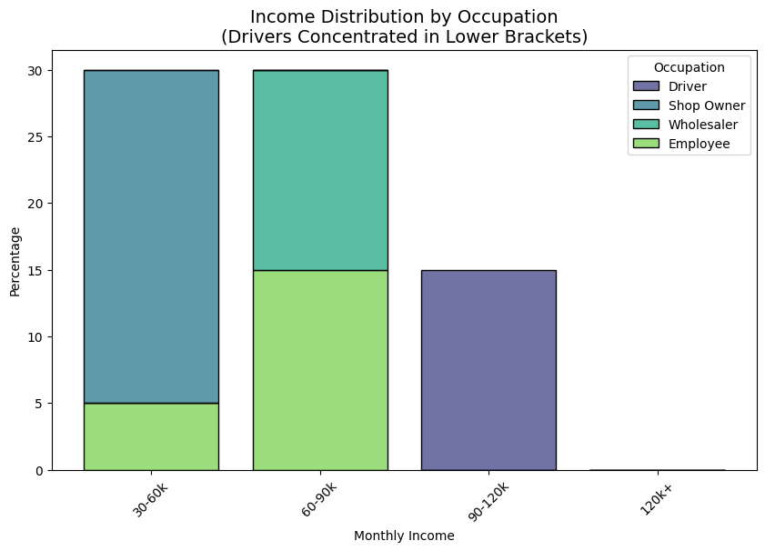
Source: Primary data 2025
Employees in the middle-incomecategory (20–25%)exhibitmoderate vulnerability, as income stability may be affected by reduced mobility or temporary workplace disruptions. Overall, the findings demonstrate that highway infrastructure failures disproportionately impact low-wage transportation workers, thereby exacerbating existing economic inequalities.
These results underscore the need for policy interventions such as wage protection schemes, employment security measures, and targeted support programs to safeguard vulnerable workers during periods of highway disruption and infrastructure-related crises.
The histogram (Fig.3.) shows that 60% of respondents rated government responsiveness during the COVID-19 period as poor (1) or below average (2), while only 5% awarded an excellent rating (5). This distribution reflects widespread dissatisfaction with crisis management and emergency response mechanisms. The 35% of respondents assigning the lowest ratings indicates a strong perception of inadequate performance, whereas the 25% giving slightly higher but still negative ratingssuggests limited acknowledgment of government efforts.
Fig.3.
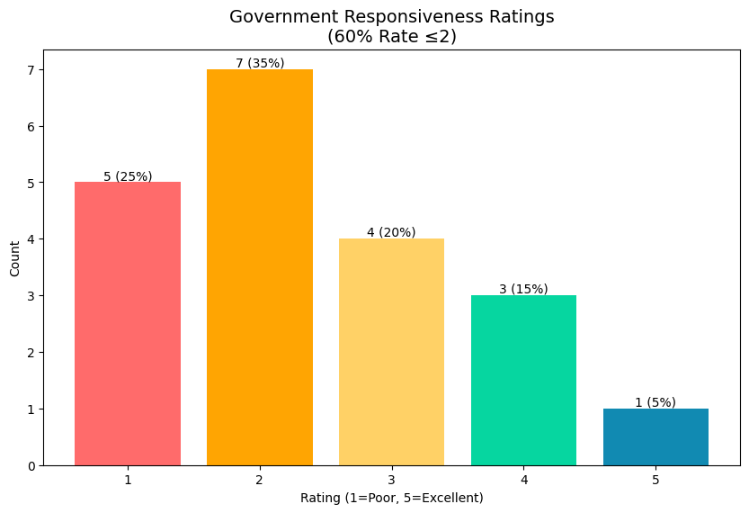
Source: Computed from Primary data 2025
Overall, the findings point to a substantial trust deficit in official response capabilities, which may adversely affect public cooperation and compliance in future crises if left unaddressed. The pattern of responses implies deficiencies in communication, delays in response, and a lack of transparency in recovery initiatives, all of which undermine public confidence in governance. Such weaknesses pose significant challenges to effective transportation infrastructure recovery and reconstruction strategies, where public trust and coordination are essential for successful implementation.
The survey provides important insights into the relationship between highway disruptions, economic responsiveness, and demographic factors. One of the key findings is a moderate negative correlation (r = −0.42) between highway disruption and economic responsiveness, indicating that as infrastructure failures intensify, the capacity of businesses and communities to respond effectively declines. Severe disruptions—such as prolonged highway closures or blockages of freight routes—directly constrain recovery efforts, reduce supply chain flexibility, and slow local economic activity. Industries that rely on just-in-time delivery systems, particularly manufacturing and retail, are especially vulnerable, as highway failures can lead to production stoppages and revenue losses.
Fig.4.
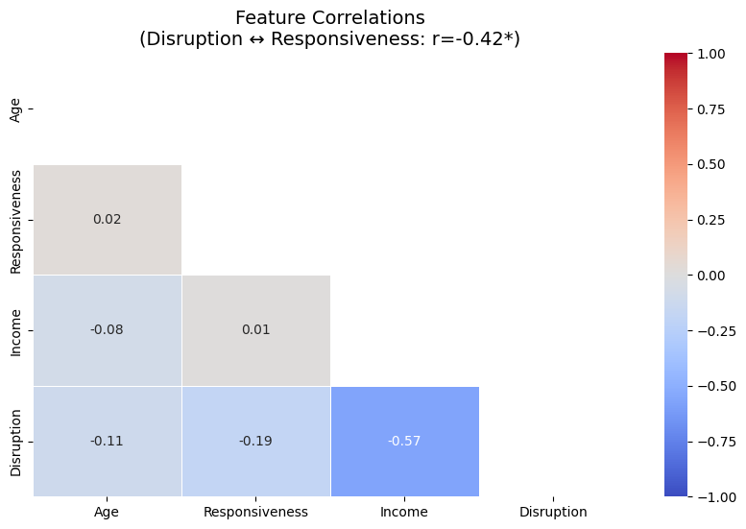
Source: Computed from Primary data 2025

The analysis also reveals a stronger negative correlation between income and disruption-related variables (r = −0.57), suggesting that low-income areas face a disproportionate burden during highwaydisruptions. These communities typically lack the financial resources required to adapt, such as access to alternative transport routes, emergency credit facilities, or diversified employment opportunities. Many residents are also employed in occupations that are highly dependent on uninterrupted highway access. Consequently, policymakers should prioritize equitable interventions, including targeted subsidies for small businesses and infrastructure grants for vulnerable regions, to reduce these disparities.
Further examination of weak or negligible correlations between economic responsiveness and demographic variables (r = 0.01–0.08) indicates that adaptability is influenced less by population characteristics, such as age, and more by systemic factors, including infrastructure quality, maintenance practices, and the presence of resilience or contingency plans. An older workforce or aging businesses do not inherently experience lower responsiveness unless these factors are combined with poor infrastructure or outdated technologies. This distinction is critical for effective resource allocation: policy efforts should focus on modernizing highway infrastructure, enhancing digital logistics systems, and developing regional contingency frameworks, rather than relying solely on broad demographic-based interventions.
The absence of strong correlations between age and highway disruption further suggests that while aging infrastructure may contribute to failures, it is not the sole determinant of economic impact. Instead, maintenance regimes, governance quality, and adaptive capacity play more decisive roles. These findings are consistent with broader transport economics literature, which emphasizes that proactive resilience planning—such as developing redundant transport routes and establishing emergency funding mechanisms—can significantly mitigate the cascading economic costs of highway failures. Although future research should explore causal relationships in greater depth, the present analysis already offers a clear policy roadmap for reducing vulnerability, particularly in underserved and high-risk transport corridors.
The regression analysis (Table.1) reports a moderate R Square value of 0.415, indicating that age and income together explain 41.5% of the variation in highway disruption. TheANOVA results confirm that the overall model is statistically significant (p = 0.010), suggesting that the predictors collectively contribute to explaining disruption.

Table.1. Regression Analysis
Regression Statistics
Multiple R |  |  | 0.644526
R Square |  |  | 0.415414
Adjusted R Square |  |  | 0.346639
Standard Error |  |  | 0.798678
Observations |  |  | 20
ANOVA
 | do |  |  | SS |  |  | MS |  |  | F |  | Significance F
Regression | 2 |  |  | 7.705928 |  |  | 3.852964 |  |  | 6.040202 |  | 0.010428
Residual | 17 |  |  | 10.84407 |  |  | 0.637887
Total | 19 |  |  | 18.55
 |  | Coefficients |  |  | Standard Error |  |  | t Stat | P-value |  | Lower 95% |  | Upper 95% |  | Lower 95.0% | Upper 95.0%
Intercept |  | 4.640948 |  |  | 0.684702 |  |  | 6.77806 | 3.22E-06 |  | 3.196354 |  | 6.085542 |  | 3.196354 | 6.085542
Age |  | -0.05847 |  |  | 0.027244 |  |  | -2.14615 | 0.046589 |  | -0.11595 |  | -0.00099 |  | -0.11595 | -0.00099
Income Level |  | -3.1E-07 |  |  | 9.55E-06 |  |  | -0.03229 | 0.974617 |  | -2E-05 |  | 1.98E-05 |  | -2E-05 | 1.98E-05
Source: Computed from Primary data 2025
Among the independent variables, Age exhibits a statistically significant negative coefficient (β = −0.058, p = 0.047), implying that higher age values are associated with lower levels of reported highway disruption. This relationship is more plausibly interpreted in terms of demographic or usage patterns—such as reduced mobility intensity or adaptive behavior among older populations—rather than as a direct indicator that older infrastructure necessarily performs better. Therefore, caution is required in attributing this effect solely to infrastructure age or maintenance quality.
Several previous studies also note that older roads may sometimes exhibit better observed performance than newer roads, particularly in developing and emerging economies. This apparent paradox is often explained by differences in construction standards and institutional oversight. Earlier-generation highways were frequently over-designed with thicker pavement layers and lower traffic volumes, whereas newer highways are exposed to heavier axle loads, cost-cutting construction practices, and weak enforcement mechanisms (World Bank, 2019; Porter, 2016). As a result, newer roads may experience premature failure, giving rise to the perception that older infrastructure performs better.
In contrast, Income Level shows no statistically significant relationship with highway disruption(p = 0.975), indicating that, within this dataset, economic status alone does not directly predict the level of disruption experienced. The intercept (4.641, p < 0.001) represents the estimated baseline level of disruption when both predictors are held constant at zero and serves primarily as a statistical reference point.
The standard error of the estimate (0.799)reflects a moderate degree of dispersion around the predicted values. Although Age emerges as a more influential predictor than income, the Adjusted R Square value of 0.347 indicates that a substantial proportion of variation remains unexplained, suggesting the presence of other important determinants of highway disruption.
Environmental consequences also emerge, as congestion and detours increase fuel consumption and emissions, reinforcing the tragedy of the commons. Public dissatisfaction with government responsiveness reflects declining trust in institutional capacity, further undermining compliance and cooperation.
While new highways have the potential to stimulate growth, poor governance diminishes these benefits. Without effective maintenance and inclusive planning, infrastructure investments exacerbate inequality and economic fragility.
- Conclusion
The findings of this research indicate that Kerala’s failures in highway infrastructure stem less from technical flaws in the design or implementation of the highway system and far more from institutional failures—specifically, failures in governance systems. The analysis demonstrates that competing governance authorities and inadequate maintenance mechanisms transform public goods into private economic liabilities, thereby validating the applicability of the Common Property Resources (CPR) framework to transportation infrastructure. The study further emphasizes that polycentric governance systems could offer viable solutions to Kerala’s highway governance challenges, particularly by addressing the persistent gap between policy design and policy implementation that currently exacerbates the “tragedy of the commons” in highway usage.
This research argues for enhanced accountability through the introduction of three key institutional innovations: decentralized monitoring processes, participatory maintenance systems, and flexible financing mechanisms capable of bridging the gap between infrastructure investment and sustainable long-term management.
The findings also open several new avenues for research by framing transportation infrastructure as a complex socio-technical system. Future studies may explore the role of digital governance tools in infrastructure monitoring and draw comparative insights from governance models adopted in other regions. Moreover, this study contributes significantly to infrastructure governance theory by advancing a reconceptualization of highways as managed commons rather than conventional public goods. This represents a transformative contribution, particularly for developing economies that are rapidly expanding infrastructure while facing persistent challenges in long-term maintenance. The analytical framework developed in this study is replicable across regions and sectors, offering a valuable tool for examining the governance of public goods in diverse contexts. Overall, these findings generate both conceptual insights and actionable policy recommendations for achieving sustainable infrastructure development in Kerala and beyond.

5. Policy Recommendations
• Performance-based maintenance: Adopt long-term PBMCs or extended warranties that link payments to pavement condition and service availability.
• Dedicated maintenance funding: Create ring-fenced maintenance funds to ensure stable, predictable financing.
• Clear governance roles: Formalize inter-agency coordination through MoUs defining responsibilities and cost-sharing.
• Participatory grievance systems: Institutionalize user and community feedback mechanisms for damage reporting and mitigation.
• Climate-resilient standards: Update design and maintenance norms to reflect Kerala’s monsoon and groundwater conditions.

Consent
As per international standards or university standards, respondents’ written consent has been collected and preserved by the author(s).

Disclaimer (Artificial intelligence)
Option 1:
Author(s) hereby declare that NO generative AI technologies such as Large Language Models (ChatGPT, COPILOT, etc.) and text-to-image generators have been used during the writing or editing of this manuscript.

References
- Banerjee, A., Duflo, E., & Qian, N. (2020). On the Road: Access to Transportation Infrastructure and Economic Growth in China. Journal of Development Economics, 145. https://doi.org/10.1016/j.jdeveco.2020.102442
- Banerjee, S. (2015). Road Infrastructure and Growth: A Review. Transport Reviews, 35(4), 460–479.
- Blomquist, W., & de Leon, P. (2019). Polycentric Governance and the Management of Public Infrastructure. Public Administration Review, 79(6), 903–915.
- Calderón, C., &Servén, L. (2010). Infrastructure and Economic Development in Sub-Saharan Africa. Journal of African Economies, 19(Suppl 1), i13–i87. https://doi.org/10.1093/jae/ejp022
- Ciriacy-Wantrup, S. V., & Bishop, R. C. (1975). Common Property as a Concept in Natural Resources Policy. Natural Resources Journal, 15, 713–727. https://digitalrepository.unm.edu/nrj/vol15/iss4/7
- Estache, A., & Goicoechea, A. (2005). Procurement and Contracting for Infrastructure: Lessons from International Experience. World Bank Policy Research Working Paper.
- Fay, M., & Yepes, T. (2003). Investing in infrastructure: What is needed from 2000 to
- 2010? World Bank Policy Research Working Paper. https://doi.org/10.1596/1813-9450-3102
- Grossman, G. M., & Krueger, A. B. (1995). Economic Growth and the Environment. The Quarterly Journal of Economics, 110(2), 353–377. https://doi.org/10.2307/2118443
- Hardin, G. (1968). The tragedy of the commons. Science, 162, 1243–1248. https://doi.org/10.1126/science.162.3859.1243
- Horne, R., & Haynes, K. (2017). Built Infrastructure as Common-Pool Resources. Infrastructure Journal, 12(3), 201–219.
- Jacoby, H. G. (2000). Access to Markets and the Benefits of Rural Roads. The Economic Journal, 110(465), 713–737. https://doi.org/10.1111/1468-0297.00562
- Kerala State Planning Board. (2018). Kerala Infrastructure Report. Thiruvananthapuram: KSPB.
- Kuznets, S. (1955). Economic growth and income inequality. American Economic Review, 45(1), 1–28. https://www.jstor.org/stable/1811817
- Olson, M. (1965). The logic of collective action: Public goods and the theory of groups. HarvardUniversityPress. https://www.hup.harvard.edu/catalog.php?isbn=9780674537514
- Ostrom, E. (1990). Governing the Commons: The Evolution of Institutions for Collective Action. Cambridge University Press. https://www.cambridge.org/core/books/governing-the-commons/F2C20000000000000000000000000000
- Ostrom, E. (2010). Polycentric Systems for Coping with Collective Action and Global Environmental Change. Global Environmental Change, 20(4), 550–557. https://doi.org/10.1016/j.gloenvcha.2010.07.004
- Porter, G. (2016). Transport services and their impact on poverty and growth in rural sub-Saharan Africa. Transport Reviews, 36(1), 20–40.
- Rothengatter, W., et al. (2018). Life-Cycle Management of Road Infrastructure. Transport Policy, 62, 120–130.
- Samuelson, P. A. (1954). The Pure Theory of Public Expenditure. The Review of Economics and Statistics, 36(4), 387–389. https://doi.org/10.2307/1925895
- World Bank. (2019). Roads to Prosperity: Road Infrastructure and Economic Growth in Developing Economies. World Bank Publications.
- World Bank. (2019). Managing road assets for better service delivery. World Bank Group.
- Yescombe, E. R. (2007). Public-Private Partnerships: Principles of Policy and Finance. Butterworth-Heinemann. https://doi.org/10.1016/B978-0-7506-8054-7.X5022-9

