ABSTRACT
Clinicopathologic variability and spectrum of dentigerous cysts : A case series

Background: Dentigerous cysts are developmental odontogenic cysts associated with impacted or unerupted teeth and are usually asymptomatic, though occasional aggressive behaviour has been reported.
Case Series: Three patients with uncommon presentations of dentigerous cysts were managed at a tertiary care centre, including a large mandibular lesion with root resorption in an elderly patient, bilateral mandibular cysts in a paediatric patient, and an incidentally detected maxillary cyst. Surgical enucleation with or without extraction was performed. Histopathology confirmed infected dentigerous cysts. Six-month follow-up showed satisfactory healing without recurrence.
Conclusion: Dentigerous cysts may show variable clinical behaviour, ranging from incidental findings to aggressive lesions causing bone destruction. The cases presented here highlight the diversity in age, location, and clinical presentation of dentigerous cysts. Early diagnosis and complete surgical enucleation in these patients resulted in favourable outcomes, emphasizing the importance of individualized management to prevent recurrence or potential complications.
Keywords: Dentigerous cyst, odontogenic, enucleation, jaws.

INTRODUCTION

Dentigerous cysts are slow-growing odontogenic cysts originating from the dental follicle that were initially described by Paget in 1863. They account for about 24% of all jaw cysts and are most commonly linked to the crowns of impacted or unerupted third molars that attach at the level of the cementoenamel junction. [1] Their prevalence is estimated to be 1.44 cysts per 100 unerupted teeth. They are typically discovered by accident during a routine radiography evaluation and are frequently asymptomatic in clinical settings. [2] Dentigerous cysts are most frequently recognized radiographically as well-defined, unilocular, pericoronal radiolucent lesions (greater than 5 mm3) with a sclerotic edge. The subtypes are circumferential, lateral, and central, depending on where pericoronal radiolucency is located. [3]
Dentigerous cysts are benign, however they can result in significant bone resorption, root displacement, and neighboring tooth resorption. Rarely, there have been reports of neoplastic transition into squamous cell carcinoma, mucoepidermoid carcinoma, or ameloblastoma. [4]
This article aims to bring forward three uncommon presentations of dentigerous cyst cases and their management.

CASE SERIES

CASE 1
A 67-year-old woman complained of tooth pain and movement in regard to her mandibular left molars when she visited the Department of Oral and Maxillofacial Surgery. She didn't have any noteworthy medical history. Clinical examination revealed that 36 and 37 were grade I mobile and exhibited tenderness to percussion, 38 was clinically absent, and there were no mucosal or bony alterations or paresthesia upon palpation. A distinct multilocular radiolucent lesion with sclerotic boundaries that covered the crown and mesial surface root of 38 was visible on OPG.
Computed Tomography (CT) confirmed an expansile lesion- measuring 51 x 34 x 25mm , extending anteriorly till mesial root of 36 , posteriorly till sigmoid notch , inferiorly till lower border of mandible with external root resorption in relation to 36 and 37.
Under general anesthesia, cyst enucleation and the extraction of 36, 37, and 38 were carried out while the inferior alveolar nerve was preserved. After surgery, the patient was monitored for six months. Excellent progressive bone healing with no recurrence was demonstrated by a sequential follow-up orthopantomogram (OPG).

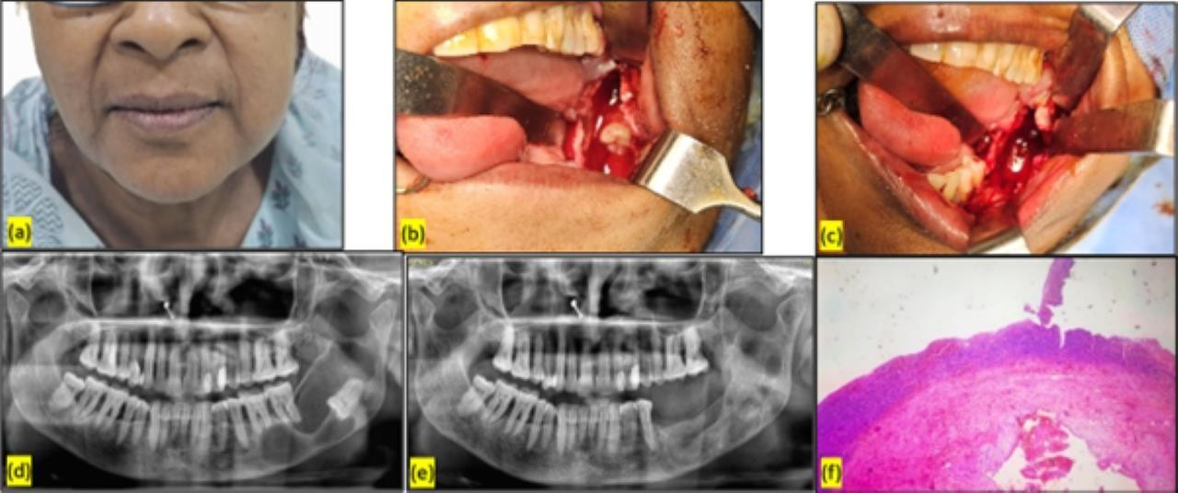
Figure 1: Left to Right (a) Preoperative extraoral image (b) Intraoperative image - lesion with impacted 38 (c) Intraoperative image post enucleation (d) Preoperative OPG (e) 6th month Postoperative OPG (f) Histopathological section -H & E stained.

CASE 2
A 10-year-old girl complained of increased edema in the area of her left lower jaw over the previous five months when she visited the pediatric dental department. The patient describes a two-year history of a stainless steel (SS) crown prosthesis and pulpectomy for a bilateral deciduous second molar. The patient was referred to the department of oral and maxillofacial surgery after an initial examination revealed a possible odontogenic cyst tumor. Examining the left body of the mandibular region revealed bony hard, non-compression, non-fluctuant, non- pulsatile widespread swelling. Vestibular obliteration and intraoral buccal cortical expansion

were observed in the 32–36 region with SS crown in relation to 75 & 85. No other mucosal alterations or neurological disorders were seen.
Bilateral unilocular radiolucency with sclerotic boundaries emerging laterally from unerupted 35 and 45 was shown by OPG. 75 and 85 were extracted while under general anesthesia. The unerupted 35 and 45 were then saved after cyst enucleation. Six months after surgery, the OPG shows unobstructed eruption of 35 and 45, adequate bone healing, and no recurrence.

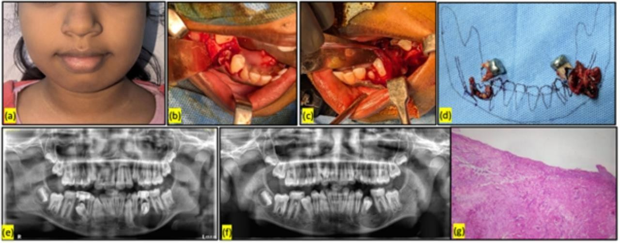
Figure 2: Left to Right (a) Preoperative extraoral image (b) Intraoperative image- right side lesion (c) Intraoperative image- left side lesion
(d) Diagrammatic representation of post enucleation specimen with extracted 75 & 85 (e) Preoperative OPG (f) Postoperative 6 months OPG (g) Histopathological section -H& E stained.

CASE 3
A 41-year-old man complained of pain during mastication in the right posterior tooth region when he visited the Department of Oral and Maxillofacial Surgery. During a screening CT scan of the patient's facial bones following a car accident an year ago, it was discovered that the patient had a dentigerous cyst in proximity to the affected 18 tooth site. After being asymptomatic for the previous ten months, he eventually started experiencing Intermittent, non-radiating throbbing pain in that area when moving his jaw laterally. Examination revealed no pertinent clinical findings. The prior diagnosis of a clearly defined central radiolucency with sclerotic boundaries originating from the cementoenamel junction of impacted tooth 18 was validated by OPG.
The Cadwell luc technique was used to treat the cyst for enucleation and extraction of 18 without piercing the intraoral mucosa. For antrostomy and sinus packing, ribbon gauze soaked in betadine and glycerine was employed; it was gradually removed over a period of seven days.
Six months later, the surgical site had healed nicely and there were no signs of maxillary sinus disorders.
Histological analyses of all these cases showed that the lesion was an infected dentigerous cyst with stratified squamous non-keratinizing cystic epithelium that ranged in thickness from two to three layers and a flat epithelial connective tissue interface. The capsule contained areas of hemorrhage, many cholesterol clefts, mucinous cystic filling, and increased vascularity. It had a moderate amount of collagen.

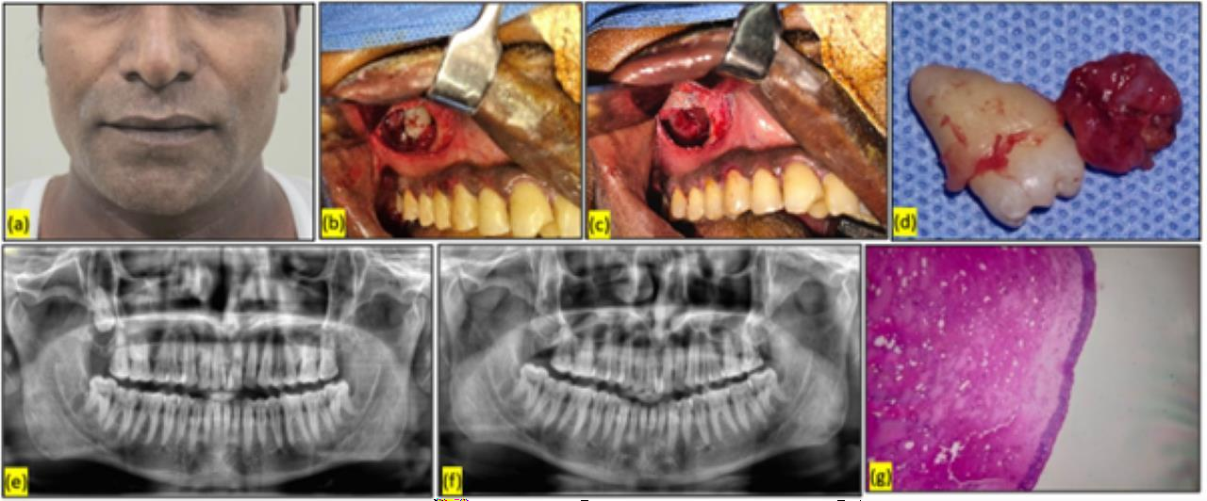
Figure 3: Left to Right (a) Preoperative extraoral image (b) Intraoperative image - lesion with the impacted 18 (c) Intraoperative image - post enucleation (d) Specimen with extracted 18 (e) Preoperative OPG (f) Postoperative 6 months OPG (g) Histopathological section - H & E stained.

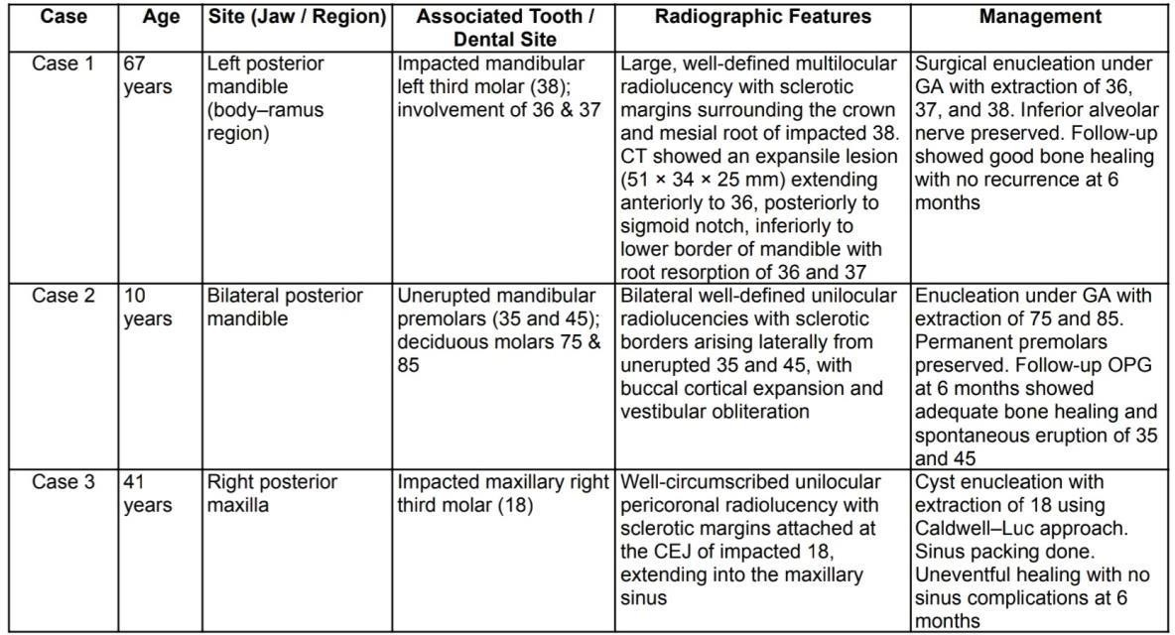

Table 1 : Case details of patients with dentigerous cysts, including age, jaw and region affected, associated teeth, radiographic features, and management.

GA = General Anesthesia; CEJ = Cementoenamel Junction; OPG = Orthopantomogram.

DISCUSSION

After radicular cysts, single dentigerous cysts are the second most prevalent kind of odontogenic cyst. Dentigerous cysts (DCs), which are growing odontogenic cysts, are most commonly linked with the crowns of unerupted or impacted teeth, especially mandibular premolars, maxillary canines, and mandibular third molars. [1,2] The current case series is compatible with this distribution since the cyst was associated with an unerupted, distinct

unilocular radiolucency on imaging. Mandibular dentigerous cysts are commonly unilateral and often coexist with disorders such as cleidocranial dysplasia and Maroteaux-Lamy syndrome. [5] There are currently less than twenty cases of non-syndromic bilateral odontogenic cysts reported in the literature.
The two most common treatments for these cysts are marsupialization and enucleation. When deciding on a course of therapy, the patient's age, the size of the lesion, the location of the linked tooth, and the relationship to neighbouring teeth are all taken into account. [6,7] Each of our patients underwent a thorough histological analysis to confirm the diagnosis. because inflammatory or secondarily infected cysts may exhibit metaplastic changes, such as mucous, ciliated, or even sebaceous epithelium, making it more challenging to differentiate them from other cystic or neoplastic lesions. [8]
The lesion had typical radiographic characteristics that are crucial for the diagnosis of DCs, such as attachment to the cementoenamel junction and pericoronal radiolucency surrounding the crown. Notably, the cyst displayed buccal cortical enlargement, elevation, vestibular obliteration, and small tooth displacement, all of which raised the likelihood of local aggression even though it was benign. Even though most DCs have an indolent history, neoplastic transition is nevertheless clinically significant despite its rarity. The epithelial lining of persistent or untreated dentigerous cysts has been known to give rise to ameloblastoma, squamous cell carcinoma, and mucoepidermoid carcinoma. Proliferative and carcinogenic markers like p53, Bcl-2, and Ki-67 have occasionally been detected by immunohistochemical investigations, suggesting a potential deregulation of cellular growth pathways. [9]
In the current case series, surgical enucleation with extraction of the associated tooth was curative, and follow-up imaging at six months showed no evidence of recurrence. This is consistent with studies demonstrating that total enucleation yields excellent results with low recurrence rates when the lesion is fully eradicated.To preserve surrounding tissues and facilitate the eruption of impacted teeth, marsupialization may be considered in larger cysts, particularly in younger patients. [10]
Comparing our three cases with those documented in the literature reveals some intriguing discrepancies as well as well-known trends. As anticipated, all of the cysts were associated with impacted teeth—a maxillary third molar in Case 3, mandibular premolars in Case 2, and mandibular third molars in Case 1—matching the typical locations reported for dentigerous cysts. They all displayed the typical, well-defined, unilocular radiolucency with a sclerotic border on imaging. However, every situation had its own peculiarities. Case 1 resulted in considerable cortical growth and root resorption in an elderly patient. In Case 2, a youngster had bilateral cysts, which is an uncommon non-syndromic presentation. And Case 3, which had been asymptomatic for months following a small trauma, was found nearly by accident.
This individuality was mirrored in the treatment choices: enucleation was the primary strategy, but we were able to save the juvenile patient's teeth, demonstrating how care may be adjusted to the patient's age and circumstances. [11] All things considered, these instances support our understanding of dentigerous cysts while also serving as a reminder that every patient may have a little different narrative to tell, underscoring the significance of thorough assessment and customized treatment. [12]

Although all three cases showed excellent healing and no recurrence at the six-month follow- up, the relatively short duration of monitoring represents a limitation of this study. A longer follow-up period would be valuable to fully assess long-term outcomes, including the rare possibility of recurrence or late complications.
This case series highlights the need of early detection and appropriate surgical management of dentigerous cysts. These lesions are frequent and typically benign, but thorough radiographic and histologic investigation is required to rule out atypical features and the risk of malignant transformation.

CONCLUSION
Dentigerous cysts, though commonly benign and asymptomatic, can demonstrate a wide spectrum of clinical behavior ranging from incidental findings to locally aggressive lesions with significant bone destruction. This case series highlights uncommon presentations across different age groups and jaw locations, emphasizing the importance of careful radiographic evaluation and histopathological confirmation. Timely diagnosis and appropriately tailored surgical management particularly complete enucleation with preservation of vital structures when feasible resulted in favorable outcomes without recurrence at six months. These cases reinforce the need for individualized treatment planning and vigilant follow up to minimize complications and address the rare but significant risk of aggressive behavior or malignant transformation.

Consent
As per international standards or university standards, patient(s) written consent has been collected and preserved by the author(s).

Disclaimer (Artificial intelligence)
Author(s) hereby declare that NO generative AI technologies such as Large Language Models (ChatGPT, COPILOT, etc.) and text-to-image generators have been used during the writing or editing of this manuscript.

References
- Šarac Z, Perić B, Filipović-Zore I, Čabov T, Biočić J. Follicular jaw cysts. Collegium antropologicum. 2010 Mar 25;34(1):215-9.
- Shafer AW, Hine MK, Levy BM. Shafer's textbook of oral pathology. Elsevier, a division of Reed Elsevier India Private Limited; 2015
- Shear, M., & Speight, P. (2007). Cysts of the Oral and Maxillofacial Regions (4th ed.). Wiley-Blackwell.
- Borrás-Ferreres J, Sánchez-Torres A, Gay-Escoda C. Malignant changes developing from odontogenic cysts: A systematic review. J Clin Exp Dent. 2016;8(5):e622-e628. Published 2016 Dec 1. doi:10.4317/jced.53256
- Bhardwaj N, Puri A, Wadhwan V, Gupta M. Cleidocranial dysplasia associated with dentigerous cyst-review of literature and case report of two siblings. Indian J Pathol Microbiol. 2025;68(2):375-381. doi:10.4103/ijpm.ijpm_532_23
- Gaurkar SS, Deshmukh PT, Singh CV, Khan FQ. A Rare Presentation of Dentigerous Cyst. Cureus. 2022 Jun 19;14(6):e26098. doi: 10.7759/cureus.26098. PMID: 35875303; PMCID: PMC9298675.
- Aldelaimi, A.A.K., Enezei, H.H., Berum, H.E.R. et al. Management of a dentigerous cyst; a ten-year clinicopathological study. BMC Oral Health 24, 831 (2024). https://doi.org/10.1186/s12903-024-04607-w
- Neville, B. W., Damm, D. D., Allen, C. M., & Chi, A. C. (2016). Oral and Maxillofacial Pathology (4th ed.). Elsevier.
- Piattelli, A., Fioroni, M., Santinelli, A., & Rubini, C. (2001). Immunohistochemical analysis of bcl-2 and p53 oncoproteins in dentigerous and radicular cysts. Oral Diseases, 7(3), 196–200.

- Kumar Mohapatra P, Joshi N. Conservative management of a dentigerous cyst associated with an impacted mandibular second premolar in mixed. J Dent Res Dent Clin Dent Prospects. 2009 Summer;3(3):98-102. doi: 10.5681/joddd.2009.025. Epub 2009 Sep 16. PMID: 23230494; PMCID: PMC3517282.
- Zakaria O, Alshehri S. Case Report : Bilateral dentigerous cysts in association with developing third molars and premolars in a non-syndromic 13-year-old: a 2-year follow-up. F1000Res. 2025;14:215. Published 2025 Feb 17. doi:10.12688/f1000research.161532.1
- Matharoo, Rupinder & Singh, Harmunish & Grewal, Pushpinder. (2024). Dentigerous cyst- A case report and review of the literature. International Journal of Oral Health Dentistry. 10. 236-239. 10.18231/j.ijohd.2024.041.

